Epidemic thunderstorm asthma campaign
Social media posts – for public audience

Social media tiles available
“Protect yourself this pollen season” | “Do you have asthma or hay fever?” |  | “Do you have asthma?” | “Do you have hay fever?” | “Do you know the four steps of asthma first aid? |  | Asthma First Aid grid
 |  |  | 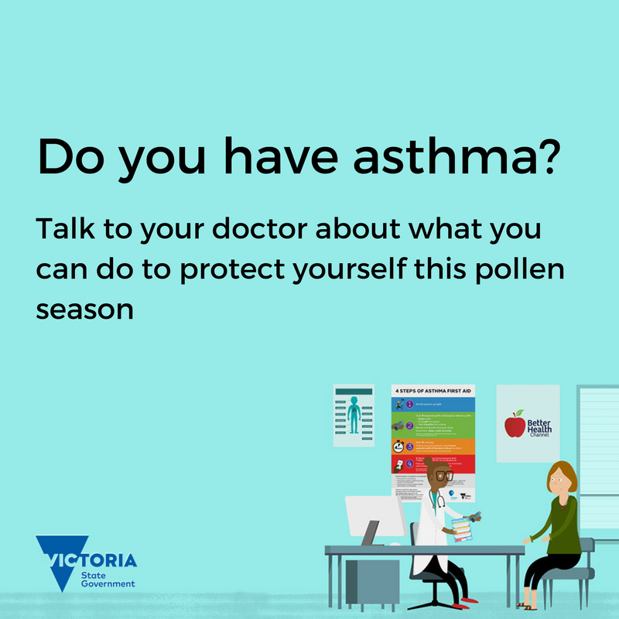 | 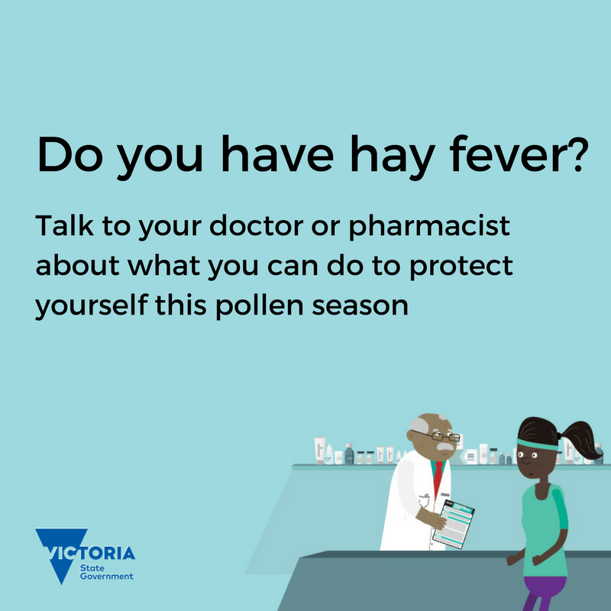 | 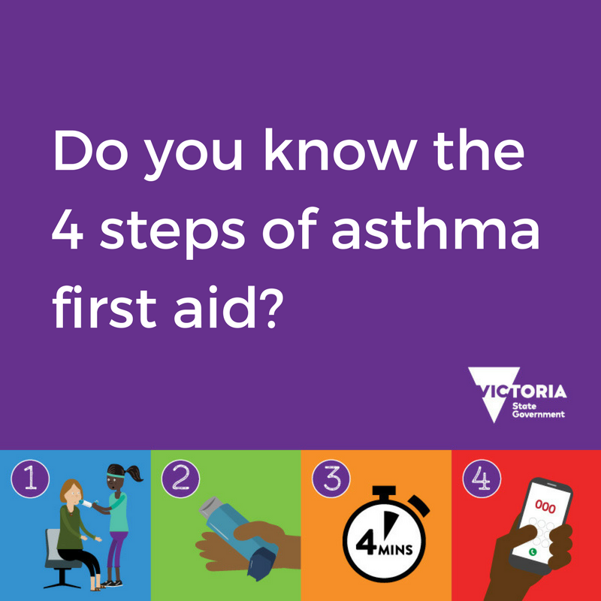 |  | 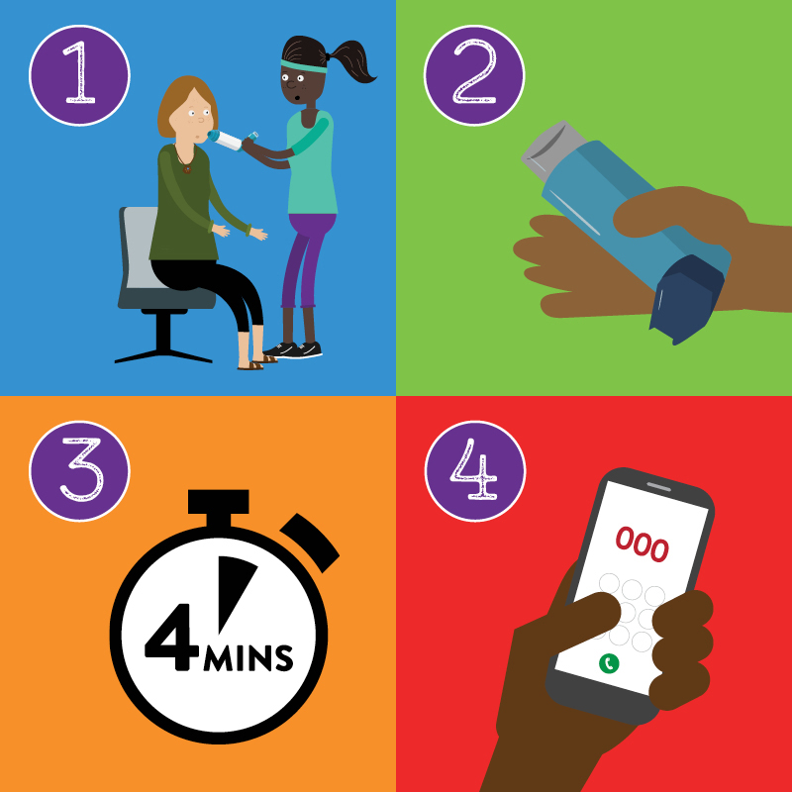
Four steps of asthma first aid: Please note, these tiles must be used together as a Facebook carousel post, as individually they provide no context and no informative advice on learning asthma first aid.
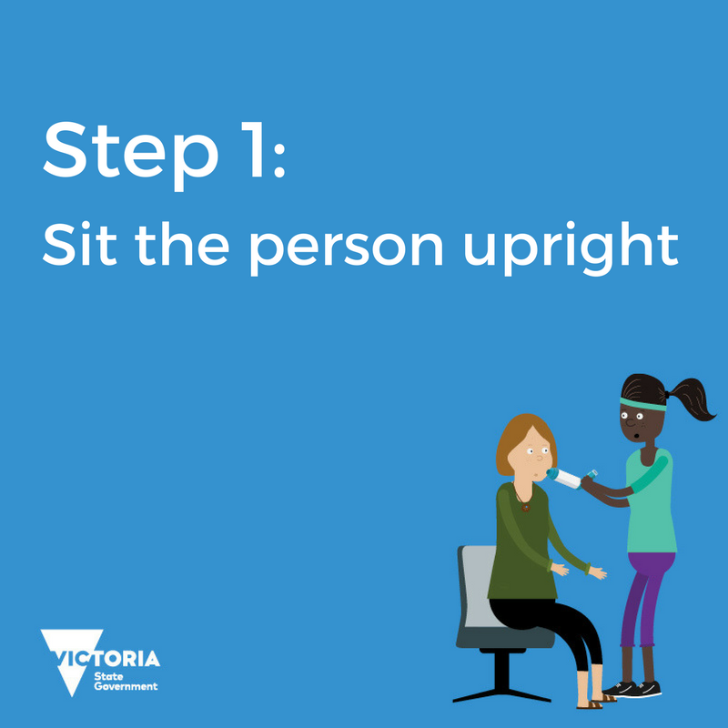 |  | 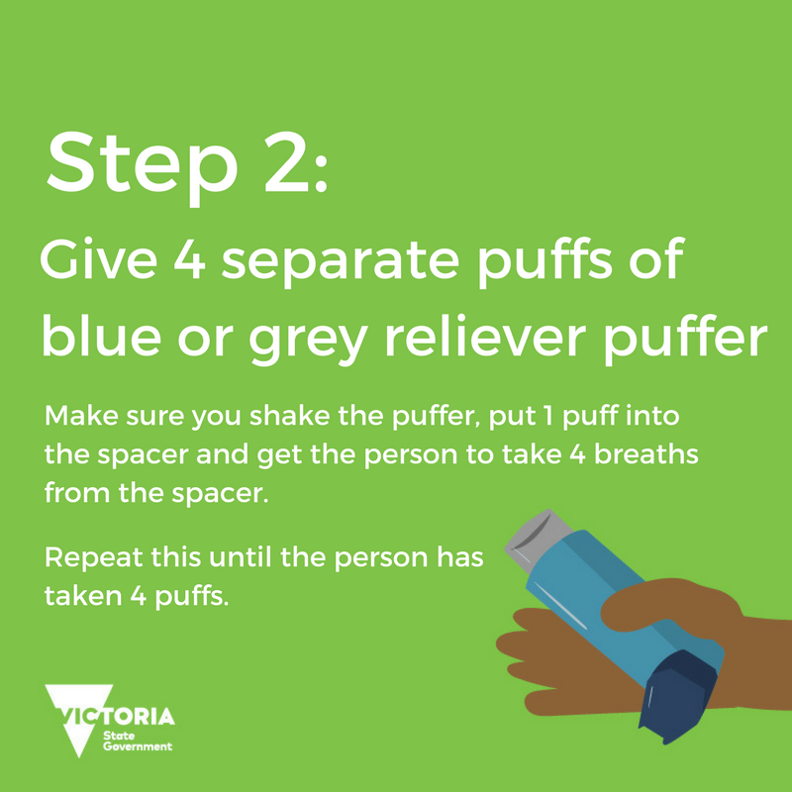 |  | 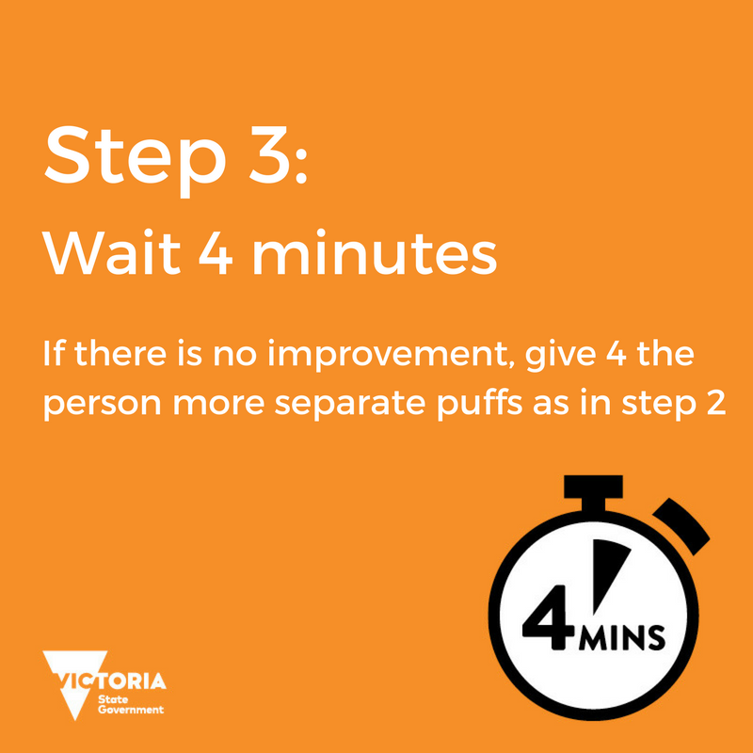 |  | 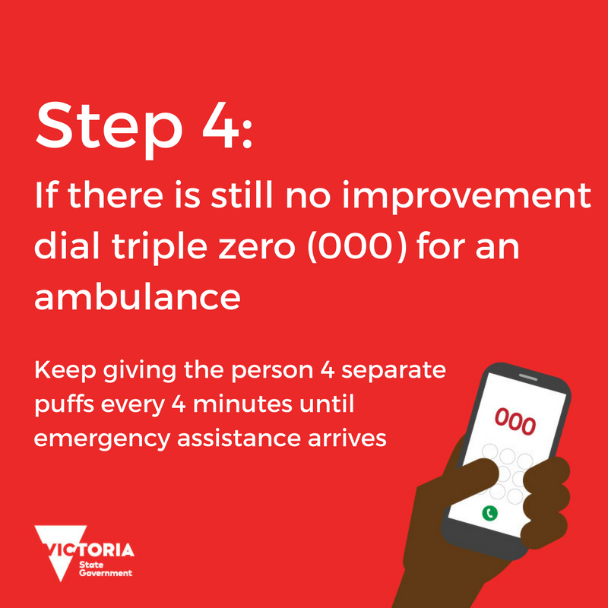

Suggested Facebook posts

For National Asthma Week (1-7 September) and in preparation of the grass pollen season
Have asthma or hay fever? This #AsthmaWeek is a great time to speak to your doctor or pharmacist and find out what you can do to help prepare yourself for grass pollen season. Remember, managing asthma and allergies matters. More info on the Better Health Channel: www.betterhealth.vic.gov.au/thunderstormasthma
Grass pollen season is on its way, bringing an increase in asthma and hay fever. It also brings the chance of #ThunderstormAsthma. If you sneeze and wheeze during pollen season, talk to your doctor or pharmacist about what you can do to protect yourself. Find out more on the Better Health Channel www.betterhealth.vic.gov.au/thunderstormasthma
Grass pollen season is on its way, bringing an increase in asthma and hay fever. It also brings the chance of #ThunderstormAsthma. If you’ve ever had asthma or hay fever, talk to your doctor or pharmacist about what you can do to protect yourself. Find out more on the Better Health Channel www.betterhealth.vic.gov.au/thunderstormasthma

What is #ThunderstormAsthma? Watch this video to find out more about thunderstorm asthma and what can you do to help prepare for grass pollen season: https://www.betterhealth.vic.gov.au/health/Videos/thunderstorm-asthma-overview
Managing your asthma and hay fever before grass pollen season can help reduce your risk of #ThunderstormAsthma. Talk to your doctor or pharmacist today and find out how you can prepare for grass pollen season. Find out more on the Better Health Channel. www.betterhealth.vic.gov.au/thunderstormasthma

During grass pollen season (October through December)
Do you have #hayfever and experience wheezing or coughing with your hay fever? You could have #asthma and not know it. Talk to your doctor today and find out. Remember, managing asthma and allergies matters and can help protect you from the risk of thunderstorm asthma. Find out more about thunderstorm asthma on the Better Health Channel. www.betterhealth.vic.gov.au/thunderstormasthma
About 1 in 9 people have #asthma, so it’s important to know what to do if someone is having an asthma attack. You could help save a life! Learn the 4 steps of asthma first aid by watching this short animation: https://www.betterhealth.vic.gov.au/health/Videos/thunderstormasthma-firstaid
Having good control of your #asthma or #hayfever can help reduce your risk of thunderstorm asthma. If you have asthma or hay fever make sure you speak to your doctor or pharmacist about what you can do to help protect yourself this grass pollen season. Find out more on the Better Health Channel. www.betterhealth.vic.gov.au/thunderstormasthma
Could you have asthma? If you have hay fever and experience coughing or wheezing with your hay fever it’s important that you check with your doctor to see whether or have #asthma. If you do have asthma, the sooner you get it under control the sooner you’ll feel better Find out more on the Better Health Channel. www.betterhealth.vic.gov.au/thunderstormasthma
Do you have asthma? Taking your asthma preventer properly and regularly is key to preventing asthma, including #ThunderstormAsthma. Speak to your doctor today about what you can do to help prepare yourself for pollen season. Watch this short animation to find out more: https://www.betterhealth.vic.gov.au/health/videos/thunderstormasthma
Would you know what to do if someone was having an asthma attack? This short video can help you learn the 4 steps of asthma first aid and could help save a life. https://www.betterhealth.vic.gov.au/health/Videos/thunderstormasthma-firstaid
Did you know that #ThunderstormAsthma can also affect people with hay fever? Check out this video to learn about thunderstorm asthma and how you can protect yourself this pollen season. https://www.betterhealth.vic.gov.au/health/videos/thunderstormasthma-hayfever

Suggested Twitter posts

For National Asthma Week (1-7 September) and in preparation of the grass pollen season
#AsthmaWeek is a great reminder to get ready for grass pollen season and help reduce your risk of #ThunderstormAsthma. More info here: www.betterhealth.vic.gov.au/thunderstormasthma
What is #ThunderstormAsthma? Find out about thunderstorm asthma and how to protect yourself this grass pollen season. Watch to find out more https://www.betterhealth.vic.gov.au/health/videos/thunderstorm-asthma-overview
Managing asthma and allergies matters – especially during grass pollen season. Find out what you can do to help protect yourself from the risk of #ThunderstormAsthma www.betterhealth.vic.gov.au/thunderstormasthma
1 in 9 people have #asthma, so it’s important for everyone to know the 4 steps of #asthmafirstaid. Find out more: https://www.betterhealth.vic.gov.au/health/Videos/thunderstormasthma-firstaid
Having good control of your asthma or hay fever can help reduce your risk of #ThunderstormAsthma Watch to find out more: https://www.betterhealth.vic.gov.au/health/videos/thunderstorm-asthma-overview
Do you have asthma? Make sure you talk to your GP about managing your #asthma & protect yourself from #ThunderstormAsthma this grass pollen season: https://www.betterhealth.vic.gov.au/health/videos/thunderstormasthma
Do you have hay fever? Talk to your pharmacist today about what you can do to manage your #hayfever and help reduce your risk of #ThunderstormAsthma https://www.betterhealth.vic.gov.au/health/videos/thunderstormasthma-hayfever
Would you know what to do if someone was having an #asthma attack? Watch this video to learn the 4 steps of asthma first aid https://www.betterhealth.vic.gov.au/health/Videos/thunderstormasthma-firstaid

During grass pollen season (October through December)
 | Grass pollen season brings the chance of #ThunderstormAsthma. If you have asthma or hay fever talk to your doctor or pharmacist about what you can do to protect yourself www.betterhealth.vic.gov.au/thunderstormasthma
 | Wheeze or sneeze during grass pollen season? Talk to your GP or pharmacist about how to protect yourself this #PollenSeason. More info: www.betterhealth.vic.gov.au/thunderstormasthma
 | Do you know what to do if someone is having an #asthma attack? Knowing the 4 steps of asthma first aid can save lives. Watch to learn more https://www.betterhealth.vic.gov.au/health/Videos/thunderstormasthma-firstaid
 | Do you have hay fever? If you wheeze and cough with your #hayfever you might also have #asthma. Talk to your doctor to find out and protect yourself this pollen grass season https://www.betterhealth.vic.gov.au/health/videos/thunderstormasthma-hayfever
 | Taking your asthma preventer properly & regularly can improve your #asthma control & help reduce your risk of #ThunderstormAsthma https://www.betterhealth.vic.gov.au/health/videos/thunderstormasthma
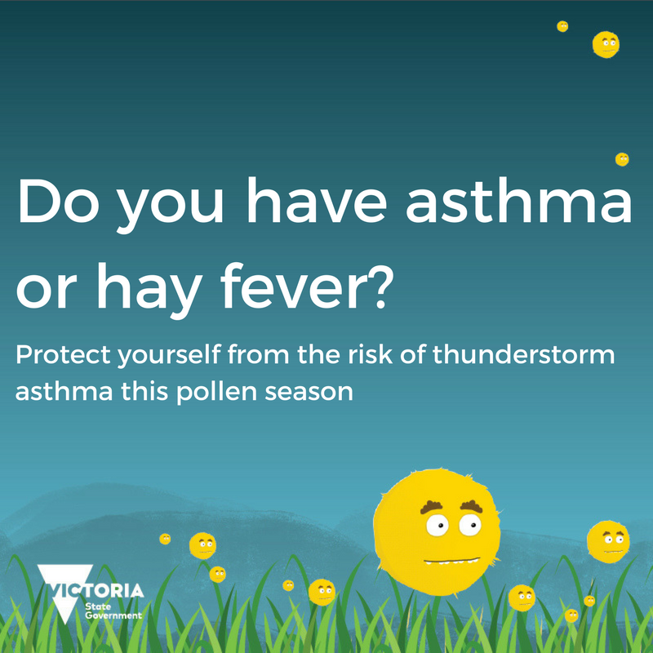 | #ThunderstormAsthma can affect many people, especially those with #asthma or #hayfever. Talk to your doctor or pharmacist about protecting yourself this grass pollen season https://www.betterhealth.vic.gov.au/health/videos/thunderstormasthma-hayfever
 | Have #asthma? Talk to your GP about what you can do to protect yourself from #ThunderstormAsthma www.betterhealth.vic.gov.au/thunderstormasthma
 | Have #hayfever? Speak to your pharmacist or doctor about what you can do to protect yourself from #ThunderstormAsthma www.betterhealth.vic.gov.au/thunderstormasthma

For advice related to COVID-19 restrictions please go to https://www.dhhs.vic.gov.au/coronavirus

To receive this document in another format email environmental.healthunit@health.vic.gov.au <environmental.healthunit@health.vic.gov.au>
Authorised and published by the Victorian Government, 1 Treasury Place, Melbourne.
© State of Victoria, Australia, Department of Health, August 2021.
Available at Epidemic thunderstorm asthma campaign toolkit <https://www2.health.vic.gov.au/public-health/environmental-health/climate-weather-and-public-health/thunderstorm-asthma/toolkit>

