Water fluoridation for healthy teeth
Community information
OFFICIAL
A message from Victoria’s Chief Health Officer
Fluoride acts as a constant repair kit for teeth. It can reduce the risk of tooth decay and even reverse it in the early stages. Water fluoridation is the process of adjusting the amount of fluoride in drinking water to an optimal level to help reduce tooth decay.
The Victorian Government recognises that oral health is important to a person’s overall health and is committed to improving the oral health of all Victorians. Preventing problems before they occur is vital to good public health.
More than 96 percent of Victorians drink water with either naturally occurring or added fluoride. Melbourne and some regional areas have enjoyed the benefits of fluoridated drinking water for more than 40 years.
In 2020 the government released the Victorian action plan to prevent oral disease 2020–30. The plan sets out a vision to achieve good oral health for all Victorians by 2030, with a focus on reducing the gap in oral health for people who are at higher risk of oral disease. This includes providing water fluoridation to Victorian communities that do not currently have access, funding public dental care for eligible people, providing free annual oral health check-ups and the follow up care needed to children in government schools through the Smile Squad program, and other oral health promotion and oral disease prevention programs.
Even with a fluoridated drinking water supply, it is important to keep looking after your teeth through healthy eating, by brushing twice a day with an appropriate fluoride toothpaste and through regular dental check-ups.
I encourage you to read the following information about water fluoridation and oral health.

Adj. Clinical Professor Brett Sutton
Chief Health Officer

How does oral health affect a person’s general health?
People need to have healthy teeth and a healthy mouth to be able to eat, speak and smile well.
Tooth decay can cause pain and have a negative effect on a person’s appearance, self-esteem, social interaction and the ability to eat, speak and chew, which can affect their general health.
The effects of tooth decay are costly in terms of time, money and personal pain and suffering.

Why is tooth decay a serious issue?
Tooth decay is still a big problem in Victoria. Almost half of all children aged 5 to 10 years have signs of tooth decay and 90 per cent of adults are affected., Some people are more likely to get oral diseases than others.
Dental problems are the biggest cause of all potentially preventable hospitalisations in children up to nine years old, mostly because of tooth decay. Across Victoria in 2019–20 there were more than 4,300 children under the age of 10 who needed a general anaesthetic to treat their tooth decay.

What is fluoride?
Fluoride is a naturally occurring mineral found in rock, air, soil, plants and water. All fresh and sea water contains some fluoride. Many foods and drinks naturally contain fluoride. It is also added to:
- drinking water, where fluoride is added to the local water supply
- fluoride toothpastes, gels and mouth rinses
- fluoride products painted on the teeth by a dental professional.

What is water fluoridation?
Water fluoridation is the process of changing the amount of fluoride in drinking water to an optimal level to help reduce tooth decay. Leading national and international health organisations recommend fluoridating drinking water. Extending fluoridation is a key strategy in Australia’s national oral health plan and is one of four goals in the Victorian action plan to prevent oral disease 2020–30.
In some parts of Victoria the local water supply naturally contains fluoride at a level that can help to prevent tooth decay. However, most water supplies naturally contain low levels that aren’t high enough to reduce the risk of tooth decay. Adding fluoride does not alter the taste or smell of water.

What are the benefits of water fluoridation?
Fluoride in drinking water is helpful because it:
- helps protect against tooth decay in people of all ages, regardless of education, income, motivation or access to dental and health care
- repairs damage to teeth caused by food and drinks
- can reduce the impacts of tooth decay including discomfort, pain and the cost of dental treatment.

How does fluoride protect against tooth decay?
Tooth decay occurs when acid destroys the outer surface of the tooth. The consumption of food and drinks containing sugar causes bacteria in the mouth to make this acid. As well as sugar, acid found in food and drinks (e.g. fizzy drinks and ‘sports’ drinks) can also damage the tooth surface and contribute to tooth decay. Fluoride works by helping to strengthen the mineral structure of developing teeth and can limit the amount of acid produced by bacteria. It can also act like a constant repair kit by repairing the early stages of tooth decay.

Why is it important to still use fluoridated toothpaste if I am drinking fluoridated water?
Fluoridated drinking water and toothpaste with fluoride provide important and complementary benefits. Fluoridated drinking water keeps low levels of fluoride in saliva and in dental plaque all day. Together, the two sources offer more protection than using either one alone. By comparison, the amount of fluoride in children’s toothpaste is around 500 parts per million and in regular toothpaste is 1,000 to 1,500 parts per million.

How is fluoride added to drinking water?
Fluoride is added to the water at drinking water treatment plants that have been designed to add carefully controlled amounts. The fluoride level in the water is continually monitored and equipment is designed to shut down if the fluoride level goes higher than it should at any point in the water treatment system. Samples of water are also taken from sites throughout the water supply network to check the fluoride concentration ‘at the tap’.

How much fluoride is added to drinking water?
To help protect teeth against tooth decay, only a very small amount of fluoride is needed in drinking water. For Victoria, the fluoride content of drinking water is adjusted to an optimal level of 1 mg/L (also known as one part per million).

How do I know water fluoridation is safe?
Australia’s peak health body, the National Health and Medical Research Council (NHMRC), strongly recommends community water fluoridation as a safe, effective and ethical way to help reduce tooth decay across the population.
The NHMRC has specified the compounds that are acceptable to add to drinking water for this purpose. These are sodium fluoride, sodium fluorosilicate and fluorosilicic acid. The local water supplier chooses the type of compound it will use based on the type of fluoridation equipment at the water treatment plant.
Studies from the NHMRC and other health authorities around the world consistently find that water fluoridation does not have any harmful effects.

Which Victorian communities have fluoridated water?
About 96 percent of Victorians have access to fluoridated water. This is broken down into 99 percent of communities in metropolitan Melbourne and 87 percent in rural and regional areas (refer to Figure 1).

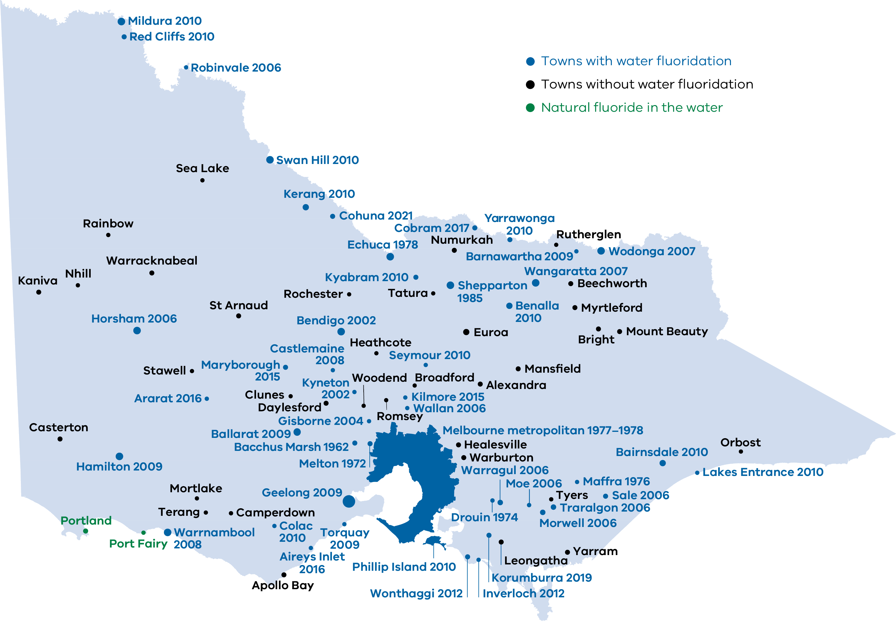
Figure 1: This map of Victoria shows locations with fluoridated drinking water in blue text, and towns with natural fluoride in the water in green text. Locations without water fluoridation are shown in black text.

Additional oral health advice

More ways to help protect your teeth
Even if your water is fluoridated, it is important to look after your teeth by:
- eating a healthy diet including limiting food and drinks that are high in sugar (particularly added sugar)
- brushing your teeth and gums two times a day using a toothpaste with the appropriate level of fluoride in it:
  - no toothpaste for children aged up to 18 months old
  - a pea-sized amount of low-fluoride toothpaste for children aged between 18 months and six years old
  - standard fluoride toothpaste for anyone over six years old
- having regular dental check-ups.
Everybody has different oral health needs. Ask your dental professional how often you should have a dental check-up.
Children should have an oral health check by the time they turn two. A dental professional, GP or maternal and child health nurse may do this.

Infant formula can be prepared with fluoridated water
Although breast milk is the best feeding choice for babies, infant formula also provides a baby with enough nutrition. If infant formula is used, it is safe to prepare it using fluoridated drinking water in Australia.

Fluoride tablets, drops and lozenges are not recommended
Regardless of whether your drinking water is fluoridated, fluoride tablets, drops and lozenges are not recommended in Australia and are no longer available. If anyone in your household has been using these products, it is important to stop. Dental professionals may still use and recommend fluoride varnishes and mouth rinses.

More information about water fluoridation
- Call the Department of Health’s water fluoridation information line on 1800 651 723.
- Visit the Better Health Channel <https://www.betterhealth.vic.gov.au/health/conditionsandtreatments/dental-care-fluoride>.
- Visit the Department of Health’s website <https://www2.health.vic.gov.au/public-health/water/water-fluoridation>.
- Talk to your dental professional, GP, pharmacist or maternal and child health nurse.
- Visit the NHMRC’s website <https://www.nhmrc.gov.au/health-advice/public-health/health-effects-water-fluoridation>.

More information about oral health and dental care
- Visit the Dental Health Services Victoria website <https://www.dhsv.org.au>.
- Visit the Better Health Channel <https://www.betterhealth.vic.gov.au/conditionsandtreatments/mouth-and-teeth>.
- Visit the Department of Health’s website <https://www2.health.vic.gov.au/primary-and-community-health/dental-health>.
- Talk to your dental professional, GP, pharmacist or maternal and child health nurse.

To receive this document in another format, phone 1300 761 874, using the National Relay Service 13 36 77 if required, or email the Water Unit <water@health.vic.gov.au>.
Authorised and published by the Victorian Government, 1 Treasury Place, Melbourne.
© State of Victoria, Australia, Department of Health, April 2021.
ISBN 978-1-76096-339-2 (pdf/online/MS word)
Available at the Department of Health’s Water fluoridation webpage <https://www2.health.vic.gov.au/public-health/water/water-fluoridation/fluoride-information>

ARCPOH. Oral health of Australian children: National Child Oral Health Study 2012–14. Adelaide: University of Adelaide, South Australia.
ARCPOH. Australia’s Oral Health: National Study of Adult Oral Health 2017–18. Adelaide: The University of Adelaide, South Australia.
Ambulatory Care Sensitive Conditions (ACSCs): Victorian Health Information Surveillance System (VHISS), Department of Health, Government of Victoria, Melbourne.
Ambulatory Care Sensitive Conditions (ACSCs): Victorian Health Information Surveillance System (VHISS), Department of Health, Government of Victoria, Melbourne.
COAG Health Council (2015) Healthy Mouths Healthy Lives: Australia’s national oral health plan 2015–2024. <http://www.coaghealthcouncil.gov.au/Publications/Reports/ArtMID/514/ArticleID/81>
Department of Health and Human Services (2020) Victorian action plan to prevent oral disease 2020–30 <https://www2.health.vic.gov.au/public-health/preventive-health/oral-health-promotion/oral-health-planning>
National Health and Medical Research Council (2011) Australian drinking water guidelines <https://www.nhmrc.gov.au/about-us/publications/australian-drinking-water-guidelines>
National Health and Medical Research Council (2021) Health effects of water fluoridation <https://www.nhmrc.gov.au/health-advice/public-health/health-effects-water-fluoridation>
For more information about which locations in Victoria have access to water fluoridation see the Department of Health’s website <https://www2.health.vic.gov.au/public-health/water/water-fluoridation/water-fluoridation-in-victoria>
In some cases a health professional may recommend using toothpaste with a different amount of fluoride that is right for you.

