The Development of an evaluation and outcomes framework for the Victorian Cancer Survivorship Program
Final report January 2016

Department of Health

The Development of an evaluation and outcomes framework for the Victorian Cancer Survivorship Program

Final report

Preferred citation
Coughlan A 2016, The Development of an evaluation and outcomes framework for the Victorian Cancer Survivorship Program.

To receive this publication in an accessible format phone (03) 909 62136, using the National Relay Service 13 36 77 if required, or email <cancerplanning@dhhs.vic.gov.au>
Authorised and published by the Victorian Government, 1 Treasury Place, Melbourne.
© State of Victoria, Department of Health and Human Services January 2016.
Except where otherwise indicated, the images in this publication show models and illustrative settings only, and do not necessarily depict actual services, facilities or recipients of services. This publication may contain images of deceased Aboriginal and Torres Strait Islander peoples.
Where the term ‘Aboriginal’ is used it refers to both Aboriginal and Torres Strait Islander people. Indigenous is retained when it is part of the title of a report, program or quotation.
January 2016
Available at the department’s website <www.health.vic.gov.au/cancer>

Contents
The Development of an evaluation and outcomes framework for the Victorian Cancer Survivorship Program 3
Final report 3
Contents 5
Introduction 6
Setting the scene – Why this framework was developed 6
How this framework was developed 7
How this framework will be used 7
The key components of the evaluation framework 7
Evaluation statement of purpose 8
Evaluation scope 8
Context for the evaluation – key elements of cancer survivorship and intended mechanisms for action for VCSP2 9
Key evaluation domains – level of focus, key questions, dimensions of interest, data sources and methods 13
Summary of proposed evaluation methods 23
Appendix I – Method for development this evaluation framework 30
Appendix 2 – Measuring potential outcomes at a patient level – list of tools for consideration in project and evaluation planning 37

Introduction
This evaluation and outcomes framework has been developed to inform the application of consistent evaluation measures and methods to the planning, conduct, delivery and evaluation of the second grant round of the Victorian Cancer Survivorship Program (VCSP).

Setting the scene – Why this framework was developed
The Victorian Cancer Survivorship Program (VCSP), an initiative of the Victorian Department of Health and Human Services (DHHS), was designed to enable the development and piloting of models of innovative and sustainable models of cancer follow-up care in various settings and patient populations. In 2011, a grant round (VCSP1) was initiated which funded six projects undertaken from 2012 to 2014. Across the projects, there were some areas of commonality such as the development of survivorship care plans and engagement with GPs. There were also elements that were unique to specific projects such as a focus on community-based delivery of exercise and nutrition interventions, shared care and nurse-led clinics.

Each project team in VCSP1 developed and implemented a series of evaluation methods and measures into their work. Some external evaluation components were also incorporated into specific projects e.g. economic analysis. A workforce evaluation of the six projects in VCSP1 was also undertaken by The Australian Health Workforce Institute. The findings from VCSP1 were compiled into a detailed report providing insights into survivorship care planning, potential models of care and enablers and barriers to improving cancer survivorship planning and care. Whilst the insights generated from VCSP1 are valuable, the absence of an overarching and consistent evaluation framework limited the capacity for meaningful comparisons across projects and thus the extent to which the Program was able to contribute to the cancer survivorship evidence base.

Other elements of VCSP include a Community of Practice and Collaborative Workspace coordinated by the Australian Cancer Survivorship Centre and the provision of further funding to three of the funding recipients from VCSP1 to support the roll out of the model of care to other sites and/or tumour streams.

The VCSP Phase II Grants Scheme (VCSP2) will be initiated in late 2015 with a call for grant applications for projects of one to three years’ duration including: capacity building grants; general cancer survivorship grants; and primary and community health grants. This evaluation framework is designed to inform the integration of a consistent approach to evaluation enquiry and reporting into VCSP2 to strengthen the quality, consistency and depth of evidence generated.

How this framework was developed
The framework was informed by a review of key documentation and literature relating to best practice cancer survivorship, outcomes from VCSP1 and potentially applicable existing evaluation frameworks such as RE-AIM. The framework was further informed by a series of individual interviews with key informants, meetings with DHHS and the Australian Cancer Survivorship Centre. A discussion of ‘success’ in the context of optimal approaches to cancer survivorship and how success can be measured was also captured at the VCSP Community of Practice meeting in September 2015. Appendix 1 lists the interview informants, key questions, documentation reviewed and outcomes of a stakeholder analysis conducted to inform the framework.

How this framework will be used
An integrated approach to the application of this framework will be used in the planning and implementation of VCSP2. Key measures and dimensions of interest outlined in this framework will be incorporated into:
- Funding guidelines for VCSP2
- VCSP2 grant application form
- Reporting templates for funded projects (to guide six monthly reporting to DHHS for the duration of the project)
- Final report template.
The VCSP Community of Practice that is administered by the Australian Cancer Survivorship Centre will provide a key mechanism for supporting the conduct of evaluation activities, troubleshooting key issues encountered and providing information and support to participating project teams.
This framework will guide evaluation activities at the project level as well as the analysis of evaluation outcomes at a whole of Program level. This will importantly provide the basis for the assessment of the overall impact achieved from the investment in VCSP2.
Whilst this framework has been designed specifically for VCSP2, it may provide a useful guide to the development and implementation of evaluation activities in other jurisdictions or in cancer survivorship initiatives in Victoria that are not part of VCSP2.

The key components of the evaluation framework
The key elements of the framework include:
- The statement of purpose
- Evaluation scope
- Context for the evaluation – key elements of cancer survivorship and intended mechanisms of action for VCSP2
- Key evaluation domains – level of focus, key questions, dimensions of interest, data sources and methods
- Summary of proposed evaluation methods.
The evaluation enquiry that is guided by this framework is both formative and summative (see box). It is also designed to capture measures of process and impact at the patient, carer and organisational levels.
A formative evaluation is one that embeds evaluation methods from the earliest point in a project’s inception, planning, development and throughout implementation with an improvement, action learning intention. It is particularly relevant for project initiatives such as VCSP2. A summative evaluation is undertaken at the end of a project or program to measure what worked, for whom and in what circumstances. When both formative and summative approaches are merged, a strong basis is provided to optimising both the success of a project and the quality and richness of evidence that is generated.

Evaluation statement of purpose
This framework is designed as a guide to the consistent capture of critical measures throughout the initiation, planning, implementation and final evaluation of VCSP2.
The purpose of this evaluation at a project level is to:
- Inform high quality project design, planning and implementation
- Generate consistent and meaningful insights throughout the project’s duration to inform an iterative action learning approach to optimising the value and success of the project
- Provide evidence of the overall impacts achieved by the project initiative that can inform concise and compelling internal and external communications and inform the business case for ongoing support for successful initiatives
- Generate robust evidence that can be published and shared with the field through peer-reviewed publication and conference presentations.

The purpose of this evaluation at a state-wide level is to:
- Generate evidence that will make a contribution to the knowledge base on cancer survivorship
- Understand the impacts achieved from the investment in VCSP2
- Inform, guide and focus the development of future initiatives seeking to further progress cancer survivorship reform in Victoria.

Evaluation scope
The evaluation framework informs the development and implementation of evaluation measures and methods throughout all phases of the initiation and conduct of VCSP2. The scope of the evaluation is framed around the conduct of activities by each project team (internal evaluation) with mixed methods used to create a rich source of data to understand elements of process and impact relevant to each project. It is anticipated that every grant recipient in VCSP2 will submit their project and associated evaluation methods for ethics approval to the relevant institution(s) in order to ensure that there is the capacity to publish the project findings upon completion and contribute to the cancer survivorship knowledge base.
The integrated approach to evaluation outlined in this framework is designed to add significant value to the process of project planning, implementation and evaluation. The focus is on enabling a formative and summative assessment of the success of the projects as they are implemented in the real world setting.

Context for the evaluation – key elements of cancer survivorship and intended mechanisms for action for VCSP2
In the development of this framework, critical components of the evolving concept and understanding of cancer survivorship were reviewed and are presented below as important context that informed the development of the six key domains for evaluation focus, guiding questions, data sources and methods.
Many of the dimensions of cancer survivorship and associated models of care that were identified in the development of this framework were also reflected in the Clinical Oncology Society of Australia’s (COSA) position statement ‘Critical Components of Cancer Survivorship Care’. Whilst still in draft form and not widely accepted or endorsed at present, the COSA model draws on international models and experience and aligns with the elements of models of cancer survivorship considered relevant by key informants to capture in this framework.
The COSA model for wellness in cancer survivorship (reproduced in Figure 1) frames the process for ‘living well’ post diagnosis of cancer and incorporates key elements that are now synonymous with approaches to cancer survivorship and reflected in the findings from VCSP1 including: needs assessment, risk stratification, self-management, nurse-led clinics and primary care led or shared care. Further, Figure 2 (also reproduced from the COSA model) presents a series of elements of an integrated approach to cancer survivorship. This model places the survivor at the centre of focussed efforts, with self-management, support in the community, primary care and then specialist services as key elements for integrated care. The model hones in on three critical stakeholder groups – health professionals, community and survivors and presents their role in survivorship as well as key elements of service delivery relating to cancer survivorship planning, transition of care and supported self-management: Risk stratification; Care Plan; Care coordination; Tools; and Time factors. These models provided a useful frame and context for the development and review of measures and domains of interest in this framework.

Figure 1: COSA model for wellness in survivorship
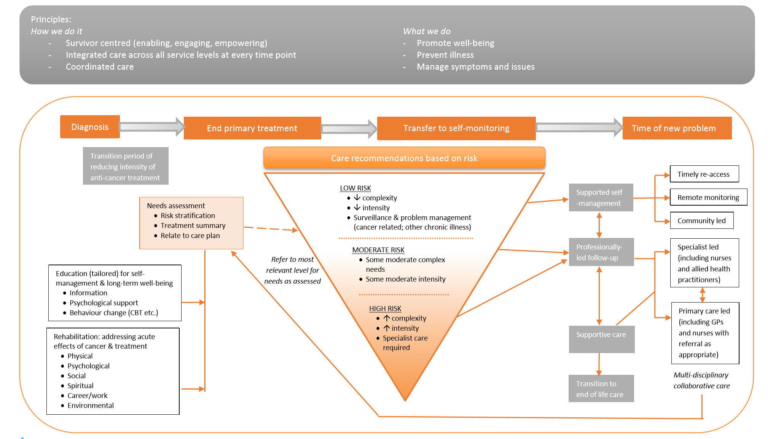

Figure 2: COSA model – integration of care for cancer survivors
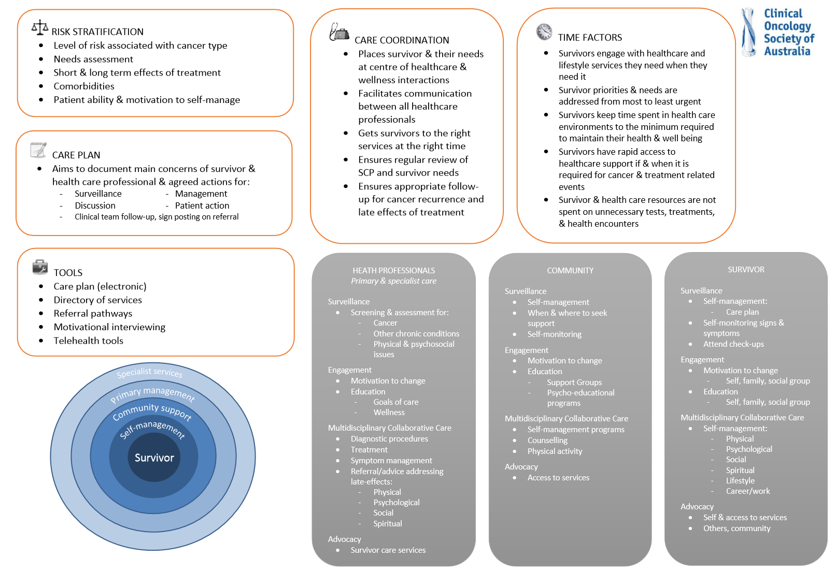
The other model that guided the development of this framework is illustrated in Figure 3. This is specifically intended to capture the mechanisms of action of VCSP2 projects. The model steps through how the projects (shown in green) can contribute to building a robust evidence base that influences care beyond the initial setting and project focus and ultimately, through repeated cycles and increasing uptake, leads to improved experience and outcomes for people living with cancer that are well beyond the scope of the focussed projects. Through a robust and consistent approach to the generation of evaluation evidence in VCSP2 at a project and statewide level, the aim is to improve the quality of evidence generated and accelerate its dissemination and spread.
Figure 3: VCSP Phase II – intended mechanisms of action

Key evaluation domains – level of focus, key questions, dimensions of interest, data sources and methods
Drawing on the context and models presented above, six key domains for evaluation focus have been identified reflecting the key mechanisms of action for VCSP2 including:
- Model of care design (unique to each program)
- Organisational engagement and leadership – creating the environment for success
- Project implementation and evaluation
- Participation
- Expected outcomes (at an individual and organisational level)
- Sustainability and spread.

The following series of tables (Table 1.1 to 1.6) provide, for each key domain:
- the RE-AIM element it maps to
- the level of focus
- key components of each dimension as well as an hierarchy of outcomes where relevant to illustrate the anticipated mechanisms for change
- key evaluation questions
- dimensions of interest
- data sources
- proposed evaluation method(s).

Table 1.1: Model of care design
Domain | Model of care design (unique to each program)
RE-AIM element | Not applicable (Project description – the intended focus, methods, tools and supporting systems)
Level of focus | Organisation
Key components of this dimension | Problem/need this initiative is designed to address  What care will be provided?  To whom will the care be provided? (defining the denominator for measuring uptake/reach)  How will carers be involved?  When will that care be provided?  Who will be providing the care?  Who will be active partners in care delivery? E.g. General practices, community health, cancer charities, specialist cancer services (for projects that are primary or community care initiated)  Where is the best setting for the care to be provided (high quality and sustainable)?  How is the care optimally delivered (model(s) of care)?  Specific tools that will be used to support implementation of the model of care:  - Risk stratification (and the risk factors that will guide stratification)  - Needs assessment  - Survivorship Care Plan (and key components reflecting Australian Cancer Survivorship Centre (ACSC) and VCSP1 learnings tailored to individual needs and tumour type and incorporating self-management recommendations)  - Chronic Disease Management (CDM) plans (translation of survivorship care plan in general practice to a CDM plan)  - Referral tools and processes  - Other  Supporting/enabling systems that will be adopted in the project such as:  - Existing frameworks and associated systems e.g. Medicare Benefits Schedule (MBS), Shared Care, Mental Health, CDM (tools (cdmNet), billing, pathways, models of care)  - IT systems/capabilities to support integrated, streamlined and effective implementation of survivorship model of care planning and implementation (auto-population, survivorship care plan generation, needs assessment, documentation, record keeping and communication)  - Existing return to work systems, programs and processes  - Communication (correspondence, telemedicine, consultation/discussion)  - Rapid re-entry systems for patients requiring acute care or specialist review  - Supporting organisations/resources – General Practice Victoria (GPV), peak bodies, primary health care networks, ACSC, quality units, Survivorship Community of Practice, consumer participation mechanisms, MoUs, meetings, third sector programs and services
Evaluation questions | What are the key components of the program design?  What tools and systems will support the program’s development and delivery?
Dimensions of interest | Key elements outlined above – Problem/need, what, to whom etc  Specific tools  Supporting/enabling systems
Data sources | Project team, executive sponsor, representatives of other organisations (participating sites)
Method | Integration of these elements in the project planning and grant application processes  Annual review (guided discussion) with outcomes of discussion documented in annual report

Table 1.2: Organisational engagement and leadership
Domain | Organisational engagement and leadership – creating the environment for success
RE-AIM element | Adoption
Level of focus | Organisation
Key components of this dimension | Outcomes hierarchies outlined below reflecting the purported steps to effective engagement and leadership respectively as critical enablers of success:  1. Engagement with the survivorship concept  Willingness to take action  Recognition of need for practice and system change  Participation in dialogue about survivorship (local +/- broader)  Acceptance of survivorship as necessary part of cancer care – engagement with evidence base  Receptive to concept of survivorship as critical concept within supportive care context  2. Authorising environment and leadership (across all relevant organisations and sectors – lead and partner services identified in 1.1 Model of care design)  Engagement of broader multidisciplinary team  Engagement of clinical champions (or other lead discipline depending on setting)  Creation of authorising environment for change – alignment with organisational culture  Executive sponsorship – leadership, support, buy-in
Evaluation questions | To what extent has the program/initiative been adopted in the intended settings/organisations?
Dimensions of interest | Criteria applied to identify potential participating sites across settings (all service types involved in the required intervention)  Sites approached; Number recruited; Suitability/appropriateness of each site  For each site involved: Organisational commitment to cancer and/or survivorship and/or innovation; Executive level sponsorship; Leader/champion (clinical or other key lead profession); Extent of participation (engagement, ownership – from design to implementation and evaluation)  Representativeness of settings in which implementation is planned/has occurred
Data sources | Project team, executive sponsor, representatives of other organisations (participating sites)
Method | Consideration of these elements in the grant application process  Annual review (guided discussion) with outcomes of discussion documented in annual report

Table 1.3: Project implementation and evaluation
Domain | Project implementation and evaluation
RE-AIM element | Implementation
Level of focus | Organisation
Key components of this dimension | Project governance in place  Stakeholder engagement and communication mechanisms established  Key elements of model of care, supporting tools, systems, resources and tailored evaluation plan developed  Ethics approval granted  Model of care implemented (and potentially refined during project)  Progress, achievements, challenges and barriers to success shared throughout the project period through mechanisms such as the Community of Practice  Cost – resource requirements both monetary and in kind  Workforce implications – competency requirements, capacity, redesign opportunities/challenges
Evaluation questions | To what extent was the program/initiative delivered as intended?  Can it be delivered across all settings and by all staff identified?  What parts of the model are flexible/adaptable without decreasing effectiveness?  What are the workforce implications/opportunities?
Dimensions of interest | Adherence to project method/protocol  Reasons for variance  Impact of variances
Data sources | Project team, personnel involved in project implementation at all participating sites, routine project documentation
Method | Consideration of these elements in the grant application process (intentions/method to incorporate these elements in the project)  Review of project documentation  Annual review (guided discussion) with outcomes of discussion documented in annual report

Table 1.4a: Participation – individual level reach
Domain | Participation
RE-AIM element | Reach
Level of focus | Individual
Key components of this dimension | Population of patients eligible to participate (the defined target group for the project and sampling frame if to be applied – this defines the denominator for determining dimensions of reach, uptake, feasibility and acceptability)  Patients invited to participated (carer involvement)  Patients consented to participate  Characteristics of patients who consented and those who opted out (demographics, tumour/disease/treatment variables)  Degree of participation of patient/carer in component(s) of intervention (Completed; Incomplete (% complete))  Needs identified  Survivorship Care Plan in place  CDM Plan in place  Acceptability to patient/carer  Action(s) taken (adherence to recommendations)
Evaluation questions | What is the size of the target population for this initiative?  What percentage of the target population for this initiative participated?  Are participants representative of the target population?  What is the extent of participation achieved (based on the intended intervention)?  What needs were identified?  What response(s) to needs were implemented?
Dimensions of interest | Target population; Invited to participate; Agreed/consented  Demographics/patient profile including level of risk (of those who opted in and opted out)  Nature and extent of acceptability and participation
Data sources | Routine data capture by staff delivering the intervention
Method | Analysis of data routinely collected as part of service provision incorporated into six monthly reports

Table 1.4b: Participation – system level reach
Domain | Participation
RE-AIM element | Reach
Level of focus | Organisational
Key components of this dimension | Settings in which the project was intended to be implemented (as outlined in 1.1 Model of care design)  Clinicians/other personnel that were identified as intended participants in the delivery of the project initiative (across service sites/settings)  Engagement and participation (at service, site and clinician level)  Degree of participation in component(s) of intervention (Completed; Incomplete (% complete))  Characteristics of services/sites/clinicians who participated and those who opted out
Evaluation questions | What is the extent of participation achieved (based on the intended intervention)?  What were the barriers to and enablers of participation?
Dimensions of interest | Nature and extent of participation
Data sources | Routine data capture by staff delivering the intervention  Clinician/service level surveys
Method | Analysis of data routinely collected as part of service provision incorporated into project dashboard in six monthly reports  Survey at completion of project

Table 1.5a: Expected outcomes – Individual level
Domain | Expected outcomes
RE-AIM element | Effectiveness
Level of focus | Individual
Key components of this dimension | (Dependent on the intervention itself and intended/anticipated impacts. Note that DHHS may require project teams that are anticipating similar outcomes to use the same measures/tools to facilitate the VCSP2 whole of program evaluation). Dimensions of interest may include:  Acceptability to patient/carer and adherence to recommendations/plan of action  Decrease in unmet needs (patient):  - Needs identified at baseline  - Components of plan to address each need  - Review of needs at 1 and 2 years post-baseline  - Attribution of intervention to change seen in needs  - Sustainability/enduring effects (follow-up at 1 and 2 years)  Experience of survivorship care planning and transition (patient/carer):  - Timely, seamless coordinated care  - Communication between professions and services involved  - Clear expectations, good information  - Patient and carer needs and preferences taken into account  - Accessibility of care – cost, timeliness, proximity to home – burden of participation  Change in behaviour (patient):  - Health seeking behaviours  - Lifestyle modifications (e.g. exercise, diet, alcohol consumption, smoking)  Proactive approach to survivorship (patient/carer):  - Health literacy/understanding of what’s required  - Education/information provision to enable self-management  - Active partner in decision making  - Confidence to self-manage  - Actions taken  Improvements to wellbeing (patient):  - Quality of life  - Symptom management/rehabilitation:  - Improved physical functioning (activities of daily living)  - Improved psychological wellbeing (anxiety, fear of recurrence, normalising, acceptance)  - Social engagement  - Capacity to work (patient/carer)
Evaluation questions | Has the project achieved its intended objectives?  What has been the impact of the project on patients and carers?  How could the effectiveness of the program be improved?
Dimensions of interest | Specific measures reflecting the intended elements of change (tailored to each program)
Data sources | Project documentation  Routine data capture (formative) by staff delivering the intervention  Patients and carers
Method | Survey/interviews with patients and carers  Documentation review  Analysis of data routinely collected as part of service provision

Table 1.5b: Expected outcomes – Organisational level
Domain | Expected outcomes
RE-AIM element | Effectiveness
Level of focus | Organisation
Key components of this dimension | For each site/setting in which the model of care was implemented including key partner organisations identified in Table 1.1 Model of care design:  Workforce impacts – impact on workforce capacity (human resources required for implementation (skills base, role, time commitment)); changes required to existing/creation of new roles  Acceptability to clinicians/other service providers  Confidence in the role/capabilities of different providers and services; working relationship  Value of survivorship care plan; Translation to CDM plan  Experience of participating in the project  Safety of patients; critical events  Rapid re-entry to acute service as required – instances required, timeliness of access, appropriateness of referral back to specialist service  Revised model of care (if differs from that proposed based on project learnings) – what it looks like; feasibility; resource implications (workforce, funding, systems and tools to support)  Indicators of impact on service access, efficiency (as relevant to project) e.g. Ratio new:review appointments in outpatients clinic; Time to first appointment for new referrals; Time to treatment; Clinic load – time with patients, quality of care provision, carer involvement.
Evaluation questions | What systems and tools were instrumental in achieving the observed outcomes for patients and carers?  Is the model of care tested in this project feasible to be delivered on an ongoing basis?  What are the implications of this model of care at an organisational level?  How could the effectiveness of the program be improved?
Dimensions of interest | Specific measures reflecting the intended elements of change (tailored to each program)
Data sources | Project documentation  Routine data capture (formative) by staff delivering the intervention
Method | Survey/interviews with personnel at participating sites  Documentation review  Analysis of data routinely collected as part of service provision

Table 1.6: Sustainability and spread
Domain | Sustainability and spread
RE-AIM element | Maintenance
Level of focus | Organisation and Individual
Key components of this dimension | Endurance of impacts at an individual patient level 1-2 years post-intervention (specific to interventions and expected effects)  Model of care integrated into usual practice and policy in services core to the project  Workforce requirements articulated: changes in workforce composition; education and training needs; revisiting the ‘who’ – who should provide each element of the model of care (setting, professional, skills, experience with consideration of effectiveness and efficiency)  Dissemination of findings/communication about model  Tools and resources generated to support implementation in practice and dissemination/spread  Value of model and views on transferability to other services/settings  Willingness to take up model in other services/settings  Successful uptake - Settings and contexts in which this has occurred
Evaluation questions | Does the project inform a feasible model that could be sustained or further developed over time in existing sites and/or spread to others?  Does the program/initiative produce lasting effects? (Patient level – enduring 1 to 2 years or longer)  Can the organisations/sites involved in the project sustain the program/initiative over time? (Organisation level)  What are the differences between services/settings in which the model is sustainable and those in which it is not?
Dimensions of interest | Leadership  Service settings and critical success factors for successful delivery  Feasibility, accessibility, cost
Data sources | Project documentation  Routine data capture (formative) by staff delivering the intervention  Patients
Method | Survey/interviews with patients  Survey/interviews with representatives from participating organisations  Documentation review  Analysis of data routinely collected as part of service provision

Summary of proposed evaluation methods
Figure 4 illustrates each of the critical timepoints for the capture of evaluation data and the methods and dimensions of interest recommended for consideration in evaluation planning and implementation by each project team. The methods are then further described in Table 2.
Figure 4: Evaluation methods and timeframe – an overview
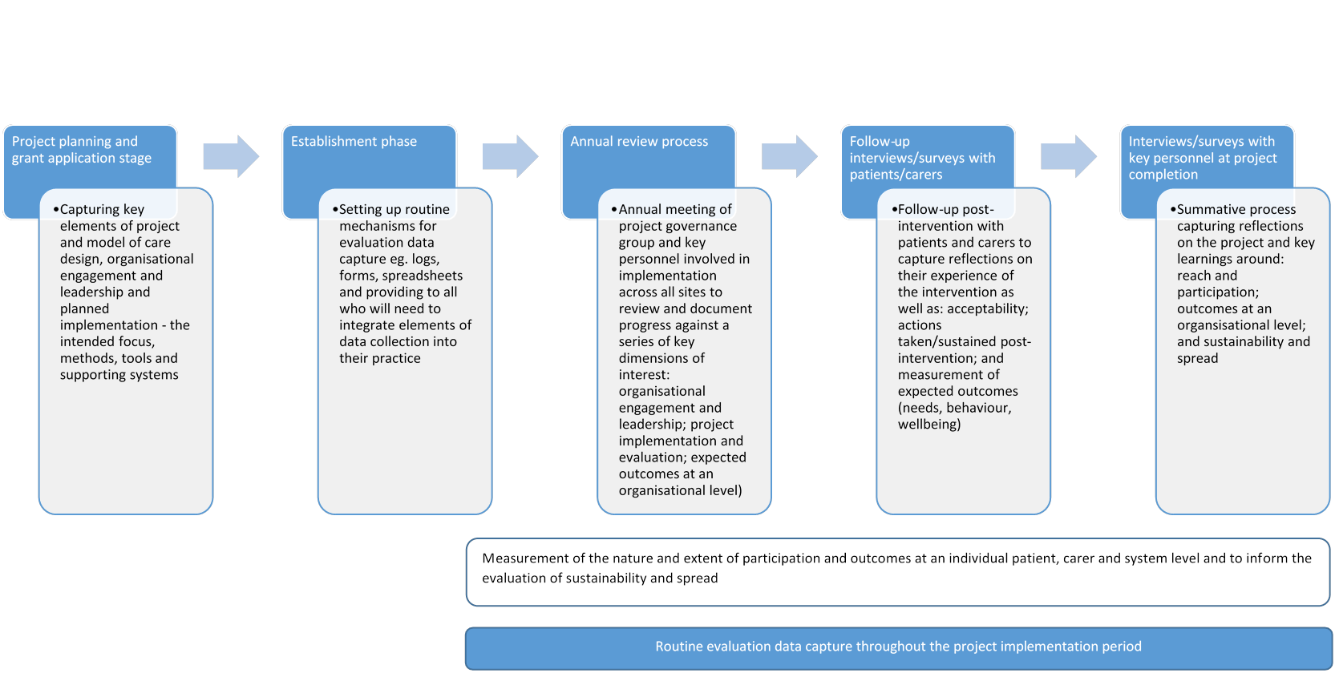
Table 2 summarises each of the key evaluation methods and maps the specific measures identified in Tables 1.1 to 1.6.
Table 2: Evaluation methods
Method | Description | Mapping of relevant measures to be captured by this method
Routine capture of key information at project planning and grant application stage | Inclusion of key elements defining the project – intended focus, methods, tools and supporting systems – in grant application fields | 1.1 Model of care design  - Problem/need this initiative is designed to address  - What care will be provided?  - To whom will the care be provided?  - How will carers be involved?  - When will the care be provided?  - Who will be providing the care?  - Who will be active partners in care delivery? (See Table 1.1 for examples)  - Where is the care to be provided (setting)?  - How is the care to be delivered (model of care)?  - Specific tools that will be used to support implementation of the model of care (see Table 1.1 for list of examples)  - Supporting/enabling systems that will be adopted in the project (see Table 1.1 for list of examples)  - Measurement of specific patient/carer-level outcomes – tools proposed  1.2 Organisational engagement and leadership  - Criteria applied to identify potential participating sites across settings (all service types involved in the intervention)  - For each site involved:  - Organisational commitment to cancer and/or survivorship and/or innovation  - Executive level sponsorship  - Leader/champion (clinical or other key lead profession)  - Extent of participation (Role identified, engagement, ownership – design/implementation/evalauation)  - Representativeness of settings in which implementation is planned  1.3 Project implementation and evaluation  - Proposed project governance model – membership, meeting mode, frequency, role  - Stakeholder map and communications plan  - Intentions re: seeking ethics approval – site specific requirements understood  - Anticipated resource requirements – cost and in kind (each participating site/setting)  - Anticipated workforce requirements – roles, competencies, expected workload, capacity
Annual review (guided discussion) with outcomes of discussion documented in annual reports | Annual meeting of project governance group and key personnel involved in implementation across all sites to review and document progress against a series of key dimensions, identify areas for improvement or refinement  A separate meeting or incorporated into this process would be a review of project data, participation statistics, critical incidents and referrals to specialist services of participating patients | 1.2 Organisational engagement and leadership  - Status of participating sites – engagement, participation, extent of participation  - Suitability/appropriateness of each site  - Representativeness of settings in which implementation has occurred  1.3 Project implementation and evaluation  - Project governance in place and operating effectively. All sites, sectors and stakeholder groups routinely represented  - Communications activities undertaken in the six month period  - Progress in development of key elements of the model of care, supporting tools, systems, resources and evaluation methods  - Ethics approval granted/in progress  - Progress in implementing model of care, achievements, challenges and barriers to success  - Refinements to intended project method/model and rationale  - Actual resource requirements for six month period – cost and in kind  - Workforce requirements for the six month period – roles, competencies, workload, capacity  1.5b Expected outcomes – Organisational level  - Review of critical events – assessment of safety and influence of project intervention on the event and outcome  - Review of referrals back to specialist service of patients involved in the project intervention – appropriateness of referral, issue/problem; timeliness of referral and access to specialist service; nature of service required; outcome for patient

Method | Description | Mapping of relevant measures to be captured by this method
Routine data capture by staff delivering the intervention | Establishment of routine mechanisms for use by all participating personnel throughout the project to capture key data items to enable measurement of the nature and extent of participation  Log of time spent on project-related delivery to be captured by all participating personnel for a typical one month period once per year for the duration of the project. This is designed to capture resource requirements as well as the impact of time on decreasing the burden of service provision as tasks become routine. | 1.4a Participation – individual level reach  - All eligible patients seen in the service (all participating sites and settings) – defining the denominator  - Patients invited to participate (carer involvement)  - Patients consented to participate  - Characteristics of patients who consented and those who opted out (demographics, tumour/disease/treatment variables)  - Degree of participation of patient/carer in component(s) of intervention (Completed; Incomplete (%Complete))  - Needs identified  - Survivorship care plan put in place (Yes/No; Key elements of plan – actions identified)  - CDM plan put in place (Yes/No; Key elements of plan)  1.4b Participation – system level reach  - Participation statistics as collected above stratified by site, setting and clinician – intended Degree of participation compared with actual  - Characteristics of services, sites and clinicians who participated and those who opted out  1.5a Expected outcomes – Individual level (See Table 1.5a for further detail on dimensions of interest and Appendix II for potential tools for consideration)  - Acceptability to patient/carer and adherence to recommendations/plan of action  - Decrease in unmet needs (patient)  - Experience of survivorship care, planning and transition (patient/carer)  - Change in behavior (patient)  - Proactive approach to survivorship (patient/carer)  - Improvements to wellbeing (patient; patient/carer in relation to return to work)

Method | Description | Mapping of relevant measures to be captured by this method
1.5b Expected outcomes – Organisational level
- For each person involved in service delivery, log of estimated time spent on project-related tasks:
- direct delivery (Patient and carer-related contact)
- administration (data capture and other behind the scenes work to set up plans, correspondence with other care providers and with patient/carer, making referrals, seeking approval or review of plans)
- project-related activities (governance or developmental work that would not be required post-project)
- Safety - Critical events for patients involved in the project during the project period (nature of each event and its resolution)
- Rapid re-entry to acute service – capture of each event, instances required, timeliness of access
- Specific indicators that demonstrate impact on service access and efficiency (as relevant to each project) e.g., ratio new:review outpatient appointments; time to first appointment for new referrals; time to treatment; clinic load – time with patients; quality of care provision
Routine data capture by staff delivering the intervention | Establishment of routine mechanisms for use by all participating personnel throughout the project to capture key data items to enable measurement of the nature and extent of participation | 1.6 Sustainability and spread  - Model of care integration into usual practice and policy in services core to the project (and extent of integration across sites/services)  - Publications and presentations arising from this work  - Tools and resources generated to support implementation in practice and dissemination/spread  - Successful uptake of model in other settings and contexts (outside project) and description of settings and services in which this has occurred
Follow-up interviews/surveys with patients/carers | Follow-up to capture reflections on experience of care as well as key information about acceptability and actions taken/sustained post-intervention | 1.4a Participation – individual level reach  - Acceptability to patient/carer of plan identified  - Actions taken (adherence to recommendations)  - Deviations from the plan and reason  1.5a Expected outcomes – Individual level (See Table 1.5a for further detail on dimensions of interest and Appendix II for potential tools for consideration)  - Decrease in unmet needs  - Experience of survivorship care  - Change in behavior  - Proactive approach to survivorship  - Improvements to wellbeing  1.6 Sustainability and spread  - Follow-up to explore whether effects seen in the patient/carer have endured (1-2 years hence) – specific to intervention and expected effects
Interviews/surveys with clinicians/personnel involved in the delivery of the intervention (intended and actual) | Summative process at program completion to capture reflections on the project and inform learnings | 1.4b Participation – system level reach  - Perspectives on the project – what worked, what didn’t, how it could be improved?  - Role personally played – how that differed from what was planned  - What were the barriers to participation experienced? How could they be overcome?  1.5b Expected outcomes – Organisational level  - Human resources required for implementation:  - Roles played, stepping out key components of each role, required skills and time commitment  - Changes required to existing roles or creation of new roles (workforce or role redesign elements)  - Acceptability of the role to the individual – how it could be done differently  - Confidence in the role/capabilities of other providers and services involved in the project  - Experience of participating in the project  - Perspectives on safety and risk  - Should this model (or the revised model of care if it differs from that proposed based on project learnings) be implemented into routine practice (Why/why not)  - If yes, key components of the model, feasibility, resource implications (workforce, funding, systems and tools)  1.6 Sustainability and spread  - Value of model and views on transferability to other services/settings  - Willingness to take up model in other services/settings  - Critical success factors for the project and for the take up of the model of care in other settings/services

Appendix I – Method for development this evaluation framework
A series of key informant interviews were undertaken to explore perspectives on:
- Components of high quality cancer survivorship
- What does success look like? (How you’d know when high quality survivorship care was in place)
- How you’d measure success
- Tools and methods that they are aware of that could potentially be transferrable across survivorship programs.
Six additional informants reviewed and provided feedback on the draft evaluation framework or provided input into specific measures or questions. The list of key informants who participated in this process is outlined in Table A1.
Table A1: Key informants
Name | Organisation/role | Role in VCSP
Key informant interviews
Dr Sharon Avery | Haematologist, Alfred Health | Project lead in VCSP first grant round
Assoc Prof Michael Jefford | Director, Australian Cancer Survivorship Centre | Convening survivorship CoP and support for project teams through ACSC
Nicole Kinnane | Project Manager, Australian Cancer Survivorship Centre | Convening survivorship CoP and support for project teams through ACSC
Donna Lever | Survivorship Nurse, Andrew Love Cancer Centre | Project lead in VCSP first grant round
Prof Bruce Mann | Director of Breast Service, Royal Melbourne and Royal Women’s Hospital | Project lead in VCSP first grant round
Linda Nolte | Former Manager, Australian Cancer Survivorship Centre | Convening survivorship CoP and support for project teams through ACSC
Amanda Piper | Acting Manager, Australian Cancer Survivorship Centre | Convening survivorship CoP and support for project teams through ACSC
Additional informants | Organisation/role | Role in evaluation framework development
Dr Haryana Dhillon | Research Fellow, University of Sydney Central Clinical School | Provided feedback on the draft framework
Tracey Doherty | Acting Service Director, SA Cancer Service, Department of Health SA | Provided feedback on the draft framework and shared experiences in SA
Prof Trisha Dunning | Chair in Nursing, Barwon Health | Identified as informant with experience in parallel area – transition to diabetes management and CDM in primary care
Chantelle Hislop | Survivorship Project Officer, SA Cancer Service, Department of Health SA | Provided feedback on the draft framework and shared experiences in SA
Dr Heather Shepherd | Research Fellow and Project Manager, PoCoG, The University of Sydney | Provided information about tools being used in the ADAPT Program
Prof Patsy Yates | Head of School, Queensland University of Technology School of Nursing | Provided feedback on the draft framework

Table A2 identifies a series of key stakeholder groups and describes what matters for each stakeholder group in relation to cancer survivorship. It is designed to provide a guide and frame of reference for review during the process of developing evaluation questions, methods and measures. Note that this is not to be seen as an exhaustive list of dimensions that must be measured.
Table A2: Stakeholder analysis
Stakeholder group | What matters to them in relation to cancer survivorship?
Government (Victoria) | - Enabling people to be productive members of society – active community participation  - Patient experience and outcomes – improved survival and wellbeing (symptoms, quality of life and empowerment)  - Cost burden to the individual  - Responsiveness to community and clinical needs  - Prevention/health promotion focus  - Return on investment – sustainability and spread  - Specific focus on acute health sector cost and burden
DHHS (including Cancer Strategy and Development team) | - As for Victorian Government in addition to:  - Cancer survivorship as recognised and accepted concept – level of profile  - Demonstrated value and return on investment from VCSP
Government (Federal)  Cancer Australia | - As for Victorian government with specific focus on community sector and Medicare  - Evidence generation  - Focussed areas of alignment with Cancer Australia’s agenda:  - Principles of survivorship care (in development)  - Specific population groups of focus – Aboriginal, CALD, those with poorer outcomes
General community/Tax payers | - That people in the community receive good care that caters for their individual needs – available, accessible, effective, best practice, underpinned with good information and support  - Value for money – cost to individual; cost to society; cost to economy
People living with cancer (the survivors) | - Survival and wellbeing  - Needs met (physical and psychosocial)  - Cost burden including capacity to work (as relevant to individual)  - Heard, informed, involved, supported, empowered  - Know what to expect and how to navigate post-diagnosis and beyond  - Confidence in system and providers – well coordinated care; good communication between all parties; reassurance
Carers | - As for people living with cancer plus additional specific focus on carers’ needs:  - To be heard, informed, involved, supported and empowered as a carer  - Carer capacity to work/timely return to work
Cancer advocates | - Involvement, representation, a ‘voice’  - Service development based on expressed needs of people personally affected by cancer (patients and carers)  - Cross-sector collaboration and service provision that is seamless and coordinated  - Community involvement  - Survivorship as a priority issue
Australian Cancer Survivorship Centre (ACSC) | - Patient experience and outcomes – improved survival and wellbeing (symptoms, quality of life and empowerment)  - Building the evidence base for survivorship – acceptance of concept and productive dialogue  - Awareness, education and training/skills development in survivorship across sectors and relevant professional groups  - National leadership role for ACSC  - Capacity building in survivorship in the system – local and statewide  - Advocating for system change
Public hospitals | - Workflow  - Cost  - Match of model(s) of care with funding flows (incentives and disincentives for changing practice where income flows do not align with best practice care)  - Clinical governance, safety  - Excellence, leadership  - Clinical leadership, advocacy
Private hospitals | - As above for public hospitals in addition to:  - Brand  - Market share
Victorian Integrated Cancer Services | - Growing evidence base and providing guidance for service improvement initiatives at ICS level  - Innovation, engagement, leverage  - Capacity building in survivorship in the system
Clinicians | All:  - Patient experience and outcomes – improved survival and wellbeing (symptoms, quality of life and empowerment)  - Own wellbeing and that of colleagues  Acute:  Concern about quality of care in other institutions/sectors/services  Want to see how people are doing – monitoring of late effects, understanding the long term toxicities and other impacts of disease and treatments  General Practice (GP, practice nurses):  - Communication, coordination, clarity  - Respect, valuing of role in care  - Contact points to enable rapid re-entry to acute systems as required  - Holistic approach – whole of life and CDM-type approaches  - Information, education – about late effects, system, supports available  - Continuity of care  - Income  - Viability of providing care within Medicare funding models/constraints  Community/Allied Health:  - Access for patients  - Funding models to support ideal practice  - More funding for cancer rehab  - Self-management, holistic approaches  - Professional acknowledgement
Non-clinical providers of cancer survivorship services (Community services, gyms/fitness industry, NGO programs and services e.g. CCV, BreaCan, BCNA, advocacy organisations, community pharmacy) | - Recognition of the role they can play in cancer survivorship  - Education, upskilling  - Demedicalising and normalising cancer  - Holistic approaches to care  - Awareness of programs and services they have available and their potential value  - Funding mechanisms to support viable service and practice models  - Coordination, navigation across sector and service boundaries – effective communication
Professional associations/Colleges | - Quality of care  - Safety  - Leadership, credibility, status of profession
Professional peak bodies (COSA, MOGA etc) | - Better outcomes and wellbeing  - Principles and essential elements of cancer survivorship as accepted – consensus  - Guidance on models of care
Pharmaceutical and medical technology organisations | - Profit  - Market share  - Commercial opportunities from cancer late effects/survivorship space  - Post-market surveillance – monitoring and reporting of late effects and critical events
Research funders | - Funding available for high quality survivorship research (attracting funders from donors, community, funding partners)  - Research expertise in the field to undertake this research  - Contribution of research funded to evidence base and improved practice and outcomes for people living with cancer
Researchers | - Targeted funding for survivorship research – priority area  - Career advancement  - Ability to answer questions of interest – contribute to evidence base and gaps
Research institutions | - Attracting funding  - Activity, impact, profile and reputation of the institution  - Influencing shareholders and donor support  - Attracting and retaining talent  - Achieving academic goals
Employers | - Productive workforce (wellbeing and outcomes with emphasis on capacity to work)  - Challenge of balancing duty of care, loyalty and commercial imperatives (financial disadvantage to business)
Schools/higher education sector | - Wellbeing and outcomes  - Return to/capacity to participate in schooling  - Smooth, well coordinated transitions
Legal advocates | - Equity of access  - Cost effective insurance coverage  - Freedom from insurance discrimination
Private health insurers | - Member satisfaction  - Low cost, quality service provision to members that supports health promoting behaviours  - Profits
Other insurers (life, income protection etc) | - Minimising the risk of claims  - Supporting clients to return to work  - Profits
Data custodians such as MBS | - Data quality, completeness and utility  - Data being used effectively and priority given to data capture – improve understanding of significant morbidity and mortality issues

Appendix 2 – Measuring potential outcomes at a patient level – list of tools for consideration in project and evaluation planning
A series of tools are listed below derived from VCSP1 (note that additional information about each tool and the key references are provided in the final report from the pilot projects undertaken in 2001 to 2014.² The Edmonton Symptom Assessment Scale (ESAS) is also included as informed by Heather Shepherd from the ADAPT Program (NSW). It is recommended that this listing is considered during project design and planning phases.

Tool name | Short title/acronym
The Assessment Quality of Life-Adolescent | AQoL-6D
Assessment of Quality of Life 8D | AQoL-8D
Assessment of self-efficacy in managing cancer symptoms and treatment side effects
Barriers Specific – Self Efficacy Scale | BARSE
Distress Thermometer and Problem List – NCCN | DT
Functional Assessment of Chronic Illness Therapy-Fatigue scale | FACIT
Functional Assessment of Cancer Therapy-Breast | FACT-B
Functional Assessment of Cancer Therapy – Bone Marrow Transplant | FACT-BMT
Godin Leisure Time Physical Activity Questionnaire | GLTEQ
Health Education Impact Questionnaire | HeiQ
Health Literacy Management Scale Version 1.1 | HeLMS
Health Literacy Questionnaire | HLQ
Menopause Rating Scale | MRS
Patient Experience Questionnaire | PEQ
Rapid Eating Assessment for Patients | REAP
Short Form 12 health-related burden of disease | SF-12

If other tools are being considered, it is important to review whether they have been used in the cancer and/or survivorship setting and ideally be validated tools, where possible.

Nacarelli L, Howard J 2014, Evaluation of Victorian Cancer Survivorship Program (VCSP) Pilot Projects: A Workforce Perspective, Final Report. The Australian Health Workforce Institute, The School of Population and Global Health, The University of Melbourne.
Howell P, Kinnane N, Whitfield K 2015, Supporting cancer survivors in Victoria: Learning from the Victorian Cancer Survivorship Program pilot projects 2011-2014. Department of Health & Human Services, State Government of Victoria, Melbourne.
Note that whilst RE-AIM is primarily designed for the evaluation of evidence-based health promotion interventions, the elements within RE-AIM provide a useful guide to informing the breadth of measures and questions included in this framework.
Howell P, Kinnane N, Whitfield K 2015, Supporting cancer survivors in Victoria: Learning from the Victorian Cancer Survivorship Program pilot projects 2011-2014. Department of Health & Human Services, State Government of Victoria, Melbourne.
Note that DHHS may require project teams that are anticipating similar outcomes to use the same measures/tools to facilitate the VCSP2 whole of program evaluation.

