2020 preoperative anaemia assessment and management in elective surgical procedures survey report
Blood Matters

To receive this publication in an accessible format phone 03 96940102, using the National Relay Service 13 36 77 if required, or email bloodmatters@redcrossblood.org.au <bloodmatters@redcrossblood.org.au>.
Authorised and published by the Victorian Government, 1 Treasury Place, Melbourne.
© State of Victoria, Australia, Department of Health and Human Services July 2020.
ISBN 978-1-76096-083-4 (pdf/online/MS word)
Available at <https://www2.health.vic.gov.au/hospitals-and-health-services/patient-care/speciality-diagnostics-therapeutics/blood-matters>

Contents
Contents 3
Acknowledgements 4
Limitations 4
Abbreviations, acronyms and definitions 5
Definitions 6
Executive summary 7
Patient blood management preoperative anaemia screening pathway checklist 8
Introduction 10
Survey aims 11
Objectives 11
Method 12
Results 13
Screening pathway absent 14
Screening pathway present 16
General practitioner involvement 18
Screening follow up 18
Consumer information 19
Survey summary 23
Recommendations 24
References 25
Appendix 1: Survey tool 27
Appendix 2: Recommendations and practice points relevant to preoperative anaemia assessment and management from PBM Module 2 – Perioperative 28
Appendix 3: Preoperative haemoglobin assessment and optimisation template 29
Appendix 4: Tools and resources 30
Appendix 5: National PBM collaborative 31

Acknowledgements
Blood Matters thanks all the health services that contributed data to this 2020 preoperative anaemia assessment and management in elective surgical procedures survey.
The data submitted has enabled us to prepare this report and compare the results with elements of an earlier more comprehensive audit conducted in 2015.
Thank you to the project team involved in the various stages of the audit:
- Blood Matters team
- Blood Matters Advisory Committee.

Limitations
The survey was a simple questionnaire aimed at ascertaining how many health services had formalised preoperative anaemia assessment and optimisation pathways and/or templates. It did not measure compliance with assessment process.
Participation was voluntary.
Data submitted based on surveyor’s interpretation.

Abbreviations, acronyms and definitions
ACSQHC: Australian Commission on Safety and Quality in Health Care
ACT: Australian Capital Territory
CRP: C-reactive protein
FBE: full blood examination
GIT: gastrointestinal
GP: general practitioner
IV: intravenous
MBS: Medicare Benefits Schedule
Module 2: National Blood Authority (NBA) 2012, Patient blood management guidelines, ‘Module 2: Perioperative’.
NBA: National Blood Authority
NT: Northern Territory
PBM: patient blood management
RBC: red blood cell
Tas: Tasmania
Lifeblood: Australian Red Cross Lifeblood
Vic: Victoria
WHO: World Health Organization
WIP: work in progress

Definitions
- Blood Matters: Victorian Government funded program run in collaboration with Australian Red Cross Lifeblood to measure and promote the quality, safety and appropriate use of blood and blood products.
- Elective surgery: planned, non-emergency surgery that is medically necessary or beneficial to the patient but does not need be done at a particular time.
- Patient blood management (PBM): the management and preservation of patients’ own blood to reduce or avoid the need for a blood transfusion (NBA 2012).
- Perioperative period: a term used to describe the three distinct phases of any surgical procedure, which includes the preoperative, intraoperative, and the postoperative phase.
- Preoperative period: ‘pertaining to the period before a surgical procedure. Commonly the preoperative period begins with the first preparation of the patient for surgery, such as when the surgery is scheduled’ (Mosby 2009).
- Pathway: defined course of action or route to guide actions. It is expected that preoperative anaemia screening pathways for surgical patients with or at risk of anaemia will vary across health services.
- Optimisation of red cell mass: requires identification, assessment and management of preoperative anaemia (NBA 2014).

Executive summary
The World Health Organization (WHO) estimates that anaemia affects approximately 25 per cent of the population worldwide (World Health Assembly 2010), leading to public health issues in both developed and developing countries (Bielby et al. 2019).
Anaemia, if uncorrected, increases the likelihood of blood transfusion, which is independently associated with increased morbidity, mortality and hospital length of stay (PBM Module 2). According to data collected by the American College of Surgeons National Surgical Quality Improvement Program® (NSQIP®), preoperative anaemia was associated with a 35 per cent increased risk of one major postoperative complication and a 42 per cent increased risk of death (Clevenger 2015).
Hong et al. (2017) describe iron deficiency as the commonest cause of preoperative anaemia, accounting for 20–28 per cent of anaemic patients presenting to pre-admission clinics.
The Australian PBM guidelines outline the importance of anaemia assessment in the perioperative patient and include a preoperative anaemia assessment and optimisation pathway template (NBA 2012). Pathways should include appropriate blood testing (full blood count, renal function, inflammatory markers and haematinics) and assessment of comorbidities, medications, and should ideally be performed to allow time for appropriate management at least six weeks preoperatively (Bielby et al. 2019; NBA 2012).
This survey of preoperative anaemia assessment and management was similar to one conducted in 2015. It showed an improved number of pathways are in place, 56 per cent compared with 36 per cent in 2015. Where pathways are present, there are limited numbers that fulfil all elements of Module 2 PBM template.
Since the previous audit, there have been dedicated PBM projects through the ACSQHC. This has worked well for many to get started, but not all health services have had access to resources to help implement PBM. Most practitioners acknowledge that PBM is good clinical practice and should be standard of care. However, it takes time, effort and resources to develop and implement in health services that are already working hard, which may be a barrier to the more rapid uptake of PBM practice. Where PBM programs are in place, it is important that these practices are part of processes rather than up to individuals.
This survey shows that there is room for improvement in both the development and the quality of anaemia assessment and management pathways. Blood Matters recommends that health services review and assess their compliance with the recommendations (p. 24) regarding appropriate preoperative anaemia assessment and management.
Note: The checklist on p. 8 will help health services undertake this assessment.

Patient blood management preoperative anaemia screening pathway checklist
Health services can use this checklist to determine compliance with strategies included in the National patient blood management guidelines, ‘Module 2: Perioperative’, and the ACSQHC National safety and quality health service standards to optimise blood volume and red cell mass.
Element | Y | N | WIP | N/A
Does your health service have a staff education program about patient blood management?
Does your health service have a preoperative anaemia screening pathway for surgical patients with or at risk of anaemia? (PBM Module 2 recommendation 1; ACSQHC National Standards 7.1 and 7.9)
If your health service has multiple sites, is this pathway used for all campuses within your health service that perform elective surgical procedures?
Does the anaemia screening pathway stipulate the timing of preoperative assessment to allow optimisation of the patient’s haemoglobin and iron stores? [according to surgical priorities] (PBM Module 2, practice point (PP) 1, PP 4, PP 5)
Are general practitioners or shared care options included in the anaemia screening pathway? (PBM Module 2, recommendation 1)
Does the pathway include a preoperative haemoglobin assessment and optimisation template?
Does the anaemia screening pathway/template include the following tests?
            - FBE (Full blood examination)
            - Iron studies including ferritin
            - CRP
            - Renal function
            - B12 and folate
(PBM Module 2, Optimisation template)
Does the anaemia screening pathway specify roles and responsibilities for each of the steps in the pathway, including whose role it is to identify at-risk anaemia patients to refer for further investigation and/or treatment?
Does the screening pathway/template include discussion/advice from or referral to a specialist?? (PBM Module 2 – PP6, PP7, template)
Does the pathway stipulate the provision of written consumer information?
This page has been deliberately left blank.

Introduction
Patient blood management (PBM) has been a main focus for the National Blood Authority (NBA) since 2006 when the decision was made to replace the National Health and Medical Research Council/Australasian Society of Blood Transfusion Guidelines on the use of blood and blood products (2001) with patient-focused guidelines (the PBM guidelines). In addition, WHO reaffirmed the importance of optimising the patient’s own blood volume before surgery at the 2010 World Health Assembly. PBM is a patient-centred approach that aims to improve clinical outcomes by avoiding unnecessary exposure to blood components. It includes the three pillars:
- Pillar 1: optimisation of blood volume and red cell mass
- Pillar 2: minimisation of blood loss
- Pillar 3: optimisation of the patient’s tolerance of anaemia.
The PBM guideline ‘Module 2: Perioperative’ (Module 2) was released in 2012 (NBA 2012) and is currently under review. It contains six recommendations and five practice points related to the management of anaemia in the perioperative patient to:
- improve practice related to the assessment and management of reversible anaemia prior to surgery
- improve outcomes for patients undergoing elective surgical procedures.
It is well accepted that preoperative management of anaemia increases haemoglobin levels and reduces perioperative transfusion rates. Althoff’s (2019) meta-analysis of multimodal, multidisciplinary PBM programs found that programs such as these were associated with a decreased transfusion rate and a significant decrease in length of stay, overall complications, and mortality rate. The highest impact was for patients undergoing orthopaedic and cardiac surgical procedures.
However, the implementation of preoperative anaemia screening and management programs can be disconnected at times. One study found only four of seven European health services had a policy in place aimed at assessing and managing anaemia before considering transfusion (Bruun 2016). Further, assessing and identifying preoperative anaemia does not guarantee management, as found by Van der Linden (2016), where treatment rate of preoperative anaemia ranged from zero per cent to 41 per cent.
More recently, Jung-König et al. (2020) found large variations regarding method of implementation of preoperative anaemia management in 10 European hospitals. While the majority of surveyed health services had at least some form of preoperative anaemia management in place, there remained a large potential for improvement, for instance with regard to better utilisation of waiting times to optimise red cell mass.
Similar results were found in 2015, when Blood Matters conducted an audit to assess if preoperative pathways for patients undergoing elective surgical procedures were in place (part A) and actual practice (part B) of health services. That audit found few health services (36 per cent) had a formalised process for optimising patient haemoglobin prior to elective surgery; that is, a pathway or algorithm that sets out the process for assessment and management of these patients in the preoperative period. Recommendations for health services were made as part of the report from this 2015 audit.
2015 recommendations for health services were to ensure:
- they have in place or develop a multidisciplinary, multimodal patient blood management (PBM) program that includes preoperative anaemia assessment and optimisation
- the PBM program clearly defines the roles and responsibility for anaemia assessment and follow up
- the PBM program clearly defines timing of assessment to appropriately manage anaemia within the clinical urgency of surgery
- the PBM program includes strategies to educate staff, such as the use of BloodSafe eLearning Australia Patient Blood Management courses, in particular the ‘Perioperative’ and ‘Iron deficiency anaemia’ courses
- a process is in place to review current pathways or implement a pathway where no pathway is in place
- compliance with the pathway is regularly monitored, reported and actions undertaken to address any gaps identified.
In 2020 Blood Matters undertook a survey reexamining questions included in part A of the 2015 audit, to assess if health services have taken on these recommendations and see what changes have been made.

Survey aims
This Blood Matters survey of preoperative anaemia assessment and management was designed to:
- determine what processes are in place at health services to assess and manage anaemia in the elective preoperative patient
- explore if any improvement in the above processes has occurred since the last audit in 2015.

Objectives
To determine:
- if health services have a screening pathway for assessment of preoperative anaemia, as defined in Module 2
- where a screening pathway is in place, whether it uses a preoperative haemoglobin assessment and optimisation template.

Method
One hundred and 29 health services from Victoria, Tasmania, Australian Capital Territory and the Northern Territory that perform surgery were invited to participate in the audit. The surveyors were not trained, however, the Blood Matters secretariat was available to provide guidance and clarification throughout the survey.
Surveyors submitted data via an online web tool, Lime Survey, from 1 February to 29 February 2020.
The survey was a simple questionnaire aimed at ascertaining how many health services had formalised preoperative anaemia assessment and optimisation pathways and/or templates.
After the survey, each participating health service was sent a summary of their data for verification and invited to correct any discrepancies or incomplete records.
Health services’ policies and pathways were compared with Module 2 recommendations and practice points (Appendix 2) and optimisation template (Appendix 3) to determine if all identified elements of the preoperative anaemia screening assessment are included.

Results
Patient blood management aims to improve the clinical outcomes of patients by avoiding unnecessary exposure to blood components. Recommendation 1 from Module 2 states:
‘Health-care services should establish a multidisciplinary, multimodal perioperative patient blood management program. This should include preoperative optimisation of red cell mass and coagulation status; minimisation of perioperative blood loss, including meticulous attention to surgical haemostasis; and tolerance of postoperative anaemia.’
This survey addressed preoperative optimisation of red cell mass. Module 2 includes an algorithm for preoperative screening and management of anaemia. Health services are encouraged to use the algorithm, adjusted to meet local circumstances (NBA 2012).
Sixty-three health services responded to the survey (response rate 49 per cent). This compares favourably to the 56 health services responding in 2015 (response rate 40 per cent). Table 1 outlines the demographics of the health services invited and responding, including peer grouping, as defined by Australian Institute of Health and Welfare of the reporting health services.
Table 1: Peer group of responding health services
 | Number of private health services | Number of public health services | Total number of health services
Number invited | 48 | 81 | 129
Principal referral responses | - | 8 | 8
Group A responses | 3 | 18 | 21
Group B responses | 3 | 5 | 8
Group C responses | 2 | 18 | 20
Group D responses | 2 | - | 2
Unpeered responses | 1 | 3 | 4
Total | 11  (response rate 23%) | 52  (response rate 64%) | 63  (response rate 49%)
Figure 1 summarises information reported about the presence of preoperative anaemia pathways and the inclusions.

Figure 1: Information reported about preoperative anaemia screening pathways
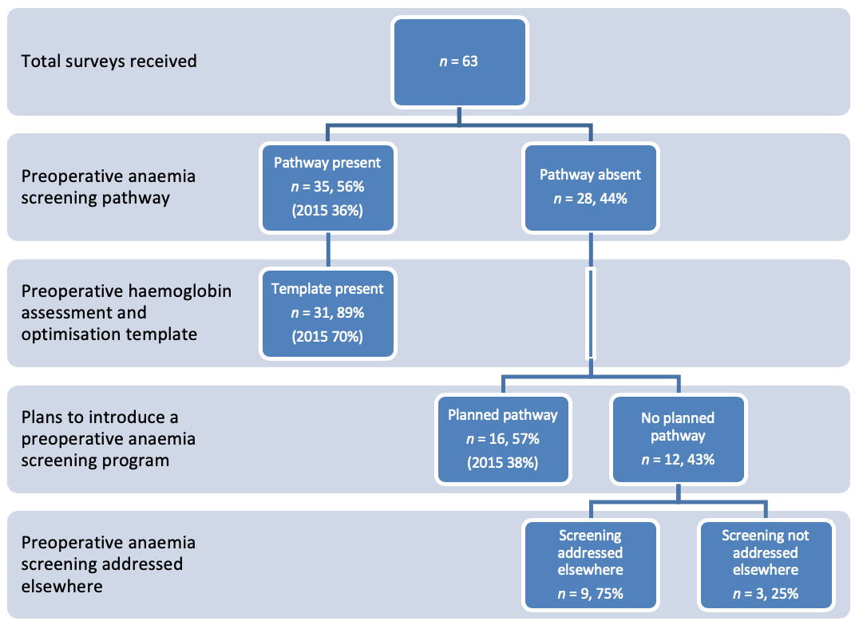

Screening pathway absent
In the 2020 survey, 28 (44 per cent) health services reported no screening pathway, which was an improvement from 2015 when 36 (64 per cent) health services reported no screening pathway in place.
Of the health services without a screening pathway in 2015, 14 (39 per cent) reported that they had plans to introduce in the next 12 months (Figure 2). The 2020 survey showed that eight achieved this and two were still planning. The remaining four did not participate in the 2020 survey. An additional five health services that had no plans for implementation in 2015 have done so in the interim, with another six planning to implement in the next 12 months.
In the 2020 survey, 16 of the 28 health services reported that they had plans to introduce a screening pathway in the next 12 months.
Figure 2: Progress of health services reporting no pathway in 2015 audit towards implementing a pathway in 2020
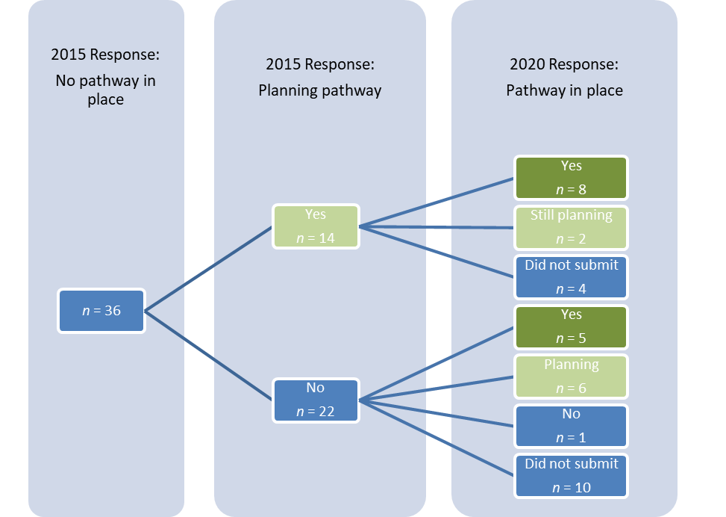
Note: the ‘Did not submit n = 10’ includes three health services that were not invited due to closure (n = 1) or do not perform elective surgery (n = 2)
Where no screening pathway was in place, 23 of the 28 (82 per cent) health services reported that anaemia identification was addressed by preoperative assessment in other areas as shown in Table 2.
Table 2: Area for preoperative assessment of anaemia when an anaemia screening pathway not in place
Area | Number (%) of health services
Preadmission clinic | 19 (83%)
GP | 13 (57%)
Specialist rooms : Surgeon | 14 (61%)
Specialist rooms: Anaesthetist | 9 (39%)
Specialist rooms: Physician | 7 (30%)
Where the introduction of a pathway was not being considered in 2020 (n = 12), the reasons reported are outlined in Table 3.
Table 3: Reasons why the introduction of anaemia screening pathway is not being considered
Reason | Number (%) of health services
Limited surgery in the health service | 3 (25%)
Other priorities in the health service | 1 (8%)
Limited clinical leadership/support (sponsorship) for this type of program | 1 (8%)
No identified need | 4 (33%)
Never considered | 1 (8%)
Other (no specific policy but covered elsewhere) | 3 (25%)
Figure 3: No screening pathways (2020 survey) – alternative screening or plans to introduce screening
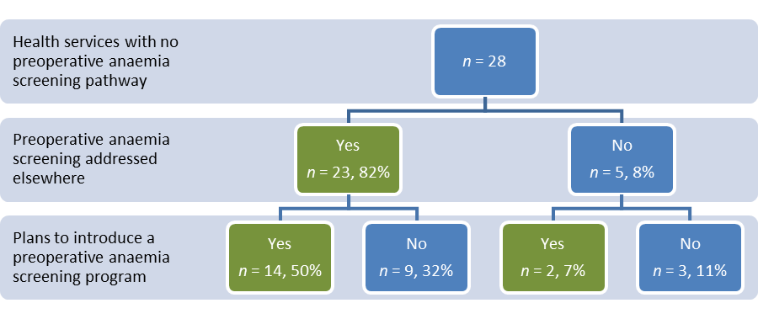
Three health services reported no plan to implement a screening pathway in the near future and reported that preoperative assessment of anaemia does not occur elsewhere in the process (Figure 3). Two health services stated that there was no identified need or limited surgery, and therefore no screening pathway was being considered. One health service did not respond to the question.

Screening pathway present
Of the 63 reporting health services in the 2020 survey, 35 (56 per cent) reported that a preoperative anaemia screening pathway was in place for elective surgical patients. This is an improvement from the 2015 audit where only 20 (36 per cent) of the 56 reporting health services had a pathway.
Where a screening pathway was in place, 31 (89 per cent) reported the pathway included a preoperative haemoglobin assessment and optimisation template (2015: n = 14, 70 per cent). Most often this is the NBA template or a modified version of this (n = 22, 71 per cent). Table 2 indicates the type of template used.
Table 4: Type of anaemia screening template
Preoperative anaemia screening template | 2020: Number (%) of health services | 2015: Number (%) of health services
NBA template used | 12 (39%) | 3 (21%)
Modified NBA template | 10 (32%) | 7(50%)
Health service designed template | 9 (29%) | 4(29%)
Total | 31 | 14
As shown in Table 5, the most common surgical area covered by the anaemia screening pathway was orthopaedic (n = 30; 97 per cent). The orthopaedic group has been a focus of PBM initiatives, as there is often time between the decision to perform surgery and the time surgery occurs, allowing health services to engage in assessment and management of identified anaemia or iron deficiency. For some other surgical groups, the time between listing for surgery and receiving surgery may be shorter, e.g. GIT surgery for patients with cancer or cardiothoracic surgery, which may limit screening practice. However PBM is still important in these groups. .
Table 5: Surgery type included in anaemia screening pathways
Surgery type | Number of health services performing surgery type  (n = 35) | Number (%) of health services with preoperative anaemia pathway by surgery type
Orthopaedic | 31 | 30 (97%)
Cardiothoracic | 15 | 6 (40%)
Gynaecology | 34 | 21 (62%)
Vascular | 21 | 11 (52%)
Urology | 32 | 19 (59%)
GIT | 32 | 20 (63%)
Hepatobiliary | 24 | 10 (42%)
General surgery | 33 | 17 (52%)
Where a preoperative anaemia screening pathway is in place, health services were asked to report which pathology tests were included in the pathway (Table 6). The majority, but not all, included a FBE (n = 34, 97 per cent) and iron studies (n = 33, 94 per cent).
Further tests that could help to diagnose the cause of anaemia were less commonly included: renal function (n = 27, 77 per cent) and CRP (n = 24, 69 per cent) being the most common.
Compared with 2015, there has been an increase in appropriate pathology testing included in the preoperative anaemia screening pathway. Other tests such as B12 and folate are less commonly included, but should be considered in patients where anaemia is present but not diagnosed. Testing of vitamin B12/folate should not be considered routine testing; however, this is a targeted test based on clinical symptoms or risk factors as identified within the Medicare Benefits Schedule (MBS) vitamin B12 testing report (refer to Figure 1.3, Australian Government Department of Health 2014).
Table 6: Tests included in anaemia screening pathway
Tests | 2020 (n = 35)  Number of health services (%) | 2015 (n = 20)  Number of health services (%)
FBE | 34 (97%) | 17 (85%)
Iron studies, including ferritin | 33 (94%) | 13 (65%)
Renal function | 27 (77%) | 14 (70%)
CRP | 24 (69%) | 10 (50%)
B12 | 4 (11%) | 3 (15%)
Folate | 5 (14%) | 3 (15%)
Module 2 template recommends that all patients at risk of blood loss should have a FBE (including haemoglobin), iron studies (including ferritin), CRP and renal function tests performed to assist with anaemia assessment.
For the benefit of the patient and time efficiency, health services may want to consider if all these tests could be ordered and completed at the same time, to prevent patients requiring multiple blood tests, and to facilitate early recognition and management of any identified anaemia.

General practitioner involvement
The NBA recommends involving general practitioners (GPs) in the preoperative haemoglobin assessment process, which may include development of referral forms/template letters for GPs highlighting their roles and responsibilities in preoperative anaemia investigation and management (NBA 2014). Fifteen (43 per cent) health services reported GPs were included in the screening pathway.

Screening follow up
An imperative part of the assessment screening pathway is defining whose role and responsibility it is to review test results, identify anaemia in at-risk patients, and subsequently commence the process of further investigation, or management as required.
Twenty-two (63 per cent) pathways explicitly stated whose role and responsibility it was to identify at-risk patients to refer for investigation and/or management (Table 7). In 2015, the audit asked if the pathway stipulated who was responsible for follow up of results of testing, 16 (80 per cent) responded that this was included, but the audit did not ask for details of who held this responsibility. Without the pathway documenting who is responsible for follow up there is the chance that although testing is performed there is no follow up on abnormal results.
Table 7: Positions assigned primary role for patient follow up
Position title with primary responsibility to provide follow up | Number of health services (%)  n = 22
Surgical liaison/coordinator nurse | 7 (32%)
Anaesthetist | 6 (27%)
Surgeon | 1 (5%)
Haematologist | -
General outpatient clinic coordinator | -
Anaemia clinic coordinator | -
Other: Anaesthetic liaison nurse | 4 (18%)
Other: multiple roles stated (GP/HMO/Anaesthetist) | 3 (14%)
Other: clinician seeing patient | 1 (5%)
Eleven (50 per cent) health services nominated nurse roles as being responsible for the patient follow up. Nurses working in preoperative assessment roles have developed the skills and knowledge to recognise the need for follow up. They also have the organisational support needed to make referrals to ensure appropriate patient management.

Consumer information
The NBA (2014) recommends establishing requirements for patient information materials related to the preoperative haemoglobin assessment process. This may include patient blood management brochures, information on iron therapy, and information regarding the risks, benefits and alternatives to transfusion. Ten (30 per cent) health services reported that their pathway stipulated the provision of written consumer information. This is unchanged since the 2015 audit, where six (30 per cent) health services reported that patient information was included in the process. This may be an area for health services to work toward improving.
Where written consumer information was part of the pathway, the following topics were included (Table 8).
Table 8: Consumer information (topics) included in screening pathway
Topics included | 2020 (n = 10): Number (%) of health services | 2015 (n = 6): Number (%) of health services
Patient blood management program | 3 (30%) | 2 (33%)
IV iron | 9 (90%) | not asked
Oral iron | 7 (70%) | not asked
Dietary iron | 3 (30%) | not asked
Dietary, oral, IV iron (2015 only) | not asked | 3 (50%)
Risks, benefits and alternatives to transfusion | 3 (30%) | 3 (50%)
Other (including blood test information and PBM information in development) | - | 3 (50%)
Tables 9 and 10 summarise the number of health services with a screening pathway, as they align with the elements of Module 2 PBM template. The number of health services with a pathway has improved over the last five years from 36 per cent to 56 per cent. The reported pathways have also shown an improvement in becoming more multimodal and multidisciplinary.
Table 9: Summary of number of health services with a screening pathway as aligned to the elements of Module 2 PBM template
Element | 2020 Yes  n (%) | 2015 Yes  n (%)
Number of health services responding | 63 | 56
Does your health service have a preoperative anaemia screening pathway for surgical patients with or at risk of anaemia? (PBM Module 2 recommendation 1; ACSQHC National Standards 7.1 and 7.9) | 35 (56%) | 20 (36%)
Does the anaemia screening pathway stipulate the timing of preoperative assessment to allow optimisation of the patient’s haemoglobin and iron stores (according to surgical priorities)? (PBM Module 2, practice point (PP) 1, PP 4, PP 5) | 25 (40%) | Did not ask
Are general practitioners or shared care options included in the anaemia screening pathway? (PBM Module 2, recommendation 1) | 15 (24%) | 7 (13%)
Does the pathway include a preoperative haemoglobin assessment and optimisation template? | 31 (49%) | 12 (21%)
Does the anaemia screening pathway/template include the following tests?  - FBE | 34 (54%) | 15 (27%)
- Iron studies including ferritin | 33 (52%) | 12 (21%)
- CRP | 24 (38%) | 10 (18%)
- Renal function test | 27 (43%) | 13 (23%)
Does the anaemia screening pathway specify roles and responsibilities:  - for all steps included  - whose role it is to identify at-risk anaemia patients to refer for further investigation and/or treatment? (PBM Module 2, recommendation 1) | 22 (35%) | 14 (25%)
Does the screening pathway/template include discussion/advice from or referral to a specialist? (PBM Module 2 – PP6, PP7, template) | 31 (89%) | Did not ask
Does the pathway stipulate the provision of written consumer information? | 10 (16%) | 6 (11%)
Table 10: Number of health services meeting each element of the checklist (Table 9)
Number of elements met within the checklist | 2020: Survey responses  (n = 63) | 2015: Survey responses  (n = 56)
11 elements | 5 (8%) – all elements | NA
10 elements | 4 (6%) | NA
9 elements | 7 (11%) | 2 (4%) – all elements
8 elements | 9 (14%) | 3 (5%)
7 elements | 5 (8%) | 6 (11%)
6 elements | 1 (2%) | 2 (4%)
5 elements | 4 (6%) | 1 (2%)
4 elements | - | 1 (2%)
3 elements | - | 3 (5%)
2 elements | - | 1 (2%)
1 element | - | 1 (2%)
health services with no pathway | 28 (44%) | 36 (64%)

Survey summary
The survey data shows there has been an increase in the number (and proportion) of health services with processes for optimising patient red cell mass prior to elective surgery (n = 35, 56 per cent compared with n = 20, 36 per cent in 2015). That is, these health services have a pathway or algorithm that sets out the process for assessment and management of these patients in the preoperative period.
Where health services did not have a pathway, 23 (82 per cent) reported that anaemia identification was addressed by preoperative assessment in other areas. However, a recognised pathway is a helpful tool to ensure consistency of assessment and follow up.
Of those health services without a current pathway, 16 (57 per cent) are considering adopting a pathway in the next 12 months.
While the improvement in the number of preoperative assessment processes/pathways is promising, there is still much work to be done in health services to include all the elements that are consistent with the best practice guidelines demonstrating a multimodal, multidisciplinary approach.
Blood Matters recommends that health services review the process of preoperative anaemia assessment and management in light of the survey findings, to determine the level of alignment of those pathways with the PBM guidelines, ‘Module 2: Perioperative’ elements, and the ACSQHC National safety and quality health service standards.
A checklist to assist health services with this review is included at the beginning of this report (p. 8).
We acknowledge that many factors such as local health service infrastructure, staff, physical and economic resources differ between hospitals, and individualisation is important for the acceptance of any change.
For this reason, anaemia screening pathways need to be specifically designed according to local conditions (Meybohm 2017). It is further noted that the operational and cultural changes required to implement best practice clinical measures such as PBM at a health service level can be significant (NBA 2017). Successful implementation requires not only clinical champions but a multidisciplinary collaborative approach.
The ACSQHC led a National Patient Blood Management Collaborative (2015–2017) to support improvements in the management of anaemia for patients having elective gastrointestinal, gynaecological and orthopaedic surgery procedures. Twelve health services participated in process improvement projects using ‘Plan, Do, Study, Act’ cycles applied to trialling and evaluating local initiatives. This aimed to reduce the number of patients proceeding to surgery with unknown levels of haemoglobin or iron stores. Over the project period, assessment rates for iron deficiency more than doubled for each surgical specialty (Appendix 5).

Recommendations
Participating health services should report their individual and comparative data to their blood management or health service transfusion committee for review and action to address gaps in preoperative anaemia assessment.
Non-participating health services should include this report as a blood management or health service transfusion committee agenda item to review. The committee should make recommendations around practice to address preoperative anaemia assessment.
Health services should ensure that:
- they have, or develop, a multidisciplinary, multimodal PBM program that includes preoperative anaemia assessment and optimisation covering all elements as outlined in the PBM Module 2 template (at least)
- the PBM program clearly defines the roles and responsibilities for anaemia assessment and follow- up
- the PBM program clearly defines the timing of assessments to appropriately manage anaemia within the clinical urgency of surgery
- patient information is made available
- a process is in place to review current pathways or implement a pathway where no pathway is in place
- compliance with the pathway is regularly monitored, reported and actions undertaken to address any gaps identified
- the PBM program includes strategies to educate staff, such as the use of BloodSafe eLearning Australia Patient Blood Management courses, in particular the ‘Perioperative’ and ‘Iron deficiency anaemia’ courses.

References
Althoff FC 2019, ‘Multimodal patient blood management program based on a three-pillar strategy’, Annals of Surgery, vol. 269, no. 5, pp. 794–804.
Australian Government Department of Health 2014, MBS reviews: vitamin B12 testing report, February 2014, <https://www1.health.gov.au/internet/main/publishing.nsf/Content/7C28F0B6D06F9FFCCA257EB9001D769B/$File/Vitamin%20B12%20testing%20Review%20Report.pdf >, accessed June 2020.
Bielby L, Moss R, Mo A, McQuilten Z, Wood E 2019, ‘The role of the transfusion practitioner in the management of anaemia’, ISBT Science Series, vol. 0, no. 1–9. DOI: 10.1111/voxs.12523.
Bruun MT, Pendry K, Georgsen J, et al. 2016, ‘Patient Blood Management in Europe: surveys on top indications for red blood cell use and Patient Blood Management organization and activities in seven European university hospitals’, Vox Sang, vol. 111, pp. 391–398.
Clevenger B, Mallett SV, Klein AA and Richards T 2015, ‘Patient blood management to reduce surgical risk’, British Journal of Surgery, vol. 102, pp. 1325–1337.
Hong FS, Sieradzki N, Pollock C, et al. 2017, ’Prevalence and causes of preoperative anaemia in elective major surgery patients’, Internal Medicine Journal, vol. 47, pp. 1400–4.
Goodnough LT, Maniatis A, Earnshaw P, Benon G, Beris P, Bisbe E, Fergusson DA, Gombotz H, Habler O, Monk TG, Ozier Y, Slappendel R and Szpalski M 2011, ‘Detection, evaluation, and management of preoperative anaemia in the elective orthopaedic surgical patient: NATA guidelines’ British Journal of Anaesthesiology, vol. 106, no. 1, pp. 1322.
Halm EA, Wang JJ, Boockvar K, Penrod J, Silberzweig SB, Magaziner J, et al. 2004, ‘The effect of perioperative anaemia on clinical and functional outcomes in patients with hip fracture’, J Orthop Trauma, vol. 18, pp.369–74.
Jung‐König M 2020, ‘Programmes for the management of preoperative anaemia: audit in 10 European hospitals within the PaBloE (Patient Blood Management in Europe) Working Group’, Vox Sang, vol. 115, pp. 182–191.
Meybohm P, Richards T, Isbister J et al. 2017, ‘Patient blood management bundles to facilitate implementation’, Transfusion Medicine Reviews, vol. 31, no. 1, pp. 62–71.
Minck S, Robinson K , Saxon B, Spigiel T and Thomson A 2013, ‘Patient blood management: the GP’s guide’, Australian Family Physician, vol. 42, no.5, pp. 291–297.
Mosby's Medical Dictionary 2009, 8th edition, Elsevier, <http://medical-dictionary.thefreedictionary.com/preoperative>.
Myers E, Grady P and Dolan AM 2004, ‘The influence of preclinical anaemia on outcome following total hip replacement’, Archives of Orthopaedic Trauma Surgery, vol. 124, pp. 699–701.
National Blood Authority NBA 2012, Patient blood management guidelines, ‘Module 2: Perioperative’, NBA, Canberra, Australia, < https://www.blood.gov.au/pbm-module-2 >.
National Blood Authority 2015, ‘Preoperative bleeding risk assessment tool: guidance for Australian health providers’, < https://www.blood.gov.au/system/files/documents/preoperative-bleeding-risk-assessment-v5.pdf >.
National Blood Authority 2014, ‘Preoperative anaemia identification, assessment and management: case study – guidance for Australian health providers’, <https://www.blood.gov.au/system/files/documents/preoperative-anaemia-identification-assessment-and-management-case-study%20grey%20cover%20v4.pdf%3E.>
National Blood Authority 2017, National patient blood management implementation strategy 2017–2021, < https://www.blood.gov.au/implementing-pbm >.
Van der Linden P, Hardy JF 2016, ‘Implementation of patient blood management remains extremely variable in Europe and Canada: the NATA bench-mark project: An observational study’, Eur J Anaesthesiol, vol. 33, pp. 913–921.
World Health Assembly 2010, ‘Availability, safety and quality of blood products’, in: Sixty-third World Health Assembly Resolutions, Geneva, 17–21 May 2010. Resolutions and decisions, annexes (WHA63/2010/REC/1), resolution WHA63.20:39–42.
World Health Organization 2001, Iron deficiency anaemia: assessment, prevention, and control – a guide for programme managers, WHO, Geneva, 2001, < https://www.who.int/nutrition/publications/en/ida_assessment_prevention_control.pdf >.

Appendix 1: Survey tool
Download a copy of the 2020 survey tool < https://www2.health.vic.gov.au/hospitals-and-health-services/patient-care/speciality-diagnostics-therapeutics/blood-matters/~/link.aspx?_id=AD4FA9905E1C460A92788DC93E46307D&_z=z>.

Appendix 2:
Recommendations and practice points relevant to preoperative anaemia assessment and management from PBM Module 2 – Perioperative
Access the Patient blood management guidelines: Module 2 – perioperative <https://www.blood.gov.au/pbm-module-2> for recommendations and practice points relating to perioperative anaemia.

Appendix 3: Preoperative haemoglobin assessment and optimisation template
Access the Preoperative haemoglobin assessment and optimisation template <https://www.blood.gov.au/system/files/documents/pbm-preoperative-template_0.pptx>.

Appendix 4: Tools and resources
Australian Commission on Safety and Quality in Healthcare: National patient blood management collaborative < https://www.safetyandquality.gov.au/national-priorities/pbm-collaborative/latest-news/%3E
Australian Red Cross Blood Service – Iron deficiency anaemia < https://transfusion.com.au/transfusion_practice/anaemia_management/iron_deficiency_anaemia >
BloodSafe eLearning Australia – Iron deficiency anaemia app < https://bloodsafelearning.org.au/resource-centre/other-resources/ida-app/>
British Society of Gastroenterology – Guidelines for the management of iron deficiency anaemia < https://www.bsg.org.uk/wp-content/uploads/2019/12/Guidelines-for-the-management-of-iron.pdf >
National Blood Authority – Iron product choice and dose calculation guide for adults < https://www.blood.gov.au/iron-product-choice-and-dose-calculation-guide-adults >
National Blood Authority – Preoperative anaemia identification, assessment and management case study < https://www.blood.gov.au/preoperative-anaemia-identification-assessment-and-management-case-study >
NPS MedicineWise – Fit for surgery: managing iron deficiency anaemia < https://www.blood.gov.au/system/files/documents/fit-for-surgery-algorithm-chronic_0.pdf >
SA Health BloodSafe – the following resources are available: < https://www.sahealth.sa.gov.au/wps/wcm/connect/public+content/sa+health+internet/clinical+resources/clinical+programs+and+practice+guidelines/blood+organ+and+tissue/blood+management/anaemia+management >
- IV iron preparations chart and oral iron dosing chart for clinicians including colour illustrations and preparation table of oral and IV iron preparations available in Australia.
- Prescribing checklist for IV iron – guidance on the indications, contradictions and precautions for the use of IV iron.
Treatment of iron deficiency anaemia in pregnancy – Guide to treatment of iron deficiency anaemia in pregnancy from the Women's Hospital, Melbourne <https://thewomens.r.worldssl.net/images/uploads/downloadable-records/clinical-guidelines/iron_deficiency_-_management_in_maternity_and_gynaecology_patients_51118.pdf>
Iron therapy –fact sheet in 18 languages, < https://www.sahealth.sa.gov.au/wps/wcm/connect/public+content/sa+health+internet/conditions/blood+organ+and+tissue/iron+deficiency+and+iron+therapy >
Iron disorders patient information resources list – resources for consumers related to both haemochromatosis and iron deficiency.
- Victorian State Government – Better health channel: Iron deficiency – adults < https://www.betterhealth.vic.gov.au/health/conditionsandtreatments/iron-deficiency-adults >
- Victorian State Government – Better health channel: Iron < https://www.betterhealth.vic.gov.au/health/conditionsandtreatments/iron >
Western Australian Department of Health – About patient blood management < https://healthywa.wa.gov.au/Articles/N_R/Patient-blood-management >

Appendix 5: National PBM collaborative
While blood and blood products can be lifesaving, their administration may also be hazardous for patients. Patients undergoing major elective surgery are at increased risk of needing a transfusion. Blood transfusions can be avoided in many patients through better patient blood management (PBM). PBM involves optimising blood volume and red cell mass, minimising blood loss and optimising the patient’s tolerance of anaemia. The National Blood Authority’s PBM Guidelines, and the Australian Commission on Safety and Quality in Health Care (the Commission) National Safety and Quality Health Service Standard 7: Blood and Blood Products assist clinicians to improve PBM. For elective surgical patients preoperative anaemia management reduces the likelihood a transfusion will be required.
From April 2015 to April 2017, the Australian Commission on Safety and Quality in Health Care led a National Patient Blood Management Collaborative to support improvements in the management of anaemia for patients having elective gastrointestinal, gynaecological and orthopaedic surgery procedures. Twelve health services across Australia participated in the project, trialling and evaluating local ‘Plan, Do, Study, Act’ cycles aimed at reducing the number of patients proceeding to surgery with unknown levels of haemoglobin or iron stores. Over the project period assessment rates for iron deficiency more than doubled for each surgical specialty.
Table 11: Assessment rates for iron deficiency from 2015 to 2017
Surgery type | 2015: assessment rate | 2017: assessment rate
Gastrointestinal | 25% | 57%
Orthopaedic | 35% | 71%
Gynaecology | 18% | 42%
More information can be found at the Australian Commission on Safety and Quality in Health Care’s Patient Blood Management Collective website <http://www.safetyandquality.gov.au/national-priorities/pbm-collaborative/latest-news/>.

B12/folate should not be considered routine testing. However, they are a targeted test based on clinical symptoms or risk factors (refer to Figure 1.3, Australian Government Department of Health 2014).
Total greater than 100 per cent as multiple responses could be selected.
Total greater than 100 per cent as multiple responses could be selected. One health service provided no response.
Targeted test based on clinical symptoms or risk factors (Australian Government Department of Health 2014).
Targeted test based on clinical symptoms or risk factors (Australian Government Department of Health 2014).
The sum of the percentages may not be exactly 100 due to rounding errors.
Percentage greater than 100, as multiple responses could be selected.

