

|  |
| --- |
| Victorian Cancer Malnutrition Collaborative 2018–19  Optimising the Cancer Nutrition Path: exploring consumer and health professionals’ experiences and expertise to co-design a cancer nutrition care pathway across the cancer care continuum  Final project report  8 November 2019 |
|  |

|  |
| --- |
| Victorian Cancer Malnutrition Collaborative 2018–19  Optimising the Cancer Nutrition Path: exploring consumer and health professionals’ experiences and expertise to co-design a cancer nutrition care pathway across the cancer care continuum  Department of Health  Final project report |
|  |

|  |
| --- |
|  |
| To receive this publication in an accessible format phone (03) 9096 2136, using the National Relay Service 13 36 77 if required, or [email Cancer and Aged Care](mailto:cancerplanning@dhhs.vic.gov.au) <cancerplanning@dhhs.vic.gov.au>.  Authorised and published by the Victorian Government, 1 Treasury Place, Melbourne.  © State of Victoria, Department of Health and Human Services, November 2019.  **ISBN** 978-1-76096-295-1 **(pdf/online/MS word)**  Available at [www.health.vic.gov.au/cancer](https://www2.health.vic.gov.au/about/health-strategies/cancer-care/cancer-projects/investigating-practices-relating-to-malnutrition-in-victorian-cancer-services) <<https://www2.health.vic.gov.au/about/health-strategies/cancer-care/cancer-projects/investigating-practices-relating-to-malnutrition-in-victorian-cancer-services>> |
|  |

# Authorship and project contributors

*Optimising the Cancer Nutrition Path: exploring consumer and health professionals’ experiences and expertise to co-design a cancer nutrition care pathway across the cancer care continuum* is an initiative of the Victorian Government. It forms part of the Victorian Cancer Malnutrition Collaborative program of work. The Nutrition and Speech Pathology Department at Peter MacCallum Cancer Centre (PMCC) was commissioned to provide statewide leadership and project management. This report was written by Jenelle Loeliger and Sarah Dewar with support from members of the project steering committee and the Victorian Cancer Malnutrition Collaborative project team.

**Suggested citation:** Loeliger J, Dewar S 2019, *Optimising the Cancer Nutrition Path: exploring consumer and health professionals’ experiences and expertise to co-design a cancer nutrition care pathway across the cancer care continuum final report*, Department of Health and Human Services, State Government of Victoria, Melbourne.

## Project team

| Team | Team members |
| --- | --- |
| Project Manager | [Jenelle Loeliger](mailto:jenelle.loeliger@petermac.org) <jenelle.loeliger@petermac.org>, Head of Nutrition and Speech Pathology, PMCC |
| Project Officer | [Sarah](mailto:Sarah) Dewar <sarah.dewar@petermac.org>, Senior Dietitian, PMCC |
| Peter Mac Project Management Team | Belinda Steer, Head of Nutrition and Speech Pathology, PMCC  Jane Stewart, Senior Dietitian, PMCC  Emma McKie, Dietitian, PMCC |
| Project Steering Committee members | Jenelle Loeliger, Project Manager, PMCC  Sarah Dewar, Project Officer, PMCC  Liz Simkiss, Department of Health and Human Services  Marita Reed, Department of Health and Human Services  Jane Stewart, Senior Dietitian, PMCC  Nicole Kiss, Senior Lecturer Nutrition and Dietetics, Deakin University/COSA Nutrition Chair  Amanda Piper, Head of Cancer Strategy, Cancer Council Victoria (previously Amber Kelaart)  Leonie Pearce, Manager Nutrition and Dietetics, Austin Health  Kate Kaegi, Senior Dietitian, Austin Health  Rebecca McIntosh, Community Dietitian, Carrington Health  Jodi Dumbrell, Project Manager, Australian Cancer Survivorship Centre, PMCC  Andrea Elliott, Dietetics Manager, Monash Health  Wendy Swan, Nutrition and Dietetics Manager, Goulburn Valley Health  Kathy Quade, Program Manager Quality and Cancer Outcomes, Western and Central Integrated Cancer Service  Alexis Butler, GP and GP Liaison, PMCC  Lian Thurston, consumer representative  Gus McLennan, consumer representative  Judy Evans, General Practice Nurse and project manager PMCC (first part of project only) |

Contents

Authorship and project contributors 5

Project team 5

Summary 8

Project objectives 8

Strategies and tasks undertaken 9

Key learnings 9

Recommendations 10

Background 11

Service gaps 12

Project plan 13

Objectives 13

Methodology 13

Project timelines 13

Project deliverables 14

Scope 14

Final budget and project expenditure 15

Project implementation 16

Project framework and strategies 16

Stakeholders 16

Risks, limitations and deviations 16

Resources used or developed 17

Communication strategies 18

Project results and evaluation 19

Summary of key results 19

Wins and gains 36

Issues and challenges 37

Impact and future directions 38

Impact of project 38

Dissemination plan 38

Implementation and sustainability plan 40

Recommendations 43

Appendix 1: Project Gantt chart 44

Appendix 2: Key stakeholder list 45

Appendix 3: Key project risk summary 48

Appendix 4: Communication strategy summary 50

Appendix 5: Consumer survey 55

Appendix 6: Focus group questions 59

Appendix 7: Nutrition and cancer reference documents 61

Nutrition (general) 61

Cancer (general) 61

Nutrition and cancer (EBPG and guidelines) 62

Abbreviations 65

References 66

Approval and sign-off 68

# Summary

Multiple evidence-based guidelines exist relating to nutrition and cancer care. However, there is a lack of resources for patients, carers and health professionals that practically guide the provision of optimal nutrition care.

The aim of this project was for consumers (patients/carers) and multidisciplinary oncology health professionals to co-design a cancer nutrition care pathway to guide and improve the provision of evidence-based nutritional care of patients throughout the cancer care continuum. This experienced-based co-design study, conducted in Victoria, used a mixed-methods design including quantitative and qualitative methods. A survey and focus groups were conducted with patients/carers in addition to co-design workshops and key stakeholder consultation with patients, carers and multidisciplinary cancer health professionals. This project was funded by Cancer Strategy and Development in the Department of Health and Human Services.

## Project objectives

1. To develop an understanding of the experience and needs of consumers (patients/carers) regarding nutrition care across the cancer care continuum through a cross-sectional survey, focus groups and individual semi-structured interviews.
2. Consumers (patients/carers) and multidisciplinary oncology health professionals will co-design a cancer nutrition care pathway to guide and improve the provision of nutritional care of patients throughout the cancer care continuum.
3. Pilot the feasibility of the cancer nutrition care pathway in clinical practice and make future recommendations for implementation.

## Strategies and tasks undertaken

Figure 1 shows the strategies and tasks undertaken for the project.

Figure 1: Project strategies and tasks

Figure 1 is a flowchart that shows the strategies and tasks undertaken for the project under each objective.

## Key learnings

### Patient and carer experience of nutrition in cancer care

* Of 165 patient/carer survey respondents, only 51 per cent (*n =* 84) reported they talked to a health professional about nutrition at any time during their cancer care, despite most (84 per cent) feeling nutrition was important at one or more time points. Support received for nutrition care was predominantly rated low by patients and carers.
* Five focus groups were held (*n =* 20: 16 patients, two carers and two both patient and carer) and six major themes emerged including information, control (over what/when to eat), importance of nutrition, networks/connections (importance of), support (from family/friends, dietitians/health professionals) and solutions (for optimal care).

*‘I felt my opinion mattered and that I was heard – by both the organisers and the other participants. This gave me a feeling of satisfaction and that my experience mattered.’*

*– Carer*

### Co-design workshops

* Two co-design workshops were held with patients, carers and health professionals to design the pathway defining optimal cancer nutrition care and addressing the patient and carer needs previously identified.
* Engagement was high from a diverse group of patients, carers and multidisciplinary health professionals who work in cancer care from across Victoria.

### The pathway

*‘I wish I had had this while I was going through my treatment.’*

*– Person with cancer*

* The pathway was co-designed by patients, carers and health professionals.
* This pathway combines evidence-based practice tips and patient/carer needs into a centralised suite of resources, tools and clinical guidance to enable the delivery of high-quality nutrition care in clinical practice.

*‘The CanEAT pathway is well written, sets a positive tone for the reader and its extremely comprehensive.’*

*– Health professional*

* Key stakeholder feedback was completed on the draft pathway before the project end and engagement was high.
* This resource is now freely available at on the [Peter MacCallum Cancer Centre website](http://www.petermac.org/CanEATpathway) <www.petermac.org/CanEATpathway> to support patients, carers and health professionals to enable optimal care to be met and implemented within cancer care.

|  |
| --- |
| **Key findings**   1. Most people with cancer and their carers felt nutrition was important at one or more time points in their cancer care but deemed support from health professionals low. Unmet nutrition needs remain for Victorian cancer patients and their carers. Further improvements in care are required to enable optimal nutrition care to meet the needs of people with cancer and their carers. 2. Experience-based co-design methodology was effective and valuable to design a cancer nutrition care pathway. 3. Further research, evidence, tools and resources are required to fill current gaps in the current cancer nutrition pathway as identified by health professionals (such as shared care models, self-management tools, strengthened networks/partnerships between health settings). 4. The CanEAT pathway is now freely available and has the potential to be nationalised, which may increase usability among end-users through a structured implementation process and more sophisticated format (web design). |

## Recommendations

A number of recommendations have been formulated from this project:

1. Unmet needs across the care continuum around nutrition and cancer exists for patients and carers and action is required to address this.
2. A focus on implementation of the CanEAT pathway into clinical practice is required.
3. Nutrition care and communication during major transition points needs action.
4. Improved access to and development of nutrition-focused self-management strategies, resources and tools are needed for patients, carers and health professionals.

# Background

Malnutrition remains a prevalent concern in health care that carries a significant health burden (1). This is particularly the case in the cancer population whereby approximately one in four patients undergoing treatment in Victoria are malnourished (2–5). Nutrition is well recognised as playing a key role within multimodal cancer care and can have a significant impact on improving the health and wellbeing of people with cancer (2, 6). With funding support from Cancer Strategy and Development at the Department of Health and Human Services, the Victorian Cancer Malnutrition Collaborative (VCMC) is a group of dietitians and interested health professionals focused on delivering a program of work to help reduce the burden of cancer malnutrition within Victoria.

The VCMC program of work to date has explored the prevalence of cancer malnutrition in Victoria, conducted a range of service improvement and education initiatives and developed a number of resources for use by consumers, clinicians and health services (7). Within the 2017–18 program of work, the VCMC investigated nutrition clinical practice, nutrition governance practices and education needs for dietitians working in health services and community and primary care and gained insights from general practitioners (GPs) and general practice nurses. This project identified gaps in nutrition care and practice (and associated health professional education) across the care continuum, in particular the transition between the acute and primary care/community sectors (8).

A number of national and international evidence-based practice guidelines (EBPG) exist in the area of nutrition and oncology that help guide nutrition interventions for some cancer groups (4, 9–12). EBPGs are usually presented in the format of clinical questions with evidence-based answers that provide a useful guide, however, can be somewhat difficult to translate and implement into clinical practice. It was therefore proposed that the development of a cancer nutrition care pathway could bring together information from relevant EBPGs and published literature, expertise from health professionals and experience from consumers as a tailored implementation strategy. A care pathway can provide an evidence-based framework to designate the actions and treatment that patients should receive at specified time intervals (13). This holds a particularly important function because it can help guide and improve the provision of consistent nutrition care of patients, in particular for known gaps in the care continuum (the transition from acute treatment into recovery and survivorship) (8). The benefits in implementing care pathways include care standardisation, reduction in practice variation, translation of evidence-based guidelines at the practice level and improvements in patient care, safety and outcomes (13–15).

|  |
| --- |
| Care pathway definition |
| *‘A complex intervention for the mutual decision making and organisation of care processed for a well-defined group of patients during a well-defined period’ (16)* |
| Defining characteristics of care pathways include (16): |
| an explicit statement of the goals and key elements of care based on evidence, best practice and patients’ expectations and their characteristics |
| the facilitation of the communication among the team members and with patients and families |
| the coordination of the care process by coordinating the roles and sequencing the activities of the multidisciplinary care team, patients and their relatives |
| the documentation, monitoring and evaluation of variances and outcomes |
| the identification of the appropriate resources. |

## Service gaps

Little is known about the needs and experiences of patients and carers regarding nutrition and cancer in Australia. Most resources, tools and information available to patients and carers on nutrition and cancer have been developed by health professionals with little consumer input (if at all) during the final stages only. Therefore, a number of resources may not meet the needs of consumers. There is some information available for consumers and health professionals about nutrition and cancer; however, knowledge of them and where to access them is generally poor. Many consumers and health professionals often find out about them too late. EBPG, key literature and existing pathways are often difficult to translate and implement into clinical practice for dietitians and other multidisciplinary health professionals. This project seeks to address these service gaps.

This project aims for patients, carers and health professionals to co-design a cancer nutrition care pathway that guides and informs effective nutrition care across a patient’s continuum of care based on identified critical components or touchpoints. This work will use experience-based co-design (EBCD) methodology and enable patients, carers and health professionals to partner and work together. EBCD is an approach to service improvement where individual patients and carers tell the story of their experience of care, then patients, carers and health professionals work together in a collaborative change process (co-design) to identify areas for improvement and design changes to services (17, 18).

# Project plan

## Objectives

1. Develop an understanding of the experience and needs of consumers (patients/carers) regarding nutrition care across the cancer care continuum through a cross-sectional survey, focus groups and individual semi-structured interviews.
2. Consumers (patients/carers) and multidisciplinary oncology health professionals will co-design a cancer nutrition care pathway to guide and improve the provision of nutritional care of patients throughout the cancer care continuum.
3. Pilot the feasibility of the cancer nutrition care pathway in clinical practice and make future recommendations for implementation.

## Methodology

The project methodology is summarised in Figure 2. Refer to the ‘Project framework and strategies’ section for specific tasks under each objective and strategy.

Figure 2: Project methodology

Focus groups +/- interviews (consumers)

Pathway finalised and implementation strategy developed

Co-design workshop 2 (health professionals and consumers)

Pathway development

Co-design workshop 1 (health professionals and consumers)

Pathway framework developed

Survey (consumers)

Piloting/key stakeholder feedback on pathway

Objective 3

Obj. 1

Objective 2

## Project timelines

This project began as planned on 12 September 2018 and was completed on 8 November 2019. Refer to *Appendix 1: Project Gantt chart* for more information.

## Project deliverables

The project deliverables are detailed in Table 1; these were all met as planned. The key tasks completed to meet the deliverables are detailed in the ‘Project results and evaluation’ section.

Table 1: Project deliverables

| Deliverables | Planned due date | Actual date |
| --- | --- | --- |
| 1. **Project commencement** | 12 September 2018 | 12 September 2018 |
| 1. **Initial project plan**   Project plan outlining proposal | Interim draft due: 19 October 2018  Final due: 16 November 2018 | Interim draft due: 19 October 2018  Final due: 16 November 2018 |
| 1. **Interim report 1**   Brief summary of progress against project plan | 15 March 2019 | 15 March 2019 |
| 1. **Interim report 2**   Brief summary of progress against project plan | 19 July 2019 | 19 July 2019 |
| 1. **Final project report (this document)**   To include:  developed cancer nutrition care pathway  executive summary  project background, aims, method, results/outcomes  communication and dissemination outcomes  recommendations and sustainability plan  final budget/financial acquittal  relevant attachments | 12November 2019 | 8 November 2019 |

## **Scope**

### Inclusions

* Those involved in data collection activities to be:
* consumers (patients and carers) who live in Victoria and have been diagnosed with cancer or have undergone cancer treatment in Victoria aged ≥ 15 years
* health professionals (may include clinicians and/or support staff involved in providing nutrition care) who have worked in cancer care in any healthcare setting.
* Development of a cancer nutrition care pathway (aligned to Cancer Council Victoria’s optimal care pathways [OCPs] to describe and support effective and optimal nutrition care across the continuum of care (designed in a basic Word/PDF format).

### Exclusions

* The care pathway will not include Step 1 of the OCPs (prevention and early detection) because the body of work about nutrition for cancer prevention is extremely large and considered outside the scope of this project.
* Professional design of pathway and/or creation of a web-based interactive pathway.
* Full implementation of the cancer nutrition care pathway into clinical practice within acute, primary or community health sectors.
* Nationalisation +/- internationalisation of the cancer nutrition care pathway.

## Final budget and project expenditure

The final budget and project expenditure are summarised in Table 2.

Table 2: Final budget and project expenditure

| Budget area | Item | Proposed budget | Actual spent (project end: 8/11/19) | Remaining balance |
| --- | --- | --- | --- | --- |
| **Staff resources** | Staffing:  Project manager – 0.2 EFT, 14 months (including 15 per cent on-costs)  Project officer – grade 3 dietitian, 0.6 EFT, 14 months (including 15 per cent on-costs) | $115,500 | $119,000 | –$3,500 |
| **Non-salary** | Development/design of pathway, testing and evaluation of resources plus contingency, conference registrations | $6,000 | $1,300 | $4,700 |
| Administration/stationery/printing costs and travel for project staff | $1,000 | $1,000 | $0 |
| Consumer interviews/focus groups – bookings, catering, filming (recording/editing), interpreters, transcription, related travel costs | $2,000 | $1,000 | $1,000 |
| Co-design workshops minimum × 2 – bookings, catering, participant incentives, filming (recording/editing) | $2,500 | $2,200 | $300 |
| Statistical/research support and data analysis | $6,000 | $2,000 | $4,000 |
| Community of Practice catering, bookings | $2,500 | $400 | $2,100 |
| **Total** | | **$135,500** | **$126,900** | **$8,600** |

Notes:

Focus group analysis was conducted by the project officer rather than outsourced therefore salary costs were higher and data analysis costs lower.

The remaining funds will be spent Nov/Dec 2019 for project staff time to fulfil dissemination plan tasks, cost of graphic design of infographic fact sheets and professional editing of the pathway to be incurred in December 2019.

# Project implementation

## Project framework and strategies

Table 3 provides a summary of the three project objectives and the key strategies employed to meet them for completion within this project, overlaid with how EBCD methodology has been used. Further detail of activities under each strategy is in the ‘Project results and evaluation’ section.

Table 3: Project objectives and key strategies

| Objective | Strategies | EBCD stage |
| --- | --- | --- |
| 1. To develop an understanding of the experience and needs of consumers (patients/carers) regarding nutrition care across the cancer care continuum through a cross-sectional survey, focus groups and individual semi-structured interviews | 1.1 Engage key stakeholders | 1 |
| 1.2 Conduct literature review and environmental scan | 1 |
| 1.3 Complete consumer survey | 2 |
| 1.4 Consumer focus groups +/- interviews | 2 |
| 1.5 Understand the experience using experience-based co-design methodology | 2 |
| 2. Consumers (patients/carers) and multidisciplinary oncology health professionals will co-design a cancer nutrition care pathway to guide and improve the provision of nutritional care of patients throughout the cancer care continuum | 2.1 Summarise the experience | 3 |
| 2.2 Explore existing frameworks and evidence-based practice guidelines on cancer nutrition | 3 |
| 2.3 Co-design workshops | 3 |
| 2.4 Develop the pathway | 4 |
| 3. Pilot the feasibility of the cancer nutrition care pathway in clinical practice and make future recommendations for implementation | 3.1 Methodology of pilot phase | 4 |
| 3.2 Pilot pathway/feedback | 4 |
| 3.3 Dissemination, implementation and sustainability plan | 5 |

**EBCD stages:** 1 = Setup for project success; 2 = Gather the experience; 3 = Understand the experience; 4 = Improve the experience, 5 = Measure the improvement.

## Stakeholders

Stakeholders were identified and engaged throughout the project. Refer to *Appendix 2: Key stakeholder list* for an overview of key stakeholders identified from the start and during the project. Refer to the ‘Communication strategies’ of this report for further details on communication strategies employed with different stakeholder groups.

## Risks, limitations and deviations

The risks and limitations of the project primarily related to time constraints and ethics approval processes. Identified factors were mitigated and overall the project was delivered as planned, on time and on budget. The following tables describe the major limitations and deviations and refer to *Appendix 3: Key project risk summary* for a summary of project risks identified and managed throughout the project.

Table 4: Project limitations

| Limitation | Explanation |
| --- | --- |
| Inability to recruit participants for the consumer survey from all health services | Due to restricted time and resources available to submit a multi-site ethics application, the project was unable to recruit consumers for the survey from all Victorian health services. Some health services allowed advertisement of the project to recruit to occur, whereas some did not without ethics at their respective health service. This may have impacted on the sample population and quality of survey data obtained. |
| Inability to outsource qualitative analysis | Due to the inability to outsource the qualitative analysis of the focus groups, the project officer had to complete this task (not accounted for in project plan) – this created a time delay of approximately one month in all other project activities, however, did not impact on major deliverables of the project. |
| Pilot/feedback process | Following co-design workshop 2, it was decided that a broad consultative feedback process was going to provide the best value based on time available. To note, multi-site piloting in clinical practice was not deemed possible with the time available and ethics requirements needed (this will be considered as part of the future implementation plan). A further challenge in seeking feedback included cybersecurity issues/email down in multiple regional hospitals, which may have reduced the reach of feedback. |
| Format of the pathway | The scope of the project did not allow for the pathway to be created as an interactive website and/or an alternative professional resource; this created some limitations as far as taking on feedback regarding format, structure and interactive possibilities of the pathway from patients, carers and health professionals. Details have been incorporated into the implementation plan (refer to the ‘Impact and future directions’ section). |
| Victorian-specific resource | This project was designed within Victoria and many resources, services and links are Victorian known; however, the project team was mindful of this and referenced nationally appropriate resources, links and references and equivalent services in other states where able. |

Table 5: Project deviations

|  |  |
| --- | --- |
| Deviation | Explanation |
| Timeline | Due to the inability to outsource the qualitative analysis as detailed above, the project timelines encountered approximately a one-month delay for the co-design workshops and the pilot/feedback process. Adjustments were made to project tasks to enable this, as outlined in the Gantt chart (Appendix 1). |

## Resources used or developed

### Used

* Stakeholders and experts engaged (as outlined in the ‘Stakeholders’ section) – in particular, patients, carers, health professionals, researchers, colleagues with EBCD and project experience, those working in government and/or non-government cancer organisations
* EBCD resources and toolkits – national and international
* EBPGs, literature, toolkits, guidelines, online pathways and other references regarding nutrition and cancer

### Developed

* Consumer survey for use in this project
* Consumer focus group questionnaire for use in this project
* Co-design workshop slide packs, worksheets and activities
* [Pathway](http://www.petermac.org/CanEATpathway) <[www.petermac.org/CanEATpathway](http://www.petermac.org/CanEATpathway)>
* Infographic fact sheet summary of pathway – to be developed after project end (as per dissemination plan)

## Communication strategies

Many communication methods have been used throughout this project and overall key stakeholder engagement has been high. Dissemination of project outcomes will be via multiple channels including this final project report, infographic fact sheets, email and e-newsletter distribution, a virtual PMCC launch of the pathway (via social media), local forums including the VCMC Community of Practice, VCMC e-newsletter, presentation at relevant forums and conferences and publication in peer-reviewed journals.

Refer to *Appendix 4: Communication strategy summary* for an overview of communication strategies used.

# Project results and evaluation

## Summary of key results

The following summarises the key results of the project. There are five steps relating to EBCD methodology:

1. Setup for success
2. Gather the experience
3. Understand the experience
4. Improve the experience
5. Measure the improvement

|  |
| --- |
| Objective 1: To develop an understanding of the experience and needs of consumers (patients/carers) regarding nutrition care across the cancer care continuum through a cross-sectional survey, focus groups and individual semi-structured interviews |

The EBCD step has been noted as the title of Table 6 against the aligned strategy used.

Table 6: Setup for project success

| Strategies | Tasks completed | Outcome |
| --- | --- | --- |
| **1.1 Engage key stakeholders** | Liaised and met with stakeholders and researchers regarding project design and methodology including EBCD and ethics  Liaised and met with PMCC consumer engagement manager regarding engaging and recruiting consumers  Statewide collaborations and engagement:   * formed project steering committee including consumer representatives * Liaison and discussion with Community of Practice members * VCMC e-newsletter distributed to key stakeholders * other stakeholders as identified | All completed, high level of engagement and support for project  Refer to *Appendix 2: Key stakeholder list* and *Appendix 4: Communication strategy summary* for further detail |
| **1.2 Conduct literature review and environmental scan** | Literature review conducted on use of EBCD in health care and the needs/experiences of cancer consumers and health professionals in relation to nutrition and cancer  Identified other grey literature, resources and toolkits to support using EBCD methodology  Identified other literature and resources investigating and supporting the needs and experiences of cancer consumers (nutrition and non-nutrition) | Summary of key literature review and environment scan findings reported below |

### Summary of literature review and environmental scan

#### Aim

To explore tools and resources available to support the use of EBCD methodology and determine the level of success using the methodology in previous research or projects.

#### Method

A literature review was undertaken in March 2019 using Ovid Medline and search engines PubMed and Google scholar (first five pages) using keywords ‘co-design’ or ‘experience-based co-design’ in combination with ‘cancer’ and/or ‘pathway’. In addition, an environmental scan of EBCD toolkits and other publicly available EBCD resources was completed through internet searches and meetings with researchers who had previously used the methodology.

#### Key results and themes

EBCD is an innovative way of actively involving patients in healthcare service design. It has been growing in interest, increasing in use, used within in a number of different health services and used with a variety of target groups including cancer patients.

EBCD involves gathering experiences from patients and staff through in-depth interviewing, observation and group discussions, identifying ‘touch points’ (emotionally significant points or crucial moments, good and bad that shape a patient’s overall experience) and assigning positive and negative feelings. Staff and patients are brought together to explore the findings and to work in small groups to identify and implement activities that will improve the service (18, 19).

This methodology was decided to be used for the following benefits:

* enabling an active consumer voice
* has been reported as best practice in leading improvements in health services (20)
* approach aims to ensure that healthcare organisations realise the full potential of patients (the biggest resource for improving the quality of care) (21).

Previous research in Australian or cancer care pathway development that has used EBCD includes the following:

* In the UK it was first piloted in head and neck cancer services in 2005 (21). EBCD was then used to implement breast and lung cancer pathways across UK hospitals with key successes in the pathway implementation being patient involvement, patient responsibility and empowerment, a sense of community, and a close connection between their experiences and the subsequent improvement priorities (22).
* EBCD has also been used in New South Wales emergency departments with success in improving patient experiences and the overall quality of the health service (23). Reported problems/challenges included maintaining consumer involvement and patient recruitment. Some reported benefits and strengths of the project included the ability to bring about improvements in both the operational efficiency and the interpersonal dynamics of care, and enabling the service to implement solutions that met the wishes, advice and insights of patients and frontline staff (23, 24).

#### Conclusion

* There are many reported benefits and successfully implemented projects using EBCD.
* There are informative, detailed resources (including Australian) available to support EBCD use.
* Recruitment and maintaining engagement of consumers throughout a project using EBCD methodology can be challenging. Key enablers and barriers to successful consumer recruitment and engagement should be considered from previous research.

|  |
| --- |
| **Implications and outcomes for this project**  EBCD resources and tools used for this project:   * NSW Health – Patient Experience and Consumer Engagement, *What is experience-Based Co-design*? (25) * *Experience Based Co-Design – A toolkit for Australia* (18) * The King’s Fund, *Experience-based co-design toolkit* (26)   Key lessons learnt from previous EBCD projects included:   * Engage consumers in the development of project (23) * One of the reported strengths of EBCD was that it allowed consumer participants to feel that their views had been heard (23). * Appoint a consumer to the project governance committee (23). * Work hard to ensure a representative spread of patients (27).   This project had a high engagement of patients and carers with EBCD methodology and minimal difficulties in recruitment. Strengths included:   * Two consumers were recruited into the project steering committee. * Participants (patients and carers) were informed of: * what may be involved in participating upfront – for example, on recruitment material we included:   *To design the best pathway, we need to listen to your story and experience of nutrition care. We want you to be involved in the development of a cancer nutrition pathway from start to end and hear about your experience with nutrition care to improve the lives of other people with cancer*  *Participation involves: completing a survey and/or attending a focus group or interview (face to face or via telephone) and/or attending workshop(s) with health professionals to design the pathway*   * the time required and timeframe of the next activity * the value of them being there. * Strategies employed with co-design workshops including: * listening and actioning – for example, during a co-design session, participants didn’t like the word ‘consumers’ so material and communication was changed after to ‘patients and carers’ (preferred alternative) * ensuring when a patient or carer was with a health professional, they were paired * incentives provided – for example, travel vouchers, refreshments (beverage vouchers). * During co-design activities health professionals listened to patients and carers and valued what they had to say. |

### Summary of literature review of experience and needs of patients and carers regarding nutrition across the cancer care continuum

#### Aim

To explore the current literature to learn more about the experience and needs of patients and carers regarding nutrition across the cancer care continuum.

#### Method

Literature search using Pubmed, Ovid Medline and Google scholar was undertaken in March 2019 using keywords (nutrition* or diet*) and (need* or experience*) and (oncolog* or cancer*), limited to the last 10 years, first 100 results screened.

#### Key results and themes

* Characteristics of five studies in Australia included: Victorian breast cancer patients who gained weight during chemotherapy (28); a similar study was undertaken in South Australia (29). Oncology patients at one Australian hospital (30), pancreatic cancer patients and caregivers Australia-wide (31) and colorectal cancer survivors in Perth. From the five studies, some themes included insufficient dietary information and support, increased needs regarding dietary advice and difficulties with access of information and increased information on specific nutrition issues (quick and easy meal ideas and managing symptoms).
* Several International studies from a variety of countries and cancer diagnosis were identified (32–37). Results from one study reported diet/nutrition needs were highly rated; in another study more than half of responders had questions concerning nutrition and/or problems with food intake such as healthy nutrition and side effects.

#### Conclusion

* There is limited research available that reports on the needs and experiences of Victorian cancer patients and carers across the continuum of care including all tumour streams.

### Summary of literature review and environmental scan for needs of oncology health professionals regarding nutrition

The information below includes existing and known future resources and research that has collected information on health professionals’ needs around nutrition and cancer in Australia (see also Table 7).

* Results from the previous VCMC project – ‘Feeding everyone from hospital to home’ (8):
* 91 per cent of GPs or general practice nurses and 75 per cent dietitians want additional support, education and resources about cancer malnutrition.
* 95 per cent of acute oncology dietitians want more information about cancer rehabilitation programs running in Victoria.
* One focus group with South Australian oncology health professionals found barriers to information provision about diet, exercise and weight management included lack of resources and time, and practitioners’ uncertainty regarding appropriate messages to provide (29).
* Known upcoming research and documents to meet health professionals’ needs includes the COSA position statement and recent research into the awareness, perceptions and practices regarding cancer-related malnutrition and sarcopenia: a survey of cancer clinicians (38).

Table 7: Gather the experience

| Strategies | Tasks completed | Outcome |
| --- | --- | --- |
| **1.3 Complete consumer survey** | Survey developed to further understand cancer consumers (patients and carers) needs and experiences with nutrition over their cancer journey  Ethics application approved on 7 January 2019 (LNR/48042/PMCC-2018) with PMCC single-site ethics and site-specific assessment through the Ethical Review Manager  Two ethics amendments to survey submitted and approved on (24/1/19 and 21/2/19) regarding small wording changes based on feedback from survey testing  Finalise survey with input from the steering committee and research – Cancer Experiences Research (CER) staff  Built survey into online REDCap research database  Distributed survey to cancer consumers Victorian wide through a number of services and organisations including Integrated Cancer Services (ICS), Primary Health Networks, cancer organisations and health services  Analysed survey results with CER support  Survey results summarised for final project report | High level of engagement from cancer consumers across Victoria  Summary of cancer consumers understanding, experience and needs regarding nutrition across the care continuum from the survey reported below |

### Summary of consumer survey

#### Aim

To develop an understanding of the experience and needs of patients/carers regarding nutrition care across the cancer care continuum.

#### Method

Patients/carers with a diagnosis of cancer treated at a Victorian hospital, or who cared for someone who did, were recruited through Victorian health services and cancer organisation consumer networks via distribution lists, e-newsletters and social media. Participants completed a study-specific online survey (refer to *Appendix 5: Consumer survey*).

#### Key results and themes

* Of 165 survey respondents, 123 (75 per cent) were a patient (or carer of) with breast or prostate cancer. Respondents were a diverse sample from metropolitan/regional areas, receiving treatment at public and private health services and receiving all types of cancer treatment.
* Only 51 per cent (*n =* 84) reported talking to a health professional about nutrition at any time during their cancer care, and of those, 62 per cent (*n =* 52) spoke with a dietitian.
* The majority (84 per cent) of patients/carers felt nutrition was important at one or more time points in their cancer care, indicating during and after cancer treatment the most important.
* However, support from health professionals for nutrition care was deemed low at all cancer care time points. For those who said nutrition was important for a particular time point, Table 8 outlines the proportion who felt supported or not supported:

Table 8: Proportion of respondents who felt supported or not supported

| Time-point/step in cancer path | Supported | Not supported |
| --- | --- | --- |
| When I first presented to the doctor/health service (*n =* 35) | 40% | 60% |
| While I was waiting for treatment (*n =* 36; *n =* 2 missing data) | 36% | 58% |
| During treatment (*n* = 103, *n =* 7 missing data) | 40% | 53% |
| After treatment (*n =* 85, *n =* 10 missing data) | 31% | 58% |
| End-of-life care (*n =* 6, *n =* 3 missing data) | 0% | 100% |

*Responses from a five-point Likert scale were re-coded as either (1) Supported = moderately supported, very supported, extremely supported or (2) Not supported = not supported, slightly supported.*

* Of those who felt nutrition was important at any time point, only 38 per cent were referred to a dietitian when they needed it.
* The results also provided some insights into the timing of nutrition information, availability and suitability of nutrition information and support from multidisciplinary health professionals regarding nutrition care.

#### Conclusion

Patients/carers felt nutrition was important during their cancer journey but support from health professionals for their nutrition care was felt to be low. This survey has identified critical time points and patient/carer views of optimal nutrition care in addition to strengths and weaknesses of the current cancer nutrition pathway (see Table 9). This information helped inform the development of the pathway.

Table 9: Gather the experience

| Strategies | Tasks completed | Outcome |
| --- | --- | --- |
| **1.4 Consumer focus groups +/- interviews** | Developed focus group (and interview questions)  Ethics application approved on 7 January 2019 (LNR/48042/PMCC-2018) with PMCC single site ethics and site-specific assessment through the Ethical Review Manager  Recruited into focus groups through survey participants; to note, semi-structured interviews were not planned as data saturation was reached from focus groups alone  Conducted five focus groups with cancer consumers: four held in metropolitan Melbourne and one held regionally based on regional area/numbers of interested participants and project team wanting to obtain regional needs and experiences  Focus groups were recorded and transcribed verbatim by an external provider  Content analysis of focus groups completed by project officer (support provided by CER)  Focus group results summarised for final project report | High level of engagement to participate in focus groups from cancer consumers across Victoria  Summary of cancer consumers’ understanding, experience and needs regarding nutrition across the care continuum from the focus groups reported below |

### Summary of consumer focus groups

#### Aim

To develop an understanding of the experience and needs of patients/carers regarding nutrition care across the cancer care continuum.

#### Method

Participants who completed the consumer survey were invited to leave their details to participate in focus groups (and/or semi-structured interviews if a focus group was not possible). Focus group questions were designed specifically for the study (refer to *Appendix 6: Focus group questions*). Focus groups were audio-recorded, transcribed and thematically analysed using interpretive description/content analysis. Focus groups were held until saturation of themes was reached.

#### Key results and themes

Five focus groups were held (*n =* 20; 16 patients, two carers, two both patient and carer); 65 per cent of participants were female and 75 per cent from metropolitan areas. Semi-structured interviews were not held due to adequate recruitment and data saturation achieved from focus groups. Six major themes emerged including information, control over food and nutrition, importance of nutrition, networks/connections (importance of), support (from family/friends, dietitians/health professionals) and solutions (for optimal care). Refer to Table 10 for a basic interpretation and key quotes collated from these themes.

Table 10: Qualitative analysis from focus groups

| Theme | Interpretation | Key quote |
| --- | --- | --- |
| **Information** | A spectrum existed for experiences and needs for receiving nutrition information regarding timing, level of advice, source, readiness and trust. Differences existed again between patients and carers. | *‘It always just seemed to be one week late, you know, try eating a meat pie, no I did that yesterday and now I … I can’t eat them. So it always felt a little bit frustrating.’*  *– Male, head and neck patient* |
| **Control over food and nutrition** | Patients felt nutrition and food was one thing they had control over during their cancer journey. Carers felt nutrition and food was one thing they had control over in how they could support the patient. | *‘Well I think that’s the thing, the things that you control which is your diet and your exercise, you can control those things, and you can’t control anything else, so I tend … I leave it to the gods, whatever happens happens but I can control what goes in my mouth and I can control how much exercise I get.’*  *– Female, breast and ovarian patient* |
| **Importance of nutrition** | Nutrition is valued by participants. Some blamed food because of their cancer, changed their diet because of a cancer diagnosis and others felt they should or shouldn’t be eating/drinking things. Priority of nutrition varied between groups (nutrition not the focus for the patient when health professional felt it was). | *‘Like, you know, we were sort of told that yes perversely, you know, a person sort of has a better death if they’re well and, you know, food is a very important thing to me and, you know, you want to do the best you can ‘cause there’s not much else you can do.’*  *– Carer to brain cancer patient* |
| **Networks/**  **connections** | Participants discussed experiences and needs regarding issues with transitions of care – for example, from hospital to primary/community care – and compared allied health care between public vs private health care. | *‘I had to then go and find somebody else in another clinic or something outside. So I thought, oh OK, there goes the continuity aspect of it, there’s just … have to restart again with somebody else.’*  *– Prostate cancer patient* |
| **Support** | Support for a person’s nutrition care came from a dietitian, other health professional or outside of the health setting (family, friends, support groups). | *‘I mean they (dietitians) were trying everything, they were very good, you know, I have no complaints about any of my treatment anywhere along the journey or people that were involved. And certainly the dietitians were trying everything, they used to come and see me daily.’*  *– Female, breast and ovarian patient* |
| **Solutions (for optimal care)** | Participants provided a variety of solutions to help meet their needs and improve their experiences. These included things such as cookbooks and recipes. Who, when and how often nutrition information should be provided and in what form was also discussed. | *‘From surgery to chemo was a month recovery period for me, so in that month before your brain starts to go oh holy, this is happening to me, um, having that information then. To me, having recipes ‘cause at that stage I probably would’ve had more energy or my husband had more energy.’*  *– Female, breast cancer patient* |

#### Conclusion

This qualitative analysis of the focus groups has identified critical time points and patient/carer views of optimal nutrition care in addition to strengths and weaknesses of the current cancer nutrition pathway. These themes and views helped inform the development of the pathway (see Table 11).

Table 11: Understand the experience

| Strategies | Tasks completed | Outcome |
| --- | --- | --- |
| **1.5 Understand the experience using experience-based co-design methodology** | Identified key themes and ‘touch points’ using tools listed in the EBCD toolkits  A combination of the results of the literature review and environmental scan, consumer survey and focus groups have been summarised for the final project report | Summary of the overall experience of cancer consumers’ understanding, experience and needs regarding nutrition across the care continuum from all methods noted above reported below |

### Summary of overall experience of cancer consumers’ understanding, experience and needs regarding nutrition across the care continuum

This comprehensive look at cancer consumers’ understanding, experience and needs regarding nutrition across the care continuum has come from a literature review and environmental scan, consumer survey and consumer focus groups. Collectively, this has provided an insightful look into aspects of nutrition cancer care that require immediate attention and must be considered carefully in the design of resources for patients and carers (but also for health professionals) and in cancer service delivery across the care continuum.

The following key points summarise the findings (see also Tables 12 and 13):

* Patients/carers felt nutrition was important during their cancer journey but support from health professionals for their nutrition care was low.
* It has identified critical time points and patient/carer views of optimal nutrition care in addition to strengths and weaknesses of the current cancer nutrition pathway. A spectrum exists for experiences and needs for receiving nutrition information regarding timing, level of advice, source and readiness.
* There is a lack of resources for patients, carers and health professionals in a central place that practically guide the provision of optimal nutrition care.



|  |
| --- |
| Objective 2: Consumers (patients/carers) and multidisciplinary oncology health professionals will co-design a cancer nutrition care pathway to guide and improve the provision of nutritional care of patients throughout the cancer care continuum |

Table 12: Understand the experience

| Strategies | Tasks completed | | Outcome |
| --- | --- | --- | --- |
| **2.1 Summarise the experience** | A summary of the high level results from objective 1 were presented in the co-design workshops; this included key quotes for presentation (note short film snippets were not used) | | Completed  Summary of key results were well received within the co-design workshops |
| **2.2 Explore existing frameworks and evidence-based practice guidelines on cancer nutrition** | | High-level literature and research conducted that explored national and international:   * cancer and/or nutrition frameworks * existing care pathways (cancer, nutrition, malnutrition, nutrition and cancer) * relevant EBPG * other relevant grey literature   A number of resources were identified | Summary of existing frameworks and EBPG on cancer nutrition reported below |

### Summary of existing frameworks and evidence-based practice guidelines on cancer nutrition

Figure 3 represents the categories, with each containing models of care, EBPG and the existing care pathways that were used to develop this project’s care pathway. Refer to *Appendix 7: Nutrition and cancer reference documents* for further details of each of these documents and resources.

Figure 3: Summary of existing frameworks and evidence-based guidelines

Table 13: Understand the experience

| Strategies | Tasks completed | Outcome |
| --- | --- | --- |
| **2.3 Co-design workshops** | Plan developed for co-design workshops  Invited/recruited consumers and health professionals to workshops through:   * consumers who participated in focus groups (no further recruitment via ICS, cancer organisations etc. required due to high interest) * oncology health professionals who attend Communities of Practice, steering committee members, via existing contacts/professional networks   Co-design workshop 1 was held on Friday 21 June 2019 at PMCC  Co-design workshop 2 was held on Friday 19 July 2019 at PMCC | High level of engagement to participate in co-design workshops from cancer consumers and multidisciplinary health professionals  Summary of the co-design workshops reported below |

### Summary of the co-design workshops

#### Aims

* Finalise the cancer nutrition pathway framework.
* Explore how to best describe and support effective nutrition care across the continuum of care, aligned to the OCPs, and identify other tools/resources to link to and/or include.
* Generate ideas and decide on the care pathway structure, format, features, functionality and clinical utility (how to use it, how/where to access it).
* Explore ways to optimise pathway useability for both consumers and health professionals in clinical practice.
* Finalise the overall design of the care pathway in preparation for use and dissemination.

#### Method

Patients and carers who participated in the focus groups were invited to indicate their willingness for involvement in the co-design workshops. Because of a large number of interested people, the project team used purposive sampling to ensure a diverse sample of patients/carers were invited to the co-design workshops. Victorian multidisciplinary oncology health professionals (working in cancer care in any health setting with regular contact with cancer patients) were invited to ensure a heterogeneous sample via cancer-related professional organisations, professional networks and contacts of the project team. The aim was to have a minimum of 20 people at each co-design workshop. Travel support was provided to patient/carer participants and refreshments offered to all participants.

Summaries of the agendas for the co-design workshops are shown in Tables 14 and 15.

Table 14: Agenda – workshop 1

| Time | Discussion point |
| --- | --- |
| 8.30–9.00 am | Networking and coffee |
| 9.00–9.30 am | Welcome, project background and plan/aim for workshop |
| 9.30–9.55 am | Consent process and break |
| 9.55–11.00 am | Small group discussion and activity – goals, key principles, framework and populating of the pathway |
| 11.00–11.20 am | Contribute to other group population of pathway |
| 11.20–11.30 am | Thanks, next steps and close workshop |

Table 15: Agenda – workshop 2

| Time | Discussion point |
| --- | --- |
| 8.30–9.00 am | Networking and coffee |
| 9.00–9.20 am | Welcome, consent process, project update and aim for workshop |
| 9.20–11.20 am | Group discussion and activity (including break) |
| 11.20–11.30 am | Thanks, next steps and close workshop |

#### Key results and themes

*‘Workshops and focus groups were very well organised and a pleasure in which to participate.’*

*– Carer*

The target number of participants was reached. Small groups were formed at co-design workshops to enable participation in activities (Table 16). Key facilitators were identified from the project team and given instructions to facilitate the small groups. Activities included using the tool ‘I Like, I Wish, What if’ to develop the goals and key principles of the pathway. Large paper and sticky notes were put up around the room to create a structure for participants to write down and/or discuss ideas for input into the pathway.

Table 16: Summary of attendance

| Category | Invited | Workshop 1 | Workshop 2 |
| --- | --- | --- | --- |
| **Total** | 72 | 32 | 32 |
| **Patients** | 12 | 4 | 6 |
| **Carers** | 2 | 2 | 2 |
| **Health professionals** | 50 (direct), > 8 (indirect) | 26 | 24 |

Key quotes from participants when asked ‘What did you get out of the co-design workshops and what did it make you think about?’:

*‘Networking, hearing a wide range of opinions on the issues, resources available and referral options. Review management at each stage.’*

*– Health professional*

*‘The importance, role and value of nutrition care for patients with cancer. How complex nutrition care can be across the many stages of the cancer journey’.*

*– Health professional*

*‘I appreciated that dietitians are trying to engage the whole community involved – doctors, nurses, patients and carers – in trying to formulate a better pathway to move forward in this critical area of patient care.’*

*– Person with cancer*

Overall most of the aims were achieved within the two co-design workshops; however, finalisation of the overall design of the care pathway was much further developed following the pilot/feedback process. Figure 4 summarises some of the pivotal achievements from the workshops.

Figure 4: Pivotal achievements from the workshops

Participant feedback of the workshops was generally positive – participants enjoyed the workshop, valued coming and reported it was well organised. Further detail on the co-design workshop activities, data collection and evaluation methods can be requested by [emailing the project team](mailto:VCMC@petermac.org) <VCMC@petermac.org>.

*‘I felt my opinion mattered and that I was heard – by both the organisers and the other participants. This gave me a feeling of satisfaction and that my experience mattered.’*

*– Carer*

*‘As a patient it gave me a much greater appreciation of the issues facing the wider “cancer” community.’*

*– Person with cancer*

#### Conclusion

There was a high level of engagement to participate in the two co-design workshops from patients, carers and multidisciplinary health professionals. The workshops were highly successful in achieving their aims and well received by participants.

*‘Getting together to address existing issues that have yet to be addressed – a good opportunity to start the process rolling. Realisation that the process is very complex and there are many gaps. Also, there needs to be involvement from all levels for this to really work.’*

*– Health professional*

Table 17: Improve the experience

| Strategies | Tasks completed | Outcome |
| --- | --- | --- |
| **2.4 Develop the pathway** | Presented key results from Objective 1 to workshop participants and used the co-design workshop to explore ideas for the pathway structure, format, inclusions and possibilities to meet consumer and health professionals’ needs  Established pathway framework:   * collated literature and existing resources from 1.2 and 2.2 to help establish pathway framework * developed overall goals for the pathway and key principles (to underpin the goals) * developed and reworked the structure with input from key stakeholders   Consulted further with co-design workshop participants, other stakeholders, steering committee members and the project team to finalise the pathway  Using the above components, drafted the pathway | Summary of the cancer nutrition pathway reported below |

*‘It’s a great piece of work.’*

*– Health professional*

*‘Overall, this is amazing. Well done to everyone involved.’*

*– Person with cancer*

### Summary of the cancer nutrition pathway

#### Goals and key principles of the pathway

|  |
| --- |
| **Goals**   1. To guide and improve the provision of consistent evidence-based nutrition care throughout the cancer care continuum and reduce unwanted variation. 2. To enable optimal nutrition care to be met and implemented through increasing awareness and supporting patients, carers and health professionals. 3. To be used as a tool to identify gaps in cancer nutrition services and inform quality improvement and research initiatives. |

|  |
| --- |
| **Key principles**   1. Shared responsibility for optimal nutrition care among patients, carers and health professionals across the continuum in all settings through:    * increasing awareness and knowledge through information, education and training    * promoting collaboration, coordination and allocation of responsibility of nutrition care    * empowering all to be active participants. 2. Optimal nutrition care will be:    * patient-centred and tailored to meet patient and carer needs    * coordinated and multidisciplinary    * integrated and consistent    * evidence-based    * easily accessible    * equitable    * timely    * from the right person    * safe    * effectively communicated    * proactive. 3. The right information at the right time from the right person:    * reputable/credible information and resources    * appropriate to those of all levels of health literacy    * practical and useful.    * centralised/easy to find and accessible |

*‘The CanEAT pathway is well written, sets a positive tone for the reader and its extremely comprehensive.’*

*– Health professional*

#### Structure of the pathway

The pathway has been created with two distinct parts:

1. The CanEAT pathway for people with cancer and their carers
2. The CanEAT pathway for health professionals

Each pathway combines evidence-based practice tips and patient/carer needs into a centralised suite of resources with interactive links, tools and clinical guidance to enable the delivery of high-quality nutrition care in clinical practice. Figures 5 and 6 indicate the contents of the pathway and the different sections covered.

The full pathway has been developed and is freely available from the [PMCC website](http://www.petermac.org/CanEATpathway) <www.petermac.org/CanEATpathway>.

Figure 5: The CanEAT pathway for people with cancer and their carers

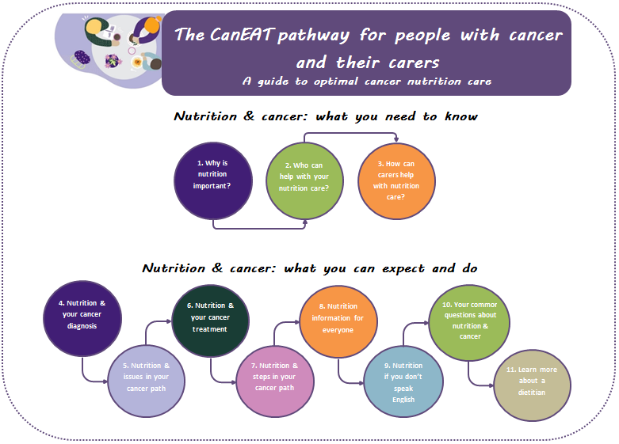

Figure 6: The CanEAT pathway for health professionals

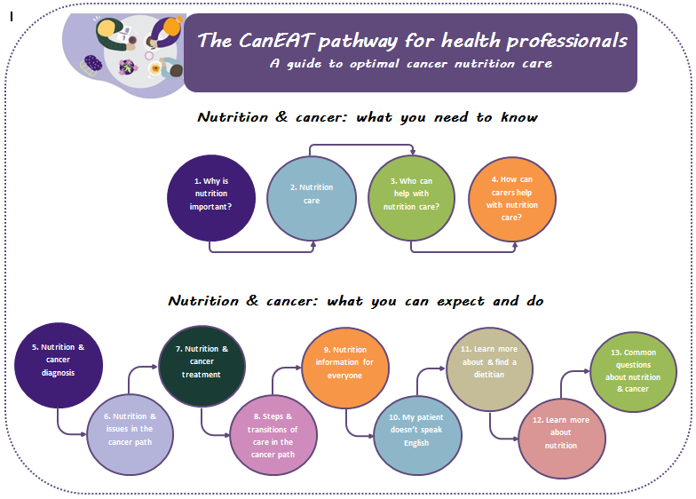

|  |
| --- |
| Objective 3: Pilot the feasibility of the cancer nutrition care pathway in clinical practice and make future recommendations for implementation |

Table 18: Improve the experience



| Strategies | Tasks completed | Outcome |
| --- | --- | --- |
| **3.1 Methodology of pilot phase** | Liaised with project steering committee and key stakeholders to confirm methodology for this pilot phase: following co-design workshop 2, it was decided that a broad consultative feedback process was going to provide the best value based on time available. To note, multi-site piloting in clinical practice was not deemed possible with time available and ethics requirements needed  Methodology developed and ethics amendment was submitted and approved on 20 August 2019 (with no changes) | Methodology of pathway confirmed during pathway development – broad consultative feedback process decided as the best option  Completed |
| **3.2 Pilot pathway/feedback** | Ethics application completed as per 3.1  Pilot/feedback completed via email invitation to complete online feedback via a secured REDcap database, verbally/meeting with project team and/or hard copy feedback  Pilot/feedback was open for approximately 3½ weeks  Incentive included to encourage participation in the feedback process (into draw to win 5 × $50 gift vouchers)  Broad consultative feedback closed on Tuesday 22 October 2019 | High level of engagement and response rate for pilot/feedback process  Summary of the pilot/feedback process reported below |

### Summary of pilot/feedback process

*‘It really is an excellent compilation of all aspects of diet and other ongoing issues in respect to most types of cancer.’*

*– Person with cancer*

#### Aim

To finalise the cancer nutrition pathway via seeking feedback from key stakeholders including patients, carers and health professionals.

#### Method

Patients and carers involved in the focus groups and/or co-design workshops and health professionals who participated in the co-design workshops and those identified as key stakeholders from Victoria and interstate were invited to participate in the pilot/feedback process. This occurred via email invitation to complete an online survey (REDcap) and/or provide feedback via email, on a hardcopy or in a pre-arranged face-to-face meeting with project staff. The aim was for a minimum of 10 patients and carers and 10 health professionals to participate. An incentive was included to increase participation rates.

#### Key results and themes

|  |
| --- |
| **Summary of feedback received and changes made based on feedback**   * Number of respondents: 46 (as of 25/10/19), target reached * Demographics: patients (*n =* 11), carers (*n =* 2), health professionals (*n =* 32) (including dietitians, researchers, GPs, physiotherapist, managers from different health settings, dietetic students, nutrition assistant) * Methods of receiving feedback: online feedback tool accessed via link sent in email, attached types notes in Word document, face to face, directly wrote notes into hard-copy documents (given in person or scanned) or over the phone |

#### Table 19: Key themes, feedback and actions

| Key themes | Feedback | Actions |
| --- | --- | --- |
| **Comprehensive and usability resource** | Participants liked:  how comprehensive and detailed the pathways were  how easy navigation was and links to internal and external links  volume of resources  clear and straightforward language  Suggestions:  long and overwhelming  increase font size | One two-page infographic fact sheet to be developed to reduce users being overwhelmed (refer to dissemination plan)  Proposal to create web version of pathway to increase usability |
| **Major areas of change** | Transition of care and emphasis on community services | More emphasis of major transition points and care transition between hospital and community |
| Model of nutrition care (plate model) | Amend to make clearer  Amend in pathway for people with cancer and their carers |
| Diagnosis section for health professional pathway | Include more practical components and align to nutrition care section |

Participants who completed the survey were asked the following questions to assist in forming an implementation plan.

* 81 per cent of people (*n =* 26) answered ‘strongly agree’ to the statement ‘I would like to see the pathway in a format that is interactive on a website’.
* 65 per cent (*n =* 11) of health professionals and 79 per cent (*n =* 19) of patients/carers strongly agreed with the statement ‘I would like a postcard flyer that has a link to the pathway on it and a brief summary of what it is’.
* 84 per cent of patients/carers (*n =* 19) and 56 per cent of health professionals (*n =* 16) strongly agreed with the statement ‘I would use the pathway (or would have previously used)’.

For those providing feedback who participated in the co-design workshops (on a three-point scale):

* 100 per cent (*n =* 16) of people stated they found the co-design methodology ‘highly effective’ or ‘somewhat effective’.
* 100 per cent of participants (*n =* 14) found participating in the project ‘highly valuable’ or ‘somewhat valuable’.

#### Conclusion

Overall, we had a high level of engagement for feedback on the pathway. Most who provided feedback had already been engaged and/or involved in the project to date. This pilot/feedback process has provided incredibly valuable insights and direction for changes to the pathway in addition to the feedback received throughout the co-design process. Themes and appropriate actions were formulated by the project team from the suggestions provided (with a considered and balanced approach) and have been useful for shaping and finalising the pathway. An online survey for feedback will remain open beyond the end of this project.

Table 20: Measure the improvement

| Strategies | Tasks completed | Outcome |
| --- | --- | --- |
| **3.3 Dissemination, implementation and sustainability plan** | Prepared plan for pathway dissemination including suggestions from co-design workshops, pilot/feedback process and in consultation with the steering committee  Prepared plan for implementation and sustainability of the pathway from co-design workshops, pilot/feedback process and in consultation with the steering committee, including details for the potential nationalisation +/- internationalisation of the pathway | Dissemination plan reported in the ‘Impact and future directions’ section  Implementation and sustainability plan reported in the ‘Impact and future directions’ section |

## Wins and gains

* Engagement of patients, carers and health professionals throughout the entire project – from concept development through to the finalised pathway
* Highly engaged and supportive steering committee – their contributions should be acknowledged – steering committee meetings were held approximately bimonthly as planned
* The use of EBCD methodology as a structured means to allow the patient and carer voice to be heard and for all participants (patients, carers and health professionals) to play a collaborative and integral role in developing and shaping the pathway
* The expansion in knowledge and insights into patient and carer experiences and needs around nutrition and cancer care
* The opportunity to promote awareness of nutrition and highlight the importance that nutrition and nutrition care plays within multimodal cancer care and for the patient and carer experience
* The online ethics approval process was successful, which enabled a large amount of work to be completed within the project timelines – the amendment approval was provided quickly and without any changes required
* Other outputs achieved within this project under the work of the VCMC:
* The VCMC hosted two Community of Practice forums in February 2019 and September 2019 – both forums included an update of this project
* Release of four VCMC e-newsletters in November 2018, April 2019, July 2019 and October 2019 – all included an update of this project
* Dissemination of outcomes from this project at the COSA scientific meeting via two poster presentations (Adelaide, November 2019; presenters Jenelle Loeliger and Sarah Dewar)
* Dissemination of the overall VCMC program of work at the PMCC ‘Talking about the C Word’ professional development event via an oral presentation (Melbourne, June 2019; presenter Jenelle Loeliger), Dietitian Connection webinar via invitation (July 2019; presenters Jenelle Loeliger and Belinda Steer), National Allied Health (NAH) Conference via an oral presentation (Brisbane, August 2019; presenter Jenelle Loeliger) and the VCCC scientific meeting via a poster presentation (Melbourne, September 2019; presenter Jenelle Loeliger).

## Issues and challenges

* This entire process highlighted the complexity of the role of nutrition in cancer care – for example, the different needs and considerations that can change significantly depending on cancer diagnosis, treatment type, stage and intent, step in the treatment path and nutrition issues experienced
* Ability to get a broad range of all key health professionals (in particular nursing and medical staff) to the co-design workshops; releasing time from usual clinical care without resourcing was an expected challenge
* Time taken to complete tasks was almost always longer than originally planned – for example:
* Ethics submission (planning around submission and meeting dates) and the approval process within a project with relatively tight timelines
* The need to complete the qualitative analysis in-house created further pressure on project staff to achieve the project milestones and deliverables
* The high level of engagement and positive response to those wanting to attend the co-design workshops led to allowing greater numbers to attend workshops than planned and therefore a larger amount of preparation, data collation and synthesis that needed to occur
* The drafting of the pathway was very time consuming because the design by patients, carers and health professionals was addressing a multitude of identified gaps from the current pathway, therefore the pathway has become a much larger resource than originally anticipated.

# Impact and future directions

## Impact of project

The achievements and the impact of the project is large. This project has highlighted that:

* Co-design has been effective at capturing the patients and carer voice and improvements and solutions can be gained by patients, carers and health professionals working together.
* Health professionals value the opinion and input from patients and carers into service improvement.
* A broad range of experiences and needs exist for people with cancer and their carers in relation to cancer and nutrition.
* A shared responsibility for optimal nutrition care should exist among people with cancer, their carers and health professionals across the continuum in all settings.
* There are many gaps in research, practical tools, communication tools and resources for people with cancer, their carers and health professionals.

The anticipated impact of this project is to have a positive effect on nutrition care delivery and better meeting patient and carer needs. In addition, we hope that knowledge and/or health behaviours relating to nutrition are improved to enable greater self-management of nutrition care by patients and their carers.

## Dissemination plan

The following describes the project’s dissemination plan at project end. Refer to *Appendix 2: Key stakeholder list* and *Appendix 4: Communication strategy summary* for details of communication and dissemination during the project.

The aim of the dissemination plan is to enable targeted distribution of the pathway in order to improve access and lead to improvement in health outcomes in the long term. This plan is to be completed before a formal and targeted implementation strategy (see next section). The future implementation plan will incorporate evaluation measures to determine what and how well this initial dissemination worked.

Figure 7 shows that the dissemination plan includes four main elements.

Figure 7: The four elements of the dissemination plan

Table 21 details the major elements of the dissemination plan.

Table 21: Major elements of the dissemination plan

| Element | Details | Timeframe | Responsibility |
| --- | --- | --- | --- |
| **1. Findings or product** | What is to be disseminated?  The CanEAT pathway for people with cancer and their carers  The CanEAT pathway for health professionals | Nov 2019 | Jenelle Loeliger and Sarah Dewar |
| **2. End-users** | Who will apply the product in practice?  People with cancer and their carers | Nov 2019 onwards | Jenelle Loeliger and Sarah Dewar to disseminate, then end-users |
| Health professionals working in cancer care (Victorian and/or Australian) |
| **3. Dissemination partners** | Individuals, organisations, networks through who you can reach the end-user:  Patient and carer networks  Researchers  Relevant government agencies  Primary care health professionals and groups  Health service health professionals  Community-based health professionals  Cancer organisations/groups | All identified by Nov 2019  Refer to *Appendix 2. Key stakeholder list* | Jenelle Loeliger, Sarah Dewar and steering committee |
| **4. Communication** | Final CanEAT pathway (and infographic fact sheet(s) once completed) available on [PMCC/VCMC webpage](http://www.petermac.org/CanEATpathway)  <www.petermac.org/CanEATpathway> and update of all related details on webpages | Nov 2019 | Jenelle Loeliger and Sarah Dewar |
| Create CanEAT pathway infographic fact sheet(s) summarising project outcomes and available on PMCC/VCMC webpages and distribution via professionals’ networks and/or key stakeholders | Dec 2019 | Jenelle Loeliger and Sarah Dewar |
| Email distribution to key stakeholders (including all participants of the survey, focus groups, co-design workshops and those who gave feedback) with link to pathway and CanEAT pathway infographic fact sheet(s) attached | Dec 2019 | Jenelle Loeliger and Sarah Dewar |
| e-newsletter blurb (including pathway link) distributed to relevant professional bodies/groups to request inclusion in e-newsletters/on website/equivalent | Dec 2019 | Jenelle Loeliger and Sarah Dewar |
| Final project report published and available on the department’s website (and link from PMCC/VCMC webpages) | Dec 2019 (or as completed) | Liz Simkiss/CSD |
| Presentation of project outcomes at relevant conferences, forums and meetings | Nov 2019 onwards | Jenelle Loeliger and Sarah Dewar |
| Preparation of project findings for peer-reviewed journal submission | Nov 2019 to mid-2020 | Jenelle Loeliger and Sarah Dewar |
|  | Virtual launch of CanEAT pathway and other related VCMC resources – social media release from PMCC | Dec 2019 | Jenelle Loeliger, Sarah Dewar and VCMC team |

## Implementation and sustainability plan

The following describes the project’s implementation and sustainability plan. This is the strategy for putting the pathway into clinical practice and ensuring it remains current over time. Implementation science methodology will be employed to underpin any ongoing work.

Full implementation of the pathway into clinical practice within acute, primary or community health sectors was out of scope for this project. The pathway at project end will be disseminated (as per the dissemination plan); however, a full implementation project with dedicated funding is required. In consultation with Cancer Strategy and Development (Department of Health and Human Services) and other stakeholders, options for funding such a proposal will be discussed. This implementation and sustainability plan provides a summary of the plans to date and hence a starting point for such a proposal (Figure 8). The project team developed a funding proposal at project end that outlined both implementation and sustainability strategies for the pathway beyond what was achieved within this project.

Figure 8: Implementation and sustainability plan

Figure 8 is a flowchart of an implementation and sustainability plan 

Table 22 details the major components of the **implementation and sustainability plan** at project end. The project manager and project team would be responsible for designing and achieving the agreed project deliverables and measures.

Table 22: Proposed implementation and sustainability plan

| Phase | Activities |
| --- | --- |
| 1. Implementation strategy | Establish project/implementation team  Decide on best option for implementation framework(s) to apply  Finalise project tasks and activities (draft detailed below)  Prepare and submit ethics |
| 1. Apply co-design to create an interactive website for the pathway | Utilise co-design methodology to create an interactive website for the pathway, with patients, carers and health professionals involved  *Feedback from this project is that an interactive website is the preferred format for the pathway. The creation of a website increases the applicability of the pathway and increases reach to end-users.*  Preparation:   * Brief review of pathway for new resources, evidence since development in November 2019 * Evaluate pathway dissemination from November 2019 project end to now (what best works, what doesn’t) to help inform preferred format, structure, medium * Recruit participants for co-design workshops   Engage web designer and understand website options – interactive functionality, etc.  Co-design workshop with end-users (patients, carers and health professionals) to identify relevant content, preferred website functionality, tools, etc.  Professional design and creation 1  Co-design workshop for prototype testing  Professional design and creation 2 |
| 1. End-user testing of clinical utility | Nominate key end-users to test in clinical practice (across health sectors, inclusive of multiple tumour streams, metropolitan/regional health centres)  Undertake testing of clinical utility (data collection method to gather barriers and enablers to implementation to be determined – could include using survey/focus group/meeting/other format). Questions asked could include: Do you feel able to implement this pathway into practice? What would help you apply it in practice? Does it meet your needs?  Evaluate clinical utility |
| 1. Determine and develop implementation resources (based on strategies most effective and suited to address identified needs and barriers) | Synthesise end-user feedback from testing phase to identify key barriers and enablers to implementation  Devise clear messages for end-users on how to implement pathway (in order to improve/achieve optimal nutrition care)  Develop project infographic fact sheet/alternative summary of key project outcomes and key messages regarding the pathway for local use/display/given to patients/carers, etc.  Develop practice tips to improve uptake of pathway – display fact sheets in patient information or wellbeing centres, incorporate handing out fact sheet as part of supportive care and/or malnutrition screening clinical processes (could include in infographic fact sheet/alternative)  Develop teaching aids that may include, for example, education material, presentation template for local use/adaptation, short video/eLearning clips, case examples  Plan training/education/workshop/roadshow (as appropriate) as means of communication and education regarding the pathway |
| 1. Engage key stakeholders and launch the pathway | Identify health professional/clinical and patient/carer champions across groups and sectors  Pilot test the implementation resources developed and update as indicated (via most appropriate method identified)  Launch the pathway website alongside multifaceted implementation interventions |
| 1. Evaluation of success | Aim for end-users to increase use of the pathway in clinical practice – measure using website analytics on website (access, who, etc.)  Collect overall satisfaction and gaps of pathway with stakeholders (methods could include interviews, focus groups, etc.)  Measure reach – assess where end-users are based, etc.  Tracking number and content of feedback received via ongoing feedback survey or other identified feedback mechanism |
| 1. Sustainability phase | Develop regular schedule for content review and resourcing required  Develop feedback portal for end-users  Ongoing communication regarding updates of pathway and associated work/resources  Other considerations for effective sustainability:   * Website host maintenance costs and engagement * Align any updates/changes with relevant policies and guidelines – OCP implementation work, *Victorian cancer plan* (or equivalent in other states) * Maintaining currency of pathway, specifically regarding new literature/EBPGs/professional consensus guidelines and new technology and treatments such as CAR-T and immunotherapy * Ongoing and changing patient/carer needs |

## Recommendations

A number of recommendations have been formulated as a result of this project:

|  |
| --- |
| 1. **Unmet needs across the care continuum around nutrition and cancer exists for patients and carers and action is required to address this**    1. Improvements in care provision in all health settings across the entire patient care continuum is required to enable optimal nutrition cancer care to be delivered at the right time.    2. Reduce unwanted variation in nutrition care and improve consistency of nutrition and cancer information provided. 2. **A focus on implementing the CanEAT pathway into clinical practice is required**    1. Professional website design is required to transform the pathway into a more implementable resource.    2. A formal implementation project is required utilising implementation science methodology as outlined in the implementation and sustainability plan.    3. A funding proposal is to be developed by the VCMC team. 3. **Nutrition care and communication during major transition points needs action**    1. A greater evidence base is required to investigate effective models and pathways of nutrition care, in particular between hospitals, primary and community care.    2. Improvements in education, resources (for example, discharge templates), communication methods and tools to aid improved nutrition care during major transitions are required.    3. Evidence, resources and tools about suitable nutrition shared care models that could be applied to nutrition pathways are needed. 4. **Improved access to and development of nutrition-focused self-management strategies, resources and tools are needed for patients, carers and health professionals**    1. Examine and determine suitability of tools used for other chronic diseases and test for use in cancer.    2. Greater availability of self-management strategies, resources and tools suitable for use by patients, carers and health professionals.    3. Empower health professionals to build self-management strategies, resources and tools into nutrition models and pathways of care and better share the responsibility of nutrition care. |

# 

Appendix 1: Project Gantt chart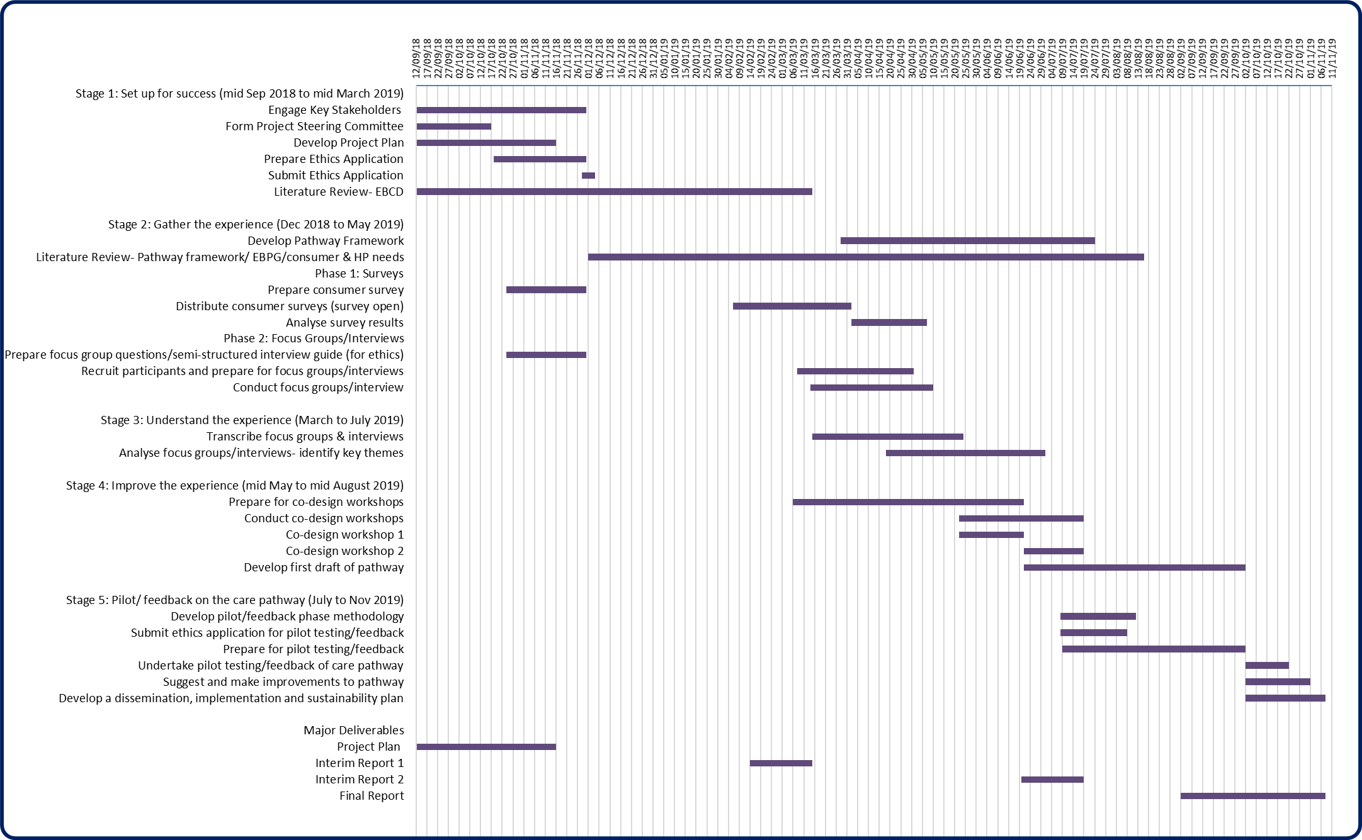

# 

# Appendix 2: Key stakeholder list

| Area/group | Stakeholder | Activities |
| --- | --- | --- |
| **Project Steering Committee** | As noted under ‘Authorship and project contributors’ section (page 5) | Oversight of project and achievement of project deliverables |
| **PMCC project management team** | As noted under ‘Authorship and project contributors’ section (page **Error! Bookmark not defined.**)  PMCC Executive and Allied Health | Oversight of VCMC program of work and support for achievement of project deliverables  Support and dissemination |
| **Patient and carer networks** | PMCC Consumer Liaison  PMCC Consumer Manager/Consumer Register  Identified cancer groups/NGOs/not-for-profit organisations:  Health Issues Centre Consumer Connect  Primary Health consumer North Western Melbourne Primary Health Network People Bank  Carers Victoria, Counter Part, participants attending Cancer Council programs (within PMCC) | Advice on distribution and communication with consumers  Steering committee representation  Participation in survey, focus groups and co-design workshops |
| **Researchers and support workers** | PMCC Allied Health Research – Lara Edbrooke  PMCC Cancer Experiences Research (CER) – Jo Phipps-Nelson, Amelia Hyatt, Alison Drosdowsky, Elizabeth Pearson, Sarah Blaschke, Trista Koproski, Iris Liu  The University of Melbourne – Cath Devereaux, Carol Jewell  Deakin University – Nicole Kiss  Australian Catholic University – Prue Cormie  PMCC Health Literacy – Tanya McKenzie  PMCC Allied Health Education – Quan Nguyen, Leo Byron | General research advice including for survey design and analysis, qualitative design, analysis and development support for feedback tool  EBCD experience  General advice  Implementation project advice  Health literacy advice  Support for establishing e-newsletter |
| **Government agencies** | Department of Health and Human Services, Cancer Strategy and Development – Marita Reed and Liz Simkiss  Integrated Cancer Services (ICS) – Kathy Quade (WCMICS)  Western and Central Integrated Cancer Services (WCMICS)  Barwon South Western Regional ICS  Gippsland Regional ICS  Grampians Regional ICS  Hume Regional ICS  Loddon Mallee ICS  North Eastern Melbourne ICS  Southern Melbourne ICS  Safer Care Victoria (SCV) | Funders, project support and guidance  Participation in survey, focus groups and co-design workshops (ICS) |
| **Primary care health professionals/groups** | Health Pathways – Cherylynn Garner  GP and PMCC GP Liaison – Alexis Butler  Primary Health Network – Western Central and Eastern  Royal Australian College of General Practitioners (RACGP)  Australian Primary Health Care Nurses Association (APNA) | Advice, distribution and engagement with health professionals working in primary care |
| **Health service health professionals/groups** | Victorian Health Services (via professional networks and distribution lists)  Dietitian Managers Victoria group – Andrea Elliot, Leonie Pearce, Wendy Swan  VCMC group/oncology dietitians in Victoria – Kate Kaegi, all participants in co-design workshops  COSA Nutrition Executive – Nicole Kiss (Chair) and committee  Dietitians Association of Australia (DAA)  Dietitian Connection  Integrated Cancer Services (ICS)  Multidisciplinary Association of Supportive Care in Cancer (MASCC) | Contribution to project activities  Advice on health service needs  Participation in co-design workshops and feedback on pathway  Support and advice for project |
| **Community-based health professionals/groups** | Carrington Health – Rebecca McIntosh | Survivorship and community health–related activities |
| **Cancer organisations groups** | Cancer Council Victoria – Amber Kelaart, Amanda Piper, Jenny Post, Joanna Ong, Julia Brancato  Australian Cancer Survivorship Centre (ACSC) – Jodi Dumbrell  Bowel Cancer Australia, Breast Cancer Network Australia, Consumer Representative Group, Lymphoma Australia, Lung Foundation Australia, Myeloma Foundation Australia, Prostate Cancer Foundation Australia (via Pathfinder Advisory Committee), Pancare Foundation, Think Pink Foundation, McGrath Foundation, Beyond Five, Australian Gynaecological Cancer Foundation (website post), Melanoma Institute Australia, Unicorn Foundation  Victorian Comprehensive Cancer Centre (VCCC)  WeCan | Cancer Council Victoria nutrition and OCP implementation projects, Cancer Council Victoria OCP Refresh project  Australian Cancer Survivorship Centre–related projects and activities  Participation in survey, focus groups and co-design workshops |

Notes:

The following stakeholders were also steering committee members: Nicole Kiss, Liz Simkiss, Kathy Quade, Alexis Butler, Andrea Elliot, Leonie Pearce, Wendy Swan, Kate Kaegi, Rebecca McIntosh, Amber Kelaart, Amanda Piper and Jodi Dumbrell

The following organisations are listed for dissemination purposes only: Safer Care Victoria, Health Pathways, RACGP, APNA, COSA Nutrition Executive, DAA, Dietitian Connection, MASCC, ACSC, VCCC and WeCan

# Appendix 3: Key project risk summary

| Risk | Controls | Likelihood | Consequence | Status at project end |
| --- | --- | --- | --- | --- |
| Appropriate staff resourcing | Ensure appropriately qualified project manager and officer appointed | Unlikely | Moderate | Experienced project manager with VCMC program oversight and well-skilled project officer appointed. |
| Budget | Realistic budget and timelines established in project proposal | Unlikely | Moderate | Project completed within allocated budget. |
| Timelines | Realistic timelines established in project proposal; PMCC leadership/VCMC program have experience/good track record in project management.  Minor amendments made to project task timelines  Some contingency built into budget | Possible | Moderate | Project tracked reasonably well to projected timelines with minor amendments. Initial amendment to project methodology in December 2018 to reduce survey activities helped to aid adherence to timelines. Small delays of about a month mid-project due to not being able to outsource qualitative analysis. This resulted in co-design workshops to be later than planned and subsequent reduced time available for pilot stage (did not impact on major deliverables). Contingency budget used for additional project days for project officer and project manager to complete project tasks and keep project on track. |
| Willingness of target audience to engage | Target minority groups through recruitment for focus groups/interviews/workshops to gain a representative sample  Utilise professional networks to ensure high engagement from health professionals for co-design workshops | Possible | Moderate | Excellent engagement and interest from consumers – for survey, focus group and workshops. Health professional engagement higher than anticipated with larger numbers engaged and in attendance for co-design workshops. |
| Delays due to ethics clearance | Explore and plan in early stages of project; close communication with Cancer Experiences Research (CER) and ethics team | Possible | Moderate | Ethics submission planned and submitted early (pre-Christmas 2018) that enabled release of survey in early 2019. A number of ethics amendments occurred for small changes to survey questions. Ethics amendment approval granted quickly for pilot/feedback phase – multi-site ethics approval was not deemed possible, which limited the scope of this part of the project (too burdensome and time consuming). |
| Lack of sustainability | Project aims to align with existing projects  Project builds on existing relationships and partnerships | Possible | Moderate | Need for a pathway confirmed early in the project. Project team built on existing and built new relationships with key stakeholders and ensured all outputs were unique and not a duplicate of existing projects/work. Objective 3 was amended before submission of interim report 1 to specifically include developing an implementation plan as part of the final report. |
| Lack of transferability of project outcomes | Detailed communication plan to ensure learnings/resources/pathway are communicated to relevant networks | Unlikely | Moderate | Good engagement and interest from key stakeholders and alignment with COSA Nutrition Group work. Detailed communication plan completed as part of the final project report. |

# Appendix 4: Communication strategy summary

| Communication actions | Tasks | Key messages | Target audience | Target completion date | Responsibility | Status at project end |
| --- | --- | --- | --- | --- | --- | --- |
| Access to project documents | All relevant project documents will be circulated over email to steering committee members and other stakeholders as appropriate  All documents stored securely on PMCC drive | Documents may include project plan, meeting agendas, minutes, project reports | Project Steering Committee  PMCC Executive Sponsor | As project documents completed | Jenelle Loeliger, Sarah Dewar | Completed as planned |
| Engage key stakeholders at start of project | Engage key stakeholders at start of project to help inform methodology, project planning and steering committee members | Engage key stakeholders at start of project to help inform methodology, project planning and steering committee members | Identified key stakeholders at start of project from all sectors (refer to *Appendix 2: Key stakeholder list*) | As identified throughout project | Jenelle Loeliger, Sarah Dewar | Completed as planned |
| Cancer Strategy and Development, Department of Health and Human Services | Oversight of project and achievement of project deliverables | Discuss project progress, problems and questions  Clarify responsibilities of stakeholders | Marita Reed and Liz Simkiss, Cancer Strategy and Development | Bi-monthly or as required | Jenelle Loeliger | Regular contact maintained  Completed as planned |
| Project Steering Committee | Oversight of project and achievement of project deliverables | Encourage stakeholder participation  Discuss project progress, problems and questions | Project Steering Committee | Bi-monthly | Jenelle Loeliger, Sarah Dewar | Completed as planned |
| PMCC project managementteam | Oversight of VCMC program of work and support for achievement of project deliverables | Discuss project progress, problems and questions  Clarify responsibilities of stakeholders | PMCC project team | 3-weekly | Jenelle Loeliger and team | Completed as planned |
| Project reports | Complete project plan, two interim reports and final project report | Report on progress of key tasks and deliverables | Cancer Strategy and Development, VCMC Community of Practice, key stakeholders as identified by steering committee and outlined in dissemination plan | Project plan: 19/10/18 (finalised on 16/11/18)  Interim report 1: 5/3/19  Interim report 2: 19/7/19  Final project report: 12/11/19 | Jenelle Loeliger, Sarah Dewar | Project plan, interim report 1, interim report 2 and final project report all submitted on time  Completed as planned |
| Communicate outcomes of project to key stakeholders | Create CanEAT pathway infographic fact sheet(s) at conclusion of project summarising project outcomes and available on [PMCC/VCMC webpages](http://www.petermac.org/CanEATpathway) <www.petermac.org/CanEATpathway>  Final CanEAT pathway (and infographic fact sheets) available on PMCC/VCMC webpage and update of all related details on webpages  Email distribution to key stakeholders with link to pathway and CanEAT pathway infographic fact sheet(s) attached  Prepared e-newsletter blurb to be distributed to relevant professional bodies/groups for inclusion in e-newsletters/on website/equivalent where appropriate  Final project report published and available on the department’s website (and link from PMCC/VCMC webpages)  Virtual launch of CanEAT pathway and other related VCMC resources – social media release from PMCC | Project outcomes | Identified key stakeholders for this project (refer to *Appendix 2: Key stakeholder list*) | Infographic fact sheet and update of VCMC webpages planned for completion in the month following project end, by Dec 2019  Final CanEAT pathway available on PMCC/VCMC webpage and update of all related details on webpages as planned Nov 2019  Email distribution to key stakeholders following completion of CanEAT pathway infographic fact, by Dec 2019  e-newsletter blurb as included in the final project report as planned Nov 2019  Final project report submitted as planned Nov 2019 – availability on the department’s webpage as soon as possible  Virtual launch of CanEAT pathway and other related VCMC resources by Dec 2019 | Jenelle Loeliger, Sarah Dewar (and Cancer Strategy and Development, for publication on the department’s website) | All tasks on track at project end  Some tasks for completion beyond project end; detail included in the dissemination plan and implementation plan |
| Communicate outcomes of the project to the wider community | As per above communication to key stakeholders  Presentation of project outcomes throughout dietetic and cancer professions and via steering committee members and their networks using the CanEAT pathway infographic fact sheet(s)  Preparation of project findings for peer-reviewed journal submission. | Project outcomes | Relevant/potential conferences:  COSA conference, DAA conference, Victorian Allied Health research conference, Victorian ICS conference, MASCC conference, National Allied Health conference, Victorian Cancer Survivorship Conference | Conference abstract submission as per conference guidelines for key conferences identified Nov 2019 onwards  Manuscript(s) to peer-reviewed journal by mid-2020 | Jenelle Loeliger, Sarah Dewar | Two accepted abstracts for COSA conference Nov 2019 (posters)  Further submissions and manuscript preparation 2019/2020 |
| Community of Practice | Present on project progress and outcomes | Update stakeholders on progress of project | VCMC + key stakeholders | Feb 2019  Sep 2019 | Jenelle Loeliger, Sarah Dewar | Completed as planned |
| VCMC e-newsletter | Regular communication with key stakeholders | Update stakeholders on progress of project | VCMC + key stakeholders | Approx. 3-monthly: Nov 2018, Apr 2019, Jul 2019, Oct 2019 | Sarah Dewar | Completed as planned |

Note: Prepared e-newsletter blurb for external stakeholder communication (to be distributed to relevant professional bodies/groups for inclusion in e-newsletters/equivalent where appropriate).

|  |
| --- |
| **The CanEAT pathway**   * Developed by patients, carers and health professionals from a Department of Health and Human Services–funded project within the VCMC program of work * Two pathways have been created:   1. The CanEAT pathway for health professionals  2. The CanEAT pathway for people with cancer and their carers   * Aims to help all people with cancer, their carers and health professionals to achieve and deliver optimal nutrition care following a cancer diagnosis and answer your questions in regards to nutrition and cancer: What you need to know, what you can expect and what you can do * Pathways provide links to trustworthy, dietitian approved information, resources and tools and provides some practical tips. It includes nutrition information for all cancer diagnosis, cancer treatments, tips for a range of nutrition issues, answers common food/diet questions and links to translated resources and tools * The feedback received so far includes: ‘Overall, this is amazing. Well done to everyone involved.’ ‘I wish I had had this while I was going through my treatment’ (person with cancer)   The pathway is freely available at: [www.petermac.org/CanEATpathway](http://www.petermac.org/CanEATpathway)   * Save it to your desktop for easy access * Provide it to your patients and their carers * Use it to guide nutrition care and service delivery |

# Appendix 5: Consumer survey

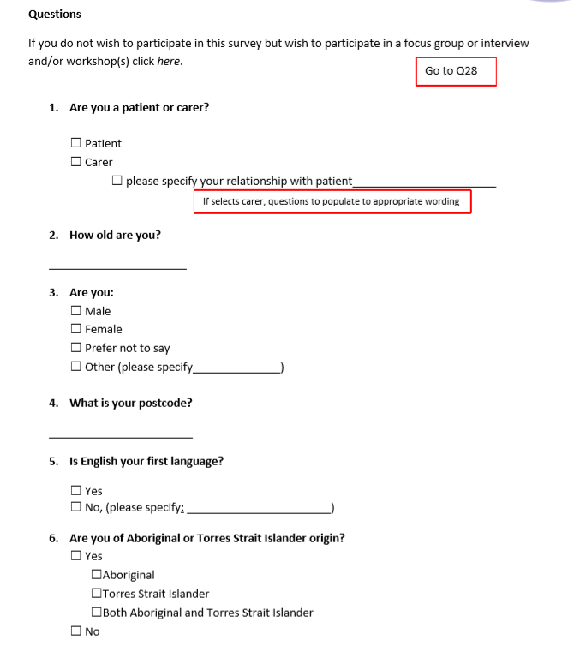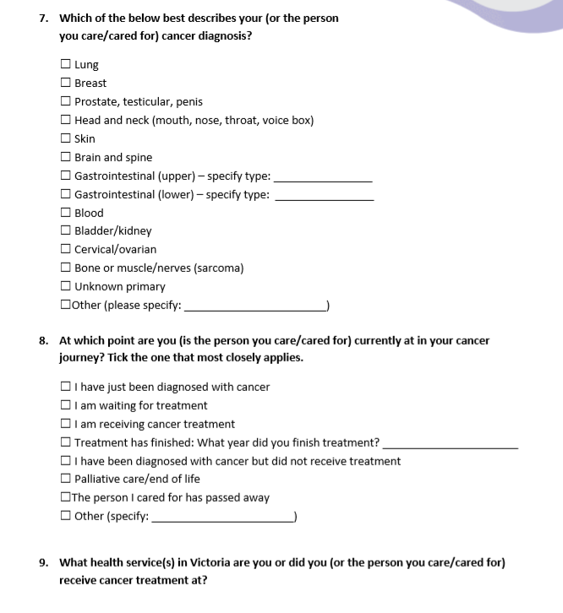

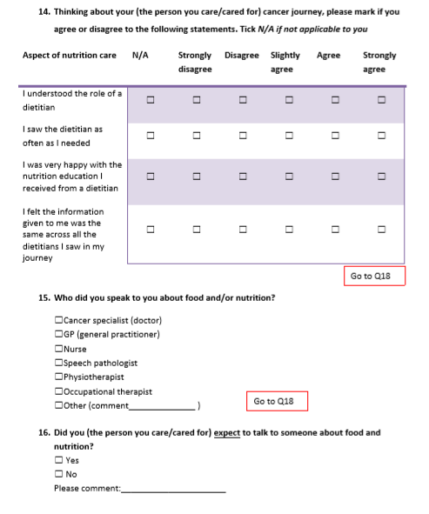

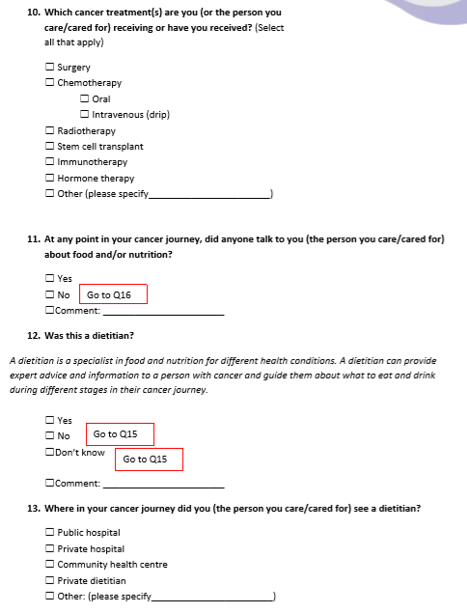

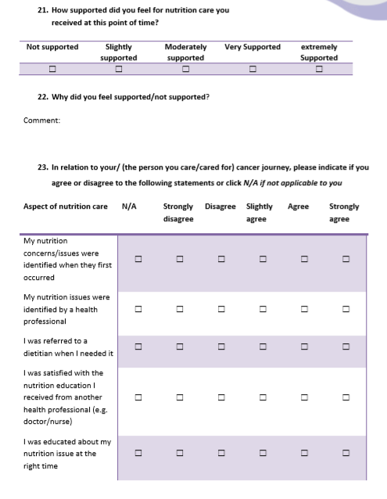

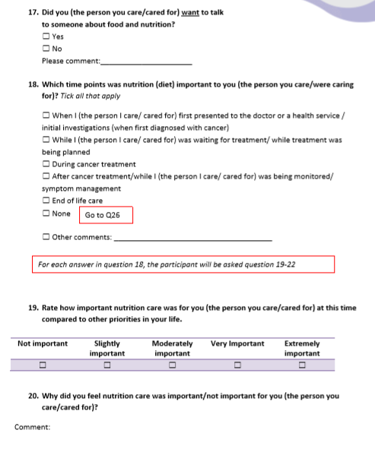

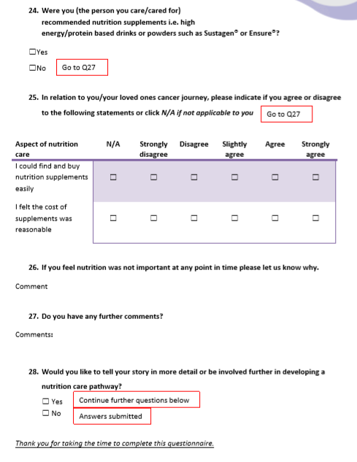

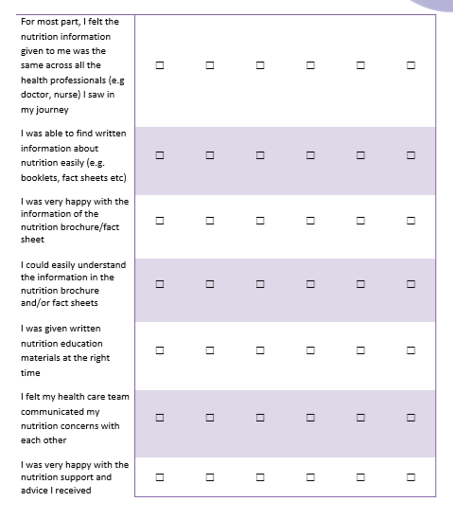

# Appendix 6: Focus group questions

**Focus group/interview question guide (patient/carers):**

1. Can you tell us about your nutrition and cancer experience? (prompt: what specific experiences stand out for you as particularly good or bad?; what did you make of this experience?, how did you deal with this experience?; what did this experience suggest to you about the service?)
2. If you (or the person you cared for) saw a dietitian along your cancer journey, can you tell me more about this? Prompts:
   * + 1. Where along your journey did you see a dietitian? i.e. in hospital, the community, community rehabilitation, private practice
       2. Where did you see a dietitian?
       3. Who referred you to the dietitian / was it requested by you?
       4. Do you know why you were referred / how did initial contact come about?
       5. Why were you seeing a dietitian?
       6. How long did you wait to see a dietitian? (prompt: was this acceptable?)
       7. Were your nutrition needs met during this time?
       8. Were you given any written information such as booklets/brochures/information sheets? (prompt: what did you think of these? Did they meet your needs?)
3. If you didn’t see a dietitian along your cancer journey, did you feel you were supported with your nutrition in other ways? Prompts:
   * + 1. Was there a time when you would have wanted to see a dietitian? Why/why not? Tell us more about this.
       2. Where did you get your advice?
       3. What did you do about your nutrition issues?
       4. How were you supported in regards to nutrition?
4. How did you feel about your nutrition care at certain time points along your cancer journey? (prompt: give examples of emotions, ask why you felt like this, did you get enough care at the right time i.e. immediately after treatment/into survivorship phase)
5. Were you given information on the impact of poor nutrition at any time during your cancer journey? For example, longer recovery times etc. (prompt: can you tell me more about this? Did it change anything for you? Who was it from?)
6. Do you have any examples of when your expectations or needs around nutrition were/weren’t met?
7. How can we as health professionals improve the experience for you in regards to your nutrition needs during your cancer journey? Prompts:
   * + 1. What could have made your experience with nutrition better/different for you during your cancer journey?
       2. What changes in the service would make a difference for you? (prompt: greater or different care/support at particular times along the cancer journey)
       3. When ideas are all covered, ask: if all these things were done what difference would that have made for you?
8. What is your view about talking with patients/carers about the word malnutrition? Do you want dietitians/health professionals to discuss this with you if you are malnourished?
9. Do you, or did you find the side effects from your cancer treatment affected social aspects of your eating and drinking? For example, leaving the house to eat and drink, being in public with a feeding tube (if you had one). Prompt: If so, could anything have changed to make it a different experience for you?
10. Do you, or did you find the side effects from your cancer treatment affected emotional aspects of your eating and drinking? For example, leaving the house to eat and drink, being in public with a feeding tube. Prompt: If so, could anything have changed to make it a different experience for you?
11. Were there any barriers to you achieving the best nutrition that you could throughout your cancer journey?
12. Is there anything you mentioned in your survey (if you completed it) that you wish to discuss?
13. Do you have any other comments you would like to add?

# Appendix 7: Nutrition and cancer reference documents

## Nutrition (general)

| Name | Author(s) | Link and/or reference |
| --- | --- | --- |
| Aspen adult nutrition care pathway, ASPEN | ASPEN, America | <https://www.nutritioncare.org/uploadedFiles/Documents/Malnutrition/ASPEN_Adult_Nutrition_Care_Pathway.pdf> |
| The Pathway for Oral Nutritional Supplements, NICE | NICE (National institute for health and care research), UK | <https://www.malnutritionpathway.co.uk/library/ons_pathway.pdf> |
| A screening and management pathway using ‘MUST’ that can be used across care settings to identify adults who are malnourished or at risk of malnutrition, NICE | NICE (National institute for health and care research), UK | <https://www.malnutritionpathway.co.uk/> |
| Enteral Nutrition Care Pathway for Critically-Ill Adult Patients, ASPEN | ASPEN, America | <http://www.nutritioncare.org/Guidelines_and_Clinical_Resources/EN_Pathway/Enteral_Nutrition_Care_Pathway_for_Critically-Ill_Adult_Patients/> |
| The Integrated Nutrition Pathway for Acute Care (INPAC) | Canadian Malnutrition Task Force | <https://nutritioncareincanada.ca/> |
| ADA (American Dietetic Association) MNT (Medical Nutrition Therapy) protocol | American Dietetic Association | Medical Nutrition Therapy Protocols. J Am Diet Assoc 99,  351, 1999. doi:10.1016/s0002-8223(99)00090-5 |
| Nutrition support in adults overview, NICE | NICE (National institute for health and care research), UK | <https://pathways.nice.org.uk/pathways/nutrition-support-in-adults> |

## Cancer (general)

| Name | Author(s) | Link and/or reference |
| --- | --- | --- |
| Optimal care pathways, Cancer Council | Cancer Council | <https://www.cancer.org.au/health-professionals/optimal-cancer-care-pathways.html> |
| What to expect guides, Cancer Council | Cancer Council | <https://www.cancer.org.au/about-cancer/cancer-pathways-what-to-expect.html> |
| Model of Survivorship Care Cancer Survivorship: Living well with and beyond a cancer diagnosis, COSA | COSA, Australia | <https://www.cosa.org.au/media/332340/cosa-model-of-survivorship-care-full-version-final-20161107.pdf> |
| American Cancer Society Survivorship Care Guidelines, American Cancer Society | American Cancer Society | <https://www.cancer.org/health-care-professionals/american-cancer-society-survivorship-guidelines.html> |

## Nutrition and cancer (EBPG and guidelines)

### Nutrition and cancer

| Name | Author(s) | Link and/or reference |
| --- | --- | --- |
| ESPEN guidelines on nutrition in cancer patients | ESPEN, Europe. European Society for Clinical nutrition and Metabolism | <http://www.espen.info/> |
| ESPEN expert group recommendations for action against cancer-related malnutrition, ESPEN | ESPEN, Europe. European Society for Clinical nutrition and Metabolism | <http://www.espen.info/> |
| Nutritional management of adult patients with head and neck cancer, COSA | COSA, Australia | <https://wiki.cancer.org.au/australia/COSA:Head_and_neck_cancer_nutrition_guidelines> |
| Nutritional Management of Cancer Cachexia, DAA | Dietitians Association of Australia | <https://www.health.qld.gov.au/__data/assets/pdf_file/0028/157618/cc_cancer_cachexia1.pdf> |
| Nutritional management of patients receiving radiation therapy and/or chemotherapy, *Nutrition and Dietetics Journal* | *Nutrition and Dietetics* journal, Australia | <https://onlinelibrary.wiley.com/doi/epdf/10.1111/1747-0080.12013> |
| Nutritional management of patients receiving radiation therapy, *Nutrition and Dietetics Journal* | *Nutrition and Dietetics* journal, Australia | <https://onlinelibrary.wiley.com/doi/pdf/10.1111/j.1747-0080.2008.00252.x> |
| *Under development:* Malnutrition and Sarcopenia in Cancer Position Statement, COSA | COSA, Australia | *Under development* |

### Nutrition (general)

| Name | Author(s) | Link and/or reference |
| --- | --- | --- |
| Enhanced Recovery After Surgery (ERAS) guidelines | ERAS Society | <http://erassociety.org/guidelines/list-of-guidelines/> |
| ESPEN guidelines:  Clinical nutrition in liver disease  Clinical nutrition in the intensive care unit  Clinical nutrition and hydration in geriatrics  Clinical nutrition in neurology  Nutritional support for polymorbid internal medicine patients  Clinical nutrition in surgery  Clinical nutrition in inflammatory bowel disease  Definitions and terminology of clinical nutrition | ESPEN, Europe. European Society for Clinical nutrition and Metabolism | <http://www.espen.info/> |
| Australian Dietary Guidelines, NHMRC | NHMRC, Australia | <https://nhmrc.gov.au/about-us/publications/australian-dietary-guidelines> |
| *Au*SPEN Home Enteral Nutrition Guidelines | The Australasian Society of Parenteral and Enteral Nutrition, Australia and New Zealand | <https://www.auspen.org.au/resources-1/> |
| *Au*SPEN Home Parenteral Nutrition Guidelines | The Australasian Society of Parenteral and Enteral Nutrition, Australia and New Zealand | <https://www.auspen.org.au/resources-1/> |
| ESPEN-endorsed recommendations:  Management of acute intestinal failure  Nutrition care for infants, children, and adults with cystic fibrosis  Ethical aspects of artificial nutrition and hydration  Chronic intestinal failure in adults  Nutrition in dementia  Protein intake and exercise for optimal muscle function with aging:  Recommendations from the ESPEN Expert Group  Nutritional therapy in major burns  Adult parenteral nutrition  Consensus statement on dietary fat intakes for pregnant and lactating women  Adult enteral nutrition  Enteral nutrition — Percutaneous endoscopic gastrostomy (PEG)  Bioelectrical impedance analysis  ERAS: perioperative care pancreaticoduodenectomy, elective rectal/pelvic surgery and elective colonic surgery (separate guidelines)  Nutrition screening 2002  Nutrition in acute pancreatitis  Nutrition in liver disease and transplantation  Nutrition in adult patients with renal insufficiency | ESPEN, Europe. European Society for Clinical nutrition and Metabolism | <http://www.espen.info/> |

# Abbreviations

COSA Clinical Oncological Society of Australia

EBCD experience-based co-design

EBPG evidenced-based practice guidelines

GP general practitioner

ICS Integrated Cancer Services

OCP optimal care pathway

PMCC Peter MacCallum Cancer Centre

VCMC Victorian Cancer Malnutrition Collaborative

# References

1. Cederholm T, Jensen GL, Correia MITD, Gonzalez MC, Fukushima R, Higashiguchi T, et al. GLIM criteria for the diagnosis of malnutrition – A consensus report from the global clinical nutrition community. Clinical Nutrition. 2019;38(1):1-9.

2. Steer B, Marshall K, Kiss N, Loeliger J. Cancer Malnutrition Point Prevalence Study 2016 summary report. In: Department of Health, State Government of Victoria, editors. Melbourne. 2018.

3. Marshall KM, Loeliger J, Nolte L, Kelaart A, Kiss NK. Prevalence of malnutrition and impact on clinical outcomes in cancer services: A comparison of two time points. Clinical Nutrition (Edinburgh, Scotland). 2019;38(2):644-51.

4. Arends J, Bachmann P, Baracos V, Barthelemy N, Bertz H, Bozzetti F, et al. ESPEN guidelines on nutrition in cancer patients. Clinical Nutrition. 2017;36(1):11-48.

5. Freijer K, Tan SS, Koopmanschap MA, Meijers JM, Halfens RJ, Nuijten MJ. The economic costs of disease related malnutrition. Clinical Nutrition (Edinburgh, Scotland). 2013;32(1):136-41.

6. Arends J, Baracos V, Bertz H, Bozzetti F, Calder PC, Deutz NEP, et al. ESPEN expert group recommendations for action against cancer-related malnutrition. Clinical Nutrition. 2017;36(5):1187-96.

7. Loeliger J, Stewart J, B S. Malnutrition in Victorian Cancer Services 2017–2018: summary report. In: Department of Health and Human Services, editor. State Government of Victoria, Melbourne.

8. Stewart J, Steer B, Loeliger J. Cancer malnutrition: feeding everyone from hospital to home final report, . In: Department of Health, editor. State Government of Victoria, Melbourne. 2018.

9. Findlay M, Bauer, J, Brown, T. Head and Neck Guideline Steering Committee. Evidence-based practice guidelines for the nutritional management of adult patients with head and neck cancer. Sydney: Cancer Council Australia. Available from: https://wiki.cancer.org.au/australia/COSA:Head_and_neck_cancer_nutrition_guidelines.

10. Isenring E, Hill J, Davidson W, Brown T, Baumgartner L, Kaegi K, et al. Evidence based practice guidelines for the nutritional management of patients receiving radiation therapy of the Dietitians Association of Australia. Nutrition & Dietetics. 2008;65.

11. Bauer JD, Ash S, Davidson WL, Hill JM, Brown T, Isenring EA, et al. Evidence based practice guidelines for the nutritional management of cancer cachexia. Nutrition & Dietetics. 2006;63(s2):S3-S32.

12. Talwar B, Donnelly R, Skelly R, Donaldson M. Nutritional management in head and neck cancer: United Kingdom National Multidisciplinary Guidelines. The Journal of Laryngology & Otology. 2016;130(S2):S32-S40.

13. Dewar SL, Porter J. The effect of evidence-based nutrition clinical care pathways on nutrition outcomes in adult patients receiving non-surgical cancer treatment: a systematic review. Nutrition and Cancer. 2018;70(3):404-12.

14. Hill A, Kiss N. Evaluation of an evidence-based nutrition care pathway for lung cancer patients undergoing radiotherapy. Journal of Thoracic Oncology. 2012(S172).

15. Lykins TC. Nutrition support clinical pathways. Nutrition in clinical practice : official publication of the American Society for Parenteral and Enteral Nutrition. 1996;11(1):16-20.

16. European Pathway Association. Care Pathways 2017. Available from: http://e-p-a.org/care-pathways/.

17. Foot C GH, Dunn P, Jabbal J, Seale B, Goodrich J, Buck D. . People in control of their own health and care: the state of involvement. The King’s Fund, London. 2014.

18. Dawda PK, A. . Experience Based Co-Design – A toolkit for Australia. Consumers Health Forum of Australia and Australian Healthcare and Hospitals Association, Deakin.

19. Ziebland S, Calabrese JD, Locock L. Understanding and using health experiences: improving patient care: OUP Oxford; 2013.

20. Fucile B, Bridge E, Duliban C, Law M. Experience-based co-design: A method for patient and family engagement in system-level quality improvement. Patient Experience Journal. 2017;4(2):53-60.

21. Robert G, Cornwell J, Locock L, Purushotham A, Sturmey G, Gager M. Patients and staff as codesigners of healthcare services. BMJ : British Medical Journal. 2015;350:g7714.

22. Tsianakas V, Robert G, Maben J, Richardson A, Dale C, Griffin M, et al. Implementing patient-centred cancer care: using experience-based co-design to improve patient experience in breast and lung cancer services. Supportive Care in Cancer: Official Journal of the Multinational Association of Supportive Care in Cancer. 2012;20(11):2639-47.

23. Piper D, Iedema R, Gray J, Verma R, Holmes L, Manning N. Utilizing experience-based co-design to improve the experience of patients accessing emergency departments in New South Wales public hospitals: an evaluation study. Health Services Management Research. 2012;25(4):162-72.

24. Iedema R, Merrick E, Piper D, Britton K, Gray J, Verma R, et al. Codesigning as a discursive practice in emergency health services: the architecture of deliberation. 2010: 73-91.

25. Agency for Clinical Innovation (ACI). Patient experience and consumer engagement: What is experience-based co-design?. 2019. Available from: https://www.aci.health.nsw.gov.au/make-it-happen/peace

26. The King’s Fund. Experience-based co-design toolkit. The Point of Care Foundation. Available from: https://www.pointofcarefoundation.org.uk/resource/experience-based-co-design-ebcd-toolkit/.

27. Boyd H, McKernon S, Mullin B, Old A. Improving healthcare through the use of co-design. Journal of the New Zealand Medical Association. 2012;125 (1357).

28. Kwok A, Palermo C, Boltong A. Dietary experiences and support needs of women who gain weight following chemotherapy for breast cancer. Supportive Care in Cancer. 2015;23(6):1561-8.

29. James-Martin G, Koczwara B, Smith EL, Miller MD. Information needs of cancer patients and survivors regarding diet, exercise and weight management: a qualitative study. European Journal of Cancer Care (Engl). 2014;23(3):340-8.

30. Isenring E, Cross G, Kellett E, Koczwara B, Daniels L. Nutritional status and information needs of medical oncology patients receiving treatment at an Australian public hospital. Nutrition and Cancer. 2010;62(2):220-8.

31. Gooden HM, White KJ. Pancreatic cancer and supportive care--pancreatic exocrine insufficiency negatively impacts on quality of life. Supportive Care in Cancer: Official Journal of the Multinational Association of Supportive Care in Cancer. 2013;21(7):1835-41.

32. Maschke J, Kruk U, Kastrati K, Kleeberg J, Buchholz D, Erickson N, et al. Nutritional care of cancer patients: a survey on patients' needs and medical care in reality. International Journal of Clinical Oncology. 2017;22(1):200-6.

33. Alberda C, Alvadj-Korenic T, Mayan M, Gramlich L. Nutrition care in patients with head and neck or esophageal cancer: the patient perspective. Nutrition in Clinical Practice: Official Publication of the American Society for Parenteral and Enteral Nutrition. 2017;32(5):664-74.

34. Koutoukidis DA, Beeken RJ, Lopes S, Knobf MT, Lanceley A. Attitudes, challenges and needs about diet and physical activity in endometrial cancer survivors: a qualitative study. European Journal of Cancer Care. 2017;26(6):e12531.

35. Hoedjes M, de Kruif A, Mols F, Bours M, Beijer S, Winkels R, et al. An exploration of needs and preferences for dietary support in colorectal cancer survivors: a mixed-methods study. PloS One. 2017;12(12):e0189178.

36. Zebrack B. Information and service needs for young adult cancer survivors. Supportive Care in Cancer. 2009;17(4):349-57.

37. Malmström M, Ivarsson B, Johansson J, Klefsgård R. Long-term experiences after oesophagectomy/gastrectomy for cancer: a focus group study. International Journal of Nursing Studies. 2013;50(1):44-52.

38. Kiss N, Boltong A, Brown T, Isenring L, Loeliger J, Steer B, Findlay M. Awareness, perceptions and practices regarding cancer-related malnutrition and sarcopenia: a survey of cancer clinicians (unpublished).

# **Approval and sign-off**

