Microbiological safety and quality of vacuum and modified atmospheric packaged food products in Victoria

Final report, June 2019

To receive this publication in an accessible format phone 1300 364 352, using the National Relay Service 13 36 77 if required, or email foodsafety@dhhs.vic.gov.au
Authorised and published by the Victorian Government, 1 Treasury Place, Melbourne.
© State of Victoria, Department of Health and Human Services, August 2019.
Available at https://www2.health.vic.gov.au/public-health/food-safety/publications-guides-resources

Contents
Executive summary 4
Purpose 4
Background 4
Results 4
Conclusions 4
Introduction 5
Materials and methods 6
Sample collection 6
Sample analysis 6
Collation of data and statistical analysis 7
Results 9
Types of samples collected 9
Physical and chemical analysis of samples 10
Microbiological analysis of samples 11
Discussion 13
Recommendations 15
References 16
Appendix 1: Photos of selected food samples 17
Appendix 2: Acronyms 21
Appendix 3: Text equivalent descriptions of figures 22

Executive summary

Purpose
This pilot survey was conducted in 2018 to assess the microbiological quality of vacuum and modified atmospheric packaged (MAP) food products with a shelf-life of greater than five days sold at retail outlets in Victoria.

Background
The number of small-scale food businesses who sell vacuum and/or MAP ready-to-eat (RTE) meals has grown in Victoria. These food products are considered high-risk foods due to the potential for cross-contamination during manufacture and packaging, and the growth opportunity for pathogenic microorganisms. Post-processing microbial contamination is primarily due to poor hygiene and handling practices. Implementation of an effective food safety management system is necessary to reduce the risk of contamination and foodborne illness. Anecdotally, it appears that many food businesses who manufacture such foods use the Department of Health and Human Services’ (the department) food safety program template; a template designed for food service businesses selling food for immediate consumption.

Results
Microbiological analysis followed by an assessment applying the Compendium of Microbiological Criteria for Food (FSANZ, 2018) found that 50 per cent of vacuum and MAP packaged RTE meal samples were of satisfactory quality. However, the microbiological quality of the remaining samples was assessed as marginal (33 per cent) and unsatisfactory (17 per cent) due to high standard plate counts (SPC) and/or detection of Bacillus cereus.
Listeria monocytogenes, Coagulase-positive Staphylococci, Escherichia coli, Clostridium perfringens and Salmonella spp. were not detected in any of the samples. It is possible that high standard plate counts could be due to the growth of lactic acid bacteria (LAB), which are known to grow under reduced oxygen conditions. The pH and water activity values of all food samples analysed were in the range that would theoretically support the growth of L. monocytogenes when assessed against the criteria in the Australia New Zealand Food Standards Code (the Code), Standard 1.6.1.
As this was designed as a pilot study to better understand these food products in the Victorian market, the limitations of this survey include the small sample size, and the analysis of single sample units of each product. In addition, testing the products for LAB would have provided more useful information about whether the high standard plate counts represented a true food safety risk to consumers, but budgetary constraints limited the scope of testing.

Conclusions
Overall, every sample of vacuum and MAP packaged RTE meals analysed would theoretically support the growth of L. monocytogenes. A third of the samples assessed was marginal in terms of total microbial load and 17 per cent of samples deemed unsatisfactory according to Food Standards Australia New Zealand (FSANZ) criteria as outlined in the Compendium of Microbiological Criteria for Food (FSANZ, 2018), but these findings must be interpreted with caution given that the contribution of LAB to the high SPC is unknown. Significantly, a substantial number of these businesses were inappropriately using the departmental food safety program template, and this should be conveyed to local government environmental health officers for appropriate follow-up.

Introduction
Vacuum and modified atmospheric packaging (MAP) can increase the shelf-life of food by delaying microbial spoilage and oxidative chemical deterioration (Rybka-Rodgers, 2001). However, these types of packaging increase the risk of certain food safety hazards. For example, the risk of Clostridium botulinum and Listeria monocytogenes growth in low oxygen environments is high and could present serious food safety concerns for food products stored for extended periods under anaerobic conditions. Such conditions provide these foodborne pathogens the opportunity and time to grow to levels high enough to cause illness in products that are not obviously spoiled.
A diverse range of MAP and vacuum packaged foods are sold commercially, including raw meat, chilled ready meals, fresh produce, raw and smoked fish and smallgoods. Food businesses recognise the financial and commercial benefits in producing and selling extended shelf-life foods. Ready-to-eat (RTE) foods pose the greater food safety risk as any pathogens present will not be destroyed by a control step prior to consumption by the consumer. Low levels of oxygen in packaging could enhance the potential of these foods to cause botulism (C. botulinum) and other anaerobic foodborne pathogens like Clostridium perfringens enterotoxin (CPE).
In a study that examined changes in sodium levels of Australian RTE meal products between 2008 and 2011, the total number of products labelled and marketed as RTE meals were 107 in 2008, 313 in 2009, 219 in 2010 and 265 in 2011 in the same five retail stores, generally suggesting a stable market for these products (Christoforou et al., 2013). An increase in the number of small-scale food businesses who sell potentially hazardous foods using modified packaging has also been noted in Victoria. The retail of refrigerated RTE meals is gaining popularity for their convenience and apparent freshness. However, a lack of expertise in managing food safety risks in craft-based small manufacturers and food service providers, along with economical and logistical pressures to extend shelf-life, the necessity for chilled distribution and the potential for temperature abuse by consumers all contribute to food safety hazards of these foods (Rybka-Rodgers, 2001). There is a need to better understand the risks associated with the sale of such foods to be able to develop food safety improvement strategies through process design and legislative considerations.
Standard 3.2.2 of the Code defines potentially hazardous food as ‘food that has to be kept at certain temperatures to minimise the growth of any pathogenic microorganism that might be present in the food or to prevent the formation of toxins in the food’. Typical examples include vacuum or MAP food products with a shelf-life of greater than five days. While some of these products require heating prior to consumption (and are thus not strictly RTE), such heating is unlikely to be enough to reduce any food safety risk introduced during manufacture.
Generally, these foods are sold in small supermarkets, grocers, cafes and delis. Many of these food businesses use the department’s food safety program template. This template was designed as a food safety management tool for food service businesses selling food for immediate consumption. Consultation with environmental health officers from a range of councils in Victoria raised concerns that the food safety program template does not adequately identify the hazards and subsequent controls, monitoring and validation for businesses producing or selling foods with modified atmosphere or vacuum packaging. In light of the concerns raised, this survey was conducted in 2018 as a pilot to assess the microbiological quality of samples of these products and to collect baseline data on the safety of selected vacuum and MAP food products including the potential for L. monocytogenes growth, and the food safety programs in place to manage the risks of these products. Budgetary constraints limited the scope of testing of samples.

Materials and methods

Sample collection
In this survey, 30 samples of vacuum or MAP food products with a shelf-life of greater than five days were collected between 1–15 June 2018. The food products were purchased from food service businesses and retailers such as independent supermarkets and grocers located in Melbourne, Victoria. Due to the food safety auditing requirements applied by the larger supermarket chains, it was assumed businesses supplying to smaller retailers were more likely to be using the department’s food safety program template. However, as the type of food safety program used by a business is not indicated on food packaging, this information was collected retrospectively by contacting the company or the registering council. Therefore, samples were also procured from the businesses who were using independently audited food safety programs. Samples were collected at the point of sale from a variety of retail food businesses by officers from the department. Information relating to shelf-life, packaging type and manufacturer was also recorded.

Sample analysis
All samples were sent to a National Association of Testing Authorities, Australia (NATA) accredited laboratory to perform analyses in accordance with standard laboratory methods. The samples were tested for several indicator and pathogenic microorganisms (Standard Plate Count (SPC), anaerobic plate count, L. monocytogenes, Bacillus cereus, coagulase-positive Staphylococci, Escherichia coli, C. perfringens and Salmonella spp.) as outlined in the Compendium of Microbiological Criteria for Food (FSANZ, 2018).
According to the Code Standard 1.6.1, a ready-to-eat food will be deemed to have failed to comply if it is a food in which the growth of L. monocytogenes can occur and any level of this bacteria is detected, or if it is a food in which the growth of L. monocytogenes will not occur and >10² colony forming units (cfu)/g of this bacteria are detected. The standard defines the parameters of ready-to-eat food in which the growth of L. monocytogenes would not occur (see Box 1).
Box 1.
The Code Standard 1.6.1- 4 Food in which the growth of Listeria monocytogenes will not occur.
- For the purposes of the table to section S27- 4, growth of L. monocytogenes will not occur in a ready-to-eat food if:
            - the food has a pH less than 4.4 regardless of water activity
            - the food has a water activity less than 0.92 regardless of pH
            - the food has a pH less than 5.0 in combination with a water activity of less than 0.94
            - the food has a refrigerated shelf life no greater than five days
            - the food is frozen (including foods consumed frozen and those intended to be thawed immediately before consumption)
            - it can be validated that the level of L. monocytogenes will not increase by greater than 0.5 log cfu/g over the food’s stated shelf-life.
Both pH and water activity for each sample were measured by the standard methods used in the NATA accredited laboratory.
Results were interpreted according to section 1 (Microbiological guideline criteria for RTE foods) of the Compendium of Microbiological Criteria for Food (FSANZ, 2018), see Table 1.

Table 1: Interpreting results for microbiological analysis of RTE food
Hazard | Result (cfu/g) | Interpretation
Salmonella spp. | Detected in 25g  Not detected in 25g | Potentially hazardous  Satisfactory
Listeria monocytogenes  1-RTE food in which growth of L. monocytogenes can occur  2- RTE food in which growth of L. monocytogenes will not occur | Detected in 25g  Not detected in 25g  >10²  Detected but ≤10²  Absent in 25g | Potentially hazardous  Satisfactory  Potentially hazardous  Satisfactory if listericidal process has not been applied  Marginal if listericidal process has been applied  Satisfactory
Staphylococcus aureus and other coagulase-positive staphylococci | >10⁴  10³- ≤10⁴  10²-10³  <10² | Potentially hazardous  Unsatisfactory  Marginal  Satisfactory
Bacillus cereus | >10⁵  10³- ≤10⁵  10²-10³  <10² | Potentially hazardous  Unsatisfactory  Marginal  Satisfactory
Clostridium perfringens | >10⁵  10³- ≤10⁵  10²-10³  <10² | Potentially hazardous  Unsatisfactory  Marginal  Satisfactory
Standard plate counts (SPC) – Category 2b | ≥10⁷  10⁴ - <10⁷  <10⁴ | Unsatisfactory  Marginal  Satisfactory
Escherichia coli | >10²  3 - <10²  <3 | Unsatisfactory  Marginal  Satisfactory

Collation of data and statistical analysis
Once the samples were analysed, the participating laboratory collated the laboratory results in a database and these were forwarded to the department’s Food Safety Unit. The data were analysed using the Microsoft Excel software program. This survey collected only a limited number of samples to generate baseline data and information; therefore, no statistical analysis was done.

Results

Types of samples collected
In total, 30 samples were collected and grouped into categories that were likely to share similar physical and chemical properties. All samples were categorised into meat/seafood dishes (n=11), pasta and rice (n=10), pies (n=2), quiches (n=3), and other foods (n=4). Table 2 provides details of the food products sampled in each of the categories.
Table 2. Products sampled in the survey study – see also Appendix 1
Category | Product | Number of samples
Meat/seafood dishes | Duck neck  Spicy pig trotter  Spicy duck giblets  Duck wings  Beef massaman  Coq au vin  Free range pork + prawn gyoza  Tandoori yoghurt tenderloins  Seared tuna  Corned beef, mash and peas  Free range chicken + chorizo paella | 11
Pasta and Rice | Ricotta and pumpkin lasagne  Risotto, risotto with roasted butternut pumpkin  Organic beef and hidden veg lasagne  Lasagne  Homestyle lasagne  Tortellini carbonara  Prawn linguine  Canneloni spinach ricotta  Vege lasagne | 10
Pies | Chicken and leek homemade pie  Chicken mushroom pie | 2
Quiches | Small quiche Lorraine  Quiche Lorraine  Basil leek and tomato quiche | 3
Other foods | Green lentil organic veggie patties  Pizza  Roast pumpkin and chickpea burger  Chickpea and leek soup | 4
Of these samples, 36.7 per cent (11 of 30) were grouped as meat/seafood dishes, 33.3 per cent (10 of 30) pasta and rice, 6.7 per cent (2 of 30) cent pies, 10.0 per cent (3 of 30) quiches and 13.3 per cent (4 of 30) other foods.
Of the businesses surveyed, 23.3 per cent (7 of 30) were inappropriately using the standard Victorian food safety program template, 16.7 per cent (5 of 30) were using an independent food safety program, and information for 60.0 per cent (18 of 30) samples were not available.

Physical and chemical analysis of samples
The pH of all food product samples was between 4.8 and 6.7, with different categories found to have different pH profiles (Figure 1). The pie category was the most acidic, with a median pH of 5.5, while spicy pig trotter in the meat/seafood dishes category was the least acidic (6.7), that group having a median pH of 6.0. The interquartile range of all categories except quiches was relatively broad.
Figure 1: pH profile of the different food product categories
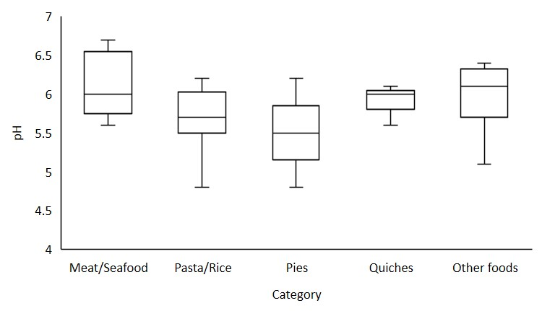
The highest and lowest pH values are represented by the whisker tips, while the median and interquartile range are represented by the internal box.
The water activity (a_{w}) of all food products was in the range of 0.96 to 0.99, and the different a_{w} profiles of each food product category can be seen in Figure 2. Two samples of pie were found to have the highest water activity values (a_{w} = 0.99).
Figure 2: Water activity profile of the different food product categories
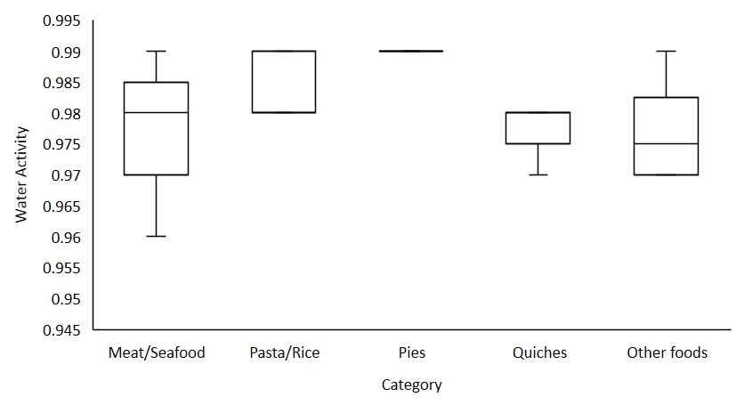
The highest and lowest water activity values are represented by the whisker tips, while the median and interquartile range are represented by the internal box.
Given that pH and water activity can have an additive effect on the ability of a food product to support the growth of specific microorganisms, Figure 3 plots the pH versus the water activity of each of the food products.
Figure 3: pH versus water activity in different food products
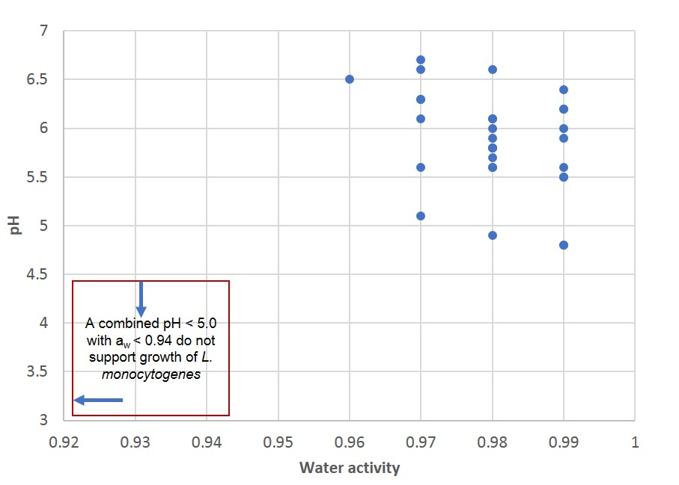
The pH and water activity of each food product sampled was assessed to determine if it would support the growth of L. monocytogenes. Samples that theoretically do not support the growth include those with a pH < 4.4, a_{w} < 0.92, or a combined pH < 5.0 with a_{w} < 0.94. Based on the pH and water activity results, all food samples analysed would support the growth of L. monocytogenes.

Microbiological analysis of samples
Food product samples were tested for a range of microorganisms and results were assessed using the Compendium of Microbiological Criteria for Food (FSANZ, 2018). The different types of microorganisms were detected in the samples and data used to assess the microbiological quality of each food product. Of the 30 samples, half of the samples (15) were deemed satisfactory, 33 per cent samples were marginal and 17 per cent samples were found to be unsatisfactory (Figure 4) based on microbiological assessment. However, as analysis did not include lactic acid bacteria, it is not clear what were the predominant organisms in the samples deemed to be marginal or unsatisfactory based on SPC.
Figure 4: Microbiological quality of food product samples
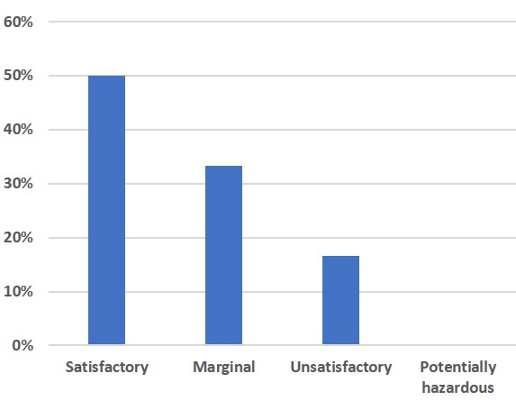
None of the sample were classified as potentially hazardous. Salmonella spp., C. perfringens, E. coli and L. monocytogenes were not detected in any of the food product samples tested in this survey.
Table 3: Microbial populations responsible for marginal and unsatisfactory quality of food product samples
Microbial analysis | Marginal | Unsatisfactory
Standard plate count | 30% | 17%
Bacillus cereus | 3% | 0%
Total | 33% | 17%

Discussion
The pH and water activity results of 30 samples of vacuum and MAP packaged RTE meals showed that these food products may have a diverse range of pH values (between 4.8 and 6.7); however, less variation was noted for water activity values (between 0.96 and 0.99). One of the aims of this survey was to determine whether RTE meals would theoretically support the growth of L. monocytogenes according to the criteria outlined in the Code. The pH values of product samples varied for different RTE meals categories from 4.8 to 6.6, which is a range conducive to bacterial growth. The water activity values of different RTE meals categories were between 0.96 and 0.99, also conducive to bacterial growth and survival. When assessed against the criteria in Standard 1.6.1, pH and water activity values of all RTE meal categories are in the range that would theoretically support the growth of L. monocytogenes. A food product is not considered to support the growth of L. monocytogenes, where the food has a pH < 4.4, or a_{w} < 0.92, or a combined pH < 5.0 with a_{w} < 0.94. Therefore, this small study confirms that vacuum and MAP packaged RTE meals are considered high risk foods. These products have been associated with several foodborne illness outbreaks (Sim et al., 2002).
Standard 1.6.1 of the Code not only considers the chemical characteristics of a food (pH and water activity) to determine whether that food would support the growth of L. monocytogenes, it also takes the storage duration and conditions into account. For example, refrigerated food with a shelf-life of no greater than five days are not considered to support growth of L. monocytogenes. One of the main reasons to employ vacuum and MAP packaging in RTE meals is to extend product shelf-life beyond five days. Therefore, vacuum and MAP packaged RTE meals with a shelf-life of greater than five days under temperature control (< 5 ºC) will theoretically support the growth of L. monocytogenes, which is known to grow, albeit slowly, at refrigeration temperatures (Walker et al., 1990). This survey found that vacuum and MAP packaged RTE meals can support the growth of L. monocytogenes based on pH, water activity, and through extension of the shelf-life beyond five days.
Half of vacuum and MAP packaged RTE meal samples in this survey were microbiologically satisfactory according to the Compendium of Microbiological Criteria for Food (FSANZ, 2018). Pathogens such as Salmonella spp., L. monocytogenes, C. perfringens, E. coli and Staphylococcal spp. were not detected in any of the samples. As this is a pilot survey, with only 30 product samples, and without statistical analysis of the data, it is difficult to make any claim about the suitability of the department’s food safety program template for these businesses.
Microbiological quality in terms of SPC and detection of B. cereus was found to be of concern for vacuum and MAP packaged RTE food products. Fifty per cent of the samples were classified as either marginal (33 per cent) or unsatisfactory (17 per cent) primarily due to high SPC. However, these findings must be interpreted with caution as it is unknown whether lactic acid bacteria (LAB) were responsible for the large number of samples with high SPC. While SPC values of 10⁴ - <10⁷ and > 10⁷ cfu/g are considered marginal and unsatisfactory for vacuum-packed and MAP meals, respectively, according to the Compendium of Microbiological Criteria for Food (FSANZ, 2018), commercial vacuum-packed or MAP food products are known to support the growth of LAB to high cell density (up to 10⁸ cfu/g), which causes spoilage during storage (Nerbrink and Borch, 1993; Chenoll et al., 2007). Testing for LAB was not included in this survey. This testing should be considered in future surveys of vacuum and modified atmosphere packaged foods.
The study indicated that a significant number of businesses (7 of 30) were inappropriately using the standard departmental food safety program template. This information should be communicated to local government environmental health officers to ensure that they check that businesses that manufacture these products adequately manage the risks of these foods.
The limitations of this survey include the small sample size and single sample units limiting the repeatability and reproducibility of the results. In addition, testing the samples for LAB bacteria would help elucidate whether the high SPC levels were likely to represent a food safety risk. Despite the limitations of this survey, it has generated important baseline information and an improved understanding of the chemical characteristics and microbiological quality of vacuum and MAP packaged RTE meals sold in Victoria. Importantly, it was observed that all samples would theoretically support the growth of L. monocytogenes. Overall, every category of vacuum and MAP packaged RTE meals examined contained samples that would support the growth of L. monocytogenes and one-third of the samples were assessed marginal in terms of total microbial load and 17 percent were found to be unsatisfactory.

Recommendations
There are certain areas that need attention to improve the microbiological quality and safety of vacuum and MAP packaged RTE meals.
- Carefully assessing the validated shelf-life (food businesses).
- Limiting the length of storage, even at refrigeration temperatures, of potentially hazardous food also reducing the chance of growth of pathogenic microorganisms (food businesses).
- Controlling post processing cross contamination and improving handling practice for these products (food businesses, environmental health officers).
- Careful adherence to temperature control during processing and storage (food businesses, environmental health officers).
- Food businesses that prepare vacuum-packaged or MAP meals of prolonged shelf-life should not be using the Food Safety Program template. These businesses should be managing the food safety risks of such manufacturing processes by using an independently audited food safety program. Council environmental health officers should confirm that this is the case where these products are manufactured and sold in their local government area.

References
Chenoll, E., Macian, M.C., Elizaquivel, P. and Anzar, R. (2007). Lactic acid bacteria associated with vacuum-packed cooked meat product spoilage: population analysis by rDNA-based methods. Journal of Applied Microbiology, 102, 498-508.
Christoforou, A.K., Dunford, E.K. and Neal, B.C. (2013). Changes in the sodium content of Australian ready meals between 2008 and 2011. Asia Pacific Journal of Clinical Nutrition, 22,138-143.
FSANZ [Food Standards Australia New Zealand] (2018). Compendium of Microbiological Criteria for Food. Available online: http://www.foodstandards.gov.au/publications/pages/compendium-of-microbiological-criteria-for-food.aspx (accessed on 27 March 2019)
Nerbrink, E. and Borch, E. (1993). Evaluation of bacterial contamination at separate processing stages in emulsion sausages production. International Journal of Food Microbiology, 20, 37-44.
Rybka-Rodgers, S. (2001). Improvement of food safety design of cook-chill foods. Food Research International, 34, 449-455.
Sim, J., Hood, D., Finnie, L., Wilson, M., Graham, B.M. and Hudson, J.A. (2002). Series of incidents of Listeria monocytogenes noninvasive febrile gastroenteritis involving ready-to-eat meats. Letters in Applied Microbiology, 35, 409-413.
Walker, S.J., Archer, P. and Banks, J.G. (1990). Growth of Listeria monocytogenes at refrigeration temperatures. Journal of Applied Bacteriology, 68, 157–162.

Appendix 1: Photos of selected food samples
Photo 1: Quiche Lorraine
Photo 2: Chicken and leek pie
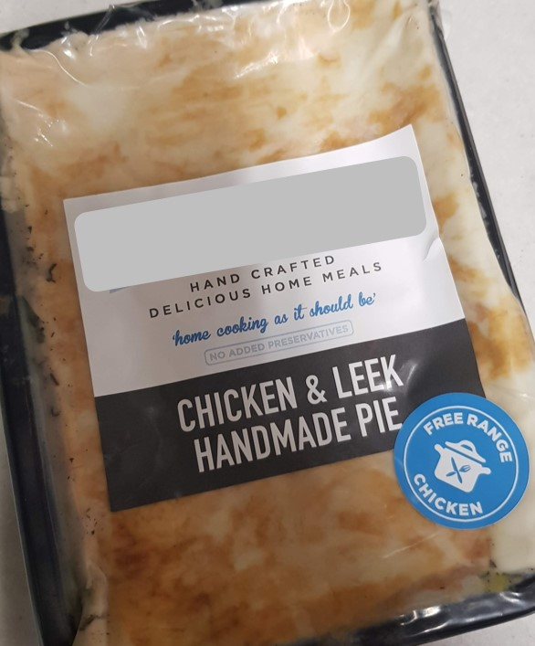
Photo 3: Organic beef and hidden veg lasagne
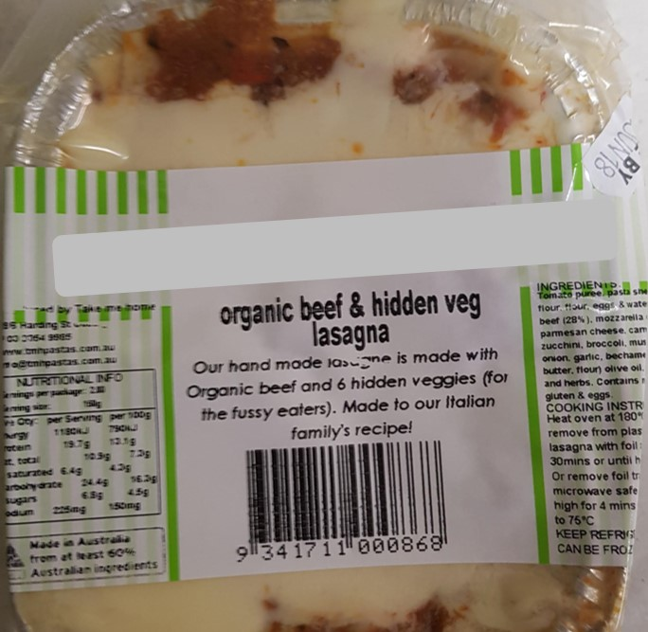

Photo 4: Duck wings
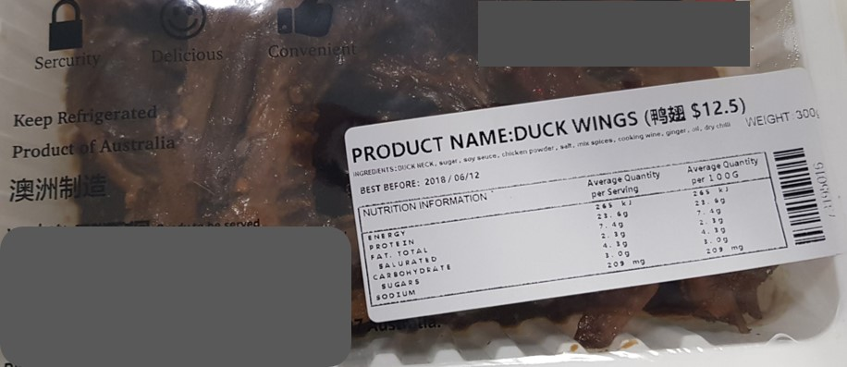

Photo 5: Beef massaman
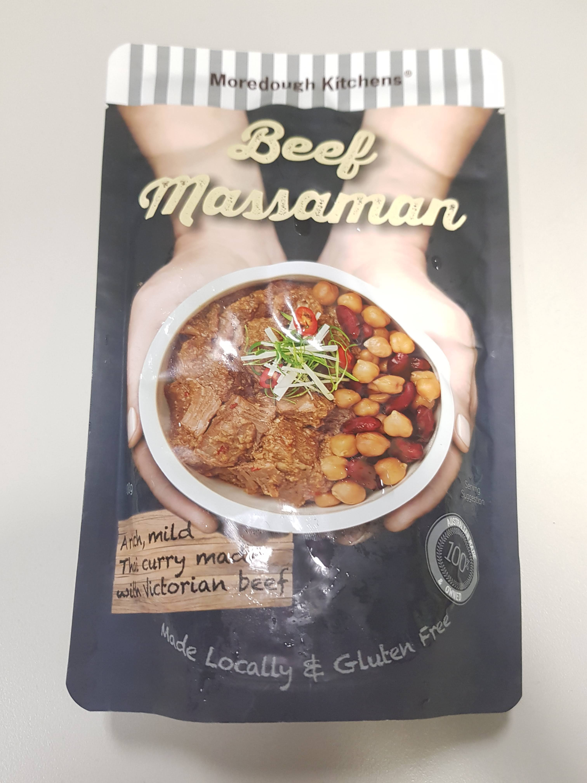

Photo 6: Pig trotters
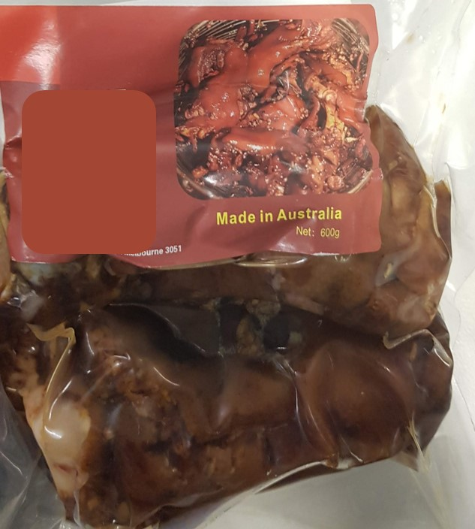

Photo 7: Pancetta and pea risotto
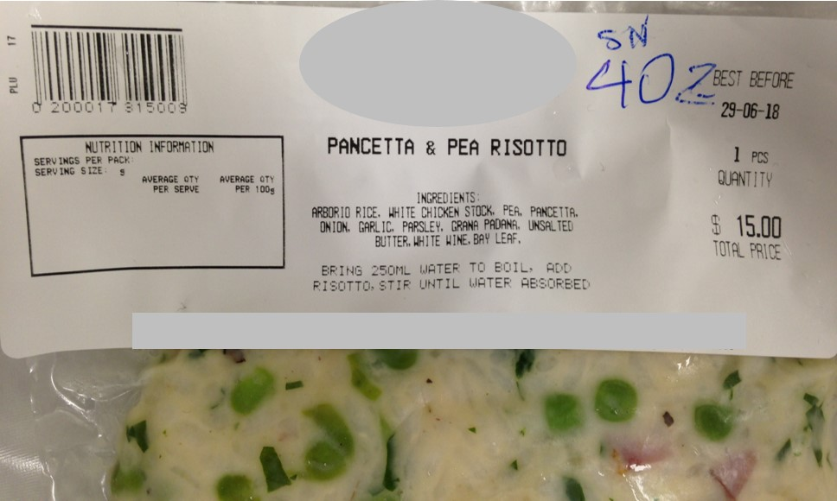

Appendix 2: Acronyms
Acronym
FSANZ | Food Safety Australia New Zealand
LAB | Lactic acid bacteria
MAP | Modified atmospheric package
NATA | National Association of Testing Authorities
RTE | Ready-to-eat
SPC | Standard plate counts
The Code | Australia New Zealand Food Standards Code
The department | The Department of Health and Human Services

Appendix 3: Text equivalent descriptions of figures
Figure 1: pH profile of the different food product categories
Meat/Seafood: Minimum = 5.6, Median = 6.0, Maximum = 6.7
Pasta/Rice: Minimum = 4.8, Median = 5.7, Maximum = 6.2
Pies: Minimum = 4.5, Median = 5.5, Maximum = 6.2
Quiches: Minimum = 5.6, Median = 6.0, Maximum = 6.1
Other foods: Minimum = 5.1, Median = 6.1, Maximum = 6.4
Figure 2: Water activity profile of the different food product categories
Meat/Seafood: Minimum = 0.96, Median = 0.98, Maximum = 0.99
Pasta/Rice: Minimum = 0.98, Median = 0.98, Maximum = 0.99
Pies: Minimum = 0.99, Median = 0.99, Maximum = 0.99
Quiches: Minimum = 0.97, Median = 0.98, Maximum = 0.98
Other foods: Minimum = 0.97, Median = 0.98, Maximum = 0.99
Figure 3: pH versus water activity in different food products
pH and water activity values are plotted to show combined effect on the ability of each food product to support the growth of Listeria monocytogenes.
Figure 4: Microbiological quality of food product samples
Satisfactory = 50.00%
Marginal = 33.33%
Unsatisfactory = 16.67%
Potentially hazardous = 0.00%

Applies to foods in which all components of the foods have been cooked but there is minimal handling and the food is packaged for extended refrigerated shelf life. • Packaged cook/chill meals (for example, curries, pastas, soups) • Vacuum-packed, MAP meals or foods (for example, packaged sliced meats)
Please note that microbiological analysis did not identify type of microorganism present (for example, contribution of LAB)

