+

|  |
| --- |
| Lung cancer in Victoria  Optimal care pathway data summary report 2019 |
|  |

Department of Health

|  |
| --- |
| Lung cancer in Victoria Optimal care pathway data summary report 2019 |
|  |

|  |
| --- |
|  |
| To receive this publication in an accessible format phone (03) 9456 3332, using the National Relay Service 13 36 77 if required, or [email the Cancer Support, Treatment and Research unit](mailto:email%20the%20Cancer%20Treatment,%20Support%20and%20Unit) <cancerplanning@health.vic.gov.au>.  Authorised and published by the Victorian Government, 1 Treasury Place, Melbourne.  © State of Victoria, Department of Health, February 2021.  **ISBN** 978-1-76096-195-4 **(pdf/online/MS word)**  Available at [the department’s cancer webpage](http://www.health.vic.gov.au/cancer) <www.health.vic.gov.au/cancer>. |
|  |

# Foreword

This report summarises the data analyses prepared for the second Lung Cancer Summit, which took place on 22 February 2019.

The Victorian Tumour Summits are clinician-led forums to identify variation in clinical practice and cancer outcomes that may be unwarranted across the state. We believe this summit was invaluable as an opportunity to bring together clinicians and consumers to identify and discuss how we can improve care for our patients. This summit was also an opportunity to highlight progress made against issues raised at the first summit in 2014.

We were pleased and honoured to co-chair the Lung Cancer Summit Working Group, which was convened to guide the analyses of statewide routine datasets to understand current patterns of care for Victorians with lung cancer. This work helped frame discussions about variations in care as well as potential actions to improve experiences and clinical outcomes for lung cancer patients across Victoria.

We would like to acknowledge and thank our colleagues on the working group and all those who attended the summit for their time, effort and active contributions to making the meeting such a success. We also acknowledge Ella Stuart, who undertook the data analyses, and the tumour summit project team for their support throughout the process.

We look forward to working collectively with our statewide colleagues to make the most of the opportunities for improvement for the benefit of all our patients.

|  |  |
| --- | --- |
| David Ball's signature | Gavin Wright's signature |

**Prof. David Ball  
Co-chair, Lung Cancer Summit**

**A/Prof. Gavin Wright  
Co-chair, Lung Cancer Summit**

Contents

Lung cancer in Victoria 3

Foreword 5

Acknowledgements 9

Introduction 10

More information 10

Data sources 11

Linked dataset 11

Other data sources 11

At a glance 12

Key findings 12

Key variations for action 15

Incidence, mortality, survival and demographics 16

Tumour characteristics, metastatic disease and survival 18

Tissue diagnosis 21

Multidisciplinary team planning and discussion 23

NSCLC: time to surgery 25

NSCLC: access to treatment and survival 27

Metastatic NSCLC 27

Non-metastatic NSCLC 27

Surgery volume 31

Radiotherapy 32

Chemotherapy 34

Palliative and supportive care 36

Abbreviations 38

Victorian Integrated Cancer Services 38

Glossary 39

Supplementary material 41

Codes 41

List of figures

Figure 1: Age-standardised incidence and mortality rate per 100,000 population, by sex, for Victorians with lung cancer (diagnosed 1982 to 2016) 16

Figure 2: Lung cancer five-year relative survival over time (diagnosed 1986 to 2015) 16

Figure 3: Percentage of lung cancer patients who had metastatic disease at diagnosis, by ICS of residence (diagnosed 2008 to 2016) 19

Figure 4: Absolute lung cancer survival time, by metropolitan or regional ICS of residence and year of diagnosis (diagnosed 2008 to 2016) 19

Figure 5: Percentage of lung cancer patients with a tissue diagnosis, by year of diagnosis (diagnosed 2008 to 2016) 21

Figure 6: Percentage of lung cancer patients with a tissue diagnosis, by age group (diagnosed 2008 to 2016) 22

Figure 7: Age-adjusted tissue diagnosis, by ICS of residence (diagnosed 2008 to 2016) 22

Figure 8: Documented multidisciplinary team meeting in the patient’s central medical record (2017) 23

Figure 9: Percentage of patients with documented evidence of communication of initial treatment plan to GP (2017) 24

Figure 10: Proportion of non-metastatic NSCLC patients whose first treatment was surgery, who received surgery within 14 days of diagnosis, by hospital (diagnosed 2013 to 2016) 26

Figure 11: Survival for metastatic NSCLC, by ICS of residence (diagnosed 2013 to 2016) 27

Figure 12: Survival for non-metastatic NSCLC, by ICS of residence (diagnosed 2013 to 2016) 28

Figure 13: Adjusted odds of having surgery for non-metastatic NSCLC patients, by ICS of residence (diagnosed 2013 to 2016) 28

Figure 14: Survival for non-metastatic NSCLC treated with or without surgery, by ICS of residence (diagnosed 2013 to 2016) 29

Figure 15: Non-metastatic NSCLC major surgery types, by ICS of surgery (diagnosed 2013 to 2016) 30

Figure 16: Victorian hospital average annual lung cancer surgery volume (2010/12 and 2016/18 financial years) 31

Figure 17: Use of radiotherapy within a year of a lung cancer diagnosis, by ICS of residence (diagnosed 2013 to 2016) 32

Figure 18: Percentage of non-metastatic NSCLC patients who began radical RT/CRT within 40 days of diagnosis, by RT centre (diagnosed 2013 to 2016) 33

Figure 19: Percentage of NSCLC patients with stage IV referred to palliative care within eight weeks of diagnosis (2017) 36

Figure 20: Percentage of lung cancer patients with documented evidence of supportive care screening (2017) 37

List of tables

Table 1: Demographic characteristics of lung cancer patients diagnosed in 2008 to 2012 and 2013 to 2016 17

Table 2: Tumour characteristics of lung cancer patients diagnosed in 2008 to 2012 and 2013 to 2016 18

Table 3: Percentage of non-metastatic NSCLC patients whose first treatment was surgery, who had surgery within 14 days of diagnosis, by diagnosis year and ICS of residence and ICS of treatment (diagnosed 2013 to 2016) 25

Table 4: Non-metastatic NSCLC patient pathways from ICS of residence to ICS of surgery (diagnosed 2013 to 2016) 29

Table 5: Percentage of non-metastatic NSCLC patients who began radical RT/CRT within 40 days of diagnosis, by diagnosis year and ICS of residence and treatment (diagnosed 2013 to 2016) 33

Table 6: Chemotherapy within one year of diagnosis for metastatic NSCLC patients, by ICS of residence (diagnosed 2013 to 2016) 34

Table 7: Chemotherapy use within one year of diagnosis of SCLC, by ICS of residence (diagnosed 2013 to 2016) 35

Supplementary Table 1: Lung cancer diagnosis codes 41

Supplementary Table 2: Surgical procedures codes used to identify patients who underwent a lung cancer resection 41

Supplementary Table 3: Diagnosis, procedure and diagnosis-related group codes used to identify patients who received chemotherapy 41

# Acknowledgements

The data, analysis and commentary provided in this report represent a joint effort by numerous key contributors from the following groups.

**Lung Cancer Summit Working Party**

Dr Andreas Baisch

Prof. David Ball (co-chair)

Mr Andrew Barling

Dr Richard De Boer

Mr David Deutscher

Dr Wasek Faisal

Prof. Michael MacManus

Prof. Danielle Mazza

A/Prof. Paul Mitchell

A/Prof. Gary Richardson

A/Prof. Jeremy Ruben

A/Prof. Rob Stirling

Dr Craig Underhill

A/Prof. Gavin Wright (co-chair)

Mr Cheng-Hon Yap

Dr Jackie Yoong

**Data analysis**

Dr Luc te Marvelde

Ms Ella Stuart

**Victorian Tumour Summits Project Team**

Ms Mirela Matthews

Ms Rebecca Miller

Ms Claire Porter

Ms Amy Sercombe

We also gratefully acknowledge the providers of the Victorian Cancer Registry data, Victorian Admitted Episodes Dataset and the Victorian Radiotherapy Minimum Dataset, as well as the Centre for Victorian Data Linkage for performing the linkages between the Victorian Cancer Registry and administrative datasets. In addition, we wish to thank A/Prof. Rob Stirling for facilitating access to data from the Victorian Lung Cancer Registry.

To view the Lung Cancer Summit data presentation and related documents, visit the [Lung Cancer Summit meeting page](https://www.nemics.org.au/page/improving_cancer_care/summits/lung/) <https://www.nemics.org.au/page/improving_cancer_care/summits/lung/>.

# Introduction

The data presented in this report are a summary of the analyses prepared for the 2019 Lung Cancer Summit. The Lung Cancer Summit is part of the Victorian Tumour Summits program, an initiative of the Victorian Integrated Cancer Services (ICS[1]) delivered in collaboration with the Department of Health and Cancer Council Victoria. The summits support the broader program of work implementing the optimal care pathways (OCPs).

The first Lung Cancer Summit was held in Melbourne on 14 November 2014. In this first summit, data on cancer care and outcomes for lung cancer patients diagnosed between 2008 and 2012 were presented. Recommendations were made for optimising cancer care in areas such as tissue diagnosis, multidisciplinary meetings (MDMs) and timeliness from referral to diagnosis and treatment.[2]

The second Lung Cancer Summit, held on 22 February 2019 in Melbourne, gathered 112 diverse stakeholders from across Victoria. The second summit provided an opportunity to review data on patterns of care for lung cancer patients in Victoria, and if there had been a shift towards optimal care in the areas highlighted at the 2014 summit. The first summit did not have access to the linked dataset, therefore the second summit provided a valuable opportunity to present more comprehensive data for patients diagnosed between 2008 and 2012 (the same period used for the first summit) and to compare this with data for patients diagnosed between 2013 and 2016. The summit also showcased examples of clinician-led local improvements to unwarranted variation in lung cancer care and facilitated discussions on where to focus future improvement efforts. Clinical commentary and recommendations from the summit are included in this report.

## More information

* Find out more about the Lung Cancer Summit from the [NEMICS website](https://www.nemics.org.au/page/improving_cancer_care/summits/lung/) <https://www.nemics.org.au/page/improving_cancer_care/summits/lung/>.
  + The lung cancer OCP can be viewed and downloaded from the [Cancer Council Australia website](http://www.cancer.org.au/OCP) <www.cancer.org.au/OCP>.

# Data sources

## Linked dataset

### Datasets

The Victorian Cancer Registry (VCR) is a population-based cancer registry that collects demographic and tumour details, including diagnosis date and region of residence, for all Victorian residents diagnosed with cancer. The Department of Health’s Centre for Victorian Data Linkage performs an annual data linkage between the VCR and administrative datasets including the Victorian Admitted Episodes Dataset (VAED), the Victorian Radiotherapy Minimum Data Set (VRMDS) and the Victorian Death Index. Linking the VCR to the VAED provides information captured within the inpatient setting in all Victorian public and private hospitals such as patient diagnoses (for example, comorbidities, distant metastases) and cancer treatment, including surgery and intravenous chemotherapy (excluding oral chemotherapy). Linking the VCR to the VRMDS provides information on admitted and non-admitted radical and palliative radiotherapy courses provided in Victorian public and private radiotherapy centres. Unless otherwise specified, the data source used for the report analyses was the linked dataset for patients diagnosed from 2008 to 2016, with a focus on comparing outcomes between two periods – 2008 to 2012 (the period used for the first lung cancer summit) and 2013 to 2016 (the most recent cohort at the time of analysis).

### Patient selection

Victorian residents aged 18 years or older with a primary diagnosis of lung cancer (see Supplementary Table 1) between 2008 and 2016 were identified using the VCR. Patients whose cancer diagnosis was notified to the VCR by death certificate only (2008 to 2012 *n* = 602, 2013 to 2016 *n* = 417, refer to glossary for definition) were excluded. When a person was diagnosed with two or more lung cancers during the study period, the record of the earliest diagnosis was retained (112 patients with more than one lung cancer).

Using morphology codes, patients were grouped as having non-small cell lung cancer (NSCLC), small cell lung cancer (SCLC), carcinoid or other. As a proxy for cancer stage, patients were grouped as having non-metastatic disease or metastatic disease at diagnosis (refer to glossary for more information).

### Data limitations

Victorians with cancer living in HRICS may receive treatment in New South Wales (Albury) hospitals, which is not captured in the VAED. Therefore, variables in this report that are derived using the VAED (comorbidity count, distant metastases, surgery and chemotherapy) are most likely underestimated for Victorians living in HRICS. Table and figure footnote text highlight where this limitation may apply.

## Other data sources

In addition to the linked dataset, this report includes data from the following:

* Victorian Cancer Statistics, [Cancer Council Victoria](http://vcrdata.cancervic.org.au) <http://vcrdata.cancervic.org.au>. This website includes Victorian lung cancer incidence data from 1982 to 2016.
* Cancer Services Performance Indicator (CSPI) medical record audit 2017. This audit collected data such as MDM use and MDM timing (prospective or retrospective to starting treatment), from the medical records of a random sample of cancer patients treated across 50 Victorian hospitals. There were 324 lung cancer patients audited.
* Victorian Lung Cancer Registry, a clinical quality registry collecting data from 15 sites across metropolitan and regional Victoria, including public and private institutions. Data about MDM presentation and time to palliative care referral after diagnosis of stage IV NSCLC was included.

# At a glance

## Key findings

### Incidence, mortality, survival and demographics

* Since 1982, lung cancer incidence and mortality has been decreasing in Victorian males, but incidence is increasing in Victorian females.
* Five-year relative survival has improved over time, from 8 per cent for those diagnosed from 1986 to 1990 to 18 per cent in 2011 to 2015.
* Demographic characteristics were similar for lung cancer patients diagnosed from 2008 to 2012 and 2013 to 2016.
* In 2013 to 2016:
  + - the median age of lung cancer patients at diagnosis was 72 years
    - 57 per cent of patients were male
    - 30 per cent lived in area classified as the most disadvantaged socioeconomic quintile
    - 83 per cent had a history of smoking.

### Tumour characteristics, metastatic disease and survival

* The morphology of lung cancers diagnosed from 2008 to 2012 and 2013 to 2016 were similar:
  + - Most were NSCLC (87 per cent) or SCLC (10–11 per cent).
      * Two per cent were carcinoid and fewer than 1 per cent other morphologies.
* Of NSCLC cases:
  + - A higher proportion were classified as adenocarcinoma in 2013 to 2016 (49 per cent) than in 2008 to 2012 (41 per cent).
      * Around half had metastatic disease at diagnosis in 2008 to 2012 (49 per cent) and 2013 to 2016 (50 per cent).
* The proportion of lung cancer patients with metastatic disease at diagnosis did not differ by ICS of residence in 2013 to 2016 (50 per cent).
  + Absolute survival was significantly poorer for patients living in regional ICS than metropolitan ICS in both 2008 to 2012 and 2013 to 2016.

### Tissue diagnosis

* The proportion of lung cancer cases with tissue diagnosis has increase significantly over time, from 88 per cent in 2008 to 91 per cent in 2016.
* Older people (85 years or older) were less likely to have a tissue diagnosis than younger people in both time periods.
* Adjusting for age, the proportion with a tissue diagnosis varied significantly by ICS:
  + - In 2008 to 2012, a lower proportion of patients in GICS, GRICS and SMICS, and a higher proportion in BSWRICS, WCMICS and NEMICS, had a tissue diagnosis compared with the state average of 88 per cent.
    - In 2013 to 2016, the proportion of patients with a tissue diagnosis remained significantly lower in GRICS and higher in NEMICS than the state average of 90 per cent.

### Multidisciplinary team planning and discussion

* The proportion of lung cancer patients with a documented MDM was 69 per cent – higher than the 2011 to 2013 average (62 per cent) but still below the target of 80 per cent.
* MDM rates were significantly lower in GRICS, HRICS and LMICS but higher in NEMICS and SMICS compared with the state average.
* Eighty-nine per cent of MDMs occurred before the patient started treatment.
* Ninety per cent of audited patients had evidence of communication of the initial treatment plan to a general practitioner (GP) but this varied by ICS, being lower in LMICS and GICS compared with the state average.

### NSCLC: time to surgery

* Of the non-metastatic NSCLC cancer patients who had surgery, 61 per cent had it within 14 days of diagnosis.
* The proportion receiving surgery within 14 days:
  + - increased over time (from 57 per cent in 2013 to 61 per cent in 2016) but not significantly so
    - was significantly lower for patients living and treated in a regional ICS (51 per cent) or travelling to a metropolitan ICS (60 per cent) than for those living and treated in a metropolitan ICS (65 per cent)
    - varied significantly by hospital.

### NSCLC: access to treatment and survival

#### Non-metastatic disease

* Adjusting for age and comorbidity, patients living in BSWRICS and LMICS were significantly less likely to receive any surgery compared with those in a metropolitan ICS in 2013 to 2016.
* Survival was also significantly poorer for those living in BSWRICS and LMICS compared with the Victorian average.
* Survival was significantly better for those living in WCMICS and NEMICS than the state average.
* For those who had surgery, survival was similar across ICS.
* For non-surgical patients, those in BSWRICS had significantly poorer survival, while those in NEMICS had better survival than the state average.
* On average, 72 per cent of patients had surgery in their local ICS. Most HRICS patients (85 per cent), and around a third of LIMCS and GICS patients, were treated in WCMICS. A high proportion of GRICS patients also received surgery in SMICS (42 per cent).

#### Metastatic disease

* Survival did not vary significantly by ICS of residence for those with metastatic disease.

### Surgery volume

* The number of public and private hospitals performing 20 or more major lung cancer surgical procedures per year increased from 10 hospitals in period one (July 2010 to June 2012) to 18 hospitals in period two (July 2016 to June 2018).

### Radiotherapy

* On average, 42 per cent of lung cancer patients in 2013 to 2016 received radiotherapy (RT) within a year of diagnosis.
* Overall RT utilisation varied by ICS of residence, being lower for HRICS (37 per cent) and higher in WCMICS (45 per cent) and LMICS (46 per cent) than the state average.
* Use of radical RT was higher for patients living in WCMICS (18 per cent) and lower in GICS (11 per cent) and BSWRICS (10 per cent) compared with the state average (16 per cent).
* For non-metastatic NSCLC patients who had radical RT or chemoradiation (CRT) as their first treatment:
  + - The median time from diagnosis to starting RT/CRT was 40 days.
    - Patients living in a regional area and treated in a regional ICS were less likely to start RT/CRT within 40 days (39 per cent) compared with those who to travelled to a metropolitan ICS (64 per cent) or those who live in a metropolitan area and were treated in a metropolitan ICS (54 per cent).
    - The proportion of patients starting RT/CRT within 40 days did not change significantly from 2013 to 2016.
    - Time to starting RT/CRT varied by RT centre, with two regional centres having a significantly lower proportion of patients starting within 40 days compared with the state average.

### Chemotherapy

#### Metastatic NSCLC

* On average, 41 per cent of patients with metastatic NSCLC in 2013 to 2016 received chemotherapy within one year of diagnosis.
* Receipt of chemotherapy ranged from 34 per cent in LMICS to 45 per cent in GRICS and NEMICS.
* Adjusting for age and comorbidity, patients in GRICS and NEMICS were significantly more likely, and patients in LMICS less likely, to receive chemotherapy within one year of diagnosis than the state average.

#### SCLC

* On average, 76 per cent of patients with SCLC in 2013 to 2016 received chemotherapy within one year of diagnosis.
* Receipt of chemotherapy ranged from 73 per cent in BSWRICS to 88 per cent in GICS (excluding HRICS).
* Adjusting for age and comorbidity, patients in GICS were significantly more likely to receive chemotherapy within one year of diagnosis than the state average (excluding HRICS).

### Palliative and supportive care

* Data from the Victorian Lung Cancer Registry (2017) show the following:
  + - Adjusting for patient age, sex, birthplace and clinical stage, 35 per cent of patients with stage IV NSCLC were referred for palliative care within eight weeks of diagnosis.
      * The proportion referred for palliative care within eight weeks of diagnosis varied from 11 per cent to 63 per cent across reporting hospital centres.
* The CSPI audit showed, on average, 52 per cent of patients with lung cancer had documented evidence of supportive care screening in their medical record, ranging from 13 per cent in WCMICS to 72 per cent in SMICS.

## Key variations for action

* Regional residents had poorer survival overall, and for those with non-metastatic disease. This is possibly due to access to curative treatment modalities.
* Supportive care screening uptake was poor across Victoria (average 52 per cent).
* New quality indicators are needed for:
  + - appropriate targeted and immunotherapy/companion tests
    - appropriate utilisation of RT.

# Incidence, mortality, survival and demographics

* Between 1982 and 2016, lung cancer incidence and mortality for males has decreased from 55.4 and 48.7 per 100,000 to 30.0 and 21.3 per 100,000 respectively (Figure 1).
* Conversely, lung cancer incidence and mortality for females has slightly increased from 13.4 and 10.2 per 100,000 in 1982 to 22.0 and 13.6 per 100,000 in 2016 respectively.
* Five-year relative survival has improved over time, from 8 per cent in 1986 to 1990 to 18 per cent in 2011 to 2015 (Figure 2).
* Demographic characteristics were similar for lung cancer patients in both time periods (Table 1).

Figure 1: Age-standardised incidence and mortality rate per 100,000 population, by sex, for Victorians with lung cancer (diagnosed 1982 to 2016)

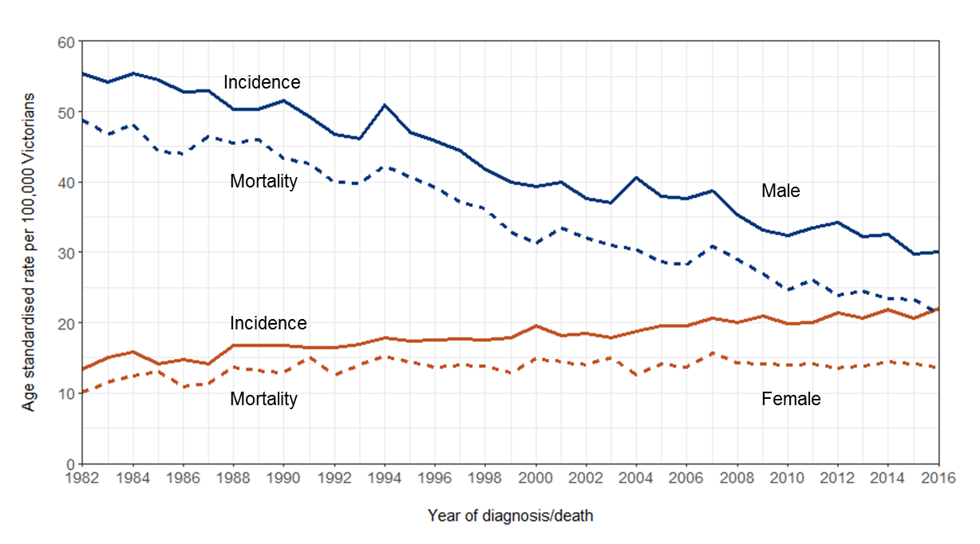

Source: [Cancer Council Victoria](http://vcrdata.cancervic.org.au) <http://vcrdata.cancervic.org.au>

Figure 2: Lung cancer five-year relative survival over time (diagnosed 1986 to 2015)

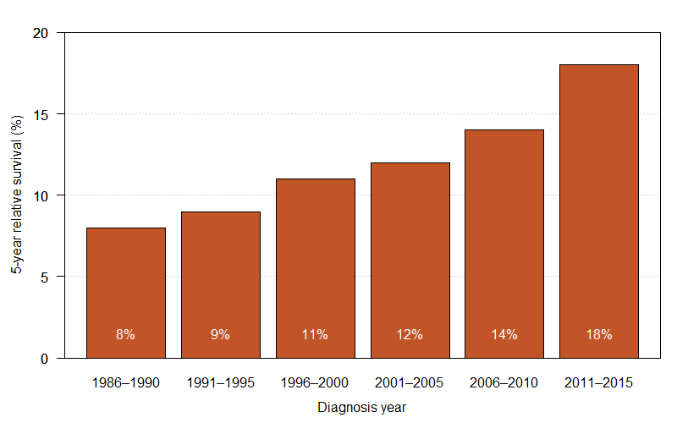

Source: Victorian Cancer Registry

Table 1: Demographic characteristics of lung cancer patients diagnosed in 2008 to 2012 and 2013 to 2016

| Demographic | Diagnosed 2008 to 2012  *N* = 12,040 | Diagnosed 2013 to 2016  *N* = 10,797 |
| --- | --- | --- |
| Male, *n* (%) | 7,170 (60) | 6,154 (57) |
| Age (median) | 72 | 72 |
| Socioeconomic status quintile 1 (most disadvantaged), *n* (%) | 3,668 (31) | 3,167 (30) |
| Ever smoked, *n* (%)  (VAED derived, two years prior and one year after diagnosis) | 9,798 (81) | 8,914 (83) |

Note: The ‘ever smoked’ figures exclude patients with no admissions between two years prior and one year after diagnosis.

### Clinical commentary

Declining lung cancer incidence and mortality in males but increasing in females strongly reflects smoking rates in the sexes and the emergence of lung cancer in never-smoking females, particularly those of Asian ethnicity. Although survival rates have improved since the mid-1980s, five-year relative survival for lung cancer remains well below the Victorian average of 68 per cent (2012 to 2016) for all cancers.[3] There were minimal changes in the lung cancer population since the 2014 summit, with a slight decrease in the proportion of males diagnosed in the later period. Almost a third of patients diagnosed with lung cancer live in areas of most socioeconomic disadvantage, which most likely reflects higher rates of smoking by people in these areas.[4]

# Tumour characteristics, metastatic disease and survival

* The morphology profile of lung cancers diagnosed in both periods were similar (Table 2).
  + - Most had NSCLC (87 per cent) or SCLC (10–11 per cent).
      * Two per cent were carcinoid and fewer than 1 per cent other morphologies.
* Of NSCLC cases (Table 2):
  + - A higher proportion were classified as adenocarcinoma in 2013 to 2016 (49 per cent) than in 2008 to 2012 (41 per cent).
    - Fewer were classified as Other / Not otherwise specified in 2013 to 2016 than 2008 to 2012 (28 per cent versus 33 per cent).
      * Around half had metastatic disease at diagnosis in 2008 to 2012 (49 per cent) and 2013 to 2016 (50 per cent).
* The proportion of lung cancer patients with metastatic disease at diagnosis differed by ICS of residence in 2008 to 2012 but did not differ in 2013 to 2016 (Figure 3).
  + Absolute survival was significantly lower for patients living in regional ICS than metropolitan ICS in both 2008 to 2012 and 2013 to 2016 (Figure 4).

Table 2: Tumour characteristics of lung cancer patients diagnosed in 2008 to 2012 and 2013 to 2016

| Tumour characteristic | Diagnosed 2008 to 2012  *N* = 12,040 | Diagnosed 2013 to 2016  *N* = 10,797 |
| --- | --- | --- |
| **Morphology, *n* (%)**  NSCLC  SCLC  Carcinoid  Other | 10,509 (87)  1,296 (11)  206 (2)  29 (< 1) | 9,412 (87)  1,122 (10)  222 (2)  41 (< 1) |
| **NSCLC cases, *n* (%)**  Adenocarcinoma  Squamous cell carcinoma  Large cell carcinoma  Other / Not otherwise specified | 4,343 (41)  2,131 (20)  521 (5)  3,514 (33) | 4,614 (49)  1,998 (21)  152 (2)  2,648 (28) |
| **NSCLC cases, *n* (%)**  Metastatic disease at diagnosis  (VCR and VAED derived, 30 days prior and four months after diagnosis) | 4,900 (49 | 4,517 (50) |

Note: The metastatic disease at diagnosis figures exclude patients with no admissions between 30 days prior and four months after diagnosis.

Figure 3: Percentage of lung cancer patients who had metastatic disease at diagnosis, by ICS of residence (diagnosed 2008 to 2016)

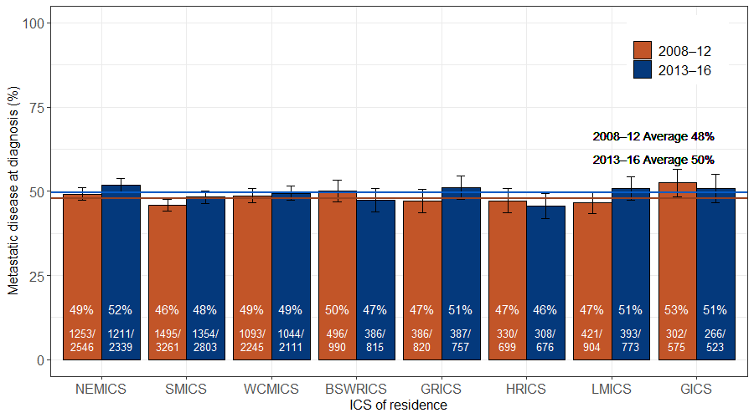

Note the HRICS data limitation.   
Pearson’s 𝝌² test for difference between ICS (excluding HRICS): 2008 to 2012 p = 0.017, 2013 to 2016 p = 0.158.

Figure 4: Absolute lung cancer survival time, by metropolitan or regional ICS of residence and year of diagnosis (diagnosed 2008 to 2016)

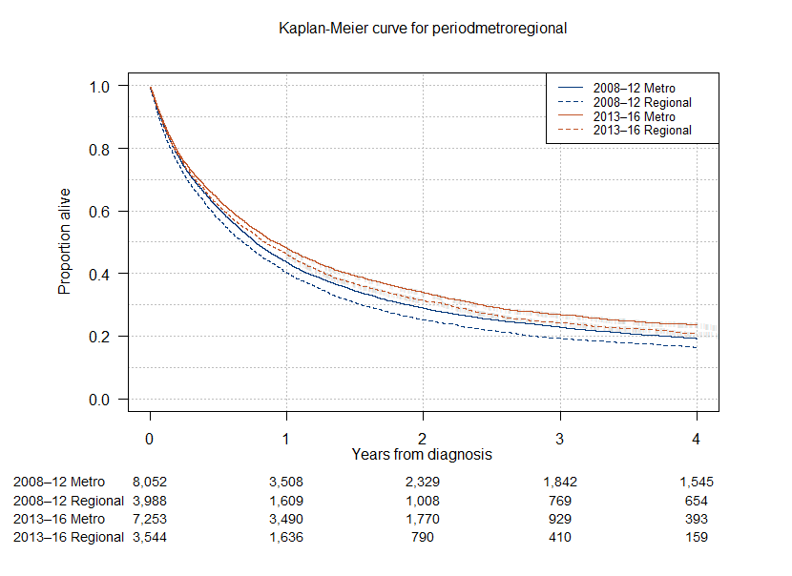

Log rank test for difference in survival between patients living in metropolitan and regional ICS: 2008 to 2012 p < 0.001, 2013 to 2016 p = 0.005.

### Clinical commentary

The patient populations in the two time periods had very similar tumour morphology. Encouragingly, there were fewer ‘Other / Not otherwise specified’ classifications of NSCLC cases in the later period, which probably indicates improved coding and more detailed pathologic assessment. However, there was no change in the proportion of people with metastatic disease at diagnosis, highlighting the ongoing challenge of early detection of lung cancer. This is unlikely to change without introducing a national lung cancer screening program. In the later time period, the proportion of patients with metastatic disease at diagnosis did not vary by ICS of residence, but survival did. This suggests that factors beyond disease stage at diagnosis (such as access to curative surgery or radiotherapy) may be important in moderating regional–metropolitan differences in cancer survival.

# Tissue diagnosis

* Excluding patients with unknown tissue diagnosis (*n* = 354, 1.6 per cent), the proportion of lung cancer patients with a tissue diagnosis (refer to glossary for definition) increased significantly over time, from 88 per cent in 2008 to 91 per cent in 2016 (Figure 5).
* Older people (85 years or older) were less likely to have a tissue diagnosis than younger people in both 2008 to 2012 and 2013 to 2016 (Figure 6).
* Adjusting for age, the proportion of patients with a tissue diagnosis varied significantly by ICS of residence (Figure 7):
  + - In 2008 to 2012, a lower proportion of patients living in GICS, GRICS and SMICS, and a higher proportion in BSWRICS, WCMICS and NEMICS, had a tissue diagnosis compared with the state average of 88 per cent.
    - In 2013 to 2016, the proportion of patients with a tissue diagnosis remained significantly lower for patients living in GRICS and higher in NEMICS than the state average of 90 per cent.

Figure 5: Percentage of lung cancer patients with a tissue diagnosis, by year of diagnosis (diagnosed 2008 to 2016)

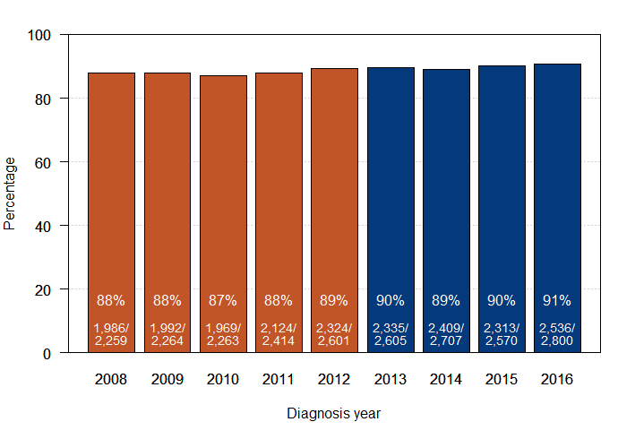

Excluding ‘unknown’ (n = 354).   
𝝌² test for trend in proportions over time p < 0.001.

Figure 6: Percentage of lung cancer patients with a tissue diagnosis, by age group (diagnosed 2008 to 2016)

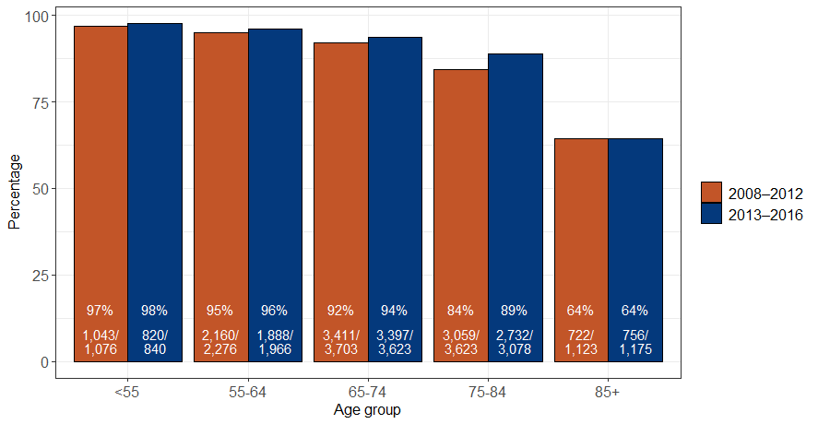

*Excluding ‘unknown’ (n = 354).   
Pearson’s 𝝌² test for difference between age groups: 2008 to 2012 p < 0.001, 2013 to 2016 p < 0.001.*

Figure 7: Age-adjusted tissue diagnosis, by ICS of residence (diagnosed 2008 to 2016)

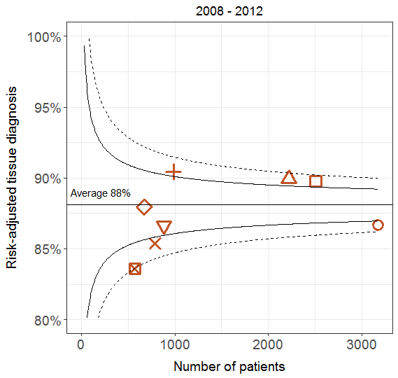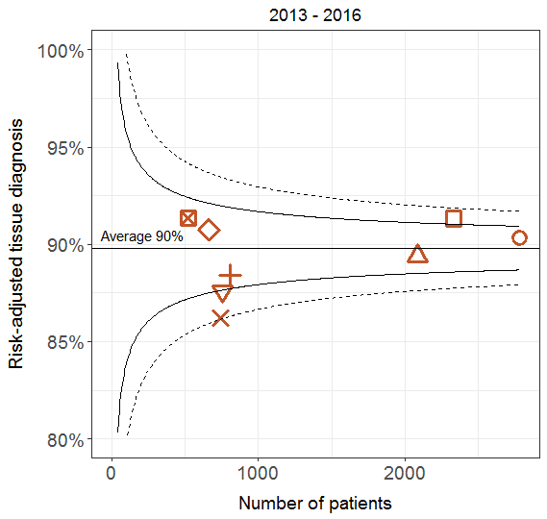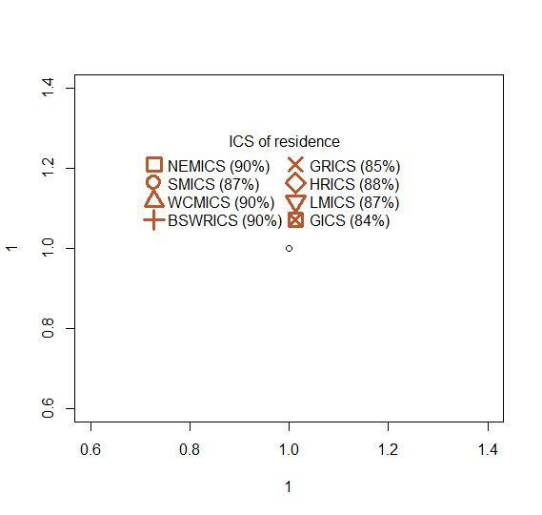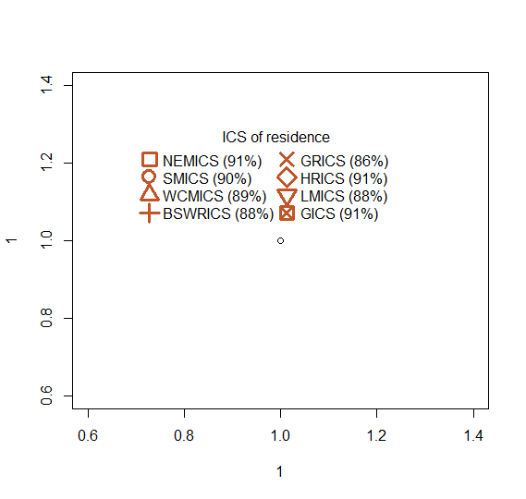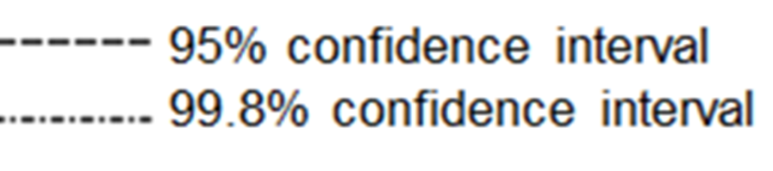

Excluding ‘unknown’ (n = 354).

### Clinical commentary

Obtaining tissue diagnoses and appropriate molecular biomarkers helps determine optimal cancer treatment. This data shows an increasing proportion of lung cancers with a tissue diagnosis since 2008 but that this was less so for older people in both time periods. Older people may be frail or have other health conditions, and clinicians and patients may be less willing to prescribe or undergo invasive procedures than younger people. After accounting for age differences, variation in tissue diagnosis by ICS of residence has reduced since the first Lung Cancer Summit, with a notable improvement in GICS from 84 per cent to 91 per cent. BSWICS and WCMICS also moved from below to above average. However, patients living in GRICS have consistently lower rates of tissue diagnosis compared with the state average. It will be important to continue monitoring this in the future.

# Multidisciplinary team planning and discussion

The lung cancer OCP states that all newly diagnosed patients should be discussed at an MDM so that a treatment plan can be recommended. There are currently no systems for routinely monitoring the occurrence of MDMs. For this analysis, data from the CSPI Audit 2017 was used where a random sample of newly diagnosed lung cancer patients (who received treatment, regardless of stage or morphology) were audited within each ICS. The presence or absence of MDM treatment recommendations in the patient’s medical record was used as a measure of whether an MDM had occurred.

* The CSPI audit showed that in 2017 the proportion of lung cancer patients with a documented MDM was 69 per cent (Figure 8).
* This was higher than the 2011 to 2013 average (62 per cent) but below the target of 80 per cent.
* Evidence of an MDM varied by ICS, being significantly lower in GRICS, HRICS and LMICS, and higher in NEMICS and SMICS, compared with the state average (Figure 8).
* On average, 89 per cent of MDMs occurred before the patient started treatment.
* Ninety per cent of audited patients had evidence of communication of the initial treatment plan to a GP (Figure 9).
  + - This varied by ICS, being lower in LMICS and GICS and higher in SMICS compared with the state average.

Figure 8: Documented multidisciplinary team meeting in the patient’s central medical record (2017)

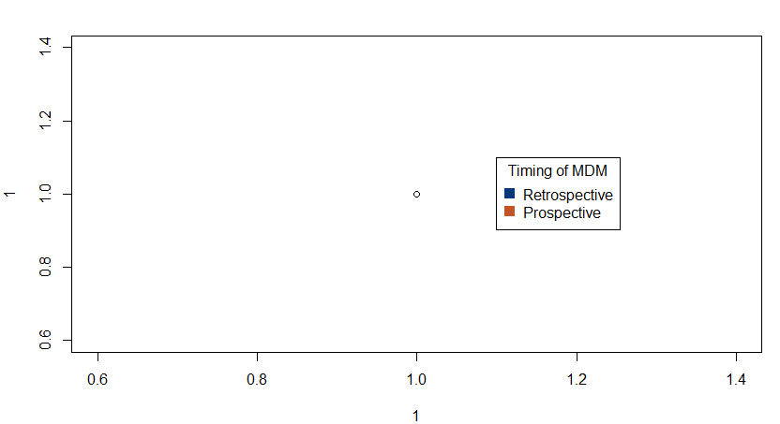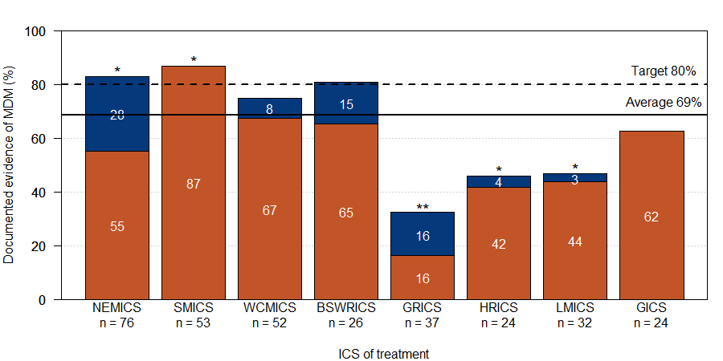

Source: CSPI medical record audit 2017.   
Note the HRICS data limitation.   
Test for difference in proportion of patients who had an MDM between ICS of treatment and Victorian average: * NEMICS, SMICS, HRICS, LMICS p < 0.05; ** GRICS p < 0.001.

Figure 9: Percentage of patients with documented evidence of communication of initial treatment plan to GP (2017)

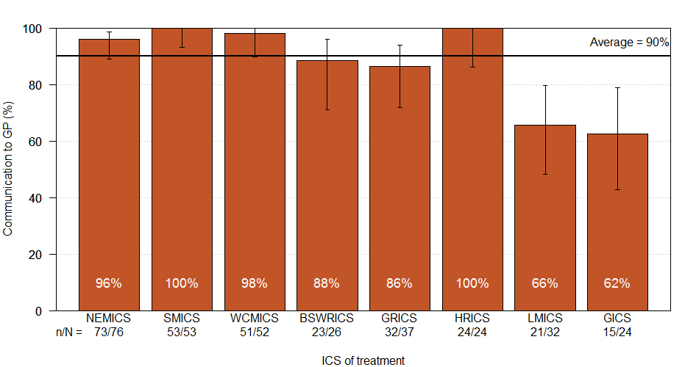

Source: CSPI medical record audit 2017.  
Bars represent 95 per cent confidence interval.   
Note the HRICS data limitation.  
Pearson’s 𝝌² test for difference between ICS of treatment p < 0.001.

### Clinical commentary

MDMs are an important component of quality cancer care and should occur before treatment begins to ensure patients are given the most appropriate care. The audit data showed that only three ICS reached the target of 80 per cent of patients having an MDM. In addition, although 90 per cent of patients had evidence of communication of the initial treatment plan to their GP, this varied significantly by ICS. The audit highlights that improvement is needed in this area, particularly in some regional ICS. Given that this was a relatively small audit study, findings should be verified with local review of patient and service records, and strategies put in place to support prospective MDM discussion of all lung cancer patients.

# NSCLC: time to surgery

* Of the non-metastatic NSCLC patients diagnosed between 2013 and 2016 who started treatment within six months of diagnosis and whose first treatment was surgery:
  + - Sixty-one per cent underwent surgery within 14 days of diagnosis.
    - The proportion receiving surgery within 14 days increased over time from 57 per cent in 2013 to 61 per cent in 2016, but not significantly so (Table 3).
    - The proportion receiving surgery within 14 days was significantly lower for patients living and treated in a regional ICS (51 per cent) compared with those living and treated in a metropolitan ICS (65 per cent) (Table 3).

Time to surgery varied significantly by hospital (Figure 10*Restricted to patients who started treatment within six months of diagnosis date.*

* + - ).

Table 3: Percentage of non-metastatic NSCLC patients whose first treatment was surgery, who had surgery within 14 days of diagnosis, by diagnosis year and ICS of residence and ICS of treatment (diagnosed 2013 to 2016)

| Variable | Level | Surgery within 14 days (%) | *p*-value |
| --- | --- | --- | --- |
| Diagnosis year | 2013 | 57 | 0.096 (trend) |
|  | 2014 | 60 |  |
|  | 2015 | 66 |  |
|  | 2016 | 61 |  |
| ICS of residence to ICS of treatment | Regional to regional | 51 | < 0.001 |
|  | Regional to metropolitan | 60 |  |
|  | Metropolitan to metropolitan | 64 |  |

*Restricted to patients who started treatment within six months of diagnosis date.*

Figure 10: Proportion of non-metastatic NSCLC patients whose first treatment was surgery, who received surgery within 14 days of diagnosis, by hospital (diagnosed 2013 to 2016)

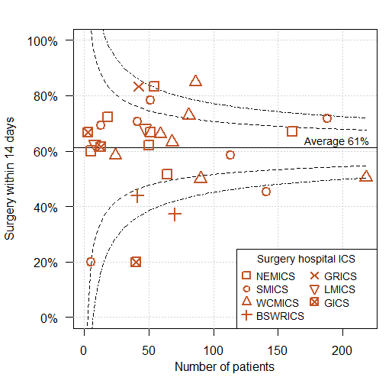

*Restricted to patients who started treatment within six months of diagnosis date.*

### Clinical commentary

The OCP for lung cancer states that, after GP referral, patients should see a specialist within two weeks and begin treatment within six weeks. Data on GP referral dates was unavailable, but date of diagnosis and surgery (first treatment) were used to calculate the proportion of patients with non-metastatic NSCLC treated within two weeks. This data showed longer wait times for patients from regional ICS treated regionally but also wide variation by hospital. This suggests individual services should review their performance and system protocols to ensure patients are treated in a timely manner.

# NSCLC: access to treatment and survival

## Metastatic NSCLC

* After adjusting for socio-demographic factors, survival did not vary significantly by ICS of residence for NSCLC patients with metastatic disease (Figure 11).

Figure 11: Survival for metastatic NSCLC, by ICS of residence (diagnosed 2013 to 2016)

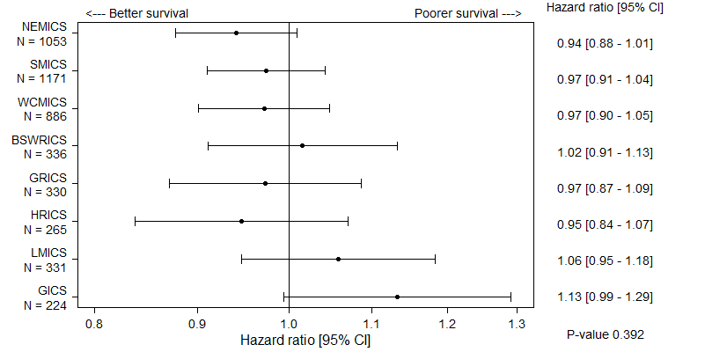

 ICS of residence

Adjusted for age, sex, comorbidities and diagnosis year.   
Bars represent 95 per cent confidence interval (CI).   
Victorian average = 1.0.

## Non-metastatic NSCLC

* Survival for non-metastatic NSCLC patients was significantly poorer for those living in LMICS and BSWRICS but better for those living in WCMICS and NEMICS compared with the Victorian average (Figure 12).
* Adjusting for age and comorbidity, surgery was also significantly less likely for patients living in LMICS and BSWRICS compared with those in a metropolitan ICS (Figure 13).
* For those who had surgery:
  + - Survival was similar across ICS (Figure 14).
    - On average, 72 per cent of patients had surgery in their local ICS.
    - Most HRICS patients (85 per cent), and around a third of LMICS and GICS patients, were treated in WCMICS (Table 4).
    - A high proportion of GRICS patients also received surgery in SMICS (42 per cent) (Table 4).
    - Type of surgery differed significantly according to ICS of surgery, with more variation in regional ICS compared with metropolitan ICS (Figure 15).
* For non-surgical patients:
  + - Survival was significantly poorer in BSWRICS and better in NEMICS than the Victorian average (Figure 14).

Figure 12: Survival for non-metastatic NSCLC, by ICS of residence (diagnosed 2013 to 2016)

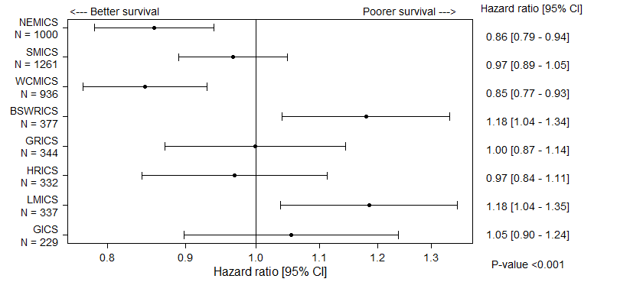

 ICS of residence

Adjusted for age, sex, comorbidities and diagnosis year.   
Bars represent 95 per cent CI.   
Victorian average = 1.0.

Figure 13: Adjusted odds of having surgery for non-metastatic NSCLC patients, by ICS of residence (diagnosed 2013 to 2016)

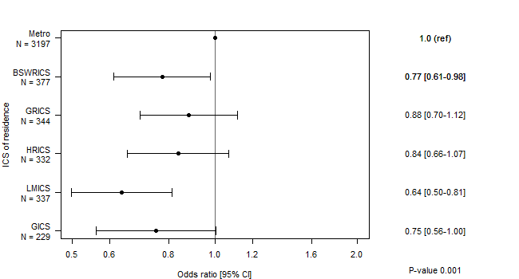

Odds ratio [95% CI]

<--- Less likely

More likely -->

Bars represent 95 per cent CI.  
Model adjusted for age and comorbidities.  
Note the HRICS data limitation.

Figure 14: Survival for non-metastatic NSCLC treated with or without surgery, by ICS of residence (diagnosed 2013 to 2016)

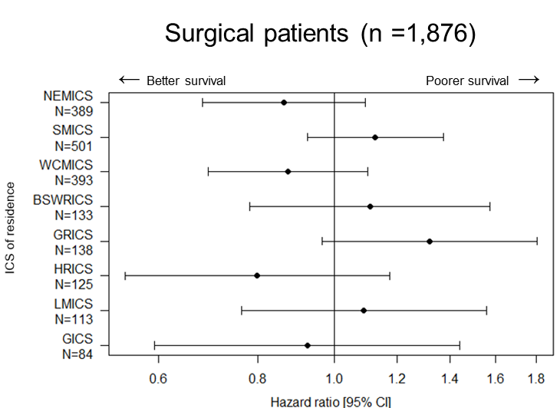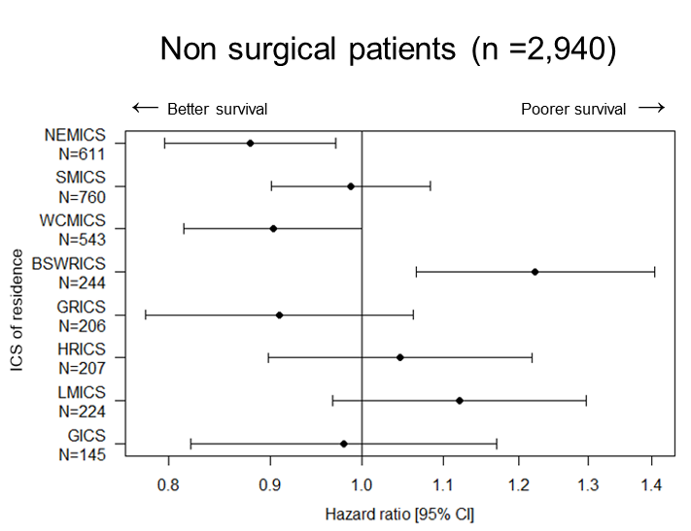

Surgical patients

Non-surgical patients

Bars represent 95 per cent CI. Victorian average = 1.0.  
Model adjusted for age, sex, comorbidities and diagnosis year.

Table 4: Non-metastatic NSCLC patient pathways from ICS of residence to ICS of surgery (diagnosed 2013 to 2016)

| ICS of residence / ICS of surgery | NEMICS | SMICS | WCMICS | BSWRICS | GRICS | HRICS* | LMICS | GICS | Total |
| --- | --- | --- | --- | --- | --- | --- | --- | --- | --- |
| NEMICS | 277  (71%) | 33  (8%) | 78  (20%) |  | 1  (0%) |  |  |  | 389  (100%) |
| SMICS | 30  (6%) | 434  (87%) | 35  (7%) |  | 2  (0%) |  |  |  | 501  (100%) |
| WCMICS | 70  (18%) | 16  (4%) | 305  (78%) | 1  (0%) |  |  |  | 1  (0%) | 393  (100%) |
| BSWRICS | 2  (2%) | 2  (2%) | 20  (15%) | 108  (81%) |  |  |  | 1  (1%) | 133  (100%) |
| GRICS | 10  (7%) | 58  (42%) | 31  (22%) |  | 39  (28%) |  |  |  | 138  (100%) |
| HRICS | 14  (11%) | 3  (2%) | 106  (85%) |  |  |  | 2  (2%) |  | 125  (100%) |
| LMICS | 15  (13%) | 4  (4%) | 37  (33%) |  |  |  | 53  (47%) | 4  (4%) | 113  (100%) |
| GICS | 1  (1%) | 3  (4%) | 26  (31%) | 3  (4%) |  |  | 1  (1%) | 50  (60%) | 84  (100%) |

Note the HRICS data limitation.

Figure 15: Non-metastatic NSCLC major surgery types, by ICS of surgery (diagnosed 2013 to 2016)

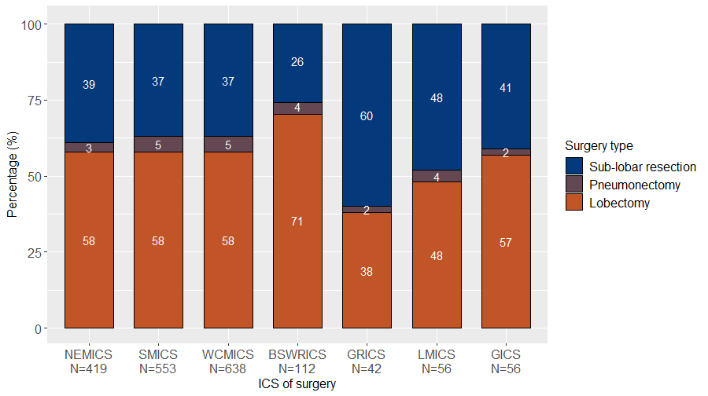

### Clinical commentary

Survival did not vary significantly by ICS for NSCLC patients with metastatic disease but did for those with non-metastatic disease. This data suggests lower rates of surgical treatment – seen particularly in all regional ICS – may contribute to this differential, although analyses did not account for more fine-level detail on stage of disease at diagnosis. Most metropolitan patients and those in BSWRICS received surgery locally, while a sizable proportion of patients in other regional areas travelled to a metropolitan ICS. Adequate support for patients who travel for surgery, such as travel and accommodation, as well as adequate clinical support upon discharge, is a consideration. There was strong consistency in the types of surgery conducted in metropolitan ICS but more variability in regional ICS. This may reflect different case disease characteristics, surgeon preferences and competencies and/or health service capabilities.

# Surgery volume

The number of public and private hospitals performing at least 20 major lung cancer surgical procedures per year increased from 10 hospitals in period one (July 2010 to June 2012) to 18 hospitals in period two (July 2016 to June 2018) (Figure 16).

Figure 16: Victorian hospital average annual lung cancer surgery volume (July 2010 to June 2012 and July 2016 to June 2018)

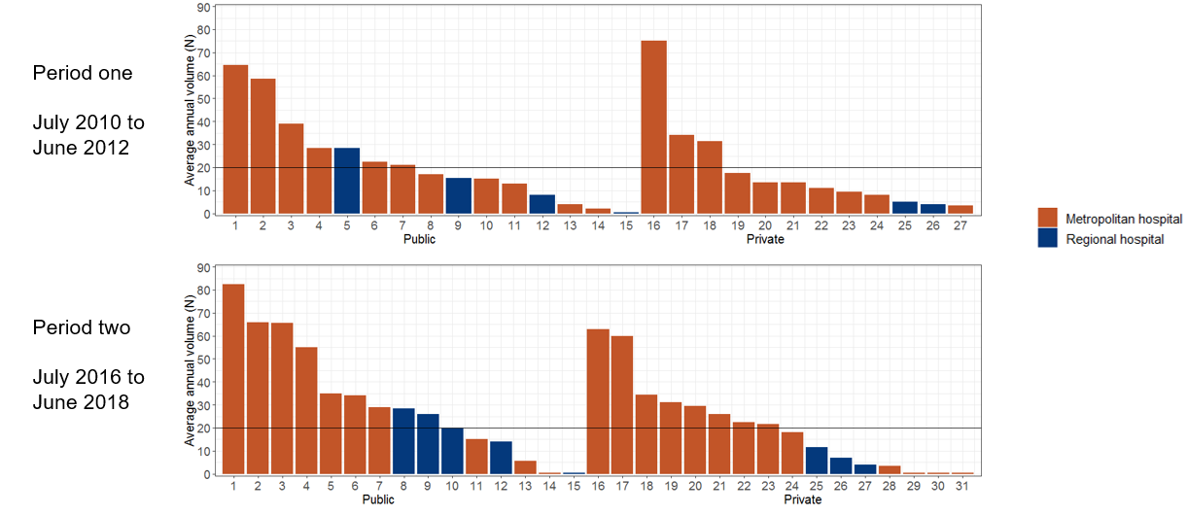

Source: VAED 2017–18 (unlinked)  
Restricted to lung surgical admissions for patients with a lung cancer diagnosis.   
FY = financial year.

### Clinical commentary

These findings are encouraging because there is international evidence that higher surgical volumes can lead to better clinical outcomes. Hospitals with annual average surgical rates lower than 20 should interrogate local data to determine the reasons for low volumes and identify strategies to reduce such admissions if possible, including establishing referral pathways to centres performing higher surgical volumes.

# Radiotherapy

* On average, 42 per cent of lung cancer patients diagnosed between 2013 and 2016 received RT within a year of diagnosis.
* Overall RT utilisation varied by ICS, being lower for patients who live in HRICS (37 per cent) and higher for patients who live in WCMICS (45 per cent) and LMICS (46 per cent) compared with the state average (Figure 17).
* Use of RT with radical intent was higher in WCMICS (18 per cent) and lower in GICS (11 per cent) and BSWRICS (10 per cent) compared with the state average (16 per cent) (Figure 17).
* Of those non-metastatic NSCLC patients whose first treatment was radical RT/CRT:
  + - The median time from diagnosis to starting RT/CRT was 40 days.
    - The proportion of patients beginning RT/CRT within 40 days did not change significantly from 2013 to 2016 (
    - Table 5).
    - Patients living in a regional area and treated in a regional ICS were less likely to start RT/CRT within 40 days (39 per cent) compared with those who to travelled to a metropolitan ICS (64 per cent) or those who live in a metropolitan area and were treated in a metropolitan ICS (54 per cent) (
    - Table 5).
    - Time to starting RT/CRT varied by RT centre, with two regional centres having a significantly lower proportion of patients starting within 40 days compared with the state average (Figure 18).

Figure 17: Use of radiotherapy within a year of a lung cancer diagnosis, by ICS of residence (diagnosed 2013 to 2016)

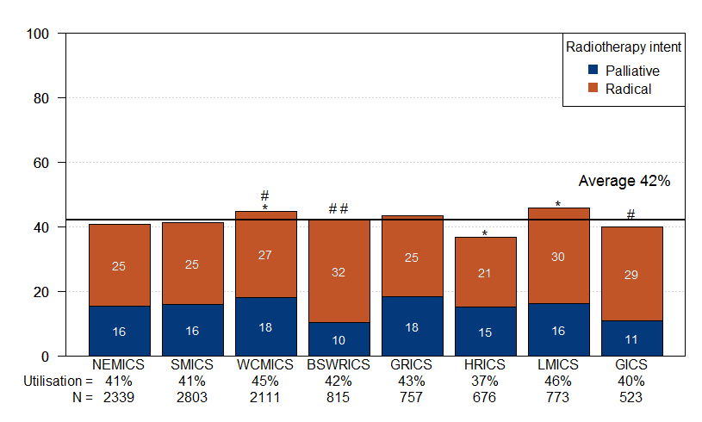

Radiotherapy utilisation (%)

Difference in RT utilisation compared with state average:* WCMICS, HRICS, LMICS p < 0.05  
Difference in radical RT proportion compared with state average: # WCMICS, GICS p < 0.05; ## BSWRICS p < 0.001.

Table 5: Percentage of non-metastatic NSCLC patients who began radical RT/CRT within 40 days of diagnosis, by diagnosis year and ICS of residence and treatment (diagnosed 2013 to 2016)

| Variable | Level | Started RT/CRT within 40 days (%) | *p*-value |
| --- | --- | --- | --- |
| Diagnosis year | 2013 | 46 | 0.215 (trend) |
|  | 2014 | 52 |  |
|  | 2015 | 54 |  |
|  | 2016 | 51 |  |
| ICS of residence to | Regional to regional | 39 | < 0.001 |
| ICS of treatment | Regional to metropolitan | 64 |  |
|  | Metropolitan to metropolitan | 54 |  |

Figure 18: Percentage of non-metastatic NSCLC patients who began radical RT/CRT within 40 days of diagnosis, by RT centre (diagnosed 2013 to 2016)

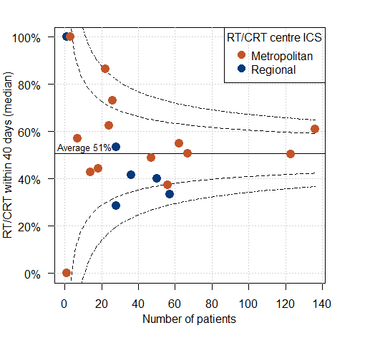

Radiotherapy with radical intent.   
Excluding patients treated with stereotactic ablative radiation therapy.

### Clinical commentary

Reasons for variable use of RT across ICS may be due to local clinical expertise, equipment and treatment preferences. Lower use of RT in HRICS is not affected by data limitations because the local RT centre for Albury/Wodonga reports to the VRMDS. Variation in the intent of radiotherapy patients receive – with more radical RT in WCMICS and less in BSWRICS and GICS – may indicate different patient staging or treating protocols. However, differences by regional or metropolitan ICS of residence and RT centre in time to beginning radical RT/CRT for non-metastatic NSCLC are unwarranted. Long wait times can be distressing to patients and lead to disease progression. It is worth investigating potential access issues to RT for lung cancer in regional Victoria.

# Chemotherapy

### Metastatic NSCLC

* On average, 41 per cent of patients diagnosed with metastatic NSCLC between 2013 and 2016 received chemotherapy within one year of diagnosis.
* Chemotherapy rates ranged from 34 per cent in LMICS to 45 per cent in GRICS and NEMICS (Table 6).
  + After adjusting for age and comorbidity, patients in GRICS and NEMICS were significantly more likely, and patients in LMICS less likely, to receive chemotherapy within one year of diagnosis compared with the state average.

Table 6: Chemotherapy within one year of diagnosis for metastatic NSCLC patients, by ICS of residence (diagnosed 2013 to 2016)

| ICS of residence | n/N (%) | Odds ratio (95% CI) | *p*-value |
| --- | --- | --- | --- |
| NEMICS | 472/1,053 (45) | 1.35 [1.17–1.55] | < 0.001 |
| SMICS | 466/1,171 (40) | 1.04 [0.91–1.19] |  |
| WCMICS | 336/886 (38) | 0.87 [0.75–1.02] |  |
| BSWRICS | 134/336 (40) | 1.04 [0.83–1.29] |  |
| GRICS | 150/330 (45) | 1.27 [1.02–1.58] |  |
| HRICS | 95/265 (36) | 0.78 [0.61–1.00] |  |
| LMICS | 112/331 (34) | 0.73 [0.58–0.91] |  |
| GICS | 97/224 (43) | 1.09 [0.84–1.42] |  |

Note the HRICS data limitation.   
The odd ratios is adjusted for age and comorbidities.   
Victorian average = 1.0.

### SCLC

* On average, 76 per cent of patients with SCLC in 2013 to 2016 received chemotherapy within one year of diagnosis.
* Chemotherapy rates ranged from 59 per cent in HRICS to 88 per cent in GICS (Table 7).
  + After adjusting for age and comorbidity, patients in GICS were significantly more likely, and patients in HRICS less likely, to receive chemotherapy within one year of diagnosis than the state average. However, differences for HRICS are most likely due to patients receiving chemotherapy in Albury (NSW), which is not captured in Victorian linked datasets (see ‘Data limitations’).

Table 7: Chemotherapy use within one year of diagnosis of SCLC, by ICS of residence (diagnosed 2013 to 2016)

| ICS of residence | n/N (%) | Odds ratio (95% CI) | *p*-value |
| --- | --- | --- | --- |
| NEMICS | 170/229 (74) | 1.21 [0.86–1.71] | 0.007 |
| SMICS | 232/294 (79) | 1.35 [0.98–1.86] |  |
| WCMICS | 185/245 (76) | 0.94 [0.67–1.30] |  |
| BSWRICS | 61/84 (73) | 0.81 [0.50–1.31] |  |
| GRICS | 54/68 (79) | 1.08 [0.62–1.91] |  |
| HRICS | 34/58 (59) | 0.41 [0.24–0.69] |  |
| LMICS | 65/87 (75) | 0.82 [0.51–1.31] |  |
| GICS | 50/57 (88) | 2.24 [1.06–4.73] |  |

Note the HRICS data limitation.   
The odds ratio is adjusted for age and comorbidities.   
Victorian average = 1.0.

### Clinical commentary

Variability in the uptake of chemotherapy by ICS of residence – as for RT – may be due to local clinical expertise, resource availability, preferences for treatment and disease characteristics of patients. Lower use of chemotherapy in HRICS could be due to patients having chemotherapy in Albury, which is not captured in the data (see ‘Data limitations’).

# Palliative and supportive care

* Data from the Victorian Lung Cancer Registry (2017 annual report) show (Figure 19):
  + - Adjusting for patient age, sex, birthplace and clinical stage, 35 per cent of patients with stage IV NSCLC were referred for palliative care within eight weeks of diagnosis.
    - The proportion of patients referred for palliative care within eight weeks of diagnosis varied from 11 per cent to 63 per cent across hospitals.
  + Across Victoria, 52 per cent of patients with lung cancer had documented evidence of supportive care screening in their medical record. This varied significantly by ICS, from 13 per cent in WCMICS to 72 per cent in SMICS (Figure 20).

Figure 19: Percentage of NSCLC patients with stage IV referred to palliative care within eight weeks of diagnosis (2017)

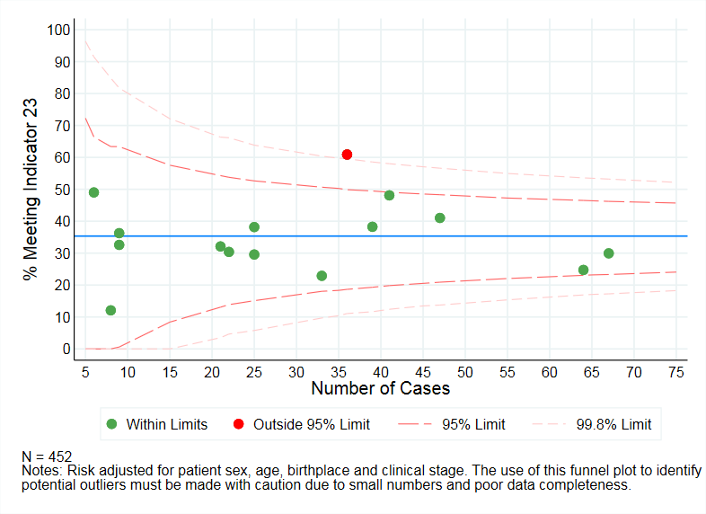

Source: Victorian Lung Cancer Registry

Figure 20: Percentage of lung cancer patients with documented evidence of supportive care screening (2017)

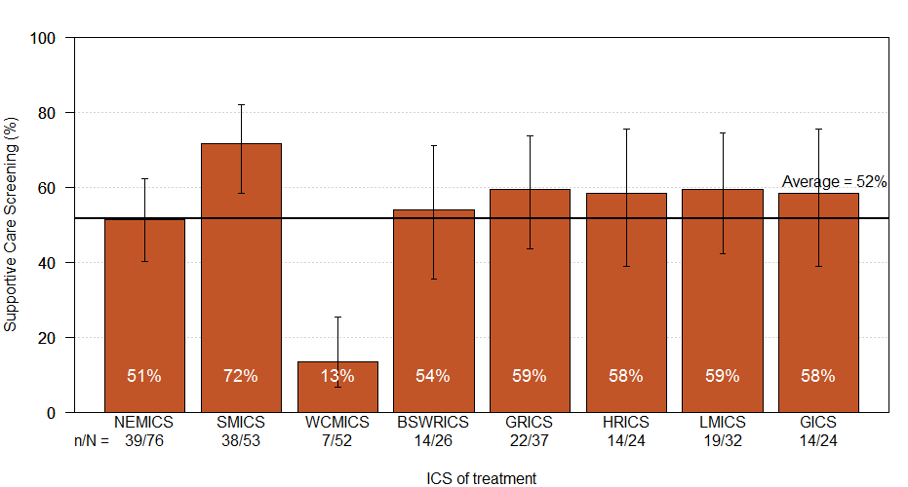

Source: CSPI medical record audit 2017  
Bars represent 95 per cent CI.   
Note the HRICS data limitation.   
Pearson’s 𝝌² test for difference between ICS of treatment p < 0.001.

### Clinical commentary

Early referral to palliative care has been associated with improved survival and quality of life and reduced use of aggressive care at the end of life for patients with cancer. Although there is no optimal time for palliative care referral noted in the lung cancer OCP, timelier referral may be particularly relevant for patients with metastatic disease. The OCP for lung cancer recommends regularly assessing patients’ supportive care needs to identify issues and services that could optimise health and quality-of-life outcomes. Data here suggest only one in three patients with stage IV lung cancer are referred to palliative care within eight weeks of their diagnosis, and only one in two have evidence of supportive care screening. In addition, some services had much lower rates than others. Low supportive care screening in WCMICS may be due to some hospitals using a different approach to identifying supportive care needs that does not involve using the screening tool assessed in the audit.

# Abbreviations

|  |  |
| --- | --- |
| CI | confidence interval |
| CRT | chemoradiation |
| CSPI | Cancer Services Performance Indicator |
| GP | general practitioner |
| ICS | Integrated Cancer Service |
| MDM | multidisciplinary meeting |
| NSCLC | non-small cell lung cancer |
| OCP | optimal care pathway |
| RT | radiotherapy |
| SCLC | small cell lung cancer |
| VAED | Victorian Admitted Episodes Dataset |
| VCR | Victorian Cancer Registry |
| VRMDS | Victorian Radiotherapy Minimum Data Set |

## Victorian Integrated Cancer Services

|  |  |
| --- | --- |
| NEMICS | North Eastern Melbourne Integrated Cancer Service |
| SMICS | Southern Melbourne Integrated Cancer Service |
| WCMICS | Western and Central Melbourne Integrated Cancer Service |
| BSWRICS | Barwon South Western Regional Integrated Cancer Service |
| GRICS | Gippsland Regional Integrated Cancer Services |
| HRICS | Hume Regional Integrated Cancer Service |
| LMICS | Loddon Mallee Integrated Cancer Service |
| GICS | Grampians Integrated Cancer Service |

# Glossary

|  |  |
| --- | --- |
| **Chemoradiation** | **Chemoradiation** was identified by at least one **chemotherapy** episode in the VAED where the admission date was in the range of the **radiotherapy (radical)** course start and end date in the VRMDS. |
| **Chemotherapy** | An admitted episode in the VAED where the admission date was between 30 days prior and one year after the patient’s lung cancer diagnosis date and included a chemotherapy diagnosis, procedure or diagnosis-related group code (refer to Supplementary Table 3). |
| **Comorbidity count** | A count measuring the number of comorbid conditions a patient has at diagnosis, which may influence their prognosis. Data on patient comorbidities was extracted from diagnosis codes of admitted episodes in the VAED in the year prior to 30 days after the patient’s lung cancer diagnosis date. Patients without admitted episodes were assumed to have no comorbidities. The comorbidity count was calculated for each patient according to Quan et al.[5] (excluding cancer and metastases) and grouped into four categories (0, 1, 2 and 3+).  Diagnosis codes for comorbidities can only be assigned in the admitted episode when the comorbidities meet criteria for coding in accordance with the Australian Coding Standards.[6] As a result, the identification of comorbidities is underestimated.  Conditions included in the comorbidity count:  AIDS/HIV  congestive heart failure  chronic pulmonary disease  dementia  diabetes with chronic complications  hemiplegia or paraplegia  mild liver disease  moderate/severe liver disease  renal disease  rheumatic disease. |
| **Death certificate only** | A method of cancer notification to the VCR whereby the death certificate provides the only notification of a person’s cancer to the registry. |
| **Diagnosis date** | The date of the pathology report or other investigative report where the diagnosis of lung cancer was first confirmed to the VCR. |
| **Metastatic disease at diagnosis** | Patients who had metastatic disease at diagnosis were identified from the VCR TNM-M variable (non-missing for 21 per cent of lung cancer patients) and from metastatic cancer diagnosis codes (ICD-10-AM C78 and C79) in admitted episodes in the VAED between 30 days prior to four months after the patient’s lung cancer diagnosis date. |
| **Non-metastatic disease at diagnosis** | Patients who were classified as not having metastatic disease at the time of diagnosis. Non-metastatic cancer was determined by an absence of metastatic indicators in associated VCR and VAED variables (refer to ‘Metastatic disease at diagnosis’) between 30 days prior to four months after the patient’s lung cancer diagnosis date. |
| **Palliative care** | Person- and family-centred care provided for a person with an active, progressive, advanced disease who has little or no prospect of cure and who is expected to die, and for whom the primary goal is to optimise the quality of life.[7] |
| **Radiotherapy (radical)** | Radiotherapy courses in the VRMDS where the *start date* was between 30 days prior and one year after the patient’s lung cancer diagnosis date, the *primary site* was a lung cancer code (ICD-10-AM C33, C34), the *target site* was ’chest/lung’ and the *treatment intent* was radical. |
| **Radiotherapy (palliative)** | Radiotherapy courses in the VRMDS where the *start date* was between 30 days prior and one year after the patient’s lung cancer diagnosis date, the *primary site* was a lung cancer code (ICD-10-AM C33, C34), the *target site* was any and the *treatment intent* was palliative. |
| **Surgery** | An admitted episode in the VAED where the admission date was between 30 days prior and one year after the patient’s lung cancer diagnosis date and the episode included a lung surgery procedure code (refer to Supplementary Table 2). If a patient had a second surgery episode within 30 days of an episode with an ‘endoscopic wedge resection of lung’ procedure code, the first surgery was considered a biopsy and the second surgery was counted as the curative resection. |
| **Tissue diagnosis** | Those diagnoses with cytology or haematology, specific tumour markers, histology of metastasis, or histology of primary tumour. Non-tissue diagnoses include those from clinical investigation (x-ray, ultrasound, exploratory surgery) or clinician-only diagnoses. |

# Supplementary material

## Codes

### Diagnosis

Supplementary Table 1: Lung cancer diagnosis codes

| ICD-10-AM | Description |
| --- | --- |
| C33 | Malignant neoplasm of trachea |
| C34 | Malignant neoplasm of bronchus and lung |

### Surgery

Supplementary Table 2: Surgical procedures codes used to identify patients who underwent a lung cancer resection

|  |  |  |
| --- | --- | --- |
| ICD-10-AM/ ACHI/ACS code | Description | Group |
| 3843800 | Segmental resection of lung | Sub-lobar resection |
| 3844000 | Wedge resection of lung |
| 3844001 | Radical wedge resection of lung |
| 9016900 | Endoscopic wedge resection of lung |
| 3843802 | Pneumonectomy | Pneumonectomy |
| 3844101 | Radical pneumonectomy |
| 3843801 | Lobectomy of lung | Lobectomy |
| 3844100 | Radical lobectomy |

### Chemotherapy

Supplementary Table 3: Diagnosis, procedure and diagnosis-related group codes used to identify patients who received chemotherapy

| Code group | Code | Description |
| --- | --- | --- |
| Diagnosis | Z511 | Pharmacotherapy session for neoplasm |
| Procedure | 9619900 | Intravenous administration of pharmacological agent |
| Diagnosis-related group | R63Z | Chemotherapy |

1. See the abbreviations for naming of eight Victorian ICS.
2. See the [recommendations from the summit](https://www.nemics.org.au/icms_docs/216624_Lung_Cancer_Summit_Recommendations.pdf) <https://www.nemics.org.au/icms_docs/216624_Lung_Cancer_Summit_Recommendations.pdf>.
3. Thursfield V, Farrugia H 2018, *Cancer in Victoria: statistics & trends 2017*, Cancer Council Victoria, Melbourne.
4. Greenhalgh EM, Bayly M, Winstanley MH 2015, ‘Trends in the prevalence of smoking by socio-economic status’. In: Scollo MM, Winstanley MH (eds). *Tobacco in Australia: facts and issues*, Cancer Council Victoria, Melbourne. Available from <http://www.tobaccoinaustralia.org.au/chapter-1-prevalence/1-7-trends-in-the-prevalence-of-smoking-by-socioec>.
5. Quan H, Li B, Couris C, et al. 2011, ‘Updating and validating the Charlson comorbidity index and score for risk adjustment in hospital discharge abstracts using data from 6 countries’, *American Journal of Epidemiology*, vol. 173, no. 6, pp. 676–682.
6. Australian Coding Standard ACS 0002 Additional Diagnoses.
7. Palliative Care Australia 2019, ‘What is Palliative Care?’ Available at: https://palliativecare.org.au/what-is-palliative-care. [Accessed 28 October 2019].