Gathering Places: Inclusion, connection and empowerment Summary of findings

Evaluator: Indigenous Health Equity Unity, University of Melbourne

Aim: To document the health and wellbeing outcomes of gathering places, understand the health services that link into gathering places, identify activities undertaken in gathering places and highlight successful elements in making gathering
places sustainable.

Thirteen gathering places participated in the evaluation.
Healing therapies that are more closely aligned with Aboriginal cultural beliefs are commonly offered at gathering places and provide an alternative to western-based health care.

Alternative healing methods, cultural activities and protocols create a culturally safe environment that enables Aboriginal people to seek support and health care
needs on their own terms.
They don’t call it a gathering place, they call it a community place.. not just because the word gathering is being commonly used primarily by the white people for so many years, they call it a community place. So they can actually—all community can come in, not just Aboriginal. So they leave that open for everybody.

(Evaluation participant)

Gathering places / Healing centres / Community centres — Program model

A gathering place that is supported by a range of enablers and adheres to some key principles is likely to lead to improved health and wellbeing for Aboriginal community members.
The model symbolises the role of a birds nest or ‘home ‘— many

Connection
- Social
- Cultural Identity

Holistic health

Sustainability

Self- determination
of n
ci

Respect
b

Health
- Physical health
- Food security
- Healing
- Health promotion and prevention

study participants frequently referred to their local gathering place as ‘home’ and see them as ‘safe’ places that provides support and connection.
models

Capacity building

GATHERING PLACES
for cultural
knowledge

Strong governance

Pathways to other
organisations

Flexible approach

Advocacy

Empowerment
  - Leadership
  - Mentorship

Inclusion
- Safe place
- Culturally safe
- Cultural awareness

Links
  - Partnerships
  - Awareness of services
  - Increased presentations
Wellbeing
- Social and emotional wellbeing
- Cultural and spiritual benefits

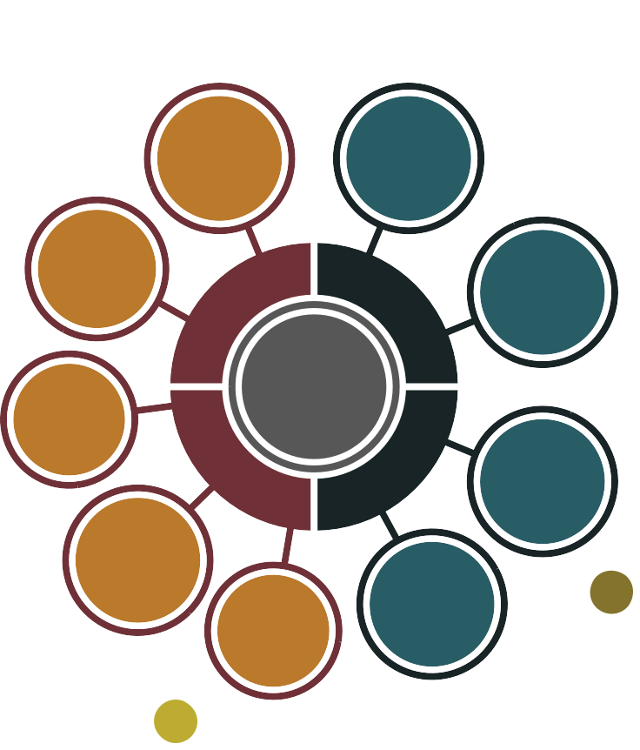

The evaluation report is available on the health.vic website. In your search engine, type ‘Koolin Balit evaluations’

A place for inclusion, connection and empowerment

This is what some of the evaluation participants said..

When the funding was lost… it was very difficult because [Aboriginal worker] had a very strong connection with the women, she also chose to
go which was absolutely her right to do, but her loyalty to the women, she felt very torn…

I think an important part about it has been our non-Indigenous members. That’s been a part of
[the gathering place] and been a very important part of it… we’ve got a lot of non-Indigenous people supporting this place. You’ve got to have all kinds of people… Everybody, this community here, has got to be a part of this place…

… the youths have been coming through saying we just want a place where we can hang. We don't want to be [meeting] medical and psychology and youth workers,
we just want a place where we can hang…

… empowering people ... that's a very basic thing in life especially in Aboriginal and Torres Strait
communities, if you empower someone to do something, they're willing to go forward on the next part of their journey as well as the next part of the community and the next part of the centre's journey. Empowering someone is the most powerful thing you can do to get them to go forward…

A place for the people to meet and to access services… and all the information is here. So if there's
anything you need, all you need to do is come here, speak to somebody and they will direct you to whoever, and this to me is part of closing the gap…

We make sure the food goes to anyone who needs it—so there isn’t any waste. If there are any left overs I’ll refrigerate most of it, and I’ll cook it up and make sure people get a feed—so there is
no waste…

The evaluator identified several opportunities for strengthening gathering places in Victoria

- Investment in long-term sustainability—consistent, appropriate long-term baseline funding for operational costs and staffing costs to

increase sustainability

- streamlined and flexible funding and reporting requirements to relieve administrative burden and to allow creative local solutions

- supporting development of formal agreements between gathering places and external agencies—

to access expertise, engage with Aboriginal people and clearly articulate roles, responsibilities, and the resources required for effective partnerships

- a planning workshop with gathering places to identify priorities,

co-ordinate funding and identify appropriate key performance indicators that benefit the community

- annual gathering place professional development in-service for gathering place workers to share stories and best practice and networking opportunities, and to inform gathering places about departmental priorities

a gathering place co-ordinator

to support and strengthen the gathering place network in Victoria

- gathering place community awards to formally recognise Community members and key contributors.
I think this place is a safe place. It’s a
sacred place, it’s
neutral. Even with all the politics that goes on out in community, we try to keep this as neutral as we can…

We have an activity group that work for our elders and they have a really strong voice for community… They're front row and centre at every consultation. Whenever a voice needs to be heard we bus them
all in and we bus them all out…

Because most of us aren't on our own Country, it's really hard as an Aboriginal person to find a space when you are not on your land and it's a complex tightrope on other peoples' Country…

… you want that sense of connectedness, like everyone wants that sense of Country or that sense of inner peace… it’s finding that, and keeping your traditions alive, like just those little things, to what make you feel like you’re Aboriginal or in peace…

… we have been identified as key Aboriginal workers in this community who are here to help… whether it’s seeking information, whether it’s helping a person link in, whether it’s just a friendly face and a cuppa and
a yarn, whether it’s supporting workers from outside the area to come in and help engage them, get them to engage with Aboriginal community…

I go and stand on the grass out here. I walk around with no shoes and feel comfortable. I don’t care what anyone thinks, because it’s about me. And I feel safe and I feel heard and I like having a laugh and have something to eat.

