Department of Health operational plan 2021–22
Accessible version
OFFICIAL

The department proudly acknowledges Victoria’s Aboriginal communities and their rich culture and pays respect to their Elders past and present.
We acknowledge Aboriginal people as Australia’s first peoples and as the Traditional Owners and custodians of the land and water on which we rely.
We recognise and value the ongoing contribution of Aboriginal people and communities to Victorian life and how this enriches us.
We embrace the spirit of reconciliation, working towards the equality of outcomes and ensuring an equal voice.

To receive this document in another format, phone email Budget Strategy, Performance and Improvement <planning@health.vic.gov.au>.
Authorised and published by the Victorian Government, 1 Treasury Place, Melbourne.
© State of Victoria, Australia, Department of Health, August 2021. (DH 210 5050)
This publication may contain images of deceased Aboriginal and Torres Strait Islander peoples.
Where the term ‘Aboriginal’ is used it refers to both Aboriginal and Torres Strait Islander people. Indigenous is retained when it is part of the title of a report, program or quotation.
ISBN/ISSN 2653-1984 – Online (PDF/Word)
Available at Our plan <https://www.health.vic.gov.au>

Our vision
Victorians are the healthiest people in the world.

One vision, two jobs, five reform directions

Our vision
Victorians are the healthiest people in the world.

Job #1
Help Victorians stay healthy and safe

Job #2
Deliver a world-class healthcare system

Reform direction #1
Prevention comes first

Reform direction #2
Closer to home

Reform direction #3
Work together as one

Reform direction #4
Always improving

Reform direction #5
Best workers, best workplaces

Our story is your story
We want Victoria to be a place where the people are the healthiest in the world, a place where future generations thrive.
For Victoria to remain a great place to live, work and play, Victorians need to know they can access healthcare that allows them to keep doing the things they love – whether it’s spending time with family and friends, getting out and about or doing things that bring them joy.
Our job is to help Victorians stay healthy and safe and deliver a world-class healthcare system that leads to better health outcomes for all Victorians.
The department supports Victorians to stay healthy and safe in lots of ways:
- To keep you in good health we provide expert health information and advice that you can trust.
- When you need a health or aged care service we will ensure that you receive quality care by the best health workers in the world.
- When we have emergencies that impact your health we will be there to help guide you and keep you safe.
- And if you are struggling with your mental health we will ensure access to a range of care and supports.
The department delivers a world-class healthcare system that meets the changing health needs of all Victorians by focusing on people first. Prevention is our starting point, creating the right conditions and supports to promote and protect good health and intervene early at every point.
You can expect our healthcare system to deliver what you need because it will:
- Look at you as a whole person respecting diversity in identity, culture and religion.
- Be culturally safe.
- Recognise that connection to culture is integral to health and wellbeing, especially for our strong and proud Aboriginal community.
We have five major reform directions to evolve our healthcare system so we can deliver better health outcomes for the Victorian community (see page 5 for details). Our reform directions are underpinned by three core principles that form the basis of everything we do:
- We deliver the health outcomes that matter the most to the community.
- We ensure fairness so we meet the needs of all Victorians, and
- We do things in partnership with the community and health sector.
Serving the Victorian community is our passion and we deeply believe that a sustainable, world-class healthcare system that delivers the best health outcomes will make Victorians the healthiest people in the world.

Our foundations
To become the healthiest people in the world, it is important that we adhere to three basic principles. These are non-negotiables, and our community and our partners will grow to expect these of us, in everything we do.
- The health outcomes that matter the most to the community
- Fairness so we meet the needs of all Victorians
- Doing the things in partnership with the community and the health sector

Five reform directions
We have an opportunity to change the way people think about health, and the ways in which healthcare is delivered. In five ways, we use our — and our partners’ — collective expertise to be a world-class health system we can be proud of.

The Victorian healthcare system is evolving to deliver better outcomes for the community

1. Prevention comes first
Victorians stay healthy and disease is stopped before it starts. We will promote good health and protect the health of the community. Where disease does start, we will intervene earlier by making it easier for you to access care in your community.

2. Closer to home
Care will come to you or be closer to you, making it easier for you to get what you need. We are doubling down on providing care in Victorian homes and communities and making the best use of technology such as telehealth.

3. Work together as one
To deliver the health outcomes that matter the most to the community, you will see us working together as one so Victorians can focus on achieving the outcome they want from their care.

4. Always improving
We continue to challenge ourselves to learn and adapt based on the best-available data and evidence, including the experiences of Victorian patients, aged care residents and health workers as well as other healthcare systems around the world.

5. Best workers, best workplaces
Our health workers will be supported and developed so we can attract and retain people who deliver the best health outcomes for Victorians and can ensure all Victorians feel safe accessing our healthcare system.
Figure 1: Top priorities for 2021–22
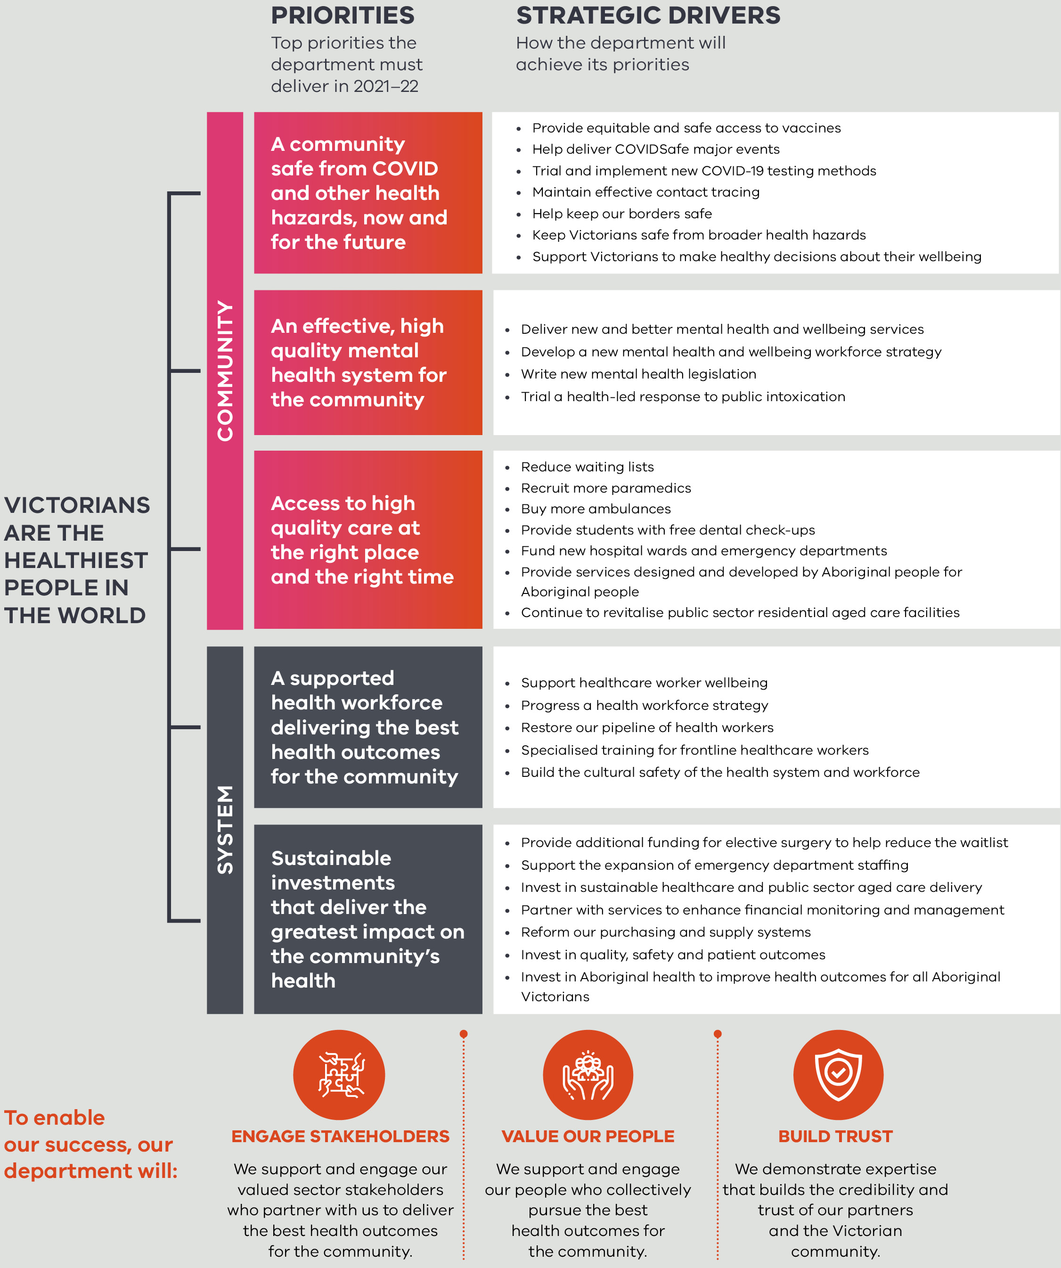

Our values
The values of the Victorian public sector describe what we stand for at the department, how we want to make decisions and how we expect each other to behave. Our values underpin all of the work that we do.
- Responsiveness
- Integrity
- Impartiality
- Accountability
- Respect
- Leadership
- Human rights

Our commitment to all Victorians
‘I am proud to lead a new department, with a renewed focus, dedicated to the health of all Victorians.’
The COVID-19 crisis created both the need and opportunities for significant improvements in health system governance and service delivery to lead bold and innovative reform. It has also shown us that a more connected health system, with closer relationships between the department, clinicians and consumers, enables us to build an even stronger Victorian health system.
Our people are already implementing the government’s commitments to Victorians, including our government’s response to COVID-19.
The Victorian community is rich and diverse with a proud and longstanding Aboriginal history. In recognition of this we are committed to self- determination and Aboriginal-led decision making across health. There are nine groups in the department that work collaboratively to deliver on government’s priorities. These include our Public Health group, which protects Victorians’ health through prevention and early intervention, reduces health inequalities, and identifies and responds to public health risks and emergencies. We have a separate COVID Response group to test, trace and isolate cases, as well as designing processes to enable the least restrictive possible economic, social and community activity until we can live freely beyond the pandemic. Our Reform and Planning group identifies and proposes short- and long-term improvements to our system so that we stay on the forefront of advances that help keep Victorians healthy and safe, and our healthcare system world class.
Our experienced Corporate Services, and Regulatory, Risk, Integrity and Legal groups capably support all of the above activity through developing our workforces, information technology and operational processes so that they are able to meet the challenges ahead.
I am particularly committed to oversight of measurable, accountable actions that ensure our resources are spent where Victorians most need them, and where we can demonstrate success clearly. We track and use results (through the Victorian Agency for Health Information) to heighten quality, improve performance, and make decisions about where to invest effort next. To provide Victorians with assurance they can get healthcare when they need it, where they need it, our Commissioning and System Improvement group funds our services, and monitors their performance. They work in collaboration with our partners from across the system and value the Aboriginal community-controlled sector as an integral part of the health system in Victoria.
A separate agency, Safer Care Victoria, works with health services – and the community – to strengthen quality and safety, so our health outcomes are the best in the world, variations in care are minimised, and we are continuously improving. Through our Mental Health and Wellbeing group, we are also leading the design of a once-in-a-generation revolution in our mental health system.
This involves a ground-up enhancement of policy, services, community engagement and workforces, so that all Victorians get preventative and responsive mental health support they need. Making mental health all of our business.
Finally, we are delivering on government’s significant investments in health infrastructure, by planning and implementing almost 100 projects with a capital value of almost $8 billion through the Victorian Health Building Authority. These include new builds and improvements of services, and will be highly visible and useable by Victorians across our population groups and regions.
Health equity is vital for a state that has a vision to have the healthiest people in the world. Therefore, our Aboriginal Health group works towards the self-determination of Aboriginal Victorians in the design and delivery of their healthcare, ensuring improved health status and reduced ill health.
I am enthusiastic about leading our purposeful, values-driven and engaged team who, like me, are motivated towards delivering government priorities, in pursuit of our big goal: for Victorians to be the healthiest people in the world.
Euan Wallace
Secretary

Our ministers
The Department of Health supports the following portfolios:
The Hon. Martin Foley MP
Minister for Health
Minister for Ambulance Services
The Hon. James Merlino MP
Minister for Mental Health
The Hon. Luke Donnellan MP
Minister for Disability, Ageing and Carers

Appendix 1: Text-equivalent descriptions

Figure 1: Top priorities for 2021–22
Victorians are the healthiest people in the world
- Priorities – top priorities the department must deliver in 2021–22
  - Community
  - A community safe from COVID and other health hazards, now and for the future
  - Strategic drivers
  - Provide equitable and safe access to vaccines
  - Help deliver COVIDSafe major events
  - Trial and implement new COVID-19 testing methods
  - Maintain effective contact tracing
  - Help keep our borders safe
  - Keep Victorians safe from broader health hazards
  - Support Victorians to make healthy decision about their wellbeing
  - An effective, high-quality mental health system for the community
Strategic drivers
Write new mental health legislation
Deliver new and better mental health and wellbeing services
Develop a new mental health and wellbeing workforce strategy
Trial a health-led response to public intoxication
Access to high-quality care at the right place and the right time
Strategic drivers
Reduce waiting lists
Recruit more paramedics
Buy more ambulances
Provide students with free dental check-ups
Fund new hospital wards and emergency departments
Provide services designed and developed by Aboriginal people for Aboriginal people
Continue to revitalise public sector residential aged care facilities
  - System
A supported health workforce delivering the best health outcomes for the community
Strategic drivers
Support healthcare worker wellbeing
Progress a health workforce strategy
Restore our pipeline of health workers
Specialised training for frontline healthcare workers
Build the cultural safety of the health system and workforce
Sustainable investments that deliver the greatest impact on the community’s health
Strategic drivers
Provide additional funding for elective surgery to help reduce the waitlist
Support the expansion of emergency department staffing
Invest in sustainable healthcare and public sector aged care delivery
Partner with services to enhance financial monitoring and management
Reform our purchasing and supply systems
Invest in quality, safety and patient outcomes
Invest in Aboriginal health to improve health outcomes for all Aboriginal Victorians
To enable our success, our department will:
Engage stakeholders
- We will support and engage our valued sector stakeholders who partner with us to deliver the best health outcomes for the community.
Value our people
- We support and engage our people who collectively pursue the best health outcomes for the community.
Build trust
- We demonstrate expertise that builds the credibility and trust of our partners and the Victorian community.

