Victorian cancer plan monitoring and evaluation framework
Report

Contents
Executive summary 5
Purpose and use 5
A long-term focus 6
Victorian cancer plans 7
Background to the framework 9
Overview of the framework 9
Goals and targets 9
Whole-of-government outcomes approach 10
Development of the framework 10
Principles 10
Purpose and application of the framework 13
Monitoring equalities 13
Reporting on and reviewing the framework 14
Structure of the framework 15
Outcomes 15
Key result areas 15
Indicators 15
Measures 15
The framework 17
Outcome: Improve cancer outcomes 17
Outcome: Equitable outcomes for all Victorians 18
Outcome: Prevent cancers 18
Outcome: Detect cancers early 20
Outcome: Optimal diagnostics and treatment 21
Outcome: Best possible experience of care systems 23
Outcome: Integrated research systems 24
Appendix 1: Development process, criteria and inequality assessment 25
Development of the framework 25
Criteria for indicators and measures 25
Breakdown of measures: local disaggregation, inequalities and equality assessment 26
Appendix 2: Available population groups and geographic area breakdowns for measures 27

The Victorian Government would like to acknowledge and thank the individuals and organisations from across the cancer control sector who contributed to the development of the Victorian cancer plan evaluation and monitoring framework.
To receive this publication in an accessible format phone 1300 650 172, using the National Relay Service 13 36 77 if required, or email Cancer Planning <cancerplanning@dhhs.vic.gov.au>
Authorised and published by the Victorian Government, 1 Treasury Place, Melbourne.
© State of Victoria, Department of Health and Human Services, June 2018.
Where the term ‘Aboriginal’ is used it refers to both Aboriginal and Torres Strait Islander people. Indigenous is retained when it is part of the title of a report, program or quotation.
ISBN 978-1-76069-370-1 (Print)
ISBN 978-1-76069-371-8 (Word/pdf/online)
Available at Cancer care <https://www2.health.vic.gov.au/about/health-strategies/cancer-care>
Printed by TDC3, Richmond (1709015 cover and figures)

Executive summary
Victoria has been at the forefront of evolving state, national and international approaches to improve cancer outcomes. Effectively monitoring such improvements requires a comprehensive framework to enable systematic reporting of achievements across the breadth of cancer outcomes.
The Victorian cancer plan monitoring and evaluation framework (‘the framework’) provides a transparent and objective approach to monitoring and reporting on the collective impact of the sector to improve cancer outcomes. By focusing on cancer outcomes, this best practice framework reflects successes in cancer prevention, early detection, treatment, care and research.
To cover the cancer continuum, the framework includes indicators and measures of the following outcomes:
- improve cancer outcomes
- equitable outcomes for all Victorians
- prevent cancers
- detect cancers early
- optimal diagnostics and treatment
- best possible experience of care systems
  - integrated research systems.
The seven outcomes in the framework broadly align with the five Victorian cancer plan 2016–2020 action areas, providing a line of sight between the cancer plan and the framework.
Cancer outcomes in Victoria are the result of the collective actions of a broad range of partners. These include those working specifically in the cancer control sector, in broader health services and in the prevention and population health sectors as well as researchers and people affected by cancer.
The outcomes, key result areas and goal of the framework are set out in the Victorian cancer plan 2016–2020 <https://www2.health.vic.gov.au/about/health-strategies/cancer-care/victorian-cancer-plan>, the first of successive four-year plans developed under the Victorian Improving Cancer Outcomes Act 2014 <http://classic.austlii.edu.au/au/legis/vic/num_act/icoa201478o2014322/>.
The framework was developed in line with the overarching whole-of-government outcomes approach and is structured according to the Department of Health and Human Services’ outcomes framework architecture.
Input from a wide range of organisations and individuals across the Victorian cancer sector is reflected in the framework. It is intended to build upon, rather than duplicate, existing frameworks and reporting processes already undertaken.
Although out of scope of this framework, it is recognised that to achieve the desired outcomes, appropriate structures and processes (such as contracting and quality management systems) need to be in place.

Purpose and use
The framework brings together a comprehensive set of measures drawn from about 30 data sources. These measures can help track whether the collective actions of the sector are improving cancer outcomes over time.
In particular the framework is designed to help understand the extent to which avoidable gaps in cancer outcomes are being reduced. It provides a mechanism, where data is available, for reporting on and monitoring of inequalities between population groups such as Aboriginal and Torres Strait Islander people and culturally and linguistically diverse groups. Inequalities can also be monitored between geographic areas across the state. Monitoring of inequalities is intended to focus attention on the gaps, which will help to prioritise the collective actions to reduce inequalities in cancer outcomes.
Reporting against the framework will serve as a tool to channel collective efforts, action and focus to improve cancer outcomes, achieve shared goals, establish common directions for change, adjust practice and implement further reforms where needed.
A wide range of organisations will use the framework in multiple ways. It is a tool for all those with responsibilities aligned with the Victorian cancer plan 2016–2020 and its successor cancer plans. The Victorian Government will use the framework to help identify investment and implementation priorities across the prevention, screening, treatment and care of people with cancer.
Statutory authorities, not-for-profits and other organisations can also use the framework to inform new plans and strategies, identify inequalities and monitor their contribution to improving cancer outcomes. The framework may be used and adapted at the Integrated Cancer Service, regional or facility levels, and researchers can use the framework to prioritise and inform their work on preventing and treating cancer.

A long-term focus
It can take years, and sometimes decades, to see real improvements in many cancer outcomes at the population level. Reflecting this timeframe, the framework will help monitor progress of the 2025 and 2040 goals outlined in the Victorian cancer plan 2016–2020. These goals will be reflected in successive four-year Victorian cancer plans.
By providing a systematic and organised mechanism to track and report changes in cancer outcomes over the long term, the framework will help to identify emerging trends and potential problems early and to monitor inequalities in cancer outcomes.

Victorian cancer plans
Through the Improving Cancer Outcomes Act 2014 <http://classic.austlii.edu.au/au/legis/vic/num_ act/icoa201478o2014322/>, the Victorian Government is committed to preparing a cancer plan for Victoria every four years. The Victorian cancer plan 2016–2020 <https://www2.health.vic.gov.au/about/ health-strategies/cancer-care/victorian-cancer-plan>, is the first cancer plan developed under the Act and establishes long-term goals that focus actions and guide the development of successive plans. The Victorian cancer plan monitoring and evaluation framework provides a long-term focus to monitor and evaluate the outcomes of the current cancer plan and its successors, as shown in Figure 1.
The cancer plans provide an agenda to improve cancer outcomes for all Victorians but, in particular, support people affected by cancer and health professionals – across public and private providers and primary, community and acute care settings – to work together towards common goals. Figure 2 provides a summary of the current cancer plan.
Figure 1: Alignment of the Improving Cancer Outcomes Act, Victorian cancer plans and the framework
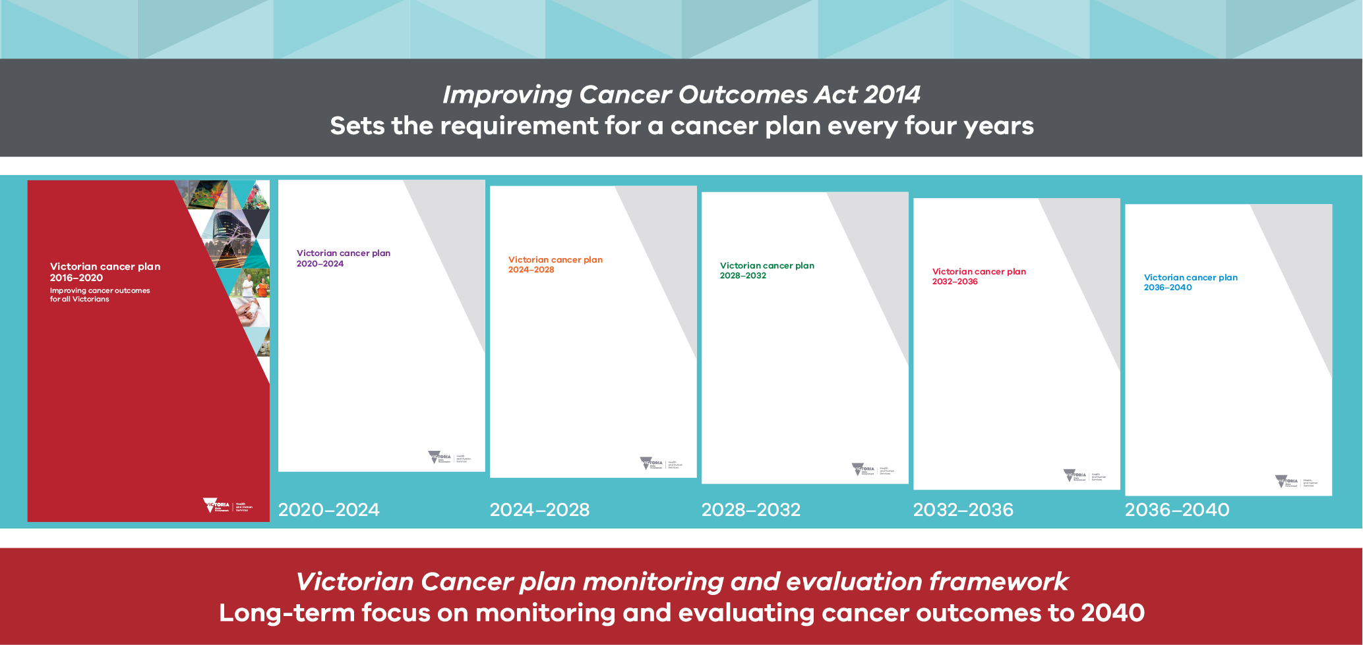

Figure 2: Victorian cancer plan 2016–2020 summary
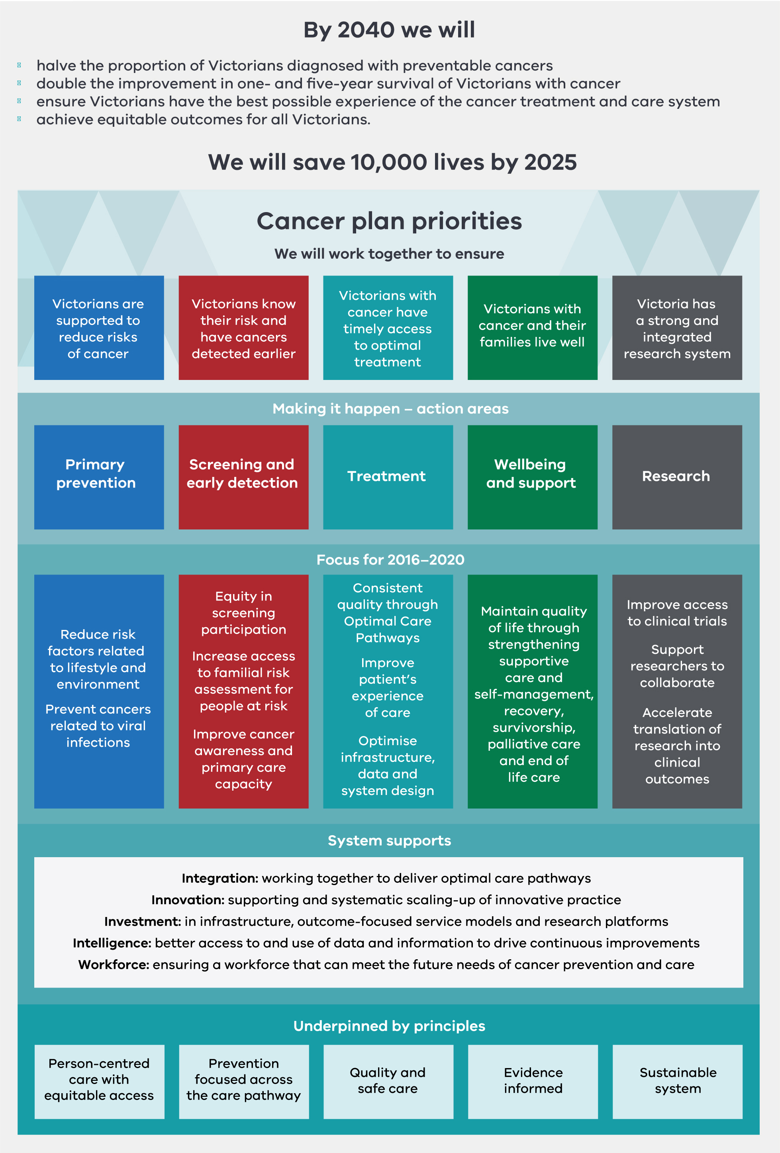

Background to the framework

Overview of the framework
The framework is population-outcomes based to better enable the cancer sector’s achievements to be monitored. The framework comprises the breath of the cancer continuum of prevention, early detection, treatment, wellbeing and support for people affected by cancer, and research.
To cover the cancer continuum, the framework includes indicators and measures of the following outcomes:
- improve cancer outcomes
- equitable outcomes for all Victorians
- prevent cancers
- detect cancers early
- optimal diagnostics and treatment
- best possible experience of care systems
  - integrated research systems.
The seven outcomes in the framework broadly align with the five Victorian cancer plan 2016–2020 action areas, providing a line of sight between the cancer plan and the framework.
Indicators and measures in the framework are principally for all Victorians and therefore universal in relation to population groups, geographic areas and tumour streams.
Recognising the importance of addressing inequalities of cancer outcomes, the framework includes a specific outcome and a limited number of measures of inequality. In addition, the framework will enable assessment of inequalities for all measures between population groups and geographic areas including Integrated Cancer Services, where data is available and reporting is appropriate.
To see real improvements in many cancer outcomes at the population level can take many years. The framework spans the period from a 2014 baseline to 2040 to enable monitoring of the goals of the Victorian cancer plan 2016–2020 described below. The framework uses data from more than 30 different Victorian or Australian data collections to comprehensively monitor changes over time.

Goals and targets
The framework identifies specific results to be achieved by a specific time. The Victorian cancer plan 2016–2020 sets goals to 2040, reflecting the Victorian Government’s commitment to long-term health system reform. By 2040 we will:
- halve the proportion of Victorians diagnosed with preventable cancers
- double the improvement in one- and five-year survival of Victorians with cancer
- ensure Victorians have the best possible experience of the cancer treatment and care system
  - achieve equitable outcomes for all Victorians.
The cancer plan also sets a medium-term goal to save 10,000 lives by 2025. The medium- and long-term goals are defined in the Victorian cancer plan monitoring and evaluation framework: data dictionary.
The framework also includes the relevant goals of the Victorian public health and wellbeing outcomes framework, to which the Victorian Government has also committed. These goals are:
- 20 per cent decrease in premature deaths due to cancer by 2025
- 30 per cent decrease in smoking by adults and adolescents by 2025
- 10 per cent decrease in excess alcohol consumption by adults and adolescents by 2025

- 10 per cent increase in sufficient physical activity prevalence by adults and 20 per cent increase by adolescents by 2025
  - five per cent decrease in the prevalence of overweight and obesity of adults, adolescents and children by 2025.

Whole-of-government outcomes approach
The Victorian cancer plan monitoring and evaluation framework was developed in line with the overarching whole-of-government outcomes approach. The focus on outcomes is central to the Victorian Government’s public sector reform agenda, providing a means of recognising and quantifying the public value created by Victorian government departments and agencies.
Identifying and measuring progress towards outcomes can help to focus effort and action on what really matters, making genuine and lasting change in the prosperity and wellbeing of Victorians. Tracking progress on outcomes provides evidence of what works, supporting more rigorous testing of public agency strategies and encouraging a culture of continuous learning.
The Department of Health and Human Services, and other departments, are developing their outcomes frameworks within the whole-of-government architecture. The Victorian cancer plan monitoring and evaluation framework is structured according to the Department of Health and Human Services’ outcomes framework architecture.
The Victorian public health and wellbeing outcomes framework provides an approach to monitor and report progress in collective action to achieve better health and wellbeing for all Victorians. The Victorian cancer plan monitoring and evaluation framework aligns with the measures of the Victorian public health and wellbeing outcomes framework.

Development of the framework
The Victorian cancer plan monitoring and evaluation framework was developed through extensive consultation with the cancer sector, including clinicians, researchers, prevention and early detection practitioners and agencies, and agencies supporting people and their families affected by cancer.
More than 120 stakeholder organisations and individuals contributed via metropolitan and regional clinician and research forums, online submissions and face-to-face meetings. Further details about the framework’s development are provided in Appendix 1.

Principles
This document outlines a best practice framework for monitoring and evaluating cancer outcomes. The overarching principle for developing the framework is to measure what really matters. Determining what needs to be measured is based on the evidence of contribution and attribution to improving cancer outcomes and information needed to guide actions at the state and local levels. The specific principles focus on universality of indicators, inequality assessment, and manageable data collection and reporting implications.

Universal indicators and measures
The indicators and measures in the framework are generally for the whole population of Victoria, and so are universal in nature. They are applicable across statewide population groups, geographic areas within the state and cancer tumour streams.
To more effectively guide actions to improve cancer outcomes, a select number of indicators relate to specific tumour streams. The criteria for selecting the tumour streams to monitor incidence, stage of detection and survival are described in the metadata of the framework in the Victorian cancer plan monitoring and evaluation framework: data dictionary. In addition, for some measures, data is currently available only for a limited number of tumour streams, as described in the data dictionary.

Inequality assessment
The framework enables inequalities in cancer outcomes to be assessed using a combined approach of specific inequality measures and by including measures where data is available for a range of population groups and geographic areas of the state. The capability of the framework to assess inequalities is further described on page 20, and for each framework measure in Appendix 2.

Manageable data collection and reporting
A useful monitoring and evaluation framework must be both broad enough to include measures of what matters and narrow enough that the value of the resultant information is substantially greater than the burden of data collection and reporting. To enable in-depth monitoring and evaluation of cancer outcomes, the framework contains 97 measures. The criteria for selecting indicators and measures are described in Appendix 1.
Figure 3 provides a summary of the framework.

Figure 3: Summary of the Victorian cancer plan monitoring and evaluation framework
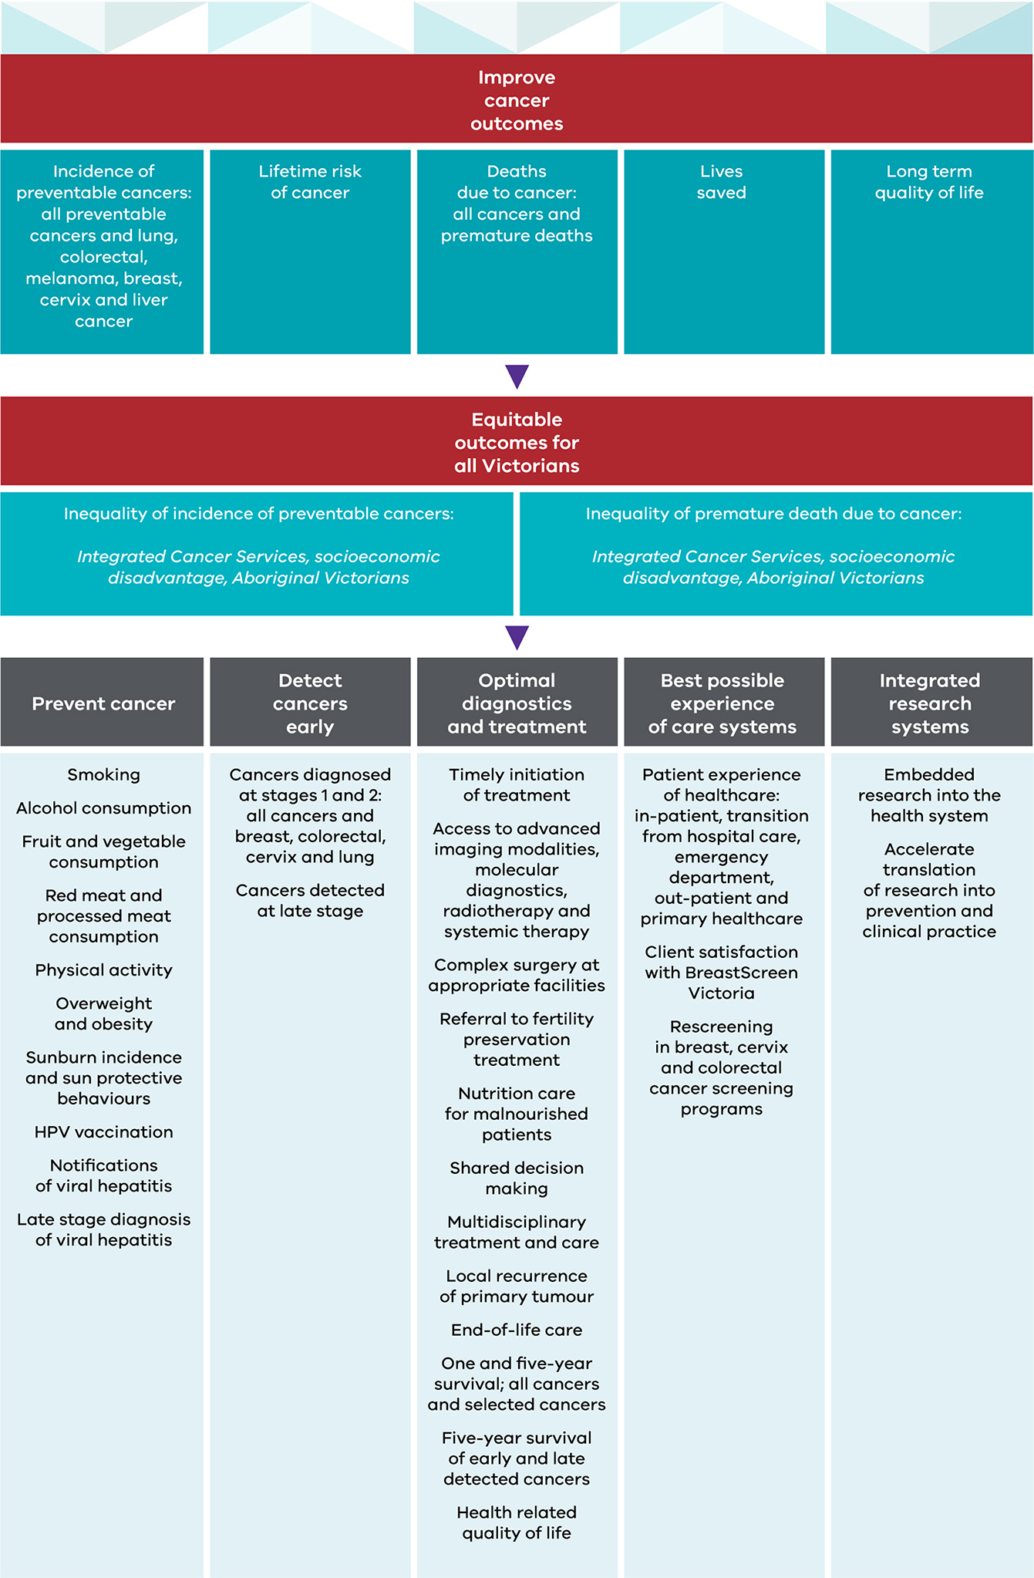

Purpose and application of the framework
The framework will be used to monitor and report on the status and impact of cancer in Victoria. It will enable a transparent and objective assessment of whether the goals of the Victorian cancer plan 2016–2020 and successive plans are achieved. Reporting against the framework will serve as a tool to channel collective efforts and actions to improve cancer outcomes, to achieve shared goals, to establish common directions for change, to adjust practice and to implement further reforms where needed.
The framework has been developed to serve multiple audiences. This includes those who will apply the framework, gather the relevant data required and/or read or disseminate the information reported.
It is a tool for all those with responsibilities aligned with the Victorian cancer plan 2016–20 and its successors. The Victorian Government will use the framework to report on cancer outcomes for Victorians, including changes over time and the equity of those changes, and will inform investment and implementation priorities across the prevention, screening, treatment and care of people with cancer.
At the statewide level, statutory authorities, not-for-profits and other organisations can use the framework to inform new plans and strategies, identify inequalities and monitor their contribution to improving cancer outcomes. It is anticipated that the framework may be used and adapted at the Integrated Cancer Service, regional or facility levels. Researchers can also use the framework to prioritise and inform their work on preventing and treating cancer. In addition, the information gained through reporting against the framework may support assessments of cancer outcomes at the national level.

Monitoring equalities
While the framework takes a whole-of-population or universal view, monitoring its progress towards the Victorian cancer plan 2016–2020 goal of ‘achieve equitable outcomes for all Victorians’ is fundamental. More generally, the framework will enable inequalities for all measures to be assessed according to specific population groups and geographic areas, where data is available and reporting is appropriate.
For many outcomes, the variation within a population group or within an area may be large. Statewide reporting masks these inequalities. The capacity of each measure to be reported at the state level by sociodemographic groups (age groups, sexes, Aboriginal and Torres Strait Islander Victorians, culturally and linguistically diverse groups and by socioeconomic status), and for reporting at multiple geographic levels, has been assessed and are listed for each measure in Appendix 2. The sociodemographic groups and geographic areas are defined in the Victorian cancer plan monitoring and evaluation framework: data dictionary.
Data collection for population groups and geographic areas is more complete for some measures than for others. For example, most measures are able to be reported for age and sex groups, but few are able to be reported for culturally and linguistically diverse populations. In addition, for some breakdowns, although data is collected it is of insufficient quality or the sample size is insufficient to robustly report.
The availability of data to report measures within population groups or areas – for example, socioeconomic status within a local council area or for Aboriginal Victorians in metropolitan Victoria – needs to be determined as part of future reporting.
Assessing inequalities requires selecting a point of comparison for each measure. The World Health Organization’s Constitution enshrines ‘the highest attainable standard of health as a fundamental right of every human being’. Reflecting the same ambition for cancer outcomes for all Victorians, and as articulated as a goal of the Victorian cancer plan 2016–2020, the point of comparison in the framework is the population/geographic area with the highest standard of health. However, it is recognised that the influences on health inequalities are extremely complex and very broad in scope, and not all factors are modifiable.

Reporting on and reviewing the framework
Through the Improving Cancer Outcomes Act, the Victorian Government is committed to preparing a cancer plan for Victoria every four years. As part of developing those plans, the Act requires a report on the status and burden of cancer in Victoria.
The Department of Health and Human Services will report against the framework in the third year of each four-year cycle. The baseline report will be finalised in 2019 to inform development of the Victorian cancer plan 2020–2025. In addition, reports on specific outcomes of the framework, or for specific population groups or geographic areas, can be produced.
The four-yearly framework reviews will fall in line with the development of future Victorian cancer plans. Regular reviews will ensure:
- new, relevant measures are included
- unspecified measures in the current framework are defined
  - measures are refined or replaced if the core components of cancer control or data availability change over time.
Changes in the framework will require updates to the Victorian cancer plan monitoring and evaluation framework: data dictionary.

Structure of the framework
The framework has four levels: outcomes, key result areas, indicators and measures. Each level provides increased specificity or technical detail. A summary of the framework architecture is shown in Figure 4.

Outcomes
Outcomes are the broad areas for action required to improve cancer outcomes. The Improving Cancer Outcomes Act and the Victorian cancer plan 2016–2020 provide the organising ‘dimensions’ required to improve cancer outcomes. While it is not stated for each desired outcome, a reduction in inequalities pertaining to the outcome is implied for each.

Key result areas
Key result areas show the direction of change required to improve specific cancer outcomes for all Victorians. They are sufficiently specific to indicate broad areas of measurement. All outcomes have more than one key result area, reflecting the multiple contributions required to achieve the desired outcome.

Indicators
Indicators define components of a key result area and indicate where improvement is clearly relevant, achievable and meaningful. All key result areas have more than one indicator, again recognising the requirement of multiple contributions to achieving the desired outcomes. The indicators are sufficiently specific to support measurement.

Measures
Measures provide an objective and standardised quantification of the size, amount or degree of the desired indicator. Measures are understandable, enable comparison and are robust. Measures were selected due to the capacity to monitor inequalities, with particular attention to the opportunity to report at the state level by sociodemographic groups, and for reporting at geographic levels. There is more than one measure for some indicators, particularly for measuring across age groups.
Measures are numbered to link with the metadata of each measure defined in the Victorian cancer plan monitoring and evaluation framework: data dictionary.

Figure 4: Architecture of the Victorian cancer plan monitoring and evaluation framework
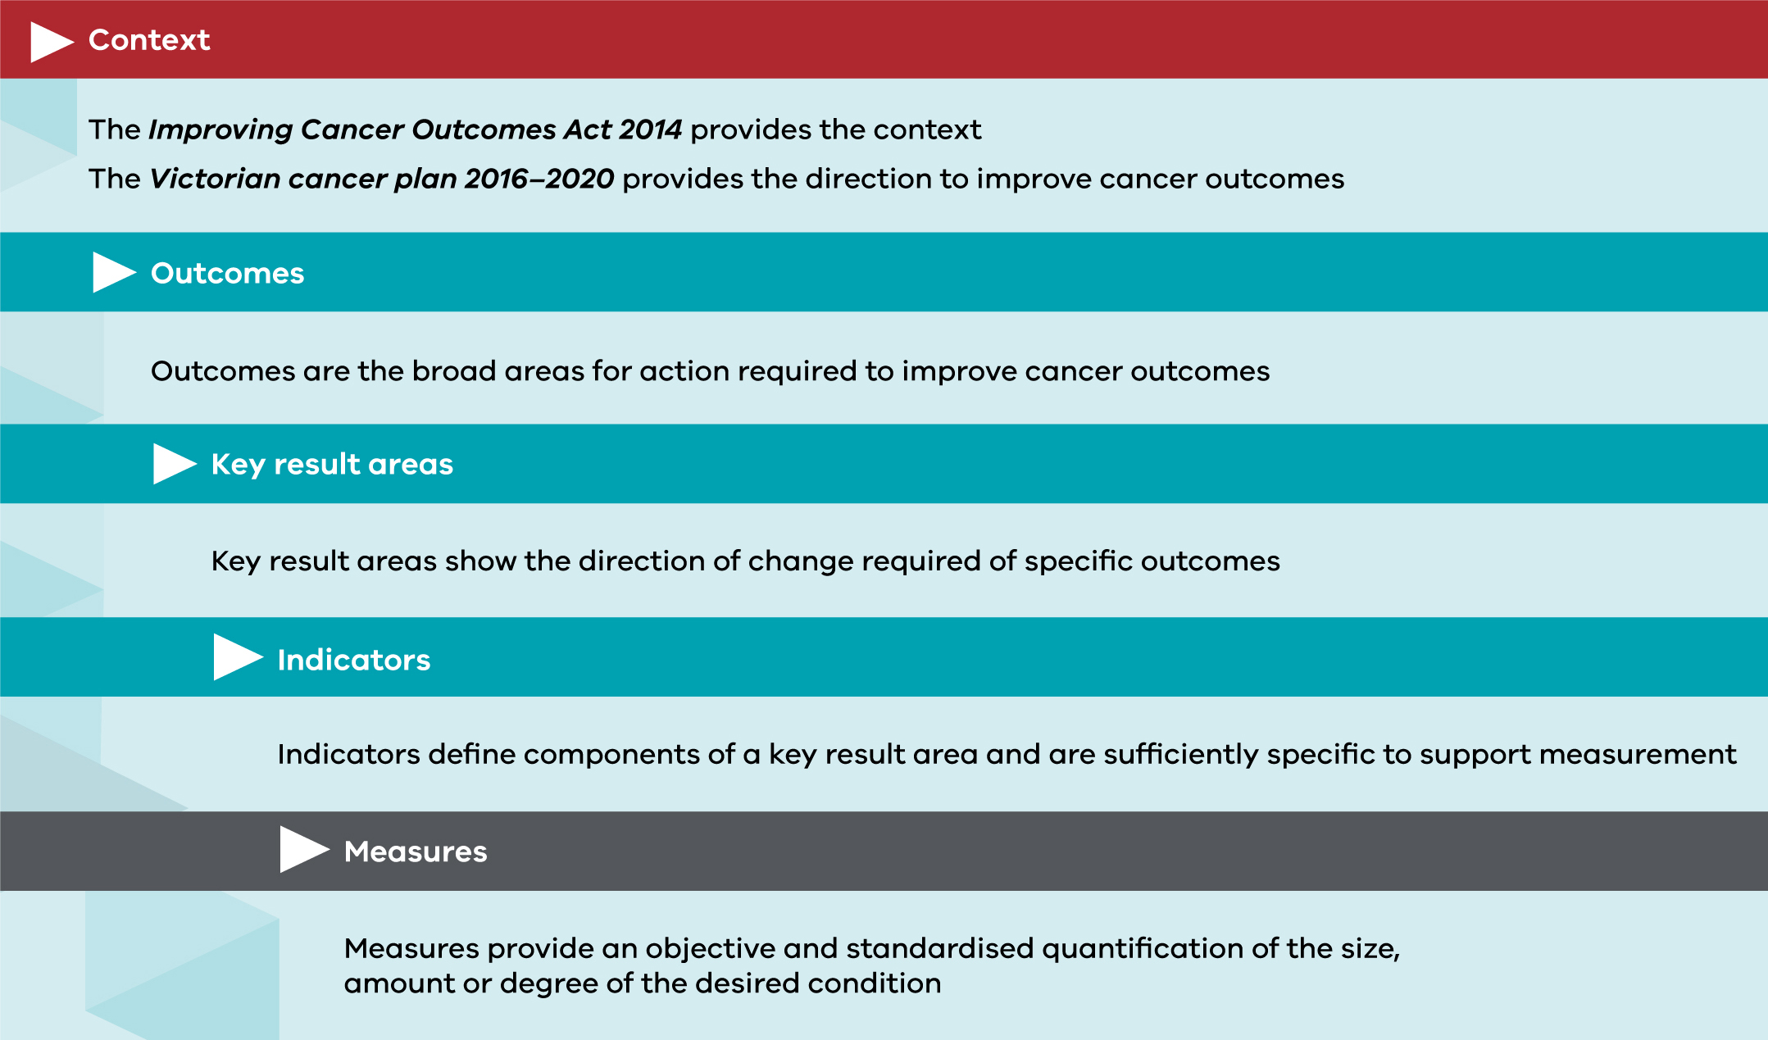

The framework

Outcome: Improve cancer outcomes

Key result area 1: Decrease incidence of preventable cancers
Indicators | Measures | Data dictionary reference
Incidence of preventable cancers | Incidence of preventable cancers | 1.1
Lifetime risk of cancer | Lifetime risk of cancer before the age of 85 years | 1.2
Incidence of lung, colorectal, melanoma, breast, liver and cervix cancer | Incidence of lung cancer | 1.3
 | Incidence of colorectal cancer | 1.4
 | Incidence of melanoma | 1.5
 | Incidence of female breast cancer | 1.6
 | Incidence of cervix cancer | 1.7
 | Incidence of liver cancer | 1.8

Key result area 2: Decrease deaths due to cancer
Indicators | Measures | Data dictionary reference
Deaths due to cancer | Death rate due to cancer | 2.1
 | Premature death rate due to cancer | 2.2
Lives saved | Number of deaths averted | 2.3

Key result area 3: Improve survivorship quality of life
Indicators | Measures | Data dictionary reference
Long-term quality of life | Quality of life post active therapy | 3.1

Outcome: Equitable outcomes for all Victorians

Key result area 4: Equitably reduce cancer incidence
Indicators | Measures | Data dictionary reference
Inequality of incidence of preventable cancers | Rate ratio of preventable cancer incidence between Integrated Cancer Services | 4.1
 | Rate ratio of preventable cancer incidence between socioeconomic disadvantage quintiles | 4.2
 | Rate ratio of preventable cancer incidence between Aboriginal and non-Aboriginal Victorians | 4.3

Key result area 5: Equitably reduce cancer deaths
Indicators | Measures | Data dictionary reference
Inequality of premature death due to cancer | Rate ratio of premature death due to cancer between Integrated Cancer Services | 5.1
 | Rate ratio of premature death due to cancer between socioeconomic disadvantage quintiles | 5.2
 | Rate ratio of premature death due to cancer between Aboriginal and non-Aboriginal Victorians | 5.3

Outcome: Prevent cancers

Key result area 6: Decrease smoking and harmful alcohol consumption
Indicators | Measures | Data dictionary reference
Smoking of adults and adolescents | Proportion of adults who smoke daily | 6.1
 | Proportion of adolescents 12–17 years who currently smoke3 | 6.2
Alcohol consumption of adults and adolescents | Proportion of adults who consume alcohol at lifetime risk of harm3 | 6.3
 | Proportion of adolescents 12–17 years who consume alcohol monthly3 | 6.4

Key result area 7: Increase healthier eating and active living
Indicators | Measures | Data dictionary reference
Fruit and vegetable consumption of adults, adolescents and children | Mean daily serves of fruit in adults | 7.1
 | Mean daily serves of fruit in adolescents 10–17 years4 | 7.2
 | Mean daily serves of fruit in children 4–12 years4 | 7.3
 | Mean daily serves of vegetables in adults4 | 7.4
 | Mean daily serves of vegetables in adolescents 10–17 years4 | 7.5
 | Mean daily serves of vegetables in children 4–12 years4 | 7.6
Red meat and processed meat consumption | Mean number of times per week that adults eat red meat | 7.7
 | Mean number of times per week that adults eat processed meat | 7.8
Physical activity of adults, adolescents and children | Proportion of adults who are sufficiently physically active4 | 7.9
 | Proportion of adolescents 10–17 years who are sufficiently physically active4 | 7.10
 | Proportion of children 5–12 years who are sufficiently physically active4 | 7.11

Key result area 8: Decrease obesity
Indicators | Measures | Data dictionary reference
Overweight and obesity of adults, adolescents and children | Proportion of adults who are overweight or obese (measured)4 | 8.1
 | Proportion of adults who are overweight or obese (self-report)4 | 8.2
 | Proportion of children 5–17 years who are overweight or obese (measured)4 | 8.3

Key result area 9: Decrease UV exposure
Indicators | Measures | Data dictionary reference
Sunburn incidence of adults | Proportion of 18–69 year olds who report getting sunburnt on the weekend | 9.1
Sun protection behaviour of adults | Proportion of 18–69 year olds wearing a combination of hats and/or sunscreen with one other key sun protective behaviour | 9.2

Key result area 10: Decrease HPV and viral hepatitis impact
Indicators | Measures | Data dictionary reference
Fully vaccinated against HPV | Proportion of adolescents 15 years of age fully vaccinated against HPV | 10.1
Notifications of viral hepatitis | Notification rate of unspecified hepatitis B | 10.2
 | Notification rate of unspecified hepatitis C | 10.3
Late-stage diagnosis of viral hepatitis | Proportion of people with hepatitis B diagnosed with liver cancer whose hepatitis B was diagnosed late | 10.4
 | Proportion of people with hepatitis C diagnosed with liver cancer whose hepatitis C was diagnosed late | 10.5

Outcome: Detect cancers early

Key result area 11: Increase early-stage diagnosis
Indicators | Measures | Data dictionary reference
Cancers diagnosed at stages 1 and 2 | Proportion of all cancers diagnosed at stages 1 and 2 | 11.1
Breast, colorectal, cervix and lung cancers diagnosed at stages  1 and 2 | Proportion of female breast cancers diagnosed at stages 1 and 2 | 11.2
 | Proportion of colorectal cancers diagnosed at  stages 1 and 2 | 11.3
 | Proportion of cervix cancers diagnosed at  stages 1 and 2 | 11.4
 | Proportion of lung cancers diagnosed at  stages 1 and 2 | 11.5
Cancers diagnosed at late stage | Proportion of all solid tumours diagnosed at  metastatic stage | 11.6

Outcome: Optimal diagnostics and treatment

Key result area 12: Increase adherence to optimal care pathways
Indicators | Measures | Data dictionary reference
Timely initiation of treatment | Median days from diagnosis to start of primary curative treatment | 12.1
Access to advanced imaging modalities | Proportion of patients receiving PET prior to primary treatment where appropriate | 12.2
Access to molecular diagnostics | Proportion of patients receiving molecular diagnostics prior to primary treatment where appropriate | 12.3
Access to radiotherapy | Proportion of patients receiving curative radiotherapy as part of their primary treatment where appropriate | 12.4
Access to systemic therapy | Proportion of patients receiving systemic therapy within recommended time lines and where appropriate | 12.5
Complex surgery at appropriate facilities | Proportion of complex surgery taking place at appropriate volume facilities | 12.6
Referral to fertility preservation treatment | Proportion of patients aged less than 40 years referred to fertility preservation treatment as part of their primary treatment | 12.7
The prevalence of malnutrition in cancer patients | Proportion of admitted cancer patients with a LOS > 1 day who have been coded as having malnutrition | 12.8
Shared decision making across the cancer pathway | Proportion of patients who reported being involved in the decisions about their care and treatment as much as they wanted to | 12.9
Multidisciplinary treatment and care | Proportion of newly diagnosed patients with evidence of multidisciplinary treatment plan in the patient records | 12.10
Local recurrence of primary tumour | Proportion of patients with local recurrence of primary tumour within two years of surgical resection or curative radiotherapy of a primary tumour | 12.11
End-of-life care | Proportion of patients receiving specialist palliative care within 12 months prior to death | 12.12
 | Proportion of patients receiving aggressive interventions within 30 days prior to death | 12.13
 | Proportion of deaths due to cancer that occur in hospitals | 12.14

Key result area 13: Increase one- and five-year survival
Indicators | Measures | Data dictionary reference
One-year survival | One-year survival from all cancers | 13.1
One-year survival from selected cancers | One-year survival from lung cancer | 13.2
 | One-year survival from pancreas cancer | 13.3
 | One-year survival from ovarian cancer | 13.4
 | One-year survival from colorectal cancer | 13.5
 | One-year survival from brain cancer | 13.6
 | One-year survival from oesophagus cancer | 13.7
 | One-year survival from acute myeloid leukaemia | 13.8
Five-year survival | Five-year survival from all cancers | 13.9
Five-year survival from selected cancers | Five-year survival from lung cancer | 13.10
 | Five-year survival from pancreas cancer | 13.11
 | Five-year survival from ovarian cancer | 13.12
 | Five-year survival from colorectal cancer | 13.13
 | Five-year survival from brain cancer | 13.14
 | Five-year survival from oesophagus cancer | 13.15
 | Five-year survival from acute myeloid leukaemia | 13.16
Five-year survival of early and late-detected cancers | Five-year survival from all cancers diagnosed at stages 1 and 2 | 13.17
 | Five-year survival from all cancers diagnosed at stages 3 and 4 | 13.18

Key result area 14: Improve quality of life
Indicators | Measures | Data dictionary reference
Health-related quality of life | Health-related quality of life following primary treatment | 14.1

Outcome: Best possible experience of care systems

Key result area 15: Improve patient experience of healthcare
Indicators | Measures | Data dictionary reference
Patient experience of inpatient health care | Proportion of adults admitted to public hospitals due to cancer who report positive overall healthcare experience | 15.1
 | Proportion of children and adolescents admitted to hospital due to cancer who report positive healthcare experience⁷ | 15.2
Patient experience of transition from inpatient health care | Proportion of adults admitted to public hospitals due to cancer who report positive transition from care index score | 15.3
Patient experience of emergency department health care | Proportion of adults attending emergency departments due to cancer who report positive overall healthcare experience | 15.4
Patient experience of outpatient health care | Proportion of people attending hospital out-patients due to cancer who report positive healthcare experience⁷ | 15.5
Patient experience of primary health care | Proportion of people attending primary care due to cancer who report positive healthcare experience⁷ | 15.6

Key result area 16: Improve patient experience of screening
Indicators | Measures | Data dictionary reference
Client satisfaction with BreastScreen Victoria | Proportion of women who have a mammogram by BreastScreen Victoria who rate the service as highly satisfactory | 16.1
Breast cancer rescreening rate | Proportion of women who are rescreened at BreastScreen Victoria within 27 months after the first screen | 16.2
Cervical cancer rescreening rate | Proportion of women who are rescreened for cervix cancer within the 30 months after the previous screen | 16.3
Bowel cancer rescreening rate | Proportion of adults who are rescreened by National Bowel Cancer Screening Program | 16.4

Outcome: Integrated research systems

Key result area 17: Innovations and improved evidence of best practice
Indicators | Measures | Data dictionary reference
Embedded research into the health system | Number of new enrolments in cancer intervention clinical trials | 17.1
 | Number of recruiting cancer intervention clinical trials | 17.2
 | Number of human research ethics committee approved cancer-related studies | 17.3
Accelerate translation of research into prevention and clinical practice | Ratio of eligible patients who receive new systemic anti-cancer therapy (SACT) medications within 12 months of listing on the Pharmaceutical Benefits Scheme (PBS) to cancer incidence | 17.4
 | Quit ratio of rate of sustained ex-smokers to rate of ever smokers | 17.5

Appendix 1: Development process, criteria and inequality assessment

Development of the framework
The Victorian cancer plan monitoring and evaluation framework was developed through research and consultation. This included:
- a review of the literature including cancer and cancer-related outcomes frameworks in use or development by the Victorian Government and organisations in other state and territory, national and international arenas
- consultation and feedback from more than 120 organisations and individuals at metropolitan and regional forums, via online submissions and through face-to-face meetings, including:
    - cancer clinicians from related specialties including oncologists, surgeons and palliative care physicians
    - screening and prevention practitioners and key stakeholder organisations from non-government organisations and universities
    - cancer prevention and treatment researchers from universities and non-government organisations
      - policy and data experts within the Department of Health and Human Services and other key stakeholders.
The final framework was then assessed for:
- coherency and comprehensiveness
- manageability, where the set of indicators and measures should be as few as possible for manageable reporting and focus on monitoring what matters.

Criteria for indicators and measures
The indicator criteria are:
- compelling
    - indicator of cancer outcome
    - major cause of cancer outcomes across the continuum
    - improvement in the indicator will improve cancer outcomes
      - improvement in the indicator will help reduce inequalities in cancer outcomes
- achievable
      - amenable to evidence-based intervention (for example, by clinicians, screening or prevention practitioners, regional and local authorities and/or state government)
- relevant
      - aligns with the government’s directions for improving cancer outcomes
- understandable
      - meaningful to, and likely to be perceived as important by, the public and stakeholders.

Measures in the framework describe how changes in indicators will be assessed. The measure criteria are:
- understandable
      - meaningful to, and likely to be perceived as important by, the public and stakeholders
- comparable
    - data available for sociodemographic populations and geographic areas, enabling assessment of inequalities
      - allows national and international comparison
- robust – statistically appropriate and fit for purpose:
    - measures what it is intended to measure
    - measure allow change over time to be detected
    - data is available (by February 2018) at least every four years, to monitor the measure
    - measure is not vulnerable to perverse incentives that might lead to the negative outcomes or behaviours.

Breakdown of measures: local disaggregation, inequalities and equality assessment
The capacity to assess if changes in cancer outcomes for the population are equally shared by all is a key intent of the framework. The availability of data for the following groups was assessed:
- age groups
- sex categories
- Aboriginal and Torres Strait Islander people in Victoria
- socioeconomic status, using the classification schemes of Socio-Economic Indexes for Areas quintiles and household income categories
- culturally and linguistically diverse populations, using classification schemes based on country of birth, preferred language and principal language spoken at home
  - geographic areas of Victoria such as metropolitan and rural Victoria, Integrated Cancer Services and local government areas.
In addition, some measures can be reported by the major tumour streams.
There are many classification schemes for most of these sociodemographic population groups and geographic areas; their use varies between the data sources included in the framework. The Victorian cancer plan monitoring and evaluation framework: data dictionary defines each of these classification schemes and lists which scheme is applied to each measure of the framework.
The capacity of each measure to be reported at the state level by sociodemographic groups and by geographic levels are listed for each measure in Appendix 2.

Appendix 2: Available population groups and geographic area breakdowns for measures
Key
 | Currently collected and available
 | Not currently collected
TBD | Further work is required to develop the measure and/or data source
N/A | Not applicable to this indicator
Definitions
Cultural diversity: | Measures can be reported for culturally diverse populations using classifications of main language other than English spoken at home or another language, or being born or having one parent born in a country of culturally and linguistically diverse background.
Socioeconomic status: | Measures can be reported for socioeconomically diverse populations using classifications of SEIFA, household income or household having a health care card.
Regions | Measures can be reported for regions based on the eight departmental operational areas.
Metropolitan/rural | Measures can be reported for regions based on the metropolitan or rural categorisation of the eight departmental operational areas or Accessibility/Remoteness Index of Australia (ARIA+), which in Victoria has three categories: major cities, inner regional and outer regional.
Further detail about these definitions is available from the Victorian cancer plan monitoring and evaluation framework: data dictionary.
Note that in the following table: Age, Sex, Aboriginal Victorians, Cultural diversity and Socioeconomic status are socio-demographic groups. Metropolitan/rural, Regions, ICS are LGA are geographical groups.

Measure | State | Age | Sex | Aboriginal Victorians | Cultural diversity | Socioeconomic status | Metropolitan/rural | Regions | ICS | LGA
1.1 Incidence of preventable cancers
1.2 Lifetime risk of cancer before the age of 85 years
1.3 Incidence of lung cancer
1.4 Incidence of colorectal cancer
1.5 Incidence of melanoma
1.6 Incidence of female breast cancer
1.7 Incidence of cervix cancer
1.8 Incidence of liver cancer
2.1 Death rate due to cancer
2.2 Premature death rate due to cancer
2.3 Number of deaths averted
3.1 Quality of life post active therapy (TBD) |  | TBD | TBD | TBD | TBD | TBD | TBD | TBD | TBD | TBD
4.1 Rate ratio of preventable cancer incidence between Integrated Cancer Services |  |  |  |  |  |  | N/A | N/A | N/A | N/A
4.2 Rate ratio of preventable cancer incidence between socioeconomic disadvantage quintiles |  |  |  |  |  | N/A | N/A | N/A |  | N/A
4.3 Rate ratio of preventable cancer incidence between Aboriginal and non-Aboriginal Victorians |  |  |  | N/A | N/A
5.1 Rate ratio of premature death due to cancer between Integrated Cancer Services |  |  |  |  |  |  | N/A | N/A | N/A | N/A
5.2 Rate ratio of premature death due to cancer between socioeconomic disadvantage quintiles |  |  |  |  |  | N/A | N/A | N/A |  | N/A
5.3 Rate ratio of premature death due to cancer between Aboriginal and non-Aboriginal Victorians |  |  |  | N/A | N/A
6.1 Proportion of adults who smoke daily
6.2 Proportion of adolescents
12–17 years who currently smoke
6.3 Proportion of adults who consume alcohol at lifetime risk of harm
6.4 Proportion of adolescents
12–17 years who consume alcohol monthly
7.1 Mean daily serves of fruit in adults
7.2 Mean daily serves of fruit in adolescents 10–17 years
7.3 Mean daily serves of fruit in children 4–12 years
7.4 Mean daily serves of vegetables in adults
7.5 Mean daily serves of vegetables in adolescents
10–17 years
7.6 Mean daily serves of vegetables in children
4–12 years
7.7 Mean number of times per week that adults eat red meat |  | TBD | TBD | TBD | TBD | TBD | TBD | TBD | TBD | TBD
7.8 Mean number of times per week that adults eat processed meat |  | TBD | TBD | TBD | TBD | TBD | TBD | TBD | TBD | TBD
7.9 Proportion of adults who are sufficiently physically active
7.10 Proportion of adolescents
10–17 years who are sufficiently physically active
7.11 Proportion of children
5–12 years who are sufficiently physically active
8.1 Proportion of adults who are overweight or obese (measured)
8.2 Proportion of adults who are overweight or obese (self-report)
8.3 Proportion of children
5–17 years who are overweight or obese (measured)
9.1 Proportion of adults 18–69 years who report getting sunburnt on the weekend
9.2 Proportion of adults
18–69 years wearing a combination of hats and/or sunscreen with one other key sun protective behaviour
10.1 Proportion of adolescents 15 years of age fully vaccinated against HPV |  | N/A
10.2 Notification rate of unspecified hepatitis B
10.3 Notification rate of unspecified hepatitis C
10.4 Proportion of people with hepatitis B diagnosed
with liver cancer, whose hepatitis B was diagnosed late
10.5 Proportion of people with hepatitis C diagnosed with liver cancer, whose hepatitis C was diagnosed late
11.1 Proportion of all cancers diagnosed at stages
1 and 2
11.2 Proportion of female breast cancers diagnosed at stages 1 and 2
11.3 Proportion of colorectal cancers diagnosed at stages 1 and 2
11.4 Proportion of cervix cancers diagnosed at stages 1 and 2
11.5 Proportion of lung
cancers diagnosed at stages 1 and 2
11.6 Proportion of all solid tumours diagnosed at metastatic stage
12.1 Median days from diagnosis to start of primary curative treatment
12.2 Proportion of patients receiving PET prior to primary treatment where appropriate |  | TBD | TBD | TBD | TBD | TBD | TBD | TBD |  | TBD
12.3 Proportion of patients receiving molecular diagnostics prior to primary treatment where appropriate (TBD) |  | TBD | TBD | TBD | TBD | TBD | TBD | TBD | TBD | TBD
12.4 Proportion of patients receiving curative radiotherapy as part of their primary treatment where appropriate
12.5 Proportion of patients receiving systemic therapy within recommended time lines and where appropriate
12.6 Proportion of complex surgery taking place at appropriate volume facilities
12.7 Proportion of patients aged less than 40 years referred to fertility preservation treatment as part of their primary treatment |  | TBD | TBD | TBD | TBD | TBD | TBD | TBD | TBD | TBD
12.8 Proportion of admitted cancer patients with a  LOS > 1 who have been coded as having malnutrition |  |  |  |  |  |  |  |  | 9
12.9 Proportion of patients who reported being involved in the decisions about their care and treatment as much as they wanted to
12.10 Proportion of newly diagnosed patients with evidence of multidisciplinary treatment plan in the patient records
12.11 Proportion of patients with local recurrence of primary tumour within two years of surgical resection or curative radiotherapy of a primary tumour
12.12 Proportion of patients receiving specialist palliative care within 12 months prior to death
12.13 Proportion of patients receiving aggressive interventions within 30 days prior to death
12.14 Proportion of deaths due to cancer that occur in hospitals
13.1 One-year survival from all cancers
13.2 One-year survival from lung cancer
13.3 One-year survival from pancreas cancer
13.4 One-year survival from ovarian cancer |  |  | N/A
13.5 One-year survival from colorectal cancer
13.6 One-year survival from brain cancer
13.7 One-year survival from oesophagus cancer
13.8 One-year survival from acute myeloid leukaemia
13.9 Five-year survival from all cancers
13.10 Five-year survival from lung cancer
13.11 Five-year survival from pancreas cancer
13.12 Five-year survival from ovarian cancer |  |  | N/A
13.13 Five-year survival from colorectal cancer
13.14 Five-year survival from brain cancer
13.15 Five-year survival from oesophagus cancer
13.16 Five-year survival from acute myeloid leukaemia
13.17 Five-year survival from all cancers diagnosed at stages 1 and 2
13.18 Five-year survival from all cancers diagnosed at stages 3 and 4
14.1 Health-related quality of life following primary treatment (TBD) |  | TBD | TBD | TBD | TBD | TBD | TBD | TBD | TBD | TBD
15.1 Proportion of adults admitted to public hospitals due to cancer who report positive overall healthcare experience
15.2 Proportion of children and adolescents admitted to hospital due to cancer who report positive healthcare experience (TBD) |  | TBD | TBD | TBD | TBD | TBD | TBD | TBD | TBD | TBD
15.3 Proportion of adults admitted to public hospitals due to cancer who report positive transition from care index score
15.4 Proportion of adults attending emergency departments due to cancer who report positive overall healthcare experience (TBD) |  | TBD | TBD | TBD | TBD | TBD | TBD | TBD | TBD | TBD
15.5 Proportion of people attending hospital outpatients due to cancer who report positive healthcare experience (TBD) |  | TBD | TBD | TBD | TBD | TBD | TBD | TBD | TBD | TBD
15.6 Proportion of people attending primary care due to cancer who report positive healthcare experience (TBD) |  | TBD | TBD | TBD | TBD | TBD | TBD | TBD | TBD | TBD
16.1 Proportion of women who have a mammogram by BreastScreen Victoria who rate the service as highly satisfactory |  |  | N/A
16.2 Proportion of women who are rescreened at BreastScreen Victoria within 27 months after the first screen |  |  | N/A
16.3 Proportion of women who are rescreened for cervix cancer within 30 months after the previous screen |  |  | N/A
16.4 Proportion of adults who are rescreened by National Bowel Cancer Screening Program
17.1 Number of new enrolments in cancer intervention clinical trials |  | N/A | N/A | N/A | N/A | N/A
17.2 Number of recruiting cancer intervention clinical trials |  | N/A | N/A | N/A | N/A | N/A
17.3 Number of human research ethics committee approved cancer-related studies |  | N/A | N/A | N/A | N/A | N/A
17.4 Ratio of eligible patients who receive new SACT medications within  12 months of listing on the PBS to cancer incidence |  | N/A | N/A | N/A | N/A | N/A
17.5 Quit ratio of rate of sustained ex-smokers to rate of ever smokers

Victorian public health and wellbeing outcomes framework measure.
Resources to resolve these outstanding measures in the future are yet to be confirmed. The baseline report will note that the measures are yet to be determined.
Victorian public health and wellbeing outcomes framework measure.
Victorian public health and wellbeing outcomes framework measure
Resources to resolve these outstanding measures in the future are yet to be confirmed. The baseline report will note that the measures are yet to be determined.
Resources to resolve these outstanding measures in the future are yet to be confirmed. The baseline report will note that the measures are yet to be determined.
Resources to resolve these outstanding measures in the future are yet to be confirmed. The baseline report will note that the measures are yet to be determined.
Available breakdowns based on current data source
Available for ICS that undertake survey/audit
Available for ICS that undertake survey/audit

