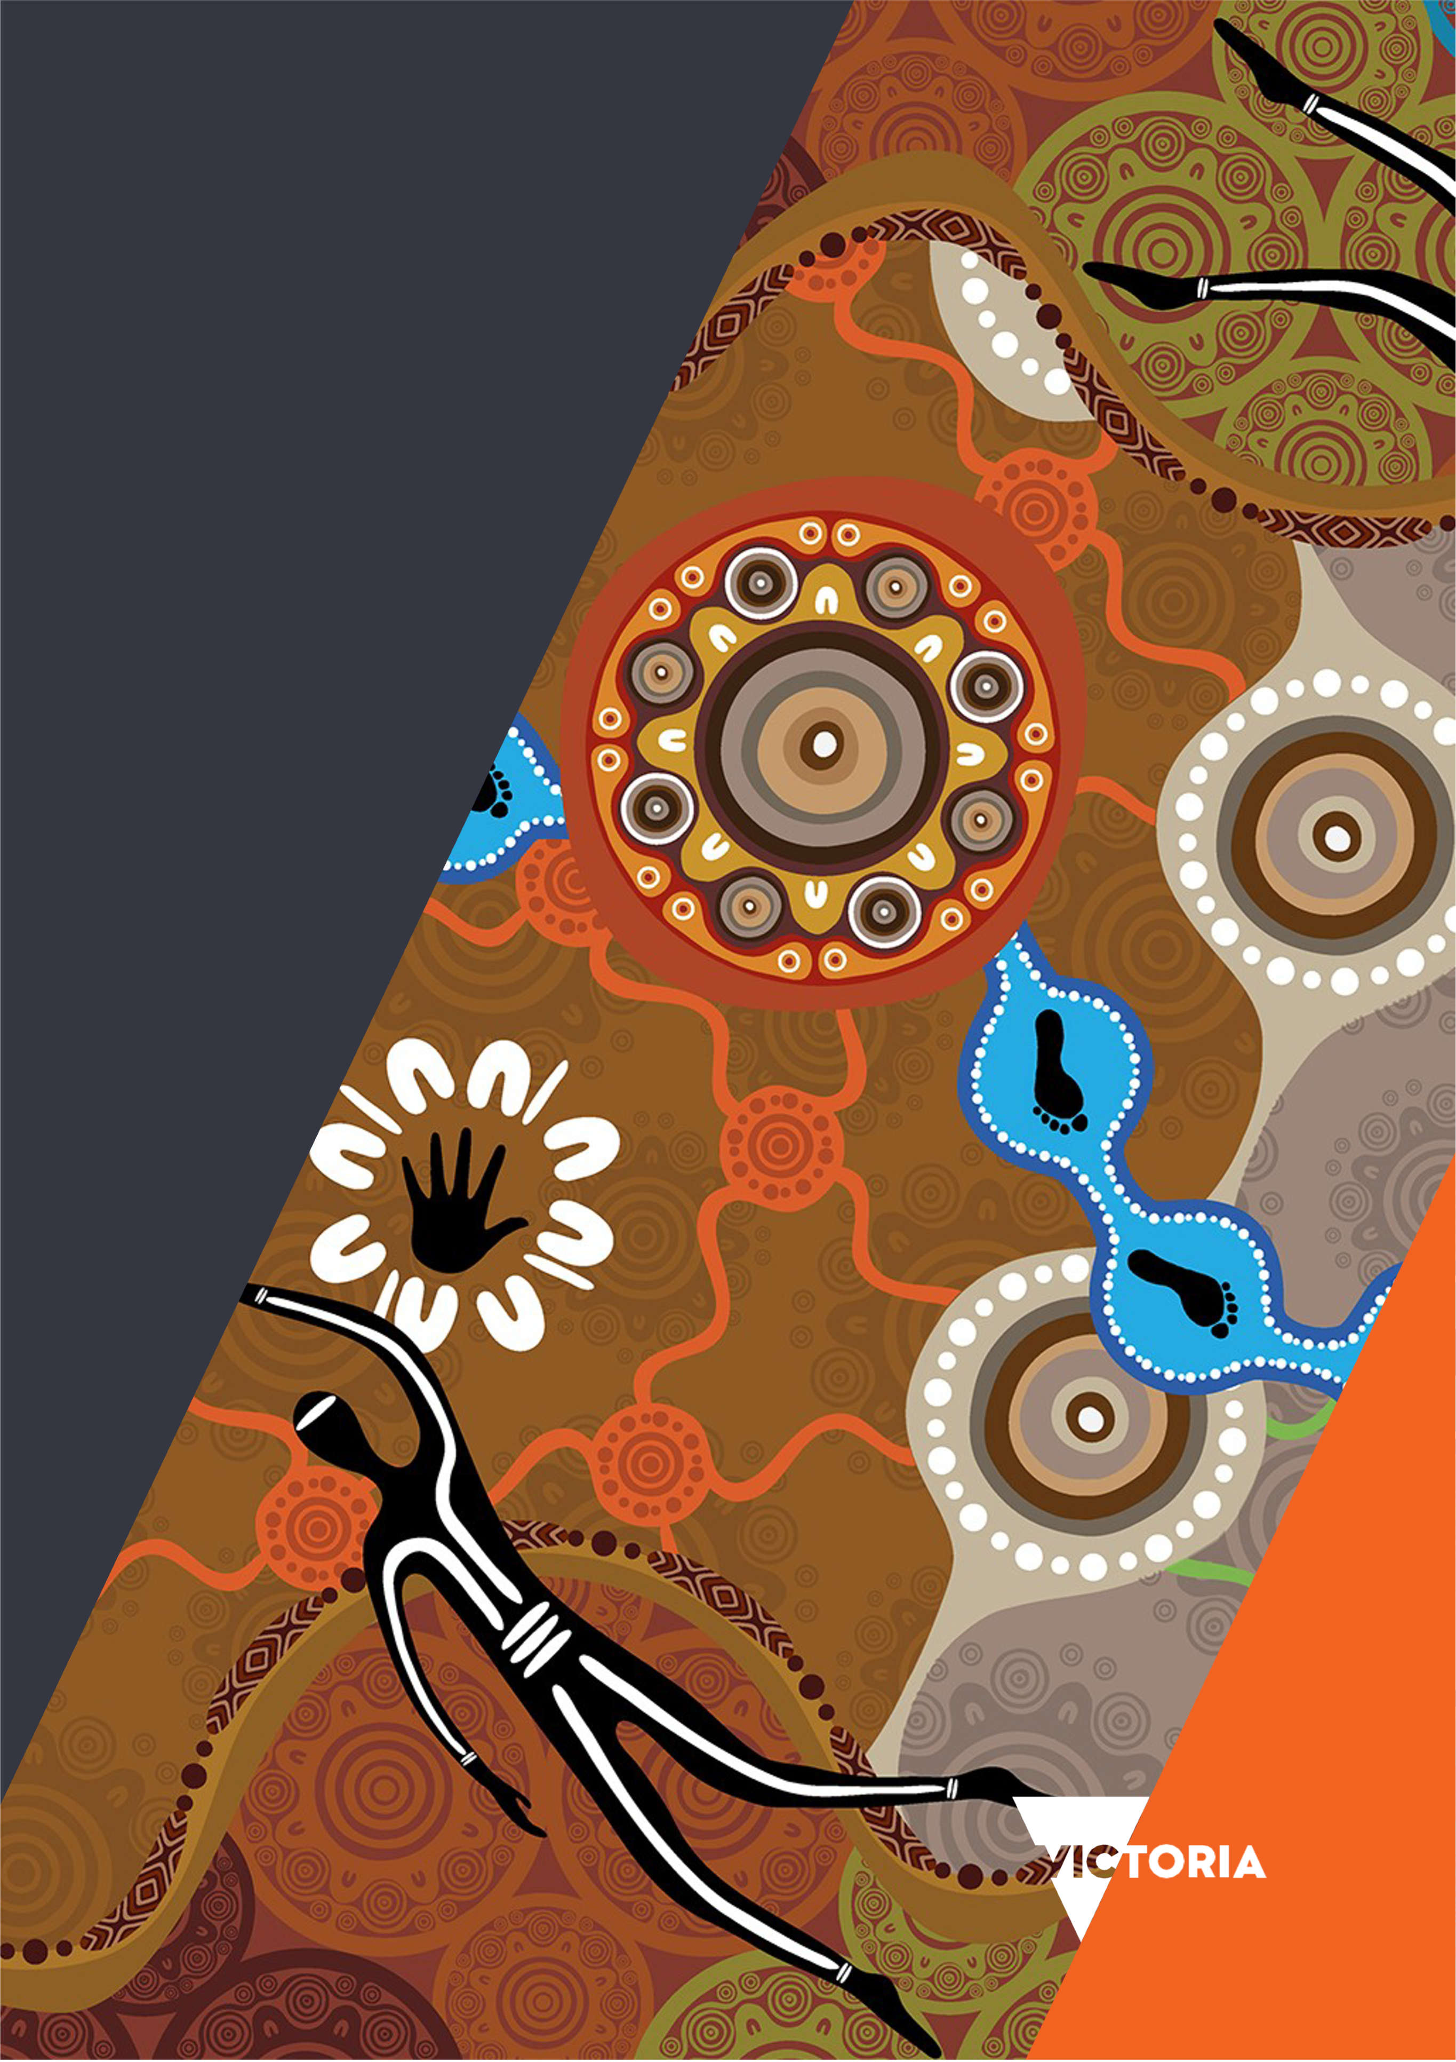
Aboriginal workforce strategy
2021–2026
Department of Health
and
Department of Families, Fairness and Housing

To receive this document in another format, email People and Culture <diversityinclusion@support.vic.gov.au>
Authorised and published by the Victorian Government, 1 Treasury Place, Melbourne.
© State of Victoria, Australia, Department of Health and Department of Families, Fairness and Housing, September 2021.
ISBN 978-1-76096-461-0 (PDF/MS Word Online)
Available at DFFH – Aboriginal workforce strategy 2021-2026 <https://www.vic.gov.au/dffh/aboriginal-workforce-strategy-2021-2026>
https://www.vic.gov.au/dffh/aboriginal-workforce-strategy-2021-2026
and Health.vic – Aboriginal workforce strategy 2021-2026 <https://www2.health.vic.gov.au/health-workforce/strategy-and-planning/workforce-strategy/aboriginal-workforce-strategy-2021-2026>
(DH2105057)

Acknowledgements

Cover artwork and about the artist
The artwork Yanyabak Dana means ‘to walk towards or on a pathway’ in the Yorta Yorta language.
The artist Dixon Patten is a traditional descendant from the Gunnai (Gippsland), Yorta Yorta (Goulburn Valley), Gunditjmara (Western District) and Dhuduroa (Snowy Mountains) peoples.
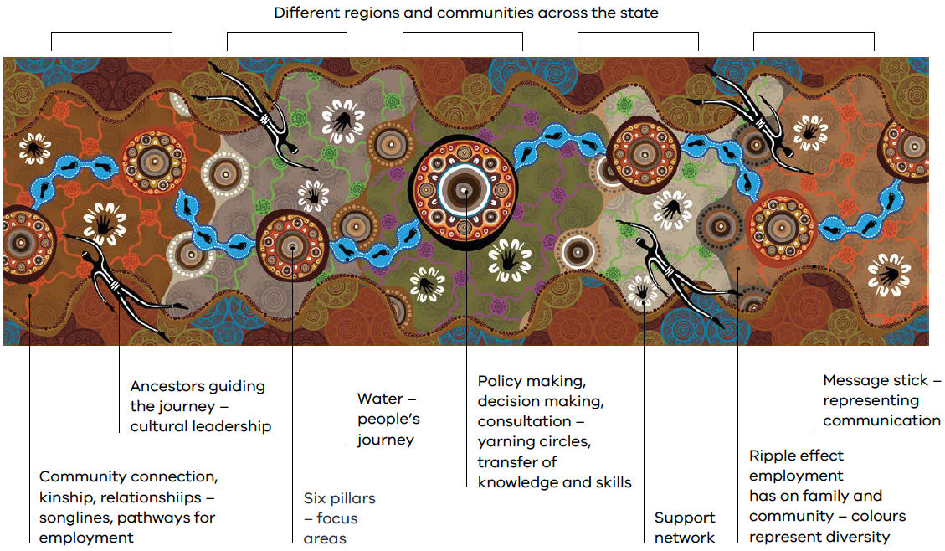

Acknowledgment of Traditional Owners
The Department of Health and the Department of Families, Fairness and Housing acknowledge the Traditional Owners of country throughout Victoria and pay respect to and recognise the contribution from their Elders past and present. We proudly acknowledge the strength and resilience of First Nation peoples as the world’s oldest living culture and the contribution of generations of Aboriginal leaders who have fought tirelessly for the rights of their people and communities.
We recognise the intergenerational consequences of colonisation, dispossession, child removal and other discriminatory government policies and acknowledge that the impacts and structures of colonisation still exist today.
Our departments are committed to addressing these impacts by embedding cultural safety and self-determination in all that we do so that Aboriginal Victorians have decision-making power and control to determine what is best for them.
Aboriginal self-determination is a human right as enshrined in the United Nations Declaration on the Rights of Indigenous Peoples. We are committed to developing strong and enduring self-determined partnerships with Aboriginal communities that will contribute to growing a prosperous, healthy and strong Victorian Aboriginal community.

Aboriginal and Torres Strait Islander Recognition statement
The Department of Health and the Department of Families, Fairness and Housing pay respect to and recognise the contribution of all Aboriginal and Torres Strait Islander people living and working in Victoria.
Throughout this document the term ‘Aboriginal’ is used to refer to both Aboriginal and Torres Strait Islander people.

Secretary foreword
We are delighted to introduce the Aboriginal workforce strategy 2021–2026, which sets out our goal to become the employer of choice for Aboriginal people.
This strategy demonstrates our commitment to embed the principles of true self-determination and cultural safety into our employee experience. By doing this, we will improve health, safety and wellbeing outcomes for Aboriginal communities.
To become an employer of choice for Aboriginal people we will create an outstanding culturally safe employee experience, where individuals are valued for their cultural knowledge and lived experience.
This strategy spans our two departments, building on the important progress and achievements made by the former Department of Health and Human Services (DHHS) under its Aboriginal employment strategy 2016–2021.
DHHS exceeded its Aboriginal employment target of two per cent, increased the number of Aboriginal executives, grew the engaged and impassioned Aboriginal Staff Network and delivered the Aboriginal and Torres Strait Islander cultural safety framework 2019.
But we both know that there is still a lot of work to do.
This strategy has been developed in collaboration with our Aboriginal and Torres Strait Islander employees. Our process was guided by listening to the lived experiences of our people.
This consultation meant we were able to develop strategic objectives and outcomes that truly reflect the work that needs to be done and how that work can be implemented in culturally safe ways.
Self-determination underpins this plan, aligning us with the Victorian Government’s commitment to the practical outcomes of both the Treaty process and truth-telling through the Yoo-rrook Commission.
We are working from a positive and progressive backdrop, where the goals set out in Victoria’s Closing the Gap implementation plan can be successfully achieved.
How we implement this strategy will be different between the Department of Health and the Department of Families, Fairness and Housing, but our commitment is shared.
We want the Aboriginal and Torres Strait workforce to feel culturally safe, have the power of self-determination and thrive in the workplace by helping shape policies and projects that support their wider community.
By improving Aboriginal and Torres Strait Islander outcomes across Victorian Government, we’re well on the way to achieving our commitments set in our previous Aboriginal and Torres Strait Islander frameworks and strategic plans.
Thank you to everyone involved in bringing this strategy to life, particularly the invaluable work, dedication and leadership of our Aboriginal staff. We are excited for the future as we walk together in partnership, delivering the very best health outcomes for all Victorians.
Professor Euan M Wallace AM,
Secretary Department of Health
Sandy Pitcher,
Secretary Department of Families, Fairness and Housing
Contents
Acknowledgements 3
Secretary foreword 5
Overview of our departments 7
Department of Health 7
Department of Families, Fairness and Housing 7
Victorian Aboriginal affairs landscape – enabling self-determination 9
Treaty in Victoria 9
Yoo-rrook Justice Commission 9
National Agreement on Closing the Gap 9
Victorian Government commitments 10
Our vision and achievements 12
Our vision 12
Cultural safety and self-determination 12
What we have achieved 12
Doing things differently: a better Aboriginal employee experience 14
What we know 14
What we’ll do 14
Our model for an improved Aboriginal employee experience 15
Our framework for change 16
Aboriginal employee journey 17
Employee touchpoints 17
Aboriginal workforce strategy outcomes framework 25
Appendix: Image descriptions 29
Cover artwork – Yanyabak Dana 29
Victorian Government commitments 31
Framework for change 32

Overview of our departments

Department of Health
The Department of Health was established to advance the government’s policy priorities in improving patient outcomes and experience for all Victorians. The department is responsible for health and ambulance services, mental health and ageing portfolios. We also lead the government’s public health response and recovery associated with the coronavirus (COVID-19) pandemic. The COVID-19 crisis has created both need and opportunities for significant improvements in health system governance and service delivery. It has shown us that a connected health system, with close relationships between the department, clinicians and consumers, will enable us to build an even stronger Victorian health system. The health system will remain at the very heart of Victoria’s recovery effort – looking after families and taking care of Victorians’ loved ones.
The final report of the Royal Commission into Victoria's Mental Health System was delivered on 3 February 2021 and tabled in Parliament by the Victorian Government on 2 March 2021. Thirty-three recommendations were made, including one recommendation focused on supporting Aboriginal social and emotional wellbeing. The recommendation:
- calls for more Aboriginal social and emotional wellbeing teams across Victoria
- supports new scholarships to help grow the Aboriginal mental health workforce
- supports the development of an Aboriginal Social and Emotional Wellbeing Centre that provides clinical support and research capacity.

Department of Families, Fairness and Housing
The Department of Families, Fairness and Housing leads policies and services dedicated to community wellbeing. The department works to create equal opportunities for all Victorians to live a safe, respected and valued life. The department is responsible for:
- child protection
- housing
- disability
- the prevention of family violence
- multicultural affairs
- lesbian, gay, bisexual, trans and gender diverse, intersex, queer and questioning (LGBTIQ) communities
- gender equality
- veterans
- women
- youth.
Korin Korin Balit-Djak system transformation is the department's overarching strategy and acknowledges the importance of culture as a determinant of Aboriginal health, wellbeing and safety. This includes identity, language, spirituality and connection to country, family and community.

The system transformation is underpinned by three guiding principles:
- Aboriginal-led collective action
- Aboriginal self-determination
- systemic change.
These principles enable stronger forms of Aboriginal self-determination across the community and health systems.
Homes Victoria works with the Aboriginal community to ensure better housing outcomes. Through the Victorian Aboriginal Housing and Homelessness Framework (VAHHF), Aboriginal Victorians have a key role in the design, development and delivery of housing, consistent with principles of Aboriginal self-determination.
At Family Safety Victoria, Dhelk Dja: Safe our way – strong culture, strong peoples, strong families 2018–2028 is the key Aboriginal-led Victorian agreement that commits Aboriginal communities, Aboriginal services and government to work together and be accountable for ensuring that Aboriginal people, families and communities are stronger, safer, thriving and living free from family violence.

Victorian Aboriginal affairs landscape – enabling self-determination
This strategy incorporates the Victorian Government Aboriginal Affairs commitments and policy to ensure we listen, learn and enable true self-determination for Aboriginal people as a fundamental requirement of how our departments deliver for communities. Our departments’ Aboriginal policies and frameworks align with embedding self-determination and cultural safety in all that we do.
The Victorian Government’s commitments and policies are set out in national, state and departmental policies, frameworks and agreements (see diagram on the next page).

Treaty in Victoria
The Victorian Government is leading the country through its work towards treaty by listening to the aspirations of Aboriginal Victorians. Treaty is an opportunity to recognise and celebrate the unique status, rights, cultures and histories of Aboriginal Victorians. It is also an opportunity to address wrongdoings and redefine relationships between the state, Aboriginal Victorians and non-Aboriginal Victorians.
The First Peoples’ Assembly of Victoria will progress treaty as the elected voice of Aboriginal people and communities.

Yoo-rrook Justice Commission
In March 2021, the Victorian Government announced the establishment of the Yoo-rrook Justice Commission as the nation’s first truth-telling process. The commission will investigate historical and ongoing injustices committed against Aboriginal Victorians since colonisation, by the state and non-state entities across all areas of social and political life. It will engage Aboriginal and non-Aboriginal community to achieve its aims of truth-telling and listening.

National Agreement on Closing the Gap
The Victorian Government is a signatory to the National Agreement on Closing the Gap. The agreement requires action in 17 socioeconomic areas that have impacted on life outcomes for Aboriginal people. Many of these action areas fall under the direct responsibility of the Department of Health and the Department of Families, Fairness and Housing and our departments will work together to take the actions required to help close the gap.

Victorian Government commitments
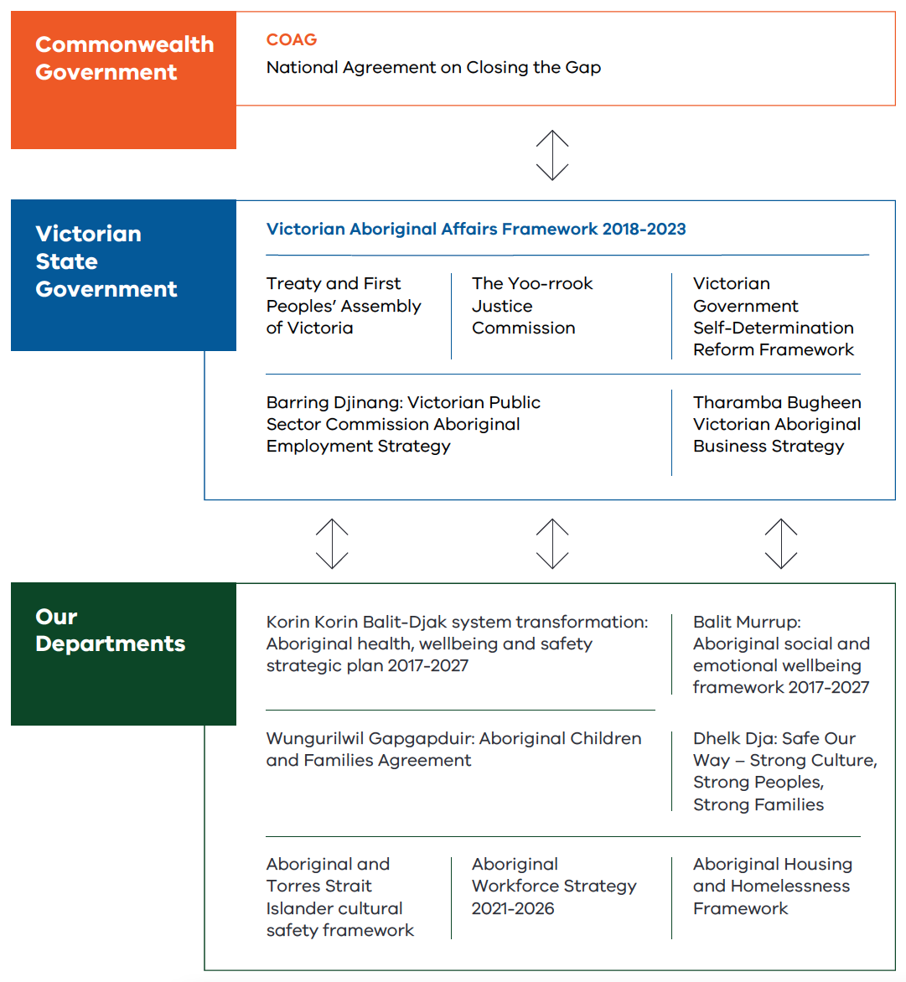

‘The Victorian treaty movement led by 32 elected Aboriginal men and women is shaping the development of architecture to build a framework to negotiate treaty across Victoria at the state and local level. Practical alignment exists with the previous Aboriginal employment strategy 2016–2021 and the Aboriginal workforce strategy 2021–2026, notwithstanding many theoretical and practical links exist with the United Nations Declaration on the Rights of Indigenous People (UNDRIP), the First Peoples’ Assembly’s work and the Aboriginal workforce strategy, all have line of sight to career empowerment. The UNDRIP is one agreement which provides a positive roadmap to realisation of full self-determination.
Our responsibilities as public servants are to stand up and ensure the strategy is operationalised with the expected intent. The workforce strategy is important for engagement, to continuously build our capacity and capability in delivering improved outcomes across communities, whilst at the same time engage in the economic benefits that society offers – of which many of our people are excluded or denied access too.’
– Troy McDonald, Chairman GunaiKurnai Land and Waters Aboriginal Corporation and Co-Chair First Peoples’ Assembly of Victoria Yoo-rrook Truth Telling Committee.

Our vision and achievements

Our vision
The purpose of this Aboriginal workforce strategy 2021–2026 (the strategy) is to provide a framework for the Department of Health and the Department of Families, Fairness and Housing to achieve our vision:
To become an employer of choice for Aboriginal people by creating an outstanding culturally safe employee experience, where individuals are valued for their cultural knowledge and lived experience.
This will be achieved through:
- effective recruitment processes
- culturally safe and supportive workplace cultures
- opportunities for professional development and mentoring
- demonstrated respect for the skills, expertise and perspectives of Aboriginal employees.

Cultural safety and self-determination
The principles of cultural safety and self-determination will underpin each touchpoint of the Aboriginal employee journey.
We will deliver an outstanding Aboriginal employee experience by:
- creating an outstanding Aboriginal employee value proposition
- delivering culturally responsive recruitment and selection
- ensuring onboarding, induction and orientation are culturally safe
- supporting flexible development
- expanding pathways for Aboriginal leadership in executive roles
- strengthening Aboriginal public and community sector careers.
This five-year strategy was developed with empowered Aboriginal voice at its core, gathered through extensive consultation with Aboriginal employees and non-Aboriginal employees, including the Wirrigirri Reconciliation Program.
The strategy sets an overarching framework for change. Dedicated departmental implementation plans will accompany the strategy and are designed to ensure we can regularly adapt our implementation actions. We will continue to engage with Traditional Owners, Aboriginal employees, Aboriginal community-controlled organisations and the tertiary education sector to ensure the implementation of our strategy remains aligned to the needs of all Aboriginal people living in Victoria.

What we have achieved
Since the inception of the Aboriginal employment strategy 2016–2021, the Aboriginal workforce has continued to grow. We have strengthened career pathways for Aboriginal employees across all stages of their career. These pathways created multiple streams for Aboriginal employees to progress in their careers and provided substantial benefits for the department from investing in the unique knowledge, skills and abilities that Aboriginal employees bring to their roles.
Key achievements include:
- delivering on the two per cent Aboriginal workforce target, achieved two years ahead of the expiration of the current strategy
- appointing six Aboriginal employees into executive roles
- becoming one of the largest employers of the CareerTrackers internship program within Victoria
- creating a customised Aboriginal graduate stream
- growing and strengthening the Aboriginal Staff Network and the annual Aboriginal Staff Network Conference to ensure cultural safety and connection for all Aboriginal employees
- starting to implement the Aboriginal and Torres Strait Islander cultural safety framework (the framework)
- delivering a cultural safety training curriculum with tailored programs for employees, managers and executives.
This strategy builds on that success.

Doing things differently: a better Aboriginal employee experience

What we know
While we have made significant progress in growing our Aboriginal workforce, we know we have more work to do to embed principles of cultural safety and Aboriginal self-determination across the employee lifecycle.
Continuing to deliver on the Aboriginal and Torres Strait Islander cultural safety framework, launched in July 2019, is critical to improving our employee experience and supporting our workforce to continue their cultural safety learning journey. In 2020, our first annual Aboriginal employee cultural safety survey found that Aboriginal employees generally believe the department is a good place to work but we need to do more to create a positive and safe employee experience.
To be an employer of choice for Aboriginal people we need to be open and transparent about racism and lateral violence in the workplace and we need to implement policies and mechanisms to report, respond to and prevent this behaviour.
We must continue to deliver on our commitments in the framework and invest our time, energy and resources into improving Aboriginal cultural safety in all workplaces, polices, programs and services.
Aboriginal cultural safety is a core component of retaining the unique skills and experience of the Aboriginal workforce and creating an environment where Aboriginal employees can be their best. Investing in the cultural development of our non-Aboriginal workforce and leveraging our Wirrigirri Reconciliation Program messengers is essential to achieving this goal.
By establishing a diverse workforce that reflects our community, we will improve services and deliver better outcomes. Aboriginal employees bring a unique cultural and community perspective that is critical to delivering culturally responsive policy, programs and services to Aboriginal communities, and improving the health, wellbeing and safety of Aboriginal Victorians.
We know that the fastest way to achieve cultural safety in our workplaces, policies, programs and services is to employ Aboriginal leaders at the most senior levels. We will increase the number of Aboriginal managers and executives across our departments to create the environment to drive system change and improve outcomes for Aboriginal Victorians.
Executive leadership, accountability and monitoring underpins the delivery of outcomes and measures designed to improve the Aboriginal employee experience. Our governance arrangements will ensure our Executive Boards and leaders play an active role in monitoring and accountability.

What we’ll do
This strategy sets out key strategic objectives and a framework that supports change to embed cultural safety and self-determination in every aspect of the Aboriginal employee journey. It identifies outcomes that we want to achieve at each stage of the employee journey and the measures we will use to achieve those outcomes.

Our strategic objectives
- Exceed a minimum three per cent Aboriginal employment target by 2026, with a stretch target of four per cent.
- Exceed four per cent Aboriginal employment at manager and executive level positions by 2026.
- Embed Aboriginal self-determination and cultural safety in all that we do, through empowering and respecting the voice of Traditional Owners, Aboriginal employees, organisations and communities throughout Victoria.
- Ensure the workforce develops a deep understanding of Aboriginal ways of listening, knowing and doing and applies this to the workplace, policy, programs and services to improve outcomes for Aboriginal communities.
- Celebrate Aboriginal culture and the achievements of Aboriginal employees, children, families and communities.

Our model for an improved Aboriginal employee experience

Aboriginal employee experience
The Aboriginal employee experience is underpinned by every interaction with organisations, from the first contact as a potential recruit to the last interaction at the end of employment. To provide a culturally safe experience for Aboriginal staff, we need to place a cultural lens over the employee experience.
To create an outstanding experience, we must act on what Aboriginal employees have told us and what they need to be empowered to be their best.

Aboriginal cultural safety
We believe that cultural safety is everyone’s business. We are committed to creating culturally safe and inclusive workplaces. The key to creating an outstanding Aboriginal employee experience is embedding cultural safety into all that we do. This way, our Aboriginal staff will feel culturally safe and can draw strength from identity, culture, family and community.
Our Aboriginal and Torres Strait Islander cultural safety framework guides our organisations and our people to embed continuous quality improvement practices and reform systems so we can collaboratively create:
- culturally safe workplaces for our Aboriginal staff
- improved health, safety and wellbeing outcomes for Aboriginal communities.
For our non-Aboriginal leaders and workforce, developing their ongoing cultural safety learning journey is critical to embedding cultural safety in all that we do.

Aboriginal self-determination
We are committed to supporting Aboriginal self-determination as part of the Korin Korin Balit-Djak system transformation.
Self-determination represents a new way of working in government. The Victorian Aboriginal affairs framework 2018–2023 outlines the Victorian Government’s commitment to supporting Aboriginal self-determination to improve outcomes and services for Aboriginal Victorians.
The Victorian Government self-determination reform framework guides public service action to enable self-determination in line with the Victorian Aboriginal affairs framework 2018–2023.

Our framework for change
Our framework for change embeds cultural safety and self-determination in every aspect of the Aboriginal employee journey. To ensure we achieve our strategic objectives, Aboriginal employees will receive a consistent and supported experience underpinned by strong leadership, governance and accountability.
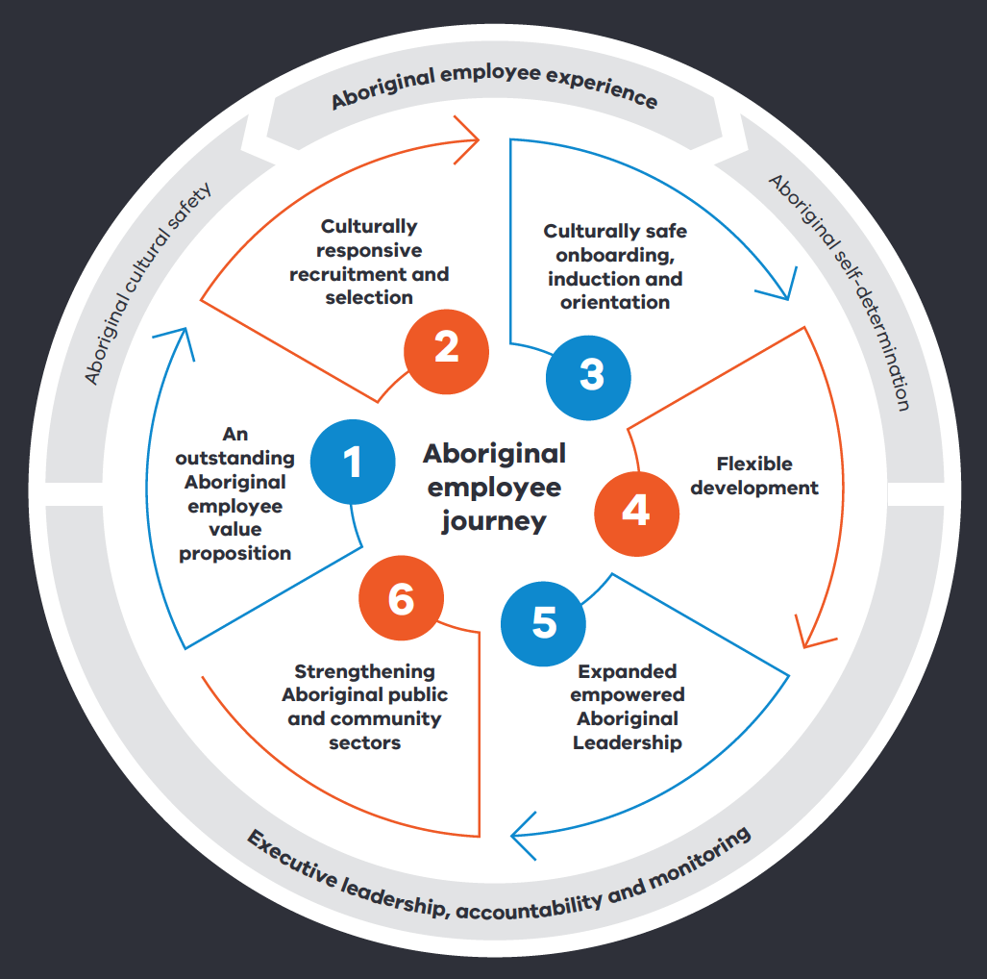
‘Cultural safety increases the organisation’s profile as a culturally safe employer of choice. While we need to meet Aboriginal employment targets, we need to increase cultural safety as well.’
– Workforce strategy consultation respondent

Aboriginal employee journey
The following sets out the outcomes we want to achieve at each of the Aboriginal employee journey touchpoints and how we will achieve them.

Employee touchpoints

Domain 1: An outstanding Aboriginal employee value proposition
The departments will attract increasing numbers of Aboriginal employees into career pathways that are diverse, inclusive and empower self-determination for Aboriginal people, families and communities.
To do this, we want to develop a reputation as employers of choice for Aboriginal people. Understanding the factors that attract Aboriginal people to establish careers in the departments and delivering on these will enable us to create an outstanding value proposition for Aboriginal candidates.
To attract and retain Aboriginal people, we need to create a culturally safe workplace and demonstrate our commitment towards becoming proficient in Aboriginal cultural safety.
Creating an environment which embeds cultural safety and amplifies Aboriginal voice in all that we do is fundamental to the cultural and emotional wellbeing of Aboriginal employees and communities. Our employees have told us they want to be more actively engaged in their work and in the design of their development and career planning. When Aboriginal employees are engaged at work, have a voice and self-determination, they are empowered to develop successful and fulfilling careers.
Communicating our value proposition through empowered relationships with key stakeholders in the Aboriginal communities, education institutions and employment services will enable us to attract more Aboriginal people to deliver on the departments’ goals and mission.
‘I believe that growing and supporting the Aboriginal child protection workforce is essential in reducing the over-representation of Aboriginal children in out-of-home care. Aboriginal child protection practitioners help families feel culturally safe in their engagement with child protection, which ultimately helps families stay together as well as improving the cultural safety of the child protection workforce as a whole. I think it is important that these practitioners are supported to manage their role as well as their cultural load and feel empowered to have input and a say at governance groups and committees.’
– Ruby Warber, Principal Practitioner, Aboriginal Children and Families.

Outcomes | Measures
- An outstanding value proposition for Aboriginal candidates  - Workplaces are culturally safe and free from racism  - Strong partnerships and employment pathways with Aboriginal communities | - Increase in percentage of Aboriginal staff reporting their division provides a culturally safe workplace  - Improvements in department assessment of learning stage of the cultural safety continuum  - Reduction in percentage of Aboriginal staff self-reported experiences of racism  - Increase in number of Aboriginal candidates employed via employment pathways

Domain 2: Culturally responsive recruitment and selection
Our goal is to continue to build a dynamic, diverse and forward-thinking workforce by increasing Aboriginal employment across the departments and creating opportunities for Aboriginal employees in all stages of their careers.
Increasing Aboriginal employment improves health and wellbeing, and is a key driver for improving access to quality and culturally appropriate services for Aboriginal communities. Building on the success of the Aboriginal employment strategy 2016–2021, this strategy increases the overall Aboriginal employment target to three per cent, with a stretch target of four per cent, by 2026. We will also implement Aboriginal employment targets for each of the departmental divisions.
To achieve this, we will:
- ensure our advertising, screening, recruitment and selection processes are culturally safe and responsive
- develop and classify positions to reflect the specialist knowledge and cultural expertise that Aboriginal people bring to the workplace (for example, qualifications listed as mandatory can be replaced with lived experience and practical knowledge in roles serving the Aboriginal community)
- continue to expand the Aboriginal employment programs, including CareerTrackers, the Aboriginal Graduate Program and YES trainees to create a strong employment pipeline.
‘We need to re-think the way positions are advertised and promoted, including how position descriptions are written.’
– Workforce strategy consultation respondent
Outcomes | Measures
- Increased number of Aboriginal employees in the department across all levels  - Recruitment and selection processes recognise Aboriginal cultural knowledge and expertise  - Recruitment and selection are culturally safe and reflect Aboriginal best practice | - Aboriginal workforce targets to increase to 3%, with a 4% stretch target  - 3% workforce targets in each division inclusive of the child protection workforce  - 4% Aboriginal leadership target  - Increased percentage of Aboriginal employees employed through employment programs  - 100% of Aboriginal identified positions include Aboriginal representation in the recruitment and selection processes  - Increase in the proportion of Aboriginal special measures roles  - Improved Aboriginal employee experience during recruitment and selection processes

Domain 3: Culturally safe onboarding, induction and orientation
Starting in a new workplace can be both exciting and overwhelming. Critical to delivering a positive employee experience is creating a welcoming, inclusive and culturally safe onboarding, induction and orientation process for Aboriginal employees to prepare them for success from the moment they start.
Onboarding is a critical time of the Aboriginal employee experience when new starters begin, meet and engage with other employees. It is important that Aboriginal employees feel culturally and personally supported throughout these initial weeks. Supervisors and managers need to play a significant role in the onboarding process and demonstrate that Aboriginal employees are respected, valued and appreciated.
A focus on Aboriginal employee engagement and wellbeing is integral to a productive and supportive workplace. The departments will ensure all Aboriginal employees are connected to the Aboriginal Staff Network and will provide tailored Aboriginal employee supports during induction and orientation. Additionally, broader induction information and training for non-Aboriginal employees will include a focus on the importance of Aboriginal cultural safety, inclusion and workplace diversity.
‘The cultural lens and mentoring for new employees are missing from the recruitment and onboarding process.’
– Workforce strategy consultation respondent
Outcomes | Measures
- Aboriginal employees are set up for success when they commence  - Aboriginal employees are supported and engaged  - Aboriginal employees are connected to Aboriginal staff networks and Aboriginal employee supports | - 95% of Aboriginal employees are linked to the Aboriginal Staff Network upon starting in a new role  - Aboriginal onboarding and induction employee experience scores increase  - Proportion of Aboriginal employees connected with an Aboriginal buddy and mentor increases  - Increasing Aboriginal employee retention rates  - Increasing proportion of Aboriginal employees using Aboriginal Peer Support and Aboriginal Employee Assistance Program (EAP)

Domain 4: Flexible development
Our goal is to provide lasting and meaningful career opportunities for Aboriginal employees, where they are empowered to advance their skills and career progress at all levels.
Many Aboriginal employees told us during consultations that they wanted more professional development choices, including:
- opportunities to progress
- to broaden skills
- cultural development opportunities across the community sector
- secondments
- developing special interests
- undertaking further training and education.
Investing in Aboriginal employees’ development is at the forefront of this strategy to ensure our employees can pursue their aspirations.
Aboriginal employees bring extensive lived and practical experiences to the workplace. This is often undervalued in favour of formal qualifications. To improve development outcomes for Aboriginal employees, we will support flexible career development pathways and establish a flexible career development fund to empower Aboriginal employees to plan meaningful and rewarding careers.
‘I started in the department as a graduate through the Aboriginal graduate program. The program has helped me shape and develop my career within the department with extensive learning and development, executive mentoring opportunities and career coaching. Since completing the program, I have worked in various programs areas and have found my passion for working within human resources and am currently studying a master’s in human resource management.’
– Scott Fogarty, Senior Advisor, Aboriginal Engagement, People and Culture
Outcomes | Measures
- Aboriginal employees are empowered to plan meaningful careers through flexible development pathways at all levels  - Aboriginal employees are recognised and valued for their important contribution and cultural expertise  - Aboriginal culture, knowledge and practice are placed at the centre of workforce development and retention | - Number of acting opportunities  - Number of secondments  - Number of Aboriginal employees enrolled in leadership programs  - Number of Aboriginal employees enrolled in Aboriginal development programs  - Number of Aboriginal women enrolled in Aboriginal career development programs  - Percentage of department employees that have incorporated cultural safety development goals in their PDP  - Number of Aboriginal employees supported to engage in cultural development initiatives

Domain 5: Expanded and empowered Aboriginal leadership
We know that the more Aboriginal leaders we have in government, the greater our capability to deliver the system changes we need to improve outcomes for Aboriginal communities.
More Aboriginal voices are needed at the centre of decision-making. We are committed to building a stronger succession pipeline to empower more Aboriginal staff to progress into senior leadership roles now and into the future.
Investing in development programs to support Aboriginal employees to progress into senior management and executive roles is a key focus of this strategy. Expanding our Aboriginal leadership group will embed greater Aboriginal representation and Aboriginal community voices in key decisions and will contribute to our commitment to support Aboriginal self-determination.
‘Aboriginal leadership within the department strengthens our ability to create an inclusive work environment and improve system responsiveness.
We bring a personal commitment, an awareness of bias and a cultural lens that benefits the work we all do.’
– Nicole McCartney, Chief Aboriginal Health Advisor, Department of Health
Outcomes | Measures
- Aboriginal employees are supported to develop and progress into senior leadership roles  - A larger Aboriginal senior management workforce to reflect the department’s priorities and commitments  - Aboriginal voice is embedded and valued throughout the department | - 4% Aboriginal leadership target  - Number of Aboriginal employees acting in higher duties  - Number of Aboriginal employees enrolled in advanced leadership programs  - Proportion of Aboriginal employees in management and executive roles  - Increased proportion of Aboriginal women in management and executive roles  - Increased number of Aboriginal senior managers with flexible working arrangements

Domain 6: Strengthen Aboriginal public and community sector careers
We work in collaboration and partnership with Aboriginal community-controlled organisations, Traditional Owners and community sector organisations across health, human and community services to deliver improved Aboriginal health, wellbeing and safety outcomes.
The health, human and community services sector is the largest employer of Aboriginal people in Victoria. Recognising the important contribution Aboriginal employees make to the sector means we need to support Aboriginal employees to access career opportunities where they are valued for their knowledge and experience and are supported in a safe environment.
Supporting Aboriginal employees to expand their skills and take opportunities in Aboriginal organisations and community services is seen as an opportunity to support our vision in self-determining, healthy and safe Aboriginal people and communities.
Offboarding in the employee experience is just as important as onboarding. If Aboriginal employees feel valued when they leave the departments, they are more likely to recommend the organisations as great places to work and are more likely to return in the future. Exit interviews are also integral in supporting organisational continuous improvement.
We will embed processes that ensure Aboriginal employees have access to an exit interview in a culturally safe and supported way. Exit interview data will be collected to inform how to improve all stages of the Aboriginal employee journey.
‘Without the opportunities offered to me through the Aboriginal employment strategy, my journey in the department would not have been so. To be able to connect regularly with my Aboriginal and Torres Strait Islander colleagues on an annual basis through the Aboriginal Staff Network Forum, this has given me the opportunity to build my confidence to become the leader I am today.’
– Matthew Duggan, Director, Aboriginal Housing
Outcomes | Measures
- A quality improvement approach informs all stages of the Aboriginal employee journey  - Aboriginal employees are supported in their public and community sector careers  - Aboriginal employees are supported to return to the department in the future | - Increase in exit interview data  - Number of Aboriginal employees on secondment in the public and community sector  - Number of Aboriginal employees on secondment and leave without pay for development opportunities  - Number of Aboriginal employees who report a positive offboarding experience

Executive leadership, accountability and monitoring
Our executive leaders can motivate and influence change. They play a key role in delivering on the outcomes and measures within this strategy and monitoring its impacts for the Aboriginal workforce and communities.
Accountability to deliver this strategy, its outcomes and targets is the independent responsibility of the Executive Board of each department.
Governance will be determined by each department and included in the department-specific implementation plans. Divisions within each department will be required to report biannually to the relevant department governance structure.
Corporate Services, Department of Health, and Corporate and Delivery Services, Department of Families, Fairness and Housing, will ensure consistent metrics are used in monitoring and tracking progress towards meeting the outcomes and targets for each department.
The Aboriginal workforce governance for each department will align with the internal Aboriginal Cultural Safety Implementation Working Group, who will provide regular updates to their relevant department governance mechanism.

Aboriginal workforce strategy outcomes framework
Strategic objectives | Outcomes | Measures
1: An outstanding Aboriginal employee value proposition | - An outstanding value proposition for Aboriginal candidates  - Workplaces are culturally safe and free from racism  - Strong partnerships and employment pathways with Aboriginal communities | - Increase in percentage of Aboriginal staff reporting their division provides a culturally safe workplace  - Improvements in department assessment of learning stage of the cultural safety continuum  - Reduction in percentage of Aboriginal staff self-reported experiences of racism  - Increase in number of Aboriginal candidates employed via employment pathways
2: Culturally responsive recruitment and selection | - Increased number of Aboriginal employees in the department across all levels  - Recruitment and selection processes recognise Aboriginal cultural knowledge and expertise  - Recruitment and selection are culturally safe and reflects Aboriginal best practice | - Aboriginal workforce targets to increase to 3% with a 4% stretch target  - 3% workforce targets in each division inclusive of the Child Protection workforce  - 4% Aboriginal leadership target  - Increased percentage of Aboriginal employees employed through employment programs  - 100% of Aboriginal identified positions include Aboriginal representation in the recruitment and selection processes  - Increase in the proportion of Aboriginal special measures roles  - Improved Aboriginal employee experience during recruitment and selection processes
3: Culturally safe onboarding, induction and orientation | - Aboriginal employees are set up for success when they commence  - Aboriginal employees are supported and engaged  - Aboriginal employees are connected to Aboriginal staff networks and Aboriginal employee supports | - 95% of Aboriginal employees are linked within the Aboriginal Staff Network upon commencing in a new role  - • Aboriginal onboarding and induction employee experience scores increase  - • Proportion of Aboriginal employees connected with an Aboriginal buddy and mentor increases  - • Increasing Aboriginal employee retention rates  - • Increasing proportion of Aboriginal employees using Aboriginal Peer Support and Aboriginal EAP
4: Flexible development | - Aboriginal employees are empowered to plan meaningful careers through flexible development pathways at all levels  - Aboriginal employees are recognised and valued for their important contribution and cultural expertise  - Aboriginal culture, knowledge and practice are placed at the centre of workforce development and retention | - Number of acting opportunities  - Number of secondments  - Number of Aboriginal employees enrolled in leadership programs  - Number of Aboriginal employees enrolled in Aboriginal development programs  - Number of Aboriginal women enrolled in Aboriginal career development programs  - Percentage of department employees that have incorporated cultural safety development goals in their PDP  - Number of Aboriginal employees supported to engage in cultural development initiatives
5: Expanded empowered Aboriginal leadership | - Aboriginal employees are supported to develop and progress into senior leadership roles  - A larger Aboriginal senior management workforce to reflect the department’s priorities and commitments  - Aboriginal voice is embedded and valued throughout the department | - 4% Aboriginal leadership target  - Number of Aboriginal employees acting in higher duties  - Number of Aboriginal employees enrolled in advanced leadership programs  - Proportion of Aboriginal employees in management and executive roles  - Increased proportion of Aboriginal women in management and executive roles  - Increased number of Aboriginal senior managers with flexible working arrangements
6: Strengthen Aboriginal public and community sector careers | - A quality improvement approach informs all stages of the Aboriginal employee journey  - Aboriginal employees are supported in their public and community sector careers  - Aboriginal employees are supported to return to the department in the future | - Increase in exit interview data  - Number of Aboriginal employees on secondment in the public and community sector  - Number of Aboriginal employees on secondment and leave without pay for development opportunities  - Number of Aboriginal employees who report a positive offboarding experience
Aboriginal employee experience | - Cultural safety  - Self-determination | Executive leadership, accountability and governance

‘Wirrigirri is an important ally network.
It is critical to have Wirrigirri as part of the new strategy and be connected to
implementation of the Aboriginal cultural safety framework.’
– Workforce strategy consultation respondent

Appendix: Image descriptions

Cover artwork – Yanyabak Dana
‘Yanyabak dana’ means ‘to walk towards or on a pathway’ in the Yorta Yorta language.
Dixon Patten, the artist, has used many symbols in the artwork.
Symbol | Meaning
 | Community connection, kinship, relationships – songlines, pathways for employment
 | Ancestors guiding the journey – cultural leadership
 | Six pillars – focus areas
 | Water – people’s journey
 | Policy making, decision making, consultation – yarning circles, transfer of knowledge and skills
 | Support network
 | Ripple effect employment has on family and community – colours represent diversity
 | Message stick – representing communication
 | Different regions and communities across the state
Return to Cover artwork and about the artist

Victorian Government commitments
Figure lists several interrelated government commitments at the Commonwealth, state and departmental level.

Commonwealth government
COAG: National agreement on closing the gap

Victorian Government
Victorian Aboriginal affairs framework 2018 to 2023:
- Treaty and First Peoples’ Assembly of Victoria
- The Yoo-rrook Justice Commission
- Victorian Government self-determination reform framework
- Barring Djinang: Victorian Public Sector Commission Aboriginal employment strategy
- Tharamba Bugheen Victorian Aboriginal business strategy

Our departments
- Korin Korin Balit-Djak: Aboriginal health, wellbeing and safety strategic plan 2017-2027
- Balit Murrup Aboriginal social and emotional wellbeing framework
- Dhelk Dja: Safe our way – strong culture, strong peoples, strong families
- Wungurilwil Gapgapduir: Aboriginal children and families agreement
- Aboriginal and Torres Strait Islander cultural safety framework
- Aboriginal workforce strategy 2021–2026
Return to Victorian Government commitments

Framework for change

Aboriginal employee journey
The Aboriginal employee journey is illustrated by two concentric circles.
Inner circle:
- An outstanding Aboriginal employee value proposition
- Culturally responsive recruitment and selection
- Culturally safe onboarding, induction and orientation
- Flexible development
- Expanded empowered Aboriginal leadership
- Strengthening Aboriginal public and community sectors
Outer circle:
- Aboriginal employee experience – made up of ‘Aboriginal cultural safety’ and ‘Aboriginal self-determination’
- Executive leadership, accountability and monitoring
Return to Our framework for change

