Voluntary assisted dying
Quick reference guide for health practitioners

Department of Health
Voluntary assisted dying
Quick reference guide for health practitioners

To receive this publication in an accessible format email the Person Directed Care team at <endoflifecare@dhhs.vic.gov.au>
Authorised and published by the Victorian Government, 1 Treasury Place, Melbourne.
© State of Victoria, Department of Health and Human Services, July 2019.
ISBN 978-1-76069-945-1 (pdf/online/MS word)
Available at the department’s website <https://www2.health.vic.gov.au/hospitals-and-health-services/patient-care/end-of-life-care>
(1905319)
Contents
Introduction 7
Purpose of this quick reference guide 7
Limitations of this quick reference guide 7
Voluntary assisted dying in Victoria 7
Commonwealth law and voluntary assisted dying 7
Eligibility criteria for access to voluntary assisted dying 8
Key contact details 8
The voluntary assisted dying process: an overview 9
Voluntary assisted dying process steps 10
Responding to questions about voluntary assisted dying 13
Step 1: Patient makes a request for voluntary assisted dying 15
Step 2: Assess the patient’s eligibility to access voluntary assisted dying 17
Step 3: Complete the request and assessment process 21
Step 4: Prescribe the voluntary assisted dying medication 22
Step 5: Administration of the voluntary assisted dying medication 23
Step 6: After the patient dies 24
Appendix 1 25

Introduction

Purpose of this quick reference guide
This Voluntary assisted dying quick reference guide (quick reference guide) is a companion to the Voluntary assisted dying guidance for health practitioners (guidance), developed to assist health practitioners to understand the Voluntary Assisted Dying Act 2017 (the Act) and their roles and responsibilities in the voluntary assisted dying process.
This quick reference guide features key figures and tables and selected excerpts from the guidance. It is intended for busy health practitioners who require a quick reference in caring for people in the clinical setting. It is expected that health practitioners assisting a patient to access voluntary assisted dying will draw on their existing clinical knowledge and expertise as they would in providing any other end-of-life care.
To access the full Voluntary assisted dying guidance for health practitioners visit the Department of Health and Human Service’s website, end of life care page <https://www2.health.vic.gov.au/hospitals-and-health-services/patient-care/end-of-life-care>.

Limitations of this quick reference guide
Users should not rely on excerpts from the quick reference guide alone, but consult the guidance for further information. The guidance is general in nature and does not restate the requirements of the legislation in full, or set out existing professional obligations. This guide and the guidance should be read with an appreciation of health practitioner professional obligations under respective codes of conduct, as well as their obligations under common law and other legislation.
This document should not be distributed electronically.

Voluntary assisted dying in Victoria
The Voluntary Assisted Dying Act 2017 commenced on 19 June 2019. The Act allows a person who is at the end of their life to take medication prescribed by a medical practitioner that will bring about their death. To access voluntary assisted dying a person will need to make a request to a medical practitioner, who may choose whether or not to participate in the process as the coordinating medical practitioner. The person will then need to complete the request and assessment process to access voluntary assisted dying.

Commonwealth law and voluntary assisted dying
All discussions, consultations and assessments with patients, family and carers regarding voluntary assisted dying must occur face-to-face. Providing patients with information about voluntary assisted dying over the telephone, via email or through the use of telehealth could be a breach of the Commonwealth Criminal Code Act 1995, sections 474.29A and 474.29B.

Eligibility criteria for access to voluntary assisted dying
To access voluntary assisted dying a person must meet all of the following eligibility criteria
- be 18 years of age or over
- be an Australian citizen or permanent resident
- be ordinarily resident in Victoria
- have been a resident in Victoria for 12 months at the time of making a first request for voluntary assisted dying
- have decision-making capacity in relation to voluntary assisted dying
- have an incurable disease, illness or medical condition that:
    - is advanced, progressive and will cause their death
    - is expected to cause their death within six months (or within 12 months for patients with a neurodegenerative medical condition)
    - is causing suffering to the person that cannot be relieved in a manner that the person considers tolerable.

Key contact details
- Voluntary assisted dying care navigators
    - Phone (03) 8559 5823 or 0436 848 344 or email the navigators <vadcarenavigator@petermac.org.au>
- Voluntary Assisted Dying Statewide Pharmacy Service
    - Phone (03) 9076 5270 or email the Service <statewidepharmacy@alfred.org.au>
- Department of Health and Human Services end-of-life care team
    - Email the end-of-life care team <endoflifecare@dhhs.vic.gov.au>
- Voluntary Assisted Dying Review Board secretariat
    - email the secretariat VADBoard@safercare.vic.gov.au

The voluntary assisted dying process: an overview
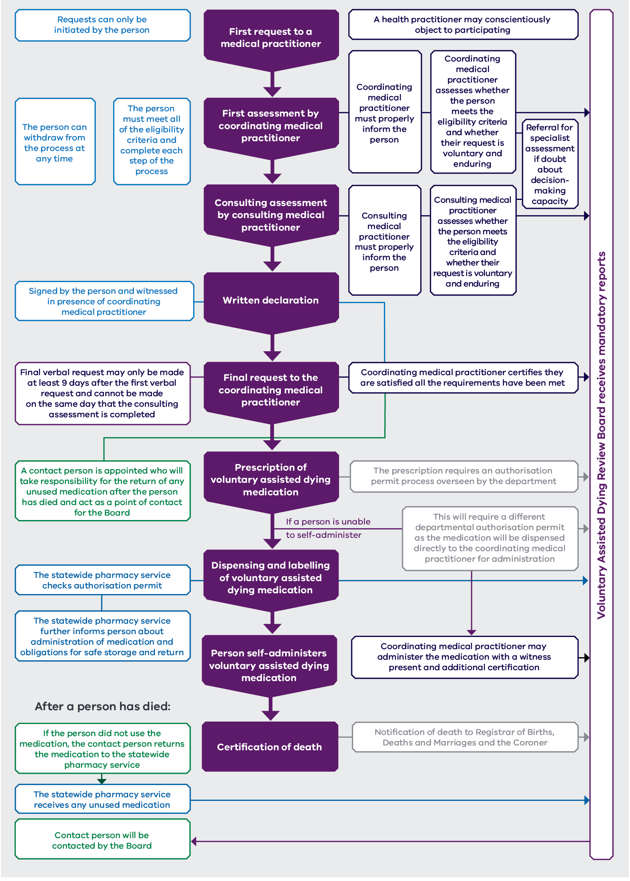

Voluntary assisted dying process steps
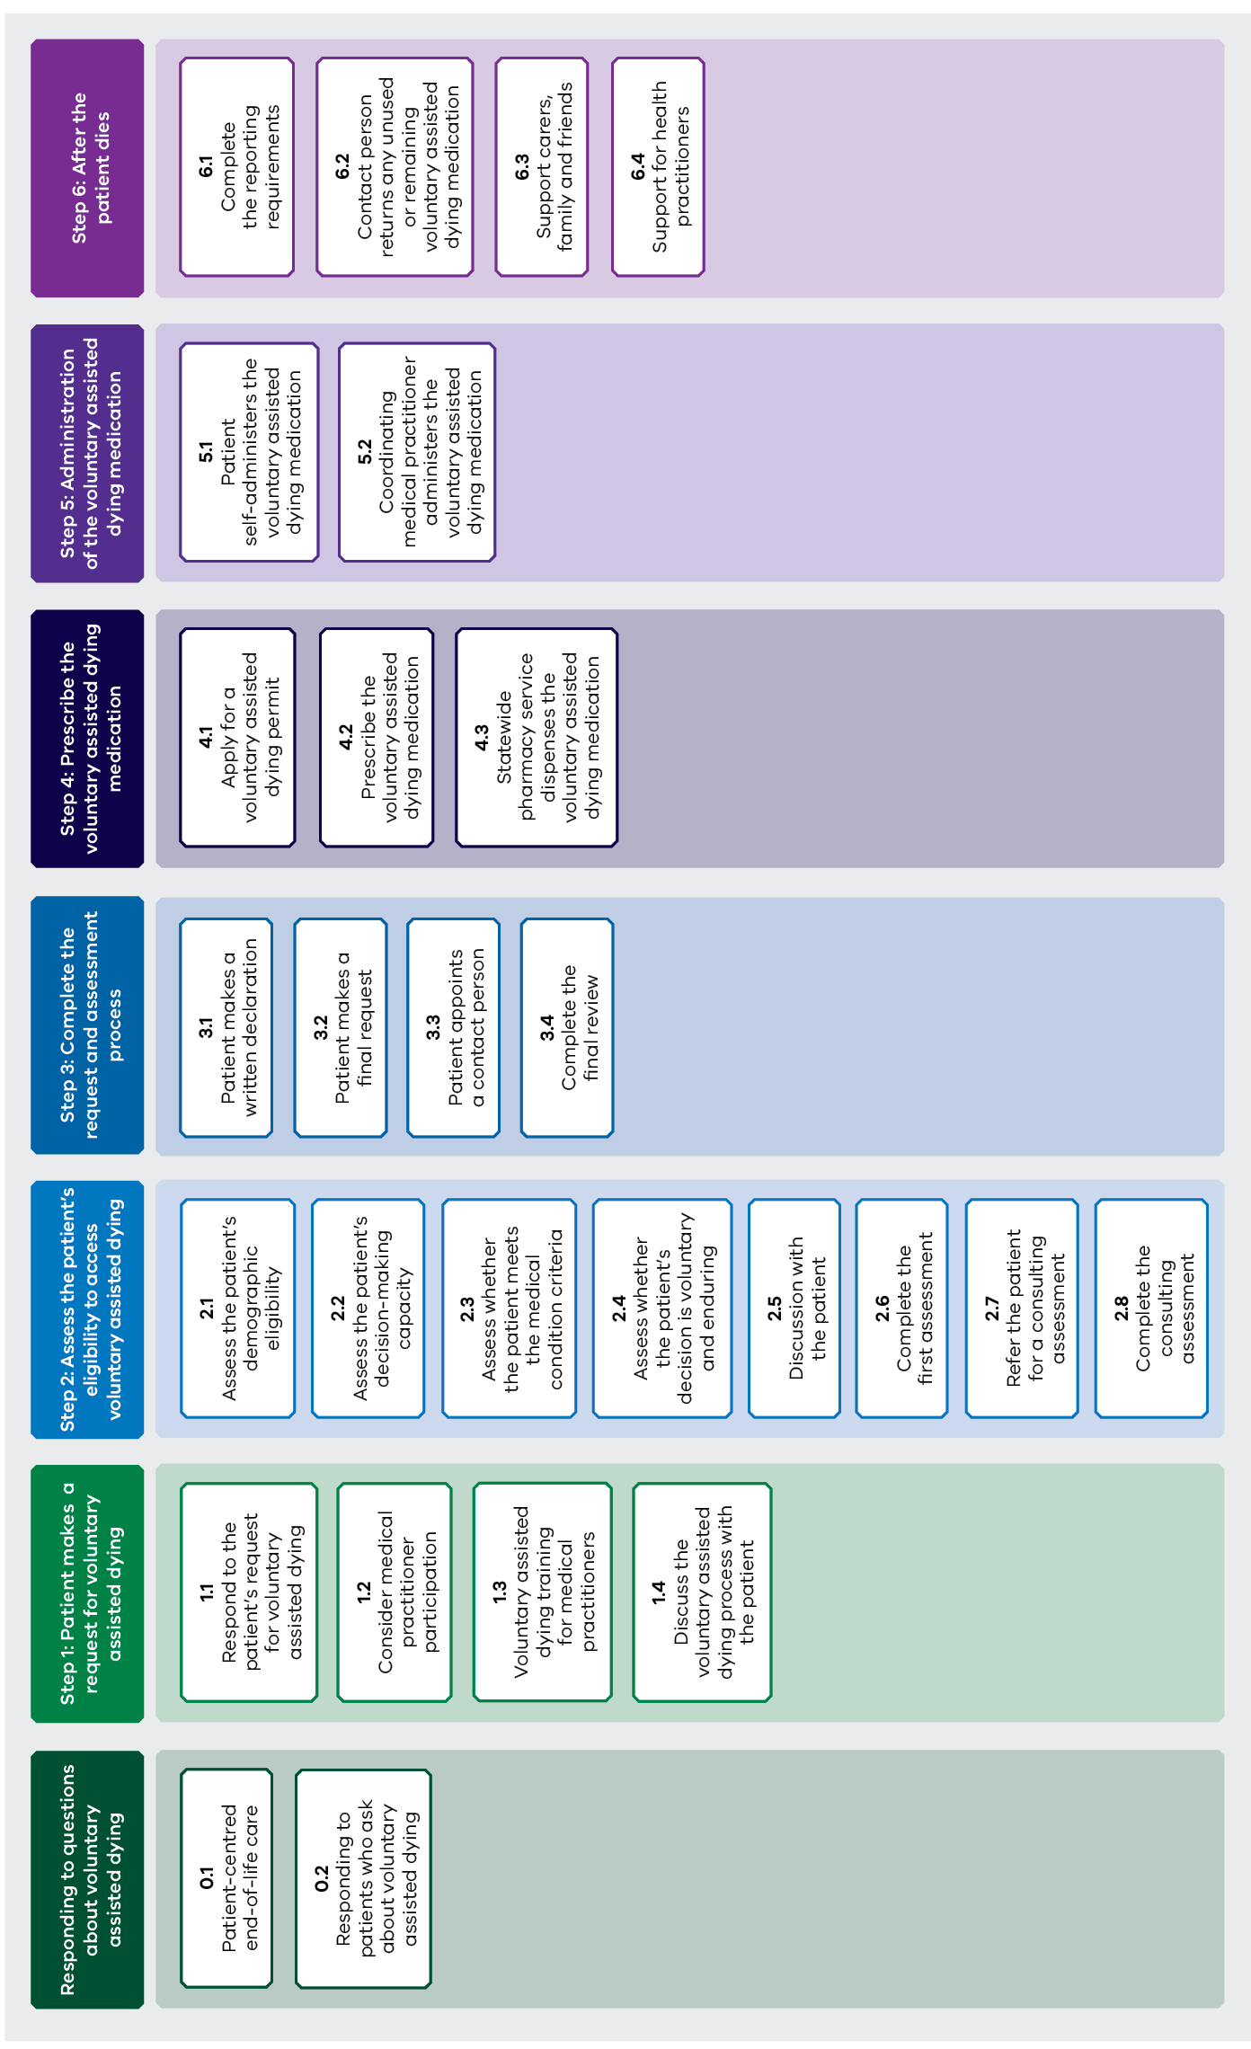

Responding to questions about voluntary assisted dying | Step 1: Patient makes a request for voluntary assisted dying | Step 2: Assess the patient’s eligibility to access voluntary assisted dying | Step 3: Complete the request and assessment process | Step 4: Prescribe the voluntary assisted dying medication | Step 5: Administration of the voluntary assisted dying medication | Step 6: After the patient dies
0.1 Patient-centred end-of-life care | 1.1 Respond to the patient’s request for voluntary assisted dying | 2.1 Assess the patient’s demographic eligibility | 3.1 Patient makes a written declaration | 4.1 Apply for a voluntary assisted dying permit | 5.1 Patient self-administers the voluntary assisted dying medication | 6.1 Complete the reporting requirements
0.2 Responding to patients who ask about voluntary assisted dying | 1.2 Consider medical practitioner participation | 2.2 Assess the patient’s decision-making capacity | 3.2 Patient makes a final request | 4.2 Prescribe the voluntary assisted dying medication | 5.2 Coordinating medical practitioner administers the voluntary assisted dying medication | 6.2 Contact person returns any unused or remaining voluntary assisted dying medication
 | 1.3 Voluntary assisted dying training for medical practitioners | 2.3 Assess whether the patient meets the medical condition criteria | 3.3 Patient appoints a contact person | 4.3 Statewide pharmacy service dispenses the voluntary assisted dying medication |  | 6.3 Support carers, family and friends
 | 1.4 Discuss the voluntary assisted dying process with the patient | 2.4 Assess whether the patient’s decision is voluntary and enduring | 3.4 Complete the final review |  |  | 6.4 Support for health practitioners
2.5 Discussion with
the patient
 |  | 2.6 Complete the first assessment
 |  | 2.7 Refer the patient for a consulting assessment
 |  | 2.8 Complete the consulting assessment

Responding to questions about voluntary assisted dying
Subject | Information
0.1 Patient-centred end-of-life care | High-quality, patient-centred end-of-life care involves working with patients to identify, assess and treat their pain and other symptoms as well as psychosocial, emotional and spiritual support. It includes:  - respecting the patient’s autonomy, supporting informed decision making and providing personalised care that is acceptable to the patient  - ensuring that medical treatment decisions respect the patient’s values and preferences  - managing symptoms and responding to the patient’s concerns  - supporting carers and family, where appropriate.
0.2 Responding to patients who ask about voluntary assisted dying | A registered health practitioner must not – in the course of providing health or professional care services – either initiate a discussion about voluntary assisted dying or suggest voluntary assisted dying to a patient.  Health practitioners can provide information about voluntary assisted dying to a patient at their request. Patients might ask about voluntary assisted dying in a variety of ways; they do not have to use the exact phrase ‘voluntary assisted dying’. If the health practitioner is unsure about what the patient is asking about, they should clarify with the patient and seek to elicit more information, relying on their existing clinical skills in having end-of-life care conversations, and using open-ended questions.  Examples of statements that are not sufficiently clear to enable discussion of voluntary assisted dying:  Can you give me all the options?  I am tired of life and just want to die  If animals can be put down when they are suffering, why can’t I?  Depending on the context, the following may constitute a request for information:  I would like you to assist me to die  How do I get that pill they say you can get to end it all that I can take when it all gets too much?  If a health practitioner is clear that the patient has asked for information about voluntary assisted dying:  - let them know information is available but that they would like to understand what has led the patient to ask about voluntary assisted dying.  - if qualified and competent to do so, explore and clarify the patient’s situation, encourage them to talk about how they are feeling, and address any specific concerns or needs.  - provide what information they can about voluntary assisted dying and/or direct the patient to additional sources of information such as their treating medical practitioner, a voluntary assisted dying care navigator or the Department of Health and Human Services end-of-life care resources on the department’s website <https://www2.health.vic.gov.au/hospitals-and-health-services/patient-care/end-of-life-care>.  The health practitioner should also let the patient know that if they wish to make a request for voluntary assisted dying they must ask a medical practitioner face to face.  If a patient requires additional support to communicate at any stage in the voluntary assisted dying process, an interpreter or speech pathologist may be required. To assist a person in relation to requesting access to or accessing voluntary assisted dying, an interpreter must be accredited by NAATI or certified by Speech Pathology Australia. For guidance about supporting a patient who has difficulty communicating see the additional resources in the full guidance.

Step 1: Patient makes a request for voluntary assisted dying
Step | Information
1.1 Respond to the patient’s request for voluntary assisted dying | Where a medical practitioner is informed of a patient’s enquiry about voluntary assisted dying by another health practitioner, the medical practitioner does not need to wait for the patient to raise voluntary assisted dying in a subsequent consultation.  If the medical practitioner is clear that the patient is requesting access to voluntary assisted dying, they should:  - listen to the patient without judgement  - check that the patient understands their prognosis and all their options for treatment and care  - explore with the patient their current circumstances, preferences for care and treatment and motivations for the request.
1.2 Consider medical practitioner participation | If satisfied that the patient has made a clear and unambiguous request for voluntary assisted dying the medical practitioner must decide if they are prepared and qualified to accept the request and participate in voluntary assisted dying as the patient’s coordinating medical practitioner. If a medical practitioner accepts a patient’s first request they become the patient’s coordinating medical practitioner.  Relevant considerations  - Medical practitioners must hold a fellowship with a specialist medical college or be a vocationally registered general practitioner to provide voluntary assisted dying  - Either the coordinating or the consulting medical practitioner must have:  - practised as a registered medical practitioner for at least five years after completing their fellowship or vocational registration  - relevant expertise and experience in the medical condition expected to cause the patient’s death, which means that they are a medical specialist in the patient’s medical condition.  One of the medical practitioners may fulfil both these requirements, or they may each fulfil one.  - The coordinating medical practitioner’s availability to support the entire process through to the administration phase.
1.3 Voluntary assisted dying training for medical practitioners | A medical practitioner can undertake the voluntary assisted dying training before receiving a request for voluntary assisted dying or after they have agreed to act as the coordinating or the consulting medical practitioner, as long as the training is completed before beginning an assessment of the patient’s eligibility for voluntary assisted dying.  The training is a nine-module online program that can be completed in about six hours. More information on the training can be found at the Department of Health and Human Services end-of-life care website <https://www2.health.vic.gov.au/hospitals-and-health-services/patient-care/end-of-life-care>.
1.4 Discuss the voluntary assisted dying process with the patient | If the coordinating medical practitioner has not already done so, they should provide the patient with information about the  voluntary assisted process including the eligibility criteria, the steps and the outcome of voluntary assisted dying. This may include providing them with a copy of the Voluntary assisted dying information for people considering voluntary assisted dying.

Step 2: Assess the patient’s eligibility to access voluntary assisted dying
All of these steps must be completed face to face.
Step | Information
2.1 Assess whether the patient meets the demographic eligibility criteria | See Table 3 below which sits in this column in the original publication.
Table 3: Possible documentary evidence for proof of demographic eligibility for accessing voluntary assisted dying
Demographic criteria | Possible documentary evidence
Aged 18 years or older | - Medical records  - Birth certificate  - Victorian driver’s licence
An Australian citizen or permanent resident | - Australian birth certificate for people born before 20 August 1986 (for people born after see ‘Additional resources’ in the full guidance for additional information)  - Passport establishing Australian citizenship  - Permanent resident visa  - Permanent resident Visa Grant Number (for more information on Visa Grant Numbers see ‘Additional resources’ in the full guidance)
A Victorian resident for 12 months or more | - Victorian driver’s licence or vehicle registration  - Registration on the Victorian electoral roll  - Patient’s medical record (showing their Victorian residential address)  - Lease document and utility bills

Step |  | Information
2.2 Assess the patient’s decision-making capacity |  | The person must have decision making capacity in relation to voluntary assisted dying. This means they must be able to:  - Understand the information relevant to the decision relating to access to voluntary assisted dying and the effect of the decision; and  - Retain that information to the extent necessary to make the decision; and  - Use or weigh that information as part of the process of making the decision; and  - Communicate the decision and the person’s views and needs as to the decision in some way, including by speech, gestures or other means.  More detailed guidance for conducting this assessment is at Appendix 1.
2.3 Assess whether the patient meets the medical condition criteria |  | Diagnosis  Determine whether the patient has an incurable, advanced and progressive medical condition that will cause death. ‘Incurable’ means a medical condition that cannot be cured and includes conditions that can be managed but not cured.  Prognosis  Determine whether the patient’s medical condition is expected to cause death within weeks or months, not exceeding six months, or 12 months in the case of a patient with a neurodegenerative condition.  Suffering  Suffering is a subjective experience of the individual. It is up to the patient to assess whether they are experiencing suffering they cannot tolerate. If the suffering is linked to the medical condition, then this eligibility criterion is met.  If the coordinating medical practitioner determines that a patient with a neurodegenerative condition is likely to die between six and 12 months, an additional assessment is required from a specialist medical practitioner with appropriate skills and training in the patient’s neurodegenerative condition.
2.4 Assess whether the patient’s decision is voluntary and enduring |  |  | The coordinating and consulting medical practitioners must be satisfied that the patient is acting voluntarily and without coercion and that their request for access to voluntary assisted dying is enduring. Sufficient time should be taken to discuss and understand the reasons why a patient is requesting voluntary assisted dying. These discussions will provide insight into the patient’s concerns and why they think accessing voluntary assisted dying will address these concerns. The medical practitioner can ask the patient how they reached their decision, including what, or who, may have influenced them. For further guidance see step 2.4 in the full guidance.
2.5 Discuss with the patient |  |  | If satisfied that the patient meets all the eligibility criteria, both the coordinating and consulting medical practitioners must inform the patient about:  - their diagnosis and prognosis  - the treatment options available to them, their risks, and the likely outcomes of that treatment  - palliative care options available to them, their risks, and the likely outcomes of that care  - the effects, potential risks (for example, unintended effects) and likely outcome of taking the voluntary assisted dying medication if they decide to take it (including how long it will take to achieve this outcome) – noting that it will lead to their death  - their ability to withdraw from the voluntary assisted dying process at any time  - the benefits of informing any other medical practitioner that they are currently receiving care from about their decision to access voluntary assisted dying.  The coordinating medical practitioner must assess the patient as eligible if the patient:  - meets all the eligibility criteria for access to voluntary assisted dying  - understands the information provided to them during the discussion about the first assessment  - is acting voluntarily and without coercion  - has an enduring request to access voluntary assisted dying.
2.6 Complete the first assessment |  |  | The coordinating medical practitioner must record their assessment, details of any relevant referrals and their final determination of the patient’s eligibility on Form 1 First assessment report form. They must submit the form to the Voluntary Assisted Dying Review Board via the online portal within seven days of completing the first assessment, along with any relevant referrals or clinical reports associated with the assessment.
2.7 Refer the patient for the consulting assessment | If the patient is assessed as eligible for voluntary assisted dying, the coordinating medical practitioner must refer the patient for a consulting assessment. The consulting medical practitioner must hold a fellowship with a specialist medical college or be a vocationally registered general practitioner and have completed voluntary assisted dying training before undertaking the assessment. The consulting medical practitioner must also meet the following criteria, if the coordinating medical practitioner does not:  - have practised for at least five years after completing their fellowship or vocational registration  - have relevant expertise and experience as a medical specialist in the medical condition expected to cause the patient’s death.  If the medical practitioner to whom the referral is made accepts the referral, they become the patient’s consulting medical practitioner and undertake the consulting assessment.
2.8 Complete the consulting assessment | The consulting medical practitioner must undertake an independent consulting assessment of the patient’s eligibility for voluntary assisted dying using the same criteria as the coordinating medical practitioner.  On completing the consulting assessment, the consulting medical practitioner must complete Form 2 Consulting assessment report form and submit it to the Voluntary Assisted Dying Review Board via the online portal within seven days of completing the assessment, along with any relevant referrals or clinical reports associated with the assessment. They must also provide the coordinating medical practitioner with a copy of their assessment and the completed Form 2.

Step 3: Complete the request and assessment process
Step | Information
3.1 Patient makes a written declaration | Once the patient has been assessed as eligible by both the coordinating and the consulting medical practitioners, the patient may make their second request for access via a written declaration.  Two witnesses and the coordinating medical practitioner must be present and also sign Form 3 Written declaration, which may require some planning.  If the patient is unable to sign for themselves they may have another person sign on their behalf. See step 3.2 in the full guidance for information about requirements in relation to witnesses and people who require assistance to complete the written declaration.
3.2 Patient makes a final request | The patient can make their final request to access voluntary assisted dying in person to their coordinating medical practitioner as soon as the written declaration is completed, providing it is at least nine days after their first request and at least one day after the consulting assessment was completed. The final request can be made on the same day that the written declaration is completed. The final request may be made verbally or by gestures or other means of communication available to the patient. (The patient may require an interpreter  or speech pathologist to make their final request.)  The nine-day waiting period between the first and final requests does not apply if the coordinating medical practitioner believes that the patient is likely to die before the nine-day period elapses and this is consistent with the prognosis from the consulting assessment.
3.3 Patient appoints a contact person | The patient must appoint a contact person, 18 years or older, who accepts responsibility for returning any unused or remaining voluntary assisted dying medication to the dispensing pharmacist for disposal within 15 days after the date of the patient’s death. This can be done at the same appointment at which the final request is made.  The patient must appoint a contact person regardless of whether the patient chooses to self-administer the voluntary assisted dying medication or requires the coordinating medical practitioner to administer the medication. The Voluntary Assisted Dying Review Board will contact the contact person within seven days of being notified of the patient’s death to remind them of their obligations to return any unused medication and outline support services available to assist them to do so.  The patient and their appointed contact person sign a completed Form 4 Contact person appointment form and provide a copy to the coordinating medical practitioner. The coordinating medical practitioner submits the form to the Voluntary Assisted Dying Review Board via the online portal along with Form 5 Final review form.
3.4 Complete the final review | Once all eligibility requirements have been met and Forms 1–4 with their accompanying documents reviewed, the coordinating medical practitioner completes Form 5 Final review form and submits it to the Voluntary Assisted Dying Review Board via the online portal within seven days of completing the final review, along with copies of all relevant reports.

Step 4: Prescribe the voluntary assisted dying medication
Step | Information
4.1 Apply for a voluntary assisted dying permit | Before prescribing voluntary assisted dying medication, the coordinating medical practitioner must apply for a voluntary assisted  dying permit from the Department of Health and Human Services through the voluntary assisted dying online portal. There are two  types of permit:  - self-administration permit for patients who can self-administer and digest the voluntary assisted dying medication  - practitioner administration permit for patients who are physically incapable of self-administering or digesting the voluntary  assisted dying medication and require the coordinating medical practitioner to administer the medication.  A practitioner administration permit will only be approved if the patient is physically incapable of self-administering or digesting the voluntary assisted dying medication.  The department will process applications for permits as soon as possible and must do so within three business days.
4.2 Prescribe the voluntary assisted dying medication | The medication protocol contains detailed instructions about prescribing and administering voluntary assisted dying medication and is available to medical practitioners who have completed the voluntary assisted dying training.  Prior to prescribing voluntary assisted dying medication, the coordinating medical practitioner should contact the Voluntary Assisted Dying Statewide Pharmacy Service (statewide pharmacy service) to discuss the prescription, and provide the patient with the information set out in step 4.2 of the full guidance.
4.3 Statewide pharmacy service dispenses the voluntary assisted dying medication | Voluntary assisted dying medication will only be dispensed by the statewide pharmacy service.  If the medication is to be self-administered, the pharmacist must dispense the voluntary assisted dying medication directly to the patient. The patient will be advised by their coordinating medical practitioner to contact the statewide pharmacy service when they want to have the medication dispensed. If the patient is unable to travel, the pharmacist will deliver the medication to the patient. When the statewide pharmacy service dispenses the voluntary assisted dying medication, they will provide the patient with a detailed explanation about all the medications they are prescribed and a demonstration of how to self-administer them.  For practitioner administration, the coordinating medical practitioner may arrange with the statewide pharmacy service to have the medications dispensed at a convenient time. The statewide pharmacy service will provide the coordinating medical practitioner with information and a demonstration of how to administer the medications.

Step 5: Administration of the voluntary assisted dying medication
All of these steps must be completed face to face.
Subject | Information
5.1 Patient self-administers the voluntary assisted dying medication | A pharmacist from the statewide pharmacy service will provide the patient with a series of medications, including the voluntary assisted dying medication, and instructions in a locked box, and explain the contents and how to administer the medications.  The patient may have carers, family and friends present when they self-administer the voluntary assisted dying medication. They may also request that a health practitioner is present.
5.2 Coordinating medical practitioner administers the voluntary assisted dying medication | The coordinating medical practitioner should confirm the patient’s preferences for the place of administration of the voluntary assisted dying medication, at a time when the coordinating medical practitioner and at least one witness who is 18 years or older and independent of the coordinating medical practitioner can attend.  Detailed information and instructions about the practitioner administration process are available from the statewide pharmacy service and will be provided to the coordinating medical practitioner when the voluntary assisted dying medication is dispensed.  Once the coordinating medical practitioner and witness are present, the patient must personally request the coordinating medical practitioner to administer the voluntary assisted dying medication, verbally or by gestures or other means of communication, in the presence of the witness.  See step 5.2 in the full guidance for more detail on the requirements that the coordinating medical practitioner and witness must be satisfied of and certify.
Unexpected events | Unexpected events  If the patient is in a health service or a health practitioner is present, the patient’s health practitioners can respond to any unexpected event. Health practitioners should provide the patient with treatment to ensure they are comfortable but cannot intentionally hasten the person’s death. Health practitioners are also under no obligation to attempt life-sustaining measures unless the patient requests this.  Where the patient is self-administering with no health practitioner present, instructions in comfort care can be provided to carers, family and friends. If an unexpected event does occur, paramedics can also provide comfort care if called to attend a patient accessing voluntary assisted dying.

Step 6: After the patient dies
Step | Information
6.1 Complete the reporting requirements | All deaths in Victoria must be notified to the Registrar of Births, Death and Marriages within 48 hours by the medical practitioner who has responsibility for a person’s care immediately before death, or who examines the body of the deceased person after death. The medical practitioner who notifies the Registrar of the death will be responsible for notifying that the person was the subject of a voluntary assisted dying permit if they are aware of this.  The death of a patient who has a voluntary assisted dying permit must be notified to the Coroner. In most cases, the Coroner will not need to investigate the death.
6.2 Contact person returns any unused or remaining voluntary assisted dying medication | If the patient dies without using the voluntary assisted dying medication, their appointed contact person is required to keep the medication safe until they return it to the statewide pharmacy service. The medication must be returned within 15 days of the patient’s death. If the contact person is unable to transport the unused voluntary assisted dying medication, the statewide pharmacy service can collect it.
6.3 Support carers, family and friends | Medical and other health practitioners should provide bereavement support to a patient’s carers, family and friends in the same way that they usually would, whether directly or via their health service’s existing bereavement support services. Where palliative care services have been involved in the care of the patient, they will generally also be able to offer bereavement support.
6.4 Support for health practitioners | Medical and health practitioners who provide care and support for the patient should be encouraged to access support programs through their health services or professional associations. The voluntary assisted dying care navigators may also assist health practitioners with accessing these services.

Appendix 1
Table 4: Assessing decision-making capacity in relation to voluntary assisted dying, possible approaches and red flags
Criterion | Patient’s task | Medical practitioner’s assessment approach | Questions for clinical assessment | Red flags
Understand the relevant information about voluntary assisted dying | Grasp the fundamental nature of voluntary assisted dying and that it would lead to the patient’s death | Encourage the patient to paraphrase what the medical practitioner has said about the patient’s medical condition, prognosis, treatment options and what is involved with voluntary assisted dying | Please tell me in your own words what I told you about:  - the problem with your health now  - the treatment options and voluntary assisted dying  - the possible benefits and risks (or discomforts) of the treatment or voluntary assisted dying  - any alternative treatments and their risks and benefits  - the risks and benefits of no treatment | Patient fails to understand their medical condition or prognosis or to recount the possible treatment options and their consequences (including no treatment) and their benefits and risks  Patient does not accept their condition (for example, those who lack insight because of delusions or denial)
Retain the information in order to make a decision about voluntary assisted dying | Remember the information provided about treatment options (including voluntary assisted dying) and their consequences | Ask the patient to describe their thoughts about their medical condition, prognosis, possible treatment options and outcomes, and about voluntary assisted dying | How do you feel about your health now?  What is treatment or voluntary assisted dying likely to do for you?  What makes you believe it will have that effect?  What do you believe will happen if you are not treated? | Patient cannot remember or is unclear about their medical condition, prognosis, possible treatment options and voluntary assisted dying  Patient cannot remember their prior choices or express them in a consistent way
Use or weigh the information to make a decision | Reason about treatment options and voluntary assisted dying using the relevant information provided by the medical practitioner | Ask the patient to compare treatment options and outcomes, including voluntary assisted dying, and provide reasons for the chosen option | How did you decide to accept or reject the other treatment options?  What makes [the chosen option] better than [the alternative option]? | People are able to make decisions that medical practitioners might think are unwise. The focus here should be on the process and whether it leads logically to the outcome. A red flag would be a decision-making process that appears unusually brief or does not appear to be grounded in the patient’s personal beliefs or values  Frequent reversals of choice because of psychiatric or neurological conditions may indicate lack of capacity
Communicate the decision | Clearly state their request to access voluntary assisted dying | Listen to the patient’s request and seek clarification if it is not clear | Have you decided which treatment option to follow?  Can you tell me what that decision is?  [If no decision] What’s making it hard for you to decide? | A patient who appears to respond inconsistently to questions

Table adapted from original article by Appelbaum PS 2007, ‘Assessment of patients’ competence to consent to treatment’, New England Journal of Medicine, no. 357, pp. 1834–1840 and Willmott L, White B 2018, Voluntary Assisted Dying Act 2017 Assessment Training Module 4, for the Department of Health and Human Services, Melbourne.

