
Victoria’s digital health roadmap
Improving patient care by lifting digital maturity in Victoria’s public health services 2021–2025
OFFICIAL

To receive this document in another format, email the Digital Health Directorate <digitalhealthdirectorate@health.vic.gov.au>.
Authorised and published by the Victorian Government, 1 Treasury Place, Melbourne.
© State of Victoria, Australia, Department of Health, August 2021.
Except where otherwise indicated, the images in this document show models and illustrative settings only, and do not necessarily depict actual services, facilities or recipients of services.
In this document, ‘Aboriginal’ refers to both Aboriginal and Torres Strait Islander people. ‘Indigenous’ or ‘Koori/Koorie’ is retained when part of the title of a report, program or quotation.
ISBN/ISSN 978-1-76096-220-3 (online/PDF/Word)
Available at Digital Health <https://www2.health.vic.gov.au/hospitals-and-health-services/quality-safety-service/digital-health>.

Message from the Secretary
Working so that Victorians continue to enjoy better and healthier lives, our teams in the Department of Health are continually rethinking how we might improve the delivery of health care. Our vision is better health for all Victorians, no matter who we are or where we live.
One element in our relentless pursuit of better health for all is to enhance the critical digital systems that good healthcare services depend on. Making care more integrated across providers, more accessible closer to home, and safer.
Strategic investment in digital health technology, while not always visible to us as consumers, will help keep all Victorians healthier.
To inform our digital health program, Victoria has implemented a digital health maturity model. This shows us where the most urgent gaps are. What needs to be improved. The Digital health roadmap for Victoria is our next step in that improvement.
The Roadmap provides a clear and structured approach to ensuring digital health investments deliver on what matters most to Victorians – care that has them at the centre.
The Roadmap’s five programs of work seek to:
- improve health services’ resilience against outages and cyber attacks
- improve patient safety by replacing paper-based care processes
- ensure health information follows the consumer, across care providers
- create more home-based and virtual care choices
- give consumers access to their own healthcare information.
The first three programs are well under way. Many of our health services have made care safer though advanced digitalisation.
But there is still much to do. Improving the resilience of health services’ systems and protecting them from cyber attacks remain a priority. So too is extending the benefits of digital healthcare into community and aged care.
Programs 4 and 5 align with our intent to increasingly move care out of hospitals and into the home, placing control of healthcare where it should be – with the individual. These programs seek to extend virtual care and give each of us access to our own healthcare information. That is exciting and transformative.
We seek to use digitalisation not as an end in itself, but as an enabler for care to be better tailored to the individual’s changing needs. And, at a system level, to better forecast demand so that resources are provided where they are most needed. Digital healthcare information allows us to track trends and patterns in healthcare utilisation, to inform better system design and local responses.
I trust that you get a sense of our hope that the Roadmap will help everyone involved in health care – the consumer and their family, the clinician and supporting staff, health services, the Department of Health, and government – to make care safer, improve care quality, and to bring decision support to the point of care.
Accessible, connected care systems should be designed to provide the best possible patient experience.
The Roadmap will guide those designs and shape our investments in programs that are robust, inclusive and focussed on delivering better health to all Victorians.
I look forward to joining you on this exciting journey.
Professor Euan Wallace, AM
Secretary

Contents
Message from the Secretary 3
Introduction 7
Aims of the Roadmap 7
Focusing on the needs of Aboriginal people 7
Five programs of work 8
Enablers 9
Rural ICT Alliances 11
Investment 11
Assurance of health ICT projects 12
Public health reform and digital health 12
The Roadmap and its context 13
About this document 13
Policy context 13
Victorian digital health maturity model 13
Royal Commission into Victoria’s Mental Health System 17
Program of work 1: Secure and resilient systems 19
Strategic objective 19
Outcomes 19
Context 20
Investment approach 21
Initiative 1.1: Improve ability and resilience 21
Initiative 1.2: Cybersecurity 22
Initiative 1.3: Clinical grade network 22
Initiative 1.4: Security Operation Centre (SOC) service 23
Initiative 1.5: Disaster recovery service 23
Initiative 1.6: Legacy server replacement 23
Program of work 2: Efficient, secure, paper-light health care 25
Strategic objective 25
Outcomes 25
Context 26
Initiative 2.1: Review of patient administration systems 27
Initiative 2.2: Electronic patient records at Victorian public health services 27
Initiative 2.3: A new statewide mental health and wellbeing record 28
Initiative 2.4: Lift digital maturity in community health organisations 29
Initiative 2.5: Lift digital maturity in alcohol and other drug services 29
Initiative 2.6: Lift digital maturity in public sector residential aged care 30
Subprojects 30
Program of work 3: Connecting care 31
Strategic objective 31
Outcomes 31
Approach 32
Context 32
Initiative 3.1: My Health Record expansion 33
Initiative 3.2: Unique patient identification 34
Initiative 3.3: Mental health information and data exchange 35
Initiative 3.4: Safer transfers of care 35
Initiative 3.5: Shared care 36
Initiative 3.6: Clinical information sharing 36
Initiative 3.7: Statewide image sharing 37
Program of work 4: Enabling virtual care and care closer to home 38
Strategic objective 38
Outcomes 38
Context 38
Initiative 4.1: Optimising telehealth in acute and community-based services 40
Initiative 4.2: Condition-specific, digitally enabled hospital in the home 40
Initiative 4.3: Digitally enhanced inpatient care 40
Initiative 4.4: Digitally supported group therapies 41
Program of work 5: Consumer access and engagement 42
Strategic objective 42
Outcomes 42
Context 43
Approach 43
Initiative 5.1: Patient portals 43
Initiative 5.2: User-friendly online consumer portal for Victorians living with mental illness 44
Initiative 5.3: Booking appointments 44
Initiative 5.4: Integrated care navigation 44
Initiative 5.5: Mobile health apps 45
Glossary 46
Appendix 1: Victoria’s digital health maturity model 49
Appendix 2: Text-equivalent descriptions of figures 50

Introduction
Victoria’s digital health roadmap (the Roadmap) is the Victorian Government’s plan for digital health technology over the next five years.
It aims to further improve the safety and efficiency of Victoria’s healthcare system, and to keep patients at the centre of care.
Much of this work is already under way.
The Roadmap was developed by the Department of Health (the department), in consultation with stakeholders across government departments, health sector clinical and service leaders, and consumers of Victoria’s public health services.

Aims of the Roadmap
The Roadmap sets out what we aim to achieve in digital health for the next five years.
Five programs of work (Figure 1) will continue to improve the safety and quality of health care by:
- improving health service resilience against technology outages and cyber attacks
- reducing the risks to patient safety associated with paper-based care processes
- embedding patient-centred care by joining up healthcare records
- creating more options for people to use home-based and virtual care, and care closer to home
- giving consumers access to their own healthcare information.
The Roadmap aligns with and supports the recommendations from the Royal Commission into Victoria’s Mental Health System’s Final Report, Volume 5: Transforming the system – innovation and implementation – particularly the chapters ‘Integrating digital technology’ and ‘New approaches to information management’.

Focusing on the needs of Aboriginal people
The Department of Health acknowledges the needs of Aboriginal people, in line with the Victorian Government’s ongoing work towards Treaty and self-determination for Aboriginal communities.
The five programs of work will be implemented with an emphasis on cultural safety, informed consent and consideration of family and kinship for Aboriginal patients and clients.
We will work with the Victorian Aboriginal Community Controlled Health Organisations (VACCHO) and other Aboriginal community-controlled health organisations to further this agenda, ensuring that Aboriginal people maintain ownership of and access to their health data.

Five programs of work
Figure 1: The five programs of work
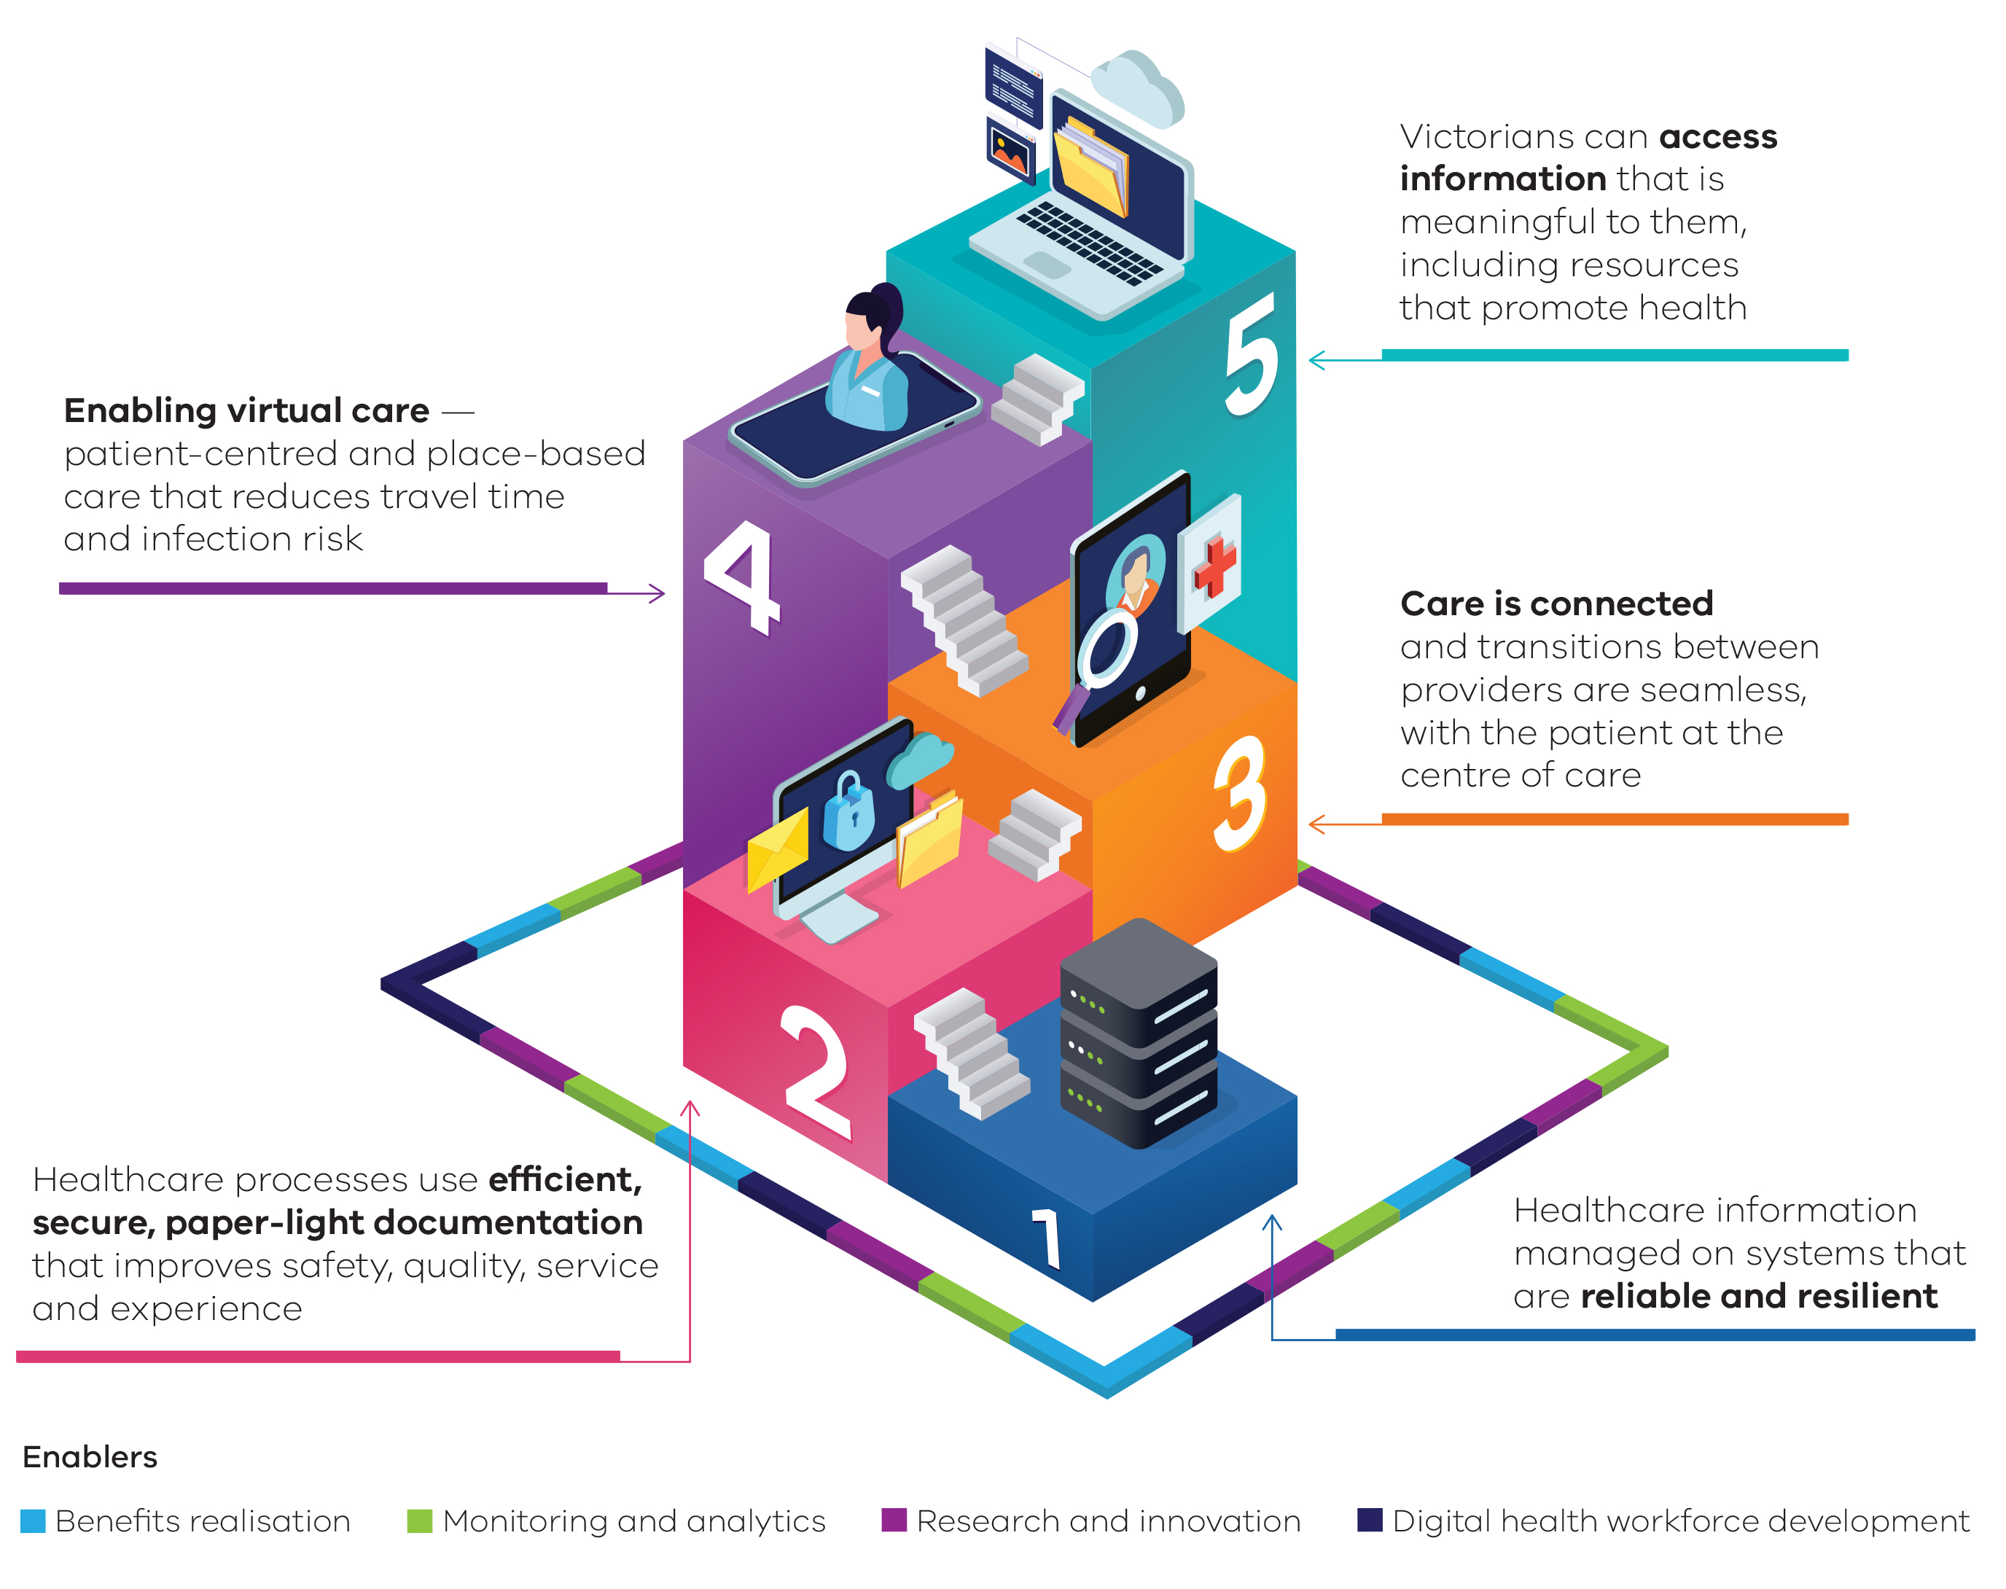

1. Reliable and resilient systems
Shared investment in ICT infrastructure and services is creating a more resilient digital backbone for Victoria’s health services. Robust ICT systems mean fewer outages and cyber incidents, and less downtime.
This program of work builds on whole-of-government and whole-of-sector contracts. It uses aggregated purchasing power to drive value-for-money, and features deep sector engagement and a cost-shared approach to service delivery.

2. Efficient, secure, paper-light health care
Transitioning to digital records and processes that offer decision support reduces errors and improves care. This program of work focuses on clinical, client and patient administration applications. It does not address back-office systems.
Publicly funded community health organisations, mental health services, maternal and child health, and child health services are in scope for digitisation.

3. Continuity of care
More than 90 per cent of Victorians have a My Health Record (MHR). Clinicians in most public health services can view MHR, which gives clinical staff access to summaries of their patients’ GP, community pharmacy and private hospital records. In 2021–22, clinicians in community health organisations will be able to view MHR.
Unique patient identification (UPI) helps people managing chronic disease to receive joined-up care. It reduces the need for patients to provide personal information at points of transition across the continuum of care. It gives clinicians confidence that patient data are current and accurate, and supports the development of individual care plans.
Clinical information sharing reduces the risk of harm at points of transition, reduces duplication of diagnostic tests and facilitates the availability of test results. The patient is uniquely identified, so results are not delayed or ‘lost’.
This program of work also extends deployment of electronic referrals. It will deliver a fit-for-purpose provider directory and statewide imaging sharing.

4. Enabling virtual care and care closer to home
Digital technologies will enable Victorians to access many types of care closer to home, for example:
- care normally provided in clinics, such as community-based services including primary care, maternal and child health, mental health and drug and alcohol services
- care normally provided in hospitals, such as specialist services, rehabilitation, an expansion of Hospital in the Home (HITH) and care for the frail, elderly and other vulnerable cohorts.

5. Consumer access and engagement
Letting Victorians book their own tests, procedures and outpatient appointments online helps people engage in self-care and shared decision making. This program of will work also give people access to their own healthcare information.

Enablers
Four enablers support the Roadmap.

1. Benefits realisation
Measuring and reporting on the benefits of digitisation informs further investment and helps to improve implementation.
Evidence shows these benefits include greater efficiency, productivity and quality and safety outcomes. The department’s Compendium of electronic medical record (EMR) benefits measures (2020) outlines some of these benefits.

2. Research and innovation
Digitisation of care processes leads to better research and innovation. It allows us to continually research which innovations, therapies and models of care are safe, effective, improve the patient experience, and use resources efficiently.
For example, deploying remote monitoring and artificial intelligence to improve patient outcomes will allow the government and the health sector to plan and continuously review, validate and improve care. Sound clinical governance underpins innovation and research partnerships.

3. Monitoring and analytics
Aggregating data from clinical and administrative systems enables monitoring and analytics to detect trends and patterns.
Better management of our data assets will lead to better outcomes for both the general population and individual patients. Using linked, de-identified population-level data, we can forecast demand and put our resources where they are needed most.
More information on Victoria’s healthcare reporting can be found in the Victorian Agency for Health Information’s (VAHI) Strategic plan 2019–2022. The department’s Health data strategy, from the Office of the Chief Data Officer, outlines how health data collections are standardised, governed and optimally used.
Health services can also build on data linkage and analytics infrastructure to identify patients at high risk of emergency department presentation or hospitalisation.

4. Digital health workforce development
Improving the digital maturity of health services requires a commitment to ongoing workforce development. This is critical to the success of local transformation projects.
The department works with health services and specialist ICT training and education providers to boost digital health workforce development.
Rural ICT Alliances  Public health care in rural Victoria relies on robust ICT infrastructure, contemporary applications, service desks with local knowledge, and secure sharing of information for continuity of care.  Within rural areas, service volumes are lower. This, for budgeting reasons, makes it more difficult for public rural health services to each maintain and uplift ICT infrastructure.  To address this issue, Rural ICT Alliances provide cost-efficient access to core ICT products and services. Rural ICT Alliances adhere to the requirements set out by the Department of Health in the Rural public health care agencies’ information and communications technology (ICT) alliance policy.  Rural ICT Alliances align their collective and individual ICT strategies with the digital health technology strategy for Victoria’s public health sector. | 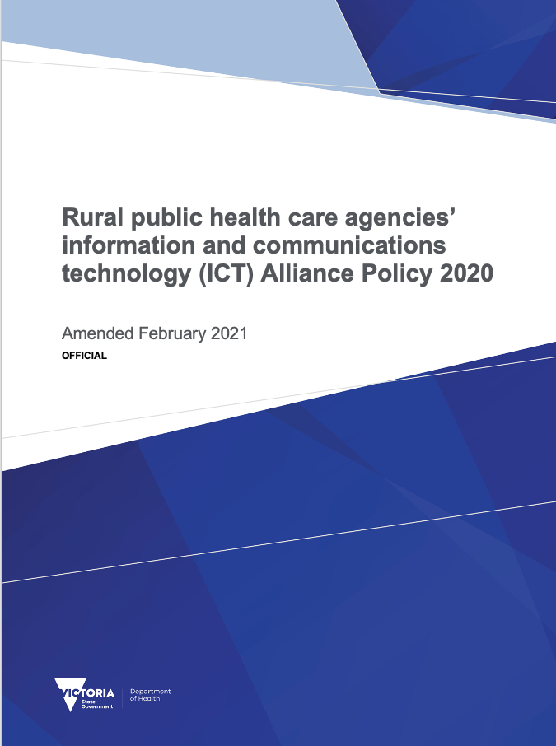
Rural ICT leaders – CIOs from Alliances and regional health services – meet monthly to tackle the challenges of regional and remote health care. Their focus for 2021–22 includes specifying electronic record system requirements for small rural health services.

Investment
The department prioritises digital health investment to strengthen Victorian health services according to the following criteria:
- election commitments, recommendations from the Victorian Auditor-General’s Office (VAGO) and Targeting zero, and ministerial priorities
- risk reduction, including cyber security, and high-availability health service infrastructure
- uplift of digital maturity to improve the safety and efficiency of care in the health sector. This includes connecting care between facilities
- targeted support for rural health services to uplift digital capability and strengthen ICT Alliances.
As a minimum, where health services are co-funded for specific initiatives, the project will be conducted so that it adds value to the rest of the system.
This means that:
- rural health services are members of their Rural ICT Alliance
- the Health Sector Assurance Framework is applied to all investments
- digital clinical system design and architecture will follow the department’s standards as described in the department’s Policy and funding guidelines. These include national standards, such as national identifiers, clinical terminology, discharge summaries, secure messaging, electronic medication management, and the ability to interact with MHR
- generation, monitoring and dissemination of departmental and state-level performance reports are out of scope. Refer to the VAHI Strategic plan 2019–2022.

Assurance of health ICT projects
All health ICT projects with a budget above $1 million are subjected to assurance by the Digital Health branch or its delegate. Figure 2 sets out this process.
Figure 2: Digital Health Branch project assurance
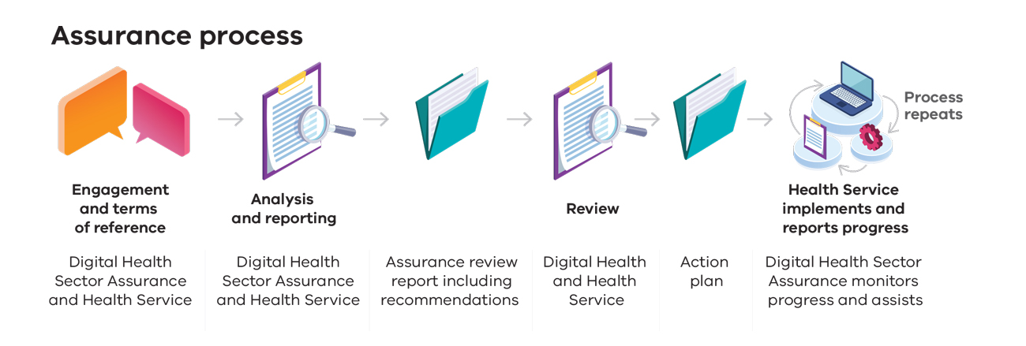

Public health reform and digital health
The department is developing its Digital Public Health workstream. This is part of the Future of Public Health project. The Roadmap does not yet address these reforms which, at the time of writing, are in development.

The Roadmap and its context

About this document
This document summarises the Roadmap, which outlines the areas of planning and execution required to achieve digital health maturity in the Victorian health system over the next five years.
It guides planning in digital health systems to support:
- value-based and patient-centred health care
- reduced risks to patients and higher-quality care
- improved service continuity
- improved patient experience, particularly for people with chronic illness
- improved population health.
The Roadmap is intended for:
- the Victorian Government
- Victorian acute and community-based health services and other Victorian healthcare providers
- patients and clients of Victorian health services.

Policy context
The Roadmap:
- responds to the VAGO reports Clinical ICT systems in the Victorian public health sector (2013), ICT strategic planning in the health sector (2017) and Security of patients’ hospital data (2019)
- responds to the digital health recommendations of Targeting zero (2016)
- will lift digital health maturity, as defined by the Victorian digital health maturity model
- supports the following departmental strategic directions:
  - person-centred services and care
  - local solutions
  - prevention and earlier intervention
  - advancing quality, safety and innovation.
Victorian health services and community health organisations manage the care of patients and clients in partnership with general practitioners and other primary health clinicians. We will work closely with Victoria’s Primary Health Networks as we implement and operationalise the Roadmap.

Victorian digital health maturity model
In 2017, the Victorian Auditor-General’s Office recommended the department create a framework for measuring and benchmarking Victorian health services’ digital health capability.
Health services self-assess against the model every second year. The model is being assessed to see if it is appropriate for Victoria’s registered community health organisations.
All health services have been assessed against the model. Victoria’s digital health maturity model provides the means to evaluate progress of the Roadmap in lifting digital maturity from ‘basic’ to ‘transformative’ states, as shown in Figure 3.
More detail on Victoria’s digital health maturity model is provided in Appendix 1.
Figure 3: Levels of digital health maturity
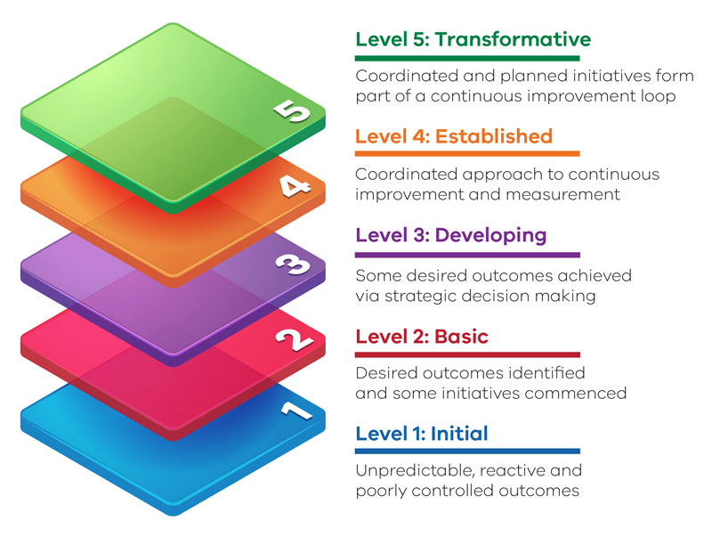

Figure 4: The roadmap
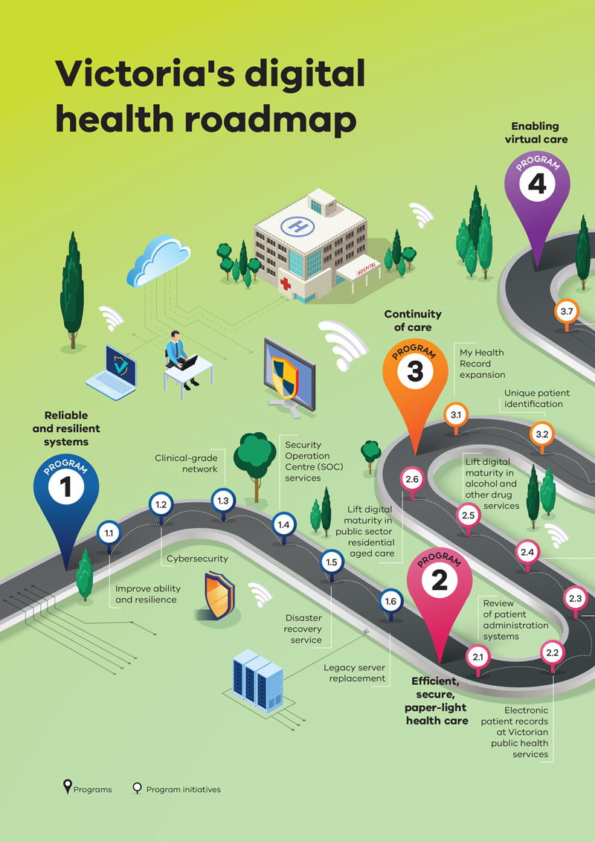
Figure 4: The roadmap (cont.)
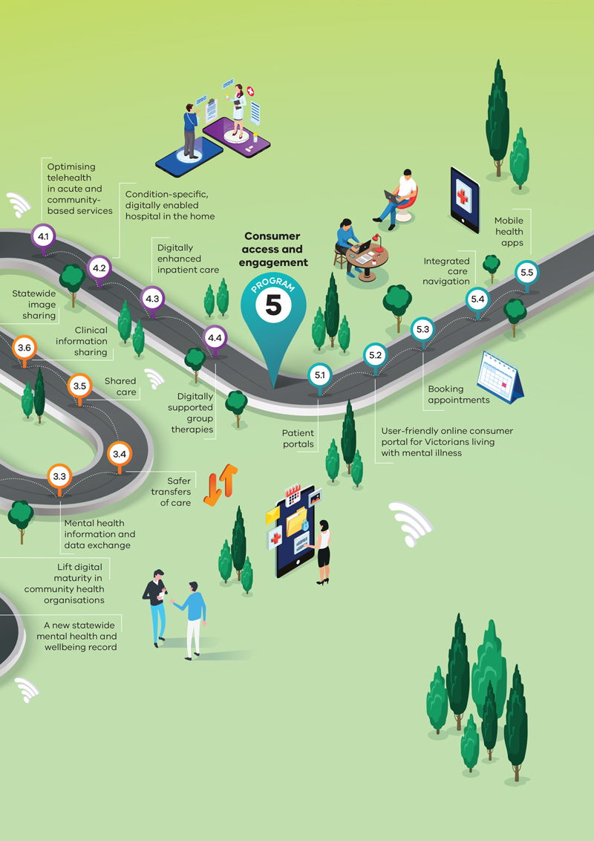

Royal Commission into Victoria’s Mental Health System
Recommendations of the Royal Commission into Victoria’s Mental Health System (RCVMHS) guide the department’s ICT planning for Victoria’s public mental health services.  Planning will focus on digital maturity initiatives that improve support for, and the experience of, Victorians living with mental illness.  The RCVMHS final report outlines ‘a new approach’ to mental health. This includes clear entry and referral criteria and better continuity of care for Victorians living with mental illness.  Recommendation 5 of the RCVMHS report specifies commissioning telehealth and digital technologies to deliver care for adult and older Victorians with mental illness.  The Victorian Government has accepted the following digital health recommendations: | 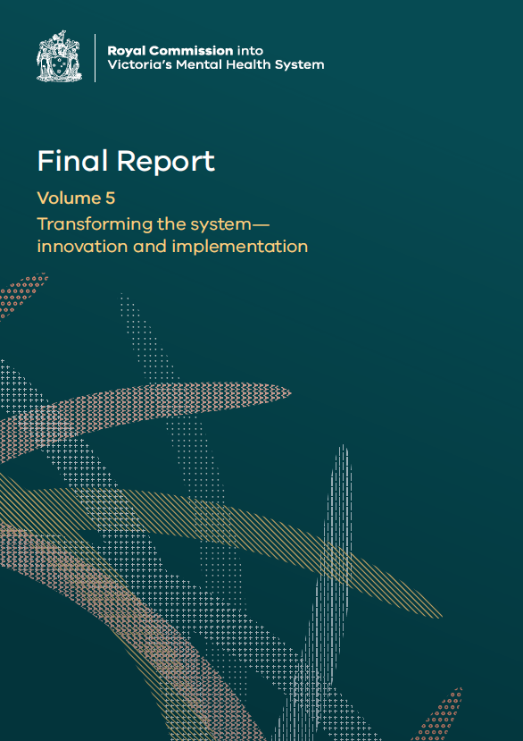
- Recommendation 39 specifies trialling two digital mental health services by the end of 2022.
- Recommendation 60 requires specification of digital mental health requirements.
- Recommendation 62 is to develop, fund and implement modern infrastructure of ICT systems.
The Commission recommends introducing three new major ICT components:
- ‘A new statewide Electronic Mental Health and Wellbeing Record – this would be for all public mental health and wellbeing services (including services within the infant, child and youth mental health and wellbeing system, and those within the adult and older adult mental health and wellbeing system), which will replace the current CMI/ODS system. For community mental health and wellbeing services, which are almost all still paper- and fax-based, using the record will bring their mental health service digitisation to a level comparable to that in hospitals and primary health care. The new record will be interoperable with hospitals that have electronic medical records, and so avoid duplication of data entry and resources’ (refer to Program of work 2).
- ‘A new Mental Health Information and Data Exchange – this would allow for sharing of information outside of public mental health and wellbeing services, such as GPs and community mental health and wellbeing services, where appropriate. This could happen for one of two purposes: to facilitate service delivery or to enable access to deidentified data for research and administrative purposes’ (refer to Program of work 3).
- ‘A new consumer portal to allow consumers to easily access their own information’ (refer to Program of work 5).
Figure 5 summarises the intent of the new ICT arrangements. The Victorian Government will partner with consumers, families, carer, supporters, service providers and frontline workers to design and implement all of the priority initiatives listed.
Figure 5: Conceptual map for ICT arrangements in the new mental health system
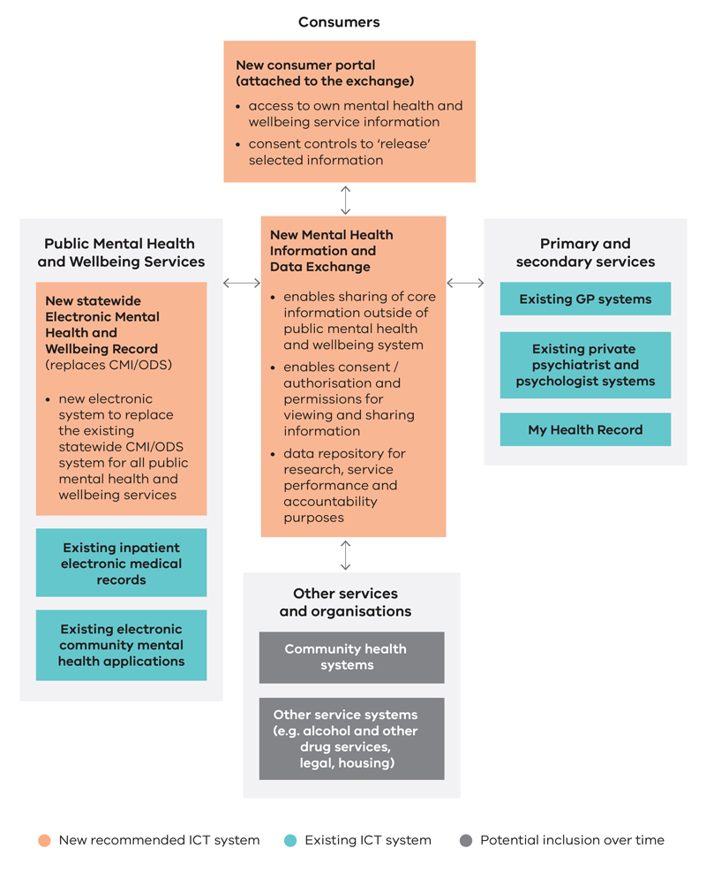

Program of work 1: Secure and resilient systems
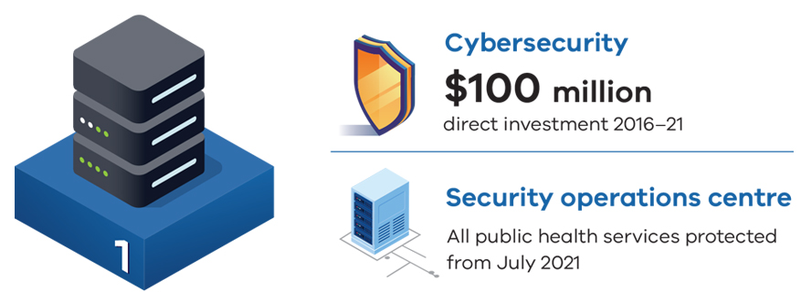
Program of work 1 | In place | In progress | Planned
1.1 Improve ability and resilience
1.2 Cybersecurity
1.3 Clinical-grade network
1.4 Security Operation Centre (SOC) service
1.5 Disaster recovery service
1.6 Legacy server replacement

Strategic objective
Healthcare information is managed on systems that are reliable and resilient.

Outcomes
- Care in Victoria is supported 24/7 by communication, networks and systems to minimise interruptions to patient care.
- Patient data are private and secure, and cyber vigilance is actively maintained and strengthened.
- Clinical and administrative systems are supported and responsive. This includes complex imaging, telehealth, portals and administrative systems.
- Systems operate with high availability. Failover and disaster recovery can be enacted quickly.
Resilient and available systems are fundamental to patient safety
As institutions continue to transition to electronic medical records (EMRs), they need contingency plans to ensure patient safety in the event of system failures.
A survey of 50 institutions [in the USA] with fully integrated EMRs found that nearly all had experienced unexpected failures in the past three years – 70 per cent of which resulted in EMR unavailability for more than eight hours.
Despite this, most had only partly implemented comprehensive safety plans to avoid patient harm during these instances.
Sittig DF, Gonzalez D, Singh H 2014, ‘Contingency planning for electronic health record-based care continuity: a survey of recommended practices’, Int J Med Inform, vol. 83, no. 11, pp. 797–804.
Digital Health Branch is working with Victoria’s public health services to develop their respective best practice business impact assessments (BIA). BIAs document the time sensitivity of each application in the event of outages.

Context
The government, department and health services continue to invest in digital health initiatives, although there is much work yet to be done to lift availability and resilience. Without this commitment, Victorian health and community services will be exposed to risks such as:
- deferral or cancellation of elective surgery
- delays in discharging patients
- extended emergency department waiting times
- reduced quality and safety of care.
Figure 6 shows the time lost by faults in 2018–19 and 2019–20 was largely due to network, hardware and infrastructure failures.
Figure 6: Time lost by fault type 2018–19 and 2019–20
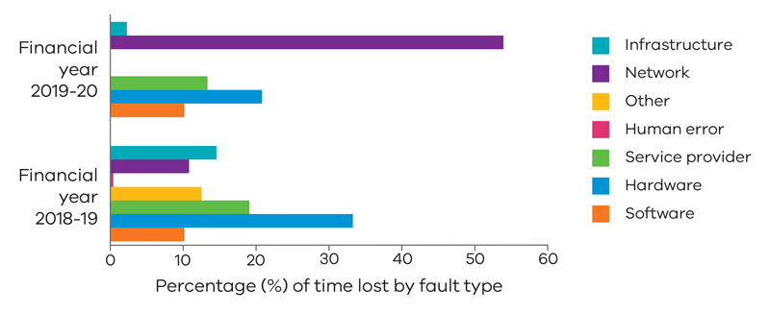
Protecting Victorian health services from cybersecurity incidents
On Monday 30 September 2019, rural and regional health services in south-western Victoria and Gippsland experienced a ransomware incident.
Information technology systems at the South West Alliance of Rural Health and Gippsland Health Alliance were taken offline as a result, with manual processes enacted to contain the incident.
It was later found that an infected email attachment was inadvertently opened, infecting the network.
Program 1 addresses these vulnerabilities by:
- improving operational resilience (replacing at-risk, legacy technical infrastructure)
- raising cybersecurity capability (mandatory training of all health service staff)
- making it more difficult for staff to accidently fall prey to these types of attacks (deployment of specialist products that constantly monitor networks for aberrant behaviour).

Investment approach
Strengthening the resilience and infrastructure of ICT in Victorian health services comprises a combination of local capital investments and operating expenditure.
Where possible, program initiatives have been supplemented by government funding of a central, single-source procurement through a sector-based working group, with State Budget support for critical elements.

Initiative 1.1: Improve ability and resilience

Purpose
Apply best practice ICT operation tools and processes across the Victorian public health sector to improve the availability and resilience of ICT systems.

Description
This initiative works with health services, government and commercial partners to:
- ensure each health service has a best practice BIA in place to map time sensitivities for each application. This underpins ICT-related business continuity planning
- provide a central asset discovery tool to manage ICT assets. The tool automatically identifies, classifies and manages devices connected to health service ICT networks. It identifies the number, type and compliance of devices
- provide a central monitoring tool that identifies non-functional or underperforming infrastructure. This allows issues to be quickly addressed
- establish and implement certification standards and vendor contract management frameworks and processes
- conduct annual assessments of ICT operational maturity.

Initiative 1.2: Cybersecurity

Purpose
Implement cybersecurity services and interventions to reduce the incidence and impact of cyber attacks on Victorian public health services.

Description
This initiative works with health services, commercial partners and the Department of Premier and Cabinet’s Cyber Incident Response Service to:
- improve the cyber vigilance, reliability and resilience of Victorian public health ICT systems
- invest in advanced antivirus and user-authentication security protections
- provide ICT policies to guide cybersecurity in Victorian public health services
- improve cybersecurity capability via training and education across the health services sector
- audit, monitor and evaluate cybersecurity performance.
Since 2019, Digital Health Branch has worked with health services to implement:
- multifactor authentication
- password blacklist tools
- next generation antivirus software
- mandatory training packages for all health service staff
- a cyber security operations centre service (refer to Initiative 1.4).

Initiative 1.3: Clinical grade network

Purpose
Provide a single, standardised, reliable and resilient network linkage contract and service across Victorian public health service networks. This replaces existing network linkage contracts and services.

Description
The department is working with health services to:
- deliver standardised interconnectivity between Victorian public health service networks
- discontinue duplicate, complex, expensive, less reliable and insecure connections
- install a single, secure, safe, reliable and scalable connection
- protect the privacy of patient and clinical information
- lower clinical and operational risk
- more easily increase bandwidth
- reduce the cost to health services of internet access.

Initiative 1.4: Security Operation Centre (SOC) service

Purpose
Provide a statewide facility to detect, analyse and respond to cybersecurity incidents using a combination of technology solutions and a strong set of processes.

Description
The health sector Security Operations Centre has been implemented to:
- collect data on network activity so that it can be analysed for any anomalous activity
- improve security incident detection through continuous monitoring and analysis of network activity and information flows
- ensure timely detection and resolution of security incidents, including cybersecurity incidents
- protect sensitive health information, giving confidence to stakeholders, including patients that information has integrity and is managed in accordance with privacy regulations and practices.

Initiative 1.5: Disaster recovery service

Purpose
Provide standardised, fast and reliable ICT disaster recovery for Victorian public health services.

Description
This initiative works with health services and commercial partners to:
- provide a standardised Disaster Recovery as a Service (DRaaS) contract for ICT disaster events
- identify and mitigate clinical and patient safety risks, and provide business continuity, during an ICT disaster event
- avoid patient harm by minimising the impact of ICT outages
- ensure shortest recovery times for patient services in the event of ICT disruptions.

Initiative 1.6: Legacy server replacement

Purpose
Replace aged and out-of-support Microsoft servers, devices and operating systems.

Description
This department worked with health services and Health Purchasing Victoria (HPV) to:
- validate the amount of legacy equipment across Victoria, its location and interdependencies, and each health service’s ability to replace it
- replace servers, devices and operating systems that are out-of-support, vulnerable to cybersecurity intrusion and are end-of-life with no industry upgrade path
- renegotiate the central service provider agreement
- implement a mix of device and server procurement, service procurement and operational change management.

Status at 30 June 2021
Total number of legacy Windows servers: | 3,638
Number of servers replaced to March 2021: | 1,727
Number of servers funded for replacement: | 1,569
Number of servers to be retired: | 342

Program of work 2: Efficient, secure, paper-light health care
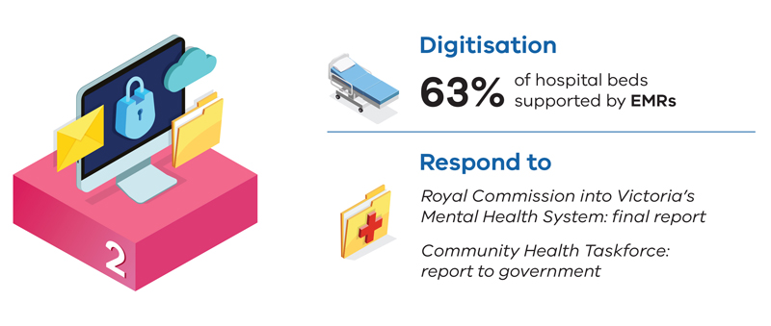
Program of work 2 | Completed | In progress | Planned
2.1 Review of patient administration systems
2.2 Electronic patient records at Victorian public health services
2.3 A new statewide mental health and wellbeing record
2.4 Lift digital maturity in community health organisations
2.5 Lift digital maturity in alcohol and other drug services
2.6 Lift digital maturity in public sector residential aged care

Strategic objective
Health care is paper-light, efficient and securely documented to improve the safety, quality and experience of care, with a focus on recommendations of the RCVMHS.

Outcomes
For publicly funded acute and community health services:
- clinical documentation is legible, auditable and provided through secure digital systems
- this includes prescribing, test ordering, medicine prescribing, administration and dispensing, patient histories, care plans, laboratory results and imaging reports, consultations and treatments
- clinicians and case managers manage care in clinics, remotely, and from the bedside with portable devices.

The impact of health information technology on patient safety
A 2017 study by Alotaibi and Frederico concluded that ‘health information technology improves patients’ safety by reducing medication errors, reducing adverse drug reactions, and improving compliance to practice guidelines. There should be no doubt that health information technology is an important tool for improving healthcare quality and safety.’
Alotaibi YK and Federico F 2017, Saudi Med J, vol. 38, no. 12, pp. 1173–1180, doi: 10.15537/smj.2017.12.20631.

Context
Moving away from paper and handwritten records reduces errors, improves decision making and increases efficiency. It enables joined-up care and forms the foundation for patients to access their own healthcare information.
Benefits of clinical information and client management systems include:
- improved patient journeys through the system
- strengthened clinical safety systems and governance
- enabling telehealth and expansion of Hospital in the Home services
- improved workforce connections.
This program of work focuses on acute, mental health and community health services:
- patient administration systems
- client management systems
- electronic patient record systems
- a statewide electronic mental health record.
Health services purchase, implement and maintain a wide range of ICT applications. It is not uncommon for a metropolitan Victorian health service to operate more than 200 applications for every element of its complex and mission-critical business.
However, transition from paper-based care processes to an electronic patient record or client management system typically requires a significant capital outlay and change management. In some cases, government co-funding allows health services to implement a transformation project that would be difficult to fund independently.
EMRs are the most complex systems to implement, operate and safely maintain. Victorian health services select the EMR most suitable for their respective service model and clinical profile. To date, more than 60 per cent of public hospital beds are supported by an EMR. Implementations or business cases are in place or in development for most metropolitan health services.
The RCVMHS makes specific recommendations for digitisation of mental health services in Victoria for similar reasons.
Recommendation 62 of the RCVMHS Final report aims to improve the safety, effectiveness and acceptability of patient care, and to enable secure and confidential ‘joining up’ of patient records across the health services managing individual patients.

Initiative 2.1: Review of patient administration systems

Purpose
Refresh and consolidate requirements for contemporary Victorian health service patient administration systems.
Replace end-of-life patient administration systems operated by the department.

Description
This initiative will:
- develop an approach to replacing end-of-life patient administration systems
- decommission end-of-life patient administration systems
- facilitate the procurement of applications and licences for replacement systems with modern capabilities
- complete technical alterations to embed replacement systems within health services’ ICT environments
- support change and process management so that health service staff can make the best use of new systems.

Initiative 2.2: Electronic patient records at Victorian public health services

Purpose
Digitise health care in Victorian public health services to enable safer and connected care. This includes supporting closed-loop medication management in hospitals.

Description
This department works with health services and EMR vendors to:
- implement electronic patient record systems at Victorian public health services
- upgrade existing electronic patient record systems at Victorian public health services
- implement active asset lifecycle management of applications
- implement current project assurance processes
- assure implementation and set standards for electronic patient record systems
- support change and process management so that health service staff can make best use of the new system.
Figure 7 shows an example of an erroneous tenfold increase in an insulin dose generated through paper prescribing with poor legibility.
Identifying deteriorating patients – a Dutch study
‘Almost half of the unplanned ICU admissions from the general ward had healthcare worker related root causes, mostly due to monitoring failures in clinically deteriorating patients …’
‘… unexpected ICU admission leads to a poor long-term survival, especially in older patients.’
van Galen LS, Struik PW, Driesen BEJM, Merten H, Ludikhuize J, van der Spoel JI, et al. 2016, ‘Delayed recognition of deterioration of patients in general wards is mostly caused by human related monitoring failures: a root cause analysis of unplanned ICU admissions’, PLoS ONE, vol. 11, no. 8, e0161393.
Figure 7: This order for 8 units of Lantus insulin was misread as 80 units
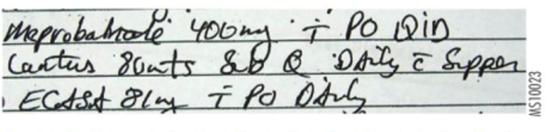
Note: Used with permission from the Institute for Safe Medication Practices, Pennsylvania.

Initiative 2.3: A new statewide mental health and wellbeing record

Purpose
Lift digital maturity in mental health services by implementing a statewide mental health and wellbeing record. This will improve the acceptability, effectiveness and safety of care for Victorians living with mental illness.

Context
Recommendation 62 from the Royal Commission into Victoria’s Mental Health System is to develop, fund and implement modern infrastructure of ICT systems including a new statewide mental health and wellbeing record.

Description
This initiative works with health services (including but not limited to designated mental health services) to lift the current state of digital mental health systems maturity through the creation of a statewide mental health and wellbeing record.

Initiative 2.4: Lift digital maturity in community health organisations

Purpose
Lift the digital capability and maturity of publicly funded community health services by digitising care, as part of the Community Health Taskforce response to the VAGO 2018 audit Community health program.

Description
This initiative works with community health services to:
- assess the current state of systems’ maturity
- scope requirements to uplift systems’ maturity to
  - ensure records and systems are safe and secure (see Program of work 1: Reliable and resilient systems)
  - digitise care processes
  - implement secure sharing of clinical information with other services (see Program of work 3: Continuity of care)
  - enable access to My Health Record, eReferral and the National Health Service Directory
- support change and process management so that community health service staff can make best use of digital systems.

Initiative 2.5: Lift digital maturity in alcohol and other drug services

Purpose
Lift the digital capability and maturity of publicly funded alcohol and other drug (AOD) services.

Description
This initiative works with publicly funded AOD services to:
- assess the current state of systems’ maturity
- scope requirements to uplift systems’ maturity to
  - ensure records and systems are safe and secure
  - digitise care processes
  - where appropriate, enable access to My Health Record, eReferral and the National Health Service Directory.

Initiative 2.6: Lift digital maturity in public sector residential aged care

Purpose
Lift the digital capability and maturity of public sector residential aged care, to enhance the safety and quality of life for residents.

Description
This initiative works with health services and the Commonwealth to:
- assess the current state of digital maturity
- scope requirements to uplift systems’ maturity to
  - ensure records and systems are safe and secure
  - enhance the safety and reliability of aged care processes, including but not limited to medication management
  - enhance the sharing of clinical information with other healthcare providers
  - enable access to My Health Record and provide electronic referral capability
- develop and implement a program of work.

Subprojects
In addition, the Roadmap will support
- maternal and child health, to enable safe, coordinated support and care for mothers, babies and children
- replacement of the legacy platform used by genomic services
- enhance the supporting applications for Early Parenting Centres and the new community hospitals.

Program of work 3: Connecting care
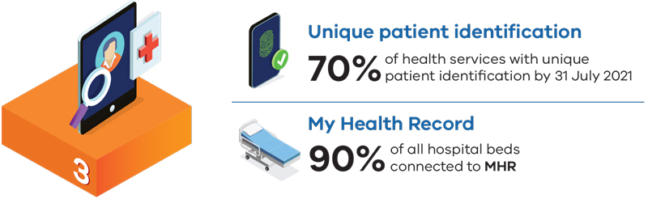

Program of work 3 | Complete | In progress | Planned
3.1 My Health Record expansion
3.2 Unique patient identification
3.3 Mental health information and data exchange
3.4 Safer transfers of care
3.5 Shared care
3.6 Clinical information sharing
3.7 Statewide image sharing

Strategic objective
Securely enable continuity of care to support Victorians in their journey across health settings and providers.

Outcomes
- Clinicians and case managers can review patient and client treatments, diagnostic information and services provided in different settings and facilities.
- Hospital discharge information is securely available to primary care and specialist services.
- Ambulatory and community care are managed and seen by all care teams supporting a patient or client.
- Victorian patients are uniquely identified.
- Transfers of care are safer.

Approach
Joining up patient and client care requires investment in centrally managed infrastructure and solutions, and a standards-based approach to implementation and operation of core system.
Unique patient identification is operated by a centrally funded team and application. Data stewards and interfaces operate in each health service. My Health Record leverages state and national investments to capture and present clinical documents to clinicians, again with local teams managing the interfaces, and change and adoption.
A particular focus is implementation of the requirement from the RCVMHS to implement a Mental Health Information and Data Exchange. Work is also planned to provide frontline Ambulance Victoria teams with secure access to clinical information for patients in their care.
Business cases are in development for Victoria’s health information exchange and image sharing plans. These core investments will require central support to underpin safe and high-quality care transitions and transfers. Models for operating expenditure post-implementation are being explored.

Safety at transitions of care
The Australian Commission on Safety and Quality in Health Care looked into the way clinical information is safely and securely shared at transitions of care.
It found four main gaps:
- Important information about patients’ medical histories on admission to acute hospitals cannot be accessed. Safety risks are increased when clinicians have incomplete medical histories.
- The quality of information in discharge summaries is variable. Missing, inconsistent, poorly presented and irrelevant information reduces the safety of patient care.
- The modes and effectiveness of information transmission are variable. Much of the communication between hospitals and primary clinicians is still paper based. Secure communication systems will improve the efficiency and safety of communication between providers.
- The timeliness of receiving discharge information is variable. GPs report that some discharge information is received long after patient discharge, or not at all.
Australian Commission on Safety and Quality in Health Care 2017, Safety issues at transitions of care: consultation report on pain points relating to clinical information systems, ACSQHC, Sydney.

Context
The Victorian health system has used a siloed approach to managing patient information. This makes it difficult for clinicians and case managers to view the clinical information they need to provide care. The risk to patient safety this creates is identified in Targeting zero: supporting the Victorian hospital system to eliminate avoidable harm and strengthen quality of care – report of the Review of Hospital Safety and Quality Assurance in Victoria, Recommendation 4.13.
Figure 8 shows that discrete parts of a patient’s clinical information can be found in a range of settings. These include GP practices, hospitals and health services, specialist rooms, pharmacies and other community service providers.
Figure 8: Appropriate sharing of clinical information across the health system creates smoother care transitions for patients
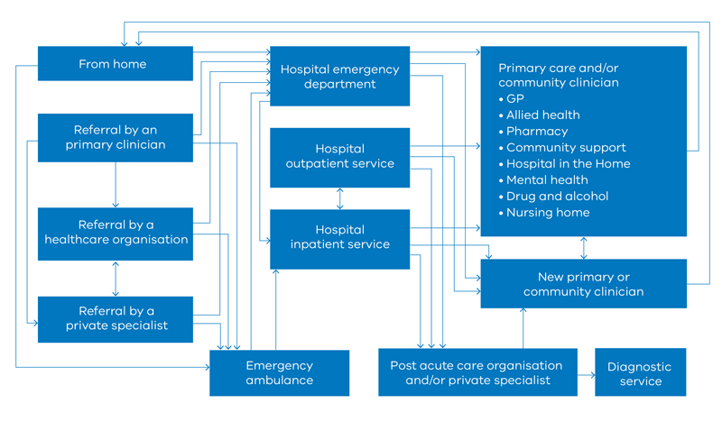
Securely sharing the right information at the right time is vital to support care. This is particularly important for patients managing chronic conditions across a range of different services.
Addressing this issue is a complex task that involves investment in technology, infrastructure, standards, and in patient and clinician identity management.
Legislative change is also planned, to enable clinical information sharing between Victorian public health services for the purpose of patient care.

Initiative 3.1: My Health Record expansion

Purpose
Provide patients and healthcare providers with access to a secure online national health summary for Victorians who have a My Health Record.

Description
This initiative works with health services, community health organisations and the Australian Digital Health Agency to:
- complete public health and diagnostic service connection of My Health Record in Victoria
- achieve routine use of My Health Record in emergency departments, outpatients, and in community health organisations
- embed My Health Record in rural health services.
This work is supported by the following subprojects:
- maintain and enhance application infrastructure for health services to connect to and engage with My Health Record
- provision of a My Health Record orientation video for new healthcare providers and employees.
The department will also assess the feasibility of providing My Health Record access for Ambulance Victoria, maternity services and anaesthetists.

Initiative 3.2: Unique patient identification

Purpose
Implement a unified view of patient details and identifiers across Victorian health services, as recommended in Targeting zero.

Description
This initiative works with health services to:
- match and link disparate patient records for the same patient, across health services and settings
- implement information-sharing agreements across health services to participate in this service
- implement a unique patient identification solution across the Victorian health sector
- improve and standardise patient registration practices across Victorian public sector health services.

Providing a unified view of patients across Victorian health services
By July 2021, 70 per cent of health services were connected to the Victorian Unique Patient Identification (UPI) platform.
The implementation process has also allowed health services to cleanse existing data by removing redundant patient records and migrating only appropriate candidate records to UPI.
For instance, at one of Melbourne’s metropolitan health services, of the possible 2.7 million patient records, 2.4 million were assessed as candidate records and migrated to UPI, removing more than 310,000 redundant records.

Initiative 3.3: Mental health information and data exchange

Purpose
To optimise the continuity, safety and acceptability of care for Victorians living with mental health conditions, in response to the RCVMHS’ description of a ‘… lack of an information-sharing culture’.

Context
Recommendation 62 of the Royal Commission into Victoria’s Mental Health System final report is to develop, fund and implement modern infrastructure of ICT systems, including a new Mental Health Information and Data Exchange.

Description
A Mental Health Information and Data Exchange will build on the foundations of the department’s legacy Client Management Interface / Operational Data Store (CMI/ODS) system, and on Victoria’s unique patient identification platform.
It will securely and confidentially enable ‘health, mental health and other information about people’s needs and preferences … to be shared between representatives of participating providers to support good outcomes’.
A contemporary health information exchange specifically for the care of Victorians living with mental illness will provide more connected care, whether the person presents to a designated mental health service, a general public health service or a community health organisation.
The exchange will apply settings for patient preferences about whom the record may be shared with, such as a family member or carer.

Initiative 3.4: Safer transfers of care

Purpose
Enable routine and secure exchange of clinical information between Victorian healthcare providers including hospitals, primary and community health sectors, to support the transfer of care.

Description
This initiative works with health services, clinicians and the primary care sector to:
- build on lessons from pilot sites to enable eReferral into public health services across Victoria, reducing reliance on fax, phone and paper referrals
- achieve routine use of eReferral, eDischarge and the National Health Service Provider Directory.

Initiative 3.5: Shared care

Purpose
Building on the COVID-positive pathways, extend this collaborative model of care across primary care, community health and acute settings.

Context
In response to the second wave of the COVID19 pandemic in Victoria, health services and community partners offered care pathways to all notified cases of COVID19.
After clinical assessment, each case was registered with programs to monitor and manage the disease. This also allowed care for other conditions, such as those exacerbated by self-isolation, to be provided by health services, and community and primary care partners.
A range of interim platforms enabled acute, community and primary care providers to jointly manage COVID-positive patients.

Description
This initiative works with acute and community health services, and primary care to:
- increase collaboration between primary care and hospital services to improve health outcomes
- enable acute and community-based health services to work with general practice to jointly support patients with chronic, acute and post-acute conditions
- decrease avoidable demand for public hospital services, particularly for patients with complex and chronic conditions
- evaluate the work to quantify benefits, test effectiveness and measure economic return on investment of the model.

Initiative 3.6: Clinical information sharing

Purpose
Implement a health information exchange to securely store and present clinical information, to support patient care across Victorian public health services.

Description
This initiative is dependent on legislative reform and government funding. The department is working with clinicians and health services to:
- facilitate legislative reform to enable the lawful sharing of information
- ensure agreement on standardised vocabularies for information capture and information exchange
- articulate the product requirements of the clinical information-sharing solution
- develop a business case and funding model
- procure an application or solution provider that meets requirements
- develop, test and implement the solution.

Initiative 3.7: Statewide image sharing

Purpose
Provide clinicians with access to diagnostic images across participating health services, regardless of their location.

Description
This initiative builds on unique patient identification and clinical information-sharing initiatives.
The department is working with clinicians, health services, and the medical imaging community to:
- establish a ‘tactical image sharing’ program for safe transfer of patients between health services
- specify requirements for a statewide image sharing solution
- establish a business case and funding model
- subject to investment planning, procure an application or solution provider
- plan, test, pilot, and implement the solution.

Program of work 4: Enabling virtual care and care closer to home
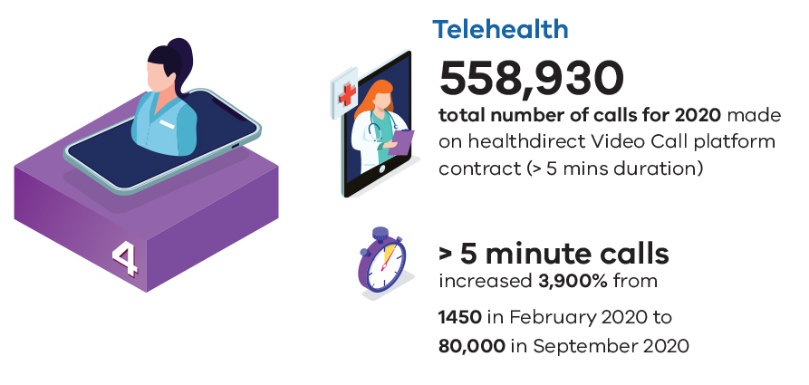
Program of work 4 | Completed | In progress | Planned
4.1 Optimising telehealth in acute and community-based services
4.2 Condition-specific, digitally enabled hospital at home
4.3 Digitally enhanced inpatient care
4.4 Digitally supported group therapies

Strategic objective
Care closer to home is the default where it is safe and supported by patient and client preference.

Outcomes
- Patient and client travel is reduced, and the patient experience is improved by place-based care where safe.
- Risk of infection to patients, clients and providers is reduced. Carbon outputs are reduced, and capital investments are applied more rationally.

Context
Clinical evidence shows some patients can achieve better outcomes at home, where they avoid the physical deterioration, sleep disruption and social isolation associated with hospital stays. Care at home also enables patients to avoid infection risks and visitor restrictions that are realities of hospitalisation.
Clinical services that can be safely delivered at home include subacute care (for example geriatric care and rehabilitation after surgeries or strokes), non-admitted diversion and substitution services (for example non-admitted dialysis, and complex care targeted at patients at risk of readmission), admitted chemotherapy (typically delivered over long periods of time, involving extensive life and family disruption when patients are required to travel for their treatment) and specialist clinic appointments.
The coronavirus pandemic saw a rapid conversion of outpatient and community consultations to telehealth. Telehealth consultations of more than five minutes duration, using the government-funded Healthdirect Video Call platform, rose from less than 1,500 in February 2020 to more than 80,000 in September 2020.
Health services are already implementing a range of virtual care models. The department supports coordinated investments that provide safe, digitally enabled care models at scale.
Figure 9: The COVID-19 pandemic saw growth in Victoria’s Healthdirect video calls of more than five minutes duration
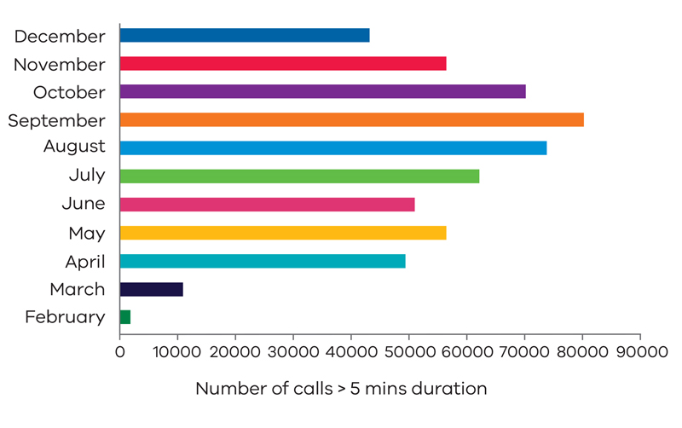
Local and global evaluations of home-delivered hospital services continue to show the benefits of delivering care in the home including better outcomes for patients, a reduction in hospital acquired complications such as institutionalisation, infections, falls and delirium and significantly higher patient and carer satisfaction.
Penelope Watson, Principal Adviser, Telehealth Programs

Initiative 4.1: Optimising telehealth in acute and community-based services

Purpose
Enable patients to access care closer to home and achieve superior health outcomes.

Description
The department will work with health services and community-based providers to establish telehealth services that:
- improve outcomes and communication
- decrease travel time
- increase access to care
- empower patients to better manage their chronic conditions
- decrease missed appointments and wait times
- decrease readmissions and improve medication adherence.

Initiative 4.2: Condition-specific, digitally enabled hospital in the home

Purpose
Extend the use of monitoring and therapeutic digital tools in condition-specific care in Hospital in the Home programs.

Description
The department will work with Safer Care Victoria, health services and clinical leaders to identify conditions for which digital monitoring and therapeutic tools can be safely applied to new cohorts and conditions.

Initiative 4.3: Digitally enhanced inpatient care

Purpose
Use digitally enhanced models of inpatient care to improve care accessibility, quality, safety and efficiency.

Description
This initiative builds on existing health services programs and projects, and engagement with health services and clinical leaders to:
- identify digitally enhanced care processes for admitted patient cohorts in Victoria’s public health services through which care can be enhanced, infection risk reduced, and the patient experience improved
- to assess the safety and efficacy of these models and care processes
- identify conditions for which care can be provided remotely to rural patients without their transfer to metropolitan and regional specialist facilities.

Virtual ward rounds
Virtual ward rounds are a form of telehealth using portable devices and meetings and video conferencing software to deliver multidisciplinary ward rounds.
Ward rounds occur with as few as one treating team member being physically present with each patient, and other team members able to view and take part in the round as appropriate.
Other staff taking part in the ward round remotely may be located elsewhere in the ward, elsewhere in the hospital, or off site.
This promotes physical distancing, supports employees working remotely and allows other professions to take part in ward rounds with more consistency than without virtual ward rounds (for example, pharmacists).
Virtual ward rounds have taken place in COVID-19 admission and management wards (in line with previous model of care), as well as across wards when led by teams who have undertaken training.
Monash Health implemented virtual ward rounds as part of their pandemic response in early 2020.

Initiative 4.4: Digitally supported group therapies

Purpose
Extend the use of telehealth infrastructure and investments to support group therapies in mental health, community-based and alcohol and other drug services.

Description
This initiative works with providers of alcohol and other drug services, clinical leaders and departmental officers to:
- assess the literature and conduct environmental scans of Australian and international practices
- identify current group therapies in health services and publicly funded, community-based health organisations
- assess whether and how group therapies can be supported without clients attending a health facility.

Program of work 5: Consumer access and engagement

Program of work 5 | Completed | In progress | Planned
5.1 Patient portals
5.2 User-friendly online consumer portal for Victorians living with mental illness
5.3 Booking appointments
5.4 Integrated care navigation
5.5 Mobile health apps

Strategic objective
Victorians can access health information that is meaningful to them to better manage their own health care and wellness.

Outcomes
- Victorians’ experience of health care is enhanced through access to relevant information.
- Patients and clients can easily – and securely – access their own healthcare information.
- Victorians and their carers can book appointments, be reminded of upcoming tests and consultations, and be supported in navigating the healthcare system.

Open Notes
The Open Notes movement started in Boston, at the Harvard Medical School and the Beth Israel Deaconess Medical Center, Pennsylvania (Geisinger Health) and a hospital in Seattle.
20,000 patients were invited to read their medical notes online, and 99 per cent responded positively.
A 2017 study of more than 25,000 patients found that:
- more than 97 per cent of participants reported that trust in the provider, activation, patient-provider goal alignment and teamwork were better or unchanged after reading one or more notes
- 75 per cent were more likely to check and understand test results
- there was higher compliance with tests and referrals.
Bell SK et al. 2018, ‘Tackling ambulatory safety risks through patient engagement: what 10,000 patients and families say about safety-related knowledge, behaviors, and attitudes after reading visit notes’, Journal of Patient Safety, 27 April 2018.

Context
Victorians increasingly expect to interact digitally with their healthcare providers. This includes being able to book appointments online and access their own health information.
While some health services already provide portals for patients to access their own care information, there is no single site or portal Victorians can use for this purpose.
Other areas where there is a need for consumer-facing digital services include:
- wayfinding services to help people navigate health services
- integrated care information to support consumer choice
- mobile health development to ensure apps for patients and clinicians meet minimum requirements and are based on evidence.

Approach
A number of health services have implemented patient portals, and self-booking will follow, as it has in primary care. Central investment will be in scoping, specification, identification of dependencies and implementation planning.

Initiative 5.1: Patient portals

Purpose
Provide Victorian patients with access to a consistent, detailed statewide healthcare information portal, and enable self-booking for patients and their carers.

Description
My Health Record provides citizens with a summary of their health care – GP and hospital visits, medicines, diagnostic reports and referrals. Patient portals give citizens a forward look at appointments and planned admissions, allow self-booking and, in some cases, direct-to-clinician or clinic interactions.
This initiative works with health services, consumers and medical software providers to:
- plan a statewide approach to patient portals
- build on lead services, unique patient identification and the clinical information-sharing platform
- provide the clinical governance and oversight to ensure information presented to patients and their family and carers is meaningful
- develop and implement a common patient portal for Victorians.

Initiative 5.2: User-friendly online consumer portal for Victorians living with mental illness

Purpose
Provide Victorians living with mental health conditions a user-friendly, online portal that will allow them to access to their own mental health care information.

Context
Recommendation 5 of the RCVMHS report specifies the commissioning of telehealth and digital technologies to deliver care for adult and older Victorians living with mental health conditions.

Description
Recommendation 62 specifies development, funding and implementation of a modern infrastructure of ICT systems. This includes a new, user-friendly online consumer portal, connected to the Mental Health Information and Data Exchange, ‘that allows consumers to view key information about themselves and authorise sharing of information with members of their care team, including family, carers and supporters’.

Initiative 5.3: Booking appointments
Digital Health Branch will explore the feasibility of providing Victorian patients, and their carers, with the ability to book outpatient appointments online. This includes:
- conducting an environmental scan and feasibility study
- identify options and architecture
- considering a business case and implementation planning study.

Initiative 5.4: Integrated care navigation
Digital Health Branch will explore the feasibility of providing personalised healthcare navigation assistance to patients and carers to access health services.
This is particularly important for those with complex and chronic conditions, and involves:
- specifying a digital solution for a personalised healthcare navigation assistance tool
- assessing feasibility, market offerings and indicative cost
- considering a business case and implementation planning study.

Initiative 5.5: Mobile health apps

Purpose
Ensure public sector health information and interactive services can be delivered through appropriate and secure mobile health (mHealth) solutions.

Description
Victoria is working with other jurisdictions and Commonwealth agencies to:
- identify appropriate healthcare apps that are secure, evidence-based, optimally designed and tested, and appropriately maintained
- deliver a national mHealth apps framework, to enable Victorian health services to assess, implement and recommend mHealth apps for consumer and clinician use.

Glossary
Term | Meaning
ADHA | Australian Digital Health Agency: a Commonwealth-established agency, co-funded by the Commonwealth and State/Territory Governments to drive better health for all Australians, enabled by seamless, safe and secure digital health services and technologies.
BIA | Business Impact Assessment: predicts the consequences of disruption of a business function and process and gathers information needed to develop recovery strategies. Potential loss scenarios should be identified during a risk assessment.
Case manager | Case managers are social service workers who coordinate care for their clients. Case managers work with agencies and institutions to ensure that clients get the care they need. Case management and case manager are terms often used when describing the ongoing management of chronic or recurrent conditions, for example, diabetes.
CMI/ODS | Client Management Interface / Operational Data Store: a legacy application operated by the department to capture presentation and admission information, and treatment orders.
Community health services (CHS) | Victoria's network of community health services delivers a range of primary health, human services and community-based support to meet local community needs. They provide universal access to services as well as targeted services for vulnerable population groups. They sit alongside general practice and privately funded services to make up the primary health sector in Victoria.
Digital health | Digital health refers to the use of information technology/electronic communication tools, services and processes to deliver health care services or to facilitate better health. Increasingly, it encompasses the provision of tools and information to empower patients to better understand and manage their health and the health of their family.
Early Parenting Centres | Early parenting centres (EPCs) are a free primary health service that provide specialist support for Victorian families with children aged 0–4 years. They deliver flexible, targeted services that aim to enhance the parent–child relationship and support parents with strategies for achieving their parenting goals. These goals are often in areas such as sleep and settling, child behaviour, and parent and child health and wellbeing.
eDischarge | The exchange of patient discharge summary information between health care providers, usually between a health service and a patient’s GP.
EMR | Electronic Medical Record: a computerised medical record created in an organisation that delivers care, such as a hospital or clinician's office. EMRs tend to be a part of a local stand-alone health information system that allows storage, retrieval and modification of records.
eReferral | Electronic Referral: the seamless exchange of significant patient information from one treating healthcare provider to another via a national system of creating, storing and sharing referral reports.
Failover | Failover is a backup operational mode that automatically switches to a standby database, server or network if the primary system fails, or is shut down for servicing. Failover functionality seamlessly redirects requests from the failed or downed system to the backup system that mimics the operating system environment.  Failover is a means of achieving high availability (HA).
Genomic | Genomics is the study of all a person's genes (the genome), including interactions of those genes with each other and with the person's environment.
Health service | Metropolitan, regional and rural public hospitals.
High availability | Refers to a system or component that is continuously operational for extended lengths of time. One of the goals of high availability is to eliminate single points of failure in an organisation’s technical infrastructure. Provides a method for organisations to protect against negative outcomes caused by a service outage.
HITH | Hospital in the Home: the provision of home-based care, allowing patients to access a range of clinical services in their home, rather than in a hospital setting.
HPV | Health Purchasing Victoria: Established in 2001 to improve the collective purchasing power of Victorian public health services and hospitals.
Health Service Provider Directory | A national directory of health services and the practitioners who provide them; also known as the National Health Provider Directory.
Integrated care | Integrated care is the provision of well-connected, effective and efficient care that takes account of and is organised around a person's health and social needs. Integrated care is especially important for more effective management of chronic diseases and for people with complex needs.
mHealth | A term used for the practice of medicine and public health, supported by mobile devices.
MHR | My Health Record: secure, electronic record of a person’s medical history, stored and shared in a network of connected systems.
Portal | A website or web page providing access or links to other sites; for instance, many healthcare providers already utilise portals through which a patient can book an appointment or access test results.
Primary Health Networks | PHNs (Primary Health Networks) are independent primary health care organisations established to reorient and reform the primary health care system by taking a patient-centred approach to medical services in their regions. The role of PHNs is to commission, rather than provide services.
Rural ICT Alliance | Regional Health ICT Alliances were established in 1998 via a Memorandum of Understanding Agreement following direction from the department, to deliver economies of scale in running ICT infrastructure and some applications. All rural and regional registered public health services, public hospitals, integrated community health centres and multipurpose services within the meaning of the Health Services Act, are required to be members of the ICT Alliance in their region.
SCV | Safer Care Victoria: the state’s healthcare quality and safety improvement specialist.
Telehealth | Telehealth services use information and communications technologies (ICTs) to deliver health services and transmit health information over both long and short distances. It is about transmitting voice, data, images and information rather than moving care recipients, health professionals or educators. It encompasses diagnosis, treatment, preventive (educational) and curative aspects of healthcare services.
VACCHO | Victorian Aboriginal Community Controlled Health Organisation: the peak body for the health and wellbeing of Aboriginal peoples living in Victoria.

Appendix 1: Victoria’s digital health maturity model
In 2017, the Victorian Auditor-General’s Office recommended the department complete ‘its assessment of health ICT application and infrastructure capability and maturity at health services’ (Recommendation 4).
In response, the department developed the digital health maturity model to help health services in their progress towards digital health maturity. Health services use the model to self-assess every two years. The model provides health services and their boards with a detailed understanding of their strengths and areas for development. It also supports departmental planning and monitoring of Victorian health service digitisation.
Figure 10: Victoria’s digital health maturity model
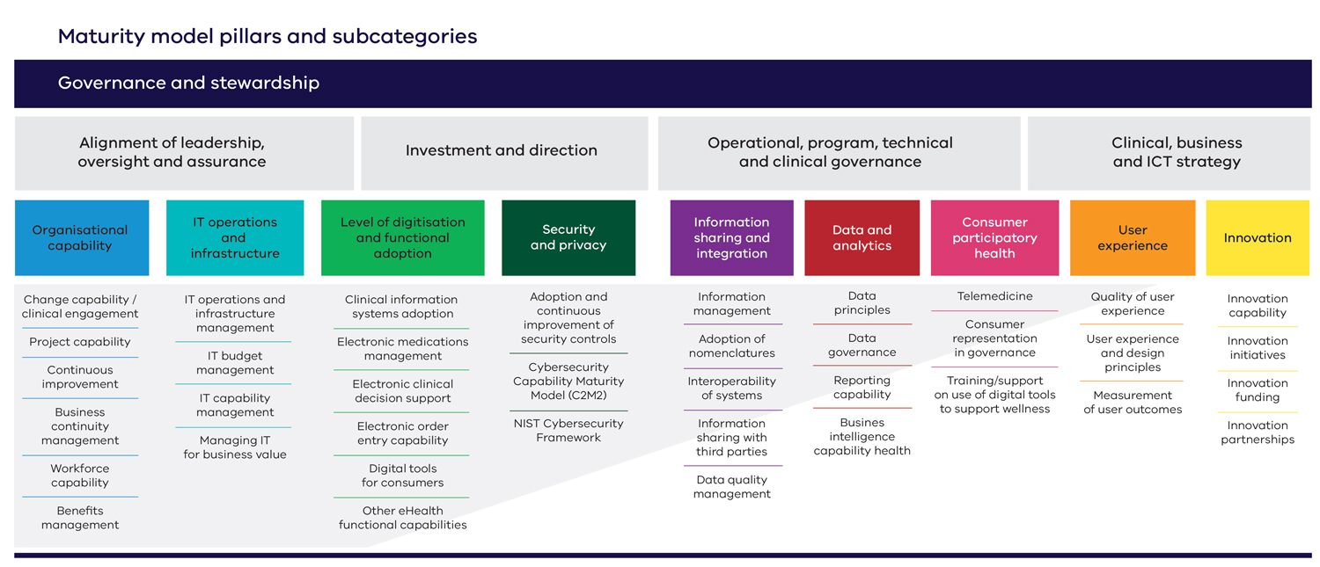

Appendix 2: Text-equivalent descriptions of figures

Figure 2: Digital Health Branch project assurance
The assurance process comprises the following steps:
- engagement and terms of reference — Digital Health Sector Assurance and Health Service
- analysis and reporting — Digital Health Sector and Health Service
- Assurance review report including recommendations
- review — Digital Health and Health Service
- action plan
- Health Service implements and reports progress — Digital Health Sector Assurance monitors progress and assists
- process repeats.

Figure 3: Levels of digital health maturity
- Level 1: Initial — unpredictable, reactive and poorly controlled outcomes
- Level 2: Basic — desired outcomes identified and some initiatives commenced
- Level 3: Developing — some desired outcomes achieved via strategic decision making
- Level 4: Established — coordinated approach to continuous improvement and measurement
- Level 5: Transformative — coordinated and planned initiatives form part of a continuous improvement loop

Figure 5: Conceptual map for ICT arrangements in the mental health system
The figure shows ICT elements of the new mental health system, comprising new recommended ICT systems, existing ICT systems and potential inclusions over time.
In the centre of the figure, the Mental Health Information Data Exchange is a new recommended ICT system that:
- enables sharing of core information outside of public mental health and wellbeing system
- enables consent / authorisation and permissions for viewing and sharing information
- data repository for research, service performance and accountability purposes
Other new recommended elements attached to the data exchanger are:
- Public Mental Health and Wellbeing Services
  - new statewide Electronic Mental Health and Wellbeing Record (replaces CMI/ODS)
  - new electronic system to replace the existing statewide CMI/ODS system for all public mental health and wellbeing services
This element also includes existing systems:
- existing inpatient electronic medical records
- existing electronic community mental health applications
New recommended elements for consumers include:
- new consumer portal (attached to the exchange)
  - access to own mental health and wellbeing service information
  - consent controls to ‘release’ selected information
Existing systems also include primary and secondary services:
- existing GP systems
- existing private psychiatrist and psychologist systems
- My Health Record
Potential systems for inclusion include:
- community health systems
- other service systems (e.g. alcohol and other drug services, legal, housing)

Figure 10: Victoria’s digital health maturity model
The model is built around four pillars and subcategories.
‘Governance and stewardship’ underpins the four pillars.
The four pillars, extending from left to right are:
- Alignment of leadership, oversight and assurance
- Investment and direction
- Operational, program, technical and clinical governance
- Clinical, business and ICT strategy
Extending from left to right under these pillars are nine subcategories:
- Organisational capability
  - Change capability
  - Project capability
  - Continuous improvement
  - Business continuity management
  - Workforce capability
  - Benefits management
- IT operations and infrastructure
  - IT operations and infrastructure management
  - IT budget management
  - IT capability management
  - Managing IT for business value
- Level of digitisation and functional adoption
  - Clinical systems adoption
  - Electronic medications management
  - Electronic clinical decision support
  - Electronic order entry capability
  - Digital tools for consumers
  - Other eHealth functional capabilities
- Security and privacy
  - Adoption and continuous improvement of security controls
  - Cybersecurity Capability Maturity Model (C2M2)
  - NIST Cybersecurity Framework
- Information sharing and integration
  - Information management
  - Adoption of nomenclatures
  - Interoperability of systems
  - Information sharing with third parties
  - Data quality management
- Data and analytics
  - Data principles
  - Data governance
  - Reporting capability
  - Business intelligence capability health
- Consumer participatory health
  - Telemedicine
  - Consumer representation in governance
  - Training/support on use of digital tools to support wellness
- User experience
  - Quality of user experience
  - User experience and design principles
  - Measurement of user outcomes
- Innovation
  - Innovation capability
  - Innovation initiatives
  - Innovation funding
  - Innovation partnerships

Department of Health and Human Services 2020, Compendium of electronic medical record (EMR) benefits Measures, State Government of Victoria, Melbourne, <www2.health.vic.gov.au/-/media/health/files/collections/research-and-reports/e/compendium-of-emr-benefit-measures-aug-2020.pdf>.
Victorian Agency for Health Information 2019, Strategic plan 2019–2022, State Government of Victoria, Melbourne, <https://www.bettersafercare.vic.gov.au/publications/vahi-strategic-plan-2019-22>.
Ibid.
State of Victoria, Royal Commission into Victoria’s Mental Health System 2021, Final report, Volume 5: Transforming the system – innovation and implementation, Parl Paper No. 202, Session 2018–21 (document 6 of 6), p. 103.
Ibid., Figure 35.4, p. 103.
This number also includes 249 servers that health services are keeping for archiving, are unable to be decommissioned/upgraded/replaced, test servers, or were discovered after initial reporting.
State of Victoria, Royal Commission into Victoria’s Mental Health System 2021, Summary and recommendations, Parl Paper No. 202, Session 2018–21 (document 1 of 6), p. 98.
Australian Commission on Safety and Quality in Health Care 2017, ‘Figure 1: Pathways between primary and acute sectors’, Safety issues at transitions of care: consultation report on pain points relating to clinical information systems, ACSQHC, Sydney, p. 15.
State of Victoria, Royal Commission into Victoria’s Mental Health System 2021, Final report, Volume 5: Transforming the system – innovation and implementation, Parl Paper No. 202, Session 2018–21, (document 6 of 6), p. 86.
Victorian Auditor-General 2017, ICT strategic planning in the health sector, State Government of Victoria, Melbourne, p. xiv.

