Victorian Health Services Performance monitoring framework 2018–19

Victorian Health Services Performance monitoring framework 2018–19

To receive this publication in an accessible format phone 9096 7120 using the National Relay Service 13 36 77 if required, or email Commissioning, Performance and Regulation <performance@dhhs.vic.gov.au>
Authorised and published by the Victorian Government, 1 Treasury Place, Melbourne.
© State of Victoria, Department of Health and Human Services July, 2018.
Where the term ‘Aboriginal’ is used it refers to both Aboriginal and Torres Strait Islander people. Indigenous is retained when it is part of the title of a report, program or quotation.
ISSN 2209-4164 – Print
ISSN 2209-4172 – Online (pdf / word)
Available at Health.Vic Funding, performance and accountability (refer to ‘Performance monitoring’) <https://www2.health.vic.gov.au/hospitals-and-health-services/funding-performance-accountability/performance-monitoring>

Contents
Introduction 7
Part 1: The framework 9
About the framework 10
Strategic directions 10
Future directions 10
Coverage 12
Key changes for 2018–19 13
Performance objectives 15
Performance domains 15
Approach to performance improvement 17
Step 1 – Identify performance risk 20
Step 2 – Analyse performance 23
Step 3 – Assess performance outcome 25
Step 4 - Address performance risk, undertake monitoring and provide support 27
Performance escalation 29
Operationalising performance monitoring 31
Role and responsibilities 31
Performance meetings 33
Performance monitoring tools 33
Performance breaches 35
Force majeure 35
Changes to performance measures in 2018–19 37
High quality and safe care related measures 37
Appendix 1: Performance risk assessment measures 39
High quality and safe care 39
Strong governance, leadership and culture 43
Timely access to care 44
Effective financial management 46
Appendix 2: Underlying risks assessment 47
Appendix 3: The performance risk assessment tool 49
Appendix 4: Guide to the risk assessment tool 51

Part 2: Indicators business rules 53
High quality and safe care 54
Accreditation 54
Infection prevention and control 57
Patient experience 59
Forensicare patient experience 63
Healthcare-associated infections 64
Adverse events 69
Mortality 71
Unplanned re-admission 79
Mental health 89
Maternity and newborn 96
Aboriginal health 101
Continuing care 103
Ambulance services 104
Strong governance, leadership and culture 110
Organisational culture 110
Timely access to care 116
Emergency care 116
Elective surgery 121
Specialist clinics 128
Timely response (Ambulance Victoria only) 130
Forensicare 135
Effective financial management 140
Attachment A: List of health services/campuses required to report Caesarean
sections surgical site infections 149
Attachment B: List of health services/campuses required to report Colorectal
surgical site infections 150

Introduction
The Victorian Health Services Performance monitoring framework (the framework) outlines the Government’s approach to overseeing the performance of Victorian health services.
It describes the contextual, strategic and operational aspects of monitoring and improving health services’ performance, including the role that Safer Care Victoria (SCV) and the Victorian Agency for Health Information (VAHI) have in supporting the implementation of the health services performance strategy.
The framework was extensively revised and updated in 2017 to take account of the findings from the Review of Hospital Safety and Quality Assurance in Victoria (the Targeting Zero review) and to reflect the roles of the then newly established SCV and VAHI. The 2018–19 framework builds on this foundation and includes a variety of changes to strengthen and improve the monitoring of health service performance in Victoria.
The framework continues to operate in accord with the Health Services Act 1988 and other contextual elements, such as:
- the Government’s commitment to making real and measurable contribution to Victorians’ lives as outlined in the Outcomes framework
- the vision for Victoria’s health system as outlined in Health 2040: advancing health, access and care
- various policies and programs to support and enhance the wellbeing of Victorians
- system and statewide plans that help guide the distribution and design of health services to meet community needs and ensure long term sustainability of the health system
- the Department of Health and Human Services strategic plan
- service delivery standards as set out in the Statement of Priorities (SoP)
- conditions of funding as outlined in the Policy and Funding guidelines.
It promotes transparency and shared accountability for performance improvement across the system and helps inform future policy and planning strategies.
Figure 1: Victorian health services performance framework – key contextual elements
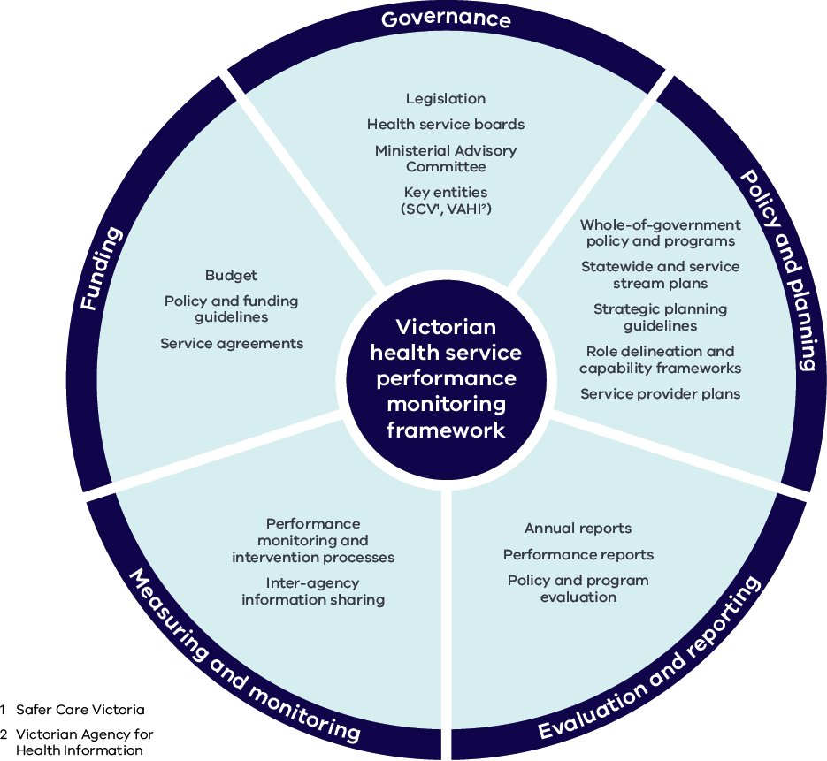

Part 1: The framework

About the framework

Strategic directions
Introduced over 10 years ago, the framework has evolved over time to increasingly draw on a broader range of factors that impact on the performance of health services and the outcomes they provide for patients and the community. The findings of the Targeting Zero review provided a further catalyst to focus on quality and safety and key contributing factors relating to clinical governance, leadership and a safe organisational culture.
The framework outlines how the department, as the system manager of Victoria’s public health sector, takes a risk-based approach to overseeing health services. It is the basis on which the department determines the level of monitoring and support it provides for each health service and the type / focus of that support.
The framework is designed to assess the level of risk posed to each service in relation to delivery of safe, high quality, accessible and sustainable health care for Victorian patients and communities. It therefore considers both:
- a service’s current performance against key quality / safety, access and organisational well-being indicators; and
- trends in those indicators, underlying performance risk factors and other intelligence that may indicate emerging or underlying risks to future performance.
The department undertakes more intensive monitoring or support for those services with greater risks to the safety, accessibility or sustainability of their service. The framework is how the department assesses that level of performance risk. It also identifies what type and focus of support is required. The 2018–19 framework continues to sharpen this focus and strengthens the emphasis on contextual factors that underpin performance. These contextual factors provide early indications of issues that can affect patient outcomes. These include: the strength of financial, corporate and clinical governance and leadership; leading indicators that may reveal underlying risks to the quality and safety of care; and qualitative measures from a variety of sources that can reveal performance issues before they become performance failures.

Future directions
Performance monitoring of Victorian health services involves a process of continual improvement to ensure that measurements are relevant to both system managers and health services, while remaining aligned to contemporary methods of service delivery. Looking beyond current practices and identifying opportunities for future improvement is a key component of this process. Areas that are likely to be the focus for the future are described below.

Quality and safety
SCV is committed to its role of supporting Victorian health services to provide safe, high quality care. In this capacity, SCV and VAHI are working together to develop new quality and safety metrics to drive continuous improvement in care provided by Victorian health services. This work will be undertaken in collaboration with the Department of Health and Human Services (the department) and Victorian health services to ensure that performance indicators accurately monitor quality and safety and encourage continuous improvement. SCV will also take a lead role in identifying and addressing quality and safety risks before adverse events occur.
In the short to medium term, there are two planned amendments to existing quality and safety indicators.
Firstly, the temporary decommissioning of the Death in Low Mortality Diagnostic Related Groups key performance indicator (KPI) for the 2018–19 financial year (planned for re-introduction in 2019–20). Joint work between SCV, VAHI and the department is underway to review and refine this KPI to improve the accuracy and reliability of this metric, with the KPI being removed from health service risk assessments while this review takes place.
Secondly, the Health care worker immunisation target has been increased to 80% of staff for the 2018–19 financial year. A goal of 90% of health care workers being vaccinated by 2022 has been set and targets will progressively increase towards this over coming years. Due to the risk that influenza poses to the community, and more specifically patients whose immunity may be already compromised, it is essential that Victorian health care workers are vaccinated against influenza. Increasing vaccination compliance within Victorian health services will not only control the spread of influenza, it will also lead to better outcomes for vulnerable populations and ensure workforce availability. Further advice on how this change will be enacted, including determining appropriate timing for target adjustments, will be communicated in the future.

Mental health
In 2018–19, the department will work towards the implementation of a new mental health funding model in community-based adult mental health services. The new model will link funding to the delivery of services and will provide different levels of funding depending on the complexity of consumer needs. The funding reforms, and related and revised performance and outcomes monitoring, will improve transparency and drive improvements in service performance and consumer outcomes.
As part of the Mental Health Outcomes Framework the department is working to include the Your Experience of Service Survey results as part of the measures for patient experience of care.
There will continue to be a focus on system improvement around safety with the implementation of Safewards across mental health inpatient units and further focus across all types of restrictive intervention and the duration of restrictive interventions through the Reducing Restrictive Interventions Committee.

Access and timeliness
A greater focus on specialist clinic reform will be supported over time by a more robust and clinically meaningful set of performance measures. This work is commencing in 2018–19 with the introduction of an urgent obstetric access measure. Further measures will continue to be explored with health services form 2018–19 and will be informed by the experience and learnings of the specialist clinics collaborative being led by Better Care Victoria.
The development of a framework to measure and monitor system change as the statewide cardiac plan is implemented will commence in 2018–19 in conjunction with the implementation of three cardiac service networks.
New investigation will begin into an emergency surgery measure to provide a fuller assessment of access and efficiency of the system in line with the recommendations of the recent Victorian Auditor General’s Office audit into hospital theatre efficiency.

Residential aged care
In 2018–19, the department will commence piloting performance measures being developed for residential aged care. The pilot will determine which of the measures will be introduced across the sector from 2019–20.

Rural and regional
The department acknowledges that many of the performance measures are either not applicable to smaller health services or result in sample sizes or other data problems that limit their applicability. For these services, the framework relies more heavily on underlying risk factors and third party reports to assess performance outcomes.

The department, working with SCV and VAHI, will develop performance measures that better reflect the service profile (e.g. aged care, primary and community health) and risks of smaller health services. It is intended that these measures will be incorporated into the framework in future years.

Coverage
In exercising its system stewardship role, the department leads the health system improvement agenda. In doing so, the department acknowledges the contribution of, and strong collaboration with, health services and other relevant entities, including private healthcare providers.
The framework captures all publically funded health service providers including:
- metropolitan health services
- regional health services
- subregional health services
- local health services
- small rural health services
- multi-purpose services
- Ambulance Victoria
- Dental Health Services Victoria
- the Victorian Institute of Forensic Mental Health (Forensicare).
The 12 metropolitan health services and six major regional health services are defined under the Health Services Act 1988 (HSA) as ‘public health services’. Together with Dental Health Services Victoria, they are governed by boards of directors as set out under section 65S of the HSA.
The nine subregional health services, 11 local health services and 36 small rural health services are defined under the HSA as ‘public hospitals’ and are governed by directors who make up boards of management as set out under section 33 of the HSA.
The seven multi-purpose services are established under Part 4A of the HSA. They are governed by boards of management as set out under section 115E of that HSA and are subject to similar governance and performance policies as public hospitals.
Mildura Base Hospital (a privately-operated public hospital) and the three denominational hospitals, Calvary Health Care Bethlehem Limited, Mercy Public Hospitals Incorporated and St Vincent’s Hospital (Melbourne) Limited, are subject to similar performance and oversight provisions as public hospitals, as set out in Part 3 and Part 3A of the HSA.
Ambulance Victoria is established under section 23 of the Ambulance Services Act 1986 (ASA) and is governed by a board of directors as set out under section 17 of the ASA.
The Victorian Institute of Forensic Mental Health is established under section 328 of the Mental Health Act 2014 (MHA) operating under the name, Forensicare. Forensicare is governed by a board of directors pursuant to provisions in the MHA (Part 14 Division 2).
Albury Wodonga Health operates across North East Victoria and Southern New South Wales. It is the only cross-jurisdictional health service in Australia and is one of six regional health services in Victoria. From July 2014, the provision of mental health services extending across the border into the Murrumbidgee region of NSW were integrated as part of Albury Wodonga Health and formed the North East and Border Mental Health Service. Beginning in 2017–18, the clinical mental health service provided by Albury Hospital was included in the performance indicators reported by Albury Wodonga Health. This inclusion aims to support the clinical mental health service integration across the North East and Border Mental Health Service.
While Private Hospitals and Day Procedure Centres are currently monitored through the Risk Based Regulatory Framework: Private Hospitals 2017, the department is working in consultation with private providers to identify opportunities for potential alignment of data monitoring and risk indicators of Private Hospitals under the relevant sections of the framework in the future.

Key changes for 2018–19
The overall structure of the framework remains unchanged and builds on the significant modifications made in 2017. It retains the emphasis on four domains of performance: high quality and safe care; strong governance, leadership and culture; timely access to care; and effective financial management.
There are a number of new indicators, and additional sources of information are being included to strengthen and broaden the foundation used to assess the performance of health services.
We have learned from the experience of implementing the new framework in 2017–18, leading to improvements in the process and greater clarity about the roles and responsibilities of health services, the department, SCV and VAHI.
Key features that remain and have been strengthened for 2018–19 are described below.
- The framework is aimed at achieving comprehensive performance analysis, using an approach based on performance risk.
- The framework continues to eschew a score-based system in favour of an approach that considers performance against each key measures as well as underlying risk factors, providing a more detailed approach to performance assessment.
- Triangulation of other performance intelligence is included as part of performance assessment, including cross agency information sharing with the Health Complaints Commissioner, Victorian Managed Insurance Authority (VMIA), and Australian Health Practitioner Regulation Agency. Formalised arrangements are being established that support early notification of risk and streamlined sharing of cross-agency information.
- There is improved clarity regarding the indicators for health service performance accountability and measures to monitor healthcare quality. SCV will continue to work with health services to identify KPIs for quality and safety across the sector. These will form a core part of performance accountability, combined with the existing measures on finance, access and governance.
- Work is continuing to further develop and refine reports on healthcare quality and safety. This work is being led by VAHI in partnership with SCV and the department.
- The identification of areas of poor performance considers whether a health service is improving over time not only whether targets are being achieved.
- In order to individualise performance discussions, assessments will be made across both quantitative and qualitative measures to inform whether a health service is improving in areas of underperformance, whilst maintaining high performing areas. This will provide all health services with the incentive not only to meet ‘target’, but also to address underlying factors that may impact on performance. This continues the change in emphasis from one predominantly based on achievement of targets, to one of continuous improvement.
- Significant departmental intervention becomes more likely if health services fail to improve performance. For example, if performance against key measures is deteriorating and action plans to address this are ineffective or have not been implemented, an increased level of monitoring may be triggered.
- The options available to assist health services to manage their performance vary depending on the area of concern and their capacity to respond effectively. Interventions may range from seeking further input from health services, to service reviews or expert clinical input (via SCV or the Office of the Chief Psychiatrist (OCP), as relevant).

Performance objectives
The performance monitoring framework is structured around four domains of performance that provide a cross-linking and mutually-supporting view of health service performance. These are:
- High quality and safe care
- Strong governance, leadership and culture
- Effective financial management
- Timely access to care
As outlined in Figure 2, each domain is informed by a number of strategic goals, which in turn are supported by relevant qualitative and quantitative measures. The following section describes this in more detail.

Performance domains

High quality and safe care
This domain assesses the ability of health services to deliver safe and high-quality services that improve patient outcomes. It includes a number of clinical indicators and an increased focus on patient experience. It also considers factors that impact the ability of services to develop and maintain a high performing clinical workforce.

Strong governance, leadership and culture
The domain assesses the strength of the organisation’s governance, leadership and culture, key attributes of high performing and safe health services. Optimising both corporate and clinical governance is essential in creating a high performing health service.
Organisational culture can significantly influence patient safety through its impact on effective communication, collaboration and engagement across the organisation.
This domain includes assessment of the strength of clinical and corporate governance in health services, and their ability to nurture safe cultures and positive clinical engagement.

Effective financial management
The ability of health services to manage the effective and efficient allocation of resources to deliver safe and cost-effective services is fundamental to their performance. This domain addresses the diligence with which health services manage their finances and seeks to identify risks to their financial stability and viability.

Timely access to care
This domain refers to the ability of health services to efficiently manage supply and demand by providing the right care in the right place and at the right time. This reflects operational capacity and delivery of services and programs. It focuses on equitable and timely access (such as reduced waiting times) as well as service efficiency.
Figure 2: Performance objectives and domains
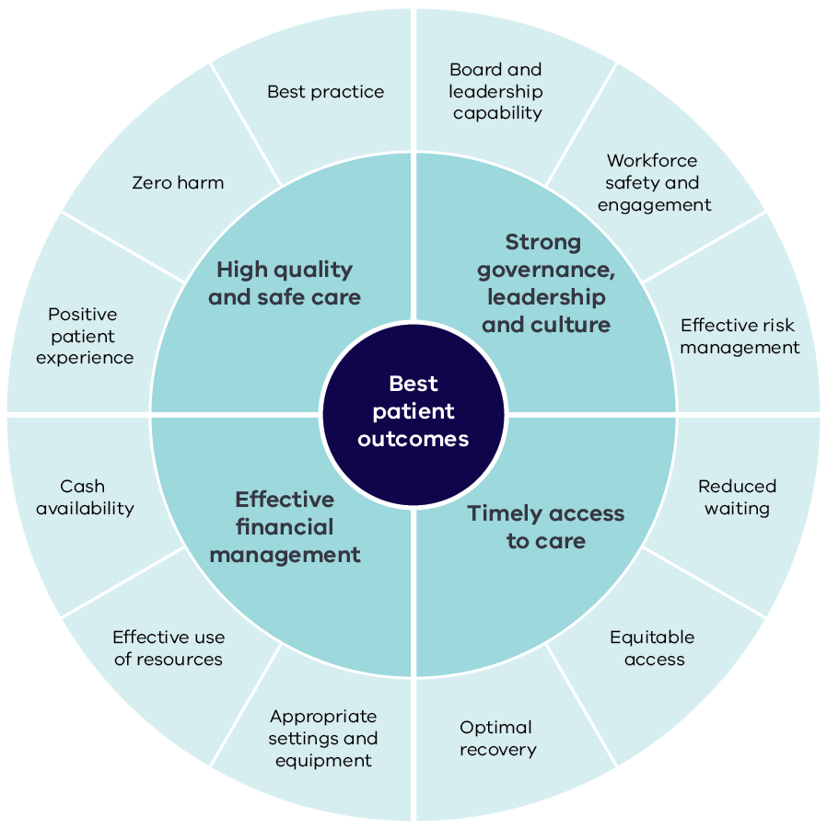

Approach to performance improvement
The goal of the framework is to ensure that health services are performing effectively to deliver the best patient outcomes and to keep patients safe from harm. To achieve this, the framework identifies issues and concerns and opportunities for improvement that feed into a continuous cycle of performance improvement. Under the framework, the department works collaboratively with health services and other stakeholders to:
- identify performance concerns and factors that may impact on health service performance
- analyse performance issues and the opportunities for improvement
- determine appropriate interventions and
- ensure that action is taken to address performance concerns and support ongoing improvement.
Figure 3: The performance improvement process
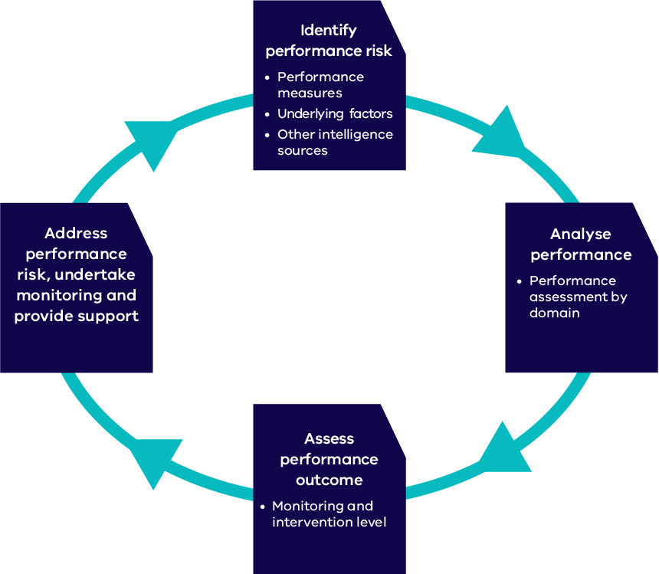
The performance improvement cycle is supported by a performance risk assessment tool that draws together information from the four domains of performance and is used to document outcomes at each step in the cycle. The tool is completed quarterly for each health service and used to inform the performance conversation. Refer to Appendix 3 for an example of a performance risk assessment tool for a hypothetical health service.
A high-level guide to using the tool is included in Appendix 4.
There are a number of key issues to consider in relation to the tool and the broader performance improvement cycle, as described below.

The performance risk assessment approach is not a technical risk management approach
While it seeks to identify risks to performance, the performance monitoring framework is not a technical risk management approach. The department, agencies and health services have their own internal risk management processes that operate separately from the performance monitoring framework.

The approach is intended to support performance conversations
The approach provides the basis for a joint conversation about performance and should not be viewed as an end product. Rather it should capture the stage the performance conversation has reached at a particular point in time, as well as the actions needed to move the conversation forward.

The approach is not intended to be punitive
Risk flags and performance concerns identified in the tool are not intended to be punitive or to highlight failings of health services. They are intended to raise issues for discussion and to point the way to potential actions for strengthening or improving performance.

The department and health services have a shared responsibility to address performance issues
The assessment tool and approach to performance monitoring represent a shared responsibility between health services and the department in understanding and addressing the issues that can affect the performance of a health service.
The following sections describe each step in the framework’s performance improvement process in more detail including how the performance risk assessment tool supports the process.
Figure 4 Summary of the steps in the performance improvement process
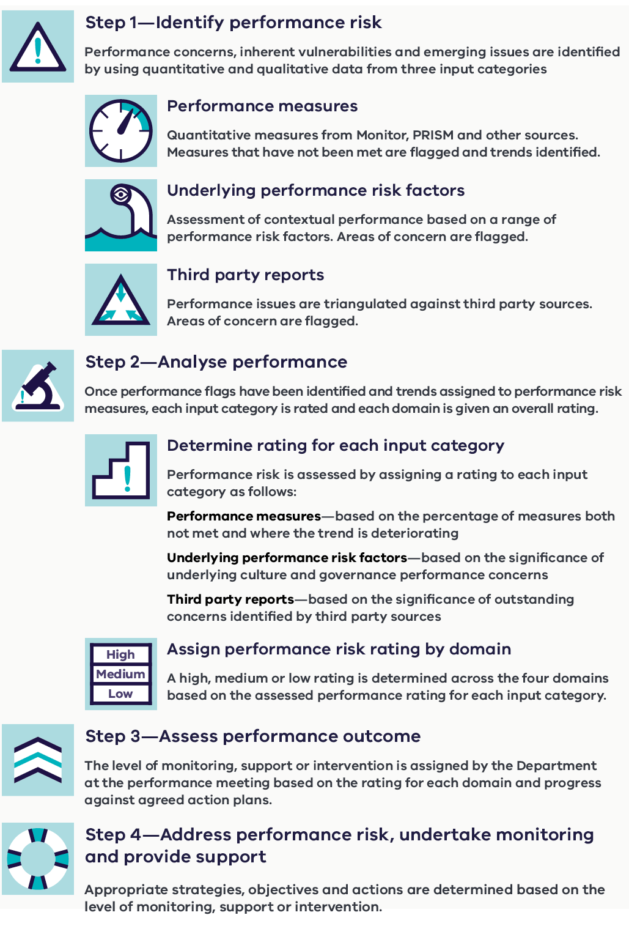

Step 1 – Identify performance risk
In this step, performance concerns, inherent vulnerabilities and emerging performance concerns are identified by using quantitative data and qualitative data from a range of sources, as described in Figure 5.

Figure 5 – Sources of information for performance risk assessment
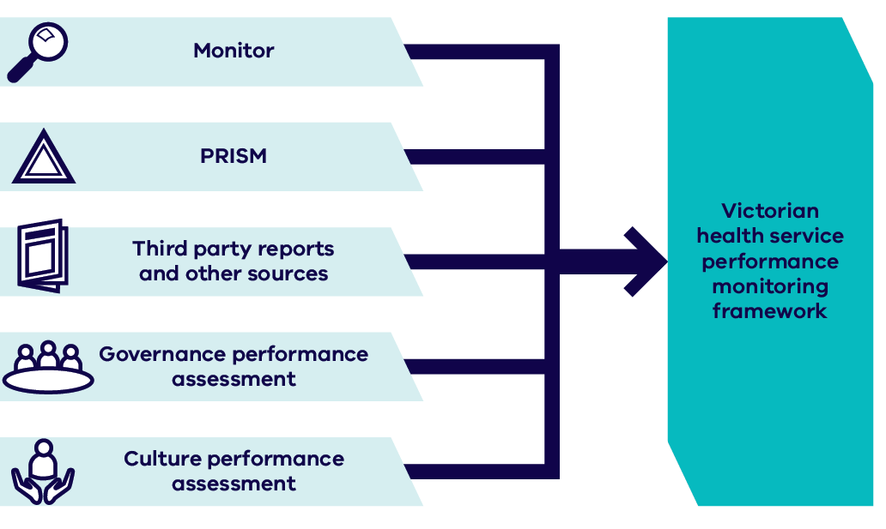
Using a wide range of sources provides a more robust understanding of a health service’s performance risks and issues, as well as the opportunities for improving performance.
For example, risks relating to organisational safety culture will be taken very seriously particularly where evidence of bullying is apparent. In this instance, performance flags from the People Matter Survey are triangulated with other available information to better understand the extent of the issues and its impact on staff engagement, reporting culture and management response.
Unusually low reporting rates of patient or staff safety concerns may flag potential fear of reporting within the organisation. Such concerns compounded by a higher than average rate of sick leave and staff turnover rates could be suggestive of more systemic cultural issues.
The department acknowledges that performance flags may not pose a concern on their own and may be easily explained by other mitigating factors. However, in combination they can help paint a sufficiently compelling picture to support a more detailed inquiry by the respective health service.
Drawing on a wide variety of sources of information, including qualitative data, encourages early identification of potential performance issues before they become performance failures. It also supports a more transparent information exchange between the department, health services and other entities to ensure a common understanding of the challenges and opportunities for improvement at the health service level and across the sector.
The performance information that is used to build a picture of performance within each domain is structured into the following three categories:
- performance measures capturing quantifiable data arising from the SoP, the Program Report for Integrated Service Monitoring (PRISM) and other KPIs
- underlying performance risk factors arising from the contextual assessment of governance, culture and other qualitative assessment of organisation’s performance management capability
- third party reports arising from cross agency information and other external reviews/reports.

Performance measures
A list of measures used to inform performance risk is included in Appendix 1. Key changes to performance measures for 2018–19 are outlined in the Changes to performance measures in 2018–19 section on pages 35 and 36 of this document.
Risk flags are identified for each measure where targets have not been met and are recorded in Column 1 of the performance risk assessment tool against the corresponding domain.
Improvement or deterioration trends are also identified by comparing outcomes to the same time last year or, where relevant, to performance over the prior six reporting periods (for example, the Victorian Healthcare Experience Survey). Improvement against a baseline is also used for particular measures (for example, days of available cash).
The range of quality and safety accountability measures will be extended over time, and further work will be done to explore the opportunities for introducing additional performance measures to assess performance in the areas of leadership, governance and culture.

Underlying performance risk factors
The Targeting Zero review identified a range of factors that can impact on the ability of a health service to deliver safe, high-quality outcomes for patients. Based on the factors identified in Targeting Zero, the 2018–19 framework includes a set of underlying performance risks intended to assess the contextual aspects of performance for each health service. These underlying performance risks areas are listed below, with considerations for assessment against each in described in Appendix 2.
- workforce availability, capacity and capability
- ability to respond to community needs
- clinical leadership
- management of complex care or changes in capability
- board governance
- leadership
- competing strategic priorities
- safety culture
- workforce sustainability
- service sustainability
- financial performance

Key changes to the assessment of underlying risk factors for 2018–19 include:
- replacement of the ‘rurality’ performance risk area with ‘workforce availability, capacity and capability’
- removing the performance risk areas ‘high reliance on locums/instability of senior clinical role’ and ‘reliance on new entrant international medical graduates (IMGs)’ and replacing them with new performance risk areas ‘clinical leadership’ and ‘management of complex care or changes in capability’
- adding the fourth domain ‘timely access to care’ with new performance risk areas and considerations for assessment
- moving/modifying a number of considerations for assessment to sit against appropriate new and revised risk areas
- including use of locums/IMGs as considerations for assessment, rather than performance risk areas
- rewording a number of the considerations for assessment to better clarify their intent.
The assessment of underlying performance risk factors is carried out annually and updated progressively during the year, as relevant.
While some of the areas of underlying performance risk may not be in the direct control of health services (for example, the size of the local recruitment pool for clinicians), they must still be acknowledged in the performance risk assessment to ensure health services are minimising concerns where possible and to explore new or additional opportunities to understand the impact of these concerns (including work that may need to be done at a system level).
For example, health services in rural areas face significant challenges in attracting and retaining skilled staff as well as board members. There may also be a higher risk of professional isolation for practitioners with limited options or no back-up cover or succession planning. Management may find it difficult to manage contracts or performance of clinicians who are difficult to replace. Recognising these challenges provides a better appreciation of the contextual environment various health services operate in, the impact this has on service delivery and the type of strategies required by the department (at a system level) and the health service (at a local level) to support improved performance.
The safe culture performance assessment will be informed primarily by data from the People Matter Survey as well as feedback from the Health Complaints Commissioners and SCV, particularly where concerns relate to a low reporting culture, poor management of complaints or general lack of interest in feedback from consumers.
Organisational governance and culture can significantly impact patient safety and are known as recurring features of serious failings in care. For example, negative culture is directly linked to communication, collaboration and engagement breakdown, which are lead indicators of increased harm and poor patient outcomes. Weaknesses in governance and leadership further compound the risk through failure to identify and/or rectify issues early or effectively.
Monitoring weaknesses in governance and culture allows for early identification of risks to patient safety before they start to manifest in patient outcomes.

Third party reports
The department continues to build formal arrangements to support cross-agency information sharing with the Australian Health Practitioner Regulation Agency, the Office of the Health Complaints Commissioner and the Mental Health Complaints Commissioner. As these formal relationships mature, additional third-party information will be introduced into the performance conversation.
These arrangements will increasingly add depth and breadth to performance monitoring by providing routine and ad-hoc advice on risks and/or other concerns relating to patient safety, governance or culture.
Recommendations from other ad-hoc reviews initiated by the department (including specialist areas such as the OCP), SCV, the Victorian Auditor General’s Office, the Independent Broad-based Anti-corruption Commission, Worksafe and so on, are also used where available to fill out the picture of performance for each health service. Reports of information technology security risks from the department’s Digital Health Branch will also be considered.
Likewise, relevant outcomes from specialist reports (such as the Victorian Perinatal Services Performance Indicators report; the reports of the consultative councils for obstetric and paediatric, surgical and anaesthetic mortality; and the Victorian Audit of Surgical Mortality) are also captured as part of this process.

Step 2 – Analyse performance
Once performance flags have been identified for each input area they are evaluated in terms of:
- the number of performance measures not met in each domain and evidence of improvement or deterioration
- the presence and magnitude of any underlying performance risk factors and
- the presence and magnitude of any concerns identified from third party reports/other intelligence.
In some cases, a flagged area of concern may be subject to interpretation as to the magnitude of its potential impact on performance. Clear communication on such issues is an important part of the performance conversation, as is the documentation of any reasoning about how the performance flag is interpreted or handled in completing the performance risk assessment tool. Performance flags are prompts to begin a conversation with health services regarding performance issues and concerns. Guidance on addressing the performance flags is included at Appendix 4.

Determine rating for each input category
Analysis is undertaken for each of the three input areas to identify performance risk across each domain, resulting in a total of 12 performance risk ratings being determined.
In relation to performance measures, higher ratings are assigned where a larger proportion of measures are not met and there is evidence of deteriorating trends. For example, a high performance risk rating is applied to any domain where over 30 percent of measures were not met and there are no signs of improvement.

As such, only measures that have not been met and are showings signs of deterioration are captured by the percentage thresholds described in Table 1. This approach acknowledges the effort of health services to maintain or improve performance, rather than focusing exclusively on whether or not a target has been met in any given quarter.
Table 1: Performance risk measures analysis
Less than 10% KPIs not met and with worsening trends | Low
10–30% of KPIs not met and with worsening trends | Medium
Over 30% of KPIs not met and with worsening trends | High
In relation to the other two performance input categories, the assigned rating for each domain increases where there is evidence of significant underlying factors or outstanding concerns from third party reports / other intelligence. Refer Table 2 and 3.
Table 2: Underlying performance risk factors analysis
No significant concerns | Low
Some underlying factors | Medium
Significant underlying risks | High
Table 3: Third party and other intelligence analysis
No major concerns | Low
Some concerns | Medium
Significant outstanding concerns | High
It is important to acknowledge that there is a degree of expert judgement that must be exercised in determining the significance of particular performance concerns and issues. It is vital that any assumptions are made explicit and communicated clearly in discussion with health services. Additionally, any reasoning used to assign a level of concern to quantitative or qualitative factors and third-party sources must be clearly and explicitly documented in the performance risk assessment tool.

Assign performance risk rating by domain
To determine a performance risk rating for each domain, performance risk is assessed by taking into account the level of risk from each of the input categories. Low and medium levels correspond to low and medium ratings. However, if one input category is identified as high, the rating of the entire domain is elevated to high, as shown in Table 4.

Table 4: Performance risk rating for each domain
All low ratings | Low
Any medium rating, no high rating | Medium
Any high rating | High
For example, if a health service met all the governance, leadership and culture measures and was therefore assessed as low against the ‘performance measures’ input of that domain, but a high level was applied to ‘underlying performance risk factors’ or ‘third party reports/other intelligence’ due to significant issues relating to governance or culture, the rating of the entire domain is automatically elevated to high.
Summary comments outlining the assessment rationale are also captured in the performance risk assessment tool and validated further in consultation with the respective health service and other stakeholders including SCV and relevant program areas in the department. The department has the ultimate decision as to the overall performance risk rating or domain rating.

Step 3 – Assess performance outcome
The performance monitoring framework includes four levels of monitoring, support and intervention:
- High performer
- Standard Monitoring (with/without an action plan)
- Performance support
- Intensive monitoring
In determining the level of monitoring, support or intervention required, the department takes into account the rating level for each domain and progress towards agreed action plans.
Table 5 summarises the criteria used to guide this determination (for example, the higher the ratings across the domains and the lesser the progress to mitigate the concern, the higher the requirement for monitoring, support or intervention).

Table 5: Criteria for determining the level of monitoring, support and intervention
High Performer | Better than target  Low ratings across all domains  Industry leader
Standard Monitoring  (with or without agreed action plan) | Low ratings across all domains or  One or more domains medium rating with an agreed action plan for each and actions or interventions identified in previous quarters in place and working
Performance support | High rating on any domains or  Medium rating with an agreed action plan in any domain not working or any actions or interventions identified in previous quarters not undertaken
Intensive monitoring | High rating on two or more domains  Service review may be required for performance issues
Performance levels are determined quarterly unless serious concerns or emerging issues require more immediate escalation and intervention.
The department assigns the level of performance for each domain and the associated level of monitoring, support and intervention. In making this determination the department will consult with the Health Service’s executives and other expert input such as SCV and the OCP.
The rationale for the assigned level of monitoring, support or intervention must be documented in the performance risk assessment tool alongside any agreed actions associated with these issues and timelines for remediation. At a minimum, these actions should specify who is responsible for undertaking the action, what action is required, and when the action should be completed or otherwise reviewed.
Where relevant, the department will take into account evidence relating to steps taken and progress by a health service and adjust the level of monitoring accordingly. This will vary from case to case but could equally support both increasing the level of monitoring (for example through an independent report indicating systemic clinical risk) or decrease monitoring (i.e. through verification of an effective remediation action).
Such decisions are dependent on the magnitude of underperformance, the capacity or demonstrated level of remediation as well as any significant issues relating to governance and culture, given their risk to achieving and supporting sustained improvement.
The assessment methodology and its sensitivity settings (for rating each input area and assigning a rating across the domain) have been reviewed based on experience gained from the implementation of the framework in 2017–18. Further review and refinement will take place based on outcomes from the 2018–19 performance improvement cycle.

Step 4 - Address performance risk, undertake monitoring and provide support
As outlined in Table 6, monitoring levels intensify proportionate to the level of underperformance and safety concern. Increasing levels of consultation, support and intervention strategies are tailored depending on the levels of monitoring required.

Table 6: Monitoring, support and intervention strategies
Monitoring level | Monitoring, support and intervention strategies
High performer | Quarterly meetings with the department.  Strategic discussion for further improvement or system leadership opportunities.
Standard Monitoring  (with or without agreed actions in train) | Quarterly performance meetings.  Routine performance risk assessment.  Progress update on agreed action plans, where relevant.
Performance Support | Closer monitoring of performance and remediation plan progress by the department until issues resolved.  Six weekly or more regular performance meetings as determined by the department.  Support to undertake and sustain improvement that may include:  - engaging an independent expert to review clinical practice, governance or financial concerns and make recommendations for improvement  - seeking SCV’s input and support with further improvement  - appointing an independent expert to the health service’s safety and quality committee.
Intensive Monitoring | Monthly performance review meetings.  May include discussions between the department and the board chair regarding strategies related to organisational issues and capability that may have an impact on performance improvement goals.  More direct intervention including imposed external service review and/or appointment of a board delegate.

High performing health services
High performing health services are identified based on their contribution to improved performance and are recognised as system-wide leaders. The ‘high performer’ level applies to health services with excellent performance across all performance domains. Health services identified as high performers will meet quarterly with the department to discuss not only individual performance priorities but also strategic and/or sector-wide objectives and leadership opportunities.
Key features of a high performing health service:
- delivers high quality care evidenced by improved patient outcomes including low/decreasing rates of preventable harm and timely access to care
- positive patient experience as evidenced from patient/carer’s feedback
- strong organisational culture as evidenced from staff feedback and other reports including cross-agency information
- effective governance and strategic leadership as evidenced from proactive risk management and continuous quality improvement
- effective financial management.

Health services with serious levels of underperformance [a high burden of risk]
Intensive monitoring is the most intense form of monitoring and applies to health services with significant areas of under-performance, including major patient safety or service delivery concerns. In this instance, departmental intervention intensifies by increasing the regularity of performance interactions and escalating the range of interventions and support to achieve the required turnaround.
Key features of a health service serious levels of underperformance:
- inherent vulnerabilities (for example, significant workforce shortages, high reliance on locums and International Medical Graduates, rapid population growth or decline)
- demonstrated pattern of poor care outcomes including significant incidents, complaints and repeated failure to meet KPIs
- weak governance or leadership including ineffective performance risk identification and/or mitigation strategies and poor financial management
- poor safety culture, including low incident reporting, evidence of bullying and staff disengagement.

Performance support
The department supports open dialogue with health services to discuss and address performance concerns as soon as they are identified. The department’s expectation is that issues are investigated by the health service in the first instance, and evidence of improvement is provided to the department as part of the routine performance review meetings or separate correspondence.
Where relevant, input from SCV, respective program areas and/or other experts may be sought to support health services in developing and/or implementing more targeted improvement.
Depending on the level of concern and nature of under-performance, a plan for improvement/remediation may be agreed between the health service and the department. SCV will provide expert input in the development and progress of actions relating to Quality and Safety improvement plans.
Where performance improvement involves implementing new models of care or service redesign, program areas, SCV, and the OCP (as appropriate) will work with health services to reorient care provision to meet acceptable standards of care.

Performance escalation
In some cases, performance issues or concerns will trigger a higher level of health service monitoring and intervention by the department to ensure that appropriate action is taken to address performance concerns and minimise the risk to patients or service delivery (Figure 6).
For example, there may be instances where the department may assign individuals to work with the health service to develop and implement a performance improvement strategy and/or the department may commission reviews of the health service’s operational effectiveness and sustainability.
The initial level of escalation and response is based on the seriousness of the performance issue and assessment of performance risk. The department will consider and determine if an issue warrants formal performance escalation following engagement with health service executives.
More serious concerns may necessitate more drastic action including an independent review of health service governance and management capability. This may include the board chair being required to demonstrate that the organisation is able to achieve turnaround within a reasonable timeframe, change to membership of the board and/or appointment of an administrator or delegate. The Health Services Act 1988 sets out the powers of the Minister regarding inadequate performance.
Importantly, following the proclamation of the Health Legislation Amendment (Quality and Safety) Act 2017 in April 2018, the bases for using intervention powers by the Secretary or portfolio Minister have been expanded to include ensuring that services being provided are safe, appropriate and patient-centred.
Where a ministerial delegate has been appointed to a health service board, the health service will remain on intensive monitoring until the end of the delegate’s appointment. In the circumstances of the Board being removed and an administrator appointed, the health service will remain on intensive monitoring until a new board is appointed.
Figure 6: Indicative options for escalating actions in response to performance issues
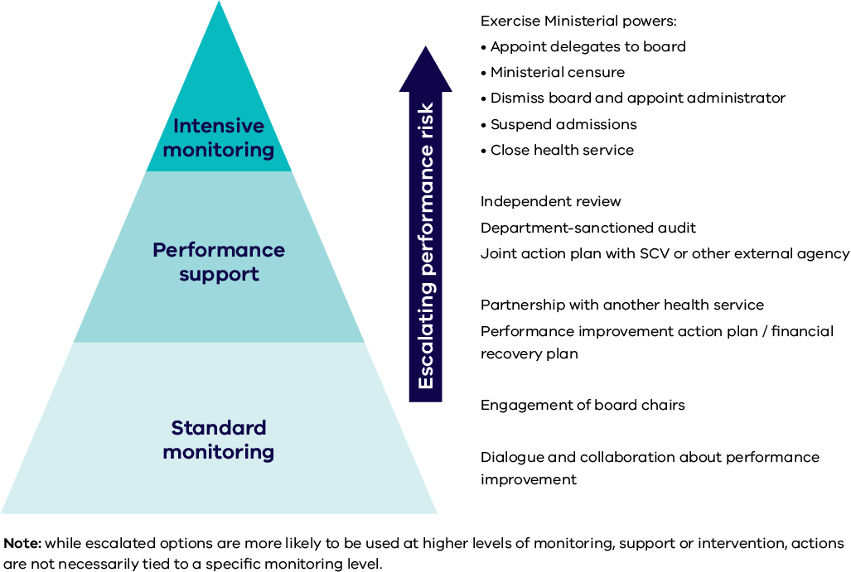

Operationalising performance monitoring

Role and responsibilities

The Department of Health and Human Services
The Department of Health and Human Services is the system manager of the Victorian health care system. It advises government on health strategy, policy, planning, funding allocation and performance oversight of health services. Its vision is to achieve the best health, wellbeing and safety of all Victorians so that they can live a life they value.
The department carries out its performance oversight role by:
- implementing the performance monitoring framework and associated processes and tools
- partnering with health services to identify and address performance concerns early and effectively
- supporting or intervening to ensure long term and sustained performance improvement
- facilitating better sector consultation and communication, including providing information on departmental policy directions and sharing with other relevant agencies
- making use of available data and third-party intelligence to maximise the depth and breadth of performance information used to assess health service performance
- maximising input from SCV, and other experts/clinical leaders
- enhancing board skills and capabilities in clinical governance and other information required to ensure high quality and safe care
- providing staff with training and mentoring in performance management and quality improvement and the tools to enable them to have an effective performance improvement role.
The department relies on SCV, the OCP and VAHI as key partners to help manage and improve sector-wide performance.

Safer Care Victoria
SCV is the peak state authority for leading quality and safety improvement in healthcare. Its role is to oversee and support Victorian health services to provide safe, high-quality care.
As well as monitoring the standards of care provided, SCV partners with consumers and their families, clinicians and health services to support continuous improvement in healthcare. There is a strong focus on listening to patients’ voices and ensuring patients and patient outcomes remain at the centre of safety and quality conversations. In terms of quality and safety performance, SCV sets expectations and leads improvement efforts across the sector.
One of SCV’s aims is to provide patients, clinicians and hospitals with tools and resources to improve quality and safety in the health system.
SCV works closely with the department on improving the performance of health services and participates in key performance conversations with health services, particularly where concerns exist about safety and quality of care.

The Office of the Chief Psychiatrist
The Chief Psychiatrist provides system-wide oversight of Victoria’s public mental health services. Supported by the OCP, the role supports quality and safety in services provided to some of Victoria’s most vulnerable people. The role (section 120) and functions (section 121) of the Chief Psychiatrist are set out under the Mental Health Act 2014.
The responsibilities under the Act include clinical leadership and quality and safety improvements across Victoria’s public mental health system. The activities undertaken by the office are far ranging and include assisting services in developing and implementing clinical best practice approaches and advice to the sector, undertaking reviews, audits and investigations as required, and promoting continuous improvement in areas of quality and safety.
The OCP incorporates the work of the Office of the Chief Mental Health Nurse. The Chief Mental Health Nurse provides nursing leadership and supports mental health nursing through education and training, promotion of best practice and workforce planning and development. The Chief Mental Health Nurse and her staff make a significant contribution to systems improvements with a focus on safety through such programs as Safewards and the work of the Reducing Restrictive Interventions Committee.

Victorian Agency for Health Information
VAHI is responsible for analysing and sharing information across the health system. In order to discharge this responsibility, it develops relevant and meaningful measures of patient care and outcomes for the purpose of public reporting, oversight and clinical improvement. Accordingly, the Agency plays a key a role in data management, standards and integrity.
VAHI’s key functions include:
- collecting, analysing and sharing data so that the community is better informed about health services and health services receive better information about their performance
- providing boards, health executives and clinicians with the information they need to best serve their communities and provide better, safer care
- providing patients and carers with meaningful and useful information about care in their local community
- improving researchers’ access to data to create evidence that informs the provision of better, safer care.
To achieve its objectives, VAHI relies on obtaining timely, accurate and high-quality data from public and private providers of health services. VAHI is vital to the effective functioning of the performance monitoring framework through its provision of performance measures data and its work on developing additional robust measures of performance.

Health services
- Victoria’s public health services are independent legal entities established under the Health Services Act 1988, the Ambulance Services Act 1986 and the Mental Health Act 2014. They are governed by boards of directors, the members of which are appointed by the Governor-in-Council on recommendation of the relevant portfolio Minister. The board oversees the health service on behalf of the Minister and in accordance with government policy and its legal obligations.
- Health services discharge their obligations under the framework by:
- partnering with the department and other agencies to improve health service and system wide performance
- reporting promptly to the department any emerging risks or potential performance issues including immediate action taken
- establishing and maintaining a culture of safety and performance improvement within the health service
- ensuring accurate and timely submission of data and other information, including implementing agreed action plans and status update reports
- collaborating with other health services and health system partners to maintain and improve their performance and to meet the health needs of their communities.

Performance meetings
Performance review meetings are usually undertaken quarterly and include a mid and end of year review of the SoP Part A actions. The department initiates additional meetings at the request of the health service or when emerging issues have been identified or performance escalation initiated.
The performance risk assessment tool provides the baseline for analysing performance at the performance meeting and is provided in draft form to health services before each quarterly performance meeting. The performance meeting is used to finalise the performance risk assessment tool and to document the monitoring, support and intervention level for each health service, as determined by the department.
The assessment tool and approach to performance monitoring and meetings represents a shared responsibility between health services and the department in understanding and addressing the issues that can affect the performance of a health service.
Progress updates on the development and implementation of agreed action plans or recommendations from third-party reports are considered as part of the performance discussion, as well as emerging performance concerns or trends that may affect future performance.
Required representation from the department and health services will depend on the level and areas of performance concern. Attendance is kept to a minimum, involving only the core group required to ensure coverage of each aspect of performance. SCV representation features regularly at performance review meetings, particularly where quality and safety concerns are apparent.

Performance monitoring tools
As determined by legislation, the SoP is the key service delivery and accountability agreement between health services and the department. It outlines key deliverables and performance targets to be achieved by the health services within the allocated annual budget. Performance against these is monitored via the Victorian Performance Monitor Report (Monitor) and reported publicly.
The performance risk assessment extends beyond the performance measures agreed in the SoP and reported in Monitor report and publically, to ensure that other concerns or emerging concerns from the PRISM, other program reports or cross-agency information are also considered.

Monitor report
The Victorian Performance Monitor (‘Monitor’) reports health service (including Ambulance Victoria) performance against the performance indicators and measures outlined in the Statement of Priorities (Part B and Part C). A similar performance-monitoring tool is produced for Forensicare.
The Monitor is produced monthly and provides interim results of indicators and measures across each performance domain. It is distributed monthly to chief executive officers (CEOs), the Minister for Health, Minister for Ambulance Services and the Minister for Mental Health and quarterly to board chairs.
The Monitor is also produced annually using the consolidated annual activity data and audited financial results. This is distributed to health service CEOs, board chairs, the Minister for Health, Minister for Ambulance Services and the Minister for Mental Health.
A Forensicare Monitor report was developed during 2017–18 to report on performance against the indicators outlined in the Statement of Priorities (Part B). While some of these measures are more specific to Forensicare, there are a number of common performance indicators, particularly in relation to financial sustainability, organisational culture, and quality. In 2018–19 the department will be working with Forensicare to determine appropriate benchmarking of performance. The Monitor will also be distributed each quarter to the CEO, board chair and the Minister for Mental Health.
The Small Rural Health Services Monitor (‘SRHS Monitor’) reports on small rural health service performance against the indicators outlined in the Statement of Priorities (Part B and Part C) as well as a broader set of program measures on health service activity. The SRHS Monitor is also produced for the multi-purpose services. The SRHS Monitor is distributed to CEOs and the Minister for Health monthly, and to board chairs quarterly. An annual SRHS Monitor report is produced using the consolidated annual activity data and audited financial results. This is distributed to CEOs, board chairs and the Minister for Health.

Reporting performance against the Statement of Priorities (Part A)
Performance against the actions and deliverables committed to in the SoP are formally reported in health services’ annual reports at the end of the financial year as consistent with the annual report guidelines (report of operations). Health services are expected to also provide a half yearly progress report on achieving Part A action items and associated deliverables.

The Program Report for Integrated Service Monitoring
The PRISM includes a broader set of measures than the Victorian Performance Monitor on health service activity and system performance. It supports the Monitor by providing further context of performance and supports health services to further benchmark their performance against similar health services. For the small rural health services, this information is incorporated in the SRHS Monitor.
The PRISM report is distributed to CEOs and board chairs quarterly. The department encourages health services to disseminate PRISM to relevant staff within their organisation. An annual PRISM report is produced using the consolidated annual activity data and audited financial results. This is also distributed to CEOs and board chairs.

Inspire
Inspire is being developed by VAHI specifically for use by clinicians in response to the Targeting Zero report. A key theme of Targeting Zero was the need to improve the flow of information in the health system to facilitate identification of deficiencies in care and focus attention on opportunities for improvement.
Inspire is intended to support conversations on safety and quality performance among clinicians and health service management. This report differs to Monitor and PRISM as small patient counts are reported, where appropriate, to demonstrate clinical variation, promote review of individual cases and support hospitals to ‘target zero’. For the same reason, data are also included for low volume health services, which are not routinely included in other reports.
While early reports will focus on those safety and quality measures that are currently reported, future issues will be informed by advice from VAHI’s Clinical Measurement and Reporting Committee on the range of measures and priorities for clinical information, priorities identified by SCV and feedback received from users of the report.

Board quality report
The Board Safety and Quality Report is produced quarterly by VAHI for board members of Victorian health services.
The Board Safety and Quality Report aims to increase access for boards to independent information on the performance of health services. It is intended to supplement the information already provided to boards by their executives. The report has been designed to acknowledge the different depths of clinical knowledge, awareness of the safety and quality measures and levels of experience with interpreting data.

Performance breaches
Failure to achieve the following KPIs is considered a performance breach and requires immediate escalation to the department by health services:
- Emergency Care Triage Category 1
- Emergency Department 24 hours waiting time
- Elective Surgery Category 1 admissions
- Accreditation criteria not met.
Health services are required to notify the department (via the Director Commissioning, Performance and Regulation, or the Director Rural and Regional Health for rural health services) within 24 hours of the breach or becoming aware of the breach, advising of the circumstances and response to the breach including whether or not patient safety has been compromised.
In circumstances where accreditation criteria have not been met, a significant risk has been identified during the survey or the health service has not been awarded accreditation, the department needs to be notified immediately.
As outlined in the Accreditation - performance monitoring and regulatory approach business rules <https://www2.health.vic.gov.au/hospitals-and-health-services/quality-safety-service/hospital-accreditation/policy-on-accreditation> the Department has a jurisdictional regulating role requiring intervention if a health service does not successfully achieve accreditation.
Performance breached will be included as a separate item for discussion at the performance meeting, with a focus on proactive initiatives and strategies that can prevent similar performance issues in the future.

Force majeure
The department acknowledges that from time-to-time, unforeseen events or force majeure may occur that adversely impact on health service performance. In these instances, it is important to consider bona fide concerns, which were extraordinary and genuinely unforeseen events beyond the control of the organisation that affected service delivery or reporting requirements (such as internal or external disasters or third-party-related failures leading to the interrupted service delivery).
Where such circumstances have a significant impact on performance, a health service may request that the department consider a ‘force majeure’ claim. The process should not be applied to ad hoc operational difficulties or for planned service interruptions such as capital works or information technology upgrades.
When a health service is reliant on services provided by a third party, the health service is responsible for ensuring that, as far as practicable, the service is of an acceptable quality and delivered in a timely manner. For this reason, the failure of a third party to deliver a product or service is not in itself regarded as acceptable grounds for a force majeure. Difficulties related to software conversion are not a force majeure unless it can be demonstrated that reasonable steps were taken to ensure the continuity of data collection and data recovery.
In applying the force majeure policy, the performance result of a health service will not change, but the department will consider adjusting the assessment, and any required actions, depending on the circumstances.

Submitting a force majeure request
Individual health services may make a formal request for consideration to the Director, Commissioning, Performance and Regulation or Director, Rural and Regional Health for rural health services. The request should clearly indicate the event(s) affecting performance and include supporting data and documentation.
The department will only consider issues of force majeure retrospectively. Health services should not apply for a force majeure in anticipation of poor results.
The department may use its discretion in extraordinary circumstances to apply a force majeure across the sector.

Changes to performance measures in 2018–19
This section summarises key changes to the performance measures including updated targets and reporting requirements. It is complemented by a separate document that outlines individual business rules for each performance measure.
Consistent with the performance framework’s objectives, changes to performance measures reflect an increased focus on quality and safety, in particular patient experience and outcomes.

High quality and safe care related measures

Patient outcomes
Death in Low Mortality Diagnostic Related Groups will be temporarily removed for the 2018–19 financial year (planned for re-introduction in 2019–20). Joint work between SCV, VAHI and the department is underway to review and refine this KPI to improve the accuracy and reliability of this metric, with the KPI being removed from health service risk assessments while this review takes place.
The risk flag attached to the occurrence of sentinel events will be removed as it disincentivises the transparent reporting of serious patient safety issues. This will be replaced with a new KPI related to the timely reporting and review of sentinel events through root cause analysis.
Minimum procedure number thresholds will be introduced for surgical site infections (SSI) post caesarean section and colorectal surgery.
Unplanned readmissions for patients following Hip Replacement will be elevated into the Statement of Priorities for 2018–19 in recognition of the strong evidence and clinical support for the prevention of these types of readmissions.

Patient safety
The Healthcare Worker Immunisation target will be increased from 75% to 80% for the 2018 flu season. This is part of a graduated increase to 90% over the next 5 years.

Mental health
As part of the continued work in addressing the Targeting Zero recommendations, the aggregate measure for the rate of seclusion events will be removed as this dilutes the performance across the three age cohorts potentially detracting from significant risks.
The target for post-discharge follow-up within seven days will be increased from 75% to 80% across the child, adult and aged patient cohort KPIs in line with reporting of this KPI in other forums.

Continuing care
The Geriatric Evaluation Management component of the combined Functional Independence Measure (FIM™) efficiency KPI will be removed in 2018–19 resulting in a single metric focused on rehabilitation patient only. The target has also been adjusted to reflect this change.

Access performance
A new maternity KPI has been introduced to monitor the number of urgent maternity referrals to level 4-6 maternity hospitals that are seen within 30 days.
The hospital initiated postponement KPI for elective surgery patients has been enhanced following a sustained period of achievement across the sector. The KPI now measures only postponements within 28 days of a scheduled surgery and the target has been reduced to 7 postponements per 100 scheduled admissions.

Financial performance
Two new financial KPIs have been introduced to strengthen the focus on health service cash management and financial oversight:
- ‘days available cash (monthly)’ indicates the number of days a health service can maintain its operations with unrestricted available cash, measured on the last day of each month.
- ‘net result from transactions’ presents the accuracy of forecasting the Net result from transactions (NRFT) for the current financial year ending 30 June.
Additionally, the ‘forecast days available cash’ KPI has been amended to include all sources of unrestricted available cash.

Appendix 1: Performance risk assessment measures

High quality and safe care
Program | KPI | KPI description | Target /  Risk trigger | Reported
Accreditation | Healthcare accreditation | Accreditation against the National Safety and Quality Health Service Standards  (or equivalent for Ambulance Victoria and Forensicare) | Accredited * # | SoP/Monitor
 | Residential aged care accreditation | Compliance with the commonwealth’s Aged Care Accreditation Standards | Accredited | SoP/Monitor
Infection prevention and control | Hand hygiene | Compliance with the Hand Hygiene Australia program | 80% # | SoP/Monitor
 | Healthcare worker immunisation | Percentage of healthcare workers immunised for influenza | 80% *# | SoP/Monitor
Patient Experience | Overall experience | Victorian Healthcare Experience Survey (VHES) – percentage of positive patient experience responses | 95% | SoP/Monitor
 | Key aspects of overall experience | VHES – confidence and trust in nursing staff | Risk flag  =<80% | Inspire
 |  | VHES – understanding health professionals explanations | Risk flag =<90%
 |  | VHES - involvement in care and treatment decisions | Risk flag =<60%
 |  | VHES – timely assistance from staff | Risk flag =<85%
 | Transition of care | VHES – percentage of very positive responses to questions on discharge care | 75% | SoP/Monitor
 |  | VHES - sufficient information about managing at home | Risk flag =<70% | Inspire
 |  | VHES - discharge planning considered patient’s home situation | Risk flag =<70%
 |  | VHES - adequate services arranged as part of discharge planning | Risk flag  =<65%
 | Perception of cleanliness | VHES – patient’s perception of cleanliness | 70% | SoP/Monitor
Forensicare | Patient Experience | % Inpatient’s overall experience at Thomas Embling Hospital | 90% | Forensicare SoP/Monitor
 |  | % Community patient’s overall experience at community Forensicare mental health services | 90% | Forensicare SoP/Monitor
Healthcare-associated infections | Surgical site infection (SSI) | Number of SSI (aggregate) | No outliers | SoP/Monitor
 |  | Number of SSI post cardiac bypass | No outliers | Inspire
 |  | Number of SSI post hip prosthesis
 |  | Number of SSI post knee prosthesis
 |  | Number of SSI post C section
 |  | Number of SSI post colorectal surgery
 | ICU CLABSI | Number of patients with ICU central line-associated blood stream infection (CLABSI) | Nil | SoP/Monitor
 | SAB | Rate of patients with SAB per occupied bed day | ≤ 1/10,000 | SoP/Monitor
Adverse Events | Sentinel Events | Sentinel events – root cause analysis (RCA) reporting | All RCA reports submitted within 30 business days# | SoP/Monitor
 | Mortality | Hospital standardised mortality ratio | No outliers | Inspire
 |  | In-hospital mortality acute myocardial infarction
 |  | In-hospital mortality fractured neck of femur
 |  | In-hospital mortality stroke
 |  | In-hospital mortality pneumonia
 | Readmission | Unplanned readmission acute myocardial infarction | No outliers | Inspire
 |  | Unplanned readmission knee replacement
 |  | Unplanned readmission paediatric tonsillectomy and adenoidectomy
 |  | Unplanned readmission heart failure
 |  | Unplanned readmission - of mother after birth
 |  | Unplanned readmission - of newborn after birth
 |  | Unplanned readmission hip replacement | Annual rate = ≤2.5% | SoP/Monitor
Mental health | Readmission | Percentage of adult acute mental health inpatients who are readmitted within 28 days of discharge | 14% | SoP/Monitor
 | Seclusion | Rate of seclusion events relating to a child and adolescent acute mental health admission | ≤ 15/1,000 | SoP/Monitor
 |  | Rate of seclusion events relating to an adult acute mental health admission | ≤ 15/1,000 #
 |  | Rate of seclusion events relating to an aged acute mental health admission | ≤ 15/1,000
 | Post-discharge follow-up | Percentage of child and adolescent acute mental health inpatients who have a post-discharge follow-up within seven days | 80% | SoP/Monitor
 |  | Percentage of acute mental health adult inpatients with post-discharge follow-up within seven days | 80% #
 |  | Percentage of acute mental health aged inpatients who have a post-discharge follow-up within seven days | 80%
Maternity and newborn | APGAR score | Rate of singleton term infants without birth anomalies with APGAR score <7 to 5 minutes | ≤1.4% | SoP/Monitor
 | FGR | Rate of severe foetal growth restriction (FGR) in singleton pregnancy undelivered by 40 weeks | ≤ 28.6% | SoP/Monitor
 | Specialist clinic waiting time – obstetrics | Proportion of urgent maternity patients referred for obstetric care to a level 4, 5 or 6 maternity service who were booked for a specialist clinic appointment within 30 days of accepted referral | 100% | SoP/Monitor
Aboriginal Health | Mortality | Perinatal mortality | 13.6/1000  (3 years rolling average) | Budget  Paper 3
 | Health prevention | Smoking cessation rate (before and after 20 weeks) | 21.4% | Victorian Perinatal Services Performance Indicators report
Continuing care | FIM™ efficiency | Functional independence gain from admission to discharge relative to length of stay for rehabilitation patients | ≥ 0.645 | SoP/Monitor
Ambulance Victoria | Patient satisfaction | Percentage of emergency patients satisfied or very satisfied with the quality of care provided by paramedics | 95% | Ambulance Victoria SoP/Monitor
 | Pain reduction | Percentage of patients experiencing severe cardiac or traumatic pain whose level of pain was reduced significantly | 90%
 | Stroke patients transport | Percentage of adult stroke patients transported to definitive care within 60 minutes | 90%
 | Trauma patients transport | Percentage of major trauma patients that meet destination compliance | 85%
 | Cardiac survival to hospital | Percentage of adult cardiac arrest patients surviving to hospital | 50%
 | Cardiac survival on hospital discharge | Percentage of adult cardiac arrest patients surviving to hospital discharge | 25%

Strong governance, leadership and culture
Risk area | Risk | KPI description | Target/Risk | Reported
Organisational Culture | Safety culture | Percentage of staff with an overall positive response to safety cultures | 80%*# | SoP/Monitor
 |  | Staff encouraged to report patient safety concerns | 80%*# | SoP/Monitor
 |  | Patient care errors are handled appropriately | 80%*#
 |  | Suggestions about patient safety are acted upon | 80%*#
 |  | Management driving safety centred organisation | 80%*#
 |  | Culture conducive to learning from errors | 80%*#
 |  | Training new and existing staff | 80%*#
 |  | Trainees are adequately supervised | 80%*#
 |  | Would staff recommend a friend or relative to be treated as a patient there | 80%*#
 | Staff engagement | Low response rates to People Matter Survey | <=30%*# | PRISM
 | Bullying | % staff who personally experienced bullying at work in last 12mths / People Matter survey responses | Risk flag  >= 20/People Matter survey responses*# | PRISM
Learner’s experience | Safety | % learners feeling safe at the organisation / total number of respondents | Risk flag  =< 80% | Best Practice Clinical Learning Environment
 | Wellbeing | % learners having a sense of wellbeing at the organisation /total number of respondents | Risk flag  =< 80%
 | Bullying | % who reported experiencing or witnessing bullying at the organisation/total number of respondents | Risk flag  >= 20%

Timely access to care
Program | KPI | KPI description | Target | Reported
Emergency care | 40-minute transfer | Percentage of patients transferred from ambulance to ED within 40 minutes | 90%* | SoP/Monitor
 | Triage 1 | Percentage of triage category 1 emergency patients seen immediately | 100%
 | Triage 1–5 | Percentage of triage category 1 to 5 emergency patients seen within clinically recommended time | 80%
 | ED < 4 hours | Percentage of emergency patients with a length of stay in the ED of less than four hours | 81%
 | ED > 24 hours | Number of patients with a length of stay in the ED greater than 24 hours | 0
Elective surgery | Cat 1, 2 & 3 admit | Percentage of urgency category 1, 2 and 3 elective surgery patients admitted within clinically recommended time | 94% | SoP/Monitor
 | Cat 1 admit | Percentage of urgency category 1 elective surgery patients admitted within 30 days | 100%
 | ESWL | Number of patients on the elective surgery waiting list | Health service specific
 | Reducing long waiting elective surgery patients | Proportion of patients on the waiting list who have waited longer than clinically recommended time for their respective triage category | 5% or  15% proportional improvement from prior year
 | Admissions | Number of patients admitted from the elective surgery waiting list | Health service specific
 | HiPS | Number of hospital-initiated postponements per 100 scheduled elective surgery admissions | <7/100
Specialist clinics | Waiting time | Waiting time for urgent patients referred by a GP or external specialist who attended a first appointment in the waiting period | 100% | SoP/Monitor
 | Waiting time | Waiting time for routine patients referred by GP or external specialist who attended a first appointment in the waiting period | 90%
Ambulance Victoria | Response times statewide | Percentage of emergency (Code 1) incidents responded to within 15 minutes | 85% | Ambulance Victoria SoP/Monitor
 |  | Percentage of emergency (Priority 0) incidents responded to within 13 minutes | 85% | Ambulance Victoria SoP/Monitor
 | Response times urban | Percentage of emergency (Code 1) incidents responded to within 15 minutes in centres with a population greater than 7,500 | 90% | Ambulance Victoria SoP/Monitor
 | Call referral | Percentage of triple zero events where the caller receives advice or service from another health provider as an alternative to emergency ambulance response – statewide | 15%
 | Clearing time | Average ambulance hospital clearing time | 20 minutes
Forensicare | Admissions TEH | Number of security patients admitted to Thomas Embling Hospital (TEH) Male Acute Units - Security | >80 | Forensicare SoP/Monitor
 |  | Percentage of male security patients admitted to TEH within 14 days of certification | 100%
 | LOS TEH – Male acute Units – Security | Percentage of security patients discharged to prison within 80 days | 75%
 |  | Percentage of security patients discharged within 21 days of becoming a civil patient | 75%

Effective financial management
Program | KPI | KPI description | Target | Reported
Finance | Operating result | Operating result as a percentage of total operating revenue | Health service specific*# | SoP/Monitor
 | Creditors | Average number of days to paying trade creditors | 60 days*#
 | Debtors | Average number of days to receiving patient fee debtors | 60 days*
 | PP WIES | Public and private Weighted Equivalent Inlier Separation activity performance to target | 100%
 | Adjusted current asset ratio (ACAR) | Variance between actual ACAR and target, including performance improvement over time or maintaining actual performance | 0.7 or 3% improvement from HS base target*#
 | Forecast days available cash | Forecast number of days a health service can maintain its operations with unrestricted available cash (based on end of year forecast) | 14 days *#
 | Days of available cash (monthly) | Actual number of days a health service can maintain its operations with unrestricted available cash, measured on the last day of each month. | 14 days *#
 | Net result from transactions | Measures the accuracy of forecasting the Net result from transactions (NRFT) for the current financial year ending 30 June. | Variance < $250,000*# | SoP/Annual Monitor
* also captured in Ambulance Victoria’s SoP/Monitor
# also captured in Forensicare SoP/Monitor

Appendix 2: Underlying risks assessment
Domain | Performance risk area | Considerations for assessment
High Quality and Safe Care | Workforce availability, capacity and capability | Inability to attract or retain suitably qualified and experienced clinicians  Lack of clinician back-up in the event of unexpected absences or complex care requirements  Professionally isolated practitioners  Difficulties managing clinician performance (e.g. due to high reliance or lack of senior clinical oversight)  High reliance on locums to maintain staffing levels  High reliance on IMGs requiring supervision or on provisional registration
 | Ability to respond to changes in community needs | Significant increase in catchment population / demand beyond physical and operational capacity  Flow-on impact from significant local industry changes  Limited capacity to redesign services in line with changes in community profile or mix of services (up or down)
 | Clinical leadership | Lack of senior clinical leadership (Director of Nursing/ Director of Clinical Services/Director of Medical Services roles unfilled or sessional/part-time)  Prolonged vacancies and high turnover in senior clinical roles  Lack of supervision capacity commensurate to the number of junior staff on limited or provisional registration
 | Management of complex care or changes in capability | Lack of appropriate infrastructure/staffing to maintain capability and manage complexity (i.e. for low volume activity or procedures)  Recent increases or decreases in clinical capability (including workforce or support services)  Inadequate clinical back-up / support arrangements for local care of complex patients  Significant increase or decrease in volume of specific activity or procedures
Strong governance, leadership and culture | Board Governance | Inability to attract appropriate skill mix across board members  Lack of quorum or long-standing gaps  Lack of clinical or clinical governance expertise  General inexperience across the board  Lack of a current and department endorsed Strategic Plan
 | Leadership | Long executive tenure  Recent turnover of executive staff  Lack of capability, engagement and succession planning of leadership and senior clinical teams
 | Competing Strategic Priorities | Major capital or information technology works underway Service continuity risks during works/transition/commissioning  Insufficient expertise in project management and/or change management
 | Safety culture | Evidence of bullying  Poor management of complaints  Poor reporting culture of patient or staff safety incidents  High levels of staff disengagement, sick leave and turnover rates  Limited mechanisms for engaging consumers and their families or poor handling of complaints  Occupational Health & Safety issues
Timely access to care | Workforce sustainability | Ongoing vacancies within clinical areas  No evidence of current workforce plan  Workforce profile that does not match projected future needs (e.g. ageing workforce, changing community needs)
 | Service sustainability | Interruption to service delivery  Public profile / reputation impacting on service utilisation  Changes in service volume impacting on service viability  Inability to adjust local service offerings to respond to changes in community needs
Effective Financial Management | Financial sustainability | Prolonged history of financial problems  Deteriorating operating result and cash position  Inherent high costs structure to maintain service delivery  Lack of responsiveness to resolve emerging financial issues  Financial issues not recognised and/or escalated in a timely manner  Quality and timeliness of financial reporting and processes reflecting regular discrepancies / inaccuracies leading to a general lack of confidence in the data submitted  Presence of a current loan with the department with limited resources to repay loan within contracted term  Requirement for additional cash during financial year

Appendix 3: The performance risk assessment tool
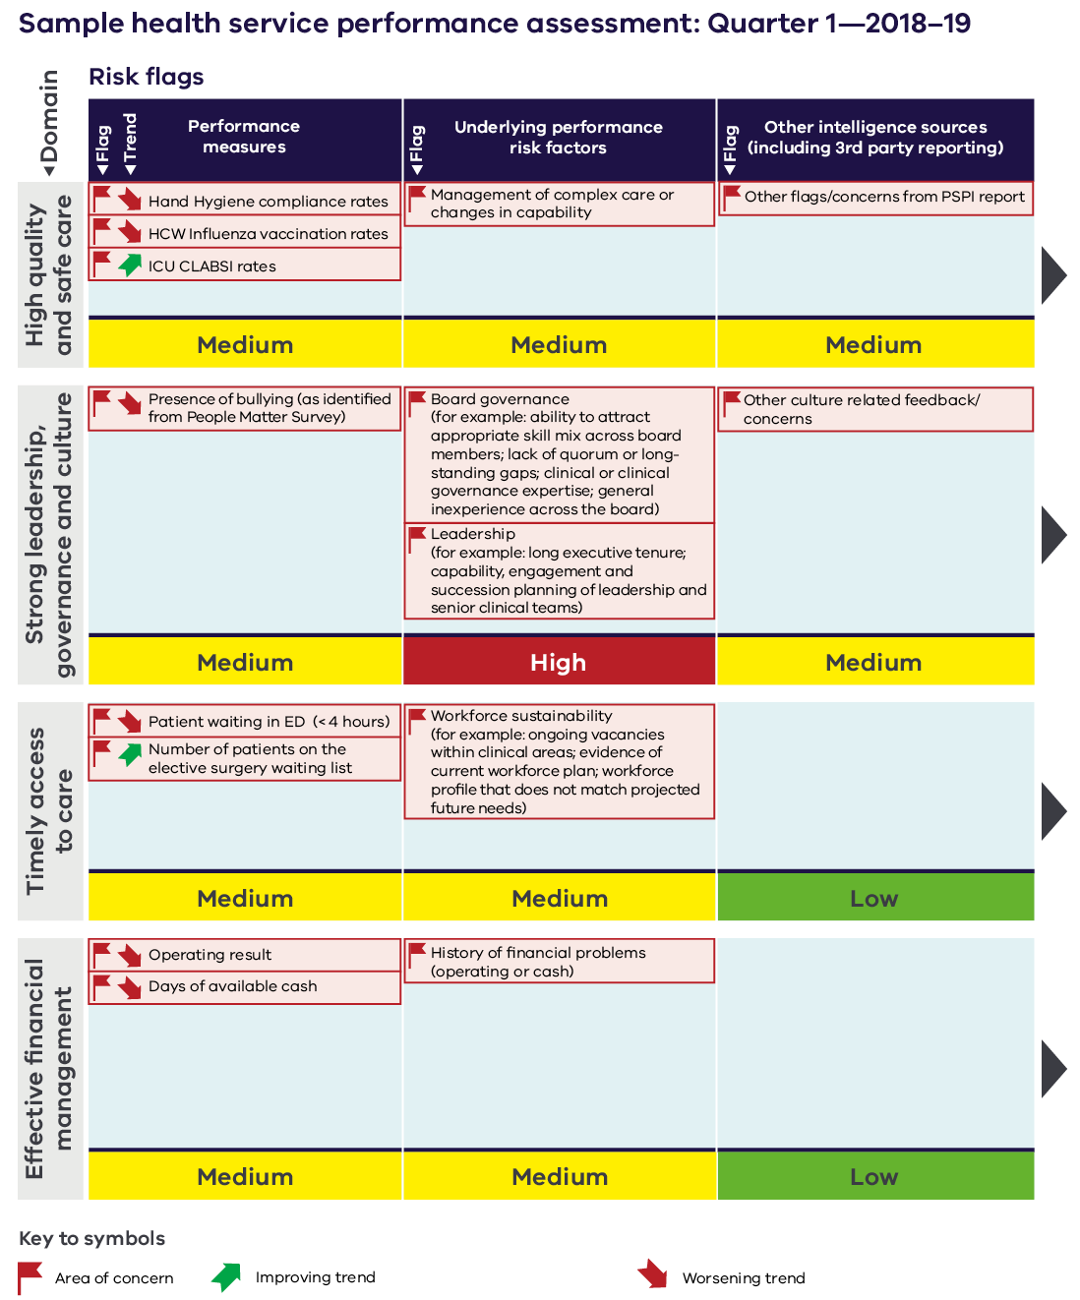

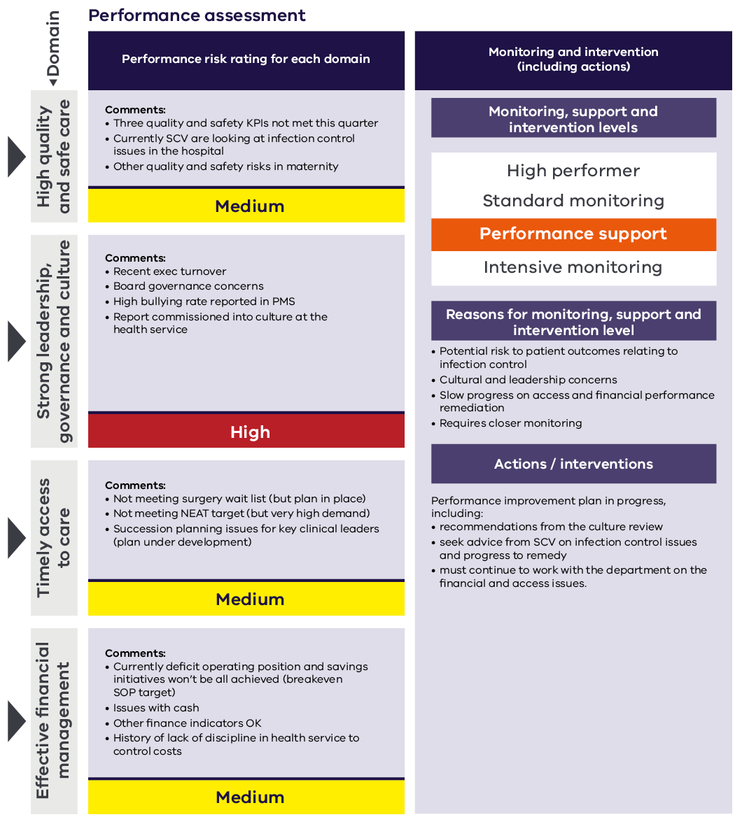

Appendix 4: Guide to the risk assessment tool
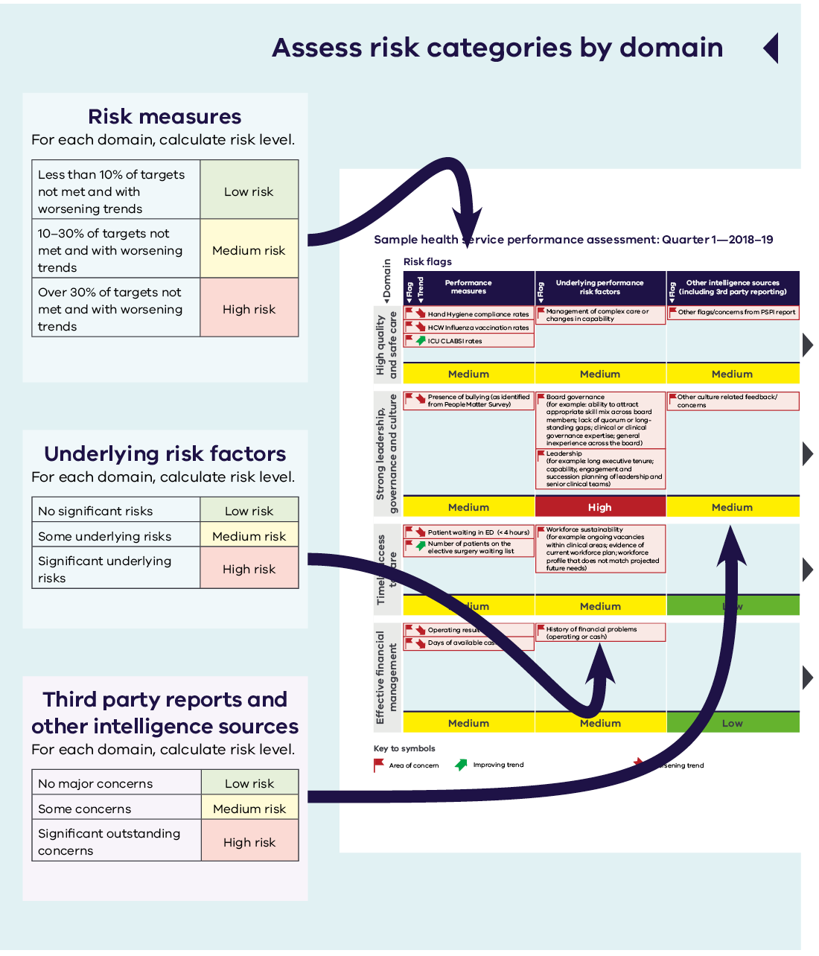

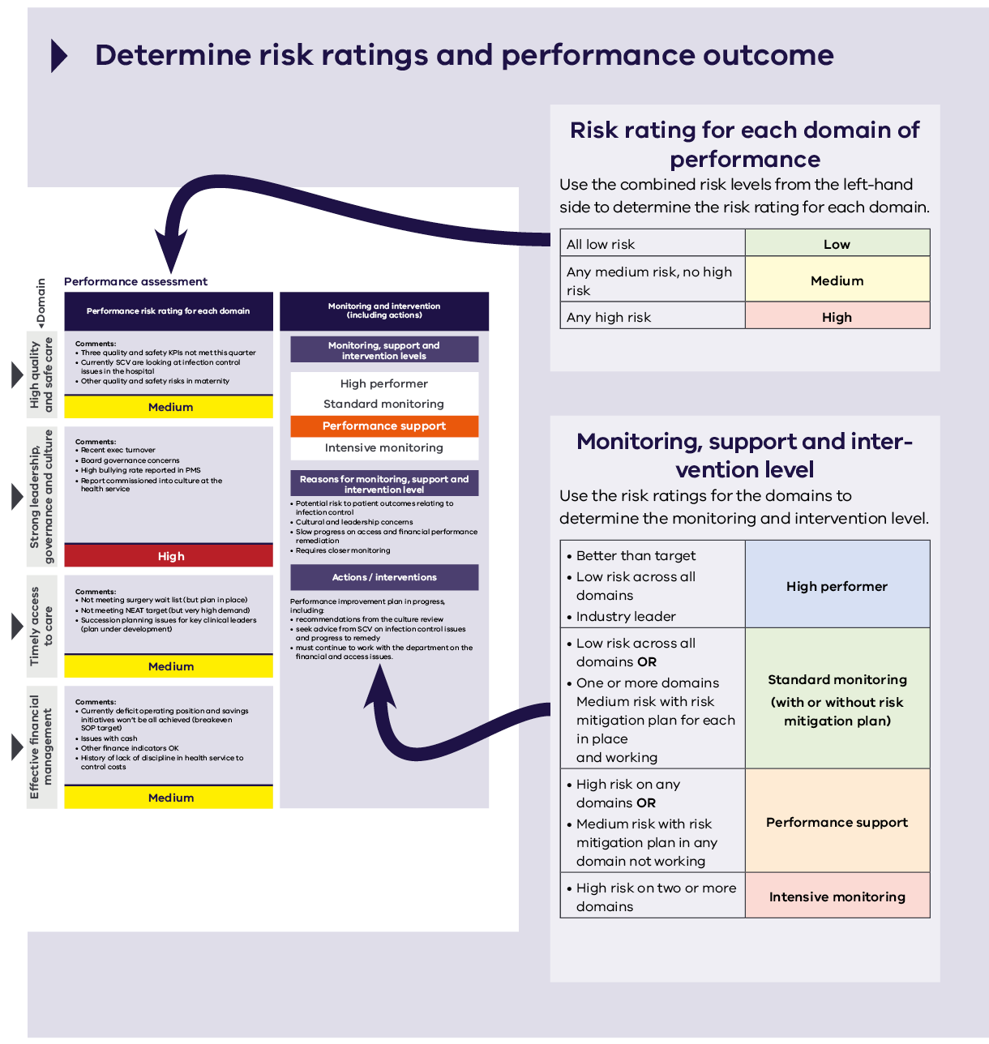

Part 2: Indicators business rules
The indicators business rules provided here complement the framework set out in Part 1 of this document.
The business rules provide the next level of detail about calculating performance for each indicator captured in the SoP for 2018–19 as well as the remainder of the performance measures reflected in the performance risk assessment approach.
The methodology for assessing improvement has also been included.

High quality and safe care

Accreditation
Indicator | Compliance with the National Safety and Quality Health Service standards
Description | Consistent with the Australian Health Service Safety and Quality Accreditation Scheme health services are required to be accredited against the National Safety and Quality Health Service Standards (‘NSQHS standards’).  This scheme applies to all health services including small rural health services and clinical mental health services. It includes contracted/outsourced services as if they are being provided by the health service.  Under the scheme the department, as the jurisdictional regulator, has responsibility for verifying the accreditation status of Victorian public health services.  In the event of an identified significant patient risk or ‘not met’ core action item, health services are required to immediately notify the department and submit an action plan to them addressing the issues. The Accreditation – Performance monitoring and regulatory approach business rules outlines the department’s approach to monitoring performance of Victorian public health services against the NSQHS standards accreditation requirements. Further details on the accreditation requirements can be found at HealthVic public hospital accreditation <https://www2.health.vic.gov.au/hospitals-and-health-services/quality-safety-service/hospital-accreditation>  Performance breach  As of 2017–18 not met criteria for accreditation is considered a performance breach. For further details about the performance breach notification process to the department, health services can refer to the Department of Health and Human Services policy and funding guidelines 2018 or by contacting their respective health service lead / regional manager.  For Ambulance Victoria ISO 9001:2008 (quality management system) certification applies.
Calculating performance | Full compliance with accreditation standards will be referred to as ‘achieved’.  Where a health service has not met accreditation standards it will be referred to as ‘not achieved’.  Where a health service does not achieve the indicator in any quarter the annual result is not achieved. Health services accreditation surveys vary in frequency depending on the accrediting body.
Statewide target | Full compliance
Achievement | Achieved  Not achieved
Improvement | For the purpose of the performance risk assessment improvement is assessed against the previous accreditation result.
Frequency of reporting and data collection | Performance is monitored quarterly at health service level.  The accreditation status as at the end of the quarter for each health service is reported for the periods:  - 1 July to 30 September 2018 in quarter 1  - 1 October to 31 December 2018 in quarter 2  - 1 January to 31 March 2019 in quarter 3  - 1 April to 30 June 2019 in quarter 4.  A performance result is also generated annually.

Indicator | Compliance with the Commonwealth’s Aged Care Accreditation Standards
Description | It is a requirement that all residential aged care facilities are accredited and maintain full compliance with the relevant accreditation standards.  The Commonwealth Government has primary responsibility for funding and regulating the residential aged care sector. In Victoria, a number of residential aged care services are provided by public health services and are subject to the Commonwealth’s Aged Care Accreditation Standards.
Calculating performance | This indicator is assessed at the health service level. Where a health service has multiple facilities, all facilities are required to meet the expected outcomes.  Full compliance with accreditation standards will be referred to as ‘achieved’.  Where a health service has not met accreditation standards they will be referred to as ‘not achieved’.  To achieve this indicator all residential aged care services must be fully compliant with all 44 expected outcomes of the Aged Care Accreditation Standards, at all times.  All episodes where expected outcomes are not met during the reporting period will be assessed as ‘not achieved’. Any breaches require health services to meet a timetable for improvements set by the Aged Care Standards and Accreditation Agency (ACSAA), usually within a three-month period, which includes submitting action plans and follow-up visits during and after this period.  Performance breach  As of 2017–18 not met criteria for accreditation is considered a performance breach. For further details about the performance breach notification process to the department, health services can refer to the Department of Health and Human Services policy and funding guidelines 2018 or by contacting their respective health service lead / regional manager.  The department’s Aged Care team should also be notified of any instances of noncompliance as soon as the ACSAA have identified them.
Statewide target | Full compliance
Achievement | Achieved  Not achieved
Improvement | For the purpose of the performance risk assessment improvement is assessed against the previous accreditation result.
Frequency of reporting and data collection | Performance is monitored and assessed quarterly. In addition to quarterly monitoring, a performance result is generated annually. Where a health service does not achieve the indicator in any quarter the annual result is not achieved.  The accreditation status as at the end of the quarter for the health service is to be reported for the periods:  - 1 July to 30 September 2018 in quarter 1  - 1 October to 31 December 2018 in quarter 2  - 1 January to 31 March 2019 in quarter 3  - 1 April to 30 June 2019 in quarter 4.  For each quarter, a list of residential aged care services that have failed to comply with the Aged Care Accreditation Standards during the relevant quarter will be obtained.

Infection prevention and control
Indicator | Compliance with the Hand Hygiene Australia program
Description | The hand hygiene program aims to improve compliance with best practice hand hygiene processes so that healthcare-associated infections are reduced.  The indicator encourages health services to achieve a high standard of hand hygiene and be fully compliant in their data submission to Hand Hygiene Australia (HHA).  This indicator measures the percentage of hand hygiene compliance achieved. This percentage represents compliance with the ‘5 moments’ for hand hygiene methodology.
Calculating performance | VICNISS coordinates the hand hygiene program for Victoria. Data are reported to HHA. VICNISS analyses the data for each audit period and reports results to the department.  Auditing requirements are outlined by Hand Hygiene Australia <http://www.hha.org.au>.  There are three hand hygiene audit periods per year:  - 1 July to 31 October  - 1 November to 31 March  - 1 April to 30 June.  The number of moments each campus is required to collect is based on acute inpatient bed numbers submitted to the Agency Information Management System as at 31 March 2018.  This indicator is assessed at the health service level. Where a health service has multiple campuses, the compliance is aggregated to produce an average health service result.  Where a health service has fewer than 25 acute inpatient beds at each campus, the number of moments required to be collected will be based on the total number of acute inpatient beds at the health service.  The department may determine alternative reporting arrangements for campuses with low bed numbers and low occupancy in consultation with SCV and the relevant health services.
Statewide target | ≥ 80%
Achievement | Equal to or above 80% | Achieved
 | Below 80% | Not achieved
Improvement | For the purpose of the performance risk assessment, improvement is compared to previous reporting period.
Frequency of reporting and data collection | Data is collected at the campus level and used to produce an aggregated health service result.  Hand hygiene compliance data is submitted to HHA throughout the year, and VICNISS creates reports for the three audit periods:  - 1 July to 31 October (reported with quarter 2)  - 1 November to 31 March (reported with quarter 3)  - 1 April to 30 June (reported with quarter 4).  Where a campus fails to submit the required number of moments in an audit period the measure is deemed not met.

Indicator | Percentage of healthcare workers immunised for influenza
Description | High coverage rates of immunisation in healthcare workers (HCW) are essential to reduce the risk of influenza transmission in healthcare settings.  This indicator aims to measure the percentage of vaccinated health service staff (including residential aged care services and community health staff) who are permanently, temporarily or casually (bank staff) employed by the nominated hospital / health service and worked one or more shifts during the influenza vaccination campaign.  The HCW categories used are aligned with the Australian Council on Safety and Quality in Health Care (ACSQHC) Australian guidelines for prevention and control of infection in healthcare. Details can be found at VICNISS <http://www.vicniss.org.au>.
Calculating performance | The period used to calculate the rate of HCW immunisation is 16 April to 31 August 2018.
Numerator | Number of category A, B and C HCW vaccinated as at 31 August 2018.
Denominator | Number of category A, B and C HCW employed as at 31 August who worked one or more shifts during the influenza vaccination campaign (16 April to 31 August 2018).
Statewide target | ≥ 80%
Achievement | Equal to or above 80% | Achieved
 | Below 80% | Not achieved
Improvement | For the purpose of the performance risk assessment improvement is assessed against the previous year performance.
Frequency of reporting and data collection | Data on vaccination rates must be submitted to VICNISS by 14 September 2018. If possible, data should be submitted by HCW category.  Where data is not submitted, the measure is deemed as not achieved.  Performance is monitored and assessed annually and reported in Q1.

Patient experience
Description | The Victorian healthcare experience survey (VHES) has been implemented in Victorian health services as a survey measuring patient experience since 2014.
Calculating performance for all questions | Indicators are measured at the health service level and mandatory participation is based on health services providing timely patient data to the contractor to enable surveying.  Participation is based on health services providing at least 42 responses per quarter and patient data issued to the contractor by the 15 of each months to enable statistically significant analysis.  Where data is not submitted in time, the measure is deemed not met.  Some small rural health services will not be able to achieve the minimum 42 response rate per quarter. Small rural health services that can meet the minimum 42 response rate as cumulative over the course of the year will have the actual results from the overall patient experience applied.  The ‘experience score’ is calculated by the survey contractor based on the positive response(s) to the questions from the adult inpatient category of VHES suite of information.  Health service results analysed quarterly.
Frequency of reporting and data collection | Health services are required to submit the details of eligible patients to the survey contractor by 15th of each month.  Reported data is lagged by one quarter.  Data is supplied at campus level and reported quarterly at health service level.
Improvement | For the purpose of the performance risk assessment improvement is assessed against the previous quarter performance.

Overall experience
Indicator | Question 76: Overall, how would you rate the care you received while in hospital?
Description | This indicator measures the results of the ‘very good’ and ‘good’ response to the adult inpatient VHES survey question relating to ‘overall experience’
Statewide target | Score equal to or above 95%
Achievement | Overall experience score equal to or above 95% | Achieved
 | Overall experience score below 95% | Not achieved

Key aspects of care questions that influence the overall experience
Indicator | Question 25: Did you have confidence and trust in the nurses treating you?
Description | This indicator measures the results of the ‘yes always’ response to the adult inpatient VHES survey question relating to ‘your nurses’.
Risk flag | <80%
Achievement | Equal to or above 80% | Achieved
 | Below 80% | Not achieved

Indicator | Question 33: How often did the doctors, nurses and other healthcare professionals caring for you explain things in a way you could understand?
Description | Measures the results of the ‘all of the time’ and ‘most of the time’ responses to the adult inpatient VHES survey question relating to ‘your care’
Risk flag | <90%
Achievement | Equal to or above 90% | Achieved
 | Below 90% | Not achieved

Indicator | Question 37: Were you involved as much as you wanted to be in decisions about your care and treatment?
Description | Measures the results of the ‘yes definitely’ response to the adult inpatient VHES survey question relating to ‘your care’.
Risk flag | <60%
Achievement | Equal to or above 60% | Achieved
 | Below 60% | Not achieved

Indicator | Question 42: If you needed assistance, were you able to get a member of staff to help you within a reasonable time?
Description | Measures the results of the ‘all of the time’ and ‘most of the time’ response to the adult inpatient VHES survey question relating to ‘your care’.
Risk flag | <85%
Achievement | Equal to or above 85% | Achieved
 | Below 85% | Not achieved

Transition of care
Indicator | Transition index
Description | Measures the quality of patient reported discharge care.
Calculating Performance | This composite indicator captures the average sum of the very positive responses to the following four questions in the adult inpatient VHES relating to transfer of care:  - Before leaving hospital, did the doctors and nurses give you sufficient information about managing your healthcare at home?  - Did hospital staff take your family and home situation into account when planning your discharge?  - Thinking about when you left hospital, were adequate arrangements made by the hospital for any services you needed?  - If follow-up with your general practitioner was required, was he or she given all the necessary information about the treatment or advice you received while in hospital?
Statewide Target | ≥ 75%
Achievement | Equal to or above 75% | Achieved
 | Below 75% | Not achieved

Indicator | Question 69: Before you left hospital, did the doctors and nurses give you sufficient information about managing your health and care at home?
Description | This indicator measures the results of the ‘yes completely’ response to the adult inpatient VHES survey question relating to ‘leaving hospital’.
Risk flag | <70%
Achievement | Equal to or above 70% | Achieved
 | Below 70% | Not achieved

Indicator | Question 70: Did hospital staff take your family or home situation into account when planning your discharge?
Description | This indicator measures the results of the ‘yes completely’ and ‘yes to some extent’ response to the adult inpatient VHES survey question relating to ‘leaving hospital’.
Risk flag | <70%
Achievement | Equal to or above 70% | Achieved
 | Below 70% | Not achieved

Indicator | Question 71: Thinking about when you left hospital, were adequate arrangements made by the hospital for any services you needed? (e.g. transport, meals, mobility aids)
Description | This indicator measures the results of the ‘yes completely’ response to the adult inpatient VHES survey question relating to ‘leaving hospital’.
Risk flag | <65%
Achievement | Equal to or above 65% | Achieved
 | Below 65% | Not achieved

Perception of cleanliness
Indicator | Patient perception of hospital cleanliness
Description | Measures the average sum of the very positive (‘very clean’) responses to the following two questions from the adult inpatient VHES relating to patient reported cleanliness:  Question 12: In your opinion, how clean was the hospital room or ward that you were in?  Question 13: How clean were the toilets and bathrooms that you used in hospital?
Statewide target | ≥ 70%
Achievement | Equal to or above 70% | Achieved
 | Below 70% | Not achieved

Forensicare patient experience
Indicator | Inpatient’s overall experience at Thomas Embling Hospital
Description | This indicator measures the results of the ‘excellent’, ‘very good’ and ‘good’ responses to the question ‘Overall, how would you rate your experience of care?’ in the annual Thomas Embling Hospital consumer survey.
Calculating performance | This indicator is measured at the health service level.
Numerator | Total number of survey respondents who answered ‘excellent’, ‘very good’ and ‘good’ to the item.
Denominator | Total number of survey respondents.
Statewide target | ≥ 90%
Achievement | Equal to or above 90% | Achieved
 | Below 90% | Not achieved
Improvement | For the purpose of the performance risk assessment improvement is assessed against the previous survey results.
Frequency of reporting and data collection | Results and participation will be reported annually in quarter 4.  Data source: Forensicare quantitative survey results.

Indicator | Patient’s overall experience at community Forensicare mental health services
Description | This indicator measures the results of the ‘excellent’, ‘very good’ and ‘good’ responses to the question ‘Overall, how would you rate your experience of care?’ in the annual Community Forensicare Mental Health Service consumer survey.
Calculating performance | This indicator is measured at the health service level.  Improvement will be compared to previous survey results.
Numerator | Total number of survey respondents who answered ‘excellent’, ‘very good’ and ‘good’ to the item.
Denominator | Total number of survey respondents.
Statewide target | ≥ 90%
Achievement | Equal to or above 90% | Achieved
 | Below 90% | Not achieved
Improvement | For the purpose of the performance risk assessment improvement is assessed against the previous survey results.
Frequency of reporting and data collection | Results and participation will be reported annually in quarter 4.  Data source: Forensicare quantitative survey results.

Healthcare-associated infections
Indicator | Number of patients with surgical site infection
Description | Surgical site infection surveillance focuses on reducing the incidence of healthcare-associated infection among nominated surgical procedures.
Calculating performance | This indicator refers to a set of specific types of procedures:  - coronary artery bypass grafts  - hip arthroplasty  - knee arthroplasty  - caesarean section for nominated health services  - colorectal surgery  Relevant procedures expressed as a crude rate per 100 procedures.  For each procedure type, where a health service is found to have a statistically significantly higher infection rate than the state aggregate rate, they are deemed an outlier. Further information on the methodology for calculating outliers for Surgical Site Infections can obtained from at VICNISS <http://www.vicniss.org.au>.  Coronary artery bypass graft  Campuses performing cardiac bypass surgery are required to conduct continuous surveillance.  Hip and knee arthroplasty  Campuses performing ≥ 50 hip and knee arthroplasty surgical procedures per annum are required to conduct continuous surveillance.  Caesarean section for nominated health services  Commencing from 2018–19 health service campuses that manage more than 400 births are required to conduct continuous surveillance of their c-section surgical site infections and report these to VICNISS.  The list of hospitals for which this measure is applicable to is based on previously reported data and can be found at Attachment A.  For those services that have not regularly collected and reported c-section surgical site infection data to VICNISS during 2017-18 compulsory reporting will be required for the period commencing  1 October 2018. The first three months of the 2018-19 year (1 July to 30 September 2018) may be used as a phase in period. VICNISS will provide additional education where required and can be contacted for assistance.  Colorectal surgery  Health services that undertake more than 50 relevant procedures a year will be required to undertake surveillance and report for the period 1 July to 31 December.  List of relevant procedures is available from VICNISS.  The list of hospitals for which this measure is applicable to is available at Attachment B.
Frequency of reporting and data collection | Performance is monitored and assessed quarterly. Data reported is lagged. Data is analysed quarterly based on two quarters of data. Rates are calculated using the most recent six months of data in a rolling fashion.  VICNISS collates and analyses data from health services and reports quarterly to participants and the department on aggregate, risk-adjusted, procedure-specific infection rates.  Data is submitted to VICNISS and performance reported for the periods:  - 1 January to 30 June 2018 in quarter 1 (of the Monitor report)  - 1 April to 30 September 2018 in quarter 2  - 1 July to 31 December 2018 in quarter 3  - 1 October to 31 March 2019 in quarter 4.  This indicator is measured at the health service level.  Where a health service has multiple campuses, an outlier at any campus will result in the health service not meeting the indicator.  If data is not submitted at a campus level in any month, the entire quarter target will be deemed as not met by the health service.  A result is generated annually. Where a health service does not achieve the indicator in a reporting period the annual result is not achieved.
Improvement | For the purpose of the performance risk assessment, improvement is assessed against the previous reporting period.

Indicator | Surgical site infection for all reported procedures
Numerator | The number of patients with a surgical site infection for all reported procedures
Denominator | The total number of all reported procedures
Statewide target | No outliers
Achievement | Achieved  Not Achieved

Indicator | Surgical site infection post coronary artery bypass grafts
Numerator | Number of surgical site infection post coronary artery bypass grafts
Denominator | The total number of coronary artery bypass graft procedures
Statewide target | No outliers
Achievement | Achieved  Not achieved

Indicator | Surgical site infection post hip arthroplasty
Numerator | Number of surgical site infection post hip arthroplasty
Denominator | The total number of hip arthroplasties
Statewide target | No outliers
Achievement | Achieved  Not achieved

Indicator | Surgical site infection post knee arthroplasty
Description | Number of surgical site infection post knee arthroplasty
Denominator | The total number of knee arthroplasties
Statewide target | No outliers
Achievement | Achieved  Not Achieved

Indicator | Surgical site infection post caesarean section delivery
Numerator | Number of surgical site infection post caesarean section delivery
Denominator | The total number of caesarean section deliveries
Statewide target | No outliers
Achievement | Achieved  Not Achieved

Indicator | Surgical site infection post colorectal surgery
Numerator | Number of surgical site infection post colorectal surgery.
Denominator | The total number of colorectal surgeries.
Statewide target | No outliers
Achievement | Achieved  Not Achieved

Indicator | Intensive care unit central-line-associated bloodstream infection surveillance
Description | This surveillance measure focuses on reducing the incidence of central-line-associated bloodstream infection (CLABSI) for patients in intensive care unit (ICU)  Neonatal intensive care units are excluded.
Calculating performance | Results are presented as rates calculated by the VICNISS on behalf of the department using the data collected from participating ICUs.  Rates = numerator/denominator × 1,000
Numerator | The number of CLABSIs
Denominator | The total number of central line days
Statewide target | Nil
Achievement | Achieved  Not achieved
Improvement | For the purpose of the performance risk assessment improvement is assessed against the previous reporting period.
Frequency of reporting and data collection | This indicator is measured at the hospital level and is relevant to hospitals with an ICU.  VICNISS collates and analyses data from health services and reports quarterly to participants and the department on aggregate, risk-adjusted infection rates.  Data is submitted to VICNISS and performance reported for the periods:  - 1 April to 30 June 2018 in quarter 1 Monitor report  - 1 July to 30 September 2018 in quarter 2  - 1 October to 31 December 2018 in quarter 3  - 1 January to 31 March 2019 in quarter 4.  Performance is monitored and assessed quarterly.  Data reported is lagged by one quarter.  Annual performance is based on full year lagged data.

Indicator | Rate of patients with Staphylococcus aureus bacteraemia per occupied bed days
Description | This surveillance measure aims to reduce the rate of health care associated Staphylococcus aureus bacteraemia (SAB) for all patients admitted to a public hospital with a bacteraemia caused by either Methicillin-susceptible S. aureus (MSSA) or Methicillin-resistant S. aureus (MRSA).
Calculating performance | A patient episode of bacteraemia is defined as a positive blood culture for S. aureus. For surveillance purposes, only the first isolate per patient is counted, unless at least 14 days has passed without a positive blood culture, after which an additional episode is recorded.  A SAB will be considered to be healthcare-associated either if:  - the patient’s first SAB blood culture was collected more than 48 hours after hospital admission or less than 48 hours after discharge, or  - the patient’s first SAB blood culture was collected less than or equal to 48 hours after hospital admission and one or more of the defined clinical criteria was met for the patient episode of SAB.  Occupied bed days are defined as the total number of days for all patients who were admitted for an episode of care in the acute health facility, including psychiatric bed days.  Further information on the SAB definition can be found at VICNISS <http://www.vicniss.org.au>.  This indicator is expressed as the rate of infections per 10,000 occupied bed days. This indicator is expressed as a rate and rounded to one decimal place (0.05 is rounded down).
Numerator | Healthcare-associated SAB patient episodes
Denominator | Number of occupied bed days for health services
Statewide target | ≤ 1.0 episodes per 10,000 occupied bed days
Achievement | Equal to or below 1.0 | Achieved
 | Greater than 1.0 | Not achieved
Improvement | For the purpose of the performance risk assessment improvement is assessed against the previous quarter performance.
Frequency of reporting and data collection | VICNISS collects and analyses data from health services and reports quarterly to participants and the department.  Reporting periods are:  - 1 April to 30 June 2018 reported in quarter 1 Monitor report  - 1 July to 30 September 2018 in quarter 2  - 1 October to 31 December 2018 in quarter 3  - 1 January to 31 March 2019 in quarter 4.  This indicator is measured at the health service level.  Where a health service has multiple campuses, an aggregate for the health service result is produced.  Data reported is lagged by one quarter.  Performance is monitored and assessed quarterly.  Performance result is generated annually based on full year lagged data.

Adverse events
Indicator | Sentinel events – root cause analysis reporting
Description | Sentinel events are serious and unexpected adverse events that often result in significant or permanent harm or death.  This indicator is a trigger for discussion regarding quality, safety and improvement in health services, as well as compliance with mandatory reporting of sentinel events.  The sentinel event program aims to improve health service system design and delivery through shared learning from a defined range of serious adverse events (sentinel events).  Increasing numbers of sentinel events are concerning particularly in the context of other safety and quality risks. Too low numbers may be a sign of an under-reporting culture. Of most importance is the timeliness of the response and effectiveness of the action taken to prevent re-occurrence.  SCV coordinates the sentinel event program for Victoria. Health services are required to notify SCV within 3 business days of a sentinel event occurring and provide a report outlining a plan to prevent recurrence. A copy of the root cause analysis (RCA) report must be submitted to SCV within 30 business days of the notification.
Calculating performance | This measure captures numbers of reportable sentinel events for which an RCA is submitted within 30 business days* from notification of the event to SCV.  Reportable sentinel events must meet one of the following specific criteria:  - procedure involving the wrong patient or body part resulting in death or major permanent loss of function  - suicide in an inpatient unit  - retained instruments or other material after surgery requiring reoperation or further surgical procedure  - intravascular gas embolism resulting in death or neurological damage  - haemolytic blood transfusion reaction resulting from ABO (blood type) incompatibility  - medication error resulting in death of a patient reasonably believed to be due to incorrect administration of drugs  - maternal death associated with labour or delivery  - infant discharged to the wrong family  - other catastrophic event: Incident severity rating one (ISR 1).  Further details on the sentinel events program including reporting requirements is outlined <https://bettersafercare.vic.gov.au/our-work/incident-response/sentinel-events>  * Under special circumstances an extension beyond the 30 business days may be provided by SCV. In these instances, this measure will be assessed against the new agreed submission date.
Statewide target | All RCA reports submitted within a 30 business day timeframe
Achievement | All RCA reports submitted within 30 business days* | Achieved
 | RCA report not submitted within 30 business days* | Not achieved
Improvement | For the purpose of the performance risk assessment improvement is assessed against the previous quarter performance.
Frequency of reporting and data collection | Data for this measure is reported at health service level.  Performance is assessed and reported quarterly.  Annual results are also calculated.

Mortality
Indicator | Hospital standardised mortality ratio
Description | Hospital standardised mortality ratios (HSMRs) are used to screen for safety and quality issues in hospitals.  It compares the hospital’s overall mortality to other hospitals within Victoria and nationally.  The ratio of observed (actual) number of in-hospital deaths to expected number of in-hospital deaths, multiplied by 100, for principal diagnoses accounting for 80 per cent of national in-hospital mortality.  The HSMR is risk adjusted by applying logistic regression to estimate the probability of an episode being separated as a death, given the patient’s characteristics. These probabilities are aggregated into expected counts.  The HSMR is compared against the national average ratio (100).
Calculating performance | An outlier result is represented by a significant variation (above 99% CI) from the national average ratio. Results within the 95% and 99% confidence interval are considered ‘higher than expected’ against the national rates.  All statistically higher or lower mortality rates should be reviewed by the health service to check the hypothesis against expected rates for age and health profile or for potential coding and classification processes that may distort the results.  High or rising HSMR should be seen as a prompt to further investigation and action to ensure that findings have been addressed effectively.  Reviews should be shared with SCV who will undertake to provide feedback.
Numerator | Observed number of in-hospital deaths x 100
Denominator | Expected number of in-hospital deaths, calculated as the sum of the estimated probabilities of death for all separations meeting the denominator criteria. Estimated probabilities are calculated using national risk-adjustment coefficients.  Denominator criteria  Inclusions:  - principal diagnosis is in the national list of the top 80 per cent of diagnoses, by frequency of in-hospital death  - age at date of admission is between 29 days and 120 years, inclusive  - care type = acute care((i.e. care types ‘0’,’4’,’5A’,’5G’,’5K’,’5S’,’K’), geriatric evaluation and management and maintenance care  - length of stay (LOS, including leave days) is between 1 and 365 days, inclusive (1 ≤ LOS ≤ 365)  - admission type is Emergency or Elective (‘O’, ‘C’, ‘K’, or ‘P’)  - sex is male or female  Exclusions:  - neonates, aged ≤ 28 days at admission  - missing admission type, sex.
Statewide target | No outliers
Achievement | Achieved  Not achieved
Improvement | For the purpose of the performance risk assessment, improvement is compared to previous quarter performance and based on the annual rate (outlier status).
Frequency of reporting and data collection | Quarterly (lagged by a quarter), representing a quarterly rate and an annual (preceding twelve months) rate.  Outliers are calculated based on the annual rate.  For quarterly results, in scope separations for the quarter is 50.  For annual reporting, in scope separations in the twelve months up to and including the reporting quarter is 100.  Data collection: Victorian Admitted Episodes Database (VAED). Results are collected and reported at campus level.  Number of observed and expected deaths is based on episodic, not patient level data. National rates supplied by ACSQHC.  Reference sets for outlier calculation can be supplied by VAHI,  upon request.

Indicator | In hospital mortality acute myocardial infarction (AMI)
Description | A condition specific mortality measure generated from admitted patient data for specific, high-morbidity populations (e.g. in this case AMI).
Calculating performance | It measures the ratio of actual number of in-hospital deaths for AMI patients (observed) to number of separations expected to end in in-hospital death for AMI patients (expected), multiplied by the national mortality rate for AMI patients (3.086038433).  This measure is risk adjusted and expressed as a rate per 100 separations.  Significant variation from the national rate should be verified in terms of data quality and consistency and/or quality and safety concerns.  Reviews of cases reflecting significant variation may identify resource, process of care or professional issues.  Reviews should be shared with who will undertake to provide feedback.  Results above the 99% confidence interval are considered outliers.  Results between the 95-99%CI reflect higher or lower than expected rates.  High outlier rates should be seen as a prompt to further investigation. Learnings may be applied from low outlier rates.
Numerator | Observed number of in-hospital deaths for AMI patients × national in-hospital  mortality rate for AMI patients, where: National mortality rate = national observed number of in-hospital deaths for AMI ÷ national observed number of separations for AMI
Denominator | Expected number of in-hospital deaths for AMI patients, calculated as the sum of the estimated probabilities of death for all separations (meeting the denominator criteria). Estimated probabilities are calculated using national risk-adjustment coefficients.  Denominator criteria  Inclusions:  - principal diagnosis of AMI (I21)  - age at admission date is between 18 and 89 years, inclusive  - admission type is Emergency  - length of stay (LOS), including leave days) is between 1 and 30 days, inclusive (1 ≤ LOS ≤ 30) (but not including same day).  Exclusions:  - additional diagnosis of Cardiac arrest (I46.x) AND Condition onset flag = Condition not noted as arising during the episode of admitted patient care  - same day separations (where date of admission is equal to the date of separation).
Statewide target | No outliers
Achievement | Achieved  Not achieved
Improvement | For the purpose of the performance risk assessment, improvement is compared to previous quarter performance and based on the annual rate (outlier status).
Frequency of reporting and data collection | Quarterly (lagged by a quarter), representing a quarterly rate and an annual (preceding twelve months) rate.  Outliers are calculated based on the annual rate.  For quarterly results, in-scope separations for the quarter is 20.  For annual results, the in-scope separations for the twelve month (including the reporting quarter) is 50.  Data collection: VAED. Number of observed and expected deaths is based on episodic, not patient level data.  National rates supplied by ACSQHC.  Reference sets for outlier calculation can be supplied by VAHI, upon request.  Results are collected and reported at campus level.

Indicator | In hospital mortality fractured neck of femur (FNOF)
Description | A condition specific mortality measure generated from admitted patient data for specific, high-morbidity populations (e.g. in this case FNOF).
Calculating performance | The ratio of actual number of in-hospital deaths for FNOF patients (observed) to number of separations expected to end in in-hospital death for FNOF patients (expected), multiplied by the national mortality rate for FNOF patients (3.022937504).  This measure is risk adjusted and expressed as a rate per 100 separations.  Results above the 99% confidence interval are considered outliers.  Results between the 95-99%CI reflect higher or lower than expected rates.  Significant variation from the national rate should be verified in terms of data quality and consistency and/or quality and safety concerns. Reviews of cases reflecting of significant variation may identify resource, process of care or professional issues.  Outcomes for management of hip fracture are sensitive to adherence to clinical best practice. There is also evidence of association between delay in operation for hip fracture and higher mortality rate, although other medical reasons can also be contributing factors.  Reviews should be shared with who will undertake to provide feedback.
Numerator | Observed number of in-hospital deaths for FNOF patients × national in-hospital mortality rate for FNOF patients, where  National mortality rate = national observed number of in-hospital deaths for FNOF ÷ national observed number of separations for FNOF
Denominator | Expected number of in-hospital deaths for FNOF patients, calculated as the sum of the estimated probabilities of death for all separations (meeting the denominator criteria). Estimated probabilities are calculated using national risk-adjustment coefficients.  Denominator criteria  Inclusions:  - principal diagnosis of NOF (S72.0, S72.10, S72.11) AND procedure code in (47519-00 [1479] , 47522-00 [1489], 47528-01 [1486],47531-00 [1486], 49315-00 [1489]) AND external cause code of Falls (W00.x – W19.x,) OR secondary diagnosis code of Tendency to fall not elsewhere classified (R29.6).  - age at date of admission is between 50 and 120, inclusive  - length of stay (LOS, including leave days) is between 1 and 30 days, inclusive (1 ≤ LOS ≤ 30).
Statewide target | No outliers
Achievement | Achieved  Not achieved
Improvement | For the purpose of the performance risk assessment, improvement is compared to previous quarter performance and based on the annual rate (outlier status).
Frequency of reporting and data collection | Quarterly (lagged by a quarter), representing a quarterly rate and an annual (preceding twelve months) rate.  Outliers are calculated based on the annual rate.  For quarterly results, in-scope separations for the quarter is 20.  For annual results, the in-scope separations for the twelve month (including the reporting quarter) is 50.  Data collection: VAED. Number of observed and expected deaths is based on episodic, not patient level data.  National rates supplied by ACSQHC.  Reference sets for outlier calculation can be supplied by VAHI, upon request.  Results are collected and reported at campus level.

Indicator | In hospital mortality stroke
Description | A condition specific mortality measure generated from admitted patient data for specific, high-morbidity populations (e.g. in this case stroke).
Calculating performance | The ratio of actual number of in-hospital deaths for stroke patients (observed) to number of separations expected to end in in-hospital death for stroke patients (expected), multiplied by the national mortality rate for stroke patients(10.50549466).  This measure is risk adjusted and expressed as a rate per 100 separations.  Significant variation from the national rate should be verified in terms of data quality and consistency and/or quality and safety concerns.  Reviews of cases reflecting of significant variation may identify resource, process of care or professional issues.  Reviews should be shared with who will undertake to provide feedback.  Results above the 99% confidence interval are considered outliers.  Results between the 95-99%CI reflect higher or lower than expected rates.
Numerator | Observed number of in-hospital deaths for stroke patients × national in-hospital mortality rate for stroke patients, where  National mortality rate = national observed number of in-hospital deaths for stroke ÷ national observed number of separations for stroke
Denominator | Expected number of in-hospital deaths for stroke patients, calculated as the sum of the estimated probabilities of death for all separations (meeting the denominator criteria). Estimated probabilities are calculated using national risk-adjustment coefficients.  Denominator criteria:  Inclusions:  - principal diagnosis of stroke (I61.x – I64.x)  - age at date of admission is between 18 and 89 years, inclusive  - care type = acute care (excluding neonates)  - length of stay (LOS, including leave days) is between 1 and 30 days, inclusive (1 ≤ LOS ≤ 30).  Exclusions:  - episodes with any of the following procedure codes: 33500-00 [700], 32703-00 [718].
Statewide target | No outliers
Achievement | Achieved  Not achieved
Improvement | For the purpose of the performance risk assessment, improvement is compared to previous quarter performance and based on the annual rate (outlier status).
Frequency of reporting and data collection | Quarterly (lagged by a quarter), representing a quarterly rate and an annual (preceding twelve months) rate.  Outliers are calculated based on the annual rate.  For quarterly results, in-scope separations for the quarter is 20.  For annual results, the in-scope separations for the twelve month (including the reporting quarter) is 50.  Data collection: VAED.  Number of observed and expected deaths is based on episodic, not patient level data.  National rates supplied by ACSQHC.  Reference sets for outlier calculation can be supplied by VAHI, upon request.  Results are collected and reported at campus level.

Indicator | In hospital mortality pneumonia
Description | A condition specific mortality measure generated from admitted patient data for specific, high-morbidity populations (e.g. in this case pneumonia).
Calculating performance | The ratio of actual number of in-hospital deaths for pneumonia patients (observed) to number of separations expected to end in in-hospital death for pneumonia patients (expected), multiplied by the national mortality rate for the pneumonia patients.  This measure is risk adjusted and expressed as a rate per 100 separations.  It compares individual hospitals against a national rate (4.597868217).  Significant variation from the national rate should be verified in terms of data quality and consistency and/or quality and safety concerns. Reviews of cases reflecting of significant variation may identify resource, process of care or professional issues.  Reviews should be shared with who will undertake to provide feedback.  Results above the 99% confidence interval are considered outliers.  Results between the 95-99%CI reflect higher or lower than expected rates.
Numerator | Observed number of in-hospital deaths for pneumonia patients × national in-hospital mortality rate for pneumonia patients, where  National mortality rate = national observed number of in-hospital deaths for pneumonia ÷ national observed number of separations for pneumonia.
Denominator | Expected number of in-hospital deaths for pneumonia patients, calculated as the sum of the estimated probabilities of death for all separations (meeting the denominator criteria). Estimated probabilities are calculated using national risk-adjustment coefficients.  Denominator criteria  Inclusions:  - principal diagnosis of pneumonia (J13.x – J16.x, J18.x)  - age at date of admission is between 18 and 89 years, inclusive  - care type = acute care (excluding neonates)  - length of stay (LOS, including leave days) is between 1 and 30 days, inclusive (1 ≤ LOS ≤ 30).
Statewide target | No outliers
Achievement | Achieved  Not achieved
Improvement | For the purpose of the performance risk assessment, improvement is compared to previous quarter performance and based on the annual rate (outlier status).
Frequency of reporting and data collection | Quarterly (lagged by a quarter), representing a quarterly rate and an annual (preceding twelve months) rate.  Outliers are calculated based on the annual rate.  For quarterly results, in-scope separations for the quarter is 20.  For annual results, the in-scope separations for the twelve month (including the reporting quarter) is 50.  Data collection: VAED. Number of observed and expected deaths is based on episodic, not patient level data. National rates supplied by ACSQHC.  Reference sets for outlier calculation can be supplied by VAHI, upon request.  Results are collected and reported at campus level.  Improvement is assessed against previous quarter performance and based on the annual rate (outlier status).

Unplanned re-admission
Description | Unplanned re-admission refers to an unexpected readmission for treatment of the same condition, a related condition or a complication of the condition for which the patient was previously hospitalised.  The unplanned readmission indicators for Acute Myocardial Infarction, Knee replacement, Hip replacement, Heart failure and Paediatric Tonsillectomy and Adenoidectomy are part of a suite of core hospital-based outcome indicators focused on improving safety and quality of patient care.
Calculating performance | Results should fall within the expected range against statewide rates.  Results above the 99.8% confidence interval are considered outliers.  Results between the 95-99.8%CI reflect higher or lower than expected rates.  High rates should be seen as a prompt to further investigation. Investigation should consider a comprehensive range of possible explanations including: case mix, structural or resource issues, changes in treatment protocols, professional practice.  Reviews should be shared with who will undertake to provide feedback.
Frequency of reporting and data collection | Quarterly (lagged by a quarter), representing a quarterly rate and an annual (preceding twelve months) rate. Outliers are calculated based on the annual rate.  For quarterly results, the in scope separations for the quarter is at least 15 or 2 or more readmissions for two consecutive quarters.  For annual results, the in-scope separations is 50 or more in the twelve months up to and including the reporting quarter.  Data collection: VAED. Results are collected and reported at campus level.
Improvement | For the purpose of the performance risk assessment, improvement is compared to previous quarter performance and based on the annual rate (outlier status).

Indicator | Unplanned readmission for Acute Myocardial Infarction
Description | Unplanned readmissions to the same hospital within 30 days of patients’ separation, for management of Acute Myocardial Infarction.
Numerator | Includes all separations with a separation date which is within the reference period and which satisfy all of the following:  - the separation is a readmission to the same hospital campus following a separation which is in scope of the denominator (either for the reference period or the previous period)  - has a principal diagnosis code (i.e. the readmission) of either I21 or I22  - occurs within 30 days of the previous date of separation  - the readmission is an acute admission (Care Type = ‘U’, ‘4’, ‘K’)  - admission type of the readmission is ‘Emergency’(‘O’ or ‘C’)  - excludes transfers from other campuses (Admission Source = ‘T’).
Denominator | Includes all separations with a separation date which is within the reference period and which satisfy all of the following:  - has an ICD-10-AM principal diagnosis code of I21 or I22  - is an acute separation (Care Type = ‘U’, ‘4’, ‘K’)  - patient age is between 30-89 years (inclusive)  - admission Type of admission is ‘emergency’ (‘O’, ‘C’)  - excludes transfers in and transfers out (Admission Source or Separation Mode = ‘T’)  - LOS is between 4-30 patient days (inclusive)  - excludes in-hospital deaths (Separation Mode = ‘D’).
Statewide target | No outliers
Achievement | Achieved  Not achieved
Improvement | For the purpose of the performance risk assessment, improvement is compared to previous quarter performance and based on the annual rate (outlier status).

Indicator | Unplanned readmission for knee replacement
Description | Unplanned readmissions to the same hospital within 60 days of patients’ separation from acute care for knee replacement surgery.
Numerator | Includes all separations with a separation date which is within the reference period and which satisfy all of the following:  - the separation is a readmission to the same hospital campus following a separation which is in scope of the denominator (either for the reference period or the previous period)  - the principal diagnosis code (i.e. of the readmission) is in (‘I21’,’I26’,’I50’,’I74’,’M17’,’M23’,’N13’,’R33’,’S89’,’T81’,’T84’,’I80.1’,’I80.2’,’I97.8’,’J15.1’,’J18.0’,’J18.9’,’J95.8’,’L89.2’,’M24.6’,’M25.6’,’N39.0’,’S82.0’,’T88.7’,’L03.11’,’S72.10’,’S83.44’,’T85.78’,’T85.88’)  - the readmission occurs within 60 days of the previous date of separation  - the readmission is an acute admission (Care Type = ‘U’, ‘4’, ‘K’).
Denominator | Includes all separations with a separation date which is within the reference period and which satisfy all of the following:  - has any of the following procedure codes: 49518-00, 49519-00, 49521-02  - is an acute separation(Care Type = ‘U’, ‘4’, ‘K’)  - patient age is at least 20 years  - LOS is greater than or equal to 4 days  - excludes in-hospital deaths(Separation Mode = ‘D’).
Statewide target | No outliers
Achievement | Achieved  Not achieved
Improvement | For the purpose of the performance risk assessment, improvement is compared to previous quarter performance and based on the annual rate (outlier status).

Indicator | Unplanned readmission for paediatric tonsillectomy and adenoidectomy
Description | Unplanned readmissions to the same hospital within 15 days of patients’ separation, for management of paediatric tonsillectomy and adenoidectomy (0 to 14 years inclusive).
Numerator | Includes all separations with a separation date which is within the reference period and which satisfy all of the following:  - the separation is a readmission to the same hospital campus following a separation which is in scope of the denominator (either for the reference period or the previous period)  - the principal diagnosis code (i.e. of the readmission) is in (‘E86’,’J03’,’J06’,’J18’,’J19’,’J20’,’J21’,’J22’,’J35’,’J36’,’R11’,’R50’,’R53’,’R56’,’R58’,’T81’,’Z48’,’E89.8’,’E8.99’,’J95.8’,’J95.9’,’K91.0’,’K91.8’,’K91.9’,’K92.0’,’R04.0’,’R07.0’,’T88.8’,’T88.9’,’Z03.8’,’Z03.9’)  - the readmission occurs within 15 days of the previous date of separation  - the readmission is an acute admission (Care Type = ‘U’, ‘4’, ‘K’).
Denominator | Includes all separations with a separation date which is within the reference period and which satisfy all of the following:  - has any of the following procedure codes: 41789-00, 41801-00, 41789-01  - is an acute separation (Care Type = ‘U’, ‘4’, ‘K’)  - patient age is at most 14 years  - LOS <= 30 patient days  - excludes in-hospital deaths (Separation Mode = ‘D’)
Statewide target | No outliers
Achievement | Achieved  Not achieved
Improvement | For the purpose of the performance risk assessment, improvement is compared to previous quarter performance and based on the annual rate (outlier status).

Indicator | Unplanned readmission for heart failure
Description | Unplanned readmissions to the same hospital within 30 days of patients’ separation, for management of heart failure.
Numerator | Includes all separations with a separation date which is within the reference period and which satisfy all of the following:  - the separation is a readmission to the same hospital campus following a separation which is in scope of the denominator (either for the reference period or the previous period)  - has a principal diagnosis code(i.e. the readmission) of I50  - the readmission occurs within 30 days of the previous date of separation  - the readmission is an acute admission (Care Type = ‘U’, ‘4’, ‘K’)  - admission Type of admission is ‘emergency’ (‘O’, ‘C’)  - excludes transfers from other campuses (Admission Source = ‘T’).
Denominator | Includes all separations with a separation date which is within the reference period and which satisfy all of the following:  - has an ICD-10-AM principal diagnosis code of I50  - is an acute separation (Care Type = ‘U’, ‘4’, ‘K’)  - patient age is between 30-89 years (inclusive)Admission Type of admission is ‘emergency’ (‘O’, ‘C’)  - excludes transfers in and transfers out (Admission Source or Separation Mode = ‘T’)  - LOS is between 1-30 patient days (inclusive)  - excludes in-hospital deaths (Separation Mode = ‘D’)  - patient must have spent at least one night in hospital (i.e. non-same day patient).
Statewide target | No outliers
Achievement | Achieved  Not achieved
Improvement | For the purpose of the performance risk assessment, improvement is compared to previous quarter performance and based on the annual rate (outlier status).

Indicator | Unplanned and potentially preventable readmission of mother within 28 days of discharge from a birthing admission
Description | This indicator measures the rate of unplanned and potentially preventable readmissions of women within 28 days of discharge from hospital following a birthing admission.  High quality and coordinated care means most women and babies do not return to hospital as an inpatient during the postnatal period. Unplanned and preventable hospital stays during this period reflect a deviation from the normal course of postnatal recovery.  Evidence suggests higher readmission rates are associated with inconsistent discharge procedures, poor postnatal care and limited support in the community.  The intersection of hospital-based maternity and newborn services and the community-based maternal and child health service system is a key point of transition within the first six weeks after the birth of a child.
Calculating performance | Readmissions that meet the criteria for inclusion are attributed to the health service that provided admitted postnatal care to the mother prior to discharge.  Women transferred to another health service following a birth separation are excluded from the numerator total, as are women who are readmitted as part of a planned follow-up plan after their birth episode.  Women who present to an emergency department or urgent care centre, but are not admitted are excluded from the numerator total.  Maternal deaths are excluded from the denominator.  Data is lagged by one quarter.  Reporting thresholds >=10 cases in the denominator.  Results are assessed and reported quarterly and expressed as percentage.  Outlier status (above 99.7% CI) assessed against state-wide rates.
Numerator | The number of women readmitted to any health service with a potentially preventable readmission diagnosis code within 28 days of a birthing admission.  Women who are readmitted and have a primary diagnosis related to their pregnancy or birth are included in the numerator total. However, diagnosis codes that are associated with a complexity that cannot be prevented (or managed) through postnatal care or that are associated with a condition that manifests after discharge from hospital, without any indication of its presence prior to this time, are excluded.  Potentially preventable readmission primary diagnosis codes are limited to the following:  - delayed and secondary postpartum haemorrhage (ICD10 Code O722)  - infection of obstetric surgical wound (ICD10 Code O860)  - puerperal sepsis (ICD10 Code O85)  - nonpurulent mastitis without attachment difficulty (ICD10 Code O9120)  - fitting and adjustment of urinary device (ICD10 Code Z466)  - spinal epidural headache during puerperium (ICD10 Code O894)  - disruption of perineal obstetric wound (ICD 10 Code O901)  - pre-eclampsia unspecified (ICD10 Code O149)  - unspecified maternal hypertension (ICD10 Code O16)  - Anemia complicating birth and puerperium (ICD10 Code O9903)  - retained portion placenta and membrane without haemorrhage (ICD10 Code O731)  - other immediate postpartum haemorrhage (ICD10 Code O721)  - haematoma of obstetric wound (ICD10 Code O902)  - urinary tract infection following delivery (ICD10 Code O862)  - disruption of caesarean section wound (ICD10 Code O900)  - care and examination of lactating mother (ICD10 Code Z391)  - gestational hypertension (ICD10 Code O13)  - urinary tract infection site not specified (ICD10 Code N390)  - nonpurulent mastitis with attachment difficulty (ICD10 Code O9121)  - severe mental and behavioural disorder associated with puerperium not elsewhere classified (ICD10 Code F531)  - mild mental and behavioural disorder associated with puerperium not elsewhere classified (ICD10 Code F530)  - other reaction to spinal and lumbar puncture (ICD10 Code G971)  - fever unspecified (ICD10 Code R509)  - retention of urine (ICD10 Code R33)  - eclampsia in the puerperium (ICD10 Code O152)  - third-stage haemorrhage (ICD10 Code O720)
Denominator | The number of women provided admitted postnatal care prior to discharge.
Statewide target | No outliers
Achievement | Achieved  Not achieved
Improvement | For the purpose of the performance risk assessment, improvement is compared to previous quarter performance and based on the state wide rate (outlier status).

Indicator | Potentially preventable readmission of a neonate within 28 days of discharge from a birthing admission
Description | This indicator measures the rate of unplanned and potentially preventable readmissions of babies within 28 days of discharge from hospital following a birthing admission.  High quality and coordinated care means most women and babies do not return to hospital as an inpatient during the postnatal period. Unplanned and preventable hospital stays during this period reflect a deviation from the normal course of postnatal recovery.  Evidence suggests higher readmission rates are associated with inconsistent discharge procedures, poor postnatal care and limited support in the community.
Calculating performance | Calculated for the hospital that discharged the newborn episode.  Includes admissions to any Victorian health service after birth, not just a readmission to the birthing hospital.  Reporting thresholds >=10 cases in the denominator.  Results are analysed, reported quarterly and expressed as a percentage.  Outlier status (above 99.7% CI) assessed against state-wide rates.  Data lagged by two quarters.
Numerator | The number of babies readmitted to any health service with a potentially preventable readmission diagnosis code within 28 days of discharge.  Babies transferred to another health service following a birth separation are excluded from the numerator total, as are babies who are readmitted as part of a planned follow-up after their birth episode.  Babies who present to an emergency department or urgent care centre but are not admitted are excluded from the numerator total.  Babies who are admitted and have a primary diagnosis related to their pregnancy or birth are included in the numerator total. However, diagnosis codes that are associated with a complexity that cannot be prevented (or managed) through postnatal care or that are associated with a condition(s) that manifests after discharge from hospital without any indication of its presence prior to this time, are excluded.  Potentially preventable readmissions are limited to the cohort of primary diagnoses listed below.  Neonate readmission diagnosis codes:  - neonatal jaundice unspecified (ICD10 Code P599)  - abnormal weight loss (ICD10 Code R634)  - feeding problem of newborn unspecified (ICD10 Code P929)  - other lack of normal physiological development (ICD10 Code R628)  - bacterial sepsis of newborn unspecified (ICD10 Code P369)  - other feeding problems of newborn (ICD10 Code P928)  - neonatal jaundice with preterm delivery (ICD10 Code P590)  - neonatal jaundice from other specified causes (ICD10 Code P598)  - other preterm infant >=32 but <37 completed weeks (ICD10 Code P0732)  - ABO isoimmunisation of fetus and newborn (ICD10 Code P551)  - observation of newborn for suspected infectious condition (ICD10 Code Z0371)  - apnoea of newborn, unspecified (ICD10 Code P2840)  - cyanotic attacks of newborn (ICD10 Code P282)  - enteroviral meningitis (ICD10 Code A870)  - omphalitis newborn with or without mild haemorrhage (ICD10 Code P38)  - dehydration of newborn (ICD10 Code P741)  - hypothermia of newborn unspecified (ICD10 Code P809)  - convulsions of newborn (ICD10 Code P90)
Denominator | The denominator includes the total number of babies discharged from a health service. Stillbirths and neonatal deaths prior to discharge are excluded.  Qualified and unqualified babies are included – irrespective of their accommodation type during the birth episode (if they spent time in a neonatal intensive care unit or special care nursery).  Babies who are readmitted on the same day of discharge are also excluded. This is because it is not possible to determine whether these are genuine readmissions or a new separation following planned transfer of care.
Statewide target | No outliers
Achievement | Achieved  Not achieved
Improvement | For the purpose of the performance risk assessment, improvement is compared to previous quarter performance and based on the state wide rate (outlier status).

Indicator | Unplanned readmission for hip replacement
Description | Unplanned readmissions to the same hospital within 60 days of patients’ separation from acute care, for hip replacement surgery.
Calculating performance | Data is collected at campus level. Reporting thresholds >=50 cases (over 4 qtrs) in the denominator.  Results are reported quarterly as a twelve month rolling rate and expressed as a percentage.  Data lagged by one quarter.
Numerator | Includes all separations with a separation date which is within the reference period and which satisfy all of the following:  - the separation is a readmission to the same hospital campus following a separation which is in scope of the denominator (either for the reference period or the previous period)  - the principal diagnosis code (i.e. of the readmission) is in (‘G46’,’I21’,’I26’,’I50’,’I74’,’I80’,’J15’,’L89’,’N13’,’N30’,’R33’,’S73’,’T84’,’T89’,’I62.1’,’I63.3’,’I97.8’,’J18.0’,’J18.9’,’J95.8’,’L03.9’,’M25.6’,’M96.8’,’N390’,’T81.1’,’T81.3’,’T81.5’,’T81.6’,’T81.8’,’T81.9’,’T85.9’,’T88.7’, ‘L03.11’,’S72.00’,’S72.08’,’T85.87’,’T85.88’)  - the readmission occurs within 60 days of the previous date of separation  - the readmission is an acute admission (Care Type = ‘U’, ‘4’, ‘K’).
Denominator | Includes all separations with a separation date which is within the reference period and which satisfy all of the following:  - has any of the following procedure codes: 49318-00,49319-00  - is an acute separation (Care Type = ‘U’, ‘4’, ‘K’)  - patient age is at least 20 years  - LOS is greater than or equal to 3 days  - excludes in-hospital deaths (Separation Mode = ‘D’).
Statewide target | Annual rate = ≤ 2.5%
Achievement | Achieved = ≤ 2.5%  Not achieved = > 2.5%
Improvement | For the purpose of the performance risk assessment, improvement is compared to previous quarter performance and based on the annual rate (outlier status).

Mental health
Indicator | Percentage of adult mental health inpatients who are readmitted within 28 days of discharge
Description | Adult specialist mental health services are aimed primarily at people with a serious mental illness or mental disorder who have associated significant levels of disturbance and psychosocial disability due to their illness or disorder. Readmission rates for adult mental health patients can reflect the quality of care, effectiveness of discharge planning and level of support provided to patients after discharge, as well as other factors.
Calculating performance | This indicator includes adult mental health patients who are admitted overnight or longer in hospital.  Exclusions are overnight separations for electroconvulsive therapy, transfers to other acute hospitals or to residential aged care, and patients who leave against medical advice or abscond.  This indicator is expressed as a percentage and rounded to the nearest whole number.
Numerator | Non-same day separations from adult general acute psychiatric inpatient units that result in a non-same-day readmission to the same or to another public sector acute psychiatric inpatient unit within 28 days of discharge
Denominator | Number of non-same-day separations from adult general acute psychiatric inpatient units
Statewide target | ≤ 14%
Achievement | Less than or equal to 14% | Achieved
 | Greater than 14% | Not achieved
Improvement | For the purpose of the performance risk assessment, improvement is compared to previous quarter performance
Frequency of reporting and data collection | Performance is monitored and assessed quarterly. In addition to quarterly monitoring, a performance result is generated annually based on the full year data.  The 28-day lag inherent in the indicator means that reporting is lagged by one month. For example, quarter 2 will report the mental health results for separations occurring in the period September to November 2018  Performance is reported for the periods:  - 1 June to 31 August 2018 in quarter 1  - 1 September to 30 November 2018 in quarter 2  - 1 December 2018 to 28 February 2019 in quarter 3  - 1 March to 31 May 2019 in quarter 4.  The data source for this indicator is the Client Management Interface (CMI), which is the local client information system used by each public mental health service. It also uses the Operational Data Store (ODS), which manages a set of select data items from each CMI. The initialism used for this data source is CMI/ODS.

Indicator | Rate of seclusion events relating to a child and adolescent acute mental health admission
Description | Reducing restraint and seclusion is a national safety priority, and incorporating this indicator ensures appropriate monitoring of seclusion use in child and adolescent mental health service (CAMHS) acute inpatient units in Victoria.  This indicator is to measure any period of seclusion relating to a child or adolescent acute admission.
Calculating performance | This indicator comprises CAMHS acute inpatient services provided by public mental health services and includes all CAMHS acute admissions.  Occupied bed days are calculated where the admission event type is one of the following:  - SA (statistical admission)  - R (return from leave)  - A (admission – formal)  - T (ward transfer).  Leave events within an admission are excluded.  Admission events that do not have any temporal overlap with the reporting period are excluded. Only the minutes of the admission events that overlap with the reporting period are counted. The minutes for each CAMHS acute admission event are then summed and divided by 1,440 to give the total occupied bed days for the campus for the reporting period.  Any period of seclusion relating to a CAMHS acute admission ending in the reporting period is counted. The number of seclusions is divided by the number of occupied bed days. The quotient is then multiplied by 1,000.  CAMHS clients are identified by program type.
Numerator | CAMHS acute seclusion events during the reference period
Denominator | Total CAMHS acute occupied bed days during the reference period
Statewide target | ≤ 15 seclusions per 1,000 bed days (< 15/1,000)
Achievement | Less than or equal to < 15/1,000 | Achieved
 | Greater than > 15/1,000 | Not achieved
Improvement | For the purpose of the performance risk assessment, improvement is compared to previous quarter performance
Frequency of reporting and data collection | Performance is monitored and assessed quarterly for the periods:  - 1 July to 30 September 2018 in quarter 1  - 1 October to 31 December 2018 in quarter 2  - 1 January to 31 March 2019 in quarter 3  - 1 April to 30 June 2019 in quarter 4.  In addition to quarterly monitoring, a performance result is generated annually based on the full year data.  The data source for this indicator is the Client Management Interface (CMI), which is the local client information system used by each public mental health service. It also uses the Operational Data Store (ODS), which manages a set of select data items from each CMI. The data source is CMI/ODS.

Indicator | Rate of seclusion events relating to an adult acute mental health admission
Description | Reducing restraint and seclusion is a national safety priority, and incorporating this indicator ensures appropriate monitoring of seclusion use in adult acute inpatient units in Victoria.  This indicator is to measure any period of seclusion relating to an adult acute admission.
Calculating performance | This indicator comprises adult acute inpatient services provided by public mental health services and includes adult acute admissions as well as patients at ORYGEN Youth Health Melbourne Clinic campus. Occupied bed days are calculated where the admission event type is one of the following:  - SA (statistical admission)  - R (return from leave)  - A (admission – formal)  - T (ward transfer).  Leave events within an admission are excluded.  Admission events that do not have any temporal overlap with the reporting period are excluded. Only the minutes of the admission events that overlap with the reporting period are counted. The minutes for each adult acute admission event are then summed and divided by 1,440 to give the total occupied bed days for the campus for the reporting period.  Any period of seclusion relating to an adult acute admission ending in the reporting period is counted. The number of seclusions is divided by the number of occupied bed days. The quotient is then multiplied by 1,000.  Improvement is compared to previous quarter performance.
Numerator | Adult acute seclusion events during the reference period
Denominator | Total adult acute occupied bed days during the reference period
Statewide target | ≤ 15 seclusions per 1,000 bed days (< 15/1,000)
Achievement | Less than or equal to 15/1,000 | Achieved
 | Greater than > 15/1,000 | Not achieved
Improvement | For the purpose of the performance risk assessment, improvement is compared to previous quarter performance
Frequency of reporting and data collection | Performance is monitored and assessed quarterly for the periods:  - 1 July to 30 September 2018 in quarter 1  - 1 October to 31 December 2018 in quarter 2  - 1 January to 31 March 2019 in quarter 3  - 1 April to 30 June 2019 in quarter 4.  In addition to quarterly monitoring, a performance result is generated annually based on the full year data.  The data source for this indicator is the Client Management Interface (CMI), which is the local client information system used by each public mental health service. It also uses the Operational Data Store (ODS), which manages a set of select data items from each CMI. The initialism used for this data source is CMI/ODS.

Indicator | Rate of seclusion events relating to an aged acute mental health admission
Description | Reducing restraint and seclusion is a national safety priority, and incorporating this indicator ensures appropriate monitoring of seclusion use in aged acute inpatient units in Victoria.  This indicator is to measure any period of seclusion relating to an aged acute admission.
Calculating performance | This indicator comprises aged acute inpatient services provided by public mental health services and includes all aged acute admissions.  Occupied bed days are calculated where the admission event type is one of the following:  - SA (statistical admission)  - R (return from leave)  - A (admission – formal)  - T (ward transfer).  Leave events within an admission are excluded.  Admission events that do not have any temporal overlap with the reporting period are excluded. Only the minutes of the admission events that overlap with the reporting period are counted. The minutes for each aged acute admission event are then summed and divided by 1,440 to give the total occupied bed days for the campus for the reporting period.  Any period of seclusion relating to an aged acute admission ending in the reporting period is counted. The number of seclusions is divided by the number of occupied bed days. The quotient is then multiplied by 1,000.  Aged clients are identified by the type of admission.
Numerator | Aged acute seclusion events during the reference period
Denominator | Total aged acute occupied bed days during the reference period
Statewide target | ≤ 15 seclusions per 1,000 bed days (< 15/1,000)
Achievement | Less than or equal to < 15/1,000 | Achieved
 | Greater than > 15/1,000 | Not achieved
Improvement | For the purpose of the performance risk assessment, improvement is compared to previous quarter performance
Frequency of reporting and data collection | Performance is monitored and assessed quarterly for the periods:  - 1 July to 30 September 2018 in quarter 1  - 1 October to 31 December 2018 in quarter 2  - 1 January to 31 March 2019 in quarter 3  - 1 April to 30 June 2019 in quarter 4.  In addition to quarterly monitoring, a performance result is generated annually based on the full year data.  The data source for this indicator is the Client Management Interface (CMI), which is the local client information system used by each public mental health service. It also uses the Operational Data Store (ODS), which manages a set of select data items from each CMI. The initialism used for this data source is CMI/ODS.

Indicator | Percentage of child and adolescent mental health inpatients with post-discharge follow-up within seven days
Description | Timely post-discharge follow-up is an important component of client care. Monitoring the proportion of discharges that are followed up within seven days is a good measure of the timeliness of this care. This indicator reflects the effectiveness of the interface between admitted care and non-admitted care. It is also monitored at a national level.
Calculating performance | Where one or more contacts fall in the seven days after the separation date, the separation is considered to have received post-discharge community care.  Separations are counted against the mental health area (catchment campus) of the client, rather than the campus of separation. The separation type is ‘home’ and patients must be admitted overnight or longer in hospital.  Contacts on the day of separation are excluded. Contacts can be of any duration, in any location for any type of recipient, whether by the local mental health service or another mental health service.  Child and adolescent mental health service (CAMHS) clients are identified by admission type in the Client Management Interface (CMI) system.  This indicator is expressed as a percentage and rounded to the nearest whole number.
Numerator | Number of post-discharge follow-ups within seven days
Denominator | Total non-same-day acute mental health CAMHS separations to a private residence
Statewide target | ≥ 80%
Achievement | Greater than or equal to 80% | Achieved
 | Less than 80% | Not achieved
Improvement | For the purpose of the performance risk assessment, improvement is compared to previous quarter performance
Frequency of reporting and data collection | Performance is monitored and assessed quarterly. In addition to quarterly monitoring, a performance result is generated annually based on the full year data.  The separation date is between the start of the reporting period (minus seven days) and the end of the reporting period (minus seven days). Separations are lagged by seven days to allow all post-discharge follow-up in the reporting period to be captured. For example, if the reporting period is from 1 July 2018 to 30 September 2018, then separations from 24 June 2018 to 24 September 2018 are included.  Results are reported for the periods:  - 1 July to 30 September 2018 in quarter 1  - 1 October to 31 December 2018 in quarter 2  - 1 January to 31 March 2019 in quarter 3  - 1 April to 30 June 2019 in quarter 4.  The data source for this indicator is the CMI, which is the local client information system used by each public mental health service. It also uses the Operational Data Store (ODS), which manages a set of select data items from each CMI. The initialism used for this data source is CMI/ODS.

Indicator | Percentage of adult mental health patients who have post-discharge follow-up within seven days
Description | Timely post-discharge follow-up is an important component of client care. Monitoring the proportion of discharges that are followed up within seven days is a good measure of the timeliness of this care. This indicator reflects the effectiveness of the interface between admitted care and non-admitted care. It is also monitored at the Commonwealth level.
Calculating performance | Where one or more contacts fall in the seven days after the separation date, the separation is considered to have received post-discharge community care.  The separation type is home and patients must be admitted overnight or longer in hospital.  Contacts on the day of separation are excluded. Contacts can be of any duration, in any location for any type of recipient, whether by the local mental health service or another mental health service.  This indicator is expressed as a percentage of post-discharge follow-ups on the total number of non-same-day acute adult separations.  This indicator is rounded to the nearest whole number.
Numerator | Number of post-discharge follow-ups within seven days
Denominator | Total non-same-day acute mental health adult separation to a private residence or accommodation
Statewide target | ≥ 80%
Achievement | Greater than or equal to 80% | Achieved
 | Less than 80% | Not achieved
Improvement | For the purpose of the performance risk assessment, improvement is compared to previous quarter performance
Frequency of reporting and data collection | Performance is monitored and assessed quarterly. In addition to quarterly monitoring, a performance result is generated annually based on the full year data.  The separation date is between the start of the reporting period (minus seven days) and the end of the reporting period (minus seven days). Separations are lagged by seven days to allow all post-discharge follow-up in the reporting period to be captured. For example, if the reporting period is from 1 July 2018 to 30 September 2018, then separations from 24 June 2018 to 24 September 2018 are included.  Performance is reported for the periods:  - 1 July to 30 September 2018 in quarter 1  - 1 October to 31 December 2018 in quarter 2  - 1 January to 31 March 2019 in quarter 3  - 1 April to 30 June 2019 in quarter 4.  The data source for this indicator is the Client Management Interface (CMI), which is the local client information system used by each public mental health service. It also uses the Operational Data Store (ODS), which manages a set of select data items from each CMI. The initialism used for this data source is CMI/ODS.

Indicator | Percentage of aged mental health inpatients who have post-discharge follow-up within seven days
Description | Timely post-discharge follow-up is an important component of client care. Monitoring the proportion of discharges that are followed up within seven days is a good measure of the timeliness of this care. This indicator reflects the effectiveness of the interface between admitted care and non-admitted care. It is also monitored at the Commonwealth level.
Calculating performance | Where one or more contacts fall in the seven days after the separation date, the separation is considered to have received post-discharge community care.  The separation type is home or residential aged care and patients must be admitted overnight or longer in hospital.  Contacts on the day of separation are excluded. Contacts can be of any duration, in any location for any type of recipient, whether by the local mental health service or another mental health service.  This indicator is expressed as a percentage of post-discharge follow-ups on the total number of non-same-day acute aged separations.  Aged clients are identified by the type of admission.  This indicator is expressed as a percentage and rounded to the nearest whole number.
Numerator | Number of post-discharge follow-ups within seven days
Denominator | Total non-same-day acute mental health aged separations to a private residence or accommodation
Statewide target | ≥ 80%
Achievement | Greater than or equal to 80% | Achieved
 | Less than 80% | Not achieved
Improvement | For the purpose of the performance risk assessment, improvement is compared to previous quarter performance
Frequency of reporting and data collection | Performance is monitored and assessed quarterly. In addition to quarterly monitoring, a performance result is generated annually based on the full year data.  The separation date is between the start of the reporting period (minus seven days) and the end of the reporting period (minus seven days). Separations are lagged by seven days to allow all post-discharge follow-up in the reporting period to be captured. For example, if the reporting period is from 1 July 2018 to 30 September 2018, then separations from 24 June 2018 to 24 September 2018are included.  Performance is reported for the periods:  - 1 July to 30 September 2018 in quarter 1  - 1 October to 31 December 2018 in quarter 2  - 1 January to 31 March 2019 in quarter 3  - 1 April to 30 June 2019 in quarter 4.  The data source for this indicator is the Client Management Interface (CMI), which is the local client information system used by each public mental health service. It also uses the Operational Data Store (ODS), which manages a set of select data items from each CMI. The initialism used for this data source is CMI/ODS.

Maternity and newborn
Indicator | Rate of singleton term infants without birth anomalies with APGAR score <7 to 5 minutes
Description | This indicator measures the wellbeing of babies at birth. It is used as a proxy for the quality of intrapartum care and neonatal resuscitation, where necessary, following birth.  Singleton infants who are more than 37 weeks gestation and without congenital anomalies are expected to be born in good condition, show healthy physiological adaption to birth and not require significant resuscitation measures.  The Apgar score is an assessment of a newborn’s wellbeing at birth based on five physiological attributes at one and five minutes (and longer if applicable): colour (circulation), breathing, heart rate, muscle tone and reflexes.  The Apgar score is a verified measure of adverse long-term outcomes and correlates highly with Victorian Managed Insurance Authority claims within the first year of life.  An Apgar score <7 at five minutes indicates an infant who requires significant or ongoing resuscitation measures or additional care that may be due to avoidable factors during labour and childbirth and/or the immediate resuscitation measures at birth. It may also indicate sub-optimal triaging and/or management of higher complexity pregnancies.  All cases of infants born with a low Apgar score (< 7) at five minutes should undergo a clinical review to determine whether appropriate management and monitoring of the pregnancy was provided and whether the case was avoidable. The review can also highlight opportunities for improvement.
Calculating performance | This indicator excludes all terminations of pregnancy, babies born at less than 37 weeks’ gestation, birthweight <150 grams, babies born with congenital anomalies, multiple births, stillbirths and babies born before arrival at hospital.
Numerator | The number of singleton, liveborn, term infants without congenital anomalies with an Apgar score < 7 at five minutes
Denominator | The number of inborn singleton, liveborn term babies without congenital anomalies
Statewide target | ≤ 1.4%
Achievement: | Less than or equal to 1.4% | Achieved
 | Greater than 1.4% | Not achieved
Improvement | Improvement is assessed against previous quarter performance.
Frequency of reporting and data collection | Data for this indicator is derived from the Victorian Perinatal Data Collection (VPDC) and lagged by one quarter.  Due to low numbers of births at some health services, this measure is calculated using a rolling two quarter data reporting period.  Results are reported quarterly at campus level, using two quarters rolling data, with one quarter lag time. For example, Q1 2018–19 result will report on data from Q3 and Q4 2017–18 (combined). Results are not reported where minimum threshold of >=10 case in denominator is not achieved.  Data is required to be submitted by health services monthly. All data reported to the VPDC is due within 30 days.  Health services are required to submit VPDC data for the previous month by the end of the following month. (This may mean that a birth may take up to 60 days to be reported by a health service if it occurred at the start of the month).

Indicator | Rate of Severe fetal growth restriction (FGR) in singleton pregnancy undelivered by 40 weeks
Description | The purpose of this indicator is to identify the proportion of severely growth-restricted singleton babies who were not born by 40 weeks’ gestation. For this indicator, a baby is considered to be severely growth restricted when their birthweight is below the third centile for gestation, sex and plurality.  Severe fetal growth restriction is associated with an increased risk of perinatal mortality and morbidity, admission to a special care nursery or neonatal intensive care unit, and long term health consequences. The risk of mortality for a severely growth-restricted baby increases as the pregnancy advances. FGR should therefore be identified early in pregnancy for appropriate medical management and delivery before 40 weeks’ gestation.  Severe fetal growth restriction closely correlates with adverse outcomes at one year of age and Victorian Managed Insurance Authority claims within one year of birth.  The rate of severe FGR in singleton babies who were not born by 40 weeks’ gestation has been chosen as the performance indicator for quality of antenatal care.  FGR can be difficult to diagnose and health services should monitor their rates at regular intervals and aim to review these cases to understand why they had not been detected or managed.
Calculating performance | Severe FGR is defined as birthweight less than the third centile for gestation, sex and plurality, whether liveborn or stillborn.  This indicator excludes all terminations of pregnancy, babies without severe FGR, multiple births and births at earlier gestations (less than 32 weeks).
Numerator | Birth at 40 or more weeks gestation of a singleton baby with severe FGR
Denominator | All singleton births (live and stillborn) with severe FGR born at and beyond 32 weeks gestation.
Statewide target | ≤ 28.6%
Achievement: | Equal to or less than 28.6% | Achieved
 | Greater than 28.6% | Not achieved
Improvement | Improvement is assessed against previous quarter performance.
Frequency of reporting and data collection | Data for this indicator will be derived from the VPDC. Data is lagged by one quarter.  This indicator is reported quarterly at campus level, with one quarter lag  From 2018–19 results are reported quarterly at campus level, using 12 months (four quarters) rolling data, with one quarter lag time. For example, Q1 2018–19 result will report on data from Q1 and Q4 2017–18 (combined). This approach will smooth out the volatility in individual campus results experienced during 2017–18.  Results are not reported where minimum threshold of >=10 case in denominator is not achieved over the 12 month period.  Data is required to be submitted by health services monthly.  All data reported to the VPDC is due within 30 days.  Health services are required to submit VPDC data for the previous month by the end of the following month. (This may mean that a birth may take up to 60 days to be reported by a health service if it occurred at the start of the month).

Indicator | Proportion of urgent maternity patients referred for obstetric care to a level 4, 5 or 6 maternity service who were booked for an appointment within 30 days of accepted referral
Description | The indicator monitors the proportion of urgent maternity patients referred to level 4, 5 or 6 maternity service, who attended a first appointment within 30 days of accepted referral.
Calculating performance | The waiting time represents the number of days between the Referral in Received Date and the First Appointment Booked Date.  Applies to health services determined by the department to provide level 4, 5 or 6 maternity capability. For details of the maternity capability levels for all public services, go to the Department of Health and Human Services policy and funding guidelines <https://www2.health.vic.gov.au/about/policy-and-funding-guidelines>.  Data for this indicator is derived from the Victorian Integrated Non-Admitted Health (VINAH) dataset.  The VINAH user manual, including data elements and business rules can be found at:  <https://www2.health.vic.gov.au/hospitals-and-health-services/data-reporting/health-data-standards-systems/data-collections/vinah>
Numerator | The number of urgent maternity patient contacts scheduled within the reporting period for an appointment within 30 days of referral to clinic.
Denominator | The number of urgent maternity patient contacts scheduled within the reporting period for an appointment.
Statewide target | 100%
Achievement | Equal to 100% | Achieved
 | Less than 100% | Not achieved
Improvement | For the purpose of the performance risk assessment, improvement is compared to same time last year performance.
Frequency of reporting and data collection | Performance is monitored and assessed quarterly for contacts scheduled within the reporting period.  Data for this indicator is derived from VINAH.  Submission date: health services are encouraged to submit data as often as desired, so long as a minimum of one submission is made for each reference month no later than 5pm on the 10th day of the following reference month.  Clean date: all errors are to be cleared by the 14th day of the following month, or the preceding working day if the 14th falls on a weekend or public holiday.  End of financial year consolidation: all errors for 2018-19 must be corrected and resubmitted before consolidation of the VINAH database on the date advised in the Department of Health and Human Services policy and funding guidelines 2018.

Aboriginal health
Indicator | Perinatal mortality rate per 1000 of babies of Aboriginal mothers
Description | Perinatal mortality reflects the health status and health care of the general population, access to and quality of preconception, reproductive, antenatal and obstetric services for women, and health care in the neonatal period.  This indicator measures changes in babies of Aboriginal mothers perinatal mortality over time.
Calculating performance | The Perinatal Mortality Rate is calculated as the number of stillbirths and neonatal deaths in babies of Aboriginal mothers per 1,000 total births (stillbirths and live births).  The rate refers to all births of at least 20 weeks gestation or, if gestation is unknown, of birth weight of at least 400 g to Aboriginal mothers.  It excludes terminations due to maternal psychosocial indication.
Numerator | Stillbirths and neonatal deaths in babies of Aboriginal mothers.
Denominator | Total births (stillbirths and live births) in babies of Aboriginal mothers.  The rate is reported by 1,000 total births
Statewide target | Less than or equal to 13.6 per 1,000 total births
Achievement | ≤ 13.6/1,000 | Achieved
 | Greater than 13.6/1,000 | Not achieved
Improvement | Improvement will be compared to previous year results.
Frequency of reporting and data collection | This indicator is systematically collected and reported since 2001 by the Consultative Council on Obstetric and Paediatric Mortality and Morbidity  The rate is calculated triennially due to very small numbers.  Results are reported annually as three year rolling average.

Indicator | Smoking cessation in Aboriginal mothers
Description | Smoking in pregnancy is a preventable cause of significant obstetric and perinatal complications and adverse outcomes. Pregnancy is therefore an important time for health professionals to implement strategies and interventions to help women quit smoking.  This indicator indirectly assesses the performance of health services in providing smoking cessation advice, assistance and follow-up during the antenatal period to reduce both the rate of smoking among pregnant Aboriginal mothers and the risk of smoking-associated adverse health outcomes for their babies.
Calculating performance | This indicator measures the rate of Aboriginal women who smoked after 20 weeks gestation as compared to before 20 weeks gestation. The ‘smoking cessation rate’ represents the relative reduction between these two rates. It reflects the effectiveness of smoking cessation interventions offered.  All Aboriginal women giving birth in public and private hospitals and homebirths will be included.
Numerator | Aboriginal women who smoked before 20 weeks’ gestation and who did not smoke after 20 weeks’ gestation
Denominator | Rate of Aboriginal women who smoked before 20 weeks’ gestation  The rate is expressed as a percentage.
Statewide target | >=37.6% Budget Paper 3 Target for 2018–19 is 21.4%. 37.6% is 16–17 Vic Statewide rate
Achievement | Equal to or above 37.6% | Achieved
 | Below 37.6% | Not achieved
Improvement | Improvement is assessed against previous quarter performance.
Frequency of reporting and data collection | The data is collected by the Consultative Council on Obstetric and Paediatric Mortality and Morbidity in the VPDC on a monthly basis.  Performance is assessed and reported quarterly. Results are not reported where minimum threshold of >=10 case in denominator is not achieved.

Continuing care

Functional Independence Measure efficiency
Description | The FIM™ instrument is a basic indicator of patient disability. FIM™ is used to track the changes in the functional ability of a patient during an episode of hospital rehabilitation or Geriatric Evaluation and Management (GEM) care.  FIM™ is comprised of 18 items, grouped into 2 subscales - motor and cognition; each of which is assessed against a seven point ordinal scale, where the higher the score for an item, the more independently the patient is able to perform the tasks assessed by that item. Total scores range from 18 to 126.  A low FIM™ score is a good indicator of need for subacute bed based care due to reduced function.  Equally, a higher FIM™ admission score may indicate that care through the Health Independence Program may be as effective in meeting the patient’s needs.
Calculating performance | FIM™ efficiency is measured by the difference between FIM™ on discharge and FIM™ on admission divided by the number of days of the episode of care.  This indicator applies to all health services providing subacute care (rehabilitation and/or GEM). Excludes palliative care, non-acute care and paediatric rehabilitation.  Performance is calculated separately as individual scores for GEM and rehabilitation.
Improvement | Improvement is compared to previous quarter performance.
Frequency of reporting and data collection | Data extracted from VAED and reported quarterly with a one quarter lag. Results are reported at health service level.

Indicator | Rehabilitation
Numerator | Total FIM™ score on discharge minus total FIM™ score on rehabilitation admission
Denominator | Length of episode stay per rehabilitation stream
Statewide target | ≥ 0.645
Achievement | Equal to or above 0.645 | Achieved
 | Below 0.645 | Not achieved

Ambulance services
Indicator | Percentage of emergency patients satisfied or very satisfied with the quality of care provided by paramedics
Description | This indicator is measured by the Council of Ambulance Authorities (CAA  The CAA conducts an annual survey to measure the service quality and satisfaction ratings of ambulance services. The patient satisfaction measure is reported annually in the Report on Government Services.  This indicator measures the proportion of emergency patients satisfied or very satisfied with the quality of care provided by the attending paramedics.
Calculating performance | This indicator is measured by randomly selecting a sample of at least 1,300 (Code 1 and 2) patients transported within two months of the sampling date. A review is performed to ensure that the percentage of samples in each Victorian region is similar to the percentage of transports performed in each region.  To avoid the risk of distressing family members or carers, known deceased patients, cardiac arrest patients and children aged under five years are excluded from the random selection process.  Data is collected by Ambulance Victoria and submitted to the CAA.  Performance results are based on the findings of the CAA annual survey and exclude nil/don’t know responses.  This indicator is expressed as a percentage to one decimal place.
Numerator | Number of completed surveys from Code 1 and 2 patients who were satisfied or very satisfied when answering the question: ‘How satisfied were you overall with your last experience using the Ambulance service?’
Denominator | Total number of completed surveys excluding nil/don’t know responses
Statewide target | 95%
Achievement | Equal to or greater than 95% | Achieved
 | Less than 95% | Not achieved
Improvement | Improvement is compared to previous year performance.
Frequency of reporting and data collection | Performance is monitored annually.  Data is submitted to the department annually from Ambulance Victoria.

Indicator | Percentage of patients experiencing severe cardiac or traumatic pain whose level of pain was reduced significantly
Description | Adequate relief of pain is one of a series of key measures of the clinical effectiveness of interventions by paramedics. The indicator of the proportion of patients experiencing severe cardiac or traumatic pain, whose level of pain is significantly reduced, focuses the attention of the organisation on the effectiveness of clinical interventions in two common areas of service provision – cardiac care and trauma care.  Assessment of pain severity and the extent of relief that paramedics can provide is central to the provision of appropriate care.  This indicator applies to patients of all ages experiencing traumatic pain and patients who are 15 years old or older with cardiac pain.
Calculating performance | This indicator measures the difference between the initial pain score and the final pain score according to Ambulance Victoria (clinical practice guidelines. Patients experiencing severe pain are defined as those having an initial pain score of 8 or more, with pain measured out of 10.  A patient is deemed to have had a significant reduction in pain if the difference between their initial and final pain score is 2 or more.  This indicator excludes: patients with a Glasgow Coma Score < 9; intubated patients; patients unable to rate pain; patients who have < 2 recorded pain scores and patients who refuse analgesia.  This indicator is expressed as a percentage to one decimal place.
Numerator | Total number of adult cardiac, adult trauma and paediatric trauma patients with an initial pain score assessed as 8 or more experiencing a reduction in score of 2 or more
Denominator | Total number of adult cardiac, adult trauma and paediatric trauma patients with an initial pain score assessed as 8 or more
Statewide target | 90%
Achievement | Equal to or greater than 90% | Achieved
 | Less than 90% | Not achieved
Improvement | Improvement is compared to previous quarter performance.
Frequency of reporting and data collection | Performance is monitored quarterly.  Data is submitted to the department quarterly from Ambulance Victoria.

Indicator | Percentage of acute adult stroke patients transported to definitive care within 60 minutes
Description | The early recognition of stroke symptoms and the timing and the destination to which patients are transported are critical to ensuring optimal outcomes for stroke patients.  This indicator is a measure of ambulance response to adult patients (15 years or older) suspected of having a stroke within the last six hours who are transported within 60 minutes to a health service with the capability to deliver intravenous thrombolysis.  A list of health services providing thrombolysis for stroke patients can be found at HealthVic statewide frameworks for acute stroke services <https://www2.health.vic.gov.au/hospitals-and-health-services/quality-safety-service/clinical-networks/clinical-network-stroke/stroke-statewide-frameworks>
Calculating performance | This indicator excludes inter-hospital transfers, patients with an estimated stroke onset of greater than six hours, patients with significant pre-existing disability or dependent on others for daily living.  This indicator is expressed as a percentage to one decimal place.
Numerator | Total number of adult patients suspected of having a stroke and meeting the above criteria who were transported within 60 minutes to a health service with the capability to deliver intravenous thrombolysis.
Denominator | Total number of adult patients suspected of having a stroke and meeting the above criteria
Statewide target | 90%
Achievement | Equal to or greater than 90% | Achieved
 | Less than 90% | Not achieved
Improvement | Improvement is compared to previous quarter performance.
Frequency of reporting and data collection | Performance is monitored quarterly.  Data is submitted to the department quarterly from Ambulance Victoria.

Indicator | Percentage of major trauma patients that meet destination compliance
Description | Mortality and morbidity can be reduced by effective field triage, treatment and transport of severely injured patients to specialised trauma hospitals.  This indicator is a measure of ambulance response to patients defined as major trauma who are transported to a major trauma service or to the highest level designated trauma service within 45 minutes of the ambulance departing the scene.  Major trauma patients are defined by the Victorian State Trauma Registry, and this process relies on hospital diagnostic procedures, and in hospital treatment data which causes a lag of one quarter for all data.
Calculating performance | This indicator excludes inter-hospital transports and patients not meeting the Ambulance Victoria Trauma Triage Guidelines.  This indicator is expressed as a percentage to one decimal place.
Numerator | Total number of major trauma patients transported to a major trauma service or to the highest level designated trauma service within 45 minutes travel time (from scene)
Denominator | Number of patients defined as major trauma
Statewide target | 85%
Achievement | Equal to or greater than 85% | Achieved
 | Less than 85% | Not achieved
Improvement | Improvement is compared to previous quarter performance.
Frequency of reporting and data collection | Performance is monitored quarterly.  Data reported is lagged by one quarter.  Data is submitted to the department quarterly from Ambulance Victoria.

Indicator | Percentage of adult cardiac arrest patients surviving to hospital
Description | Cardiac arrest survival is strongly impacted by Emergency Medical Services (EMS) response times, clinical interventions and treatments.  The cardiac arrest survival to hospital rate describes the percentage of adult patients in out-of-hospital cardiac arrest, that initially present in a shockable rhythm where any chest compressions and/or defibrillation was undertaken by ambulance/EMS (fire brigade first responders, community emergency response teams or ambulance) or where defibrillation was performed by a public access defibrillator (PAD) and who have a return to spontaneous circulation (palpable pulse) on arrival at hospital.  Data is collected and reported according to the internationally recognised Utstein template and definitions. The Victorian Ambulance Cardiac Arrest Registry captures data on all out-of-hospital cardiac arrest patients attended by EMS in Victoria.  This indicator applies to adult patients (15 years or older) who are in ventricular fibrillation or pulseless ventricular tachycardia (VF/VT) on EMS arrival for whom resuscitation is commenced (minimum is cardiopulmonary resuscitation) by EMS.
Calculating performance | This indicator applies to adult patients who are in VF/VT on EMS arrival for whom resuscitation is commenced by EMS or patients defibrillated by PAD.  Excludes cardiac arrests witnessed by EMS and patients where vital signs at hospital are unknown.  This indicator is expressed as a percentage to one decimal place.
Numerator | The number of adult VF/VT cardiac arrest patients with a palpable pulse on arrival at hospital
Denominator | The total number of adult VF/VT cardiac arrest patients meeting the criteria
Statewide target | 50%
Achievement | Equal to or greater than 50% | Achieved
 | Less than 50% | Not achieved
Improvement | Improvement is compared to previous quarter performance.
Frequency of reporting and data collection | Performance is monitored quarterly using 12-months rolling percentages due to small sample sizes.  Data is submitted to the department quarterly from Ambulance Victoria.

Indicator | Percentage of adult cardiac arrest patients surviving to hospital discharge
Description | Cardiac arrest survival is strongly impacted by Emergency Medical Services (EMS) response times, clinical interventions and treatments.  Data is collected and reported according to the internationally recognised Utstein template. The Victorian Ambulance Cardiac Arrest Registry captures data on all out-of-hospital cardiac arrest patients attended by EMS in Victoria.  This indicator applies to adult patients (15 years or older) who were in ventricular fibrillation or pulseless ventricular tachycardia (VF/VT) on EMS arrival for whom resuscitation was commenced by EMS or who were defibrillated via public access defibrillator (PAD).
Calculating performance | This indicator applies to adult patients who were in VF/VT on EMS arrival for whom resuscitation was commenced by EMS or patients defibrillated by PAD.  Excludes cardiac arrests witnessed by EMS and patients where discharge status is unknown.  This indicator is expressed as a percentage to one decimal place.
Numerator | The number of adult VF/VT cardiac arrest patients discharged alive from hospital
Denominator | The total number of adult VF/VT cardiac arrest patients meeting the criteria
Statewide target | 25%
Achievement | Equal to or greater than 25% | Achieved
 | Less than 25% | Not achieved
Improvement | Improvement is compared to previous quarter performance.
Frequency of reporting and data collection | Performance is monitored quarterly using 12-month rolling percentages.  Data is submitted to the department quarterly from Ambulance Victoria.

Strong governance, leadership and culture

Organisational culture
Description | Organisational culture can significantly influence patient safety through its impact on effective communication, collaboration and engagement across the health service. Poor safety cultures have been identified internationally as recurring features of serious failings in care.  Organisational culture surveys (such as the People Matter survey) offer an independent mechanism of assessing staff’s anonymous perception of safety within the organisation.  As of 2017, all Victorian public healthcare organisations must participate in the People Matter survey annually.  While staff participation in the survey is voluntary, low participation rates can generate misleading results or signal staff engagement concerns.
Calculating performance | The survey includes eight questions that specifically assess health service staff perspectives about the safety culture of the organisation.  For the overall response measure, performance is based on a composite score of the eight safety culture agreement questions and expressed as the percentage of staff responses that either ‘agree’ or ‘strongly agree’ with each question.  Performance against each of the eight individual safety questions is also measured by assessing the percentage of staff responses that either ‘agree’ or ‘strongly agree’ with each question.  Denominator excludes ‘Neither agree or disagree’ and ‘Don’t know’ responses.
Improvement | Improvement for any of the People Matter survey related measures is assessed against the previous year result.
Frequency of reporting and data collection | Performance is monitored and assessed annually.  These indicators measure performance at the health service level.  The data source for this measure is the Victorian Public Sector Commission.  Health services receive a report on their results and are also benchmarked against other like healthcare organisations.  Data is submitted to the department by 31 August 2018 and reported in quarter 1.

Indicator | Percentage of staff with an overall positive response to safety culture question in People Matter survey
Numerator | The number of ‘agree’ or ‘strongly agree’ responses to each of the eight safety culture questions in the health service’s People Matter survey
Denominator | The total number of ‘agree’, ‘strongly agree’, ‘disagree’ or ‘strongly disagree’ responses to each of the eight safety culture questions in the health service’s People Matter survey
Statewide target | 80%
Achievement | Equal to or greater than 80% | Achieved
 | Less than 80% | Not achieved

Indicator | I am encouraged by my colleagues to report any patient safety concerns I may have
Numerator | The number of ‘agree’ or ‘strongly agree’ responses to the People Matter survey question: I am encouraged by my colleagues to report any patient safety concerns I may have
Denominator | The total number of ‘agree’, ‘strongly agree’, ‘disagree’ or ‘strongly disagree’ responses to the assessed question.
Statewide target | 80%
Achievement | Equal to or greater than 80% | Achieved
 | Less than 80% | Not achieved

Indicator | Patient care errors are handled appropriately in my work area
Numerator | The number of ‘agree’ or ‘strongly agree’ responses to the People Matter survey question: Patient care errors are handled appropriately in my work area
Denominator | The total number of ‘agree’, ‘strongly agree’, ‘disagree’ or ‘strongly disagree’ responses to the assessed question.
Statewide target | 80%
Achievement | Equal to or greater than 80% | Achieved
 | Less than 80% | Not achieved

Indicator | My suggestions about patient safety would be acted upon if I expressed them to my manager
Numerator | The number of ‘agree’ or ‘strongly agree’ responses to the People Matter survey question: My suggestions about patient safety would be acted upon if I expressed them to my manager
Denominator | The total number of ‘agree’, ‘strongly agree’, ‘disagree’ or ‘strongly disagree’ responses to the assessed question.
Statewide target | 80%
Achievement | Equal to or greater than 80% | Achieved
 | Less than 80% | Not achieved

Indicator | Management is driving us to be a safety-centred organisation
Numerator | Percentage of staff with a positive response to the safety culture question: Management is driving us to be a safety-centred organisation
Denominator | The total number of ‘agree’, ‘strongly agree’, ‘disagree’ or ‘strongly disagree’ responses to the assessed question.
Statewide target | 80%
Achievement | Equal to or greater than 80% | Achieved
 | Less than 80% | Not achieved

Indicator | The culture in my work area makes it easy to learn from the errors of others
Numerator | The number of ‘agree’ or ‘strongly agree’ responses to the People Matter survey question: The culture in my work area makes it easy to learn from the errors of others
Denominator | The total number of ‘agree’, ‘strongly agree’, ‘disagree’ or ‘strongly disagree’ responses to the assessed question.
Statewide target | 80%
Achievement | Equal to or greater than 80% | Achieved
 | Less than 80% | Not achieved

Indicator | This health service does a good job of training new and existing staff
Numerator | Percentage of staff with a positive response to the safety culture question: This health service does a good job of training new and existing staff
Denominator | The total number of ‘agree’, ‘strongly agree’, ‘disagree’ or ‘strongly disagree’ responses to the assessed question.
Statewide target | 80%
Achievement | Equal to or greater than 80% | Achieved
 | Less than 80% | Not achieved

Indicator | Trainees in my discipline are adequately supervised
Numerator | Percentage of staff with a positive response to the safety culture question: Trainees in my discipline are adequately supervised
Denominator | The total number of ‘agree’, ‘strongly agree’, ‘disagree’ or ‘strongly disagree’ responses to the assessed question.
Statewide target | 80%
Achievement | Equal to or greater than 80% | Achieved
 | Less than 80% | Not achieved

Indicator | I would recommend a friend or relative to be treated as a patient here
Numerator | Percentage of staff with a positive response to the safety culture question: I would recommend a friend or relative to be treated as a patient here
Denominator | The total number of ‘agree’, ‘strongly agree’, ‘disagree’ or ‘strongly disagree’ responses to the assessed question.
Statewide target | 80%
Achievement | Equal to or greater than 80% | Achieved
 | Less than 80% | Not achieved

Indicator | Percentage of staff who responded to the People Matter Survey
Numerator | Number of staff who responded to the People Matter Survey
Denominator | Total number of staff who could have participated in the survey
Statewide target | 30%
Achievement | Equal to or greater than 30% | Achieved
 | Less than 30% | Not achieved

Indicator | Bullying
Description | Relates to the People Matter survey question: Have you personally experienced bullying at work in the last 12months’?  This measure aims to identify bullying risks within the organisation.  A target is not applied as no staff should be experiencing bullying.  The risk flag should trigger further attention to potential bullying concerns within the organisation.
Numerator | The responses ‘yes but not currently experiencing it’ and ‘Yes and currently experiencing it’ are counted for the numerator
Denominator | All responses to the People Matter survey are included in denominator
Risk Flag | 20%
Achievement | Less than 20% | Achieved
 | Equal to or over 20% | Not achieved

Indicator | Learner’s experience
Description | Learner perceptions about their feeling of safety and wellbeing as identified through the Best Practice Clinical Learning Environment (BPCLE) Framework.
Calculating performance | The BPCLE Framework is a guide for health and human services organisations, in partnership with education providers, to coordinate and deliver high-quality training for learners.  The BPCLE Framework and supplementary resources are available from HealthVic Best Practice Clinical Learning Environment (BPCLE) <https://www2.health.vic.gov.au/health-workforce/education-and-training/building-a-quality-health-workforce/bpcle-framework>  Results obtained through BPCLE Framework can provide additional context to potential safety culture or bullying concerns within the organisation.  For 2018–19, the Victorian Health Services Performance Monitoring Framework prescribes no specific performance targets for BPCLE Framework related measures. Health service performance will however be assessed against key risk flags associated with the three components of the BPCLE Framework (Indicator 23):  - learner perceptions of their safety  - learner perceptions of their own wellbeing  - learner experience/awareness of bullying.  Each of these components will be assessed as individual measures to ascertain if there are potential safety and wellbeing vulnerabilities pertaining to students and other learners employed by health services.  Each of these measures apply to four learner levels:  - professional entry (formerly ‘undergraduate’) – defined as learners enrolled in a higher education course of study leading to initial registration for, or qualification to, practice as a health professional.  - early graduate – An individual who has completed their entry-level professional qualification within the last one or two years. For example, this will encompass:  - junior doctors employed in pre-vocational positions for postgraduate years 1 and 2 (PGY1 and PGY2) (also referred to as Hospital Medical Officers).  - registered Nurses and Midwives in Graduate Nurse (or Midwifery) Programs (GNP/GMP).  - enrolled Nurses (formerly ‘Division 2’) in their first year post-qualification.  - allied health professionals in their first two years post-qualification (generally employed at Grade 1 level). Where internship programs exist (e.g. Pharmacy), this would include the internship year and the first year post-internship.  - vocational/postgraduate – defined as learners enrolled in formal programs of study, usually undertaken to enable specialty practice. Examples include registrars in specialist medical training programs; nurses and allied health professionals enrolled in Graduate Certificate, Graduate Diploma or Masters courses.
Improvement | For the purpose of the performance risk assessment, improvement is calculated annually compared to previous year’s survey results.
Frequency of reporting and data collection | Performance is assessed throughout the calendar year and reported annually at health service level.  Data is submitted by health service as per the BPCLE Framework reporting requirements associated with the Training and Development Grant.

Indicator | Percentage of learners feeling safe at the organisation
Numerator | The number of learners that rated their feeling of safety favourably (i.e. agree or strongly agree on the 5-point Likert scale of: strongly disagree – disagree – neither agree nor disagree – agree – strongly agree) to the statement: I feel safe at this organisation
Denominator | The total number of learners that responded to the statement
Risk Flag | 80%
Achievement | Over 80% | Achieved
 | Equal to or under 80% | Not achieved

Indicator | Percentage of learners having a sense of wellbeing at the organisation
Numerator | The number of learners that rate their sense of personal wellbeing favourably (i.e. agree or strongly agree on a 5-point Likert scale of strongly disagree – disagree – neither agree nor disagree – agree – strongly agree) to the statement: I had an overall sense of wellbeing while in this organisation
Denominator | The total number of learners that responded to the statement
Risk Flag | 80%
Achievement | Over 80% | Achieved
 | Equal to or under 80% | Not achieved

Indicator | Percentage of learners who reported experiencing or witnessing bullying at the organisation
Numerator | The number of learners that indicate a ‘yes’ answer to the statement:  I personally experienced bullying or witnessed bullying of others in this organisation.
Denominator | The total number of learners that responded to the statement
Risk Flag | 20%
Achievement | Under 20% | Achieved
 | Equal to or over 20% | Not achieved

Timely access to care

Emergency care
Indicator | Percentage of patients transferred from ambulance to ED within 40 minutes
Description | Timely reception of ambulance patients in emergency departments (EDs) is essential to delivering responsive and safe emergency care, and good performance impacts positively on patient outcomes, patient flow in the ED and ambulance response times.  This indicator monitors the percentage of patients who were transferred from paramedic care to hospital emergency care within 40 minutes of ambulance arrival.
Calculating performance | Ambulance patient transfer time is the total time from ambulance arrival at the hospital (‘at destination time’) to the physical transfer of the patient and handover of care to hospital staff (‘ambulance handover complete’).  This indicator captures the percentage of cases where ambulance patient transfer time is less than or equal to 40 minutes.  This indicator includes patients who arrive by ambulance to the ED but excludes patients arriving by Non-Emergency Patient Transport.  This indicator is expressed as a percentage and rounded to the nearest whole number (0.5 is rounded up).
Numerator | Patients arriving by emergency ambulance who are transferred within 40 minutes to the ED
Denominator | All patients arriving by emergency ambulance who are transferred to the ED
Statewide target | 90%
Achievement | Greater than or equal to 90% | Achieved
 | Less than 90% | Not achieved
Improvement | Improvement is calculated based on same time last year performance.
Frequency of reporting and data collection | This indicator is measured at the campus level.  Performance is monitored and assessed monthly. Quarterly and annual results are also generated.  From 1 July 2016, this indicator is calculated using data submitted by health services via the Victorian Emergency Minimum Dataset (VEMD). Refer to the Department of Health and Human Services policy and funding guidelines 2018 for further information on VEMD data submission timelines.

Indicator | Percentage of triage category 1 emergency patients seen immediately
Description | Triage category 1 patients have a condition that is clinically assessed as immediately life threatening and requires immediate intervention. The clinical benchmark is 100 per cent due to the high clinical needs of patients.  The aim of this indicator is to ensure the treatment of patients occurs within appropriate clinical benchmark times.  All patients attending emergency departments (EDs) are triaged or assessed for urgency. The Australasian College of Emergency Medicine has identified five triage categories and defines the desirable time by when treatment should commence for patients in each category.
Calculating performance | A patient is categorised as having been seen immediately if the time to treatment, as defined in the VEMD manual, is less than or equal to one minute.  Time to treatment equals b – a, where:  - ‘a’ is arrival date and time  - ‘b’ is the date and time of the initiation of patient management (either by a doctor, a mental health practitioner or a nurse, whichever is earliest).  This indicator excludes those presentations with a departure status code of:  - 10 – left after advice regarding treatment options  - 11 – left at own risk without treatment  - 30 – referred to collocated clinic.  This indicator is expressed as a percentage and rounded to the nearest whole number (0.5 is rounded up).  Improvement is calculated based on same time last year performance.  Performance breach notification  If a category 1 ED patient was not seen immediately and the event has been verified and confirmed as accurate, the patient will be regarded as a breach for the purposes of performance and a departmental notification procedure must be initiated by the health service.  For further details about the performance breach notification process, health services can refer to the Department of Health and Human Services policy and funding guidelines 2018 or by contacting their respective health service leads / regional manager.
Numerator | Number of triage category 1 emergency patients seen immediately
Denominator | Total number of triage category 1 emergency patients
Statewide target | 100%
Achievement | Equal to 100% | Achieved
 | Less than 100% | Not achieved
Frequency of reporting and data collection | Performance is monitored and assessed monthly.  Quarterly and annual results are also generated.  Data is submitted by health services via the VEMD. Refer to the Department of Health and Human Services policy and funding guidelines 2018 for further information on VEMD data submission timelines.  This indicator is measured at the campus level.

Indicator | Percentage of triage category 1 to 5 emergency patients seen within clinically recommended time
Description | All patients attending emergency departments (EDs) are triaged or assessed for urgency. The Australasian College of Emergency Medicine has identified five triage categories and defines the desirable time by when treatment should commence for patients in each category.  The aim of this indicator is to ensure the treatment of patients occurs within appropriate clinical benchmark times.
Calculating performance | A patient is categorised as having been seen within clinically appropriate time where the time to treatment is as defined in the VEMD manual.  Time to treatment equals b – a, where:  - ‘a’ is arrival date and time  - ‘b’ is the date and time of the initiation of patient management (either by a doctor, a mental health practitioner or a nurse, whichever is earliest).  This indicator excludes those presentations with a departure status code of:  - 10 – left after advice regarding treatment options  - 11 – left at own risk without treatment  - 30 – referred to collocated clinic.  This indicator is expressed as a percentage and rounded to the nearest whole number (0.5 is rounded up).
Numerator | Number of triage category 1 to 5 emergency patients seen within desirable times
Denominator | Total number of triage category 1 to 5 emergency patients
Statewide target | 80%
Achievement | Greater than or equal to 80% | Achieved
 | Less than 80% | Not achieved
Improvement | Improvement is calculated based on same time last year performance.
Frequency of reporting and data collection | Performance is monitored and assessed monthly.  Quarterly and annual results are also generated.  Data is expected to be submitted by health services via the VEMD. Refer to the Department of Health and Human Services policy and funding guidelines 2018 for further information on VEMD data submission timelines.  This indicator is measured at the campus level.

Indicator | Percentage of emergency patients with a length of stay in the ED of less than four hours
Description | This indicator measures the effectiveness of hospital processes and patient flow. The measure aims to encourage more timely management of emergency department (ED) patients who are admitted to the hospital, referred to another hospital or discharged within four hours.
Calculating performance | This indicator is measured at the campus level and excludes patients referred to a collocated clinic.  This indicator is expressed as a percentage and rounded to the nearest whole number (0.5 is rounded up).
Numerator | Number of patients with an ED length of stay of less than or equal to four hours (240 minutes).
Denominator | Total number of patients presenting to the ED
Statewide target | 81%
Achievement | Greater than or equal to 81% | Achieved
 | Less than 81% | Not achieved
Improvement | Improvement is calculated based on same time last year performance.
Frequency of reporting and data collection | Performance is monitored and assessed monthly.  Quarterly and annual results are also generated.  Data is submitted by health services via the VEMD. Refer to the Department of Health and Human Services policy and funding guidelines 2018 for further information on VEMD data submission timelines.

Indicator | Number of patients with a length of stay in the ED greater than 24 hours
Description | This indicator measures the timely transfer of emergency patients to an inpatient bed or discharge from the ED. It reflects the effectiveness of hospital patient flow processes and discharge planning.
Calculating performance | This indicator is measured at the campus level and excludes patients whose status is dead on arrival.  Performance breach notification  As of 2017, if a patient has exceeded 24hrs length of stay in ED and the event verified as accurate, the patient will be regarded as a breach for the purposes of performance and a departmental notification procedure must be initiated by the health service.  For further details about the performance breach notification process, health services can refer to the Department of Health and Human Services policy and funding guidelines 2018 or by contacting their respective health service leads / regional manager.
Numerator | Number of patients with an emergency department length of stay of greater than 24 hours (1,440 minutes), regardless of departure status code
Statewide target | 0 patients
Achievement | 0 patients | Achieved
 | Greater than or equal to 1 patient | Not achieved
Improvement | Improvement is calculated based on same time last year performance.
Frequency of reporting and data collection | Performance is monitored and assessed monthly.  Quarterly and annual results are also generated.  Data is submitted by health services via the VEMD. Refer to the Department of Health and Human Services policy and funding guidelines 2018 for further information on VEMD data submission timelines.

Elective surgery
Elective surgery performance indicators aim to encourage improved performance in managing healthcare for elective surgery patients. Elective surgery services should be provided in accordance with the Elective surgery access policy (2009). HealthVic Surgical services <http://www.health.vic.gov.au/surgery/policies>.
Indicator | Percentage of elective surgery patients admitted within clinically recommended time
Description | All elective surgery patients are allocated an urgency category that indicates the desirable timeframe for admissions due to their clinical condition.  There are three urgency categories:  - urgency category 1 patients – admission within 30 days is desirable  - urgency category 2 patients – admission within 90 days is desirable  - urgency category 3 patients – admission within 365 days is desirable.  This indicator is measured at the health service level. Where a health service has multiple campuses, the aggregate for all campuses is used.
Calculating performance | Only records assigned a principal prescribed procedure code of less than 500 and with a readiness status of R (ready for surgery) are used to assess this indicator.  A removal in the Elective Surgery Information System (ESIS) is counted when the reason for removal is any one of the following:  - W – admitted to the intended campus and has received the awaited procedure  - S – admitted to another campus arranged by ESAS and has received the awaited procedure  - X – admitted to another campus arranged by this campus/health service and has received the awaited procedure under other contract or similar arrangement  - Y – procedure received at intended campus, not planned at admission (excludes emergency admission)  - M – admitted to the intended campus or any campus with the health service and has received the awaited procedure as an emergency admission.  A broader range of removal codes is used for this indicator compared with the indicator that measures the number of patients admitted.  This indicator is expressed as a percentage and rounded to one decimal place (0.05 is rounded up).
Numerator | Number of patients admitted within clinically recommended timeframes, aggregated across all urgency categories
Denominator | Total number of patients admitted
Statewide target | 94%
Achievement | Greater than or equal to 94% | Achieved
 | Less than 94% | Not achieved
Improvement | For the purpose of the performance risk assessment, improvement is compared to same time last year performance.
Frequency of reporting and data collection | Performance is monitored and assessed monthly.  Data is submitted by health services via ESIS. Refer to Department of Health and Human Services policy and funding guidelines 2018 for further information on ESIS data submission timelines.

Indicator | Percentage of urgency category 1 elective surgery patients admitted within 30 days
Description | Urgency category 1 elective surgery patients are patients for whom admission within 30 days is desirable for a condition that has the potential to deteriorate quickly to the point that it might become an emergency.
Calculating performance | Only records assigned a principal prescribed procedure code of less than 500 and with a readiness status of R (ready for surgery) are used to assess this indicator.  A removal in ESIS is counted when the reason for removal is any one of the following:  - W – admitted to the intended campus and has received the awaited procedure  - S – admitted to another campus arranged by ESAS and has received the awaited procedure  - X – admitted to another campus arranged by this campus/health service and has received the awaited procedure under other contract or similar arrangement  - Y – procedure received at intended campus, not planned at admission (excludes emergency admission)  - M – admitted to the intended campus or any campus with the health service and has received the awaited procedure as an emergency admission.  A broader range of removal codes is used for this indicator compared with the indicator that measures the number of patients admitted.  This indicator is expressed as a percentage and rounded to one decimal place (0.05 is rounded up).  This indicator is measured at the health service level. Where a health service has multiple campuses, the aggregate for all campuses is used.  Performance breach notification  If a category 1 elective surgery patient is overdue and the event has been verified and confirmed as accurate, the patient will be regarded as a breach for the purposes of performance and a departmental notification procedure must be initiated by the health service.  For further details about the performance breach notification process, health services can refer to the Department of Health and Human Services policy and funding guidelines 2018 or by contacting their respective health service leads / regional manager.
Numerator | Number of urgency category 1 patients admitted within 30 days
Denominator | Total urgency category 1 patients admitted
Statewide target | 100%
Achievement | Equal to 100% | Achieved
 | Less than 100% | Not achieved
Improvement | For the purpose of the performance risk assessment, improvement is compared to same time last year performance.
Frequency of reporting and data collection | Performance is monitored and assessed monthly.  Data is submitted by health services via ESIS. Refer to the Department of Health and Human Services policy and funding guidelines 2018 for further information on ESIS data submission timelines.

Indicator |  | Number of patients on the elective surgery waiting list
Description | Elective surgery performance indicators aim to encourage improved performance in managing healthcare for elective surgery patients.  This indicator measures the number of patients waiting for elective surgery as at the end of the reporting period and is measured at the health service level. Where health services have multiple campuses, the aggregate for all campuses is used.
Calculating performance | Only records assigned a principal prescribed procedure code of less than 500 and with a readiness status of R (ready for care) are used to assess this indicator.  This indicator is expressed as a whole number.  Agreed individual health service quarterly targets take into account external factors impacting on service capacity such as peaks in emergency demand and seasonal fluctuations. Notional monthly targets are used to assist with monitoring performance.
Numerator | Number of patients, for all urgency categories, waiting for elective surgery at the end of the reporting period
Specific health service target | As agreed in the Statement of Priorities
Achievement | Target achieved |  | Achieved
 | Target not achieved |  | Not achieved
Improvement | For the purpose of the performance risk assessment, improvement is assessed quarterly based on performance against phased targets, compared to previous quarter performance.
Frequency of reporting and data collection | Performance is monitored and assessed monthly.  Data is submitted by health services via ESIS. Refer to the Department of Health and Human Services policy and funding guidelines 2018 for further information on ESIS data submission timelines.

Indicator | Reduce long waiting elective surgery patients
Description | Percentage of patients on the waiting list who have waited longer than clinically recommended time for their respective triage category
Calculating performance | Only records assigned a principal procedure code of less than 500 are used to assess this indicator.  The measure considers the ‘total’ waiting list at a health service, not only patients who are ‘ready for surgery’. ‘Total number of patients on the waiting list’ means all patients with readiness status of R,S,F,C or P.  Proportional improvement (under the Achievement section below) denotes the incremental performance improvement required to achieve the KPI should the statewide target not be achieved at 30 June 2.  This indicator is measured at the health service level. Where a health service has multiple campuses, the aggregate for all campuses is used.  Example  At 30 June 2018, Health Service A has:  - 100 patients on the Elective Surgery Waiting List who have waited longer than clinically recommended time for their given urgency category (regardless of their current readiness status).  - 1000 patients on the Elective Surgery Waiting List (regardless of readiness status).  Therefore, 10 per cent of patients had waited longer than clinically recommended time.  At June 30 2019, Health Service A has:  - 85 patients on the Elective Surgery Waiting List who have waited longer than clinically recommended time for their given urgency category (regardless of their current readiness status)  - 1000 patients on the Elective Surgery Waiting List (regardless of readiness status)  Therefore, Health Service A had 8.5 per cent of patients who had waited longer than clinically recommended time at this time  Health Service A did not achieve the state wide target (less than 5 per cent), however did achieve a 15 per cent proportional improvement (10 per cent vs 8.5 per cent), therefore meeting this KPI in 2018–19
Numerator | Total number of patients on the Elective Surgery Waiting List (regardless of readiness status) who have waited longer than clinically recommended times (>30 ‘ready for care days’ for category 1, >90 ‘ready for care days’ for category 2, >365 ‘ready for care days’ for category 3).
Denominator | Total number of patients on the Elective Surgery Waiting List (regardless of readiness status).
Statewide target | 5%
Achievement | Less than or equal to 5% OR if state wide target not met, at least 15% proportional improvement from prior year as calculated at 30 June 2018 | Achieved
 | Greater than 5% AND less than 15% proportional improvement from prior year as calculated at 30 June 2018 | Not achieved
Improvement | The 15 per cent proportional improvement from prior year (as indicated under the achievement section) is different to improvement achieved for the purpose of the risk assessment.  The former denotes an alternative level of achievement calculated at the end of year and reflected in the Annual Report against the SoP targets.  Quarterly improvement for the purpose of the performance risk assessment is the proportional reduction in overdue patients compared to previous quarter. As such, for Q1 2018 this will be compared to Q4 2017; Q2 2018 to Q1 2018 and so on.
Frequency of reporting and data collection | Performance is monitored and assessed quarterly.  Data is submitted by health services via ESIS.

Indicator | Number of patients admitted from the elective surgery waiting list
Description | This indicator measures the stocks and flows of elective surgery patients and assists the understanding of the demand management of elective surgery patients.  Individual targets are negotiated with each health service. Targets for the number of patients admitted from the waiting list during each month are set at the health service level, rather than individual hospital level.  The phased targets set for individual health services reflect peaks in emergency demand and seasonal capacity limitations. To enable this indicator to be monitored on a monthly basis health services provide the department with phased monthly targets.
Calculating performance | The number of patients during the reporting period who have been admitted for the awaited procedure, or related procedure, that addresses the clinical condition for which they were added to the elective surgery waiting list.  Only records assigned an ESIS principal prescribed procedure code of less than 500 are used to assess this indicator.  Within ESIS data, a removal is counted as a planned admission if the removal date falls within the quarter being reported and the reason for removal is either:  - W – admitted to the intended campus and has received the awaited procedure  - S – admitted to another campus arranged by ESAS and has received the awaited procedure  - X – admitted to another campus arranged by this campus/health service and has received the awaited procedure under other contract or similar arrangement.  Planned admissions have a narrower range of removal codes than the codes used for the indicators dealing with the percentage of patients removed within time.  This indicator is expressed as a whole number.
Numerator | Number of admitted patients
Target | Specific health service target as agreed in the Statement of Priorities
Achievement | Achieved  Not achieved
Improvement | For the purpose of the performance risk assessment, improvement is assessed quarterly based on performance against phased targets, compared to previous quarter performance.
Frequency of reporting and data collection | Performance is monitored and assessed monthly. In addition to monthly monitoring, a performance result is generated annually based on the full year data.  Data is submitted by health services via ESIS. Refer to the Department of Health and Human Services policy and funding guidelines 2018 for further information on ESIS data submission timelines.

Indicator | Number of hospital initiated postponements made within 28 days of a scheduled elective surgery admissions per 100
Description | This indicator measures the number of hospital-initiated postponements (HiPs) that occur within 28 days of a scheduled elective surgery admission experienced by elective surgery patients during a quarter.
Calculating performance | Only records assigned a principal prescribed procedure code of less than 500 are used to assess this indicator.  All HiPs that occur within 28 days of a scheduled elective surgery admission within the quarter will impact on performance regardless of whether the patient is ‘ready for surgery’, ‘not ready for surgery – staged patients’, ‘not ready for surgery – pending improvement of clinical condition’, ‘not ready for surgery – deferred for personal reasons’ or has been removed from the waiting list.  HiPs are counted for the quarter in which they actually occur, even if the procedure being postponed was scheduled for a different quarter.  A postponement is hospital-initiated if the reason for the scheduled admission date change in ESIS is recorded as:  - 100 – surgeon unavailable  - 101 – surgical unit initiated  - 102 – hospital staff unavailable  - 103 – ward bed unavailable  - 104 – critical care bed unavailable  - 105 – equipment unavailable  - 106 – theatre overbooked  - 108 – emergency priority  - 109 – elective priority  - 110 – hospital or surgeon has not prepared patient  - 111 – clerical or booking error.  This indicator is rounded to one decimal place (0.05 is rounded up).
Numerator | Number of HiPs that occur within 28 days of a scheduled elective surgery admission within the quarter
Denominator | Number of procedures scheduled to occur in the quarter, regardless of whether the procedure actually takes place
State-wide target | 7 per 100 scheduled admissions
Achievement | Less than or equal to 7 per 100 scheduled admissions | Achieved
 | Greater than 7 per 100 scheduled admissions | Not Achieved
Frequency of reporting and data collection | Performance is monitored and assessed quarterly. In addition to the monthly monitoring, a performance result is generated annually based on full year data.  This indicator is measured at the health service level. Where a health service has multiple campuses, the aggregate for all campuses is used.  Data is submitted by health services via ESIS. Refer to the Department of Health and Human Services policy and funding guidelines 2018 for further information on ESIS data submission timelines.

Specialist clinics
Specialist clinic performance indicators aim to encourage improved performance in managing access for patients who are referred to a specialist clinic by a GP or external specialist. Management of patient referrals to specialist clinics, including allocation of appointments should be provided in accordance with the Specialist clinics in Victorian public hospitals: access policy (2013).
Indicator | Proportion of urgent patients referred by a GP or external specialist who attended a first appointment within 30 days
Description | The indicator monitors the proportion of urgent patients referred by a GP or external specialist who attended a first appointment within 30 days of referral.
Calculating performance | Specialist clinic referrals that have been clinically prioritised as urgent are used to assess this indicator.  The indicator includes all patients referred from either a GP or external specialist, who attended a first appointment during, or had a first appointment booked date before the end of the reporting period.  This indicator includes those patients with a scheduled appointment but failed to attend.  The waiting time for a first appointment is the number of days between the Referral in Received Date and the Contact Date/Time or First Appointment Booked Date, whichever occurs first.
Numerator | The number of urgent patients referred by a GP or external Specialist, who waited 30 calendar days or less for a first appointment, or first appointment booked date before the end of the reporting period.
Denominator | The number of all urgent patients referred by a GP or external Specialist, who attended a first appointment or had a first appointment booked date before the end of the reporting period.
Statewide target | 100%
Achievement | Equal to 100% | Achieved
 | Less than 100% | Not achieved
Improvement | For the purpose of the performance risk assessment, improvement is compared to same time last year performance.
Frequency of reporting and data collection | Performance is monitored and assessed monthly.  Data is submitted by health services via VINAH.  Submission date: Health services are encouraged to submit data as often as desired, so long as a minimum of one submission is made for each reference month no later than 5pm on the 10th day of the following reference month.  Clean date: All errors are to be cleared by the 14th day of the following month, or the preceding working day if the 14th falls on a weekend or public holiday.  End of financial year consolidation: All errors for the financial year must be corrected and resubmitted before consolidation of the VINAH database on the date advised in the Department of Health and Human Services policy and funding guidelines 2018

Indicator | Proportion of routine patients referred by a GP or external specialist who attended a first appointment within 365 days
Description | The indicator monitors the proportion of routine patients referred by a GP or external specialist who attended a first appointment within 365 days of referral.
Calculating performance | Specialist clinic referrals that have been clinically prioritised as routine are used to assess this indicator.  The indicator includes all patients referred from either a GP or external Specialist, who attended a first appointment during, or had a first appointment booked date before the end of the reporting period.  This indicator includes those patients with a scheduled appointment but did not attend.  The waiting time for a first appointment is the number of days between the Referral in Received Date and the Contact Date/Time or First Appointment Booked Date, whichever occurs first.
Numerator | The number of routine patients referred by a GP or external Specialist, who waited 365 calendar days or less for a first appointment, or first appointment booked date before the end of the reporting period.
Denominator | The number of all routine patients referred by a GP or external Specialist, who attended a first appointment or had a first appointment booked date before the end of the reporting period.
Statewide target | 90%
Achievement | Equal to or above 90% | Achieved
 | Less than 90% | Not achieved
Improvement | For the purpose of the performance risk assessment, improvement is compared to same time last year performance.
Frequency of reporting and data collection | Performance is monitored and assessed monthly.  Data is submitted by health services via VINAH.  Submission date: Health services are encouraged to submit data as often as desired, so long as a minimum of one submission is made for each reference month no later than 5pm on the 10th day of the following reference month.  Clean date: All errors are to be cleared by the 14th day of the following month, or the preceding working day if the 14th falls on a weekend or public holiday.  End of financial year consolidation: All errors for the financial year must be corrected and resubmitted before consolidation of the VINAH database on the date advised in the Department of Health and Human Services policy and funding guidelines 2018

Timely response (Ambulance Victoria only)
Indicator | Percentage of emergency (Code 1) incidents responded to within 15 minutes
Description | Statewide response times are an indicator of the provision of accessible and effective ambulance service to communities.  Code 1 incidents are potentially life threatening and are time-critical, requiring a lights and sirens response.
Calculating performance | Response time measures the time from a triple zero (000) call being answered by the Emergency Services Telecommunications Authority (ESTA) to the time of the first arrival at the incident scene of an Ambulance Victoria paramedic, a community emergency response team or an ambulance community officer.  This indicator applies to all emergency road Code 1 incidents responded to statewide.  This indicator excludes:  - incidents for which the response time was recorded as > 2 hours or where there are missing time stamps  - responses to ambulance incidents by the Metropolitan Fire Brigade, the Country Fire Authority, NSW Ambulance Service and remote area nurses  - responses by air ambulance resources.  This indicator is expressed as a percentage to one decimal place.
Numerator | The sum of all first arrival responses from each emergency road Code 1 incident responded to within 15 minutes
Denominator | Total number of emergency road Code 1 incidents responded to in that same reporting period
Statewide target | 85%
Achievement | Equal to or greater than 85% | Achieved
 | Less than 85% | Not achieved
Improvement | For the purpose of the performance risk assessment, improvement is compared to same time last year performance.
Frequency of reporting and data collection | Performance is monitored and assessed monthly.  Ambulance Victoria submits data to the department monthly.

Indicator | Percentage of emergency (Priority Zero) incidents responded to within 13 minutes
Description | Percentage of emergency (Priority Zero) cases attended within 13 minutes of the Triple Zero (000) call.  Statewide response times are an indicator of the provision of accessible and effective ambulance service to communities.  Priority Zero cases are immediately life-threatening emergencies where patient is known or suspected to be in cardiac arrest.
Calculating performance | Response time measures the time from a triple zero (000) call being answered by the Emergency Services Telecommunications Authority (ESTA) to the time of the first arrival at the incident scene of an Ambulance Victoria paramedic, a community emergency response team or an ambulance community officer.  This indicator applies to all emergency road Priority Zero incidents responded to statewide.  This indicator excludes:  incidents for which the response time was recorded as > 2 hours or where there are missing time stamps  responses to ambulance incidents by the Metropolitan Fire Brigade, the Country Fire Authority, NSW Ambulance Service and remote area nurses  responses by air ambulance resources.  This indicator is expressed as a percentage to one decimal place.
Numerator | The sum of all first arrival responses from each emergency road Priority Zero incident responded to within 13 minutes
Denominator | Total number of emergency road Priority Zero incidents responded to in that same reporting period
Risk flag | 85%
Achievement | Equal to or above 85% | Achieved
 | Below 85% | Not achieved
Improvement | For the purpose of the performance risk assessment, improvement is compared to same time last year performance.
Frequency of reporting and data collection | Performance is monitored and assessed monthly.  Ambulance Victoria submits data to the department monthly.

Indicator | Percentage of emergency Code 1 incidents responded to within 15 minutes in centres with a population greater than 7,500
Description | Statewide response times are an indicator of the provision of accessible and effective ambulance service to communities.  Code 1 incidents are potentially life threatening and are time-critical, requiring a lights and sirens response.
Calculating performance | Response time measures the time from a triple zero (000) call being answered by the Emergency Services Telecommunications Authority (ESTA) to the time of the first arrival at the incident scene of an Ambulance Victoria paramedic, a community emergency response team or an ambulance community officer.  Urban response times are emergency (Code 1) incidents responded to within 15 minutes in centres with a population > 7,500. Urban centres with a population > 7,500 are identified using the Australian Bureau of Statistics resident population statistics and Urban Centre Locality (UCL) boundaries.  This indicator applies to all emergency road Code 1 incidents responded to in centres with a population > 7,500.  The locations of Code 1 incidents are identified using the x and y coordinates generated by the ESTA Computer Aided Dispatch (CAD) system. These coordinates are mapped to UCL boundaries to identify those events that fall within the UCLs where the population exceeds 7,500.  This indicator excludes:  - incidents for which the response time was recorded as > 2 hours or where there are missing time stamps  - responses to ambulance incidents by the Metropolitan Fire Brigade, the Country Fire Authority, NSW Ambulance Service and remote area nurse  - responses by air ambulance resources.  This indicator is expressed as a percentage to one decimal place.
Numerator | Number of emergency Code 1 incidents aggregated across all the UCLs with a population > 7,500 responded to within (≤) 15 minutes
Denominator | Total number of emergency Code 1 incidents across all the UCLs with a population > 7,500 responded to in that same reporting period
Statewide target | 90%
Achievement | Equal to or greater than 90% | Achieved
 | Less than 90% | Not achieved
Improvement | For the purpose of the performance risk assessment, improvement is compared to same time last year performance.
Frequency of reporting and data collection | Performance is monitored and assessed monthly.  Ambulance Victoria submits data to the department monthly.

Indicator | Percentage of triple zero cases where the caller receives advice or service from another health provider as an alternative to an emergency ambulance response – statewide
Description | Low-acuity triple zero (000) cases diverted to the Referral Service may be offered a more appropriate alternative to an emergency ambulance dispatch.  A successful referral is when a triple zero call does not result in an emergency ambulance dispatch and is diverted to a non-emergency response or referred to an alternative service provider such as a medical practitioner, nursing service, other health professional service, home self-care or advice.  Ambulance Victoria manages call diversion via a Referral Service that performs a secondary triage with the patient, following the primary triage from the Emergency Services Telecommunications Authority (ESTA) call-taker.  This indicator applies to all triple zero calls statewide that do not result in an emergency dispatch after triage by the Referral Service.
Calculating performance | Proportion of triple zero cases where the caller receives advice or service from another health provider or non-emergency ambulance transport as an alternative to emergency ambulance response statewide.  This indicator is expressed as a percentage to one decimal place.  Improvement is compared to same time last year performance
Numerator | Total number of cases managed by the Referral Service that did not result in an emergency response
Denominator | Total number of emergency cases + total number of Referral Service managed cases that did not result in an emergency response
Statewide target | 15%
Achievement | Equal to or greater than 15% | Achieved
 | Less than 15% | Not achieved
Improvement | For the purpose of the performance risk assessment, improvement is compared to same time last year performance.
Frequency of reporting and data collection | Performance is monitored and assessed monthly.  Ambulance Victoria submits data to the department monthly.

Indicator | Average ambulance hospital clearing time
Description | Clearing time is a key component of total paramedic hospital time that is directly attributable to Ambulance Victoria.  This indicator measures the elapsed time from the handover of an emergency patient at a hospital emergency department to completion of all tasks to ensure the ambulance crew is available to respond to another incident.  Handover involves a patient being physically transferred to a hospital trolley, bed, chair or waiting area. The ambulance handover completion time (also known as ‘off-stretcher time’) is recorded in a Patient Care Record (PCR) by a paramedic after agreement with an emergency department clinician.  This indicator applies to all emergency transports to a hospital emergency department statewide.
Calculating performance | The average time for the given period. Off-stretcher time and clearing time are sourced from the PCR.  This indicator excludes:  - hospital transports where the clearing time was recorded as > 3 hours or where there are missing time stamps  - transports by air ambulance resources  - non-emergency hospital transports  - inter-hospital transports.  This indicator is expressed as either minutes to one decimal place or in the following format: MM:SS.  Improvement is compared to same time last year performance
Numerator | The sum of emergency road clearing times
Denominator | The total number of emergency road clearing times in that same reporting period
Statewide target | 20 minutes
Achievement | Less than or equal to 20 minutes | Achieved
 | Greater than 20 minutes | Not achieved
Improvement | For the purpose of the performance risk assessment, improvement is compared to previous quarter performance.
Frequency of reporting and data collection | Performance is monitored and assessed monthly.  Data is lagged by one month.  Ambulance Victoria submits data to the department monthly.

Forensicare

Admissions to Thomas Embling Hospital (TEH)
Indicator | Number of male security patients admitted to acute units in TEH
Description | Number of security patients admitted to male acute units at TEH
Calculating performance | Performance is assessed quarterly.
Numerator | The number of admissions to Forensic inpatient units where the client is male and on a security order at the time of admission.  Numerator calculation: Select admissions to Forensicare acute units in the applicable time period, where the client is male, and is on a security order (order codes 105 and 202) at the time of admission.
Denominator | N/A
Statewide target | 80
Achievement | Equal to or greater than 80 | Achieved
 | Less than 80 | Not achieved
Improvement | For the purpose of the performance risk assessment improvement is compared to previous quarter performance.
Frequency of reporting and data collection | Performance is reported for the periods:  - 1 July to 30 September 2018 in quarter 1  - 1 October to 31 December 2018 in quarter 2  - 1 January to 31 March 2019 in quarter 3  - 1 April to 30 June 2019 in quarter 4.  The data source for this indicator is the Client Management Interface (CMI), which is the local client information system used by each public mental health service. It also uses the Operational Data Store (ODS), which manages a set of select data items from each CMI. The initialism used for this data source is CMI/ODS.

Indicator | Percentage of male security patients admitted to TEH within 14 days of certification
Description | Percentage of male security patients admitted to Thomas Embling Hospital within 14 days of being certified as requiring compulsory treatment.
Calculating performance | Performance is assessed quarterly.
Numerator | Total number of male security patients who were certified as requiring compulsory treatment, and who were transferred to Thomas Embling within 14 days.  Numerator calculation:  Total number of male clients admitted to TEH who were placed on a court secure treatment order or a secure treatment order (order codes 105 and 202) within the applicable time period and count the number of days between certification and transfer to TEH.
Denominator | Total number of male clients placed on a court secure treatment order or a secure treatment order (order codes 105 and 202) within the applicable time period.
Statewide target | 100%
Achievement | Equal to 100% | Achieved
 | Less than 100% | Not achieved
Improvement | For the purpose of the performance risk assessment improvement is compared to previous quarter performance.
Frequency of reporting and data collection | Data collection TBC.  Indicator is reported quarterly.  Performance is reported for the periods:  - 1 July to 30 September 2018 in quarter 1  - 1 October to 31 December 2018 in quarter 2  - 1 January to 31 March 2019 in quarter 3  - 1 April to 30 June 2019 in quarter 4.  The data source for this indicator is the Client Management Interface (CMI), which is the local client information system used by each public mental health service. It also uses the Operational Data Store (ODS), which manages a set of select data items from each CMI. The initialism used for this data source is CMI/ODS.

Length of stay – Male security patients
Indicator | Percentage of male security patients discharged to prison within 80 days
Description | Percentage of male security patients within TEH discharged to a correctional centre within 80 days.
Calculating performance | Performance is assessed quarterly.
Numerator | Total number of discharges within 80 days from Forensicare inpatient units (TEH) in the applicable time period, where the client was male and on a security order. Exclude same day stays.  Calculating Numerator:  - Select discharges from Forensicare acute units in the applicable time period, where the client was on a security order (order codes 105 and 202) at the time of discharge.  - This is based on episode end date, except in instances where a client was discharged whilst in leave, then take the date sent on leave.  - Calculate length of stay by taking the difference in minutes between the episode start date & time and the end date & time. Convert time difference to days by multiplying by *0.000694444444 (1/60mins/24hrs).  - Exclude those instances where the length of stay is greater than 80.  - Exclude same day stays  - Count the number of discharges per team.
Denominator | Total number of occupants in the Forensicare inpatient units (TEH) in the applicable time period, where the client was male and was on a security order (at discharge/end of reporting period). Exclude same day stays.  Calculating Denominator:  - Select all male clients in Forensicare acute units in the applicable time period. Exclude same day stays.  - Include only those clients on a security order (order codes 105 and 202) at the end of the reporting period, or for those clients that were discharged within the reporting period, at the time of discharge.  - For those clients not discharged within the applicable time period, exclude those clients that have length of stay less than 80 days.  - Count the number of episodes per team.
Statewide target | 75%
Achievement | Equal to or greater than 75% | Achieved
 | Less than 75% | Not achieved
Improvement | For the purpose of the performance risk assessment improvement is compared to previous quarter performance.
Frequency of reporting and data collection | CMI/ODS (Mental Health Client Management Information / Operational Data Store). Indicator is reported quarterly.  Performance is reported for the periods:  - 1 July to 30 September 2018 in quarter 1  - 1 October to 31 December 2018 in quarter 2  - 1 January to 31 March 2019 in quarter 3  - 1 April to 30 June 2019 in quarter 4.  The data source for this indicator is the Client Management Interface (CMI), which is the local client information system used by each public mental health service. It also uses the Operational Data Store (ODS), which manages a set of select data items from each CMI. The initialism used for this data source is CMI/ODS.

Indicator | Percentage of male security patients at THE discharged within 21 days of becoming a civil patient
Description | Percentage of male security patients at TEH whose security order expired, who were discharged to community or Designated Mental Health Service within 21 days.
Calculating performance | Performance is assessed quarterly.
Numerator | Total number of male security patients at TEH whose security order expired during the reference period, and were subsequently discharged to the community or an area mental health service within 21 days.  Numerator calculation:  - Obtain male clients admitted to TEH acute units who had a security order (code 105 & 202) expire during the reporting period. Include only those clients that were discharged from Forensicare Thomas Embling Hospital within 21 days after the security order expired.  - Obtain all Forensicare acute unit clients who had a security order expire (order codes 105 & 202) during the reporting period  - Exclude those who have had an extension with a subsequent security order or who have returned to MAP Exclude those who are still in TEH 21 days after their security order expired  - Count the number.
Denominator | Total number of male Forensicare inpatient (TEH) clients whose security order expired during the reference period.  Denominator calculation:  - Obtain male clients admitted to TEH acute units who had a security order (code 105 & 202) expire during the reporting period.  - Obtain all Forensicare acute unit clients who had a security order expire (order codes 105 & 202) during the reporting period  - Include only those who had a civil order to follow. Exclude those who have had an extension with a subsequent security order or who have returned to MAP  - Count the number
Statewide target | 75%
Achievement | Equal to or greater than 75% | Achieved
 | Less than 75% | Not achieved
Improvement | For the purpose of the performance risk assessment improvement is compared to previous quarter performance.
Frequency of reporting and data collection | CMI/ODS (Mental Health Client Management Information / Operational Data Store). Indicator is reported quarterly.  Performance is reported for the periods:  - 1 July to 30 September 2018 in quarter 1  - 1 October to 31 December 2018 in quarter 2  - 1 January to 31 March 2019 in quarter 3  - 1 April to 30 June 2019 in quarter 4.  The data source for this indicator is the Client Management Interface (CMI), which is the local client information system used by each public mental health service. It also uses the Operational Data Store (ODS), which manages a set of select data items from each CMI. The initialism used for this data source is CMI/ODS.

Effective financial management
Indicator | Operating result as a percentage of revenue
Description | This indicator is a measure of financial sustainability.  The agreed SoP target should achieve an operating surplus necessary to maintain or, where necessary, improve the current operating cash position. This requirement aligns with the department’s reform priority to increase the financial sustainability and productivity of the health system.
Calculating performance | This indicator is predicated on the year-to-date (YTD) operating result in the SoP. The variance between the actual YTD result reported in the Agency Information Management System (AIMS) F1 and the target which is the YTD budget loaded in the F1 (based on the agreed SoP outcome) is the measured outcome. It is expressed as a percentage and rounded to two decimal places.  The indicator excludes consolidated entities (with the exception of Monash Health, which includes Jessie McPherson Private Hospital and Western Health which includes the Foundation).  Phased monthly targets are based on the September AIMS F1 submission for the financial year. Changes thereafter are only reported on agreement between the department and the health service regardless of the data submitted in the AIMS F1.  The opportunity to prospectively re-phase monthly targets tracking to the agreed annual operating result should be negotiated with the department. Should the phasings require adjusting; these changes will be considered on a quarterly basis and, where agreed, submitted in the F1 by the health service.  Note that the department does not support retrospective changes to phased targets.
Numerator | YTD operating result before capital and depreciation
Denominator | YTD total revenue
Target | As agreed in the SoP for each health service
Achievement | Actual F1 YTD operating as % of revenue is greater than Budgeted F1 YTD operating as % of revenue | Achieved
 | Actual F1 YTD operating as % of revenue is less than Budgeted F1 YTD operating as % of revenue | Not achieved
Improvement | For the purpose of the performance risk assessment, improvement is assessed against phased target result, except for Q1 (no change).
Frequency of reporting and data collection | Performance is monitored and assessed monthly.  The annual result is generated on receipt of audited financial data submitted in the AIMS F1.  Data is submitted by health services monthly via AIMS F1. Refer to the Guidelines for completing the F1 (finance return) 2018–19 for further information on completing the F1.  Refer to the Department of Health and Human Services policy and funding guidelines 2018 for further information about funding policy changes.

Indicator | Trade creditors
Description | This indicator is a short-term liquidity indicator. It represents the average number of days a health service takes to pay creditors. Increasing days beyond the 60-day target may indicate significant cash liquidity issues.  Note: in response to feedback from health services, and consistent with outcomes from the benchmarking group, an adjustment to the calculation of this indicator has been made to include account codes related to inter hospital and accrual expenses.
Calculating performance | Average trade creditors divided by the average daily non-salary costs.  Trade creditors are defined as account codes between:  - 80101 to 80199: trade creditors – system generated  - 80600 to 80649: creditors – Inter hospital  - 81001 to 81099: accrual expenses.  Non-salary costs are defined as account codes in the ranges:  - 20001 to 38900 (excludes accounts 37036–37040: PPP interest expense)  - 12501 to 13211.  This indicator is calculated at a health service level and calculation of the indicator does not include controlled entities cost range Z9002–Z9101 and Z9502–Z9655 (with the exception of Monash Health, which includes Jessie McPherson Private Hospital and Western Health which includes the Western Health Foundation).  The indicator is expressed as a number of whole days, therefore rounded to the nearest whole number (0.5 is rounded up).
Numerator | The sum of trade creditors at the end of the previous financial year and trade creditors at the end of the reporting month divided by two
Denominator | YTD non-salary costs divided by the YTD number of days
Statewide target | 60 days
Achievement | Less than or equal to 60 days | Achieved
 | Greater than 61 days | Not achieved
Improvement | For the purpose of the performance risk assessment, improvement is assessed against prior year’s results for the same period.
Frequency of reporting and data collection | Performance is monitored and assessed monthly.  The annual result is generated on receipt of audited financial data submitted in the AIMS F1.  Data is expected to be submitted by health services monthly via AIMS F1. Refer to the Guidelines for completing the F1 (finance return) 2018–19 for further information on completing the F1.

Indicator | Patient fee debtors
Description | This indicator is a short-term liquidity indicator. It represents the average number of days a health service takes to collect debts in relation to patient fees. The length of time it takes for private health funds and statutory bodies (such as the TAC) to settle their accounts will influence the result. A fall in days indicates more effective collection.
Calculating performance | Average patient fees receivable divided by the average daily patient fee revenue.  Patient fees receivable are defined as the following account codes:  - 71001 to 71049: debtors – private inpatients  - 71071 to 71075: debtors – private inpatients (uninsured overseas visitors)  - 71100 to 71149: debtors – private outpatients  - 71200 to 71249: debtors – nursing home / hostel  - 71300 to 71349: debtors diagnostic billing  - 71401 to 71449: other patient debtors – for example: day hospital.  Patient fees revenue are defined as the following account codes:  - 50001 to 50040: admitted patient fees – acute  - 50041 to 50043: admitted patient fees uninsured debtors  - 50051 to 50396: admitted patient fees – other  - 50401 to 50730: non-admitted patient fees  - 50751 to 50756: transport fees – Ambulance Victoria  - 50901 to 50960: private practice fees  - 59111 to 59149: private practice fees.  This indicator is calculated at a health service level and calculation of the indicator does not include controlled entities cost range Z9002–Z9101 and Z9502–Z9655 (with the exception of Monash Health, which includes Jessie McPherson Private Hospital and Western Health, which includes the Western Health Foundation).  The indicator is expressed as a number of whole days, therefore rounded to the nearest whole number (0.5 is rounded up).
Numerator | The sum of patient fees receivable at the end of the previous financial year and the patient fees receivable at the end of the reporting month divided by two
Denominator | YTD patient fee revenue divided by the YTD number of days
Statewide target | 60 days
Achievement | Less than or equal to 60 days | Achieved
 | Greater than 61 days | Not achieved
Improvement | For the purpose of the performance risk assessment, improvement is assessed against prior year’s results for the same period.
Frequency of reporting and data collection | Performance is monitored and assessed monthly.  The annual result is generated on receipt of audited financial data submitted in the AIMS F1.  Data is expected to be submitted by health services monthly via AIMS F1. Refer to the Guidelines for completing the F1 (finance return) 2018–19 for further information on completing the F1.

Indicator | Public and private Weighted Equivalent Inlier Separation (WEIS)
Description | The year-to-date (YTD) public and private (PP) WIES indicator aims to reinforce the need for health services to manage their activity in line with the published recall policy.
Calculating performance | In assessing performance, the department recognises that there may be circumstances whereby a health service falls outside the KPI tolerance levels without significantly impacting financial viability. These cases are assessed on a case-by-case basis.  Phased monthly targets are based on the September F1 submission for the financial year. Changes thereafter are only reported on agreement between the department and the health service regardless of data submitted in the AIMS F1.  The phased end-of-year targets (as reported for the F1 activity budget) should reflect the agreed activity targets.  YTD activity performance against the target is expressed as a percentage and rounded to two decimal places (0.055 is rounded up).
Numerator | YTD actual PP WIES
Denominator | YTD PP WIES target
Statewide target | 100%
Achievement | Between 98% and102% | Achieved
 | Less than 98% or over 102% | Not achieved
Improvement | For the purpose of the performance risk assessment improvement is assessed against the YTD phased target results, except for Q1 which is assessed against same time last year performance.
Frequency of reporting and data collection | Performance is monitored and assessed monthly.  An annual result is generated based on the YTD result at 30 June 2019 (following final consolidation of VAED).  Data is submitted by health services monthly via the AIMS F1. Refer to the Guidelines for completing the F1 (finance return) 2018–19 for further information on completing the F1.  For further information on the funding policy changes and recall policy please refer to the Department of Health and Human Services policy and funding guidelines 2018.

Indicator | Adjusted current asset ratio (ACAR)
Description | This indicator is a measure of financial liquidity.  The generally accepted current asset ratio (CAR) is a financial ratio that measures whether or not an organisation has enough resources to pay its debts over the next 12 months. It compares an organisation’s current assets to its current liabilities.  The CAR for hospital performance has been adjusted to include ‘Long-Term Investments: Other financial assets’ (which excludes Land and Buildings). This recognises the different cash management approaches/strategies employed by health services. For example, health services may move short-term cash assets into longer term investments, which are not recognised by the traditional CAR calculations. Further, the Long Service Leave liability will be adjusted so that only the current portion of the liability is included. This will utilise a factor based on the previous year’s full year full year balances.  Additionally, the SoP targets will be established. These will recognise the different starting points for health services and focus on achieving performance improvement overtime or maintaining good performance. This aligns with the department’s reform priority to increase the financial sustainability and productivity of the health system.
Calculating performance | The variance between the actual ACAR based on the audited 30 June result and the target/benchmark is the measured outcome. Targets are based on a health service’s final audited ACAR result for the previous financial year, which will form the ‘base’ upon which health services will be measured.  Health services that have a ‘base’ of 0.7 or above (that is, their audited ACAR for the previous year was 0.7 or greater) will obtain full achievement of the indicator provided they maintain their ACAR above 0.7 (statewide benchmark).  Health services starting with a ‘base’ below 0.7 will be required to achieve a 3 per cent ‘improvement’ (‘improvement target’) from their ‘base’ in order to. be recognised as having improved from their base point.
Numerator | Current asset and long-term investment is defined as:  - accounts 70001 to 73391: cash at bank and on hand, patient trusts, other trusts and short-term investments – cash equivalents  - accounts 75001 to 75269: long-term investments
Denominator | All short-term liabilities is defined as accounts 80000 to 86699  Excludes the non-current portion of long service leave (LSL) liability, based on previous year’s % of total LSL balance for each health service.
Statewide target | 0.7
Achievement | Statewide target achieved OR  3% improvement from health service base target
Statewide target not achieved OR
less than 3% improvement from health service base target
Improvement | For the purpose of the performance risk assessment improvement is assessed against the phased target results, except for Q1 which is assessed against same time last year performance.
Frequency of reporting and data collection | Performance is monitored and assessed monthly.  The annual result is generated on receipt of audited financial data submitted in the AIMS F1.  Data is submitted by health services monthly via AIMS F1. Refer to the Guidelines for completing the F1 (finance return) 2018–19 for further information on completing the F1.  Refer to the Department of Health and Human Services policy and funding guidelines 2018 for further information about funding policy changes.

Indicator | Forecast days of available cash
Description | This measure presents the number of days a health service can maintain its operations with unrestricted available cash, projected as at 30 June.  Ideally, health services will project, at the end of the financial year, to have sufficient cash and cash equivalents to cover tied funding obligations and also meet their daily working capital requirements for a period of at least 14 days.
Calculating performance | The results are derived by dividing the numerator by the denominator and rounded to one decimal place.  Health service will be measured against the targets stipulated in the ‘Achievement’ section below. However, for health services that have finished the previous financial year (June 30) below the targeted 14 days, the June 30 result from the previous year will become a ‘base’ target upon which health service will assessed against for improvement.
Numerator | ‘Total available funds’: unrestricted cash at the end of June, which is all short- and long-term financial assets less committed funding to present the net available cash (total unrestricted funds) that is available to the health service for its operations.  Exclude both short-term and long-term:  - ‘committed obligations for internally managed specific purpose funds’  - ‘prior year recall  - ‘other commitments’.
Denominator | ‘Working capital’ – this is equal to total operating expenditure excluding controlled entities as reported in the F1 Budget Income – SoP worksheet. This is then divided by 365 (total days in year) to arrive at the average daily working capital requirement.
Statewide target | 14.0 days
Achievement | June End of Year Forecast is equal to or above 14.0 days | Achieved
 | June End of Year Forecast is less than 14.0 days | Not achieved
Improvement | For the purpose of the performance risk assessment improvement is assessed against the 30 June 2018 base.
Frequency of reporting and data collection | Projected cash at 30 June is based on the AIMS F1 submission (Actual cashflow worksheet) for the financial year.  If the Actual cashflow worksheet does not provide forecast (out-months) cashflow data through to the end of year, the target will be assessed as not achieved.  Performance is monitored and assessed monthly.  The annual result is generated on receipt of audited financial data submitted in the AIMS F1.  Data is submitted by health services monthly via AIMS F1. Refer to the Guidelines for completing the F1 (finance return) 2018–19 for further information on completing the F1.  Refer to the Department of Health and Human Services policy and funding guidelines 2018 for further information about funding policy changes.

Indicator | Days of available cash (monthly)
Description | This measure presents the number of days a health service can maintain its operations with unrestricted available cash, measured on the last day of each month.  Ideally, health services will report sufficient cash and cash equivalents to cover funding obligations and also meet their daily working capital requirements for a period of at least 14 days.
Calculating performance | The results are derived by dividing the numerator by the denominator and rounded to one decimal place.  Health services will be measured against the targets stipulated in the ‘Achievement’ section below.
Numerator | ‘Total available funds’: unrestricted cash at the end of each month, which is all short- and long-term financial assets less committed funding to present the net available cash (total unrestricted funds) that is available to the health service for its operations.  Exclude both short-term and long-term:  - ‘committed obligations for internally managed specific purpose funds’  - ‘prior year recall  - ‘other commitments’.
Denominator | ‘Working capital’ – this is equal to total operating expenditure excluding controlled entities as reported in the F1 Budget Income – SoP worksheet. This is then divided by 365 (total days in year) to arrive at the average daily working capital requirement.
Statewide target | 14.0 Days available cash is attained each month  10 or more months of 14 days available cash are attained annually
Achievement | At least 14.0 Days available cash is attained. | Achieved
 | Less than 14.0 Days available cash is attained. | Not achieved
Improvement | For the purpose of the performance risk assessment improvement is assessed against the 30 June 2018 base.
Frequency of reporting and data collection | For the purpose of annual reporting, achievement will be assessed as 10 or more months (during the financial year) for which 14 days of available cash has been attained.  Days available cash (monthly) is based on the monthly AIMS F1 submission (Actual cashflow worksheet) for the financial year.  If the Actual cashflow worksheet does not provide cashflow data for the relevant month, the target will be assessed as not achieved.  Performance is monitored and assessed monthly.  Data is submitted by health services monthly via AIMS F1. Refer to the Guidelines for completing the F1 (finance return) 2018–19 for further information on completing the F1.  Refer to the Department of Health and Human Services policy and funding guidelines 2018 for further information about funding policy changes.

Indicator | Net result from transactions
Description | This measure presents the accuracy of forecasting the Net result from transactions (NRFT) for the current financial year ending 30 June.  Ideally, health services will report this result with sufficient accuracy to be within a $250,000 acceptable variance.
Calculating performance | The result compares the consolidated forecast NRFT as reported to the department by 7 June* of the current financial year, in the Revised Estimates F1 submission, with the consolidated actual NRFT reported in the Comprehensive Operating Statement in the Audited Financial Statements. This comparison is expressed as a numerical variance.  It is expected that the final F1 consolidated trial balance will accurately reflect the NRFT as reported in the audited financial statements.  The NRFT is the sum of all revenue and all expenses from transactions for all cost centres. This will exclude Other economic flows included in the net result.  The calculation will be the variance expressed in absolute dollars.
Numerator | Actual NRFT as reported in the audited financial statements, subtract Forecast NRFT as reported in the Revised Estimates F1 submission to the department by 7 June* for the current financial year.
Statewide target | $250,000
Achievement | Variance less than or equal to $250,000 | Achieved
 | Variance greater than $250,000 | Not achieved
Improvement | Reduced variance from the previous year
Frequency of reporting and data collection | Annually.  The Revised Estimates are updated and provided to the Department of Treasury and Finance multiple times each financial year. As year-end approaches, the forecasts should be most accurate when the Revised Estimates for the final feed to the Department of Treasury and Finance are provided in early June.  These estimates assist the Treasurer in determining the State’s final financial result.  Performance is monitored and assessed annually.  Data is submitted by health services monthly via AIMS F1. Refer to the Guidelines for completing the F1 (finance return) 2018–19 for further information on completing the F1.
* The date is subject to change and will be dependent on timelines published by DTF for the 2018–19 financial year. The date will be early June and anticipated to be on 7 June 2019.

Attachment A: List of health services/campuses required to report Caesarean sections surgical site infections
Angliss – Eastern Health
Bacchus Marsh – Djerriwarrh Health
Ballarat Health
Bendigo Health Care Group
Box Hill – Eastern Health
Casey – Monash Health
Clayton – Monash Health
Dandenong – Monash Health
Frankston – Peninsula Health
Heidelberg Women’s – Mercy Health
Latrobe Regional Hospital
Mildura Base Hospital
The Northern – Northern Health
Royal Women’s Hospital (Carlton)
Sale – Central Gippsland Health
Sandringham – Royal Women’ Hospital
Shepparton – Goulburn Valley Health
Sunshine – Western Health
Wangaratta – Northeast Health
Warnambool – South West Health
Warragul – West Gippsland Health
Werribee – Mercy Health
Wodonga – Albury/Wodonga Health
University Hospital Geelong – Barwon Health

Attachment B: List of health services/campuses required to report Colorectal surgical site infections
The Alfred – Alfred Health
Austin Hospital – Austin Health
Ballarat Health
Bendigo Health Care Group
Box Hill – Eastern Health
Clayton – Monash Health
Dandenong – Monash Health
Footscray – Western Health
Frankston – Peninsula Health
Latrobe Regional Hospital
Maroondah – Eastern Health
The Northern – Northern Health
Peter MacCallum Cancer Institute
Royal Children’s Hospital [Parkville]
Royal Melbourne Hospital
Shepparton – Goulburn Valley Health
St Vincent’s Hospital
Sunshine Western Health
University Hospital Geelong – Barwon Health

This policy is currently being refreshed

