Voluntary assisted dying guidance for aged care providers

About this guidance
This document provides guidance to people within the aged care sector who are responsible for incorporating voluntary assisted dying into their existing end-of-life care service provision. The guidance focuses on:
- delivering person centred care to people requesting information about or access to voluntary assisted dying
- providing support for the treating healthcare team and other staff involved in the person’s care.
It is recommended that the guidance be read in conjunction with other guidance available at: https://www2.health.vic.gov.au/hospitals-and-health-services/patient-care/end-of-life-care/voluntary-assisted-dying.

About the model of care
Residential and community aged care service providers (aged care service providers) should consider voluntary assisted dying as a part of their end-of-life care framework.
The Voluntary assisted dying guidance for aged care service providers aims to support the implementation of consistent care pathways across Victoria, placing the needs of a person requesting access to voluntary assisted dying at the centre of care while providing support for the treating healthcare team and other staff within the aged care service.
There are three high-level voluntary assisted dying care pathways for aged care service providers:
- Pathway A: Single service - This is likely to include tertiary metropolitan health services, regional and subregional health services. These services are likely to have the necessary suite of services and staff with sufficient expertise to provide voluntary assisted dying within their existing health service or network.
- Pathway B: Partnership service - This is likely to include smaller metropolitan health services, local, small rural and multi-purpose services that currently provide care to people who are at the end of their life. These services may support and facilitate the request and assessment process but will need to establish partnerships with other health services and refer people to other services to access appropriate specialists. This may include developing partnerships with general practitioners who are willing to participate.
- Pathway C: Information and support service - This is likely to include health services that do not provide care to people who are at the end of their life as well as health services that have chosen not to provide voluntary assisted dying. These health services will be able to provide information and/or referrals for people who want to request voluntary assisted dying and, where appropriate, continue to provide support to these people.
To determine the most appropriate model of care, aged care service providers should:
- review the voluntary assisted dying decision-making diagram and care pathways contained in the Voluntary assisted dying model of care pathways for health services document available at: https://www2.health.vic.gov.au/hospitals-and-health-services/patient-care/end-of-life-care/voluntary-assisted-dying/health-practitioners
- consider their workforce’s capacity to deliver each model
- consider whether there are medical practitioners and other health practitioners willing to participate in voluntary assisted dying
- consider the support needs for staff who are involved in voluntary assisted dying and for those who choose not to be involved.
It is expected that aged care service providers will implement Pathway B: Partnership service or Pathway C: Information and support service.

Pathway B: Partnership service

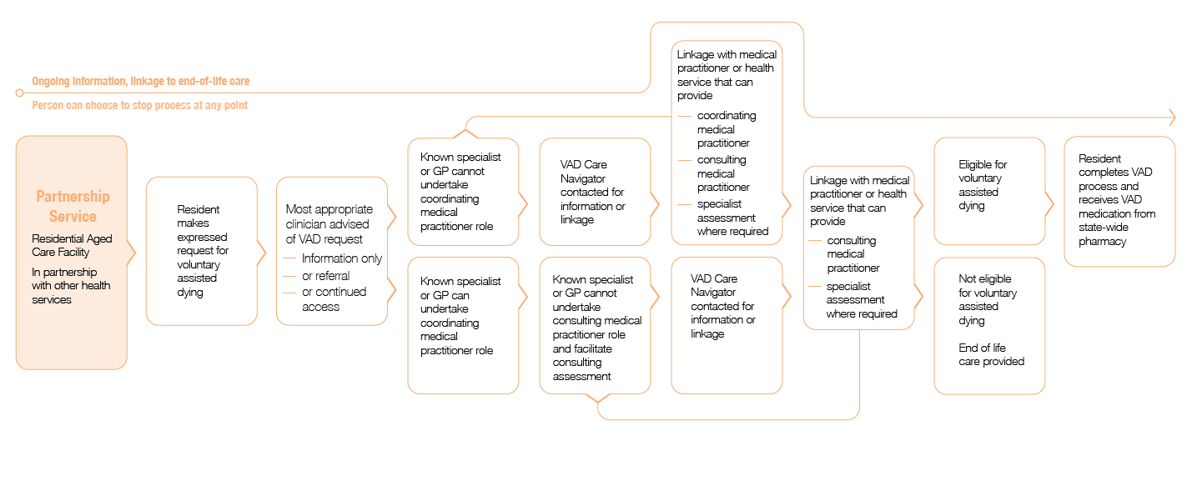

Aged care service providers following Pathway B may support and facilitate the request and assessment process but will need to establish the level of participation of the treating general practitioner (GP) before a partnership is established.
A person may seek information or assistance from any medical practitioner or health practitioner about voluntary assisted dying. It is possible that the person may not have a medical practitioner who is willing or able to undertake the role of the coordinating medical practitioner. If the person’s treating medical practitioner is not willing or able to be their coordinating medical practitioner, they may seek a referral to another medical practitioner. If a willing and able medical practitioner cannot be identified, the person can contact the voluntary assisted dying care navigator service.
At least one of the assessing medical practitioners must have relevant expertise and experience in the disease, illness or medical condition expected to cause the person’s death. This means that at least one of the medical practitioners must be a specialist in the person’s medical condition.

Pathway C: Information and support service

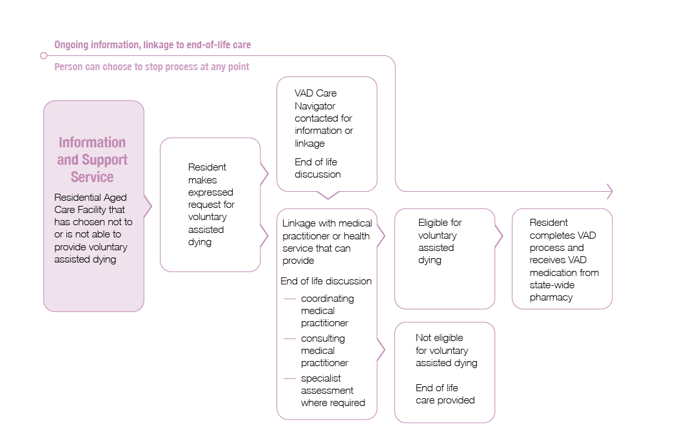

Aged care service providers that have chosen not to, or are unable to, provide voluntary assisted dying will most likely implement Pathway C. These providers will be able to provide information and/or referrals for people who want to request access to voluntary assisted dying and continue to provide care and support to these people.
People who make an enquiry about voluntary assisted dying can be referred outside the service to coordinating and consulting medical practitioners.
Even if an aged care service provider decides that it is not able to participate in the voluntary assisted dying request and assessment process, it may be able to support the person once they are in possession of the voluntary assisted dying medication and have made the decision to take it. This should be discussed with the person and their coordinating medical practitioner.

Planning for implementation
Once a pathway has been selected, the aged care service provider can start developing their organisational approach for the provision of voluntary assisted dying. This may include:
- developing a readiness checklist to guide the service through the key steps
- developing a survey for staff
- establishing an organisational position statement to ensure all staff and volunteers:
  - understand the local response to voluntary assisted dying; and
  - update policies, charters and values statements (where necessary)
- developing a procedure for responding to a request and effective referral for voluntary assisted dying
- aligning voluntary assisted dying legislative requirements with the Aged Care Quality Standards.
A range of resources are available to support aged care providers plan for implementation. These resources can be accessed on the Department of Health and Human Services’ end-of-life care website at: https://www2.health.vic.gov.au/hospitals-and-health-services/patient-care/end-of-life-care/voluntary-assisted-dying/health-practitioners.

Voluntary assisted dying medication
If an aged care service provider is concerned about a person taking the voluntary assisted dying medication at a residential aged care service, staff may meet with the person to discuss the concerns, and potential alternatives that are respectful of the person’s individual circumstances and the organisation’s needs. This may include discussions and exploration of the following alternatives:
- the person may be able to go to a carer’s, family member or friend’s home when they plan to take the voluntary assisted dying medication
- the person may remain at the service and consider an external referral for a health service/provider to provide additional care provision in relation to voluntary assisted dying.
Further discussions with the person’s coordinating medical practitioner or a voluntary assisted dying care navigator may be helpful in exploring other avenues.
If the person loses the ability to self-administer or digest the voluntary assisted dying medication, the person must contact their coordinating medical practitioner to request practitioner administration. If the voluntary assisted dying medication for self-administration has already been dispensed to the person it must be returned to the statewide pharmacy service before a practitioner administration permit can be issued.

Staff education and support
The Voluntary Assisted Dying Act 2017 imposes specific obligations and restrictions on medical practitioners and other health practitioners, including a prohibition on initiating a discussion about voluntary assisted dying with a person to whom they are providing health services or professional care services.
Aged care service provider governance structures should ensure that the principles of the Act are:
- articulated to wider health care support staff, and
- reflected in their scope of practice.
Health practitioners and other health service providers that are not regulated by the Australian Health Practitioner Regulation Agency must adhere to the Victorian Code of Conduct for General Health Services and should also adopt their professional body and organisational codes of conduct when delivering care.
Aged care service providers should establish a strategy to educate health practitioners and other staff in relation (but not limited to):
- the provider’s position regarding voluntary assisted dying
- an identified escalation process for receiving information, responding to a request and effective referral
- the workforce implications and competency, experience and expertise
- updating existing guidelines, policies and procedures to include voluntary assisted dying legalisation and processes
- documentation requirements of any interaction regarding voluntary assisted dying in the person’s medical record
- data collection and reporting structures.

Contact information
The voluntary assisted dying care navigators can be contacted for linkages to participating health services or medical practitioners and for further information on voluntary assisted dying.
Email <vadcarenavigator@petermac.org>

