Evaluation of TACO swing tag awareness campaign
OPTIONAL
Health services have requested an evaluation template of the swing tag campaign.
This process will assist your health service to meet Standard 7 (2nd edition) by demonstrating quality improvement systems have occurred.
Although Blood Matters will not be formally evaluating the impact within your health service it is strongly encouraged that the individual services complete the evaluation.
It is suggested that the evaluation process be discussed at your local Transfusion/Blood Management Committee or equivalent on how best to disseminate the forms, collect data and collate the summary report.
It would be greatly appreciated that any completed evaluation summary reports be forwarded to Blood Matters for our records by Wednesday, 28 February 2018.
A sample template is attached for your use. This document is currently set with “restricted editing” to allow for the data entry, which automatically calculates the percentages. The document can be easily edited by going to the “Review” tab and “Restrict Editing”. There is no password.

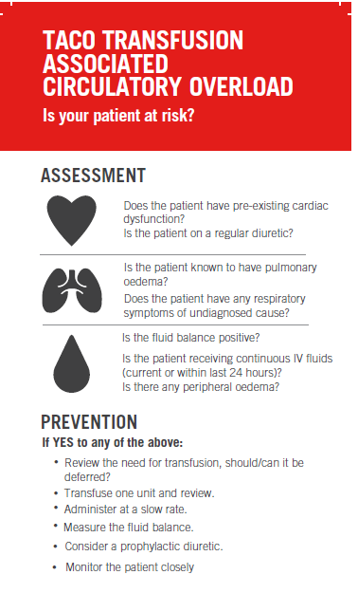
TACO awareness campaign
Summary Report
As part of the Blood Matters program to raise awareness of transfusion associated circulatory overload (TACO), our health service took part in the TACO awareness campaign. Swing tags were provided by Blood Matters to attach to units of red cells as issued to patients from the laboratory/blood bank. In addition posters were provided to display in clinical areas and at blood fridges. The swing tags and posters provided education to assist clinical staff to recognise patients at risk of TACO and what to do to prevent and treat.
TACO is the most common cause of death and major morbidity due to transfusion and is potentially avoidable. The 2016 Annual Serious Hazards of Transfusion (SHOT) report found TACO contributed to 14 deaths and 18 cases of major morbidity in the reporting period. The NBA Australian Haemovigilance Report (2016) has expressed concern that the TACO events in Australia may be under-reported. Due to the voluntary nature of the haemovigilance program, it is difficult to know if this is due to not being recognised or due to not reporting.
The aim of the campaign was to raise the awareness of TACO – identifying at-risk patients, how to prevent, what to monitor, and how to treat.

Health Service Code
TACO awareness month/s
Date evaluation collected
Approx. swing tags attached
Total responses from staff
Demographics | Medical  Nurse  Scientist  Other

Our Health Service Recommendations

Question | Yes response
Were you aware of the recent TACO awareness campaign
Did you notice any TACO awareness campaign tools
- TACO swing tags
- TACO posters
- Information at blood fridge

If yes to noticing the TACO swing tags and/or posters, please rate the following:
 | Strongly  agree | agree | disagree | strongly disagree
The layout was easy to follow
The language was easy to understand
The tools will guide my future decision making
Staff would be able to use these tools with minimal training & support

Impact of TACO swing tags and/or posters on practice | Number of respondents agreeing (%)
I feel confident in assessing if a patient may be at high risk for TACO
I learnt something new
This information confirmed I did (am doing) the right thing
I am motivated to learn more
I am reassured
I am reminded of something I already knew
My practice is (will be) changed and improved
I am dissatisfied
There is a problem with this information
I disagree with the content of this information
I think the information is potentially harmful

How frequently are you involved in the issue/distribution/administration of blood
  - More than once a week
  - About once a week
  - About once a month
  - Less than once a month

How frequently do you see/treat a patient experiencing TACO
  - More than once a month
  - About once every 6 months
  - About once a year
  - Less than once a year

Summary responses of comments on the strengths, limitations and overall perception of the use of this tool

