
Specialist clinics service improvement guide

Specialist clinics service improvement guide

If you would like to receive this publication in an accessible format, please phone 1300 253 942 using the National Relay Service 13 36 77 if required, or email: enquiries@health.vic.gov.au
© Copyright, State of Victoria, Department of Health, 2013
Published by the Health Service Programs Branch, Victorian Government, Department of Health, Melbourne, Victoria. This publication is copyright, no part may be reproduced by any process except in accordance with the provisions of the Copyright Act 1968.
This document is on the internet at: www.health.vic.gov.au/outpatients
Authorised and published by the State Government of Victoria, 50 Lonsdale Street, Melbourne.
May 2013

Contents
Acknowledgements 1
Introduction 2
Section 1: Process redesign in specialist clinics 3
1.1 Process mapping and flow modelling 4
1.2 Measuring process redesign in specialist clinics 7
1.3 Managing change 9
1.4 Process redesign examples in Victorian specialist clinics 10
Barwon Health – orthopaedic clinic reform 11
Barwon Health – redesigning specialist clinics 12
Northern Health – redesign of outpatient diabetes services 13
Section 2: Improving clinic processes 15
2.1 Referral management 15
2.2 Triage and clinical prioritisation 23
2.3 Waiting list management 26
2.4. Appointment scheduling and booking 28
2.5 Care pathways 36
2.6 Discharge practice 39
2.8 Information and communication technology 51
2.9 Workforce innovation 53
Section 3: Letter templates 58
References 88

Acknowledgements
The Specialist clinics service improvement guide has been developed by the Department of Health in collaboration with the Specialist Clinics Advisory Committee and the Specialist Clinics Nurse Unit Managers Benchmarking Group. Members of the advisory committee and the benchmarking group are listed on the Specialist Clinics Program website at www.health.vic.gov.au/outpatients. The department acknowledges the contribution of health services that have undertaken specialist clinics redesign work.
Particular acknowledgment is made to the Welsh National Leadership Agency for Health Care. Some content from the publication A guide to good practice: elective services (2005) has been incorporated into this guide. Some content is also adapted from material developed by the United Kingdom’s National Health Service (NHS) Institute for Innovation and Improvement. The institute has published extensively on the challenges faced by planned, non-emergency services in public hospitals, and has developed a suite of tools and resources for improving the quality and productivity of these services.
Introduction
Specialist clinics in Victoria’s public hospitals deliver planned services to non-emergency, non-admitted patients. They provide medical, obstetric and surgical assessment and treatment, as well as a range of specialised nursing and allied health services. Specialist clinics provide an interface between primary care (general practitioners (GPs) and community-based health services) and other parts of the health service. Public hospital specialist clinics are a major part of the healthcare system, delivering more than two million appointments to Victorians each year.
Specialist clinics have experienced strong growth in demand, driven by factors such as an ageing population, an increasing burden of chronic disease, reducing inpatient length of stay (and consequent increase in patient acuity) and rising community expectations.
In 2013 the Department of Health published Specialist clinics in Victorian public hospitals: access policy. The access policy outlines the department’s expectations of specialist clinic service delivery, including indicative timeframes for completing key processes. The access policy is available at www.health.vic.gov.au/outpatients
This Specialist clinics service improvement guide is a companion document to the access policy. It contains information, templates, ‘real-world’ examples of good practice and resources to assist health services to undertake successful redesign work in the specialist clinics environment, as well as meet the requirements and principles of the access policy.
The service improvement guide consists of three main sections:
Section 1: Process redesign in specialist clinics
Outlines key process redesign concepts for reviewing current service provision and implementing improvement initiatives. This section provides example measures for health services to consider when undertaking redesign activities, as well as some examples of redesign projects undertaken.
Section 2: Improving clinic processes
Discusses opportunities for improving particular specialist clinic processes at key stages of the care pathway. For each stage the following are presented:
- key messages from a literature review and consultation with service providers
- strategies to improve service delivery related to that stage
- examples of good practice.
Section 3: Letter templates
This section provides letter templates and other example documents to support key clinic processes and communication.

Section 1: Process redesign in specialist clinics
Victoria’s public hospital specialist clinic services offer high standards of care, but there are well recognised opportunities to improve service delivery. To realise these opportunities, health services may consider undertaking process redesign. Many health services have redesign teams available to assist with process redesign activities. Process redesign is a formal approach to mapping, reviewing and redesigning the patient journey to maximise safety, effectiveness and efficiency of care. The key principles of redesign in healthcare are:
- the centrality of the consumer – adopt the patient’s eye view
- describe and redesign work processes
- measure components of the process
- recognise the expertise of the people who work on the frontline.
Commonly used process redesign methodologies are Lean Thinking, Six Sigma, Lean Six Sigma and the Theory of Constraints. Each methodology differs in theory, application, principles and focus.
The Department of Health’s Redesigning Hospital Care Program (RHCP) is a statewide initiative delivering significant health system improvements by applying process redesign methodologies in Victorian public hospitals. The RHCP website provides numerous resources relating to process redesign (see www.health.vic.gov.au/redesigningcare ).
Redesigning Hospital Care Program – an introduction to process redesign (Department of Health 2012) (available at www.health.vic.gov.au/redesigningcare ) provides an overview of process redesign. It is a useful resource for specialist clinics considering redesign and covers:
- key principles of process redesign
- redesign approaches
- phases of the redesign process
- defining the scope of work
- diagnosing the issues
- developing appropriate interventions
- evaluating the outcomes
- sustaining the improvement
- change management
- project management
- measurement for improvement.

Additional information is provided below relating to process mapping, flow modelling (as part of ‘diagnosing the issues’) and ‘measurement for improvement’ to assist health services considering, or in the initial stages of, a redesign project in specialist clinics.

1.1 Process mapping and flow modelling
Process mapping
Process mapping creates a map of each administrative and clerical stage of a patient’s journey through a specialist clinic. It can identify delays, unnecessary steps, waste, duplication of effort, illogical steps and common bottlenecks or constraints. Involving clinical, clerical and support staff from all relevant departments in process mapping will result in a more comprehensive map. An example process map for specialist clinics is shown in Figure 1.
A constraint is a factor that ultimately restricts the capacity of the system, for example, the number of consulting rooms, availability of medical specialists and availability of nursing staff skilled in particular procedures. Once identified, strategies can be implemented to remove the constraint or minimise the impact on service delivery. Often constraints are not easily removed without substantial investment in staffing or facilities.
By comparison, bottlenecks limit specialist clinic activity. Examples of bottlenecks in specialist clinics are delayed appointment bookings while triage staff are on leave and delayed clinic activity due to patients waiting to have investigations before their appointment. Often, resolving bottlenecks do not require the investment that resolving constraints can require.

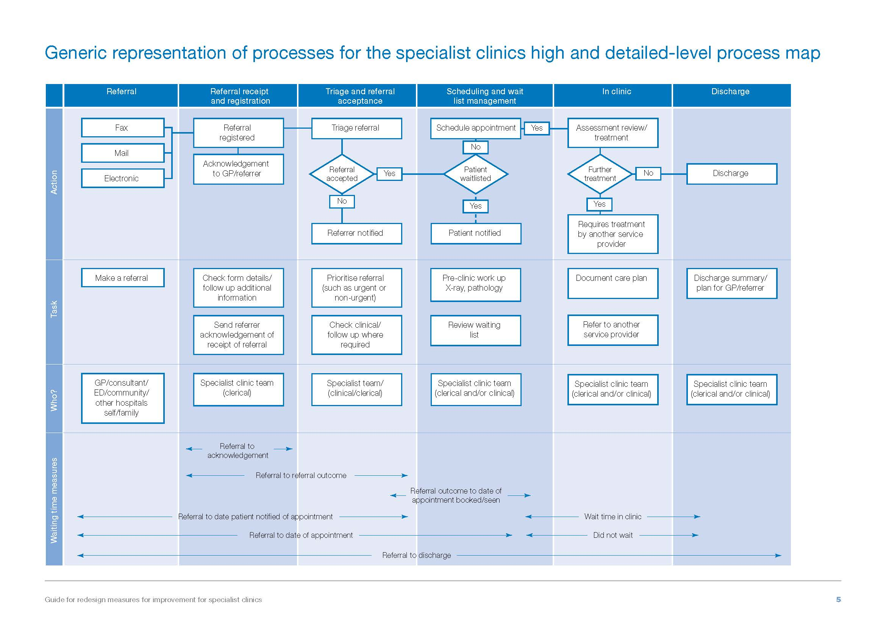
Figure 1: Example process map for specialist clinics
Flow modelling
Flow modelling builds on process mapping to analyse constraints and bottlenecks from the perspective of the service. Flow modelling enables work to be scheduled around identified constraints to maximise efficiency and increase capacity within existing resources. An example of flow modelling in specialist clinics is time-stamping the beginning and end of each step in the pathway to determine the duration of each step. A time-stamping example for a sample clinic of 10 patients with appointments scheduled 15 minutes apart is shown in Tables 1 and 2 and Figure 2.
Table 1: Time stamps
Patient | Patient  arrival | Scheduled appointment | Registration complete | Imaging starts | Imaging complete | Consultation starts | Consultation complete | Check out complete
1 | 08:22 | 08:30 | 08:35 | 08:35 | 08:48 | 08:48 | 09:20 | 09:26
2 | 08:29 | 08:45 | 08:53 | 08:53 | 09:13 | 09:20 | 09:34 | 09:42
3 | 08:34 | 09:00 | 09:09 | 09:13 | 09:39 | 09:39 | 10:04 | 10:09
4 | 09:01 | 09:15 | 09:23 | 09:39 | 09:53 | 10:04 | 10:28 | 10:32
5 | 09:19 | 09:30 | 09:41 | 09:53 | 10:09 | 10:28 | 10:47 | 10:56
6 | 09:19 | 09:45 | 09:55 | 10:09 | 10:19 | 10:47 | 11:03 | 11:10
7 | 09:46 | 10:00 | 10:11 | 10:19 | 10:36 | 11:03 | 11:26 | 11:31
8 | 10:02 | 10:15 | 10:20 | 10:36 | 10:46 | 11:26 | 11:47 | 11:57
9 | 10:26 | 10:30 | 10:39 | 10:46 | 10:58 | 11:47 | 11:56 | 12:03
10 | 10:28 | 10:45 | 10:55 | 10:58 | 11:18 | 11:56 | 12:08 | 12:14

Table 2: Process step durations (minutes)
Patient | Patient  arrival | Wait for registration | Registration | Wait for imaging | Medical imaging | Wait for consultation | Consultation | Check out
1 | 08:22 | 00:08 | 00:05 | 00:00 | 00:13 | 00:00 | 00:23 | 00:10
2 | 08:29 | 00:16 | 00:08 | 00:00 | 00:20 | 00:07 | 00:14 | 00:08
3 | 08:34 | 00:26 | 00:09 | 00:04 | 00:26 | 00:00 | 00:25 | 00:05
4 | 09:01 | 00:14 | 00:08 | 00:16 | 00:14 | 00:11 | 00:24 | 00:04
5 | 09:19 | 00:11 | 00:11 | 00:12 | 00:16 | 00:19 | 00:19 | 00:09
6 | 09:19 | 00:26 | 00:10 | 00:14 | 00:10 | 00:28 | 00:16 | 00:07
7 | 09:46 | 00:14 | 00:11 | 00:08 | 00:17 | 00:27 | 00:23 | 00:05
8 | 10:02 | 00:13 | 00:05 | 00:16 | 00:10 | 00:40 | 00:21 | 00:10
9 | 10:26 | 00:04 | 00:09 | 00:07 | 00:12 | 00:49 | 00:09 | 00:07
10 | 10:28 | 00:17 | 00:10 | 00:03 | 00:20 | 00:38 | 00:12 | 00:06

Figure 2: Graphical representation of Tables 1 and 2 (white bars indicate periods when patients are waiting)
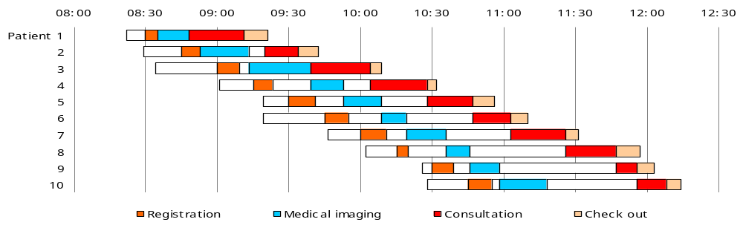

1.2 Measuring process redesign in specialist clinics
Measuring the impact of change is an essential step in service improvement. Measures can be used to identify and prioritise areas for improvement, to develop a baseline against which to measure change, and to demonstrate the impact of improvement initiatives. The choice of measures will depend on the focus of the redesign activity and the overall aims and priorities of the service.

Redesigning Hospital Care Program – guide to redesign measures for improvement for specialist clinics

Redesigning Hospital Care Program – guide to redesign measures for improvement for specialist clinics (Department of Health 2013) is an RHCP publication that provides information about measurement in specialist clinics process redesign including:
- why measurement is important
- different types of measures
- presentation of data
- example measures specific to specialist clinics redesign.
The example measures provided in the guide are neither prescriptive nor exhaustive. Health services are encouraged to consider measures most relevant to particular design projects, and adapt the example measures or create new measures as appropriate. The guide is available at <www.health.vic.gov.au/redesigningcare> and www.health.vic.gov.au/outpatients>.

A guide to using data for health care quality improvement (Department of Health 2008a) (available at www.health.vic.gov.au/qualitycouncil ) is another useful resource when planning how to measure process redesign. It describes the fundamental concepts associated with data collection, analysis, interpretation and reporting, and how these relate to the various stages of the quality improvement cycle.

Table 3 is a reproduction of the key specialist clinic processes and associated timeframes as outlined in the access policy.

Table 3: Key specialist clinic processes and timeframes
Process | Timeframe
Referral screening (identifies referrals that are in the wrong place or missing required information, and therefore contact with referrers if necessary) | Within three working days of referral receipt
Closure of referrals pending further information and reconsideration (where the referral is retained by the health service) | Within 30 days of requesting additional referral information, where the referrer has not responded
Referral acceptance/rejection | Within five working days of receiving a referral containing necessary referral information
Referral acknowledgement  The referral acknowledgment conveys information to the referrer about the referral outcome (for example, acceptance or rejection) or requests additional information | Within eight working days of referral receipt
Clinical prioritisation | Within five working days of receipt of referral containing necessary referral information
Addition to waiting list, offer to book appointment or scheduling of urgent appointment | Within three working days of referral acceptance and clinical prioritisation
First appointment for urgent patients | Within 30 days of referral receipt
Patient notification of new appointment date where health service has cancelled scheduled appointment | Within five working days of cancellation
Communication with referrer about the findings of initial assessment/treatment* | Within five working days of completed initial assessment/treatment
Discharge summary sent to referrer and/or other provider* | Within five working days of discharge from the clinic
* The access policy outlines circumstances in which discretion may be applied to these requirements.
1.3 Managing change
Significant information has been published on organisational change management. One well-established change model was developed by John Kotter (2007). Kotter’s model describes eight critical success factors for leading ‘transformational’ change:

- establishing a sense of urgency
- forming a powerful guiding coalition
- creating a vision
- communicating the vision
- empowering others to act on the vision
- planning for and creating short-term wins
- consolidating improvements and producing still more change
- institutionalising new approaches.

Within Kotter’s model, the change process goes through a series of phases that often requires a considerable length of time; however, skipping steps rarely produces a satisfactory result.

Engagement and motivation
The uncertainty of change can provoke strong emotional responses in staff. The introduction of change in the specialist clinics environment should include anticipation of resistance and therefore strategies to acknowledge and respond to concerns. Effective staff engagement underpins each of Kotter’s steps and is fundamental to all models of organisational change.
It is particularly important that health services engage clinicians in change processes as clinicians make decisions that determine the quality and efficiency of care for individual patients, and also have the knowledge to help guide overall approaches to service delivery. Research in the United Kingdom (UK) and the United States has shown that higher levels of clinician engagement are associated with better financial, operational and clinical performance outcomes (Mountford & Webb 2009; Silow-Carrol & Lashbrook 2009).
Health services are expected to create cultures that encourage clinician input into policy, procedures and the management of resources. The Victorian clinical governance policy framework (Department of Human Services 2008b) (available at www.health.vic.gov.au/clinrisk ) promotes a stronger role and capacity for clinical leadership in quality and safety and related activities such as staff supervision, professional development and credentialing. To support clinical engagement within health services, the department’s Statewide Quality Branch developed the Clinical Engagement Program. Details are available at www.health.vic.gov.au/clinicalengagement .
Communication
Clear channels of communication that convey vision and encourage staff engagement are essential to implementing change. Early consultation will prepare staff to participate in the change process, and encourage ownership of the project.
Communicating the evaluation of a change initiative is often essential to sustaining change. It is important to communicate successes, as well as failures and lessons learnt.
Continuous improvement
In addition to large, discrete improvement projects, smaller ongoing continuous improvement activities are also important to ensure delivery of high-quality specialist clinics services. The Plan, Do, Study, Act model promotes change as a normal and continuous process. Small changes are often more acceptable to staff and patients, and less disruptive to clinic operations than major redesign programs.
Engaging staff in generating ideas and piloting a new approach before it is fully embedded will reduce the barriers to change. Further information on the Plan, Do, Study, Act model can be found at the Australian Resource Centre for Healthcare Innovations website at www.archi.net.au/home .
1.4 Process redesign examples in Victorian specialist clinics
Department of Health – Specialist Clinics Redesign Demonstration Project
In 2009–10 the department funded the Specialist Clinics Redesign Demonstration Project as part of the RHCP. This was undertaken across four speciality areas (maternity, orthopaedics, gastroenterology and urology) at three health services.
The project interventions were:
- load levelling of referral management
- reallocation of clerical work to ensure new referrals were processed within three days of receipt
- collection of demand data to determine the resources required
- redesign of processes to promote flow
- assessment of first-time quality of referrals
- template alignment with actual start time
- alignment of the booking template with medical staff start time
- communication hub (visual management system)
- a whiteboard detailing clinic activity, team members, relevant changes or concerns, clinician arrival and departure times
- clinic kickstart
- short team meetings at the beginning of the clinic at the communication hub
- activity report
- a weekly report posted in a communication hub to show key metrics including planned capacity, actual capacity, activity and failure to attend (FTA) rates.

The project findings were:
- One site reduced referral receipting time from up to 120 days to less than three days.
- The number of patients seen within one hour of their appointment increased from 38 per cent to 71 per cent in one clinic.
- Although additional capacity existed within current resources, utilisation would require a significant change to current work processes.
- Redesign within specialist clinics is a significant task with unique complexities and challenges.
- The scope of a large redesign initiative should be defined after initial diagnostics are complete.
- Recruiting a stable internal team with sufficient redesign knowledge and capability, as well as adequate representation from the range of relevant work areas, is an important enabler of redesign work.
Figure 3 outlines a model for redesign projects in specialist clinics developed as part of the Specialist Clinics Redesign Demonstration Project. This model focuses on the steps and phases of redesign, rather than the specific changes to be implemented.

Figure 3: Model for redesign projects in specialist clinics
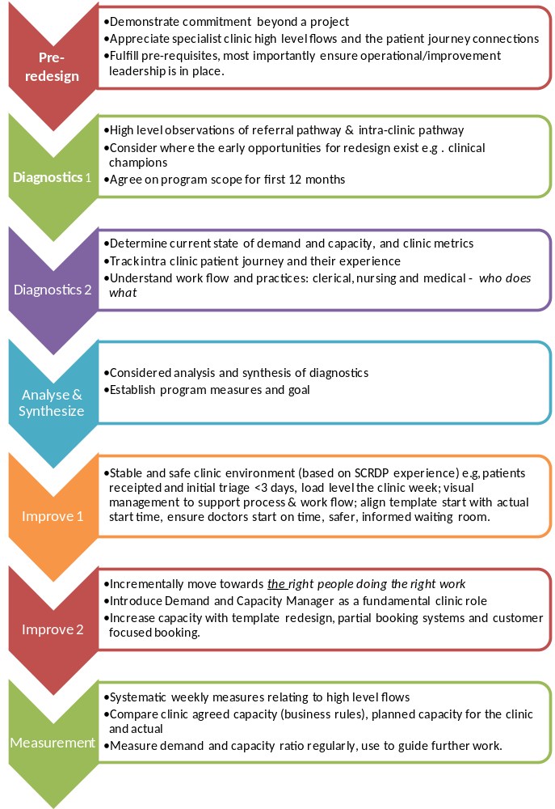

Barwon Health – orthopaedic clinic reform
From 2005 Barwon Health undertook a series of reforms to its orthopaedic outpatient service to address the following issues: an increasing number of referrals, inefficient referral management and triage, long waiting times for non-urgent appointments, high rates of patients failing to attend their appointments and poor utilisation of conservative therapies before referral to a surgeon. Numerous improvement strategies were implemented including:
- an audit of waiting lists for first appointments to identify patients who did not need to be on the list (this resulted in 273 (24 per cent) of the 1,100 waiting patients being removed from the list)
- physiotherapy-led clinics and an orthopaedic lead nurse role
- adherence to a policy for managing patients who failed to attend their appointments
- development of triage guidelines to allow new referrals to be triaged by more junior clinicians
- introduction of a patient-focused appointment booking system, resulting in a reduction in FTA rates from 18 per cent to 7.9 per cent in surgeons’ clinics, and from 30 per cent to 7.4 per cent in physiotherapy-led clinics
- appointment of an additional orthopaedic surgeon.
Together these initiatives resulted in a 66 per cent reduction in waiting list numbers by mid-2011. There was also an 87 per cent reduction in waiting times from referral to first appointment over the same period.
Figure 4: Orthopaedic clinic patient numbers, 2004–05 to 2010–11

Initial waiting list audit
Hip and Knee Service physiotherapy-led clinic established
Patient-focused bookings introduced
Orthopaedic Access Service physiotherapy-led clinics made permanent

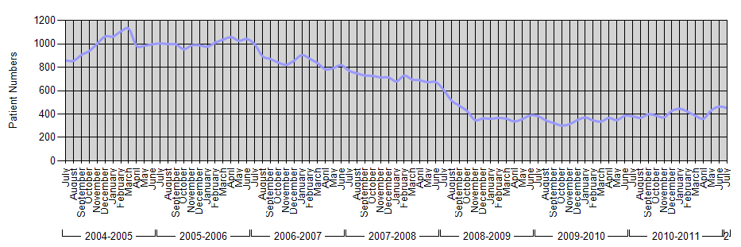
Additional orthopaedic surgeon commences
Did not attend policy introduced

Barwon Health – redesigning specialist clinics
In November 2011 Barwon Health began a program of work to transform its delivery of specialist clinics in partnership with primary healthcare providers and consumers. While there appeared to be a mismatch between the demand for specialist care and the activity undertaken by specialist clinics, there was limited knowledge about the true demand, capacity and activity across public and private clinics. The absence of a consistent data collection and reporting mechanism was a key barrier to developing a shared understanding of specialist clinic work and defining clear goals for service improvement.
A comprehensive analysis of all medical and surgical specialist clinics was undertaken. It was agreed that effective stakeholder engagement, along with a rigorous data collection, would enable Barwon Health to better align the provision of specialist services with the needs of the community. Four key focus areas for improvement were identified: access, capacity, operating structure and data reporting.
A number of related performance measures were selected to monitor the success of improvement work:

- number of patients added to the waiting list
- number of new patients seen
- number of new patients on the waiting list
- ratio of new to review appointments
- ratio of attendances to FTAs
- ratio of referrals added to referrals closed
- waiting time from referral received to first appointment.

A range of ‘check’ measures were also chosen including:
- waiting list movement
- number of patients with an urgent referral who waited longer than 30 days for their first appointment.
Specific improvement initiatives identified as part of the redesign program include:
- a sophisticated information and communication (ICT) technology infrastructure (including an electronic queue management system) to support the core business of specialist clinics
- enhanced communication including revised patient correspondence templates, short message service (SMS) reminders for review appointments and using social media where appropriate
- care pathways, to be developed in collaboration with GPs, to promote a seamless transition of care on referral and discharge.
Each improvement initiative described above will be led by a member of the health service executive and supported by dedicated project resources.

Northern Health – redesign of outpatient diabetes services
Key drivers for quality improvement and service redesign at Northern Health’s outpatient diabetes services included long waiting times and high levels of FTA rates for both new and review appointments. Also, patients were frequently unaware of the rationale for the referral and not sure what to expect.
Northern Health adopted a Lean Six Sigma methodology, with the aim of delivering more timely access to specialist diabetes care. The program of work involved a multifaceted approach, including developing referral triage processes to ensure patients with the greatest clinical need were seen in an appropriate timeframe by the clinician with the most appropriate skill set.
At the outset of the project all referred patients were waitlisted to see an endocrinologist. This led to long delays to access first appointments with the diabetes service. Based on evidence that interventions led by nurses and allied health professionals, along with changes to the structure of care, can improve diabetes outcomes in outpatient settings, Northern Health redesigned its intake process so that, at the completion of the trial, only 42 per cent of all patients needed referral to the endocrinologist before hospital-based care could begin. This care was able to be delivered by other suitably qualified health professionals working closely with the patients’ GPs.

