safe

|  |
| --- |
| Using SafeScript - most commonly asked questions  For prescribers and pharmacists |
| May 2020 |

Most commonly asked questions from prescribers and pharmacists

#### I can’t find a patient on SafeScript, but I know that I hold a permit/this patient has had a monitored medicine dispensed recently?

The best way to search for patients is to type the **first 3 letters** of the patient’s first name and surname with the date of birth. This will ensure all potential matches are visible and to reduce the possibility that variable spelling might affect the search. You will need to open and view each possible match to obtain the complete history of the patient.

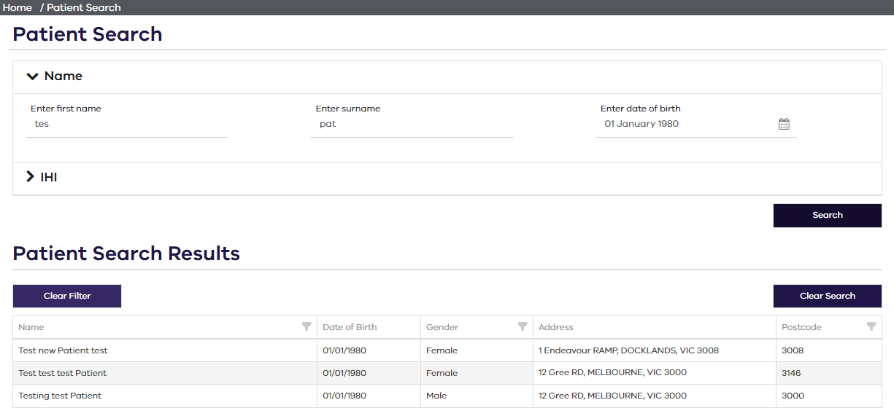

Some patients are using slight variations of their names and different dates-of-birth (as well as completely false identities) in order to conceal the extent of their use of monitored drugs.

Prescribers are reminded of their regulatory responsibility (to take all reasonable steps to confirm a person’s identity) by carefully checking the name and date-of-birth plus photo-identification before issuing a prescription for a drug of dependence for any person who has not previously established their bona fides at the clinic.

#### I have applied for a permit a while ago but have not received any response, how do I know if it’s been approved?

To check the status of your permit application(s), please visit the SafeScript portal at [www.safescript.vic.gov.au](http://www.safescript.vic.gov.au). Once logged into the SafeScript portal, select **Permits** from the navigation menu. The Permits screen lists all your permits and permit applications in SafeScript.

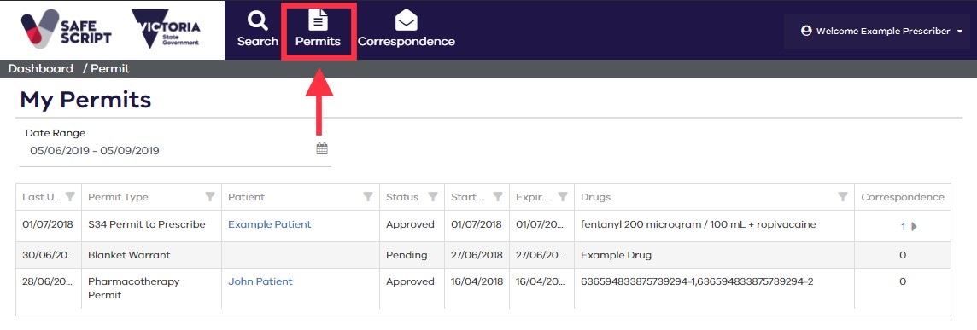The status of each permit is shown as *Active* (permit has been issued), *Inactive* (permit has not been issued or has expired) or *Pending* (application being processed).

**Alternatively**, you can find the permit status for a specific patient in the relevant patient profile by clicking the “Permits” tab in the “Patient Details” screen.

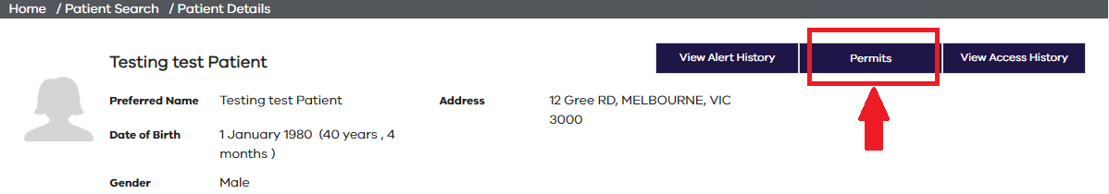

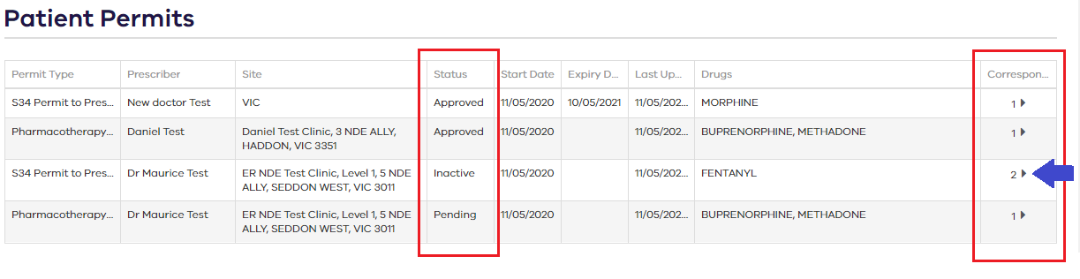

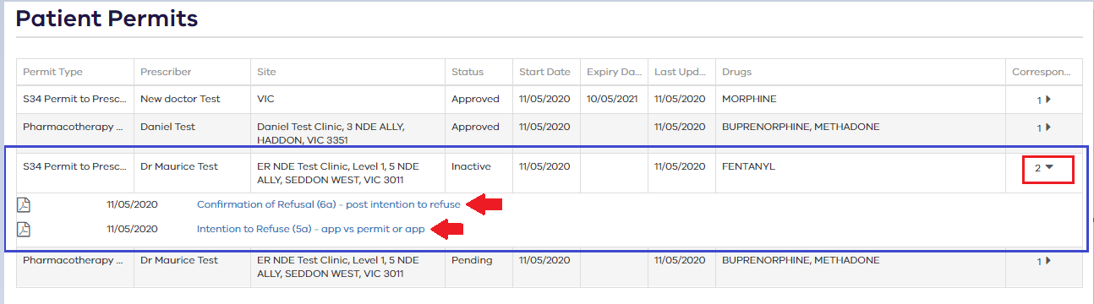Correspondence can be accessed from the Permits screen, or alternatively by selecting **Correspondence** from the navigation menu (see next page).

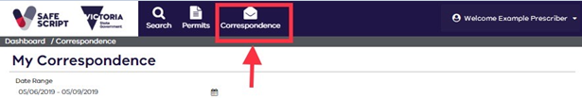

Prescribers are currently not required to hold a permit when treating non-drug dependent patients with Schedule 8 medications during the COVID-19 pandemic under a Public Health Emergency Order (PHEO #3). This Order came into effect in Victoria on the 26th of March 2020 and continues to be in force until midnight 27th September 2020, unless earlier revoked or amended.

Medicines and Poisons Regulation will not be processing any Schedule 8 permit applications for non-drug dependent patients during the public health emergency order. If you have reason to believe your patient to be drug dependent and therefore still require a permit, please resubmit your application and indicate this clearly on it so that the application will be processed.

For details on all permit requirements, please visit <https://www2.health.vic.gov.au/about/publications/policiesandguidelines/schedule-8-treatment-permits-requirements-vic>

#### There is a lot of information showing on SafeScript, what is the easiest way to access it?

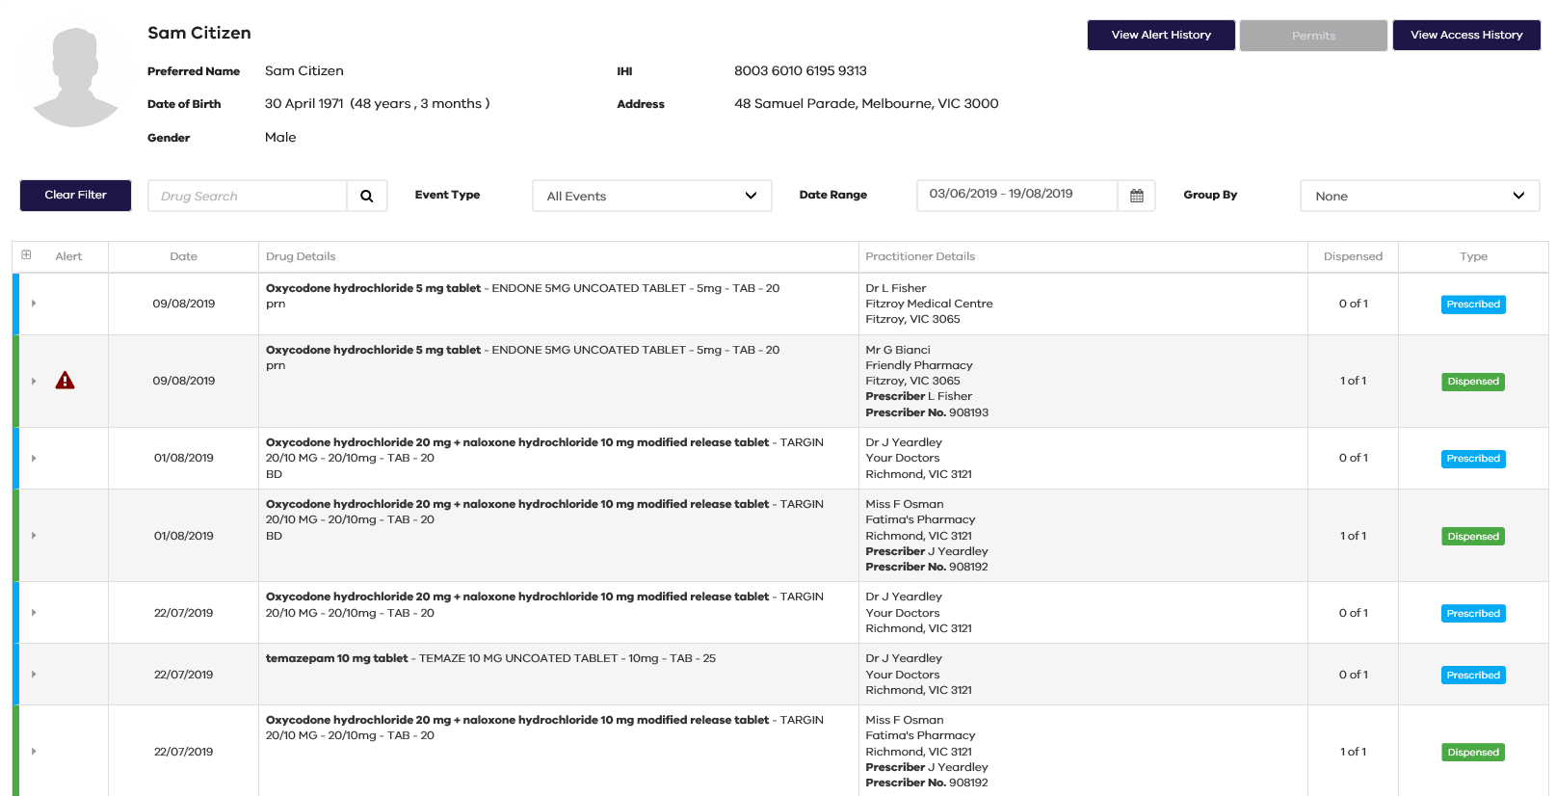The green and blue colour coding are there to help you identify whether it is a prescribing event or dispensing event. The green indicates a dispensing event and the blue indicates a prescribing event.

Clicking on a row with a blue margin will expand to show the prescriber details. Clicking on a row with a green margin will expand to show the pharmacy details.

Please note that only recording of dispensing events are mandatory, so you can save time by only looking at the dispensing events.

**Alternatively**, you can select the Event Type to “Dispense” or search for a specific drug in “Drug Search” to review the use of a particular monitored medication.

The Dispensed column indicates the number of supplies of a prescription, e.g. “3 of 6” means three supplies out of six total supplies have been dispensed already and there are three repeats remaining.

For more details on the information included in the patient profile and to learn how to filter and sort the listed events, please visit <https://help.safescript.vic.gov.au/help-topics/patients-medication-history.htm>

#### Can I prescribe for a patient when another doctor holds the permit?

The decision to prescribe is at the prescriber’s discretion based on clinical appropriateness and patient safety. SafeScript will provide real time information on recent supplies of monitored medicines to your patients as well as Schedule 8 permit information. Where SafeScript identifies concurrent or too-frequent supplies, especially on prescriptions from different prescribers, issuing a prescription may be difficult to justify for any more than a minimal quantity without repeats.

It is your responsibility to coordinate treatment with other prescribers and/or permit holder(s) identified on SafeScript. Good communication between prescribers ensures coordination of safe treatment and minimises the risk of a patient inadvertently receiving concurrent treatment by multiple prescribers.

#### I have found more than one SafeScript record for my patient. What should I do?

Duplicate profiles may occur when the same patient details (Name, Date of Birth, Medicare or IHI) are entered differently by different prescribers and pharmacists. If you identify multiple profiles for the same patient, please contact SafeScript IT support on 1800 723 379 or email [it.safescript@dhhs.vic.gov.au](mailto:it.safescript@dhhs.vic.gov.au) so that records can be merged.

#### Why isn’t the prescription I wrote appearing on SafeScript?

The data required for SafeScript is collected automatically from the Prescription Exchange Services (PES) which currently support the electronic transfer of prescriptions from medical clinics to pharmacies.

When a prescription is issued at a medical clinic or dispensed at a pharmacy, the PES sends a record of the prescribing or dispensing of the prescription in real-time to SafeScript.

If you are unable to see one or more of your prescriptions in SafeScript, it is because your prescribing software is not connected to the PES or the prescription was handwritten. If this is the case, you will only be able to see your prescription when the pharmacy has dispensed the medicines you prescribed.

#### For further information on SafeScript please visit <https://www2.health.vic.gov.au/public-health/drugs-and-poisons/safescript> or email queries to [safescript@dhhs.vic.gov.au](mailto:safescript@dhhs.vic.gov.au)

|  |
| --- |
| To receive this publication in an accessible format phone 1300 364 545, using the National Relay Service 13 36 77 if required, or email [dpcs@dhhs.vic.gov.au](mailto:dpcs@dhhs.vic.gov.au)  Authorised and published by the Victorian Government, 1 Treasury Place, Melbourne.  © State of Victoria, Australia, Department of Health and Human Services May 2020. |