Preparing for voluntary assisted dying
Voluntary Assisted Dying Act 2017

On 29 November 2017, the Victorian Parliament passed the Voluntary Assisted Dying Act 2017 (the Act). From 19 June 2019, Victorians at the end of life who meet strict eligibility criteria will be able to request access to voluntary assisted dying.
All Victorian health services will need to be prepared for the commencement of the Act.
Whether or not your health service decides to provide voluntary assisted dying, you will need to develop appropriate responses for when a person using your service requests information about, or access to, voluntary assisted dying.
Making decisions about your health service’s role in, and response to, voluntary assisted dying is likely to be based on a number of factors including decisions at the Board and executive levels, the existing suite of services provided, the location and size of your service, and workforce capacity and willingness to participate.

The purpose of this document is to:
- assist health services to make decisions about their level of involvement in voluntary assisted dying; and
- provide a range of resources to assist health services to prepare for the commencement of the Act.

This document provides you with:
- a decision-making diagram that will help you consider your health service’s level of involvement in voluntary assisted dying;
- a health service readiness checklist to guide you through the key steps to prepare;
- a suite of sample survey questions for medical and health practitioners; and
- a PowerPoint presentation about the Voluntary Assisted Dying Act 2017 for education purposes.
Experience from other jurisdictions has shown the importance of engaging with and providing clear information and education about voluntary assisted dying to assist health practitioners to determine their level of participation.
In addition to the resources included here, further resources are being developed and will be available in early 2019. Stay updated with the resources being developed by the Voluntary Assisted Dying Implementation Taskforce by checking the webpage: https://www2.health.vic.gov.au/hospitals-and-health-services/patient-care/end-of-life-care/voluntary-assisted-dying.

Considering your health service’s level of involvement in voluntary assisted dying
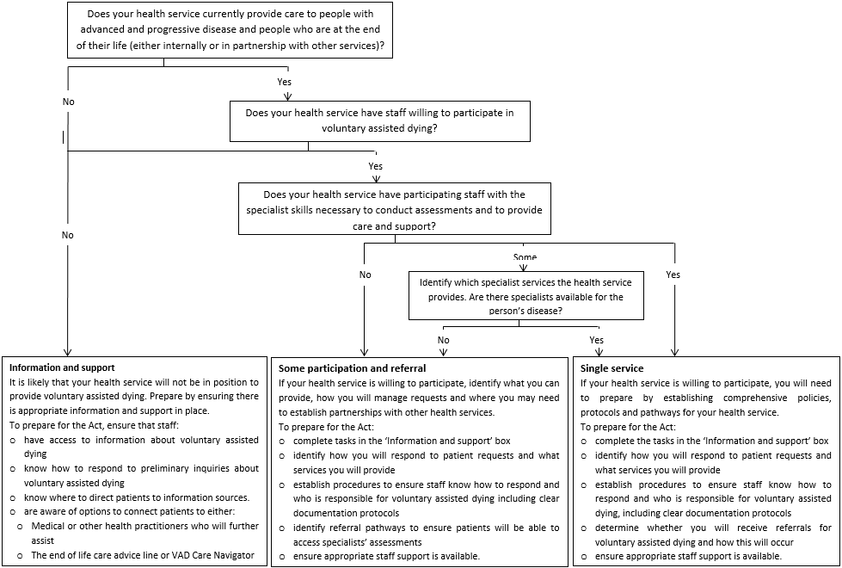

Health service readiness checklist
In the first instance, health services should start to consider how they will implement voluntary assisted dying by:
- Identifying clinicians and members of the executive to lead work on voluntary assisted dying.
- Considering the projects being undertaken by the Voluntary Assisted Dying Implementation Taskforce:
https://www2.health.vic.gov.au/hospitals-and-health-services/patient-care/end-of-life-care/voluntary-assisted-dying.
- Undertaking a mapping exercise to determine enablers, gaps and priority areas of change.

Priority area | Key task | Completed
Getting started | Establish a voluntary assisted dying implementation working group or steering committee. You may like to consider the following membership:  - executive  - clinical  - clinical governance/quality personnel  - VMO/general practitioner  - experienced consumer representative.
 | Identify appropriate staff members who can be supported to act as points of contact for voluntary assisted dying questions. Link them into the voluntary assisted dying team at the Department of Health and Human Services – endoflifecare@dhhs.vic.gov.au.
Communication and education | Develop a communication plan to organise and track education and communication activities. This may include provision of information through:  - newsletters  - intranet, internet and social media  - emails to staff  - staff education sessions, for example, Grand Round, Allied Health staff forum, nursing education calendar, ward based or team meetings, orientation, HMO/Registrar programs (the Department of Health and Human Services is available to support these sessions)  - engaging with staff through information and education sessions and surveys (see set of sample questions below).
Update or create policies, procedures and guidelines | Develop a new policy in relation to voluntary assisted dying, including a health service response and expected level of involvement. Consider:  - processes such as the provision of information, referrals, documentation, and communication  - availability of specialists  - other workforce considerations such as clinical (medical, nursing, allied health, pharmacy, spiritual care) and non-clinical (administration, volunteers, cleaners)  - physical environment such as place of care and storage of medication.
Update policies, procedures and guidelines relating to patient deterioration, limitations of treatment, and goals of care. For example:
- goals of patient care
- palliative care
- end of life care.
Update policies, procedures and guidelines relating to medical treatment decision making. For example:
- assessment of decision-making capacity
- clinical ethical dilemmas
- patient rights and responsibilities.
Update policies, procedures and guidelines relating to care of the deceased. For example:
- death verification
- death certification requirements
- notification to the Coroner.
Identify and prepare documentation requirements for voluntary assisted dying | Become familiar with the range of forms (set out in the Schedule to the Act) that will need to be reported to the Voluntary Assisted Dying Review Board.
 | Identify how you will document the voluntary assisted dying process.
Identify how your systems will implement voluntary assisted dying | Review IT capacity and forms to capture voluntary assisted dying process.
 | Consider a section in the patient record to store documentation of the voluntary assisted dying process.
 | Create alerts for voluntary assisted dying.
 | Consider communication across the health sector, for example, communication with general practitioners, other health services and making referrals.

Voluntary assisted dying - sample staff survey questions

[Sample preamble]
The Voluntary Assisted Dying Act 2017 (Vic) will take effect in Victoria from 19 June 2019. Patients who meet the following criteria will be eligible for voluntary assisted dying:
• Adult > 18 years
• Australian citizen or permanent resident
• Normally resides in Victoria (>12 months)
• Has decision-making capacity in relation to voluntary assisted dying
• Has a disease, illness or medical condition that is:
- incurable, advanced and progressive, and will cause death within 6 months (or if the patient has a neurodegenerative condition, within 12 months); and
- causing suffering to the person that cannot be relieved in a manner that the person considers tolerable.
Regardless of one’s personal views about voluntary assisted dying, it will be a legally available option for some patients near the end of life. As a health service, we will have patients requesting information about and/or access to voluntary assisted dying. This survey will help inform how [name of health service] can respond in an effective way to such enquiries.
It is important to remember that a health practitioner cannot be required to be involved in voluntary assisted dying and has the right to conscientiously object to participating.
All information collected in this survey will be de-identified. Any personal information you provide will remain strictly confidential.
The questionnaire will close for responses on [day month 2019].

-------------------------------------------------------------------------------------------------------------------------------------------

Sample questions for health practitioners about participating in voluntary assisted dying
- Do you agree that voluntary assisted dying should be available to eligible people as set out above (and in the Act)?
- Yes
- No
- Uncertain

- Would you be willing to give a patient information about voluntary assisted dying if they request it?
- Yes
- No
- Uncertain
- Depends on the circumstances

- If no, would you be willing to refer a patient for information about voluntary assisted dying if they requested that information?
- Yes
- No
- Uncertain
- Depends on the circumstances

-------------------------------------------------------------------------------------------------------------------------------------------

Sample questions for medical practitioners about participating in voluntary assisted dying

Each voluntary assisted dying request will involve two medical practitioners: the co-ordinating medical practitioner and the consulting medical practitioner. To perform either of these roles the medical practitioner must:
- hold a fellowship with a specialist medical college; or
- be a vocationally registered general practitioner.

Expertise and experience
Either the co-ordinating medical practitioner or the consulting medical practitioner must have practised as a medical practitioner for at least five years after completing their fellowship or vocational registration.
Either the co-ordinating medical practitioner or the consulting medical practitioner must have relevant expertise and experience sufficient to understand the person’s medical condition. To have expertise and experience in the person’s disease, illness or medical condition a medical practitioner is required to be a medical specialist in the person’s disease, illness or medical condition.

Training
Medical practitioners who choose to participate in voluntary assisted dying are required to complete voluntary assisted dying training before assessing a person's eligibility. This training can be undertaken online.

Taking into consideration the information above, please answer the following:
- Assuming you meet all required criteria, would you be willing to be a co-ordinating medical practitioner?
- Yes
- No
- Uncertain
- Depends on the circumstances

- Assuming you meet all required criteria, would you be willing to be a consulting medical practitioner?
- Yes
- No
- Uncertain
- Depends on the circumstances

- Are you willing to assist with a specialist assessment for the purposes of voluntary assisted dying (for example, the co-ordinating medical practitioner or the consulting medical practitioner may make a referral to you for a specialist opinion)?
- Yes
- No
- Uncertain
- Depends on the circumstances

- I am willing to prescribe voluntary assisted dying medication to an eligible person:
- Yes
- No
- Uncertain
- Depends on the circumstances

- I am willing to administer voluntary assisted dying medication to an eligible person if they are unable to self-administer the voluntary assisted dying medication:
- Yes
- No
- Uncertain
- Depends on the circumstances

- What other level of support would you be comfortable providing to patients who request access to voluntary assisted dying? (tick all that apply)
- No support
- Referral elsewhere only
- Care for patients who have chosen voluntary assisted dying and want to die in hospital
- Care for people who have chosen voluntary assisted dying and want to die in other settings e.g. their home or their residential aged care facility
- Other (please specify)

- What is your area of medical specialty?
(free text)
Please provide other comments that you feel are important:
……………………………………………………………………………………………………………………………………………………………………………………………………………………………………………………………………………………………………………………………………………………………………………………………………………………………………………………………………………..…………………………..……………………………………………………………………………………………..…………………………..

---------------------------------------------------------------------------------------------------------------------------------------

Sample questions about knowledge of the Voluntary Assisted Dying Act 2017
This section asks questions about your knowledge of Victoria’s new voluntary assisted dying legislation. We are interested in honest responses about how people in healthcare, including aged care and the community setting, understand the new legislation. There are no right or wrong answers. The information you provide will help us understand where we may need to provide more information and your responses will remain strictly confidential.
- How would you describe your level of understanding about the requirements of the Voluntary Assisted Dying Act 2017?
- Excellent
- Good
- Some
- Very little
- I have no understanding of the Act

- Have you attended an information session about voluntary assisted dying?
- Yes
- No

- Have you received any other information about voluntary assisted dying?
- Yes
- No
- If yes, in what format?

---------------------------------------------------------------------------------------------------------------------------------------

Sample questions to gather demographic information
This information will be used to ensure that we have engaged staff working in our health service from a range of backgrounds and professions. Please select the response which best describes you. All information collected in this section will be de-identified. Any personal information you provide will remain strictly confidential.
- Tick your profession:
- Medical practitioner
- Registered nurse
- Specialist nurse (please specify)
- Nurse practitioner
- Physiotherapist
- Social worker
- Spiritual care
- Occupational therapist
- Speech therapist
- Interpreter
- Pharmacist
- Health administrator
- Other (please specify)

- How many years have you worked in healthcare?
- 1-5
- 6-10
- 11-15
- 16-20
- 21-25
- 26-30
- > 31

- I am aged between:
- 18-24
- 25-34
- 35-44
- 45-54
- 55-64
- 65-74

