Victorian General Practitioner – Rural Generalist (GP-RG)
2016-17 Guidelines

Introduction
The Victorian General Practitioner – Rural Generalist (GP-RG) program integrates training in primary care and procedural practice from internship through to postgraduate year five. This program aims to give medical graduates a supported and cohesive pathway to a rural career as a GP with advanced skills in areas such as obstetrics, anaesthetics, emergency medicine, geriatrics, paediatrics, indigenous health and mental health.
The GP-RG program training pathway spans the five years from internship to postgraduate year (PGY) 5, and upon completion, trainees are eligible for fellowship with the Australian College of Rural and Remote Medicine (FACRRM), or a fellowship in Advanced Rural General Practice fellowship (FARGP) in addition to a fellowship with the Royal Australian College of General Practitioners (FRACGP).
From July 1 2016, the GP-RG program will be administered by the Rural Workforce Agency Victoria (RWAV) on behalf of the Victorian Department of Health and Human Services. Selection in to the training program is based on the needs of the community and region in which the doctor intends to practise. Preference is given to applicants from rural clinical schools or students of rural origin.
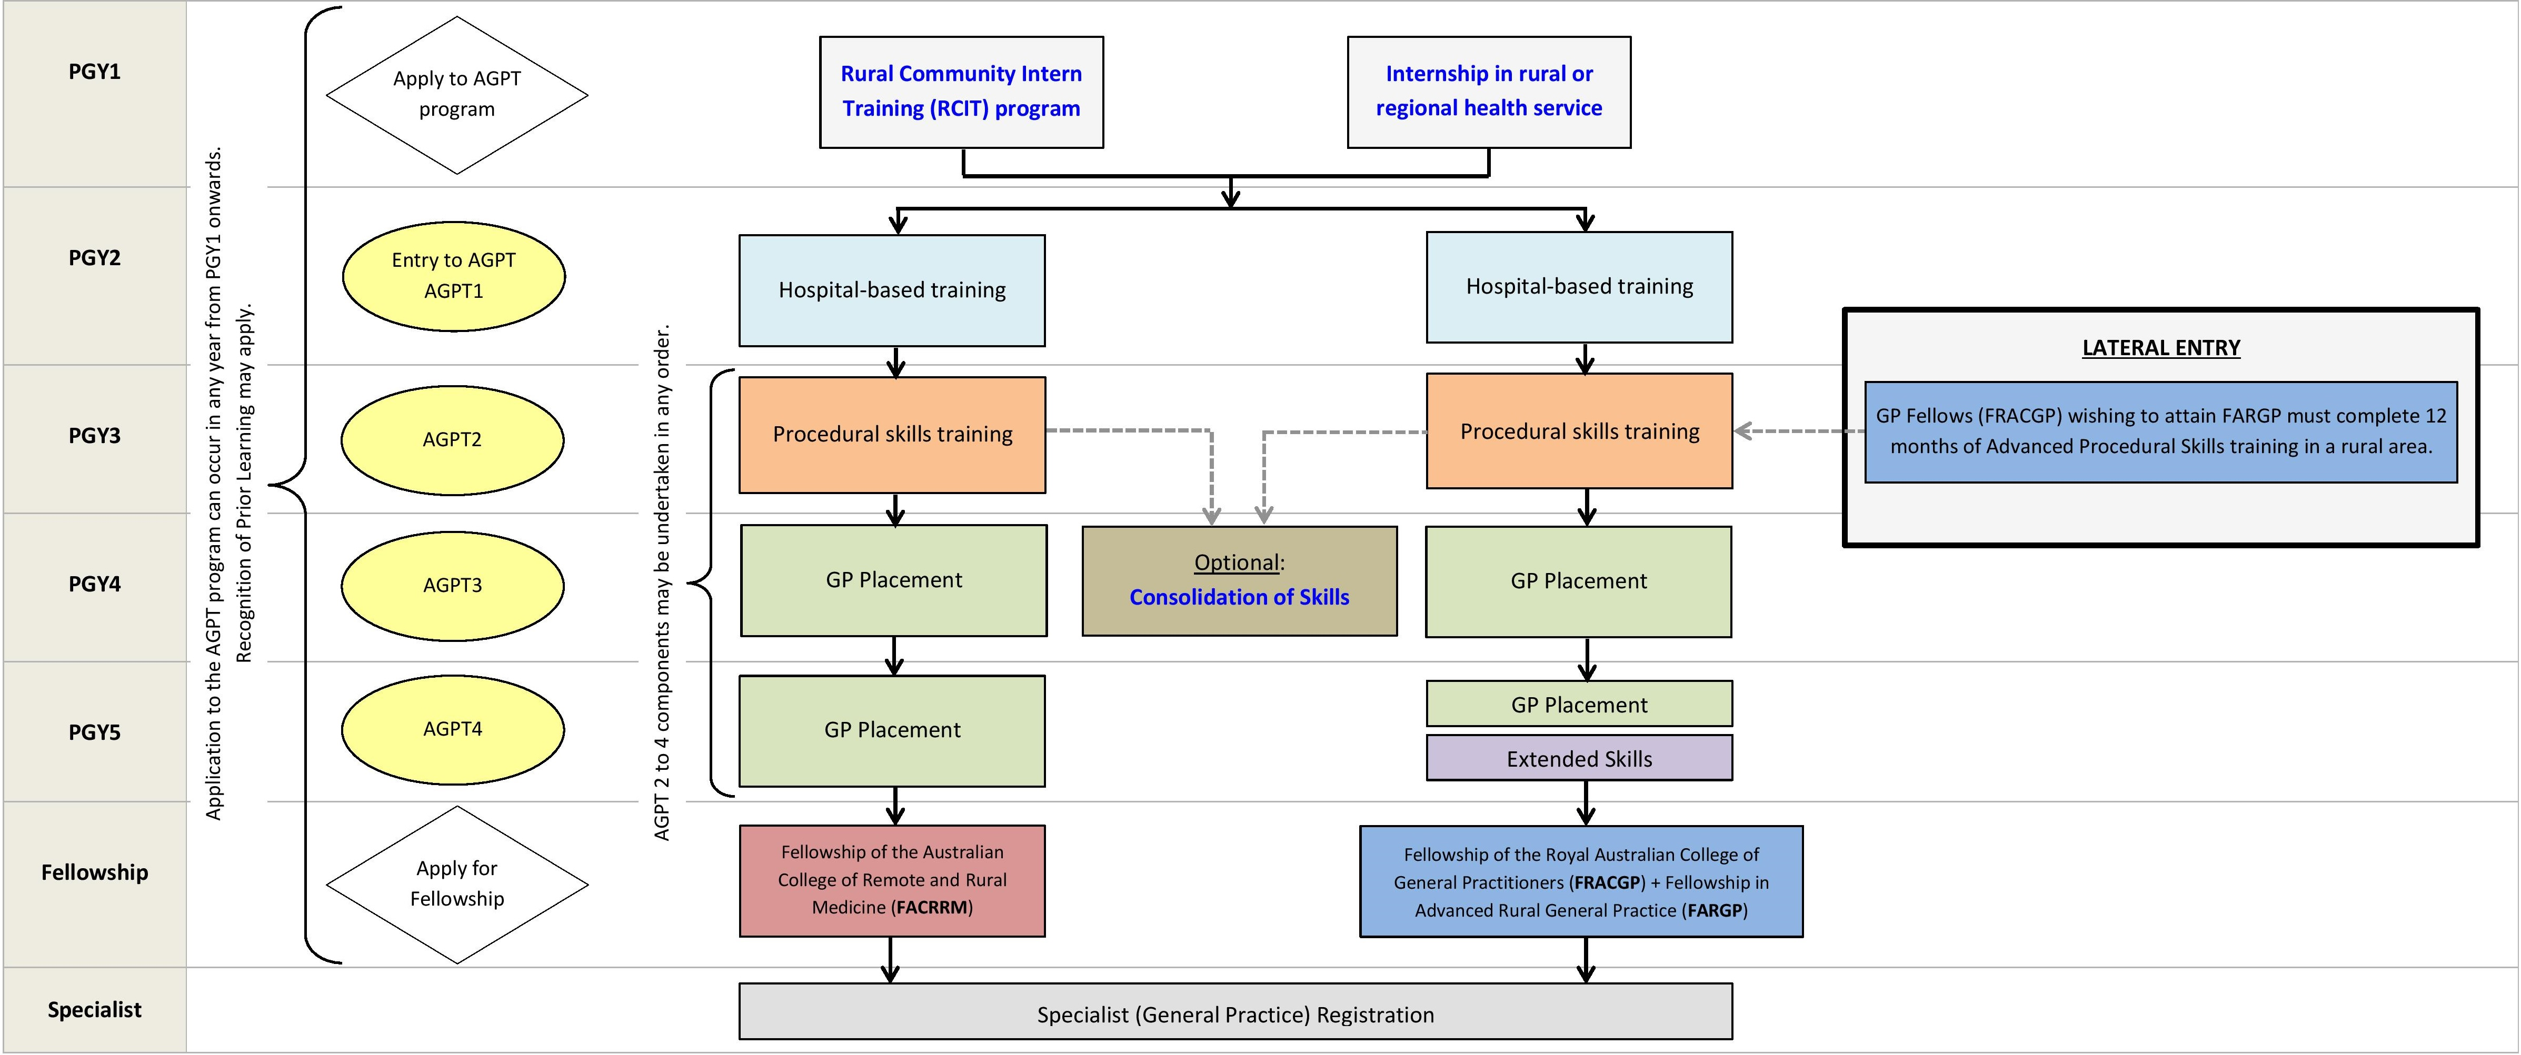Diagram 1: GP-RG program training pathway

Applications and selection to a GP-RG pathway
Selection to a GP-RG pathway is managed separately by each GP-RG provider. Applicants from Rural Community Intern Training (RCIT) programs, or applicants who are undertaking other rural/regional internships, will generally be given preference. Lateral entry into the pathway may also be possible.
Medical students interested in pursuing a GP-RG pathway are advised to seek an internship in a rural or regional health service, a regional intern program, or one of Victoria’s five RCIT programs:
- South West Community Intern Program (Warrnambool)
- Grampians Rural Community Intern Program (Ararat)
- East Gippsland Community Based Intern Program (Bairnsdale and Sale)
- Murray to Mountains Intern Program (Numurkah)
- Echuca Intern Network (Echuca)
RWAV will be responsible for managing all funding and ensuring that any proposed training will address the medical service needs of the community in which the General Practitioner is based.
The Regional Training Organisations – Eastern Victoria GP Training Limited and Murray City Country Coast GP Training Limited will be responsible for monitoring the quality of education, training and mentoring provided, and ensuring that the posts meet the specified standards.

Contact

For more information about the GP-RG program in Victoria and how to apply, please contact RWAV or any one of the GP-RG providers listed below:

Rural Workforce Agency Victoria
Contact: Gemma Bilardi, Team Leader
E: GemmaB@rwav.com.au
T: 03 9349 7800

Eastern Victoria GP Training Limited
Contact: Julie Rogalsky, Director of Operations
E: Julie.rogalsky@evgptraining.com.au
T: 03 5132 3111

Murray City Country Coast GP Training Limited
Contact: Linda Moon, Chief Operations Officer
E: Linda.Moon@mccc.com.au
T: 02 6057 8600

Barwon Health
Contact: Rodney Fawcett, Director Medical Education and Training
E: rodney@barwonhealth.org,au
T: 03 4215 3239

Murray to the Mountains Intern Program
Contact: Shane Boyer, Program Manager
E: shane.boyer@ndhs.org.au
T: 03 5823 4569

