Forensic Mental Health in Community Health (FMHiCH) program –
Data Transmission Protocol
Version 1.2
June 2019

To receive this publication in an accessible format phone 03 9096 2670, using the National Relay Service 13 36 77 if required, or email info.management@dhhs.vic.gov.au
Authorised and published by the Victorian Government, 1 Treasury Place, Melbourne.
© State of Victoria, Department of Health and Human Services November 2019.
Except where otherwise indicated, the images in this publication show models and illustrative settings only, and do not necessarily depict actual services, facilities or recipients of services.
Where the term ‘Aboriginal’ is used it refers to both Aboriginal and Torres Strait Islander people. Indigenous is retained when it is part of the title of a report, program or quotation.

Document Version Control
Version | Release Date | Author | Description
1.0 | 23 January 2019 | R Martin
1.1 | 7 February 2019 | R Martin | Minor corrections
1.2 | 5 June 2019 | R Martin | Minor corrections

Contents
1. Introduction 5
1.1 About this document 5
1.2 Audience 5
2. Submitting Forensic Mental Health in Community Health Program data 5
2.1 Submission Process 5
2.2 Key dates for reporting 6
3. Secure Data Exchange (SDE) 7
3.1 Registering as a new user 8
3.2 Accessing the FMHiCH dataset folder 9
3.3 Upload a data extract 10
3.4 Downloading files 12
4. Submission logs or other reports 12

Introduction

About this document
This document details the transmission protocols for the initial version (v1.0 December 2018) of the Forensic Mental Health in Community Health (FMHiCH) program data set reporting requirements for agencies funded by the Victorian Department of Health and Human Services (DHHS) to deliver the FMHiCHP.
This document should be cross referenced to the following accompanying documents:
- FMHiCH program data set specification v1.2
- Multiple client data collection – FMHiCHP data set v1.2
- Single client data collection – FMHiCHP data set v1.2

Audience
The audience for the FMHiCH data transmission protocol includes:
- funded organisations who deliver the FMHiCH program
- software vendors, who develop and provide software solutions utilised by funded organisations to collect, store and report FMHiCH program activity
  - Victorian Department of Health and Human Services staff (data collection and program managers) responsible for the development and management of data collections and associated documentation.

Submitting Forensic Mental Health in Community Health Program data

Submission Process
The responsibility for the submission of data and the quality of that data rests with funded agencies.
Funded agencies are required to submit a quarterly extract to DHHS via the Secure Data Exchange (SDE) Portal. Submission logs (or similar confirmation reports and data quality feedback) will also be provided to funded organisations via the SDE Portal. Funded agencies are required to correct any identified errors prior to the next submission, or earlier if requested.
Figure 1 outlines the FMHiCH program data submission and validation process.
Figure 1: FMHiCH program data submission and validation process
Review data collection spreadsheets and/or extract data from your software
Upload files to Secure Data Exchange Portal
Validation report uploaded to SDE. Email notification sent to agency.
Validation errors corrected as requested, or by next data upload
Data validation
Valid data saved to FMHiCHP Repository

Key dates for reporting
Agencies are required to submit their data reports to DHHS according to the timeframes in Table 1. Agencies may choose to submit data more often (e.g. monthly).
Table 1: Quarterly data submission dates
Quarter | Data collection period | Data submission period
1 | July – September | 1st – 15th October
2 | October – December | 1st – 15th January
3 | January – March | 1st – 15th April
4 | April - June | 1st – 15th July

To ensure data quality, agencies are encouraged to submit their data prior to the close of submission periods (before the 15th of the data submission period). This will ensure the opportunity to resubmit any missing, incomplete or corrected FHMiCH program data before the close of the submission period (should the need arise).
Agencies may be asked to resubmit their data in the resubmission periods. This may arise because an agency:
- Failed to submit data during the reporting period
- Required to submit additional records
  - Failed to correct critical rejection errors within the data submission period
Unless otherwise specified, Table 2 shows the resubmission periods.
Table 2: Resubmission dates
Quarter | Data collection period | Data submission period
1 and 2 | July – December | 15th- 31st March
1 to 4 | July - June | 15th- 31st August

Secure Data Exchange (SDE)
If you are unsure whether your organisation is registered for eBusiness access, contact the eBusiness administrator on 1300 799 470.
If you already have an eBusiness login, you only need to apply to access the SDE application by logging into the DHHS web portal at https://hns.dhs.vic.gov.au/dhsportal/wps/myportal. Select and add the Secure Data Exchange from the eBusiness application list. Your request will be sent to the SDE Administrator for approval. Once your access has been approved follow the Upload and Download instructions below.

Registering as a new user
The eBusiness portal can be accessed via https://hns.dhs.vic.gov.au/dhsportal/wps/myportal.
Click on “I want to register” on the right-hand side. The eBusiness Request for Registration page will appear.
Select and add the Secure Data Exchange from the eBusiness Applications List. Click “Next”.
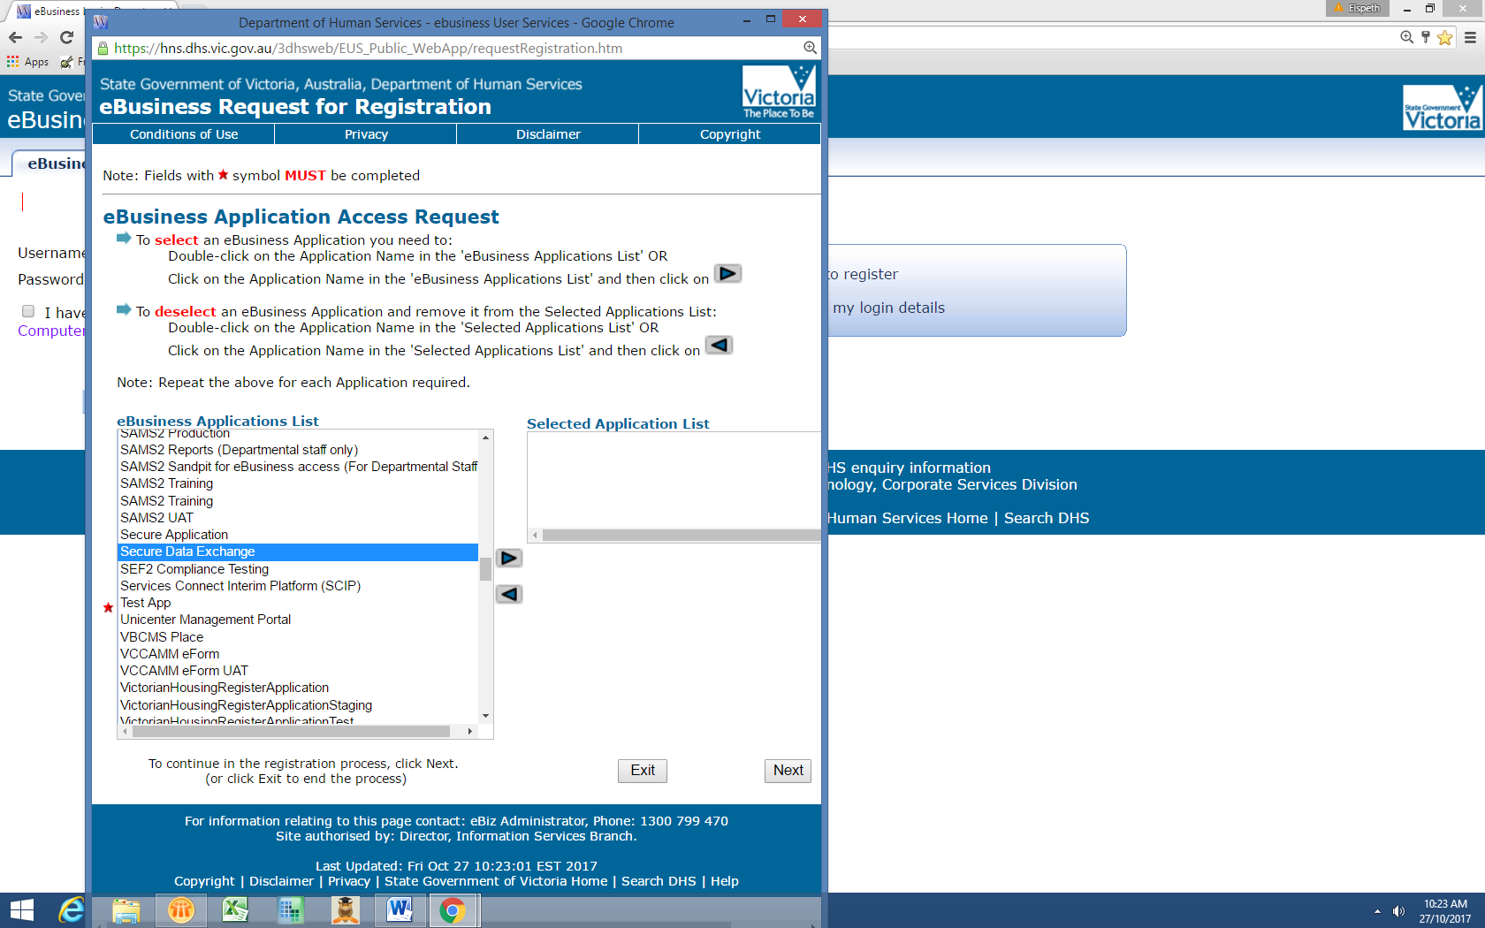
From the next page, fill in the compulsory fields. If your organisation is not in the dropdown list, select ‘P’ in the purple alphabet, then private individual from the Organisation Name list.
Submit request. Your submission will be sent to the SDE Administrator for approval. Once your access has been approved, follow the emailed instructions to generate a new password.
If you have any difficulty with registration, please contact the SDE Helpdesk on 1300 799 470.

Accessing the FMHiCH dataset folder
Log into the SDE portal and select the Secure Data Exchange option. Select the tab marked 'Request'.
Enter the following dataset name: Forensic Mental Health in Community Health
Ensure both File upload and File download access types are checked and select 'submit'.
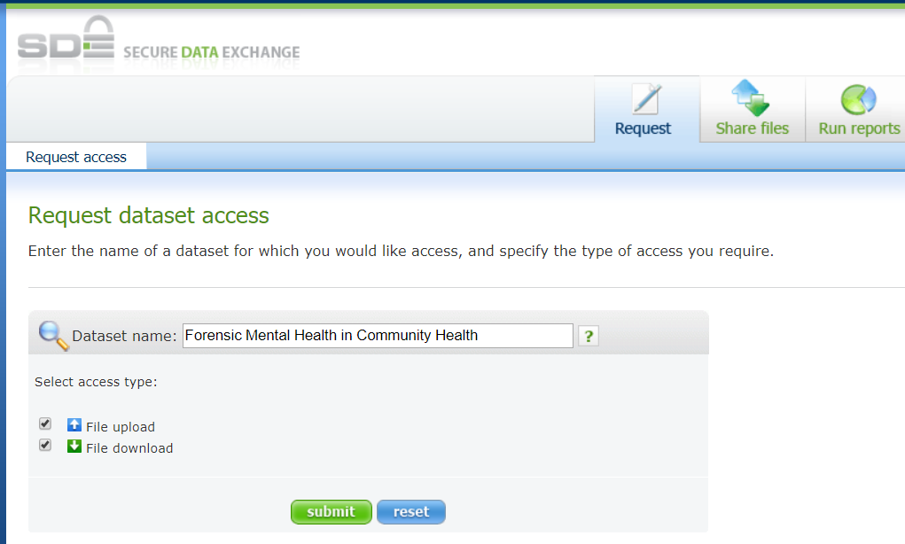
The request is then sent to the dataset administrators who can approve your request. You will receive a system generated notification once your request has been approved/declined.

Upload a data extract
Go to the “Share Files” tab. Choose “Upload files” in the top left corner.
Enter the dataset name: Forensic Mental Health in Community Health
Select ‘Search’, and then ‘ok’.
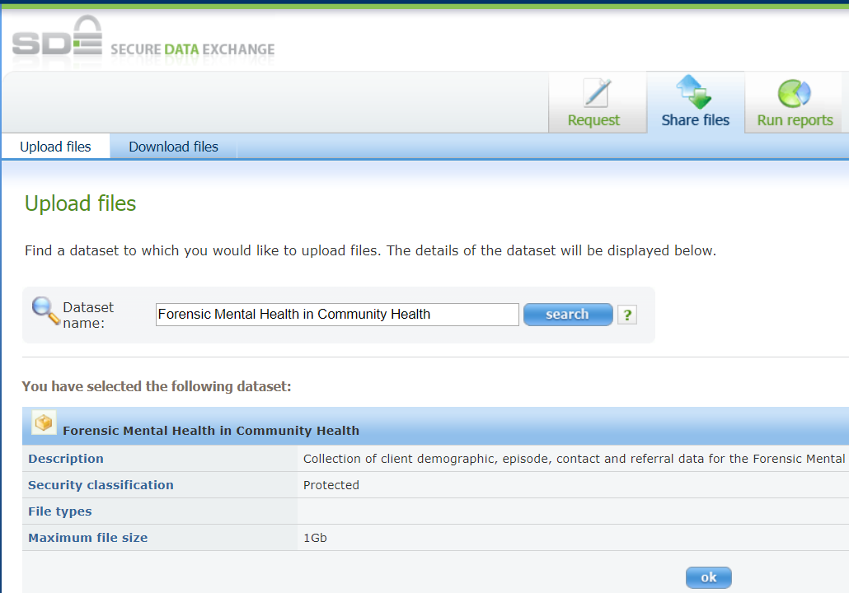

The pop-up Java applet will then launch and load, from which you can select and upload your files.
If you are prompted with a security dialog box, select ‘Run’.
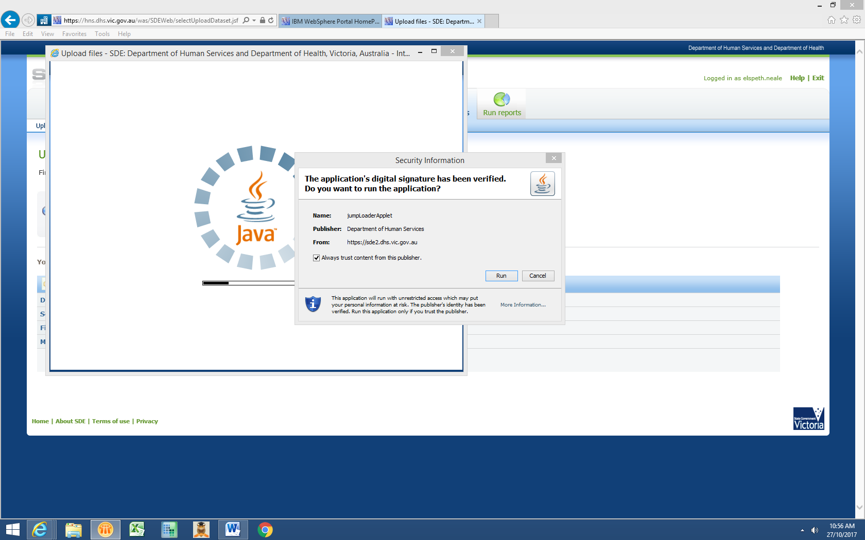

Downloading files
FMHiCHP submission logs or other reports will be uploaded to your folder when complete.
Go to the “Share Files” tab. Choose “Download files” in the top left corner.
Enter the dataset name: Forensic Mental Health in Community Health
When you select “Search”, the dataset details will populate below this box. Click “Ok” and the main download screen will open.
Select the file to be downloaded by placing a tick in the download flag box to commence the process. Securely save the file on your local directory. The files expire after 15 days.

Submission logs or other reports
Submission logs or other feedback reports will be made available to agencies through the Secure Data Exchange portal. To ensure the process runs smoothly agencies are requested to:
- inform the department of any changes to the contact details of the person/s responsible for receiving the submission log
- contact Rohan Martin on rohan.martin@dhhs.vic.gov.au or 9096 1003 if a submission log has not been received
  - review your submission log and correct any identified data quality issues.

