Evaluation Plan for the
Koolin Balit investment
March 2015

Department of Health
Evaluation Plan for the Koolin Balit Investment
March 2015

To receive this publication in an accessible format, please phone 03 9096 1026 using the National Relay Service 13 36 77 if required, or email aboriginal.health@health.vic.gov.au.
Authorised and published by the Victorian Government, 1 Treasury Place, Melbourne.
© State of Victoria, March 2015
This work is licensed under a Creative Commons Attribution 3.0 licence (creativecommons.org/licenses/by/3.0/au). It is a condition of this licence that you credit the State of Victoria as author.

Contents
Overview 6
Background 7
Consultation and development 7
Evaluation challenges 7
Purpose of the evaluation 8
A. Accountability 8
B. Improvement 8
Scope of the evaluation 8
Priority evaluation activities 10
A. Priority activities: Accountability focus 11
Key principles 11
Key activities led by the Aboriginal Health Branch 12
Key activities led by regions and statewide program areas 13
B. Priority activities: Improvement focus 14
Key principles 14
Key activities led by the Aboriginal Health Branch 15
Key activities led by regions and statewide program areas 17
C. Priority activities: Evaluation capacity building 18
Key activities led by the Aboriginal Health Branch 18
Key activities led by regions and statewide program areas 19
Timeline 20
Terminology 22

Overview

Evaluation helps us learn what works, how and why. If we evaluate well, and use what we learn, we will make a difference and make it happen faster.
Evaluation helps us improve how we do our work and helps us make sure we direct our limited resources and energies in the best possible ways.
We always need to be monitoring our work to check we are on track. Good evaluation supports our accountability obligations. It can help us explain what we have achieved as well as what extra help we might need to make sure we achieve our goals.
For evaluations to be useful, they need to ask the right questions, work closely and respectfully with people doing the work on the ground and then be used to inform future work and funding decisions.
Since the 2008 Nation Apology, Victorian governments have invested a record $121.5 million in Aboriginal health, in addition to ongoing investments in healthcare services which Aboriginal Victorians use. These new investments have occurred in close consultation with Aboriginal communities. The devolved governance has created tremendous diversity and innovation. At present, there are 93 different projects being implemented across Victoria through the Koolin Balit investment.
The approach to evaluation of the Koolin Balit investment will need to be similarly diverse.
The Department of Health and Human Services (DHHS) Aboriginal Health Evidence and Evaluation Working Group, which brings together data and evaluation experts, consulted widely to develop an evaluation plan.

The Evaluation Plan for the Koolin Balit Investment describes the approach that the Department of Health and Human Services (DHHS) is taking to evaluate the Koolin Balit investment. It includes the purpose, scope, principles and timelines of the evaluation, the rationale for selection of the priority activities, which are each outlined.

Priority evaluation activities will include:
- Publishing a suite of indicators for Aboriginal health in Victoria, which DHHS will report against annually
- Analysis of six-monthly reports submitted through the Koolin Balit Performance Management Framework
- Supporting longer-term projects to evaluate their outcomes and impacts
- External evaluations will be commissioned in the following priority areas, which were selected based on four criteria: investment size, opportunities for replicability and comparability and critical information needs:
    - Improving cultural responsiveness of hospitals
    - Case management and care coordination models
    - Documenting the impacts and opportunities for the gathering place model
      - Impacts of workforce development strategies
- Supporting project-level evaluations, including coordinated evaluation of the eye health projects
- Active dissemination of evaluation findings, including producing digital stories, supporting the preparation of abstracts, supporting attendance to present at relevant conferences and publications in key journals
- Developing an evaluation capacity building strategy for the Aboriginal health sector in Victoria

Timelines
The majority of evaluation activities will occur during 2015 with most activities due to be completed by the middle of 2016.

Background
Since the 2008 National Apology and the subsequent Council of Australian Governments agreement, Closing the Gap, consecutive Victorian Governments have invested the record amount of $121.5 million in Aboriginal health. $59.8 million was invested over the four years 2008-12 under the Closing the Health Gap commitment followed by $61.7 million over the four years 2013-17 towards implementing Koolin Balit: Victorian Government strategic directions for Aboriginal health.
This document outlines the purpose, scope and priority activities for evaluating the Koolin Balit investment and concludes with a commitment to evaluation capacity building that underpins the plan.

Consultation and development
The DHHS Aboriginal Health Evidence and Evaluation Working Group (the Working Group), comprising experts in health data, research and evaluation from across the Department, has had a key role in planning the evaluation. The Working Group recommended external consultants be commissioned to develop a program logic model which describes the organising concepts that underpin the evaluation. The program logic model is at Appendix 1.
Other formal input has been received through a series of workshops with DHHS program areas and regional offices responsible for Koolin Balit–funded programs. The Victorian Expert Advisory Panel on Aboriginal Health also provided input to the evaluation plan at their November 2014 meeting.
The evaluation approach for Koolin Balit has also been informed by the formal review of the Closing the Health Gap evaluation (conducted by Urbis Pty Ltd) which provided insights into the benefits and challenges of the approach taken for that evaluation.
The most notable difference is that where the Urbis evaluation endeavoured to identify the impact of the investment as a whole and collect data on every single funded project, the Koolin Balit evaluation will comprise a diverse range of evaluative activities, some focused on the impact of the investment as a whole for accountability purposes (eg. indicators), and others looking more deeply into specific topics.

Evaluation challenges
Evaluating an initiative with the complexity and diversity of the Koolin Balit investment involves a range of challenges which have informed the evaluation approach. These include:
- Attributing effects to any one project or initiative can be problematic, if not impossible.
- Health outcomes of a population can rarely be demonstrated in a four-year period. This is compounded for the Aboriginal community by the difficulty of measuring small changes in a small population.
- Devolved governance is a great strength of the implementation approach, enabling community connection and control but the diversity in the resulting programs and information collection create significant evaluation challenges.
- Evaluation capacity of program implementers has been identified as needing substantial development. The success and quality of any evaluation is dependent upon the capacity of those implementing programs to fully participate.
  - Data collection and management around Aboriginal health in Victoria is significantly impeded by issues including population size, accuracy of Aboriginal identification and a reliance on proxy measures.
Some of these challenges are being addressed through activities included in the evaluation plan. Others will be addressed through the more detailed work of designing and implementing each evaluation activity.

Purpose of the evaluation
The Koolin Balit investment is being evaluated to assist in answering the following questions related to accountability and improvement.

A. Accountability
- Has Victoria made progress against the aims and indicators outlined in the Koolin Balit Funding Implementation Plan, including improvements in health and wellbeing outcomes?
- What progress has been made against performance outcomes in key programs and initiatives funded through the Koolin Balit investment, as documented in regions’ and divisions’ Action Plans?
- To what extent have programs/initiatives been delivered within their given budget, timeframe, and in line with appropriate processes?

B. Improvement
- What projects and strategies are working best? Documenting and analysing these will provide an evidence base to support improved performance.
- How should programs funded in 2013-17 be continued, replicated, ceased or changed in future?
- Where is innovation occurring, has it been successful and should it be continued?
- How can successful strategies be made sustainable?

Scope of the evaluation

The focus of this evaluation is the Koolin Balit investment for 2013-17
The $61.7 million investment over four years is described here as ‘the Koolin Balit investment’.
A program logic model (Appendix 1) describes the planned activities (regional and statewide) within the Koolin Balit investment and how they each relate to agreed commitments underpinning the investment. These include the three Investment Focus Areas, long-term objectives and short- to medium-term objectives. This model will underpin the evaluation. The preliminary evaluation planning work included mapping all regional and state-wide activities to the outcomes in the model.
The Victorian Government has substantial funding and policy commitments to Aboriginal health outside of the Koolin Balit investment. The Koolin Balit Strategic Directions apply to all Victorian Government programs and initiatives which aim to improve Aboriginal health. These are set out under six Key Priorities and three Enablers. The Koolin Balit Statewide Action Plan outlines the activity across government in more detail.
The scope of this evaluation is largely limited to the 2013-17 Koolin Balit investment, though its findings will have relevance to broader activity and will contribute to improving the effectiveness of both resource allocation by government and program implementation in the health sector.

The two-year investment versus the four-year funding commitment
The Koolin Balit Funding Implementation Plan was approved in June 2014. This plan details $28.4 million of state-wide programs funded for four years, and $16.0 million of regional activity funded for only two years, to allow for changes in local priorities and increased flexibility to respond to changing community needs. As the evaluation commences, the second two years of regional allocations ($17.3 million) remain uncommitted. Furthermore, some state-wide programs have not yet detailed their planned activities for the full four-year period, and some of the regions have not confirmed details of the full amount of their first two years of funding.
This provides an opportunity for the evaluation of the current activity to directly and rapidly inform program and project development, enable continuous learnings and program improvements and influence future funding allocations. However, timeframes are tight with the regional planning for the second two year period needing to have determined priority areas by April 2015 and have project plans detailed by October 2015.

Building on ‘Closing the Health Gap’ investments 2008-12
The Koolin Balit investment 2013-17 immediately follows the major investment made through a COAG agreement in 2007, known as Closing the Gap. The then Victorian Government provided $59.8 million over the 2008-12 four year period.
Urbis Pty Ltd was commissioned to undertake a single evaluation of Closing the Health Gap. The results of the evaluation, including interim reports, a final report, and eight case studies, were published in 2013 and are available at http://www.health.vic.gov.au/aboriginalhealth/.
As the Koolin Balit investment is a second tranche of government investment in Aboriginal health, it is important to evaluate impacts not just relating to the 2013-17 investment but to also include the 2008-12 efforts, especially where long-term outcomes are concerned.

Complementary activities
This evaluation framework sits within the context of many activities which the department is pursuing to improve data, evidence, performance and accountability. Activities most closely related to the evaluation are the Koolin Balit Performance Management Framework and data improvement projects.

Koolin Balit Performance Management Framework
A revised Koolin Balit Performance Management Framework was published in March 2015.
The Framework outlines the reporting systems and processes for all initiatives under the Koolin Balit State-wide Action Plan, of which the Koolin Balit investment is a component.
Information collected through the implementation of the Framework, such as six-monthly reports by regions and state-wide program areas will be a critical data source for the accountability components of the Koolin Balit evaluation. The reports will assist in active program monitoring and identifying any issues arising. It is especially important for determining whether funds have been spent in an appropriate manner which is a key accountability requirement.
The Framework will seek to ensure reporting by funded agencies, regions and state-wide programs allows for analysis that can quickly and accurately describe the outputs and achievements of the investment. It is important that timelines are aligned to ensure this analysis can inform accountability obligations and the decision making necessary for future investments. The critical timelines are described on page 20.

Data improvement projects
The Department of Health and Human Services is implementing a number of projects to improve the quality of data and evidence around Aboriginal health. Those with specific relevance to the Koolin Balit evaluation include:
- Improving identification rates through a program of audits across health services, and expanding this activity to mental health, community health, and screening and early detection services.
- Identifying a valid and acceptable measure for life expectancy of Aboriginal Victorians.
- Developing an appropriate measure for Aboriginal people’s experience of health care.
- Obtaining data from the Commonwealth’s OCHREstreams system about service delivery and workforce, and identifying opportunities this provides to streamline reporting.

Priority evaluation activities
The following section describes the priority evaluation activities which will be pursued against each of the evaluation purposes: accountability and improvement. It also notes critical timelines. It concludes with a section on activities to build evaluation capacity. The activities and how they relate are summarised in Figure 1.

Figure 1: Summary of the Koolin Balit evaluation priority activities
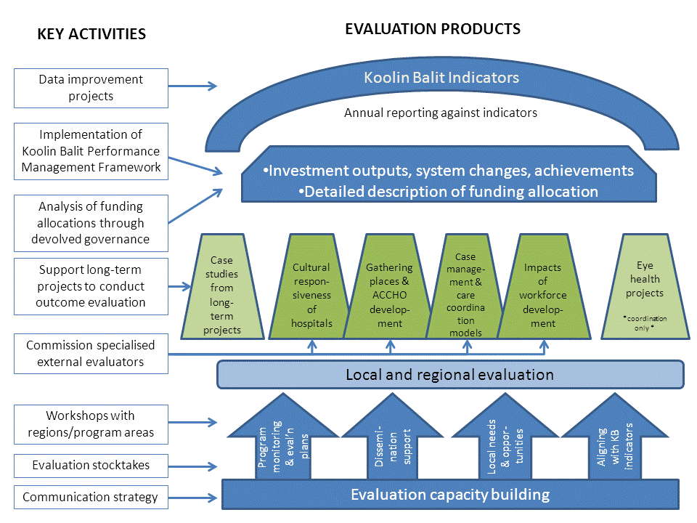

Priority activities: Accountability focus
This section describes the evaluation activities primarily concerned with issues of accountability, reporting upon the impact of the $61.7 million Koolin Balit investment to the Minister for Health, Treasury, the Aboriginal community and the broader public.

Key principles
Aboriginal concepts of health
Aboriginal and Torres Strait Islander concepts of health and wellbeing are broader than non-Indigenous concepts. They recognise cultural differences and acknowledge the impacts of historical and social determinants on wellbeing, including the importance of employment, housing and education. It would be difficult from the Aboriginal perception to conceptualise ‘health’ as one aspect of life. It is ‘not just the physical well-being of the individual but the social, emotional, and cultural well-being of the whole community. This is a whole-of-life view and it also includes the cyclical concept of life-death-life.’
These concepts influence both the choice and development of initiatives funded by the Koolin Balit investment, and evaluation of the impact of those initiatives. Applying an Aboriginal concept of health and wellbeing to evaluation means considering that initiatives can deliver benefits beyond those narrowly conceived of as health outcomes, to include cultural strengthening and social and economic benefits.
Participatory evaluation and community involvement
It is critical to ensure the Aboriginal community’s perspective on the impact of the investment is prioritised through any evaluation. This will be done by use of culturally sensitive participatory methods and through both consulting with, and prioritising the views of the community. Principles of respect and reciprocity are central to the evaluation, and the critical roles these play has been widely recognised.
Data improvement and limitations
A comprehensive and reliable set of data on Aboriginal health in Victoria is not available due to issues of population size, the accuracy of Aboriginal people being identified in data sets, the lack of an agreed methodology for estimating the life expectancy for Aboriginal Victorians and a lack of data in some key outcomes which require a reliance on proxy measures. The Victorian Aboriginal Community Controlled Health Organisation (VACCHO)’s Data Strategy highlights the need to develop both the quality and use of data within Aboriginal community controlled health organisations (ACCHOs) to improve service delivery and planning. The department has a substantial program of work to improve Aboriginal health data. This was noted by the recent Victorian Auditor General’s Office (VAGO) audit as a serious commitment to improving data and understanding of the service needs of Aboriginal Victorians.
Partnerships
The Closing the Health Gap evaluation found that strong partnerships within the health system are critical to improving Aboriginal health. Partnerships need to be strong at all levels: between Aboriginal organisations and mainstreams services, between peak bodies such as VACCHO and the Department. Future evaluation activity must acknowledge the important work involved in building and maintaining strong partnerships, whilst looking towards the outcomes these partnerships are now achieving.

Key activities led by the Aboriginal Health Branch
- A suite of indicators for monitoring performance
The Aboriginal Health Branch is developing a suite of indicators for monitoring the performance of the department’s Aboriginal health investments and other activities. ACIL Allen was engaged to develop a suite of proposed indicators. This was done in consultation with the Aboriginal Health Evidence and Evaluation Working Group (the Working Group) and a series of workshops with staff from all regions and relevant state-wide program areas. The indicators were selected for their relevance to the Koolin Balit investment, the availability of baseline data, the ability to be measurable in the short-medium term, and the reliability of the data source.
Several of the proposed indicators needed additional work to confirm their baseline data and/or data source. The Aboriginal Health Branch is also identifying whether data for each indicator is available at the regional and subregional levels to inform project-level impacts.
A suite of indicators will be published in 2015 and its application will include:
- Preparing and publishing baseline data against the indicators;
- Preparing annual reports against the indicators as a new report, Aboriginal Health in Victoria;
- Project level evaluations, where conducted, can use relevant indicators to align their evaluation with the broader Koolin Balit evaluation;
- Contributing baseline and subsequent years’ data, where available, into regional priority-setting processes;
- All Koolin Balit regional project plans for 2015-17 will require nomination of relevant indicators; and
- Reporting on changes in Aboriginal health over the eight year investment of the Closing the Health Gap and Koolin Balit periods to inform a future funding bid and the 2017 report to Parliament on impacts of the Koolin Balit investment.
The suite of indicators will evolve over time as data improvement activities reap their benefits. It will also be important they provide consistency in monitoring the department’s Aboriginal health activities.
- Analyses of activities funded, outputs and system changes achieved
Several factors, including the devolved governance arrangements and the revisions of the Koolin Balit Performance Management Framework suggest a systematic analysis of what activities have been funded, and what outputs and system changes have been achieved, will be required in order to fulfil accountability obligations. This will be a descriptive activity, based primarily on the reporting developed through the Framework with additional inquiry likely required to gain consistent information across the 93 projects which comprise the investment.
This analysis will also include identifying any gaps between the focus areas of the current investments and the Koolin Balit Strategic Directions which can inform future priorities.
- Program-specific case studies
To complement the two activities above, which are over-arching descriptions of activities and outcomes of the investment, a set of case studies will be developed. The case studies will illustrate specific activities or programs which demonstrate outcomes and achievements, or they may focus on specific outcomes and evidence of their contributing factors.
A small number of projects have been operating continually, with evaluation frameworks in place, since the Closing the Health Gap investment 2008-12. The longevity presents an opportunity to potentially be demonstrating impacts on health and wellbeing outcomes. These projects’ evaluations will be explored to determine the extent to which they are investigating achievement of outcomes and could produce a robust case study. Additional evaluation resources may be provided to these projects if required to achieve this.

Key activities led by regions and statewide program areas
The following activities, which contribute predominantly to the accountability aims of the evaluation will be led by the Department’s regional offices and state-wide program areas implementing initiatives funded by the Koolin Balit investment:
- Monitor and report as prescribed in the KBPMF, including revisions if reporting is not sufficiently clear or comprehensive for purposes of evaluation (Activity 2 above)
- Local and/or project-specific evaluations aligned, where possible, with the forthcoming ‘Koolin Balit indicators’ and Koolin Balit program logic.
- Collaborate with the Aboriginal Health Branch on enhancing the evaluation capacity of program implementers and of longer-term evaluands detailed above.
- Align local evaluation timelines, wherever possible, with state-wide accountability obligations.

Priority activities: Improvement focus
A critical role for the evaluation is producing information that can help to strengthen and improve the initiatives which are working to improve Aboriginal people’s health in Victoria. The evaluation will subsequently include some components which take a developmental evaluation approach. Findings from these evaluation activities will be able to inform broader work in Aboriginal health beyond specific program investments, including informing decisions by the department, ACCHOs and other service providers around replication and continuation of innovative approaches. This section describes the priority activities which have an ‘improvement’ focus.

Key principles
Participatory evaluation and community involvement
It is critical to ensure the Aboriginal community’s perspective on ‘what works’ is prioritised through any evaluation. This will be done by using participatory methods and through both consulting with, and prioritising the views of community members in the analysis of evaluation findings. This concept affects both the choice and development of initiatives funded through the Koolin Balit investment, and also the evaluation of the impact of the initiatives, which can deliver benefits beyond those narrowly conceived of as health benefits, including cultural strengthening and social and economic benefits.
Devolved governance and local decision making
The Victorian Government’s approach to the Koolin Balit investment, and Closing the Health Gap before it, prioritised the role of local communities in identifying priorities, and in some cases also in allocating funding, with the primary mechanism for this being the eight Regional Aboriginal Health Committees co-chaired by a local Aboriginal community leader and the Regional Director of Health and Aged Care. This is devolved governance.
Replicability
Replicability refers to the capacity of an initiative (program, project, strategy etc.) to be repeated in a different setting and achieve the same outcomes (be it a different geographical location or completely different delivery mode, for example moving an in-person program to online delivery, or a program that worked in a hospital into a community clinic).
In an evaluation context this often means breaking down the initiative being evaluated to understand the program’s different components as well as how it was implemented, which may differ from what was intended. It means gaining a thorough understanding of local conditions and systems which enabled an initiative’s success. Investigating replicability can include identifying what components of an initiative that could be defined as fundamental, which should remain unchanged, and what components are the ‘soft periphery’ which must be adapted to the local context.
Replicability is an important domain to be included in much of the evaluation design, and closely relates to the devolved governance making and local decision making which underpins the approach to Aboriginal health in Victoria.

Key activities led by the Aboriginal Health Branch
Commissioning external evaluations of priority areas
The Aboriginal Health Evidence and Evaluation Working Group determined the criteria for selection of priority evaluations should be as follows:
- investment - activities where there are major investments
- replicability - initiatives which appear to be progressing well and have the potential for wider roll-out, or where roll-out is being proposed, and the replication approach could benefit from some evaluation of the original initiative
- comparability - whether similar projects have been implemented that can be compared, providing, among other things, insights into replicability
- critical information needs - such as whether innovative approaches should be continued or modified
Four external evaluations will be commissioned.
The focus areas (or evaluation domains) for each of the four commissioned evaluations will be four-fold:
- client health outcomes
- reach - who did (and didn’t) the project benefit?
- success factors; and
- replicability.
The evaluations will be commissioned as individual projects to evaluators with the specific expertise of each content area and the differing evaluation methodologies which they require.
The four evaluations planned to be commissioned are:
- improving cultural responsiveness of hospitals
- documenting successes and opportunities of community-controlled places in Victoria
- case management and care coordination models
- impacts of workforce development strategies.
- Improving cultural responsiveness of hospitals
Cultural responsiveness of mainstream health services is one of the three Enablers defined in the Koolin Balit Strategic Directions for Aboriginal Health. Furthermore, the 2014 VAGO audit of Accessibility of mainstream services to Aboriginal Victorians recommended a continued focus on issues of accessibility of mainstream services. This evaluation will make an important contribution to that focus.
Eight projects in the Koolin Balit investment totalling $3.2 million are focused on improving cultural competency in mainstream services. This includes some components of the state-wide workforce plan, particularly implementing Aboriginal employment plans in public health services which is supporting projects in 22 health services.
In addition, there are several initiatives which include improving cultural competency of mainstream services as a substantial, though not exclusive, focus of their activities. These include the clinical engagement projects in hospitals ($1.193 over four years) and the client journey project in Hume region, which is implementing an Aboriginal Health Cultural Competence Framework across the region.
It is notable there is considerable regional and program variation in strategies for facilitating cultural responsiveness of mainstream services which may provide an opportunity for comparison of effectiveness of different approaches. There are also substantial programs, outside the current investment, driving improvements in cultural responsiveness of hospitals, in particular, the department’s long-running Improving Care for Aboriginal Patients (ICAP) program.
The majority of the investment in cultural responsiveness of mainstream services to date has been in hospitals therefore this evaluation will focus on hospitals.
- Documenting successes and opportunities of community-controlled places in Victoria
Strengthening Aboriginal community organisations is also an Enabler in the Koolin Balit Strategic Directions.
Ten projects in the current investment aim to build capacity of Aboriginal community-controlled health organisations (ACCHOs). This includes several investments in developing new gathering places, mostly in communities where there has not previously been an Aboriginal community-controlled organisation. The evaluator to be appointed for this project will be required to take a strengths-based approach, and demonstrate capacity to partner and engage, if not strong existing relationships with local Aboriginal communities.
The gathering place model has been an area of considerable investment whilst there is a limited evidence base for the most effective and appropriate strategies to employ in the Victorian context and there is an opportunity to increase understanding and grow the evidence base for this important work.
- Case management and care coordination models
There are five long-term projects implementing case management and care coordination models, each developed out of their local community and service system needs. Several have conducted some local evaluative activity which is demonstrating positive impacts. The projects are:
- South West Family Case Management (Barwon South West region)
- Chronic Disease Prevention and Management Program at Ballarat and District Aboriginal Cooperative (Grampians region)
- Aboriginal Client Journey project’s Transition Officers (Hume region)
- Early Years Project (Loddon Mallee region)
- Integrated Koori Services project – transition officer position in the emergency department at Dandenong Hospital (Southern Metropolitan Region)
In addition, the four eye health projects and their evaluations may to be able to contribute data into this evaluation.
There is an opportunity to both support the local evaluation activity of each of these models, especially the long-term projects, and to bring the projects together and/or introduce some meta-evaluation to identify common success factors, and develop strategies for sustainability and replication of success.
There are several other programs which may provide evidence to inform this evaluation including the Aboriginal Health Promotion and Chronic Care Partnership program (AHPACC) in community health services and ACCHOs, Improving Care for Aboriginal Patients in hospitals, the Koori Maternity Services Program and a pilot of Ice Coordinator positions currently underway.
- Impacts of workforce development strategies
There has been substantial investment in Aboriginal health workforce development since 2008. The Koolin Balit workforce strategy comprises six state-wide projects. In addition, several regional Koolin Balit investments include a workforce development component, which could be in scope.
State-wide workforce development strategies have been monitored comprehensively with some data on outcomes collected, though the focus of the monitoring has predominantly been outputs. There has not been an opportunity to analyse this monitoring data with an evaluative lens. There is also an opportunity to investigate more fully the impact of the strategy on Aboriginal people’s career pathways in the health sector and concurrently investigate what other strategies have enabled Aboriginal people to establish successful careers in the Victorian healthcare system.
This evaluation will inform both ‘accountability’ and ‘improvement’. There would be value in using the evaluation to identify opportunities for changes to the program monitoring arrangements. This may allow for ongoing and systematic monitoring of the strategy’s impact within available resources.

Supporting project-level evaluations
There is considerable evaluation activity planned and underway at the regional and project levels. A stocktake of evaluation activity in September 2014 identified 12 local project evaluations within the Koolin Balit investment had commenced with a further 24 planned. This makes a total of 36 project-level evaluations occurring within the scope of this evaluation plan.
Regional Aboriginal Health Managers play a critical role in supporting many of these evaluations. Managers of statewide programs generally design and commission, if necessary, evaluation of statewide programs. The Aboriginal Health Branch’s Performance & Accountability Unit can provide technical and other support to project-level evaluation activity, as required.
The Aboriginal Health Evidence & Evaluation Working Group identified that the four eye health projects occurring across the state present an opportunity for an example of this support.
Coordinated evaluation of eye health projects
Four projects to improve service system and pathways to eye health services in Grampians, Loddon Mallee, Barwon South West and North West Metro regions have been funded under Koolin Balit with almost identical intended outcomes and outputs. The Victorian Aboriginal Community Controlled Health Organisation (VACCHO) through its Eye Health Coordinator is supporting the implementation of these projects. Other experts in the field are also supporting the projects including the Australian College of Optometry and the University of Melbourne Indigenous Eye Health Unit.
The Aboriginal Health Branch will provide any necessary support to facilitate these projects to produce and disseminate a coordinated evaluation. There will not be an independent evaluator commissioned as the projects have already been planned to incorporate an evaluation component.

Key activities led by regions and statewide program areas
Regions and statewide program areas with responsibility for Koolin Balit-funded programs have a critical role in monitoring their implementation which may include evaluation.
Some of the specific activities they are responsible for within this plan include:
- Monitoring and reporting as prescribed by Koolin Balit Performance Management Framework.
- Contributing to the design of evaluations where the region or program area has projects in scope of those four evaluations being commissioned centrally.
- Introducing appointed evaluators to the necessary funded services and community stakeholders for state-wide evaluations.
- Sharing evidence of ‘best practice’ approaches, including local evaluation findings with colleagues, community stakeholders and sector both within their own region and across regions
- Aligning local evaluations, wherever possible, with the suite of state-wide indicators and contributing their findings into state-wide accountability obligations.

Priority activities: Evaluation capacity building
Consultations through the development of this evaluation plan identified a need for concerted effort in evaluation capacity building within the Aboriginal health sector in Victoria. This is consistent with a finding from the Aboriginal Health Branch’s review of the Closing the Health Gap evaluation which found substantial capacity building was required amongst key stakeholders to conduct any future quality evaluation activity, and that a more proactive approach was needed to develop local and regional evaluation capacity.
Strong data collection practices are fundamental to quality evaluation. The work to develop and report against a core suite of indicators for Aboriginal health in Victoria is a substantial contribution to improved use of data in Aboriginal health. A continued commitment to and investment in improving the quality of data collection across the Victorian healthcare system is critical to ensuring the quality of any evaluation activity and subsequently decision-making informed by good quality evidence.
The implementation of this evaluation will continue in a manner that actively facilitates evaluation capacity building. This section of the evaluation plan identifies some of the activities that will be conducted with the intention of, either in whole or in part, building evaluation capacity. Some of the activities are necessary steps to implement the evaluation, which are described here because they will support a capacity building approach to the whole evaluation.

Key activities led by the Aboriginal Health Branch
Disseminating evaluation findings
A program of actively disseminating evaluation findings and evidence of ‘what works’ will be conducted.
This will include:
- Developing digital stories out of the case studies being developed in Section A.
- Contributing Victorian evaluations into the national Closing the Gap Clearinghouse.
- Actively supporting project evaluations to be written up and submitted for presentation at relevant conferences or publication in relevant journals.
  - Workshops to facilitate sharing of evidence, best practice and evaluation results.
Existing communication mechanisms will be employed wherever possible, such as Kukna Watnanda, the Director of Aboriginal Health’s monthly newsletter, Aboriginal Health Working Group meetings and Victorian Expert Advisory Panel on Aboriginal Health.
Evaluation communications strategy
The Department will develop a strategy for communications around the evaluation, from the activities planned to disseminating evaluation findings, which will include concise products for public distribution. The planning for the evaluation has identified many misconceptions and anxieties about evaluation. These will be addressed through developing clear and consistent messages about what and why the department is conducting this evaluation.
Monitoring evaluative activity
An initial stocktake of evaluation activity was conducted to inform the development of this plan. This will be conducted annually with its scope extended to all Aboriginal health programs, not just the Koolin Balit investment.
The stocktake will be considered by the Department’s Aboriginal Health Evidence and Evaluation Working Group for identification of gaps and opportunities.

Workshops with each region and statewide program area
In early 2015 departmental staff in each region and statewide program area are being consulted to discuss and confirm evaluation and monitoring arrangements in each respective region or program.
Roles and responsibilities in implementing the evaluation will be determined, as well as opportunities for connecting project-level evaluations with the overarching indicators and/or other related projects.
The workshops will also be a forum to confirm changes to the monitoring arrangements with a revised Performance Management Framework and clarify the interplay between evaluation and monitoring.

An evaluation capacity building strategy for Victoria’s Aboriginal health sector
Further consultation and research will be conducted with key stakeholders and an evaluation capacity building strategy for the Aboriginal health sector in Victoria developed by 2016.
The strategy will address issues of organisational context, resources and structures required to build the evaluation capacity of the Aboriginal health sector in Victoria. It will also address the role of other bodies such as VACCHO and the Commonwealth Department of Health, both of which play critical roles in improving data collection and evaluation capacity.

Key activities led by regions and statewide program areas
Regions and statewide program areas have a critical role to play in evaluation capacity building.
Potential activities include:
- Identify appropriate evaluation capacity building needs of the sector and contribute to the state-wide strategy.
- Lead evaluation capacity building activities in region and program area as appropriate, with support from Aboriginal Health Branch as required.
- Contribute to evaluation stocktakes annually.
- Disseminate each of the 36 planned local evaluations as they are completed.
- Identify local evaluations that could be published or submitted to conferences and collaborate with Aboriginal Health Branch as required on facilitating this dissemination.

Timeline
Evaluation activities are aligned with some critical timeframes in the implementation of the Koolin Balit investment.
Future funding for Aboriginal health
A future bid for funding beyond 2017 will be considered in October 2016. The evaluation should be timed to provide information to inform this process.
Unallocated 2015-17 funding
In June 2014, some allocations of the Koolin Balit investment were approved by the then Minister for Health. Regional allocations were approved for two years (2013-15). Statewide initiatives were approved for the full four-year period.
Planning towards the 2015-17 funding allocation in regions is currently underway with priority areas for investment to be finalised by April 2015. Detailed project plans for each investment will be confirmed in October 2015.
Funding for state-wide programs in 2015-17 has been allocated, though detailed program implementation plans for this period are still in development for most areas. These are due for completion in April 2015.
Figure 2: Timeline for Koolin Balit 2013-17 investment Implementation and Evaluation
Implementation |  |  | Evaluation
Koolin Balit investment announced in Budget | 2013 | May
Community consultation and planning processes |  | July - December
Minister approved state-wide program funding and first 2 years regional funding | 2014 | June
Implementation of 2013-15 programs commenced |  | July
Revised Koolin Balit Performance Monitoring Framework published | 2015 | February | Koolin Balit evaluation plan to be finalised and communicated  Detailed specifications for the four external evaluations developed, in consultation with the Aboriginal Health Evidence & Evaluation Working Group
 |  | Jan- Feb | Workshops with all regions and state-wide programs to agree evaluation and monitoring approaches
 |  | March - April | Request for quotes and/or call for tenders for external evaluations

Continues...
Figure 2 (continued): Timeline for Koolin Balit 2013-17 investment Implementation and Evaluation
Implementation |  |  | Evaluation
Regions to determine local priority areas  Aboriginal Health Branch seek Ministerial approval for allocation of 2015-17 funds |  | April | Koolin Balit indicators published
 |  | April - May | Active dissemination of Closing the Gap case studies, including digital stories
 |  | April - July | External evaluations commence
Regions receive 2015-17 funding |  | July
 |  | September | Workforce and Gathering place evaluations completed, and dissemination commences
Project plans for all 2015-17 investments finalised |  | October
 | 2016 | June | Cultural responsive hospitals and Case management models evaluations completed
 |  | July - Sep | Active dissemination of evaluation findings to stakeholders, community etcetera
Bids for funding beyond 2017 commence |  | October
Accountability to Parliament on achievement of Koolin Balit investment’s objectives | 2017
Note: There is some regional and program variation to the implementation timeframes.

Terminology
Aboriginal Health Branch is a part of the Department of Health and Human Services Division of Mental Health, Wellbeing, Social Capital and Ageing and is responsible for leading the department’s Aboriginal health activity.
Ambulatory Care Sensitive Conditions (ACSCs) are those conditions for which hospitalisation is thought to be avoidable with the application of public health interventions and early disease management, usually delivered in ambulatory setting such as primary care. High rates of hospital admissions for ACSCs may provide indirect evidence of problems with patient access to primary healthcare, inadequate skills and resources, or disconnection with specialist services.
Closing the Health Gap refers to the Victorian Government Department of Health’s contribution to the COAG commitment to Aboriginal Health in 2008-12, the funding and strategy immediately preceding Koolin Balit.
Evaluand is the subject of an evaluation, usually a project, program or strategy.
Koolin Balit means ‘healthy people’ in the Boonwurrung language. It may refer to a range of documents and programs. As below:
Koolin Balit Funding Implementation Plan details the 2013-17 investment.
Koolin Balit investment - In the 2013 State budget, the Victorian Government invested $61.7 million over four years towards a range of initiatives which go towards implementing the Koolin Balit: Victorian Government strategic directions for Aboriginal health 2012–22. There are three Investment Focus Areas, and several intended outcomes associated with this investment.
Koolin Balit Strategic Directions refers to the policy document ‘Victorian Government Strategic Directions for Aboriginal health 2012-22’
Koolin Balit Statewide Action Plan 2013-15 details the actions being taken by all relevant government departments towards the Koolin Balit Strategic Directions.
Regions – The Department’s eight regions play a key role in gathering local intelligence, agency performance management, coordinating the department’s local activity and being the public face of the department in regional Victoria. Regions play a critical role in emergency management and in dealing with the department’s regulatory obligations where community safety is at risk. Regional offices manage 51 per cent of the Koolin Balit investment. Each region has an Aboriginal Health Committee co-Chaired by the Regional Director of Health and Aged Care and a local Aboriginal community leader. The regions are: Barwon South Western, Eastern Metropolitan, Gippsland, Grampians, Hume, Loddon Mallee, North and West Metropolitan and Southern Metropolitan. Note that at the time of writing the Eastern and Southern Metropolitan regions had shared administration of some activities, including Aboriginal Health, under a single Director and a single Aboriginal Health Manager.
Statewide program areas refer to areas within the Department of Health and Human Services responsible for components of the Koolin Balit investment. These projects are generally being implemented across all of Victoria. They represent 49 per cent of the Koolin Balit investment, with the remainder being managed by the department’s regional offices. The statewide projects/strategies, with their responsible state-wide program area noted in brackets, are as follows:
- Aboriginal Eye Health Plan (Aboriginal Health Branch)
- Aboriginal Health Workforce Plan (Health Workforce Branch)
- Alcohol and drug community education (Drugs, Primary Care and Community Programs Branch)
- Clinical engagement projects (Aboriginal Health Branch)
- Data and evidence improvement projects (Aboriginal Health Branch)
- Strengthening Primary Healthcare for Aboriginal People (Aboriginal Health Branch)
- Making Aboriginal health everyone’s responsibility (Aboriginal Health Branch)
- Starting well, living well (Prevention and Population Health Branch)
- Working together for Health (Prevention and Population Health Branch)
Appendix 1: Koolin Balit Plan 2013-15: Program Logic
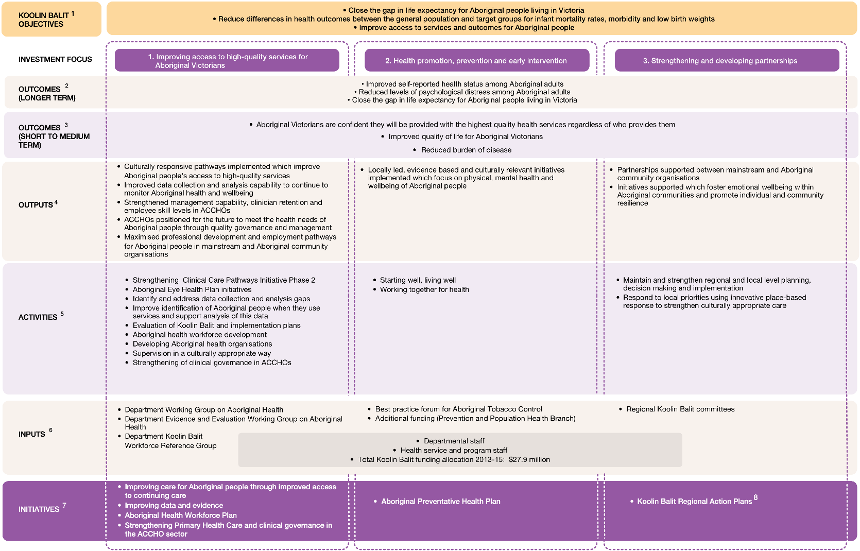
Note: ¹ Koolin Balit 2012-2022 Objectives; ² Koolin Balit 2012-2022 Whole of Life Indicators; ³ Key benefits identified in Koolin Balit Funding Implementation Plan 2013-15; ⁴Adapted from Koolin Balit Funding Implementation Plan 2013-15 Investment Aims; ⁵Adapted from Koolin Balit Funding Implementation Plan 2013-15 What We Will Do activities; ⁶Koolin Balit Funding Implementation Plan 2013-15 Resources; ⁷Koolin Balit Funding Implementation Plan 2013-15 Initiatives. ⁸ See Table 2.
Source: ACIL Allen Consulting 2014.
Expansion of Koolin Balit Program Logic to map regional activities and outputs
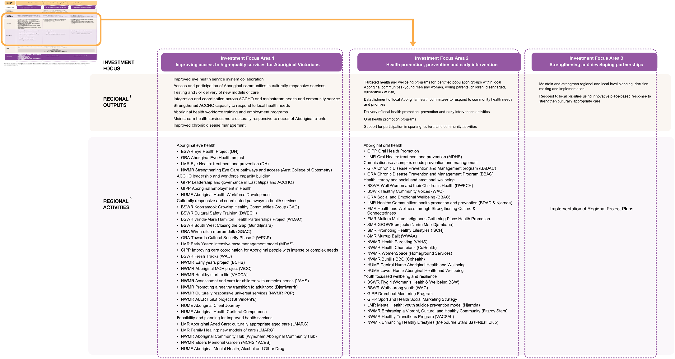
Note: ¹ and ² adapted from Koolin Balit Regional Project Plans
Source: ACIL Allen Consulting 2014.

Gee G, Dudgeon P, Schultz C, Hart A, and Kelly K, ‘Social and Emotional Wellbeing and Mental Health: An Aboriginal Perspective’, Chapter 4, In Dudgeon, Milroy and Walker (eds.) Working Together: Aboriginal and Torres Strait Islander Mental Health and Wellbeing Principles and Practice – Revised Edition, Commonwealth of Australia, Canberra, 2014, p63.
National Health Strategy Working Party 1989. A National Aboriginal Health Strategy, Canberra.
Victorian Health Promotion Foundation (VicHealth) 2011, Life is health is Life: Taking action to close the gap – Victorian Aboriginal evidence-based health promotion resource, Carlton.
National Health & Medical Research Council, 2003, Values and Ethics: Guidelines for Ethical Conduct in Aboriginal and Torres Strait Islander Health Research, Canberra.
Greenhalgh, et al (2004), Diffusion of innovations in Service Organisations: Systematic Review and Recommendations. The Milbank Quarterly, 82(4), 581-629)
King, J. A., & Volkov, B. (2005). A framework for building evaluation capacity based on the experiences of three organizations. CURA Reporter, 35(3), 10-16.

