

eReferral Standard

Digital Health - DHHS

October 2020

Department of Health

# Copyright and confidentiality statement

This work is Copyright © Department of Health and Human Services. Other than as permitted by law, no part of this document may be reproduced, stored in a retrieval system or transmitted in any form or by any other process without prior written permission.

Department of Health and Human Services reserves all rights to the information and intellectual property contained herein. This document may contain information relating to the business, commercial, financial, clinical and technical activities of Department of Health and Human Services. This information is intended for the sole use of the recipient as the disclosure of this information to a third party may expose Department of Health and Human Services to a considerable disadvantage. Except for the purpose of its intention, no part of this document may be reproduced, stored in a retrieval system or transmitted in any form by any process without prior written permission

# Table of Contents

Copyright and confidentiality statement 2

Table of Contents 3

Version control and reviews 4

1 Standard overview 5

2 Introduction 6

2.1 Background 6

2.2 Purpose 6

2.3 Benefits of eReferral 7

2.4 Assumptions 7

2.5 Scope 7

2.6 Audience/Stakeholders 8

2.7 Governing documents 9

3 eReferral solution methodology 11

3.1 Victorian Minimum Standards 13

3.2 Workflows 16

4 Conclusion 19

Appendix A – Digital Health branch 20

Appendix B – Terms and Definitions 21

Appendix C – Governing documents 22

1. Legislation 22

2. Policy/Regulation 23

3. Technical Specifications 24

4. Guidelines 25

Appendix D – Service Referral Information Requirements 26

Summary of Mandatory Fields 26

# Version control and reviews

**The following tables details the reviews on this document:**

**Endorsement:** This document is endorsed as follows:

|  |  |  |  |
| --- | --- | --- | --- |
| Version | Date | Name | Action |
| 1.0 | October 2020 | Digital Health Design and Standards Reference group (DHDSR) | Endorsed |

**Quality reviews:** This table define the reviews conducted prior to the release of this document:

| Version | | Date | Name | Action | | |
| --- | --- | --- | --- | --- | --- | --- |
| 0.2 | August 2020 | | Digital Health Design and Standards Reference group (DHDSR) | | Final review |
| 0.1 | | June 2020 | Health Sector Standards and Advisory, DHHS | Quality review | | |

**Referenced artefacts/publications:** This table identifies the various artefacts/publications referenced or considered in this document:

| Document Name | Owner /Author | Comments |
| --- | --- | --- |
| Digital Health Unified Standard | Health Sector Standards and Advisory, DHHS | Referenced |

**Authorised endorsements:** The following groups have reviewed and endorsed this document for publication:

| **Authority** | **Role/Title** |
| --- | --- |
| Digital Health Design and Standards Reference group (DHDSR) | Acting Chair: Paul Gladwell, Program Manager, Health Service ICT. Mercy Health.  Co-Chair: Terri Fiorenza (T.F), Director Health Information Services, Northern Health. |
| Digital Health branch (DH)  Department of Health & Human Services (DHHS) | Neville Board, Chief Digital Health Officer |

# Standard overview

This standard defines the minimum set of functional requirements for any implementation of electronic referrals by health services in the Victoria Public Health Sector. They are a base set of criteria, data definitions and functions that enable the secure and interoperable transfer of health information between healthcare providers external to a health service.

The standard defines minimum technical requirements that enable healthcare providers to generate a written request for the review, diagnosis or treatment of a specific condition and with pre-existing information recorded in the local clinical information system.

The standard includes both mandatory and optional requirements to be included in the eReferral. This information must be assembled in a structured format to enable the exchange of information between clinical systems. The information in the eReferral message is encrypted so only the intended referral recipient can access the information in it.

The mandatory requirements cover the categories of terminology, interfacing and conformance to Australian Digital Health Agency (the Agency) specifications, localisation to Australian and Victorian requirements and functional requirements.

For Victorian Public Health Service, this eReferral standard is based on the technical specifications that have been developed by the Agency with adjustments that are aligned to the Department of Health and Human Services (the department) policies and guidelines. This standard supports the department’s Access Policies for managing referrals.

# Introduction

## Background

The Victorian government’s Department of Human Services initiated a Primary Care Partnerships (PCP) Strategy in 2000. One of the primary objectives of the PCP strategy was to develop and utilise information and communications technology to enhance service coordination.

The department developed a suite of documents collectively known as the Service Coordination Tool Templates (SCTT) which specified information and data standards to enable standardised information to be shared electronically. This initiative was the foundation to implementing eReferral in Victorian public health services.

The Agency developed documentation which included specifications, standards, guidelines and the required digital infrastructure to enable a nationally interconnected health sector. This included the use of a common language for health communications; and created unique health care identification numbers for all individuals, providers and organisations.

These documents would provide the foundational framework and parameters for healthcare services to build capacity to better manage electronic healthcare documents including eReferral.

The Victorian government, working in partnership with the Agency, has funded multiple pilot projects to implement and test the use of the technical specifications as well as the information requirements that have been defined by the SCTT - General Practice Referral Form. The principles established through the development of the SCTT has informed the development of this eReferral standard.

## Purpose

This standard defines the principles and design considerations required by Victorian public health services to successfully implement and manage effective transition of care using eReferral.

The successful exchange of healthcare information is dependent on multiple technologies and this document identifies and references key supporting legislation, policy, technical specifications and guidelines that underpin interoperability capability from within and external to a health service.

The purpose of this standard is to:

* define the information required by Victorian public health services to implement eReferral solutions to enable secure exchange of healthcare information between independent health services.
* identify national and state policies and guidelines that inform the governance parameters directly related to use of eReferral in Victorian public health services.
* stipulate the national and state technical specifications that must be implemented in development of eReferral solutions used in Victorian public health services
* develop a methodology that can be adapted to meet the needs of current and emerging digital initiatives such as My Health Record, the Healthcare Identifier service (HI Service) and other evolving services.
* provide a summary key source documentation that informs the requirements of this standard.
* identify relevant technical specifications that:
  + defines how the eReferral document will be structured using atomic data
  + documents the configuration requirements to receive eReferral in health service applications
  + identifies how to access contemporary healthcare provider information when making an eReferral
* aligns the data elements of the referral to the clinical criteria defined by the state-wide referral criteria
  + detail how to access National Health Services Directory (NHSD) data and maintain the accuracy of healthcare provider data within NHSD
  + document the base model eReferral workflow

The application of this standard will enable consumer/patient information to be exchanged in consistent human and machine-readable format which will enable the efficient and secure exchange of health information between healthcare services.

## Benefits of eReferral

It is expected that eReferral will provide, but not limited to, the following benefits:

* Improved efficiencies through integrated workflow improvements
* Decreased administrative overheads (paper, printing, postage, fax, personnel time)
* Improved knowledge about status of referral through automated notifications
* Improved quality of referral by enforcing mandatory requirements and inclusion of information extracted from the Clinical Information System
* Improved access to referral information
* Decreased rejection of referrals due to lack of required information
* Improved patient/consumer follow-up care coordination due to improved communication between referral sender and referral receiver

## Assumptions

The following assumptions apply to the use of this standard document:

* Vendors’ products that assemble the eReferral will use codified data that has been entered into the referral sender’s primary clinical information system
* The use of free text data will be minimised
* Services will be selected from a curated list of healthcare services from a validated source.
* All messages associated with an eReferral messages will be transported via a secure/encrypted delivery channel.

## Scope

### In Scope

The Standard includes the following:

* This is for eReferral solutions to enable secure exchange of healthcare information between independent health services
* Approach for eReferral solutions to leverage existing capability to integrate current and emerging national digital health initiatives such as My Health Record, the HI service and other national repositories.
* State policies, guidelines and specifications that underpin the formal governance arrangements that inform the use of eReferral in Victorian public health services.
* Approach to identify requirements for the creation, secure transport and acknowledgement of an eReferral.
* Relevant technical specifications for the definition, documentation of configuration requirements, governance guide for roles and responsibilities of stakeholders
* Documentation of the base model eReferral workflow

### Exclusions

* This Standard does not recognise the following documents and transport platforms under the definition of an electronic referral:
  + standard unencrypted email
  + saved document attached to an email - Word, pdf, Plain Text.
  + faxed document
* The standard does not cover integration to other solutions.

## Audience/Stakeholders

This standard has application for:

* The Agency
* Department of Health and Human Services (DHHS)
* Victorian public health services planning/implementing an eReferral solution
* Primary care healthcare providers (General, Practice, Allied Health)
* Primary Health Networks (PHN)
* Vendors of eReferral solutions
* Vendors of Clinical Information Systems

## Governing documents

This Standard draws from several documents that are managed across multiple jurisdictions. The governing documents provide the parameters that directly inform the operation and/or implementation of this Standard or by which the amended workflows can be implemented. The technical specifications inform end-to-end process of creating, sending and receiving an eReferral. The governing documents are shown below and include their name, type and purpose of the document. The documents provide:

* Origins of the documents and how they relate to each other
* Function of the documents and authority responsible for their maintenance and regulation
* Information on how electronic health care information should be managed as part of the transition of care between healthcare providers

Each document has a role in defining the requirements pertaining to the content and technical structure of the eReferral document and are fully detailed in Appendix C – Governing documents.

The documents and their relationships are as shown in the figure below:

Figure 1: Governing documents

A summary of content, links to the source document and the authority responsible for administering the document are shown below:

### Legislation

**Commonwealth**

* The Privacy Act 1988
* The Healthcare Identifiers Act 2010
* Healthcare Identifiers Regulations 2010

**State**

* The Privacy and Data Protection Act 2014
* The Health Records Act 2001

### Policy/Regulation

**State**

* Specialist Clinics in Victorian public hospitals: Access policy (the Policy)
* State-wide Referral Criteria for Specialist Clinics

### Technical Specifications

**International**

* HL7 International Standards

**Commonwealth**

* Service Referral - Structured Content Specification v1.1
* Service Referral - CDA Implementation Guide v1.1

**State**

* Digital Design Unified Implementation Guide

### Guidelines

**Commonwealth**

* Service Referral - Information Requirements v1.1

# eReferral solution methodology

The eReferral solution introduces efficiencies that can only be maintained through digital workflows that include reuse of data, enforcement of mandatory fields (Appendix D – Service Referral Information Requirements, Page 25) validated referral destination details and immediate delivery of the referral requesting service. The governing documents (Section 2.7, Page 9) provides the required parameters by which the amended workflows can be implemented.

Enabling the different healthcare systems to natively send an eReferral requires each system to be updated to incorporate the necessary technical changes and workflows to send/receive eReferral.

Third party vendors have developed products that can augment the existing clinical systems to facilitate the secure exchange of referral information.

An important consideration for Victorian public health services implementing eReferral is adapting business process capabilities to align with the eReferral workflow. This increases the quality and consistency of information being exchanged between healthcare providers whilst also significantly reducing the administrative and delivery overheads.

The simplified eReferral Workflow in Figure 2 below shows a typical business process to support eReferral:

Figure 2: Simplified eReferral Workflow

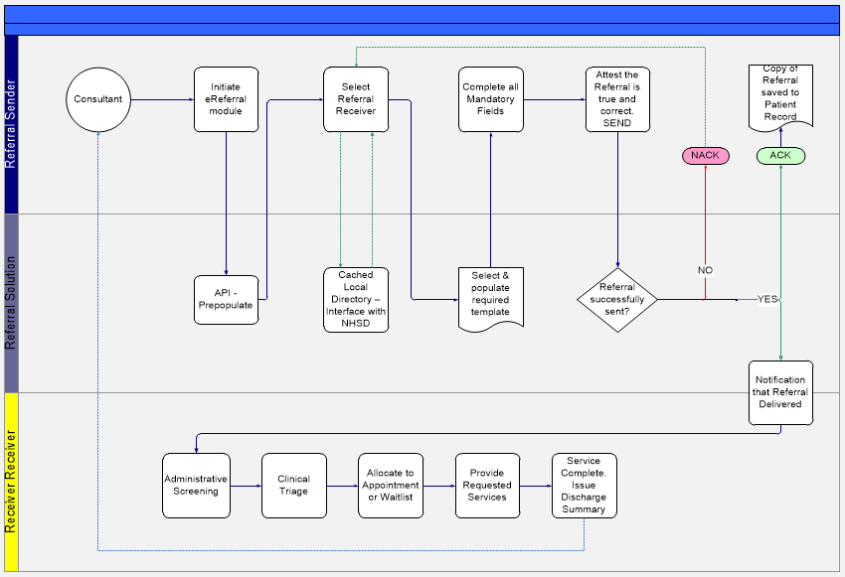

## 

## Victorian Minimum Standards

The governing documents (Section 2.7, Page 9) provides a complete overview of the documents that inform the processes and accountabilities for implementing an eReferral solution. Many of the documents identified as having a governance function to eReferral have a broader application across the health sector.

The documents that identify the underlying rationale for the inclusion of specific information in referrals and the technical requirements for transforming a standard referral into an eReferral are listed below. These documents directly inform the minimum information requirements required by Victorian public health services:

Figure 3: Key documents for eReferral implementation

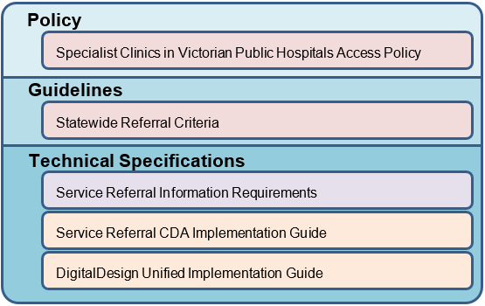

### Policy

#### Specialist Clinics in Victorian Public Hospitals Access policy

This policy provides an overview of the obligations of Victorian public health services to maximise the effective delivery of healthcare services. The policy includes standardised metrics that identify timeframes to complete key processes performed by specialist clinics.

The communication needs between the referring healthcare provider and the specialist clinic being requested to provide specialised services is outlined. Specifically, for a request to be prioritised and processed, referrals should contain:

1. patient demographic information
2. clinical information including reason for referral, presenting problems, preliminary diagnosis, physical examination results, management to date, investigation results, relevant medical and social history
3. referrer details - name, contact information, referrer provider number and signature
4. referral details - date of referral, name of specialist clinic, name of specialist to whom the person is being referred.

### Guidelines

#### Statewide Referral Criteria

The Statewide Referral Criteria (SRC) have been developed to improve access to specialist clinics in public hospitals by improving the quality and appropriateness of referrals. The documentation of standard and consistent referral criteria will provide the specialist clinics with information they need to more efficiently assess the needs of the referred patient in a timely manner.

The provision of SRC removes any confusion about investigations that should be completed before a referral is sent and provides a clearly articulated pathway to enable the exchange of health information consistently and efficiently.

The requirements of the SRC are made available to general practice and other primary care organisations via on-line referral pathways by their designated Primary Health Network E.g. Health Pathways.

Each of the referrals that have endorsed SRC, must include the completion of the Summary and Referral Information form. Currently the SRC does not differentiate between mandatory and desirable information.

The following is an overview of the common information that is requested to be completed as part of the referral:

1. **Consumer/patient demographics**

* Name
* Date of Birth
* Sex

1. **Presenting issue**
2. **Reason for referral as identified by service provider**
3. **Description of presenting and underlying identified issues**

* Presenting and underlying issues
* Significant History (medical, medication issues, developmental, functional/daily living skills, social, emotional, trauma including abuse or neglect etc)
* Social, spiritual and diversity considerations (including cultural practices, beliefs, traditions, important to the consumer
* Other

1. **Court and statutory orders**

* Mental Health Orders
* Orders relating to Children
* Intervention Orders
* Guardian and administration orders
* Other type of court or statutory order

1. **Alerts**

* Allergies
* Risks (Attach any risk assessments)
* Risk Management strategies
* There are concerns that the consumer is not capable of making their own decisions
* Enduring power of attorney are in place
* Access to the referred service has been discussed with the consumer
* Barriers to service
* Support required to address barrier to service

1. **Current services**

* *Services used in the last twelve months. Consider all health and community services*

|  |  |  |
| --- | --- | --- |
| Agency | Service Type (Code) | Record contact details or other information as appropriate  (e.g. key contact) |

1. **Referral sent**

|  |  |  |  |  |
| --- | --- | --- | --- | --- |
| Agency | Service Type (Code) | Contact Details | Purpose of referral | Feedback required |

1. **This information collected by**

* Name
* Position/Agency
* Sign
* Date
* Contact Number

### Technical Specifications

An eReferral is constructed with the same requirements as a standard referral, however, the information in the referral is assembled from codified data that is already in the referral sender’s clinical information system. To achieve this, the information that has been described in the Policy and the SRC has been defined into single data elements.

The three documents referenced as part of this standard perform three functions:

1. ***Service Referral Information Requirements***

This document presents the information requirements for the content of an eReferral, as recommended for use in Australian eHealth systems. It is therefore recommended to be implemented in any system that creates or transfers referrals.

These information requirements are a logical set of data items for exchange, and are therefore independent of any platform, technology, exchange format, or presentation format. They are the minimum set of data items that are required for implementation in any system that creates and transfers electronic referrals, to support the delivery of quality collaborative care.

The inclusion of data in this minimum set is determined by two criteria:

* the relevance of the data to a referral process; and
* the potential for the data to improve an individual’s care and well-being in a collaborative care environment.

Additionally, the document defines the information needs to enable information sharing between healthcare providers in Australia, independent of exchange or presentation formats.

1. ***Service Referral CDA Implementation Guide***

The Service Referral CDA Implementation Guide provides a guide to implementing the logical model detailed by the Agency's Service Referral Structured Content Specification as an HL7 Clinical Document Architecture (CDA) Release 2 XML document. The primary aim of the implementation guide is to take implementers step by step through mapping each data component of the Service Referral Structured Content Specification to a corresponding CDA attribute or element.

This implementation guide contains descriptions of both constraints on the CDA and, where necessary, custom extensions to the CDA, for the purposes of fulfilling the requirements for Australian implementations of eReferral solutions. The resulting CDA document can be used for the electronic exchange of eReferral information between healthcare providers.

In addition, this implementation guide presents conformance requirements against which implementers can attest the conformance of their systems.

1. ***Digital Design Unified Implementation Guide***

The Digital Design Unified Implementation Guide is intended to assist health services with definitive usage of the HL7 2.4 Standard for applications that send HL7 messages to, and receive HL7 messages from, Digital Design applications. Digital Design hosts the core financial, human resources, patient management, client management and clinical applications used by several public health services in Victoria.

The guide is generic in its purpose, and although Digital Design specific products are nominated, this is also a foundation level interoperability guide for several standardised interfaces, e.g.: Pathology and Imaging Orders and Results, Medication Orders, Patient Administration, Emergency Department, Discharge Summary and general Clinical Systems interfaces. (These topics are not within the scope of this document and are discussed in other standard artefacts).

The guide supports the design and implementation of broadly accepted and standards based HL7 2.4 interfaces between vendor applications. This guide forms the basis on which standard interfaces should be designed and implemented, with any potential variations to the guide being agreed in consultation with Digital Health branch.

## Workflows

Health services will need to modify their current workflows to align to a common, organisation wide process. Key to this change will be creating a central entry point for incoming eReferral. It will require some of the administrative supports to be rationalised as some of the manual processes will be made redundant. The enforcement of mandatory fields and the elimination of physical documents that need to be manually moved through the health service, will reduce the effort to progress a referral through the system.

The following flowcharts provide an example of the flow of information based on the current referral processes and via the eReferral process.

### Standard Referral Workflow

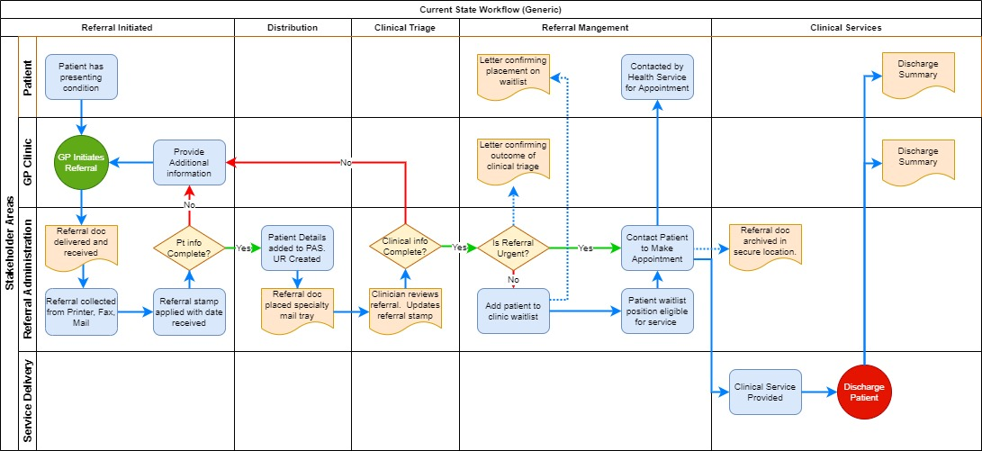

### eReferral Workflow

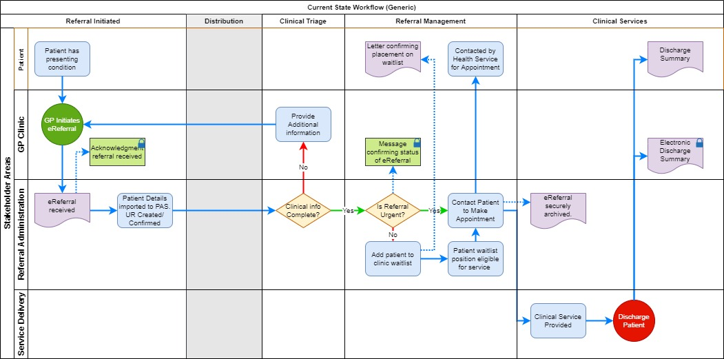

# Conclusion

To enable the successful transition of health information between healthcare providers it is imperative that the eReferral solutions align with the requirements that have been defined by the department’s SRC guidelines and the technical requirements defined by the Agency. Collectively this combines to define the requirements to create an eReferral that can be sent securely between healthcare providers.

Health services will need to review both current and reviewed (i.e. to be) business processes to identify the required changes to enable the effective use of eReferral. As part of the review it will be necessary to align the existing paper-based processes with the digital workflow to minimise duplication of processes and potential confusion.

This standard will evolve as the sector’s digital maturity increases, the requirements of the national health sector develop, and the expectations of healthcare recipients increase. Changes to this standard will be done in consultation with jurisdictions, health sector representatives and subject matter experts in the vendor community.

# Appendix A – Digital Health branch

The Digital Health branch led by the Chief Digital Health Officer reports to the Deputy Secretary of Health and Wellbeing. As a branch in the Health and Wellbeing division, Digital Health collaborates closely with a wide range of stakeholders across the department, sector agencies and other jurisdictions to perform the following functions:

* Provides engagement, standards, policy advice, planning and assurance functions across the health sector in the areas of digital health
* Is responsible for the system management required to operationalise health sector reform
* Provides outward-facing whole of health sector leadership in digital health enablement as well as commissioning of digital health and ICT functions
* Maintain a close working relationship with other branches of the division which has the levers, relationships and responsibilities across the health system to ensure digital projects are properly governed, resourced, and ensure all risks are well managed
* Guides health ICT initiatives towards an interoperable future eHealth environment using well-established standards, best practice guides, methodologies and principles

Digital Health utilises the people, process and technology components, with a strong emphasis on transformational change elements when implanting new health systems and workflow processes.

Digital Health focus on four areas:

1. Digital Health strategy, policy and architecture standards for the Victorian health sector.
2. Commissioning of digital health functions within Victorian public health services.
3. Sponsoring digital health programs to implement sector-wide health information sharing platforms including those at a national level (to which Victoria contributes) as well as sector-enabling capabilities sponsored by DHHS.
4. Health service system management function including sector assurance (e.g. major program, operations and cybersecurity).

Digital health program areas include:

* Health Sector Standards and Advisory (HSSA) which provide information on emerging health technologies, feasibility, architecture, design and integration.
* Sector Assurance which provides assurance on all approved health service projects funded or co-funded by the government to ensure health services operate safely, securely and cost-effectively.
* Sector Governance and Reporting which provides governance and reporting on the system manager function and the overall digital health branch function.
* Health Sector Planning which provide planning and pipeline management for the health sector, managing concept proposals, business bases, funding bids and subsequently funding allocation and funding agreements.

HSSA is committed to open, independent and best practice view of healthcare Information and Communication Technology (ICT), application solution principles. HSSA can provide recommendations to the overarching enterprise application design and associated services to integrate healthcare applications.   
For this guide, HSSA will:

* Deliver guides and advice around interoperability across healthcare applications
* Define messaging standards for Victorian health applications.
* Facilitate a higher level of integration knowledge and associated quality processes in the Victorian health sector.
* Align innovation, efficiencies and effective use of ICT within health to encourage and drive standards-based approaches that encourage a high level of interoperability.

# Appendix B – Terms and Definitions

|  |  |
| --- | --- |
| Term | Description |
| CDA | Clinical Document Architecture |
| DHDSR | Digital Health Design and Standards Reference Group |
| eReferral | Electronic Referral |
| GP | General Practitioner |
| HL7 | Health Level 7, a widely accepted standard to support exchange of medical information, both administrative and clinical |
| HI Service | Healthcare Identifiers Service |
| HSSA | Health Services Standards and Advisory |
| HTS | Health Technology Solutions |
| ICT | Information & Communication Technology |
| MHR | My Health Record (Formally PCEHR) |
| NEHTA | National Electronic Health Transition Authority |
| NHSD | National Health Services Directory |
| PCEHR | Personally Controlled Electronic Health Record |
| PCP | Primary Care Partnerships |
| PHN | Primary Health Network |
| SCTT | Service Coordination Tool Templates |
| SRC | Statewide Referral Criteria |
| the Agency | Australian Digital Health Agency |
| the department | Victorian Department of Health & Human Services |
| the Policy | The Specialist Clinics in Victorian public hospitals Access policy |

# Appendix C – Governing documents

## Legislation

### Commonwealth

|  |  |
| --- | --- |
| ***Document:*** | **The Privacy Act 1988** |
| ***Link:*** | <https://www.oaic.gov.au/privacy/the-privacy-act> |
| ***Administered by:*** | Office of Australian Information Commissioner. |
| ***Description:*** | A national law that protects personal information that is collected and handled by Federal Government organisations, such as Centrelink and the Australian Tax Office.  The legislation has application to some private organisations, which includes but is not limited to banks and telecommunications providers |
| ***Document:*** | **The Healthcare Identifiers Act 2010** |
| ***Link:*** | <https://www.legislation.gov.au/Details/C2017C00239> |
| ***Administered by:*** | Office of Australian Information Commissioner regulates privacy aspects |
| ***Description:*** | A national law that implements a national system for assigning unique identifiers to individuals, healthcare providers, and healthcare provider organisations. The identifiers are assigned and administered through the Healthcare Identifiers Service (HI Service), currently operated by the Chief Executive Medicare |
| ***Document:*** | **Healthcare Identifiers Regulations 2010** |
| ***Link:*** | <https://www.legislation.gov.au/Details/F2017C00833> |
| ***Administered by:*** | Office of Australian Information Commissioner. |
| ***Description:*** | The Regulations set out provisions relating to the assignment, collection, use, adoption and disclosure of healthcare identifiers. The Regulations do not seek to regulate other aspects of electronic health |

### State

|  |  |
| --- | --- |
| ***Document:*** | The Privacy and Data Protection Act 2014 |
| ***Link:*** | <https://jade.io/article/347583> |
| ***Administered by:*** | Office of Victorian Information Commissioner |
| ***Description:*** | A Victorian law that protects the privacy of personal information when handled by Victorian public sector organisations, including Victorian government departments, local councils, statutory offices, government schools, universities and TAFEs.  The legislation has application to personal information when it is handled by private or community sector organisations who are carrying out functions for or on behalf of a Victorian public sector organisation. |
| ***Document:*** | The Health Records Act 2001 |
| ***Link:*** | <https://www.legislation.vic.gov.au/in-force/acts/health-records-act-2001/045> |
| ***Administered by:*** | Health Complaints Commissioner |
| ***Description:*** | A Victorian law that protects health information that is held by public and private health service providers in Victoria.  In addition to qualified healthcare providers, the legislation applies to any other organisation that holds health information, such as fitness centres and employers. |

## Policy/Regulation

### State

|  |  |
| --- | --- |
| ***Document:*** | **Specialist Clinics in Victorian public hospitals: Access policy** |
| ***Link:*** | <https://www2.health.vic.gov.au/about/publications/policiesandguidelines/Specialist-clinics-in-Victorian-public-hospitals-Access-policy> |
| ***Administered by:*** | Department of Health and Human Services Health Service Policy Branch |
| ***Description:*** | The Policy outlines the Victorian Government’s expectations for service delivery.  These include indicative timeframes for the completion of key processes performed by specialist clinics. |
| ***Document:*** | **Statewide Referral Criteria for Specialist Clinics** |
| ***Link:*** | <https://src.health.vic.gov.au/> |
| ***Administered by:*** | Department of Health and Human Services Health Service Policy Branch |
| ***Description:*** | The department has developed state-wide referral criteria to assist GPs and clinicians referring patients to specialist clinics. These referral criteria have been developed to improve access to specialist clinics in public hospitals by improving the quality and appropriateness of referrals. |

## Technical Specifications

### International

|  |  |
| --- | --- |
| ***Document:*** | **HL7 International Standards** |
| ***Link:*** | <https://www.hl7.org/> |
| ***Administered by:*** | HL7 International |
| ***Description:*** | Health Level Seven International (HL7) is a not-for-profit, ANSI-accredited standards developing organization dedicated to providing a comprehensive framework and related standards for the exchange, integration, sharing, and retrieval of electronic health information that supports clinical practice and the management, delivery and evaluation of health services. HL7 is supported by more than 1,600 members from over 50 countries. |

### Commonwealth

|  |  |
| --- | --- |
| ***Document:*** | **Service Referral - Structured Content Specification v1.1** |
| ***Link:*** | <https://developer.digitalhealth.gov.au/specifications/clinical-documents/ep-2718-2018/dh-2638-2018> |
| ***Administered by:*** | This document describes the recommended structured content of service referral documents for exchange between health and human service providers in Australian digital health systems. |
| ***Description:*** | Australian Digital Health Agency |
| ***Document:*** | **Service Referral - CDA Implementation Guide v1.1** |
| ***Link:*** | <https://developer.digitalhealth.gov.au/specifications/clinical-documents/ep-2718-2018/dh-2639-2018> |
| ***Administered by:*** | Australian Digital Health Agency |
| ***Description:*** | This document provides a guide to implementing the logical model detailed by the Agency's Service Referral Structured Content Specification as an HL7 Clinical Document Architecture (CDA) Release 2 XML document. This implementation guide is based on Version 1.1 of the Service Referral. The primary aim of the implementation guide is to take implementers step by step through mapping each data component of the Service Referral Structured Content Specification to a corresponding CDA attribute or element |

### State

|  |  |
| --- | --- |
| **Document:** | **Digital Design Unified Implementation Guide** |
| ***Link:*** | <https://www2.health.vic.gov.au/hospitals-and-health-services/quality-safety-service/digital-health/dh-standards-guidelines/digital-design-unified-implementation-guide> |
| ***Administered by:*** | Department of Health and Human Services Health Sector Standards and Advisory |
| ***Description:*** | The Digital Design Unified Implementation Guide is intended to assist health services with definitive usage of the HL7 2.4 Standard for applications that send HL7 messages to, and receive HL7 messages from, Digital Design applications. Digital Design hosts the core financial, human resources, patient management, client management and clinical applications used by several public health services in Victoria.  The guide is generic in its purpose, and although Digital Design specific products are nominated, this is also a foundation level interoperability guide for several standardised interfaces, e.g.: Pathology and Imaging Orders and Results, Medication Orders, Patient Administration, Emergency Department, Discharge Summary and general Clinical Systems interfaces. |

## Guidelines

### Commonwealth

|  |  |
| --- | --- |
| ***Document:*** | **Service Referral - Information Requirements v1.1** |
| ***Link:*** | <https://developer.digitalhealth.gov.au/specifications/clinical-documents/ep-2718-2018/dh-2675-2018> |
| ***Administered by:*** | Australian Digital Health Agency |
| ***Description:*** | This document presents the information requirements for the content of a Service referral, as recommended for use in Australian eHealth systems. It is therefore recommended to be implemented in any system that creates or transfers referrals. Note that it does not cover the content of communication exchanges between organisations related to workflow. |

# Appendix D – Service Referral Information Requirements

## Summary of Mandatory Fields

|  |  |  |  |
| --- | --- | --- | --- |
| **INDIVIDUAL** | | |  |
|  |  | Individual section | mandatory |
|  |  | Individual identifier | mandatory |
|  |  | Individual identifier Issuer | mandatory |
|  |  | Individual's family name | mandatory |
|  |  | Individual's sex | mandatory |
|  |  | Individual's date of birth | mandatory |
|  |  | Individual's address | mandatory |
|  |  | Indigenous status | mandatory |
| **SERVICE REFERRAL DETAIL** | | |  |
|  |  | Request Date and time | mandatory |
| **CURRENT AND PAST MEDICAL HISTORY** | | |  |
|  |  | Problem/Diagnosis description | mandatory |
|  |  | Procedure name | mandatory |
| **CURRENT MEDICATIONS** | | |  |
|  |  | Exclusion statement - medications | mandatory |
|  |  | Therapeutic good identification | mandatory |
|  |  | Medication directions | mandatory |
| **ADVERSE REACTIONS** | | |  |
|  |  | Exclusion statement - adverse reactions | mandatory |
|  |  | Substance/agent | mandatory |
| **CURRENT SERVICES** | | |  |
|  |  | Current service agency name | mandatory |
|  |  | Current service, service type | mandatory |
| **ALERTS** | | |  |
|  |  | Alert type | mandatory |
|  |  | Alert description | mandatory |
| **DOCUMENT AUTHOR** | | |  |
|  |  | Document author section | mandatory |
|  |  | Healthcare provider identifier | mandatory |
|  |  | Healthcare provider identifier issuer | mandatory |
|  |  | Healthcare organisation identifier | mandatory |
|  |  | Healthcare organisation identifier issuer | mandatory |
|  |  | Healthcare provider family name | mandatory |
|  |  | Healthcare provider organisation name | mandatory |
|  |  | Healthcare provider employer organisation electronic communication detail | mandatory |
|  |  | Healthcare provider professional role | mandatory |

|  |  |  |  |
| --- | --- | --- | --- |
| **NOMINATED CONTACTS** | | |  |
|  |  | Nominated contact - person or organisation | mandatory |
|  |  | Individual's family name | mandatory |
|  |  | Nominated contact's means of contacting | mandatory |
|  |  | Nominated contact person identifier | mandatory |
|  |  | Organisation name | mandatory |
|  |  | Nominated contact's means of contacting | mandatory |
| **PRIMARY CARE PROVIDER** | | |  |
|  |  | Healthcare provider identifier | mandatory |
|  |  | Healthcare provider identifier issuer | mandatory |
|  |  | Healthcare organisation identifier | mandatory |
|  |  | Healthcare organisation identifier issuer | mandatory |
|  |  | Healthcare provider family name | mandatory |
|  |  | Healthcare provider organisation name | mandatory |
|  |  | Healthcare provider professional role | mandatory |
|  |  | Organisation name | mandatory |
|  |  | Healthcare organisation identifier | mandatory |
|  |  | Healthcare organisation identifier issuer | mandatory |
| **REFERRAL RECEIVER** | | |  |
|  |  | Healthcare provider identifier | mandatory |
|  |  | Healthcare provider identifier issuer | mandatory |
|  |  | Healthcare organisation identifier | mandatory |
|  |  | Healthcare organisation identifier issuer | mandatory |
|  |  | Healthcare provider family name | mandatory |
|  |  | Healthcare provider organisation name | mandatory |
|  |  | Healthcare provider employer organisation electronic communication detail | mandatory |
|  |  | Healthcare provider professional role | mandatory |
|  |  | Organisation name | mandatory |
|  |  | Healthcare organisation identifier | mandatory |
|  |  | Healthcare organisation identifier issuer | mandatory |
|  |  | Healthcare organisation electronic communication details | mandatory |
| **INTERESTED PARTIES TO RECEIVE CORRESPONDENCE** | | |  |
|  |  | Interested parties - person or organisation | mandatory |
|  |  | Healthcare provider identifier | mandatory |
|  |  | Healthcare provider identifier issuer | mandatory |
|  |  | Healthcare organisation identifier | mandatory |
|  |  | Healthcare organisation identifier issuer | mandatory |
|  |  | Healthcare provider family name | mandatory |
|  |  | Healthcare provider organisation name | mandatory |
|  |  | Healthcare provider employer organisation electronic communication detail | mandatory |
|  |  | Healthcare provider professional role | mandatory |
|  |  | Organisation name | mandatory |
|  |  | Healthcare organisation identifier | mandatory |
|  |  | Healthcare organisation identifier issuer | mandatory |
|  |  | Healthcare organisation electronic communication details | mandatory |
| **ENTITLEMENTS** | | |  |
|  |  | Entitlement Type | mandatory |
|  |  | Entitlement Number | mandatory |
| **DIAGNOSTIC INVESTIGATIONS** | | |  |
|  |  | Investigation type | mandatory |
|  |  | Investigation name | mandatory |
|  |  | Result status | mandatory |
| **ATTACHMENTS** | | |  |
|  |  | Attachment name | mandatory |
| **DOCUMENT CONTROL** | | |  |
|  |  | Document instance identifier | mandatory |
|  |  | Document version number | mandatory |
|  |  | Date and time of document creation | mandatory |
|  |  | Document type | mandatory |

|  |
| --- |
| To receive this publication in an accessible format email DigitalHealth@dhhs.vic.gov.au  Authorised and published by the Victorian Government, 1 Treasury Place, Melbourne.  © State of Victoria, Department of Health and Human Services, October 2020. |