Application solution guide

Digital Health Standard

September 2020

Department of Health

Copyright and confidentiality statement
This work is Copyright © Department of Health and Human Services. Other than as permitted by law, no part of this document may be reproduced, stored in a retrieval system or transmitted in any form or by any other process without prior written permission.
Department of Health and Human Services reserves all rights to the information and intellectual property contained herein. This document may contain information relating to the business, commercial, financial, clinical and technical activities of Department of Health and Human Services. This information is intended for the sole use of the recipient as the disclosure of this information to a third party may expose Department of Health and Human Services to a considerable disadvantage. Except for the purpose of its intention, no part of this document may be reproduced, stored in a retrieval system or transmitted in any form by any process without prior written permission.

Table of Contents
Copyright and confidentiality statement 2
Table of Contents 3
Version control and reviews 5
1 Overview 7
2 Introduction 8
2.1 Background 8
2.2 Document Purpose 9
2.3 Scope 9
2.4 Audience/Stakeholders 10
2.5 Other related specifications 10
3 Generic Design Principles 11
3.1 Health Application Solution Objectives 11
3.2 Application Initiation requirements 11
3.3 Application Function requirements 12
3.4 Governance 13
4 Design elements for health application 14
4.1 EMR Results reporting and order entry 14
4.2 EMR Results and Orders model (EMR as a master system for generating orders) 16
4.3 EMR – Medications Design 18
4.4 EMR Medications solution design configuration 18
4.5 EMR Medications design constraints and assumptions 19
4.6 EMR Medications management model 20
4.7 Code Set Design 24
4.8 Standards 26
4.9 Summary of Principles and Constraints 27
Appendix A – Digital Health branch 29
Appendix B – Terms and Definitions 31

List of Tables
No table of figures entries found.

List of Figures
Figure 1: Application Solution Design Governance 13
Figure 2: Results and Orders Model (EMR as a master system for generating orders) 17
Figure 3: Patient encounter history of medications across episodes 19
Figure 4: Allerts and Allergies model 1 23

Version control and reviews
Developers: This table identifies the developer and subject matter expert of this document:
Version | Issue Date | Author | Comments
1.0 | 09/09/20 | Digital Health branch | Final

Quality reviews: The table defines the reviews conducted prior to the release of this document:
Version | Date | Name | Action
0.3 | 04/09/20 | Digital Health branch (DHHS) – Final review | Final editorial review
0.2 | 18/06/20 | Digital Health Design and Standards Reference Group (DHDSR) | Review and endorsement

Referenced artefacts/publications: This table identifies the various artefacts/publications referenced or

considered in this document:
Document Name | Owner /Author | Comments
Digital Design unified implementation guide | Digital Health branch | https://www2.health.vic.gov.au/hospitals-and-health-services/quality-safety-service/digital-health/dh-standards-guidelines/digital-design-unified-implementation-guide
Statewide pathology and imaging catalogues | Digital Health branch | https://www2.health.vic.gov.au/hospitals-and-health-services/quality-safety-service/digital-health/dh-standards-guidelines/statewide-pathology-imaging-catalogues
eHealth Prescription Record v1.2.1 | Digital Health branch | https://developer.digitalhealth.gov.au/specifications/clinical-documents/ep-2689-2018
DH Health Systems HL7 2.4 Unified Specification | Digital Health branch | The HL7 event messaging specification was devised to improve interoperability with any Digital Health application, however the HL7 Unified event messaging specification can be adopted, adapted or referenced as a guide for any Health Service implementing an EMR.

Endorsements and approvals: This document is endorsed and approved for publication as follows:
Version | Date | Authorized Officer and role | Action
0.4 | 18/06/20 | Zoltan Kokai (DHDSR Chair)  Executive Director, Information Technology and Capital Projects, Eastern Health. | Endorsed.
FINAL | 24/07/20 | Neville Board,  Chief Digital Health Officer, Digital Health branch,  Department of Health & Human Services | Endorsed.

Overview
This guide defines the principles and design considerations to successfully implement and manage key Clinical and Electronic Medical Record (EMR) applications within a complex digital environment.
eHealth is a complex environment in which many healthcare applications interact with each other. In addition, national initiatives require interaction with national identifiers (IHI, HPI-O, HPI-I) and the My Health Record.
The guide aims to provides a foundation for health services as they traverse through their digital health journey.
The guide covers:
- Application initiation requirements, which are standard requirements to successfully implement a digital health project.
- Functional requirements to ensure the application delivers key clinical scope.
- Governance to manage delivery of the application within the complex environment.
- Solution guidance for key clinical applications i.e. Design configuration, constraints and assumptions for EMR, Alerts and Allergy Design (as an example).
Also included are the international, national and local Victorian standards appropriate for the implementation of key clinical applications.

Introduction

Background
The Victorian Department of Health and Human Services (the department) specifies digital health standards and guides to the Victorian Public Health Sector (VPHS). These standards and guides not only support inter-operability within the state in the current environment, but position health services to better receive and implement national initiatives, like My Health Record. The Digital Health branch has worked with the Australian Digital Health Agency (ADHA) over the past decade, to provide a foundation for better national inter-operability. The branch has delivered the Digital Design Unified Implementation, Medications catalogues and design principles localised to the Victorian health care environment.
Health services can determine functional requirements for their future applications. This document addresses key considerations and design principles to successfully implement and manage applications in the health service. It provides guidance to health services, to ensure implementation and management of applications comply with the principles listed here and adhere to the common standards across the solutions.
This document was developed by Digital Health branch of DHHS (For more information on the digital health branch refer to appendix A) and should be included in any tender for a new key application. For further clarification of this standards, the Digital Health branch can be contacted on digitalhealth@dhhs.vic.gov.au, or as per the contact details available on the DHHS Digital Health’s website.
More information on ADHA and Victorian standards can be found at:
- https://www.digitalhealth.gov.au/
- https://www2.health.vic.gov.au/hospitals-and-health-services/quality-safety-service/digital-health/dh-standards-guidelines
Australian Digital Health Agency has delivered a suite of national eHealth services in conjunction with technology partners. The services include:
- My Health Record
- The Healthcare Identifiers (HI) Service, supporting access to national identifiers for patients, healthcare provider organisations (i.e. health services) and healthcare provider individuals (i.e. clinicians).
- Electronic Transfer of Prescriptions (eTP) – delivery pending
- The National Authentication Service for Health (NASH)
  - Discharge Summary
  - Electronic Referral
  - Shared Health Summary
  - Event Summary
  - Specialist letter
  - Diagnostic Imaging Report
  - Pathology Report
  - Prescription and Dispense Records

Document Purpose
The purpose of this document is to provide guidance and identify pertinent considerations to successfully implement and manage key clinical applications in acute health services.
The guide includes the following:
- Defines generic design principles which are based on an overview of common healthcare applications and how this suite of products interacts with the national initiatives, including national identifiers (IHI, HPI-O, HPI-I) and the MyHealth record.
- Includes a more detailed overview of the introduction to an Electronic Medical record (EMR) and how the suite of modules will interact with other health services applications (i.e. PAS)
- Contributes to the digital maturity of the application being implemented for the health service.

Scope

In Scope
The guide includes the following:
- Application initiation requirements and Governance
- Principles for interaction of common healthcare applications with national initiatives.
- Detailed overview of Electronic Medical Record (EMR) and interaction to health service applications.

Audience/Stakeholders
The intended audience for this document includes:
- Victoria public health services
- Digital Health branch
- DHHS Health Sector Solutions Unit
- DHHS Health Technology Solutions

Other related specifications
Other related specifications to this guide include:
- SNOMED-CT
- ICD-10
- Pharmaceutical Benefit Scheme (PBS)
- Australian Medicines Terminology (AMT)
- National Human Service Directory
- HL7 2.4

Generic Design Principles

Health Application Solution Objectives
Health Application Solution objectives generally have some common objectives that drive the solution and its design. Typical objectives include:
- Increase the quality and safety of care and improve health outcomes for patients and health services
- Increase the efficiency of healthcare provision
- Increase the effective management and utilisation of resources
- Attract, retain and support a highly skilled workforce
- Build a unified and integrated healthcare system
- Develop a more consumer-oriented healthcare system
For these objectives to be realised, appropriate governance structures need to be in place.

Application Initiation requirements
While health service ICT projects will vary depending on business requirements, there are several basic initiation requirements which should be included in any project. When initiating a typical health service project for application configuration/implementation and/or overall solution design, consideration should be given to the followings:
- Confirm executive endorsement to support the project through a strong high-level project brief.
- Business requirements and scope: The relevant stakeholders should review and approve the high-level business requirements through established approaches. Confirm approval prior to product selection and/or solution development with key business stakeholders and representatives of key user groups.
- Initial projected expenditure should be outlined to determine the magnitude and cost of the desired outcome. Details to be provided/supplied in the Business Case.
- Develop and get approval for an appropriate business case to include justification for the project, governance structures and process, funding, resourcing, duration and appropriate scope definitions.
- Perform a high-level gap analysis and feasibility process including a high-level design process in the form of an architecture. Also, define a view of the current and future state vision. This process determines the cost impacts, areas of business change, and associated changes within the health service environment that would need to change because of the initiative.
- Once the project is approved and executive endorsement is confirmed, initiate funding arrangements, proceed to product selection, undertake procurement and move to the delivery/development phase.

Application Function requirements
The project needs to clearly articulate the solution scope, specifically itemising what is in scope and what is out of scope and list cost impacts. Examples of such items in scope are:
- Implementation of an enterprise/national patient master index.
- Implementation of a data warehouse or consolidated reporting solution.
- Any interfaces required outside of agreed functional and contract scope.
- EMR integration with specialist clinical applications (for example, ICU and cardiology).
- Department of Health activity reporting systems.
From this point, application design, integration design, business change activity, and overall solution design can progress. These activities may follow a typical Software Development Life Cycle (SDLC) or any other appropriate project delivery methodology.

Governance

Application Solution design governance
A typical health service project for application configuration/implementation and/or overall solution design should include a governance process.
A Product or Project Planning Group (PPG) for each heath service application to work together with integration services should be established to ensure that application functions are designed appropriately and can interface with applications from across the health service product set. A solution architecture role provides support and guidance to assist health services achieve strategic business goals that impact on the solution design. Typically, the following types of groups govern design. Each group has a defined set of responsibilities, operational scope and context.
- Health Service PPG: Initial implementation configuration and product specific enhancements to applications are managed by the relevant project team and/or project/product planning group.
- Health Service Integration Services: A group or role of this nature is responsible for the design and design principles of any interfaces across health service applications. Interfaces should follow the business and functional requirement where practical and feasible.
- Heath Service Application Solution Architecture role/group (SA): This group/role governs the use of business solution architecture for the health service solution suite of applications and the functional interoperability. The SA should evolve the solution design toward alignment with national strategies.
Figure 1: Application Solution Design Governance

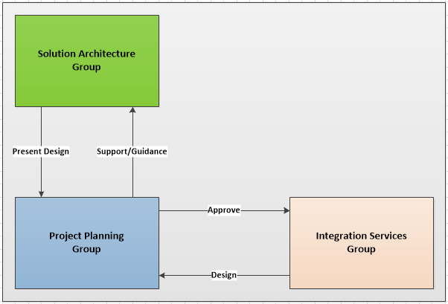

Design elements for health application
This section describes the design elements for EMR, a key health application. The following solution design elements are integral to developing an EMR solution.
Within Victorian public health services, the term EMR refers to a patient-centred system that staff can use to fulfil their patient-care duties without using paper medical records and which is created and resides within a single healthcare organisation.
An EMR is an electronic record that contains enough information to identify the patient to whom it relates and information relevant to that patient's treatment. An EMR record is a transformation of a patient’s paper medical record into an electronic form. This includes medical history, the results of any physical examination or tests performed, clinical notes, emergency visits and information relating to allergies or other factors that may require special consideration. Transforming the patient’s record into an electronic version adds further clarification for clinicians including decision support, drug interactions, duplicate drug checking and alerts.
To achieve the Health ICT project objectives and principles, health services can adopt a similar model to the HIMSS EMRAM model to track EMR progress.
The introduction of an EMR to a health service enables some common objectives and benefits to be realised.
Some key benefits realised by the introduction of an EMR are:
- Reduction in the occurrence of medical adverse events
- Reduced risks to businesses e.g. quality & safety including patient safety
- Reduced time locating/collecting patient information
- Reduction in transcription, legibility and omission errors
- Enables delivery of clinically relevant information at the point of care
- Reduction in the number of administrative tasks, leading to efficiencies in providing services
The cornerstone of most health ICT programs is the interoperability between systems, and the use of an overarching design facilitates this delivery.
The introduction of EMRs and clinical systems is associated with a lift in a health service’s digital maturity. EMRs will generally include the following functions and specialist EMR modules.

EMR Results reporting and order entry
Health service EMRs are the designated applications for initiating orders and receiving results. An EMR implementation scope should ideally be restricted to one pathology system and one imaging system.
The EMR should be designed to bring together, for the treating clinical team, and pathology and imaging systems within a health service. The design parameters for this to be achieved should be reviewed during a health service implementation planning study process which can be undertaken in conjunction with the Department of Health & Human Services (DHHS).

- Order Entry Solution design configuration
The recommended design for a centralised EMR order entry and result reporting solution should
apply the following parameters:
- Orders should only be initiated from the EMR. This is a fundamental quality design principle to ensure that there is a single source of truth for all orders. The reason for this design principle is to ensure that clinical decisions support can be facilitated in relation to this process, including drug monitoring and duplicate ordering checking. Although health services may wish to initiate orders from other systems, such as emergency, this approach is not recommended when utilising an EMR as there is an added risk of not being able to check duplicate orders. In the Victorian context, pathology results are typically capable of being received as discrete information; it is common for other results to be received as a report. Where pathology and imaging department software has the capability to initiate orders, this functionality should only be accepted for add-on or reflex orders.
- An EMR should reference a state-wide or national pathology and imaging catalogue. Decision support is a key EMR capability and reporting can be severely compromised without this standardisation in place. DHHS can provide information on Victorian pathology and imaging catalogue definitions should Victorian health services be adopting an EMR.
- EMR should act as the master and allocate relevant unique identifiers for orders and results. For example, the placer, accession and order identifiers.
- Ideally, “send out” test orders should be transmitted by hosted pathology or imaging third party applications and not by the “send out” laboratories to avoid duplication.
- Results and Order Design constraints and assumptions
The following constraints currently apply to results and ordering design in an EMR:
- Transmitting orders and results from multiple pathology/imaging services is discouraged. Although it is possible for a health service to have multiple providers, the following parameters need to be considered:
  - The EMR should treat multiple pathology or imaging services at a health service as if they are one. Victoria has defined a state-wide pathology and imaging catalogue. Ideally catalogue test codes should not overlap across two or more result providers. Each catalogue item should be unique to each pathology/imaging systems. If the same test was ordered simultaneously and received by multiple pathology/imaging systems, then it would not be possible to resolve/compare testing information, (reference ranges, etc). Consequently, results would display varying reference ranges and abnormal predictors would vary. The issue is more prominent for high volume cumulative result views.
  - Health service will need to determine the relevant rules for routing orders to the correct pathology/imaging system.
  - Add-on, reflex and send-out tests must also be managed uniquely across multiple providers. The same add-on, reflex or send-out cannot be initiated across multiple systems.
  - State-wide pathology and imaging catalogues: Victoria has defined a state-wide definition for pathology and imaging catalogues. The catalogue was created by a Pathology and Imaging Clinical System Working Group. This group has representation from health services across Victoria. It was determined by this working group, that to adequately address the unique requirements of pathology or imaging for Victoria, a Victorian catalogue was required. This process was performed in consultation with the ADHA. It is recommended that any health services embarking on an EMR journey should consider the state-wide pathology and imaging catalogue and should map local pathology and imaging system codes to the state-wide pathology and imaging catalogues.
  - Pathology and imaging - patient details. An EMR relies on accurate and unique patient identifier details across a health service. It is critical that the health service patient administration system (PAS) is the trusted source for patient identifiers and associated details, and that the pathology and imaging system is integrated with the PAS/EMR. A publish and subscribe messaging methodology must be used for this synchronisation. This enables immediate and efficient synchronisation. Query-based methodologies are only accurate at the time that information is requested, leading to lack of concurrency of information and therefore potential inaccuracy in the calculation of clinical result information. Query-based methodologies in this context typically have unnecessary heavy messaging loads and have an impact on system performance.

EMR Results and Orders model (EMR as a master system for generating orders)
The model below shows the flow of information for an EMR. The model includes other systems connected to a health service as an example. The EMR should be the master system for generating all
orders.

Figure 2: Results and Orders Model (EMR as a master system for generating orders)
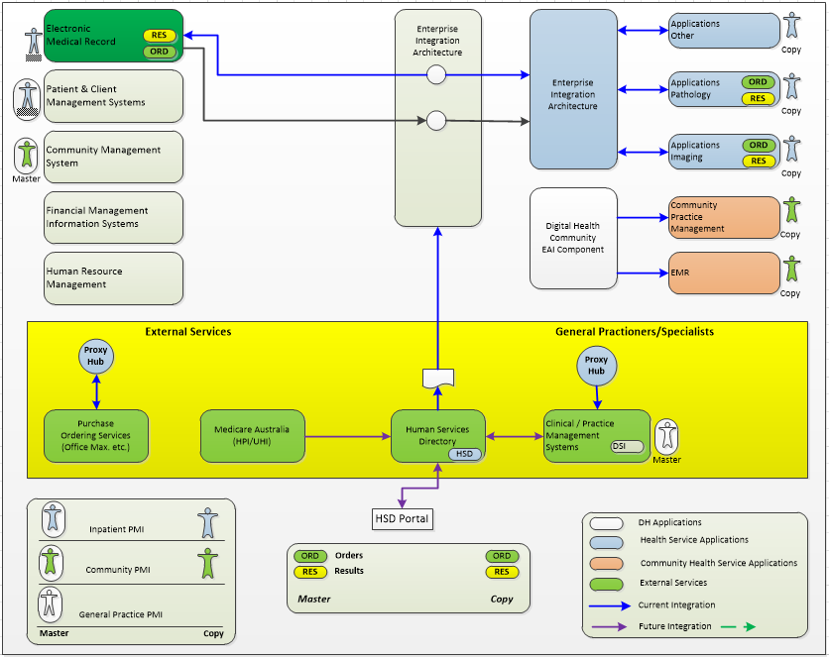

EMR – Medications Design
The health service EMR is usually the designated master system for medications management. This includes discharge medications, medications history, electronic medication administration for inpatients, and inpatient and outpatient medication orders. One of the core principles of any EMR is to reduce medication errors. For this to be realised and managed effectively, a single source of truth for this information should be nominated, otherwise there is potential for repeat/or contradicting administration or prescription orders for a patient. It is recommended that an EMR should rely on or be mapped to the ADHA’s medication catalogue, AMT (Australian Medicines Terminology), and associated SMOMED content. AMT has been developed and proven to be “fit for purpose”, unambiguously identifying Therapeutic Goods Administration (TGA) identified 'registrable' medicines, marketed for clinicians in Australia; that provides the following activities:
- Prescribing
- Recording
- Review
- Supply
- Administration and communication of the above in a discharge summary.

EMR Medications solution design configuration
A health service EMR medications design should adhere to the following design parameters:
- Medication orders (for both inpatients and outpatients) and other associated medication functions should ideally be initiated in the EMR.
- The EMR should be designed to share the following controlled information with other applications, for specific business processes:
  - The EMR design should include a very simple and standard interface to a pharmacy application for business continuity around stock control and other administrative non-clinical functions
  - Medication history and current medications on discharge should be included in the discharge summary for distribution to general practitioners and other providers
- Prescriptions that are for outpatient visits may be printed for the patient. Patients may choose to use the hospital pharmacy or local pharmacy to dispense medications for this order. Community/Outpatient prescriptions in electronic format should follow ADHA electronic transfer of prescriptions (ETP) or ePrescribing standards.
- Prescriptions orders for discharge may also be printed and may be validated by the clinical pharmacist within the EMR.
- Dispensing label generation should remain in the pharmacy system. Ideally medication orders should be clinically validated for appropriate product detail assignment in the EMR, this detail would then be messaged to the pharmacy system for dispensing label generation, stock control, billing and other functions.
- Discharge medication information is available for inclusion in the discharge summary. The EMR is used to create discharge summaries, this information can be distributed to general practitioners via electronic or manual means.
- The pharmacy application should not be used to perform clinical decisions support practices as there are several core decision support functions and data items that are managed by an EMR such as:
  - Clinical alerts, allergies checking and documentation
  - Drug–to-drug interaction checking
  - Drug duplication checking
  - Dose range checking
- The national AMT and SNOMED content should be utilised for the decision support functions.

EMR Medications design constraints and assumptions
The following constraints currently apply to the design of medication ordering:
Sharing medication details across multiple systems: There is a requirement amongst clinicians to view ordered and administered medications longitudinally across episodes. The illustration below displays a patient encounter history where medications are cross multiple encounters. When an enterprise application is selected the view of medications longitudinally is significantly improved.
Figure 3: Patient encounter history of medications across episodes

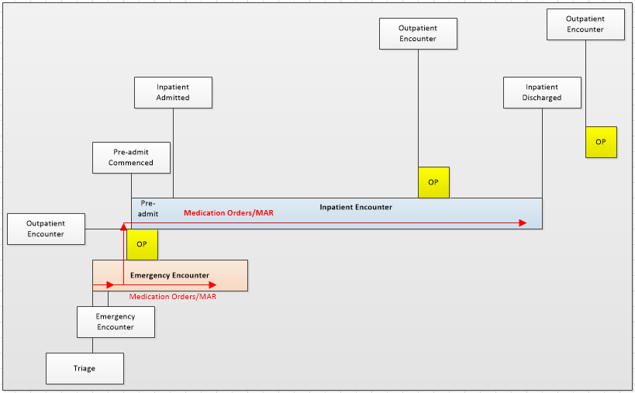
It is possible to easily duplicate or mimic medication orders and administration details in multiple interconnected clinical applications without causing significant clinical risk.
It is recommended that an EMR is the master system for medications management. This includes discharge medications, medications history, electronic medication administration for inpatients and outpatient medication orders.
AMT - Medication information is based on the Australian Medicines Terminology (AMT). Currently there are limited applications that are using this content. Victoria has worked closely with pharmacy vendors to ensure that the correct level of interoperability is available for this content. Medication information can initially be distributed in discharge summaries as textual report details for the reasons above. Distribution of this information to other applications requires application vendors to have a good understanding of the AMT. It should be noted that the AMT is complex to adopt, and it is anticipated that this maturity level will be adopted over a period.

EMR Medications management model
The model below shows the typical medications management functions that should be performed within an EMR which includes pharmacy integration with a closed loop design. A considerable change in business practice (around the use of IT systems) has been defined. This model has been reviewed, designed and endorsed by a state-wide pharmacy reference group. The following model represents typical functions between a clinical and pharmacy system, should a health service adopt a consolidated model then the relevant HL7 encoded order message would not be required, it is anticipated that this model would be a future state, and would only be adopted if the single vendor could comply with Australian billing and reporting requirements.
Figure 3: Medications Management Model
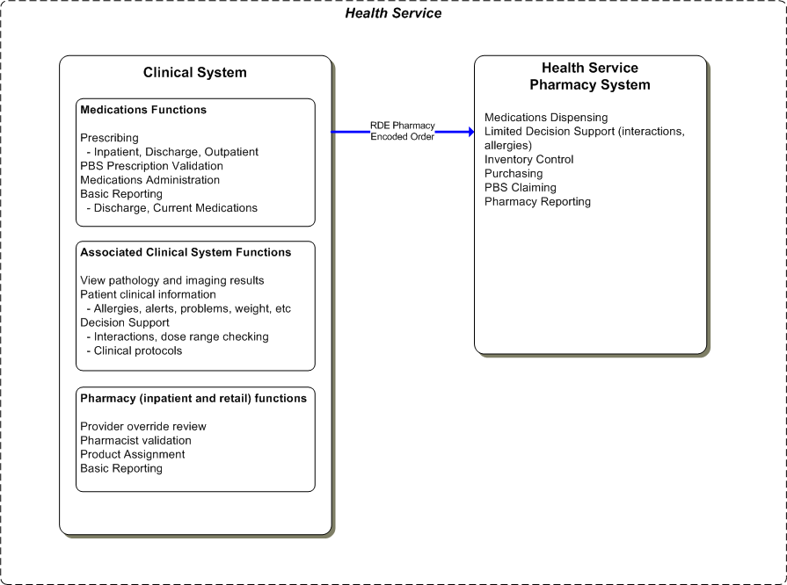

EMR Alerts and Allergy Design
The introduction of a robust and comprehensive EMR with decision support for health service application solutions has changed the manner this information is captured and distributed across applications. In the past allergies and alerts were typically captured in emergency department systems and in PAS. An analysis and assessment of the quality and consistency of this information has shown that very basic and unstructured information is generally captured in these applications.
The groups reviewed and defined a revised business process for capturing alerts and allergies: an EMR should be used as the central system for the capture of clinical alerts and allergies and the PAS should be used to capture administrative alerts. Applications such as pharmacy and emergency will receive allergies from an EMR system. The EMR system is usually the master system for this information. Conversely, it is recognised that in certain circumstances alert information will be recorded in the PAS and those alerts maybe similar. An example of an alert recorded in both applications includes: “patient in wheelchair” or “violent patient”. Where this is recognised as a potential risk, health services should refer to their best business practice guide/s.

EMR Alerts and Allergies solution design configuration
A health service EMR’s alert and allergy design should follow the below design parameters:
- The EMR should be used to manage clinical alerts and allergies, this compliments active decisions support functionality, such as drug interaction checking
- The health service PAS should be used to manage administrative alerts
- A community Client Management System (CMS) will be used to manage clinical and administrative alerts
- The EMR will publish alert and allergy details to other local applications such as emergency department systems
- It is recommended that an EMR will be the central system for orders (pathology, imaging and medications), results, drug interaction checking and other clinical functions. It will be the single trusted system for managing structured clinical alerts and allergies. Alerts and allergy information should not be received from other applications, refer to the “Design Constraints and Assumptions” for further details on this design.

EMR Alert and Allergies design constraints and assumptions
The following constraints currently apply to the alert and allergy design in an EMR:
- It is recognised that relevant alert and allergy information may be available in a health service PAS. During an EMR implementation, indicators (from the PAS or other system) can be migrated (via a data migration processes) to the EMR to indicate that details in the PAS should be reviewed. These indicators can be disabled once this information is reviewed and updated into the EMR, ongoing management of clinical alerts and allergies should be managed in the EMR.
- There are significant technical limitations with sharing alert and allergy information across current Victorian health applications:
  - The introduction of an EMR should utilise the currently agreed Victorian catalogue and national sources for this information as a base e.g.:
    - The food allergies catalogue has been agreed across Victoria
    - The medication alerts and allergies are provided in SNOMED and the decision support engine should be sourced/related to the AMT.
  - Many applications across Victoria are not capable of storing codified alerts and allergies, many of the applications in Victoria currently store unstructured alert and allergy information.
  - Many applications across Victoria have technical limitations in receiving allergies from an EMR. An EMR typically utilises a robust and mature HL7 structure to ensure that this information is synchronised accurately, in many instances current applications either do not receive allergy details or work to an older HL7 paradigm. There is an intrinsic risk in ensuring accurate synchronisation of this information. To perform full alert and allergy functionality, when receiving this HL7 information, systems such as an emergency system must either be able to load the SNOMED-CT or “other” and associated food allergies catalogue or receive this information for display. This is complex functionality and is not anticipated to be implemented by vendors in a short timeframe, or without significant cost.
  - With the introduction of an enterprise EMR system, it is not recommended that clinical alerts and allergies continue to be entered into the PAS, emergency, pharmacy or other application, without suitable business process design.

EMR Alerts and Allergies model
The model below shows the flow of information for alert and allergy details. Codified clinical alerts and allergies are published to a health service for use in any applications, the diagram below shows this information being utilised in a pharmacy application as an example.

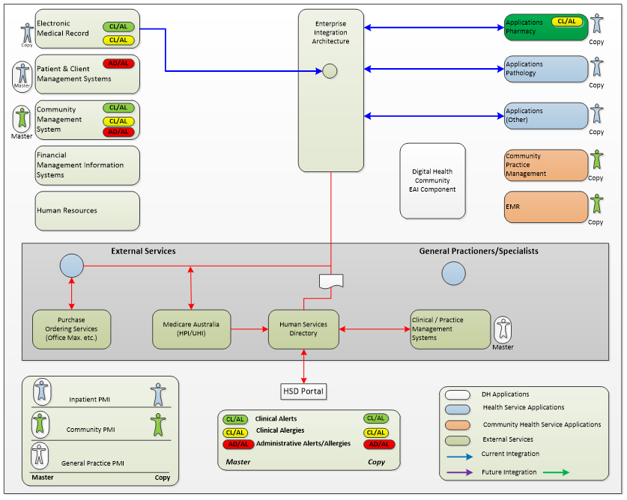
Figure 4: Allerts and Allergies model 1

Code Set Design

Code Set solution design configuration
The VPHS has an explicit need to share information across several healthcare applications as well as between general practice vendors and other more widely used hospital systems. This requirement is further re-enforced with the future need to have interoperability and consistency across national eHealth initiatives. The VPHS, via Digital Health, have established a base for several key code-sets to align with HL7 and other standards, which can be used by the sector to form the basis of an integrated environment for the future.
Key applications such as patient and client management systems and EMR applications via HL7 Australian Standards, require a mandatory foundation to enable this interoperability. This standard allows health services to standardise code-set data values to allow for greater interoperability of these applications. Put simply, for specific code-sets and values that are transmitted via HL7 from one application to another, it can be ensured via standardisation that the meaning of those values is the same across healthcare applications.
Where possible, and a standard exists, code-sets are set in line with Australian Standards. This approach has been successful with large majority of code-sets that are used across the VPHS.
Standardised code-sets across all Victorian Public Health Services allows for greater interoperability and ensures the referential integrity of the data is maintained through a consistent and transparent process. This is a foundation element for EMR, EHR and reporting capability.

Code Set design constraints and assumptions
Code-sets are constantly evolving and are utilised by many applications within the health care setting. Given the individual requirements of each health service, it is difficult to get alignment for all code-sets. Health services should align with common code-sets standards, particularly for information that is commonly shared across health applications. The following constraints apply with limited code-sets alignment and standardisation:
- Capability to realise full EHR functionality
- Limited interoperability capability
- Limited EMR capability
- Limited capability to align with national initiatives
- Limited and inefficient reporting capability.

Code set model
Sector code-sets have been developed over time and in consultation with health agencies using a “top down methodology” where possible. This methodology ensures the highest level of standard is utilised. Where mandatory statutory reporting or specific business requirements necessitated specific data values, a “bottom up methodology” was utilised to ensure these requirements are satisfied.
The following code-sets, standards and authorities are considered when establishing VPHS code-sets:
- Health Level Seven Global Standard (HL7)
- Australian Standard for HL7 (AS 4700.x)
- Person and provider identification in healthcare AS 4846:2014
- Australian Digital Health Agency (ADHA)
- Victorian Common Core Data Set (CCDS)
- Victorian Admitted Episodes Data Set (VAED)
- Victorian Emergency Minimum Dataset (VEMD)
- Application specific requirements (i.e. system constraints such as hardcoded values)
- Other additional or specific values to meet business requirements (e.g. “Medicare Bulk Bill” code required for privatised outpatients).

Standards
Health Service applications should follow a consistent international, national, and local Victorian standard. In many instances’ standards are not adequate, well established or cause confusion in adoption. While it is anticipated that standards will change over time and standards are designed to be flexible, as a principle Digital Health will put forward a list of international or national standards mature enough to provide the relevant operational and usability requirements that meet the needs of health application users.

Standards solution design configuration
VPHS solution standards should adhere to the following design parameters:
- Health Event messaging standards:
  - In most instances HL7 event messages are used to interface (share information) between health applications, as defined in the DH HL7 2.4 Unified Guide.
  - Financial systems should use cXML for messaging purchase orders to suppliers. This is the endorsed standard by GS1 for this type of messaging. ADHA standards will supersede this capability.
- State-wide Pathology and Imaging catalogues:
  - The VPHS has defined a state-wide pathology and imaging catalogue. This catalogue was created by the Pathology and Imaging Clinical System Working Group which included representation from health services across Victoria. It was determined by these groups that SNOMED and LOINC, as well as other known pathology and imaging catalogues, do not adequately address all the requirements for Victoria. A Victorian catalogue was created for use across Victoria and contains substantial input from ADHA and specifically designed to move towards a national catalogue once this catalogue becomes available.
    - Victorian Pathology Catalogue
    - Victorian Imaging Catalogue.
- SNOMED-CT: An enterprise EMR System typically uses SNOMED-CT for clinical classification terminology for systematically organising clinical terms for diseases, findings and procedures. Structured SNOMED terminology is used in an EMR System to enable strong active decision support for clinical users, this includes features such as “drug-to-drug” and “drug-to-allergy” checking. This is a nationally and international accepted standard that is also strongly supported by ADHA. The ICD-10-AM/ACHI/ACS classification system is comprised of the following disease and intervention classifications:
  - International Statistical Classification of Diseases and Related Health Problems, Tenth Revision, Australian Modification (ICD-10-AM) used to classify diseases and other health problems
  - Australian Classification of Health Interventions (ACHI) used to classify procedures and interventions
  - Australian Coding Standards (ACS) specifies coding standards that provide guidelines to assist users of the classifications in obtaining consistency in clinical coding nationally.
- ICD and DRG coding: ICD coding is used to classify procedures and diagnosis information. Patient Administrations Systems use ICD terms to classify inpatient procedures for administrative/funding purposes. Once medical notes have been interpreted into a set of ICD codes, DRG and MDC codes are identified for this set of ICD codes via a grouper application. ICD groupers are generally a separate application. ICD, MDC and DRG information is distributed to other applications via HL7, the CS displays ICD, DRG and MDC details that are sent from PAS.
- National Product Catalogue (NPC): The National Product Catalogue was implemented in healthcare to support the industry need for standardised, supplier managed data across the whole of the healthcare value chain to ensure accuracy and efficiency. The NPC is referenced in pharmacy and financial management systems, as there is a link to AMT, there is also a link to a clinical system with medications management capability.
- Alerts and Allergy classifications: Allergies are classified in the following manner:
  - Victorian Food and Environment allergy catalogue
  - Drug Identifier: AMT SNOMED codes
- International Dietetics and Nutrition Terminology (IDNT): The VPHS is working toward using the IDNT. Initially this will be for Diet orders.
- AMT: A clinical system should adopt the use of the AMT for its medicines catalogue. This is a comprehensive national nomenclature for medications.
- National Human Services Directory (NHSD): Victoria has adopted the NHSD as the standard definition for a provider (General practitioners and specialists) in its core applications.
- Patient Identifiers: The ADHA IHI service will be adopted in the future. Refer to the solutions design in this document. Healthcare applications are anticipated to adopt use of the Victorian State-wide Unique Patient Identification and IHI in the future.

Summary of Principles and Constraints
Key solution principles and technical constraints that align with typical EMR program objectives are summarised below.
Medications – There is an identified requirement amongst clinicians to view ordered and administered medications longitudinally across episodes. It is not possible to easily duplicate or mimic medication management in detail in multiple interconnected clinical applications without causing significant clinical risk.
It is recommended that an EMR is the master system for medications management. This includes discharge medications, medications history, electronic medication administration for inpatients, and inpatient and outpatient medication orders. All medications should be documented in a single application within the EMR.
Ordering – Orders should be hosted by a single application within the EMR. A single system hosting orders is recommended to ensure clinical decision support and drug monitoring are facilitated consistently and instances of duplicate ordering are reduced. Conversely, in some circumstances add-on, reflex and send-out tests are required to be triggered from third party applications. Where this practice is in place, messaging needs to be managed with uniquely identified numbers that are informed from the PAS and EMR.
Whilst health services may wish to initiate orders for pathology and radiology from other systems such as an emergency application (that is not part of an enterprise solution), this approach is not recommended, feasible or endorsed, when utilising a robust and centralised EMR, as there is significant clinical risk in duplicating orders.
Scheduling – Scheduling applications are not designed by vendors to synchronise scheduling functionality with another scheduling application. Only one application can be the master application to allocate and manage scheduling details. Interoperability standards (HL7 or other) are not designed to enable this capability, third party vendors do not design their applications to work in this manner. It is not feasible (or technically practical) to achieve this capability. This limit other applications setting schedules and reflecting this information back to the master scheduling system, e.g. Oncology applications.
Master Patient Master Index – A health service or community centre must have a single master patient index in which all patients are registered, and a unique health service identifier is generated. It is recommended that the PAS or CMS be the master application for registration of patient details or likewise an enterprise clinical application or EMR is selected that encompasses a PAS. Allocation of more than one master application for registering patient details (and bi-directional interfaces for this purpose) leads to data inconsistencies across applications and is not an endorsed, industry standard or recommended approach for this function.
Open Database Connectivity (ODBC) – ODBC is not considered to be an industry standard approach for accessing information from an online application. This method of interaction with an application has performance, security and ongoing maintenance issues. This is not an approved method of data access for any healthcare application. Access to information must be controlled via event base transactions (HL7) or regulated extraction processes that are designed to manage the distribution of information for purposes such as reporting.

Assumptions
It is assumed that many health services will lean toward the implementation of a comprehensive EMR over time. While this is a goal, it is recognised that that there will be a transition period for this process.

Constraints
This document assumes the following constraints:
- This document is a guide, overlay and reference base that should be used as an approach to adopt key health applications. This is not a prescriptive or concise guide that will describe all health service environments, the factors described in this document should be considered when implementing VPHS solutions.

Appendix A – Digital Health branch
The Digital Health branch is led by the Chief Digital Health Officer. As a branch in the Health and Wellbeing division, Digital Health collaborates closely with a wide range of stakeholders across the department, sector agencies and other jurisdictions to perform the following functions:
- Provides engagement, standards, policy advice, planning and assurance functions across the health sector in the areas of digital health
- Is responsible for the system management required to operationalise health sector reform
- Provides outward-facing whole of health sector leadership in digital health enablement as well as commissioning of digital health and ICT functions
- Maintain a close working relationship with other branches of the division which has the levers, relationships and responsibilities across the health system to ensure digital projects are properly governed, resourced, and ensure all risks are well managed
- Guides health ICT initiatives towards an interoperable future digital health environment using well-established standards, best practice guides, methodologies and principles
Digital Health utilises the people, process and technology components, with a strong emphasis on transformational change elements when implanting new health systems and workflow processes.
Digital Health focus on four areas:
- Digital Health strategy, policy and architecture standards for the Victorian health sector.
- Commissioning of digital health functions within Victorian public health services.
- Sponsoring digital health programs to implement sector-wide health information sharing platforms including those at a national level (to which Victoria contributes) as well as sector-enabling capabilities sponsored by DHHS.
- Health service system management function including sector assurance (e.g. major program, operations and cybersecurity).
Digital health program areas include:
- Health Sector Standards and Advisory which provide information on emerging health technologies, feasibility, architecture, design and integration.
- Sector Assurance which provides assurance on all approved health service projects funded or co-funded by the government to ensure health services operate safely, securely and cost-effectively.
- Sector Governance and Reporting which provides governance and reporting on the system manager function and the overall digital health branch function.
- Health Sector Planning which provide planning and pipeline management for the health sector, managing concept proposals, business bases, funding bids and subsequently funding allocation and funding agreements.
- Research and Innovation which works in partnership with academia and industry to identify and implement health informatics and digital-enabled solutions for greater efficiency, productivity and quality and safety outcomes. The team also oversees the benefit realisation portfolio and the advanced use of healthcare data to support early intervention, system management and better patient outcomes.
HSSA is committed to open, independent and best practice view of healthcare Information and Communication Technology (ICT), application solution principles. HSSA can provide recommendations to the overarching enterprise application design and associated services to integrate healthcare applications. Below are some of HSSA activities:
- Deliver guides and advice around interoperability across healthcare applications
- Define messaging standards for Victorian health applications
- Facilitate a higher level of integration knowledge and associated quality processes in the Victorian health sector
- Align innovation, efficiencies and effective use of ICT within health to encourage and drive standards-based approaches that encourage a high level of interoperability

For further clarification on this standard, the Digital Health branch can be contacted on digitalhealth@dhhs.vic.gov.au or as per the contact details available on the DHHS Digital Health’s website.

Appendix B – Terms and Definitions
Term | Description
ACHI | Australian Classification of Heath Interventions
ACK | HL7 positive acknowledgement message
ADHA | Australian Digital Health Agency
ADT | Admissions, Transfers and Discharges, relating the Patient Administration System
AIE | Health service/Agency Integration Engine
AMT | Australian Medicines Terminology, this information has been produced by ADHA as an extension to SNOMED-CT
AtoA | Sharing of Application information (Application functions) across multiple applications
B2B | Sharing of business information (Business functions) across business entities
CIS | Clinical Information System
CMBS | Commonwealth Medicare Benefits Schedule
CMS | Client Management System for community health
DHHS | Victorian Department of Health & Human Services
DH | Digital Health
DRG | Diagnostic Related Group
Dose Range Checking | Functional medications administration capability that:  - assists pharmacists to validate a patient’s dose based on age, weight and surface area, frequency and route of administration, and other patient criteria  - takes into consideration, dosing interval and duration of therapy  - enables decision support rules across atomic pathology and medication doses to be formed
EHR | Electronic Healthcare Record
EIPS | Enterprise Implementation Planning Study
ELS | Endpoint Locator Service
EMR | Electronic Medical Record
EMPI | Enterprise Master Patient Index. This can be implemented in a health service State wide / Nationally
Event Message Set | A HL7 interface message that relates to a business function within an application. For example, the HL7 transfer message (A02).
eTP | Electronic Transfer of Prescriptions
GP | General Practitioner
HealthNET | Wide Area Network between various health services and OHIS
HPI-I/O | ADHA national provider and organisation index
HSD | Human Services Directory
HSIE | Health Systems Integration Engine
HSSA | Health Sector Standards and Advisory
HI | Healthcare Identifier
HL7 Data Extraction | The process used to gather HL7 information for loading into the Enterprise IPS phase of the Clinical System project
HL7 | Health Level 7 Message Standard
ICT | Information & Communication Technology
IHI | Individual Healthcare Identifier, national ADHA patient identifier
Integration Engine | An application-to-application integration solution toolset. The solution toolset resolves application-to-application protocol connectivity and synchronises logical sets of information
ICD | International Classification of Diseases
ICT | Information and Communication Technology
IDNT | International Dietetics and Nutrition Terminology
IPS | Implementation Planning Study
JCAPS | Sun Interface Engine, Java Composite Architecture Platform. Previously named as SeeBeyond and eGate.
MHR | My Health Record
NASH | National Authentication Service for Health
OUS | DH HL7 2.4 Unified Specification
OPD | Outpatient Department
PACS | Picture Archiving Communication System
PAS | Patient Administration System – a system used for the recording of patient and provider information to support management and coordination of service provision.
PDS | The Medicare Provider Directory Service
PMI | Patient Master Index
PBS | Pharmaceutical Benefit Scheme
RIMS/RIS | Radiology Information Management System
SHS | Shared Health Summary
SNOMED CT | SNOMED CT (Systematized Nomenclature of Medicine-Clinical Terms) is considered to be the most comprehensive, multilingual clinical healthcare terminology in the world
Third Party Application | An application supplied by a vendor other than Cerner. For example, Homer PAS, Kestral Imaging, etc.
TPN | Total Parenteral Nutrition’s. Nutrition’s/meals that are not ingested via the stomach.
URL | Uniform Resource Locator
VPHS or Health Service Agency | Victorian Public Health Sector  One of the 85 Victorian Public Health Services offering healthcare across the state
VEMD | Victorian Emergency Minimum Dataset
VAED | Victorian Admitted Episodes Data
VPHS | Victorian Public Health Sector

To receive this publication in an accessible format email DigitalHealth@dhhs.vic.gov.au
Authorised and published by the Victorian Government, 1 Treasury Place, Melbourne.
© State of Victoria, Department of Health and Human Services, September 2019.

https://www2.health.vic.gov.au/hospitals-and-health-services/quality-safety-service/digital-health/dh-standards-guidelines/digital-design-unified-implementation-guide
https://www.digitalhealth.gov.au/implementation-resources/clinical-documents/electronic-transfer-of-prescription
http://apps.who.int/classifications/icd10/browse/2016/en
https://www.himssanalytics.org/emram
https://www2.health.vic.gov.au/hospitals-and-health-services/quality-safety-service/digital-health/dh-standards-guidelines/digital-design-unified-implementation-guide
https://www2.health.vic.gov.au/hospitals-and-health-services/quality-safety-service/digital-health/dh-standards-guidelines/statewide-pathology-imaging-catalogues

