Admissions, Transfers and Separations
in CMI/ODS
Program Management Circular
Revised: May 2016 Review Date: May 2017
Key Message 1
Purpose 1
Background 2
Scope 2
Which Function Should Be Used? 3
Which Separation Mode Code Should Be Used? 4
Which Admission Source Code Should Be Used? 5
Ward Transfer Function 6
Unit Transfer Function 7
Program Classification Function 9
Separation Function 12
Relevant Code Sets 14

Key Message
When a client moves into, between or out of admitted or residential subcentres within the clinical mental health collection it is important to establish program classifications, as well as correct admission and separation codes for departing and receiving subcentres.
- If a client changes to an admitted subcentre with the same program classification a ward transfer is performed.
- If a client changes to an admitted subcentre with a differing program classification, then the program classification function is used.
- If a client moves between mental health residential subcentres with different residential program classifications, the program classification function needs to be used.
- If a client moves between mental health residential subcentres and they have the same residential program classification, then the unit transfer function needs to be used.
- If a client is moved to a PARC, CCU or residential (mental health nursing home) from a non-residential subcentre, then the separation function needs to be used.

Purpose
To clarify the reporting requirements and improve the consistency and quality of data submitted to the CMI/ODS in relation to the recording of admissions, transfers and separations. Recording of admission and separation details is critical to calculation of a number of key performance indicator results, for example pre-admission contact rate, post discharge follow up rate, 28 day readmission rate, length of stay and bed occupancy rates.

Background
CMI/ODS is the Victorian public mental health client information management system and comprises:
- Client Management Interface (CMI). The CMI is the local client information system used by each public mental health service
- Operational Data Store (ODS). The ODS manages a set of select data items from each CMI. The ODS is used to:
- Allocate a unique (mental health) registration number for each client, known as the statewide Unit Record (UR) number
- Share select client level data between Victorian public AMHS to support continuity of treatment and care
- Ensure the legal basis for providing treatment is evident to all public mental health service providers where a client may be unable or unwilling to consent to treatment
- Meet the various reporting requirements of the Department of Health and Human Services
- Support the statutory functions of the Chief Psychiatrist and the Mental Health Tribunal.

Scope
The following Program Management Circular (PMC) provides descriptions of which functions and codes to use when clients move into, between and out of clinical mental health admitted or residential subcentres. It is not intended to provide advice regarding the recording of activity outside of the clinical mental health service settings (ie for the Victorian Admitted Episode Data collection).

The PMC includes a series of matrices to assist with decision making about which functions and codes to use in a given situation. Specifically, the PMC is intended to ensure consistent use of CMI/ODS functions in addition to the recording of Separation Mode and Admission Source codes.

The PMC does not provide an exhaustive list of all possible transitions between settings. Rather, the matrices are intended to provide general principles that should be applied to determine the appropriate functions and codes to use in any given circumstance.

The PMC is not intended to address the following:
- Acute health data collection requirements (eg for the Victorian Admitted Episode Data collection)
- Temporary moves between admitted and residential settings (eg trials in residential mental health settings)
- Patient leave
- Codesets other than Separation Mode and Admission Source codes

Which Function Should Be Used?
Use this matrix to assess which CMI function should be used by the ‘Going From’ campus.
Note: not all of these options are likely or possible from a clinical perspective. For a full list of program classes see section on relevant code sets.
 |  | Going To
 |  | Within Same CMI Campus |  |  |  |  |  |  |  | Acute Admitted  Same/Different Hospital | Another MH (CMI) Campus | Private Residence / Accommodation
 |  | Inpatient  MH |  |  |  |  | Residential  MH
 |  | Acute |  |  |  | Non-Acute | CCU | PARC | Residential (Mental Health Nursing Home)
 |  | CAMHS | ADULT | AGED | Specialist Acute | SECU
Going From
Acute  MH | CAMHS | WT | PC | - | PC | PC | SEP | SEP | SEP | SEP | SEP | SEP
 | ADULT | PC | WT | PC | PC | PC | SEP | SEP | SEP | SEP | SEP | SEP
 | AGED | - | PC | WT | PC | PC | SEP | SEP | SEP | SEP | SEP | SEP
 | Specialist Acute | PC | PC | PC | WT | PC | SEP | SEP | SEP | SEP | SEP | SEP
Non-Acute  MH | SECU | PC | PC | PC | PC | WT | SEP | SEP | SEP | SEP | SEP | SEP
Residential  MH | CCU | SEP | SEP | SEP | SEP | SEP | UT | PC | PC | SEP | SEP | SEP
 | PARC | SEP | SEP | SEP | SEP | SEP | PC | UT | PC | SEP | SEP | SEP
 | Residential (Mental Health Nursing Home) | SEP | SEP | SEP | SEP | SEP | PC | PC | UT | SEP | SEP | SEP

Legend: WT – Ward Transfer function to be used
SEP – Separation function to be used
PC – Program Classification function to be used

UT – Unit Transfer function to be used

Which Separation Mode Code Should Be Used?
After determining which CMI function should be used, the following matrix helps determine which code/selection is required to be used for Separation Mode by the ‘Going From’ campus.
Note: not all of these options are likely or possible from a clinical perspective.

 |  |  | Going To
 |  |  | Within Same CMI Campus |  |  |  |  |  |  |  | Acute Admitted  Same Hospital | Acute Admitted  Different Hospital | Another MH (CMI) Campus | Private Residence / Accommodation
 |  |  | Inpatient MH |  |  |  |  | Residential MH
 |  |  | Acute |  |  |  | Non-Acute | CCU | PARC | Residential (Mental Health Nursing Home)
 |  |  | CAMHS | ADULT | AGED | Specialist Acute | SECU
Going From
Acute  MH |  | CAMHS | N/A | P * | - | P * | P * | A | A | A | S | T | T | H
 |  | ADULT | P * | N/A | P * | P * | P * | A | A | A | S | T | T | H
 |  | AGED | - | P * | N/A | P * | P * | A | A | A | S | T | T | H
 |  | Specialist Acute | P * | P * | P * | N/A | P * | A | A | A | S | T | T | H
Non-Acute MH |  | SECU | P * | P * | P * | P * | N/A | A | A | A | S | T | T | H
Residential MH |  | CCU | T | T | T | T | T | N/A | P * | P * | S | T | T | H
 |  | PARC | T | T | T | T | T | P * | N/A | P * | S | T | T | H
 |  | Residential (Mental Health Nursing Home) | T | T | T | T | T | P * | P * | N/A | S | T | T | H

Legend:
A – Separation and transfer to mental health residential or PARC

H - Separation to private residence/accommodation

S - Statistical Sep (change in Care Type within this hospital)

T – Separation and transfer to other acute hospital/extended care/ rehabilitation/geriatric

N/A – Ward or unit transfer – Separation Mode not required

P - Program Class Change (statistical separation) - within Mental Health

* - Pre-populated by Program Classification function

Which Admission Source Code Should Be Used?
The following matrix helps determine which code/selection is required to be used for Admission Source by the ‘Going To’ campus.
Note: not all of these options are likely or possible from a clinical perspective.
 |  | Going To
 |  | Inpatient MH |  |  |  |  | Residential MH
 |  | Acute |  |  |  | Non-Acute | CCU | PARC | Residential (Mental Health Nursing Home)
 |  | CAMHS | ADULT | AGED | Specialist Acute | SECU
Going From
Within Same MH (CMI) Campus
Acute  MH | CAMHS | N/A | P * | - | P * | P * | T | T | T
 | ADULT | P * | N/A | P * | P * | P * | T | T | T
 | AGED | - | P * | N/A | P * | P * | T | T | T
 | Specialist Acute | P * | P * | P * | N/A | P * | T | T | T
Non-Acute  MH | SECU | P * | P * | P * | P * | N/A | T | T | T
Residential  MH | CCU | A | A | A | A | A | N/A | P * | P *
 | PARC | A | A | A | A | A | P * | N/A | P *
 | Residential (Mental Health Nursing Home) | A | A | A | A | A | P * | P * | N/A
Acute Admitted  Same Hospital |  | S | S | S | S | S | S | S | S
Acute Admitted  Different Hospital |  | T | T | T | T | T | T | T | T
Another MH (CMI) Campus |  | T | T | T | T | T | T | T | T
Private Residence / Accommodation |  | H | H | H | H | H | H | H | H
Legend:
A - Transfer from mental health residential facility

S - Statistical admission (change in Care Type within this hospital)

T - Transfer from acute hospital/extended care/rehabilitation/geriatric

H - Admission from private residence/accommodation

N/A – Ward or unit transfer – Admission Source not required

P - Program Class/Care Type Change or Leave greater than 7 days

* - Pre-populated by Program Classification function

Ward Transfer Function
Where a client moves from one mental health acute inpatient subcentre (ward) to another mental health acute inpatient subcentre of the same program classification, within the same CMI campus, the ward transfer function is to be used.

For example if a client is going from adult inpatient first floor (classed as an acute general adult) to ground floor (classed as an acute general adult), a ward transfer is used as they both have a program classification of acute general adult.

The ward transfer button is located in the toolbar of the admission summary screen.
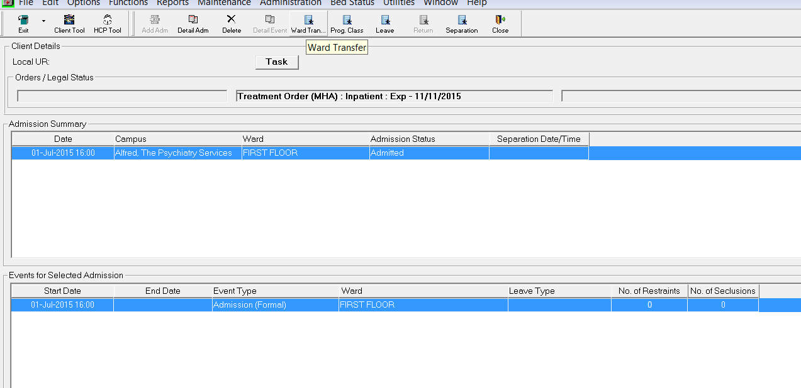

The ward transfer details will be displayed, add transfer date/time, select new ward and save.
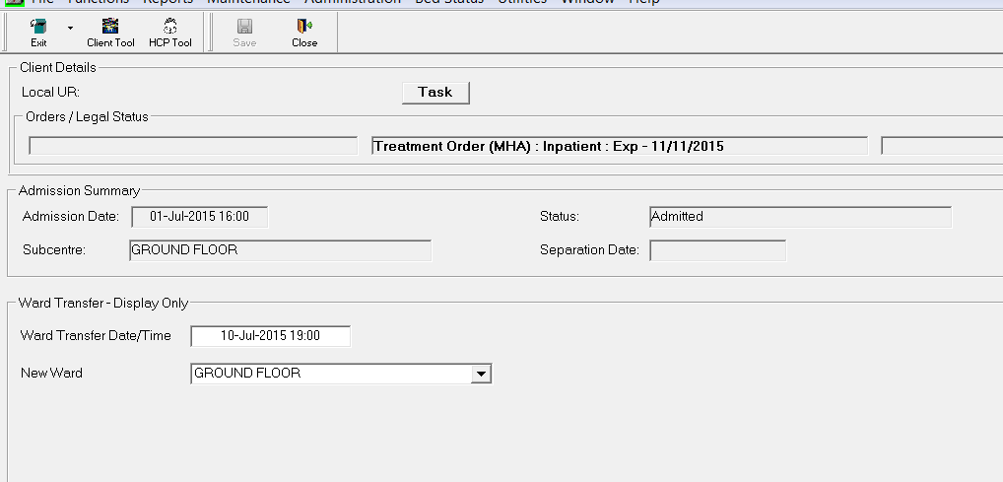

Back in the admission summary screen the ward transfer appears as an admission event.
A ward transfer appears as a new event in the current admission episode and therefore does not trigger any additional outcome measurement reporting requirements.
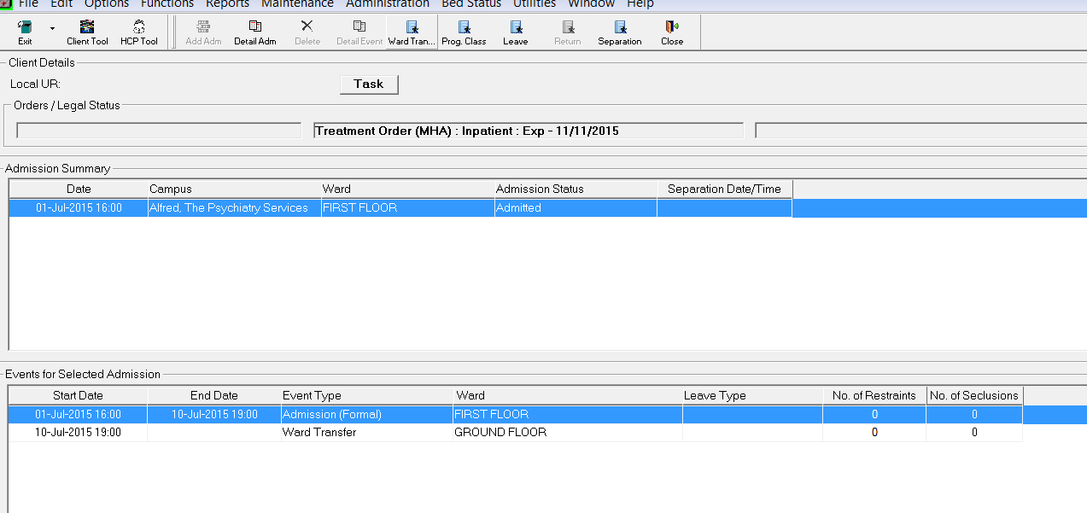

Unit Transfer Function
Where a client moves from a PARC, CCU or residential (mental health nursing home) unit, within the same campus, and with the same residential program classification then the unit transfer function needs to be used.

For example if a client moves from a mental health nursing home to another mental health nursing home or a CCU to another CCU within the same campus, the unit transfer function is to be used.

The unit transfer button is located in the toolbar of the residential summary screen
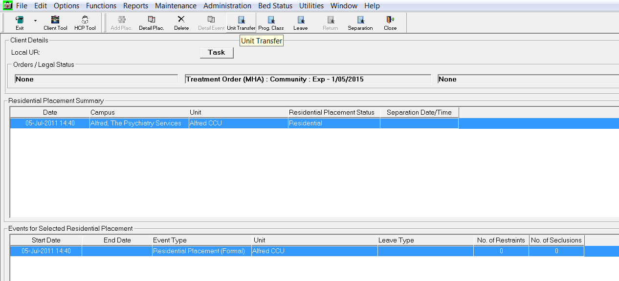

The unit transfer details will be displayed, add transfer date/time, select new unit and save.
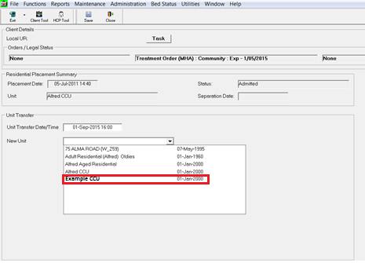

Back in the residential summary screen the unit transfer appears as an admission event.
A unit transfer appears as a new event within the current admission episode, and therefore does not trigger any additional outcome measurement reporting requirements.
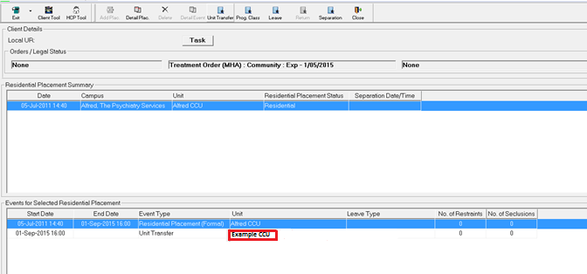

Program Classification Function
The program classification function must be used when:
- A client moves from an inpatient subcentre (ward) of one program classification to another inpatient subcentre of a differing program classification.

- A client moves between residential subacute subcentres with different program classifications (e.g. from a PARC to a CCU).

For example a client moves from adult inpatient, classed as an acute general adult subcentre to ground floor, classed as non-acute general, the program classification is used as the client is going from an acute general adult unit to an non-acute general unit.

Please note: the program classification function creates a separate admission episode (rather than a new event within a single admission), and therefore triggers additional Outcome Measurement reporting requirements.

Do NOT use the program classification function if a client is transferred to a PARC, CCU or residential (mental health nursing home); please refer to the Separation Function section.

The program classification button is located in the toolbar of the admission summary screen.
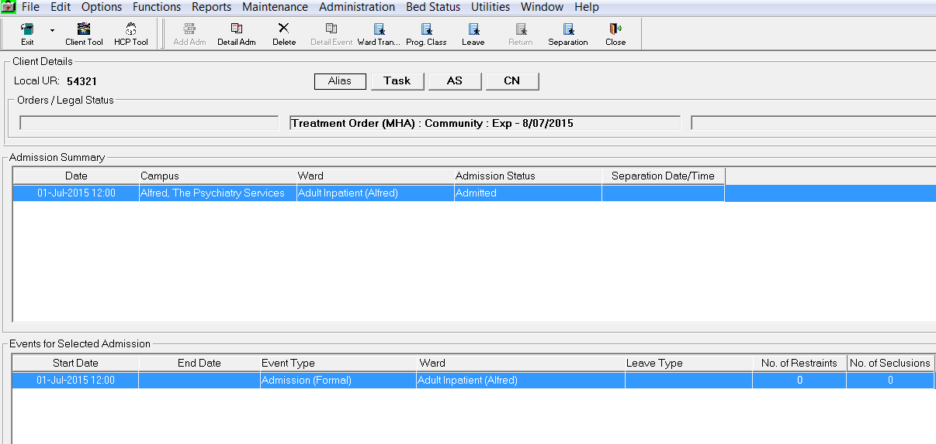
Complete the change program classification section; select relevant program classification from drop down list for program classification.
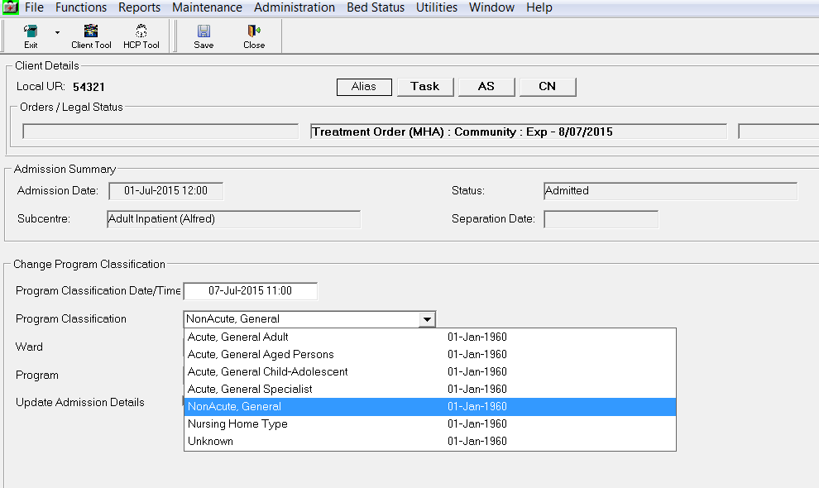

After selecting the program classification, the subcentres with that selected Program Classification will be displayed, select relevant subcentre and program, then save.
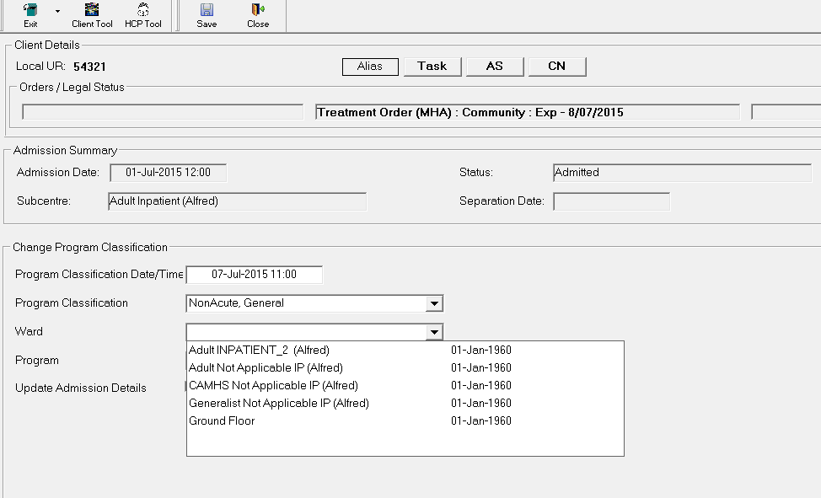
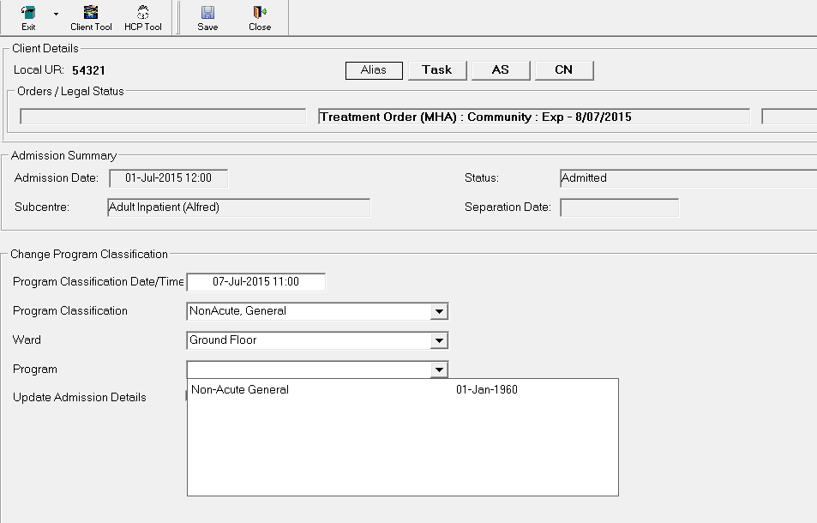
When the record is saved a new episode is created
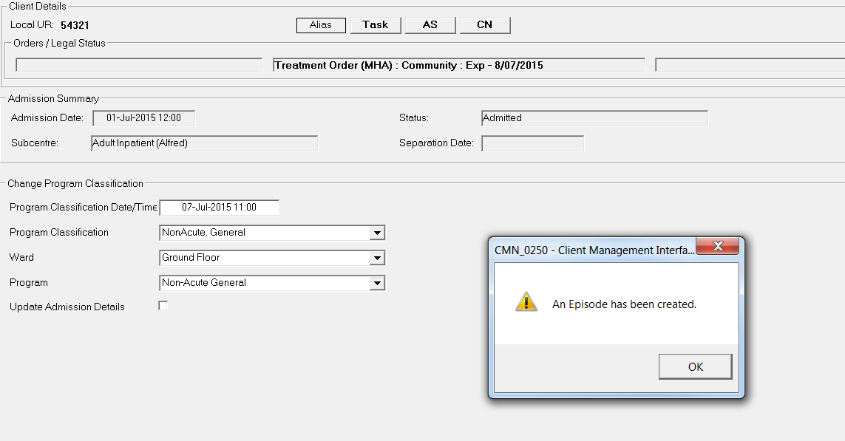

You will notice that a program classification change triggers statistical separation and admission records within the episode.
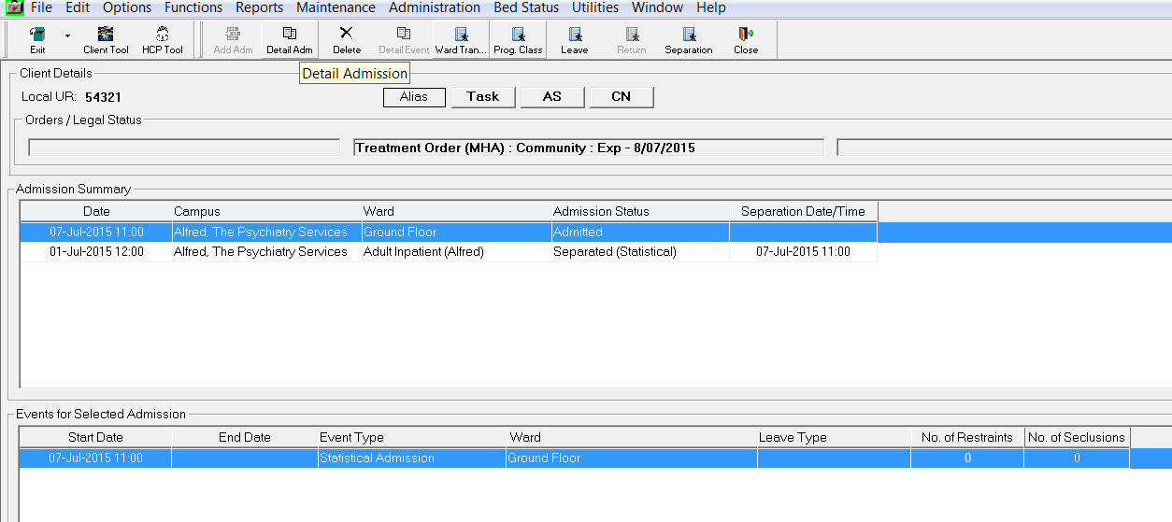

A new episode created by the program classification change will be displayed in the case summary.
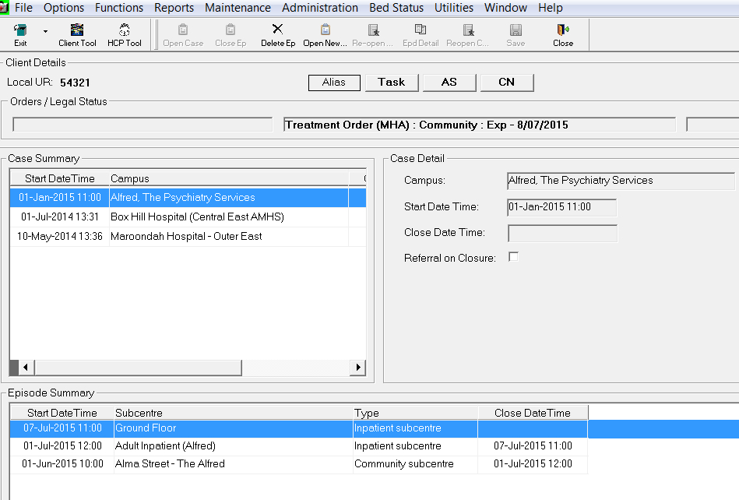
Depending on the set up of the subcentres, tasks DISINP (Discharge from Inpatient) and ADMINP (Admission to Inpatient) outcome measures may be generated.

Separation Function
If a client is moved from a mental health acute inpatient setting to a PARC, CCU, residential (mental health nursing home), another campus or discharged home, the separation function is to be used and a formal discharged created.

The separation button is located on the right hand side of the toolbar on the admission summary screen.
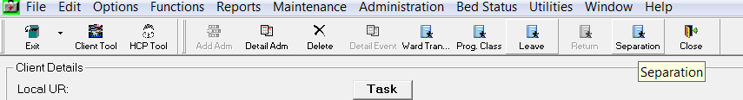

The separation screen will appear, complete the fields in the separation section.
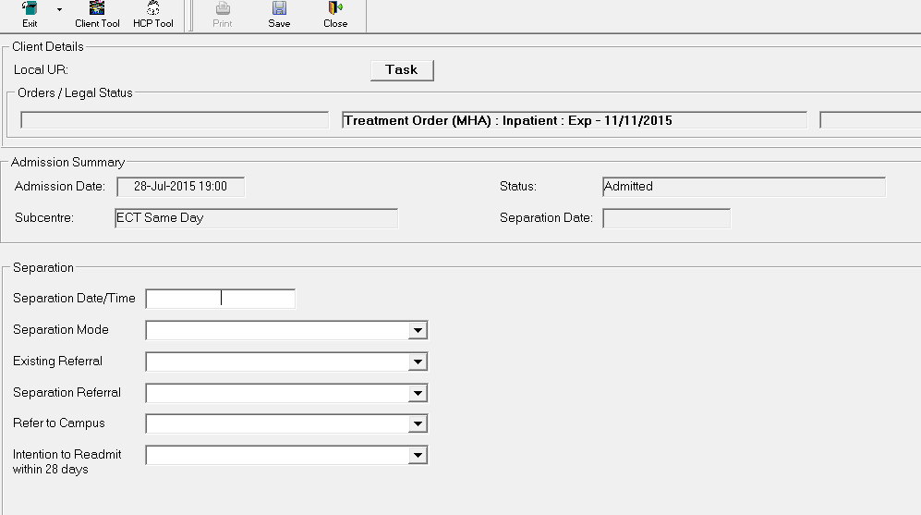

The separation mode field is a drop down list; refer to the ‘Which code should be used for separation mode’ matrix on page 4 for the relevant selection.
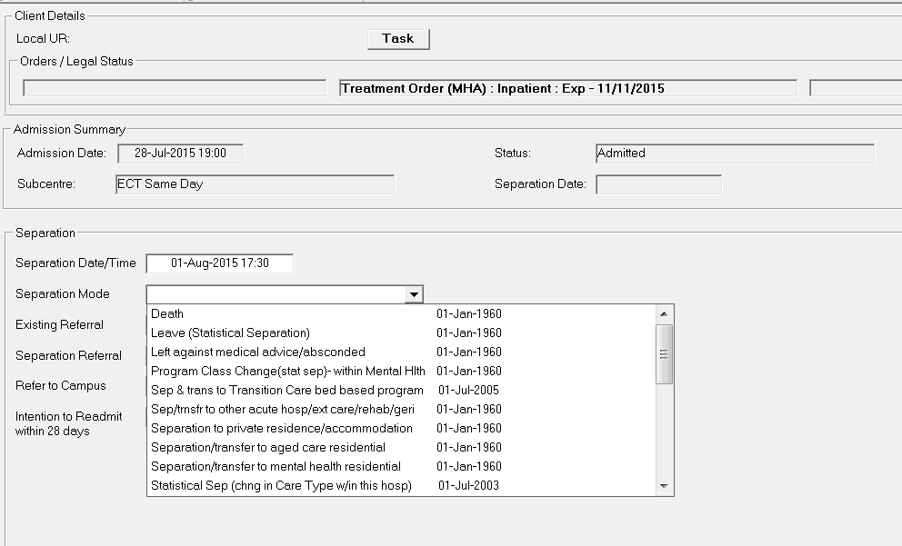
With the existing referral field, if a referral is saved it will be displayed in the drop down list and can be selected.
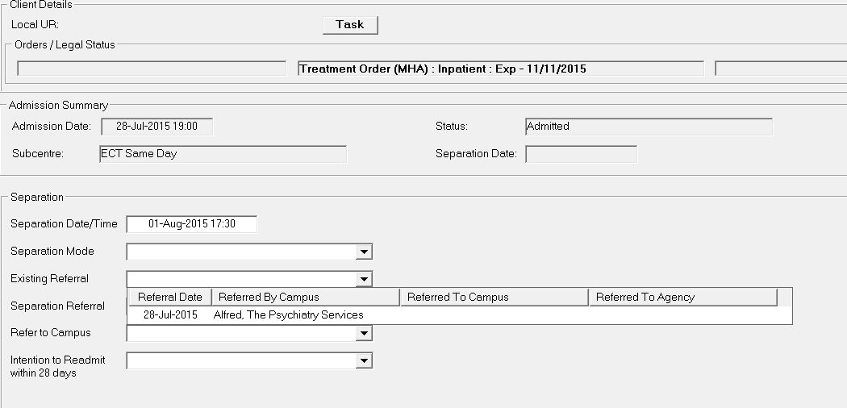

The separation referral and intention to readmit within 28 days are both drop down lists, select the relevant option for each.
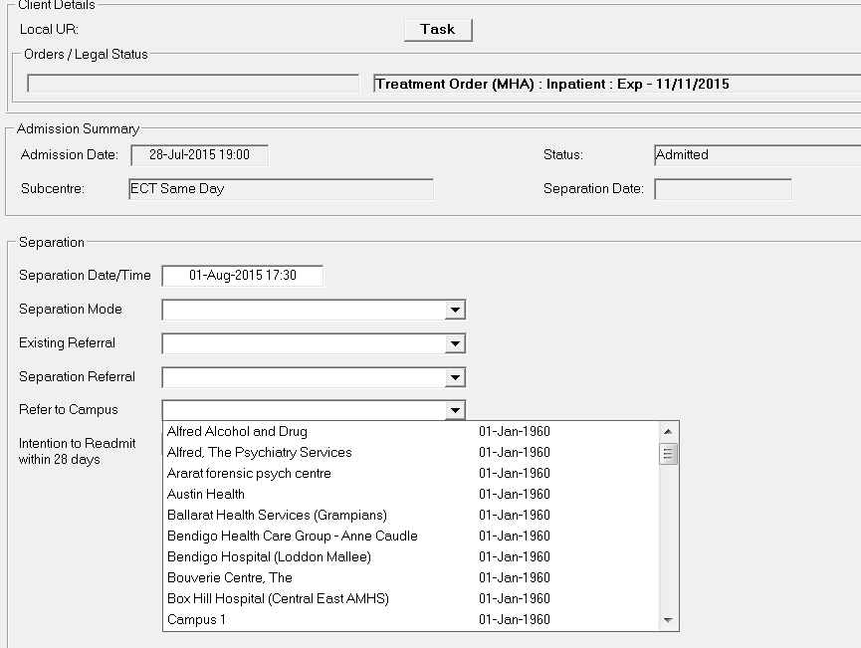

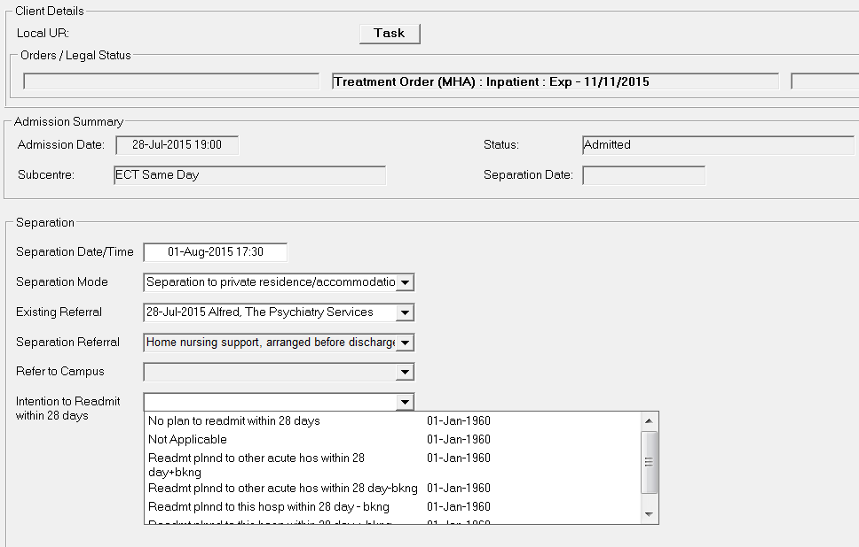

Relevant Code Sets
This table contains a list of codes available for the functions mentioned in this document.

Field Description | Code Range | Code Description
Admission Source | A  B  H  N  P  S  T | Transfer from mental health residential facility  Transfer from Transition Care bed based program  Admission from private residence/accommodation  Transfer from aged care residential facility  Program Class/Care Type Change or Leave greater than 7 days  Statistical admission (change in Care Type within this hospital)  Transfer from acute hospital/extended care/rehabilitation/geriatric
Program Class | A  C  E  G  K  N  R  S  T | Acute, General Adult  Community  Non-Acute, General  Acute, General Aged Persons  Acute, General Child-Adolescent  Residential, Aged Persons Residential Service  Residential, Community Care Unit  Acute, General Specialist  Nursing Home Type (Nursing home types for clients in acute inpatient units longer than 28 days awaiting placement (no longer acute))
Separation Mode | A  B  D  H  L  N  P  S  T  Z | Separation/transfer to mental health residential  Separation & transfer to Transition Care bed based program  Death  Separation to private residence/accommodation  Leave (Statistical Separation)  Separation/transfer to aged care residential  Program Class Change(stat separation)- within Mental Health  Statistical Sep (change in Care Type within this hospital)  Separation/transfer to other acute hospital/extended care/ rehabilitation/geriatric  Left against medical advice/absconded

Authorised and published by the Victorian Government, 1 Treasury Place, Melbourne.
© State of Victoria, May 2016. Except where otherwise indicated, the images in this publication show models and illustrative settings only, and do not necessarily depict actual services, facilities or recipients of services. This publication may contain images of deceased Aboriginal and Torres Strait Islander peoples.
Available at http://www.health.vic.gov.au/mhdr-info/rules.htm

