Aboriginal governance and accountability framework
(Accessible)

To receive this publication in an accessible format, please phone 03 9096 5836 using the National Relay Service 13 36 77 if required, or email Aboriginal Health and Wellbeing <aboriginalhealthandwellebeing@dhhs.vic.gov.au>
Authorised and published by the Victorian Government, 1 Treasury Place, Melbourne.
© State of Victoria, Australia, Department of Health and Human Services, September 2017.
In this document, ‘Aboriginal’ refers to both Aboriginal and Torres Strait Islander people. ‘Indigenous’ or ‘Koori/Koorie’ is retained when part of the title of a report, program or quotation.
ISBN 978-1-76069-023-6 (print) ISBN 978-1-76069-024-3 (pdf/online).
Available at Aboriginal governance and accountability framework on the DHHS website <https://www.dhhs.vic.gov.au/publications/aboriginal-governance-and-accountability-framework>
Printed by Metro Printing 203-205 Roberts Rd, Airport West (1705012).

Acknowledgement of Aboriginal Victoria
The Victorian Government proudly acknowledges the Victorian Aboriginal community and its rich culture and pays respect to its Elders past and present. We acknowledge Aboriginal people as Australia’s First Peoples and as the Traditional Owners and custodians of the land and water on which we live, work and play. We recognise and value the ongoing contribution of Aboriginal people and communities to Victorian life and how this enriches our society more broadly. We embrace the spirit of self-determination and reconciliation, working towards equality of outcomes and ensuring equitable voice.
Victorian Aboriginal communities and peoples are culturally diverse, with rich and varied heritages and histories both pre and post-invasion. The impacts of colonisation, while having devastating effects on the traditional life of Aboriginal Nations, have not diminished Aboriginal peoples’ connection to country, culture or community. Aboriginal Nations continue to strengthen and grow with the resurgence of language, lore and cultural knowledge. These rich and varied histories need to be understood and acknowledged by all Victorians, to truly understand the resilience and strength of previous generations, as well as the history of the fight for survival, justice and country that has taken place across Victoria and around Australia.
As we work together to ensure Victorian Aboriginal communities continue to thrive, the government acknowledges the invaluable contributions of generations of Aboriginal warriors that have come before us, who have fought tirelessly for the rights of their people and communities towards Aboriginal self-determination. We are honoured to be part of that vision.

Artwork
Korin Korin Balit-Djak Artwork
Artist – Dixon Patten
The artwork for the Aboriginal governance and accountability framework uses a section of the artwork from Korin Korin Balit-Djak , the Aboriginal health, wellbeing and safety strategic plan (2017-20127) and has been adapted with the artists permission and depicts the Aboriginal community and our connection to culture and each other.
Within the detailed circles, DHHS and community work together to help with system reform across the health and human services sector with the ultimate goal of physical, social and emotional wellbeing for all Aboriginal people. The ripples represent the positive impact on community that this strategy will have and that Aboriginal culture and community is a priority.
The hands represent individuals, couples and families. The white circles represent various tribes/families/regions. The various paths with the footprints depicts our life journeys and transference of knowledge, history and culture.
Dixon Patten was commissioned by the Department of Health and Human Services to produce the artwork for Korin Korin Balit-Djak.
Permission to use Korin Korin Balit-Djak for this policy was provided by the Wurundjeri Tribe Land Council.
Contents
Acknowledgement of Aboriginal Victoria 3
Artwork 3
Secretary’s foreword 5
About the framework 6
Background 7
Policy context 8
Development of the framework 10
Guided by Aboriginal self-determination 11
Principles for engaging and partnering 11
Design parameters 12
Governance mechanisms 13
Transitioning to the new mechanisms 17
Achieving consistency 17
Implementation and coordination 18
Appendix A: Governance mechanisms 20
Area Aboriginal Governance Committees 20
Divisional Aboriginal Governance Committees 21
Aboriginal Strategic Governance Forum 23
Appendix B: Figure descriptions 25
Figure A: The department’s Aboriginal policies and reforms 25
Figure B: Governance mechanisms 25
Figure C: Aboriginal community participation continuum 28
Figure D: Timeline sequencing of governance mechanisms and information flow 29
List of abbreviations and terminology 30
References 31

Secretary’s foreword
Advancing self-determination and ensuring that all health and human services meet the needs of Aboriginal Victorians can achieve real improvements in Aboriginal health, wellbeing and safety.
The Victorian Government supports the advancement of Aboriginal self-determination to improve the health, wellbeing and safety of Aboriginal Victorians.
The Department of Health and Human Services (the department) is working hard to ensure that the principle of Aboriginal self- determination informs how we work, now and into the future.
A crucial part of that is Aboriginal people and organisations taking over control and delivery of more services. Recent successful developments include implementing Section 18 of the Children Youth and Families Act 2005 (Vic) – which enables the authorisation of specified powers in relation to a protection order of an Aboriginal child to the principal officer of an Aboriginal organisation – and the recent transfer of ownership of 1448 properties from the department’s Director of Housing to Aboriginal Housing Victoria.
We are also working to increase Aboriginal community leadership and decision-making in the design, development and delivery of policies and programs.
Aboriginal communities will play a leading role in the implementation, monitoring and evaluation of all Aboriginal specific initiatives and will have a real say in resource allocation.
Additionally, we will make non-Aboriginal people and mainstream services more accountable for delivering culturally safe and responsive health and human services. An important step in this process is developing a Cultural Safety Framework. Designed on the premise that cultural safety is everyone’s business, it will acknowledge that non-Aboriginal people and mainstream services need to play a major role in the delivery of culturally safe and responsive care and support.
The Aboriginal governance and accountability framework (the framework) will help us to do all this by building on successes to date and forging a strong and lasting partnership with the Victorian Aboriginal community.
Employing a bottom-up approach to program design and development, the framework aims to use local knowledge to drive place based initiatives and ensure that programs and services are appropriate to local Aboriginal communities.
The framework provides a guide for how we partner with communities to take forward the work of Korin Korin Balit-Djak, the Aboriginal health, wellbeing and safety strategic plan and Balit Murrup, the Aboriginal social and emotional wellbeing framework. It will also provide an Aboriginal-led mechanism for oversight and accountability of the departments’ commitment to advance self-determination and improve outcomes in health, wellbeing and safety.
I am confident that our strong commitment to a truly collaborative approach will make a real difference to the health, wellbeing and safety outcomes of Aboriginal Victorians.
Kym Peake
Secretary Department of Health and Human Services

About the framework
The framework is a commitment to support and embed Aboriginal leadership and self-determination in health, wellbeing and safety.
Its purpose is to enshrine the rightful place of Aboriginal people and communities as central to achieving sustainable improvements in health, wellbeing and safety for Aboriginal Victorians.
The framework aims to:
- embed Aboriginal leadership and decision making at all levels of the department.
- strengthen accountability and transparency to the Aboriginal community.
  - engage and promote the diversity of Aboriginal voices – particularly from local communities.
The framework will establish a set of robust and interconnected governance mechanisms that extend across the department’s Operational Divisions and Areas. The governance mechanisms will facilitate joint leadership between Aboriginal communities and the department to guide and oversee all Aboriginal policies, programs and initiatives.

Background
Victorian Aboriginal communities and peoples are culturally diverse, with rich and varied heritages and histories. With culture as a protective factor, Aboriginal people continue to strengthen and grow with the revival of language, lore and cultural knowledge.
This year as we marked the 50th anniversary of the 1967 Referendum, evidence demonstrates that there has been limited progress in improving and addressing the health, wellbeing and safety outcomes of Aboriginal Victorians (DPM&C 2017; AIHW 2016). Evidence also shows that Aboriginal self-determination is the key to achieving sustainable improvements in the health, wellbeing and safety outcomes for Aboriginal people (Behrendt, Jorgensen & Vivian 2016; Ng et al. 2012; Hertzman & Siddiqi 2009).The department listened to Aboriginal communities across Victoria through a widespread community consultation process. This included speaking to those working in the sector.
The message heard was that the ‘system is part of the problem’ and that existing government structures, policies and accountability mechanisms act as barriers to achieving better health, wellbeing and safety outcomes for Victorian Aboriginal people. The department heard that:
[Quote] We (the community) know the problems and we know the solutions. We are the experts and we want to have control of our own affairs. (Elder - community consultation)
In 2015, the Premier of Victoria, the Hon. Daniel Andrews MP, described the Victorian Government’s commitment to self-determination as ‘ensuring Aboriginal people are the decision-makers when it comes to Aboriginal affairs. To make self-determination a reality, the way forward must be led by Aboriginal Victorians, and respected by governments.’ (Andrews, 2015)
[Quote] At the moment, our definition of leadership is giving Aboriginal Victorians a seat at our table. But real leadership is about making it their table, too. Our effort must have heart and it must have ears. It must be for Aboriginal people by Aboriginal people. (Andrews, 2015)
The framework represents the way forward. It is underpinned by the 10-year vision of Korin Korin Balit-Djak: Aboriginal health, wellbeing and safety strategic plan and Balit Murrup: Aboriginal social and emotional wellbeing framework. In the short term, it will offer a foundational platform for the Aboriginal community to lead the department’s policy direction, program development, and monitoring and accountability of outcomes. Over time the framework will be the catalyst for the transference of control and authority from the department back to Aboriginal communities.

Policy context
By elevating the Aboriginal voice at all levels of decision making, the framework will facilitate Aboriginal leadership to enable the work of Korin Korin Balit-Djak and other departmental policies and reforms including:
Balit Murrup: Aboriginal social and emotional wellbeing framework 2017–27 aims to improve the social and emotional wellbeing of Victorian Aboriginal people and seeks to reduce the incidence, severity and duration of mental illness, reduce suicide rates, and prevent and lessen the devastating impacts of family violence, alcohol and other drug use.
The Aboriginal children and families agreement and strategic action plan (under development) is being designed to improve outcomes for Aboriginal children and families in Victoria. This includes supporting Aboriginal organisations to build their organisational and workforce capacity to successfully take on an expanded role to further support children and young people in or at risk of entering out-of-home-care.
The department is also developing a cultural safety framework that will lead a whole of systems approach to cultural safety and respect and will provide guidance at an individual, organisational and systems level.
Additionally, the department has developed an Aboriginal employment strategy 2016–21. This is the department’s renewed commitment to the recruitment, retention and development of Aboriginal staff.
Figure A illustrates how the policies and frameworks work together.
Figure A: The department’s Aboriginal policies and reforms
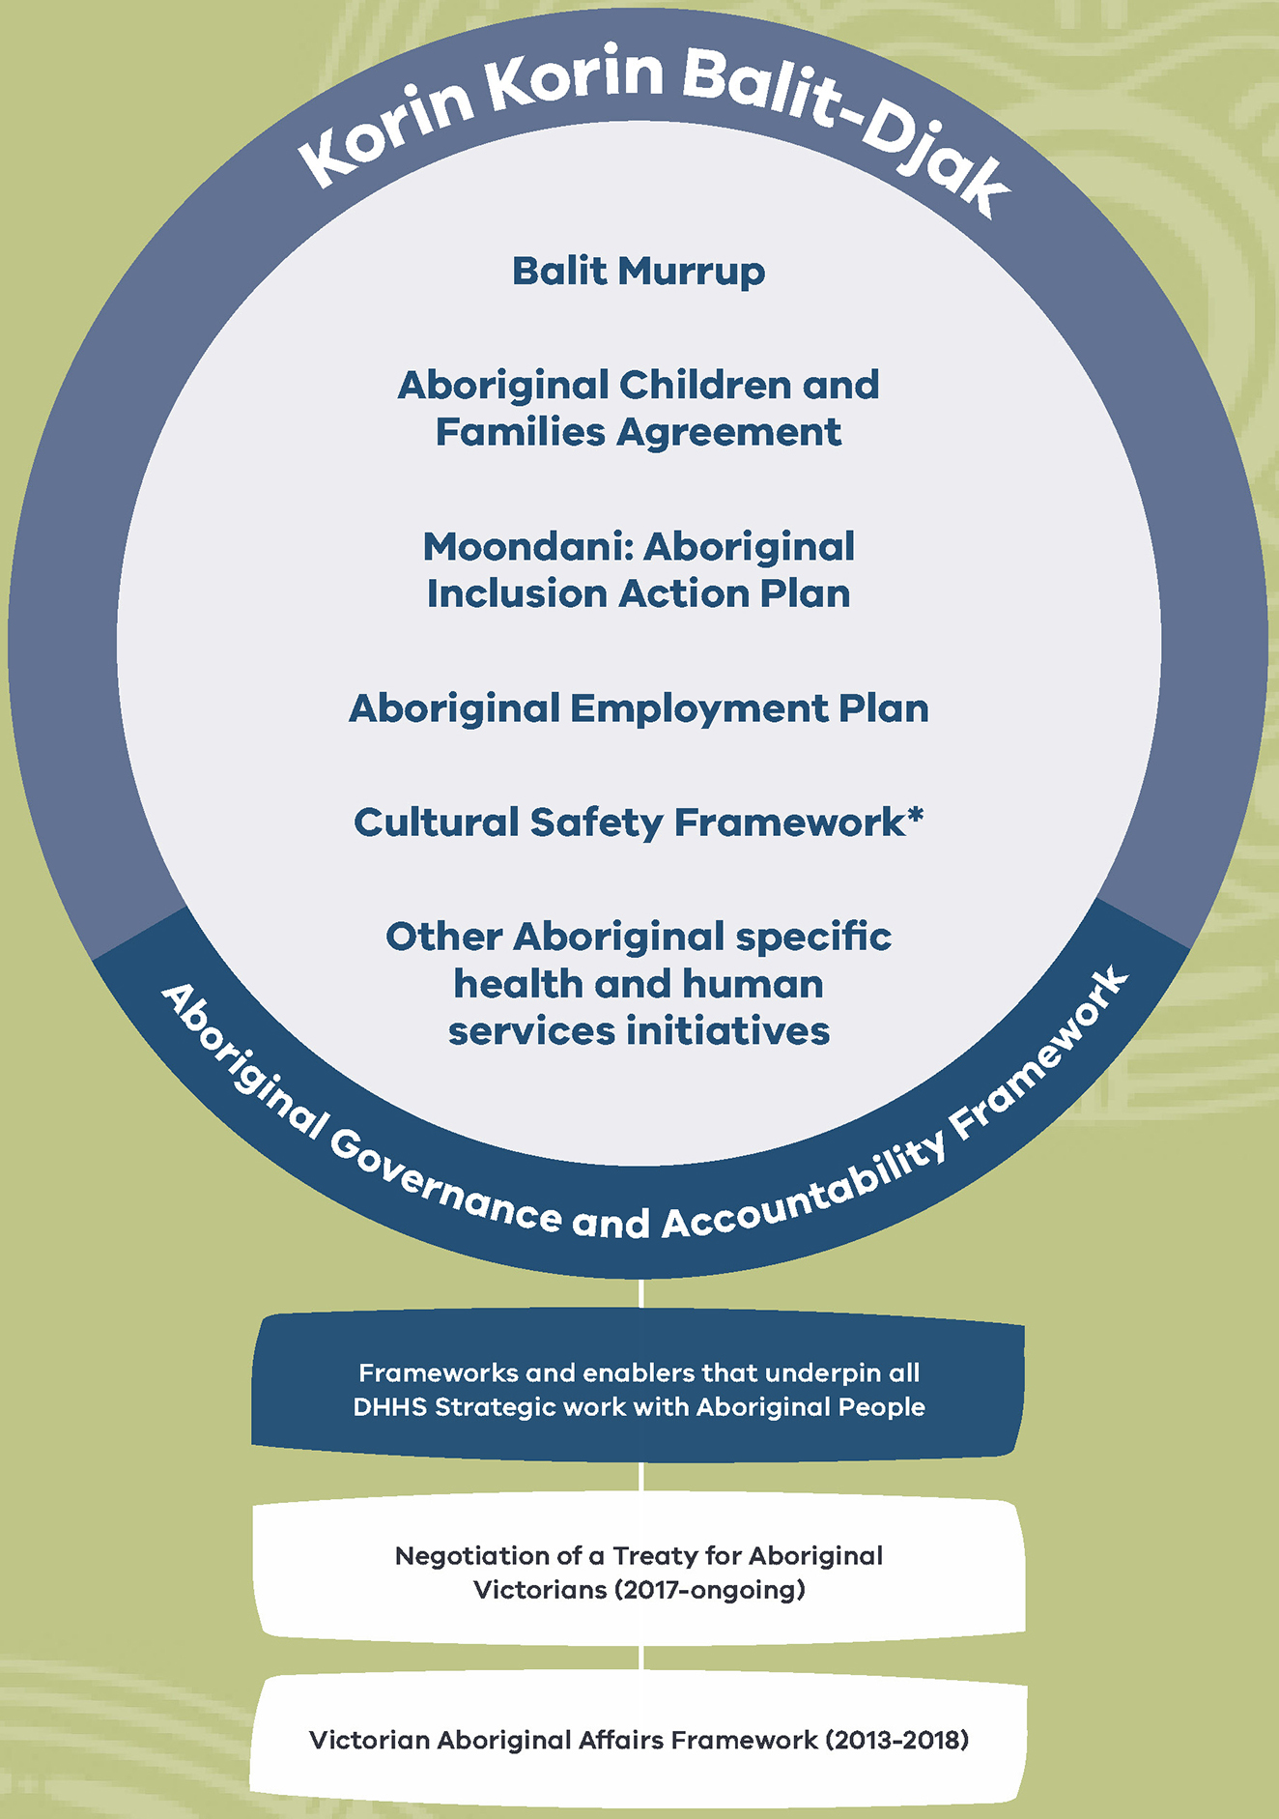

Development of the framework
The department commenced the development of the framework in early 2016. Consultants were engaged to review previous policies and frameworks that aimed to improve the health, wellbeing and safety outcomes of Aboriginal people. These included roundtables, Koolin Balit Committees and a range of other local and statewide consultation and advisory approaches.
The consultants worked closely with the department and Aboriginal community stakeholders using the following methods:
- six community forums held across regional and metropolitan Victoria. Aboriginal communities and organisations came together with department representatives to explore new forms of engagement.
- a statewide symposium provided a forum where themes, standards and accountabilities for engagement were discussed.
- advice provided by the Executive Board, central office, program areas and key staff across the four Operational Divisions of the department, including Aboriginal staff.
- extensive research highlighted a number of challenges and opportunities in establishing the framework.
- engagement with Aboriginal stakeholders through Aboriginal advisory groups, forums and networks across the department, including the Expert Panel for Korin Korin Balit-Djak.
- a review of the department’s current and previous Aboriginal engagement and governance mechanisms and key findings from other structures across the Victorian Government.
- a literature review examined evidence on different models and approaches (national and international and specific to First Nations people).
- a series of conversations were had with Aboriginal leaders, community members and organisations and departmental and other government stakeholders.
  - a review of the previous consultations across Victoria was undertaken by Aboriginal Victoria (formerly Aboriginal Affairs Victoria) in 2011, seeking advice from the Victorian Aboriginal community with regard to effective engagement with the Victorian Government.
Other evidence used to inform the framework include:
- evaluations of the Koolin Balit investment
- six month program reports for Koolin Balit
  - commissioned research on Aboriginal self-determination (Behrendt 2016)

Guided by Aboriginal self-determination
The consultations confirmed that Aboriginal Victorians, organisations and the funded sector do not think that Aboriginal health, wellbeing and safety outcomes will be improved without a self-determined approach. It was emphasised that Aboriginal communities must be authorised and empowered to own, direct and make strategic decisions on policies and programs that affect them.
Feedback highlighted the importance of understanding the uniqueness of each community and that Aboriginal self- determination is the role of community – not government - to define.
Irrespective of how self-determination is understood, the National Aboriginal Community Controlled Health Organisation describes the fundamental essence of self-determination as:
[quote] The ability of Aboriginal people to determine their own political, economic, social and cultural development is an essential approach to overcoming Indigenous disadvantage. (NAHSWP 1989)
Importantly, self-determination is a human right, as described in article one of the International Covenant on Civil and Political Rights and in article one of the International Covenant on Economic, Social and Cultural Rights:
- ‘All peoples have the right of self-determination. By virtue of that right they freely determine their political status and freely pursue their economic, social and cultural development.’
- ‘All peoples may, for their own ends, freely dispose of their natural wealth and resources without prejudice to any obligations arising out of international economic co-operation, based upon the principle of mutual benefit, and international law. In no case may a people be deprived of its own means of subsistence.’
  - ‘The States Parties to the present Covenant, including those having responsibility for the administration of Non-Self-Governing and Trust Territories, shall promote the realisation of the right of self-determination, and shall respect that right, in conformity with the provisions of the Charter of the United Nations.’
The United Nations Declaration on the Rights of Indigenous Peoples reinforces the right to self-determination:
- Article 3 – ‘Indigenous peoples have the right of self-determination. By virtue of that right they freely determine their political status and freely pursue their economic, social and cultural development.’
- Article 4 – ‘Indigenous peoples, in exercising their right to self-determination, have the right to autonomy or self-government in matters relating to their internal and local affairs, as well as ways and means for financing their autonomous functions.’
- Article 18 – ‘Indigenous peoples have the right to participate in decision-making in matters which would affect their rights, through representatives chosen by themselves in accordance with their own procedures, as well as to maintain and develop their own Indigenous decision-making institutions.’
  - Article 19 – ‘States shall consult and cooperate in good faith with the Indigenous peoples concerned through their own representative institutions in order to obtain their free, prior and informed consent before adopting and implementing legislative or administrative measures that may affect them.’

Principles for engaging and partnering
To inform the development of the framework, a review of the department’s existing Aboriginal engagement mechanisms was undertaken. The review highlighted six core principles that inform good practice in engaging and partnering with Aboriginal leaders, communities and organisations:
- Principle 1 –The impact of past and ongoing trauma experienced by Victorian Aboriginal communities is acknowledged.
- Principle 2 – The diversity, context and capacity of Victorian Aboriginal communities is understood and that partnership and engagement practices reflect diverse and multiple Aboriginal voices.
- Principle 3 – Partnerships and engagement with Victorian Aboriginal communities are characterised by high levels of cultural safety, whereby engagement is culturally appropriate and respectful.
- Principle 4 – Partnerships that are mutually beneficial, where knowledge and expertise are shared in ways that benefit Aboriginal people and the department.
- Principle 5 – Capacity building through partnerships that support participatory governance and a willingness to share power.
  - Principle 6 – Victorian Aboriginal people lead the monitoring and evaluation processes accompanying the framework.
The six principles are designed to:
- give Victorian Aboriginal people and communities a legitimate place in the decision-making process.
- ensure trusting relationships and partnerships can be built.
- ensure engagement is culturally sensitive and enables a ‘people to people’ process.
- develop an ongoing process of accountability to and from Victorian Aboriginal communities.
  - ensure department staff are aware of Aboriginal culture and community dynamics.

Design parameters
The framework was shaped by the following design parameters, as agreed by Aboriginal communities and organisations.
Parameter | Description
Victorian Aboriginal communities vision of self-determination | The framework is bound by Victorian Aboriginal communities’ vision for self-determination.
Human rights based approach | The framework must be developed in the context of Human Rights based approach (United Nations Declaration of the Rights of Indigenous Peoples) and key charters to which Australia is a signatory.
Whole-of-government | The framework must align with whole-of-government directions.
Department-funded sector | The framework must reflect accountability of the broader department-funded sector.
Develop a common language | The framework must provide agreed definitions of key concepts and terms (such as engagement and partnership).
Existing decision-making and engagement mechanisms | The framework must identify links with existing decision-making and engagement structures.
Clear roles and responsibilities | The framework must articulate clear roles and reporting structures with the department’s role to focus on enabling and facilitating community action and leadership
Capturing local voices and responding appropriately to community concerns | The framework must identify mechanisms to capture local voices (clients, ACCOs and the department’s Aboriginal staff) and provide clear direction on the different engagement methods.
Flexible and adaptable structures | The framework must be flexible, adaptable and responsive to community needs.

Governance mechanisms
This framework will establish a set of governance mechanisms (Figure B) to ensure Aboriginal communities lead the implementation of Korin Korin Balit-Djak and other initiatives – with the support of the department.
Spanning across the three levels of the department’s operations: local, divisional and statewide, the governance mechanisms will facilitate joint leadership between Aboriginal communities and the department.
Each governance mechanism sets out the purpose, frequency, membership and format of interactions between Aboriginal communities and the department.
The governance mechanisms include:
- up to 17 Area Aboriginal Governance Committees (in line with the existing 17 local areas of the department), including conducting at least two community conversations per year for broader community engagement
- four Divisional Aboriginal Governance Committees (one for each Operational Division)
  - one Aboriginal Strategic Governance Forum (statewide), including an Aboriginal Evaluation and Research Committee.
Where appropriate, the governance mechanisms:
- build on and adapts existing Aboriginal engagement and governance mechanisms within the department
  - complement existing whole- of-government structures and strengthens relationships and information sharing at all levels.
Parallel with establishment of these new governance mechanisms, the Aboriginal community will lead the formation of an Aboriginal Evaluation and Research committee. Its role will be to deliver and oversee the Aboriginal health, wellbeing and safety evaluation plan. This committee will ensure the use of Aboriginal indicators, methods and measures of success.

Figure B: Governance mechanisms
Note: Membership listed within these mechanisms is not exhaustive. See Appendix A for more details.
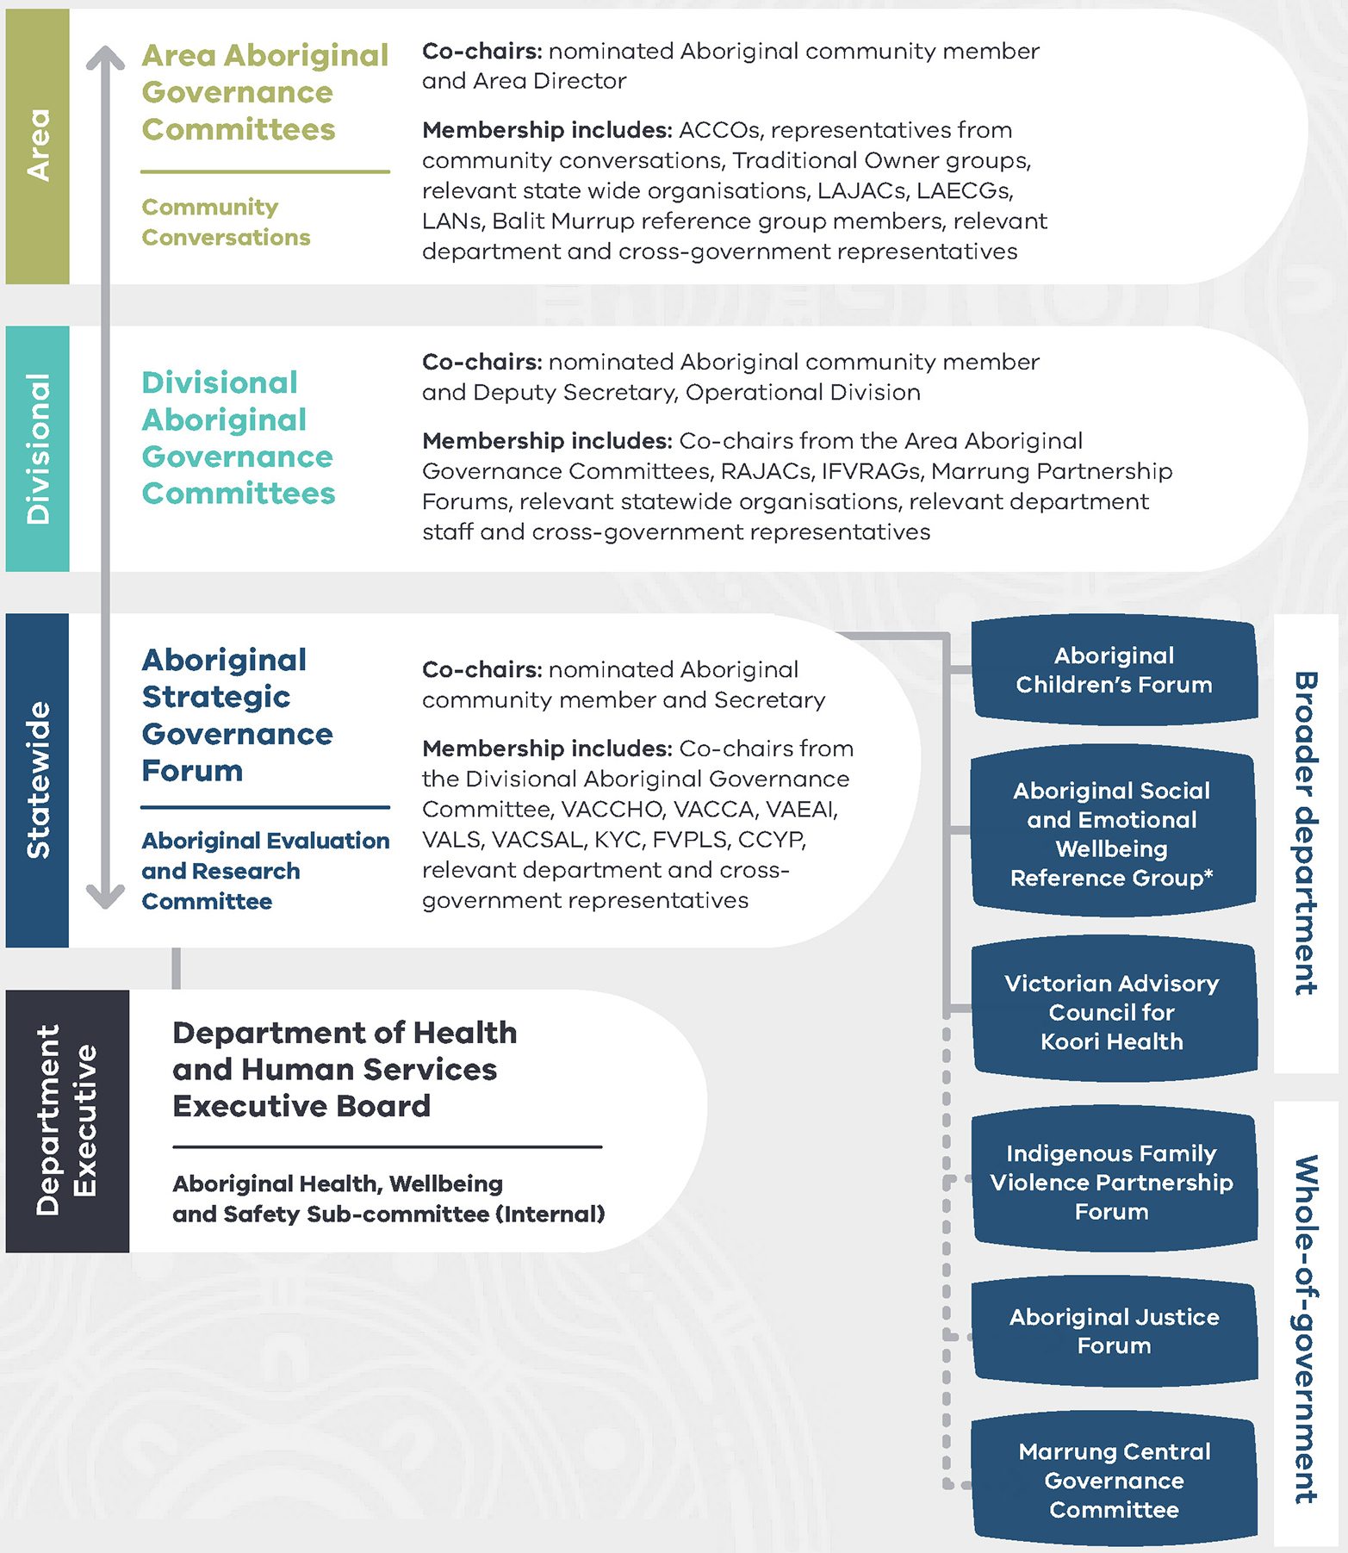

The three jurisdictional levels are fundamental in providing opportunities for:
- local communities to identify and communicate their aspirations and challenges, and work with the department to develop action plans to address these.
- Aboriginal decision-making at all levels.
- Aboriginal leadership to provide strategic advice on current and future issues.
- continuity across all levels within the governance mechanisms through common membership
- a platform to communicate and raise issues as necessary.
  - Advice and direction in relation to funding priorities.
The tables in Appendix A describe the proposed purpose, format, secretariat and membership arrangements.
Figure C outlines the continuum of participation for Aboriginal community members. This illustrates how Aboriginal community membership moves through the levels from Area to Statewide.
Throughout this process it will be important to monitor, review and adapt governance mechanisms to ensure they remain responsive to the needs of Aboriginal communities. A formal review is scheduled for 2020 to align with the planned update of Korin Korin Balit-Djak.
Figure C: Aboriginal community participation continuum
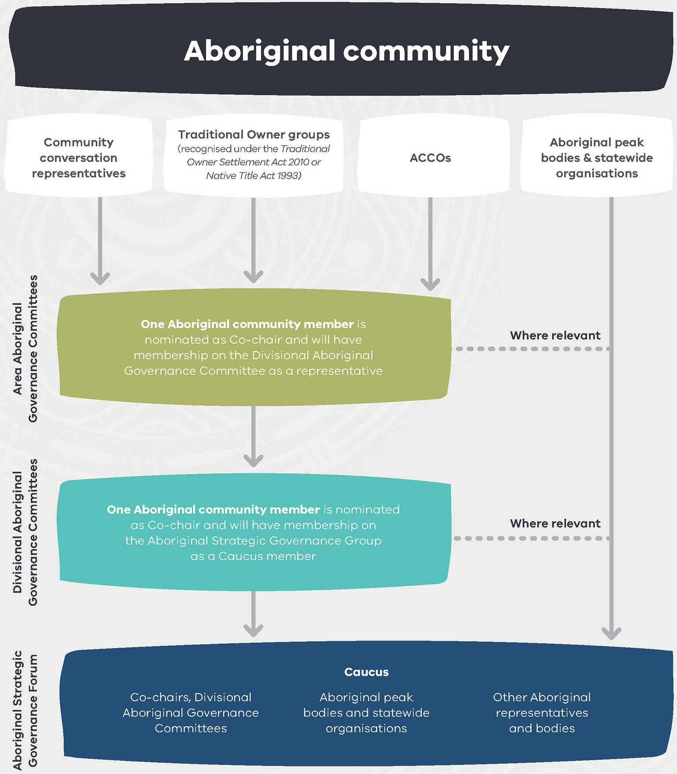

Transitioning to the new mechanisms
The governance mechanisms presented in Figure B will build on the efforts of preceding arrangements including the Koolin Balit Committees and the Divisional and Central Aboriginal Outcomes Committees.
The following table outlines which mechanisms will evolve and take on broader functions in-line with Korin Korin Balit-Djak and other initiatives.
Level | Preceding mechanisms | New mechanisms
Area | - Area Aboriginal Advisory Groups | - Community conversations  - Area Aboriginal Governance Committees
Divisional | - Department of Health and Human Services’ Divisional Aboriginal Outcomes Committees  - Koolin Balit or Closing the Gap Committees | - Divisional Aboriginal Governance Committees
Statewide | - Department of Human Services, Human Services Aboriginal Roundtable  - Department of Health Secretary Roundtable  - Department of Health and Human Services, Aboriginal Outcomes Committee | - Aboriginal Strategic Governance Forum

Achieving consistency
The framework acknowledges existing Aboriginal community-led governance and decision-making arrangements that are already leading the way.
The framework will not impose a one-size-fits-all approach on communities. Each of the four Operational Divisions will implement a model that works for local communities. Operational Divisions may choose to have a metropolitan and regional focus as is the case in the North Division. The best example of this is the Loddon Mallee Aboriginal Reference Group (LMARG) who have combined two department areas (Loddon and Mallee) to provide leadership, guidance and direction to all groups responsible for the provision of funding, services, and resources relating to the health, wellbeing and safety of the region’s Aboriginal communities.
The governance mechanisms outlined in Figure B will allow for flexibility and innovation at an area level. This will ensure communities and ACCOs can be self-determining to find the best arrangements for their communities.
This framework contains a number of fixed requirements to ensure consistency.
These elements are:
- ensuring there is always an Aboriginal community member as co-chair
- ensuring agendas for each meeting have significant involvement from the Aboriginal co-chair or an Aboriginal community member
- ensuring each committee and forum must have at least 50 per cent Aboriginal community membership
  - ensuring each local area holds a minimum of two community conversations per year to identify area health, wellbeing and safety priorities and feedback progress.
These elements must continue to form the basis of future governance mechanisms so that Aboriginal communities remain central to the decision- making process.

Implementation and coordination
The framework represents a substantial challenge and opportunity to implement, coordinate and sustain participation at all levels.
Guided by the Aboriginal community, the department will commence and facilitate the process of forming the new governance mechanism. This work will be also guided by the broader implementation approach of Korin Korin Balit-Djak.
Figure D illustrates the proposed sequence of each governance mechanism throughout a calendar year. Successfully coordinating the intricate flows of information and accountabilities between them will be critical to the success of this framework.
A framework practice guide will be developed in 2018 to support the implementation.

Figure D: Sequencing of governance mechanisms and information flow
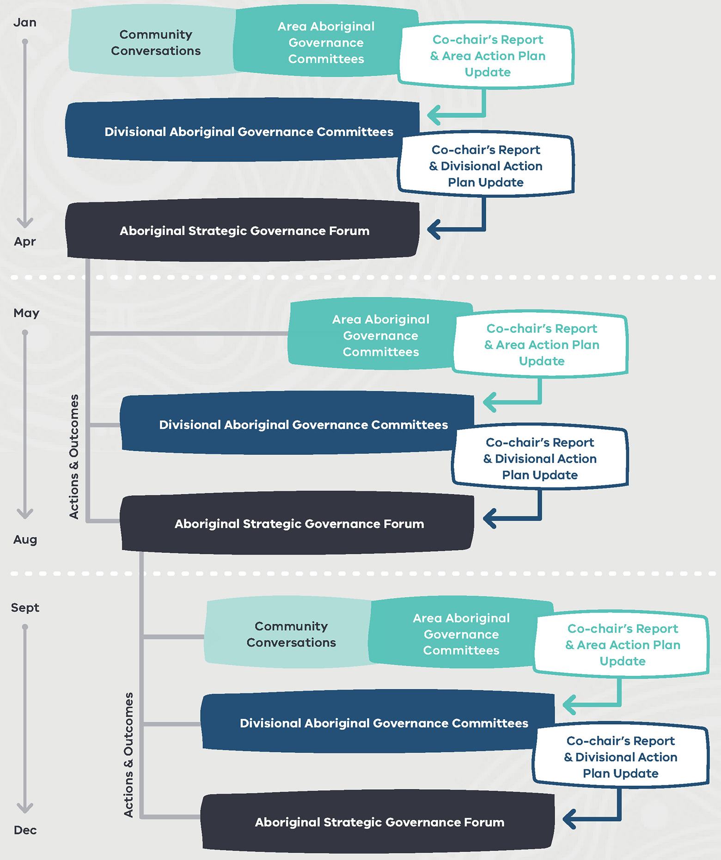

Appendix A: Governance mechanisms

Area Aboriginal Governance Committees

Purpose
Area Aboriginal Governance Committees will:
- provide a forum to capture localised Aboriginal perspectives, aspirations and challenges for their communities and identify actions that need to be addressed.
- develop and oversee localised Korin Korin Balit-Djak health, wellbeing and safety action plans and allocate resources to support these.
- strengthen the network of department-funded sector agencies required to deliver services to Aboriginal communities.
  - provide local monitoring of departmental responsibilities in particular in relation to Aboriginal employment and inclusion, cultural support plans, Taskforce 1000 and other identified priorities.

Co-chairs
A nominated Aboriginal community member and the relevant Area Director.

Format
Area Aboriginal Governance Committees will:
- be convened a minimum three times per year.
- host at least two community conversations per year prior to the convening of the Area Aboriginal Governance Committees. These conversations will provide an insight from a localised level encompassing current priorities and challenges of Aboriginal communities.
  - focus discussions to capture the voices and perspectives of various stakeholder groups including young people, Elders and people with a disability.

Secretariat
The relevant area will lead the secretariat support with assistance from the Operational Divisional Aboriginal Engagement and Outcomes units. This support will include:
- coordinating logistics and communications.
- developing the agenda in collaboration with Aboriginal community members.
  - communicating outcomes of each meeting to members.

Membership

Aboriginal community
- Local Aboriginal community-controlled organisations
- Representative, Local Aboriginal Justice Advisory Committees
- Representative, Local Aboriginal Education Consultative groups
- Representative, Indigenous Family Violence Regional Action Groups
- Representative, Local Aboriginal Networks
- Representatives, Traditional Owner (recognised under the Traditional Owner Settlement Act or Native Title Act)
- Representative, Koorie Youth Council
  - Relevant Aboriginal statewide services

Department of Health and Human Services
- Director, Area (co-chair)
- Divisional Aboriginal Engagement Manager and other relevant Aboriginal staff
  - Other relevant department staff

Additional members
- Local health and human services agencies
- Local government representatives
  - Organisation and other government departments in receipt of local, state and federal government funding and whom provide services to departmental clients (for example Primary Health Networks (PHNs)).

Community Conversations (two per year)
An invitation to Aboriginal community members will be provided to form an open conversation regarding the needs of the community. The frequency of meetings is subject to change as per community’s needs.

Divisional Aboriginal Governance Committees

Purpose
The four Divisional Aboriginal Governance Committees (one in each Operational Division) will:
- develop and oversee a divisional action plans.
- provide oversight of the implementation of local area action plans and core portfolio responsibilities. In particular, Aboriginal employment and inclusion, cultural support plans, Taskforce 1000 and other identified priorities.
- develop divisional reports outlining progress on department lead responsibilities which will be tabled at the Aboriginal Strategic Governance Forum.
- make decisions on the allocation of department funding.
- identify emerging issues and opportunities.
  - monitor divisional data, KPIs and continuously evaluate in line with adhering to the agreed priorities and outcomes measures.

Co-chairs
A nominated Aboriginal community member and relevant Deputy Secretary, Operational Division.

Format
The duration of the meeting will be at least three hours, allowing time to encompass the various portfolio discussions.
There will be at least three meetings organised per year. The meeting will be held prior to the Aboriginal Strategic Governance Forum.
The Aboriginal co-chair will take up membership on the Aboriginal Strategic Governance Forum.

Secretariat
The Deputy Secretary, Operational Division will be responsible for convening this committee.
The department will:
- ensure that the logistics and communication related to this group are conducted in a culturally safe manner
- develop the agenda in collaboration with members
  - be responsible for the communication outcomes of each of these meetings to their members.

Membership

Aboriginal community
- Co-chair, Area Aboriginal Governance Groups
- ACCO representatives
- Chair or representative, relevant Indigenous Family Violence Regional Action Group
- Chair or representative, relevant Regional Marrung Partnership Forum
- Chair or representative, relevant Regional Aboriginal Justice Advisory Committee
  - Relevant statewide Aboriginal organisations

Department of Health and Human Services
- Deputy Secretary, Operational Division (Co-chair)
- Directors, Area
- Director, Health
- Director, Client Outcomes Service Improvement
- Manager, Aboriginal Engagement and Outcomes
  - Members of Aboriginal Staff Support Network (up to two)

Aboriginal Strategic Governance Forum

Purpose
The Aboriginal Strategic Governance Forum will:
- set and oversee strategic directions in the context of all Aboriginal-specific matters relevant to departmental portfolio areas.
- oversee and monitor strategic plans and frameworks including, but not limited to Korin Balit-Djak, Balit Murrup, and Barring Djinang – the Aboriginal employment strategy.
- identify emerging issues, opportunities and priorities contributing to departmental planning and budget development.
- inform funding allocations and budget setting.
- monitor data, KPIs and produce an annual report assessing progress against agreed priorities and outcomes measures.
- support the work of the Aboriginal Evaluation and Research Committee.
  - identify opportunities to collaborate across Victorian Government mechanisms such as the Aboriginal Justice Forum and the Murrung Central Governance Committee.

Chaired by
Co-chaired by a nominated Aboriginal community member and the Secretary.

Format
There are four key elements to the Aboriginal Strategic Governance Forum:
- a Caucus comprising of Aboriginal members will convene six weeks prior to the governance committee. During this meeting, members will contribute forthcoming agenda items and provide discussion points across various portfolios (optional for community).
- a collective report will be prepared and provided to the full group membership.
- the Aboriginal Strategic Governance Forum comprising all members will be held six weeks after the convening of the Caucus (meetings to be held at the various locations).
  - an Aboriginal community member will lead the Aboriginal Strategic Governance Forum alongside the Secretary as co-chair.

Secretariat
The department will provide full secretarial support for the Aboriginal Strategic Governance Forum through the Aboriginal Health and Wellbeing branch.
The Aboriginal Strategic Governance Forum will be convened three times a year. The agenda will be developed in collaboration with all members.

Membership

Aboriginal community
- Co-chairs, North, South, East, West Divisional Aboriginal Governance Committees (ensuring regional representation exists)
- Victorian Aboriginal Community Controlled Health Organisation
- Victorian Aboriginal Childcare Agency
- Victorian Aboriginal Education Association Incorporated
- Victorian Aboriginal Legal Service
- Victorian Aboriginal Community Services Association Limited
- Aborigines Advancement League
- Aboriginal Family Violence Prevention and Legal Service
- Aboriginal Housing Victoria
- Koorie Youth Council
- Aboriginal Children and Young People’s Alliance
- Representative from the Aboriginal social and emotional wellbeing reference group
- A nominated representative from the sport and recreation sector (TBC)
- A nominated representative from the drug and alcohol sector (TBC)
- A nominated representation from the homelessness sector (TBC)
- Chairperson, Aboriginal evaluation and research committee
  - Commissioner for Aboriginal Children and Young People

Department of Health and Human Services
- Secretary (co-chair)
- Deputy Secretary, North, South, East, West Divisions
- Deputy Secretary, Children, Families, Disability and Operations
- Deputy Secretary, Health and Wellbeing
- Deputy Secretary, Housing, Infrastructure, Sport and Recreation
- Deputy Secretary, Strategy and Planning
- Deputy Secretary, Community Participation, Health and Wellbeing
- Director, Aboriginal Health and Wellbeing
- CEO, Safer Care Victoria
  - CEO, Family Safety Victoria

Other government representatives
- Director, Koori Justice Unit, Department of Justice and Regulation
- Executive Director, Koorie Outcomes Unit, Department of Education and Training
- Executive Director, Aboriginal Victoria, Department of Premier and Cabinet
- Director, Aboriginal Affairs Policy, Department of Premier and Cabinet
  - Regional Manager, Regional Network, Prime Minister and Cabinet

Other possible stakeholders
- CEO, Victorian Council of Social Services
- CEO, Centre for Excellent in Child and Family Welfare
- CEO, Health service
  - CEO, Primary Health Network

Appendix B: Figure descriptions

Figure A: The department’s Aboriginal policies and reforms
Figure A illustrates how the department’s policies and frameworks work together.

Korin Korin Balit-Djak
Korin Korin Balit-Djak informs the following policies, plans and initiatives:
- Balit Murrup
- Aboriginal children and families agreement
- Moondani: Aboriginal inclusion action plan
- Aboriginal employment plan
- Cultural safety framework (to be developed in 2018)
  - other Aboriginal-specific health and human services initiatives
These are underpinned by the Aboriginal governance and accountability framework.

Frameworks and enablers that underpin all DHHS strategic work with Aboriginal people
- Negotiation of a Treaty for Aboriginal Victorians (from 2017 and ongoing)
- Victorian Aboriginal affairs framework (2013–2018).

Figure B: Governance mechanisms
Membership listed within the mechanisms that follow is not exhaustive. See Appendix A for more details.
The governance mechanisms include:
- up to 17 Area Aboriginal Governance Committees (in line with the existing 17 local areas of the department), including conducting at least two community conversations per year for broader community engagement
- four Divisional Aboriginal Governance Committees (one for each Operational Division)
  - one Aboriginal Strategic Governance Forum (statewide), including an Aboriginal Evaluation and Research Committee.
The department’s internal governance mechanisms include:
- Department of Health and Human Services Executive Board
  - Aboriginal Health, Wellbeing and Safety Subcommittee.

Area Aboriginal Governance Committees
Co-chairs: nominated Aboriginal community member and Area Director.
Membership includes:
- ACCOs
- representatives from community conversations
- Traditional Owner groups
- relevant state wide organisations
- LAJACs
- LAECGs
- LANs
- Balit Murrup Reference Group members
  - relevant department and cross-government representatives.

Divisional Aboriginal Governance Committees
Co-chairs: nominated Aboriginal community member and Deputy Secretary, Operational Division.
Membership includes:
- Co-chairs from the Area Aboriginal Governance Committees
- RAJACs
- IFVRAGs
- Marrung Partnership Forums
- relevant statewide organisations
  - relevant department staff and cross-government representatives.
Aboriginal Strategic Governance Forum and Aboriginal Evaluation and Research Committee
Co-chairs: nominated Aboriginal community member and Secretary

Membership includes:
- Co-chairs from the Divisional Aboriginal Governance Committee
- VACCHO
- VACCA
- VAEAI
- VALS
- VACSAL
- KYC
- FVPLS
- CCYP
  - relevant department and cross government representatives.

Broader departmental and whole-of-government mechanisms
Where appropriate, the governance mechanisms:
- build on and adapts existing Aboriginal engagement and governance mechanisms within the department
  - complement existing whole- of-government structures and strengthens relationships and information sharing at all levels.
Broader department:
- Aboriginal Children’s Forum
- Aboriginal Social and Emotional Wellbeing Reference Group (name is subject to change)
  - Victorian Council for Koori Health.
Whole-of-government:
- Indigenous Family Violence Partnership Forum
- Aboriginal Justice Forum
  - Marrung Central Governance Committee.

Figure C: Aboriginal community participation continuum
Figure C is a flow chart showing the continuum of participation for aboriginal community members and how aboriginal community membership moves through levels from area to statewide.

Aboriginal community
These members of the Aboriginal community connect with Area governance committees:
- Community conversation representatives
- Traditional Owner groups (recognised under the Traditional Owner Settlement Act 2010 or Native Title Act 1993)
  - ACCOs.
Aboriginal peak bodies and statewide organisations connect with the statewide governance but may connect with area and divisional governance committees where relevant.

Area Aboriginal Governance Committees
One Aboriginal community member is nominated as Co-chair and will have membership on the Divisional Aboriginal Governance Committee as a representative.

Divisional Aboriginal Governance Committees
One Aboriginal community member is nominated as Co-chair and will have membership on the Aboriginal Strategic Governance Group as a Caucus member.

Statewide: Aboriginal Strategic Governance Forum
Caucus of:
- Co-chairs, Divisional Aboriginal Governance Committees
- Aboriginal peak bodies and statewide organisations
  - other Aboriginal representatives and bodies.

Figure D: Timeline sequencing of governance mechanisms and information flow
Figure D illustrates the proposed sequence of each governance mechanism throughout a calendar year.

January to April
- Community Conversations and Area Aboriginal Governance Committees: provide Co-chair’s Report and Area Action Plan Update to divisional committees
- Divisional Aboriginal Governance Committees: provide Co-chair’s Report and Divisional Action Plan Update to statewide governance forum
- Aboriginal Strategic Governance Forum: actions and outcomes from here feed into May to August mechanisms.

May to August
- Area Aboriginal Governance Committees: provide Co-chair’s Report and Area Action Plan Update to divisional committees
- Divisional Aboriginal Governance Committees: provide Co-chair’s Report and Divisional Action Plan Update to statewide governance forum
- Aboriginal Strategic Governance Forum: actions and outcomes from here feed into September to December mechanisms.

September to December
- Community Conversations and Area Aboriginal Governance Committees: provide Co-chair’s Report and Area Action Plan Update to divisional committees
- Divisional Aboriginal Governance Committees: provide Co-chair’s Report and Divisional Action Plan Update to statewide governance forum
- Aboriginal Strategic Governance Forum.

List of abbreviations and terminology
ACCOs: Aboriginal Community Controlled Organisations
CCYP: Commission for Children and Young People
CEO: Chief Executive Officer
DHHS: Department of Health and Human Services
FVPLS: Family Violence Prevention and Legal Service
IFVRAGs: Indigenous Family Violence Regional Action Groups
KPIs: Key Performance Indicators
KYC: Koorie Youth Council
LAECGs: Local Aboriginal Education Consultative Committees
LAJACs: Local Aboriginal Justice Action Committees
LANs: Local Area Networks
PHN: Primary Health Network
RAJACs: Regional Aboriginal Justice Advisory Committees
VACCA: Victorian Aboriginal Child Care Agency
VACCHO: Victorian Aboriginal Community Controlled Health Organisation
VACSAL: Victorian Aboriginal Community Services Association Limited
VAEAI: Victorian Aboriginal Education Association Incorporated
VALS: Victorian Aboriginal Legal Service

References
Andrews, D 2015, Premier’s speech: Closing the Gap’, 19 March.
Available at: Closing the Gap — Premier’s Speech <http://www.premier.vic.gov.au/closing-the-gap-premiers-speech/>
Australian Institute of Health and Welfare (AIHW) 2016, Australia’s health 2016, AIHW, Canberra. Available at: Reports & statistics <https://www.aihw.gov.au/reports-statistics>.
Behrendt, L, Jorgensen, M & Vivian, A 2016, Self-determination: Background concepts – Scoping paper 1 for the Victorian Department of Health and Human Services, UTS Jumbunna Indigenous House of Learning, Sydney.
Department of the Prime Minister and Cabinet 2017, Closing the Gap: Prime Minister’s report 2017, Australian Government, Canberra. Available at: CLOSING THE GAP PRIME MINISTER’S REPORT 2017 <http://closingthegap.pmc.gov.au/>.
Hertzman, C & Siddiqi, A 2009, ‘Population health and the dynamics of collective development’, in P A Hall & M Lamont (eds), Successful societies. How institutions and culture affect health, Cambridge University Press, New York, NY.
Ng, J, Ntoumanis, N, Thøgersen- Ntoumani, C, Deci, E, Ryan, R, Duda, J & Williams, G 2012, ‘Self- determination theory applied to health contexts: A meta-analysis’, Perspectives on Psychological Science, vol. 7, no. 4, pp. 325–340.
National Aboriginal Health Strategy Working Party (NAHSWP) 1989, A national Aboriginal health strategy National Aboriginal Health Strategy Working Party, Canberra.

