|  |
| --- |
| Blood Matters on the  Bench and Beyond |
| Issue 4 – October 2020 |

Welcome to the Blood Matters newsletter for Scientists, written for Victorian transfusion scientists. It will be distributed throughout the year to share information that may be helpful to you, and to let you know of upcoming activities which may be of interest.



##### Lifeblood Update by Dr James Daly

**Thursday 29th October 2020, 12.00pm – 1.00pm**

Virtual meeting via Webex

Registration is required – [**Click here to register**](https://lifeblood.webex.com/mw3300/mywebex/default.do?service=1&siteurl=lifeblood&nomenu=true&main_url=%2Fmc3300%2Fe.do%3Fsiteurl%3Dlifeblood%26AT%3DMI%26EventID%3D1085455737%26UID%3D580586002%26Host%3DQUhTSwAAAATivAOE0-bdSJ53H3-pV4utIgpVjpCTLB6mV9JQmyQE44RxTG-KKM2UmPsjEnzlzkoeAGaf99ZGJJYvPmvntRE40%26RG%3D1%26FrameSet%3D2%26RGID%3Dr17499d82843da06004ffa3a6de371a5c)

* Presented by Dr James Daly - Medical Director, Pathology Services, Clinical Services and Research, Australian Red Cross Lifeblood.
* This education session is aimed at transfusion scientists of all levels, offering an extended update from Lifeblood, building upon the information discussed at the Scientist Summit in August.
* The session will include participant interaction to share expertise and experiences to contribute to the greater blood management community.

**Further upcoming education sessions**

We are working hard behind the scenes to provide more virtual education sessions for you, and will communicate these as soon as details are finalised.

**Updated Serious Transfusion Incident Reporting (STIR) guide**

The STIR reporting guide has been updated. Please be sure to review the new definitions and updated information when reporting incidents. The STIR guide can be located on the [Serious Transfusion Incident Reporting](https://www2.health.vic.gov.au/hospitals-and-health-services/patient-care/speciality-diagnostics-therapeutics/blood-matters/serious-transfusion-incidents) webpage.

Reporting of de-identified data about transfusion reactions to STIR assists local and national reporting requirements and supports:

* Health service requirements for accreditation.
* NBA National haemovigilance report.

STIR also provides bulletins on current areas/issues related to transfusion safety. These convey timely information, to increase awareness and improve reporting.

**Changes in the updated STIR guide include:**

* RhD isoimmunisations now reported to STIR on their own form.
  + This is used where a woman has become sensitised and developed an RhD antibody during or following (and attributable) to pregnancy.
* The definitions for delayed haemolytic transfusion reactions (DHTR) and delayed serologic transfusion reactions (DSTR) have been updated to only include those reactions that occur within 24 hours to 3 months after a transfusion has occurred. It is difficult to attribute the antibody development to a particular transfusion for longer periods.
* An “Other procedural” category has been added:
  + This is where the patient receives blood intended for them, but where there were a number of serious errors that were not picked up prior to transfusion.
  + This includes problems in an aspect of the transfusion process that don’t fit into either the incorrect blood component transfused (IBCT) or near miss categories.
* For the purposes of reporting, the transfusion is considered to have started once the blood bag is spiked. This is to help discriminate between near miss and IBCT events.

When reporting an incident, the more information provided at the time of reporting the better. This reduces the need for additional follow-up and could assist with more timely publication of data.

The 2018-19 STIR report and summary is available now on the [STIR Blood Matters webpage](https://www2.health.vic.gov.au/hospitals-and-health-services/patient-care/speciality-diagnostics-therapeutics/blood-matters/serious-transfusion-incidents), along with the initial reporting form, STIR reporting guide and previous STIR bulletins.

**‘STOP the waste’ festive campaign 2020-21**

The festive season is fast approaching, and once again it is time for us to consider how we can keep blood wastage to a minimum over this period. Donated blood is a precious gift, and we all need to do our part to protect and manage this valuable resource.

This year has been like no other, and we are mindful that this festive season the traditional reduction in services may not occur if health services are increasing capacity in response to resuming elective surgery.

As restrictions due to COVID-19 ease or change please remember to monitor how this may impact anticipated blood use and adjust the inventory accordingly.

Attached to this email and available on the Blood Matters webpage are two checklists – one for smaller/rural health services and one for larger/metropolitan health services.

There is also a festive campaign infographic to be displayed in clinical areas and the transfusion laboratory to remind staff to be vigilant in reducing waste over this period.

Your continued support of the ‘STOP’ the waste’ campaign is appreciated.

**TransfusEd in the Lab**

TransfusEd in the Lab is an innovative learning event that has been developed by Australian Red Cross Lifeblood to help transfusion scientists improve their knowledge of antibody testing and investigation.

It will be delivered in two streams to ensure that laboratories of all capabilities are able to participate by using combined methods of video presentations, practical sample testing and webinars facilitating discussion.

[Watch this video to find out more](https://www.youtube.com/watch?reload=9&v=OVayslMmWYw&feature=youtu.be) and email [transfusionlearning@redcrossblood.org.au](mailto:transfusionlearning@redcrossblood.org.au) to register your interest in participating.

**Lifeblood Red Cell Compatibility Calculator**

**I’ve found a new antibody – what should I do next?**

* Should I order blood for the patient?
* Should I take units for compatibility testing from my current inventory?
* Is the antibody clinically significant?
* What further testing do I need to do?

Check out this handy tool developed by the Transfusion Policy and Education team at Lifeblood.

Enter your patient’s RhD status and antibodies identified to see how common the compatible phenotype is in the general population.

The calculator also indicates the clinical significance of the antibody and what further steps are necessary for compatibility testing.

[Click here to view the Red Cell Compatibility Calculator](https://transfusion.com.au/node/727)

**E.g.** I have a patient who is RhD positive and has an Anti-M, Anti-K and Anti-Fya.

Discover whether you are likely to find compatible units in your own inventory or whether you will need place a BloodNet Special Order.

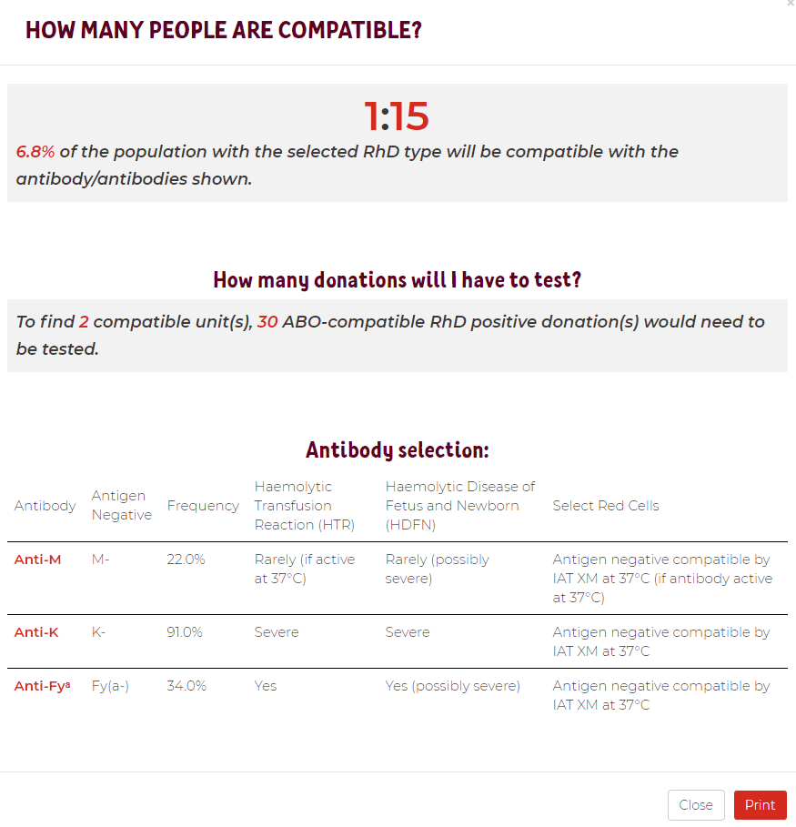

**Outcome:** I would have to test 30 units of RBC from my inventory to find 2 compatible units – I think I’d better place a BloodNet Special Order to receive phenotype matched RBC from Lifeblood.

A **Red Cell Phenotype Calculator** also available – how common is that phenotype?

[Click here to view the Red Cell Phenotype Calculator](https://transfusion.com.au/node/728)

### image of a certification documentNational certification of the medical scientist profession

A national professional certification scheme for the medical laboratory science profession in Australia has come into effect.

The Australian Council for Certification of the Medical Laboratory Scientific Workforce (ACCMLSW) is a newly created not for profit company established to administer the voluntary certification scheme.

* Join now at [www.accmlsw.org.au](https://accmlsw.wildapricot.org/)
* A 10% discount will apply to the normal certification fee for new registrants until the end of 2020
* You will need to upload
  + A certificate of primary qualification
  + Continuing professional development (CPD) record – PDF copy of the most recent CPD certificate or an outline of CPD activities in the previous 2 years
  + Declaration of competency assessment and experience (downloadable from the website) signed by your employer.

**Why become certified?**

* This can be seen as a first step towards mandatory certification, which would ensure only high calibre practitioners are employed in our laboratories, demanding recognition of our professional standing as part of Australia’s health service workforce.
* Certification will be the best benchmark available to assure competent professional practice.
* With a certified workforce there will be more obligation on the employer to ensure staff have professional development opportunities afforded to them.
* As a nationally certified medical scientist you can demonstrate your ongoing commitment to professional development and self-improvement and be recognised as passionate, progressive and pro-active.

Blood Matters is committed to providing support and education to assist in the early stages of this scheme, if you require any assistance or have any questions feel free to contact Rae French at [rfrench@redcrossblood.org.au](mailto:RFrench@redcrossblood.org.au) or by phone on 03 9694 3524.

**How can Blood Matters help you?**

The Blood Matters team is here to assist health services and laboratories through education and providing resources.

We welcome open and collaborative discussion to ensure we can work together to support and enhance your contribution to safe, efficient and effective blood management.

If you have suggestions, comments or ideas on tools and resources that could assist in day to day activities and towards achieving accreditation please let Rae French or any of the Blood Matters team know by email to [bloodmatters@redcrossblood.org.au](mailto:bloodmatters@redcrossblood.org.au)

**ISSN** 2652-7278 **- Online (pdf / word)**