Cryptosporidiosis outbreak linked to an aquatic facility
Communication plan template for aquatic facilities

About this template
The Department of Health and Human Services has developed this communication plan template to help your organisation to manage communication with staff, visitors and stakeholders when planning for and managing an outbreak of cryptosporidiosis in an aquatic facility.
Tailor the information in [brackets] to include details specific to the outbreak event and to your facility’s response. Provide as much background and local knowledge as possible where prompts or questions are posed in italics.

Tips for better communication

Know your stakeholders
Get to know who you need to work with in your local council (environmental health officer) and at the Department of Health and Human Services (Water Unit and divisional public health officers). We are all working together to prevent further spread of Cryptosporidium and protect public health.

Localise your message
You know your staff and visitors best, so use your local knowledge to make your messages more meaningful to your audience. Think about targeting groups that are vulnerable, particularly community members who speak English as a second language.

Timely and transparent messaging
Provide information to staff, visitors and stakeholders as early as possible to reduce the risk of further exposure to Cryptosporidium. It’s not an easy message to promote, but timely and transparent information can help to reduce reputational risks.

It’s better to be proactive
Promote Healthy Swimming messages throughout the year to encourage visitors to be healthy swimmers and to help prevent future outbreaks. Educate staff about Cryptosporidium, Healthy Swimming and how to manage an outbreak. Promoting Healthy Swimming during normal business means you will be better prepared to respond to an outbreak quickly and effectively.

Rinse and repeat
Finally, don’t worry about repeating messages. The best messages are simple and repeated again and again. The average number of times a person needs to hear a message in order to recall it is three to five times. So say it, then say it again (and again!).

Communication plan

Purpose
This plan has been developed to guide communication activity in response to a cryptosporidiosis outbreak notified on [date] affecting [this facility/facilities in the local government area/Victoria state-wide].

Background

What is Cryptosporidium?
Cryptosporidium is a tough germ that can be spread when recently infected swimmers contaminate the water with tiny amounts of the germ present on their body. Cryptosporidiosis (crypto) is the disease caused by the germ, and possible sources of contamination include someone who has recently had the illness, domestic animals such as pets, and farm animals such as cattle.
Cryptosporidium lives in the bowel and is found in the faeces (poo) of infected people. The germ is normally spread through poor hygiene (such as not washing), usually by ingesting contaminated food or water.
Outbreaks of crypto associated with pools occur when swimmers accidentally swallow pool water contaminated with the germ.
One person infected with crypto can pass enough germs in a single visit to contaminate a large swimming pool. The germs are highly resistant to chlorine, the usual form of pool disinfection. Up to 50,000,000 of the germ can be found in a single millilitre of faeces. Swallowing as few as two of the germs can lead to infection.
The symptoms of crypto (watery diarrhoea, often with cramping and abdominal pain) usually last about two weeks; however, it can cause prolonged and potentially life-threatening illness in people with weakened immune systems. An infected person can continue to shed the parasite in their faeces for at least two weeks after the diarrhoea has stopped.

What is the issue?
Management was notified by [your local council or Department of Health and Human Services] on [date] about an outbreak of Cryptosporidium linked to [your facility].
To prevent any further spread of crypto the facility needs to prove its ability to address Cryptosporidium risk within the pools and treatment system. Most facilities aren’t designed to inactivate Cryptosporidium oocysts, which are highly resistant to chlorine. One treatment method that has been proven to inactivate Cryptosporidium oocysts is a hyperchlorination procedure. The facility is required to [for example, close to the public and perform hyperchlorination] to address the issue. This process will begin [at/on time/date].
Does your facility have a response plan for responding to outbreaks or a closure? If so, provide details here.

Target audience
List the key people you need to communicate with. Some examples include:
- Visitors
  - Staff

Audience insights
What do you know about your visitors that could change the way you communicate with them? For example, does your local government area have a large proportion of community members who speak English as a second language? Demographic information can be sourced from <http://profile.id.com.au/>

Other stakeholders
Who else do you need to communicate with during an outbreak? Some examples might include:
- Department of Education and Training or other swim school organisers
- Other facilities in the area
- Other affiliated facilities
  - Management

Communication objectives
This communication plan aims to:
- inform staff, visitors and stakeholders of the situation and advise them of necessary actions
- raise awareness of Healthy Swimming preventive actions and encourage visitors to be healthy swimmers to reduce the potential for future outbreaks
  - foster and/or restore public and stakeholder trust and confidence in the facility’s management of this incident.

Key messages

Awareness raising
Use the following key messages when promoting Healthy Swimming practices to your visitors and staff.
We are all responsible for keeping our pools clean and free from germs that can cause illness and closures of aquatic centres.
Help keep the pool clean by following these simple steps:
- Do not swim if you have diarrhoea or have had diarrhoea in the past 14 days.
- Shower and wash with soap, especially your bottom, before you start swimming.
- Wash your hands with soap after using the toilet and changing a nappy.
- Change nappies in the nappy change areas only.
  - Avoid swallowing pool water.

Response
Tailor these key messages to communicate with staff, visitors and stakeholders about the outbreak.
- [Your facility] is working with [local council] and the Department of Health and Human Services to manage the presence of Cryptosporidium in our pool(s).
- Even tiny amounts of Cryptosporidium in the water can make you sick, so the facility will be closing [at/on time/date] until [time/date] to clean the pool(s).
- [Your facility] is taking this action to protect your health and to stop the spread of germs. We apologise for any inconvenience.
- If you feel unwell, visit your doctor or call NURSE-ON-CALL on 1300 60 60 24.
- Let us know if you become aware of faeces in our pool or if you become ill after swimming at our facility.
- We are all responsible for keeping our pools clean and free from germs that can cause illness and pool closures.
- You can help keep the pool clean by following these simple steps:
- Do not swim if you have diarrhoea or have had diarrhoea in the past 14 days.
- Shower and wash with soap, especially your bottom, before you start swimming.
- Wash your hands with soap after using the toilet and changing a nappy.
- Change nappies in the nappy change areas only.
- Avoid swallowing pool water.

Channels
What communication channels are available to you? Some channels might include:
- Social media
- Staff email/newsletter
- On-site promotional materials (such as posters, banners and TV screens)
- Website
- Media release/response
- Visitor email/newsletter
- Customer service/front desk
- Phone/information line
  - Email enquiries

Key contacts

Department of Health and Human Services

Water Unit
Phone: 1300 761 874 (business hours)
Email: water@dhhs.vic.gov.au

Divisional public health officer
Add the contact details of the divisional public health officer in your area.

Key staff
Add the contact details of any key staff you may need to contact urgently.

Local government
Add the contact details of the local government environmental health officer in your municipality.

Others
Add the contact details of other people you may need to contact in the event of an outbreak.

Approvals
Who will approve this document and communications being delivered to staff, stakeholders and visitors?

Communication resources
Contact the Department of Health and Human Services’ Water Unit to request hard copies of the following resources or download PDF files from <https://www2.health.vic.gov.au/public-health/water/aquatic-facilities/healthy-swimming>.
Aquatic facilities can order the posters and postcard using the online order form <http://ewfds.wfds.com.au/ewfds/?th=WUR&N1=WUR1&N2=WUR1>.

Healthy Swimming toolkit
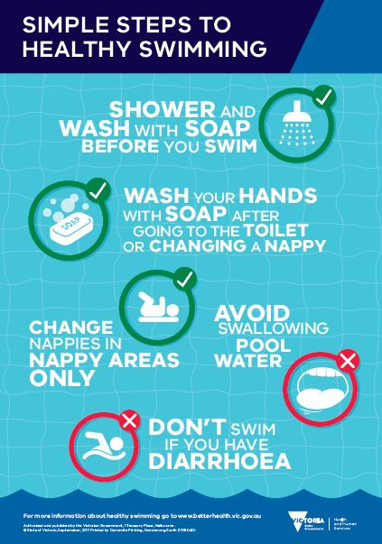 | 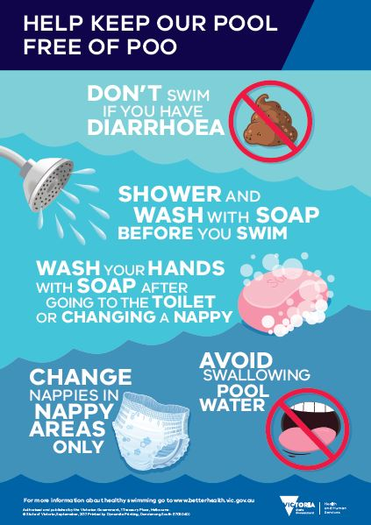
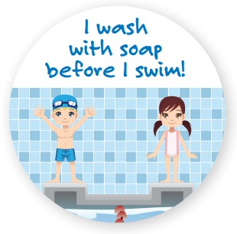 | 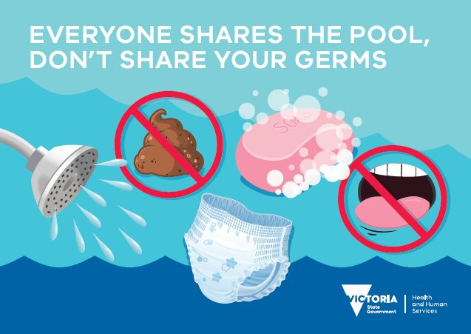

Animation
You can request the Healthy Swimming animation file from the Water Unit to use in your communications (such as on-site TV screens and social media). View the animation online:
- full version <https://www2.health.vic.gov.au/about/news-and-events/videos/healthy-swimming-long-version>
  - short version <https://www2.health.vic.gov.au/about/news-and-events/videos/healthy-swimming-short-version>

Better Health Channel
The Better Health Channel hosts information for the public about water quality and healthy swimming.
- Healthy Swimming campaign page <www.betterhealth.vic.gov.au/healthy-swimming>
- Swimming – keeping the water clean <https://www.betterhealth.vic.gov.au/health/healthyliving/swimming-keeping-the-water-clean>
  - Swimming pools and water quality <https://www.betterhealth.vic.gov.au/health/healthyliving/swimming-pools-water-quality>

Health.vic.gov.au
The Health website provides information for aquatic facilities.
- Information for aquatic facilities <https://www2.health.vic.gov.au/public-health/water/aquatic-facilities>
- Healthy swimming <https://www2.health.vic.gov.au/public-health/water/aquatic-facilities/healthy-swimming>
- Cryptosporidium in pools <https://www2.health.vic.gov.au/public-health/water/aquatic-facilities/cryptosporidium-in-pools>
- Faecal incident response – recommendations for aquatic facilities <https://www2.health.vic.gov.au/public-health/water/aquatic-facilities/faecal-incident-response>
  - Pool operators and local government – guidelines <https://www2.health.vic.gov.au/public-health/water/aquatic-facilities/pool-operators>

Frequently asked questions
Use these FAQs to help staff manage phone, email and social media enquiries.

Why is the pool closed?
[Your facility] is working with [local council] and the Department of Health and Human Services to manage the presence of Cryptosporidium in the pool(s).
Even tiny amounts of Cryptosporidium in the water can make you sick, so the facility will be closing [at/on time/date] until [time/date] to clean the pool(s).
[Your facility] is taking this action to protect your health and to stop the spread of germs. We apologise for any inconvenience.

What is Cryptosporidium?
Cryptosporidium is a tough germ that can be spread when recently infected swimmers contaminate the water with tiny amounts of the germ present on their body.
Cryptosporidium lives in the bowel and is found in the faeces (poo) of infected people. The germ is normally spread through poor hygiene (such as not washing), usually ingesting contaminated foods or water.
Cryptosporidium is highly contagious. One person infected with Cryptosporidium can pass enough germs in a single visit to contaminate a large swimming pool. The germs are highly resistant to chlorine, the usual form of pool disinfection. Up to 50,000,000 of the germ can be found in a single millilitre of faeces. Swallowing as few as two of the germs can lead to infection.
Go to the Better Health Channel to find out more about healthy swimming actions <https://www.betterhealth.vic.gov.au/health/healthyliving/swimming-keeping-the-water-clean> you can take to help keep the pool clean.

What is cryptosporidiosis?
Cryptosporidiosis (‘crypto’) is the disease caused by the germ Cryptosporidium. Possible sources of contamination include someone who has recently had the illness, domestic animals such as pets, and farm animals such as cattle. Outbreaks of crypto from pools happen when swimmers accidentally swallow pool water contaminated with the germ.
The symptoms of crypto are usually mild, but illness can be more severe for people with low immunity, in children and pregnant women. After infection, it can take one to 12 days (on average seven days) before you become ill.
Symptoms may include:
- severe diarrhoea, often with abdominal cramping
- bloating
- fever
  - loss of appetite, fatigue, nausea and vomiting.
The symptoms usually last for about two weeks. People with low immunity may be sick for longer. An infected person can continue to shed the parasite in their faeces for at least two weeks after feeling better and the diarrhoea has stopped.
To prevent further spread of crypto, it is important for any swimmers who have had crypto not to swim for two weeks after the diarrhoea stops. There is no treatment for crypto. Speak to your doctor for medical advice.
Go to the Better Health Channel to find out more about crypto <https://www.betterhealth.vic.gov.au/health/conditionsandtreatments/gastroenteritis-cryptosporidiosis>.

Have I / has my family been exposed to germs while swimming at your pool?
When someone has a confirmed case of cryptosporidiosis, the person’s doctor must notify the Department of Health and Human Services. A departmental or local government health officer may contact the patient to find out where they may have picked up the bug. If cases can be linked to a swimming pool, the facility management are notified immediately and begin to take action to prevent the further spread of germs.
Cryptosporidium is a tough germ that can be spread when recently infected swimmers contaminate the water with tiny amounts of the germ present on their body. One person infected with crypto can pass enough germs in a single visit to contaminate a large swimming pool. That is why we are taking action to close the pool and to treat the water – to ensure no one else gets sick.
Go to the Better Health Channel to find out more about swimming pools and water quality <https://www.betterhealth.vic.gov.au/health/healthyliving/swimming-pools-water-quality>.

I feel unwell after swimming, what should I do?
If you think you or your child may have cryptosporidiosis, contact your doctor. The doctor will ask you for a stool (faeces or poo) sample for testing. If the results of the tests show that you have cryptosporidiosis, the doctor will be able to provide you with advice and will also notify the Department of Health and Human Services.
Let the pool management know if you become aware of faeces in our pool or if you become ill after swimming at our facility.
Find out more about crypto on the Better Health Channel at <https://www.betterhealth.vic.gov.au/health/conditionsandtreatments/gastroenteritis-cryptosporidiosis>.

I have been sick recently, what should I do?
If you think you or your child may have cryptosporidiosis, contact your doctor. The doctor will ask you for a stool (faeces or poo) sample for testing. If the results of the tests show that you have cryptosporidiosis, the doctor will be able to provide you with advice and will also notify the Department of Health and Human Services.
Let the pool management know if you become aware of faeces in our pool or if you become ill after swimming at our facility.
Find out more about crypto on the Better Health Channel at <https://www.betterhealth.vic.gov.au/health/conditionsandtreatments/gastroenteritis-cryptosporidiosis>.

Is the water safe to swim in once you reopen the pools?
[Your facility] closed its doors to the public on [date] to prevent the spread of germs to visitors and to treat the water using a hyperchlorination process. The hyperchlorination process is proven to inactivate Cryptosporidium germs. As a precaution [facility name] has treated all the pools within the centre to ensure if any germs are present that they are destroyed so visitors are safe to swim in our facility.
We are all responsible for keeping our pools clean and free from germs that can cause illness and pool closures. Go to the Better Health Channel to find out more about healthy swimming actions you can take to help keep the pool clean <https://www.betterhealth.vic.gov.au/health/healthyliving/swimming-keeping-the-water-clean>.

What actions are you taking / have you taken to clean the pool(s)?
[Your facility] closed its doors to the public on [date] to prevent the spread of germs to visitors and treat the water using a hyperchlorination process. The hyperchlorination process is proven to inactivate Cryptosporidium germs. As a precaution [facility name] has treated all the pools within the centre to ensure if any germs are present that they are destroyed so visitors are safe to swim in our facility.
We are all responsible for keeping our pools clean and free from germs that can cause illness and pool closures. Go to the Better Health Channel to find out more about healthy swimming actions you can take to help keep the pool clean <https://www.betterhealth.vic.gov.au/health/healthyliving/swimming-keeping-the-water-clean>.

Has this affected only one pool? Why do you have to close the whole facility?
As a precaution [facility name] has treated all the pools within the centre to ensure if any germs are present that they are destroyed so visitors are safe to swim in our facility.
We are all responsible for keeping our pools clean and free from germs that can cause illness and pool closures. Go to the Better Health Channel to find out more about healthy swimming actions you can take to help keep the pool clean <https://www.betterhealth.vic.gov.au/health/healthyliving/swimming-keeping-the-water-clean>.

I thought you used chlorine to kill germs in the pool. Why doesn’t chlorine kill the germs?
Germs such as bacteria, viruses and parasites may enter swimming pools when contaminants are brought into the water. You share the pool water with others, and practising good hygiene before going swimming can prevent germs on swimmers’ bodies from contaminating pool water.
Most pools have treatment systems in place to kill germs. Depending on the type of germ and how long it takes for the germ to be killed, sometimes visitors can get sick when they come in contact or swallow small amounts of contaminated water.
Chlorine is able to kill most germs, but it doesn’t happen straight away. Some germs such as Cryptosporidium can live in pool water for days. Without your help, even the best maintained pools can spread germs.
Go to the Better Health Channel to find out more about healthy swimming actions you can take to help keep the pool clean <https://www.betterhealth.vic.gov.au/health/healthyliving/swimming-keeping-the-water-clean>.

Activity planner
Use the table below to help plan your communication activities. The details in the table below have been provided as an example. Tailor the information and activities to suit your facility.
Channel | Activity | Responsibility | Timing
Social media | - Post a notice about the closure on Facebook  - Use FAQs to field customer enquiries  - Post updates as required (such as about the reopening time)  - Promote Healthy Swimming actions | Communications officer | - ASAP  - As required  - As required  - Post-incident; schedule throughout the year/peak swim season
Staff meeting | - Notify staff of the closure to the public and the need for extra resources to resolve the issue | Facility manager | - ASAP on notification
Email to staff | - Notify staff of the closure to the public and the need for extra resources to resolve the issue  - Thank staff for helping | Facility/operations manager | - ASAP on notification  - Post-incident
Staff newsletter | - Provide info about Cryptosporidium and Healthy Swimming actions to prevent outbreaks | Communications officer | - Post-incident
Website | - Post a notice about the closure on your website  - Use FAQs to field customer enquiries  - Post updates as required (such as about the reopening time)  - Promote Healthy Swimming actions | Communications officer | - ASAP  - As required  - Post-incident
On-site: posters | - Put up a notice about the closure on the front doors  - Request Healthy Swimming posters from the Water Unit or by using the online order form  - Put up Healthy Swimming posters on available wall space and/or toilet door mounts | Operations manager | - ASAP  - ASAP  - Post-incident
On-site: screens | - Request the Healthy Swimming animation file from the Water Unit  - Run the animation on reception area screens | Operations manager | - ASAP  - Post-incident and schedule during peak swim season
On-site: front desk | - Request hard copies of the Healthy Swimming brochure from the Water Unit  - Place the brochure at the front desk or in other display areas | Operations manager | - ASAP  - Post-incident and during peak swim season
Customer enquiries: phone line | - Use FAQs to field customer enquiries  - Detail customer enquiries not included in FAQs to assist departmental staff to update responses – send to the Water Unit contact | Operations manager / staff | - As required  - Post-incident
Customer enquiries: email | - Use FAQs to field customer enquiries  - Detail customer enquiries not included in FAQs to assist departmental staff to update responses – send to the Water Unit contact | Operations manager / staff | - As required  - Post-incident
New starter or learn to swim packs | - Include Healthy Swimming resources (brochure, sticker, colouring sheets) in packs provided to new members or swim schools | Communications officer | - As required

