Tattooing (including cosmetic tattooing)
Client information

Key advice
- Choose an experienced tattooist whose premises (shop) is registered with their local council.
- Only sterilised needles, instruments and equipment should be used.
- Care for your tattoo while the site heals. Keep the site clean. Only touch the tattoo when necessary and always wash your hands before doing so.
  - If you experience pain, swelling, inflammation or discharge seek medical advice immediately.

Tattooing is a very popular form of body art. It involves injecting ink into the dermal layer of the skin to permanently or semi-permanently colour the skin. Tattooing can be for body art or cosmetic purposes.
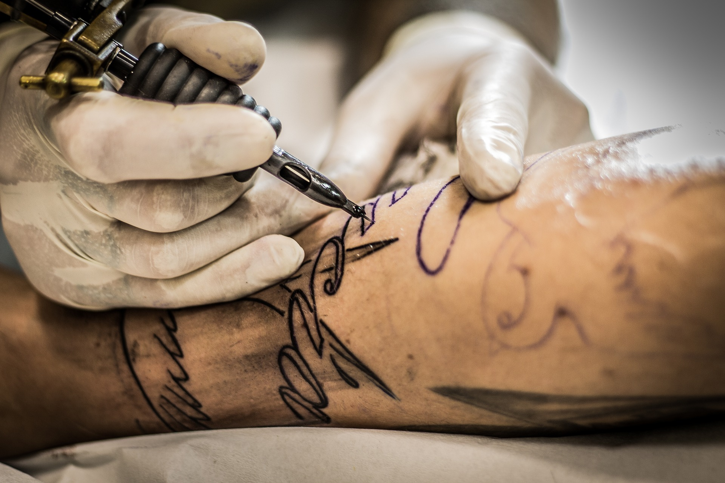
Cosmetic tattooing, also called micropigmentation, semi-permanent or permanent make-up, may be a service offered by some beauty therapy clinics. Cosmetic tattoos are used to define lips, eyebrows, and eyes.
Microblading or feathering of eyebrows is another form of cosmetic tattoo, although these usually fade much more quickly than other cosmetic tattoos.
If you are thinking about having a tattoo done you should read this fact sheet to find out about the law, the risks, and aftercare for your tattoo.

The law in Victoria
In Victoria it is against the law to tattoo any person under the age of 18 years.

Go to a registered premises
Tattoo businesses, including those who offer cosmetic tattooing services, must be registered with their local council. A certificate of registration should be available for you to see.
To comply with health legislation:
- the premises must be kept clean and hygienic
- tattoo needles must be sterile at the time of use; the operator should be able to explain how they have been sterilised
- the tattooist should not have exposed cuts or wounds and their clothes must be clean
- the premises must have accessible handwashing facilities
  - the tattooist must provide you with health information before any procedure is done.

Risks
The most common complications from tattooing are skin infections and allergic reactions to the ink.
All tattooing procedures, including cosmetic tattoos, if not performed under hygienic conditions can lead to infection or blood-borne diseases such as hepatitis B, hepatitis C or HIV.
In recent years, some inks have been recalled due to the presence of dangerous chemicals or contamination with microorganisms (germs). Ask your tattooist for details about the inks they use. They should be able to provide you with a safety data sheet.
Avoid getting tattoos in other countries, particularly in Asia, Africa, Eastern Europe and South America. The risk for complications and infections, including hepatitis B and C and HIV, is much greater.
People who have tattoos, including cosmetic tattoos, cannot donate blood for four months after getting a tattoo.

What to look for
The following are best practice recommendations for tattooists.
The tattooist should wash their hands at the beginning and end of the procedure and whenever they take a break during the procedure such as when answering the phone. They should also wear single-use disposable gloves during the procedure.
The tattooist should clean and disinfect your skin thoroughly before and after the procedure.
Needles or instruments used to pierce the skin must be sterile at the time of use. Tattoo needles should be single-use only and disposed of after each client. Other associated equipment such as the tattoo gun must be cleaned and sterilised or disinfected between each client. The tattooist should be able to explain how their equipment is cleaned and sterilised.
Ink containers should be single-use only or cleaned and sterilised between uses due to the risk of contamination with blood. Only sterile water, not tap water, should be used to dilute inks or to rinse needles while tattooing.
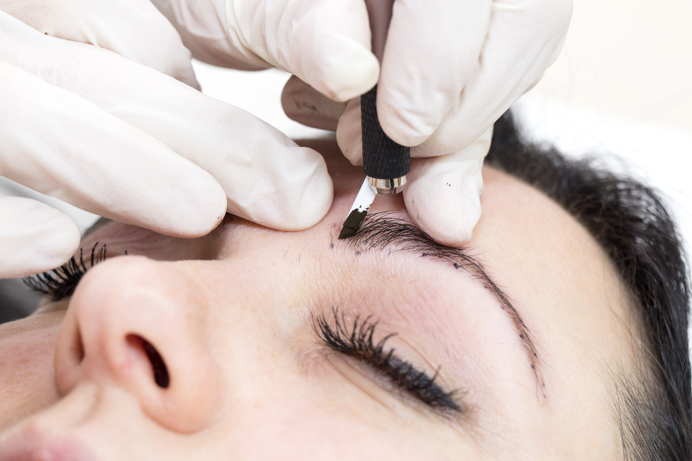

Caring for your tattoo
Your tattooist should provide you with detailed aftercare advice.
Some suggestions for looking after your tattoo include the following:
- Always wash your hands before touching the tattoo while it is healing.
- Do not rub, pick or scratch at the new tattoo.
- Cover the tattoo in the first instance with a non-stick dressing such as gauze. If cling film is used, make sure it is taken straight from the pack.
- Only use creams as advised by your tattooist or a pharmacist. Antibiotic creams should only be used for infections and under the supervision of a doctor.
- Do not wear tight or dirty clothing over the tattoo.
- Avoid sunbathing, but if you do, apply sunscreen.
  - Avoid swimming until the tattoo has healed. Use a barrier cream if you have frequent contact with water.
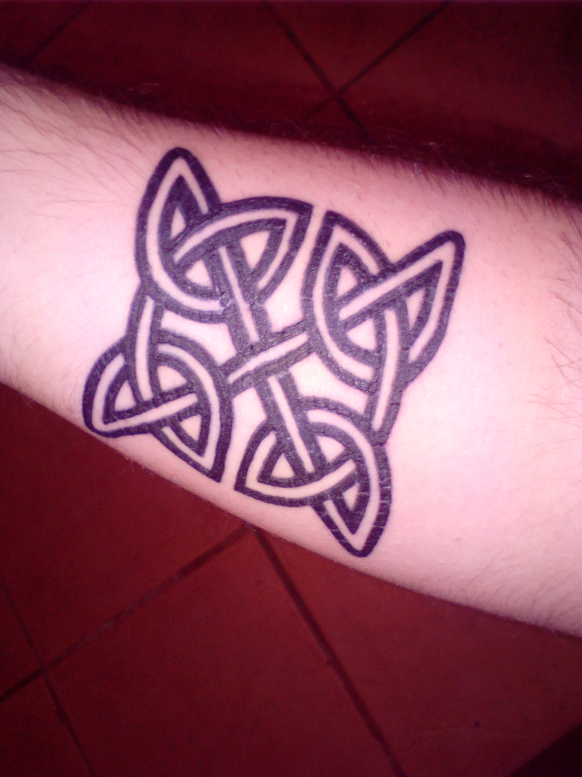

Tattoo removal
Unwanted tattoos can cause distress, especially if they are easily visible. In the past tattoo removal almost always led to extensive scarring. The development of newer treatments, such as laser therapy, means that most tattoos can be safely and effectively removed.
If you are considering removing a tattoo, consult your doctor for advice.

Further information
Councils register premises under the Public Health and Wellbeing Act 2008 for the purpose of overseeing infection control standards. Registration does not apply to the quality of procedures undertaken or the abilities or qualifications of individuals undertaking the business.
If you have concerns about the premises, the services you have received or need information on your rights please contact:
- the council in which the premises is located
  - Consumer Affairs Victoria <https://www.consumer.vic.gov.au/>.
To receive this publication in an accessible format phone Communicable Disease Prevention and Control on 1300 651 160, using the National Relay Service 13 36 77 if required, or email infectious.diseases@dhhs.vic.gov.au
Authorised and published by the Victorian Government, 1 Treasury Place, Melbourne.
© State of Victoria, Department of Health and Human Services, December 2019
Available at www2.health.vic.gov.au/public-health/infectious-diseases/personal-care-body-art-industries

