This document is to support you while you register for access to SafeScript.
Health practitioners in Victoria will be able to use SafeScript from October 2018.

Make sure you have:
- Your AHPRA number.
- A unique email address accessible only to you.
By default, SafeScript uses your email address held by AHPRA. If this address is shared by other practitioners at your organisation, you will need to enter an alternative email address during registration.

Step 1: Registrant details
When SafeScript training becomes available in your region, an invitation email to register for SafeScript will be sent to the email address linked with your AHPRA registration.
- Click the link in your SafeScript invitation email.
Or, if you have not received an invitation email, go to https://register.safescript.vic.gov.au
Result: The SafeScript Practitioner Registration screen is launched in your web browser.
  - If you came here from the link in your invitation email: Your AHPRA Number is pre-populated. If it is incorrect, please contact support on 1800 723 379.
  - If you have not received an invitation email: Enter your AHPRA Number.
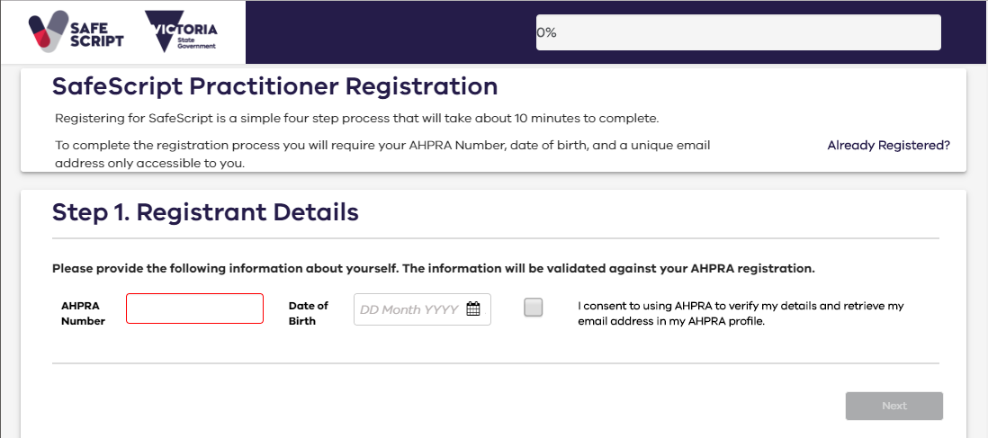
- Enter your Date of Birth, then tick I consent to using AHPRA to verify my details and retrieve my email address in my AHPRA profile.
Result: SafeScript checks your AHPRA registration status. If your date of birth is correct and your registration is current, further details from your AHPRA registration are displayed.
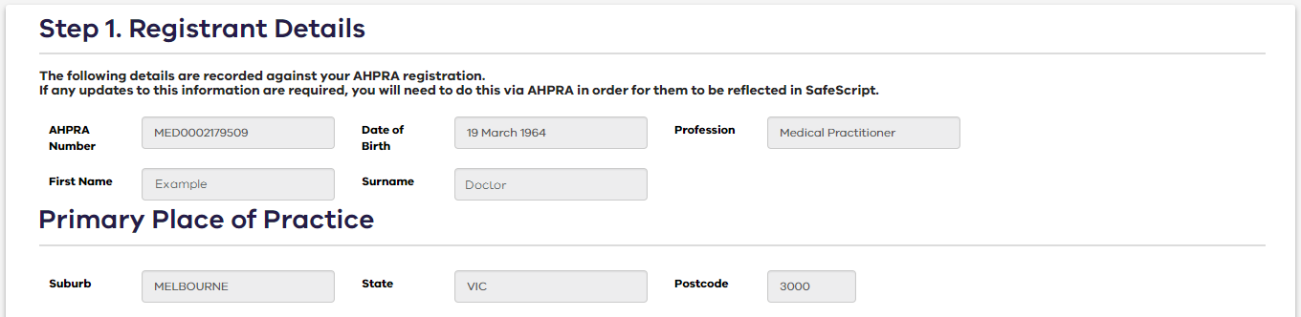
  - If the registration details are out-of-date, please contact AHPRA to update them.
SafeScript sends an email containing a verification code to the email address associated with your AHPRA registration (as shown in the screenshot in the next step).

Step 2: Contact details
- Go to the email account used for your AHPRA registration, then copy the verification code sent by SafeScript.
- In the SafeScript registration portal, enter the Verification Code, then click Verify.
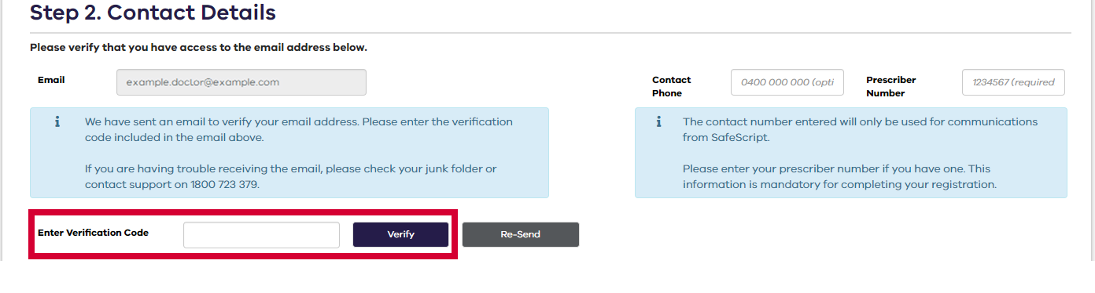
- Optional: Enter your Contact Phone number. This number will be kept private and will be used only to communicate with you about SafeScript.
- Required for prescribers: Enter your Prescriber Number (Note: This field is not displayed to pharmacists).
  - If you are a prescriber but do not have a Prescriber Number, please contact support on 1800 723 379 to complete your registration.
- Click Next.

Step 3: Preferred email address
If you prefer to use a different email address for SafeScript, you can set up your alternative email address at this point.
Note: If the email address you use for AHPRA is also used by other people in your organisation, you must choose a different email address for SafeScript that only you have access to.
- To continue with the email address you use for AHPRA, click Next to skip this step.
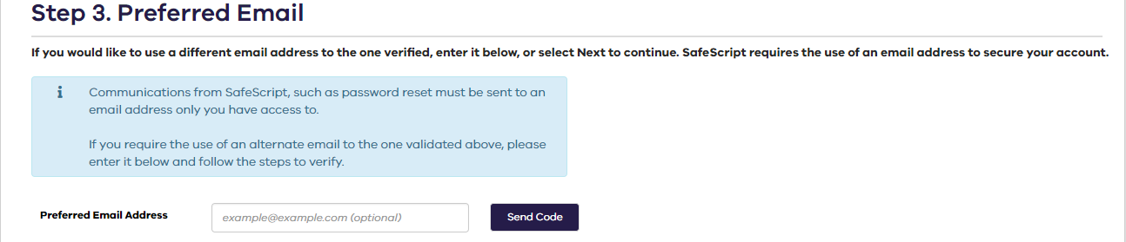
- Enter your Preferred Email Address, then click Send Code.
Result: SafeScript sends an email with a verification code to the email address you entered.
- Go to your email account, then copy the verification code sent by SafeScript.
- In the SafeScript registration portal, enter the Verification Code, then click Verify.
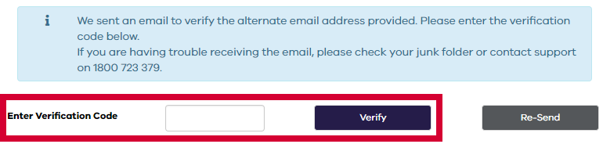
- Click Next.

Step 4: Account Information
- SafeScript suggests a Username based on your email address. If you prefer, you can enter a different username.
  - Your username will always have the suffix “@safescript.vic.gov.au”.
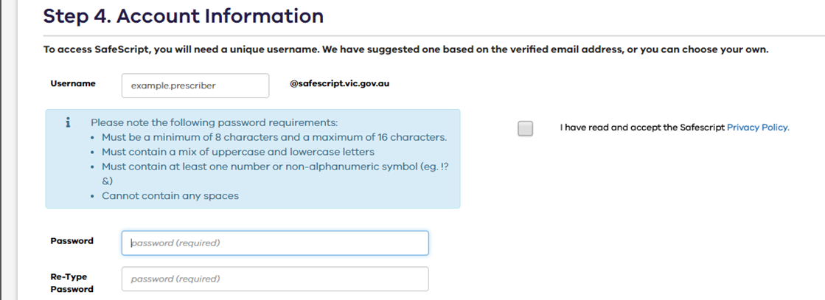
- Enter the Password you will use to access SafeScript, then enter it again in the Re-Type Password field.
  - Your password must be between 8 and 16 characters, and contain uppercase and lowercase letters, at least one number or symbol (eg. !?&), and no spaces.
- Tick the checkbox to confirm that you have read and accepted the Privacy Policy.
- Click Submit.
Your registration is now complete. The registration portal displays a message to confirm your registration, and you are sent an email confirming your registration and username. Please keep this email for reference.

Access SafeScript
From October 2018, you will be able to log into SafeScript at www.safescript.vic.gov.au

