

|  |
| --- |
| Secondary School Immunisation Program Instructions for schools to transfer contact details to local council SchoolPRO2 |

##### The [Public Health and Wellbeing Regulations 2019](http://classic.austlii.edu.au/au/legis/vic/consol_reg/phawr2019331/s112.html) authorises a Council to request the person in charge of a secondary school located within the municipal district to disclose student and parent/guardian contact information to Councils for any student scheduled to receive a vaccination in the Victorian Secondary School Immunisation Program.

Contents

If your school software package is not listed on the [Immunisation health.vic website](https://www2.health.vic.gov.au/public-health/immunisation/vaccination-adolescents/secondary-school) or you have problems with the instructions available for your software system, please refer to this guide for ‘All other systems’.

## Step 1

Distribute a collection statement ([Secondary school vaccination program collection statement-sample](https://www2.health.vic.gov.au/public-health/immunisation/vaccination-adolescents/secondary-school)) to parents/guardians

1. Take note of all students whose parents/guardians do not want their information shared with local council.
2. Liaise with your local council immunisation coordinator regarding the Secondary School Immunisation Program for the year and request a secure email address to send data to.

## Step 2

Download the [Exporter zip file](http://immunehero.health.vic.gov.au/school/school-admin/data-transfer/schoolpro2/) and follow the instructions contained in this document.

#### Support

* If you have problems extracting the data following these instructions, please contact [SchoolPRO support](https://schoolpro.com.au/contact/)

Alternatively, follow the manual extraction instructions contained in the ‘All other systems’ download on the [Immunisation health.Vic website](https://www2.health.vic.gov.au/public-health/immunisation/vaccination-adolescents/secondary-school)

## Student Details Exporter Instructions

## Installation and Operation

## The Student Details Exporter is supplied as a download ZIP from the [Immunisation health.vic website](https://www2.health.vic.gov.au/public-health/immunisation/vaccination-adolescents/secondary-school)

To install the student details exporter-

1. Download the ZIP file.

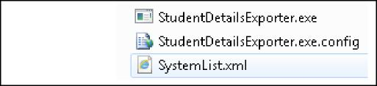

ZIP contents:

1. Unzip the file to your preferred local folder.

To run the Student Details Exporter-

1. Access your preferred local folder.
2. Double-click on the StudentDetailsExporter.exe.
3. Follow the instructions below.

*Please note: If your Folder view excludes file extensions, the above name will actually represent the .config file and not the application. In this case, ensure that you double-click* StudentDetailsExporter*.*

## Support

If any issues are encountered during installation or operation of the Student Details Exporter:

1. review this document
2. contact support with your designated secondary school provider software program

iii contact your nominated local council contact

## Exporting Student Details

## Configuration

## Before exporting students, several configuration steps are required. These are likely performed once only, including:

1. Database Connection
2. Email Configuration
3. System
4. Configuration

*Note: The details in* ***blue*** *may require IT advice.*

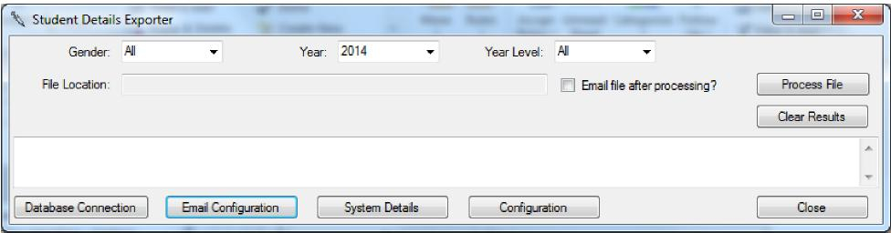

**a b c d**

|  |  |  |  |
| --- | --- | --- | --- |
| 1. Database Connection   These details indicate which database to export from, as well as the  credentials used to access it.  **Server**: Server name where database is located.  **Windows Authentication**: Network credentials used for access to  database.  **SQL Server Authentication**: Specific user credentials used for access  to database.  **Database**: Select database from list (based on server). |  |  |  |
| 1. Email Configuration   Users have the option to automatically email generated export files.  These configuration details determine content and attributes for  generated emails, as well as details of the email server to connect to.  **From**: Sender email.  **To\***: Recipient email, as advised by the council.  **CC\***: Email for copy.  **Subject**: Description of email content (e g. Student details –  Melbourne High).  **Body**: Content for body of email.  **Server**: Email server name.  **Port**: Network credentials used for access to database.  **Username**: Specific user used to access the email server.  **Password**: User password used to access the email server.  * Multiple email addresses, separated by semi-colons, may be used. |  |  |  |
|  |

Student Details Exporter Instructions

|  |  |
| --- | --- |
| 1. System Details   This screen should only be accessed at the instruction of the ImPS support provider. |  |
| d. Configuration  This screen covers static parameters used for the export operation.  **System**: School administration system used as the export source. List includes those systems catered for by Student Details Exporter.  **File Location**: Folder for storage of the resulting export file. **File Type**: The export uses some Excel functions. Nominate which version is installed on your machine.  **Site Identification**: This value identifies your school to the council and it appears within the export data. Nominate a value that makes sense to both you and the council – eg. school name. |  |

**Export**To run the export:

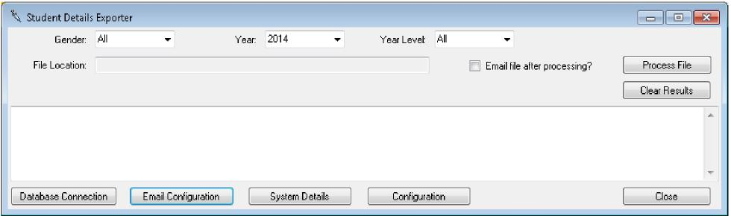

1. Revise the above configurations
2. Nominate the Gender, Year and Year Level to export. Note that Year relates to the calendar year and Year Level indicates the level of the students, as at the nominated calendar year.
3. If Email Configuration has been completed, then a checkbox is available for Email file after processing?*.* If there is no need to review the export before sending to council, check this box.
4. Press Process File.
5. If the process has any issues, an error message is displayed and a button may be highlighted, indicating that remedial action is required on that screen.

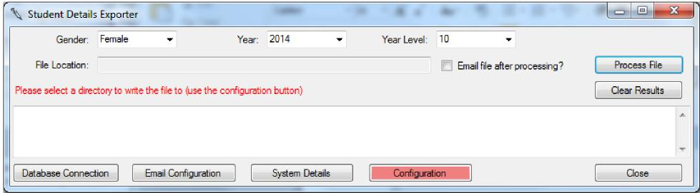

1. Progress and completion messages are listed on-screen.

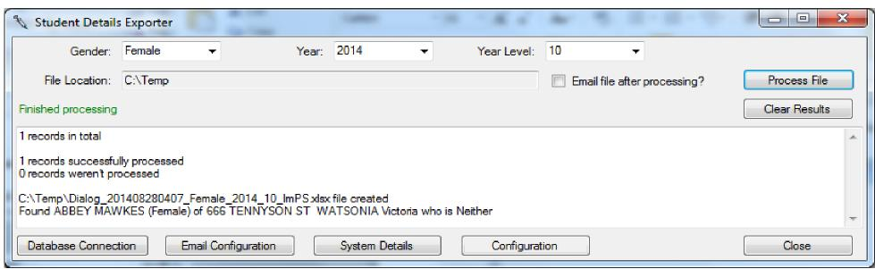

|  |  |
| --- | --- |
| 7.These can be cleared for subsequent runs by pressing | Clear Results . |

8.The process automatically determines the file name based on the parameters nominated.

This ensures consistency for the school and council administrators. File name is derived as follows: *SiteIdentification_DateTime_Gender_Year_YearLevel_System.XLfiletype*

## Post-Export

As in Step one some parents/guardians may nominate not to send details to the council. This option is catered for in the legislation. While the intention is for all school administration systems to enable the capture of this option, it may not yet be available in your system.

If your system indeed stores this option, then the Exporter will likely already take this into account. If your system does not, then you will need to record the option outside the system and you will need to review the export to remove these students. You may need to remove students, whose parent/guardian has nominated not to send their details. In this case, ensure that the *Email file after processing?* option above is unchecked when running the export.

Please note:

* Depending on your School system, you may need to review the export before sending it to council, whether created by the Student Details Exporter or by the School system’s inbuilt function.
* We recommend that you carefully review the first couple of exports. Check that the student details appear as expected and that students who opted-out are excluded

Once the export is ready to send, email it to the address advised by your council for this purpose.

|  |
| --- |
| To receive this publication in an accessible format phone 1300 882 008 using the National Relay Service 13 36 77 if required, or email [immunisation@health.vic.gov.au](mailto:immunisation@health.vic.gov.au)  Authorised and published by the Victorian Government, 1 Treasury Place, Melbourne.  © State of Victoria, Australia, Department of Health September 2021  Available from the [Secondary school vaccination program for adolescents](https://www2.health.vic.gov.au/public-health/immunisation/vaccination-adolescents/secondary-school) page on the Health.vic website <https://www2.health.vic.gov.au/public-health/immunisation/vaccination-adolescents/secondary-school > |