CDIS Client Not Present
Victorian Maternal and Child Health (MCH) Child Development Information System (CDIS) July 2021
Contents
Overview 2
Service Date & Start time 3
Program 3
Agency 3
Service Type 4
Location 5
Others involved 5
Professionals involved 5
Notes 5
Time 5

Overview
This user guide explains how to use the CDIS Client Not Present (CNP) screen, and the purpose of each field.
The Client Not Present is accessed through an individual client CDIS record, via the Clinical Activity > Client Not Present menu.
The following content provides examples of built-in text styles that must be used.
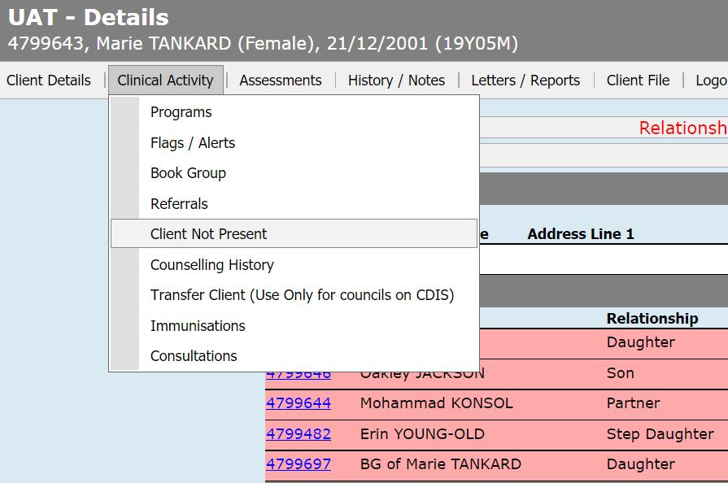
Completed notes will only appear in the CDIS record of the client where the Client Not Present was completed.
If the notes from the Client Not Present need to be included in another client’s notes such as in a family group, then the details can be copied from the first client’s history/notes and pasted into each other relevant history using the add notes function.
Note: MCH staff need to be aware of the Information Sharing Legislation and the Child Development Information System process guidance for information sharing workaround, which is completed using the Client not present screen.
https://www2.health.vic.gov.au/primary-and-community-health/maternal-child-health/child-development-information-system.

Service Date & Start time
These fields are auto completed with the current date and time. If required, they can be adjusted to reflect the date and time of the action being recorded.

Program
The Program field allows you to link this CNP to any program that the client is currently enrolled in. This includes non-lead clients of Integrated Programs.
Note: for non-Integrated programs this Program field has no effect and can be ignored.
If you wish the CNP to be included as part of an Integrated Program case, you must select that Program in this field to ensure that:
- The CNP appears in the Case Summary Screen for the case
- The CNP delivery time (Direct, Indirect, Travel) counts towards the overall case time

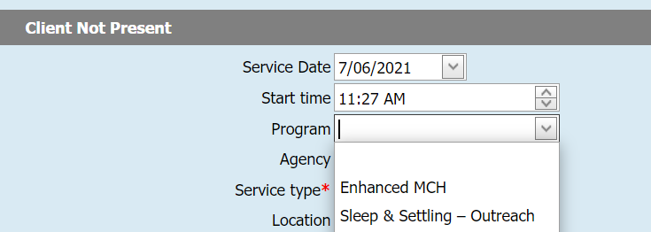

Agency

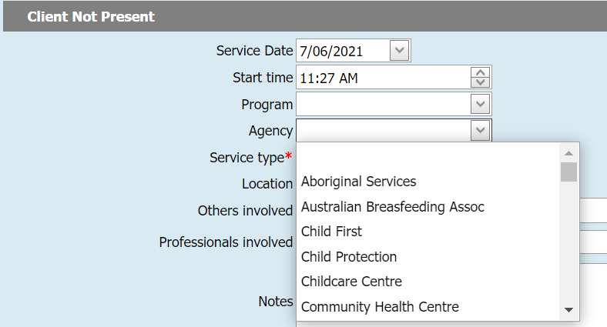
The Agency field should be completed if possible, however although the choices are extensive, there may be occasions where the relevant agency is not listed. Regardless of whether the relevant agency can be selected here, it is important that the name of the Agency and the contact details be included in the Notes section (see below).

Service Type
Service Type is a mandatory field:
Service Type | Usage
Referral | Used when a referral has been generated
Case Conference/discussion | For when the client is not present at a professional discussion regarding a specific client or program (including Integrated Programs)
Data adjustment | Not for regular use
Reports | For attaching reports received from other agencies, or when writing a report pertaining to a client or program
Telephone Consultation | For conversations with clients
Email | For email/SMS correspondence pertaining to a client or program
SMS
Follow-up | Sending letters; recording DNAs; any other follow-up activities related to a client or program
Information Sharing - Making a request | Only to be used when meeting the requirements of the Child Information Sharing Scheme and the Family Violence Information Sharing Scheme
Information Sharing - Receipt of requested information
Information Sharing - Receiving a request
Information Sharing - Responding to a request
Information Sharing - Proactively Sharing
Information Sharing - Update to Responder Post Sharing
Migration - EMCH | No longer in use
The ‘Follow-up’ service type has recently been added. It can be used for a range of different activities, including when no other service type is suitable.
Please note that the Did Not Attend (DNA) must be completed in the calendar if a client does not attend an appointment. However, you may add additional information by completing a Client Not Present if you have undertaken a more extensive follow-up after the DNA. The follow–up may relate to additional work that the MCH Nurse has done to assist a client in Universal and may include advocacy for the client, or the client has multiple DNA’s and additional work is required.
Follow–up can be used in the Enhanced MCH / Sleep & Settling - Outreach programs when for example, the client is not at home when the staff member attends the home, or the MCH staff member is making contact with other agencies or organisations concerning the client. This ensures that all time spent as part of the Enhanced MCH / Sleep & Settling - Outreach programs can be captured.

Location
The location data field lists many of the most likely locations however this is normally not completed as the MCH staff are usually attending to CNP administratively within an office setting.

Others involved
This is a free text field which can be completed if relevant.

Professionals involved
This is a drop down field that allows you to add any professionals that are listed in CDIS and have been already linked to the client’s record. It often will have no options for selection. Professionals you are engaged with during the CNP can be added in the ‘Others involved’ free text field.

Notes
The notes should be comprehensive and enable other staff to ascertain the purpose of the Client Not Present. Make sure to include the name and contact details of who was involved.

Time
The time is included in the Client Not Present screen and must be completed. Although both the Direct and Indirect appear mandatory as they both have a red * only one of the fields in those two rows needs to be completed.
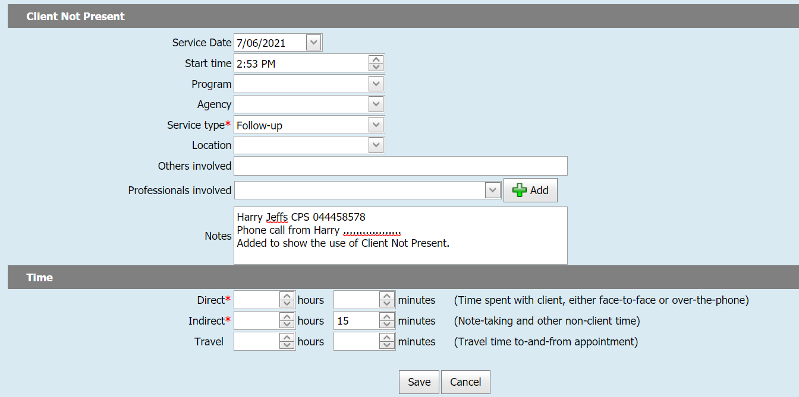
Estimate the time taken for completing the activity being recorded in the CNP.
In the Enhanced MCH / Sleep & Settling – Outreach programs, the time for the CNP contributes to the delivered hours for that case.
To receive this publication in an accessible format phone 1300 650 172, using the National Relay Service 13 36 77 if required, or email mch@health.vic.gov.au
Authorised and published by the Victorian Government, 1 Treasury Place, Melbourne.
© State of Victoria, Australia, Department of Health July 2021.

Except where otherwise indicated, the images in this publication show models and illustrative settings only, and do not necessarily depict actual services, facilities or recipients of services. This publication may contain images of deceased Aboriginal and Torres Strait Islander peoples.
In this document, ‘Aboriginal’ refers to both Aboriginal and Torres Strait Islander people. ‘Indigenous’ or ‘Koori/Koorie’ is retained when part of the title of a report, program or quotation.
ISBN 978-1-76096-466-5 (pdf/online/MS word)
Available at health.vic – Child Development Information System <https://www2.health.vic.gov.au/primary-and-community-health/maternal-child-health/child-development-information-system>

