Alexandra District Hospital longitudinal study
The impact of hospital design on health and wellbeing
Contents
Background 1
Methodology 1
External factors 2
Study outcomes 2
Applying the outcomes in healthcare capital works 3

Background
In June 2010 the Department of Health & Human Services engaged Woods Bagot to undertake a longitudinal study of the Alexandra District Hospital to provide a quantitative measure of the improved performance (through improved staff productivity, patient outcomes and building efficiency) of building a healthier hospital as compared with an existing hospital.
The Alexandra District Hospital was chosen as a new hospital was being built adjacent to replace the existing hospital. The new hospital would have the same staff and patient catchment area.
The study was part funded by Sustainability Victoria. The full report is available at <www.dhhs.vic.gov.au>.

Methodology
The study extended over four years and through three specific data collection periods. The first survey period was undertaken in the old hospital in 2011. The second survey period took place in the new hospital in 2012, six months post occupancy. The third survey period was undertaken in the new hospital in 2013 approximately two years post occupancy.
Each period incorporated a quantitative measure of indoor environment quality by CETEC, a scientific services company, in multiple locations on each site, and repeated morning and afternoon.

Quantitative measures were taken for thermal comfort, indoor pollutants, acoustics and lighting levels in reception, support services, patient rooms, the operating theatre and at the nurse’s station (Figure 1).
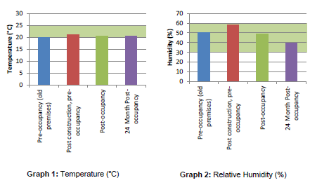
Figure 1: Qualitative measures
Thermal comfort (old and new hospitals)
Staff were invited to complete a hard-copy or web-based survey, and patients were invited to complete a hard-copy survey at discharge. Staff and patients were asked to rate their degree of satisfaction of specific conditions throughout the old and new buildings, from acoustics, lighting and air freshness to space planning and views. Staff and patient satisfaction was considered a qualitative measure of better patient outcomes and increased staff productivity, as literature in the field of ‘healthy building design’ consistently reports this correlation. Importantly, many staff and patients experienced both hospital environments.
The fourth component of the methodology process was collecting de-identified staff data relating to hours of sick leave and annual leave expended.

The surveys were undertaken in accordance with the approval of the Department of Health & Human Services Human Research Ethics Committee (Project number 23/10).
Collected data was analysed in a comparative sense but also in the context of research relating to the indoor environment quality impact of healthcare environments.

External factors
As with any longitudinal study the results are representative of views and data at a particular point in time. As such, external factors can affect the results and therefore need to be considered when interpreting the outcomes.
First, a new hospital is always welcomed by both staff and patients, therefore survey results immediately post occupancy may not fully reflect the attributes of a building.
Obtaining data from patients is dependent on their ability and willingness to respond to surveys. Patients were asked to complete surveys prior to discharge, though this was not always possible. The response rate for patients who took surveys home was lower, despite including a stamped addressed envelope.
The air-conditioning in the new hospital took longer than anticipated to commission due to the weather extremes experienced in Alexandra. This was reflected in some responses from staff and patients in respect to thermal comfort and was exacerbated by having to complete one round of surveys during December when extreme temperatures were experienced.
The landscaping in the new hospital was delayed due to poor planting conditions, which was reflected in some responses from staff and patients in respect to the hospital outlook. The old hospital had sweeping views over the Alexandra countryside, whereas the new hospital was built at the bottom of a hill with reduced distant views.

Study outcomes
The longitudinal comparison between the old and new Alexandra District Hospitals set out to support the contention that a healthy hospital building leads to better patient outcomes and greater staff productivity.
While the collective body of data for this study does appear to support this contention, one study on its own cannot prove this contention beyond doubt.
That being said, this study, together with other related research studies, does add weight to the contention that healthy hospital buildings lead to better patient outcomes and improved staff productivity.
The study reviewed the findings in the context of relevant research undertaken in health settings. In some cases this was difficult because there was no one singular study that exactly mirrored the methodology, context and objectives. Therefore, the study drew upon various literature for a range of specific issues relevant to circumstances at the Alexandra District Hospital.
A large part of the study sought patient and staff satisfaction of various environmental conditions in both the old and new hospital (Figures 2 and 3), on the basis that satisfaction leads to better patient outcomes and increased staff productivity.
Figure 2: Staff satisfaction with work points (old hospital)
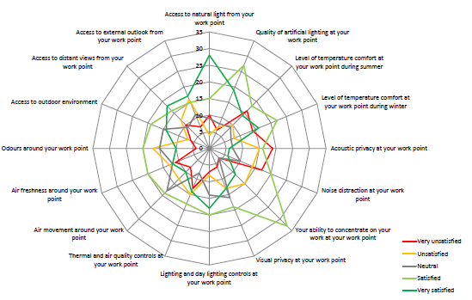
Although the patient and staff respondents at both hospitals varied, there were reasonable numbers of participants who were able to complete the surveys having experienced both the old and new hospitals.
Figure 3: Staff satisfaction with work points (new hospital)
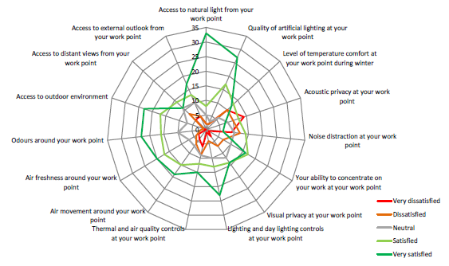
Staff productivity was explored through de-identified data relating to staff sick leave and annual leave. While the findings begin to indicate increased staff productivity, it was too soon to draw a conclusion. The pattern of productivity is, however, heading in the right direction.
While patient satisfaction was quite high for the old hospital, there was a noticeable reduction in dissatisfaction of aspects of the new hospital, combined with very high satisfaction ratings for the new hospital (Figures 4 and 5).
Figure 4: Patient satisfaction with care room (old hospital)
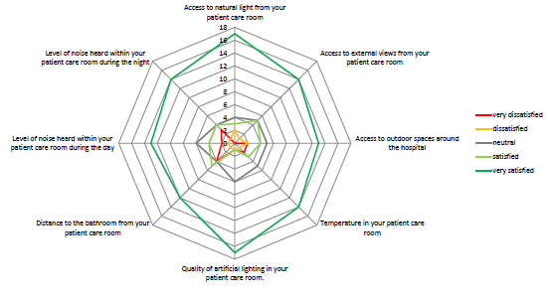
It was too early to say if patient length of stay has decreased since the new hospital has opened, but this data may be tracked over a longer period of time to establish a pattern of hospital stays.
Figure 5: Patient satisfaction with care room (new hospital)
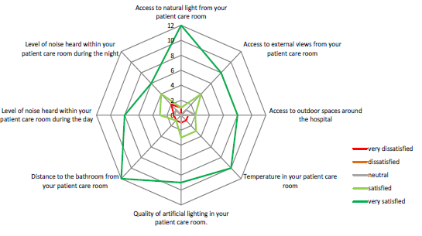
In general the findings from the study contribute to a larger collection of related research studies supporting the contention that a healthy hospital building leads to better patient outcomes and increased staff productivity.
The list of references is available in the full report.

Applying the outcomes in healthcare capital works
The sustainable design of hospitals in Australia has been predominantly focused on what many see as ‘hard’ sustainability; namely, energy and water. It could be argued that this has occurred due to the familiarity of energy and water efficiency, the skills of consultants engaged on projects, the ability to clearly identify a return on investment and government policy.
While energy and water efficiency is important and should continue, energy and water costs are a minor component of a hospital’s overall operating costs.
The majority of hospital’s costs relate to staff and patient care, and even a marginal reduction in these costs would greatly outweigh a significant reduction in utility costs. However, it is difficult to accurately quantify the benefits of investing in softer sustainability issues, such as thermal comfort, lighting, acoustics and indoor environment quality, due to the complexity of linking specific outcomes to the investment, as well as the range of factors that can influence staff productivity and patient outcomes.
The outcomes of this confirm that investing in a quality indoor environment should be an integral aspect of hospital design and that there is benefit in doing so.
The department continues to support this investment through its Guidelines for sustainability in healthcare capital works. The guidelines can be downloaded from <www.capital.health.vic.gov.au>.

To receive this publication in an accessible format phone 03 9096 2119, using the National Relay Service 13 36 77 if required, or email sustainability@dhhs.vic.gov.au.
Authorised and published by the Victorian Government, 1 Treasury Place, Melbourne.
© State of Victoria, October 2015. Except where otherwise indicated, the images in this publication show models and illustrative settings only, and do not necessarily depict actual services, facilities or recipients of services.
Available at www.dhhs.vic.gov.au.

