Residential rehabilitation alcohol and other drug treatment
Information about residential rehabilitation and how to access this treatment
The Victorian Government is rapidly expanding access to residential rehabilitation services across the state to create more treatment spots, reduce pressure on the system, and improve access to treatment for people who may struggle to attend community-based services.
Read on to find out more about this treatment type, who it is most suitable for, and where you can go for further information.

The Victorian treatment system
Alcohol and other drug problems are complex, affecting not just individuals but their families, their friends and their communities.
People accessing drug treatment in Victoria go through intake, comprehensive assessment and treatment as part of their recovery journey.
A range of state-funded community-based and residential treatment options are available, including counselling, withdrawal, rehabilitation, care and recovery coordination and pharmacotherapy.

What is residential rehabilitation?
Residential rehabilitation is a treatment option for people who have already started their journey to recover from drug issues.
Services provide 24-hour supervision by suitably qualified staff in a live-in program that typically emphasises self-help and peer work to support reintegration into community living.
People stay on average for three months, engaging in activities that support lasting behavioural change, social and life skills development and relapse prevention, including counselling and group work.
Who is residential rehabilitation for?
This treatment option may be suitable for people who:
- have experienced drug dependence or harm
- are motivated to address the issues related to problematic drug use
- are at high risk of drug-related harm impacted by multiple life complexities, such as mental illness, homelessness, and/or family violence
- would benefit from a sustained period of structured intervention in a therapeutic environment
- have social circumstances that are not supportive of non-residential rehabilitation options
  - are treatment-ready at admission (i.e. drug-free or stabilised on pharmacotherapy treatment).

How do people access residential rehabilitation treatment services?
Pathways into residential rehabilitation include catchment-based intake or referral from another treatment provider (see Client pathways overleaf). Comprehensive assessment information should accompany clients to their treatment provider.

Specialist services
Population-specific residential rehabilitation is available for cohorts with specific needs including Aboriginal clients and women.
Youth residential rehabilitation is for clients aged 16–21. Clients aged up to 25 may access youth or adult services depending on choice and clinical judgment.
Specialist dual diagnosis residential rehabilitation is for clients with moderate to severe co-occurring drug and mental health needs, who experience complexities not accommodated in standard services (see the Dual Diagnosis factsheet for more information).

Priority access
Prioritisation is based on level of need, including psychosocial need, noting:
- clients discharged from compulsory withdrawal under the Severe Substance Dependence Treatment Act 2010 are prioritised
  - clients with judicial or correctional (forensic) orders may require prompt access to treatment.

Client pathways through the drug treatment system
The figure below illustrates client pathways through the state-funded alcohol and other drugs treatment system.
Person-centred treatment is a governing principle in the service system. In order to refer a client appropriately, providers work with the client and intake services to understand the range of treatment options available to meet the client’s needs.
Recognising that residential rehabilitation doesn’t suit everyone, the Government has also implemented new Therapeutic day rehabilitation services across the state, which are providing up to 500 additional places in treatment each year, with a particular focus on regional Victoria.
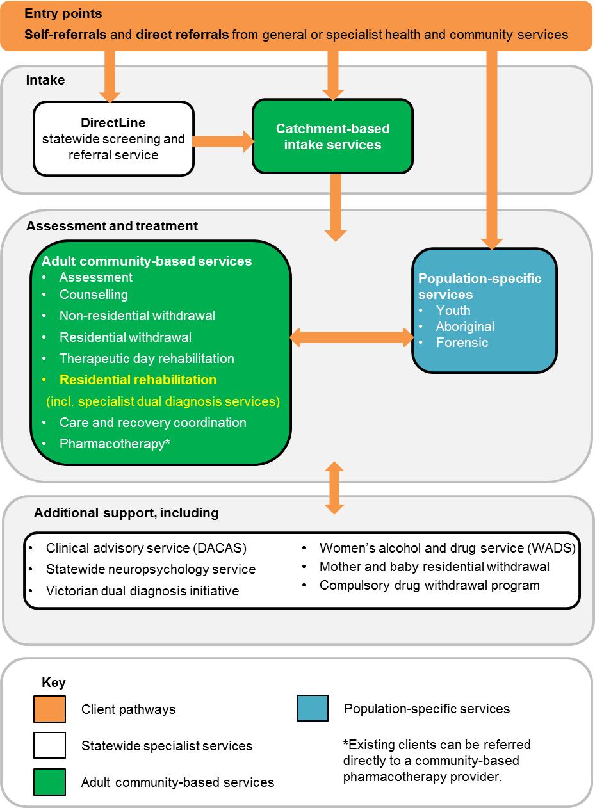

Where do I go for more information?
If you have any questions about residential rehabilitation or other drug treatment services, please:
- speak with your local catchment-based intake service (see below)
  - contact the statewide drug treatment information and referral service, DirectLine on 1800 888 236 or at <www.directline.org.au>.
Catchment-based intake services
Intake services are the critical point of entry into the alcohol and other drug treatment system. They provide local knowledge to support client pathways to all Victorian state-funded services, including residential rehabilitation.
Working closely with DirectLine, and other treatment providers, intake services facilitate client intake, triage, and referral to drug treatment, including the use of brief interventions and bridging support as required. They also support families and significant others of people with alcohol and other drug issues.
The table below provides the contact details for catchment-based intake providers.
Provider / consortium | Contact | Local government area | Catchment
Bayside Integrated Services | 1800 229 263  9690 9778 | Cities of: Port Phillip, City of Glen Eira, Bayside, Stonnington, Kingston | Bayside
South Eastern Consortium of AOD Agencies (SECADA) | 1800 142 536 | Cities of: Greater Dandenong, Casey, Cardinia Shire | South East Melbourne
Frankston and Mornington Drug and Alcohol Services (FaMDAS) | 1300 665 781 | City of Frankston  Mornington Peninsula Shire | Frankston-Mornington Peninsula
Eastern Health Turning Point AOD Consortium | 1800 778 278 | Cities of: Boroondara, Manningham, Whitehorse, Monash | Inner East
EACH SURE Consortium | 1300 007 873 | Cities of: Knox, Maroondah  Shire of Yarra Ranges | Eastern Melbourne
UnitingCare ReGen and Odyssey House Victoria:  North and West Metro Alcohol and Other Drug Service | 1800 700 514 | Cities of: Moreland, Moonee Valley, Melbourne, Yarra | Inner North
 |  | Cities of: Whittlesea, Darebin, Banyule  Shire of Nillumbik | North Melbourne
 |  | Cities of: Brimbank, Hume, Maribyrnong  Shire of Melton | North West Melbourne
 |  | Cities of: Hobsons Bay, Wyndham | South West Melbourne
Barwon AOD Consortium | 1300 094 187  Colac area:  1300 763 254 | City of Greater Geelong  Shires of Colac-Otway, Surf Coast  Borough of Queenscliff | Barwon
Australian Community Support Organisation (ACSO) | 1300 022 760 | Shires of: Bass Coast, South Gippsland, Baw Baw, Wellington, East Gippsland  City of LaTrobe | Gippsland
 |  | Rural Cities of: Wodonga, Wangaratta, Benalla  Shires of: Indigo, Towong, Mansfield, Alpine | Hume
 |  | Shires of: Moira, Strathbogie, Mitchell, Murrindindi  City of Greater Shepparton | Goulburn Valley
 |  | Shires of: Moorabool, Golden Plains, Pyrenees, North Grampians, West Wimmera, Hindmarsh, Yarriambiack, Hepburn  Rural Cities of: Ararat, Horsham  City of Ballarat | Grampians
 |  | Rural Cities of: Mildura, Swan Hill  Greater City of Bendigo  Shires of: Buloke, Gannawarra, Loddon, Campaspe, Central Goldfields, Mount Alexander, Macedon Ranges | Loddon-Mallee
 |  | Shires of: Glenelg, Southern Grampians, Moyne, Corangamite  City of Warrnambool | Great South Coast

The DirectLine service finder is also accessible at <www.directline.org.au/service-finder>.
Other important statewide contacts are listed below.
Service | Contact | Provider
Youth Drug and Alcohol Advice (YoDAA) | 1800 458 685 | Youth Support and Advocacy Service (YSAS)
Family Drug Help | 1300 660 068 | Self Help Addiction Resource Centre (SHARC)

Department resources online
The Department of Health and Human Services’ Alcohol and other drugs program guidelines describe the objectives and functions of the whole Victorian alcohol and other drug treatment system, and are available for download from the department’s website at <www2.health.vic.gov.au/alcohol-and-drugs/aod-service-standards-guidelines/aod-program-guidelines>.
A factsheet for the new dual diagnosis services is available at <www2.health.vic.gov.au/alcohol-and-drugs/aod-treatment-services/aod-residential-treatment>.
To receive this publication in an accessible format phone 9096 0000 using the National Relay Service 13 36 77 if required, or email aod.enquiries@dhhs.vic.gov.au
Authorised and published by the Victorian Government, 1 Treasury Place, Melbourne.
© State of Victoria, Department of Health and Human Services, March 2018.
Available at www2.health.vic.gov.au/alcohol-and-drugs/aod-treatment-services/aod-residential-treatment

