

|  |
| --- |
| CDIS Enhancements  Workaround for Group Session Outcomes |
| December 2020 |

Contents

Overview 1

Changes 1

Workaround 1

Using the new Information Page 2

Information Page 2

## 

## 

# Overview

As the result of the upgrade an unexpected change has altered the way Group session outcomes can be recorded. This change is temporary, and this document is written to provide you with a workaround that can support your practice until this is rectified.

## Changes

After the completion of a group session and clinicians are recording session outcomes, the drop-down box (with the list of available group topics discussed) will only list the activity/topic(s) that were set up prior to the commencement of the session. Previously, the drop-down box would list every activity/topic that is available state-wide.

## Impact

Sometimes at group sessions, the activities/topics discussed are different to the activities/topics that were set up for that session. This change prevents users from selecting different activities/topics from the drop-down box when recording session outcomes.

# Workaround

Although there is a red asterisk next to the Select group topic(s) discussed, this drop-down box is not mandatory. If the clinician assesses that the scheduled group topic was not discussed, they do not need to select the activity/topic available.

For any unscheduled activities/topics discussed, these can simply be written into the Generic group comment field.

An information page has been created in CDIS to support the workforce with managing this workaround.

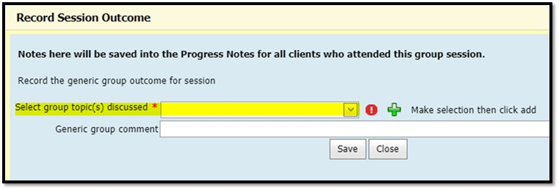

# Using the new Information Page

For the newly created information page to be accessible, it should be opened as soon as the clinician first opens the Group attendance / Outcome screen.

1. Open the screen named Group Attendance / Outcome (General > Groups > Group Attendance Outcomes)

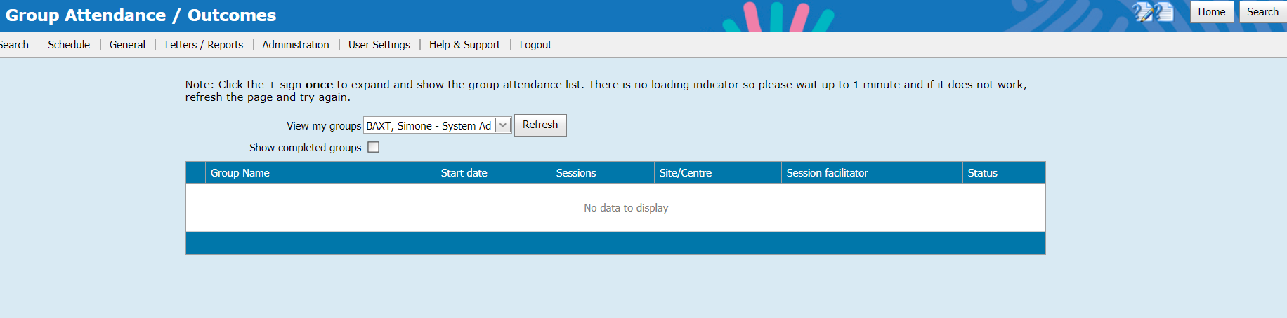

1. Click on the Help icon in the top right next to the Home and Search buttons

Screen shot of information above

1. You will now have two CDIS pages open; the first to record outcome, and the second from which you can reference, and copy from, to paste information into the generic group comments field to support your work.

|  |  |
| --- | --- |
| Screen shot of information above | Screen shot of information above |

1. In the information page, highlight the text you want to copy, right click and select copy (or CTRL+C).

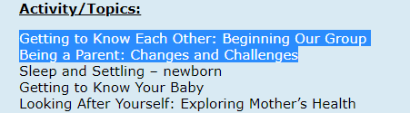

1. Navigate back to the Group Attendance Outcomes page, and paste into the *Generic group comment field*, and click Save

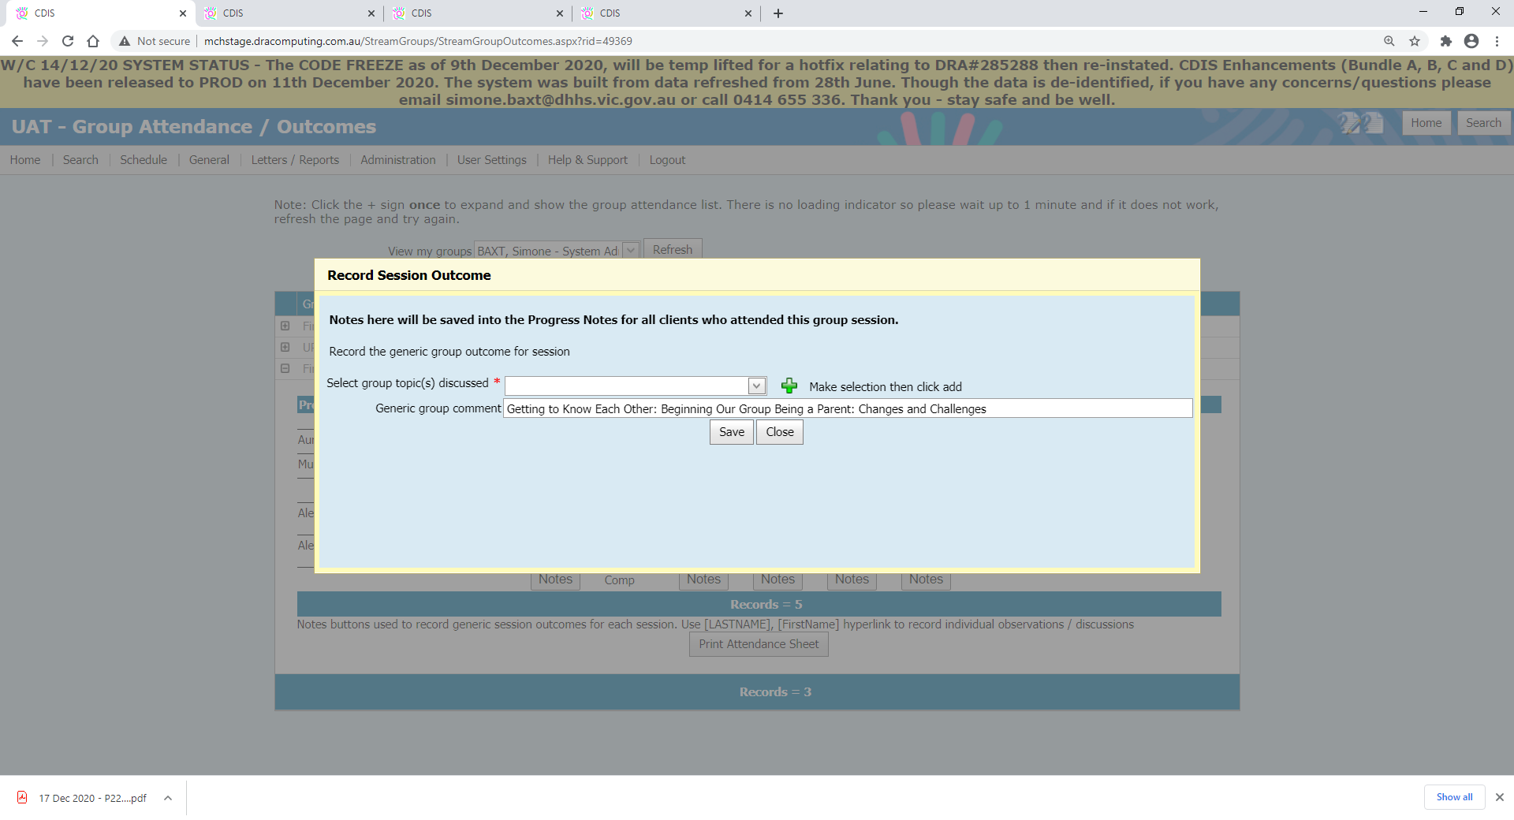

## Information Page

The following is what is available on the new Group Attendance / Outcomes Information page.

**Several activity/topics have always been available to Group Types.  These are maintained for all LGA's (i.e. at a state-wide level). DHHS can change these to support the MCH service across the state.**

**Activity/Topics:**

Getting to Know Each Other: Beginning Our Group

Being a Parent: Changes and Challenges

Sleep and Settling – newborn

Getting to Know Your Baby

Looking After Yourself: Exploring Mother’s Health

Baby’s Ages and Stages: What to Expect

Managing Childhood Illnesses

What to do in an Emergency (1): Resuscitation

What to do in an Emergency (2): First Aid

Keeping Your Child Safe: Preventing Accidents

Food: Your Baby and the Family

Teething and Looking After Baby’s Teeth for Life

Returning to Paid Work

Play: More than Fun and Games

Being a New Parent in Australia and Other Countries

Communicating With Your Baby Through Music and Books

Where to From Here?

Group Cancelled

**Existing Groups (prior to upgrade) with that contained these activity/topics above**

Baby Makes 3 - Young Parents - Fathers - Antenatal - Breastfeeding Support - Food and Nutrition - Behaviour management - Psychosocial & Emotional Wellbeing - Parent/Infant Attachment - Healthy Relationships - Speech & Language Development - Mother Goose - Music & Movement - Culturally Specific - New arrivals and Refugee - Single Session Workshop - Other.

**New groups (available from 11 Dec upgrade)**

**Introduced for Integrated Programs**

* Enhanced -This group contains the full list of activity/topics above
* First Time Parent Group - This group contains the full list of activity/topics above
* Sleep and Settling – newborn - This group contains 1 activity/topic Sleep and Settling – newborn
* Sleep and Settling – baby - This group contains 1 activity/topic Sleep and Settling – baby
* Sleep and Settling – toddler - This group contains 1 activity/topic Sleep and Settling – toddler

**Introduced for Universal Programs**

NB: These groups currently have no activity/topics

* Circle of Security
* Early parenting
* PND Support Group
* Supported Playgroup

To receive this publication in an accessible format phone 1300 650 172, using the National Relay Service 13 36 77 if required, or email Commissioning Performance and Improvement Aged and Community Based Health Care and Cancer Services [mch@dhhs.vic.gov.au](mailto:mch@dhhs.vic.gov.au)

Authorised and published by the Victorian Government, 1 Treasury Place, Melbourne.

© State of Victoria, Australia, Department of Health and Human Services December 2020.

Except where otherwise indicated, the images in this publication show models and illustrative settings only, and do not necessarily depict actual services, facilities or recipients of services. This publication may contain images of deceased Aboriginal and Torres Strait Islander peoples.

In this document, ‘Aboriginal’ refers to both Aboriginal and Torres Strait Islander people. ‘Indigenous’ or ‘Koori/Koorie’ is retained when part of the title of a report, program or quotation.

ISBN 978-1-76096-230-2 (pdf/online/MS word)

Available at health.vic – Child Development Information System <https://www2.health.vic.gov.au/primary-and-community-health/maternal-child-health/child-development-information-system>