



Victorian Respiratory Surveillance Report
30 October 2026

Contents
About this report 1
Summary 2
Laboratory surveillance 3
Case notifications 3
Testing 9
Community surveillance 12
FluTracking 12
How to use this report 13
Data sources 13
Definitions 13

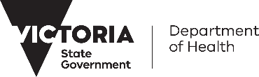
About this report
The Victorian Respiratory Surveillance Report summarises the latest surveillance information on COVID-19, influenza and respiratory syncytial virus (RSV) in Victoria. This report provides an overview of the current levels and trends of acute respiratory illness from these conditions in the community. Please see the section on How to use this report for more information.
Measurements of the greatest value for summarising respiratory illness in Victoria are presented in this report. Other systems are also reviewed by the Department of Health to understand patterns of respiratory disease in Victoria which inform the overall summaries presented.
Data are presented as at 28 October 2026 for the week ending 24 October 2026.
Each report reflects the data available at the time the report was prepared. Information may differ from previous reports as new data are received or updated.

Victorian Respiratory Surveillance Report | Summary | 30 October 2026 2

Summary

In Victoria, activity of influenza remains moderate, whilst RSV and COVID-19 activity are low.

COVID-19 activity is low
TEST POSITIVITY (LAST 2 WEEKS)
The percentage of tests that were positive have increased

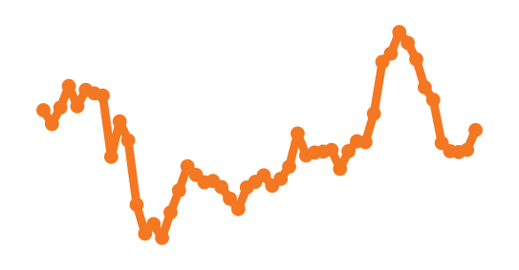
NOTIFICATIONS LAST 12 MONTHS
MODELLED CURRENT TRENDS
COVID-19 cases were most likely stable

COVID-19 activity remains low.

Influenza activity is moderate
TEST POSITIVITY (LAST 2 WEEKS)
The percentage of tests that were positive have increased

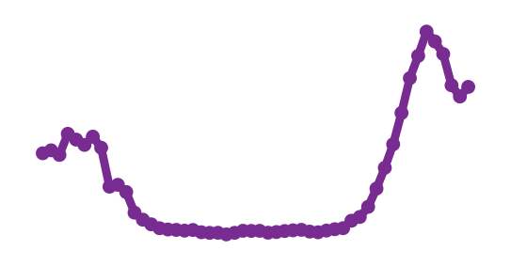
NOTIFICATIONS LAST 12 MONTHS
MODELLED CURRENT TRENDS
Influenza cases were most likely stable

Influenza activity remains moderate, following a short period of high activity. Influenza activity remained low throughout early winter, increased from July, peaked in mid-September and has since declined. The 2026 influenza season onset and peak have occurred later than in recent years.

RSV activity is low
TEST POSITIVITY (LAST 2 WEEKS)
The percentage of tests that were positive have slightly decreased

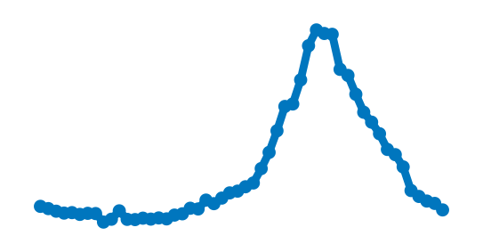
NOTIFICATIONS LAST 12 MONTHS
MODELLED CURRENT TRENDS
RSV cases were almost certainly decreasing
RSV activity increased from April and peaked in early July at moderate levels, before declining steadily to current low levels. Trends in RSV case notifications are broadly similar to previous seasons, however, with a lower peak in 2026.

Laboratory surveillance

Case notifications
Laboratory-confirmed cases of COVID-19, influenza and RSV are notified to the Victorian Department of Health. Notified infections that are diagnosed through laboratory testing are only a subset of the total number of infections in the community. Trends in notifications may be impacted by changes in testing.

Notifications (last two weeks)
In the past week (to 24 October 2026), COVID-19 notifications have increased (+12%), influenza notifications have slightly increased (+7%) and RSV notifications have decreased (-21%).
Influenza
RSV
21% decrease
COVID-19
12% increase
7% increase

Modelled current trends
The Australia-Aotearoa Consortium for Epidemic Forecasting & Analytics (ACEFA) performs modelling throughout the winter respiratory season using data provided by the Victorian Department of Health. The results of modelling to 18 October 2026 were:
Influenza
RSV
Almost certainly decreasing
1% probability case notifications were increasing
Most likely stable
33% probability case notifications were increasing
COVID-19
Most likely stable
38% probability case notifications were increasing

COVID-19

Figure 1: COVID-19 notified cases by week, Victoria, 26 October 2025 to 24 October 2026
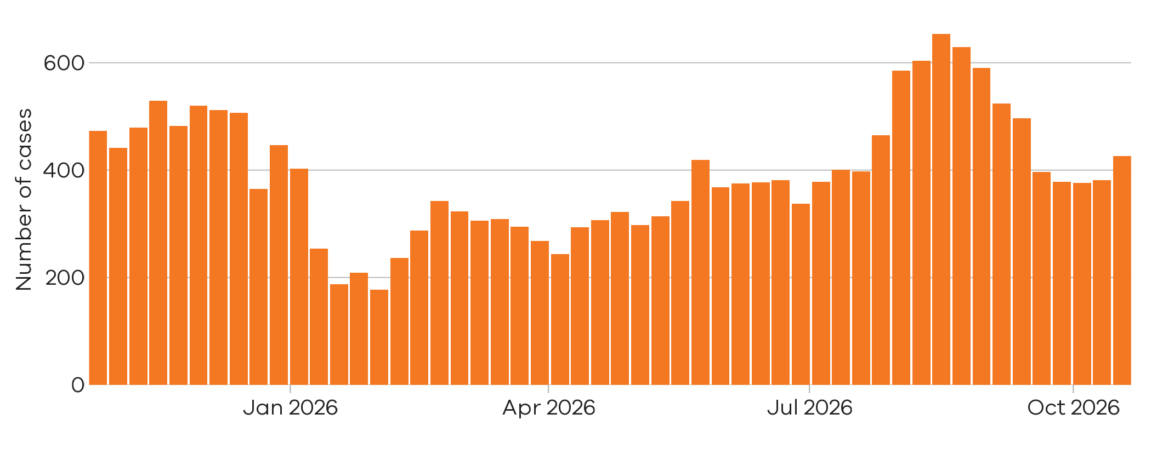
There were 426 notified COVID-19 cases last week
18 Oct 2026 to 24 Oct 2026
There were 381 notified COVID-19 cases two weeks ago

11 Oct 2026 to 17 Oct 2026

12% increase

Figure 2: COVID-19 trends in notified cases (7-day rolling average), Victoria, 1 January 2023 to 24 October 2026

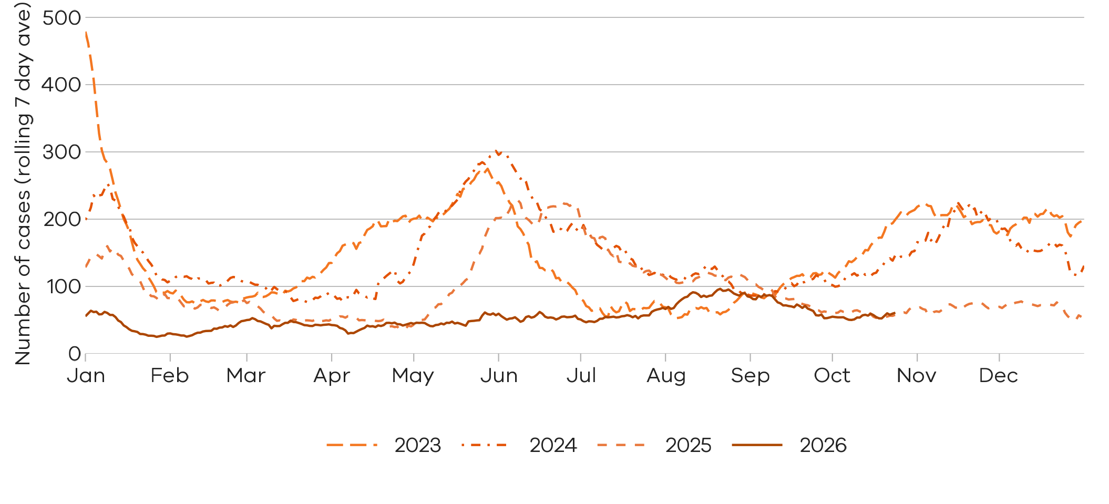
Notified COVID-19 cases are at similar levels to the same time last year. There has been a slight increase in cases in the most recent reporting week

Influenza

Influenza notifications presented in this report are reported from a subset of laboratories in Victoria, generally comprising around 85% of total influenza notifications.
Figure 3: Influenza notified cases by week, Victoria, 26 October 2025 to 24 October 2026
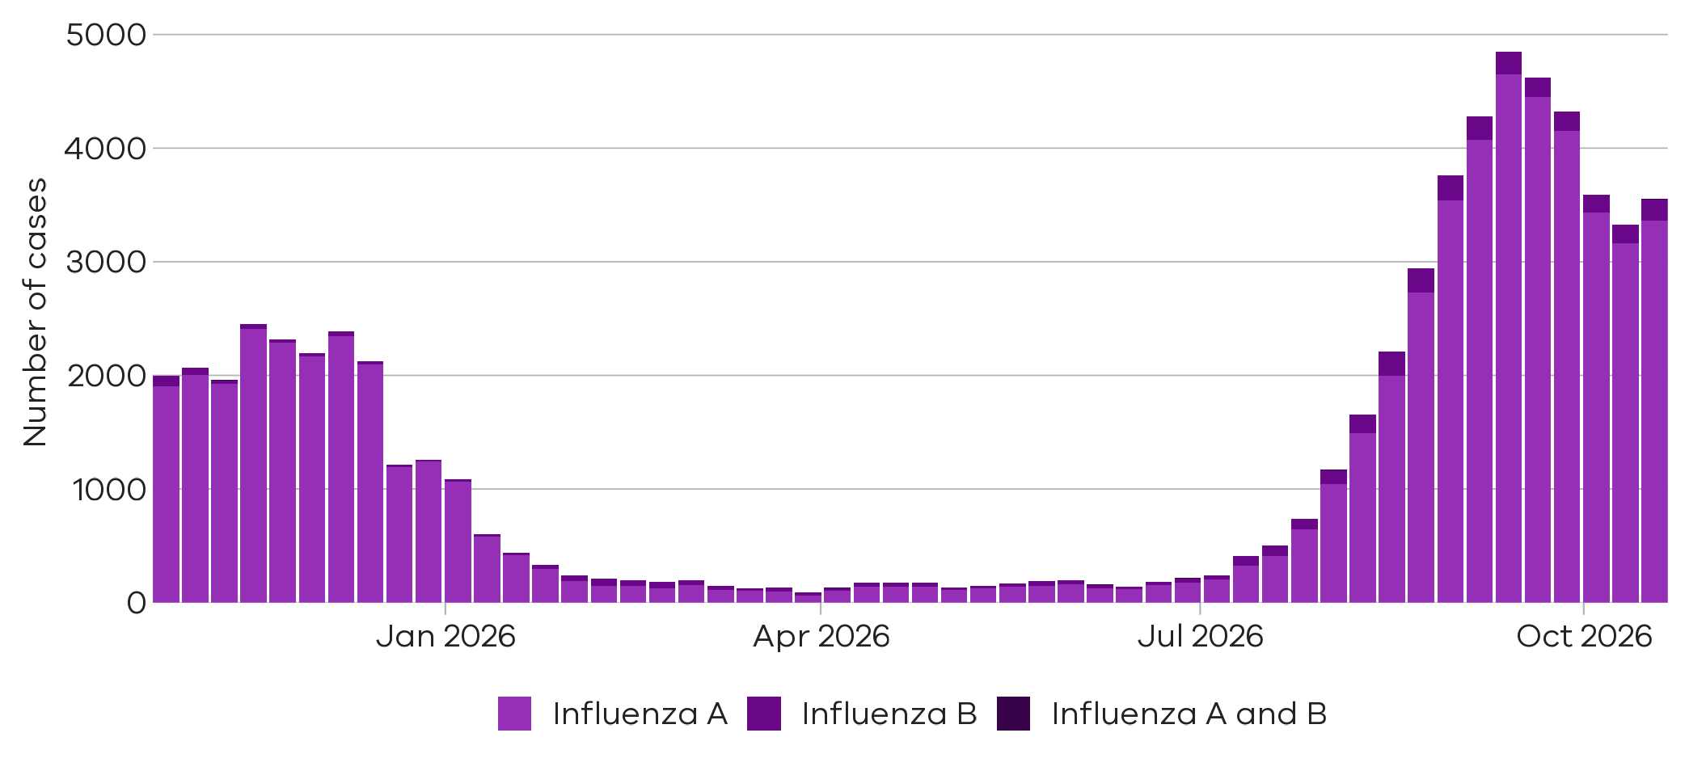
7% increase
6% increase

12% increase

There were 3162 cases of influenza A notified two weeks ago
11 Oct 2026 to 17 Oct 2026
There were 185 cases of
influenza B notified last week

18 Oct 2026 to 24 Oct 2026
There were 165 cases of influenza B notified two weeks ago

11 Oct 2026 to 17 Oct 2026
There were 3364 cases of
influenza A notified last week
18 Oct 2026 to 24 Oct 2026
There were 3328 cases of influenza (overall) notified two weeks ago
11 Oct 2026 to 17 Oct 2026
There were 3553 cases of
influenza (overall) notified last week
18 Oct 2026 to 24 Oct 2026

Figure 4: Influenza A trends in notified cases (7-day rolling average), Victoria, 1 January 2023 to 24 October 2026
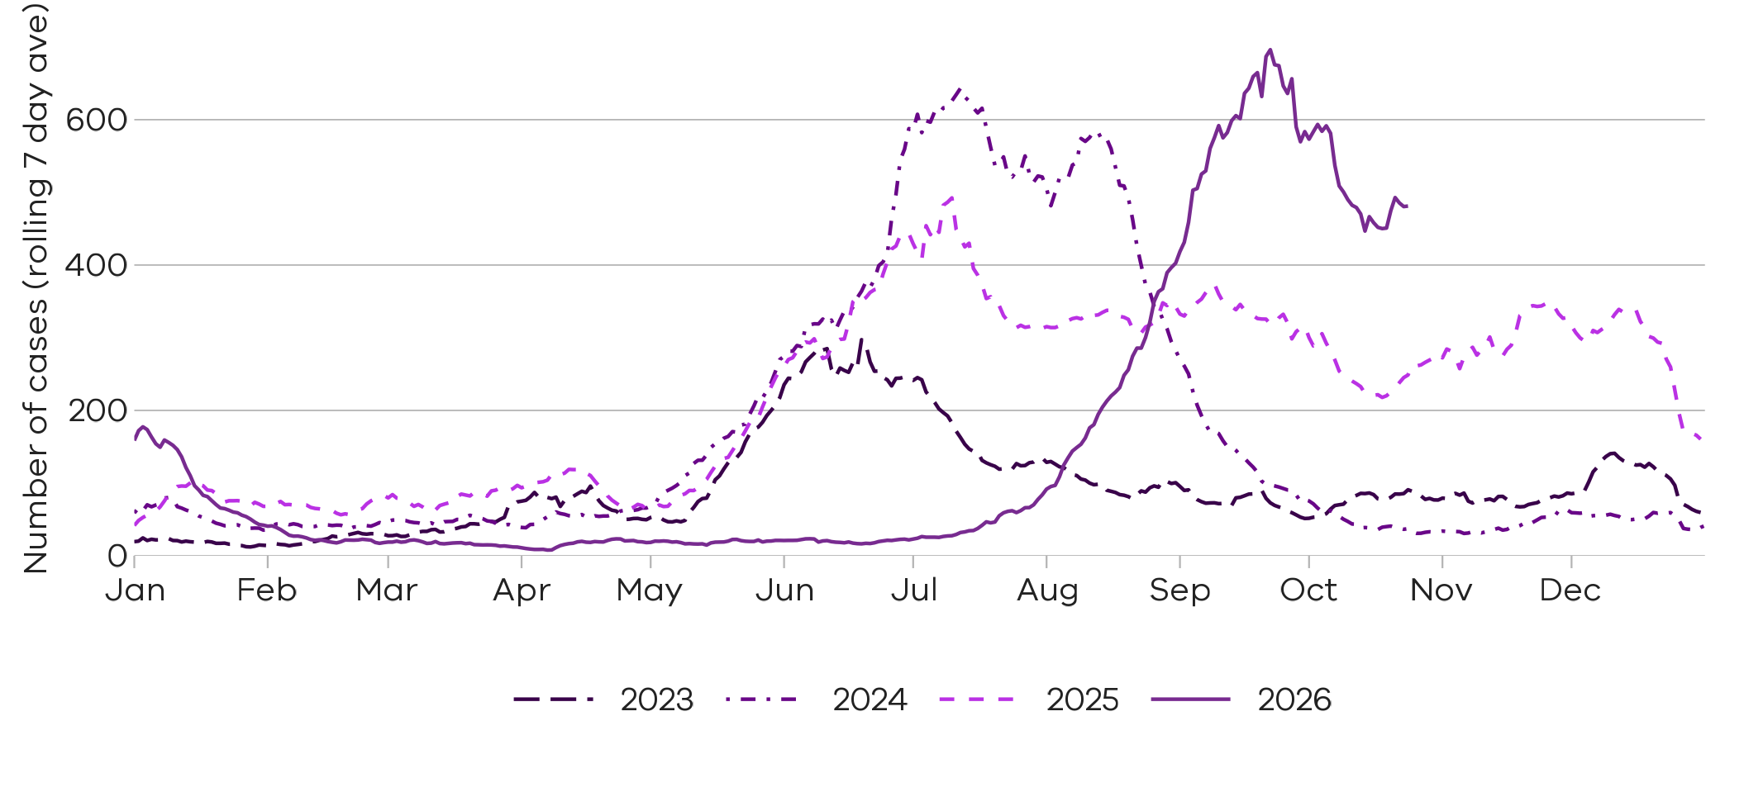

Notified influenza A cases are at higher levels than at the same time in recent years

Figure 5: Influenza B trends in notified cases (7-day rolling average), Victoria, 1 January 2023 to 24 October 2026
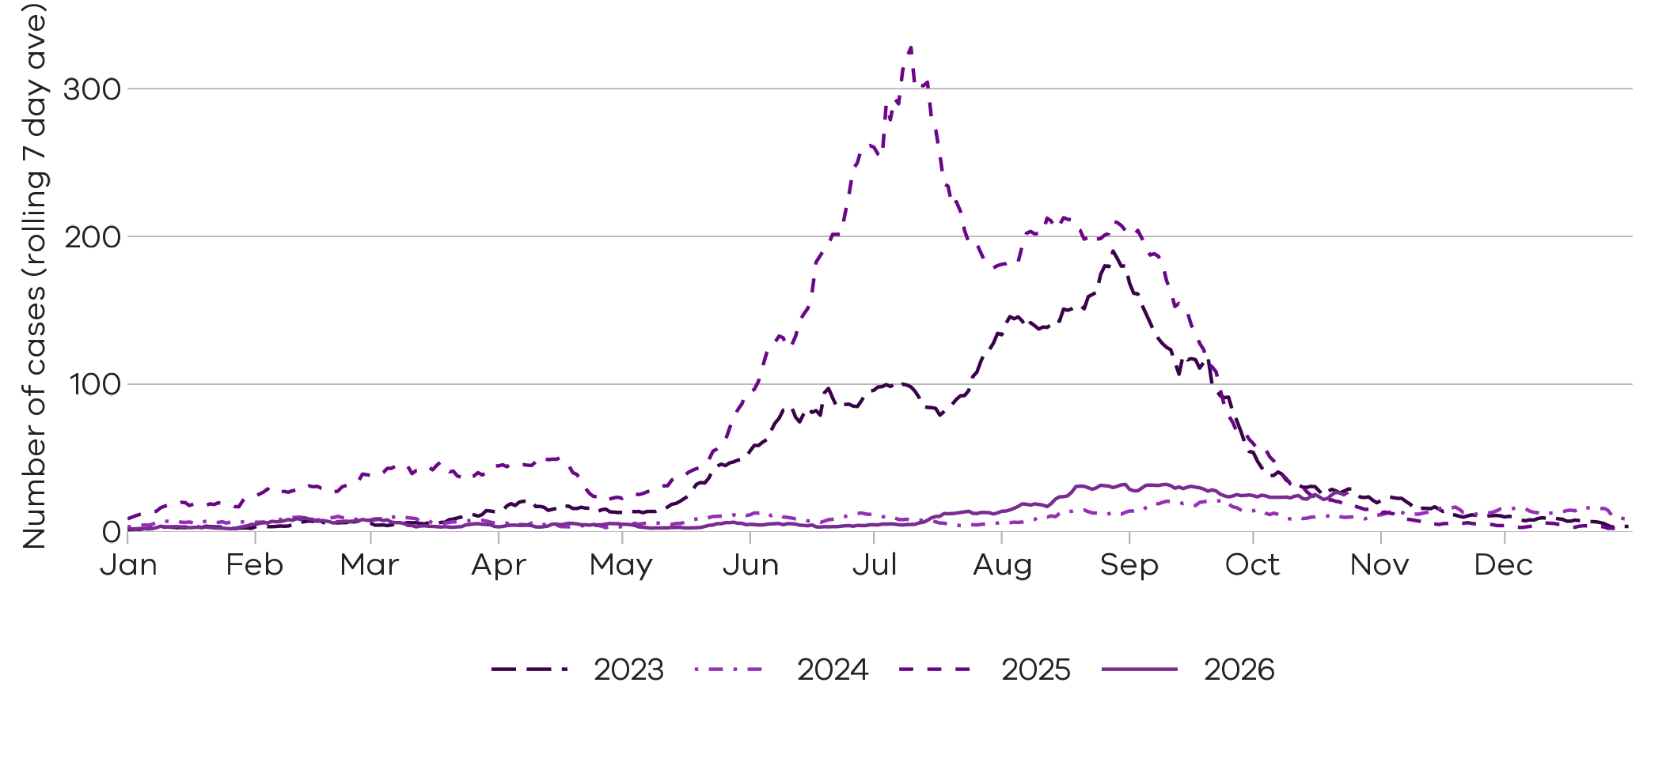
Notified influenza B cases are at similar levels to the same time in recent years

Respiratory Syncytial virus (RSV)

RSV notifications presented in this report are reported from a subset of laboratories in Victoria, generally comprising around 85% of total RSV notifications.
Figure 6: RSV notified cases by week, Victoria, 26 October 2025 to 24 October 2026
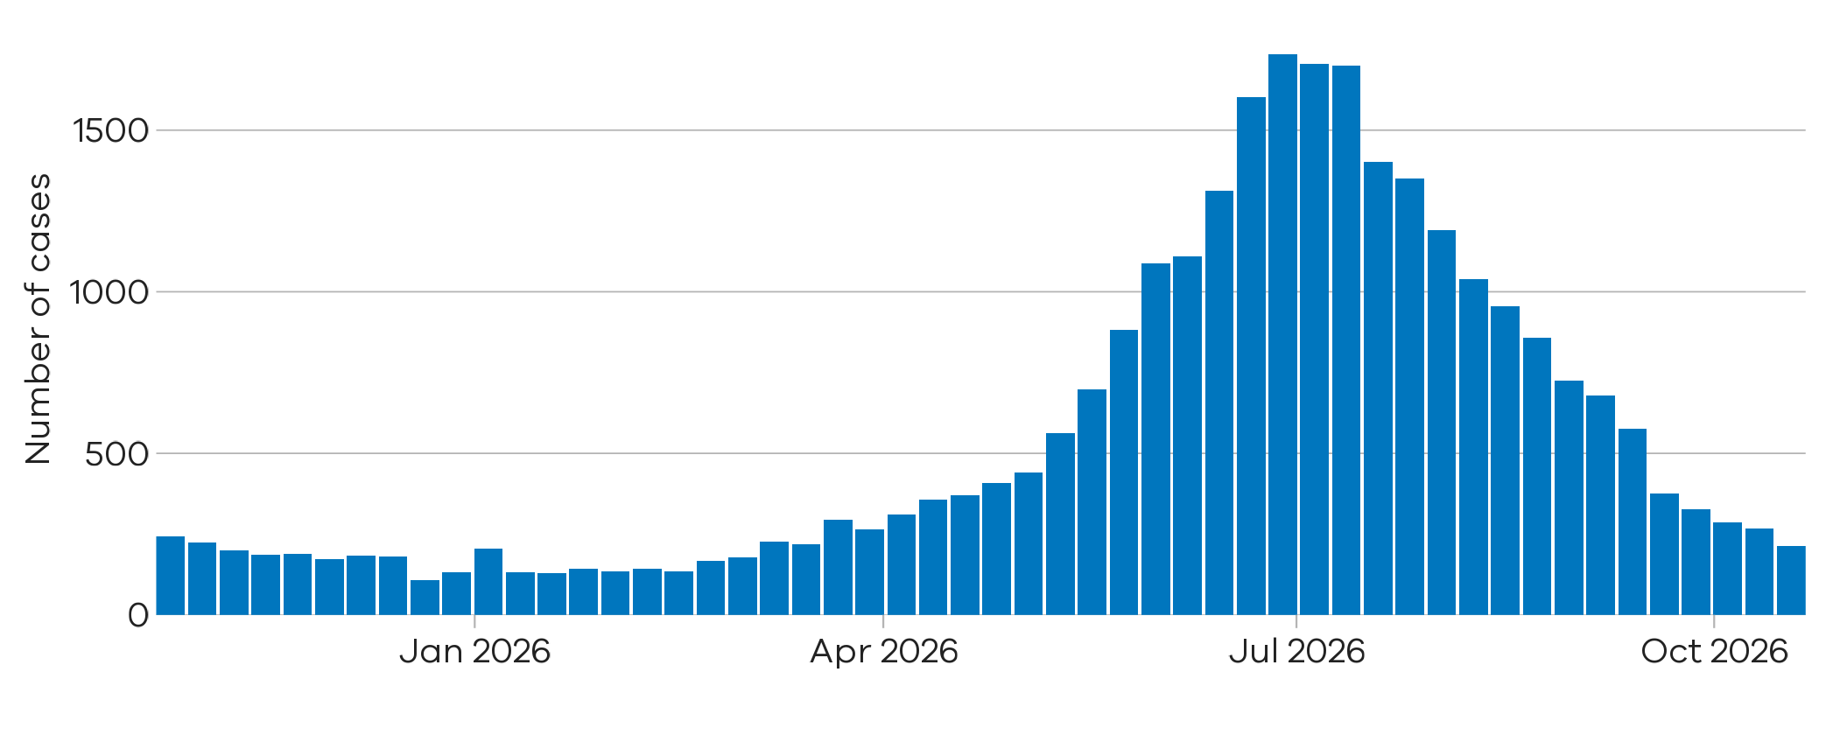
There were 212 notified RSV cases last week
18 Oct 2026 to 24 Oct 2026
21% decrease
There were 267 notified RSV cases two weeks ago

11 Oct 2026 to 17 Oct 2026

Figure 7: RSV trends in notified cases (7-day rolling average), Victoria, 1 January 2023 to 24 October 2026
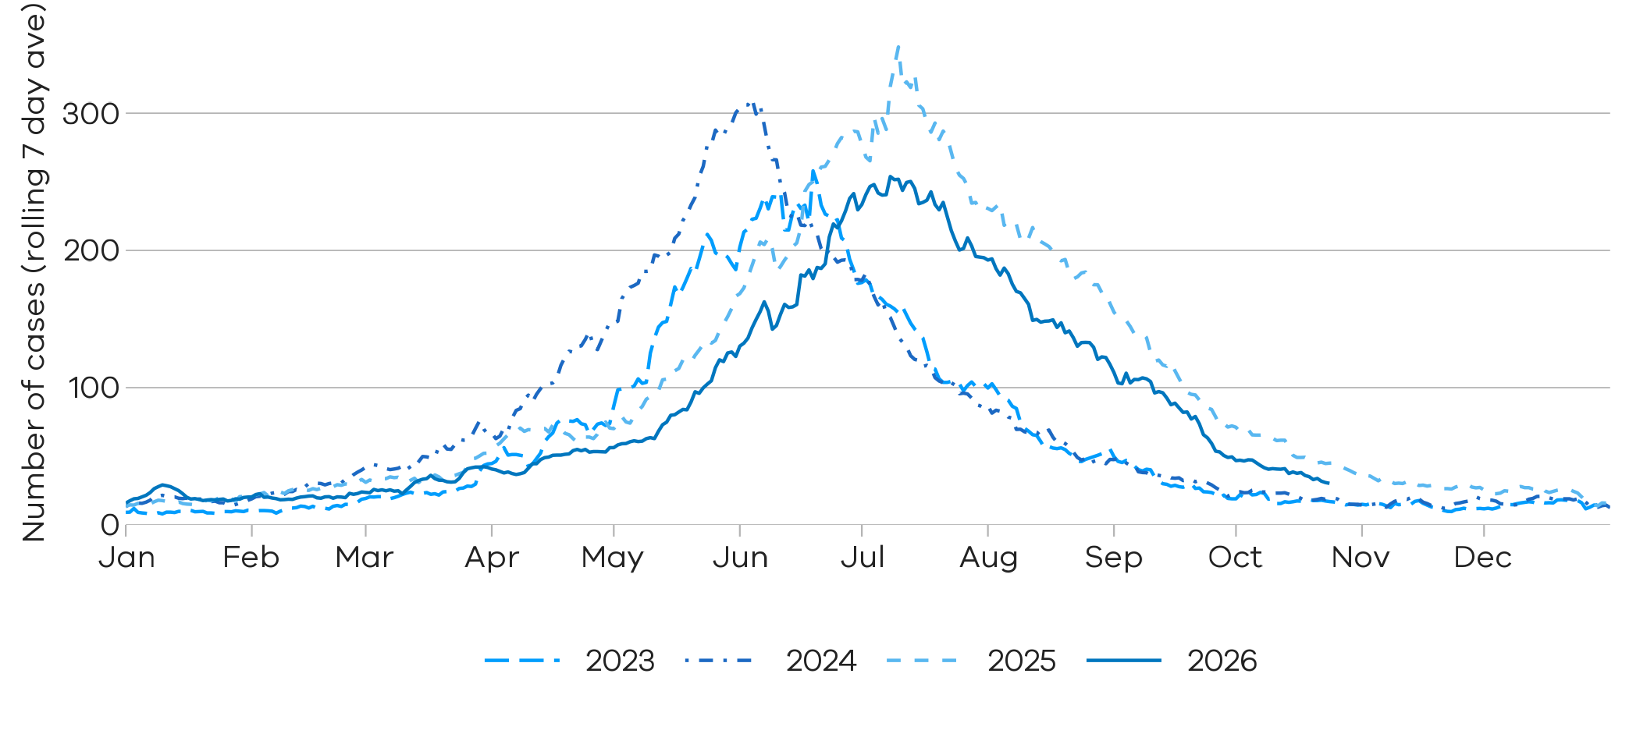
Notified RSV cases are at similar levels to the same time in recent years

Young children and older adults
Young children and older adults are at greater risk of severe disease from RSV.
Figure 8: RSV trends in notified cases by week in young children (under 5 years), Victoria, 26 October 2025 to 24 October 2026
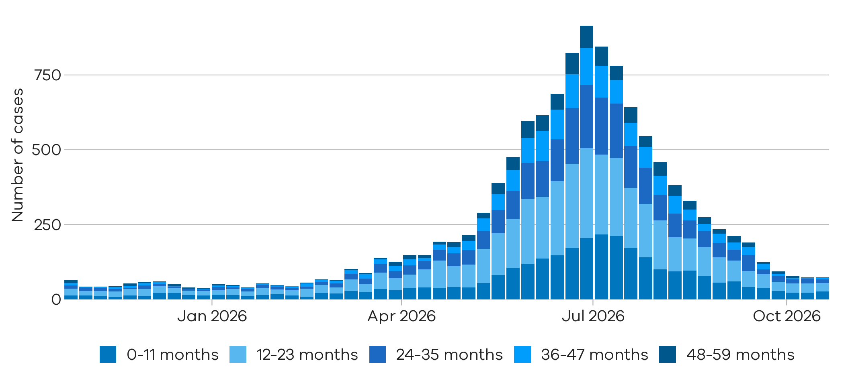
RSV case numbers have continued to decrease in younger children

Figure 9: RSV trends in notified cases by week in older adults (65+ years), Victoria, 26 October 2025 to 24 October 2026
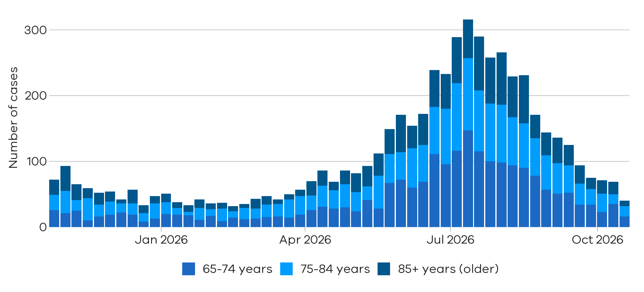
RSV case numbers have continued to decrease in older adults

Testing

Laboratory testing for respiratory illnesses changes over time. Tracking the percentage of tests with the notifiable condition detected (i.e. test positivity) is a useful measure to understand trends in disease surveillance over time.
Test results presented in this report are from selected laboratories. These include private and hospital laboratories and represent tests completed across Victoria.

Summary
In the past week, the percentage of COVID-19 tests that were positive have increased (1.6% to 2.5%), the percentage of influenza tests that were positive have increased (10.0% to 11.1%) (influenza A: 18.9% to 21.1%; influenza B: 1.1% to 1.2%), and the percentage of RSV tests that were positive have slightly decreased (1.6% to 1.3%).
COVID-19
1.6% to 2.5%
Influenza A
18.9% to 21.1%

RSV
1.6% to 1.3%

Influenza B
1.1% to 1.2%



Figure 10: Weekly test positivity for COVID-19, influenza and RSV, Victoria, 26 October 2025 to 24 October 2026
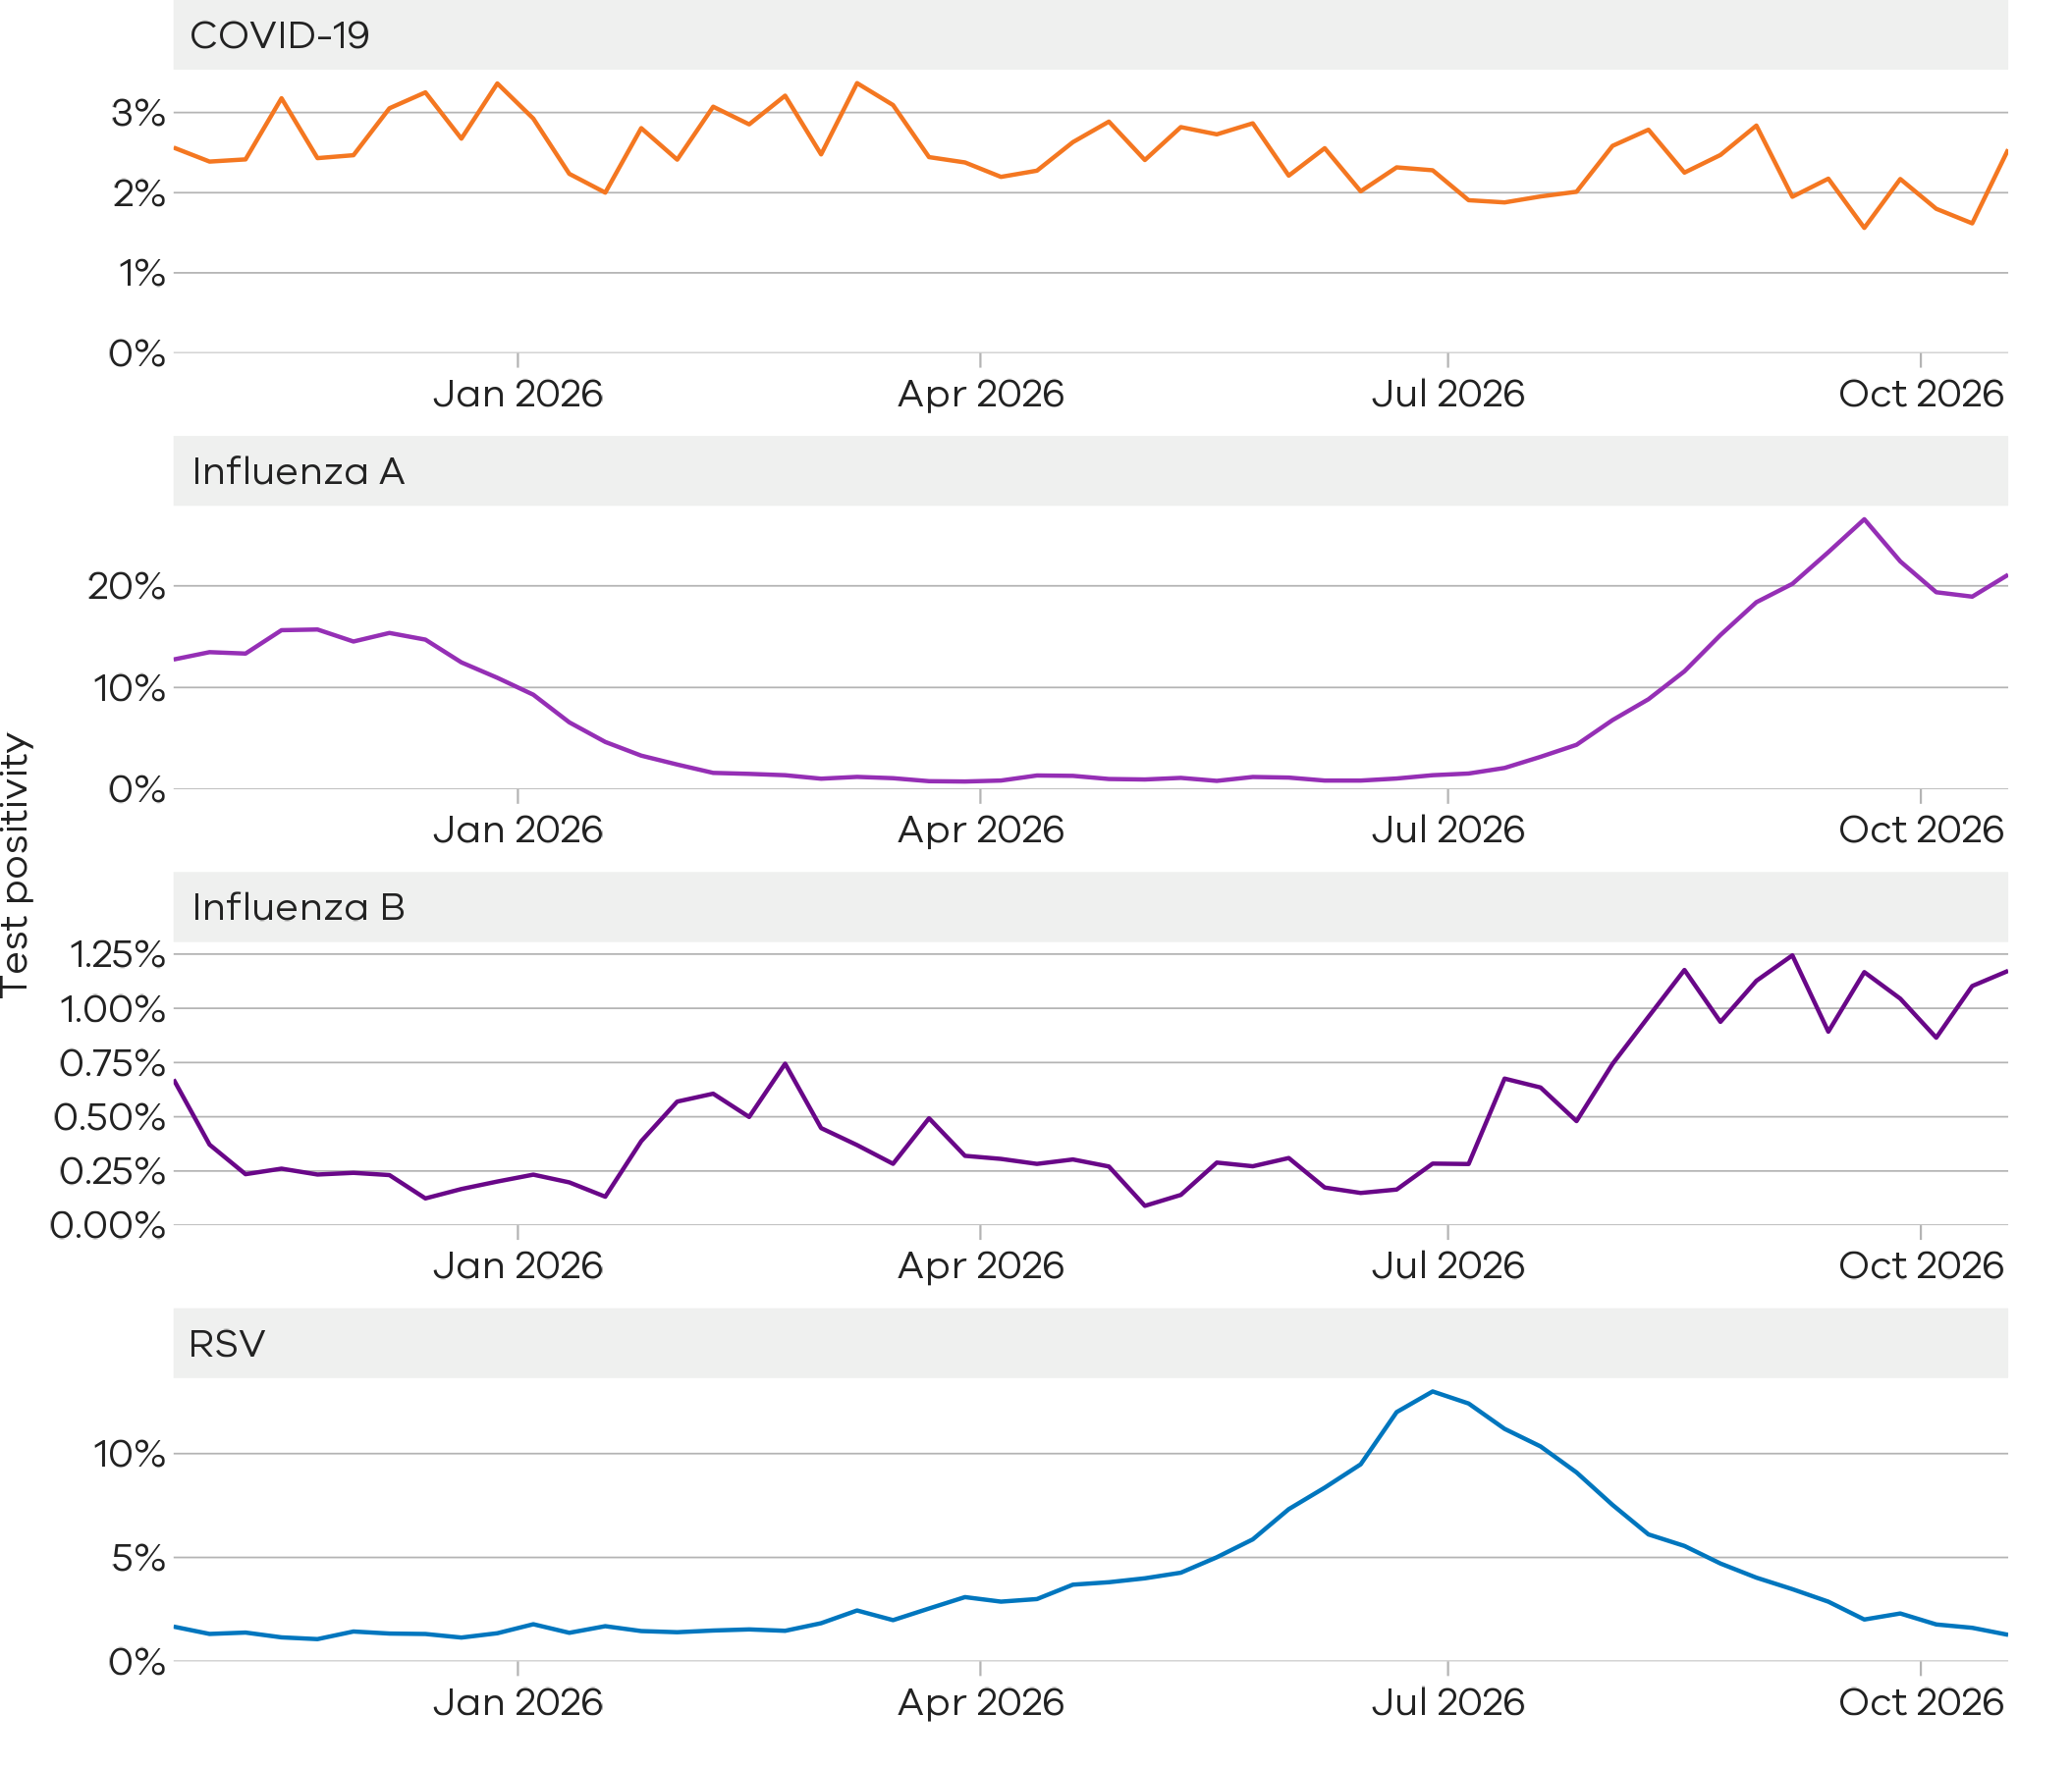
COVID-19 test positivity remains low
Influenza A test positivity has decreased to moderate in the same period as case notifications
Influenza B test positivity remains low and stable
RSV test positivity is low and has decreased in the same period as case notifications

Figure 11: Weekly test positivity by age groups for COVID-19, influenza and RSV, Victoria, 26 October 2025 to 24 October 2026

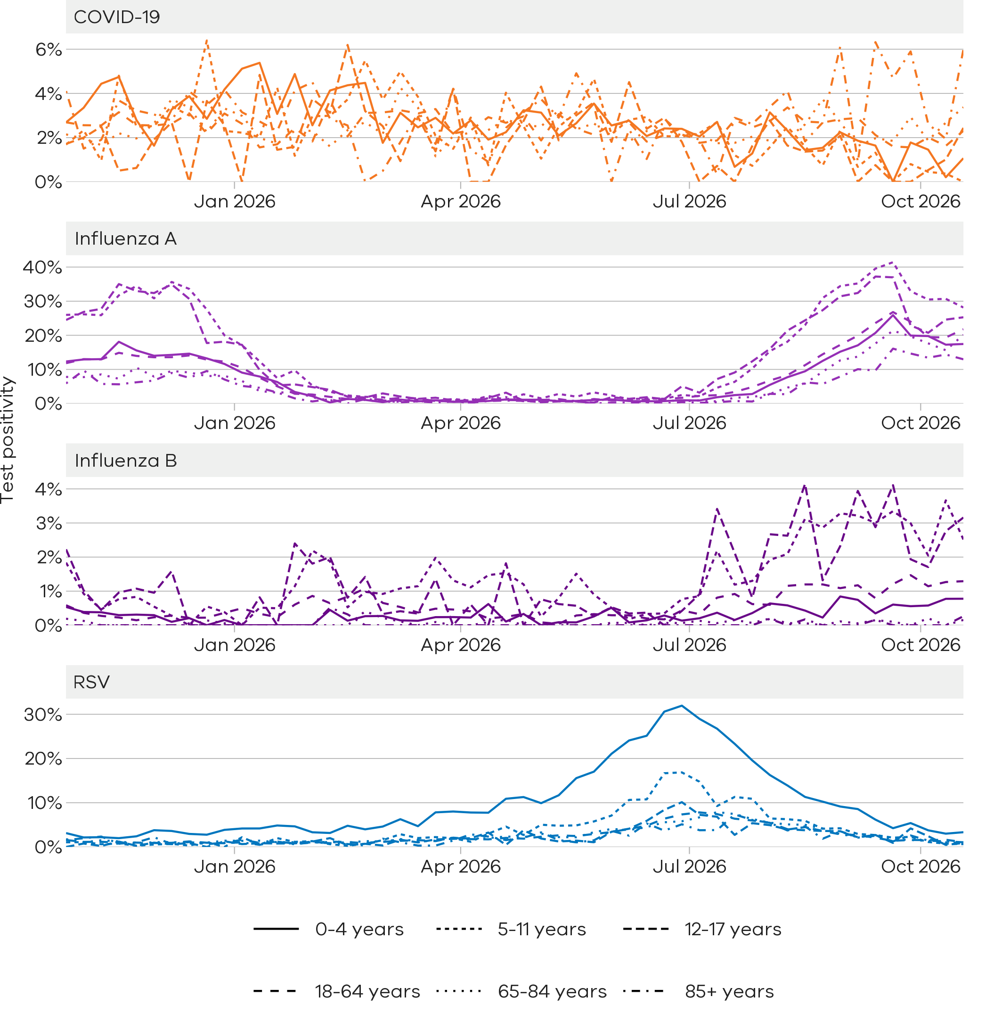

Community surveillance

Respiratory illnesses are not limited to the notifiable conditions presented above. Understanding the overall burden of respiratory illness in the community is useful to understand broader trends in illness over time.
FluTracking
FluTracking is an online surveillance system across Australia, Hong Kong and Fiji. Volunteer participants complete a simple weekly online survey which collects self-reported information on respiratory symptoms. Data used in this report are received up to 12:00PM Tuesday. More information about FluTracking and ways to be involved are available here: https://info.flutracking.net/

Summary
In the past week, the percentage of Victorian FluTracking participants reporting respiratory illness (fever and cough) have slightly decreased from the previous week.
Figure 12: Proportion of FluTracking participants reporting respiratory illness by week, Victoria, 1 January 2023 to 25 October 2026. Respiratory illness is defined as fever & cough.
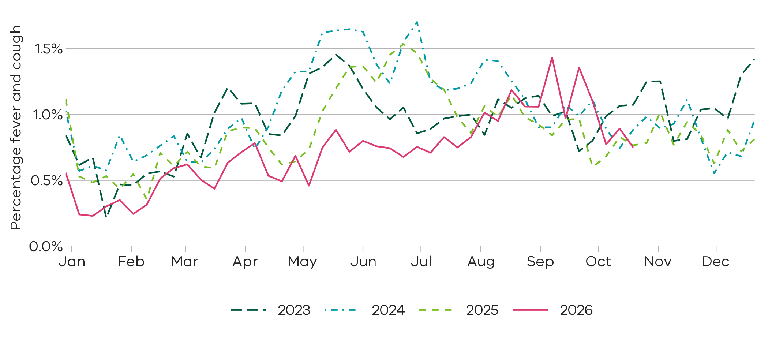
Reported respiratory illness from FluTracking is similar to recent years

How to use this report

Data sources
All notified cases in Victoria are recorded in the Victorian Public Health Events Surveillance System (PHESS). Under the Public Health and Wellbeing Act 2008 and Public Health and Wellbeing Regulations 2019, the Victorian Department of Health is authorised to collect information from doctors and laboratories about diagnoses of certain health-related conditions in Victoria.
Modelling is performed by the Australia-Aotearoa Consortium for Epidemic Forecasting & Analytics (ACEFA) throughout the winter respiratory season using data provided by the Department of Health. https://github.com/acefa-hubs
Pathology services are required to notify the Department of Health of all tests performed during a weekly period for schedule 4A conditions including influenza, RSV and COVID-19.
The FluTracking surveillance system collects data from volunteer participants in a weekly survey. FluTracking reports are available here: https://info.flutracking.net/reports/australia-reports/
The Victorian Department of Health continually reviews surveillance methods to monitor respiratory disease in Victoria. Measurements included in this report may be updated or removed accordingly.
Definitions
Notified cases: Laboratory-confirmed cases of COVID-19, influenza, and RSV are reported according to the CDNA case definitions https://www.health.gov.au/resources/collections/cdna-surveillance-case-definitions/ Where multiple positive test results are received for the same person within 30 days of the initial test result they are counted as a single case.
Rapid antigen test results are not collected by the Victorian Department of Health, however, remain an important tool for individuals to access treatment and protect their community.
Case notifications are included in the Victorian dataset if the postcode of residence of the case is in Victoria. This does not necessarily reflect where the infection was acquired.
Modelled current trends: Modelled current trends indicate whether cases are likely to be increasing, decreasing or stable based on modelled trends in expected cases for each condition. Details of the statistical modelling methods can be found in the paper at https://doi.org/10.1093/aje/kwaf119
Test positivity: Test positivity is the percentage of total tests where the notifiable condition was detected. This is reported by the date of specimen collection.
Dates: Case notifications are based on the date the notification was first received by the Victorian Department of Health. Test positivity is based on the date of specimen collection.
Weeks: For the purposes of this report, data are aggregated by week, with the week starting Sunday and ending Saturday unless otherwise specified.
Activity levels: The Victorian Department of Health monitors activity of acute respiratory illnesses assessed against trends from recent seasons and determined by expert review of multiple surveillance inputs informed by statistical analysis of all data sources available at the time the report is prepared.

Authorised and published by the Victorian Government, 1 Treasury Place, Melbourne.
© State of Victoria, Australia, Department of Health, October 2026
ISSN 2982-3161 - Online (pdf/word)

