
Victoria’s digital health vision and roadmap 2026–31
OFFICIAL

To receive this document in another format, email <digitalhealth@health.vic.gov.au>.
Authorised and published by the Victorian Government, 1 Treasury Place, Melbourne.
© State of Victoria, Australia, Department of Health, October 2026.
Except where otherwise indicated, the images in this document show models and illustrative settings only, and do not necessarily depict actual services, facilities or recipients of services. This document may contain images of deceased Aboriginal and Torres Strait Islander peoples.
In this document, ‘Aboriginal’ refers to both Aboriginal and Torres Strait Islander people. ‘Indigenous’ or ‘Koori/Koorie’ is retained when part of the title of a report, program or quotation.
ISBN- 978-1-76195-075-9
Available at Victoria's digital health roadmap | <https://www.health.vic.gov.au/publications/victorias-digital-health-roadmap>

Minister’s foreword
Every Victorian should be able to access safe, high-quality healthcare that is connected, responsive and centred on their needs.
As our population grows and people live longer with more complex health needs, we must continue to evolve how care is delivered. People should not have to repeat their story each time they move between services. Clinicians should be able to access the information they need, when they need it, and spend less time searching for records or completing administrative tasks and more time providing care.
Digital health can help make this possible. Connected information, modern clinical systems and digital and virtual models of care can make services easier to navigate, support safer and better coordinated care, and enable more people to receive care closer to home.
Across Victoria, we are already seeing the benefits of digital investment. Electronic medical records are making important clinical information more accessible. Virtual care is helping services reach people beyond hospital walls. Health information sharing is improving continuity between services, and stronger cybersecurity controls are helping to protect the information and systems on which modern healthcare depends.
There is, however, more to do. Digital capability remains uneven across our health system, and too many clinicians and consumers still experience fragmented information, paper-based processes and disconnected services.
Victoria’s digital health vision and roadmap 2026–31 sets the direction for the next phase of digital transformation. It provides a framework to guide investment in the connected systems, information and digital capabilities needed to deliver more integrated care, support our health workforce and build a more productive, sustainable and resilient health system. It will also help Victorians access their health information, understand their options and play a more active role in managing their health and wellbeing.
The roadmap has been shaped through engagement with health services, clinicians, consumers, First Peoples representatives and delivery partners across Victoria. I thank everyone who has contributed their experience, expertise and ideas.
By working together, we can build a health system where information follows the person, care is better connected, and our workforce has the tools and time to focus on what matters most: providing high-quality care to Victorians

Ingrid Stitt MP
Minister for Health
Minister for Mental Health
Minister for Ambulance Services
Special Minister of State

Commitment to First Peoples
Victoria’s digital health vision and roadmap 2026–31 commits to improving health and wellbeing outcomes for First Peoples, embedding principles of self-determination, cultural safety and accountability across digital health governance, design and delivery.
This commitment aligns with the Victorian Aboriginal Health and Wellbeing Partnership Agreement and national Closing the Gap priorities, recognising the importance of partnership and First Peoples leadership in shaping how digital health is implemented across the system. It also acknowledges the evolving context of the Statewide Treaty and will adapt approaches to engagement, governance and delivery in line with Treaty principles.
Delivery of the roadmap will be undertaken in partnership with First Peoples, ensuring that digital health initiatives are designed and implemented in ways that are culturally safe, accessible and responsive to community needs. This will enable self-determination through engaging Aboriginal Community Controlled Organisations and Aboriginal and Torres Strait Islander people who live and work in and around Victoria.
Indigenous data governance and sovereignty are central to this approach. The roadmap commits to applying Indigenous data principles across the full data lifecycle, ensuring data is collected, managed and used in ways that respect First Peoples’ perspectives and support community control, trust and appropriate oversight.
Outcomes will be monitored as part of the broader benefits framework to ensure digital investment contributes to reducing gaps in access, experience and outcomes for First Peoples.
Contents
Minister’s foreword 3
Commitment to First Peoples 4
Executive summary 7
The future of health in Victoria 9
Establishing the signposts for delivery 9
Our 10-year vision for digital health 11
Digital capability as a catalyst for change 12
Our starting point 12
Drivers of change 13
Why action is needed now 18
Developing the roadmap 19
Engagement and co-design 19
Aligned to strategic priorities and system reform 19
Approach to delivery 21
Digital Health Roadmap 2026–31 23
1. Connecting Health 24
From paper to intelligence 24
Design principles 25
Programs of work 26
Connecting Health in 2031 29
2. Care Anywhere 30
From episodic to continuous care 30
Design principles 30
Programs of work 31
Care Anywhere in 2031 34
3. Engaged Consumers 35
From fragmented to connected experiences 35
Design principles 35
Programs of work 36
Engaged Consumers in 2031 38
4. Sustainable Operations 39
From reactive to predictive and proactive 39
Design principles 40
Programs of work 40
Sustainable Operations in 2031 44
Accelerators 45
Measuring success 46
Embedding the roadmap 49
Governance 49
Glossary 51
Appendix A. Accessible text equivalents 54
Figure 1. Victoria's digital health vision and roadmap 2026–31 54
Figure 2. Priority outcomes for digital health in Victoria that underpin the roadmap 55
Figure 3. Impacts of limited digitisation and integration 55
Figure 4. Example benefits of digital investment in healthcare 56
Figure 5. The rate of chronic disease in Australia 56
Figure 6. Healthcare consumers are open to AI being used to support care access and navigation 56
Figure 7. Advances in technology are enabling continuous patient monitoring 57
Figure 8. New large language models for disease management 57
Figure 9. Federated health data network enabled by the European Health Data Space 57
Figure 10. Findings from the clinician and consumer surveys 58
Figure 11. Specialist Care Reform Blueprint – pillars of change 58
Figure 12. Target state architecture for Victoria's connected health system 59
Figure 13. Integrated, personalised consumer application 59
Figure 14. Roadmap accelerators 60
Figure 15. Benefit categories aligned to priority outcomes 61
Figure 16. Delineation of roles across national, state and the sector 61
Figure 17. Governance framework supporting delivery of the roadmap 62
Table 1. Connecting health programs and initiatives 63
Table 2. Care Anywhere programs and initiatives 65
Table 3. Engaged Consumers programs and initiatives 66
Table 4. Sustainable Operations programs and initiatives 67

Executive summary
Victoria's health system is facing growing demand, increasing complexity and rising expectations from consumers, clinicians and the community. Improving health outcomes is dependent on the ability to prevent illness, intervene earlier and better support people to manage their health and wellbeing. At the same time, advances in digital technology, data, artificial intelligence (AI) and virtual care are creating new opportunities to transform how health and wellbeing services are delivered, improving outcomes and supporting long-term system sustainability.
While Victoria has made significant progress in digital health, progress has not been consistent across the sector. Digital maturity remains uneven, with variation in infrastructure, systems and adoption across services. In approximately half of Victorian health services, critical health information remains on paper, limiting the timeliness, accuracy and availability of information and contributing to duplication, delays and inefficiencies in care delivery. Continued reliance on paper-based and fragmented systems also constrains the ability to leverage emerging technologies such as AI, advanced analytics and automation at scale.
Victoria’s digital health vision and roadmap 2026–31 (the roadmap) sets the direction for digital health investment and transformation. It recognises that digital is no longer a supporting function operating alongside healthcare delivery. It is becoming an increasingly integral component of how health is promoted, illness is prevented, and care is accessed, coordinated, delivered and improved.
The roadmap is also not a standalone digital strategy. It aligns to state and national strategic priorities and outcomes. It is intended to support broader health system reform, including more integrated models of care, increased access to virtual services, improved care coordination, stronger consumer participation and more efficient use of resources.
The roadmap establishes a vision for a connected, intelligent and resilient digital health system that improves outcomes for consumers, supports the workforce and enables a more sustainable health system.
It is centred on five outcomes that describe the future state Victoria is seeking to achieve:
- Healthy Victorians – people have access to the digital tools and information required to maintain their health and wellbeing on their own terms.
- Integrated Care Journeys –a health system where information flows, services connect, and consumers experience seamless care across their health and wellbeing journey.
- Equitable Health Outcomes – high-quality data and insights support evidence-based decisions for individuals and populations.
- High Performing Health System – digital capability streamlines operations, optimises resource use and enhances service delivery.
- Supported Workforce – a workforce with the right digital tools to allow them to focus on what matters most.
The roadmap is organised around four strategic pillars and three system-wide accelerators, providing a clear line of sight between long-term outcomes, programs of work and delivery priorities.
Figure 1. Victoria's digital health vision and roadmap 2026–31
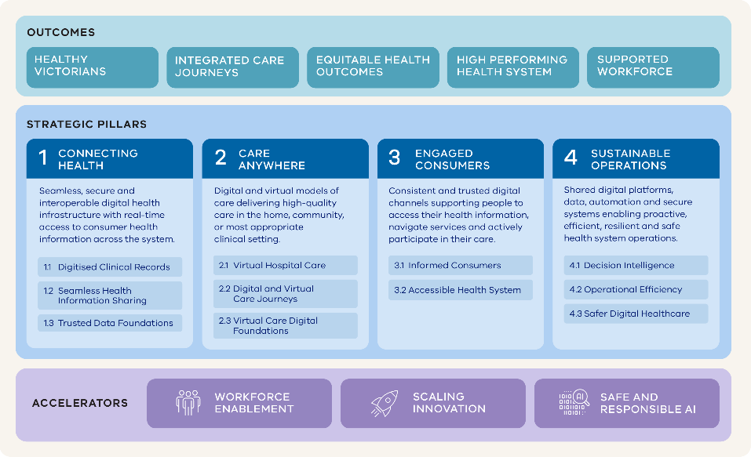
The roadmap adopts a horizon-based approach that balances immediate priorities with longer-term transformation. Horizon 1 focuses on initiatives that are sufficiently mature to support near-term planning, investment and delivery. Horizons 2 and 3 provide a longer-term direction of travel, identifying the capabilities required to support future models of care, emerging technologies and evolving health system priorities.
Importantly, the roadmap is not intended to represent an implementation plan. Through a combination of strategic investment, shared accountability, strong governance and continuous review, it provides a strategic investment framework that identifies the capabilities required to deliver Victoria's long-term digital health vision.
While some initiatives are funded and ready for delivery, others represent priorities that will require further planning, business case development and investment consideration as the roadmap evolves.
Successful delivery will require sustained collaboration across government, health services, clinicians, consumers and delivery partners. The result will be a health system where care is delivered in ways that better meet people's needs, information is easier to access and share, and digital technologies help improve outcomes for consumers, the workforce and the broader health system over the coming decade.

Our 10-year vision for digital health
By 2036, all Victorians will be supported to lead healthier lives through digitally enabled experiences that prioritise wellbeing, prevent illness, and deliver care that is proactive, personalised and equitable.
In realising this vision, people will experience more connected, personalised and continuous healthcare that is easier to navigate and better aligned to their needs. Services will work together more effectively, enabling consumers to move more seamlessly between providers and settings, while remaining active participants in their own health and wellbeing.
Information will flow across services and settings, supporting more coordinated experiences, better decisions and improved outcomes. Consumers, families and carers will have clearer access to information and services, while the workforce will be equipped with the information, tools and insights needed to spend less time on administration and more time delivering high-quality care.
At a system level, this will support more sustainable models of care to improve productivity, reduce duplication and enable more efficient use of resources to better manage demand over time. Enhanced access to data and insights will support more proactive evidence-based decision-making across the system. This will strengthen system stewardship, improve understanding of community need and future demand, support prevention and earlier intervention, and enable more informed decisions about service delivery, workforce and long‑term investment priorities.
This vision aligns with the broader transformation of the health system and establishes a clear set of five priority outcomes that define success (see Figure 2). These outcomes act as the roadmap’s primary signposts, providing a consistent reference point for prioritisation, investment and delivery.
Figure 2. Priority outcomes for digital health in Victoria that underpin the roadmap
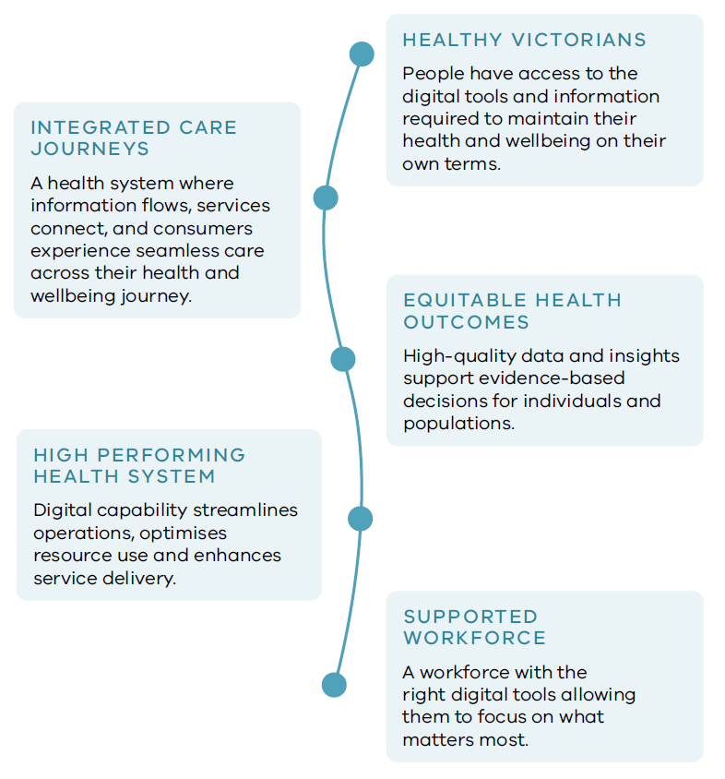

Digital capability as a catalyst for change
Digital capability is integral to how the health system operates and evolves. It underpins the system-wide reforms that are needed to deliver more connected, integrated and sustainable care. In practice, this means that achieving the system’s transformation goals depends on digital capability to be implemented effectively at scale.

Our starting point

Victoria’s digital health roadmap 2021–2025
The 2021–2025 roadmap delivered a significant uplift in digital capability across Victoria’s public health system and established the foundations for more connected, resilient and digitally supported care.
Key investments strengthened cybersecurity and system resilience, progressed the rollout of EMR and clinical systems, supported the expansion of virtual care and delivered the foundation for statewide health information sharing. These initiatives demonstrated the value of coordinated system-wide investment in digital capability.
However, progress has not been consistent across the system. Variation in governance, funding, digital maturity and delivery models has resulted in uneven adoption and outcomes across health services. In some areas, digital capability has become embedded in day-to-day operations, while in others, reliance on manual and fragmented processes remains.
Experience from delivery highlights several important lessons. Outcomes are strongest where there is clear accountability, aligned funding, well-defined scope and practical delivery models. Conversely, fragmentation in decision-making and investment has limited scalability and system-wide impact.
These lessons shape the approach taken in this roadmap. The focus shifts from discrete initiatives towards a more structured, system-wide approach, with clearer direction, stronger alignment and a stronger emphasis on capability that can be scaled and sustained over time.

Victoria’s operating context
Victoria’s public health system operates under a devolved governance model. Responsibility for healthcare delivery and public health functions is distributed across health services and system partners, while the Department of Health (the department) provides system stewardship, policy direction and oversight. This balances local decision-making and responsiveness with statewide coordination and accountability.
In 2024, the Health Services Plan introduced Local Health Service Networks, bringing health services together to strengthen coordination, improve access and support more integrated models of care. This supported a greater focus on joint planning and shared responsibility for managing care across each region, with clearer care pathways for consumers.
These arrangements also create opportunities for stronger collaboration across the broader health system, including organisations involved in prevention and population health.
This operating model requires a clear and consistent approach to how digital capability is developed and applied across the system, ensuring that information can be shared, services can be coordinated and new models of care can operate effectively at scale.

Drivers of change
Healthcare in Victoria is undergoing significant change. Growing demand for services, workforce constraints, evolving consumer expectations and rapid technological advancement are reshaping how care is delivered. As healthcare needs continue to grow faster than the system's capacity to expand through traditional models of care, digital transformation is becoming a critical enabler of high quality care and long-term system sustainability, productivity and value.

Digital capability to address system pressures
The health system is operating under increasing pressure, with structural constraints that limit its ability to respond to growing demand and deliver new models of care at scale. Continued reliance on paper-based and fragmented systems also limits the ability to leverage emerging technologies such as AI, reducing opportunities to improve care, productivity and system performance.
Figure 3. Impacts of limited digitisation and integration,
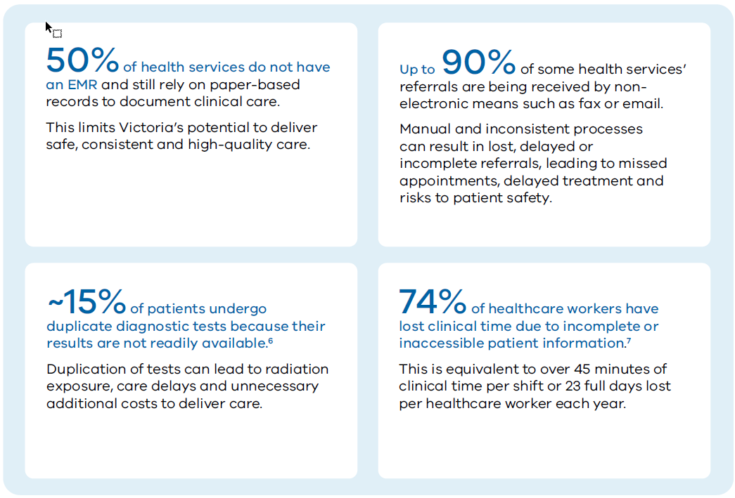
The impacts of limited digitisation and integration include that:
- digital maturity remains uneven across the sector – many healthcare services lack interoperable systems, secure infrastructure and the workforce capability required to adopt and scale digital solutions. In some services, foundational digital systems, including EMR, are not yet in place. This constrains information sharing, care coordination and the ability to deliver care effectively across services and settings
- system settings are not aligned to integrated, digitally driven care – current funding and governance arrangements do not consistently support digital-first or integrated models of care. Key activities, such as remote patient monitoring, care navigation and virtual clinician support, are often unfunded, reducing incentives for adoption and scale
- the system is not configured for coordinated and preventative care – delivering care across settings, managing population health and supporting earlier intervention requires timely access to shared, high‑quality data, which is not yet consistently available across the system. This constrains the ability to move beyond episodic care and respond effectively to growing demand
- workforce capacity is increasingly constrained – workforce shortages and administrative burden limit the ability to deliver care efficiently. Variability in systems and processes adds complexity and reduces the time available for direct clinical care
- opportunities to improve productivity and sustainability are not being fully realised – digital capability can reduce duplication, improve workforce productivity and support more efficient use of resources,. Realising these benefits requires targeted outcome-aligned investment.
Figure 4. Example benefits of digital investment in healthcare^{9, 10,}
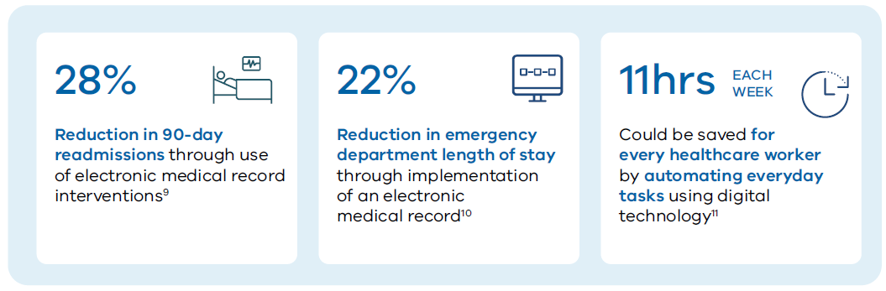

Evolving expectations
Expectations of the health system are changing as health needs become more complex and consumer expectations continue to evolve. People increasingly expect health services to be accessible, connected and responsive, with digital interactions that match their experiences in other parts of their lives.
Health needs are becoming more complex. An ageing population, rising chronic disease and lower physical activity levels are increasing demand for ongoing, coordinated, proactive care and greater emphasis on prevention, population health and early intervention.
Figure 5. The rate of chronic disease in Australia
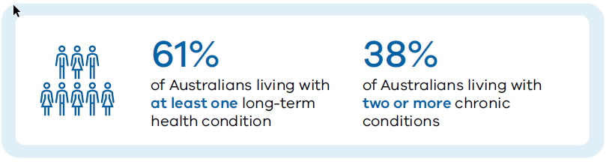
Equity in access and outcomes remains a priority. People have diverse needs shaped by culture, geography, age, gender and lived experience. Persistent gaps for regional and remote communities, First Nations people and priority populations highlight the need for inclusive, culturally safe and accessible services.
Experience expectations are shaped beyond the health system. People increasingly expect seamless, intuitive and responsive interactions, with access to guidance, next steps and support across their care journey¹³.
Figure 6. Healthcare consumers are open to AI being used to support care access and navigation
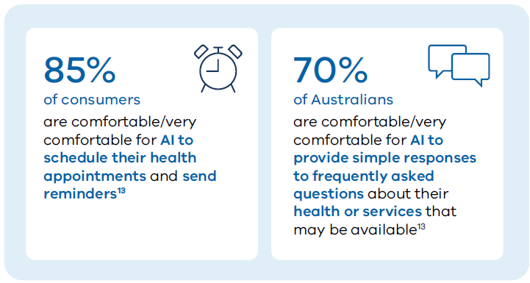
Access to information and insight is expanding. People are increasingly turning to online tools, social media and generative AI to understand symptoms, explore care options and make health decisions. As access to information becomes more widespread, clinical knowledge and expertise that has traditionally sat within health services will need to become more accessible, helping consumers distinguish trusted advice from misinformation and participate more actively in their care.
Trust, safety and privacy are essential. People expect their data to be secure, managed appropriately and used transparently. Maintaining trust is essential to supporting the safe and effective use of data and digital services across the system.

Technology-enabled shifts
Technology is evolving rapidly, changing what is possible across care delivery, system operations and how information is used. These changes are already evident across the system and are accelerating.
Care is moving from episodic to continuous. Consumer-generated signals, remote monitoring and contextual data are enabling care to be managed over time, with earlier identification of need rather than reliance on presentation for care.
Figure 7. Advances in technology are enabling continuous patient monitoring
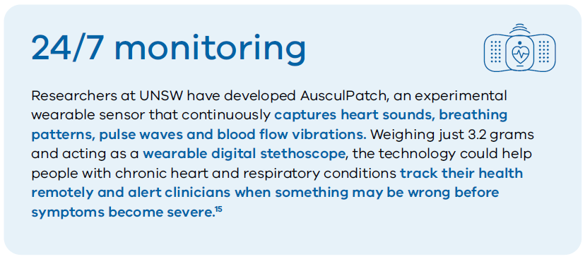
Care is becoming more personalised. Advances in genomics, diagnostics and digital technologies are enabling treatment decisions to be informed by a deeper understanding of individual characteristics, risks and likely responses.
Figure 8. New large language models for disease management
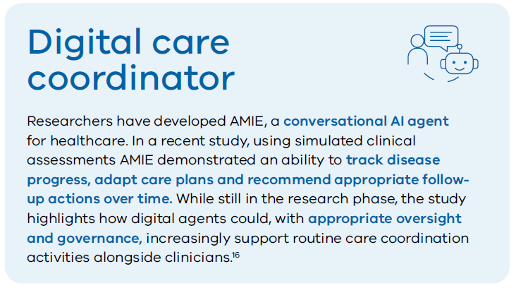
Coordination is increasingly supported by automation. Workflow automation, digital assistants and emerging AI capabilities are creating new opportunities to support coordination, follow-up and escalation activities, enabling care and operations to be managed more proactively, consistently and at scale.
Systems are becoming more adaptive and proactive. Advances in sensing, prediction and automation are creating opportunities to better anticipate demand, identify emerging risks, and dynamically adjust capacity, resources and services, before demand pressures translate into delays or poorer outcomes.
Monolithic systems are giving way to modular platform architectures. Traditional, tightly coupled systems are being replaced by application programming interface-driven platforms that enable integration, flexibility and faster adoption of new capability over time.
Data are becoming more connected and accessible. Modern approaches to data sharing enable information to be securely accessed and used across organisational boundaries, while maintaining appropriate stewardship, privacy protections and local control. This supports more coordinated care, better decision-making and improved system-wide insight.
Figure 9. Federated health data network enabled by the European Health Data Space
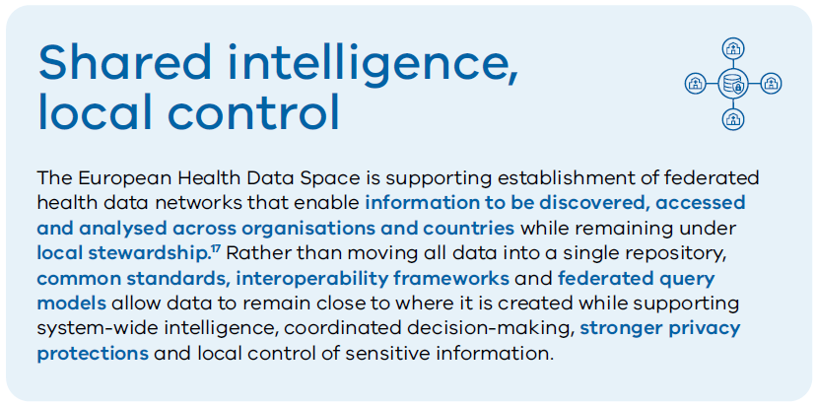
Trust and security are becoming dynamic capabilities. As digital capability expands, privacy, cybersecurity and resilience must continuously adapt to support safe, trusted and reliable system operation.

Why action is needed now
Victoria has already demonstrated what connected digital capability can deliver. It is no longer a matter of whether digital health creates value, but whether the system will apply that capability consistently to deliver impact at scale.
The current approach, where investment, data and systems continue to develop unevenly across services, limits the ability to deliver reform and realise system‑wide benefit. It contributes to variation in access, experience and outcomes, creating a risk that the quality and availability of health services depend on where a person receives care. It also reinforces fragmentation, constrains coordination and embeds inefficiency into how the system operates.
At the same time, the conditions for change are accelerating. Advances in data, interoperability and AI are rapidly shifting what is possible, but these capabilities depend on the same foundational requirement – connected, consistent and trusted health information across the system.
The roadmap provides a clear mechanism to act, aligning investment, scaling what works and directing effort towards initiatives that deliver measurable value. It enables the system to move from fragmented improvement to coordinated transformation.
The question is whether investment is applied deliberately to deliver system-wide impact now or deferred until the cost of inaction is greater and the opportunity to lead has passed.

Developing the roadmap
The roadmap was developed through a structured, evidence‑based process, combining system‑wide engagement, alignment to reform priorities and a clear focus on delivery.
It reflects a shared direction for digital health transformation across Victoria, shaped by the input of clinicians, consumers, health services and delivery partners.

Engagement and co-design
Extensive engagement and co-design across the Victorian health system informed development of the roadmap including metropolitan, regional and rural services, clinicians, consumers, First Nations representatives and delivery partners.
This was complemented by targeted consultation, advisory forums, working groups and surveys to identify the outcomes and capabilities that matter most to consumers, the workforce and services.
This approach ensures the roadmap reflects real‑world challenges, service needs and consumer expectations, while building shared ownership for delivery across the sector.
Figure 10. Findings from the clinician and consumer surveys
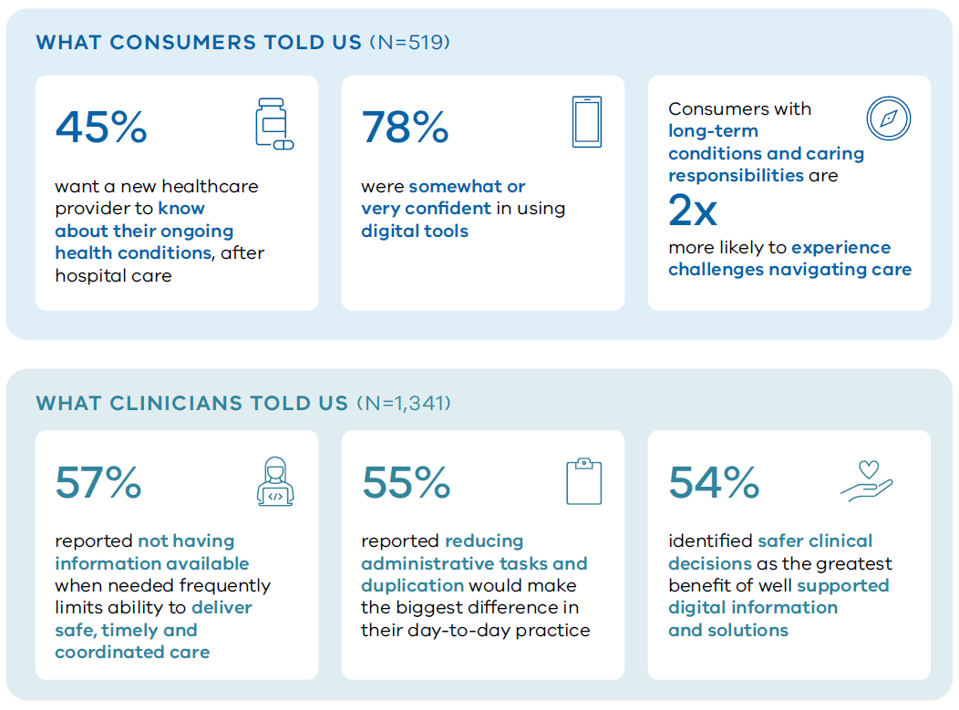

Aligned to strategic priorities and system reform
The roadmap is not a standalone digital strategy. It is intended to support delivery of broader health system objectives and priority reforms across the Victorian health system.
At a national level, Australia is progressing a more connected and digitally enabled health system through delivery of initiatives outlined in the National Digital Health Strategy 2023–2028, including My Health Record modernisation, interoperability reforms and national data sharing frameworks. These initiatives are creating the foundations for greater information sharing, consumer participation and connected care across jurisdictions.
The roadmap builds on this direction, enabling Victoria to adopt and scale emerging national capabilities while translating them into value-adding outcomes across Victorian health services and care settings.
At a Victorian Government level, strategic outcomes are increasingly focused on improving service quality and access, productivity, and sustainability. Through implementation of initiatives, such as EMR, statewide medical image sharing and virtual hospital care, Victoria's Infrastructure Strategy 2025–2055 identifies digital health as an important contributor to improving access to care, increasing system capacity and supporting more sustainable models of healthcare delivery.
Within the health system, the roadmap is designed to accelerate delivery of the department’s strategic objectives by embedding digital capability as a core component of system reform. Key reforms, including those outlined in the Health Services Plan, the Victorian Maternity Taskforce report, the Specialist Care Reform Blueprint and the Planned Care Reform Blueprint focused on improving access, coordination and sustainability through more integrated models of care.
Delivering this requires shared information, system-wide visibility of demand and capacity, access to virtual models of care and coordinated delivery across services – capabilities that are inherently digital.

Spotlight: Specialist Care Reform Blueprint
The Specialist Care Reform Blueprint sets a statewide direction for more responsive, integrated and sustainable specialist care. It depends on digital capabilities that improve coordination, increase visibility of demand and capacity, support new models of care and enable consumers to play a more active role in their care journey.
Figure 11. Digital capabilities enabling the Specialist Care Reform Blueprint.
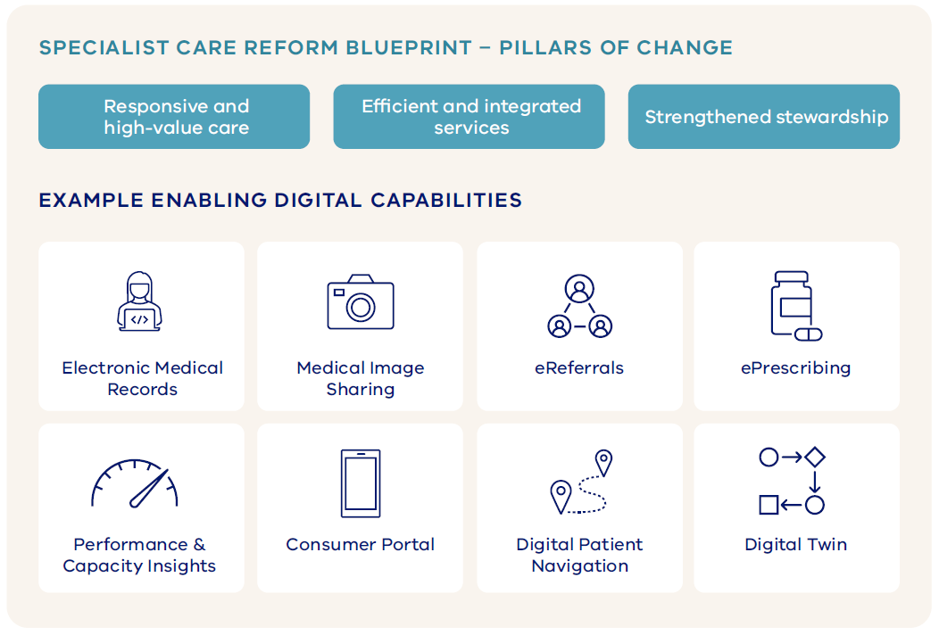

Approach to delivery
The roadmap translates strategic intent and outcomes into a clear delivery model, supported by defined programs of work, sequencing and investment over time.

Balancing foundational capability and transformation
The roadmap balances investment between foundational capability that creates consistent, statewide digital maturity, and transformation that delivers immediate improvements in care, access and system performance.
This is not a sequential ‘foundations first, benefits later’ approach. It recognises that transformation can be progressed now where readiness exists, while continuing to build the shared platforms, standards and capabilities required to deliver consistent and scalable change across the system over time.
Foundational investment focuses on establishing the core enabling capability for the system, including EMR, data and integration, reusable digital services and secure infrastructure, creating a consistent and adaptable base for future growth.
At the same time, transformation is delivered in priority areas where services are ready, supporting the adoption of new models of care, improved coordination and more efficient service delivery.
This approach delivers early value while reducing duplication and enabling innovation to be scaled, ensuring that benefits can be realised now and sustained across the system over the longer term.

Accelerators of delivery
The roadmap is supported by a small number of system‑wide accelerators that strengthen delivery capability across all pillars and programs. They ensure that key enablers, such as workforce capability, innovation and the safe use of AI, are built into delivery from the outset, enabling consistent implementation, reducing duplication and supporting scale across the system.
Rather than standalone initiatives, these accelerators are embedded in how programs are designed and delivered, ensuring that new capability can be adopted, sustained and extended over time.

Iterative and adaptive delivery
The roadmap is designed to be iterative, recognising that system needs, technologies and priorities will continue to evolve.
Delivery will be regularly reviewed and refined to remain aligned to system priorities and continue to deliver value. This includes ongoing assessment of progress against expected outcomes and benefits, ensuring that investment remains focused on initiatives that deliver measurable impact.
Where benefits are not being realised, investment will be re‑evaluated and adjusted. This enables resources to be redirected to higher‑value opportunities, while incorporating new capability and emerging priorities as they mature.
This approach supports a disciplined and responsive model of delivery, ensuring the roadmap can adapt over time without losing focus on outcomes, value and system impact.

Digital Health Roadmap 2026–31
The roadmap provides a clear line of sight between the outcomes Victoria is seeking to achieve and the investments required to realise them.
Four strategic pillars provide the organising structure for the roadmap, with each pillar comprising a series of programs of work that group related initiatives and investments around shared objectives. Each pillar is supported by a set of design principles that guide investment, architecture and delivery decisions. Together, these principles help ensure initiatives are implemented consistently across the health system, while maintaining alignment to the roadmap's long‑term outcomes.
Three system-wide accelerators extend across all four pillars, strengthening the system's ability to adopt, scale and sustain change.
The accelerators are:
- workforce enablement
- scaling innovation
- safe and responsible AI.
Together, they ensure that key capabilities are embedded consistently across the roadmap, rather than delivered in isolation (see Figure 1).
The roadmap adopts a horizon-based approach to balance certainty with flexibility. Horizon 1 focuses on the next 12–24 months and includes defined initiatives that are sufficiently mature to support immediate planning, investment and delivery.
Horizons 2 and 3 provide a longer-term direction of travel, identifying the capabilities and outcomes required to achieve the roadmap vision, while allowing future initiatives to evolve in response to changing priorities, emerging technologies, funding decisions and lessons learned through implementation.
The roadmap provides a strategic investment framework that identifies the capabilities required to deliver Victoria's long-term digital health vision. While some initiatives are funded and ready for delivery, others will require further planning, business case development and future investment consideration.
To maintain flexibility while providing a clear long-term direction, delivery will be sequenced according to strategic priorities, dependencies, readiness and available funding. Annual roadmap reviews will assess progress, benefits realisation, emerging opportunities and system needs, enabling priorities, initiatives and investment pathways to be refined over time, while maintaining alignment to the roadmap's long-term outcomes.

Connecting Health
Goal | Seamless, secure and interoperable digital health infrastructure with real-time access to consumer health information across the system

From paper to intelligence
Victoria has established many of the building blocks of a modern digital health system. However, many healthcare providers still rely on paper records, manual processes and information spread across multiple systems. As care becomes increasingly connected and distributed, enabling information to move securely and seamlessly with the consumer is becoming essential to delivering safe, coordinated and efficient care.
Connecting Health addresses this challenge by creating the digital health infrastructure required for a connected, interoperable and intelligence‑enabled health system, supporting prevention, earlier intervention and more effective care. Through investment in EMR, information sharing and data foundations, necessary health information can move securely and seamlessly with the consumer, regardless of where care is delivered.
Data are digitised and liberated from systems of record and securely made available wherever needed, enabling more informed decision‑making, supporting automation and creating new opportunities for innovation.
The target state architecture represents a deliberate shift away from paper-based processes, isolated systems and monolithic technology platforms towards a modern, modular infrastructure built on interoperability, shared data and open standards.
A digital marketplace provides the vehicle for new solutions to be adopted, integrated and scaled more efficiently across the health system, accelerating innovation, while reducing duplication and integration complexity. Underpinning this approach is a strong commitment to privacy, security and trust, ensuring information is protected and used appropriately.

Figure 12. Target state architecture for Victoria’s connected health system
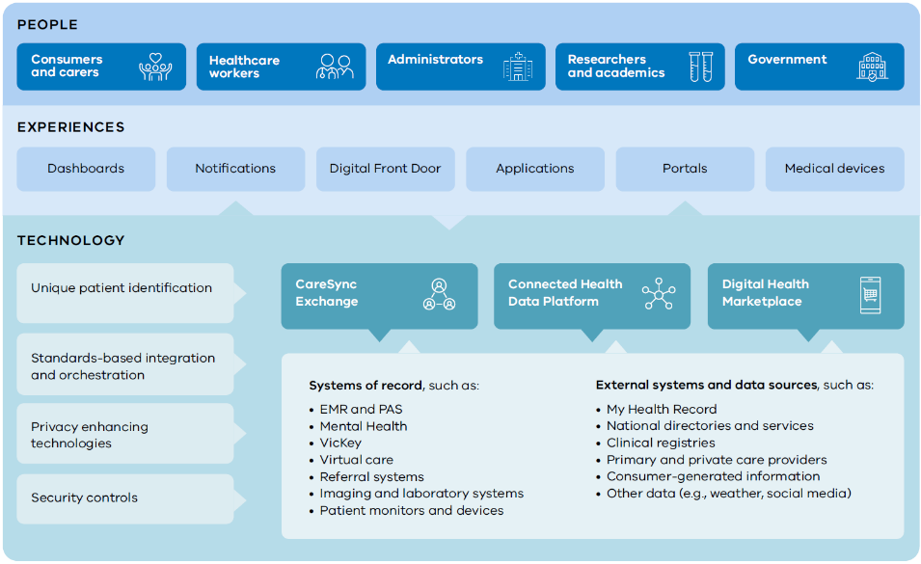
By building on existing investments and investing in the capabilities emerging across the global health technology landscape, Victoria can improve care today, while creating the conditions for future transformation.

Design principles

Digital by default
Information should be captured digitally at the source, reducing reliance on paper records, manual processes and duplicate data entry.

Interoperability by design
Information should flow securely and seamlessly across systems, organisations and care settings using open standards and shared approaches to data exchange.

Data liberated, not replicated
Data should be accessible where it is needed without creating unnecessary duplication, supporting a single, trusted source of information, while enabling broader use across the health system.

Privacy, security and trust built in
Privacy, security and appropriate use of information must be embedded into the design of systems, platforms and data sharing arrangements from the outset.

Shared and scalable
Digital capabilities should be delivered through shared platforms, reusable services and modular architectures that build on existing investments, reduce duplication and enable innovation to be adopted and scaled across the system.

Programs of work

Digitised Clinical Records
Objective | Expanding and modernising digitised clinical records across all health services to reduce reliance on paper‑based processes, and improve safety and quality of care
The Digitised Clinical Records program of work builds on Victoria’s existing investments in EMR, while addressing ongoing reliance on paper records, fragmented information, and ageing clinical and administrative systems.
In Horizon 1, the focus is on progressing delivery of key statewide capabilities, including EMR and contemporary patient administration systems, as well as completing delivery of the Mental Health and Wellbeing Client Management System.
Across Horizons 2 and 3, the focus shifts to scaling, embedding and optimising these foundational capabilities across the health system. This includes:
- continued delivery of EMR and patient administration system modernisation
- expanding access to core EMR functionality where gaps remain
- optimising the value realised from the Mental Health and Wellbeing Client Management System
- addressing priority areas where ageing clinical systems constrain care delivery.
Over time, the program expands digital clinical record capability to support emerging models of care and key reform priorities, including areas such as maternity care and other specialised clinical domains.

Seamless Health Information Sharing
Objective | Enabling clinical information to be securely accessed and shared across the health system to support continuity and coordination of care
Building on foundational capabilities, such as CareSync Exchange and Unique Patient Identification, the Seamless Health Information Sharing program of work creates the pathways, standards and governance required for information to flow across organisations, care settings and jurisdictions.
In Horizon 1, the focus is on completing delivery of the current CareSync Exchange scope, implementing Program Wominjeka across Aboriginal Community Controlled Organisations (ACCOs), progressing statewide adoption of Healthcare Identifiers, and expanding digital referral and referral management capability. Delivery will also focus on securing the legislative, policy and funding foundations required to support broader information sharing and priority expansion use cases, such as diagnostic image sharing.
Across Horizons 2 and 3, the program progressively expands information sharing across other clinical domains, providers and care settings. This includes scaling priority information sharing use cases, strengthening participation in national information sharing initiatives and increasing access to connected clinical information wherever care is delivered.

Trusted Data Foundations
Objective | Establishing trusted statewide data foundations that enable insight, planning, innovation, intelligence and system-wide improvement
The Trusted Data Foundations program of work establishes the data platforms, standards, governance and capabilities required to support clinical care, population health, disease surveillance, operational decision-making, system planning, research and innovation, while ensuring information is managed securely and used responsibly.
In Horizon 1, the focus is on establishing core statewide data capabilities, including:
- the Connected Health Data Platform
- modernising mandatory reporting
- implementing priority statewide digital platforms, such as the medicine’s formulary and genomics platform
- strengthening Indigenous data sovereignty and governance.
These investments create the foundations for more consistent, trusted and accessible health information across the Victorian health system.
Across Horizons 2 and 3, the focus shifts to increasing the value realised from these investments through greater standardisation, integration and reuse of data. The program progressively enables advanced analytics, decision support, automation and AI, while establishing a digital health marketplace that allows innovative solutions to be evaluated, adopted and scaled across the system.

Table 1. Connecting health programs and initiatives
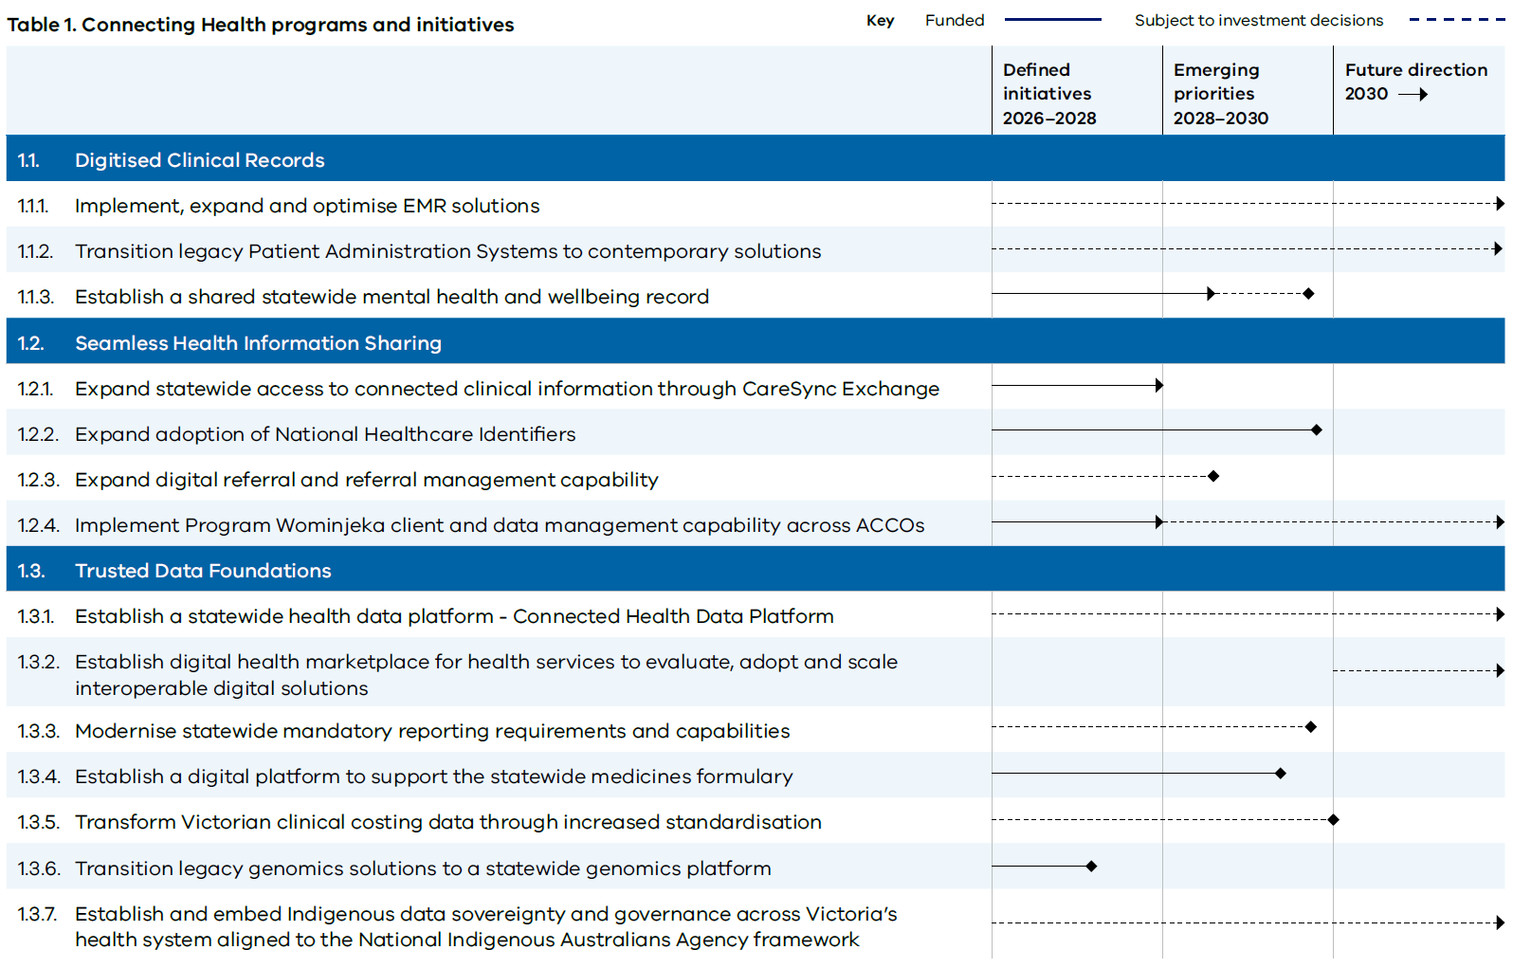
This table outlines the initiatives within the Connecting Health pillar and their progression across three planning horizons:
- Defined initiatives (2026–2028): Initiatives that are sufficiently mature to support immediate planning, investment and delivery.
- Emerging priorities (2028–2030): Initiatives expected to expand or mature over the medium term.
- Future direction (2030 onwards): Longer-term areas of focus that support the roadmap vision.
Further detail about this table can be found in the appendix.

Connecting Health in 2031
By 2031, health information will no longer be constrained by organisational boundaries, disconnected systems, paper records or fax-based processes. Victoria’s health system will be supported by seamless, secure and interoperable digital infrastructure that enables real-time access to information wherever care is delivered.
As information moves securely with people throughout their care journey, clinicians will have access to a more complete view of a person's health needs, supporting safer decisions, smoother transitions between services and more coordinated care.
Consumers will experience less need to retell their story, reduced duplication of tests and investigations, and more personalised care that is informed by complete and accessible health information. Clinicians will spend less time searching for information, reconciling records and managing paper-based processes, allowing more time to focus on delivering care.
Across the health system, trusted and connected information will improve productivity, reduce duplication and support more efficient delivery of services. Real-time access to data will strengthen service planning, performance management and system stewardship, while enabling more proactive and integrated models of care. The reduction of paper, fax and manual administration will lower operational burden and create capacity within the workforce.
By connecting information, liberating data and creating shared digital infrastructure, Victoria will establish a platform for innovation that supports advanced analytics, decision support, automation and AI. Together, these capabilities will enable a more sustainable, intelligence-enabled health system that delivers better outcomes, better experiences and better value for all Victorians.

Care Anywhere
Goal | Digital and virtual models of care delivering high‑quality care in the home, community or most appropriate clinical setting

From episodic to continuous care
Victoria's health system has made significant progress in adopting new models of care, including virtual care, Hospital in the Home and community-based services. However, access to alternative models of care remains inconsistent, often constrained by workforce availability, local infrastructure and fragmented digital technologies that have developed independently across services.
As a result, care continues to be organised around appointments, facilities and episodes of treatment, rather than the ongoing needs of individuals and communities.
Care Anywhere addresses this challenge by creating a more connected and flexible approach to care delivery. The pillar focuses on ensuring people can access the most appropriate model of care based on their clinical need, preferences and circumstances, whether that care is delivered virtually, in the home, in the community or through traditional clinical settings. Care becomes part of a connected continuum rather than a series of disconnected interactions.
Digital capability is a key enabler of this shift. Shared platforms, virtual care technologies, remote monitoring and digital care coordination create a consistent foundation for new models of care, reducing fragmentation and enabling services to be scaled across the system. Emerging capabilities such as consumer-generated health data, predictive analytics, AI and personalised care pathways will increasingly support more coordinated, responsive and proactive models of care.
Care Anywhere creates the conditions for care to be delivered in the right place, at the right time and through the right model, while enabling the health system to adapt to changing community needs and future advances in healthcare delivery.

Design principles

Value-led
Virtual care models should be prioritised where changes to where and how care is delivered can be supported by sustainable funding, workforce and operating models that deliver measurable substitution, avoided demand or efficiency benefits.

Person-centred
Care should be designed around the ongoing needs of individuals and communities, enabling people to move seamlessly across care settings as needs, preferences and circumstances change.

Equity and cultural safety by design
Approaches should be culturally safe, inclusive and accessible, reducing barriers associated with location, culture, language, digital access or circumstance, such as designing services and systems that support culturally safe identification of Aboriginality.

Integrated experiences
New models of care must operate as part of a connected care journey, supported by shared information, care coordination and integrated workflows rather than stand-alone services.

Balance scale with local delivery
Models should be delivered at statewide, network or local levels based on where shared capability delivers the greatest value, while enabling deliberate local tailoring where it improves outcomes, access or consumer experience.

Programs of work

Virtual Hospital Care

Objective | Shifting hospital‑level care to the home and augmenting in‑hospital care to optimise access, capacity and quality of care
Virtual Hospital Care brings together virtual hospital services, Residential in Reach, and virtually enabled inpatient care models to support admission avoidance, hospital substitution, earlier discharge, and more efficient delivery of acute care.
In Horizon 1, the focus is on establishing the foundations for scale through development of a statewide Virtual Hospital Strategy, continued delivery and evaluation of the Virtual Hospital pilot, expansion of Residential in Reach services and the introduction of virtual models that augment inpatient care. This will include early implementation of capabilities such as virtual ward rounds, virtual observation models, and remote specialist consultation. These initiatives will establish a consistent statewide approach to virtual hospital delivery and inform future scaling decisions.
Across Horizons 2 and 3, the focus is on scaling and embedding proven models into routine acute care delivery. Virtual hospital pathways become increasingly integrated with Ambulance Victoria, Virtual Emergency Department, aged care, community services, and hospital networks.
As virtual models mature, capability is progressively standardised and expanded across the health system, enabling specialist expertise, remote monitoring, and clinical oversight to be delivered more consistently and efficiently, regardless of location.

Digital and Virtual Care Journeys
Objective | Enabling proactive monitoring, chronic disease management and population-based care, supporting prevention, timely intervention and safe transitions between care settings as needs change
The Digital and Virtual Care Journeys program of work brings together remote monitoring, specialist advice, virtual care coordination, and population-based approaches to support earlier intervention, better management of chronic conditions and smoother transitions between care settings as needs change.
In Horizon 1, the focus is on establishing and evaluating key capabilities that support proactive, coordinated, and continuous care, including Assisted Self-Management pathways for chronic disease, Specialist Advice Now consultation services and stronger virtual care coordination across Local Health Service Networks. Horizon 1 will also build on successful digital mental health pilots to scale proven approaches that improve access to care in regional Victoria.
Early work will also explore population risk stratification capabilities and the data required to support population health at scale, establishing the foundations for more consistent identification, prioritisation, and management of populations with complex or emerging needs.
Across Horizons 2 and 3, the focus shifts to scaling proven approaches and embedding them into routine care delivery. Remote patient monitoring, specialist consultation services, population health management and coordinated virtual care pathways become increasingly integrated across health services and settings.
Alongside capability expansion, the program will work to establish sustainable models that support long-term delivery beyond pilots and short-term initiatives, ensuring these approaches become a routine part of care.

Virtual Care Digital Foundations
Objective | Establishing shared technology platforms, digital capabilities and standards to enable safe, scalable and consistent delivery of virtual care.
The Virtual Care Digital Foundations program of work creates a common foundation for virtual care delivery, reducing fragmentation and enabling virtual care models to be implemented, integrated and scaled consistently across the health system.
In Horizon 1, the focus is on defining the statewide virtual care architecture, technology standards, and future platform ecosystem, including telehealth, remote monitoring, and asynchronous care capabilities. Common approaches to interoperability, consumer-generated health data, procurement, security, and implementation will establish the foundations required for more connected and reusable virtual care capability.
Across Horizons 2 and 3, the focus shifts to expanding adoption of shared platforms, integrating virtual care technologies into care pathways, and strengthening interoperability across hospitals, primary care, community services, and virtual care providers.

Table 2. Care Anywhere programs and initiatives
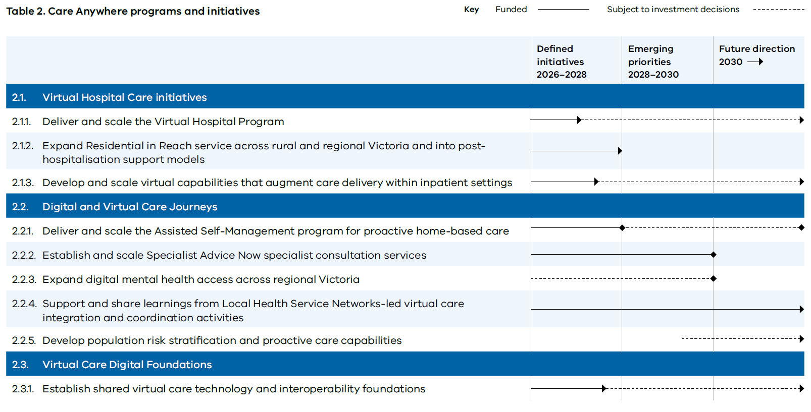
This table outlines the initiatives within the Care Anywhere pillar and their progression across three planning horizons:
- Defined initiatives (2026–2028): Initiatives that are sufficiently mature to support immediate planning, investment and delivery.
- Emerging priorities (2028–2030): Initiatives expected to expand or mature over the medium term.
- Future direction (2030 onwards): Longer-term areas of focus that support the roadmap vision.
Further detail about this table can be found in the appendix.

Care Anywhere in 2031
By 2031, care will no longer be defined by where it is delivered, but by what people need and when they need it. Victorians will be able to access acute, chronic, preventative and specialist care through a coordinated mix of in‑person, virtual, home‑based and community models that work together as part of a connected care journey.
Hospital-level care will increasingly be delivered beyond hospital walls. Digital and virtual care pathways will support people to manage health conditions more effectively, access specialist advice sooner and receive more coordinated support as their needs change.
Consumers will experience more personalised and convenient services, spending less time travelling, waiting, or navigating between providers. Clinicians will have greater visibility of consumer needs between encounters, supported by remote monitoring, virtual care coordination and connected information that enables timely intervention and continuity of care.
Across the health system, digitally enabled models will improve access, particularly for rural and regional communities, reduce avoidable hospital activity and create additional capacity within hospitals and community services. Care will increasingly be delivered through sustainable, scalable models that improve outcomes, enhance experience, and make better use of workforce and system resources.
Supported by shared digital foundations, interoperability and statewide platforms, virtual care will move beyond isolated pilots and local solutions to become a routine and integrated part of healthcare delivery, enabling safer, more responsive, and more equitable care for all Victorians.

Engaged Consumers
Goal | Consistent and trusted digital channels supporting people to access their health information, navigate services and actively participate in their care

From fragmented to connected experiences
Many Victorians struggle to access and understand their health information, navigate an increasingly complex health system and know what to do next. Information, guidance and services are often fragmented, reactive and inconsistent, making it difficult for people to take an active role in their care and contributing to unequal experiences and outcomes.
Engaged Consumers addresses this challenge by providing people with easier access to their health information, clearer guidance and more personalised support throughout their care journey. This pillar focuses on helping people understand their health, make informed decisions and navigate services with confidence, while ensuring digital interactions remain inclusive, culturally safe and trusted.
Consumer health portals, digital navigation tools, personalised communications and connected care experiences create more seamless interactions between people and the health system. Emerging capabilities, such as conversational and agentic AI, consumer-generated health data and personalised digital guidance, will increasingly enable people to access information, receive support and take action in ways that are more intuitive, responsive and tailored to their needs.
By combining trusted information, personalised guidance and connected digital experiences, Engaged Consumers creates the foundations for people to become more informed, confident and active participants in their own health and wellbeing.

Design principles

Co-design and lived experience
Solutions should be shaped with consumers, carers and communities, ensuring services, information and digital experiences reflect real needs, preferences and lived experience.

Cultural safety, equity and digital inclusion by design
Approaches must be culturally safe, inclusive and accessible, reducing barriers to participation and ensuring all Victorians can benefit, regardless of location, culture, language, health literacy or circumstance. Services should be designed to support consumers with varying levels of confidence and ability to access and use digital health tools.

Transparency, privacy and trust
Consumers must understand how information, recommendations and guidance are generated, have confidence that their information is protected, and retain appropriate control over how it is used and shared.

Human support remains essential
Digital capability should complement, not replace, trusted human interactions, providing the right balance of self-service, professional support and care coordination.

Programs of work

Informed Consumers
Objective | Improving consumers’ ability to access, understand and use their health information through digital tools to actively participate in their care
The Informed Consumers program of work improves people's ability to access, understand and use their health information, enabling them to become more active participants in their care. It focuses on creating a trusted and personalised digital experience through which consumers can access information, interact with health services and manage their health.
Over time, this will establish the foundation for an integrated consumer application that brings together health information, clinical services and digital interactions through a single, personalised entry point.
In Horizon 1, the focus is on strengthening the foundations for consumer access through expansion of local consumer portal capabilities, establishment of a statewide consumer portal foundation for mental health and wellbeing patient records, increased sharing of priority information through My Health Record and implementation of electronic prescribing across public health services.
Together, these initiatives provide consumers with greater access to information that has traditionally been difficult to access or fragmented across the system.
Across Horizons 2 and 3, the focus is on expanding integration and personalisation. Existing consumer portals, health information and digital health services are progressively brought together through a single consumer experience, reducing the need for people to navigate multiple applications and websites.
Over time, this evolves into an integrated application that facilitates consumer self-management, informed decision-making and active participation in care through personalised content and conversational assistance tailored to individual needs and circumstances.

Accessible Health System
Objective | Providing consumers with clear, trusted and consistent digital tools to navigate the health system, reducing complexity and uncertainty about where to go and what to do next
The Accessible Health System program of work provides consumers with clear, trusted and consistent digital tools to navigate the health system, reducing uncertainty about where to go, what to do next and how to access the services they need.
The program focuses on improving transparency and coordination across referrals, appointments, waitlists and assessments, while providing clearer pathways into care and supporting people to navigate increasingly complex health services with confidence.
In Horizon 1, the focus is on completing statewide implementation of VicKey’s core planned care capabilities, including referral management, specialist care workflows, waitlist management and digital health questionnaire management. Investment also supports implementation of a digital aged care assessment platform, and exploration of emerging digital navigation and triage capabilities that can help consumers identify the most appropriate care pathway and access services more easily.
Across Horizons 2 and 3, the focus shifts to expanding VicKey beyond core planned care workflows, introducing new capabilities that improve coordination across care pathways and provide greater visibility of referrals, appointments and waitlist information. Digital navigation, virtual assistant and triage capabilities become increasingly integrated with consumer portals, health information and service directories, helping people understand what to do next and connect with the right service more quickly.
Over time, consumers will experience a more transparent, navigable and responsive health system, supported by connected information, personalised guidance and coordinated digital services.
Table 3. Engaged Consumers programs and initiatives
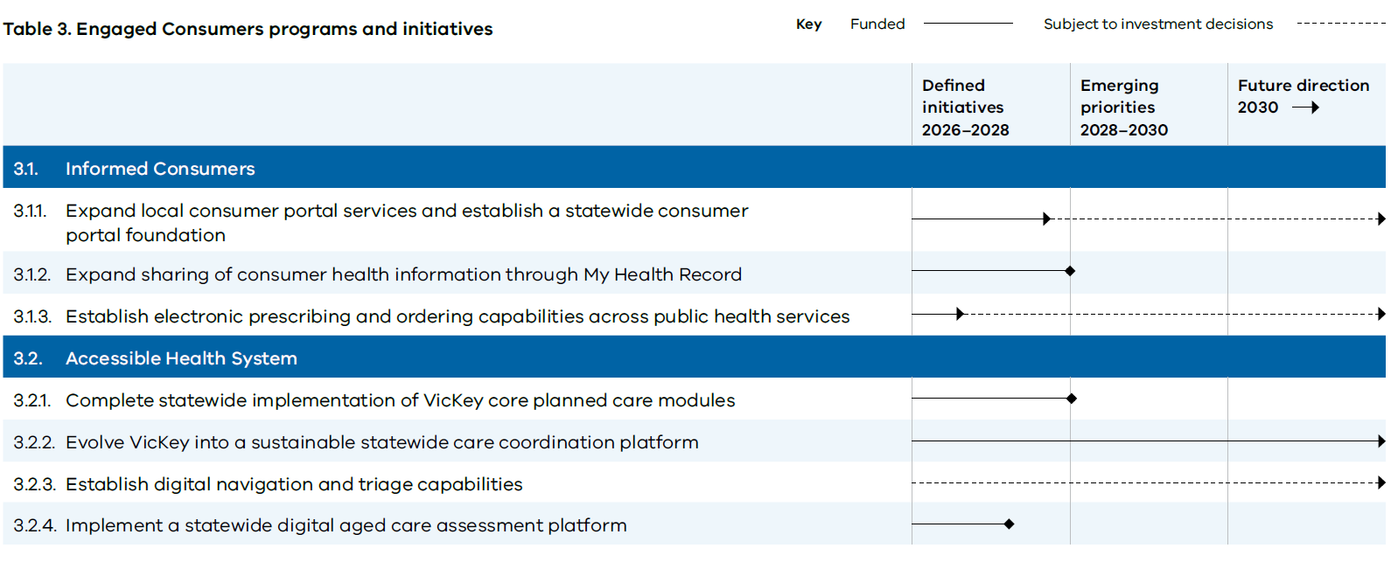This table outlines the initiatives within the Engaged Consumers pillar and their progression across three planning horizons:
- Defined initiatives (2026–2028): Initiatives that are sufficiently mature to support immediate planning, investment and delivery.
- Emerging priorities (2028–2030): Initiatives expected to expand or mature over the medium term.
- Future direction (2030 onwards): Longer-term areas of focus that support the roadmap vision.
Further detail about this table can be found in the appendix.

Engaged Consumers in 2031
By 2031, Victorians will have greater visibility, understanding and control of their health information and care journeys. Accessing health information, managing appointments, viewing test results, receiving prescriptions and navigating services will be simple, consistent and available through connected digital experiences that place consumers at the centre of care.
Consumers will no longer need to navigate complex health services on their own. A personalised consumer app, intelligent navigation services and trusted virtual assistants will help people understand their options, access the right services and know what to do next. Information, guidance and support will be tailored to individual needs, preferences and circumstances, enabling people to make more informed decisions and take a more active role in managing their health and wellbeing.
Across the health system, digital engagement will improve health literacy, strengthen self-management and reduce barriers to accessing care. Consumers will experience greater transparency, fewer administrative burdens and more connected interactions across services and care settings.
By combining trusted information, personalised support and connected digital experiences, Victoria will create a health system that is easier to navigate, more responsive to individual needs and better able to support people throughout their health and wellbeing journey.
Figure 13. Integrated, personalised consumer application
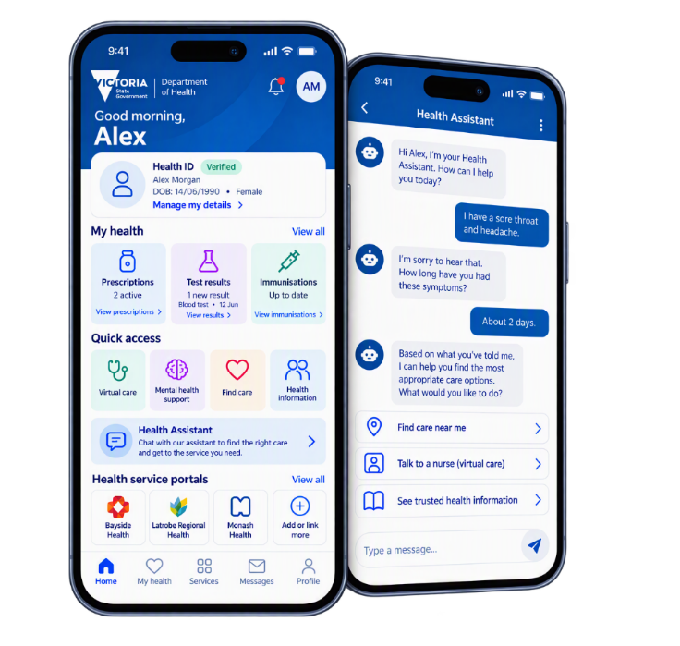

Sustainable Operations
Goal | Shared digital platforms, data, automation and secure systems enabling proactive, efficient, resilient and safe health system operations

From reactive to predictive and proactive
Victoria's health system faces growing demand, rising costs and increasing operational complexity. However, many operational decisions remain fragmented, retrospective, and reliant on data that is difficult to access, inconsistent across organisations or disconnected from day-to-day decision-making. At the same time, duplication of platforms and increasing cyber and resilience risks create inefficiencies and increase the cost of delivering care.
The Sustainable Operations program of work addresses this challenge by creating the digital capabilities required to proactively manage demand, capacity, performance, and risk across the health system. This pillar focuses on improving operational decision-making, enabling shared digital services, and strengthening the secure and resilient foundations required to support safe, reliable, and sustainable service delivery.
Advances in AI, automation and simulation will increasingly enable the health system to predict demand, identify risks earlier and optimise operations in real-time. Workflow automation and digital agents will reduce administrative burden, while intelligent operational platforms will support more proactive and responsive management of workforce, resources, and service delivery.
By combining decision intelligence, shared platforms and resilient digital foundations, Sustainable Operations creates the conditions for a more efficient, productive and adaptive health system that can respond to growing demand, while continuing to deliver high-quality care.

Design principles

Action and outcome-led intelligence
Data, analytics and decision-support capabilities should be designed around clear operational decisions, actions and accountabilities, enabling insight to translate into measurable improvements in performance, demand management and service delivery.

Shared where it adds value
Common platforms, services and capabilities should be adopted where they improve efficiency, consistency, resilience or scale, while allowing local flexibility where it supports operational effectiveness.

Standards enable local innovation
Shared data, interoperability and security standards should provide a consistent foundation that allows local solutions to be developed, integrated and scaled across the health system.

Automation with purpose
Automation should reduce manual effort, administrative burden and duplication, allowing the workforce to focus on higher-value activities and improving the efficiency of system operations.

Security and resilience by default
Digital services and operational capabilities must be designed to be secure, reliable and resilient, ensuring continuity of operations, protection of information and public trust.

Programs of work

Decision Intelligence
Objective | Strengthening how the system anticipates and responds to pressure on workforce, capacity and demand, so operational decisions are made earlier and more consistently
The Decision Intelligence program of work strengthens how the health system anticipates and responds to changing demand, capacity and risk, enabling operational and strategic decisions to be made earlier, more consistently and with greater confidence. It focuses on providing timely, actionable insight that supports planners, operational leaders and frontline teams to make better decisions at local, network and statewide levels.
In Horizon 1, the focus is on establishing the foundations for operational intelligence through demand forecasting, digital twin expansion, operational visibility and real-time decision support for priority areas such as emergency departments and theatres. Early implementation will demonstrate how better visibility, forecasting and governance can improve operational performance and support more proactive management of pressure across the system.
Across Horizons 2 and 3, the focus shifts to scaling and integrating these capabilities into routine system operations. Operational intelligence becomes increasingly connected across health services, Local Health Service Networks and statewide functions.
As digital twin capabilities mature, they evolve from modelling specific services and programs to supporting patient flow, capacity optimisation and whole-of-system modelling that informs policy development, investment planning and system-wide service redesign. This enables both system planners and operational leaders to test scenarios, understand the impact of policy and investment decisions, and proactively optimise capacity before pressure emerges.

Operational Efficiency
Objective | Establishing shared digital platforms and automated solutions that streamline workflows, reduce duplication and improve productivity across the health system
The Operational Efficiency program of work establishes shared digital capabilities, platforms and automation solutions that reduce duplication, improve consistency and enable workforce effort to be directed towards higher-value activities.
In Horizon 1, the focus is on establishing the foundations for shared services and automation through modernisation of priority corporate systems, implementation of a statewide identity and access management capability, and clinically governed automation for high-volume clinical administrative tasks. Early use cases include clinical documentation support, discharge summaries, translation services and clinical coding.
Alongside these initiatives, workflow automation will be expanded across administrative and operational processes such as AI-enabled clinical coding.
Across Horizons 2 and 3, the focus shifts to scaling proven capabilities and embedding automation into routine operations across the health system. Shared digital platforms, common identity services and workflow automation will increasingly support finance, workforce and operational processes, while clinically governed automation is expanded into additional use cases where it demonstrably improves efficiency, experience and quality.
As generative AI capabilities mature, the program will support safe and responsible adoption of AI-enabled solutions, navigating evolving clinical, legal and regulatory requirements, while ensuring that appropriate governance, oversight and human accountability remain in place.

Safer Digital Healthcare
Objective | Maintaining safe, secure and resilient digital and technology solutions, protecting consumers, clinicians and services from digital failures and disruptions that could compromise care delivery
The Safer Digital Healthcare program of work focuses on strengthening cyber resilience, modernising critical infrastructure and reducing technology risks that could impact the availability, reliability or safety of digital health services.
In Horizon 1, the focus is on strengthening statewide cyber capability and governance, improving sector-wide visibility of cyber risk, and modernising critical hosting environments through the migration of key Health Technology Services platforms from legacy data centres to contemporary cloud and hosting solutions.
The program also establishes the foundations for long-term infrastructure renewal by identifying and prioritising high-risk legacy systems, unsupported technologies and any areas of vulnerability across the health sector.
Across Horizons 2 and 3, the focus shifts to embedding resilience at scale through expanded adoption of modern cyber platforms, shared security services and coordinated statewide cyber operations. Legacy infrastructure is progressively modernised; technology risks are reduced through sustainable lifecycle management and common security capabilities become increasingly standardised across the sector.
As emerging technologies such as AI become more deeply embedded in healthcare delivery, cyber and resilience capabilities will continue to evolve to address new threats, strengthen trust and ensure critical digital services remain reliable and available when they are needed most.

Table 4. Sustainable Operations programs and initiatives
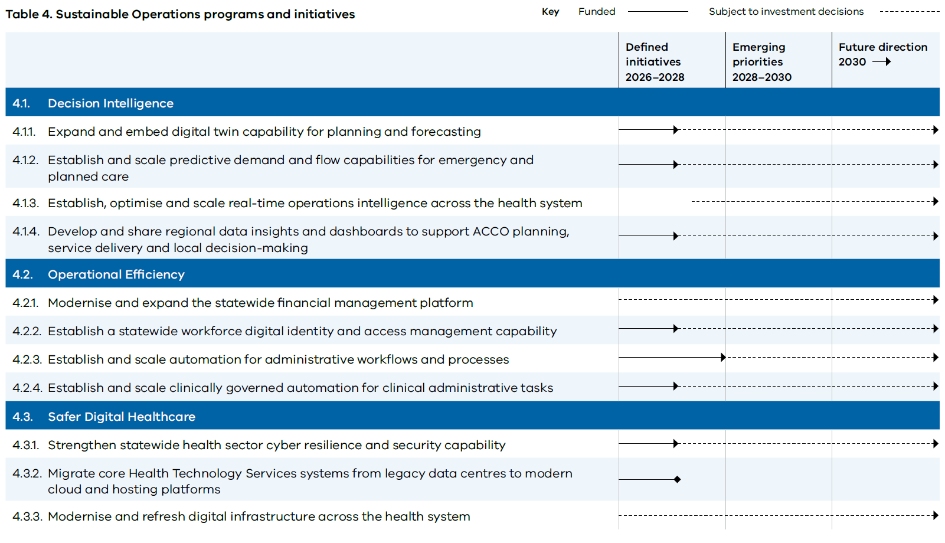
This table outlines the initiatives within the Sustainable Operations pillar and their progression across three planning horizons:
- Defined initiatives (2026–2028): Initiatives that are sufficiently mature to support immediate planning, investment and delivery.
- Emerging priorities (2028–2030): Initiatives expected to expand or mature over the medium term.
- Future direction (2030 onwards): Longer-term areas of focus that support the roadmap vision.
Further details about this table can be found in the appendix.

Sustainable Operations in 2031
By 2031, Victoria's health system will operate with greater visibility, coordination and intelligence. Operational leaders will have access to real-time information, predictive insights and decision-support capabilities that enable demand, capacity and risk to be identified earlier and managed more proactively.
Routine administrative and operational processes will be increasingly streamlined through shared platforms, automation and AI. Clinicians and staff will spend less time on repetitive tasks, manual reporting and administrative processes, allowing more time to be directed towards providing care, service delivery and higher-value activities. Generative and agentic AI and automation will be safely embedded into workflows where they improve productivity, quality and experience, supported by appropriate governance, oversight and human accountability.
Across the health system, decision intelligence capabilities will support more effective planning, workforce management and resource allocation. Digital twins, predictive analytics and operational intelligence will enable health services and government to model future demand, test scenarios and optimise capacity before pressures emerge. Decisions will increasingly be informed by real-time and predictive insights, rather than retrospective reporting.
Modern, secure and resilient digital infrastructure will underpin these capabilities, reducing technology risk and improving the reliability of critical systems. Shared digital services, common identity and access management capabilities, and coordinated cybersecurity approaches will strengthen resilience, while reducing duplication across the sector.
Together, these capabilities will support a more productive, adaptive and financially sustainable health system that is better equipped to manage growing demand, respond to emerging risks and continue delivering high-quality care for Victorians.

Accelerators
The four pillars of the roadmap are supported by three cross-cutting accelerators that create the conditions for successful delivery. These accelerators are not standalone programs of work; they are capabilities that must be embedded across all initiatives to ensure digital investments are adopted and scaled, delivering sustainable value for consumers, clinicians and the health system.
Each accelerator is supported by a foundational initiative that provides a shared capability for the Victorian health system. These foundational initiatives are intended to create common assets that can be leveraged across multiple programs and organisations, accelerating delivery, reducing duplication and enabling more consistent outcomes at scale.
Figure 14. Roadmap accelerators
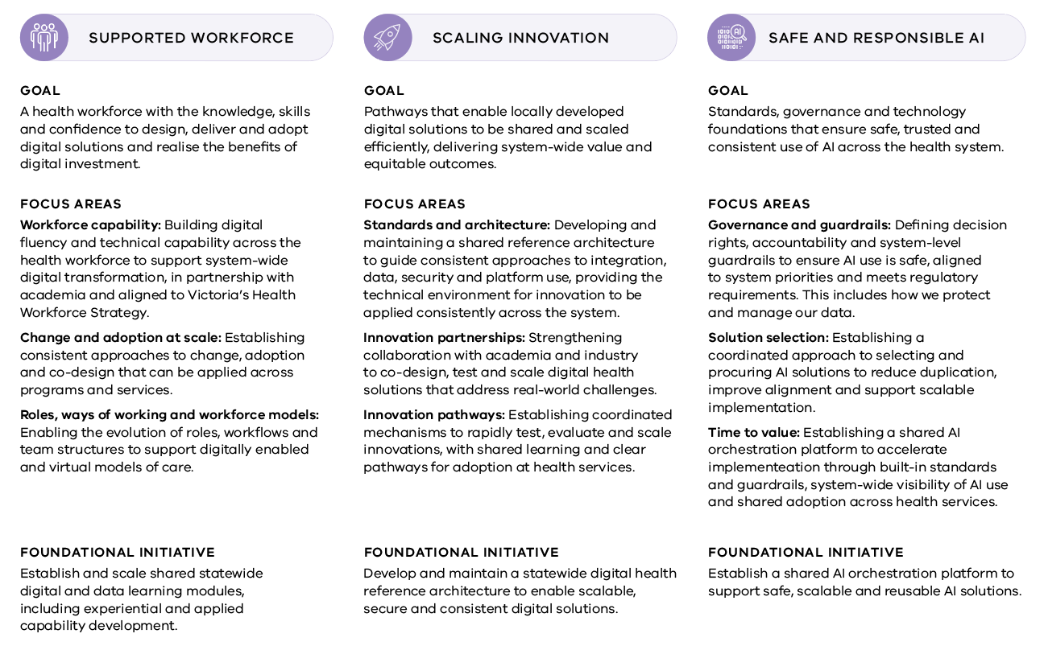

Measuring success
The roadmap is intended to deliver meaningful improvements for consumers, the workforce and the health system. Measuring progress is therefore critical to ensuring investment remains focused on initiatives that deliver tangible value and contribute to the long-term vision for digital health in Victoria.
Success will be assessed through two complementary lenses. The Victorian Digital Health Maturity Model will measure the extent to which the foundations required for transformation are being established across the health system.
These foundations include:
- governance
- workforce capability
- information technology operations
- clinical systems
- interoperability and information sharing
- data, analytics and AI
- virtual care and consumer engagement
- benefits realisation
- innovation.
Improvements in digital maturity provide an indication of the system's readiness to adopt and scale new digital capabilities. However, digital maturity alone is not the objective. The ultimate measure of success is whether digital investment is translating into improved outcomes for Victorians.
Progress will therefore be assessed against the roadmap's five priority outcomes of Healthy Victorians, Integrated Care Journeys, Equitable Health Outcomes, High Performing Health System and Supported Workforce. Each outcome is supported by a set of benefits categories that describe where value is expected to be realised and provide a consistent basis for monitoring progress over time.
Benefits will be defined, measured and managed at the initiative level, with accountability for benefits realisation sitting alongside delivery. Through the roadmap's governance framework, benefits will be monitored and aggregated across programs and pillars, providing visibility of progress towards the roadmap's five priority outcomes. This approach enables performance, outcomes and value to be assessed consistently across the portfolio, supporting evidence-based decision-making, prioritisation and future investment planning.

Figure 15. Benefit categories aligned to priority outcomes
Priority Outcome | Benefit Category | Description | Example Measure
Healthy Victorians | Health outcomes | Improved health outcomes through safer, higher quality and more effective care | Morbidity and mortality rate
Healthy Victorians | Prevention and early intervention | Earlier identification of risk and intervention to prevent deterioration and improve outcomes | Rate of preventable ED admissions
Healthy Victorians | Consumer engagement and experience | Improved experience for consumers across all care settings | Net promoter score
Integrated Care Journeys | Care access and navigation | Improved access to timely, appropriate and convenient healthcare | Time from referral to appointment
Integrated Care Journeys | Care coordination | Improved coordination of care across all services and settings | Rate of adverse events post care transfer
Integrated Care Journeys | Connected information | Improved availability and flow of health information across services and settings | Electronic medical record coverage
Equitable Health Outcomes | Equity in access and outcomes | Improved equity in access to care, services and health outcomes across population groups and geographic locations | Average distance travelled to receive care
Equitable Health Outcomes | Variation in care | Reduced unwarranted variation in care delivery | Rate of low value care
Equitable Health Outcomes | Trusted data and insight | Improved availability of trusted data and insights to support equitable and evidence-based decision-making | Data quality and completeness
High Performing Health System | Service efficiency | Improved efficiency of care delivery across all care modalities (in-person/virtual) | Average length of stay
High Performing Health System | Resource utilisation | More effective use of available resources to improve capacity, efficiency and service delivery | Same-day discharge rate
High Performing Health System | Financial sustainability | Improved financial sustainability through reduced avoidable costs and better use of resources | Average cost per episode of care
Supported Workforce | Productivity | Improved workforce productivity and capacity | Time taken to complete administrative workflows
Supported Workforce | Experience | Improved workforce engagement and satisfaction | Staff satisfaction scores
Supported Workforce | Digital Capability | Improved workforce digital fluency and capability | Digital training completion rate and satisfaction
Together, the maturity model and outcomes framework provide a balanced view of capability uplift, benefits realisation and overall system transformation, informing investment decisions, roadmap refreshes and continuous improvement.

Embedding the roadmap
Delivering the roadmap will require sustained collaboration across government, healthcare providers, clinicians, consumers and delivery partners. While the roadmap provides direction for digital transformation, successful implementation depends on aligned governance, shared accountability, ongoing investment and a commitment to continuous improvement.
Digital health in Victoria is delivered within a complex ecosystem where responsibility is shared across national, state and local levels.
National bodies establish policy, standards, interoperability frameworks and shared platforms. The State (through the department) provides system stewardship, statewide strategy, investment, governance and shared digital capabilities. Healthcare services are responsible for the implementation, adoption and integration of digital capability into service delivery.
Together, these layers create a coordinated model for delivery that balances statewide consistency with local flexibility and innovation.
Figure 16. Delineation of roles across national, state and the sector
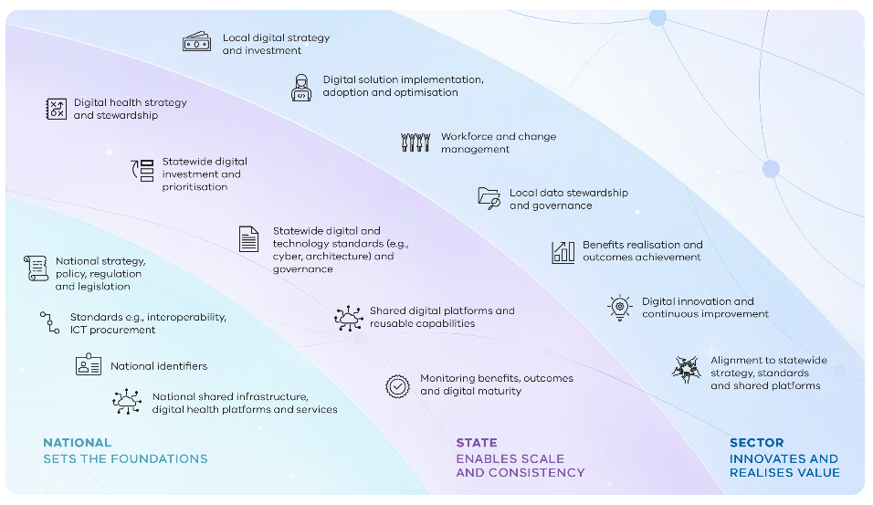

Governance
A structured governance framework will support delivery of the roadmap and ensure investment remains aligned to health system priorities. The framework establishes clear lines of accountability from strategic pillars through to programs of work and individual initiatives.
Governance forums will provide oversight of delivery, investment, risks, dependencies and performance across the roadmap, while supporting coordination between national, state and local stakeholders. They will monitor progress against the roadmap's priority outcomes, digital maturity and benefits realisation, providing a consistent basis for decision-making and portfolio management.
Governance arrangements will provide a framework for First Peoples participation, with clear principles to guide when consultation, partnership or governance involvement is appropriate, including for matters relating to Indigenous data governance and data sharing.
Recognising that technology, service models and system priorities will continue to evolve, governance arrangements will also support an annual roadmap review cycle. This process will assess progress, outcomes and realised benefits, identify emerging opportunities and risks, and inform adjustments to priorities, sequencing and investment pathways. This ensures the roadmap remains responsive to changing circumstances, while maintaining a clear long-term direction.
Figure 17. Governance framework supporting delivery of the roadmap
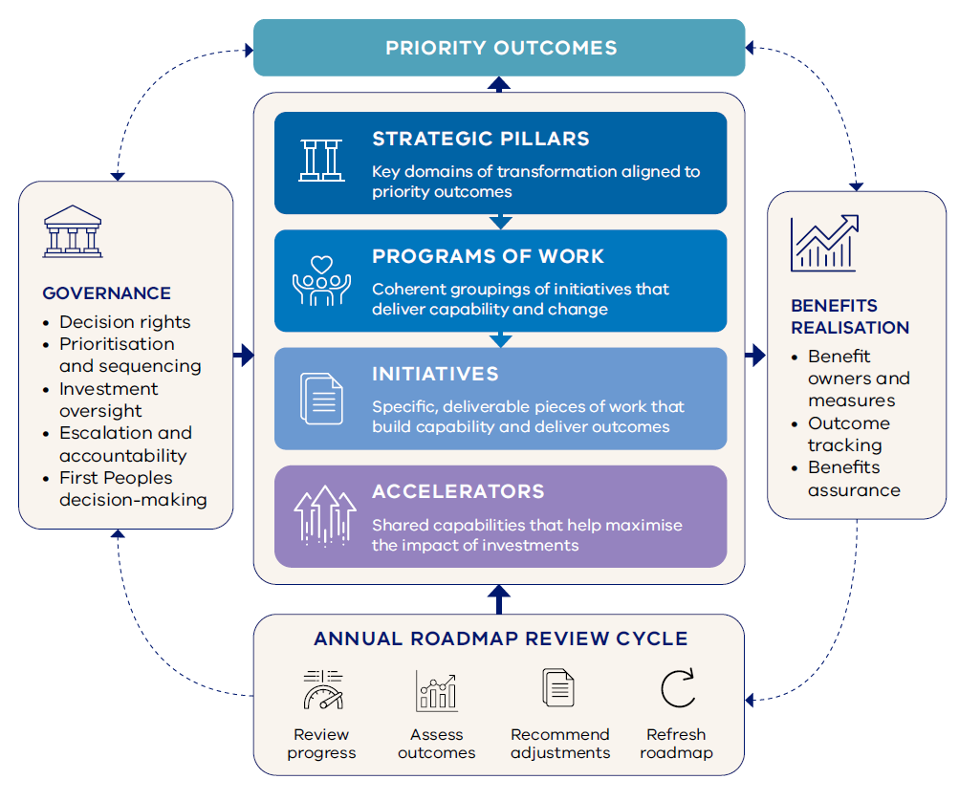

Glossary
Term | Meaning
AI | Artificial intelligence – computer-based systems that use data to generate outputs such as predictions, recommendations, content or decisions. AI is increasingly used in healthcare to support improvements in quality of care, consumer and workforce experience, and health system efficiency.
ACCOs | Aboriginal Community Controlled Organisations
CareSync Exchange | Victoria's statewide health information sharing platform, enabling authorised public healthcare providers to securely access and exchange patient information across participating health services.
Consumer-generated health data | Health-related information created, recorded or gathered by consumers outside traditional healthcare settings, including data from wearable devices, remote monitoring technologies and health applications.
Consumer portal | A secure digital platform that enables consumers to access health information and interact with healthcare providers and services. Patient portals can support access to records, appointments, test results, care plans, communications and other digital health services.
Digital health | The use of digital technologies, data and information to improve health outcomes, healthcare delivery, consumer and workforce experience, and health system performance.
Digital twin | A digital representation of a service, system or process that can be used to monitor performance, model scenarios, forecast demand and test potential changes before they are implemented in the real world.
EMR | Electronic medical records – an integrated clinical information system that contains patient-centric, electronically maintained information about an individual’s health status and care.
eReferral | Electronic referral – the secure electronic exchange of referral information between healthcare providers and services. eReferrals support more efficient referral management, improved visibility of referral status and better coordination of care.
Federated data | A data architecture that enables information to remain under local stewardship while supporting secure access, analysis and use across organisations. Federated approaches allow shared intelligence and system-wide coordination to be achieved without centralising all data into a single repository.
Genomics | The study of a person's genes (genome) and how genetic variation influences health, disease, treatment response and health outcomes. In healthcare, genomics supports more precise approaches to prevention, diagnosis, treatment and disease management by enabling care to be tailored to an individual's genetic characteristics.
Health service | An organisation that delivers publicly funded health and wellbeing services to Victorians, including hospitals, Local Health Service Networks, preventative health services, community health services, specialist services, mental health services, residential aged care services and other publicly funded providers across Victoria.
Health system | The interconnected organisations, services, workforce, infrastructure and functions that work together to improve, maintain and protect the health and wellbeing of Victorians. This includes healthcare delivery, public health, prevention, health promotion, mental health, aged care, and the policy, planning and stewardship activities that support them.
Indigenous Data Governance | The right of Indigenous peoples to autonomously decide what, how and why Indigenous Data are collected, accessed and used. It ensures that data on or about Indigenous peoples reflects our priorities, values, cultures, worldviews and diversity.
Indigenous Data Sovereignty²⁵ | The right of Indigenous peoples to exercise ownership over Indigenous Data. Ownership of data can be expressed through the creation, collection, access, analysis, interpretation, management, dissemination and reuse of Indigenous Data.
Interoperability | The ability of different digital systems, applications and organisations to securely exchange, interpret and use information in a consistent and meaningful way.
Local Health Service Network | A collaborative network of health services within a defined region that work together to improve coordination, planning and delivery of healthcare services.
My Health Record | Australia’s national digital health record system, which enables individuals and their authorised healthcare providers to securely access and share key health information.
the department | Department of Health (Victoria)
the roadmap | Victoria’s digital health vision and roadmap 2026–31 (this document)
Victorian Aboriginal Community Controlled Health Organisation | The peak body for Aboriginal Community Controlled Health Organisations in Victoria, providing leadership, advocacy and support to improve the health, wellbeing and self-determination of Aboriginal and Torres Strait Islander peoples.
VicKey | A secure digital platform used by Victorian public health services to support patient communication, referral management, waitlist management and care coordination for surgical and specialist services.
Virtual care | The delivery of healthcare services using digital technologies that enable care to be provided without requiring an in-person interaction. Virtual care includes services delivered by telephone, video, remote monitoring, secure messaging and other digital channels, supporting access to care, continuity of care and care delivery closer to home.

Appendix A. Accessible text equivalents

Figure 1. Victoria's digital health vision and roadmap 2026–31
Figure 1 provides an overview of Victoria’s digital health vision and roadmap 2026–31. Five priority outcomes are presented across the top of the figure. Beneath them are four strategic pillars, each with a goal and supporting programs of work. The pillars collectively contribute to the five priority outcomes. Three cross-cutting accelerators form a foundation across all four pillars: Workforce Enablement, Scaling Innovation, and Safe and Responsible AI.
The four strategic pillars collectively contribute to all five priority outcomes. The diagram does not show a one-to-one relationship between individual outcomes and pillars.
Roadmap component | Content shown in the diagram
Strategic pillar 1: Connecting Health | Goal: Seamless, secure and interoperable digital health infrastructure with real-time access to consumer health information across the system.  Programs of work: 1.1 Digitised Clinical Records; 1.2 Seamless Health Information Sharing; 1.3 Trusted Data Foundations.
Strategic pillar 2: Care Anywhere | Goal: Digital and virtual models of care delivering high-quality care in the home, community or most appropriate clinical setting.  Programs of work: 2.1 Virtual Hospital Care; 2.2 Digital and Virtual Care Journeys; 2.3 Virtual Care Digital Foundations.
Strategic pillar 3: Engaged Consumers | Goal: Consistent and trusted digital channels supporting people to access their health information, navigate services and actively participate in their care.  Programs of work: 3.1 Informed Consumers; 3.2 Accessible Health System.
Strategic pillar 4: Sustainable Operations | Goal: Shared digital platforms, data, automation and secure systems enabling proactive, efficient, resilient and safe health system operations.  Programs of work: 4.1 Decision Intelligence; 4.2 Operational Efficiency; 4.3 Safer Digital Healthcare.
Cross-cutting accelerator: Workforce Enablement | Applies across all four strategic pillars.
Cross-cutting accelerator: Scaling Innovation | Applies across all four strategic pillars.
Cross-cutting accelerator: Safe and Responsible AI | Applies across all four strategic pillars.

Figure 2. Priority outcomes for digital health in Victoria that underpin the roadmap
Figure 2 presents five related priority outcomes. Together, they describe the intended consumer, workforce and system benefits of digital investment.

Priority outcome | Description
Healthy Victorians | People have access to the digital tools and information required to maintain their health and wellbeing on their own terms.
Integrated Care Journeys | A health system where information flows, services connect and consumers experience seamless care across their health and wellbeing journey.
Equitable Health Outcomes | High-quality data and insights support evidence-based decisions for individuals and populations.
High Performing Health System | Digital capability streamlines operations, optimises resource use and enhances service delivery.
Supported Workforce | A workforce with the right digital tools to allow them to focus on what matters most.

Figure 3. Impacts of limited digitisation and integration
The infographic highlights four examples of how limited digitisation and integration affect care delivery, workforce productivity and health system performance across Victoria.

Impact | Description
Limited access to digitised clinical information | 50% of health services do not have an Electronic Medical Record (EMR) and continue to rely on paper-based records to document clinical care. This limits the ability to deliver safe, consistent and high-quality care.
Duplicate testing and investigations | Approximately 15% of patients undergo duplicate diagnostic tests because results are not readily available. This can lead to unnecessary costs, delays in care and avoidable radiation exposure.
Lost clinical time | Approximately 74% of healthcare workers have lost clinical time due to incomplete or inaccessible patient information. This is equivalent to more than 45 minutes per shift, or around 23 days per healthcare worker each year.
Manual referral processes | Up to 90% of health service referrals are still received by non-electronic methods such as fax or email. This can result in lost, delayed or incomplete referrals, leading to missed appointments, delayed treatment and patient safety risks.

Figure 4. Example benefits of digital investment in healthcare
The infographic presents three reported examples of measurable benefits associated with digital health investment. The results relate to the specific healthcare settings and interventions examined in the cited sources and should not be interpreted as applying universally.
Benefit | Digital intervention
28% reduction in 90-day readmissions | Use of electronic medical record interventions
22% reduction in emergency department length of stay | Implementation of an electronic medical record
11 hours each week could be saved for every healthcare worker | Automation of everyday tasks using digital technology

Figure 5. The rate of chronic disease in Australia
Figure 5 presents two statistics on the prevalence of chronic disease in Australia.
Proportion of Australians | Chronic disease prevalence
61% | Living with at least one long-term health condition
38% | Living with two or more chronic conditions

Figure 6. Healthcare consumers are open to AI being used to support care access and navigation
Figure 6 presents two findings about consumers’ comfort with the use of AI for healthcare access and navigation.
Proportion of consumers | Use of AI
85% | Comfortable or very comfortable with AI scheduling their health appointments and sending reminders
70% | Comfortable or very comfortable with AI providing simple responses to frequently asked questions about their health or services that may be available

Figure 7. Advances in technology are enabling continuous patient monitoring
Figure 7 presents AusculPatch as an example of an experimental wearable technology that may enable continuous patient monitoring, rather than a capability already in routine use.
Feature | Description
Technology | AusculPatch, an experimental wearable sensor developed by researchers at UNSW
Monitoring capability | Continuously captures heart sounds, breathing patterns, pulse waves and blood flow vibrations
Size and function | Weighs 3.2 grams and acts as a wearable digital stethoscope
Potential benefit | Could help people with chronic heart and respiratory conditions monitor their health remotely and alert clinicians when something may be wrong before symptoms become severe

Figure 8. New large language models for disease management
Figure 8 presents AMIE as an example of a research-stage conversational AI system evaluated for supporting disease management.
Feature | Description
Technology | AMIE, a research-stage conversational AI system for healthcare
Study context | Evaluated in a recent study using simulated clinical assessments
Demonstrated capabilities | Tracked disease progress, adapted care plans and recommended appropriate follow-up actions over time
Development status | Remains in the research phase
Potential benefit | Could, with appropriate oversight and governance, support routine care coordination activities alongside clinicians

Figure 9. Federated health data network enabled by the European Health Data Space
Figure 9 presents the European Health Data Space as an example of a federated health data network. It supports the primary use of health data for healthcare delivery. It also supports the secondary use of health data for purposes such as research, innovation, policy and system planning. Appropriate local stewardship and control are maintained.
Feature | Description
Approach | Federated health data networks across organisations and countries
Primary use of health data | Health data can be accessed and used to support the delivery and continuity of healthcare for individuals
Secondary use of health data | Health data can be accessed and analysed for approved purposes such as research, innovation, policy development and health system planning
Local control | Data remains under local stewardship rather than moving into a single repository
Enabling capabilities | Common standards and interoperability frameworks allow data to remain close to where it was created
Potential benefits | System-wide intelligence, coordinated decision-making, stronger privacy protections and local control of sensitive information

Figure 10. Findings from the clinician and consumer surveys
Figure 10 summarises findings from consumer and clinician surveys undertaken during development of the roadmap.
Survey group | Proportion | Finding
Consumers (n=519) | 45% | Want a new healthcare provider to know about their ongoing health conditions after hospital care
Consumers (n=519) | 78% | Were somewhat or very confident in using digital tools
Consumers (n=519) | More likely | Consumers with long-term conditions and caring responsibilities were approximately twice as likely to experience challenges navigating care
Clinicians (n=1,341) | 57% | Reported that information was not available when needed, frequently limiting their ability to deliver safe, timely and coordinated care
Clinicians (n=1,341) | 55% | Reported that reducing administrative tasks and duplication would make the biggest difference in day-to-day practice
Clinicians (n=1,341) | 54% | Reported that safer clinical decisions improve most when care is well supported by digital information and solutions

Figure 11. Specialist Care Reform Blueprint – pillars of change
Figure 11 presents the three pillars of change in the Specialist Care Reform Blueprint. Eight example digital capabilities are shown as collectively enabling reform across the pillars. The diagram does not assign individual capabilities to a single pillar.

Category | Content shown in the diagram
Pillars of change | Responsive and high-value care; Efficient and integrated services; Strengthened stewardship
Example enabling digital capabilities | Electronic Medical Records; Medical Image Sharing; eReferrals; ePrescribing; Performance and Capacity Insights; Consumer Portal; Digital Patient Navigation; Digital Twin

Figure 12. Target state architecture for Victoria's connected health system
Figure 12 presents the target state architecture for Victoria’s connected health system. Read from top to bottom, people access digital experiences that are supported by three technology capabilities and common enabling foundations. These capabilities connect to systems of record and external systems and data sources. Information can flow through these connected layers to support digital experiences and informed decision-making.

Architecture layer | Content shown in the diagram
People | Consumers and carers; Healthcare workers; Administrators; Researchers and academics; Government
Experiences | Dashboards; Notifications; Digital Front Door; Applications; Portals; Medical devices
Technology | CareSync Exchange; Connected Health Data Platform; Digital Health Marketplace
Common enabling foundations | Unique patient identification; Standards-based integration and orchestration; Privacy enhancing technologies; Security controls
Systems of record | Electronic medical record (EMR) and patient administration system (PAS); Mental Health; VicKey; Virtual care; Referral systems; Imaging and laboratory systems; Patient monitors and devices
External systems and data sources | My Health Record; National directories and services; Clinical registries; Primary and private care providers; Consumer-generated information; Other data, including weather, social and media data

Figure 13. Integrated, personalised consumer application
Figure 13 illustrates a future concept for an integrated, personalised consumer application, rather than an existing application. The screen displays personal and health information. It also shows functions available to the consumer, including access to services, portals and action options. A separate illustrative conversational exchange demonstrates how a health assistant could help a consumer describe symptoms and identify a possible next step.

Application area | Content shown in the diagram
Personal profile | Consumer name, verified health ID, date of birth, sex and access to manage personal details
My health | Upcoming appointments, including a GP video consultation; active prescriptions and next refill information; new test results
Quick access | Virtual care; Mental health support; Allied health; Prescriptions; Immunisations; Find care
Health Assistant | Access to an assistant that can help the consumer understand symptoms and identify appropriate care
Health service portals | Access to linked health service portals through the application, with an option to add or link another portal
Conversational support | A chat-based interaction in which the consumer describes symptoms, provides further information and receives guidance on a possible next step
Action options | The consumer can choose to book an appointment or view other care options

Figure 14. Roadmap accelerators
Figure 14 presents three cross-cutting roadmap accelerators. Each accelerator includes a purpose, three focus areas and one foundational initiative.

Workforce Enablement
Purpose | A health workforce with the knowledge, skills and confidence to design, deliver and adopt digital solutions and realise the benefits of digital investment.
Focus areas | Workforce capability: Building digital fluency and technical capability across the health workforce to support system-wide digital transformation, in partnership with academia and aligned to Victoria’s Health Workforce Strategy.  Change and adoption at scale: Establishing consistent approaches to change, adoption and co-design that can be applied across programs and services.  Roles, ways of working and workforce models: Enabling the evolution of roles, workflows and team structures to support digitally enabled and virtual models of care.
Foundational initiative | Establish and scale shared statewide digital and data learning modules, including experiential and applied capability development.

Scaling Innovation
Purpose | Pathways that enable locally developed digital solutions to be shared and scaled efficiently, delivering system-wide value and equitable outcomes.
Focus areas | Standards and architecture: Developing and maintaining a shared reference architecture to guide consistent approaches to integration, data, security and platform use, providing the technical environment for innovation to be applied consistently across the system.  Innovation partnerships: Strengthening collaboration with academia and industry to co-design, test and scale digital health solutions that address real-world challenges.  Innovation pathways: Establishing coordinated mechanisms to rapidly test, evaluate and scale innovations, with shared learning and clear pathways for adoption at health services.
Foundational initiative | Develop and maintain a statewide digital health reference architecture to enable scalable, secure and consistent digital solutions.

Safe and Responsible AI
Purpose | Standards, governance and technology foundations that ensure safe, trusted and consistent use of AI across the health system.
Focus areas | Governance and guardrails: Defining decision rights, accountability and system-level guardrails to ensure AI use is safe, aligned to system priorities and meets regulatory requirements. This includes how data is protected and managed.  Solution selection: Establishing a coordinated approach to selecting and procuring AI solutions across health services to reduce duplication, improve alignment and support scalable implementation.  Time to value: Establishing a shared AI orchestration platform to support faster and more consistent implementation through automated application of standards and guardrails, system-wide visibility of AI use and improved sharing across health services.
Foundational initiative | Establish a shared AI orchestration platform to support safe, scalable and reusable AI solutions.

Figure 15. Benefit categories aligned to priority outcomes
Figure 15 is presented in accessible table format within the main body of the document under Measuring success. No additional information is conveyed by the original figure.

Figure 16. Delineation of roles across national, state and the sector
Figure 16 shows a three-level hierarchy of responsibility across national, state and sector levels. National bodies establish the policy, regulatory, standards and shared infrastructure foundations. The state translates these foundations into statewide strategy, investment priorities, governance, standards and shared capabilities. Healthcare providers and Local Health Service Networks implement, adopt and optimise digital capability in service delivery. Accountability flows through alignment with national and statewide requirements, while information about delivery, benefits, outcomes and digital maturity informs state and national oversight and future priorities.

Level | Role | Responsibilities shown in the diagram
National | Sets the foundations | National strategy, policy, regulation and legislation; standards, including interoperability and ICT procurement; national identifiers; national shared infrastructure, digital health platforms and services
State | Enables scale and consistency | Digital health strategy and stewardship; statewide digital investment and prioritisation; statewide digital and technology standards, including cyber and architecture, and governance; shared digital platforms and reusable capabilities; monitoring benefits, outcomes and digital maturity
Sector | Innovates and realises value | Local digital strategy and investment; digital solution implementation, adoption and optimisation; workforce and change management; local data stewardship and governance; benefits realisation and outcomes achievement; digital innovation and continuous improvement; alignment to statewide strategy, standards and shared platforms

Figure 17. Governance framework supporting delivery of the roadmap
Figure 17 presents the governance hierarchy supporting delivery of the Digital Health Roadmap. The roadmap’s priority outcomes provide the strategic direction for the pillars, programs of work, initiatives and cross-cutting accelerators. Delivery information, risks, dependencies, performance and benefits are reported through governance forums for oversight and decision-making. Accountability extends from individual initiatives through programs and pillars to roadmap-level governance. The annual review cycle uses evidence about progress, outcomes, digital maturity and benefits realisation to recommend adjustments to priorities, sequencing and investment, refreshing the roadmap where required.

Component | Content shown in the diagram
Priority outcomes | Provide the overarching outcomes that guide roadmap delivery and are informed by governance, benefits realisation and the annual review cycle.
Digital Health Roadmap | Strategic pillars: Key domains of transformation aligned to priority outcomes.
Digital Health Roadmap | Programs of work: Coherent groupings of initiatives that deliver capability and change.
Digital Health Roadmap | Initiatives: Specific, deliverable pieces of work that build capability and deliver outcomes.
Digital Health Roadmap | Accelerators: Shared capabilities that help maximise the impact of investments.
Governance | Decision rights; prioritisation and sequencing; investment oversight; escalation and accountability; First Peoples decision-making.
Benefits realisation | Benefit owners and measures; outcome tracking; benefits assurance.
Annual roadmap review cycle | Review progress; assess outcomes; recommend adjustments; refresh roadmap.
Continuous feedback | Governance and benefits realisation inform roadmap delivery. The annual review cycle considers progress and outcomes. It recommends adjustments, refreshes the roadmap and maintains alignment with the priority outcomes.

Table 1. Connecting health programs and initiatives
Table 1 presents 14 initiatives grouped under three Connecting Health programs of work: 1.1 Digitised Clinical Records, 1.2 Seamless Health Information Sharing and 1.3 Trusted Data Foundations. Each initiative is mapped across three planning horizons: Defined initiatives (2026–2028), Emerging priorities (2028–2030) and Future direction (2030 onwards). Funding status is shown as either funded or subject to investment decisions. Initiatives progress through the planning horizons in different ways: some span all three horizons, some conclude during the Emerging priorities horizon, some are limited to Defined initiatives, and the Digital Health Marketplace (1.3.2) commences in the Future direction horizon. The following table provides the planning horizon and investment status for each initiative.

Program | Initiative | Planning horizon | Investment status
1.1 Digitised Clinical Records | 1.1.1 Implement, expand and optimise EMR solutions | Defined initiatives 2026–2028; emerging priorities 2028–2030; future direction 2030 onwards | Subject to investment decisions across all three horizons
1.1 Digitised Clinical Records | 1.1.2 Transition legacy patient administration systems to contemporary solutions | Defined initiatives 2026–2028; emerging priorities 2028–2030; future direction 2030 onwards | Subject to investment decisions across all three horizons
1.1 Digitised Clinical Records | 1.1.3 Establish a shared statewide mental health and wellbeing record | Emerging priorities 2028–2030 | Funded in 2026–2028; subject to investment decisions from 2028 onwards
1.2 Seamless Health Information Sharing | 1.2.1 Expand statewide access to connected clinical information through CareSync Exchange | Defined initiatives 2026–2028 | Funded
1.2 Seamless Health Information Sharing | 1.2.2 Expand adoption of National Healthcare Identifiers | Defined initiatives 2026–2028; emerging priorities 2028–2030 | Subject to investment decisions
1.2 Seamless Health Information Sharing | 1.2.3 Expand digital referral and referral management capability | Defined initiatives 2026–2028; emerging priorities 2028–2030 | Subject to investment decisions
1.2 Seamless Health Information Sharing | 1.2.4 Implement Program Wominjeka client and data management capability across ACCOs | Defined initiatives 2026–2028; emerging priorities 2028–2030; future direction 2030 onwards | Funded in 2026–2028; subject to investment decisions from 2028 onwards
1.3 Trusted Data Foundations | 1.3.1. Establish a statewide health data platform – Connected Health Data Platform | Defined initiatives 2026–2028; emerging priorities 2028–2030; future direction 2030 onwards | Subject to investment decisions across all three horizons
1.3 Trusted Data Foundations | 1.3.2 Establish a digital health marketplace for health services to evaluate, adopt and scale interoperable digital solutions | Future direction 2030 onwards | Subject to investment decisions
1.3 Trusted Data Foundations | 1.3.3 Modernise statewide mandatory reporting requirements and capabilities | Defined initiatives 2026–2028; emerging priorities 2028–2030 | Subject to investment decisions
1.3 Trusted Data Foundations | 1.3.4 Establish a digital platform to support the statewide medicines formulary | Defined initiatives 2026–2028; emerging priorities 2028–2030 | Funded
1.3 Trusted Data Foundations | 1.3.5 Transform Victorian clinical costing data through increased standardisation | Defined initiatives 2026–2028; emerging priorities 2028–2030 | Subject to investment decisions
1.3 Trusted Data Foundations | 1.3.6 Transition legacy genomics solutions to a statewide genomics platform | Defined initiatives 2026–2028 | Funded
1.3 Trusted Data Foundations | 1.3.7 Establish and embed Indigenous data sovereignty and governance across Victoria’s health system, aligned to the National Indigenous Australians Agency framework | Defined initiatives 2026–2028; emerging priorities 2028–2030; future direction 2030 onwards | Subject to investment decisions across all three horizons

Table 2. Care Anywhere programs and initiatives
Table 2 presents nine initiatives grouped under three Care Anywhere programs of work: 2.1 Virtual Hospital Care, 2.2 Digital and Virtual Care Journeys and 2.3 Virtual Care Digital Foundations. Each initiative is mapped across three planning horizons: Defined initiatives (2026–2028), Emerging priorities (2028–2030) and Future direction (2030 onwards). Funding status is shown as either funded or subject to investment decisions. Some initiatives are funded during the Defined initiatives horizon and are subject to investment decisions from 2028 onwards. The following table provides the planning horizon and investment status for each initiative.

Program | Initiative | Planning horizon | Investment status
2.1 Virtual Hospital Care | 2.1.1 Deliver and scale the Virtual Hospital program | Defined initiatives 2026–2028; emerging priorities 2028–2030; future direction 2030 onwards | Partially funded then subject to investment decision
2.1 Virtual Hospital Care | 2.1.2 Expand Residential in Reach services across rural and regional Victoria and into post-hospitalisation support models | Defined initiatives 2026–2028 | Funded
2.1 Virtual Hospital Care | 2.1.3 Develop and scale virtual capabilities that augment care delivery within inpatient settings | Defined initiatives 2026–2028; emerging priorities 2028–2030; future direction 2030 onwards | Funded across all three horizons
2.2 Digital and Virtual Care Journeys | 2.2.1 Deliver and scale the Assisted Self-Management program for proactive home-based care | Defined initiatives 2026–2028; emerging priorities 2028–2030; future direction 2030 onwards | Funded in 2026–2028; subject to investment decisions from 2028 onwards
2.2 Digital and Virtual Care Journeys | 2.2.2 Establish and scale Specialist Advice Now specialist consultation services | Defined initiatives 2026–2028; emerging priorities 2028–2030 | Funded
2.2 Digital and Virtual Care Journeys | 2.2.3 Expand digital mental health access across regional Victoria | Defined initiatives 2026–2028; emerging priorities 2028–2030 | Subject to investment decisions
2.2 Digital and Virtual Care Journeys | 2.2.4 Support and share learnings from virtual care integration and coordination activities led by Local Health Service Networks | Defined initiatives 2026–2028; emerging priorities 2028–2030; future direction 2030 onwards | Funded across all three horizons
2.2 Digital and Virtual Care Journeys | 2.2.5 Develop population risk stratification and proactive care capabilities | Emerging priorities 2028–2030; future direction 2030 onwards | Subject to investment decisions
2.3 Virtual Care Digital Foundations | 2.3.1 Establish shared virtual care technology and interoperability foundations | Defined initiatives 2026–2028; emerging priorities 2028–2030; future direction 2030 onwards | Funded in 2026–2028; subject to investment decisions from 2028 onwards

Table 3. Engaged Consumers programs and initiatives
Table 3 presents seven initiatives grouped under two Engaged Consumers programs of work: 3.1 Informed Consumers and 3.2 Accessible Health System. Each initiative is mapped across three planning horizons: Defined initiatives (2026–2028), Emerging priorities (2028–2030) and Future direction (2030 onwards). Funding status is shown as either funded or subject to investment decisions. Some initiatives change investment status across the planning horizons. The following table provides the planning horizon and investment status for each initiative.

Program | Initiative | Planning horizon | Investment status
3.1 Informed Consumers | 3.1.1 Expand local consumer portal services and establish a statewide consumer portal foundation | Defined initiatives 2026–2028; emerging priorities 2028–2030; future direction 2030 onwards | Partially funded then subject to investment decision
3.1 Informed Consumers | 3.1.2 Expand sharing of consumer health information through My Health Record | Defined initiatives 2026–2028 | Funded
3.1 Informed Consumers | 3.1.3 Establish electronic prescribing and ordering capabilities across public health services | Defined initiatives 2026–2028; emerging priorities 2028–2030; future direction 2030 onwards | Partially funded then subject to investment decision
3.2 Accessible Health System | 3.2.1 Complete statewide implementation of VicKey core planned care modules | Defined initiatives 2026–2028 | Funded
3.2 Accessible Health System | 3.2.2 Evolve VicKey into a sustainable statewide care coordination platform | Defined initiatives 2026–2028; emerging priorities 2028–2030; future direction 2030 onwards | Funded across all three horizons
3.2 Accessible Health System | 3.2.3 Establish digital navigation and triage capabilities | Emerging priorities 2028–2030; future direction 2030 onwards | Subject to investment decisions
3.2 Accessible Health System | 3.2.4 Implement a statewide digital aged care assessment platform | Defined initiatives 2026–2028 | Funded

Table 4. Sustainable Operations programs and initiatives
Table 4 presents 11 initiatives grouped under three Sustainable Operations programs of work: 4.1 Decision Intelligence, 4.2 Operational Efficiency and 4.3 Safer Digital Healthcare. Each initiative is mapped across three planning horizons: Defined initiatives (2026–2028), Emerging priorities (2028–2030) and Future direction (2030 onwards). Funding status is shown as either funded or subject to investment decisions. Some initiatives change investment status across the planning horizons. The following table provides the planning horizon and investment status for each initiative.

Program | Initiative | Planning horizon | Investment status
4.1 Decision Intelligence | 4.1.1 Expand and embed digital twin capability for planning and forecasting | Defined initiatives 2026–2028; emerging priorities 2028–2030; future direction 2030 onwards | Partially funded then subject to investment decision
4.1 Decision Intelligence | 4.1.2 Establish and scale predictive demand and flow capabilities for emergency and planned care | Defined initiatives 2026–2028; emerging priorities 2028–2030; future direction 2030 onwards | Partially funded then subject to investment decision
4.1 Decision Intelligence | 4.1.3 Establish, optimise and scale real-time operations intelligence across the health system | Emerging priorities 2028–2030; future direction 2030 onwards | Subject to investment decisions
4.1 Decision Intelligence | 4.1.4 Develop and share regional data insights and dashboards to support ACCO planning, service delivery and local decision-making | Defined initiatives 2026–2028; emerging priorities 2028–2030; future direction 2030 onwards | Partially funded then subject to investment decision
4.2 Operational Efficiency | 4.2.1 Modernise and expand the statewide financial management platform | Defined initiatives 2026–2028; emerging priorities 2028–2030; future direction 2030 onwards | Subject to investment decisions across all three horizons
4.2 Operational Efficiency | 4.2.2 Establish a statewide workforce digital identity and access management capability | Defined initiatives 2026–2028; emerging priorities 2028–2030; future direction 2030 onwards | Partially funded then subject to investment decision
4.2 Operational Efficiency | 4.2.3 Establish and scale automation for administrative workflows and processes | Defined initiatives 2026–2028; emerging priorities 2028–2030; future direction 2030 onwards | Partially funded then subject to investment decision
4.2 Operational Efficiency | 4.2.4 Establish and scale clinically governed automation for clinical administrative tasks | Defined initiatives 2026–2028; emerging priorities 2028–2030; future direction 2030 onwards | Partially funded then subject to investment decision
4.3 Safer Digital Healthcare | 4.3.1 Strengthen statewide health sector cyber resilience and security capability | Defined initiatives 2026–2028; emerging priorities 2028–2030; future direction 2030 onwards | Partially funded then subject to investment decision
4.3 Safer Digital Healthcare | 4.3.2 Migrate core Health Technology Services systems from legacy data centres to modern cloud and hosting platforms | Defined initiatives 2026–2028 | Funded
4.3 Safer Digital Healthcare | 4.3.3 Modernise and refresh digital infrastructure across the health system | Defined initiatives 2026–2028; emerging priorities 2028–2030; future direction 2030 onwards | Subject to investment decisions across all three horizons

First Peoples is inclusive of Aboriginal Victorians, Aboriginal and Torres Strait Islanders, Indigenous peoples, Traditional Owners, Aboriginal Community Controlled Organisations or other entities led by First Peoples.
Victorian Aboriginal Health and Wellbeing Partnership Agreement 2023–2033 <https://www.vaccho.org.au/wp-content/uploads/2023/06/Aboriginal-Health-and-Wellbeing-Agreement-2022-2032-FINAL-22-Mar-23.pdf>
National Agreement on Closing the Gap <https://www.closingthegap.gov.au/national-agreement>
First Peoples' Assembly of Victoria and the State of Victoria, Statewide Treaty <https://www.firstpeoplesrelations.vic.gov.au/sites/default/files/2025-11/Victorias-Statewide-Treaty-SIGNED.pdf>
Expert Advisory Committee, Health Services Plan <https://www.health.vic.gov.au/healthcare-reform/health-services-plan>, accessed July 2026.
Canada Health Infoway, Reduce Duplicate Tests
Philips, Future Health Index 2025: Building Trust in Healthcare AI
Independent Health and Aged Care Pricing Authority (IHACPA), Virtual Care Project – Final Report <https://www.ihacpa.gov.au/resources/virtual-care-project-final-report>, accessed July 2026.
Pattar, BSB et al., ‘Electronic Health Record Interventions to Reduce Risk of Hospital Readmissions: A Systematic Review and Meta-Analysis’, JAMA Network Open, 2025.
Infrastructure Victoria, Victoria’s Infrastructure Strategy 2025–2055 <https://www.infrastructurevictoria.com.au/resources/victorias-30-year-strategy>, accessed July 2026.
Productivity Commission, Leveraging Digital Technology in Healthcare, <https://www.pc.gov.au/inquiries-and-research/digital-healthcare/>, Australian Government, 2024, accessed July 2026
Australian Institute of Health and Welfare, Chronic conditions <https://www.aihw.gov.au/reports/australias-health/chronic-conditions>, and Chronic disease overview <https://www.aihw.gov.au/reports-data/health-conditions-disability-deaths/chronic-disease/overview>, accessed July 2026.
Consumers Health Forum of Australia, Results of Australia’s Health Panel survey on Artificial Intelligence in 2024 <https://chf.org.au/get-involved/australia-s-health-panel/what-australia-s-health-panel-said-about-artificial-intelligence-in-healthcare-ju>, accessed July 2026.
PwC, Healthcare Consumer Insights Survey 2025, PwC, 2025.
Dang TB et al., ‘Wearable, broadband auscultation patch with cantilever pressure transducer for remote healthcare monitoring’, Nature, 2026.
Liévin V et al., ‘Towards conversational AI for disease management’, Nature, 2026.
Raab R, et al., ‘Federated electronic health records for the European Health Data Space’, The Lancet Digital Health, 2023.
Australian Digital Health Agency, National Digital Health Strategy 2023–2028 <https://www.digitalhealth.gov.au/sites/default/files/documents/national-digital-health-strategy-2023-2028.pdf>, accessed July 2026.
Infrastructure Victoria, Victoria’s Infrastructure Strategy 2025–2055 <https://www.infrastructurevictoria.com.au/infrastructure-strategy>, accessed July 2026.
Department of Health Expert Advisory Committee, Health Services Plan <https://www.health.vic.gov.au/healthcare-reform/health-services-plan>, accessed July 2026.
Victorian Maternity Taskforce, Victorian Maternity Taskforce Report <https://www.safercare.vic.gov.au/sites/default/files/2025-11/Vic%20Maternity%20Taskforce%20Report.pdf>, accessed July 2026.
Department of Health, Specialist care reform blueprint <https://www.health.vic.gov.au/patient-care/specialist-care-reform>, accessed July 2026.
Department of Health, Planned Surgery Reform Blueprint <https://www.health.vic.gov.au/planned-surgery-reform-blueprint>, accessed July 2026.
Department of Health, Victoria's Digital Health Maturity Model <https://www.health.vic.gov.au/quality-safety-service/victorias-digital-health-maturity-model>, accessed July 2026.
, Victorian Aboriginal Community Controlled Health Organisation, VACCHO Position Statement – Indigenous Data Sovereignty <https://www.vaccho.org.au/policies/vaccho-position-statement-on-indigenous-data-sovereignty/>, accessed July 2026.

