Victorian Health Services Performance Monitoring Framework 2026-27
OFFICIAL



The Victorian Government proudly acknowledges Victoria’s Aboriginal and Torres Strait Islander communities and their rich cultures and pays respect to their Elders past and present. We acknowledge Aboriginal and Torres Strait Islander Peoples as Australia’s First Peoples and as custodians of the land and water on which we live, work and play. We recognise and value the ongoing contribution of Aboriginal and Torres Strait Islander people and communities to Victorian life and how this enriches our society more broadly. We embrace self-determination and reconciliation, working towards equality of outcomes and ensuring an equitable voice.
To receive this publication in an accessible format phone 9096 7120 using the National Relay Service 13 36 77 if required, or email Health Service Performance Oversight <hv.healthperformance@health.vic.gov.au>
Authorised and published by the Victorian Government, 1 Treasury Place, Melbourne.
© State of Victoria, Department of Health, August 2026.
This publication is copyright. Apart from any use permitted under the Copyright Act 1968 (Cth), no part may be reproduced by any process, nor may any other exclusive right be exercised, without the permission of the Department of Health, 2026.
`ISSN 2209-4172 – Online (pdf / word)
Available at Performance monitoring framework webpage <https://www.health.vic.gov.au/funding-performance-accountability/performance-monitoring-framework>
Contents

Overview 5
1. Scope of the Framework 7
1.1 Alignment with broader operating parameters set by key policy documents 8
1.2 Coverage and Exclusions 8
1.3 Victorian Health Services Performance Monitoring Framework Business Rules 2026-27 9
1.4 Health Services undergoing voluntary merger 9
2. Key components of the Framework 10
2.1 How the three components interact. 11
2.2 The Performance Domains 12
2.3 The Performance Tiers 13
3. The Performance Cycle 15
3.1 Planning and Strategy 15
3.2 Continuous Improvement 16
3.3 Accountability 17
4. Performance tier criteria, assessment and exit criteria 20
4.1 Performance Tier Criteria 20
4.2 Performance Tier Assessment (escalation and de-escalation) 21
4.3 Performance Tier Assessment Outcome 22
4.4 Exit Criteria 22
4.5 Escalation Options 23
4.6 Performance Tier Change and Notification 24
5. Quarterly Performance Cycle 25
5.1 Formal Quarterly Performance Meeting (QPM) 25
5.2 In-cycle meeting 26
5.3 Tailored accountability approach for effective oversight 27
6. Multi-Purpose Services (MPS) and Denominational services 28
6.1 Multi-Purpose Services (MPS) 28
6.2 Denominational Services 28
7. Roles and Responsibilities 29
7.1 Health services 29
7.2 Department of Health 29
8. Reporting Requirements 34
8.1 Specific events – Breaches 34
8.2 Reporting of temporary change to capability level, including Code Yellow 34
Appendix 1: Coverage of the Framework 36
Appendix 1a: Detailed List of publicly funded health service 37
Appendix 2: Performance Monitoring Framework Overview 40
Appendix 3 Performance Monitoring Framework 2026-27 Measure Mapping 41
Appendix 4: Statement of Priorities (SoP) 45
Appendix 5: Performance Tier Criteria 47
Appendix 6: Implications for health services in each performance tier 49
Appendix 7: Initiatives to support performance improvement 51
Appendix 8: Escalation options and considerations for use 53
Attachment 1: Health service notification process 55
Attachment 2: Health Service Name Performance Improvement Plan 57
Attachment 3: Temporary Capability Change Notification Template 58

Overview
The Victorian Health Services Performance Monitoring Framework (the framework) sets out how the Department of Health (the department) oversees the performance of publicly funded health services. Its purpose is to support safe, high-quality, accessible and sustainable care for Victorian patients, consumers and communities.
The framework provides a clear and consistent approach to performance oversight and improvement across Victorian public health services. It establishes shared accountability between the department and health services, supporting effective monitoring, early identification of risks, and timely action to improve performance.
The department monitors performance against the Statement of Priorities. It draws on data, evidence and informed assessment to evaluate performance against agreed expectations. It tailors its oversight approach based on each health service’s performance tier and level of assessed risk.
Where performance concerns emerge, the department works in partnership with health services and statewide entities to understand underlying drivers, agree to improvement actions and, where necessary, apply proportionate accountability mechanisms available under the Health Services Act 1988 consistent with the department’s stewardship role.
The framework strengthens how performance is managed by setting out a clear escalation and de‑escalation pathway, a consistent approach to assessing performance tiers, and a standardised Exit Criteria lifecycle (develop–agree–monitor–close) linked to health service Performance Improvement Plans (PiP).
Performance oversight under the framework is organised around a set of core performance priorities—quality and safety (including cultural safety), access to care, workforce sustainability, and financial sustainability—while retaining flexibility to respond to emerging government and departmental priorities and evolving system risks.
The updated framework also strengthens engagement with the introduction of the Health Service Interface and Collaboration team (HSIC) as the primary point of contact for health services and formalising in‑cycle meetings between formal quarterly performance meetings (QPMs).
The framework includes specific provisions for Multi-Purpose Services (MPS), denominational health services and statewide entities reflecting differences in governance, service profiles and legislative arrangements.
The updates in the 2026-27 framework support more consistent decision-making, clearer accountability, and a stronger focus on early action and sustained improvement in health service performance.
The remainder of this document is structured as follows:
- Section 1 sets out the scope of the framework, including its legislative basis in the Health Services Act 1988, its application to publicly funded health services, and links to key policy documents and operating parameters.
- Section 2 outlines key components of the framework including performance cycle, performance domain and performance tiers.
- Section 3 details each stage of the performance cycle encompassing planning and strategy, continuous improvement (including health service engagements led by sub-domain teams) and formal accountability.
- Section 4 outlines formal performance assessments, performance tier implications, exit criteria, and processes for escalation and de-escalation.
- Section 5 outlines the quarterly performance cycle. It describes formal quarterly performance meetings (QPMs) and in-cycle meetings to support sustained performance improvement and clear accountability.
- Section 6 Multi-Purpose Services (MPS) and Denominational Services (new): dedicated guidance for MPS and denominational services oversight.
- Section 7 details distributed roles and responsibilities across the department, including key points of contact for health services.
- Section 8 specifies formal reporting requirements - specific event breaches and temporary capability changes.
The department values feedback from the sector and is committed to partnering with health services to strengthen performance through this framework. In 2026–27, the department will continue to evaluate the framework’s effectiveness and engage with the sector to prioritise further refinement in the following areas:
- Enhanced Autonomy tier – refining the criteria to ensure this tier is clearly defined, achievable, and represents a meaningful aspiration, with clearer benefits for services that attain it.
- Recognition of local context – improving how local circumstances are considered to support consistent and fair application of the framework.
- Shared understanding of performance data – strengthening how performance data (for example, through MONITOR, PRISM, HeART) is used to inform preparation for, and discussion during, performance oversight meetings.
- Support for escalated tiers – enhancing the practical, targeted support provided to services in the Performance Support and Mandated Intensive Support tiers.

Scope of the Framework
The framework applies to publicly funded Victorian health services listed in Appendix 1a. In this document, “health services” includes public hospitals, public health services and multi-purpose services established under the Health Services Act 1988 unless otherwise stated. References to 'the department' encompass relevant areas within and alongside the Department of Health, including independent entities such as Safer Care Victoria (SCV), and the Office of the Chief Psychiatrist.
The framework draws its primary authority from, and operates in accordance with the Health Services Act 1988, which defines the roles of the Minister for Health and Ambulance Services, the Secretary, the department and boards in relation to health service performance and accountability.
While the principles of the framework apply to Ambulance Victoria, Oral Health Victoria, Forensicare and the Parkville Youth Mental Health and Wellbeing Service, implementation may be adapted to reflect the unique role and operating environment of these statewide entities. Specific requirements are outlined in the Policy and Funding Guidelines and other relevant legislation, agreements or accountability mechanisms.
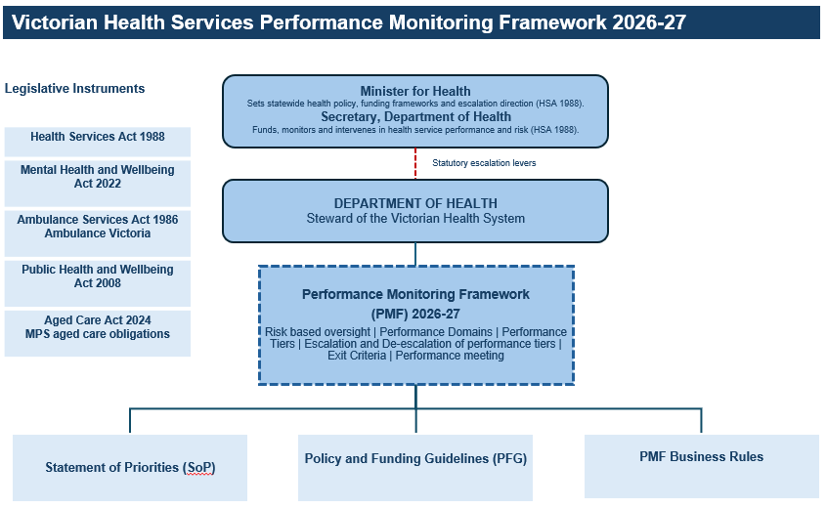
Figure 1 Overview of the Victorian Performance Monitoring Framework (the framework)
See Appendix 2 for Legislative and Accountability Instruments, DH areas (sub-domains) and data flows.

Alignment with broader operating parameters set by key policy documents
The framework aligns with broader operating parameters set by key policy documents, including:
- strategic priorities and service delivery targets set out in each health service’s Statement of Priorities (SoPs) <https://www.health.vic.gov.au/funding-performance-accountability/statements-of-priorities>, the key service delivery and accountability agreements between health services and the Minister for Health and Ambulance Services
- the Department of Health’s Strategic Plan 2023-27 <https://www.health.vic.gov.au/our-strategic-plan-2023-27> and Outcomes Framework <https://www.health.vic.gov.au/our-strategic-plan-2023-27/our-outcomes-framework>, which reflect the Victorian Government’s priorities and inform the SoPs
- the conditions of health service funding (including detailed program and policy requirements) outlined in the Policy and Funding Guidelines <https://www.health.vic.gov.au/policy-and-funding-guidelines-for-health-services>
- the Victorian Clinical Governance Framework <https://www.safercare.vic.gov.au/best-practice-improvement/publications/clinical-governance-framework>, which articulates expectations of clinical governance to ensure quality and safety of care
- Statutory Duty of Candour and protections for SAPSE reviews https://www.safercare.vic.gov.au/report-manage-issues/adverse-events/duty-of-candour
- the Mental Health and Wellbeing Outcomes and Performance Framework <https://www.health.vic.gov.au/mental-health/research-and-reporting/mental-health-and-wellbeing-outcomes-and-performance-framework>.
- Service capability frameworks are being introduced for clinical streams across Victoria's health system. Service capability frameworks for Victoria | health.vic.gov.au < https://www.health.vic.gov.au/health-system-design-planning/service-capability-frameworks-for-victoria
- the Chief Psychiatrist guidelines https://www.health.vic.gov.au/chief-psychiatrist/chief-psychiatrist-guidelines which contain specialist information and advice on clinical practice in mental health and wellbeing services.

Coverage and Exclusions
The framework is designed to assess the performance of health services with direct clinical service delivery responsibilities. Appendix 1A describes in detail the services in scope, the legislative basis for their establishment and the services whose functions place them outside the direct scope of the framework.
HealthShare Victoria is a statutory authority under the HSA and remains subject to Statement of Priorities requirements where relevant. However, because its role centres on purchasing and shared services, it sits outside the framework’s performance tiering and escalation arrangements.

Victorian Health Services Performance Monitoring Framework Business Rules 2026-27
The Victorian Health Services Performance Monitoring Framework Business Rules 2026-27 sit alongside this framework. They set out indicator definitions, thresholds, data sources, reporting frequency and ownership (see Appendix 3).
The Business Rules may be updated during the year to reflect new indicators or technical refinements. This allows the department to update operational settings without reissuing the full framework each time.
For more information see Business Rules <https://www.health.vic.gov.au/funding-performance-accountability/performance-monitoring-framework>.

Health Services undergoing voluntary merger
Some Victorian health services are undertaking voluntary mergers. During this transition, existing accountability arrangements stay in place until they are formally replaced, usually at the start of the next financial year or when a new Statement of Priorities is signed.
The department will work with affected services and boards to make sure oversight remains proportionate, practical and aligned to transitional governance arrangements.

Key components of the Framework
The framework has three core components: the performance cycle, the performance domains and the performance tiers which together drive strategic alignment, continuous improvement and accountability across Victoria's public health system.
The performance cycle sets the annual and quarterly rhythm for performance monitoring. The performance domains identify what the department assesses. The performance tiers determine the level of oversight, support and intervention required.
- The Performance Cycle provides a structured process (Planning and Strategy, Continuous Improvement, Accountability) that integrates the SoP to set and monitor performance expectations. Refer to Section 3 for further detail.
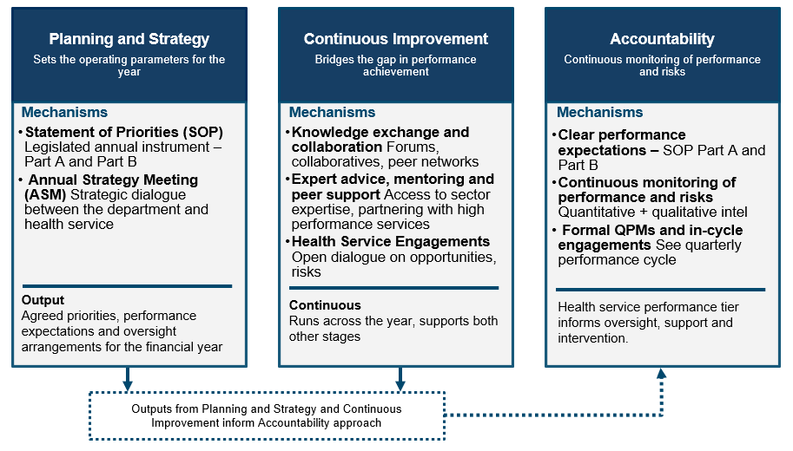
Figure 2: Outlines components of the performance cycle: Planning and Strategy, Continuous Improvement, and Accountability.
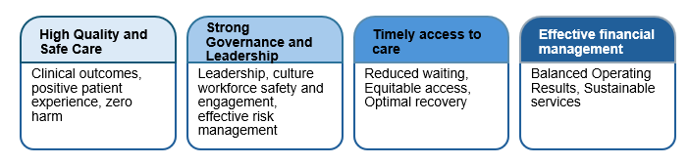
- The Performance Domains define the key areas of focus (High quality and safe care; strong governance, leadership and culture; timely access to care and effective financial management) within the SoP, ensuring metrics align with overall health system priorities.
Figure 3: Four performance domains used to assess health service performance.
- The Performance Tiers result from quarterly assessments of performance against SoP measures and risk signals, and guide the level of oversight, support or intervention required.
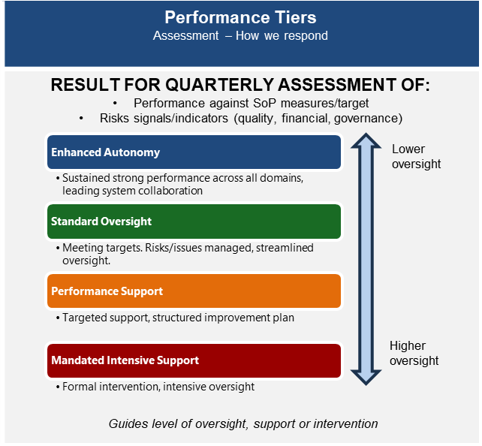

Figure 4: Outlines the four performance tiers—Enhanced Autonomy, Standard Oversight, Performance Support, and Mandated Intensive Support.

2.1 How the three components interact.
The Statement of Priorities is established at the start of each year and monitored through the performance cycle. The department draws on domain performance, risk signals and other intelligence to assign a performance tier. Performance is assessed across four domains to determine each service’s quarterly performance tier, which in turn informs the cadence, participants and focus of subsequent quarterly performance monitoring and engagement.
- Performance cycle (annual) → performance domains The Statement of Priorities (SoP) is signed at the start of the year. Performance is then reviewed regularly across four domains. All health services take part in an annual strategy meeting.
- Performance domains → performance tiers: Information from all domains is combined with risk signals (from RAT, Monitor, and other sources) to decide the health service’s performance tier each quarter.
- Performance tier → performance cycle(quarterly): The performance tier sets how often monitoring occurs, who is involved, and what actions, support or intervention are needed in the next quarterly performance cycle.

2.2 The Performance Domains
The framework assesses a health service performance against four performance domains that collectively determine the overall performance of a health service. These domains are central to the SoP and to quarterly performance assessment:
- High quality and safe care – delivery of safe, high-quality, evidence-based care that improves patient outcomes and provides a positive and culturally safe experience of care.
- Strong governance, leadership and culture – organisational maturity, including Board and executive leadership and capability, workforce safety and engagement, and effective clinical and corporate governance.
- Timely access to care – equitable access to the right care, in the right place, at the right time, reflecting operational capacity, service efficiency and demand management.
- Effective financial management – efficient allocation of resources to deliver cost-effective, sustainable services within agreed budgets, with demonstrable value from resources.
These domains are grounded in legislation and policy. They are monitored using both quantitative measures and qualitative information. They form the foundation of the SoP and underpin each performance tier assessment. See Appendix 4 for more detail on how the domains are reflected in the SoP structure.
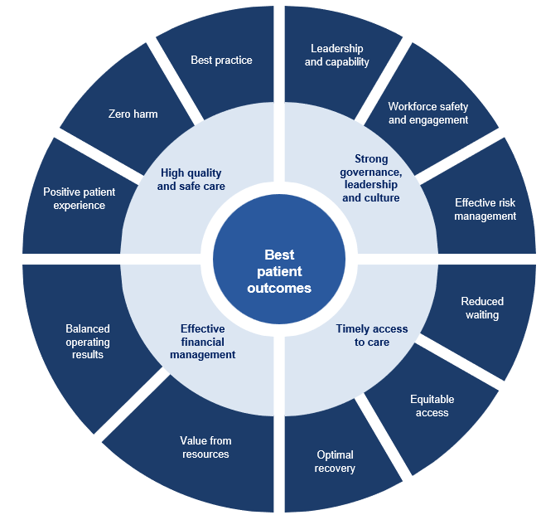

Figure 5: Four PMF performance domains

2.3 The Performance Tiers
Each quarter, the department assigns every health service to 1 of 4 performance tiers based on performance and risk. The performance tiers are Enhanced Autonomy, Standard Oversight, Performance Support and Mandated Intensive Support. The performance tier affects the level of autonomy, support, intervention and performance meeting requirements. The performance tiers are set out below:
Performance Tier | Definition | Monitoring Approach | Quarterly Engagement/Agenda focus
ENHANCED AUTONOMY | Sustained strong performance across all domains and SoP deliverables, supported by effective leadership, continuous improvement, and innovation. Health service excels in core priorities and demonstrates leadership through innovation and system collaboration. | Improvement, collaboration and focus on system innovation.  Quarterly desktop review of SoP measures and performance data. | No formal QPM unless requested.  Where a meeting is requested, discussion may focus on innovation, strategic progress, system leadership, and emerging risks to maintain strong performance.
STANDARD OVERSIGHT | Performance generally within tolerance, with no material performance concerns identified. Health service meets most targets, with credible plans in place to address specific gaps, and demonstrate active collaboration and sustained improvement. | Quarterly desktop review of performance data and other intel also considered (incidents, complaints); targeted management of issues as they arise. | No formal QPM unless emerging risks or concerns are identified during the desktop review or as raised by the sub-domain.  Where a meeting is required, discussion may focus on sustaining performance, identifying potential barriers to and action on any emerging issues.
PERFORMANCE SUPPORT  Escalated Tier | Material underperformance and/or specific risks identified, requiring targeted departmental support to return to Standard Oversight. Services are not meeting core priorities or carry significant underlying risks, necessitating active intervention to stabilise performance and prevent further deterioration. | Active Oversight.  Documented Exit Criteria and Performance Improvement Plan (PiP).  In-cycle engagements (monthly, 6 weekly or as required)  Board Chair/Delegate meetings – where applicable. | Formal QPM Required.  Progress against Exit Criteria reviewed each quarter (with additional in-cycle meetings based on risk severity to monitor PiP).  Progress against the PiP, barriers to success, and progress toward exit criteria for de-escalation.
MANDATED INTENSIVE SUPPORT  Escalated Tier | Significant, sustained, or escalating underperformance across domains requiring directed and mandatory intervention. This performance tier applies where failures are systemic, critical, or persistent (for example, serious patient safety events, governance breakdowns, or major financial distress) and cannot be managed through routine or targeted support. Intensive oversight, formal directions, and strengthened assurance and accountability arrangements are required to protect service viability and patient safety. | Intensive oversight with directed actions.  Senior departmental leadership attends  Documented Exit Criteria and PiP.  In-cycle engagements (weekly, bi-weekly, monthly or 6 weekly) focusing on remediation and critical priorities.  Board Chair/Delegate meetings – where applicable | Formal QPM Required.  Progress against Exit Criteria and emerging risks reviewed each quarter (with additional in-cycle meetings based on risk severity to monitor PiP).  Critical performance gaps, remediation actions, progress against exit criteria, and coordination with escalation options under Appendix 7.

Table 1: A structured comparison table describing each performance tier. It outlines the definition of each tier, the level of departmental monitoring, and the required frequency and focus of engagement activities, including meetings.

Refer to Section 4 for the formal performance assessment process. See Appendix 5 for detailed performance tier criteria and Appendix 6 describes the implications of each tier for health services.

3. The Performance Cycle
The performance cycle sets how the department and health services work together through the following stages: Planning and Strategy, Continuous Improvement and Accountability. Engagement continues throughout the year, the level of oversight depends on each service’s performance tier and risk profile.
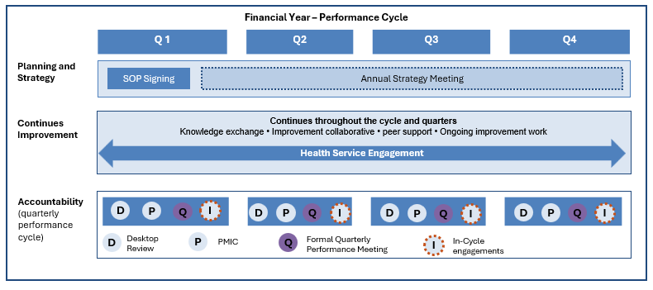
Figure 6: Maps key activities within the stages of Planning and Strategy, Continuous Improvement, and Accountability.

3.1 Planning and Strategy
The Planning and Strategy stage sets priorities, expectations and operating settings for the year. It is supported by two main mechanisms: the Statement of Priorities and the Annual Strategy Meeting.

3.1.1 Statement of Priorities
The Statement of Priorities (SoP) is the annual service delivery and accountability agreement between the Victorian Government and publicly funded health entities. It sets out the strategic priorities, performance targets, service delivery expectations, activity commitments and funding arrangements for the financial year.
Under the Health Services Act 1988 and relevant funding and accountability arrangements, the following entities are required to enter into an annual SoP with the relevant Minister and/or the Secretary:
- Public health services and certain statewide public health service entities (for example, Oral Health Victoria) with the Minister for Health.
- Public hospitals with the Secretary, Department of Health.
- Ambulance Victoria with the Minister for Ambulance Services.
- The Victorian Institute of Forensic Mental Health (Forensicare) with the Minister for Mental Health.
- The Parkville Youth Mental Health and Wellbeing Service with the Minister for Mental Health.

The detailed structure, content and performance requirements of the SoP are outlined in Appendix 4.
Note: Multi-Purpose Services do not sign a SoP. Performance expectations for MPS are carried through Tripartite Agreements, Service Plans and aged care regulatory requirements, as set out in Section 6.
Local Health Service Network arrangements operate alongside each health service’s direct accountability through its own Statement of Priorities and Statement of Expectations.

3.1.2 Annual Strategy Meeting
The department meets with each health service once a year through an Annual Strategy Meeting. This meeting provides a structured discussion between the department and health service leaders and is a key part of the performance cycle.
The meeting focuses on how the health service is delivering on government and department priorities set out in the Statement of Priorities (SoP) Part A. This includes:
- progress over the past year
- key priorities, risks, challenges and support needed for the next year
- opportunities to improve innovation, integration and collaboration
For health services in escalated performance tiers, the Annual Strategy Meeting may be combined with performance meetings. This helps streamline discussions and maintain focus on accountability and improvement.
All meetings follow a standard agenda based on SoP Part A.

3.2 Continuous Improvement
Health services are responsible for leading and delivering their own performance improvement. The department supports this through ongoing engagement, knowledge sharing, alignment of system-wide efforts, and access to expert advice and support.
As part of this approach, the department engages with all health services through regular, ongoing health service engagement and a range of forums to address issues, support improvement and promote collaboration i.e. formal programs, peer learning and specialist advice

3.2.1 Health Service Engagement
Health service engagement involves regular, flexible engagements or interactions between the department and health services outside formal performance meetings.
Engagement may include check-ins, discussions and targeted support to monitor progress, manage risks and respond to emerging issues. It can be formal or informal, with a focus on collaborative problem-solving.
Key aims:
- Maintain strong working relationships between the department and health services and a shared understanding of performance and emerging risks
- Identify and respond to issues early, without waiting for formal performance meetings
- Connect health services to the right areas in the department.
Health services can contact their local Health Service Interface and Collaboration (HSIC) Manager via <HSIC@health.vic.gov.au> as their main point of contact. HSIC helps connect services with the right areas of the department and supports navigation of processes and issues.
Health services may also engage directly with other areas in the department see Section 7.2.2.
Where issues are not able to be resolved through health service engagement the relevant area may nominate for the matter to be escalated to a formal QPM for more structured discussion and oversight.
3.2.2 Knowledge exchange and collaboration
The department supports system improvement through collaboratives, peer networks and reform programs. This includes initiatives across areas such as emergency care, planned surgery, specialist clinics, quality and safety, workforce wellbeing, financial sustainability and cultural safety see Appendix 7.
3.2.3 Expert advice and peer support
Improvement expertise sits strongly within the sector. The department facilitates access to peer health services, clinical leaders and networked problem-solving to support health service leadership in addressing challenges and driving improvement.
3.2.4 Ongoing improvement work
The department maintains regular, open dialogue with health services on risks, performance and system-wide improvement opportunities.
This engagement, led by relevant sub-domains (see Section 7.2.2), helps monitor progress, identify risks and support services to address complex challenges and deliver high-quality, culturally safe care.
Engagement occurs with visibility to the health service CEO, with direct involvement guided by preference. Issues not resolved through this process may be escalated to formal performance meetings.

3.3 Accountability
The accountability stage involves continuous monitoring of performance and risks against the Statement of Priorities and, where applicable, relevant service agreements or written directives. These instruments translate Government, Ministerial and Departmental strategic objectives into service‑specific goals, deliverables and measures aligned to the four performance domains.
Each quarter, health services are assessed and assigned to one of four performance tiers (Enhanced Autonomy, Standard Oversight, Performance Support or Mandated Intensive Support). Tiering reflects performance against agreed targets and priorities, broader domain performance, other relevant risk information and informs the level of oversight, support and intervention required or applied.

3.3.1 Setting clear performance expectations
The Statement of Priorities (SoP) sets the core performance expectations for health services.
Part A outlines mandatory strategic goals and deliverables, while Part B sets targeted, risk-based indicators and performance targets. Services are required to report progress against Part A and, where applicable, meet or demonstrate credible improvement against Part B targets.
Performance against Part B targets is assessed using approved Business Rules, which consider factors such as seasonal variation, peer comparison and related measures. Ongoing monitoring supports early identification of risks, informs performance tiering, and enables timely escalation where expectations are not being met.
Improvement targets may include multi-year pathways with interim milestones where system or capability change is required.
Regardless of improvement trajectories, all services are expected to meet baseline expectations in priority areas, including safety and cultural safety, financial sustainability, and timely access to care. Failure to meet these minimum standards may result in escalation of health service performance tier.

3.3.2 Continuous monitoring of performance and risk
Continuous monitoring involves quarterly review of performance against agreed targets, using data and broader intelligence to identify emerging risks early. This is supported by coordinated input from relevant sub-domains (see Section 7.2.2) and ongoing engagement with health services. Sub-domains are responsible for monitoring SoP measures and performance targets they own (see Appendix 3), working directly with health services to address performance issues, support continuous improvement, and respond to emerging risks.
Monitoring draws on both quantitative data—such as performance trends, financial metrics and eHealth analytics—and qualitative intelligence, including third-party reports, cross-agency insights and Board correspondence.
This integrated approach supports early identification of risks, informs performance tiering decisions, and enables timely intervention where there is a risk that SoP obligations and performance expectations may not be met.
Where performance deteriorates, relevant sub-domains work with the health service to address issues. Where performance concerns are identified and not resolved through health service engagements, they may be escalated to more formal oversight mechanisms see Section 5.

3.3.3 Formal quarterly performance meetings (QPMs) and in-cycle meetings
Formal QPMs and in-cycle meetings are primarily applied to services in escalated performance tiers - Performance Support and Mandated Intensive Support. Formal QPMs for Standard Oversight services may be initiated where emerging performance issues are identified and that are not resolved through ongoing health service engagement (see Section 3.2.1)

- Formal QPMs are structured meetings with the primary purpose of addressing performance issues and agreeing actions to mitigate emerging or ongoing risks. Meetings focus on clarifying accountability outlined in the Exit Criteria and progress against the health service PiP. The performance meeting approach is outlined in Section 5.1
- In-cycle meetings are meetings that take place between formal QPMs with services on escalated performance tiers. Further details on how the in-cycle meetings connect with a formal QPM cycle to broader performance oversight is outlined in Section 5.2

4. Performance tier criteria, assessment and exit criteria
The framework sets out a clear approach to performance assessment, performance tier assignment, escalation, de-escalation and related accountability arrangements.
Health services are assigned a performance tier at the end of each quarter. The decision reflects performance against deliverables and agreed targets, broader domain performance and other relevant risk information.

4.1 Performance Tier Criteria
Performance tiers determine the level of oversight, support and intervention provided to a health service. In line with the criteria for performance tiers, the department may change a health service’s performance tier, and the proportionate response/support provided.
Criteria for each of the performance tiers is defined in Appendix 5: Performance Tier Criteria and is centred around three key considerations:
- Performance against SoP priorities and targets, and other measures - meeting core government expectations of balanced operating results; safe services, including culturally safe care; timely emergency care; and planned surgery and specialist clinic reform programs; achieving locally specific improvement targets; and identifying emerging concerns through quantitative and qualitative data from a range of sources and other intel. See Appendix 7: Box 2 and Box 3.
- Evidence of continuous and sustained improvement - developing collaborative action plans to address performance gaps; engaging with departmental program areas to drive improvement; and implementing innovation and sustained improvement to address identified challenges.
- Contribution to system collaboration and shared priorities - contributing positively to system-wide place-based, regional and statewide priorities.

4.2 Performance Tier Assessment (escalation and de-escalation)
Escalation may occur when a health service does not meet agreed performance targets, shows deteriorating trends or presents material safety, governance, finance or service delivery risk.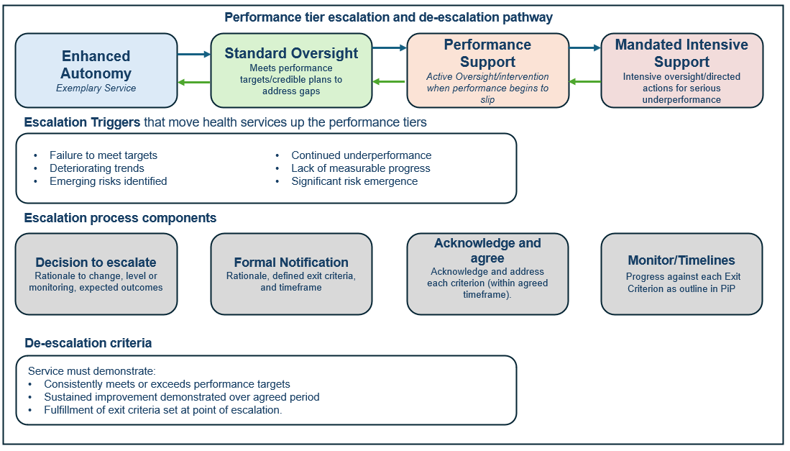
Figure 7 Performance tier escalation and de-escalation pathway

Escalation
Escalation occurs when a health service is not meeting performance targets or is demonstrating declining performance, as identified through data, risk assessments and other intelligence.
When a health service is escalated to a higher performance tier:
- The department documents the rationale for escalation, including required actions and timeframes.
- The Board Chair is formally notified of the change in performance tier, including the Exit Criteria and review timeframe (see Section 4.6).
- The health service develops or updates a Board‑approved Performance Improvement Plan (PiP) to address performance concerns (see Attachment 2).
- Progress against the Exit Criteria and PiP is actively monitored during formal QPMs and in-cycle meetings.
- Further escalation options may be considered if required (see Appendix 8).

De-escalation
De-escalation occurs where a health service consistently meets or exceeds performance targets, demonstrates sustained improvement, and satisfies the defined Exit Criteria outlined in its Performance Improvement Plan. De-escalation reflects the resolution or effective mitigation of identified risks and the completion of required improvement milestones over an agreed sustained period (typically two consecutive quarters).
The de-escalation process mirrors escalation arrangements. Progress is confirmed through a formal performance meeting, the performance tier change is formalised by the department, and the Board Chair is formally notified.

4.3 Performance Tier Assessment Outcome
Tier change | Typical triggers / evidence | Examples of movement
Hold at current tier | Performance is stable; progress is being made against existing improvement plans or Exit Criteria but is not yet sufficient to de-escalate. | Performance Support service maintained pending closure of remaining Exit Criteria; Standard Oversight service maintained with no emerging performance concerns.
Escalation | Failure to meet performance targets; deteriorating trends; new material risks; non-progress against existing Exit Criteria; significant safety or governance concerns. | Standard Oversight to Performance Support; Performance Support to Mandated Intensive Support.
De-escalation | Sustained achievement of agreed targets; demonstrated continuous improvement; closure of Exit Criteria for the agreed sustained period (typically two consecutive quarters). | Mandated Intensive Support to Performance Support.  Performance Support to Standard Oversight.
Promotion to Enhanced Autonomy | Sustained strong performance across all domains; effective leadership; demonstrated capability to lead system improvement. | Standard Oversight to Enhanced Autonomy. Currently no services meet this threshold.
Table 2: Summary of possible outcomes of quarterly performance assessments. (e.g. no change, escalation, de-escalation), the typical triggers or evidence for that outcome, and examples of how services move between tiers.

4.4 Exit Criteria
Where a health service is placed on an escalated performance tier—Performance Support or Mandated Intensive Support—the department establishes Exit Criteria to set clear, time-bound expectations for addressing identified performance risks and concerns. Exit Criteria define what must be achieved for the department to be satisfied that risks have been appropriately mitigated and sustained improvement has been demonstrated.
Exit criteria set out the specific actions and outcomes a health service must achieve to address the risks that led to escalation. They provide a clear pathway to de-escalation and are linked to the service’s Performance Improvement Plan (PiP).
The exit criteria lifecycle has 4 stages:
1. Develop | 2. Agree | 3. Monitor | 4. Close
- Identify performance gaps  - Design measurable criteria linked to identified risks/performance concerns.  - Set expectations and timeline. | - Formal notification  - Agree exit criteria and timelines.  - Develop Board approved Performance Improvement Plan (PiP). | - Heath service provides progress updates against the PiP  - Assess and review progress at the quarterly performance meeting. | - Confirm all criteria met and sustained over agreed period.  - Formally record/note closure of exit criterion.  - Performance tier assessed.
Figure 8 Exit criteria lifecycle: develop, agree, monitor, and close.
Performance concerns are translated into specific exit criteria agreed between the department and the health service. Progress is monitored through ongoing engagement and performance meetings. Once criteria are met and sustained, they are formally closed.
From 2026-27, all services moving to an escalated tier will have a defined set of exit criteria. The department monitors progress through quarterly performance meetings and evidence supplied by the health service.
Exit Criteria are formally monitored and assessed through quarterly performance meetings. Health services report progress against each criterion using the PiP and supporting evidence, which is reviewed by the department.
Where Exit Criteria are met and sustained, closure is formally recorded, and the department may recommend a performance tier review and potential de-escalation at the end of the relevant quarter. Formal confirmation is provided in writing to the health services when all exit criteria have been closed, or where it is determined that new or amended exit criteria are required

4.5 Escalation Options
Where risks or performance concerns result in an elevated performance tier, the department will work with the health service to ensure appropriate action is taken to address concerns and minimise risk to patients or service delivery. Where performance does not improve despite support, escalation options outlined in Appendix 8 will be considered – including appointing a Board delegate, commissioning an independent review or Department -sanctioned audit, or, in extreme cases, Ministerial direction, censure or dismissal of the Board and appointment of an administrator.
The department applies escalation options progressively, taking account of the severity, duration and nature of the concern.

4.6 Performance Tier Change and Notification
Following the formal QPM, where a decision is made to change a health service’s performance tier, the department will formally notify the health service and the Board Chair of the decision.
The notification will outline:
- the new performance tier and the rationale for the decision;
- the department’s expectations of the health service at the assigned tier;
- the review timeframe, including clearly defined Exit Criteria and the pathway for de-escalation;
- acknowledgement and acceptance of the agreed Exit Criteria;
- any escalation options that may be considered where improvement is not sustained; and
- a request for the health service to develop, or revise, a Board-approved Performance Improvement Plan (PiP) that sets out agreed actions, responsibilities and timeframes.
The department will document the rationale for the tier change, the associated level of monitoring, support or intervention, and any agreed actions and timeframes. At a minimum, each action will clearly identify the responsible party, the required action, and the timeframe for completion or review.

5. Quarterly Performance Cycle
The quarterly performance cycle provides a structured approach to performance oversight between the department and health services, supporting sustained performance improvement and clear accountability.
The department reviews performance each quarter against agreed targets and identifies unmet or deteriorating measures. Where sustained deterioration is identified, issues are discussed with the health service through ongoing health service engagement at the local level. Health services engage with the relevant sub-domain responsible for each measure or performance expectation (see Section 7.2.2)
For services in Standard Oversight, formal Quarterly Performance Meetings (QPMs) are only convened where emerging issues are not resolved through ongoing health service engagement. In these cases, formal QPMs are targeted and time-limited, with escalation and defined exit criteria developed if performance continues to decline.
For services in escalated performance tiers—Performance Support and Mandated Intensive Support—formal QPMs and in-cycle meetings form the primary mechanism for oversight. QPMs focus on addressing key performance issues, clarifying accountability, and tracking progress against Exit Criteria and the Performance Improvement Plan (PiP), while in-cycle meetings provide ongoing monitoring and support between formal meetings.
Performance assessments may draw on both quarterly reporting and available live operational data, where appropriate, to support timely oversight of health service performance. This is particularly relevant for financial performance discussions, where most current financial data may be used to assess emerging risks, trends and financial sustainability.

5.1 Formal Quarterly Performance Meeting (QPM)
Formal Quarterly Performance Meeting (QPM) is a structured meeting with health service to discuss emerging risks and performance concerns outlined in the Exit Criteria. This ensures performance risks are actively managed, progress is transparent, and improvement efforts remain focused and outcome oriented.
Key aims:
- Formal QPMs support timely intervention ensure sustained focus on performance concerns.
- Establish clear accountability for performance outcomes and monitor progress against agreed actions, including delivery of Performance Improvement Plans (PiPs) and Exit Criteria where applicable.
- Drive shared understanding of performance issues, expectations and priorities between the department and the health service.
- Drive disciplined follow through by agreeing clear, measurable actions with defined responsibilities and timeframes.
Formal QPMs are required for services in Performance Support or Mandated Intensive Support. They may also be used for a service in Standard Oversight if the department considers that formal discussion is needed for an emerging issue.
Where a decision is made to change a health service’s performance tier from Standard Oversight to an escalated performance tier, the Exit Criteria process will be initiated in accordance with the framework.
To maximise the impact of formal QPMs:
- Agendas focus on an overarching view of the highest-priority performance issues for the service as per the exit criteria.
- Performance issues are not generally raised for the first time at the meeting (raised prior to formal QPMs)
- Consistent participation of relevant departmental representatives, at a seniority level appropriate to authorise actions arising from discussion.

5.2 In-cycle meeting
In-cycle meeting is the structured work that happens between formal QPMs for services in escalated tiers to support progress momentum on agreed actions.
Key aims:
- Provide structured support against the specific performance concerns outlined in the exit criteria.
- Track progress against the agreed PiP
- Surface emerging risks early so they can be addressed

5.3 Tailored accountability approach for effective oversight
There are two types of performance meetings for health services requiring focused oversight - formal QPM and in-cycle meetings. The table below outlines each approach, the applicable performance tier, meeting format, frequency, purpose, lead responsibility, and health service participants.
Meeting Type | Performance tier | Format and Agenda | Cadence | Focus | Lead | Health Service Participants
Formal Quarterly Performance Meetings (QPM) | Services on escalated tiers. For Standard Oversight, where emerging issues are not resolved through ongoing health service engagement. | Formal meeting led by HSPO | Quarterly (ongoing until issues are resolved; time‑limited for Standard Oversight) | Address key performance issues  Track progress against Exit Criteria and PiP  Agree actions and clarify accountability | HSPO, with support from relevant sub-domains | Health Service Executives
In-cycle meetings | Services on escalated tiers | Formal Meeting chaired by sub-domain lead.  Where performance concerns are significant may be led by HSPO team. | Monthly or every 6 weeks between QPMs | Track progress against PiP and Exit Criteria  Provide active support on key issues  Identify new or emerging risks | Sub‑domain or HSPO has assumed primary oversight responsibility (as outlined in the Exit Criteria) | Health Service Executives
Table 3: Two types of performance meetings for health services requiring focused oversight

6. Multi-Purpose Services (MPS) and Denominational services

6.1 Multi-Purpose Services (MPS)
MPS are small rural services that deliver integrated acute, primary and aged care, typically in communities where standalone services would not be viable. MPS are established under Part 4A of the Health Services Act 1988 and operate under joint Commonwealth-State funding arrangements. They are subject to similar governance and performance policies as public hospitals but are not required to sign a SoP.
For Multi‑Purpose Services (MPS), performance expectations are articulated across a suite of interconnected instruments, including Tripartite Agreements, MPS Service Plans, strengthened aged care regulatory requirements under the Aged Care Act 2024, and the Policy and Funding Guidelines (PFG).
Performance oversight for MPS is undertaken through the framework using a tailored, risk‑based approach, comparable to that applied to small rural health services. This approach draws on the available contractual, funding, and regulatory levers to support proportionate risk assessment, monitoring, assurance and, where required, escalation.

6.2 Denominational Services
Denominational health services are an integral part of the Victorian public hospital system and receive state funding to deliver public hospital services to Victorian patients and communities.
Denominational services have a Statement of Priorities (SoP) and are subject to performance oversight on the same basis as other public health services. Performance oversight is supported by the SoP, Health Services Act (1988), Policy and Funding Guidelines, and modelled budget. These instruments set out:
- the scope of public hospital activity to be delivered;
- funding parameters and conditions;
- reporting and accountability obligations; and
- performance expectations aligned with the broader public hospital system.
Where the Department requires increased assurance under the framework—including in cases of sustained or elevated performance risk, or where confidence in a service’s capacity to meet its SoP commitments is reduced an escalated performance approach can be applied.
Escalation under the Health Services Act 1988 and other statutory powers applies where the legislation extends to the service. Where statutory powers do not directly apply, equivalent contractual levers will be exercised.

7. Roles and Responsibilities
This section sets out the responsibilities of health services (Section 7.1) and the different parts of the department (Section 7.2.2) in implementing the framework. These roles collectively support coordinated, system-wide performance oversight under the framework.

7.1 Health services
Health services are responsible and accountable for:
- meeting expectations set through the Statement of Priorities or equivalent instruments
- maintaining a culture of improvement and delivering required performance improvements
- engaging constructively with the department’s oversight processes
- reporting significant emerging risks or performance issues promptly
- work collaboratively with the department through engagement between formal performance meetings.
- submitting accurate and timely data and other information
- collaborating with other health services and system partners to share knowledge, align effort and improve system-wide performance; and
- ensuring board and executive leadership respond appropriately to performance tier changes and exit criteria

7.2 Department of Health
The department is the steward of the Victorian health care system. It advises Government on health strategy, policy, planning, funding allocation and performance oversight of health services.

7.2.1 Overarching departmental responsibilities
The department carries out its performance oversight role by:
- setting strategic priorities and operating parameters (translating government priorities into health service targets, providing timely budgets and financial and policy parameters, and engaging with health services to drive improvement);
- supporting continuous improvement (facilitating sharing of knowledge and expertise, enhancing Board skills and capabilities, and ensuring departmental staff have effective performance monitoring and quality improvement capabilities);
- continuous monitoring of performance and risk (implementing the framework and associated tools transparently and consistently, using available data and third-party intelligence, and maximising input from across the department and from clinical leaders);
- formally assessing performance and assigning tiers (consistently applying tier assessment and monitoring approaches, and advising the Minister on escalation mechanisms as appropriate); and
- coordinating performance meetings and responses (ensuring appropriate, relevant and consistent representation, and working across teams to ensure a cohesive approach).

7.2.2 Roles and responsibilities across areas of the department (sub-domain)

Hospitals Victoria division
Hospitals Victoria stewards’ health service financial sustainability and performance through system-level commissioning, funding, and accountability. The division leads systemwide strategy, planning and performance oversight for Victorian health services, with a focus on driving efficiency, financial sustainability and service performance. The division leads and coordinates savings and efficiency initiatives, provides oversight, quality assurance and risk management, and delivers insights and analytics to monitor progress across the system. It oversees health service performance assessment, funding policy, costing and pricing arrangements, and systemwide financial governance, supporting health services to implement improvement programs and informing executive decision making to ensure sustainable, high quality hospital services.

Health Service Performance Oversight
Leads end-to-end performance oversight for hospitals and health services through the Performance Monitoring Framework and drives performance improvement through targeted deep dives and data analysis.

Health Service Financial Performance and Capability (sub-domain)
Leads system-wide financial oversight, including financial policy advice and financial performance frameworks to support sustainable health service operations. Supports health services to implement efficiency and productivity initiatives, including overseeing improvement programs and providing advice to support executive decision-making. Leads programs to strengthen financial capability, data quality, productivity and revenue optimisation across the sector.

Health System Reform and Partnerships division
The Health System Reform and Partnerships Division leads the commissioning, stewardship and oversight of Victoria’s hospitals and health services.
The division leads system reform, policy and program design and implementation, issues management, system improvement and cross sector collaboration across ambulance and emergency, planned care, system access, aged care services, end of life care, cancer and specialist services, specialist programs, health workforce capability and strategy, and whole of system planning with a focus on improving integration, equity and outcomes for priority communities.
The division is the department’s primary liaison and engagement partner for health services and works collaboratively with them to inform policy and program design and implementation, commissioning and funding decisions, and supports continuous improvement in service delivery and system performance.
The division also leads health service governance and accountability and leads the delivery of the Local Health Service Network reforms to strengthen collaboration between hospitals and improve how care is delivered to local communities.

Health Service Interface and Collaboration (sub-domain)
The department’s primary point of engagement with public hospitals and health service leaders to understand local needs to strengthen collaboration, inform commissioning, service and funding decisions, and drive integrated, high quality system outcomes.
The branch leads policy, targeted improvement and partnerships across maternity and newborn services and operational commissioning. It also plays a critical role in governance and health system reform by overseeing voluntary amalgamations and leading performance monitoring of the Local Health Service Networks.
System Access and Reform (sub-domain)
The branch is responsible for driving best practice across the emergency and planned care patient journey. This includes co-design and delivery of system reform as well as system governance and accountability, underpinned by a focus on equity and priority populations to ensure timely and equitable access to ambulance services and emergency care, as well as planned care for all Victorians.
Aged Care and System Priorities (sub-domain)
The branch leads the delivery of key health system priorities within the Health System Reform & Partnerships Division, overseeing policy, reform initiatives and specialist programs across aged care, disability health interface, voluntary assisted dying, end of life care, and cancer and specialist therapies. It manages a specialised portfolio and works with sector partners and clinical experts to translate system priorities into targeted policy and program responses that improve integration, access, performance and outcomes across Victoria’s health system.
Other branches
System Planning, Reform and Priority Communities
Provides strategic leadership and oversight of the health service system planning and reform agenda, ensuring the Victorian health system is planned, designed and improved in a coordinated, evidence-based and equity-led manner. The branch is accountable for shaping system-wide planning priorities, strengthening system performance, and ensuring priority communities are consistently embedded into policy, planning and service design decisions.

Workforce Strategy, Planning and Leadership
Provides strategic workforce policy leadership, analysis, planning and system support across the health portfolio. The branch leads workforce strategy and reform across key professional streams, including mental health, medical, nursing and midwifery, and allied health. The branch also leads and coordinates Victoria’s input into national workforce reform and workforce regulation and hosts the Commonwealth funded NRAS Policy function, which provides policy and regulatory advice to support the administration of the National Registration and Accreditation Scheme.

Safer Care Victoria (SCV) (sub-domain)
SCV is the state authority for supporting Victorian health services to provide safe, high-quality care and is a key partner in quality and safety-focused performance conversations with health services in this domain. SCV supports implementation of the framework by monitoring and analysing key quality and safety indicators to understand system-level safety risks and emerging issues, and by providing expert advice, tools, resources, education and targeted programs to support service and system improvement.
SCV plays a central role in assuring and supporting learning from adverse events, including Sentinel Events and Serious Adverse Patient Safety Events, in line with the Policy and Funding Guidelines. SCV works with boards, executives and clinicians to strengthen clinical governance, workforce safety, wellbeing and capability, and to drive continuous improvement in quality and safety outcomes across the system.

Mental Health and Wellbeing division (sub-domain)
The Mental Health and Wellbeing Division (MHWD) leads the delivery of Victoria’s mental health and wellbeing reform agenda, as set out by the Final report of the Royal Commission into Victoria’s Mental Health System (2021). It is responsible for the performance oversight, stewardship and commissioning of mental health and alcohol, and other drug (AOD) services to create a mental health and wellbeing system that delivers inclusive, personalised, compassionate, and integrated care.
The division steward’s mental health reform governance, service planning and system design, leads prevention and promotion initiatives including mental health prevention, suicide prevention and gambling harm, embeds lived and living experience, and supports culturally informed approaches to improve equity and outcomes across the mental health and wellbeing system.
MHWD supports implementation of the Framework through monitoring and driving performance improvement at health services designated under the Mental Health and Wellbeing Act 2022. The Mental health performance report is used as a companion document to the Framework and provides a structure for tracking service and system performance in Victorian state-funded clinical mental health services.

Office of the Chief Psychiatrist
Within MHWD, the Chief Psychiatrist provides system-wide oversight of Victoria’s public mental health services. Supported by the Office of the Chief Psychiatrist (OCP), the role supports quality and safety in services provided to some of Victoria’s most vulnerable people. The role and functions of the Chief Psychiatrist are set out under the Mental Health and Wellbeing Act 2022 (MHWA).
Responsibilities under the MHWA and which support implementation of the Framework include clinical leadership and quality and safety oversight across Victoria’s public mental health system and mental health and wellbeing services in custodial settings. The activities undertaken by the OCP include assisting services in developing and implementing clinical best practice approaches, undertaking reviews, audits and investigations as required, providing expert clinical advice and promoting the rights of people receiving a mental health and wellbeing service.

eHealth division
The eHealth division is responsible for stewardship of digital health, data and information systems across Victoria’s public health system. It supports implementation of the Framework by enabling high-quality performance monitoring and system insight and by managing digital and information-related risks.
eHealth relies on obtaining timely, accurate and high-quality data from health services and is responsible for data management, standards and integrity. It plays a vital role in implementing the Framework by providing performance data and supporting relevant areas across the department to develop relevant and meaningful performance measures.
eHealth is the departmental lead for digital health, information technology and cyber security. In this role, it supports health services to strengthen the security, resilience and reliability of digital systems and infrastructure, including preparedness for cyber threats and unplanned ICT disruptions. Where cyber incidents or significant ICT outages occur, eHealth works closely with health services and relevant sub-domain to support system coordination, incident management and recovery, with the objective of minimising impacts on patient care and service delivery. ​​​​​​​ ​​​​​​​

Aboriginal Health and Wellbeing division (sub-domain)
Aboriginal Health and Wellbeing lead the development of Aboriginal health and wellbeing policy, embeds cultural safety and Aboriginal data sovereignty, and supports sector sustainability, Aboriginal workforce and governance across the department.
It delivers strategic initiatives and reforms, including funding and legislative reform, Aboriginal budget strategy, and Treaty preparedness and implementation. In addition, the division engages in whole of government approaches to improving outcomes for First Peoples in Victoria.
The division demonstrates leadership through close collaboration with Aboriginal communities and organisations, driving improvements in health outcomes and equity for Aboriginal Victorians through culturally informed policies, programs, and system reform.

Community and Public Health division
The Community and Public Health division provides system wide leadership on public and community health policy, protection, prevention and promotion to improve population health and reduce preventable illness. The division provides statewide public health expertise and responses to communicable diseases and environmental health risks, delivers regulatory policy and public health programs, and provides advice, performance oversight and governance for public health activities and programs.
The division drives prevention strategy and health promotion initiatives, oversees community and women’s health programs including maternal and child health, leads emergency management preparedness and response, and supports population health outcomes through coordinated, evidence informed policy and system improvement.

8. Reporting Requirements

8.1 Specific events – Breaches
The following events must be recorded as a breach and immediately escalated to the department. See Attachment 1: Health service notification process:
Breach Type | Reporting Requirements | Key Contact
Emergency Care Triage Category 1 Failure | Report via standard VEMD process within 24 hours of a breach or becoming aware of one. | Health Service Interface and Collaboration contact  hsic@health.vic.gov.au
Emergency Department 24 Hours Waiting Time Failure
Planned surgery category 1 not treated within recommended time | Notify the department within 24 hours of a breach or becoming aware of a breach.  Health services are required to include in the notification the circumstances and response to the breach, including whether patient safety has been compromised. If a health service experiences high volumes of these breaches, the department may implement an alternative interim breach notification process. | Access, Insight and Accountability, System Access and Reform  plannedcare@health.vic.gov.au
Colonoscopy category 1 not treated within recommended time
Non-compliance with National Safety and Quality Health Service Standards | Notify the Department of Health within 24 hours or becoming aware of one.  Health Service Interface and Collaboration contact will coordinate with the Safer Care Victoria to provide support and assistance in responding to and addressing non-compliance. | Health Service Interface and Collaboration  accreditation@health.vic.gov.au
Non-compliance with Aged Care Standards | Notify the Aged Care contact as soon as practicable. The Aged Care Team will provide support and assistance in responding to and addressing non-compliance. | VICPSRACS@health.vic.gov.au

8.2 Reporting of temporary change to capability level, including Code Yellow
The Health Services Act 1988 outlines that health services are required to notify the department about any issues of public concern or risks that affect or may affect the health service.

This includes changes to capability levels (diversion or bypass), and/or code yellows that impact upon the ability to provide safe delivery of health services to communities.
Health services must notify the department upon becoming aware of the need for such a change by completing Attachment 3: Temporary Capability Change Notification Template to document details of the code, diversion or bypass. Submit the completed template to the designated HSIC lead manager or executive via hsic@health.vic.gov.au for your health service and include hsim@health.vic.gov.au

Note: Force Majeure has been replaced by Exceptional Events in the Policy and Funding Guidelines.

Appendix 1: Coverage of the Framework
Victoria’s public hospitals and health services are independent legal entities established under the Health Services Act 1988 (HSA), Ambulance Services Act 1986(ASA) and Mental Health and Wellbeing Act 2022 (MHWA) where applicable. They are governed by boards of directors, who are appointed by the Governor-in-Council on recommendation of the Minister for Health and Ambulance Services. The board oversees the health service on behalf of the Minister for Health and Ambulance Services and in accordance with government policy and its legal obligations.
The Framework captures all publicly funded health service providers including:
- metropolitan and regional health services, defined under the Health Services Act 1988 as ‘public health services’ Schedule 5
- subregional, local and small rural health services, defined under the Health Services Act 1988 as ‘public hospitals’ Schedule 1 (with the exception of Queen Elizabeth Centre and Tweddle Child and Family Health Service Section 40G).
- multi-purpose services – Schedule 1A of the Health Services Act 1988
See Appendix 1a for a detailed list of publicly funded health services
Public health services (including Oral Health Victoria) are governed by boards of directors under s 65S of the Health Services Act 1988, and public hospitals are governed by boards under s 33.
Multi‑purpose services are established under Part 4A of the Health Services Act 1988 and governed by boards under s 115E. They are subject to similar governance and performance expectations but not required to sign a Statement of Priorities in the same way as public hospitals.
Three denominational hospitals listed in Schedule 2 of the Health Services Act 1988 — Calvary Health Care Bethlehem Limited, Mercy Hospitals Victoria Limited, and St Vincent’s Hospital (Melbourne) Limited — are subject to similar performance and oversight provisions as public hospitals, as set out in Part 3 and Part 3A of the Health Services Act 1988.
Ambulance Victoria is established under section 23 of the Ambulance Services Act 1986 (ASA) and is governed by a board of directors as set out under section 17 of the ASA.
Forensicare, as Victoria’s specialist forensic mental health service, operates within the legislative framework of the Mental Health and Wellbeing Act 2022 under section 610 from 1 September 2023, replacing the Mental Health Act 2014 and establishing a new legislative framework for the delivery, regulation and oversight of mental health and wellbeing services in Victoria. Forensicare is governed by a board of directors pursuant to provisions in the MHWA (Part 14.2).
Parkville Youth Mental Health and Wellbeing Service is established under section 673 of the Mental Health and Wellbeing Act 2022 (MHWA) and governed by a board pursuant to provisions in the MHWA Part 16.1, Division 2).
The Framework is designed to assess and manage the performance of health services with direct clinical service delivery responsibilities. HealthShare Victoria, as a system‑level statutory authority with purchasing and shared services functions, falls outside the scope of the Framework and its associated performance tiering and escalation mechanisms.

Appendix 1a: Detailed List of publicly funded health service
Public Health Services | Health Service
Metropolitan (11) Health Services Act 1988 Schedule 5 | Austin Health  Bayside Health  Eastern Health  Melbourne Health  Monash Health  Northern Health  Peter MacCallum Cancer Institute  The Royal Children's Hospital  The Royal Victorian Eye and Ear Hospital  The Royal Women's Hospital  Western Health
Regional (6) Health Services Act 1988 Schedule 5 | Albury Wodonga Health  Barwon Health  Bendigo Health  Goulburn Valley Health  Grampians Health  Latrobe Regional Health
Denominational (3) Health Services Act 1988 Schedule 3 | Calvary Health Care Bethlehem Limited  St Vincent's Hospital (Melbourne) Limited  Mercy Hospitals Victoria Limited
Statewide/Other Entities (5) | Ambulance Victoria  Parkville Youth Mental Health & Wellbeing Service  Oral Health Victoria  Forensicare  HealthShare Victoria*

Public Hospitals  Health Services Act 1988 Schedule 1 | Health Service
Sub-Regional (9) | Central Gippsland Health Service  Bairnsdale Regional Health Service  Echuca Regional Health  Mildura Base Public Hospital  Northeast Health Wangaratta  South West Healthcare  Swan Hill District Health  West Gippsland Healthcare Group  Western District Health Service
Local (7) | Benalla Health  Colac Area Health  Dhelkaya Health  East Grampians Health Service  Kyabram District Health Service  Maryborough District Health Service  Portland District Health
Small Rural Health Service (27) | Alexandra District Health  Beaufort and Skipton Health Service  Central Highlands Rural Health  Cohuna District Hospital  Beechworth Health Service  Boort District Health  East Wimmera Health Service  Great Ocean Road Health  Heathcote Health  Hesse Rural Health Service  Heywood Rural Health  Inglewood and Districts Health Service  Kerang District Health  Mansfield District Hospital  Moyne Health Services  NCN Health  Omeo District Health  Rochester and Elmore District Health Service  Rural Northwest Health  Seymour Health  South Gippsland Hospital  Tallangatta Health Service  Terang and Mortlake Health Service  West Wimmera Health Service  Yarram and District Health Service  Yarrawonga Health  Yea and District Memorial Hospital
Multi- Purpose Services (6) | Alpine Health  Corryong Health  Mallee Track Health and Community  Orbost Regional Health  Robinvale District Health Service  Timboon and District Healthcare Services

Note: Tweddle Child & Family Health Service and The Queen Elizabeth Centre are established as Public Health Services under the Act but are not required to enter into and sign a Statement of Priorities.
**HealthShare Victoria is established as a Public Health Service under the Act however is out of scope of the PMF (see Section 1.2).

Appendix 2: Performance Monitoring Framework Overview
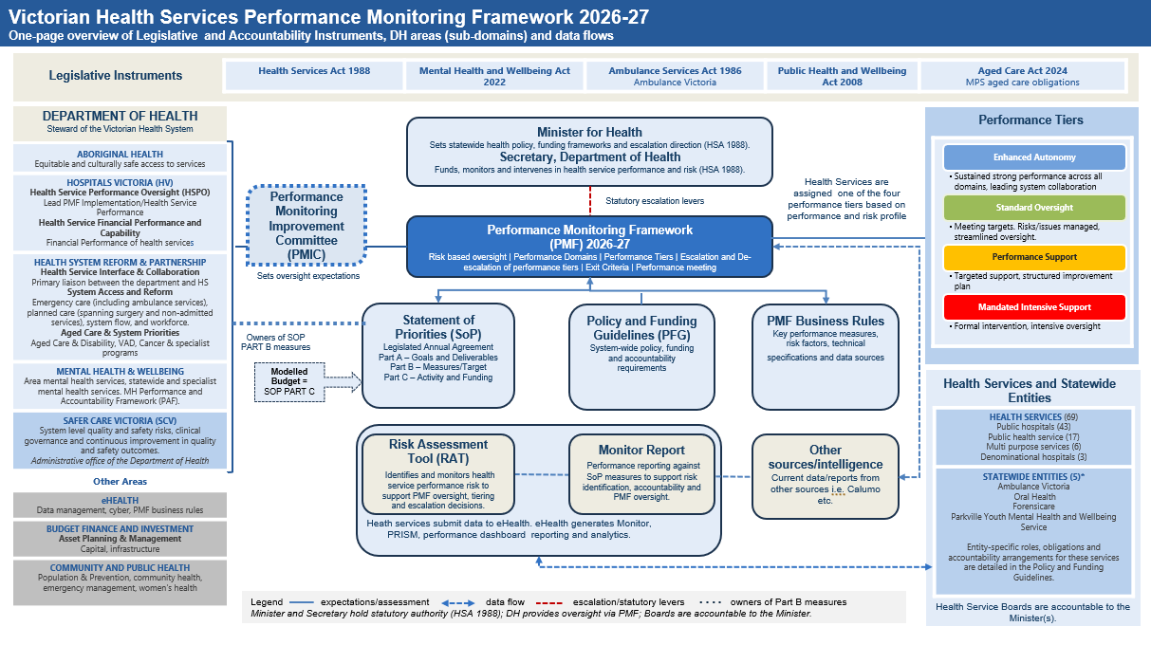
Figure 9 High-level overview of the PMF 2026–27.

Appendix 3 Performance Monitoring Framework 2026-27 Measure Mapping

Statement of Priorities (Part B)/Monitor Reports Measures - Program Owners (sub-domain) - PMF Business Rules
Key Performance Measure | Target | Measure Owner (Sub-Domain) | PMF Business Rules  (Source; Reporting Frequency)
High Quality and Safe Care
Infection prevention and control
Percentage of healthcare workers immunised for influenza | 94% | Safer Care Victoria | Victorian Nosocomial Infection Surveillance System (VICNISS); reported in Q1
Adverse events
Percentage of reported sentinel events for which a root cause analysis report (RCA) or similar approved methodology, was submitted within 30 business days from notification of the event | 100% | Safer Care Victoria | SCV Sentinel event data collection; quarterly and annually
Aged care
Public Sector Residential Aged Care Services (PSRACS) overall star rating (≥ 3 stars) | 100% | HSRP, Aged Care & System Priorities | Australian Institute of Health and Welfare – GEN Aged care Star Ratings; quarterly
Patient experience
Percentage of patients who reported positive experiences of their hospital stay | 95% | Safer Care Victoria | Victorian Healthcare Experience Survey (VHES); quarterly
Aboriginal Health
Difference between the percentage of patients who left against medical advice between Aboriginal and Torres Strait Islander people compared with non-Aboriginal and Torres Strait Islander people | 0% | Aboriginal Health | Victorian Admitted Episodes Dataset (VAED); quarterly
Difference between the percentage of Aboriginal or Torres Strait Islander patients and non-Aboriginal or Torres Strait Islander patients presenting to ED who did not wait to be treated | 0% | Aboriginal Health | Victorian Emergency Minimum Dataset (VEMD); quarterly
Mental Health Patient Experience
Percentage of consumers who rated their overall experience with a service in the last three months as positive | 80% | MHW Performance & Commissioning | YES survey (clinical services); annually
Percentage of families/carers reporting a ‘very good’ or ‘excellent’ overall experience of the service | 80% | MHW Performance & Commissioning | Carer Experience of Service (CES); annually
Percentage of families/carers who report they ‘always’ or ‘usually’ felt their opinions as a carer were respected | 90% | MHW Performance & Commissioning | Carer Experience of Service (CES); annually
Percentage of mental health consumers reporting they ‘usually’ or ‘always’ felt safe using this service | 90% | MHW Performance & Commissioning | YES survey (clinical services); annually
Mental Health follow-ups, readmissions, and seclusions
Percentage of consumers followed up within 7 days of separation – Inpatient | 88% | MHW Performance & Commissioning | Client Management Interface (CMI) / Operational Data Store (ODS); quarterly and annually
Percentage of consumers re-admitted within 28 days of separation - inpatient | < 14% | MHW Performance & Commissioning
Rate of seclusion episodes per 1,000 occupied bed days - inpatient | ≤ 6 seclusion episodes per 1,000 bed days | MHW Performance & Commissioning
Strong governance, leadership, and culture
People matter survey – Percentage of staff with an overall positive response to safety culture survey questions | 80% | Safer Care Victoria | Victorian Public Sector Commission; annually
Timely access to care
Planned Surgery
Percentage of urgency category 1 planned surgery patients admitted within 30 days. | 100% | HSRP, System Access and Reform | Elective Surgery Information System (ESIS); monthly
Percentage of all planned surgery patients admitted within the clinically recommended time | 94% | HSRP, System Access and Reform | Elective Surgery Information System (ESIS); monthly
Number of patients admitted from the planned surgery waiting list | Specific to health service | HSRP, System Access and Reform | Elective Surgery Information System (ESIS); monthly
Percentage reduction in the volume of patients waiting overtime on the planned surgery preparation list | Greater than or equal to 25% reduction OR ≤6% of patients waiting overtime. | HSRP, System Access and Reform
Optimisation of surgical inpatient length of stay (LOS), including through the use of virtual and home-based pre- and post-operative models of care | Reduction in average LOS for surgical patients by 2% from prior year | HSRP, System Access and Reform | Victorian Admitted Episodes Dataset (VAED) and Elective Surgery Information System (ESIS); monthly based on year-to-date results and annually at the health service level
Emergency Care
Percentage of patients transferred from ambulance to emergency department within 40 minutes | Specific to health service | HSRP, System Access and Reform | Victorian Emergency Minimum Dataset (VEMD); monthly and annually
Number of emergency patients with a length of stay in the ED greater than 24 hours | 0 | HSRP, System Access and Reform
Average ED length of stay for admitted patients, in minutes | Individual Targets: Less than or equal to 414 minutes or at least 5 per cent improvement on the same time last year | HSRP, System Access and Reform | Victorian Emergency Minimum Dataset (VEMD); monthly, quarterly and annually at the campus level.
Average ED length of stay for non-admitted patients, in minutes | Avg LOS <240 minutes OR, if not met, a 3% improvement from the same time last year | HSRP, System Access and Reform
Mental Health
Percentage of mental health-related emergency department presentations with a length of stay of less than 4 hours | 65% OR, if not met, 5% improvement compared to the previous quarter | MHW Performance & Commissioning | Victorian Emergency Minimum Dataset (VEMD); monthly, quarterly and annually
Percentage of departures from emergency departments to a mental health bed within 8 hours | 80% | MHW Performance & Commissioning
Number of admitted mental health occupied bed days | Specific to health service | MHW Performance & Commissioning | Client Management Interface (CMI)/  Operational Data Store (ODS); quarterly and annually by Designated Mental Health Service.
Number of community mental health service hours | Specific to health service | MHW Performance & Commissioning
Specialist Clinics
Percentage of urgent patients referred by a GP or external specialist who attended a first appointment within 30 days. | 100% | HSRP, System Access and Reform | Victorian Integrated Non-Admitted Health (VINAH) Minimum Dataset; monthly
Percentage of routine patients referred by a GP or external specialist who attended a first appointment within 365 days. | 90% | HSRP, System Access and Reform
Home Based Care
Percentage of admitted bed days delivered at home | Specific to health service | HSRP, System Access and Reform | Victorian Admitted Episodes Dataset (VAED); quarterly and annually at the health service level.
Effective financial management
Statement of Priorities operating result ($M) | 0 | Hospitals Victoria -Health Service Financial Performance | Health Agencies Reporting Tool (HeART); monthly and annually
Variance between the forecast and actual operating result (OR) as a percentage of the forecast OR for the current financial year ending 30 June | 4% movement in forecast revenue and expenditure forecasts | Hospitals Victoria -Health Service Financial Performance | Health Agencies Reporting Tool (HeART); monthly and annually
Average number of days to pay trade creditors | 60 days | Hospitals Victoria -Health Service Financial Performance | HeART; Q4 (April to June) and annually.
Table 4: Performance measures across domains. For each measure, it includes the agreed target, the responsible departmental owner (sub-domain), and the data source and reporting frequency used to monitor the measure.

Appendix 4: Statement of Priorities (SoP)
The Statement of Priorities (SoP) is the legislated annual service delivery and accountability agreement between each Victorian public health service and the Minister for Health.
The SoP is designed to articulate a focused set of strategic performance priorities, rather than serve as a comprehensive performance framework. Health services are accountable for delivering against a defined set of core qualitative and quantitative strategic priorities outlined within the SoP.
To support performance oversight, the department applies data analytics and broader system intelligence—drawing on tools such as the Risk Assessment Tool and departmental reports—to assess performance, identify emerging risks, and inform decision-making
This approach enables the department to monitor sector-wide trends while recognising that not all performance measures warrant elevation to core priority status.
To ensure alignment with system-wide reform and performance accountability, core priorities from across the performance domains are elevated into the SoP and structured across four distinct parts:

Part A – Strategic Priorities
This section outlines qualitative commitments aligned with the Department’s Strategic Plan and Ministerial directions. For 2026-27 SoPs are structured around five overarching strategic priorities that reflect the government’s highest health system objectives. These are articulated through mandatory goals and fixed deliverables that each health service must commit to achieving within the financial year.
Each mandatory goal contains a fixed number of set deliverables, with no scope for modification to the prescribed deliverable. Removal of the option to select and deliver on elective priorities.
For health services with increased service capabilities, additional mandatory goals and deliverables may be specified to reflect areas of heightened strategic focus. This ensures that services with greater capacity contribute meaningfully to broader system improvements while remaining accountable to core expectations. This approach supports a differentiated performance model that recognises capability and scale and aligns effort with system-wide reform priorities.
The allocation of additional goals applies to services that meet the following criteria:
- Operate an Emergency Department (excluding Urgent Care Centres)
- Deliver Planned Surgery
- Are a designated Area Mental Health Service

Part B – Performance Priorities
This section sets out quantitative performance metrics across key domains such as financial sustainability, access, safety, and quality. Each metric includes a defined target that health services are expected to meet, forming the basis for performance monitoring and accountability.
In line with this principle, the Department maintains a ‘one in, one out’ policy for managing the set of core priorities. For 2026-27 the priorities have been consolidated into 33 key performance measures. As new measures are developed, they will either remain within PRISM or replace existing SoP measures, ensuring the priority set remains focused and manageable. All measures are reviewed annually to ensure alignment with contemporary issues and the government’s highest strategic priorities.
To support a more constructive and context-sensitive approach to performance monitoring, some targets in Part B of the SoPs have been reframed as improvement-focused rather than static benchmarks. This shift acknowledges the diverse operating environments of health services and aims to:
- Encourage continuous improvement by setting tiered or service-specific trajectories based on current performance levels.
- Recognise local context and resource availability while still upholding minimum standards.
- Promote accountability and transparency through measurable, achievable progress expectations.
- Align with the department’s broader performance framework, which now emphasises dynamic, data-informed targets over uniform thresholds.

Nonetheless, it is expected that all health services will work towards achieving normative statewide performance levels, where appropriate.
Other measures that contribute to the broader analysis of performance will continue to be monitored as part of risk management and will be reported to health services.

Part C – Activity and Funding:
This section details the agreed service activity levels and associated funding for the financial year. It ensures that service delivery expectations are appropriately resourced and aligned with statewide planning and funding frameworks.
Performance Domains
While Parts A and B of the SoP outline the annual high-level strategic performance priorities, health services remain fully accountable for performance across all areas defined by the four domains of:
- High quality and safe care
- Strong governance leadership and culture
- Timely access to care
- Effective financial and asset management

Appendix 5: Performance Tier Criteria
Criteria for each performance tier are centred on three considerations applied consistently across the sector:
- Performance against SoP priorities, targets and other measures
- Continuous and sustained improvement
- System collaboration
Tier | Performance | Improvement | System Collaboration
Enhanced autonomy  All of: | Consistently high performing across core performance domains, including:  Meeting core Government expectations (quality and safety -including cultural safety, access to care, workforce sustainability, and financial sustainability - balanced operating results);  Achieving or exceeding local improvement targets agreed with DH;  Strong relative performance – priority metrics typically top of peer group and top quartile statewide (or nationally for specialist services). | Continuous and sustained improvement; innovating to redefine and maintain excellence; evidence of established improvement capability and capacity; active engagement in local, regional and statewide improvement; willingness to experiment, fail fast and learn and move on, with long term progress on priority metrics | Effective leadership: plays an active and effective leadership role with system partners to support and drive place-based, regional and statewide priorities
Standard oversight  All of: | Meeting core government expectations. Operating within acceptable parameters and performance against agreed targets, with credible plans to remediate areas of challenge. | Credible plans to address specific areas of challenge, with evidence of effective follow-through and holistic improvement within an acceptable timeframe. | Positively contributes to and actively supports efforts with system partners.
Performance support  Any of: | Significant support needs in one or more domains – not meeting core Government priorities (for example actual or forecast deficit; overall safety and quality, including cultural safety, requiring systemic improvement; or significantly off-target emergency and planned surgery access); inadequate local performance; poor relative performance; significant underlying risk factors or outstanding concerns from intelligence analysis. | Improvement required: plans to address identified areas of challenge are not in place, are not being delivered, or are not delivering holistic improvement within an acceptable timeframe. | Limited collaboration: limited positive contribution to partnership-based efforts to progress place-based, regional and statewide priorities.
Mandated intensive support  Any criteria for above, plus any of: | Additional complex and serious issues manifesting as critical quality and safety, finance, or governance concerns: for example long-standing or complex issues preventing agreed improvement (such as a full year on Performance Support without improvement); a catastrophic failure in safety (or equivalent overall safety/quality, including cultural safety, assessment); a catastrophic failure in leadership, integrity or governance; or a significant deficit and/or significant actual or forecast gap to plan. | As above, with stronger accountability measures for improvement. | As above, with mandated partnerships and departmental-directed improvement support.

Appendix 6: Implications for health services in each performance tier
Tier | Autonomy and oversight | Leadership and collaboration | Accountability
Enhanced autonomy | No requirement for formal QPMs. Engagement focused on system performance, innovation and progress against agreed priorities. Proactive improvement or collaboration meetings may be arranged to pursue innovative initiatives or address emerging opportunities. | Strong expectation to share learnings and help drive improvement across the sector; share best practice broadly and provide tailored guidance and/or optional peer review to other services. | Accountability is maintained through continuous engagement focused on innovation, system leadership and sustained performance.
Standard oversight | No requirement for formal QPMs unless emerging risks or performance concerns identified. Responsibility to inform the Department of how brief periods of unexpected issues are being managed through local/health service engagements | Ability to learn from and support other health services; share best practice in domains where the service has demonstrated success. | Targeted management of issues as they arise, including development and monitoring of action or improvement plans for current or emerging risks.
Performance Support | Formal QPMs with additional in-cycle meetings informed by Exit Criteria and Performance Improvement Plans (PiP) | Opportunity to learn from high performing services; option to pair with a high performing health service to receive support, guidance and/or peer review. | Early and structured engagement to prevent extended decline, including:  • development and monitoring of a PiP  • Board Chair may be engaged in performance monitoring processes.  • Minister may exercise option to appoint a Board delegate.
Mandated Intensive Support | Formal QPMs with additional in-cycle meetings informed by Exit Criteria and Progress Improvement Plans. More frequent reporting of progress against PiP. | Required to actively seek support and learn from high-performing services; mandatory pairing with a high-performing service (with recipient service funding these supports). | Strong and formal accountability arrangements, including:  • development and monitoring of board approved PiP  • option to appoint a Board delegate and/or commence an independent review or DH sanctioned audit following three quarters without improvement (or sooner where risk is immediate or elevated, or time in Performance Support has already been extended);  • Minister may recommend that the Governor in Council dismiss the Board and appoint an administrator following six quarters without improvement (or sooner in cases of catastrophic or systemic failure);  • other Ministerial powers may be exercised in exceptional circumstances, including issuing directions or suspending or closing services.

Appendix 7: Initiatives to support performance improvement
Box 1: Improving timely access to emergency care
Through the Timely Emergency Care (TEC) program, the department is working in partnership with the Institute for Healthcare Improvement (IHI) as well as health services and Ambulance Victoria (AV) to improve safe and timely access to emergency care across Victoria.
Established in 2022, TEC responded to sector feedback that sustained improvements in emergency access required a whole-of-hospital approach to patient flow, rather than a focus on ambulance services and emergency departments alone. The program provides a structured mechanism for health services, clinicians and system partners to come together to identify shared challenges, test improvement ideas and embed better flow across the patient journey.
From 2026, TEC brings together improvement, performance and the Standards for Safe and Timely Ambulance and Emergency Care for Victorians (the Standards) under a single, aligned program. This integration supports health services to deliver consistent, high-quality emergency and inpatient care, while strengthening alignment between continuous improvement activity, performance monitoring and accountability.
TEC takes a whole-of-system approach to improving experiences for patients and staff as well as uplifting performance through continuous improvement. Key aspects of the program relevant to the PMF include the following:
- Planning and Strategy: The department worked closely with the sector to map the drivers of performance across the system – not just within emergency departments. This stage focussed on working with health services to develop a whole of project driver diagram aligned to the Standards, and on identifying and prioritising improvement ideas. In parallel:
  - An overarching TEC aim statement was developed to set the overarching improvement goal for the project, aligned to the intent of the Standards. Participating health services also developed locally tailored improvement goals aligned to the overarching aim.
  - Measures were developed around the key drivers of emergency performance – the factors that are most likely to shift the dial and impact on patient outcomes and staff experiences. From 2024-25, some of them will replace older measures in the SoP to ensure alignment with the Standards and encouraging health services to focus on improving flow across hospitals to reduce pressure on emergency departments. Superseded measures will continue to be captured through PRISM and other government reporting processes.
- Continuous Improvement: TEC supports health services to test, scale and implement measurement-driven improvement strategies, guided by improvement science and aligned to the Standards, including:
  - Clinician led development of improvement ideas
  - Regular testing and refinement of improvement ideas within health services
  - Regular reporting of progress, trends and drivers through run charts
  - Accessing expert advice on improvement science in partnership with IHI
  - Sharing existing and new strategies and expertise to avoid having to reinvent the wheel.
- Accountability: TEC has also informed a new approach to performance assessment and response, strengthening alignment between improvement and accountability:
  - Active participation in TEC and alignment to Standards has reduced the need for reactive escalation of deteriorating emergency access performance during formal performance meetings, as issues are often identified early and addressed through agreed improvement actions. In many cases, performance is already improving or credible strategies are in place and can be noted.
  - Accountability measurement itself was redesigned, focussing on continuous improvement in performance based on past health service performance. SoP targets are designed around annual improvement on prior year performance, except where expectations aligned to the Standards have already been met (in which case the expectation is of sustained improvement), or for indicators where there can be zero tolerance of underperformance (for example, 24-hour breaches in ED).

Box 2: Examples of underlying risk factors the department considers in risk monitoring
- workforce supply, capacity, capability and sustainability  - ability to respond to community needs  - clinical governance co-leadership by board and executive  - management of complex care or changes in capability  - board corporate governance  - executive and managerial leadership behaviour and capability | - safety culture  - service sustainability  - financial performance  - delivery of new services or models of care  - complexity of the patient cohort  - competing strategic priorities  - major capital projects  - major asset failure incidents

Box 3: Examples of how underlying risk factors can impact performance
Geographical impacts
Health services in rural areas face significant challenges in attracting and retaining skilled staff as well as board directors. There may also be a higher risk of professional isolation for practitioners with limited career options, no back-up cover and no succession planning. Management may find it difficult to manage contracts or performance of clinicians who are difficult to replace.
Recognising these challenges provides a better appreciation of the contextual environment various health services operate in, the impact this has on service delivery, and the type of strategies required by the department (at a system level) and the health service (at a local level) to support improved performance.

Culture
Organisational culture can significantly impact patient safety. Poor culture is directly linked to reduced engagement and collaboration and increased communication breakdown, which are lead indicators of harm and adverse patient outcomes. Ineffective governance and unacceptable leadership behaviour further compound the risk as this causes failure to identify and remediate issues early and successfully.
Monitoring organisational culture allows for early identification of risks to patient safety before they begin manifesting in patient outcomes. Organisational culture informed by data from the People Matter Survey, as well as consumer feedback from the Health Complaints Commissioner and SCV and monitoring of Sentinel Event and VHIMS reporting. Health services are encouraged to monitor their organisational culture through local measures in addition to those in the Performance Monitoring Framework. More information on how best to do this can be found in SCV’s Victorian Safety Culture Guide.

Appendix 8: Escalation options and considerations for use
Acronyms: Performance support (PS), Mandated intensive support (MIS)
Escalation option | Considerations for use | Relevant tier
Dialogue and collaboration on performance | Continuing strategic dialogue focussed on improvement and innovation | All
Partnerships with another provider | Learning from / leveraging the expertise of a high performing service to support capability uplift and improvement | Encouraged for all  Mandated for MIS
Performance improvement plans | Targeted improvement plans agreed with the department to rectify risk, underperformance or deterioration of performance in a given domain | PS, MIS
Action plans with SCV or external agencies | Action plan addressing a specific issue or opportunity for improvement, including clinical governance; models of care; emergency and planned surgery access | PS, MIS
Direct engagement with Board Chairs | Dialogue focused on improvement and innovation and addressing any areas of concern within the four domains. | PS, MIS
Independent review | Where there is a performance concern that is not being adequately addressed, an independent review could assess clinical practice, governance or financial concerns and make recommendations for improvement | PS, MIS
Department-sanctioned audit | Where the department needs additional line of sight and/or additional detail about an area of concern regarding a health service’s performance or where the service is failing to develop or enact plans to address risk, underperformance or deterioration of performance | MIS (option following 3 quarters in MIS without improvement, or sooner  if there is an immediate and elevated risk and/or an extended period has already been spent in PS)
Limits or controls on expenditure or entering into contracts etc | Where the Secretary considers that the health service is not effectively managing its resources | PS, MIS
Appointment of delegate to board | Where the Minister / Department needs to assess how the Board is functioning and performing, or where the Board could benefit from additional skills expertise | PS, MIS
Suspend services | Where there is a quality and safety risk or event that necessitates a suspension of specific services | MIS
Ministerial direction | Where the Minister wishes to direct the health service as per their legislative authority | MIS
Ministerial censure | Where the Minister issues a censure, which is tabled in each House of the Parliament | MIS
Dismiss board and appoint administrator | Where there is sustained and significant underperformance; or a catastrophic failure in governance; quality and safety or the performance and the Minister has lost confidence in the Board to execute its functions | MIS (Minister may choose to recommend Governor in Council exercise this option following 6 quarters in MIS without improvement, or sooner in circumstances of catastrophic and systemic performance failure)
Closure | Where there is sustained and significant underperformance; or a catastrophic failure in governance; quality and safety or performance and the health service is unlikely to be able to operate sustainably and effectively into the future | MIS
Note: Escalation options may be used for health services on Standard Oversight if deemed necessary.

Attachment 1: Health service notification process
Health services are required to inform the Health System Reform and Partnership (HSRP) division in the Department of Health (the department) to seek support for and provide intelligence to the department in relation to critical emerging or high-risk issues. This includes matters related to safety, reputational, media or operational issues.
Early escalation can facilitate rapid response to emerging issues, support timely notification to the Department of Health Secretary and/or Minister for Health, and enable knowledge-sharing and system learning.
- Health service performance issues
Should the following events be realised, the events are recorded as a breach and require escalation to the department:
- Emergency Care Triage Category 1 failure
- Planned Surgery Category 1 not treated within recommended time
- Colonoscopy Category 1 not treated within recommended time
- Non-compliance with the National Safety and Quality Health Service standards
- Non-compliance with Aged Care Standards
- Significant media issues.
Health services are required to notify the department (via the Health Service Interface and Collaboration Director for the relevant Local Health Service Partnership catchment) within 24 hours of a breach or becoming aware of a breach. Notification will include the circumstances and response to the breach, including whether patient safety has been compromised.
In the case of 24-hour emergency department breaches, health services are required to report the breach via standard VEMD process within 24 hours of a breach or becoming aware of a breach. The department will track these breaches via an Emergency Department dashboard and will seek further detail on operational factors contributing to breaches and steps taken by a health service in response. Further detail will be provided on reporting required.
If a health service experiences high volumes of Planned Surgery and Colonoscopy Category 1 timeliness breaches, the department may implement an alternative interim breach notification process.
- Health system incident management
These incidents may impact one or multiple health services but have an impact on the wider health system and exceed the threshold for management through a health services’ business continuity plan. If there is a health system incident that has a significant impact on patient treatment and outcomes and the ability of services to provide health care to the community, health services are required to notify the department who will assess the severity and scale and determine an appropriate response to support services.
Examples of a health system incidents may include:
- Significant infrastructure failure, such as flooding, washer failures where service delivery or patient care is impacted.
- Supply chain issues, such as pharmaceutical or prosthesis availability impacting safe delivery of services to patients.
- Patient flow restrictions impacting access to services and care in ED, particularly those incidents resulting in delays to ambulance patient transfer (in excess of baseline).
- Health system emergencies
Health services and the health system may be impacted by health emergencies and natural hazard emergencies (such as heatwaves, fires, floods and storms) that have impacts on human health and the health system.
A health emergency is an emerging, imminent or actual threat or risk to the health and wellbeing of the Victorian community that requires a significant and coordinated effort from the health system and others to ensure the effective response to and relief and recovery from the emergency.
Notification process
How to contact the department
- Health system emergency
During an emergency or if you need to call a Code Brown, please immediately notify the department’s State Coordination Centre on 1300 790 733 (24 hrs, seven days a week).
Please ask the call operator to speak to the Health - State Duty Officer; and leave your name and phone number. The State Duty Officer will immediately return your call.
- Health system incident and/or health service performance issue
Monday to Friday 8am to 5pm please contact your usual HSIC lead manager or executive directly by phone or email to notify of any critical emerging or high-risk issues and/or health system incidents.
After hours Monday to Friday from 5pm to 12am please contact your HSIC Executive Director directly by phone if the issue is a significant health system incident.
For all other times (i.e. from 12am until 8am) including weekends and public holidays please call 1300 528 552 or email hsim@health.vic.gov.au

Attachment 2: Health Service Name Performance Improvement Plan
This update: dd/mm/yyyy

Attachment 3: Temporary Capability Change Notification Template

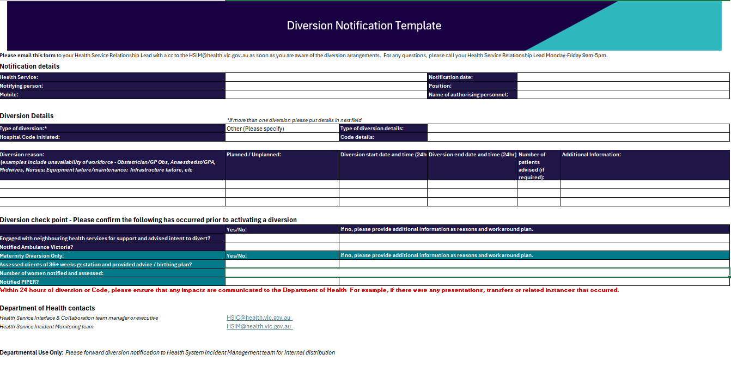



The Mental Health and Wellbeing Act 2022 (MHWA) replaced the existing Mental Health 2014 (MHA) from 1 September 2023.
per section 33 of the Health Services Act 1988
As defined under section 59 of the Health Services Act 1988

