
Serious Transfusion Incident Reporting (STIR) annual report 2019–20
Blood Matters program
OFFICIAL

To receive this document in another format, phone 03 9694 0102, using the National Relay Service 13 36 77 if required, or email STIR<STIR@redcrossblood.org.au>.
Authorised and published by the Victorian Government, 1 Treasury Place, Melbourne.
© State of Victoria, Australia, Department of Health, August 2021.
ISSN 2651-8872 – Online (pdf / word) format
Available at Blood Matters <https://www2.health.vic.gov.au/hospitals-and-health-services/patient-care/speciality-diagnostics-therapeutics/blood-matters>

Contents
Acknowledgements 4
Abbreviations and acronyms 4
Executive summary 6
Key messages 7
Introduction 8
Method 10
Withdrawn reports 11
Validation and reconciliation 11
Demographics 13
Clinical reports 15
Febrile non-haemolytic transfusion reaction (FNHTR) 17
Allergic/anaphylactic 19
Acute haemolytic transfusion reaction 22
ATR other 25
Delayed haemolytic and serologic reactions 26
Transfusion associated circulatory overload (TACO) 28
Transfusion related acute lung injury (TRALI) 31
Transfusion associated dyspnoea 32
Transfusion transmitted infection – bacterial 32
Transfusion-associated graft vs host disease (TAGVHD) 33
Post-transfusion purpura (PTP) 33
Procedural reports 34
Incorrect blood component transfused (IBCT) 35
Procedural – other 37
Near miss 38
Wrong blood in tube (WBIT) 39
RhD immunoglobulin errors 43
Cell salvage 44
Sentinel events 44
Future 45
References 46
Appendix 1: STIR Expert Group members 48
Appendix 2: STIR publications and promotions 49
Appendix 3: Imputability and severity scores 50
Appendix 4: STIR timeline 51

Acknowledgements
The Blood Matters program is a collaboration between the Victorian Department of Health and Australian Red Cross Lifeblood. It is founded on the expectation that providing haemovigilance information supports the community by promoting better transfusion practice.
The Serious Transfusion Incident Reporting (STIR) program thanks the participating Victorian, Tasmanian, Australian Capital Territory and Northern Territory public and private health services for their contribution to the program.
Blood Matters recognises and appreciates the generous in-kind support of the STIR Expert Group, whose input is invaluable in reviewing the incidents and providing recommendations and direction for the work.

Abbreviations and acronyms
Abbreviation | Definition
ABO | the most important of the blood grouping systems
APPT | activated partial thromboplastin time
ATR | acute transfusion reaction
BloodNet | BloodNet is a web-based system that allows staff in health facilities across Australia to order blood and blood products in a standardised way and to do so, quickly, easily and securely from Australian Red Cross Lifeblood
COVID-19 | Coronavirus disease (COVID-19) is an infectious disease caused by a newly discovered coronavirus, causing respiratory illness in those infected
DHTR | delayed haemolytic transfusion reaction
DSTR | delayed serologic transfusion reaction
ECMO | extracorporeal membrane oxygenation
ED | emergency department
EDTA | ethylenediaminetetraacetic acid
EMR | electronic medical record
FBE | full blood examination
FDA | Food and Drug Administration
FFP | fresh frozen plasma
FNHTR | febrile non-haemolytic transfusion reaction
FY20 | financial year 2020, 1 July 2019 – 30 June 2020
Hb | haemoglobin
HFIT | human factors investigation tool
IBCT | incorrect blood component transfused
ICU | intensive care unit
Ig | immunoglobulin
INR | international normalised ratio
Lifeblood | Australian Red Cross Lifeblood
LIS | laboratory information system
MCV | mean corpuscular volume
NSQHS | National Safety and Quality Health Service
NBA | National Blood Authority
PEG | polyethylene glycol
PTP | post transfusion purpura
RCA | root cause analysis
Rh | Rh – blood grouping system, including the D antigen
RhD Ig | RhD immunoglobulin
SCV | Safer Care Victoria
SHOT | Serious Hazards of Transfusion – haemovigilance program in the UK
SR | severity rating
STIR | serious transfusion incident reporting system
TACO | transfusion associated circulatory overload
TAD | transfusion associated dyspnoea
TAGVHD | transfusion associated graft versus host disease
TRALI | transfusion related acute lung injury
WBIT | wrong blood in tube

Executive summary
The Blood Matters program is pleased to present the 2019-–20 Serious Transfusion Incident Reporting (STIR) annual report.
The STIR program is part of a larger program of work to help health services improve the care of patients receiving blood and blood products in Victoria, Tasmania, Northern Territory and Australian Capital Territory.
This report provides information on serious transfusion reactions and incidents reported from these four jurisdictions. Although reporting to STIR is voluntary, the National Safety and Quality Health Service’s (NSQHS) ‘Blood Management Standard’ requires participation in haemovigilance activities and reporting in accordance with national guidelines.
This year, STIR received 214 notifications, with 26 withdrawn by the health service and 22 excluded by the Expert Group, leaving a total of 166 investigations included in this report. Of the 104 health services registered with STIR, 40 (38 per cent) submitted reports.
Clinical reactions to blood products, often unavoidable, are the largest proportion of the investigations received (105, 65 per cent). Procedural errors, including near-miss events, make up the remainder of reports. Although most often these incidents cause little harm to patients, they do provide an opportunity to learn and refine our processes to ensure blood products are handled and used safely.
There was one event reported to STIR as both an acute transfusion reaction and wrong blood in tube (WBIT), in which the WBIT led to the patient receiving a unit of red cells that was ABO incompatible. This was designated severity rating 1 due to the failure of systems and the potential for serious outcomes to the patient.
This highlights the ongoing need to ensure staff understand the positive patient identification process and its importance in all steps of the transfusion chain. This includes clerical staff who admit patients. In this report, there were two incidents where changes were made incorrectly to patient details at time of admission, leading to the wrong blood group being attributed to the patient (WBIT), but fortunately without further serious consequences.
Blood Matters has developed key messages (p. 10) to be shared with clinical and governance staff to help determine if work is needed in these areas and to raise awareness of the issues.

Key messages
Area | Recommendation
Governance | Health services should have a clear process to report and investigate transfusion reactions using both laboratory and clinical investigation.
Clinical | Blood products should only be administered where there is a clear indication for their use and benefit to the patient (case study 3).  A unit of blood disconnected from the patient for any reason should not be recommenced. This is both an infection-control risk as well as a risk of recommencing on the wrong patient if identity checks are not re-performed (case study 13).
Procedural | Staff should be educated to inform the laboratory when a WBIT is identified, so that all specimens/results can be withdrawn, for both patients involved in the error. It is important to ensure wrong or misleading results do not remain in affected patients’ records.  When determining the need for RhD immunoglobulin for women, clinicians should refer to the laboratory information on blood group and not rely on information transcribed into the patient record or in letters or care plans. Transcription errors can cause missed doses of immunoglobulin, putting subsequent pregnancies at risk (case study 18).  This year, there were fewer near-miss events reported. One explanation for this may be because staff see this as something that does not need reporting due to a perceived lack of harm to the patient. However, this is an opportunity to learn how our systems are functioning, where things could potentially go wrong and how we can prevent them. Staff should be educated to report near-miss events.
Patient identification | Positive patient identification is crucial at every step in the transfusion process (case studies 11 and 12).  Health services should ensure that procedures for the identification and registration of patients are consistent and meet minimum requirements for identification to prevent registration errors that confuse patient details. (case studies 15; 16)

Introduction
Welcome to the 2019–20 annual STIR report, incorporating data from 1 July 2019 to 30 June 2020 (FY20).
This reporting year has ended with the World Health Organization declaring 2020 the International Year of the Nurse and the Midwife, an opportunity to recognise and showcase the work and contributions of nurses and midwives to patients and to the health system more broadly.
Nurses and midwives are an important part of the transfusion chain, as they are often the last checkpoint before blood products are given to the patient, and their work is essential in monitoring patients during the transfusion to assess for reactions.
It is well worth remembering that although STIR deals with incidents where a reaction occurs or there is a process failure, the process in most transfusion episodes works well and the right product goes to the right patient, without any adverse outcomes.
We also acknowledge transfusion professionals, who are most commonly nurses. These are often the clinicians who report to STIR, follow up on errors that occur and work to embed the patient blood management practices that help to reduce the need for transfusion.
STIR receives reports on those instances where either the process has not worked as expected or the patient has had a transfusion reaction. STIR aims to analyse and report recurrent or high-risk adverse events to reduce the risk of repetition by others and increase the safety of the transfusion process.
2020 was a particularly challenging year due to the COVID-19 pandemic. We appreciate that with all the uncertainty around workload, transfusion requirements and product availability, health services have continued to maintain transfusion safety and reported to STIR as required.
The 2019–20 report includes information on 166 validated clinical and procedural reports from the 214 notifications received. There were 26 reports withdrawn by the health service prior to submitting investigation forms and 22 reports that after expert review were deemed not related to the transfusion, or had insufficient information for the experts to confirm as transfusion related.
Of the 104 health services registered with STIR, 40 (38 per cent) submitted reports, including 34 public health services, and six private health services. In this reporting period, reactions to blood products, often unavoidable, represent the largest proportion of events received (105, 65 per cent).
Procedural events, which are largely preventable, made up the remainder of all reports (Figure 1).
Figure 1: Number of validated clinical and procedural reports and health services reporting each financial year, FY2006–FY2020
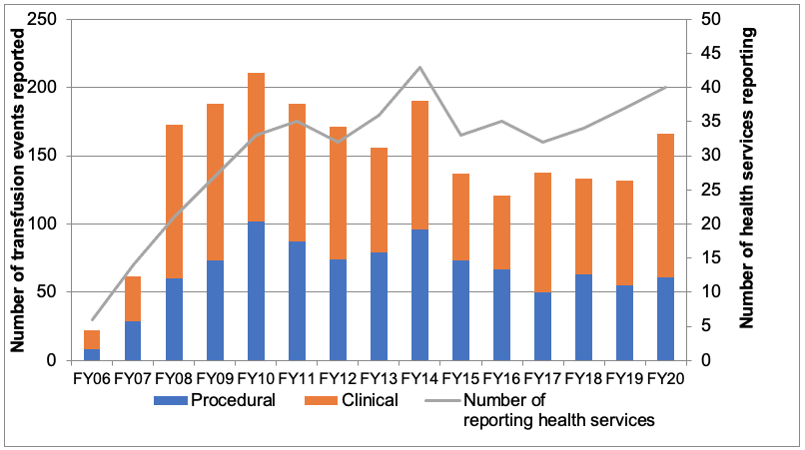
This year, there was one event reported to STIR as both an ATR and WBIT in which the WBIT led to the patient receiving a unit of red cells that was ABO incompatible (see case study 11). The patient had minimal signs of a reaction to this, but was designated severity rating (SR) 1 due to the failure of systems and the potential for serious outcomes to the patient.
A second report of anaphylaxis in a young child was also designated SR 1 after the child required emergency treatment, including cardiopulmonary resuscitation (case study 1). This report was deemed only possibly transfusion related, as the patient was receiving other medications that may have caused the anaphylaxis at the same time.
See Appendix 3 for severity rating definitions.
The National Blood Authority (NBA) via BloodNet provides total blood issue data. Table 1 shows total blood issues per jurisdiction 2019–20 (FY20).
Table 1: Total blood issues per jurisdiction 2019–20 (FY20)
Issues 2019–20 | VIC | ACT | TAS | NT
Total red cells | 171,247 | 9,454 | 12,375 | 3,920
Total platelets | 35,319 | 1,526 | 2,748 | 839
Total FFP | 22,473 | 1,083 | 1,155 | 528
Total cryoprecipitate | 28,365 | 2,823 | 1,908 | 709
Total | 257,404 | 14,886 | 18,186 | 5,995
The NBA data is used to determine an estimate of the frequency of serious clinical reactions to blood (Table 2). As incident reporting is voluntary, this rate would be an underestimate and needs to be considered with care.
STIR also only requires reports of more serious reactions, so does not include all minor reactions. No national data on numbers of patients transfused, or numbers of blood products received by individual patients, to serve as denominator data is available in Australia.
Table 2: Estimated frequency of clinical reactions per product in Victoria
Product | Blood issues (Victoria) | Validated clinical events | Frequency
Red cells | 171,247 | 65 | 1:2,635
Platelets | 35,319 | 16 | 1:2,207
FFP | 22,473 | 9 | 1:2,497
Cryoprecipitate | 28,365 | 1 | 1:28,365

Method
Table 3 shows the steps in the reporting and validation of health service notifications to STIR. There are a number of validation steps built into the process at notification, and on return of investigation forms.
All investigation forms are sent for validation to nominated reviewers from the Expert Group, with all SR 1 and 2 events requiring a full Expert Group panel review.
Table 3: Steps in the reporting and validation of health service notifications
Icon | Steps
 | 214 notifications from health services
 | 26 notifications withdrawn before investigation form returned
 | 188 investigation forms sent to STIR Expert Group for review
 | 22 investigation forms required second review
 | 22 investigations excluded by expert review
 | 166 final validated reports included for analysis

Withdrawn reports
For FY20, 26 reports were withdrawn before an investigation form was received. A further 22 were excluded after expert review.
Table 4 shows the reasons reports were withdrawn. Reports excluded by the Expert Group occur because the report does not fit STIR guidelines for reporting, does not contain enough information for the reviewer to decide whether the patient’s symptoms are due to the blood product administered or because the reviewer considered there was a more likely alternate explanation for the patient’s signs or symptoms.
Table 4: Reasons for withdrawal of notifications to STIR
Financial year | Duplicate | Not in scope | Deemed not transfusion related by health service | Not completed | Excluded after expert review | Total
2012–13 | 2 | 4 | - | 4 | - | 10
2013–14 | 1 | 6 | 4 | 16 | - | 27
2014–15 | 9 | 11 | 6 | 8 | 4 | 38
2015–16 | 6 | 11 | 5 | 5 | 4 | 31
2016–17 | 5 | 4 | 2 | 1 | 5 | 17
2017–18 | 3 | 5 | - | 2 | 15 | 25
2018–19 | 5 | 16 | 3 | 1 | 14 | 39
2019–20 | 9 | 11 | 4 | 2 | 22 | 48

Validation and reconciliation
Validation of data is an important component of the STIR program. All completed investigation forms are reviewed by individual members of the STIR Expert Group. All SR 1 and 2 events are reviewed further by the full Expert Group panel to ensure consistency of reporting. In addition, if the initial reviewer has any uncertainty, these may also go to the group for consensus review and validation.
Infrequently reported reactions, such as transfusion transmitted bacterial infection and TRALI, are also reviewed by the group. These types of reports are also reconciled with Australian Red Cross Lifeblood (Lifeblood) to ensure correct and consistent reporting occurs.
In FY20, Lifeblood received reports of 38 reactions from Victorian health services; five were also reported to STIR, with the remaining 33 not reported to STIR.
Of the five reported to both Lifeblood and STIR:
- three reports reconciled with both Lifeblood and STIR attributing the same diagnosis (TACO, two events; TRALI, one event)
- one event could not be attributed a reaction type on the information provided to STIR (Lifeblood assigned this as TACO)
- one event was determined by STIR to be a possible FNHTR, while Lifeblood decided this was unrelated to transfusion.
The 33 events reported to Lifeblood but not STIR included:
- five from health services not currently reporting to STIR
- 10 were determined to be unrelated to the transfusion and were not reported to STIR
- one not meeting STIR criteria for reporting
- 17 reports that appear to meet STIR criteria for reporting, but were not.
The review process uses the information provided in the investigation forms to confirm the diagnosis, severity rating and imputability as ascribed by the reporting health service. A number of reports had the diagnosis (Table 5) or severity rating (Table 6) changed after expert review.
Table 5: Changes to incident type following STIR Expert Group review
Original incident type | Valid-ated as:  FNHTR | Valid-ated as:  AHTR | Valid-ated as:  Allerg-ic/ anaph-ylactic react-ion | Valid-ated as:  Other acute trans-fusion react-ion | Valid-ated as:  TACO | Valid-ated as:  TAD | Valid-ated as:  DHTR | Valid-ated as:  DSTR | Valid-ated as:  IBCT/ other pro-cedural
FNHTR | - | - | - | 2 | 1 | - | 2 | - | -
ATR – other | 3 | 1 | 1 | - | - | - | - | - | -
TRALI | - | - | - | - | - | 1 | - | - | -
TACO/TAD | - | - | - | - | 1 | - | - | - | -
TACO | 1 | - | - | - | - | - | - | - | -
Bacterial | - | - | - | - | 1 | - | - | - | -
DHTR | - | - | - | - | - | - | - | 1 | -
DSTR | - | - | - | - | - | - | 1 | - | -
Near miss | - | - | - | - | - | - | - | - | 2
Table 6: Changes to the severity rating following expert review
Incident type (number) | Incident severity rating submitted as: | Incident severity rating validated as:
Allergic/anaphylactic reaction (1) | SR4 | SR3
Febrile non-haemolytic transfusion reaction (5) | SR4 | SR3
TACO (2) | SR4 | SR3
DHTR (3) | SR4 | SR3
DSTR (1) | SR4 | SR3
IBCT (1) | SR4 | SR3
IBCT (1) | SR2–3 | SR1

Demographics
Figure 2: Number of validated reports per reporting jurisdiction
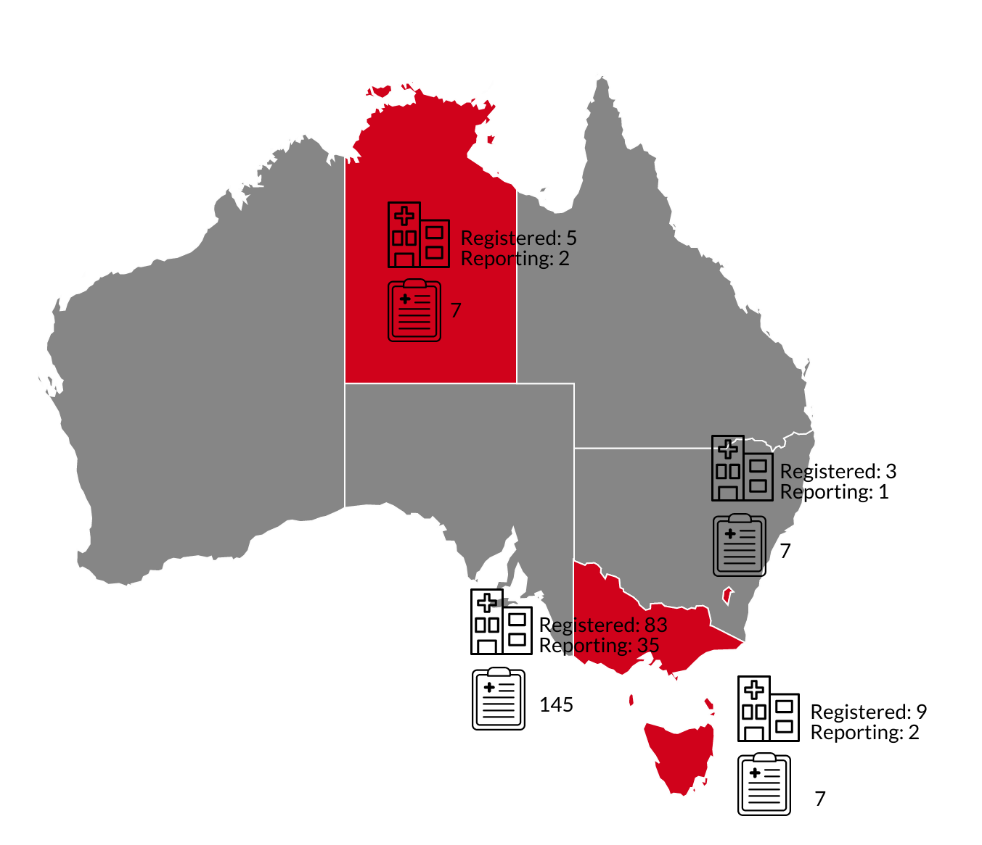
Table 7: Demographics for all validated reports
Demographic | Statistic
Age | 0–96 years (mean 52 years)
Gender | Male: 54 (41%); female: 78 (59%)
Blood products notifications | Red cells: 84  Platelets: 19  Fresh frozen plasma: 9  Cryoprecipitate: 1  Multiple products: 4  RhD Ig: 19
Other | (includes WBIT n = 27 and near miss n = 3): 30

Clinical reports
In this period, there were 105 clinical reports validated. The largest proportion of these were allergic (29, 28 per cent) and FNHTRs (22, 21 per cent).
Figure 3: Validated clinical reactions FY20
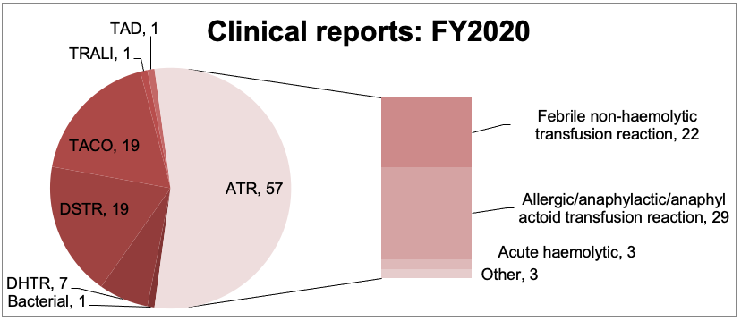
For a small number of reports it was noted that a complete work up post reaction to eliminate a more serious cause of the reaction did not occur.
Health services should have a clear process for the reporting and investigation of transfusion reactions.
The investigation process should include both a clinical and laboratory component.
The clinical component should include:
- patient condition, reason for admission and transfusion
- all signs and symptoms associated with the suspected adverse reaction
- any comorbidities or preceding clinical features to which current signs and symptoms may be attributed
- treatment and response to treatment
- previous history of transfusion, pregnancy or transfusion reactions.
Depending on the signs and symptoms exhibited, investigations could include:
- blood cultures both patient and unit (fever), if possible
- chest X-ray (respiratory compromise)
- haemolytic screen, Hb/platelet increment
- pretransfusion IgA levels for severe allergic/anaphylactic reaction.
The laboratory investigation will centre around confirming compatibility of the unit with the patient and parameters of haemolysis:
- repeat group and screen
- direct antiglobulin test (DAT)
- urine and serum samples to examine for signs of haemolysis.
While all transfusions should be stopped at the first signs of a reaction and until the patient is reviewed, not all transfusions will need to be discontinued. Where the reaction is relatively mild and the patient responds well to treatment, the transfusion may be able to be recommenced (usually at a slower rate).
Note, the transfusion still needs to be completed within four hours of release from storage. If signs and symptoms reappear after recommencing then consider discontinuing transfusion of that unit.

Febrile non-haemolytic transfusion reaction (FNHTR)
Table 8: Data summary – febrile non-haemolytic transfusion reaction, n = 22
Characteristic | Number | Percentage
Age: < 1 year | -
Age: 1–18 years | 1 | 5%
Age: 19–29 years | -
Age: 30–49 years | 4 | 18%
Age: 50–69 years | 3 | 14%
Age: 70–79 years | 8 | 36%
Age: 80+ years | 6 | 27%
Gender: male | 10 | 45%
Gender: female | 12 | 55%
Implicated blood product: red cells | 21 | 95%
Implicated blood product: platelets | 1 | 5%
This report includes 22 FNHTRs, 21 per cent of all clinical reports, which was the second most common type of transfusion reaction in this period.
Febrile non-haemolytic transfusion reactions are reported to occur in 0.1 per cent to 1 per cent of transfusions with leucocyte depleted products (Fung MK [ed.] 2014). STIR may have fewer reports than literature suggests as STIR only receives reports of more serious events.
The STIR definition for reporting is:
Fever (> 38.5° C or a change of 1.5° C above baseline), occurring during or within four hours of the transfusion with one or more of the following:
- chills/rigor
- headache
- nausea/vomiting.
Reports to STIR most often related to red cells and occurred in most age groups and relatively evenly across gender (Table 8).
Table 9: Severity rating and imputability – febrile non-haemolytic transfusion reaction
Severity rating | Imputability:  certainly | Imputability:  probably | Imputability:  possibly | Total
SR 1 | - | - | - | -
SR 2 | - | - | - | -
SR 3 | - | 2 | 8 | 10
SR 4 | - | 3 | 9 | 12
Total | - | 5 | 17 | 22
Imputability and severity rating tend to be low (SR 3-4 and imputability possible most often) as described in Table 9. FNHTR is a diagnosis of exclusion based on clinical findings, absence of product incompatibility and elimination of other causes for the fever. It is important to exclude other more serious reactions in which fever may be a sign, e.g. bacterial sepsis, haemolytic reactions.
Treatment for FNHTRs (Table 10) most often included the use of antipyretics, which would be appropriate for patient comfort. A small number of patients also required oxygen. Antihistamines are unlikely to be useful in this type of reaction, however two patients received antihistamine as part of the treatment. This occurred in reactions with higher severity rating and may have occurred prior to definitive diagnosis. A small number of patients received no treatment for the reaction. As STIR accepts reports for more serious reactions, it is expected that most patients would receive some form of treatment.
Table 10: Immediate treatment given at time of reaction by severity rating
Treatment | SR3 | SR4
Antipyretics | 6 | 9
Antihistamine | 2 | -
Oxygen | 3 | -
IV fluids | - | 1
No treatment | 1 | 2

Allergic/anaphylactic
Allergic reactions (n = 24) were the most often reported acute transfusion reaction, at 28 per cent of clinical reports. Anaphylactic reactions which most often occurred in younger patients, accounted for 17 per cent of all allergic reactions (Table 11). This includes one SR1 event and eight SR2 (Table 12).
Table 11: Data summary – allergic and anaphylactic reactions
Characteristic | Allergic  n = 24 | Anaphylactic  n = 5
Age: < 1 year | - | -
Age: 1–18 years | 9 (38%) | 3 (60%)
Age: 19–29 years | - | 2 (40%)
Age: 30–49 years | 3 (13%) | -
Age: 50–69 years | 6 (25%) | -
Age: 70–79 years | 5 (21%) | -
Age: 80+ years | 1 (4%) | -
Gender: male | 9 (38%) | 2 (40%)
Gender: female | 15 (63%) | 3 (60%)
Implicated blood product: red cells | 4 (17%) | -
Implicated blood product: FFP | 7 (29%) | 2 (40%)
Implicated blood product: platelets | 13 (54%) | 2 (40%)
Implicated blood product: cryo | - | 1 (20%)
Table 12: Severity rating and imputability – allergic and anaphylactic reactions
Severity rating | Imputability:  certainly | Imputability:  probably | Imputability:  possibly | Total
SR 1 | - | - | 1 | 1
SR 2 | - | 5 | 3 | 8
SR 3 | 3 | 9 | 4 | 16
SR 4 | 1 | 2 | 1 | 4
Total | 4 | 16 | 9 | 29

Case study 1: Anaphylactic reaction in an infant
A patient undergoing cardiac surgery was given a bag of pooled platelets. They had also received a unit of red cells and bag of FFP for prolonged cardiopulmonary bypass and active bleeding.
Approximately 10 minutes into the transfusion, the patient became hypotensive and went into cardiac arrest.
As the patient was largely covered by surgical drapes, it was difficult to assess some of the signs of an allergic reaction, such as skin rash. The patient was treated with antihistamine, steroids, adrenaline, cardiopulmonary resuscitation and defibrillator.
Postoperatively, the patient required extracorporeal membrane oxygenation and an extended intensive care unit (ICU) admission.
Investigations showed tryptase 5.3 micrograms/L (within normal range) and IgA level, taken on a pre-operative sample was 0.15 mg/L, (low compared with normal range). The patient went on to have another similar, but less severe reaction reported after a further platelet transfusion.

Comments
Validated by STIR as a possible anaphylactic reaction, SR 1.
Although the reaction in both instances was severe, determining that transfusion was the cause of the reaction was difficult. In both instances, the patient was receiving concomitant drugs (in theatre and in ICU) and while one explanation for these reactions is the transfusion, other causes could not be completely excluded.
The follow-up by the health service was appropriate and awareness of the first reaction meant the health service was cautious when administering further blood products. Although a further reaction was unpredictable, the health service was aware of the risk and could monitor and take appropriate action when a second reaction occurred.
Although it does not appear to be the case for this reaction, consideration should be given to a potential allergic reaction associated with reduced IgA levels and the development of IgA antibodies.

Patients with IgA deficiency
Total immunoglobulin A deficiency is defined as an undetectable serum IgA level at a value < 0.05 g/L. Partial IgA deficiency refers to detectable but decreased IgA levels that are more than 2 standard deviations below normal age-adjusted mean.
Although a significant proportion of these patients will develop anti-IgA antibodies, it is rare for anti-IgA antibody-mediated transfusion reactions to occur, estimated at 1.3 per million units of blood products transfused in one study (Latiff A and Kerr M 2007). Where they do occur, IgA deficient or washed red cells may be used for these patients, after consultation with Transfusion Medicine Specialist at Lifeblood.

Case study 2: allergic reaction to FFP, for warfarin reversal
A 79-year-old man was being prepared for emergency surgery for investigation of worsening abdominal pain. The man was taking warfarin (INR 2.8) and was given Prothrombinex, vitamin K and a bag of FFP to reverse the effect prior to surgery (INR 2.0).
Approximately 20 minutes into the transfusion he developed nausea and vomiting, diaphoresis and severe hypotension, requiring Metaraminol, as well as decreased oxygen saturation (95% to 90% on room air), requiring oxygen therapy.

Comments
Validated by STIR as a severe allergic reaction, SR 3.
Although the use of FFP may still be considered appropriate in order to replace FVII (not present in Prothrombinex), adequate reversal of warfarin without additional blood products is often achievable with Prothrombinex and/or vitamin K alone if giving adequately in advance and at appropriate dose (refer to the warfarin reversal guidelines <https://www.mja.com.au/journal/2013/198/4/update-consensus-guidelines-warfarin-reversal> for more information).

Case study 3: Anaphylaxis to FFP, given without clear indication
A 24-year-old woman in ICU, with a prolonged hospital stay, underwent rapid infusion (10 minutes) of a bag of FFP in preparation for surgery as assessed to be at ‘extreme risk of a major bleeding’ despite normal coagulation profile (INR 1.2; APTT 32).
The patient developed facial flushing, urticaria, tachycardia, hypotension and dyspnoea. She was treated with antihistamine, adrenaline and oxygen therapy.
Investigations showed tryptase was normal (5.7 micrograms/L).
The patient required no further blood product support during her admission.

Comments
Validated by STIR as probable anaphylaxis, SR 2.
Administration of blood products, outside of clinical appropriateness guidelines, without consideration of the true need, benefits and risks is to be discouraged.
This patient had a normal coagulation profile, and it does not appear there was benefit in transfusing FFP prophylactically.
The rate of transfusion (10 minutes) may also have been excessive given the patient was not bleeding and there was no clinical urgency. Giving the product quickly may have caused the reaction to be more fulminant than otherwise, as the entire product, with the presumed causative allergen, had been administered before the reaction began.
There was no opportunity to mitigate the reaction by stopping infusion of more allergen.

Acute haemolytic transfusion reaction
ABO/Rh incompatibility occurs in about 1:40,000 transfusions (Fung MK [ed.] 2014). Acute haemolytic reactions can be either immune or non-immune mediated. Immune reactions may be associated with:
- ABO/Rh mismatch (case study 4)
- red cell antibodies (non-ABO) as a result of patient immunisation from previous pregnancy or transfusion (case study 5)
- rare cases when group O donor platelets with high titres of anti-A and/or anti-B are transfused to a non-group O recipient.
Transfused red cells are destroyed due to incompatibility of antigen on transfused red cells with antibody in the recipient circulation (refer to Lifeblood’s acute haemolyitc reaction page <https://transfusion.com.au/adverse_transfusion_reactions/acute_haemolytic_reaction> for more information).
Table 13: Data summary – acute haemolytic reactions, n = 4
Characteristic | Number | percentage
Age: < 1 year | - | -
Age: 1–18 years | - | -
Age: 19–29 years | - | -
Age: 30–49 years | 1 | 25%
Age: 50–69 years | 3 | 75%
Age: 70–79 years | -
Age: 80+ years | -
Gender: male | 2 | 50%
Gender: female | 2 | 50%
Implicated blood product: red cells | 4 | 100%
STIR has received small numbers of reports (three) of acute haemolytic reactions due to ABO incompatibility over the past 10 years.
The Serious Hazards of Transfusion (SHOT) report for 2019, which has been receiving reports from all health services in the UK for many years, reported six ABO incompatible transfusions (four related to red cells and two to FFP), with no deaths reported and no major morbidity.
In the USA, the Food and Drug Administration (FDA) found that the rate of fatalities due to ABO incompatible transfusions has declined to from one death per two million red cells in 2000–09 to one in 7.1 million red cell transfusions in 2010 to 2019 (Storch EK, Rogerson B, Eder AF 2020).
The FDA report also notes only 61 per cent of fatal transfusions were reported to the transfusion service on the day of transfusion, and in many cases the diagnosis was significantly delayed. This may be due to adequate supportive care resulting in delayed recognition of acute haemolytic transfusion reactions among patients with complex comorbid conditions.
In Victoria, reporting of ABO incompatible transfusions is part of the Safer Care Victoria (SCV) sentinel event program. A haemolytic blood transfusion reaction resulting from ABO incompatibility that leads to serious harm or death must be reported.
Serious harm is considered to have occurred when, as a result of the incident, the patient has:
- required life-saving surgical or medical intervention
- shortened life expectancy
- experienced permanent or long-term physical harm, or
- experienced permanent or long-term loss of function.
When determining whether or not serious harm has occurred, health service staff should adopt a consumer-focused approach.
All public and private health services, and all services under their governance structures, are required to report sentinel events to SCV (Safer Care Victoria 2019).
However, this does not require the reporting of all ABO incompatible transfusion events, and may underestimate the number of these events that occur, if health services do not report events in which no ‘serious harm’ occurred. In the 2019–20 sentinel event report, there are no reports of ABO incompatible transfusions.
STIR is not a mandatory haemovigilance reporting scheme, and the Expert Group is aware, via personal communications, that a small number of ABO incompatible transfusions (not necessarily fatalities) are not reported.
The apparent decrease in occurrence from data reported overseas does not mean we can relax. Processes must be in place to ensure the correct product is cross matched for and administered to the correct patient, as the majority of these events should never occur. The FDA report noted that over 50 per cent of errors could have been prevented by the appropriate and complete bedside checking procedure prior to administration.
Changes to how we work, for example the implementation of electronic medical records, can help to reduce risk further, or be a potential source of new risk.
Although ABO incompatible transfusions are of greatest concern, serious transfusion reactions can also occur with other red cell alloantibodies. The majority of acute haemolytic reactions reported to STIR occur as a result of these other red cell alloantibodies.

Case study 4: Acute haemolytic reaction due to ABO incompatible transfusion
Refer to ‘Case study 11: IBCT due to WBIT’.

Comments
Despite receiving an ABO incompatible unit of red cells (B RhD negative red cells to A RhD positive patient), this patient only showed a mild elevation of bilirubin, with other markers for haemolysis unchanged.

Case study 5: Non-ABO haemolytic transfusion reaction due to anti-PP1Pk
A 57-year-old man was admitted for surgical management of empyema. He was found to have a haemoglobin (Hb) 71g/L and he received a unit of red blood cells.
An hour into the transfusion, he became tachycardic (70 to 140 beats/minute), hypertensive (110/70 to 210/122), with dyspnoea (18 to 30 breaths/minute), chills and rigors. Post-transfusion testing showed a positive haemolysis screen. He required ICU admission for monitoring and care.
The patient had no transfusion history with the laboratory. The pretransfusion antibody screen was positive due to an autoantibody.
A serological cross-match was performed and the least incompatible unit was transfused. The post-transfusion specimen and the unit were compatible using adsorbed plasma. The reported clinical features, review of the clinical record and pathology results suggested a likely non-ABO haemolytic transfusion reaction.
Anti-PP1Pk antibody was subsequently identified by Lifeblood Red Cell Reference laboratory.

Comments
Validated by STIR as an acute haemolytic reaction, SR 2.
These types of rare antibodies are difficult to detect using current serological techniques that are aimed at finding common incompatibilities. Anti-PP1Pk is produced by all p individuals without red cell sensitisation by transfusion or pregnancy. The antibody is usually a mixture of IgM and IgG, and efficiently binds complement, which can make it a potent haemolysin.
This patient should be provided with a medical alert that he can share with other health services. Ideally, a national red cell antibody registry would assist laboratories to manage these types of patients.

ATR other
Three events were validated as ATR – other. The events, as reported, did not fit into the usual category of reaction type, but a transfusion reaction could not be excluded.
Table 15: Data summary – acute transfusion reactions, other causes n = 3
Characteristic | Number | percentage
Age: < 1 year | - | -
Age: 1–18 years | - | -
Age: 19–29 years | - | -
Age: 30–49 years | - | -
Age: 50–69 years | 1 | 33%
Age: 70–79 years | 1 | 33%
Age: 80+ years | 1 | 33%
Gender: male | 2 | 67%
Gender: female | 1 | 33%
Implicated blood product: red cells | 3 | 100%

Delayed haemolytic and serologic reactions
Delayed haemolytic transfusion reactions are almost invariably caused by secondary (anamnestic) immune responses in patients immunised by previous transfusions, allogeneic stem-cell transplants, or pregnancy (Panch SR, Montemayor‑Garcia C, Klein HG 2019). Where new alloantibodies appear on routine blood bank testing within three months of a transfusion and are not associated with clinical manifestations, these are reported as delayed serologic transfusion reactions.
In the FY20 period, there were more serologic than haemolytic reactions reported, with more females developing antibodies (Table 16).
Imputability depends on the ability to link the transfusion to the antibody found. Where possible, reports are classified as certain. However, in some instances, imputability is less obvious, or the information is not available (Tables 17 and 18).
Table 16: Data summary – delayed haemolytic and delayed serologic reactions
Characteristic | DHTR  n = 7 | DSTR  n = 19
Age: < 1 year | - | -
Age: 1–18 years | - | -
Age: 19–29 years | - | -
Age: 30–49 years | - | 6
Age: 50–69 years | 3 | 5
Age: 70–79 years | - | 6
Age: 80+ years | 4 | 2
Gender: male | 3 | 8
Gender: female | 4 | 11
Implicated blood product: red cells | 7 | 19
Table 17: Severity rating and imputability – delayed haemolytic reaction
Severity rating | Imputability: certainly | Imputability: probably | Imputability: possibly | Total
SR 1 | - | - | - | -
SR 2 | 1 | - | - | 1
SR 3 | 3 | 1 | 1 | 5
SR 4 | 1 | - | - | 1
Total | 5 | 1 | 1 | 7
Table 18: Severity rating and imputability – delayed serologic reaction
Severity rating | Imputability: certainly | Imputability: probably | Imputability: possibly | Total
SR 1 | - | - | - | -
SR 2 | - | - | - | -
SR 3 | - | - | 7 | 7
SR 4 | 11 | 1 |  | 12
Total | 11 | 1 | 7 | 19

Case study 6: Delayed haemolytic reaction with multiple antibodies detected
An 85-year-old woman was admitted with chest pain on background of anaemia (Hb 49 g/L) due to gastrointestinal blood loss.
She was administered three units of red cells via electronic cross match, (O positive units to O positive patient) in the emergency department (ED), with no reaction at the time of transfusion.
Two weeks later, she was readmitted due to jaundice (bilirubin 105 mg/dL) and recurrent anaemia, with a positive DAT, elevated LDH (980 units/L), a low haptoglobin (<0.06 g/L) and evidence of spherocytosis on her blood film.
Historical and immediate pretransfusion testing produced a negative antibody screen. On post-transfusion testing, she had a positive antibody screen, an elution reacting with all panel cells except D negative cells. The patient had three red cell alloantibodies identified, anti-c, anti-E and an anti-MAR-like antibody.

Comments
Validated by STIR as a DHTR, certainly, SR 2.
This patient’s specimen was sent to the Red Cell Reference laboratory at Lifeblood. It was noted there were no known donors suitable for this patient in Australia and that transfusion would be difficult for this patient and required a search for appropriate donors.
In this case, it was suggested that if she had suitable siblings who could become or are donors, this should be considered.
Of note in the results sent, her blood film also indicated changes consistent with iron deficiency. Investigation and management of the iron deficiency would be essential in this patient to try and reduce the need for transfusion in the future.

Transfusion associated circulatory overload (TACO)
In the 2019 SHOT report, TACO resulted in nine deaths, with a further 33 patients experiencing major morbidity. This remains the main cause of transfusion-related death in the UK. In the same report TRALI was associated with three reports and no deaths.
The estimated frequency of TACO in haemovigilance reports, varies from 1 per cent up to 8 per cent in postoperative elderly patients, and up to 11 per cent in critically ill patients (Semple JW, Rebetz J and Kapaur R 2019).
The majority of TACO reports received by STIR occurred in the over-50 age group, with 53 per cent occurring in those over 70 years of age (Table 19). There were no SR1 reports, but six SR2 reports in this period (Table 20).
Table 19: Data summary – TACO, n = 19
Characteristic | Number | Percentage
Age: < 1 year | - | -
Age: 1–18 years | 1 | 5%
Age: 19–29 years | - | -
Age: 30–49 years | 2 | 11%
Age: 50–69 years | 6 | 32%
Age: 70–79 years | 6 | 32%
Age: 80+ years | 4 | 21%
Gender: male | 8 | 42%
Gender: female | 11 | 58%
Implicated blood product: red cells | 15 | 79%
Implicated blood product: FFP | 2 | 11%
Implicated blood product: platelets | 4 | 21%
Table 20: Severity rating and imputability – TACO
Severity rating | Imputability: certainly | Imputability: probably | Imputability: possibly | Total
SR 1 | - | - | - | -
SR 2 | 1 | 5 | - | 6
SR 3 | 3 | 6 | 2 | 11
SR 4 | - | - | 2 | 2
Total | 4 | 11 | 4 | 19
Diagnostically, it remains challenging to distinguish TACO and TRALI from underlying causes of lung injury and/or fluid overload as well as from each other (Semple JW, Rebetz J and Kapaur R 2019).

Case study 7: Possible TACO
A 76-year-old woman with a lymphoproliferative neoplasm was being transfused for symptomatic anaemia. Approximately two and a half hours after the transfusion had commenced and 150 mL given, the patient developed dyspnoea, with a fever (1.4 degree rise from baseline).
Her pretransfusion fluid volume was unknown, pretransfusion weight was 76 kg, but no post-transfusion weight provided. She was not on a regular diuretic. She was reported to have received a diuretic, along with hydrocortisone and salbutamol as treatment for the reaction.
Chest X-ray showed mild bilateral pulmonary congestion, echocardiogram showed normal left ventricular size and systolic function, with moderate tricuspid regurgitation. All other investigations, serological compatibility and bacterial cultures were normal.

Comments
STIR validated this event as possible TACO, SR 3.
In this case of fever and dyspnoea, the differential diagnosis could include an underlying infection, however, bacterial culture of patient and product were negative. TRALI was unlikely as the chest X-ray was not consistent with this diagnosis. The health service completed all investigations to help eliminate other possible causes and determined the most likely cause in this patient was TACO.
Although fever is not generally associated with TACO, STIR Expert Group agreed TACO was a possible explanation in this patient.

Case study 8: TACO intraoperatively
An 80-year-old woman was admitted with exacerbation of congestive cardiac failure (CCF) and underwent an aortic and mitral valve repair.
Over a four-hour period in theatre, the patient was administered four units of red cells, five bags of FFP, and one bag of platelets. She was not receiving concomitant fluids, and was noted to have a positive fluid balance, although volume was not reported.
She was receiving regular diuretics prior to the reaction. She had an increased fraction of inspired oxygen (FiO2) requirement and was difficult to ventilate during surgery and in recovery, with reduced oxygen saturation.
She had an increased requirement for oxygen, with the patient already intubated for surgery. Of note the transfusion continued, uninterrupted.
Reported chest X-ray showed bilateral pleural effusions. The health service initially thought this may be TRALI and reported this to Lifeblood, however this was excluded by Lifeblood.

Comments
STIR validated as TACO, probably SR 2.
This is a patient with multiple risk factors for TACO including older age, pre-existing cardiac condition and diuretic requirement, and positive fluid balance. It is important to monitor these patients closely, as would be the case intraoperatively, and have a high degree of suspicion of signs and symptoms that may indicate overload, so treatment can be started promptly.
Several years ago Blood Matters developed a checklist to help clinicians assess the risk of TACO (Figure 4).
Figure 4: TACO checklist
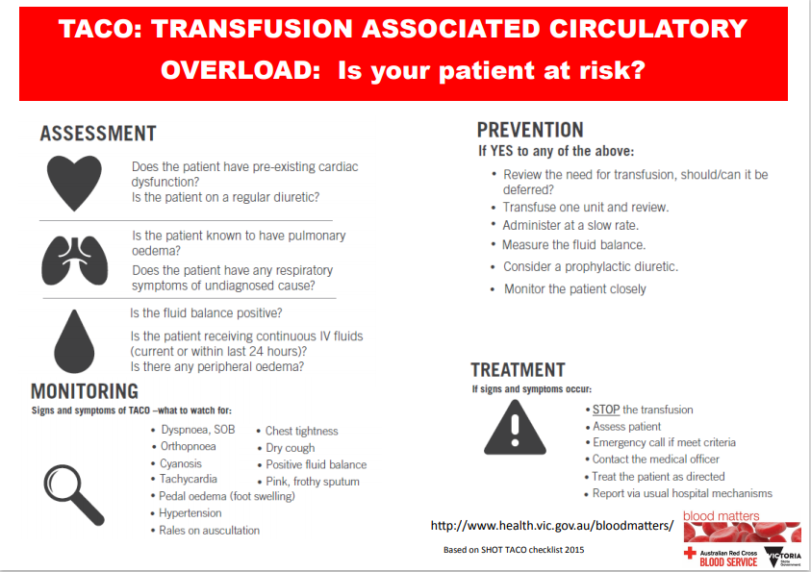

Transfusion related acute lung injury (TRALI)
In FY20, there were two reports of TRALI to STIR. One was validated as a possible TRALI, despite no confirmatory donor antibodies that may have caused the reaction. This event was confirmed with Lifeblood as a possible TRALI. As noted previously, there were three confirmed cases of TRALI to SHOT in the 2019 report, with no deaths.

Case study 9: Validated possible TRALI
An 83-year-old man was admitted with febrile neutropenia, on a background of myelodysplasia. He was found to have symptomatic anaemia, Hb 73g/L and transfusion of a unit of red cells was commenced.
The transfused unit was completed prior to signs and symptoms of a reaction occurring.
The patient developed respiratory wheeze, dyspnoea and reduced oxygen saturation, requiring high-flow oxygen. He was given frusemide due to risk of TACO (> 1L positive fluid balance, history of pulmonary fibrosis and recent myocardial infarction), without improvement in his condition.
He continued to experience worsening respiratory symptoms with arterial blood gas consistent with type I respiratory failure. The next day, computed tomography scan showed widespread ground glass opacities in both lungs.
The health service continued to treat the patient empirically for an infectious agent. Unfortunately, after discussion of the patient’s wishes regarding further treatment, he passed away four days after the transfusion.
Lifeblood was informed of the event and the health service requested their opinion as to TRALI as a potential cause of the respiratory signs and symptoms.
In this patient. Lifeblood were able to test the donor who had no neutrophil or human leukocyte antigen (HLA) class I or II IgG antibodies detected.
The interpretation was that this was a possible case of TRALI with no donor antibodies detected. As noted by Lifeblood, TRALI is still primarily a clinical diagnosis.

Comments
This was validated by STIR as possible TRALI, SR 2.
When the STIR Expert Group reviewed this case they also considered Lifeblood’s determination about the likelihood of TRALI and came to a consensus consistent with Lifeblood.
As noted, diagnosis of TRALI remains a primarily clinical diagnosis. In this case differential diagnosis included respiratory infection, TACO or possible progressive pulmonary fibrosis. The lack of improvement after diuretics indicates TACO is less likely, the pre-existing respiratory infection had been improving prior to the transfusion and there had been no indication of progression of pulmonary fibrosis prior to transfusion. TRALI remains a possibility in this case.

Transfusion associated dyspnoea
There was only one validated event of TAD, which was initially submitted by the health service as a TACO event.
In addition, another four reports of TAD were received; however, they were excluded following expert review due to either being unlikely to be transfusion-related or not enough information to assess.

Case study 10: Possible TAD
A 73-year-old man with anaemia (Hb 47g/L) associated with an upper gastrointestinal bleed, was receiving a fourth unit of red cells when he developed dyspnoea with fever. The patient required admission to ICU with assisted ventilation.
The health service did not report use of diuretics or other treatments. A chest X-ray at the time was suggestive of either unilateral oedema or infection. A follow up chest X-ray approximately seven hours later showed improvement of earlier abnormalities.
This was reported to STIR as TACO, with the possibility of TRALI.

Comments
The STIR Expert Group validated this as possible TAD, SR 2. The reported negative fluid balance, unilateral oedema or possible infection, associated with fever and lack of diuretics, meant this report did not meet the criteria for TACO. This was assigned possible TAD, although it was recognised that this reaction may be due to and newly developed respiratory infection.

Transfusion transmitted infection – bacterial
There were two notifications of bacterial infection associated with transfusion. Following expert review, one event was confirmed as a TACO. This was noted as a possible diagnosis by the health service with the patient admitted with acute pulmonary oedema. Although a staphylococcus species was grown from the blood bag, this was considered likely to be a contaminant. The patient did not become febrile and had three sets of blood cultures that were negative.
The second notification was confirmed as bacterial, which was also supported by the Lifeblood review. The patient received a bag of pooled platelets in a day area, and became febrile with rigors, tachycardia, hypotension and dyspnoea. Care was escalated with a code blue call and transfer to ICU for three days. Patient and product cultures grew Staphylococcus aureus.
Transfusion transmitted infections are rare. For platelets, the risk is estimated at 1:250,000 units, for red cells it is less than 1:1 million units (Lifeblood 2019). Patients frequently become febrile during transfusions, and they should always be assessed for the potential to have received a bacterially contaminated unit. However, all other causes, including those unrelated to the transfusion, should be considered. Where there is any concern regarding the patient condition, the transfusion should be stopped and appropriate investigation and treatment commenced as soon as possible. Broad-spectrum antibiotic cover can be lifesaving if a bacterial infection has occurred.
STIR bulletin no. 7 relates to transfusion-transmitted bacterial infection and current mitigation strategies in Australia <https://www2.health.vic.gov.au/about/publications/factsheets/Transfusion-transmitted-bacterial-infection-and-current-mitigation-strategies-in-Australia>.

Transfusion-associated graft vs host disease (TAGVHD)
As in previous years, there have been no reports of TAGVHD in FY20.
TAGVHD is extremely rare, presenting within one to two weeks of the implicated transfusion and leading to profound marrow aplasia with a mortality rate greater than 90 per cent (Australian Red Cross Lifeblood 2021b).
Like SHOT we have had a number of reports of IBCT where the patient received a non-irradiated unit when this was a known transfusion requirement. Despite this we have not received any reports of TAGVHD.
Leucodepletion may provide some protection from TAGVHD, but should not be relied on. As noted in the 2020 British Society of Haematology Transfusion Task Force, Guidelines on the use of irradiated blood components, there is insufficient evidence to recommend leucocyte depletion alone to prevent TA-GvHD in susceptible patients. Irradiation of blood components for patients at risk, remains the best prevention.

Post-transfusion purpura (PTP)
PTP is a rare, delayed transfusion reaction where a patient develops dramatic, sudden and self-limiting thrombocytopenia, typically 7 to 10 days after a blood transfusion (Australian Red Cross Lifeblood 2021c).
Patients usually have a history of sensitisation by either pregnancy or transfusion with five times more female patients affected than males.
PTP is considered a self-limiting disease with recovery of platelet counts in approximately 20 days. However, severe and life-threatening bleeding can occur due to the profound thrombocytopenia that may be associated with this.
Again, in FY20, there have been no reports of this reaction to STIR. In the NBA Annual haemovigilance report for 2018–19, there was one report from a non-STIR jurisdiction.

Procedural reports
Figure 5: Validated procedural events FY20
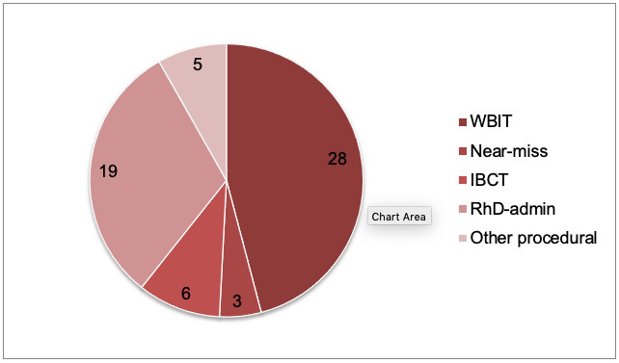
In FY20, there were 61 reported procedural events validated by expert review. This is 37 per cent of reports received by STIR.
As in previous years, wrong blood in tube (WBIT) is the largest proportion of reports received, with 28 (46 per cent).
RhD immunoglobulin errors are the second most common reported procedural event with 19 (31 per cent), followed by incorrect blood component transfused (IBCT) with six reports (10 per cent).
Human factors influence the number and types of reports seen. While it is difficult to address these issues, it is important that we minimise the chance for human error. Staff do not come to work intending to make mistakes, but the busy and complex work environment adds to the chance of errors occurring.
Rather than blaming the error on an individual, investigation should focus on underlying systems and processes to assess how they may have influenced the person or event. This enables the institution to learn from errors. If the workforce sees the organisation as blaming an individual rather than addressing the underlying issues, they may be less likely to report errors and engage in activities to reduce errors.
SHOT has developed a human factors investigation tool (HFIT) for transfusion safety incidents over the last few years. SHOT has also developed training resources to improve the value of root cause analysis (RCA) investigations. and suggests that the HFIT questions could be added to local incident investigation documents, so human factors are considered while gathering information (SHOT 2019). The 2019 report includes a chapter on human factors in error incidents. Refer to Useful tips for the SHOT Human Factors Investigation Tool (HFIT) <https://www.shotuk.org/wp-content/uploads/myimages/HFIT-Training-2021.pdf>.

Incorrect blood component transfused (IBCT)
Table 21: Types of IBCT events FY20
Category | Number reported  N = 6
Antigen-antibody issues | 2
Components that did not meet specific requirements for patient | 1
ABO compatible | 1
ABO incompatible | 1
ABO incompatible (plasma) | 1

Case study 11: IBCT due to WBIT
A 68-year-old woman was admitted for elective surgery. Pre-surgery investigations included a full blood examination (FBE) and group and screen. In the postoperative period she developed symptomatic anaemia and was ordered a red cell transfusion.
Within an hour of starting a unit of red cells, the patient developed a fever (two degree rise) and rigors but no other change in vital signs. She was treated immediately with intravenous antibiotics (assuming possible bacterial infection) and fluids. Investigation included compatibility check, blood culture of both patient and product (cultures were negative), disseminated intravascular coagulation and haemolysis screen (both within normal limits), Hb incremented from 80 g/L to 89 g/L. The patient length of stay was increased by 24 hours.
Investigation showed the pretransfusion specimen typed as B RhD positive, and the patient was transfused a B RhD negative unit. However, on post-transfusion testing the lab found a mixed field with cells of A RhD positive. Further testing on another EDTA specimen (FBE pretransfusion) found this specimen was A RhD positive.
The unit of blood transfused was incompatible for this patient.
This was the patient’s first presentation to this health service. There was no historical blood banking record for this patient. The specimen was collected as a routine specimen, during business hours, on the ward and the collector was certain they had followed the correct checking procedures, but could not otherwise account for the wrong blood in tube.
Fortunately, the only sign of reaction in this case was the fever. There is a real likelihood an event such as this could lead to the patient’s death.

Comments
This event was reported as a WBIT and ATR, the STIR Expert review also recorded this as an IBCT (B RhD negative unit to A RhD positive patient – ABO incompatible). Due to the patient actually receiving an incorrect blood component, and the serious risk this posed to the patient, this event was rated SR 1.
This was reported to STIR via the laboratory and information on the health service investigation was not provided despite requests from STIR to the health service.

Case study 12: Wrong red cell unit sent from laboratory and administered during massive transfusion
Patient in the ED required urgent transfusion due to bleeding oesophageal varices. The laboratory sent a unit of red cells.
However, the scientist had inadvertently sent an O RhD negative unit cross matched for another patient.
At the bedside, the nurses performing the checks noted the unit was O RhD negative, but not that it was assigned to a patient other than the one for whom they were checking the blood.
The blood was administered without any problems for the patient and the transfusion was complete before the error was noted.

Comments
This was validated by STIR as an IBCT, SR 4.
Regardless of the urgency of transfusion, safety protocols need to be followed. Patient identification and requirements of products must be communicated to the laboratory, in every instance. Ideally this should be written communication to allow for checking in the laboratory of the product dispensed with the request.
At the time of administration checking procedures must be followed to ensure the correct product is transfused to the correct patient. Documentation sent with each product should be checked, even when emergency O RhD negative units are expected and the patient identification on the product matched with any current patient identification attached to the patient, including Unknown Patient identification.
In this case there were a number of errors that led to the blood being administered to the wrong patient and it was fortuitous that the unit was ABO compatible and no harm came to the patient.
Figure 6: Steps in transfusion where patient identification is vital
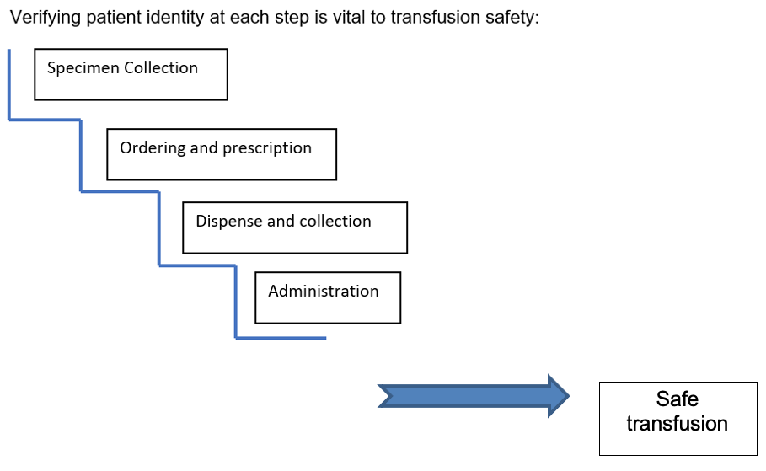

Procedural – other
In FY20, STIR commenced a new reporting category, ‘Procedural – other’. This includes incidents where a patient received the correct blood product/s despite one or more prescription, identification or administration errors occurring.
This also includes problems in any aspect of the transfusion process, not fitting into IBCT or near-miss categories. Examples include:
- transfusions that run over the four-hour time period for administration
- administration of blood where there is a mis-match in one or more patient identifiers e.g. ‘DOB 5/3/64’ instead of ‘3/5/64’
- transposed patient (compatibility) labels on blood bags, meaning that the donation number on the patient (compatibility) label did not match the donation number on the Lifeblood label.
In this report, the five events in this category were most often reported as near-miss or IBCT events, but expert review determined they fit better into this category.
The errors reported included:
- a unit of red cells run over more than five hours
- a unit of red cells transfused with an expired cross match, taken from remote blood fridge
- a unit of red cells run via a non-transfusion line
- error in signing out unit from blood fridge
- a unit of red cells, sent to the lab as part of potential transfusion reaction investigation and then returned to ward to complete the transfusion when the decision was made there was no reaction (see case study 13).

Case study 13: Restarting a discontinued unit of blood
In the ED, a patient admitted with chest pain and shortness of breath associated with ongoing blood loss (Hb 47 g/L) was receiving his third unit of red cells when he complained of heaviness in the chest.
The transfusion was stopped due to a possible transfusion reaction (approximately 40 mL administered).
The patient was reviewed by the ED medical officer and transfusion reaction investigation was commenced, including returning the unit of blood to blood bank for investigation.
A short time later, the admitting unit team arrived, assessed the patient and decided to cancel the transfusion reaction investigation (signs and symptoms spontaneously resolved). The medical officer requested the unit be returned by blood bank.
The blood bank scientist did not refuse, but sought further information from the laboratory medical officer, who advised the blood transfusion could be recommenced but would need to be completed within four hours of when it was first dispensed.
The nursing staff raised concerns about restarting the transfusion after it had been disconnected, but complied with the instruction.

Comments
The STIR review assigned this as ‘Procedural other – inappropriate storage and handling’.
Despite a number of staff recognising this was not usual practice and expressing concern, no-one thought to stop the blood from being restarted in line with hospital infection control processes. The blood administration guidelines did not specifically cover units discontinued, however the health service is now adding this to their guideline.
Where a unit is disconnected from a patient, whatever the reason, it should not be reconnected. This is a safety issue in relation to infection control, as disconnecting and reconnecting lines is an infection risk.
Additionally, it was unclear if pretransfusion checks were re-performed prior to reconnecting the blood, which could lead to the blood being restarted on the incorrect patient.

Near miss
In FY20 there were three near miss events reported.
Table 22: Types of near miss events received by STIR in FY20
Category | Number reported
Inappropriate component issued | -
Labelling/documentation | 2
Laboratory | 1
Administration | -
Storage and handling | -
In FY20, there were few near miss reports received. The five ‘Procedural – other reports’ received may have previously been included in near-miss events.
In the 2019 SHOT report, near-miss events accounted for 38.7 per cent of all received reports. Potential system or process problems can be recognised and addressed before they cause actual harm.
Busy staff may not see the advantage to reporting something that ‘did not happen’, but should be encouraged to understand these events can help improve the safety culture of a health service.

Wrong blood in tube (WBIT)
There were 28 WBIT reports to STIR in FY20. WBIT continues to be one of the most common reported errors to STIR, representing 46 per cent of procedural errors reported. This is despite a number of health services moving to electronic medical records, that often include systems for patient identification and specimen labelling. Electronic medical records (EMR) may help to improve specimen collection, but if not set up following safe processes, may contribute to an increase in errors.
STIR have added questions to report forms to consider how the EMR may contribute to an incident. This commenced in FY21 and will be reported in the next annual report.
A WBIT is most often an error that is detected prior to blood product administration, but as noted in IBCT, some WBITs can lead to an incompatible product being administered to a patient. Unless a patient has a historical blood group on record with the transfusion service, this serious error can go undetected. This is the reason laboratories are so adamant about stringent processes for blood-banking specimens with correct patient identification and labelling.
As in previous years, the most commonly documented contributing factor for WBIT is failure of the patient identification check (Figure 8). To assist health services with this process, Blood Matters has developed lanyard cards that outline the steps to correct patient identification and specimen labelling (Figure 7), available on the Blood Matters webpage.
Figure 7: ABCD of blood sampling lanyard card
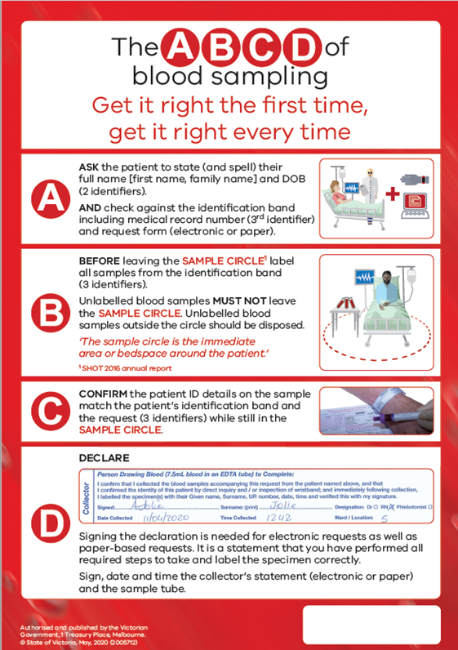
Figure 8: Factors contributing to WBIT incidents (multiple responses per event)
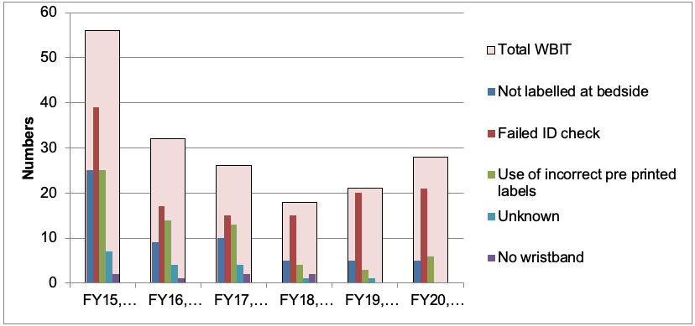
Emergency departments and maternity wards remain the main areas where WBIT events occur (Figure 9). These are both areas where there may be a stressful workload and patients who are unable to participate in the patient identification process.
Figure 9: Where WBIT errors occur
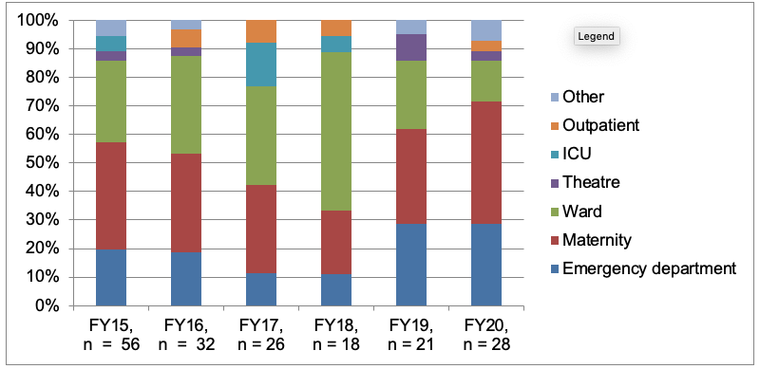
The WBIT events reported to STIR are reported because they are recognised (Table 23). It is likely that a number of WBIT events are not reported because they are not recognised.
This may be because the blood was actually from a patient with the same blood group as the named patient, or because there was no need for transfusion at the time and a second specimen that could have shown a different blood group was not needed (patients without historical group).
As seen in IBCT, a WBIT can lead to an ABO incompatible transfusion, if not discovered.
Table 23: How the WBIT was discovered (n = 28)
Category | Number | Percentage (%)
Recognised prior to testing | 11 | 40
Discrepancy noted when comparing sample results with historical record | 12 | 43
Recognised post testing but prior to issue | 6 | 21
Significant change in MCV compared with prior testing | -
Recognised post issue but prior to transfusion | -
Other: patient recognised error | 1 | 4
Total incidents | 28

Case study 14: Multiple specimens taken together
An infant had a specimen taken in a pathology collection service of the health service. There were several family members in attendance and requiring blood testing. This was a routine sample taken in business hours. The sample was collected from the right patient but labelled as a different patient. It appears two samples had the labels switched, which then meant another patient was also put at risk.

Comments
This was validated by STIR as a WBIT event.
Each specimen collection must be completed as a single episode of care with all collection and labelling of specimens occurring together at the patient side. The collection and labelling must be completed before moving on to the next patient.
Even in events where the patient is unable to assist in the identification process, as in this situation, this should still occur. Specimens must not leave the patient side until they are labelled. Where pre-printed labels are able to be used, if the collector has forgotten to bring labels with them, the specimen can still have the details written on the specimen.
Again, all details must be identical to the patient identification and request. Be aware, it is not good practice to then put a pre-printed label over the written details. In some laboratories this may lead to rejection of the specimen.

Case study 15: Registration errors leading to WBIT
Two similar episodes from the same health service were reported. More recently (FY21) other health services have reported similar errors.
A patient presented to the ED and was registered under another patient's UR number. The patient did not have English as is first language and it is unclear how the identification process at this point occurred. This error was not identified for several hours and multiple investigations were completed under the incorrect UR number, including a group and screen sample. It is apparent that positive patient ID processes could not have been completed when taking this sample.
The transfusion laboratory was not informed at the time the error was identified. The patient’s details were changed in a downstream program (EMR program) and were not changed in the laboratory information system (LIS). The patient's encounter was moved from the incorrect patient to the correct patient in EMR program, which meant there was a mismatch between LIS and EMR, and that the patient had an incorrect blood group registered in the LIS.
Comments: The second report was almost identical in all aspects, including not informing the transfusion laboratory.
In other reported incidents there have been two patients with the same name registered with the health service. When one is admitted for treatment the wrong patient is chosen and then other details are updated to match the admitted patient details. Therefore John Smith 1 is admitted as John Smith 2, and the error only realised if a WBIT is found (John Smith 1 and John Smith 2 have different blood groups). If the patient has no historical blood group they may have an incorrect blood group attributed to them.
It is important that all staff, including clerical, understand the need for accurate patient identification and where major changes in patient identification details are needed, that there is a checking process to ensure the correct changes to the correct patient identification occur.

Case study 16: Wrong patient record open when ordering and labelling specimens in the electronic medical record (EMR)
A medical officer inserted an intravenous canula and collected blood for FBE and blood group and antibody screen in preparation for a procedure.
The tests were ordered in the electronic medical record (EMR) after the collection process. However, another patient record was open in EMR at time of ordering bloods, printing requisition form and specimen labels, and was not noted by the medical officer at the time.
The wrong requisition form and labels were printed and used, without checking against the patient identification wristband. The medical officer realised the error immediately after samples were sent to the laboratory and contacted the laboratory to discard samples prior to processing.

Comments
This WBIT occurred due to a lack of correct process, checking the request form and specimen labelling against the patient stated and wristband details.
Where at all possible, the request should be generated prior to the collection, to assist in performing the patient identity checks. Where the request is purely electronic, the electronic request must be available at the patient side for those checks, that means the computer or handheld device is at the patient side at the time of sample collection.
In addition, the EMR should not allow the user to have two patient records open at the same time. This could lead to confusion and errors in printing requests and specimen labels.

RhD immunoglobulin errors
RhD immunoglobulin (RhD Ig) errors continue to occur regularly across all administration points (Table 24). The most commonly reported error (Table 25) is when RhD Ig is omitted (n = 7) or delayed (n = 6), which puts women at risk of developing an antibody that could cause issues in future pregnancies.
There were three incidents where a woman received an unnecessary dose, one each for a woman with known RhD negative infant, a RhD positive woman and a woman with preformed immune anti-D.
Table 24: RhD Ig errors – intended administration (n = 19)
Intended administration | Number
Antenatal prophylaxis | 8
Sensitising event | 4
Postnatal | 7
Table 25: Types of RhD Ig incidents
Type of incident | Number  (n = 19)
Administered, not required (Rh negative mother with known RhD negative baby) | 1
Administered, not required (RhD positive woman) | 1
Administered, not required (woman with immune Anti-D) | 1
RhD Ig dose omitted | 6
Delay in administration (> 72 hours.) | 6
Wrong or inadequate dose | 3
Other: near miss (RhD positive patient prescribed RhD Ig) | 1

Case study 17: Incorrect RhD Ig dose administered after errors at both dispense and administration
A woman (RhD negative) delivered an RhD-positive baby and required RhD Ig post-partum. A dose of RhD Ig was ordered from the laboratory and administered to the woman.
However, after administration, staff recognised this was the incorrect dose: 250 IU instead of 625 IU. It appears the prescription for the product was correct, but the dose was not checked at the time of dispense from the laboratory and at administration.
In response, the laboratory has added processes to highlight the different doses of RhD Ig for the dispensing scientist. For clinical staff, there have been changes to the prescription form to highlight the difference in dosing, revision of the administration guideline and supplementary online educational resources for midwives.

Comments
Correct checking of any blood product must include the product and dose required, both at the time of dispense and administration.

Case study 18: Delayed administration of RhD Ig due to documentation error
A woman delivered a baby via caesarean section (RhD positive baby to RhD negative woman). A transcription error on the post caesarean section care-plan documented that anti-D was not needed for this woman. This error was then transcribed onto a subsequent care plan. Prescription for anti-D was not written until omission detected by ward staff. The error was not detected until after the recommended 72 hours for optimal administration of RhD Ig. The appropriate dose was administered once the error was found.

Comments
It is important that any process for RhD Ig administration is robust. In this instance it may be better to document that the blood group has been checked and the required treatment (if needed) at that time. This would ensure that an earlier error could be found and mitigated.
The NBA have recently released revised version of the Guideline for the prophylactic use of Rh D immunoglobulin in pregnancy care <https://www.blood.gov.au/anti-d-0>. The guideline is intended to guide health care professionals in making clinical decisions about the prophylactic use of Rh D immunoglobulin in Rh D negative pregnant women.
While the guideline recommends non-invasive prenatal testing (NIPT) for fetal RhD from 11 weeks of pregnancy to determine fetal RhD genotype, Lifeblood is the only service providing this testing and has not been approved to provide NIPT for RhD for the purpose of targeted antenatal RhD immunoprophylaxis.
The Lifeblood Red Cell Reference laboratory is currently only approved to provide NIPT for RhD in pregnant women at high risk of RhD haemolytic disease of the fetus and newborn (HDFN) (i.e. alloimmunised women with preformed anti-D).
The Lifeblood website includes information about the Lifeblood testing service, sample requirements and request form <https://transfusion.com.au/node/809>.

Cell salvage
Although cell salvage incidents remain reportable via STIR, we did not receive any reports this year.

Sentinel events
Although we have a small number of SR 1 reports in this period, including one ABO-incompatible transfusion, there were no root cause analysis associated with a sentinel event reported to STIR in this period.
In the Safer Care Victoria annual report for 2019–20, there are no reports of haemolytic blood transfusion reaction resulting from ABO incompatibility resulting in serious harm or death.

Future
STIR continues to review investigation forms and the reporting process to ensure full information is available to reviewers to be able to assign event type, severity and imputability.
From 1 July 2020, RhD isoimmunisations can be reported to STIR. This may be associated with RhD Ig errors or occur without a known error.
From 1 January 2021, questions about electronic medical records have been included in some procedural forms to address errors that occur where the EMR is part of the problem. This is in acknowledgement of the increased number of health services who have, or are moving to use of an EMR.

References
Australian Commission on Safety and Quality in Health Care 2017, 2021, National Safety and Quality Health Service Standards, 2nd ed., ACSQHC, Sydney, <https://www.safetyandquality.gov.au/publications-and-resources/resource-library/national-safety-and-quality-health-service-standards-second-edition>.
Australian Red Cross Lifeblood 2018, ‘Relative risk of transfusion chart’, <https://transfusion.com.au/node/2378>.
Australian Red Cross Lifeblood 2021a, ‘Acute haemolytic transfusion reactions’, <https://transfusion.com.au/adverse_transfusion_reactions/acute_haemolytic_reaction>.
Australian Red Cross Lifeblood 2021b, ‘Transfusion-associated graft-versus-host disease (TA-GVHD)’, <https://transfusion.com.au/adverse_transfusion_reactions/TA-GVHD>.
Australian Red Cross Lifeblood 2021c, ‘Post-transfusion purpura’
Blood Matters 2020, Serious transfusion incident reporting guide, version 5, State Government of Victoria, Melbourne, <https://www2.health.vic.gov.au/hospitals-and-health-services/patient-care/speciality-diagnostics-therapeutics/blood-matters/serious-transfusion-incidents>.
Bolton-Maggs PHB and Watt A 2019, ‘Transfusion errors — can they be eliminated?’ British Journal of Haematology, <doi: 10.1111/bjh.16256>.
Bosboom JJ, Klanderman RB, Migdady Y, Bolhuis B, Veelo DP, Geerts BF, Murphy MF, Vlaar APJ 2019, ‘Transfusion-associated circulatory overload: a clinical perspective’, Transfusion Medicine Reviews, <https://doi.org/10.1016/j.tmrv.2019.01.003>.
Dolina MY and Bascom R 2018, ‘Immunoglobulin A deficiency’, Medscape, <https://emedicine.medscape.com/article/136580-overview>.
Foukaneli T, Kerr P, Bolton-Maggs PHB, Cardigan R, Coles A, Gennery A, Jane D, Kumararatne D, Manson A, New HV, Torpey N on behalf of the British Society for Haematology Guidelines Transfusion Task Force 2020, ‘Guidelines on the use of irradiated blood components’, British Journal of Haematology, <doi: 10.1111/bjh.17015>.
Fung MK (ed) 2014, ‘Non-infectious complications of blood transfusion’, Chapter 27, AABB Technical Manual, 18th ed., AABB, Bethesda.
Huyen A Tran, Sanjeev D Chunilal, Paul L Harper, Huy Tran, Erica M Wood and Alex S Gallus, on behalf of the Australasian Society of Thrombosis and Haemostasis 2013, ‘An update of consensus guidelines for warfarin reversal’, Medical Journal of Australia, <https://www.mja.com.au/journal/2013/198/4/update-consensus-guidelines-warfarin-reversal>.
Latiff, A and Kerr M 2007, ‘The clinical significance of immunoglobulin A deficiency’, Annals of Clinical Biochemistry, vol. 44, pp. 131–139.
Narayan S (ed.), D Poles et al. on behalf of the Serious Hazards of Transfusion (SHOT) Steering Group 2020, The 2019 annual SHOT report.
National Blood Authority 2015, Australian haemovigilance minimum data set, <https://www.blood.gov.au/haemovigilance>.
National Blood Authority 2019, National haemovigilance report: 2017–18, <https://www.blood.gov.au/system/files/documents/Australian-Haemovigilance-Report-2018-19-FINAL_v2.pdf>.
National Blood Authority 2021, ‘Prophylactic use of Rh D immunoglobulin in pregnancy care’, <https://www.blood.gov.au/anti-d-0>.
Panch SR, Montemayor‑Garcia C, and Klein HG 2019, ‘Hemolytic transfusion reactions’, The New England Journal of Medicine, vol. 381, no. 2, pp. 150–162.
Safer Care Victoria 2019, Victorian sentinel event guide: essential information for health services about managing sentinel events in Victoria, State Government of Victoria, Melbourne.
Safer Care Victoria 2021, Supporting patient safety: learning from sentinel events – annual report 2019–20, State Government of Victoria, Melbourne, <https://www.bettersafercare.vic.gov.au/sites/default/files/2021-01/Sentinel events annual report 201920.pdf>.
Semple JW, Rebetz J, Kapaur R 2019, ‘Transfusion-associated circulatory overload and transfusion-related acute lung injury’, Transfusion Medicine, vol. 133, no. 17, pp. 1840–1853.
Storch EK, Rogerson B, Eder AF 2020, ‘Trend in ABO-incompatible RBC transfusion-related fatalities reported to the FDA, 2000–2019’, Transfusion, <https://doi.org/10.1111/trf.16121>.
WA Health 2020, Western Australian haemovigilance report 2019–20, State Government of Western Australia, Perth.

Appendix 1: STIR Expert Group members
Amanda Davis (Chair), Haematologist, Alfred Health, Victoria
Christine Akers, Transfusion Nurse, Blood Matters program, Victoria
Kaylene Bastin, Education Coordinator, Blood Matters program, Victoria
Gerald Bates, Blood Bank Scientist, Tasmania
Linley Bielby, Manager, Blood Matters program, Victoria
Merrole Cole-Sinclair, Director of Haematology, St Vincent’s Hospital, Victoria
Mary Comande, Blood Bank Scientist, Royal Children’s Hospital, Victoria
Philip Crispin, Consultant Haematologist, The Canberra Hospital, Australian Capital Territory
James Daly, Medical Director of Pathology Services, Australian Red Cross Lifeblood, Queensland
Rae French, Scientist, Blood Matters Program, Victoria
Bridget Glazebrook, Data Manager, Blood Matters program, Victoria
Clare Hennessy, Transfusion Nurse Consultant, Eastern Health, Victoria
Chris Hogan, Director Pathology Services, Austin Health, Victoria
Giles Kelsey, Consultant Haematologist, Royal Melbourne Hospital, Victoria
Glenda Mann, Blood Bank Scientist, Cabrini Health, Victoria
Ellen Maxwell, Director of Haematology, Melbourne Pathology, Victoria
Tina Noutsos, Haematologist, Royal Darwin Hospital, Northern Territory
Linda Saravanan, Haematologist, Melbourne Pathology, Victoria
Kobie Von Wielligh, Haematologist, Australian Red Cross Lifeblood
Erica Wood, Associate Professor, School of Public Health and Preventative Medicine, Monash University, Victoria

Appendix 2: STIR publications and promotions
Oral presentation: ‘RhD immunoglobulin (Ig): are we getting it right in obstetrics?,’ ACM 2019 and 29th Regional Congress of ISBT.
Oral presentation: ‘Itchy and scratchy – seriously!’, Blood 2019.
Poster presentation: ‘Increasing safety and awareness of RhD immunoglobulin through haemovigilance reporting’, Giant Steps conference, Safer Care Victoria, and 29th Regional Congress of ISBT.

Appendix 3: Imputability and severity scores
Imputability/causality | Definition
Not assessable | When there is insufficient evidence for an imputability definition.
Excluded | When there is conclusive evidence that the cause of the incident is attributable to other causes and not the transfusion.
Possibly | When the evidence is indeterminate for attributing the incident to either the transfusion or other causes.
Probably | When the evidence is clearly in favour of attributing the incident to the transfusion.
Certainly | When the evidence is conclusively attributable to the transfusion.

Severity | Incident
1 | Relatively infrequent, clear-cut events that occur independently of a patient’s condition; commonly reflect health service system and process deficiencies; result in, or have the realistic potential to result in, an unexpected death or a permanent and disabling injury or psychological harm to a person and includes reportable sentinel events.
2 | Events that result in a temporary loss of function (sensory, motor, physiological or intellectual) which is unrelated to the natural course of the patient’s illness and differ from the expected outcome of the patient’s management.
3 | Events that result in a person requiring increased treatment, but not hospitalisation or an increased length of stay.
4 | Events that result in minor injury requiring only first aid treatment or no injury.

Appendix 4: STIR timeline
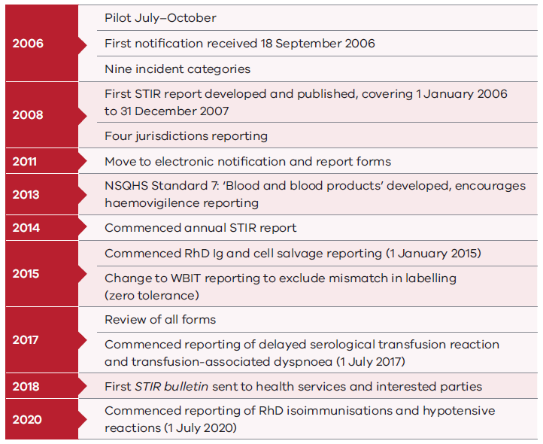
Text-equivalent description:
2006:
- Pilot July–October
- First notification received 18 September 2006
- Nine incident categories
2008:
- First STIR report developed and published, covering 1 January 2006 to 31 December 2007
- Four jurisdictions reporting
2011:
- Move to electronic notification and report forms
2013:
- NSQHS Standard 7: ‘Blood and blood products’ developed, encourages hemovigilance reporting
2014:
- Commenced annual STIR report
2015:
- Commenced RhD Ig and cell salvage reporting (1 January 2015)
- Change to WBIT reporting to exclude mismatch in labelling (zero tolerance)
2017:
- Review of all forms
- Commenced reporting of delayed serological transfusion reaction and transfusion-associated dyspnoea (1 July 2017)
2018:
- First STIR bulletin sent to health services and interested parties
2020:
- Commenced reporting of RhD isoimmunisations and hypotensive reactions (1 July 2020)

Validated clinical events includes Victoria only (n = 91).
Patients may have received more than one treatment option for a reaction.
Includes one event also classified as IBCT (ABO incompatible)
Implicated blood product: multiple products can be reported.
Multiple responses were possible

