
Cemetery sector newsletter
Edition 2, 2026
OFFICIAL

In this issue
Welcome 1
Data security reporting due to the Office of the Victorian Information Commissioner 1
Pet burials update 1
Celebrating the Central Victorian Cemetery Network 2
Selling pre-need rights of interment 3
Trust member spotlight Michael Kefford and Les Hemphill 3
Paynesville Cemetery Trust grant project 4
Trust fees – GST 4
Blue Tree Project 4
Fun fact 4
Free governance training 5
Links to key resources 5

Contact us
 | Email <cemeteries@health.vic.gov.au>
 | Phone 1800 034 280
 | Cemeteries and Crematoria website <https://www.health.vic.gov.au/public-health/cemeteries-and-crematoria>
 | Cemeteries and Crematoria  Department of Health  PO Box 4057  MELBOURNE VIC 3001

Welcome
Welcome to the Department of Health’s cemetery sector newsletter.

Data security reporting due to the Office of the Victorian Information Commissioner
All Class B cemetery trusts need to submit the 2026 Protective Data Security Plan (PDSP) to the Office of the Victorian Information Commissioner (OVIC) by 31 August 2026.
The PDSP form and a How-To Guide can be downloaded from OVIC’s webpage for Class B cemetery trusts <https://ovic.vic.gov.au/information-security/agency-reporting-obligations/class-b-cemetery-trust-stakeholders/>.
For physical copies of these documents or to obtain your trust’s previous submissions, please email the OVIC Security Team <security@ovic.vic.gov.au>.
Trust members can watch a video of a recent information session on preparing trusts for 2026 reporting on OVIC’s events and resources webpage <https://ovic.vic.gov.au/information-security/victorian-information-security-network/#past-events-and-resources>.
Thanks all trusts that have already submitted their 2026 PDSPs.

Pet burials update
Planning is underway for the commencement of the legislative change in late 2025 to allow animal remains to be interred in public cemeteries.
There are no actions for cemetery trusts to take at this stage. We will continue to keep the sector updated as this work progresses.


Celebrating the Central Victorian Cemetery Network
The department would like to acknowledge the work of the Central Victorian Cemetery Network.
The network is made up of a group of enthusiastic Class B cemetery trusts that have come together to support and learn from one another, build connections and share experiences.
The idea for the network was sparked by a conversation between Christine Fitzgerald (Maldon Cemetery Trust) and Debra Tranter (Castlemaine Cemetery Trust). They recognised that while cemetery trusts face similar challenges, many volunteers find themselves tackling these challenges in isolation.
Invitations were sent to cemetery trusts across Mount Alexander Shire and beyond, and the response was enthusiastic.
Member trusts include Maldon, Castlemaine, Baringhup, Chewton, Muckleford, Guildford, Newstead, Fryerstown, Vaughan, Sutton Grange, Clunes, Elphinstone, Taradale, Franklinford, Tylden and Woodend.
The network meets quarterly in Castlemaine, with the local Police Station providing a conference space. Beyond these meetings, communication flows through phone calls, emails, and face-to-face connections, ensuring members remain supported.
The results speak for themselves. By sharing knowledge and resources, members are no longer ‘reinventing the wheel’. Instead, they are building collective expertise and confidence. Highlights of the network’s achievements include:
- sharing practical tools, such as spreadsheets developed by Maldon for OVIC reporting
- securing additional local training opportunities through the department
- hosting guest speakers from the department and the Cemeteries and Crematoria Association of Victoria (CCAV)
- organising a tour of a local funeral home to deepen understanding of mortuary processes.
In a particularly innovative step, Maldon and Castlemaine have jointly applied for a grant to purchase a burial lowering machine. This is equipment that would otherwise be out of reach for smaller cemeteries with only a handful of annual services. By sharing resources, the network is ensuring that even low-activity trusts can access essential tools.
The network’s success is also gaining attention. At a recent CCAV meeting in Bendigo, representatives from other regions expressed strong interest, suggesting that this model could benefit communities beyond Central Victoria.
This initiative shows what can be achieved when volunteers come together with a shared purpose. Through cooperation, generosity, and a willingness to learn from one another, the Central Victorian Cemetery Network is strengthening not only its members, but the broader community they serve.
Congratulations to everyone involved in building this thriving network!
If your trust is interested in connecting with other trusts in your local area, you are welcome to email us for advice <cemeteries@health.vic.gov.au>.
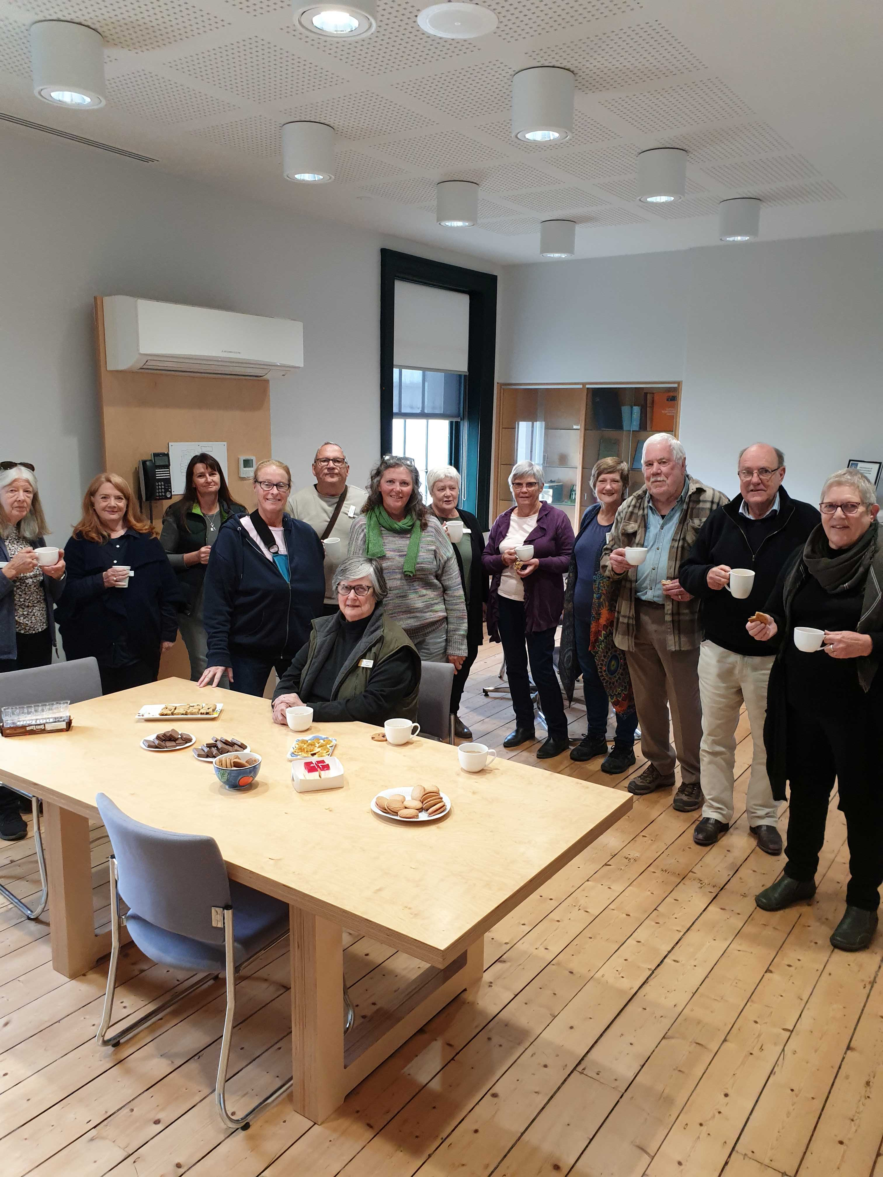

Selling pre-need rights of interment
Pre-need rights of interment are purchased in advance for future interments. At the time of purchase, the full pre-need right of interment fee is to be paid to the trust.
There may also be other applicable fees depending on the trust’s gazetted fee list. Examples include administration fees for issuing a certificate or for site selection.
The department advises against accepting part payments, deposits or ‘reservations’ for pre-need rights of interment. This can cause confusion as fees increase over time.
The department also advises against bundling interment and memorialisation fees with pre-need rights of interment into a pre-paid ‘package’. This practice creates a future financial risk for trusts as costs increase.
If a trust chooses to include memorialisation fees when a pre-need right of interment is sold, they need to be aware that it is not mandatory for a memorial to be established at a place of interment, even if the memorialisation fee has been pre-paid.
The right of interment holder is within their rights to change their mind and decide they do not want to establish a memorial. In these cases, the trust needs to refund applicable fees to the purchaser.
Selling pre-need rights of interment is not mandatory. Many cemetery trusts sell only at-need rights of interment when there are remains ready to be interred.
Trusts that do sell pre-need rights of interment, may be approached by an individual or group seeking to buy multiple pre-need rights of interment at once – for example, a full row or section of plots.
When considering requests for bulk purchases of pre-need rights of interment, trusts should consider remaining capacity in the cemetery and the ability to meet community needs into the future.

Trust member spotlight Michael Kefford and Les Hemphill
The department would like to acknowledge and recognise the significant contribution of Michael Kefford and Les Hemphill of the Avenel Cemetery Trust for their dedication, leadership and generosity of time in supporting the re-establishment of the Nagambie Cemetery Trust.
At the department’s request Michael took on the important role of leading the re-establishment of the Trust with support from Les. Their commitment and hours spent rebuilding sound governance structures, reinstating trust finances and recruitment of suitable new trust members from the local community has been instrumental in restoring a renewed sense of purpose and community engagement.
Under their direction, a number of significant projects have been undertaken, including:
- The refurbishment of the pavilion (photo below) and restoration of the original gates, preserving heritage character
- Upgrades to mobility and safety access
- Extensive mapping and development of new areas which strengthen asset management and future planning
These achievements demonstrate the heartwarming story of working together and a clear commitment to ensure the cemetery remains a respectful, well-maintained, and welcoming place for the community.
The department also acknowledges the work of the new members Trevor Forbes, Sissy Hoskins, Neil McLeod, Sandra Speck, Traci Stumer and James Tehan in supporting the renewal of the trust.
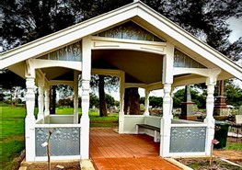

Paynesville Cemetery Trust grant project
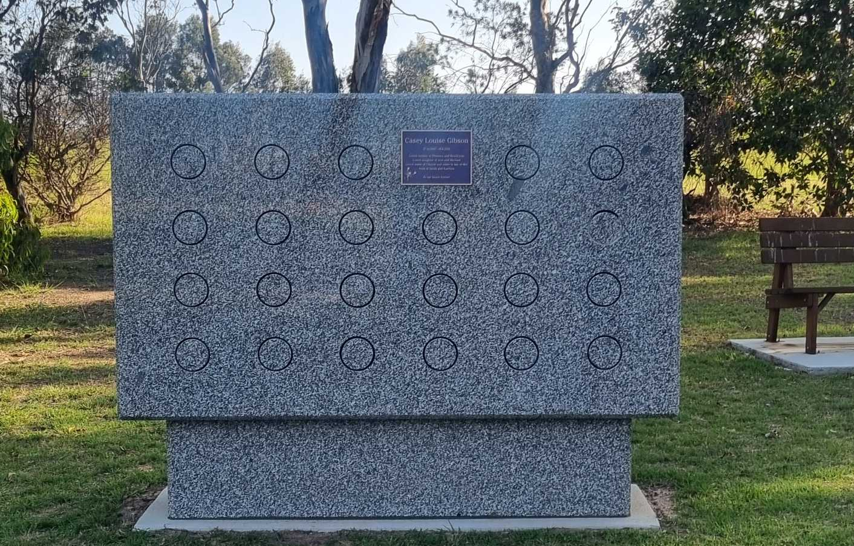
Congratulations to Paynesville Cemetery Trust on the installation of a new niche wall for ashes interments. The wall is made of Harcourt granite and has 24 niches on each side.
This project was funded through the department’s Cemetery Grants Program. The trust received a full grant of $29,271 and completed the project in November 2025.

Trust fees – GST
Trusts should charge goods and services tax (GST) for goods and services if the trust:
- has an annual turnover (from sales of goods and services) of $150,000 or more, or
- is registered for GST, regardless of turnover.
The following fees are exempt from GST:
- rights of interment
- memorialisation permits and approvals
- permits
- miscellaneous fees and charges (for example, record search fees).
If a trust’s turnover is $150,000 or more or the trust is registered for GST, any products and services not covered in the list above will attract GST. This will include fees for services such as gravedigging, exhumations and the sale of products such as plaques, granite, urns and other memorials.
For those fees where GST is applied, the total gazetted price is GST inclusive (the trust cannot charge an additional amount for GST).
To register for GST, you must have an ABN.
If the threshold applies to your trust, please phone the ATO on 1300 130 248 to register for GST and to discuss any queries. Trusts need to advise the ATO that they are a not-for-profit incorporated entity.


Blue Tree Project
Have you ever spotted a tree that has been painted blue?
The Blue Tree Project is a charity working to break the silence and stigma surrounding mental health and suicide.
What began as a grassroots movement in Western Australia has grown into a global mental health charity, driving change and amplifying the conversation around mental health. There are now more than 1,600 blue trees around the world.
Geelong Cemeteries Trust has installed locally made Blue Tree sculptures at Geelong Memorial Park and Gisborne Cemetery. These sculptures stand as an acknowledgement and recognition of mental health within the Greater Geelong and Macedon Ranges region.
Visit the Blue Tree Project website for more information <https://bluetreeproject.com.au/>.
If you or someone you know needs help, please visit the Victorian Government’s Better Health Channel website for information about support services <https://www.betterhealth.vic.gov.au/servicesandsupport/mental-health-services>.

Fun fact
Assistens Cemetery in Copenhagen, Denmark, has a headstone with the following inscription:
Andreas Morgenrødt
Time Traveler
1996–2064
The headstone was erected in 2015 by a local artist without permission. The city council that manages the cemetery decided to leave the headstone in situ and has stated they will consider the merit of any future guerrilla art installations on a case-by-case basis.


Free governance training
Free face-to-face governance training workshops for Class A and Class B cemetery trusts are held across Victoria. The workshops are delivered by ICDA, an enterprise of Our Community, on behalf of the department.
To register for an upcoming workshop in your area please visit the ICDA website <https://communitydirectors.com. au/training/victorian-cemetery-trusts-governance-and-operational-training>.
For help with registrations or to arrange a workshop in your area by request, please contact Our Community:
Phone: 1300 137 475
Email: <learn@ourcommunity.com.au>

Class B online training
The department offers a free online training program called Cemetery Essentials for Class B Cemetery Trusts.
If you would like to take part, please email Our Community <learn@ourcommunity.com.au> to request an invitation.
Please note: To access the course, participants need to have an email address.

Links to key resources
- Manual for Victorian cemetery trusts <https://www.health.vic.gov.au/cemeteries-and-crematoria/class-b-cemetery-trust-governance>
- Recruitment toolkit for Class B cemetery trusts <https://www.health.vic.gov.au/cemeteries-and-crematoria/recruitment-and-advertising>
- Secretary’s handbook: guidance for Class B cemetery trust secretaries <https://www.health.vic.gov.au/cemeteries-and-crematoria/class-b-cemetery-trust-governance>
- Right of interment permit and factsheet <https://www.health.vic.gov.au/cemeteries-and-crematoria/right-of-interment-permit>

Newsletter ideas…
Is there a cemetery trust or trust member whose efforts or achievements you think should be celebrated?
Are there topics that you would like us to cover in a newsletter?
Please email us the details.

To receive this document in another format, phone 1800 034 280, using the National Relay Service 13 36 77 if required, or email the department <cemeteries@health.vic.gov.au>.
Authorised and published by the Victorian Government, 1 Treasury Place, Melbourne.
© State of Victoria, Australia, Department of Health, July 2026.
ISSN 2208-8830 (print) 2208-8849 (online/PDF/Word)
Available on the Cemeteries and Crematoria website <https://www.health.vic.gov.au/cemeteries-and-crematoria/cemetery-sector-newsletters>

