
Victorian Perinatal Data Collection (VPDC) manual 2024-25
Section 5a: Perinatal Webform and HealthCollect
Version 12.0
OFFICIAL

To receive this document in another format email HDSS Helpdesk <HDSS.Helpdesk@health.vic.gov.au>.
Authorised and published by the Victorian Government, 1 Treasury Place, Melbourne.
© State of Victoria, Australia, Department of Health, published June 2024, effective 1 July 2024.
ISBN 978-1-76131-593-0 (pdf/online/MS word)
Available at the VPDC website < https://www.health.vic.gov.au/quality-safety-service/victorian-perinatal-data-collection>

Contents
Introduction 4
HealthCollect portal – general information 5
Requesting access to HealthCollect for VPDC reporting 5
Help with using the Perinatal Webform 5
Logging into the HealthCollect Portal 5
Username and password 6
Password reset 6
Changing password 9
Change user contact details 9
Perinatal webform via HealthCollect portal 10
Introduction 10
HealthCollect – contexts, functions and announcements 10
Perinatal context and functions 10
Link to VPDC manual 11
Perinatal webform 11
Navigating between the Perinatal webform pages 12
Data entry validations within the Perinatal webform 13
Perinatal webform pages 13
Page 1 – Mother’s details 14
Page 2 – Baby’s details 15
Page 3 – Reproductive history 16
Page 4 – This pregnancy 17
Page 5 – Labour, birth & postnatal 18
Data entry completed 19
Amending, updating or correcting details in a Perinatal webform – before submission for processing 20
Deleting a webform 20
Submitting the Perinatal webform record 21
VPDC transmission reports 23
Download and save transmission reports 24
Reviewing transmission reports 25
Amending, updating or correcting details in a Perinatal webform – after submission for processing 25

Introduction
The Perinatal webform is available in the HealthCollect secure portal to health services and other health care providers that do not have an information system with the capacity to report birth data to the Victorian Perinatal Data Collection (VPDC). The Perinatal webform allows all health services to meet their obligations to report births at their health service to the VPDC, as required under the Public Health and Wellbeing Act 2008.
Authorised users can enter data in the Perinatal webform, compile completed webforms into VPDC submission files and send those submissions through the HealthCollect secure portal to the department for processing.
Reports generated by processing data submissions are returned to the user through the HealthCollect portal. These reports highlight data errors which users must correct in the HealthCollect portal webform, then resubmit those records.
This document provides information on:
- obtaining a user login to access the Perinatal webform,
- entering data into the Perinatal webform,
- creating a submission file,
- sending that file for processing,
- accessing and downloading reports sent back through the HealthCollect portal
- correcting data and resubmitting to resolve errors.
Webform users will also find it beneficial to refer to other sections of this current VPDC manual, in particular Section 3: Data definitions, for data item descriptions, code sets and reporting guides and Section 4: Business rules, for valid combinations of data in different data items.

HealthCollect portal – general information

Requesting access to HealthCollect for VPDC reporting
To request access to HealthCollect for VPDC reporting purposes:
- Visit the HDSS website < https://www.health.vic.gov.au/data-reporting/health-data-standards-and-systems>
- Click on the ‘HealthCollect’ tile on the homepage of this site, then click on the ‘HealthCollect Portal User Request’ link <https://forms.office.com/Pages/ResponsePage.aspx?id=H2DgwKwPnESciKEExOufKIQCYRhq7MNNvvjya8xeYoZUNzE3UEZWTlpPNlc0WUhaMERaMEw1SjRDSS4u>.
- You will be taken to the ‘HealthCollect Portal User Request’ form.
- Follow the prompts to enter the details requested, including the health service/entity and campus for which data will be reported by this user.
- If the request is for a private homebirth midwife, indicate this in the health service/entity and campus fields. A unique code to identify each private homebirth midwife is assigned by the department for VPDC reporting when requests for HealthCollect access are processed.
- As you progress through the HealthCollect Portal User Request form, you will be asked if you need access to AIMS forms: respond ‘no’.
- You will then be taken to the ‘Portal Access Required’ page: select ‘VPDC Perinatal webform’.
- Once you have completed all required details, submit the request.
- After the request is processed, an email will be sent to the address provided in the request, notifying the UserName assigned and other HealthCollect access information.
- A second email will also be sent providing information on completing the Perinatal webform and submitting VPDC data.
- Please allow 1 to 2 business days for these emails. If not received in that time, please contact to the HDSS HelpDesk <hdss.helpdesk@health.vic.gov.au>

Help with using the Perinatal Webform
- Questions about using the HealthCollect portal for VPDC reporting, or entering data into the Perinatal webform, can be directed to the HDSS HelpDesk <hdss.helpdesk@health.vic.gov.au>
- The current version of the VPDC Manual is accessible at the VPDC website <https://www.health.vic.gov.au/quality-safety-service/victorian-perinatal-data-collection>.
Check the manual you access is the correct version for the financial year of the birth you are reporting, as different code sets may apply in different years. Previous years’ manuals can also be found at the VPDC website.

Logging into the HealthCollect Portal
- Open an internet browser, and enter the HealthCollect portal address <https://www.healthcollect.vic.gov.au/desktopdefault.aspx>.
- Bookmark this address to facilitate easy access in future.
- Please note: Internet Explorer is no longer a supported browser for accessing HealthCollect.

Username and password
- Enter your ‘UserName’ and ‘Password’ in the boxes provided, then click on the ‘Logon’ button. Note that passwords are case sensitive.
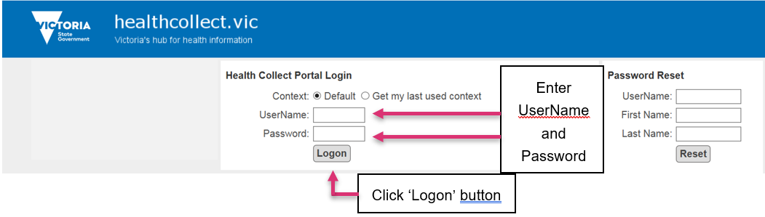

5. The HealthCollect Default page will appear (see ‘Perinatal webform via HealthCollect portal, below, for further details on accessing the webform through the Perinatal context).
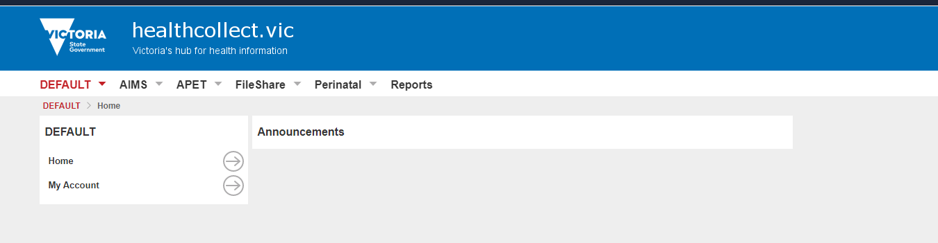

Password reset
If you need to reset your password (eg if you have forgotten your password), go to the HealthCollect Portal Login screen using an internet browser eg Chrome, Edge, Firefox – do not use Internet Explorer.
- In the ‘Password Reset’ portion at the right side of that screen, enter your current UserName, and First Name and Last Name as they are registered with HealthCollect.
- Click the ‘Reset’ button.
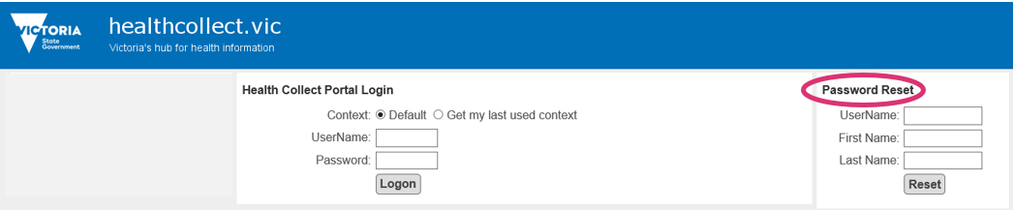

- A message will appear in red, beneath the Password Reset area, indicating ‘a link to reset your password has been emailed to your nominated email address’. This is the email address provided when your HealthCollect user access was requested.
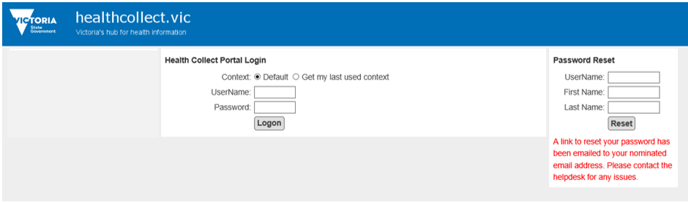

- Contact the HDSS HelpDesk <hdss.helpdesk@health.vic.gov.au> if an email is not received within a few minutes.
- The email will be sent from the HDSS HelpDesk, with a link to the password reset screen:
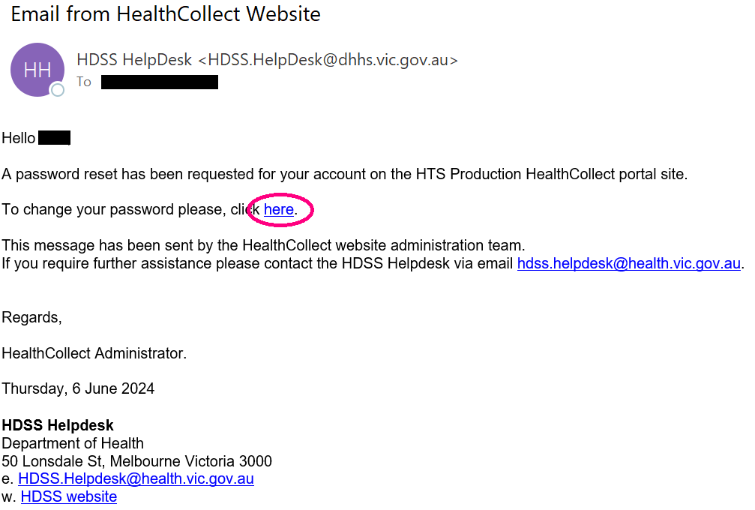

- Follow the instruction in the email above to ‘click here’. A new screen will open, in which you can enter a new password.
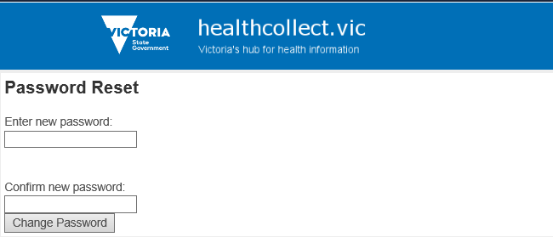
- Advice on password strength will appear as you progress. If your new password does not meet system requirements, your proposed new password will disappear, and a message will be shown indicating minimum requirements:
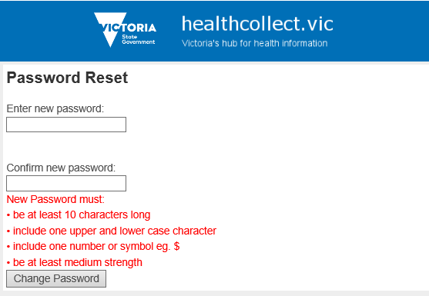
- When an acceptable password has been entered, repeat it in the ‘Confirm new password’ window, and click the ‘Change Password’ button. When the new password is acceptable, and confirmed, you will receive confirmation that your password has been changed:
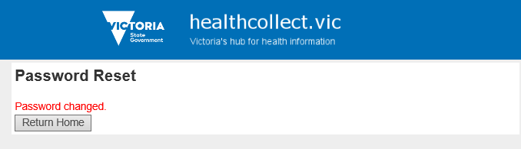
- Click the ‘Return Home’ button to be taken back to the HealthCollect login screen.
- Login using the new password.
- Refer to the ‘Perinatal webform via HealthCollect portal’ section below.

Changing password
Another pathway to changing password is available after login.
- In the HealthCollect Default page, click on ‘My Account’: your current HealthCollect login details will be displayed beneath the heading ‘Edit My Details’ near the centre of the screen.
- In the ‘Change Password’ portion at the right of the screen, complete ‘Enter current password’.
- Type the new password in the ‘Enter new password’ box, then enter the same new password in the ‘Confirm new password’ box.
- Click the ‘Change Password’ button to save the new password details.
- Log out of the HealthCollect portal: click on ‘Logoff’ in the black bar at the top of the screen.
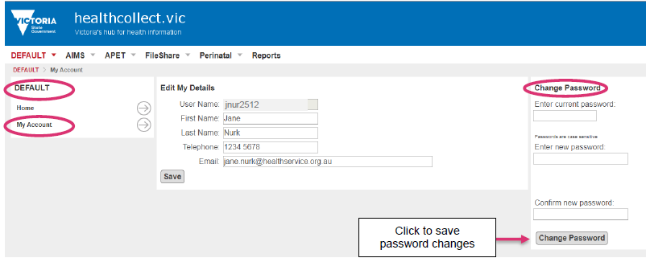

Change user contact details
Authorised users can update selected contact details through the HealthCollect Default page.
- Log in to the HealthCollect portal, and in the Default page, click on ‘My Account’.
- In the ‘Edit My Details’ portion in the centre of this page, users can update their own name, and telephone and email contact details, by entering relevant details in the appropriate box.
- Click ‘Save’ to submit the changes.
- Click ‘Log Off’ in the black bar at the top of the screen.
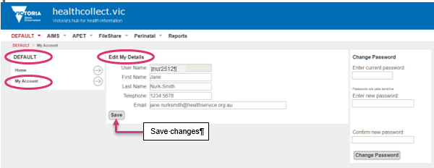

Perinatal webform via HealthCollect portal

Introduction
Health services and other health care providers that do not have an information system to capture and report birth information can submit the required data to the VPDC using the Perinatal webform, which lists all the VPDC data items for the selected financial year.
The Perinatal webform is accessible to those with a HealthCollect login and VPDC authorisation. Refer to ‘Requesting a HealthCollect log in and password’ to seek access to the Perinatal webform.
Email questions about HealthCollect or the Perinatal webform to the HDSS HelpDesk <hdss.helpdesk@health.vic.gov.au>

HealthCollect – contexts, functions and announcements
The HealthCollect portal is used to report data to a number of data collections, or ‘contexts’. The individual user’s Default page provides links – listed across the screen beneath the blue banner – to the contexts to which the user has access. When a context is selected, functions relevant to that context appear at the left of the screen. Announcements posted by the department appear here.

Perinatal context and functions
To access the VPDC webform, select the ‘Perinatal’ context in the row beneath the blue banner.
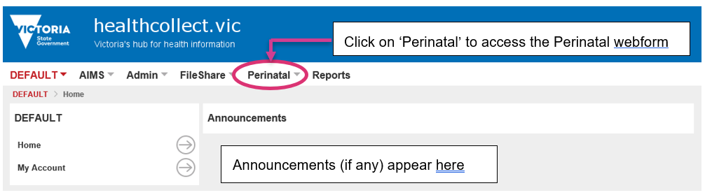
Selecting the Perinatal context reveals Perinatal functions, listed at the left of the screen:
- Home
- Secure Data Exchange
- VPDC Selector
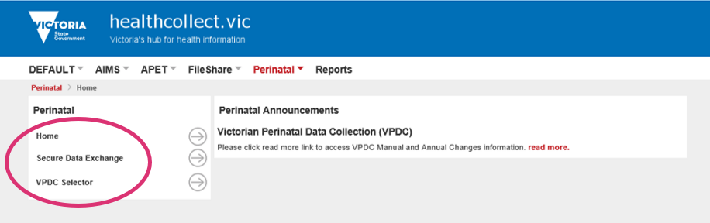

Link to VPDC manual
In the Perinatal context, a link is provided to the VPDC manual, for reference when entering data.
Be sure to refer to the version of the VPDC manual relevant for the financial year of the birth being reported.
Section 3 of the VPDC manual provides data definitions, code sets and reporting guidelines for all Perinatal webform data fields.
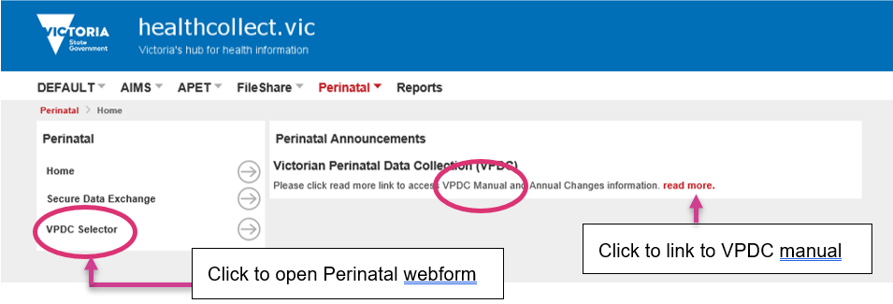

Perinatal webform
Click the VPDC Selector in the Perinatal functions list on the left of the screen to open the initial page of the ‘Victorian Perinatal Data Online Entry and Transmission System’, and select key items:
- Birth Year: select the Birth Year that includes the baby’s birth date, to ensure all relevant data items are listed in the Perinatal webform.
- Agency: click the drop-down list to display health services. Select the site at which the birth occurred. Homebirth midwives registered with the department as Perinatal webform users are listed in alphabetical order under ‘Midwife’. Contact the HDSS HelpDesk if your name is not present.
- If you are starting a new birth record, the ‘Birth record Mother UR:’ drop-down box must be left at the pre-set value of ‘New Record’, then click the ‘Create Birth Record’ button to open a new Perinatal webform, and open the webform’s first page. (Refer to Amending, updating or correcting details in a Perinatal webform when you want to re-open a pre-existing webform.)
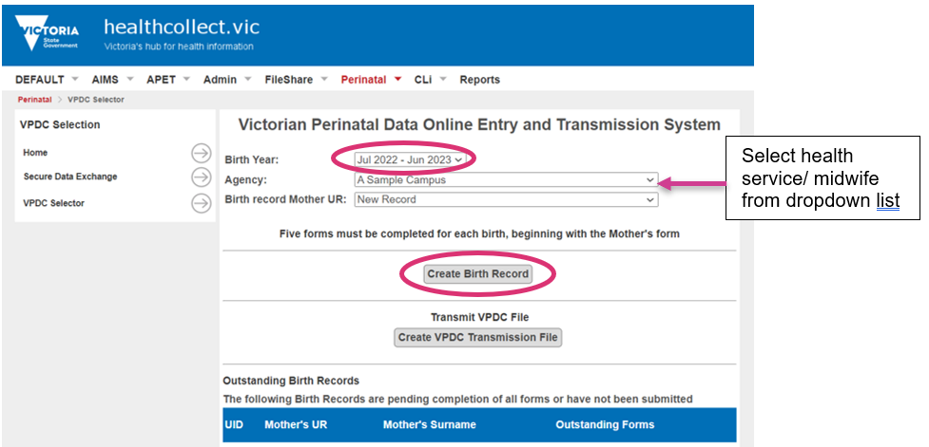

Navigating between the Perinatal webform pages
The webform opens in a new browser window.
Each Perinatal webform is comprised of five pages/screens:
- Mother’s details
- Baby’s details
- Reproductive history
- This pregnancy
- Labour, birth & postnatal
The title of the page currently open is shown in white, within the blue bar across the screen.
Maximise the window to full screen and scroll down to ensure all items are completed on each page.
Click the ‘Save’ button (upper left of ‘Mother’s details’ page; upper right of other pages) before leaving any page to ensure details are retained.
You can return to a page, or record, later to update or add further details throughout the pregnancy or delivery episode, before and after data submission.
Click the ‘Continue’ button (upper right of all pages except ‘Labour, birth & postnatal’) to move to the next page listed in the blue bar near the top of the screen.
Click the ‘Go Back’ button (upper left of all pages except ‘Mother’s details’ page) to return to the previous page.
Print the current page by clicking the ‘Print’ button at the top right corner of the page (grey bar).
Movement between pages can only occur to the adjacent page by clicking the ‘Continue’ or ‘Go Back’ buttons, as above. For example, click ‘Continue’ to move from ‘Mother’s details’ to ‘Baby’s details’. It is not possible to move directly from ‘Mother’s details’ to ‘Reproductive history’.
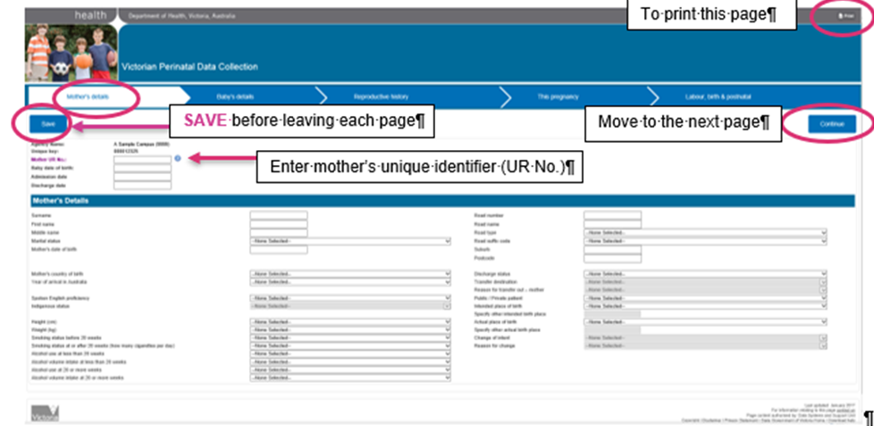

Data entry validations within the Perinatal webform
While the Perinatal webform includes all VPDC data item specifications, it must allow for data to be reported for all birth situations.
Some VPDC data items are mandatory to report for all births, while others are required only in specific circumstances, for example a labour that is induced must report a value in the data item ‘Indication for induction (main reason)’; in addition, one or more values may also be reported in the data item ‘Indications for induction (other) but it is not necessary to report any values in this latter field if none are relevant.
These format specifications and code sets are set out in VPDC manual Section 3: Data definition. The mandatory data items, and valid combinations of codes, are set out in VPDC manual Section 4: Business rules.
Some of the VPDC business rules are being introduced to the Perinatal webform. Where data entry has omitted a value for a mandatory data item (eg HIV antenatal screening – mother) a validation message will appear in the upper portion of the screen and the relevant data entry field will be highlighted. To progress from this screen, select the appropriate value for this data item, and click ‘Save’. There may be more than one validation message on any screen. The absence of a validation message does not guarantee there is no error in the combination of values reported, as not all combinations are tested in the Perinatal webform.
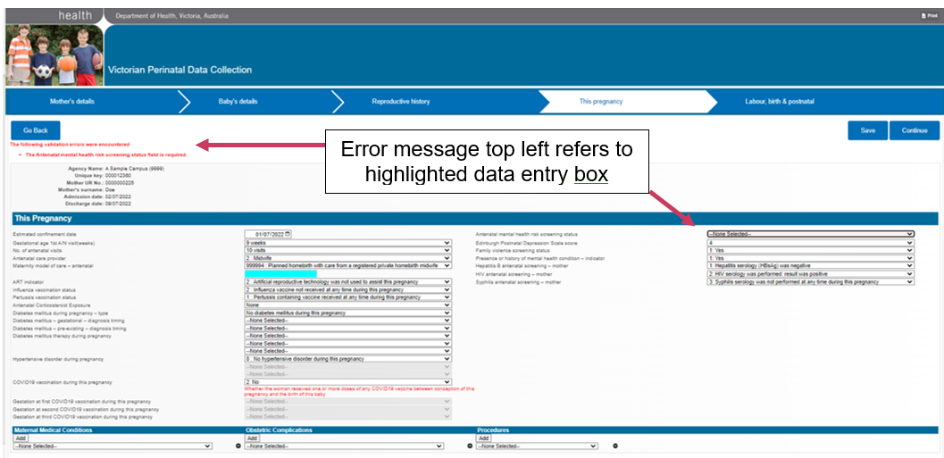

Perinatal webform pages
The following examples of Perinatal webform screens display data items to be reported for births in the 2024-2025 financial year.
Other data entry tips are provided where demonstrated on the relevant webform page.

Page 1 – Mother’s details
The first webpage records ‘Mother’s details’:
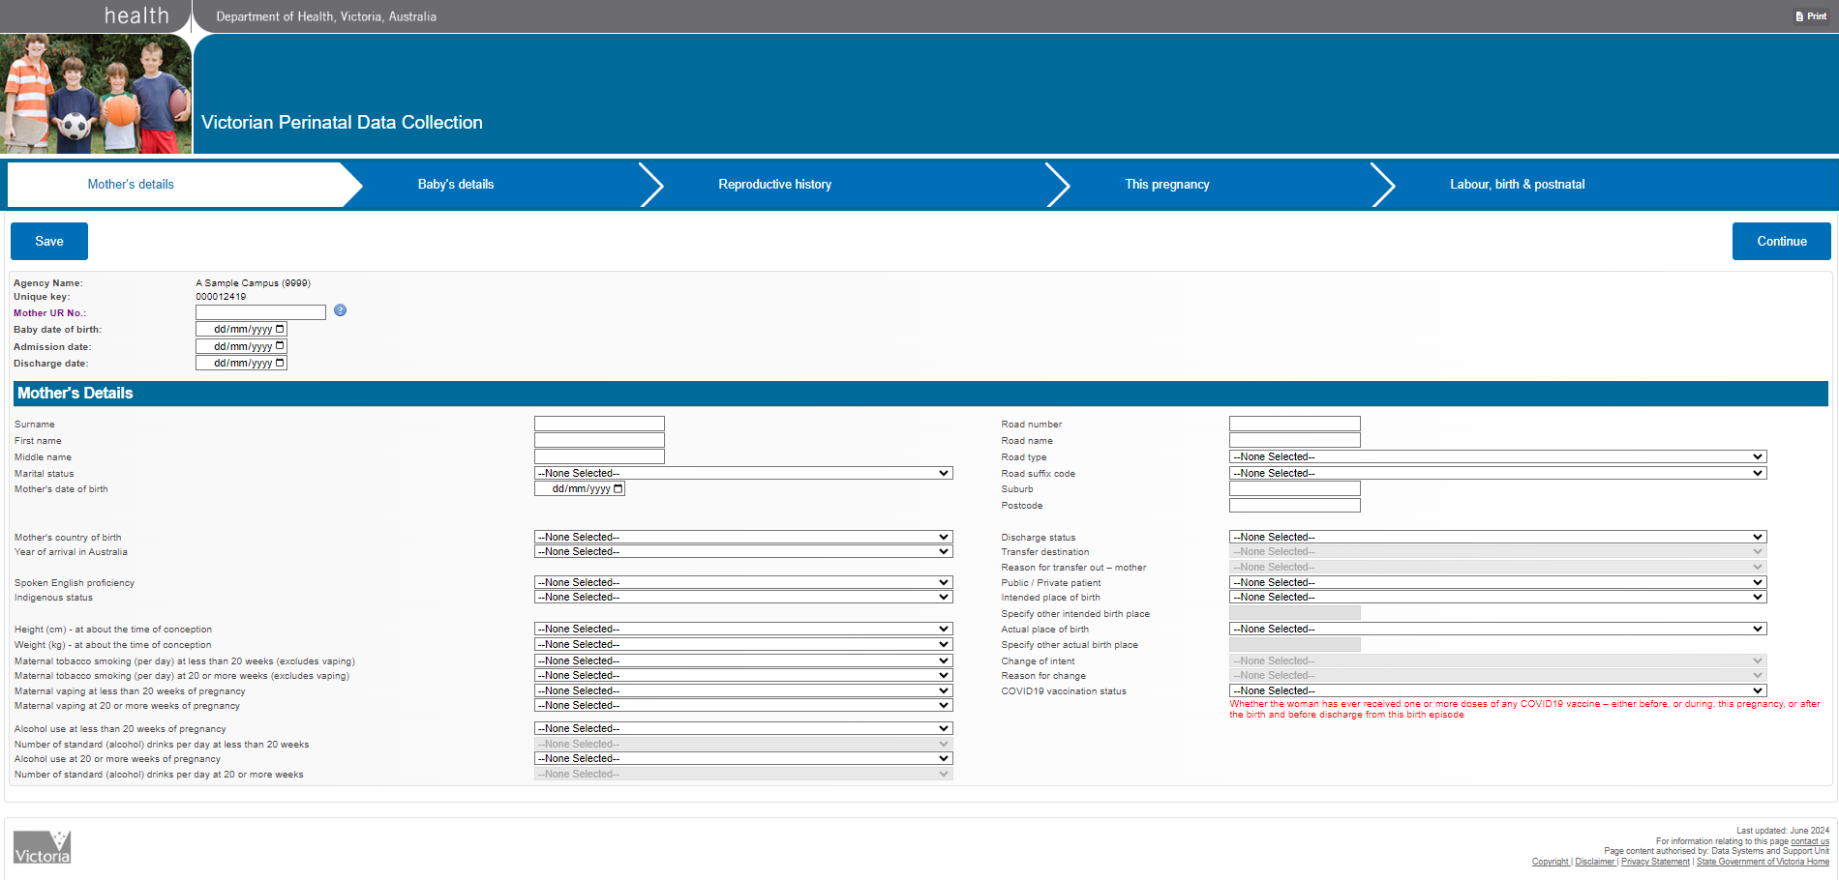
- Begin by entering the mother’s UR number: this must be unique to the mother, and never re-issued to another mother or used to identify a baby. The identifier details entered on the ‘Mother’s details’ page will be carried over to subsequent pages.
- Many data fields have drop-down lists to allow selection from the valid range of codes or options for that data item.
- Other data items require details to be entered in a specific format (for example, Postcode must be a four-digit code that is valid for the Suburb entered).
- The ‘Save’ button appears at the top left of the ‘Mother’s details’ screen. On all other screens, the ‘Save’ button appears at the top right of the screen, beside the ‘Continue’ button.
- After saving this screen, click the ‘Continue’ button to progress to the next screen, ‘Baby’s details’.

Page 2 – Baby’s details
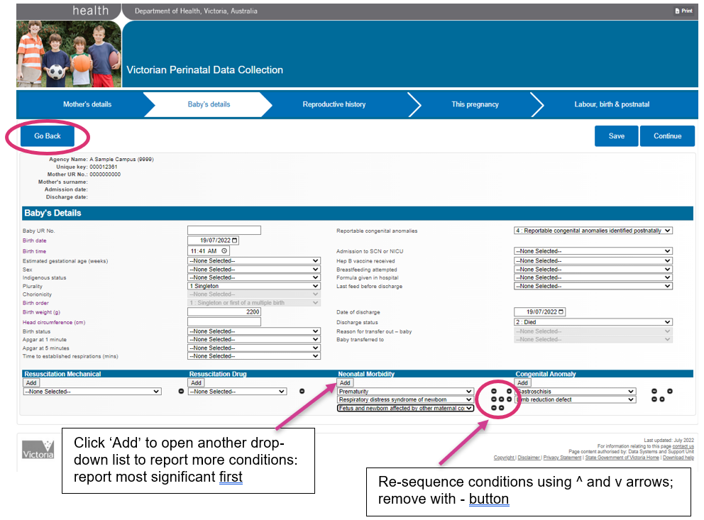

- Some data items allow selection of multiple responses but initially show only the item name and one place for a response. An ‘Add’ button appears above (see Resuscitation Drug, above).
- To report more than one response, select one option from the drop-down list, then click the ‘Add’ button to open a space to select another response, and repeat as many times as needed or allowed (see Neonatal Morbidity and Congenital Anomalies, above).
- When reporting multiple responses, always report the most significant response first.
- Re-sequence responses by clicking on the small black ^ (up arrow) or v (down arrow) buttons to the right of the selections listed.
- Remove a selection by clicking on the small black ‘-‘ button.
- The option selected in some data items will determine whether details are required in other data items (for example, selecting ‘Singleton’ in the data item ‘Plurality’ prevents selection of a value in the data item ‘Chorionicity’, as Chorionicity is only reported for multiple births)
- Selecting ‘Singleton’ in the ‘Plurality’ data item also automatically populates the ‘Birth Order’ data item with the relevant code for a single birth.
- The ‘Save’ button is at the top right of the ‘Baby’s details’ screen. Click ‘Save’ before progressing to the ‘Reproductive history’ screen by clicking the ‘Continue’ button, or returning to the ‘Mother’s details’ screen by clicking the ‘Go Back’ button (top left).

Page 3 – Reproductive history
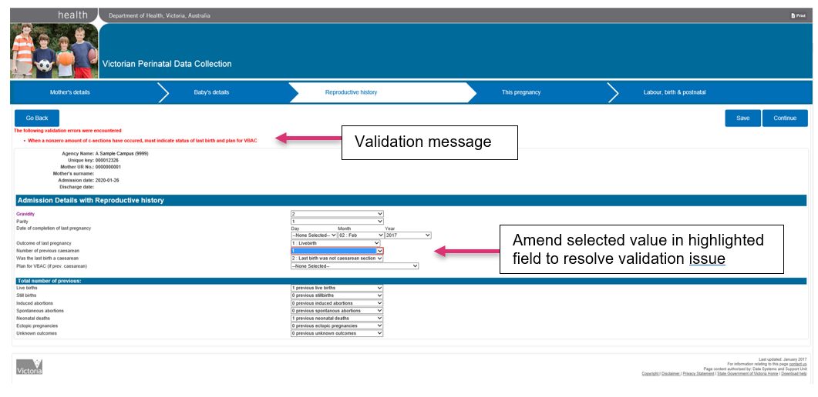
- As noted above, some validations are being introduced to the Perinatal webform to provide immediate feedback to webform users at the point of data entry, with the goal of assisting webform users to enter data in such a way that rejection errors are reduced, and data accuracy improved.
- One validation is shown on the ‘Reproductive history’ page above: the red validation message displayed at the top of the screen indicates an invalid combination has been selected. One of the data items causing the validation error is highlighted on the screen. In this example, while valid values are selected for Gravidity (2), Parity (1), and Number of previous caesareans (1), the value selected for ‘Was the last birth a caesarean’ is ‘Last birth was not caesarean section’: this combination is invalid.
- Where such a validation message appears, the user must correct the error before moving to the next screen.

Page 4 – This pregnancy
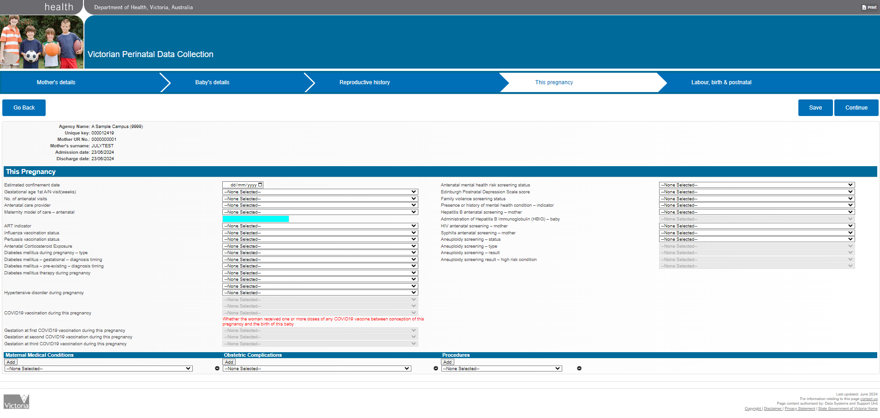
- A number of questions about screening conducted during this pregnancy appear on this screen: on-screen validations will indicate whether a response to these is mandatory.
- The ‘Maternity model of care – antenatal’ data item appearing on this screen reports the Maternity model of care that was in place for the majority of pregnancy care. It may be different from the ‘Maternity model of care – at onset of labour or non-labour caesarean section’ (reported on the ‘Labour, birth & postnatal’ screen) if there was a change of plan near the end of the pregnancy. Some Maternity model of care codes are available in the drop down selector, including code 999994 for Planned homebirth with care from a registered private homebirth midwife. However if the majority of antenatal care was under a Maternity model of care at a hospital, identify the appropriate six-digit code from the AIHW’s Maternity Care Classification System DCT website <https://maccs.aihw.gov.au/> . To enter the code, select ‘Other, please specify’ from the drop down list: this will remove the turquoise colour from the data entry box so the relevant six-digit code can be entered in the data entry box.

Page 5 – Labour, birth & postnatal
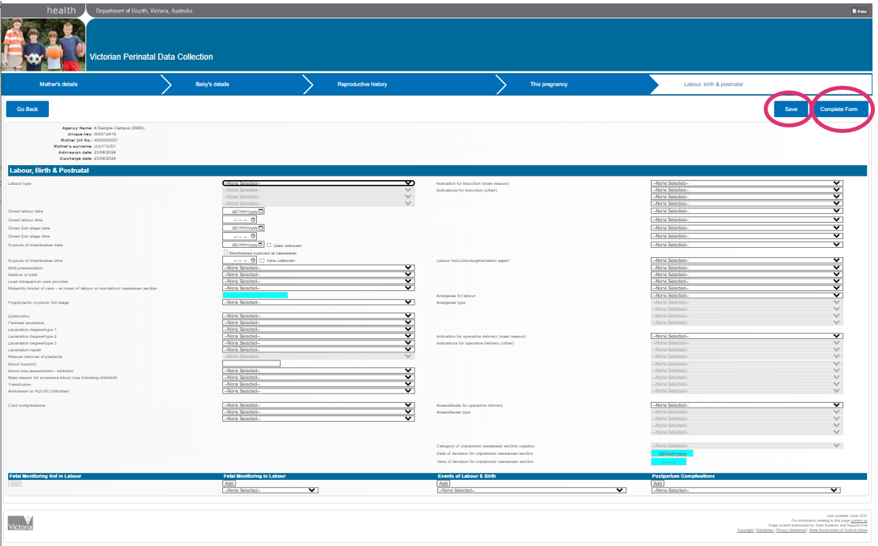
- This final page has a large number of data items: scroll down the page to complete all items.
- Whenever changes are made, click ‘Save’ again. A reminder message appears at the top left.
- When all details have been entered click the ‘Complete Form’ button at the top right corner of the ‘Labour, birth & postnatal’ page.

Data entry completed
- When all details have been entered, and the ‘Complete Form’ button at the top right corner of the ‘Labour, birth & postnatal’ page is clicked, this Perinatal webform will close.
- After the Perinatal webform closes, a query box will appear.
To confirm that you want to close the webform, click ‘Yes’.
If you want to return to the webform, click ‘No’, then click the back arrow in your browser to return to the webform.
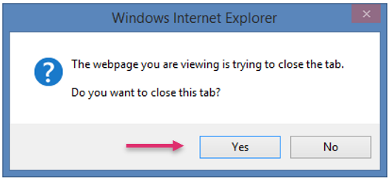
- If you select ‘Yes’ and close the webform, you will return to the Perinatal webform homepage screen.
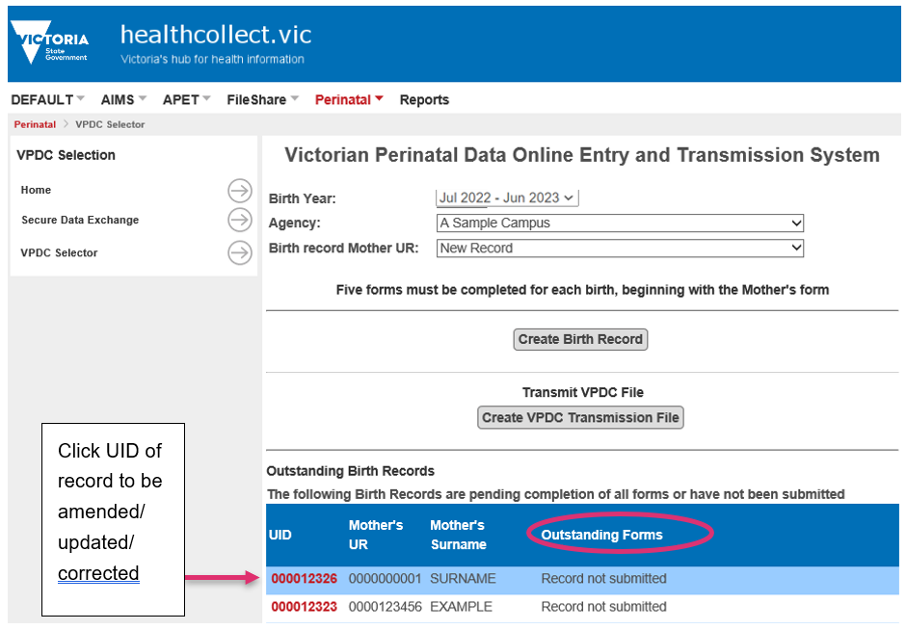
- Webforms that have at least some data entered, but have not been submitted to the VPDC, are listed as ‘Outstanding Birth Records’.
- Webforms should be checked before submission to ensure all required details have been completed.

Amending, updating or correcting details in a Perinatal webform – before submission for processing
- Amending, updating or correcting details in a Perinatal webform may be required where details are added at different stages of the pregnancy and delivery, and to ensure all details are complete before the webform is submitted for processing.
- When changes are required to details entered previously, return to the original webform for that birth. Do not create a new record, as that risks duplicate reporting of the same birth.
- To access a webform before submission for processing, find the record in the list beneath the Outstanding Birth Records heading, and click the UID number, which appears in red font.
- Clicking on the UID re-opens that webform at the ‘Mother’s details’ page. Navigate through the webform as described above to update or correct details as required.
- Save before moving on from each successive page to ensure updates are retained.
- When amendments are completed, click the ‘Complete Form’ button at the top right corner on the ‘Labour, birth & postnatal’ page, and confirm that you want to close the tab. You will be taken back to the Perinatal webform home screen again.

Deleting a webform
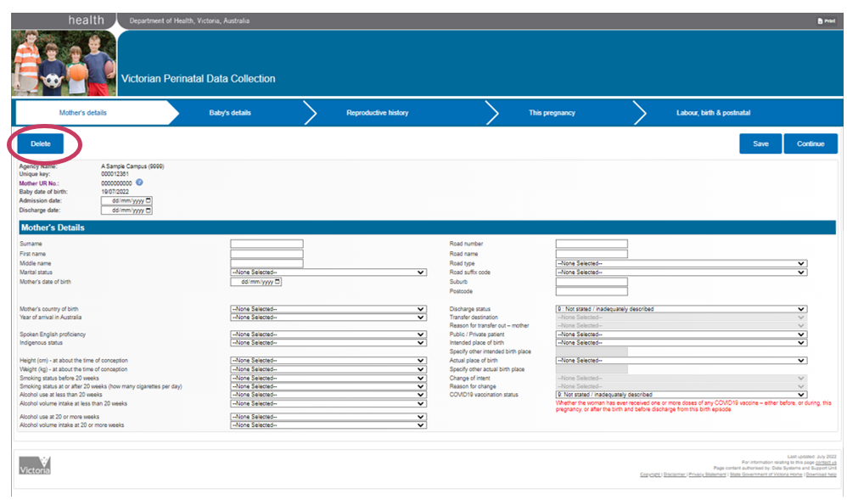
- Report only one webform for each birth.
- If a second webform is created for a single birth, it can be deleted by clicking the ‘Delete’ button, top left of the ‘Mother’s details’ screen.
- A webform can be deleted before the birth record is submitted to the VPDC, or after. If it is deleted after being submitted, a ‘Deactivation’ will be submitted to the VPDC the next time a Submission file is created.
- Double-check before deleting: it cannot be reversed.

Submitting the Perinatal webform record
- When a Perinatal webform is complete, it must be formatted into a VPDC transmission file and forwarded to the department for processing against the VPDC business rules. The data will then be included in the VPDC database along with birth records reported by other health care providers.
- To create a transmission file, click the ‘Create VPDC Transmission File’ button. The file will include all webforms that have been marked as ‘complete’ but have not previously been submitted.
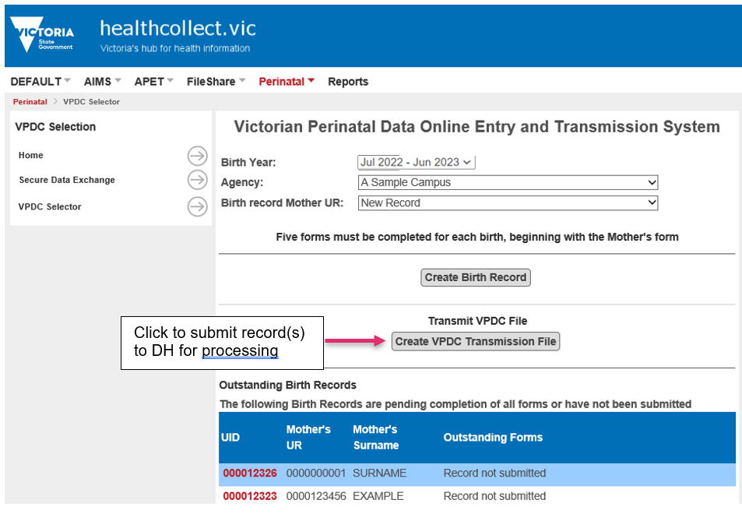
- A new window will open, showing – for the Birth Year selected in the VPDC home screen – the number of webforms to be included in this submission (‘Total New Birth Records’), and those already sent for this calendar year (‘Total Existing Birth Records’).
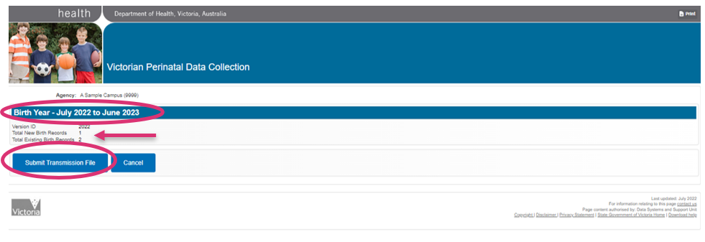
- To create and submit the transmission file, click the ‘Submit Transmission File’ button. Where multiple webforms for births in the same financial year are ready for submission, they will be combined into a single submission file and be submitted together.
- When the ‘Submit Transmission File’ button is selected, a confirmation screen will appear after a few moments, to indicate the record/s that have been transmitted successfully.
- The ‘Submission identifier’ and ‘Submission Number’ for this submission are displayed, with confirmation of the number of records (webforms) included in the file. Note the Submission identifier and Submission number: these will appear on the transmission reports generated from processing the transmission file. If multiple files are submitted together, the Submission number and Submission identifier will allow the correct reports to be matched with the records submitted in that transmission file.
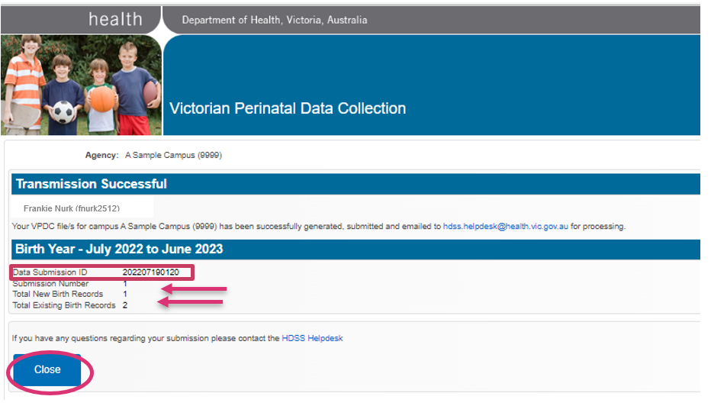
- Select ‘Close’ to return to the Perinatal context (home screen).
- The HealthCollect secure portal will forward the transmission file to the department, where it will be transferred for processing against VPDC system validations.

VPDC transmission reports
- For each transmission file submitted, the VPDC processor generates two reports:
- Clinician Report (.pdf)
- Submitted Data Report (Excel)
- These transmission reports are returned to the user’s HealthCollect portal, usually by the next business day.
- To access these reports, login to HealthCollect, select Perinatal, and click on ‘Secure Data Exchange’ in the functions menu on the left. The Perinatal File Download window will open and display the reports.
- If the reports are not found, click ‘Refresh File List’. If the reports still do not appear, email the HDSS HelpDesk <hdss.helpdesk@health.vic.gov.au>.
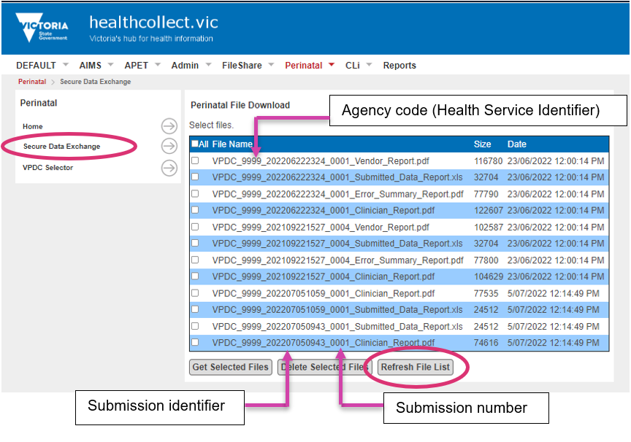
- The report filename includes:
- Agency code: the four-character Health Service Identifier for the agency selected in the Victorian Perinatal Data Online Entry and Transmission System screen, before the webform was opened;
- Submission identifier and Submission number: these will be the same as were shown on the ‘Transmission Successful’ screen;
- Report name.

Download and save transmission reports
- Download all reports from HealthCollect and save them in a suitable directory on your health service’s computer. Remember that they contain confidential identifying details and save them accordingly (not the C:\ drive).
- Select the reports to download (click on the ‘All’ box, or click the box next to each report’s name individually), then click the ‘Get Selected Files’ button.
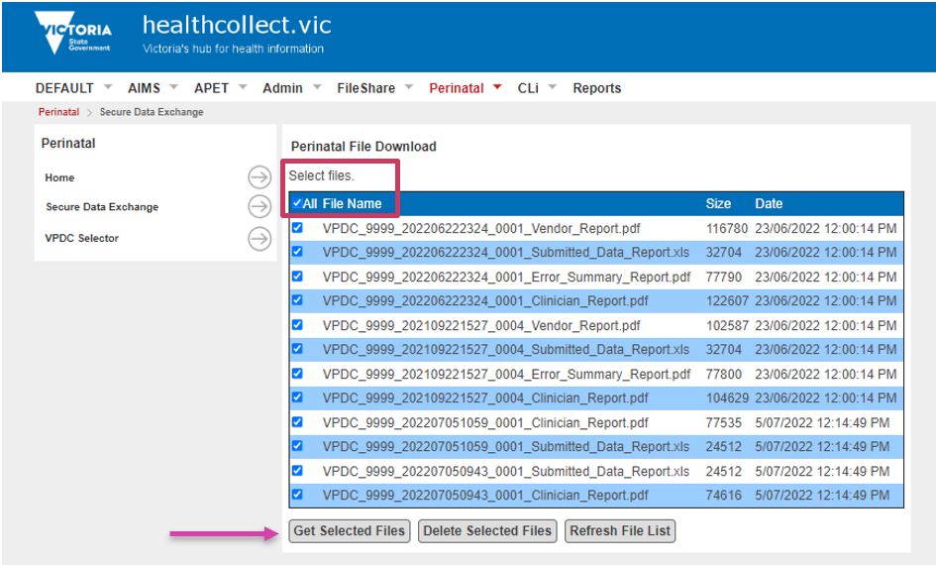

- A pop up will appear at the base of the screen asking if you want to open or save the downloaded file. Select ‘Save’: this will save the files to the Downloads directory in your computer. The files are saved as a zipped folder with the user’s HealthCollect identifier as the zipped filename.
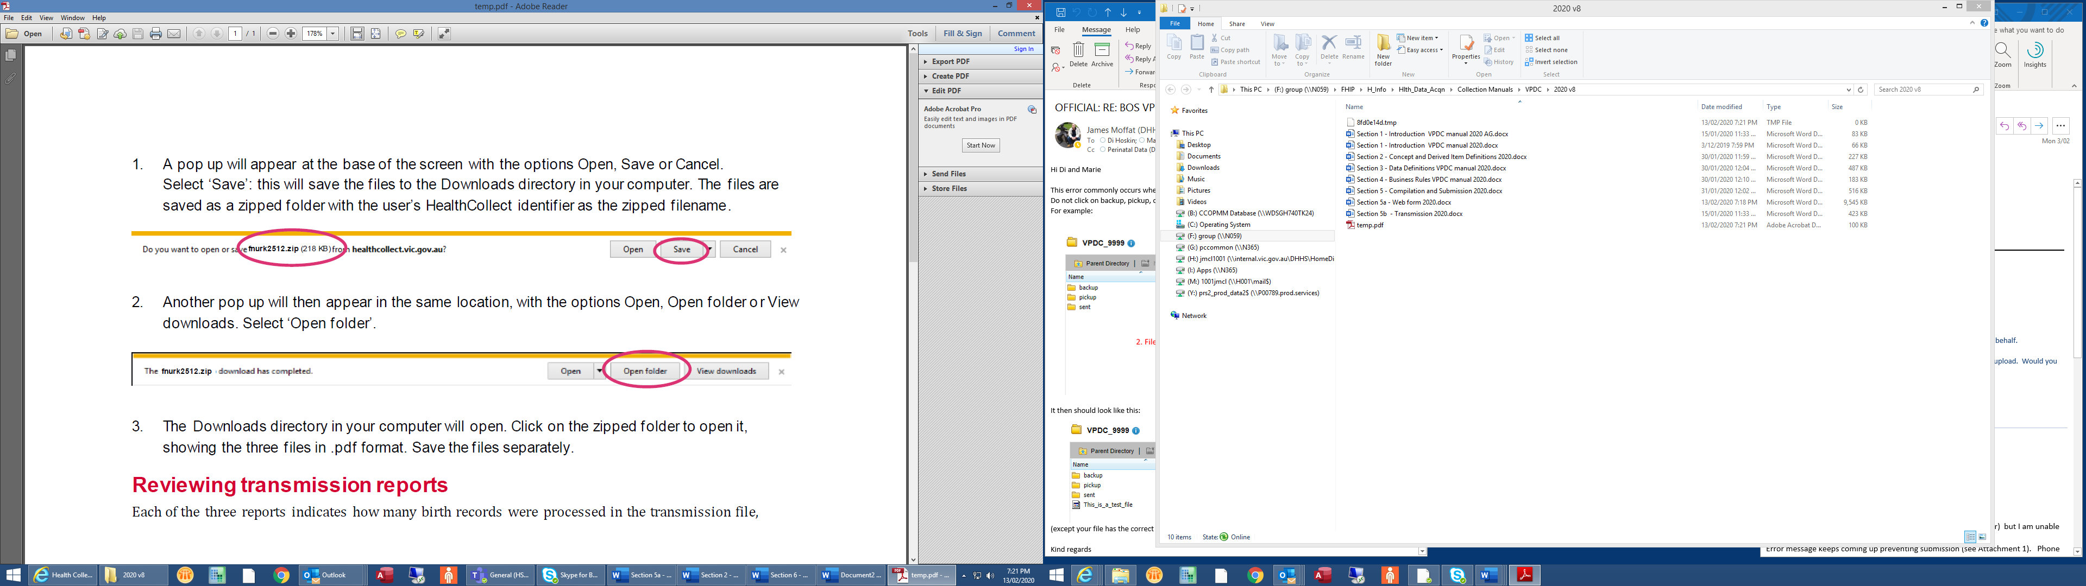
- Another pop up will then appear in the same location, indicating the download has been completed. Select ‘Open folder’ to go to the Downloads directory in your computer.
- The Downloads directory in your computer will open. Click on the zipped folder to open it, showing the two files. Save the files separately to a suitably secure location, appropriate for the confidential nature of the data in the files.

Reviewing transmission reports
- Both reports indicate how many birth records were processed in the transmission file and how many records were rejected.
- Check that the number of records submitted is consistent with the number you expected to be sent.
- The Clinician report shows the reason/s for those rejection/s. The explanation of rejections is to help users go to the Perinatal webform for the birth with the error, correct the error, and resubmit that birth record (see below).
- Using the Clinician Report, check all error messages that indicate a record was rejected. The reason/s for any rejections will be listed in detail. All rejections must be checked and the data in the webform corrected and then resubmitted.
- The Submitted Data Report lists the value reported in each data field for each record in that submission file, in Excel format, which can be sorted and filtered. It is useful for reviewing records for data quality purposes.
- Review Section 3 Data definitions and Section 4 Business rules to clarify reporting rules or data code set restrictions. If unable to identify the cause of any rejection, email the HDSS HelpDesk <hdss.helpdesk@health.vic.gov.au> .

Amending, updating or correcting details in a Perinatal webform – after submission for processing
- To correct details in a webform that has been submitted, return to the Victorian Perinatal Data Online Entry and Transmission System screen, click to open the list of ‘Birth record Mother UR’ and select the record to be corrected:
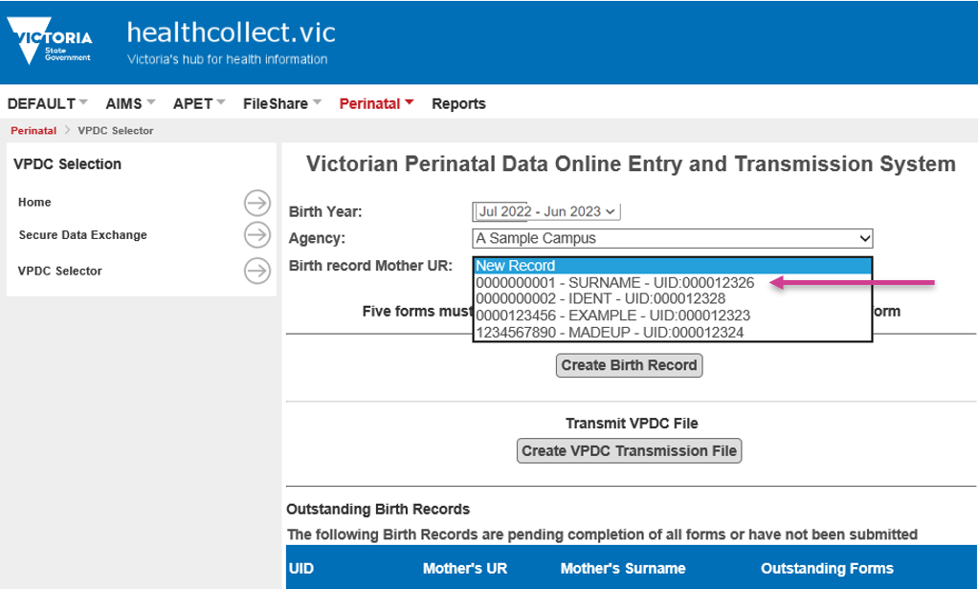
- When the record is selected, two options will be offered: ‘Edit Birth Record’ or ‘View Birth Record’: select ‘Edit Birth Record’ to open the webform with the details as submitted.
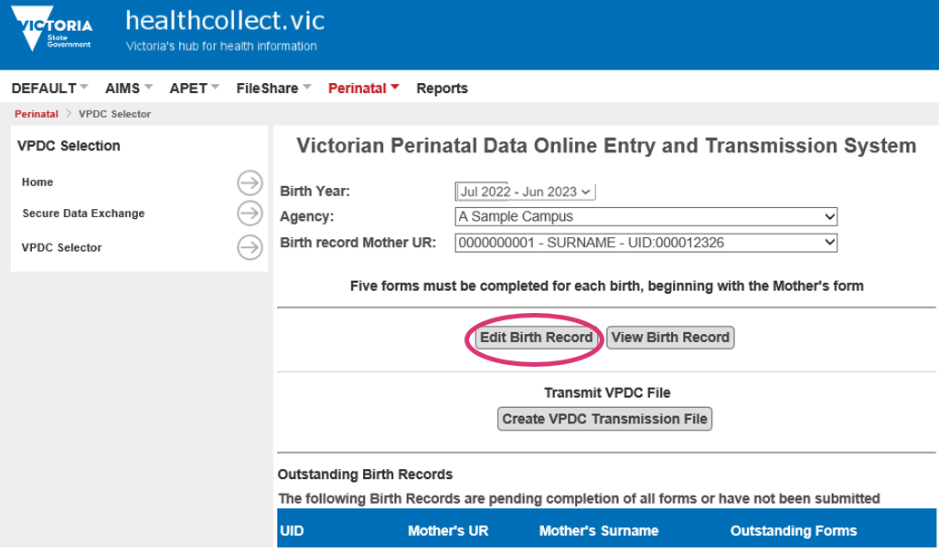
- Navigate to the page with the details to be corrected, make appropriate changes, and click ‘Save’.
- When all corrections have been made, progress to the ‘Labour, birth & postnatal’ page, and click ‘Complete Form’, and confirm as before.
- Return to the Victorian Perinatal Data Online Entry and Transmission System screen again, and click ‘Create VPDC Transmission File’, check the number of records in the submission file is as expected, and click ‘Submit Transmission File’, in the same way as was done for the original submission.
- The next business day, check the Secure Data Exchange, and download the files, check again and repeat until all rejections have been resolved.
- To view or print an entire webform record, select ‘View Birth Record’: all data items will be displayed in a single window: scroll down to see all data entered. Click the ‘Print’ button (top right corner, in the grey bar) to print all details.

