

Summary STIR Report 2017–18

Figure 1 (from full report): Number of validated clinical and procedural reports and health services reporting
to STIR each financial year.
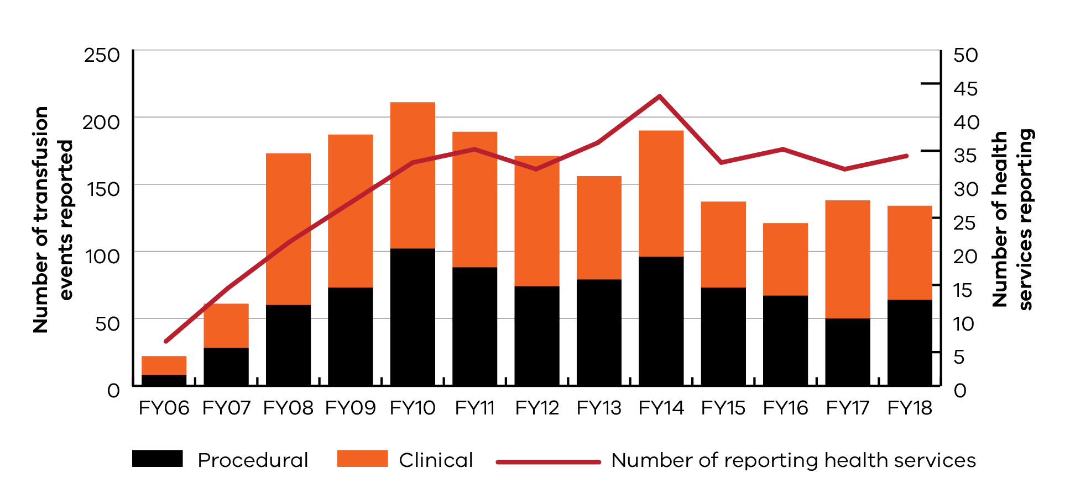

Icon | Information
 | 159 notifications  10 withdrawn
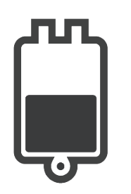 | 149 investigations returned  15 excluded

Figure 4 (from full report): Validated clinical events
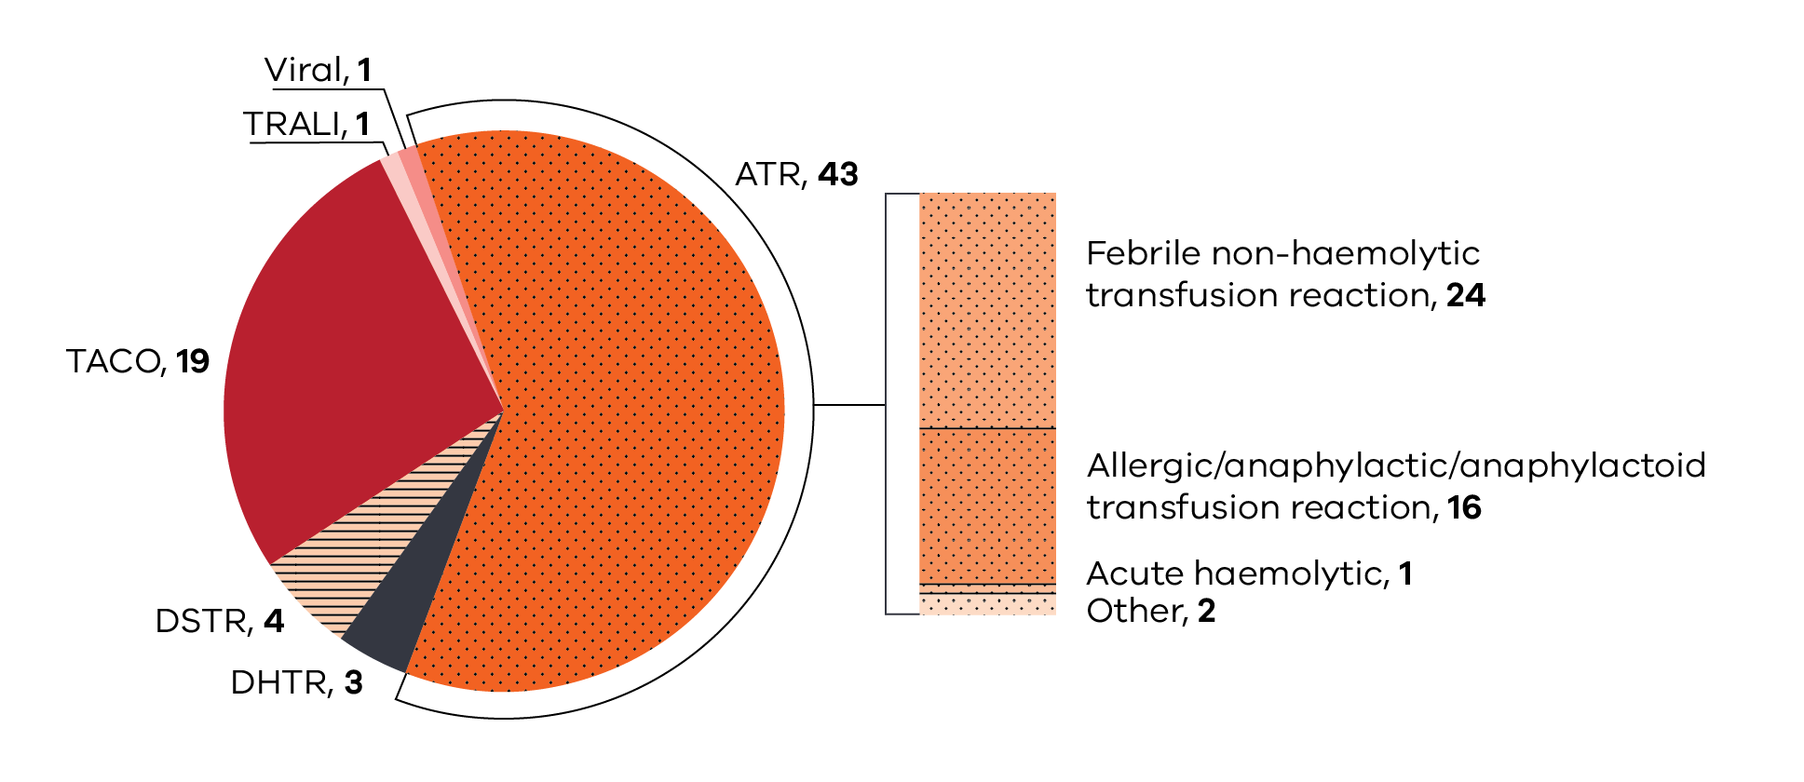
Clinical recommendations
Always consider a potential transfusion reaction when clinical deterioration is noted in a patient receiving,
or who has received, a blood product. When considering the clinical picture of the deteriorating patient during transfusion, the transfusion should be stopped (with intravenous (IV) access maintained), while the patient is assessed and a transfusion reaction investigated (refer to case study 3 allergic, in full report).
The routine use of FFP as replacement for patients undergoing therapeutic plasma exchange is not recommended unless there is a clear indication to replace coagulation factors (refer to case study 4 allergic, in full report).
Figure 7 (from full report): Validated procedural events
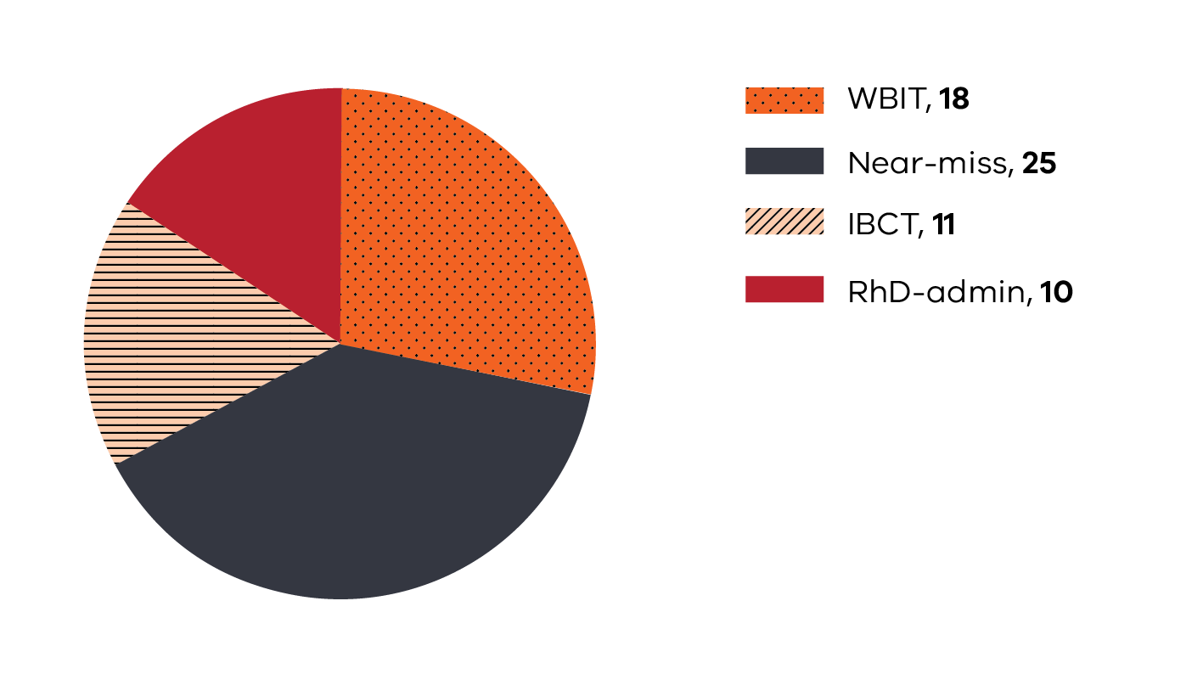

Incorrect Blood Component Transfused (IBCT)
This year there were two root cause analysis after blood was administered to the wrong patient or did not match the patient blood group. See full report for information from these investigations.

Procedural recommendations
Positive patient identification (PPID) at each step in the transfusion process is vital, regardless of the situation.
This includes asking the patient to state their name and date of birth where possible, use of an interpreter when required and confirmation of stated identity with name band, blood product or labelled specimens and order/prescription (refer to case studies 11 incorrect blood component transfused (IBCT); 17, 18 and 19 WBIT; 15 near miss, in full report).
Blood administration must only occur after double independent checking has occurred. This involves both staff performing all checks at the bedside. Both staff should be able to independently confirm that the product to be commenced is intended for the patient (refer to case studies 11 IBCT; 16 near miss, in full report).
Health services considering the use of pneumatic chutes for the delivery of blood products must establish processes for verification when collecting the product from a chute, ensure appropriate training of staff in product collection and reporting of adverse events should they occur. Assessment of the risks to patients associated with the collection and incorrect delivery of blood from the pneumatic delivery system needs to be considered, just as much as the risks to the blood product itself (refer to case studies 11 IBCT; 16 near miss, in full report).
Review of incidents reported to STIR has demonstrated that there are some similarities between the incidents we
see reported to STIR and those reported to the UK serious hazards of transfusion (SHOT) system. There are some
key messages from the SHOT 2017 report, which also apply in our experience.
From SHOT 2017:
Do not assume, verify: At each step in the transfusion process, do not assume that no errors have been made in previous steps; verify each step, particularly patient identification.
Human factors: Failure of communication, distractions, interruptions, wrong assumptions, poor handovers
and overriding alerts in the laboratory information systems are all important contributory factors.
It is the clinician’s responsibility to determine, document and communicate the patient’s specific transfusion requirements.
The full STIR report is available on the Blood Matters website on the Serious Transfusion Incident Reporting system page <https://www2.health.vic.gov.au/hospitals-and-health-services/
patient-care/speciality-diagnostics-therapeutics/blood-matters/serious-transfusion-incidents>

To receive this publication in an accessible format phone 9694 0102, using the National Relay Service 13 36 77 if required, or email STIR <stir@redcrossblood.org.au>
Authorised and published by the Victorian Government, 1 Treasury Place, Melbourne.
© State of Victoria, Department of Health and Human Services , November, 2019
ISSN 2651-8872 – Online (pdf / word)
Available on the Blood Matters website <https://www2.health.vic.gov.au/hospitals-and-health-services/patient-care/speciality-diagnostics-therapeutics/blood-matters>
(1910524)

