

Summary STIR Report 2019-20
OFFICIAL
Number of validated clinical and procedural reports and health services reporting each financial year: FY2006- FY2020
214 notifications from health services
26 withdrawn
166 investigations returned
22 excluded by expert review
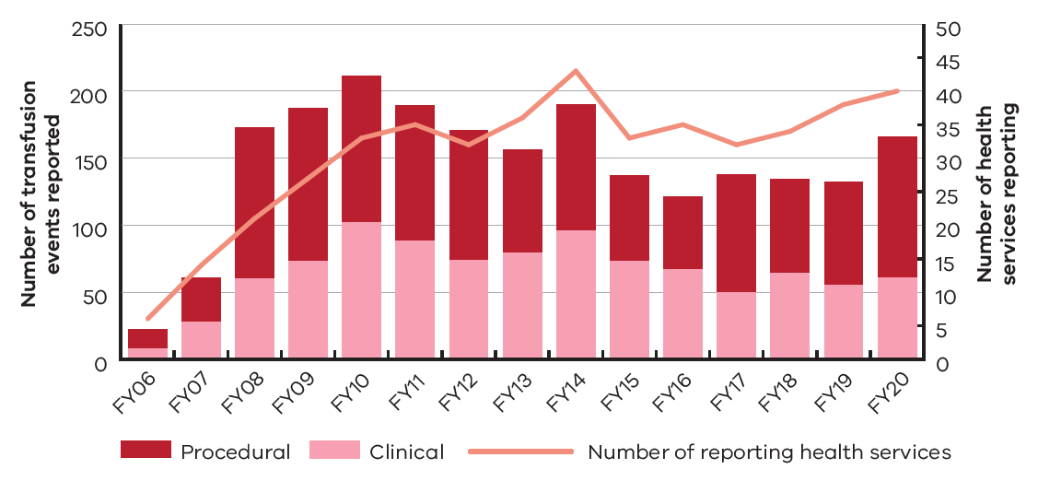

Validate clinical events reported to STIR FY20
 Positive patient identification at ALL stages of the transfusion process reduce the risk of an acute haemolytic reaction due to an incorrect product being administered.
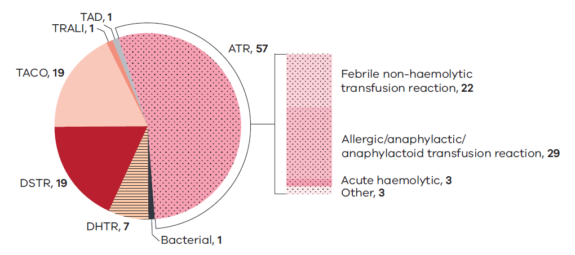
Wrong blood in tube events continue to be the largest proportion of procedural reports received.

RhD administration errors continue to occur regularly and where doses are missed, put future pregnancies at risk. Health services need to have good processes in place to check the need for and administration of RhD immunoglobulin.
Validated procedural events reported to STIR FY20
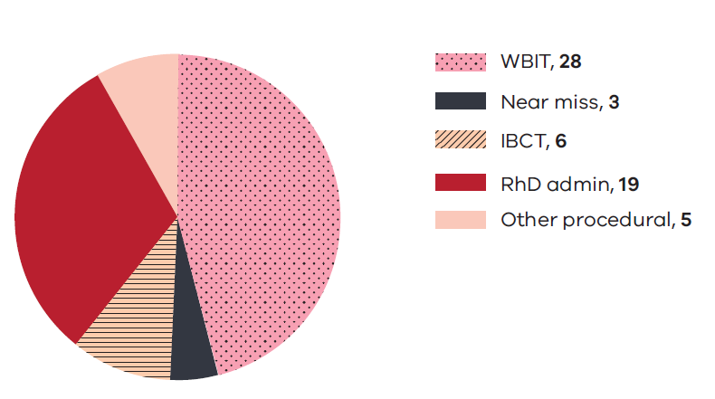

Key messages and recommendations:
Area | Recommendation
Governance | Health services should have a clear process to report and investigate transfusion reactions using both laboratory and clinical investigation.
Clinical | Blood products should only be administered where there is a clear indication for their use and benefit to the patient (case study 3).  A unit of blood disconnected from the patient for any reason should not be recommenced. This is both an infection-control risk as well as a risk of recommencing on the wrong patient if identity checks are not re-performed (case study 13).
Procedural | Staff should be educated to inform the laboratory when a WBIT is identified, so that all specimens/results can be withdrawn, for both patients involved in the error. It is important to ensure wrong or misleading results do not remain in affected patients’ records.  When determining the need for RhD immunoglobulin for women, clinicians should refer to the laboratory information on blood group and not rely on information transcribed into the patient record or in letters or care plans. Transcription errors can cause missed doses of immunoglobulin, putting subsequent pregnancies at risk (case study 18).  This year, there were fewer near-miss events reported. One explanation for this may be because staff see this as something that does not need reporting due to a perceived lack of harm to the patient. However, this is an opportunity to learn how our systems are functioning, where things could potentially go wrong and how we can prevent them. Staff should be educated to report near-miss events.
Patient identification | Positive patient identification is crucial at every step in the transfusion process (case studies 11 and 12).  Health services should ensure that procedures for the identification and registration of patients are consistent and meet minimum requirements for identification to prevent registration errors that confuse patient details. (case studies 15; 16)

The full STIR report is available on the Blood Matters website
https://www2.health.vic.gov.au/hospitals-and-health-services/patient-care/speciality-diagnostics-therapeutics/blood-matters/serious-transfusion-incidents

To receive this document in another format, phone 03 9694 0102, using the National Relay Service 13 36 77 if required, or email Blood Matters bloodmattters@redcrossblood.org.au.
Authorised and published by the Victorian Government, 1 Treasury Place, Melbourne. © State of Victoria, Australia, Department of Health, September 2021.
ISSN 2651-8872 – Online (pdf / word) format
Available at Blood Matters <https://www2.health.vic.gov.au/hospitals-and-healthservices/patient-care/speciality-diagnostics-therapeutics/blood-matters>
(DH 2109105)

