
STIR annual report 2018–19
Blood Matters program

STIR annual report 2018–19
Blood Matters program

To receive this publication in an accessible format phone 03 9694 0102, using the National Relay Service 13 36 77 if required, or email STIR<STIR@redcrossblood.org.au>.
Authorised and published by the Victorian Government, 1 Treasury Place, Melbourne.
© State of Victoria, Australia, Department of Health and Human Services August 2020.
ISSN 2651-8872 - Online (pdf / word) format
Available at <https://www2.health.vic.gov.au/hospitals-and-health-services/patient-care/speciality-diagnostics-therapeutics/blood-matters/serious-transfusion-incidents>
(2008773)

Contents
Acknowledgements 6
Abbreviations and acronyms 7
Executive summary 9
Key messages and recommendations 10
Introduction 11
Method 12
Withdrawn reports 13
Validation and Reconciliation 13
Demographics 16
Clinical reports 17
Febrile non-haemolytic transfusion reaction (FNHTR) 17
Allergic 19
Acute haemolytic transfusion reaction (AHTR) 20
Delayed haemolytic transfusion reaction (DHTR) 21
Delayed serologic transfusion reaction (DSTR) 22
Transfusion-associated circulatory overload (TACO) 23
Transfusion related acute lung injury (TRALI) 24
Transfusion-associated dyspnoea (TAD) 25
Transfusion-associated graft vs host disease (TAGVHD) 25
Posttransfusion purpura (PTP) 25
Other–ATR 25
Procedural reports 26
Incorrect blood component transfused (IBCT) 26
Near miss 29
Wrong blood in tube (WBIT) 30
RhD immunoglobulin (Ig) administration 32
Cell salvage 33
Sentinel events 33
Future 33
References 34
Appendix 1–Expert group members 35
Appendix 2–STIR publications and promotions 36
Appendix 3–Imputability and severity scores 37
Appendix 4–STIR timeline 38

Acknowledgements
The Blood Matters program is a collaboration between the Victorian Department of Health and Human Services and the Australian Red Cross Lifeblood. It is founded on the expectation that providing haemovigilance information supports the community by promoting better transfusion practice.
The Serious Transfusion Incident Reporting (STIR) program thanks the participating Victorian, Tasmanian, Australian Capital Territory and Northern Territory public and private health services for their contribution to the program.
Blood Matters recognises and appreciates the generous in-kind support of the STIR Expert Group, whose input is invaluable in reviewing the incidents and providing recommendations and direction for the work.

Abbreviations and acronyms
ABO | major human blood group system
AHTR | acute haemolytic transfusion reaction
BloodNet | a web-based system through which staff in health facilities across Australia can order blood and blood products from the Australian Red Cross Lifeblood in a standardised, secure and efficient way
BP | blood pressure
DHTR | delayed haemolytic transfusion reaction
DSTR | delayed serologic transfusion reaction
ED | emergency department
EMR | electronic medical record
FNHTR | febrile non-haemolytic transfusion reaction
FFP | fresh frozen plasma
FY19 | period 1 July 2018 to 30 June 2019
Hb | haemoglobin
IBCT | incorrect blood component transfused
ICU | intensive care unit
IM | intramuscular
IV | intravenous
Lifeblood | Australian Red Cross Lifeblood, formerly Blood Service
MET | medical emergency team
NBA | National Blood Authority
NSQHS | National Safety and Quality Health Service
PCC | prothrombin complex concentrate
PTP | posttransfusion purpura
RCA | root cause analysis
RhD | Rh blood group D
SCV | Safer Care Victoria
SR | severity rating
STIR | Serious Transfusion Incident Reporting
TACO | transfusion-associated circulatory overload
TAD | transfusion-associated dyspnoea
TAGVHD | transfusion-associated graft versus host disease
TRALI | transfusion-related acute lung injury
TTI | transfusion-transmitted infection
VHIMS | Victorian health incident management system
WBIT | wrong blood in tube

Executive summary
The Serious Transfusion Incident Report (STIR) program is part of a larger program of work to help health services improve the care of patients receiving blood and blood products. The Blood Matters program, under which STIR functions, provides education, audit and benchmarking activities, and clinical expertise to health services in four jurisdictions. This report provides information on the serious transfusion reactions and incidents that occur in those jurisdictions. We encourage all health services to register and report as appropriate to STIR.
This year 171 notifications were received with 25 withdrawn by the health service and 14 excluded by the Expert Group, leaving a total of 132 investigations completed for this annual report. Of the 100 health services registered with STIR, 38 (38 per cent) submitted reports. It is unknown how many non-submitting health services had reactions or incidents that could have been reported. We know from discussions with health service personnel and reconciliation with Lifeblood reports that there are a number of reactions occurring in health services that are not being reported to STIR. Although reporting through to STIR is voluntary, the NSQHS standards, Blood Management Standard does require participation in haemovigilance activities and reporting in accordance with national guidelines.
This year clinical reactions to blood products, often unavoidable, are the largest proportion of the investigations received (59 per cent). A focus on patient blood management in health services, thereby reducing the number of transfusions, may assist in reducing the number of clinical reactions to blood products.
In the past several years, procedural errors represented more than 50 per cent of all reports received. These are almost universally preventable, and it is encouraging to see these dropping back to less than 50 per cent of received investigations. It is fortunate that the majority of these reports cause no actual harm to the patient. However, the potential for harm remains. We can learn from these errors and put in place procedures, education and systems that promote and assist clinical and laboratory staff to ensure they are handling and using blood products correctly.
Many health services are moving to electronic medical record systems (EMR); some incorporate systems for patient identification for both specimen collection and blood administration. Anecdotally, some health services have reported concerns re increased errors in labelling (Wrong Blood in Tube events). Currently, STIR investigation forms do not explicitly enquire about the role EMR played in the error. Consequently, investigation forms are currently being reviewed to include questions to better identify how EMR systems contributed to the event, if at all.

Key messages and recommendations
Clinical
For warfarin reversal, Prothrombinex® is preferred over FFP, and its use should be encouraged for all clinicians, following the warfarin reversal guidelines <https://www.mja.com.au/journal/2013/198/4/update-consensus-guidelines-warfarin-reversal>.
FFP is not routinely needed in combination with Prothrombinex®, and should only be used according to the guidelines, such as when Prothrombinex® is unavailable
Case study 3: allergic (FFP)
Patients undergoing transfusion should be assessed for risk factors for overload and the rate of transfusion adjusted to run at the slowest rate appropriate to the situation. Where possible, a single unit should be administered and the patient assessed for both the need for further transfusion and indications of overload before any further transfusions occur.
Case study 4: TACO in patient with risk factors
Procedural
Positive patient identification (PPID) at each step in the transfusion process is vital, regardless of the situation. This includes asking the patient to state their name and date of birth where possible, use of an interpreter when required and confirmation of stated identity with name band, blood product or labelled specimens and order/prescription.
Case study 7: WBIT
Blood administration must only occur after double independent checking has occurred. This involves both staff performing all checks at the patient side. Both staff should be able to independently confirm that the product to be commenced is intended for the patient and must include checks that blood groups are compatible for both ABO and Rh groupings and that any special requirements are met, for example, irradiation.
Case study 5: RhD incompatible red cell units cross matched and transfused
General
Education of all staff involved in the transfusion chain to ensure appropriate handling, ordering and administration is important to address safety issues.
Reporting of reactions to STIR assists in local and national reporting, including to the NBA National haemovigilence report, and the health service requirements for accreditation.
All incidents and reactions that meet STIR criteria should be reported to STIR in a timely manner.

Introduction
This report covers the period 1 July 2018 to 30 June 2019. This year, 171 notifications were received, with 25 withdrawn by the health service and 14 excluded by the Expert Group; leaving a total of 132 validated investigations for this annual report. Of the 100 health services registered with STIR, 38 (38 per cent) submitted reports. In this reporting period, reactions to blood products, often unavoidable, are the largest proportion of the investigations received (58 per cent). Procedural events, which are largely preventable, have dropped and for the third year are fewer than the clinical events reported (Figure 1).
Figure 1: Number of validated clinical and procedural reports and health services reporting each financial year, FY2006–FY2019
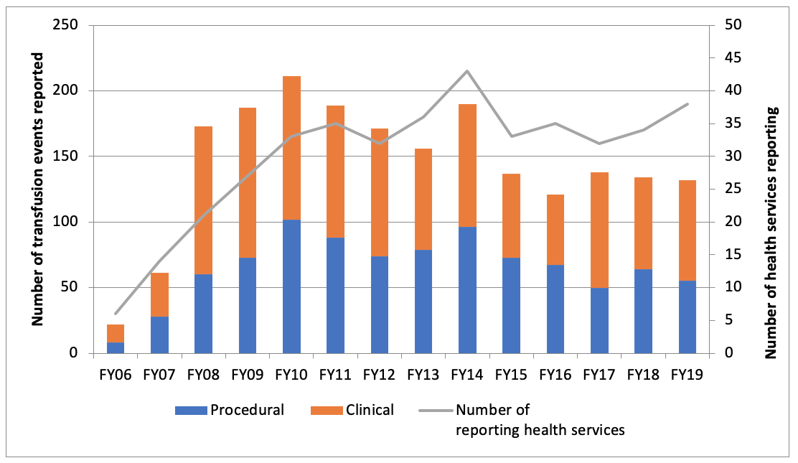
There were no severity rating (SR) 1 events reported this year, and no deaths attributed to transfusion.
The National Blood Authority (NBA) via BloodNet provides total blood issue data. Table 1 shows total blood issues per jurisdiction 2018–19 (FY19) (distributed units minus units lost due to wastage, damage or other reasons).
Table 1: Total blood issues per jurisdiction 2018–19 (FY19)
Issues 2018–19 | VIC | ACT | TAS | NT
Total red cells | 173,818 | 9,215 | 11,355 | 4,015
Total platelets | 34,861 | 1,450 | 2,361 | 824
Total FFP | 27,429 | 1,062 | 1,275 | 619
Total cryoprecipitate | 29,525 | 1,848 | 2,075 | 828
Total | 265,632 | 13,575 | 17,066 | 6,286

The NBA issue data can then be used to determine an estimate of the frequency of serious clinical reactions to blood, as shown in Table 2. As incident reporting is voluntary, this rate would be an underestimate and needs to be considered with care. No national data on numbers of patients transfused, or numbers of blood products received by individual patients, to serve as denominator data is available in Australia.
Table 2: Estimated frequency of clinical reactions per product in Victoria
Product | Blood issues (Victoria) | Validated clinical events | Frequency
Red cells | 173,818 | 44 | 1:3950
Platelets | 34,861 | 14 | 1:2490
FFP | 27,429 | 8 | 1:3429
Cryoprecipitate | 29,525 | - | -

Method
Table 3 shows the steps in the reporting and validation of health service notifications to STIR. There are a number of validation steps built into the process at notification, and on return of investigation forms. All investigation forms are sent to members of the Expert Group for review, with all SR 1 and 2 events requiring a full Expert Group panel review.
Table 3: Steps in the reporting and validation of health service notifications
Icon | Steps
 | 171 notifications from health services
 | 25 notifications withdrawn before investigation form returned
 | 146 investigation forms sent to STIR Expert Group for review
 | 30 investigation forms required second review
 | 14 investigations excluded by expert review
 | 132 final validated reports included for analysis

Withdrawn reports
As shown in Table 4, there were 39 reports withdrawn or excluded for various reasons. Reports out of scope for STIR reporting accounted for nearly half of these. These ‘not in scope’ reports were mostly related to minor allergy/simple rash (n = 5), wastage due to delayed return to blood bank (n = 5) and stem cell reactions (n = 2).
Over a quarter of the withdrawn reports were due to exclusion after expert review. The expert reviewers excluded 10 events as the reported symptoms were more likely due to underlying disease processes than due to the transfusion. A further three were not assessable due to insufficient information and one event was not in scope.
Table 4: Reasons for withdrawal of notifications to STIR
Fiscal year | Duplicate | Not in scope | Deemed not transfusion related by health service | Not completed | Excluded after expert review | Total
2012–13 | 2 | 4 | - | 4 | - | 10
2013–14 | 1 | 6 | 4 | 16 | - | 27
2014–15 | 9 | 11 | 6 | 8 | 4 | 38
2015–16 | 6 | 11 | 5 | 5 | 4 | 31
2016–17 | 5 | 4 | 2 | 1 | 5 | 17
2017–18 | 3 | 5 | - | 2 | 15 | 25
2018–19 | 5 | 16 | 3 | 1 | 14 | 39

Validation and reconciliation
Validation steps are undertaken by the STIR Expert Group, which reviews all investigation forms sent from health services. This may be a single review, or the reviewer may ask for a second review. For all incidents that are reported or validated as SR 1 or 2, the group together reviews these to ensure consistency. In this reporting period there were 28 SR 1 or 2 events reviewed by the group.
The review process assesses the information to ensure it supports the diagnosis, imputability and severity ascribed by the reporting health service. A number of reports have the diagnosis (Table 5), or severity rating changed (Table6) after expert review.
Table 5: Changes to incident type following STIR Expert Group review
Original incident type submitted | Validated incident type: FNHTR | Validated incident type: AHTR | Validated incident type: Allergic/ anaphylactic reaction | Validated incident type: other acute transfusion reaction type | Validated incident type: TACO only | Validated incident type: IBCT / other procedural
Allergic/anaphyl-actic reaction | - | - | - | 1 | - | -
Febrile non-haemolytic transfusion reaction | - | 1 | 1 | 2 | - | -
TRALI | - | - | - | - | 2 | -
TACO/TAD | - | - | - | - | 3 | -
TRALI/TACO | - | - | - | - | 1 | -
Near miss | - | - | - | - | - | 4
Of note are the number of incidents submitted as near miss that were changed to incorrect blood component transfused (IBCT), as in each event the transfusion had commenced. Further clarification of IBCT and near miss events, as well as when the transfusion is considered to have commenced, will be in the STIR reporting guide, updated 2020.
In addition, it should be noted that of the 18 validated TACO events, six (33 per cent) were initially reported as a combination with either TAD or TRALI.
Table 6: Changes to the severity rating following expert review
Incident severity rating submitted as SR 4 | Incident severity rating validated as SR 2 | Incident severity rating validated as SR 3
Allergic/anaphylactic reaction | 3 | -
Febrile non-haemolytic transfusion reaction | 1 | 4
ATR – other | 1 | -
TACO | 2 | 3
DHTR | 1 | -
All events having a severity rating reassigned to SR 2 had either documented increased length of stay, required adrenaline or assisted ventilation or required admission to intensive care unit (ICU) due to the reaction.
There is a process of annual reconciliation in place for Australian Red Cross Lifeblood (Lifeblood) reports (reactions reported to Lifeblood by health services).
Health services are required to inform Lifeblood of any adverse reaction that may relate to the quality of the product which will prompt Lifeblood to recall any associated products (for example, transfusion transmissible infection and TRALI) or cause an alternative product to be requested (for example, washed red cells in patients with repeated anaphylactic reactions or IgA deficient products).
For the 2018–19 period, there were 41 reports to Lifeblood in Victoria; seven were also reported to STIR, with the remaining 34 unreported.
Of the seven reported to STIR:
- four reports reconciled with both Lifeblood and STIR attributing the same diagnosis
- two reports were reported to Lifeblood as possible TRALI and determined to be unrelated; one was report to STIR as TRALI, the other as TACO and both were validated as TACO
- one was reported to Lifeblood as TAD and validated as this; however, this event was reported to STIR as an allergic transfusion reaction and STIR validated it as unassessable (excluded) due to insufficient information provided to attribute the reaction to the transfusion.
The 34 unreported events to STIR included:
- seven not meeting STIR criteria for reporting
- seven reported to Lifeblood were determined to be unrelated to the transfusion and were not reported to STIR
- four reported to Lifeblood from health services not currently reporting to STIR
- 16 reports to Lifeblood that appear to meet STIR criteria for reporting, but were not.
Once data has been reviewed and validated, STIR prepares data that meets the reporting guidelines of the Australian Haemovigilance Data Dictionary to the NBA. Each jurisdiction is responsible for submitting final reports of their data to the NBA for the national haemovigilance report.

Demographics
Figure 2: Number of validated reports per reporting jurisdiction
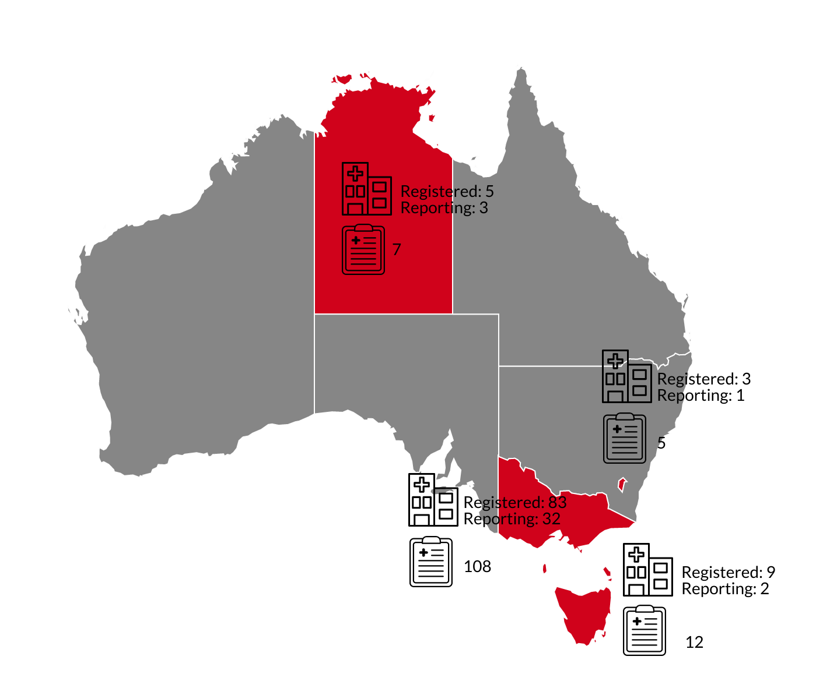
Four jurisdictions report to STIR: Victoria, Tasmania, Australian Capital Territory and Northern Territory. As seen in Figure 2, the number of reports varies in each area, and this reflects transfusion rates as much as reporting behaviour.
Table 7 shows the demographics for all validated reports. As in previous years, the age range for events is large, with red cells being the most common implicated product.
Table 7: Demographics for all validated reports
Demographic | Statistic
Age | 0–94 years (mean 52 years)
Gender | Male: 54 (41%); female: 78 (59%)
Blood products | Red cells: 70 notifications  Platelets: 14  Fresh frozen plasma: 6  Cryoprecipitate: 1  Multiple products: 7  RhD Ig: 13  Other (includes near miss n = 1 and WBIT n= 20): 21

Clinical reports
Figure 3: Validated clinical events reported to STIR FY19
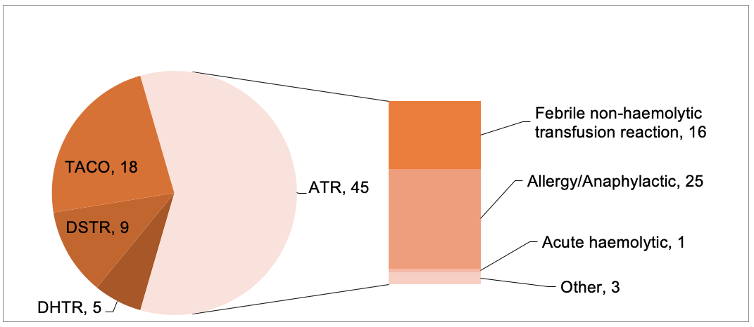
In this year’s report, 77 clinical events were validated from an initial 89 notifications (Figure 3). Allergic reactions make up the largest number of reports with TACO and FNHTR making up the majority of reported reactions.

Febrile non-haemolytic transfusion reaction (FNHTR)
Table 8: Data summary – febrile non-haemolytic transfusion reaction, n = 16
Characteristic | Number | Percentage
Age: < 1 year | - | -
Age: 1–18 years | - | -
Age: 19–29 years | - | -
Age: 30–49 years | - | -
Age: 50–69 years | 6 | 38%
Age: 70–79 years | 6 | 38%
Age: 80+ years | 4 | 25%
Gender: male | 9 | 56%
Gender: female | 7 | 44%
Implicated blood product: red cells | 15 | 94%
Implicated blood product: platelets | 2 | 12%
Table 9: Severity rating and imputability – febrile non-haemolytic transfusion reaction
Severity rating | Imputability:  certainly | Imputability:  probably | Imputability:  possibly | Total
SR 1 | - | - | - | -
SR 2 | - | - | 1 (6%) | 1 (6%)
SR 3 | - | 1 (6%) | 3 (19%) | 4 (25%)
SR 4 | - | 2 (13%) | 9 (56%) | 11 (69%)
Total | - | 3 (19%) | 13 (81%) | 16 (100%)

Case study 1: FNHTR
An 88-year-old man with haematuria and platelet count of 33 x 10⁹/L was administered two bags of platelets. The first bag was given and completed within approximately 45 minutes, then the second bag was started. Approximately 45 minutes into the second bag, a reaction was noted and the transfusion stopped. The patient’s temperature had increased from 37.3° C to 38.8° C, and continued to rise to 39.6° C approximately four hours after the transfusion. The patient had not been febrile in the previous 24 hours and had not received any pre medication prior to the transfusion, although he had received pre medication with other transfusions.
There was no indication of any incompatibility between patient and product. Blood cultures of both patient and bag were negative.
(STIR review: FNHTR, probably, SR 4)

Comment
FNHTR is a diagnosis of elimination. Other transfusion reactions that could have caused fever in the patient have been eliminated. In this case, there was no evidence of incompatibility causing a haemolytic reaction, the blood cultures of both patient and blood product were negative, indicating a septic reaction is unlikely, and there was no evidence of respiratory symptoms that might indicate TRALI. There was minimal information on the patient history provided, so it is unclear if there may have been another reason for the fever, but given the information provided, it was considered this was probably FNHTR.
Many reports received are unclear on either the investigations undertaken or the patient history that might indicate another reason for the fever. Therefore, a large percentage of reports validated as FNHTR have a low imputability.

Allergic
Table 10: Data summary – allergic and anaphylactic reactions, n = 25
Characteristic | Allergic  n = 14 | Anaphylactic  n = 11
Age: < 1 year | - | 1 (9%)
Age: 1–18 years | 4 (29%) | 3 (27%)
Age: 19–29 years | 1 (7%) | 1 (9%)
Age: 30–49 years | 2 (14%) | 2 (18%)
Age: 50–69 years | 4 (29%) | 3 (27%)
Age: 70–79 years | 1 (7%) | -
Age: 80+ years | 2 (14%) | 1 (9%)
Gender: male | 5 (36%) | 7 (64%)
Gender: female | 9 (64%) | 4 (36%)
Implicated blood product: red cells | 4 (29%) | 2 (18%)
Implicated blood product: FFP | 3 (21%) | 6 (55%)
Implicated blood product: platelets | 7 (50%) | 5 (45%)
Nearly one-third of all allergic reactions reported occurred in patients 18 years of age or younger, with half of these being anaphylactic reactions.

Table 11: Severity rating and imputability – allergic and anaphylactic reactions
Severity rating | Imputability:  certainly | Imputability:  probably | Imputability:  possibly | Total
SR 1 | - | - | - | -
SR 2 | 6 (24%) | 4 (16%) | 3 (12%) | 13 (52%)
SR 3 | 5 (20%) | 2 (8%) | 2 (8%) | 9 (36%)
SR 4 | - | 2 (8%) | 1 (4%) | 3 (12%)
Total | 11 (44%) | 8 (32%) | 6 (24%) | 25 (100%)

Case study 2: allergic (red cells)
A man was admitted with symptomatic anaemia of unknown aetiology. A unit of red cells was commenced, and approximately 10 minutes into the transfusion the patient became hypotensive (115/70 mmHg to 47/34 mmHg), with chest pain/discomfort, difficulty breathing (without change in rate or oxygen saturation), tachycardia (85 to 128 bpm) and developed a rash and swelling of lips and tongue. A medical emergency team (MET) call was initiated and the patient received treatment with oxygen, antihistamine, steroids, IM adrenaline, IV metaraminol and fluid support. The patient required ICU admission.
Investigations showed a tryptase of 1 microgram/mL (in normal range), an IgE 268 UI/mL (normal range). Patient blood cultures were negative, haptoglobin was in normal range, Hb had risen from 67g/L to 76g/L.
The patient went on to receive two further red cell units the following day with nil reactions. He was referred for immunology review, as he also had a previous reaction to computed tomography contrast.
(STIR review: anaphylaxis, certainly, SR 2)

Comment
Allergic reactions, including anaphylaxis, occur regularly due to the inherent, but not necessarily faulty characteristic of the blood product. Patients with an allergic history are possibly somewhat more at risk than others, but these reactions are unpredictable.
As in this case, serious allergic reactions can occur early and continuous monitoring of the patient during the early part of the transfusion, that is, the first 15 minutes, is critical to recognise these reactions, stop the transfusion and start treatment.

Case study 3: allergic – FFP used for warfarin reversal
A patient taking warfarin was admitted with haematuria and severe anaemia. In the emergency department, he was given FFP for warfarin reversal. Approximately 20 minutes into the transfusion, the patient complained of blurred vision and was becoming less responsive. His heart rate increased, blood pressure (BP) and oxygen saturation dropped. He was treated with antipyretic, antihistamine, steroids, adrenaline, oxygen and IV fluid support. The patient required a temporary increase in care, without the need for increased length of stay or ICU admission.
Review by the health service noted the warfarin reversal guidelines had not been followed and recommended further education around these.
(STIR review: anaphylaxis, certainly, SR 2)

Comments
This is not a lone event, and a number of reactions to FFP used in warfarin reversal have been received. The Australian guidelines state <https://www.mja.com.au/journal/2013/198/4/update-consensus-guidelines-warfarin-reversal>:
‘For immediate reversal, prothrombin complex concentrates (PCC) are preferred over fresh frozen plasma (FFP). Prothrombinex®-VF is the only PCC routinely used for warfarin reversal in Australia and New Zealand. It contains factors II, IX, X and low levels of factor VII. FFP is not routinely needed in combination with Prothrombinex®-VF. FFP can be used when Prothrombinex®-VF is unavailable. Vitamin K1 is essential for sustaining the reversal achieved by PCC or FFP.’
FFP has greater risk of allergic reactions, compared to other blood products including PPCs, as in this case study. FFP should always be used cautiously, as it may also be associated with TACO, due to the larger volume compared Prothrombinex®-VF. In addition, TRALI is also a risk with any plasma containing blood component.

Acute haemolytic transfusion reaction (AHTR)
For this period, there was one AHTR event. This was reported as a possible FNHTR, but on review, it was noted mild haemolysis had occurred post transfusion, with a decreased haptoglobin and a mild increase in both bilirubin and LDH in an otherwise stable individual.

Delayed haemolytic transfusion reaction (DHTR)
For FY19, there were five validated reports.
Table 12: Data summary – delayed haemolytic and delayed serologic reactions
Characteristic | DHTR  n = 5 | DSTR  n = 9
Age: < 1 year | - | -
Age: 1–18 years | - | -
Age: 19–29 years | - | -
Age: 30–49 years | - | -
Age: 50–69 years | 1 (20%) | 1 (13%)
Age: 70–79 years | 2 (40%) | 6 (75%)
Age: 80+ years | 2 (40%) | 2 (25%)
Gender: male | 2 (40%) | 3 (33%)
Gender: female | 3 (60%) | 6 (67%)
Implicated blood product: red cells | 5 (100%) | 9 (100%)
Implicated blood product: FFP | - | -
Implicated blood product: platelets | - | -
As shown is Table 12, the reported delayed haemolytic and delayed serologic reactions were reported in patients over the age of 50, with women being slightly more commonly affected.
Table 13: Severity rating and imputability – delayed haemolytic reaction
Severity rating | Imputability: certainly | Imputability: probably | Imputability: possibly | Total
SR 1 | - | - | - | -
SR 2 | 2 (40%) | - | - | 2 (40%)
SR 3 | - | - | - | -
SR 4 | 3 (60%) | - | - | 3 (60%)
Total | 5 (100%) | - | - | 5 (100%)
The incidence of DHTR is about 1:2500, with those at risk of delayed haemolytic or serological transfusion reactions being patients with a history of red blood cell antibodies (through pregnancy or transfusion exposure), in which the antibody titre subsequently decreases to levels undetectable by routine antibody detection testing. (Delany M et al. 2016).
The mechanism for both delayed haemolytic and serologic reactions is similar due to an anamnestic immune response when the recipient is unknowingly transfused with a red blood cell unit that expresses the cognate antigen.

Delayed serologic transfusion reaction (DSTR)
For FY19, there were nine validated reports.
Due to the nature of DSTR and the fact that these reactions are only identified if a new sample is tested at some point post transfusion, the time interval between transfusion and detection can range from 24 hours to months or even years.
Consequently, STIR has refined the definition to capture those occurring more recently: delayed serologic transfusion reaction is when, within 24 hours to three months after a transfusion, there is demonstration of clinically significant antibodies against red blood cells (as described in the ANZSBT guidelines for transfusion and immunohaematology laboratory practice, 1st edition, revised 2020) which were previously absent, and where there are no clinical or laboratory features of haemolysis. This change will be effective from 1 July 2020.
Table 14: Severity rating and imputability – delayed serologic reaction
Severity rating | Imputability: certainly | Imputability: probably | Imputability: possibly | Total
SR 1 | - | - | - | -
SR 2 | - | - | - | -
SR 3 | - | - | - | -
SR 4 | 3 (33%) | 3 (33%) | 3 (33%) | 9 (100%)
Total | 3 (33%) | 3 (33%) | 3 (33%) | 9 (100%)
As DSTR do not cause signs or symptoms in the patient, the severity rating is low, as shown in Table 14. However, these reactions do have an implication for future transfusions, as antigen-negative blood must be found.

Transfusion associated circulatory overload (TACO)
Table 15: Data summary – TACO, n = 18
Characteristic | Number | Percentage
Age: < 1 year | - | -
Age: 1–18 years | - | -
Age: 19–29 years | - | -
Age: 30–49 years | 1 | 6%
Age: 50–69 years | 5 | 28%
Age: 70–79 years | 4 | 22%
Age: 80+ years | 8 | 44%
Gender: male | 9 | 50%
Gender: female | 9 | 50%
Implicated blood product: red cells | 17 | 94%
Implicated blood product: FFP | - | -
Implicated blood product: platelets | 4 | 22%
Table 16: Severity rating and imputability – TACO
Severity rating | Imputability: certainly | Imputability: probably | Imputability: possibly | Total
SR 1 | - | - | - | -
SR 2 | 1 (6%) | 5 (28%) | 3 (17%) | 9 (50%)
SR 3 |  | 3 (17%) | 5 (28%) | 8 (44%)
SR 4 |  |  | 1 (6%) | 1 (6%)
Total | 1 (6%) | 8 (44%) | 9 (50%) | 18 (100%)
TACO continues to occur regularly, with the majority of reports to STIR occurring in those over the age of 50. The differential diagnosis of TACO includes transfusion-related acute lung injury, septic transfusion reaction and acute haemolytic transfusion reaction.

Case study 4: TACO in patient with risk factors
An 82-year-old woman admitted with infective exacerbation of asthma and community-acquired pneumonia required a transfusion for symptomatic anaemia with Hb 79g/L on day of admission. She had a history of ischaemic heart disease with cardiac stents, a previous non-ST elevation myocardial infarction, and an ejection fraction of 40 per cent. She was taking regular diuretics.
While receiving the second of two units of red cells (the second unit run over approximately three hours), she developed dyspnoea/difficulty breathing, reduced oxygen saturation, tachycardia and hypertension. Fluid balance was unknown, the patient weighed 74 kg.
She was treated with oxygen and assisted ventilation, diuretics and morphine. She also received paracetamol for an elevated temperature (38.5° C). Chest X-ray showed increased basal opacity/atelectasis, hazy perihilar infiltrates consistent with fluid retention / heart failure. She was transferred to ICU.
(STIR Expert review: TACO, probably, SR2)
The reviewer commented:
‘Deterioration occurred same day as admission – possible normal progression of admission diagnosis (community-acquired pneumonia). Two units prescribed/transfused, patient with multiple TACO risk factors. Patient review post first unit may have abrogated need for second unit and/or prompted intervention (e.g. diuretics) that may have reduced risk of transfusion reaction.’

Comment
Review between units looking at both the risk of fluid overload and the need for further transfusion is important, particularly in situations where there are risk factors for TACO. A slow transfusion rate, as in this case, is helpful but not the entire answer to reduce the risk of overload.

Transfusion related acute lung injury (TRALI)
During FY19, three potential cases of TRALI were reported; however, none were validated as TRALI by the STIR Expert Group.
As noted in validation and reconciliation, a number of TRALI events were reported both to Lifeblood and to STIR. None of those reported to STIR were validated as TRALI by either STIR or Lifeblood. There was one report to Lifeblood that was determined to be TRALI, but we cannot report this as a case study as it was not reported to STIR.
Figure 4 shows that the number of validated TRALI reports to STIR is very small. We encourage health services to report to Lifeblood in the first instance, to ensure appropriate quarantine of associated products and follow up of donors to prevent further clinical reactions.
Figure 4: Validated TRALI reactions reported to STIR – FY06–FY19

Transfusion associated dyspnoea (TAD)
During FY19, three TAD were reported, with none validated as TAD. All events were reclassified following expert review as TACO.

Transfusion associated graft vs host disease (TAGVHD)
There were no reports of TAGVHD in FY19. This is a rare complication of transfusion and the use of irradiation of products for those patients we know to be at risk ensures this remains the case.

Post-transfusion purpura (PTP)
There have been no reports of PTP in FY19.

Other – ATR
There were three ATRs which were notified and validated as possible other acute reactions.
These included a child who developed bradycardia and broad QRS complexes leading to CPR after rapid infusion of red cells in the setting of surgical bleeding. These symptoms were due to possible hyperkalaemia associated with the transfusion.
A patient with haemoglobin H disease, admitted with infection, developed haemoglobinuria post transfusion. It was unclear if the haemoglobinuria related to the transfusion or underlying disease, but was possibly transfusion related.
A patient who developed tachycardia, hypotension and dyspnoea, without fever towards the end of a red cell transfusion. There was no sign of serologic incompatibility with the unit on testing, but it was thought this could be a reaction to HLA antigens.

Procedural reports
Figure 5: Validated procedural events reported to STIR FY19
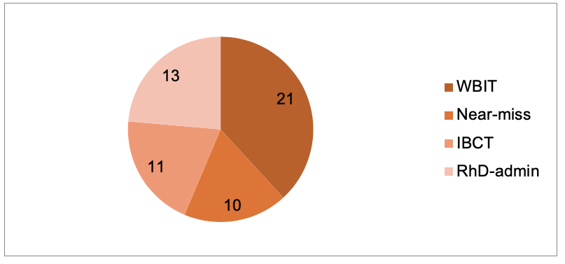
In FY19, there were 55 procedural events validated. Procedural errors predominantly occur due to human error and are often preventable if protocols and guidelines are put in place and followed. In FY19, 41 per cent of investigations were for procedural errors. As shown in Figure 5, wrong blood in tube events are the largest proportion of all procedural events reported again this year.

Incorrect blood component transfused (IBCT)
In FY19, there were 11 reports of IBCT. Although there was one ABO-incompatible transfusion reported (Table 17) to cryoprecipitate, it does not appear to have caused harm to the patient.
Communication between clinical and laboratory staff regarding the need for irradiated products continues to be an issue for health services. Components that did not meet specific requirements for the patient were all instances where irradiated units were not provided as needed.
Table 17: Types of IBCT events FY19
Category | Number reported  N = 11
Antigen-antibody issues | 1 (9%)
Components that did not meet specific requirements for patient | 4 (36%)
Inappropriate platelet/plasma product | -
ABO compatible | -
ABO incompatible (cryoprecipitate) | 1 (9%)
RhD incompatible | 1 (9%)
Other:  Excessive time to transfuse (x1)  Administration with incorrect/incomplete details on the label (x2)  Crossmatched blood knowingly given to another patient (x1) | 4 (36%)

Case study 5: RhD incompatible red cell units cross matched and transfused
A patient with melaena and anaemia (blood group A RhD negative) was admitted for investigation of possible upper gastrointestinal bleeding on a background of transfusion dependent myelodysplastic syndrome. He required transfusion for Hb 70g/L and ongoing blood loss. Two units of red cells and one bag of platelets were requested. Two units of A RhD positive red cells were assigned by the laboratory scientist, manually overriding warnings in the transfusion module alerting to an RhD discrepancy.
Subsequently, one of the units was transfused to the patient. There was no double independent check of the unit or compatibility. Of the two staff members involved in checking, one checked the information on the unit of blood and the second checked the information on the transfusion report. Neither crosschecked both nor questioned the discrepancy in blood groups.
The error was not discovered until two days after the event. The patient did not develop signs or symptoms of a reaction at the time, and there was no evidence of antibody development.

Comments
The 2018 ANZSBT/ACN administration guidelines were updated to reinforce the need for ‘double independent checking’, as distinct from the shared checking that often occurs in practice with two-person checks. Shared checks allow for important pieces of information to be missed when each person assumes the other has reviewed something, such as blood group. Double independent checking requires each person to complete all the checks independently. Blood Matters has prepared posters to reinforce double independent checking <https://www2.health.vic.gov.au/about/publications/factsheets/two-person-independent-checking-safe-transfusion-poster>.
While in some circumstances, it may be necessary to transfuse an RhD incompatible unit, it does not appear to be the case in this instance. If a clinical decision was made that waiting for blood of the correct group is not in the patient’s best interest, then this would not be an IBCT. This event occurred after a series of errors (laboratory selecting incorrect component, laboratory overriding system alerts, bedside check not performed correctly), not as a considered clinical decision.
The 2017–18 STIR annual report reported a similar incident, which resulted in the health service undertaking a root cause analysis of the event <https://www2.health.vic.gov.au/about/publications/researchandreports/serious-transfusion-incident-report-2017-18>.

Case study 6: Kell-positive red cell unit to woman of child-bearing age
A 25-year-old woman post a normal vaginal birth had a retained placenta and postpartum haemorrhage. A Code Pink (obstetric emergency) was called and the patient prepped for theatre, where manual removal of placenta and insertion of Bakri balloon was performed. Total blood loss of 2,800 mL.
When the patient arrived in theatre, the first unit of emergency O RhD negative blood was requested and a second unit followed. The first unit transfused carried an attached handwritten message, ‘Do not use on pregnant patient!’. Staff questioned the use of this unit at the time the unit was to be transfused and were advised to give as the patient was no longer pregnant.
Follow up of the transfusion incident identified the woman was given a Kell-positive transfusion, and had the potential to develop an alloantibody which could affect future pregnancies.
An open disclosure meeting was held with the patient and her family and blood tests ordered for the patient. The blood test results showed there was no evidence of antibody development from the transfusion.
A root cause analysis investigation was commissioned to ascertain if the blood transfusion was appropriate and to identify system and process improvement opportunities.

Recommendations: |  | Strength:
 | Labelling being clear about meaning | Moderate
 | Provision of Kell-negative blood only by Lifeblood | Strong
 | Separate blood registry folders for emergency O RhD negative blood and red cells for specific patients with appropriate labelling | Moderate
 | Blood policies and procedures to reflect changes in recommendation 2 and 3 | Weak
 | Staff documentation education  - Hospital transfer form  - Data entered on birthing outcomes system  - Recording of observations as per hospital procedures  - Fluid balance chart  - Code Pink – document time of MET attendance, actions, handover to theatre. Stand down only when Bakri balloon inserted.  - Blood transfusion documentation in theatre – to be on anaesthetic chart and fluid balance chart | Weak
 | Complete postpartum haemorrhage checklist | Moderate
 | Develop process for open disclosure and/or debrief for patients experiencing a major event and transfer. Include who will take responsibility for initiating the process | Weak

Near miss
In FY19, there were 10 reports validated as near miss events.
The types of reports are shown in Table 18. There were a number of events reported as a near miss that on review were changed to IBCT. Although the units were compatible and intended for the patients who received them, there were serious missed opportunities to address errors in identification that could have resulted, in other circumstances, in an incompatible transfusion being administered. The updated STIR reporting guide for 2020 will address these issues to make it clearer how to report these types of events based on whether a transfusion has commenced or not.
Table 18: Types of near miss events received by STIR in FY19
Category | Number reported
Inappropriate component issued | 2
Labelling/documentation | 1
Laboratory | 3
Administration | 1
Storage and handling | 3

Wrong blood in tube (WBIT)
There were 21 WBIT reports for FY19. The contributing factors listed by reporters remain similar to previous years, with failed identity check being the main cause (Figure 6). Further investigation into why staff do not perform this check correctly may help to identify areas for improvements.
After several years of a decrease in WBIT events occurring in the emergency department (ED), this report sees a slight increase again (Figure 7). The reason for this is not clear. ED and maternity units combined provided more than 60 per cent of all WBIT events in this financial year.
Table 19 lists how these errors are discovered. Most often this occurs prior to testing taking place, often when the staff member who took and sent the samples realises an error has occurred. The laboratory finds a significant number also when comparing results with the patient historical record, in the event the patient has a historical record within the health service. This is dependent on the blood groups of the patients being different, some WIBTs will never be detected in the laboratory.
Figure 6: Factors contributing to WBIT incidents (multiple responses per event) since FY19

Figure 7: Where WBIT errors occur

Table 19: How the WBIT was discovered
Category | Number | Percentage (%)
Recognised prior to testing | 12 | 57%
Discrepancy noted when comparing sample results with historical record | 6 | 29%
Recognised post testing but prior to issue | 1 | 5%
Significant change in MCV compared with prior testing | - | -
Recognised post issue but prior to transfusion | 1 | 5%
Unknown | 1 | 5%
Total incidents | 21

Case study 7: WBIT
Bloods were taken in the ED and sent to the laboratory. The specimens met the requirements of the laboratory for acceptance, with the blood bank specimen hand labelled as per policy. The specimens were being processed when the ED staff contacted the laboratory to inform them the blood was collected from a different patient to the stated identity on the specimens and request. All testing was stopped at this point.

Comment
Despite the use of hand-labelling to try to reduce the risk of errors when labelling specimens, if the labelling occurs away from the patient side and no direct correlation occurs between the specimen and the patient ID band, errors will still occur.
Use of electronic systems that directly match the ID on the patient band to the ID on the specimen, with labels printed at the patient side, assist to further reduce error when used correctly.
Positive patient identification by asking the patient to state their name and date of birth is required to check the correct ID band is on the patient and the details on the request (paper or electronic) match the ID band, that is, you are taking blood from the correct patient.
All systems, whether electronic or other, require adequate training and re-training of staff to ensure they know how to perform the procedure and why it is important to follow the steps as set out.

RhD immunoglobulin (Ig) administration
Table 20: RhD Ig errors – intended administration (n = 13)
Intended administration | Number
Antenatal prophylaxis | 3
Sensitising event | 6
Postnatal | 6
Table 21: Types of RhD Ig incidents
Type of incident | Number  (n = 13)
Administered, not required (Rh negative mother with known Rh negative baby) | 1 (8%)
Administered, not required (Rh positive woman) | -
Administered, not required (woman with immune Anti-D) | -
RhD Ig dose omitted | 5 (38%)
Delay in administration (> 72 hours.) | 2 (15%)
Wrong or inadequate dose | 2 (15%)
Other: released or administered to incorrect patient | 3 (23%)

Case study 8: missed RhD immunoglobulin and testing
An RhD negative woman delivered twins, both RhD positive. At delivery it was found the woman had not received any prophylactic RhD immunoglobulin during her pregnancy. It was revealed that although the woman had attended her 28 and 34 week antenatal appointments, the testing for blood group and subsequent prophylaxis did not occur due to the woman not attending for these. There was no follow up with the woman, by medical or midwifery staff to ensure it was done.
At birth, both babies had a positive DAT, with anti-A eluted and a rising bilirubin, requiring phototherapy.
The woman’s anti-D titre was elevated, indicating an immune anti-D had been formed and putting future pregnancies at risk.

Comment
It is important that women are appropriately educated to understand the necessity of RhD testing and prophylaxis and the risks of not following up on appointments. It is important for staff to follow up on the testing and, where it has not occurred, arranging for immediate testing and prophylaxis as required.

Case study 9: writing up orders ahead of testing
An RhD negative woman delivered a baby and the medical officer wrote up a dose of RhD immunoglobulin in preparation if the infant was RhD positive. However, nursing staff found the prescription and gave the RhD immunoglobulin without first checking the baby’s blood group, assuming it had been written up to give.

Comment
The Blood Matters RhD immunoglobulin in obstetrics audit (2018) noted that a small number of women received inappropriate RhD immunoglobulin after delivery of an RhD negative infant. The practice of writing up the RhD immunoglobulin before knowledge of need may contribute to this. It may be seen as a timesaving way of doing things, but it is important that staff confirm the baby’s blood group before administration. Instructions and handover of the order need to occur to prevent inappropriate administration.

Cell salvage
STIR has not received any notifications related to cell salvage.

Sentinel events
‘Patients and donors are important contributors to haemovigilance. They represent the “lived experience” of actual and potential adverse consequences of blood donation and transfusion’ (Wood et al. 2019).
Safer Care Victoria recognises this in their request that health services include a consumer representative in the root cause analysis process for sentinel events (Haemolytic blood transfusion reaction resulting from ABO incompatibility resulting in serious harm or death).
Blood Matters staff can provide an external representative with experience in transfusion and haemovigilance for sentinel event reporting.
There were no sentinel events reported to STIR in this period.

Future
We continue to liaise with the department to consider how STIR may be incorporated into the Victorian Health Incident Management System (VHIMS).
Work on forms for the collection of investigations into women who develop a RhD antibody related to pregnancy (isoimmunisations) to look for common themes and whether this is due to failure of prophylaxis or failure to provide prophylaxis has commenced and will be reportable from July 2020.
A review of investigation forms to add information relating to events where the use of an EMR may have been a contributing factor in the event is under way.

References
Wood EM, Ang AL, Bisht A, Bolton-Maggs PH, Bokhorst AG, Flesland O, Land K, Wiersum-Osselton JC, Schipperus MR, Tiberghien P and Whitaker BI 2019, ‘International haemovigilance: what have we learned and what do we need to do next?’ Transfusion Medicine, <https://onlinelibrary.wiley.com/doi/pdf/10.1111/tme.12582>.
Safer Care Victoria 2019, Victorian sentinel event guide: Essential information for health services about managing sentinel events in Victoria, State Government of Victoria, Melbourne.
Tran HA, Chunilal SD, Harper PL, Tran H, Wood EM and Gallus AS, on behalf of the Australasian Society of Thrombosis and Haemostasis 2013, ‘An update of consensus guidelines for warfarin reversal’, Med J Aust, vol. 198, no. 4, pp. 198–199.
Delaney M, Wendel S, Bercovitz R, Cid J, Cohn C, Dunbar D, et al. 2016, ‘Transfusion reactions: prevention, diagnosis and treatment’, BJH, vol. 388: pp. 2825–36.

Appendix 1: Expert Group members
Giles Kelsey, (Chair June 18–March 19) Consultant Haematologist, Royal Melbourne Hospital
Christine Akers, Transfusion Nurse, Blood Matters Program, Victoria
Helen Evans, Transfusion Nurse, Royal Hobart Hospital, Tasmania
Gerald Bates, Laboratory manager, Launceston General Hospital, Tasmania (resigned)
Linley Bielby, Program manager, Blood Matters Program, Victoria
Philip Crispin, Consultant Haematologist, The Canberra Hospital, Australian Capital Territory
Erica Wood, Associate Professor, School of Public Health and Preventative Medicine, Monash University, Victoria
Bridget Glazebrook, Data Manager, Blood Matters Program, Department of Health, Victoria
Clare Hennessy, Transfusion Nurse Consultant, Eastern Health
Chris Hogan, Director Pathology Services, Austin Health
Ellen Maxwell, Director of Haematology, Melbourne Pathology
Tina Noutsos, Haematologist, Royal Darwin Hospital, Northern Territory
Richard Rogers, Blood Bank Scientist, Cabrini Health, Victoria (resigned)
Merrole Cole-Sinclair, Director of Haematology, St Vincent’s Hospital, Victoria
Anissa Yttrup, Transfusion Nurse, Barwon Health
Adrienne Wynne, Transfusion Quality Officer, St Vincent’s’ Hospital
Cindy Flores, Education Coordinator, Blood Matters Program, Victoria (resigned)
Linda Saravanan, Haematologist, Melbourne Pathology
Mary Comande, Blood Bank Scientist, Royal Children’s Hospital
James Daly, Medical Director of Pathology Services, Australian Red Cross Lifeblood
Kaylene Bastin, Education Coordinator, Blood Matters Program, Victoria (September 2018)
Kobie Von Wielligh, Haematologist, Australian Red Cross Lifeblood (December 2018)
Glenda Mann, Blood Bank Scientist, Cabrini Health, Victoria (December 2018)

Appendix 2: STIR publications and promotions
Article: 2019, ‘Misinterpretation of blood group and antibody screen leading to serious errors in RhD immunoglobulin administration: a report on first 2 years of data from Serious Transfusion Incident Reporting Program’, ANZJOG, vol. 59, no. 1, pp. 161–164.
Poster: TACO: How do we promote awareness and reporting? ISBT Toronto.
Oral presentation: ‘Transfusion-associated circulatory overload: promoting awareness and reporting’, Blood 2018.
Oral presentation, Linley Bielby: ‘The value of a structured haemovigilance program: experiences from Blood Matters serious transfusion incident reporting (STIR) system’, Blood 2018.
Oral presentation: ‘RhD Immunoglobulin: should I, will I, do I give it?’, ACM 2018.

Appendix 3–Imputability and severity scores
Imputability/causality | Definition
Not assessable | When there is insufficient evidence for an imputability definition.
Excluded | When there is conclusive evidence that the cause of the incident is attributable to other causes and not the transfusion.
Possibly | When the evidence is indeterminate for attributing the incident to either the transfusion or other causes.
Probably | When the evidence is clearly in favour of attributing the incident to the transfusion.
Certainly | When the evidence is conclusively attributable to the transfusion.

Severity | Incident
1 | Relatively infrequent, clear-cut events that occur independently of a patient’s condition; commonly reflect health service system and process deficiencies; result in, or have the realistic potential to result in, an unexpected death or a permanent and disabling injury or psychological harm to a person and includes reportable sentinel events.
2 | Events that result in a temporary loss of function (sensory, motor, physiological or intellectual) which is unrelated to the natural course of the patient’s illness and differ from the expected outcome of the patient’s management.
3 | Events that result in a person requiring increased treatment, but not hospitalisation or an increased length of stay.
4 | Events that result in minor injury requiring only first aid treatment or no injury.

Appendix 4: STIR timeline
2006
- Pilot July–October
- First notification received 18 September 2006
- Nine incident categories
2008
- First STIR report developed and published, covering 1 January 2006 to 31 December 2007
- Four jurisdictions reporting
2011
- Move to electronic notification and report forms
2013
- NSQHS Standard 7: ‘Blood and blood products’ developed, encourages haemovigilence reporting
2014
- Commenced annual STIR report
2015
- Commenced RhD Ig and cell salvage reporting (1 January 2015)
- Change to WBIT reporting to exclude mismatch in labelling (zero tolerance)
2017
- Review of all forms
- Commenced reporting of delayed serological transfusion reaction and transfusion-associated dyspnoea (1 July 2017)
2018
- First STIR bulletin sent to health services and interested parties
2020
- Commenced reporting of RhD isoimmunisations and hypotensive reactions (1 July 2020)

Validated clinical events includes Victoria only (n = 60). In some incidences multiple products were recorded for one event.
One report stated multiple products
Health services could select multiple implicated products
Multiple blood products could be selected
The health service thoroughly reviewed the incident and potential causative factors, developing a number of recommendations. However, the recommendation concerning the provision of only Kell-negative blood may not be feasible, given the need for this product in a large number of health services. A consensus statement on the use and allocation of Kell-negative red cells, developed by Lifeblood and the Australian and New Zealand Society of Blood Transfusion, addresses this issue. It states that the practice of provision of Kell–negative only inventory is unjustified, and unfairly burdens some laboratories with an excess inventory of K-positive units, thereby increasing the likelihood of wastage and the need for further individual patient orders. It also provides recommendations on when Kell-negative units are required. Access the consensus statement for more <https://anzsbt.org.au/wp-content/uploads/2018/06/Kellnegativeredcells-F.pdf>.
Two patients had errors reported for more than one administration time point.

