Serious transfusion incident report 2017–18



Serious transfusion incident report 2017–18

To receive this publication in an accessible format phone 9694 0102, using the National Relay Service 13 36 77 if required, or email STIR <stir@redcrossblood.org.au>
Authorised and published by the Victorian Government, 1 Treasury Place, Melbourne.
© State of Victoria, Department of Health and Human Services October, 2019.
ISSN 2651-8872 – Online (pdf / word)
Available on the Blood Matters website <https://www2.health.vic.gov.au/hospitals-and-health-services/patient-care/speciality-diagnostics-therapeutics/blood-matters>
(1910524)

Contents
Acknowledgements 7
Abbreviations, acronyms and definitions 8
Executive summary 10
Key messages and recommendations 11
Clinical 11
Procedural 11
Key messages from SHOT 2017 11
Introduction 12
Method 14
Withdrawn reports 15
Validation 16
Demographics 18
Timing of transfusion 19
Health service review of incidents/reactions 19
Clinical reports 21
FNHTR 21
Case study 1: ATR – FNHTR in patient with history of reactions 22
Allergic, including anaphylaxis 23
Case study 2: ATR – allergic reaction in outpatient area 26
Case study 3: ATR – allergic reaction made worse by continuing the transfusion 26
Case study 4: ATR – allergic reaction to FFP in plasma exchange 26
Acute haemolytic 27
Delayed haemolytic 27
Case study 5: Delayed Haemolytic – increased length of stay associated with a delayed haemolytic reaction 28
Delayed serologic 28
Case study 6: Delayed serologic – development of anti-K without apparent clinical effect 29
TACO 29
Case study 7: TACO – timing of transfusion 32
Transfusion associated acute lung injury (TRALI) 32
Case study 8: Possible TRALI 33
Transfusion associated dyspnoea (TAD) 33
Transfusion transmitted infection including bacterial sepsis 33
Case study 9: TTI – parvovirus in a susceptible patient 33
Transfusion associated graft versus host disease (TAGvHD) 34
Post transfusion purpura (PTP) 34
Procedural reports 35
Incorrect blood component transfused (IBCT) 35
Case study 10: IBCT – ABO incompatible transfusion 36
Case study 11: IBCT – RhD incompatible transfusion 37
Case study 12: IBCT – over-transfusion of infant 38
Case study 13: IBCT – communication issues lead to wrong patient transfused 39
Near miss 39
Case study 14: Near miss – wrong blood checked and spiked 39
Wrong blood in tube (WBIT) 40
Case study 15: WBIT – bloods taken in Medical Emergency Team (MET) call 42
Case study 16: WBIT – patient identification incomplete 42
Case study 17: WBIT – patient identification from medical folder 43
RhD immunoglobulin (RhD Ig) 43
Blood Matters RhD Ig use in obstetrics audit 44
Case study 18: RhD Ig administration – electronic ordering and understanding of blood group and antibody results 45
Case study 19: RhD administration – transcription error leading to inappropriate administration 46
Cell salvage 46
Sentinel events 46
Future 47
References 48
Case study references 48
Appendix 1: STIR Expert Group members 2017–18 49
Appendix 2: STIR publications and promotions 50
Appendix 3: Imputability and severity scores 51
Appendix 4: Case studies 52

Acknowledgements
The Blood Matters program is a collaboration between the Victorian Department of Health and Human Services and the Australian Red Cross Blood Service. It is founded on the expectation that providing haemovigilance information supports the community by promoting better transfusion practice.
The Serious Transfusion Incident Reporting (STIR) program thanks the participating Victorian, Tasmanian, Australian Capital Territory and Northern Territory public and private health services for their contribution to the program.
Blood Matters recognises and appreciates the generous in-kind support of the STIR Expert Group, whose input is invaluable in reviewing the incidents and providing recommendations.

Abbreviations, acronyms and definitions
Term | Definition
ABO | major human blood group system
ADAMTS13 | a disintegrin and metalloproteinase with a thrombospondin type 1 motif, member 13
AHMDS | Australian Haemovigilance Minimum Data Set
ANZSBT | Australian and New Zealand Society of Blood Transfusion
ASFA | American Society for Apheresis
ATR | acute transfusion reaction
B19V | B19 virus, also known as parvovirus
BloodNET | a web-based system through which staff in health facilities across Australia can order blood and blood products from the Australian Red Cross Blood Service in a standardised, secure and efficient way
Blood Service | Australian Red Cross Blood Service
DAT | direct agglutination test
DHTR | delayed haemolytic transfusion reaction
DNA | deoxyribonucleic acid
DSTR | delayed serologic transfusion reaction
ED | emergency department
FDA | Food and Drug Administration (USA)
FFP | fresh frozen plasma
FNHTR | febrile non-haemolytic transfusion reaction
FY18 | financial year, 1 July 2017 to 30 June 2018
Hb | haemoglobin
HPA | human platelet antigen
IBCT | incorrect blood component transfused
ICU | intensive care unit
IgA | immunoglobulin A, a blood protein that's part of the immune system
IM | intramuscular
INR | international normalised ratio
ISBT | international society of blood transfusion
IV | intravenous
LDH | lactate dehydrogenase
MET | medical emergency team
NBA | National Blood Authority
PCR | polymerase chain reaction
PPID | positive patient identification
PTP | post-transfusion purpura
RBC | red blood cells
RCA | root cause analysis
Rh | Rhesus, blood group
RhD Ig | RhD immunoglobulin
SCV | Safer Care Victoria
SHOT | Serious Hazards of Transfusion (UK)
SR | severity rating
STIR | Serious Transfusion Incident Reporting
TACO | transfusion-associated circulatory overload
TAD | transfusion-associated dyspnoea
TAGVHD | transfusion-associated graft versus host disease
TPE | therapeutic plasma exchange
TRALI | transfusion-related acute lung injury
VHIMS | Victorian Health Incident Management System
WBIT | wrong blood in tube

Executive summary
Serious Transfusion Incident Reporting (STIR) has 93 registered health services. In financial year 2017–18, STIR received 159 notifications of transfusion incidents from 34 health services. Of these 159 notifications, 134 were validated and included in this report. This year clinical reports represented 53 per cent of the reports received, and 47 per cent were procedural errors.
Clinical incidents include febrile non-haemolytic reactions (34 per cent of all clinical reactions), transfusion associated circulatory overload (TACO) (27 per cent) and allergic reactions, ranging from mild to anaphylaxis (22 per cent). No deaths were attributed to any of the reactions reported, however a number of patients required ICU admission due to the reaction.
Procedural errors include near misses (39 per cent). These allow us to learn from errors and determine how we can improve processes without harm to the patient. Wrong blood in tube events (WBIT), another type of near miss involving specimens, accounted for 28 per cent of procedural reports. Approximately one-third of all WBIT events are reported in emergency or midwifery departments, putting patients at risk of receiving an incorrect blood component. Incorrect blood component transfused comprised 17 per cent of procedural errors.
Two events required a root cause analysis (RCA) in this reporting period. The outcomes of these RCAs are reported here to assist others to review their processes and assess the need for change. We thank the health services involved for their willingness to share this information.
As in previous reports, there are a number of case studies to highlight interesting aspects of incidents and reactions that have occurred. We hope these can be used to help educate staff regarding the risks of transfusion.
We have developed key messages and recommendations from the events reported. These represent best practice as described in Australian and international guidelines.
STIR continues to work with health services to improve processes. Information from the STIR reports has contributed to the Blood Matters program of work, such as TACO information tags to increase awareness and the recent RhD immunoglobulin (Ig) use in obstetrics audit. STIR reports have also influenced clinical education.

Key messages and recommendations

Clinical
Always consider a potential transfusion reaction when clinical deterioration is noted in a patient receiving, or who has received, a blood product. When a patient deteriorates during transfusion, stop the transfusion (with intravenous access maintained), assessing the patient and investigate whether a transfusion reaction has occurred (refer to ‘Case study 3: ATR – allergic reaction made worse by continuing the transfusion).
The routine use of FFP for patients undergoing therapeutic plasma exchange is not recommended unless there is a clear indication to replace coagulation factors (refer to ‘Case study 4: ATR – allergic reaction to FFP in plasma exchange).

Procedural
Positive patient identification (PPID) at each step in the transfusion process is vital, regardless of the situation. This includes asking the patient to state their name and date of birth where possible, use of an interpreter when required and confirmation of stated identity with name band, blood product or labelled specimens and order/prescription (refer to ‘Case study 11: IBCT – RhD incompatible transfusion’, ‘Case study 17: WBIT – patient identification from medical folder’, ‘Case study 18: RhD Ig administration – electronic ordering and understanding of blood group and antibody results’, Case study 19: RhD administration – transcription error leading to inappropriate administration’ and ‘Case study 15: WBIT – bloods taken in Medical Emergency Team (MET) call).
Blood administration must only occur after double independent checking has occurred. This involves both staff performing all checks at the bedside. Both staff should be able to independently confirm that the product to be commenced is intended for the patient (refer to ‘Case study 11: IBCT – RhD incompatible transfusion’ and ‘Case study 14: Near miss – wrong blood checked and spiked ’).
Health services considering using pneumatic chutes for the delivery of blood products must establish processes for verification when collecting the product from a chute, ensure appropriate training of staff in product collection, and reporting adverse events if they occur. The risks to patients associated with the collection and incorrect delivery of blood from pneumatic delivery systems need to be assessed as much as risks to the blood product itself (refer to ‘Case study 11: IBCT – RhD incompatible transfusion’ and ‘Case study 14: Near miss – wrong blood checked and spiked’).
Reviews of incidents reported to STIR show that there are some similarities between the incidents we see reported and those reported to the UK serious hazards of transfusion (SHOT) system. There are some key messages from the SHOT 2017 report that also apply to the Australian context.

Key messages from SHOT 2017
Do not assume, verify: At each step in the transfusion process, do not assume that no errors have been made in previous steps. Verify each step, particularly patient identification.
Human factors: Failure of communication, distractions, interruptions, wrong assumptions, poor handovers and overriding alerts in the laboratory information systems are all important contributory factors.
It is the clinician’s responsibility to determine, document and communicate the patient’s specific transfusion requirements.

Introduction
Welcome to the fifth annual STIR report, covering the period 1 July 2017 to 30 June 2018.
This year includes reports on two new categories: delayed serologic and transfusion-associated dyspnoea. Reporting for these categories commenced from 1 July 2017 as requested by the National Blood Authority (NBA).
Reporting to STIR is voluntary and all data is de-identified before inclusion for review or reporting. Health services are encouraged to report to STIR, as doing so contributes to the bigger picture across multiple states. This helps to improve our understanding of transfusion-related errors, and allows us to identify safety and quality measures for better transfusion outcomes. In addition, it may assist in meeting some of the requirements for institutional accreditation.
STIR continues to analyse local data on serious transfusion reactions and incidents, provide case studies that highlight risks associated with transfusion practice, and develop tools and recommendations for health services to address haemovigilance issues. In addition, to ensure more timely information to clinicians, STIR also sends bulletins highlighting important clinical information to health services.
This annual report provides information from 134 validated investigations, reported by 34 health services from Victoria, Tasmania, Australian Capital Territory and Northern Territory (Figure 1). In this reporting period, STIR received more clinical than procedural reports (53 per cent versus 47 per cent). Acute transfusion reaction was the largest clinical category at 61 per cent, with TACO second at 27 per cent.
Figure 1: Number of validated clinical and procedural reports and health services reporting to STIR each financial year
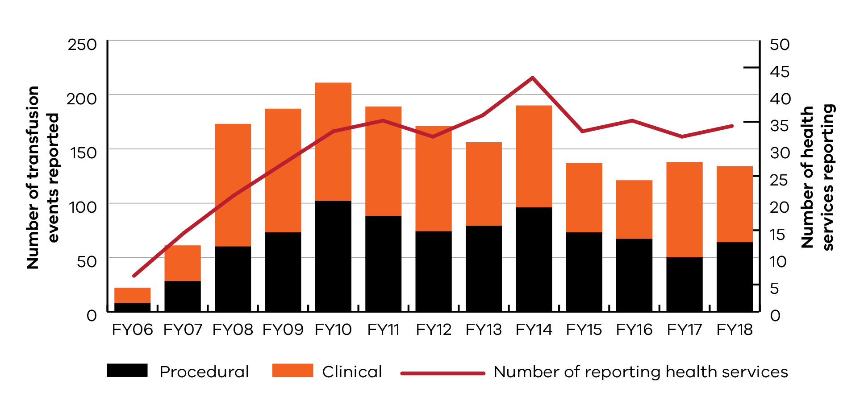

This year for the first time, near miss events were reported more often than WBIT events (39 per cent versus 28 per cent of procedural events). This is the first time WBIT has not been the leading cause for procedural incident reports, even after changes to the reporting criteria for WBIT in 2015 (excluding zero tolerance).
The STIR Expert Group continues to supply expert advice and review of received reactions and incidents.
The NBA via BloodNET provides total blood issue data. Table 1 shows total blood issues per jurisdiction 2017–18 (FY18) (distributed units minus units lost due to wastage, damage or other reasons). In comparison with previous annual data, there continues to be a slight decline in the total number of blood products issued to each jurisdiction.
Table 1: Total blood issues per jurisdiction reporting to STIR 2017–18
2017–18 | Vic | ACT | Tas | NT
Total red cells | 176,011 | 9,431 | 11,374 | 3,988
Total platelets | 33,561 | 1,549 | 2,293 | 852
Total fresh frozen plasma (FFP) | 27,311 | 1,170 | 1,594 | 226
Total cryoprecipitate | 24,876 | 1,704 | 1,486 | 759
Total | 261,759 | 13,854 | 16,747 | 5,825
The NBA issue data can then be used to determine an estimate of the frequency of serious clinical reactions to blood, as shown in Table 2. As incident reporting is voluntary, this rate would be an under-estimate and needs to be considered with care. No national data on numbers of patients transfused, or numbers of blood products received by individual patients, to serve as denominator data is available in Australia.
Table 2: Frequency of clinical events per product issued in Victoria
Product | Blood issues (Victoria) | Validated clinical events | Frequency
Red cells | 176,011 | 31 | 1:5678
Platelets | 33,561 | 13 | 1:2582
FFP | 27,311 | 7 | 1:3902
Cryoprecipitate | 24,876 | - | -
Note: Validated clinical events includes Victorian notifications only (n = 51)

Method
Figure 2 shows the steps in the reporting and validation of health service notifications to STIR. There are a number of validation steps built into the process. At notification, information is reviewed to ensure the notification meets STIR guidelines. On return of investigation forms, the information provided is checked for clarity and to ensure as much information as possible is available to the reviewer. All investigation forms are sent to members of the Expert group for review, with all severity rating (SR) one (1) and two (2) events requiring a full Expert group panel review.
Figure 2: Steps in the reporting and validation of health service notifications
Icon | Steps
 | 159 notifications from health services
 | 10 notifications withdrawn before investigation form returned
 | 149 investigation forms sent to STIR Expert Group for review
 | 29 investigation forms required second review
 | 15 investigations excluded by expert review
 | 134 final validated reports included for analysis

Withdrawn reports
This year, 25 reports were withdrawn by the health service or excluded by the Expert Group. This is summarised in Table 3. Reports were excluded due to the event being out of scope, unlikely to be attributable to the transfusion, or there was not enough information provided to determine if it was indeed related to the transfusion or to determine type of reaction.
Table 3: Reasons for withdrawal of notifications to STIR
Fiscal year | Duplicate | Not in scope | Deemed not related | Not completed | Excluded after Expert review | Total
2012–13 | 2 | 4 | - | 4 | - | 10
2013–14 | 1 | 6 | 4 | 16 | - | 27
2014–15 | 9 | 11 | 6 | 8 | 4 | 38
2015–16 | 6 | 11 | 5 | 5 | 4 | 31
2016–17 | 5 | 4 | 2 | 1 | 5 | 17
2017–18 | 3 | 5 | - | 2 | 15 | 25

Validation
As part of the validation process, each returned investigation form is assessed for completeness by the secretariat before undergoing validation by the STIR Expert Group reviewer. The reviewer reviews the information to ensure it supports the diagnosis, imputability and severity ascribed by the reporting health service. Where there is uncertainty, the reviewer can request a second review. All incidents identified as severity rating (SR) 1 or 2 are reviewed by the STIR Expert Group.
Tables 4 and 5 record the changes to incident type and severity rating that occurred after expert review.
Table 4: Changes to incident type following STIR Expert Group review
Original incident type submitted | Validated incident type: febrile non haemolytic transfusion reaction (FNHTR) | Validated incident type: transfusion associated circulatory overload (TACO) only | Validated incident type: incorrect blood component transfused (IBCT)
Acute haemolytic transfusion reaction | 1 | - | -
Allergic/anaphylactic reaction | 2 | - | -
Acute transfusion reactions (ATR) – other | 2 | - | -
TACO / transfusion associated dyspnoea (TAD) | - | 2 | -
Transfusion associated lung injury (TRALI) / TACO | - | 2 | -
Near miss | - | - | 4
Of note is the number of incidents submitted as near miss that were changed to incorrect blood component transfused, as in each event the transfusion had commenced.
Table 5: Changes to the severity rating following expert review
Incident severity rating submitted as SR 4 | Incident severity rating validated as SR 2 | Incident severity rating validated as SR 3
FNHTR | 2 | 12
Allergic/anaphylactic | 1 | 1
Delayed serologic transfusion reactions (DSTR) | - | 2
TACO | 2 | 6
IBCT | - | 1
Initially, all incidents that had their severity rating (see Appendix 3) altered were notified as SR 4, defined as events that result in minor injury requiring only, first aid treatment or no injury (no obvious clinical problem). However, the ATRs and TACOs all reported a combination of increased length of stay or admission to intensive care, and/or treatment with antihistamine, steroid and/or oxygen. This warrants a higher severity rating.
The severity of FNHTR and TACO is most often changed (14 of 24 for FNHTR and 8 of 19 for TACO), increasing the rating at validation. This may be, in part, because the reporters consider these minor reactions, or because the rating system is unclear to them.
Overall, 35 per cent of all returned investigation forms were altered by either event type or severity rating or excluded (Table 6).
Table 6: Summary of impact of validation process
Action | Number | Percentage of all incidents reviewed  (n = 149)
Incidents excluded by STIR Expert Group | 15 | 10%
Reclassification of incident type | 13 | 9%
Adjustment of severity rating | 27 | 18%
Unique incidents altered following review | 52 | 35%
There is also a process of validation in place for Blood Service reports (reactions reported to the Blood Service by health services). This is especially important for reports of transfusion transmitted infection (TTI), TRALI and post-transfusion purpura (PTP), where the Blood Service will conduct testing of donors. This information is useful when determining imputability.
In FY18, the Blood Service recorded 34 reactions submitted by Victorian health services. Of these:
- nine were also reported by the health service to STIR
- nine were determined by the Blood Service not to be related to the transfusion, and these were not reported to STIR
- four reports did not fit STIR criteria
  - 12 reactions occurred at health services registered with STIR, however, none were reported to STIR. Most of these (nine out of 12) may have been because they were mild reactions generally not fitting STIR criteria for reporting. However, a small number would have been appropriate to report.
When reactions were submitted to the Blood Service and STIR, there was good agreement between Blood Service determination of incidents and that validated by the STIR Expert Group.
Reporting to STIR is voluntary and focuses on more serious reactions, which means some reports to the Blood Service may not be submitted to STIR, especially if they are deemed mild.

Demographics
Figure 3: Number of validated reports per reporting jurisdiction
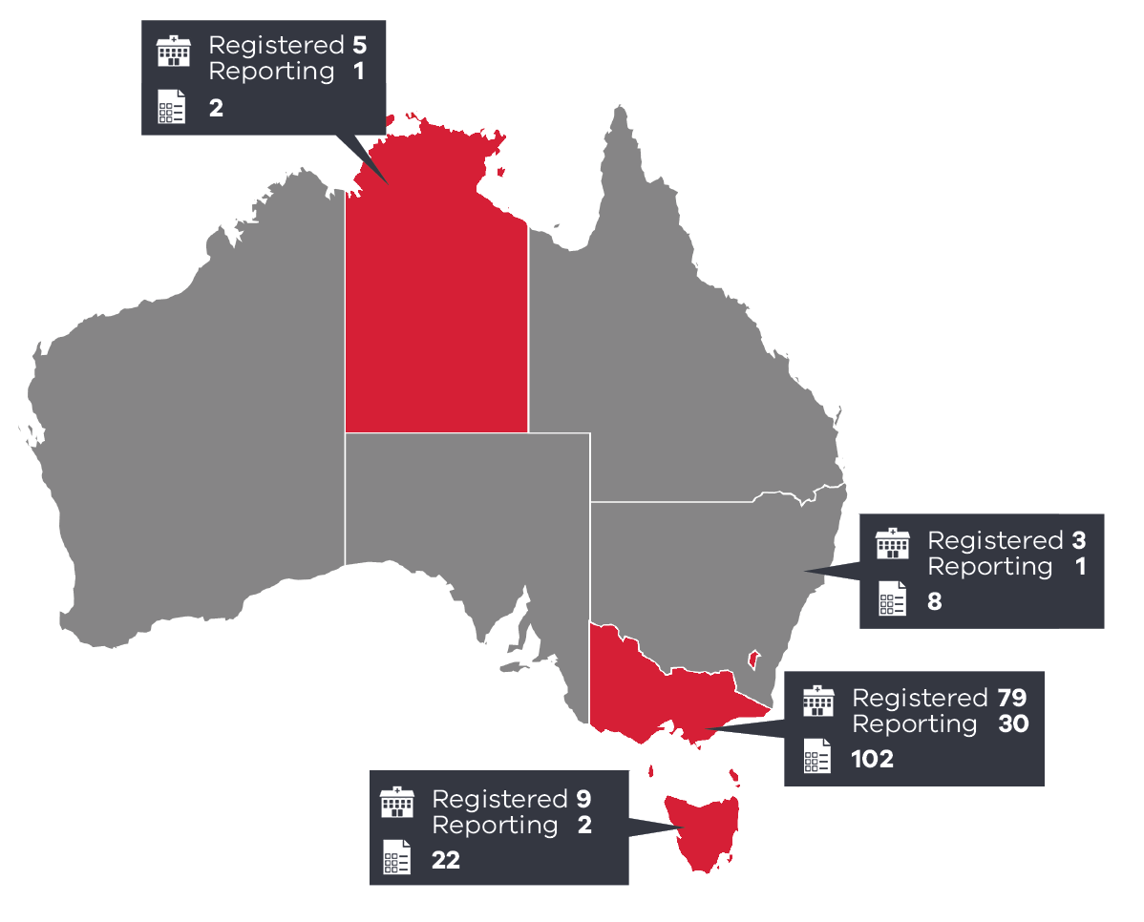
Four jurisdictions report to STIR. As seen in Figure 3, the number of reports varies in each area and this reflects transfusion rates as much as reporting behaviour. Each jurisdiction is responsible for final reports of their data to the NBA for the national haemovigilance report.
As shown in Table 7, the mean age of patients was 49 years, with more reports for male compared to female patients. Red cells continue to represent the majority of products in cases contributing to STIR reports.
Table 7: Demographics for all validated reports
Demographic | Statistic
Age | 0–100 years (mean 49 years)
Gender | Male: 69 (52%); female: 65 (48%)
Blood products | Red cells: 76 notifications  Platelets: 17  Fresh frozen plasma: 7  Cryoprecipitate: 0  Multiple products: 1  RhD Ig: 10  Other (includes near miss n = 7 and WBIT n= 16): 23

Timing of transfusion
Routine transfusions continue to occur out of hours (between 8 pm and 8 am). Seventeen per cent of reported procedural incidents occurred out of hours; similarly, 17 per cent of clinical reactions occurred during this time (although clinical forms do not ask details regarding urgency of transfusion) (Tables 8 and 9).
Guidelines (ANZSBT 2018) recommend that unless the transfusion is urgent, out-of-hours transfusions should be avoided. Transfusion must take place when enough trained staff are available to monitor the patient and emergency medical support is readily available, if necessary. Overnight or out-of-hours transfusion should be avoided unless clinically indicated.
Table 8: Timing of procedural incidents by urgency of transfusion – IBCT, near miss, WBIT (n = 54)
Time | Routine | Emergency | Unknown | Total
8 am – 8 pm | 29 | 8 | 2 | 39
8 pm – midnight | 3 | 3 | - | 6
Midnight – 8am | 3 | 4 | 1 | 8
Unknown | 1 | - | - | 1
Total | 36 | 15 | 3 | 54
Table 9: Timing of clinical reactions – ATR, TRALI, TACO (n = 63)
Time | Number
8 am – 8 pm | 49
8 pm – midnight | 3
Midnight – 8am | 8
Unknown | 3
Total | 63

Health service review of incidents/reactions
Despite health services reporting high rates of review processes to blood management committees, chief medical officers and/or clinical governance (Table 10), very few health services reported changes to procedures. This may be appropriate for clinical reactions (allergic, FNHTR), because the reaction is often idiosyncratic and inherent to the blood product characteristics and cannot be avoided.
However, procedural incidents provide an opportunity to review processes and make changes. In many instances, it may be that staff have not followed protocols, investigation may be required. For example, whether the protocol is available, easy to understand and follow, or whether increased workload meant staff were looking for and using shortcuts.
These are less easy to investigate and manage, but are critical to improve patient safety.
Table 10: Review process
Reaction | Hospital blood management committee or equivalent | Chief medical officer / senior medical officer | Clinical governance or equivalent | Lead to changes at the health service
ATR  (n = 43) | 37 | 13 | 11 | 2 (5%)
IBCT  (n = 11) | 7 | 6 | 6 | 3 (27%)
Near miss  (n = 25) | 25 | 3 | 13 | 8 (32%)
RhD Ig admin  (n = 10) | 10 | 6 | 6 | 5 (50%)
TACO  (n = 19) | 16 | 8 | 7 | 1 (5%)
WBIT  (n = 18) | 16 | 6 | 9 | 3 (17%)
Delayed  (n = 7) | 7 | 2 | 3 | 0
Note: multiple answers may be given

Clinical reports
In this year’s report, 71 clinical events were validated from an initial 75 reports, with FNHTR reactions representing the largest proportion (Figure 4).
Figure 4: Validated clinical events
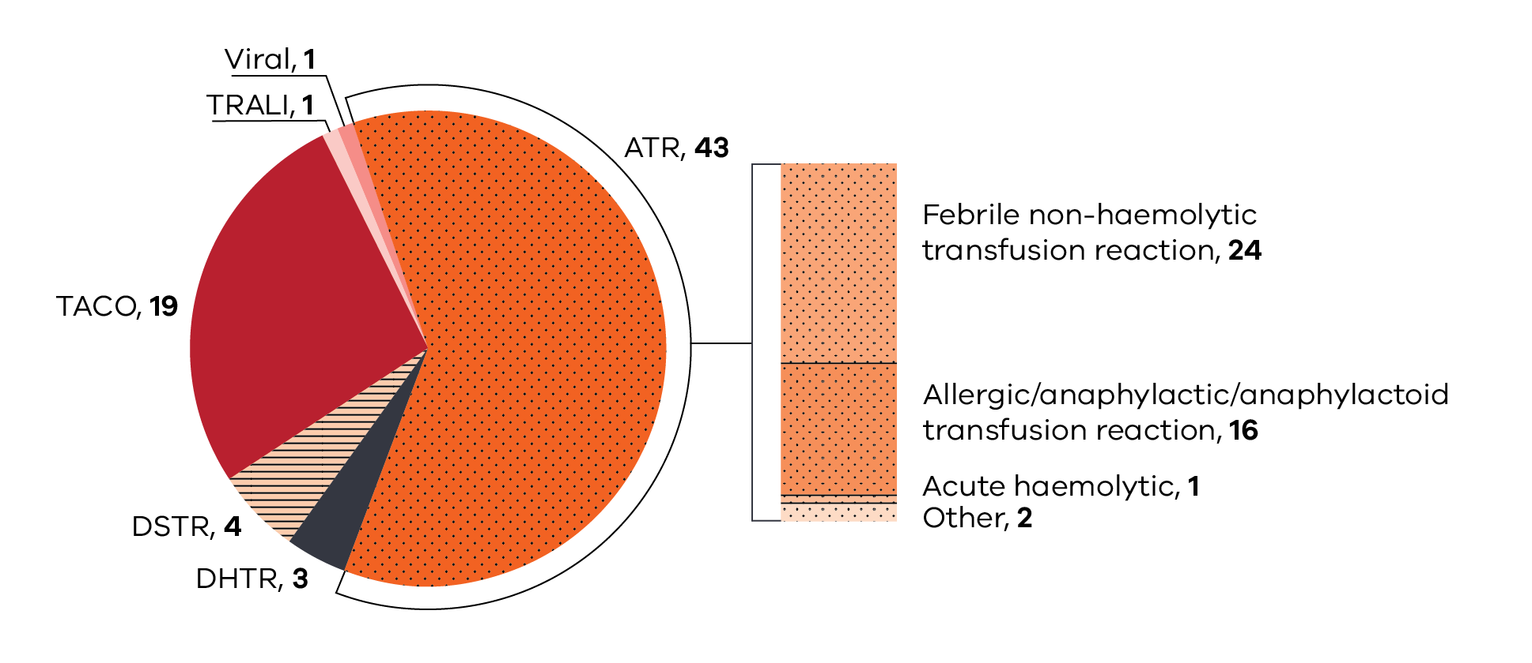

FNHTR
Febrile non-haemolytic transfusion reactions involve patients presenting with an unexpected temperature rise (≥ 38.5ºC or ≥ 1.5ºC above baseline) during or within four hours of the transfusion, which cannot be attributed to any other reason (STIR reporting guide 2017).
Table 11: Data summary – febrile non-haemolytic transfusion reaction, n = 24
Characteristic | Number | Percentage
Age: < 1 year | - | -
Age: 1–18 years | 1 | 4%
Age: 19–29 years | 2 | 8%
Age: 30–49 years | 2 | 8%
Age: 50–69 years | 10 | 42%
Age: 70–79 years | 5 | 21%
Age: 80+ years | 4 | 17%
Gender: Male | 12 | 50%
Gender: Female | 12 | 50%
Implicated blood product: red cells | 20 | 83%
Implicated blood product: platelets | 4 | 17%
Table 12: Severity rating and imputability – febrile non-haemolytic transfusion reaction
Severity rating | Imputability:  certainly | Imputability:  probably | Imputability:  possibly | Total
SR 1 | - | - | - | -
SR 2 | - | 2 | 2 | 4
SR 3 | - | 1 | 12 | 13
SR 4 | - | 1 | 6 | 7
Total | - | 4 | 20 | 24
Pre-medication is used for a number of patients who experience reactions. Table 13 shows the types of medications used in patients who have then gone on to experience FNHTR. The majority of reactions occur in patients who have not received premedication. Those who do have premedication most commonly have a combination of paracetamol and/or antihistamine. See further comments in ‘Case study 1’.
Table 13: Type of premedication given to patients prior to transfusion, where recorded in cases reported to STIR
Premedication | FNHTR incidents
Steroids | 1 (4%)
Antihistamine | 4 (17%)
Paracetamol | 3 (12%)
Pethidine | -
No premed | 19 (79%)
Note: multiple responses per patient reaction

Case study 1: ATR – FNHTR in patient with history of reactions
A female patient with myelodysplastic syndrome (MDS) requiring ongoing transfusion support was receiving a transfusion in a day clinic area. She received two units of red cells for anaemia, followed by a bag of platelets for a low platelet count. A premedication of oral cetirizine and paracetamol had been given approximately four hours prior to the reaction, due to a history of previous reactions. The patient had an extensive transfusion history and had at least one pregnancy.
Twenty minutes after completing the platelet transfusion, she developed chills, rigors and dyspnoea (without alteration in oxygen saturation), a rise in blood pressure and minor temperature rise. She was treated with an antipyretic and an antihistamine. A post-platelet transfusion increment (within one hour) showed no increment. Human leucocyte antibody (HLA) testing showed HLA class 1 antibodies with a frequency of greater than 99 per cent panel reactive antibody. It was recommended that further platelet support be HLA matched platelets. The patient recovered quickly and was able to go home the same day.
The final determination by the STIR Expert Group was possible FNHTR with SR 4.

Comments
While FNHTR is typically not life threatening, it can be uncomfortable and distressing to patients, particularly if they experience a severe rigor. When a patient initially develops a fever during a transfusion, it is not usually immediately clear what the cause is. Patient review by the medical officer and investigations are required to rule out a more serious cause for the fever (for example, acute haemolytic, bacterial contamination or TRALI). The fever may also be caused by the patient’s underlying disease or other complications. There are no specific tests that confirm or exclude a diagnosis of FNHTR, so a process of excluding other potential causes is required. Patients attending day centres for treatment may require an inpatient stay to allow for investigation of a fever. Severity ratings increase when this occurs, as this is an unexpected admission related to the transfusion. While FNHTR may be seen as a mild reaction, there is still a burden to the health service as investigation and exclusion of other causes (sepsis, haemolytic reactions) is required. Judicious use of blood products, avoiding unnecessary transfusion may help to reduce the number of FNHTR seen (Cohen et al. 2017).
Premedication may be helpful in reducing transfusion reactions in patients with recurrent reactions. However, consideration of the timing and type of medication used is necessary. In this instance, the effects may have worn off as it was more than four hours since administration. Considering the timing of premedications is important to ensure they cover the period of transfusion. It is unclear the type of previous reactions the patient had, but an antihistamine for FNHTR will not be useful. The SHOT report 2018 suggests using only paracetamol to treat fever in a febrile reaction.

Allergic, including anaphylaxis
Allergic reactions involve patients presenting with one or more of the following during or within four hours of the transfusion (and where there is no evidence of hypotension):
- rash
- allergic dyspnoea (stridor, cyanosis, wheezing)
- angioedema
  - urticaria.
When attributing the reaction to the transfusion, also consider other possible causes for the allergic reaction, for example drug reactions.
Patients with a severe or anaphylactic reaction may present as above, with additional signs and symptoms such as hypotension, cough, respiratory distress or wheezing, laryngospasm, hypoxemia, shock and/or loss of consciousness (STIR reporting guide 2017).
Table 14: Data summary – allergic and anaphylactic reactions, n = 16
Characteristic | Allergic  n = 10 | Anaphylactic  n = 6
Age: < 1 year | - | -
Age: 1–18 years | 2 (20%) | 1 (17%)
Age: 19–29 years | - | 3 (50%)
Age: 30–49 years | 2 (20%) | 1 (17%)
Age: 50–69 years | 1 (10%) | 1 (17%)
Age: 70–79 years | 5 (50%) | -
Age: 80+ years | - | -
Gender: male | 6 (60%) | 3 (50%)
Gender: female | 4 (40%) | 3 (50%)
Implicated blood product: red cells | 2 (20%) | -
Implicated blood product: FFP | 2 (20%) | 4 (67%)
Implicated blood product: platelets | 6 (60%) | 2 (33%)
Table 15: Severity rating and imputability – allergic and anaphylactic reactions
Severity rating | Imputability:  certainly | Imputability:  probably | Imputability:  possibly | Total
SR 1 | - | - | - | -
SR 2 | - | 9 | 2 | 11
SR 3 | - | 3 | 1 | 4
SR 4 | - | - | 1 | 1
Total | - | 12 | 4 | 16
To prevent or reduce the severity of recurrent allergic reactions, a patient may be given premedication such as antihistamines prior to future transfusions, even though there is little evidence these are effective. For patients who experience only mild reactions of rash and/or urticarial, premedication for future transfusions may not be necessary.
In the reports received by STIR, 56 per cent had not received premedication. Patients given premedication may still go on to have a reaction (Table 16).
Table 16: Type of premedication given to patients prior to transfusion
Premedication | Allergic  (n = 10) | Anaphylactic  (n = 6)
Steroids | - | 3 (50%)
Antihistamine | 2 (15%) | 3 (50%)
Paracetamol | 1 (10%) | -
Pethidine | - | -
No premed | 7 (70%) | 2 (33%)
Note: multiple responses per patient reaction
Where an allergic reaction has occurred, close monitoring of the patient during future transfusions may assist in early detection and treatment of further reactions, if they occur.
Treatment of allergic reactions, as recommended in the SHOT 2017 report:
- For allergic reactions, give an antihistamine as first line; give adrenaline if anaphylaxis is suspected.
- The effect of steroids is delayed by several hours, will have no immediate effect, and should only be used to prevent a late recurrence.
- The use of steroids may further immunosuppress already immunocompromised patients and increase the risk of side effects such as infection.
Immediate treatment at the time of the reaction, as reported to STIR, included antihistamine and steroids (44 and 50 per cent, respectively), inotropes were used in 69 per cent of reactions (Table 17).
Table 17: Type of treatment administered at time of reaction
Reaction | Allergic (n = 10) | Anaphylactic (n = 6)
Antipyretic | - | 1 (16%)
Antihistamine | 4 (40%) | 3 (50%)
Steroid | 6 (60%) | 2 (33%)
Oxygen | 2 (20%) | 4 (67%)
Assisted ventilation | 1 (10%) | 1 (16%)
Intubation | 1 (10%) | -
Inotropes | 5 (50%) | 6 (100%)
Volume support | 1 (10%) | 3 (50%)
Note: multiple responses per patient reaction
Reported investigations following a reaction varied. Some, such as a chest X-ray or serologic compatibility check, may be performed to eliminate other possible causes where the type of reaction is not clear. More specific testing, such as tryptase or IgA levels/antibodies may not be appropriate in all cases, but should be considered for more severe reactions to assist in the determination of the reaction type and to assess if there is a need for change in blood product requirements (IgA antibodies). Table 18 shows the tests undertaken for these reactions.
Table 18: Type of investigations performed at time of reaction
Investigation | Allergic  n = 10 | Anaphylactic  n = 6
Serological compatibility check | 4 (40%) | -
Chest X-ray | 1 (10%) | 2 (33%)
Product culture | 4 (40%) | 3 (50%)
Patient culture | 2 (20%) | 1 (17%)
IgA antibodies | 1 (10%) | 4 (67%)
IgA level | 3 (30%) | 2 (33%)
Tryptase level | 4 (40%) | 3 (50%)
Renal function | 3 (30%) | 1 (17%)
Hb (post transfusion) | 1 (10%) | 2 (33%)
Note: multiple responses per patient reaction

Case study 2: ATR – allergic reaction in outpatient area
A 45-year-old woman who had received an allogeneic transplant for myelodysplasia was attending a day unit for blood product support. She received a bag of pooled platelets, run over 30 minutes, when she developed itching rash and throat tightness following completion of the transfusion. Observations as reported were stable. She was administered steroids and adrenaline. Post-reaction tryptase and IgA level were normal.
The patient required an increased length of stay and increased care, with no long-term ill effects.
The final determination by the STIR Expert Group was probable severe allergic reaction, SR 2, due to the need for admission from the day ward.

Comments
Tryptase and IgA levels may help with the assessment of suspected allergic reactions, but are not always done (see Table 18).

Case study 3: ATR – allergic reaction made worse by continuing the transfusion
A young boy was receiving FFP for coagulopathy (INR 2.1) and bleeding post-surgery in intensive care unit (ICU). The patient became hypotensive with a decrease in oxygen saturation during the transfusion. The clinical judgement attributed the change in condition to postoperative instability, and the FFP rate was increased to provide fluid resuscitation. It was only after this that a rash became apparent and wheeze and stridor were observed.
The transfusion was stopped and noradrenaline, already in use, was increased. The patient required a temporary increase in care.
The final determination by the STIR Expert Group was probable anaphylaxis, SR 2.

Comment
It is important to consider that a transfusion reaction may have occurred in any patient who experiences a change in condition and is receiving a blood product. Until shown otherwise, the transfusion is stopped and IV access is maintained. Rapid rates of infusion may be associated with more severe reactions, as the signs and symptoms may not be apparent for some time, by which time the patient has received a large amount of the product and any allergen.

Case study 4: ATR – allergic reaction to FFP in plasma exchange
A young male was undergoing therapeutic plasma exchange (TPE) for nephritis with FFP replacement. On day one, at the start of the procedure (after 150 mL given), he developed chest pain/discomfort, headache, nausea and vomiting, hypotension (152/96 to 94/55), dyspnoea and swollen lips and tongue. He required intramuscular (IM) adrenaline, oxygen and IV fluid support.
On the second day, despite premedication with steroids and antihistamines, he again developed similar signs and symptoms, this time during the third unit of FFP. In addition, he developed wheeze, itching rash and periorbital oedema. This time he required two doses of adrenaline and nebulised salbutamol, in addition to oxygen and IV fluid support.
The patient had a history of anaphylactic nut allergy.
The final determination by the STIR Expert Group was probable anaphylaxis, SR 2.

Comments
TPE is used for the treatment of a number of conditions. It involves the removal of large amounts of patient plasma to remove a pathogenic protein or solute, and requires replacement with a suitable fluid.
In recent years, STIR has received a number of reports of allergic reactions to FFP used for replacement during TPE procedures. The large volume and rapid infusion of FFP during these procedures may result in more severe reactions. Rash is seen in almost all, dyspnoea or difficulty breathing is common, circumoral or periorbital oedema can also commonly occur.
Treatment often includes an antihistamine and/or adrenaline. Oxygen therapy and the use of a bronchodilator is common.
Usually there is only a temporary increase in care, however one patient required ICU admission.
TPE is nonselective. It removes both normal and pathologic plasma components. For example, during a one plasma volume exchange using albumin as the replacement fluid, coagulation factor activity decreases and coagulation tests may become abnormal.
Significant declines in factor V (FV), FVII, FVIII, FIX, FX, and VWF activity occurs, however FVIII, FIX, and VWF return to normal within four hours after TPE, the remaining coagulation factors achieve pre-TPE activity levels by 24 hours. The exception to this is fibrinogen, which reaches 66 per cent of pre-apheresis levels by 72 hours (Winters JL 2012).
The use of FFP for TPE is not routinely recommended, according to the American Society for Apheresis (ASFA) guidelines. However, in the treatment of thrombotic thrombocytopenic purpura (TTP), FFP is the replacement fluid of choice to replace ADAMTS13. In other procedures, FFP is only recommended where coagulation is depleted and invasive procedures will follow the plasma exchange. Even then it is not necessary to complete the entire procedure using FFP replacement. Albumin may be used for the initial part of the procedure with a smaller number of FFP units given at the end of the procedure to replace clotting factors.

Acute haemolytic
Acute haemolytic reaction is suspected if the patient has fever and other signs/symptoms of haemolysis (including dyspnoea, hypotension, tachycardia, back pain, dark urine) within 24 hours of transfusion and one or more of the following:
- failure to achieve expected rise of the Hb post-transfusion or a drop in Hb > 20 g/L within 24 hours (excluding all causes for ongoing bleeding)
- rise in LDH > 50 per cent within 24 hours
  - rise in bilirubin, free haemoglobin (plasma or urine) (STIR reporting guide 2017).
These may be caused by immune (for example, blood group or red cell antigen incompatibility) or non-immune factors.
During FY18, one acute haemolytic reaction was reported due to an ABO incompatible blood component. See ‘Case study 10: IBCT – ABO incompatible transfusion’.

Delayed haemolytic
Delayed haemolytic transfusion reactions occur more than 24 hours following a transfusion of blood or blood components in which haemolysis occurs due to the development of red cell antibody. They may present with one or more of the following, usually two to 14 days after transfusion of a red blood cell component:
- a fall in Hb or failure of increment
- rise in bilirubin
  - incompatible cross match not detectable pre-transfusion (STIR reporting guide 2017).
For FY18, there were three validated reports.
Table 19: Severity rating and Imputability – delayed haemolytic reaction
Severity rating | Imputability: certainly | Imputability: probably | Imputability: possibly | Total
SR 1 | - | - | - | -
SR 2 | 1 | - | - | 1
SR 3 | - | - | - | -
SR 4 | 2 | - | - | 2
Total | 3 | - | - | 3

Case study 5: Delayed Haemolytic – increased length of stay associated with a delayed haemolytic reaction
A 68-year-old woman with a previous history of transfusion and pregnancy (both risks for the development of red cell antibodies) was transfused a unit of red cells post emergency surgery. Pre-transfusion testing showed no evidence of red cell antibodies, which was supported by historic blood bank testing. However, a week later the patient was found to have signs of anaemia and jaundice and a positive direct agglutination test (DAT). Her lactate dehydrogenase (LDH) was elevated and haptoglobin was very low. Further investigation identified an anti-Jka antibody. The patient required further transfusion, and had an increased length of stay associated with this.
The final determination by the STIR Expert Group was DHTR certainly, SR 2.

Comments:
Delayed haemolytic transfusion reactions typically occur in patients who have previously been sensitised to a red cell antigen (other than ABO) through transfusion or pregnancy and have already developed an antibody. Pre-transfusion testing may not identify all antibodies if levels are below the detectable range. When patients are exposed to the antigen again, the level of antibody rises and a reaction occurs over days to weeks (usually two to 14 days) post transfusion.
A national register of patients with antibodies, accessible to transfusion providers, would assist in assuring the risk of reactions in these patients is minimised, particularly when they move between health care providers. STIR has issued this recommendation in previous reports.

Delayed serologic
This is the first reporting period to include delayed serologic reactions. Delayed serologic transfusion reaction (DSTR) has been included to meet reporting requirements of the NBA Australian Haemovigilance Minimum Data Set. Previously, the development of a red cell antibody without clinical problems for the patient was not reportable to STIR. Patients who developed jaundice or anaemia with the development of a new antibody were reportable as a delayed haemolytic reaction.
A DSTR occurs when, after a transfusion, there is demonstration of clinically significant antibodies against red blood cells (as described in the ANZSBT guidelines for transfusion and immunohaematology laboratory practice, 1st ed., 2016, https://www.anzsbt.org.au/pages/anzsbt-guidelines.html) which were previously absent, as far as is known, and when there are no clinical or laboratory features of haemolysis. This term is synonymous with alloimmunisation (STIR reporting guide 2017).
Due to the lack of clinical reaction, and often in the absence of post transfusion follow-up testing, a delayed serologic reaction may not be detected for weeks, months or even years from the originating transfusion. The reporting year is based on date of detection rather than date of transfusion.
Table 20: Severity rating and imputability – delayed serologic reaction
Severity rating | Imputability: certainly | Imputability: probably | Imputability: possibly | Total
SR 1 | - | - | - | -
SR 2 | - | - | - | -
SR 3 | 1 | 1 | - | 2
SR 4 | 1 | 1 | - | 2
Total | 2 | 2 | - | 4

Case study 6: Delayed serologic – development of anti-K without apparent clinical effect
A 77-year-old woman received two units of red cells during a surgical procedure with no problem. Her pre-operative screening had found her to be O RhD positive without any unexpected antibodies detected. Historical blood bank screening had also been negative (no antibodies detected). When the woman was at the hospital nearly five months later, she had blood tests including blood group and antibody screen, which now showed a positive DAT. On further investigation, she was found to have an anti-K antibody, not previously seen. There was no indication that the patient had been transfused in the interim period, and so this transfusion is likely to be the initiating event.

TACO
Transfusion associated circulatory overload (TACO) is caused by heart failure leading to pulmonary oedema as a result of rapid infusion or large volumes (relative to the patient’s blood volume) of blood products. Cases of TACO are confirmed by any four of the following which occur within six hours of transfusion:
- acute respiratory distress
- tachycardia
- increased blood pressure
- acute or worsening pulmonary oedema evident on chest X-ray
  - evidence of positive fluid balance (STIR reporting guide 2017).
Table 21: Data summary – TACO, n = 19
Characteristic | Number | Percentage
Age: < 1 year | - | -
Age: 1–18 years | 1 | 5%
Age: 19–29 years | 1 | 5%
Age: 30–49 years | 1 | 5%
Age: 50–69 years | 4 | 21%
Age: 70–79 years | 7 | 37%
Age: 80+ years | 5 | 26%
Gender: male | 10 | 53%
Gender: female | 9 | 47%
Implicated blood product: red cells | 16 | 84%
Implicated blood product: FFP | 1 | 5%
Implicated blood product: platelets | 2 | 11%
Table 22: Severity rating and imputability – TACO
Severity rating | Imputability: certainly | Imputability: probably | Imputability: possibly | Total
SR 1 | - | - | - | -
SR 2 | 1 | 5 | - | 6
SR 3 | 1 | 7 | 4 | 12
SR 4 | - | - | 1 | 1
Total | 2 | 12 | 5 | 19

TACO is recognised as a commonly occurring adverse transfusion reaction with a risk of serious morbidity or mortality. In the USA, the Food and Drug Administration (FDA) recognise that up to 24 per cent of transfusion-related mortality occurs due to TACO (Henneman et al. 2017). SHOT data (SHOT 2017) from the period 2010 to 2017 found 44 per cent of transfusion-related deaths were attributable to TACO. The number of TACO events reported to STIR continues to be low. However, four (21 per cent) were admitted to ICU as a result of the transfusion reaction. The only other reaction type to result in ICU admission was anaphylactic reactions (2/6, 33 per cent).
TACO is a potentially preventable transfusion reaction. Many patients have identifiable risk factors (such as pre-existing cardiac or respiratory illness, see below). Staff managing transfused patients should be aware of, and educated about, TACO so they can employ risk mitigation strategies to prevent TACO occurring or monitor the patient closely to intervene early if TACO does occur. Some TACO cases occur in patients without known risk factors and/or with small volumes infused (Henneman et al. 2017).
In September 2017, Blood Matters ran a TACO awareness campaign that included swing tags for blood bags, posters for clinical areas and information sheets (Figure 5). The tags and information used was based on information developed by SHOT to improve TACO recognition and management. The aim was to assist in education and awareness of risk factors, monitoring and treatment. The resources are available on the Blood Matters website <https://www2.health.vic.gov.au/hospitals-and-health-services/patient-care/speciality-diagnostics-therapeutics/blood-matters/serious-transfusion-incidents>.
Figure 5: TACO swing tags
Risk factors for TACO (Henneman et al. 2017) include:
- age (very young/old)
- female sex
- underlying cardiac, renal, or pulmonary disease
- regular diuretic requirement
- positive fluid balance > 500 ml in the 24 hours prior to transfusion
- concomitant IV fluids, or drugs diluted in 500 ml or more, in 24 hours prior to transfusion
  - prior fluid overload.
Preventive measures include:
- assess for patient risks before transfusion – use a formal pre-transfusion risk assessment for TACO, such as the SHOT example
- transfuse according to patient symptoms and clinical condition, not on Hb alone
- monitor, assess, and document vital signs and intake and output during the transfusion period (≤ six hours after transfusion)
- use single-unit transfusion policy where appropriate
  - administer diuretics as prescribed.
For inpatients at risk of TACO:
- monitor fluid balance before, during and after transfusion
- prescribe one unit at a time
- transfuse at a slower rate
- consider use of a prophylactic diuretic
- monitor the observations closely, including oxygen saturations
  - review the patient following each unit.
Any patient developing respiratory distress during or within 24 hours of transfusion needs prompt clinical assessment and treatment. Including:
- stopping or slowing the transfusion
- chest X-ray
- considering a trial of diuresis
- early involvement of intensive care or outreach team if patient does not respond to treatment
- reporting to STIR.

Case study 7: TACO – timing of transfusion
A 68-year-old man with end stage lung cancer and anaemia received a transfusion of red cells.
The patient weighed 57 kg, and had been receiving IV fluids in the 24 hours prior to transfusion, however fluid balance was unknown. Approximately three hours after commencing a unit of red cells at 22.40 hours, the patient developed dyspnoea, with a reduced oxygen saturation and tachycardia. He required oxygen and diuretics and the transfusion was stopped. It was reported that he recovered from the reaction, but died two days later of his underlying disease.
The final determination by the STIR Expert Group was possibly TACO, SR 3.

Comments:
The timing of this transfusion was not ideal. Unless there was a risk to the patient by not receiving the transfusion urgently, this could have waited until business hours when staff to patient ratios are higher. The ability to monitor the patient and have additional help in the event of a transfusion reaction is greatly reduced when performed out of hours.

Transfusion associated acute lung injury (TRALI)
TRALI is an uncommon, but serious reaction to blood components. TRALI is suspected when a patient presents the following clinical features:
- acute onset respiratory distress with hypoxia
- bilateral pulmonary infiltrates, evidenced on radiology imaging
- occurs during or within six hours of transfusion
- no other apparent cause of acute lung injury
  - no evidence of TACO (STIR reporting guide 2017)
During FY18, one TRALI was reported.
Figure 6: Validated TRALI reactions reported to STIR – FY06–FY18
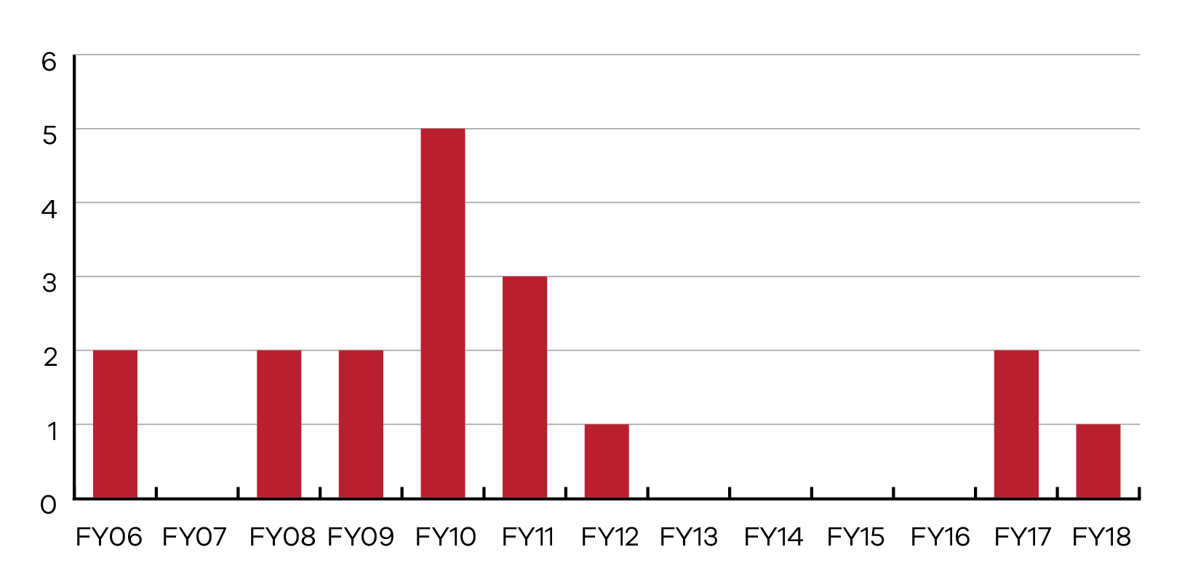

Case study 8: Possible TRALI
A female patient received three units of red cells for chronic anaemia, had a cardiopulmonary arrest and was transferred to a tertiary health service, where the reaction was reported. She was admitted to ICU and required intubation. Chest X-ray showed bilateral lower-lobe consolidation, and ground glass opacities in both upper lobes.
The patient recovered and was discharged from ICU several days later.
HLA testing of the recipient showed HLA type 2 antibodies. Although the Blood Service was unable to follow up with the donors, the clinical picture was considered consistent with TRALI.
The STIR Expert Group consensus agree this was a possible TRALI, SR 2.

Comments:
Final determination of the diagnosis and imputability of these reports is difficult as there is often a delay in waiting for donor follow up. Despite the Blood Service attempting to follow up with donors for testing, it is not always possible or timely.

Transfusion associated dyspnoea (TAD)
This is the first reporting period that has included TAD as a clinical reaction reportable to STIR. TAD has been included to meet reporting requirements of the NBA Australian Haemovigilance Minimum Data Set (AHMDS 2015).
The definition of TAD has been developed from SHOT (2017) and the AHMDS.
TAD is characterised by respiratory distress within 24 hours of transfusion that does not meet the criteria of TRALI, TACO, or allergic reaction. Respiratory distress should be the most prominent clinical feature and should not be explained by the patient’s underlying condition or any other known cause (STIR reporting Guide 2017).
Two adverse events were initially notified as suspected TAD; however, on review by the expert group were reclassified as probable TACO and the other as possible TACO.

Transfusion transmitted infection including bacterial sepsis
Transfusion transmitted infection (TTI) is low in Australia due to effective strategies to reduce contamination of blood components, through pre-donation questionnaire, and comprehensive screening of donations for infectious agents.
A TTI should be reported where the recipient has evidence of infection post transfusion and there was no evidence of infection with the agent of infection prior to transfusion and:
- at least one component received by the recipient was donated by a donor who had evidence of the same transmissible infection, or
  - at least one component received by the recipient was shown to have been contaminated with the agent of infection (STIR reporting guide 2017).
In this reporting period, one case of viral infection was reported.

Case study 9: TTI – parvovirus in a susceptible patient
A teenage male was transfused a number of red cell units (RBC) as part of a chronic transfusion regimen. He presented 10 days later with lethargy and a 30 g/L drop in haemoglobin. There was no history of bleeding. Investigations showed a new reticulocytopenia, raising the suspicion of parvovirus B19 virus (B19V) infection. Acute B19V infection was confirmed by peripheral blood polymerase chain reaction (PCR). A blood sample collected prior to transfusion was retrospectively tested for B19V by PCR and was found to be negative. Further history excluded any sick contacts or other risk factors for parvovirus, and the transfused red cells were investigated as a possible source of infection. Donor testing was undertaken for all implicated donors. A single donor tested positive for B19V by PCR. The donor was asymptomatic at the time of the donation. These findings are consistent with transfusion-associated B19V transmission with a subsequent aplastic crisis. The patient required further transfusion support and hospitalisation for five days.
The final determination by the STIR Expert Group was probably viral, SR 2.

Comments
This case study was the subject of the first STIR bulletin to health services. Download the bulletin <https://www2.health.vic.gov.au/about/publications/researchandreports/stir-bulletin-1>

Transfusion associated graft versus host disease (TAGvHD)
TAGvHD is characterised by the development of the classical symptoms of fever, rash, liver dysfunction, diarrhoea, pancytopenia and bone marrow hypoplasia, occurring less than 30 days following transfusion, without other apparent cause (STIR reporting guide 2017).
There have been no reports of TAGvHD since reporting to STIR commenced.

Post transfusion purpura (PTP)
PTP is characterised by sudden and self-limiting thrombocytopenia occurring five to 12 days following transfusion of red cells or platelets. It is associated with the presence of antibodies directed against the human platelet antigen (HPA) system (STIR reporting guide 2017).
There were no events reported this year, with the last report occurring in 2009.

Procedural reports
Procedural errors predominantly occur due to human error and are often preventable if protocols and guidelines are put in place and followed. The majority of WBITs, near misses and IBCTs are a result of inadequate patient or sample identification either at time of pre-transfusion sampling or time of blood administration. For this reporting period there were a total of 64 validated reports (Figure 7).
Figure 7: Validated procedural events
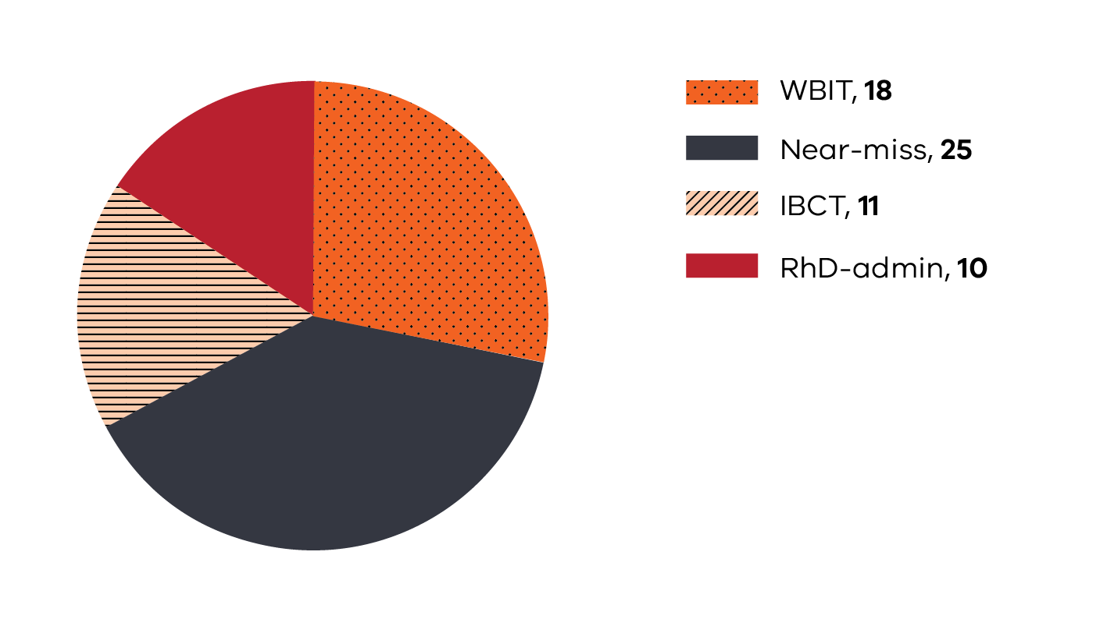

Incorrect blood component transfused (IBCT)
Incorrect blood components transfused includes reports of incidents in which:
- the component did not meet the specific requirements for the patient
- transfusion of a component intended for another patient (ABO compatible)
- all unintentional incompatible transfusions, including ABO incompatible
- transfusion of product other than that prescribed (for example, platelets instead of FFP)
  - unnecessary or inappropriate transfusion (STIR reporting guide 2017)
Four validated IBCTs (total 11) were originally submitted to STIR as near misses. However, in all cases the patient had commenced the transfusion.
Table 23: Types of IBCT events FY18
Category | Number reported
Antigen-antibody issues | 1
Components that did not meet specific requirements for patient | 1
Inappropriate platelet/plasma product | 1
Inappropriate – over-transfusion | 2
Inappropriate – unnecessary | 1
Incorrect blood component to incorrect patient | -
ABO compatible | 4
ABO incompatible | 1
In this reporting period, there were four events that were an incorrect component to incorrect patient, but ABO compatible (Table 23).
Two reported events underwent a root cause analysis (RCA). One was an ABO incompatible transfusion of red cells, which requires an RCA under the Safer Care Victoria program (haemolytic blood transfusion reaction resulting from ABO blood group incompatibility). The other case was conducted voluntarily by the health service due to the nature and potential seriousness of the event. We thank both health services for sharing their findings and recommendations from these events.

Case study 10: IBCT – ABO incompatible transfusion
A middle-aged patient was brought in by ambulance to the emergency department (ED) with hypotensive shock following a collapse at home. Past history of hepatitis C, liver cirrhosis with oesophageal varices and ascites. Provisional diagnosis was upper gastrointestinal bleed.
The patient’s haemoglobin was 65 g/L and the critical bleeding protocol was activated. After initial resuscitation with emergency blood products (including red cells, plasma, platelets and albumin) and other medical treatments, the patient was stabilised. The blood products were delivered from blood bank via a pneumatic chute (as is the usual practice). The delivered products were collected by various staff and taken to the resuscitation area, and placed on a trolley outside the patient’s cubicle. On review there was no evidence of a checking process undertaken when collecting blood from the chute. The patient’s blood group was found to be O RhD positive.
Several hours after admission there was further deterioration noted. Around the same time, a unit of red cells was delivered to the trolley outside the patient’s cubicle; the red cells had not been requested at that time. The two RNs assumed the patient required more blood and checked the details of the red cell unit against the compatibility tag and cross match report outside the patient’s cubicle and commenced the unit of red cells without performing any patient identification checks. The unit of red cells administered was A RhD positive and cross-matched for another patient in the ED who required a blood transfusion. There was no similarity in names, birth date or sex.
After approximately 50–100 mls of the incorrect red cell unit being transfused, further deterioration occurred and while changing the blood to a rapid infuser the error was recognised. The transfusion was stopped immediately, the ED doctor and Blood Bank were notified and appropriate testing performed in line with the transfusion reaction procedure. Testing confirmed an ABO incompatible transfusion causing haemolysis. A further two units of red cells were administered following the error and the patient was moved into an isolation cubicle for palliation in line with the patient’s and family’s previously expressed wishes and died three hours later. The cause of death was determined to be oesophageal varices with haemorrhage and cirrhosis of the liver. The incompatible transfusion was noted.
The final determination by STIR Expert Group was possible IBCT/AHTR, SR 1.

Comments
While this type of error is alarming, it is not an isolated incident and remains a significant clinical risk. The unit collected from the chute was placed at the wrong bedside. The staff checking the blood had a match between the pathology paperwork and the blood product. The failure was in confirming the patient identity at the bedside, this is a vital step in preventing error. These types of errors often occur with experienced staff in busy, stressful situations. The need for positive patient identification directly between the blood product and the patient cannot be reinforced strongly enough. It is critically important to check the product and the patient each and every time.
The use of pneumatic chutes for delivery of blood products to areas is becoming more common. The literature focuses on the validation of the chutes in relation to viability of the product, but does not provide safety advice on the collection of the product from the chute and then the delivery to the patient. Unlike collection from a blood fridge or blood bank, there is often no requirement for the use of patient identifiers and/or the qualification of the person permitted to collect blood from a chute. In addition, staff members passing the chute, being aware of the limitations around time out of refrigeration for blood products, can collect and take blood to patients they are not assigned. In a busy department, it may be left near or at the patient side for the assigned nurse caring for that patient to find and check. There may be no check if it has been delivered to the correct patient.
Health services introducing pneumatic chute systems need to validate not only the safety of the chute for delivery of blood products, but also the safety of the collection process from that chute.
The actions resulting from the incident investigation included:
- an education campaign highlighting the need to ensure patient identification checks matched to the product are carried out correctly
- blood delivery via the chute has been reduced
- increased use of onsite blood fridges for planned transfusions
- one pneumatic chute in the clinical area involved has been dedicated to blood only
- staff collecting blood from that chute must be appropriately qualified to collect the product
- working towards replacing the crossmatch report that comes with the blood with a sticker, to remove the potential to use the pathology form as patient identification
- a business case for an electronic blood scanning system was unsuccessful
- staffing and workflow are being looked at as ongoing issues in the ED.

Case study 11: IBCT – RhD incompatible transfusion
A man was admitted with symptomatic anaemia. He received a red cell transfusion without incident and was subsequently discharged. The patient returned to the health service two weeks later and another blood grouping was performed. At this time the laboratory noted that the patient blood group was AB RhD negative, consistent with previous results. However, it was also noted at this time the patient had received A RhD positive red cell units in his last visit. This had not been noted prior to this. Neither the laboratory nor the nurses administering the product noted the discrepancy in RhD status at the time of transfusion. Long-term follow up was not possible as the patient had been on holiday in Australia and had returned home. Open disclosure of the event did occur.
The health service investigated and performed a RCA on this event. This included consultation with the external pathology service, which was instrumental in implementing the changes required.
There were four main root causes identified:
- The electronic crossmatch system generates caution/alert pop-ups for all mismatches, even when O RhD negative (universal donor) blood is matched. This results in pop-ups occurring frequently, ultimately causing alarm fatigue and diminished interrogation of such alerts.
- Caution/alert pop-ups for RhD mismatch can be overridden with a single click by a staff member. No additional information is required. The electronic crossmatch system does not require evidence of consultation with the treating clinician and haematologist as required in local work flow.
- There is no visual cue on blood unit label or issue report to alert staff administering the blood that a mismatch has been identified.
- Nursing staff felt rushed and distracted by family members in the room while the checking process was being undertaken.
The changes implemented to address these issues are:
- The electronic crossmatching system has been reconfigured to reflect the changes, that is, clinically irrelevant alerts have been stopped, and there have been changes to the wording of the RhD mismatch alert.
- The relevant standard operating procedures have been altered to reflect the new process and IT changes. This includes workflow requiring the scientist to consult with the haematologist and referring clinician.
- A memo has been sent to all laboratory managers to ensure communication of the changes occurs in all areas.
- In addition, there has been additional communication with each of the laboratory managers as to the new changes.
The final determination by the STIR Expert Group was IBCT, certainly, SR 4.

Comments
The health service worked closely with the pathology provider, which was an integral part of the investigation and implementation of changes to prevent a recurrence.
Excessive pop-up alerts in electronic systems have long been recognised as an issue, causing alert fatigue. When many of the alerts are not critical and are easily over-ridden, it becomes second nature for staff to react to the alert without really reading it. This can lead to missing vital warnings. Removing unnecessary alerts is an important aspect of the work undertaken to prevent a recurrence of this event. Consideration could also be given to force the user to record a comment explaining the reason for the override, which would focus the mind of the issuing biomedical scientist (positive acknowledgment), (SHOT 2017).
Nursing staff also need to be aware of the importance of the bedside checks and the need to focus on what they are checking so as not to miss discrepancies such as this. Patients and family need to be made aware of the importance of this checking process, so that they do not interrupt unnecessarily.
There are electronic systems available to assist nurses to complete the bedside checking procedure. Before these are implemented, it is important to ensure the system does what is needed and does not add complexity to the checking. It is also vital to ensure staff do not become reliant on the system to perform the patient identity check. This still needs to be a positive patient identification process involving the patient wherever possible.

Case study 12: IBCT – over-transfusion of infant
An infant who had undergone neurological surgery was prescribed three units of red cells via an electronic order. Orders are usually weight-based for children of this age, and as this child was less than 20 kg, the order should have been placed in mL rather than units.
The health service electronic system does not allow for ordering of units for a child under 20 kg, so the medical officer overrode the system by changing the weight to greater than 20kg. The laboratory filled the order as requested. Nursing staff did question the order with the prescribing medical officer and raised it with senior nursing staff, but did not take the concern further.
The infant received two units, with review between units. The third unit was not started after the nursing staff were unable to withdraw blood from the central venous catheter, and there was concern that it was dislodged. A decision was made to wait until the morning review for any further transfusion. The next day the infant was noted to have some facial and head swelling, which was not unexpected given the type of surgery. A problem was noted when the check Hb came back at 201 g/L. Intravenous access and venesection was difficult and initially the decision was made to observe the infant and venesect if there was a change in condition. When the next day the Hb was still 199 g/L, and the patient was hypertensive; venesection was undertaken. Two venesections on consecutive days were required, with a final Hb of 169 g/L.

Comments
Orders must be clear at all steps in the transfusion chain. Where there is any concern or confusion, this must be remedied prior to moving on.

Case study 13: IBCT – communication issues lead to wrong patient transfused
The medical Fellow handed over to the Registrar, who then handed the instruction over to the night intern that patient A needed a single unit of red cells transfused. A miscommunication in the handover resulted in patient B, receiving an unnecessary transfusion.

Comments
The report indicated this was a routine transfusion that occurred overnight. As stated previously, routine transfusions should be occurring in business hours when possible and not overnight. Had the decision been delayed to the morning (if suitable), staff who knew the patients would have been overseeing the treatment, and identified the error and the unnecessary transfusion may have been avoided.
It is also important that communication between staff is completely clear and accurate, to avoid this type of error.

Near miss
A near miss is an incident that is discovered before the start of the transfusion and that could have led to a wrong transfusion or a reaction in a recipient if transfusion had taken place (STIR reporting guide 2017).
In FY18 there were 25 reports received of near misses.
Table 24: Types of near miss events received by STIR in FY18
Category | Number reported
Inappropriate component issued | 3
Labelling/documentation | 3
Laboratory | 4
Administration | 10
Incorrect prescription or request for blood | 2
Storage and handling | 3
Table 24 shows a number of areas where near misses occurred. The largest proportion is attributed to the administration process, as this is the final check that can identify an error prior to transfusing the patient.

Case study 14: Near miss – wrong blood checked and spiked
A unit of red cells arrived from the laboratory in the pneumatic chute. A nurse collected the unit without confirmation of patient details and took it to the room of the patient who required transfusion. The bedside checks failed to note the discrepancy in details between the compatibility form and the unit of blood – both labelled for different patients. During the checking, only one of the nurses went to the patient bedside; the other was at the desk just outside the room, completing paperwork associated with the transfusion. Patient wristband details were not matched to the red cell unit and it is unclear if the patient identity was checked. The unit was spiked, connected to the patient line and commenced. A phone call from the nurse’s station to alert the nurse that a red cell unit for the patient had arrived via the chute caused the nurse to realise the error and immediately stop the red cells. Fortunately, the red cells had not made their way down the IV line to the patient at this time. The patient was informed of the error and a case review was performed by the health service.

Comments
Changes to the ANZSBT guidelines for administration of blood components, that is, double independent checking, are designed to stop this type of incident occurring. The checking process must be completed by each person, as if the other person were not there. Both staff must be independently certain that the product is intended for the patient.
Checks should be completed at the patient’s side and include the patient in the process wherever possible.

Wrong blood in tube (WBIT)
This is a special category of near-miss incident where the error is picked up prior to transfusion.
This includes specimens where:
- samples are taken from the wrong patient but labelled as per the intended patient, or
  - sample is taken from the intended patient but labelled as per another patient (STIR reporting guide 2017)
These events have the potential to cause harm to patients, because while labelling is consistent and passes zero-tolerance guidelines, the blood group may be different to that of the named patient.
Eighteen WBIT events were reported for FY18. The number of reports continues to drop over time (Figure 8) and is no longer the main procedural report received, with more near misses reported for this year. There appears to be a decrease in WBIT errors occurring in maternity and emergency departments, two areas that have contributed a large number of events (Figure 9), with more being reported from general ward areas.
The majority of events (50 per cent) were recognised via a discrepancy when comparing sample results with the patient historical record (Table 25). This does not protect the patient who has no record with the pathology provider. Thirty three per cent were noted prior to testing; often as a result of the clinician who took the sample realising an error had been made.
Figure 8: Factors contributing to WBIT incidents (multiple responses per event) since FY15
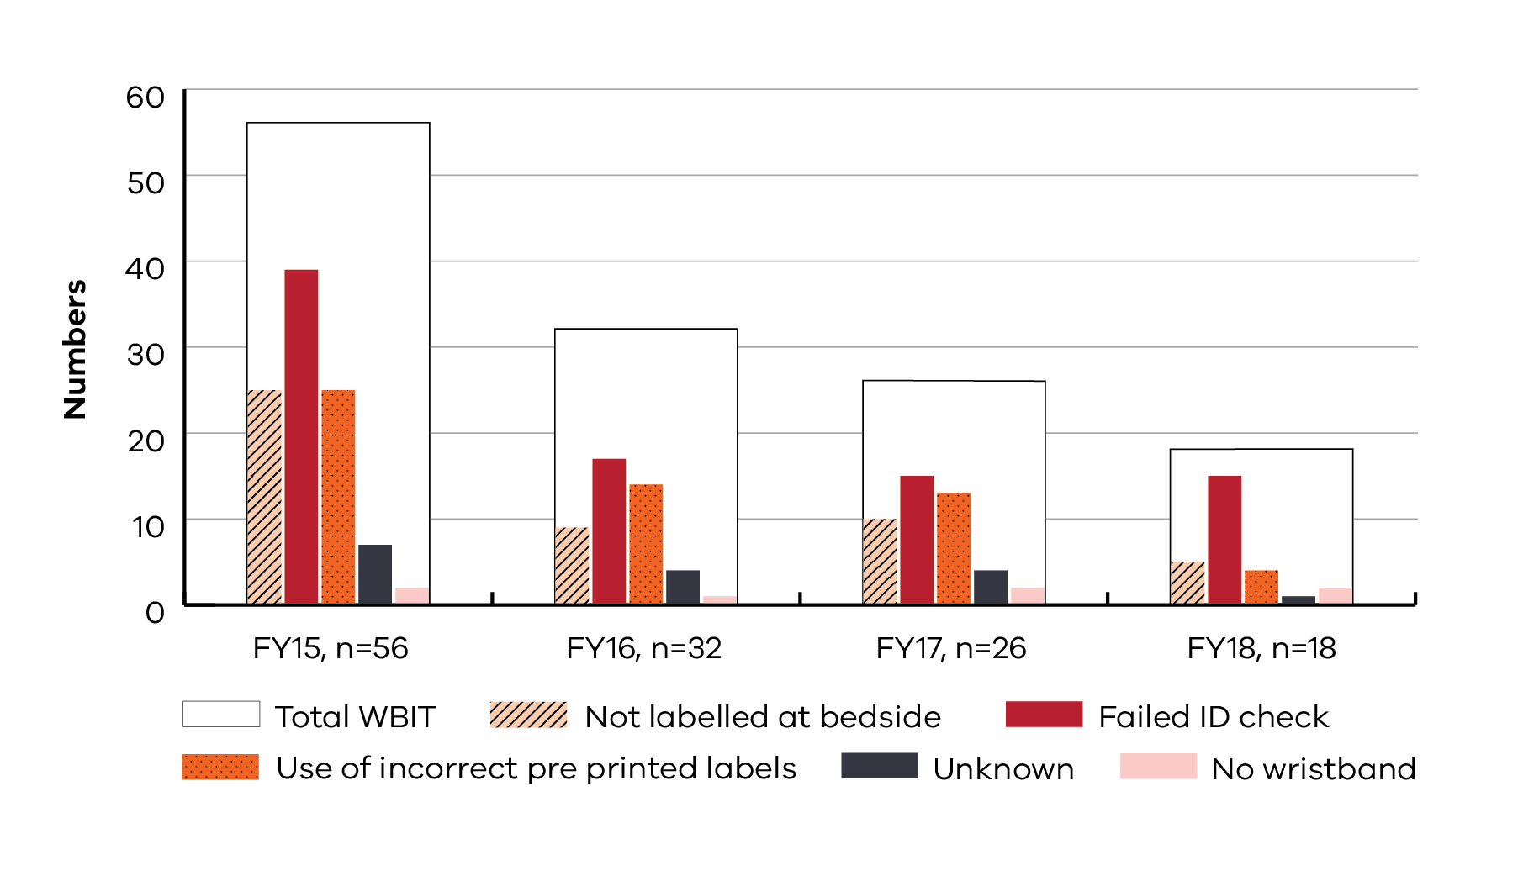
Prior to FY15, the definition for WBIT included zero tolerance.
Figure 9: Where WBIT errors occur
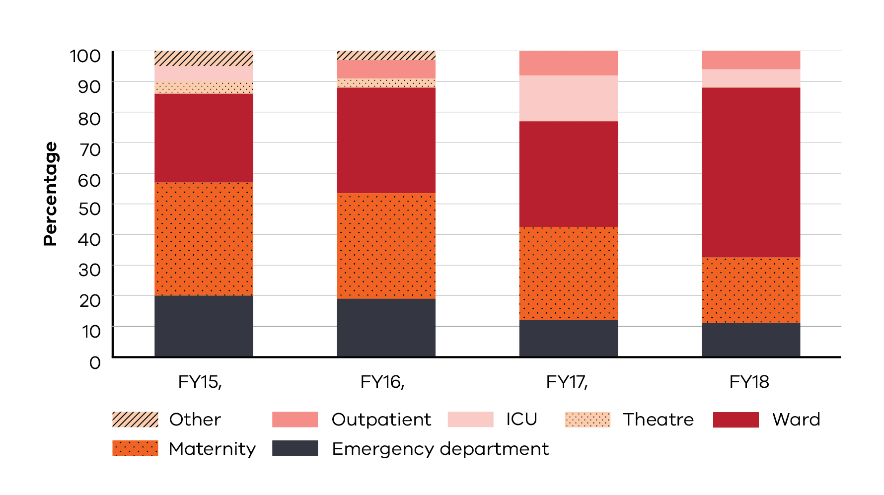

Table 25 How the WBIT was discovered
Category | Number | Percentage (%)
Recognised prior to testing | 6 | 33
Discrepancy noted when comparing sample results with historical record | 9 | 50
Recognised post testing but prior to issue | 4 | 22
Significant change in MCV compared with prior testing | 2 | 11
Recognised post issue but prior to transfusion | - | -
Other | 1 | 5
Total incidents | 18 | 100
Note: multiple responses given

Case study 15: WBIT – bloods taken in Medical Emergency Team (MET) call
Bloods were taken from a patient during a MET call. At the time of collection, there was no request form to check patient details at the bedside; the medical officer completed the request form after collection and away from the bedside. The medical officer inadvertently placed the wrong patient details on the form. The nurse who took the bloods then copied the wrong patient details onto the tubes from the request form. At no stage did either check details against the patient identification (ID) band.
The laboratory noted the discrepancy in blood group between specimen and historic group, indicating a WBIT.

Comments
In urgent situations, paperwork is one of the last things to be considered in caring for the patient. However, the checking of patient identity is always a vital part of patient safety. At all times samples should be labelled at the bedside. In a time-critical event when it is not always possible to have the request form available at the time of taking the blood sample, it is still necessary and possible to label the sample before leaving the patient. The mismatch in patient ID on the request form and sample would have been immediately apparent to laboratory staff and reduced the risk to the patient.
At some point, confirmation of the labelling of the sample and request form with the patient ID band and/or stated ID must occur and will reduce errors.
In this case, it was the discrepancy in historical blood group that allowed the WBIT to be identified. Had the specimens been processed, clinical staff following up results for the patient would be unable to find them as they would have been attributed to the patient whose identifiers had been used. When assuming the laboratory has ‘lost’ the specimens, consider whether they were labelled correctly in the first instance.

Case study 16: WBIT – patient identification incomplete
A patient attended for pre-transfusion testing in preparation for red cell exchange to take place a few days later. The patient was not admitted, therefore did not have an ID band in situ.
The nurse found the patient’s medical record containing a pre-transfusion request form (labelled) and identification labels. The request form and labels were for another patient with the same name and similar age, which was not recognised at the time. The nurse used this form and identification labels to take and label specimens for the patient, however the patient was never asked to state his name, date of birth nor address (three identifiers) as required by the health service. The nurse gave the request form to the patient and asked him to check his details. The patient quickly glanced at the form and said, ‘Yes, that is me’. The sample was sent to pathology where the error was discovered. Both patients are regular attendees with transfusion records at the pathology provider.

Comments
While having the patient confirm their identity on the request form may seem efficient, if the patient is unaware of the consequences of getting it wrong and the necessity to check carefully, then this type of error will occur. This final check does not remove the need to ask the patient to state name and date of birth and check these against the request before starting the procedure.

Case study 17: WBIT – patient identification from medical folder
Specimens were received in Blood Bank for a patient in the coronary care unit. Labelling was consistent between specimen and request, so testing was undertaken. Testing showed that the blood group of the specimen received was B RhD positive, the patient had a historical record of A RhD positive. The nurse was notified of the error and found that the folders (labels included) that had been used to label the request and specimens had been switched over. She had two patients, who both required blood specimen collection, and had used the folders for identification. Both patients required second specimen collections.

Comments
For both of the above incidents, the identification of the patient directly and as per health service policy did not take place. The use of the patient to self-identify should be effective, but only if the patient is made aware of the reason for doing this and is carefully checking the information. It should not replace the use of positive verbal identification whenever it can be done. Where the patient cannot participate in the positive identification process, direct confirmation of the identification on request and/or specimens with the patient identification band must occur. The use of other means to identify patients, especially medical records which can be very mobile, is never acceptable.
The majority of WBIT events reported are a result of poor patient identification at the time of collection, and/or labelling of specimens and request away from the bedside. If there are only two things to remember for specimen collection patient identification and labelling, they are:
- Always have a labelled form at the bedside – this will allow you to check you are at the right patient, even in an emergency situation.
- Always label specimens at the patient’s side. This allows direct comparison of details on specimens with the patient ID band.
If these two processes are always observed then the risk of a WBIT is minimised.

RhD immunoglobulin (RhD Ig)
Includes incidents related to anti-D request or administration for women of childbearing potential or following transfusion of RhD mismatched red cells or platelets. This includes incidents where:
- RhD Ig is omitted or administered late at routine prophylaxis or sensitising events
- RhD Ig is erroneously administered to a Rh D positive woman, a Rh D negative woman with immune anti-D, or the woman of a Rh D negative infant
- RhD Ig is administered to the wrong patient
- the incorrect dose of RhD Ig is administered
  - an expired product is administered (STIR reporting guide 2017)
There were 10 reports of RhD immunoglobulin administration errors in this year. Fifty per cent of reports related to sensitising events (Table 26). Sixty per cent of reports related to RhD Ig being administered when it was not required (Table 27).
Table 26: RhD Ig errors – intended administration
Intended administration | Number
Antenatal prophylaxis | 1
Sensitising event | 5
Post-natal | 3
Note: One dose given in error, wrong immunoglobulin product.
Table 27: Types of RhD Ig incidents
Type of incident | Number
Administered, not required (Rh negative mother with Rh negative baby) | 2
Administered, not required (Rh positive woman) | 4
Administered, not required (woman with immune Anti-D) | -
Rh D dose omitted | 1
Delay in administration (> 72 hours.) | -
Wrong or inadequate dose | -
Other: released or administered to incorrect patient, incorrect immunoglobulin product released | 3
The number of reports of RhD Ig events to STIR has remained small. In 2017, SHOT received 426 reports of incidents relating to RhD Ig, 77 per cent of which related to omission or late administration.

Blood Matters RhD Ig use in obstetrics audit
Although the number of RhD Ig reportable events has been small, some concerning themes have emerged. As a result, Blood Matters performed an RhD Ig use in obstetrics audit that covered the period 1 July 2017 through to 30 June 2018. Data submitted in the practice audit found 294 potentially reportable events over the 18-month period of the clinical audit from January 2017 – June 2018 (Table 28).

Table 28: Potential RhD Ig errors found in Blood Matters audit
Intended administration | Potential error | Number
Routine prophylaxis | At least one missing dose  Incorrect timing  Incorrect dose | 87  112  40
Sensitising events  (1st trimester) | Dose unnecessary | 14
Sensitising events  (2nd and 3rd trimesters) | Dose omitted | 17
Post-natal | Dose omitted  Dose unnecessary (RhD neg woman with RhD neg baby | 13  11
The report results and tool are available at the Blood Matters website <https://www2.health.vic.gov.au/hospitals-and-health-services/patient-care/speciality-diagnostics-therapeutics/blood-matters>.

Case study 18: RhD Ig administration – electronic ordering and understanding of blood group and antibody results
An RhD positive woman diagnosed with a miscarriage (vaginal bleeding) at an emergency department and was discharged home. However, a medical officer mistakenly interpreted the negative antibody screen to mean the woman was RhD negative and requested the patient re-attend for RhD Ig.
The health service has an electronic system for ordering of blood and blood products. When ordering the RhD Ig, the system includes a pop-up advising the medical officer that the patient is RhD positive and there is no requirement for RhD Ig. This is not a hard stop in the system, and the medical officer was able to over-ride this and order the product.
The laboratory provided the product; it appears there was no check of the patient blood group prior to dispensing, and no questioning of the clinical staff. There was nothing preventing the scientist dispensing RhD Ig to an RhD positive individual.
At administration there was no check of blood group prior, even when the woman questioned the need, and the dose was administered.
The incident was discovered when the woman questioned a nursing friend about the need for RhD Ig at this time, when she had not been given it in previous pregnancies, and then contacted the emergency department to report the error.

Comments
Despite several opportunities to prevent this event, an inappropriate product was administered.
There is, unfortunately, a common theme related to the misinterpretation of blood group and antibody screen results that lead to inappropriate RhD Ig administration. One health service has overcome this by working with their pathology provider to change the way the antibody screen is reported to detected/not detected, rather than positive/negative which can be confusing to clinicians in a hurry.
Of note, the patient had questioned the need for the product at the time of administration, but no one investigated to confirm the appropriateness. Not all patients will know their blood group or what they need, but when a patient asks these type of questions it should alert staff to investigate prior to administration.

Case study 19: RhD administration – transcription error leading to missed RhD administration
A woman attending a health service for antenatal care had her blood group taken at an outside laboratory; it was incorrectly transcribed into her medical record as B RhD positive when she was actually B RhD negative. Consequently, this woman did not receive any RhD Ig during her pregnancy. Fortunately, the baby blood group was also B RhD negative, so no harm came to either the woman or infant.

Comments
It is recommended when checking the patient blood group that the primary source of information is used at all times. Transcription errors occur frequently, and could lead to serious consequences to the patient. When checking blood groups, always go to the electronic pathology system, if available, or results documented on the pathology service letter head. Results transcribed into medical records or letters should not be relied upon.

Cell salvage
Incidents and near misses involving the use of intraoperative and/or postoperative cell salvage where the incident may be due to:
- operator error
- machine failure
- administration error
  - adverse reactions to the reinfused product.
There have been no reports of cell salvage errors since reporting to STIR commenced in January 2015.

Sentinel events
During this reporting period STIR received two reports that underwent root cause analysis (RCA). One was related to an AB negative patient being given an A positive unit of red cells. The health service decided to perform the RCA in order to review their practices as the patient did develop a RhD antibody and it was considered a serious event (see ‘Case study 11: IBCT – RhD incompatible transfusion’).
The other RCA related to a patient who attended the emergency department at the health service and received a unit of red cells that was labelled and intended for a different patient (see ‘Case study10: IBCT – ABO incompatible transfusion’).
Both health services have implemented changes in processes to help reduce the risk of recurrence of these events.
Safer Care Victoria (SCV) has implemented changes to the RCA process, to help ensure that health services receive timely advice and recommendations from this process. Health services are encouraged to have an external expert on the RCA review panel, and Blood Matters is able to provide assistance with this. Additionally consumer involvement in RCAs is encouraged to improve open discussion and appropriate recommendations.
A culture of accountability (as distinct from blame) is integral to prevention of mistakes. RCAs of all adverse incidents should be thorough and identify system-related and human factors so that appropriate preventive actions can be instituted (SHOT 2017).

Future
Blood Matters will continue to develop bulletins to highlight important information and case studies in a timely way.
We are also investigating integrating STIR notifications into the Victorian Health Incident Management System (VHIMS) to streamline reporting and reduce duplication.

References
ANZSBT 2018, Guidelines for the administration of blood products, 3rd edition.
Blood Matters 2017, STIR reporting guide 2017, State Government of Victoria, Melbourne.
Henneman EA, Andrzejewski C, Gawlinski A, McAfee K, Panaccione T and Dziel K 2017, ‘Transfusion-associated circulatory overload: evidence-based strategies to prevent, identify, and manage a serious adverse event’, Critical Care Nurse, vol, 37, no. 5, pp. 58–65.
National Blood Authority (NBA) Australian Haemovigilance Minimum Data Set 2015, on the NBA webpage for Haemovigilance Reporting via the link for Australian Haemovigilance Report 2015 <https://www.blood.gov.au/haemovigilance-reporting>.
PHB Bolton-Maggs (ed.), D Poles et al. on behalf of the Serious Hazards of Transfusion (SHOT) Steering Group 2018, The 2017 annual SHOT report, UK Government, London.
SHOT 2017, Audit of transfusion associated circulatory overload (TACO), UK Government, London.

Case study references
ASFA 2018, ‘Choosing wisely, five things physicians and patients should question’, <http://www.choosingwisely.org/societies/american-society-for-apheresis/>, accessed 30 January 2019.
Brown K, Anderson S and Young N 1993, ‘Erythrocyte P antigen: cellular receptor for B19 parvovirus’, Science, vol. 262, pp. 114–17
Cohen RR, Escorcia A, Tasmin F, Lima A, Lin Y, Lieberman L, Pendergrast J, Callum J, Cserti‐Gazdewich C 2017, ‘Feeling the burn: the significant burden of febrile nonhemolytic transfusion reactions’, Transfusion, vol 57, pp. 1674–83.
Cossart Y, Field A, Cant B, Widdows D 1975, ‘Parvovirus-like particles in human sera’. The Lancet, vol. 1, pp. 72–73.
Juhl D, Ozdemir M, Dreier J et al. 2015, ‘Look-back study on recipients of parvovirus B19 (B19V) DNA positive blood components’, Vox Sang, vol. 109, no. 4, pp. 305–11.
Marano G, Vaglio S, Pupella S et al. 2015. ‘Human parvovirus B19 and blood product safety: a tale of twenty years of improvements’, Blood Transfusion, vol. 13, no. 2, pp. 184–96.
Norja P, Lassila R and Makris M 2012, ‘Parvovirus transmission by blood products – a cause for concern?’ British Journal of Haematology, vol. 159, no. 4, pp. 385–93
Winters JL 2012, ‘Plasma exchange: concepts, mechanisms, and an overview of the American Society for Apheresis guidelines’, Hematology, vol. 2012, no. 1, pp. 7–12.

Appendix 1: STIR Expert Group members
2017–18
Giles Kelsey, (Chair) Consultant Haematologist, The Royal Melbourne Hospital, Victoria
Christine Akers, (secretary) Transfusion Nurse, Blood Matters Program, Victoria
Gerald Bates, Laboratory Manager, Northern Tasmanian Pathology Service, Launceston General Hospital, Tasmania
Linley Bielby, Program Manager, Blood Matters Program, Victoria
Karen Botting, Senior Program Advisor, Blood Pharmaceutical Organ and Tissue Donation Programs, Department of Health and Human Services
Merrole Cole-Sinclair, Director of Haematology, St Vincent’s Hospital, Victoria
Mary Comande, Blood Bank Scientist, The Royal Children’s Hospital
Philip Crispin, Consultant Haematologist, Canberra Hospital, Australian Capital Territory
James Daly, Medical Director of Pathology Services, Australian Red Cross Blood Service
Helen Evans, Transfusion Nurse, The Royal Hobart Hospital, Tasmania
Cindy Flores, Education Coordinator, Blood Matters Program, Victoria (resigned)
Bridget Glazebrook, Data Manager, Blood Matters Program, Department of Health, Victoria
Clare Hennessy, Transfusion Nurse Consultant, Eastern Health Victoria
Chris Hogan, Director Pathology Services, Austin Health
Anastazia Keegan, Haematologist, Australian Red Cross Blood Service (resigned)
Ellen Maxwell, Director of Haematology, Melbourne Pathology, Victoria
Tina Noutsos, Haematologist, The Royal Darwin Hospital, Northern Territory
Richard Rogers, Blood Bank Scientist, Cabrini Health, Victoria (resigned)
Linda Saravanan, Haematologist, Melbourne Pathology
Erica Wood, Associate Professor, School of Public Health and Preventative Medicine, Monash University, Victoria
Adrienne Wynne, Transfusion Quality Officer, St Vincent’s’ Hospital, Victoria
Anissa Yttrup, Transfusion Nurse, Barwon Health, Victoria

Appendix 2: STIR publications and promotions
RhD: What’s the problem? poster, HAA conference, Sydney, November 2017.
‘Patient ID: the consequences of getting it wrong are serious’, oral presentation by Linley Bielby, International Society of Blood transfusion (ISBT).
‘Serious transfusion incident reporting: a key activity of the Australian Blood Matters blood management program’, oral presentation by Erica Wood, International Haemovigilance Network Seminar, Manchester, July 2018.

Appendix 3: Imputability and severity scores
Imputability/causality | Definition
Not assessable | When there is insufficient evidence for an imputability definition.
Excluded | When there is conclusive evidence that the cause of the incident is attributable to other causes and not the transfusion.
Possibly | When the evidence is indeterminate for attributing the incident to either the transfusion or other causes.
Probably | When the evidence is clearly in favour of attributing the incident to the transfusion.
Certainly | When the evidence is conclusively attributable to the transfusion.

Severity | Incident
1 | Relatively infrequent, clear-cut events that occur independently of a patient’s condition; commonly reflect health service system and process deficiencies; result in, or have the realistic potential to result in, an unexpected death or a permanent and disabling injury or psychological harm to a person and includes reportable sentinel events.
2 | Events that result in a temporary loss of function (sensory, motor, physiological or intellectual) which is unrelated to the natural course of the patient’s illness and differ from the expected outcome of the patient’s management.
3 | Events that result in a person requiring increased treatment, but not hospitalisation or an increased length of stay.
4 | Events that result in minor injury requiring only first aid treatment or no injury.

Appendix 4: Case studies
Case study 1: ATR – FNHTR in patient with history of reactions
Case study 2: ATR – allergic reaction in outpatient area
Case study 3: ATR – allergic reaction made worse by continuing the transfusion
Case study 4: ATR – allergic reaction to FFP in plasma exchange
Case study 5: Delayed haemolytic – increased length of stay associated with a delayed haemolytic reaction
Case study 6: Delayed serologic – development of anti-K without apparent clinical effect
Case study 7: TACO – timing of transfusion
Case study 8: Possible TRALI
Case study 9: TTI – Parvovirus in a susceptible patient
Case study 10: IBCT – ABO incompatible transfusion
Case study 11: IBCT – RhD incompatible transfusion
Case study 12: IBCT – over transfusion of infant
Case study 13: IBCT – communication issues lead to wrong patient transfused
Case study 14: Near miss –wrong blood checked and spiked
Case study 15: WBIT – bloods taken in Medical Emergency Team (MET) call
Case study 16: WBIT – Patient identification incomplete
Case study 17: WBIT – Patient identification from medical folder
Case study 18: RhD Ig administration – electronic ordering and understanding of blood group and antibody results
Case study 19: RhD administration – transcription error leading to missed administration

