

Check you are using the correct Pneumococcal vaccines
National Immunisation Program age recommendations for different vaccine brands
OFFICIAL

Use this resource in conjunction with the National Immunisation Program Schedule https://www.health.gov.au/sites/default/files/2026-05/national-immunisation-program-schedule.pdf
Prevenar 20®  Pneumococcal conjugate vaccine (13vPCV)  Infants and adolescents aged < 18 years | 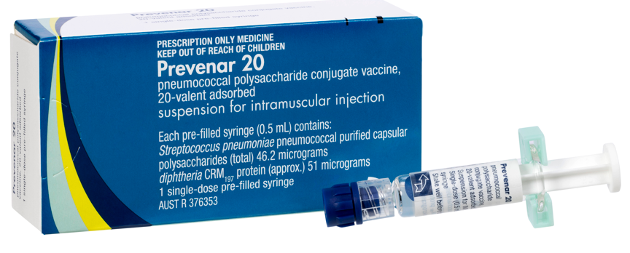
Age recommendation  - 2 (from 6 weeks), 4 & 12 months  - 6 months – additional dose for:  - Aboriginal and Torres Strait Islander children  - all non-indigenous children with risk conditions  - 12 months to <18 years – newly diagnosed risk condition  - Catch-up from 13 months to <5 years | Notes  - Prefilled syringe
Capvaxive®  Pneumococcal conjugate vaccine (21vPCV)  Adults aged 18 years and over | 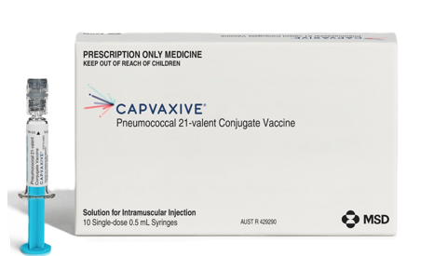
Age recommendation  - From 18 years and older – newly diagnosed risk conditions  - From 25 years – Aboriginal and Torres Strait Islander people  - From 65 years – all adults | Notes  - 0.5 mL single-dose prefilled syringes.

Reference
The Australian Immunisation Handbook <https://immunisationhandbook.health.gov.au/>.
Material adapted from the Australian Immunisation Handbook, Australian Government Department of Health.
Images of packaging reproduced with permission.
To receive this document in another format, email the Immunisation Program <immunisation@health.vic.gov.au>.
Authorised and published by the Victorian Government, 1 Treasury Place, Melbourne.
© State of Victoria, Australia, Department of Health, July 2026

