

Variation to an existing Management Licence
Victorian Radiation Management Licence – Online Licensing Portal.
OFFICIAL

When do I need to submit an application to vary my radiation management licence?

You need to apply for a variation to your management licence if you want to:
- Add or remove an authorisation on the licence
- Add or remove a site on the licence
- Update your company name but the ACN has not changed
- Move your practice to another address

If you want to:
- Change a company ACN, or
- Sell a practice
this requires a transfer of licence instead. Transfer of licence must be done via this smart form
<https://survey.forms.health.vic.gov.au/form-response/e00c8916-d0a5-4bc6-a1a7-08de2c59437b/>

If you want to:
- Take possession of a radiation source that you already have an authorisation for on your licence, you need to submit a Notification of Acquisition (not a variation).

How to submit an application to vary my radiation management licence

Step 1: Go to the online licensing portal <https://licensing.health.vic.gov.au>

Step 2: Click on the three dots on the top right of the licence tile and select Add Variation.

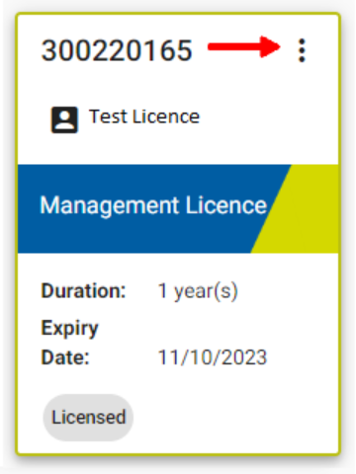
Step 4: Enter the changes you want to make to your licence.

- To update the licence holder phone number, email address, business head office address, or mailing address, click Licence holder details then the pencil icon.
- To add sites or authorisations, click on Add radiation practice(s)

Enter all the details. Upload the requested supporting documents then click Next. Sign or upload a signature then click Submit.

- To remove an authorisation, find the correct site then the correct A number. Check the location details carefully. Click on the three dots, select Remove then Confirm. Click Next. Upload the requested supporting documents then click Next. Sign or upload a signature then click Submit.

- To remove a site, find the correct site. Check the address details carefully. Click on the three dots, select Remove then Confirm. Click Next. Upload the requested supporting documents then click Next. Sign or upload a signature then click Submit.

The following message will pop up:

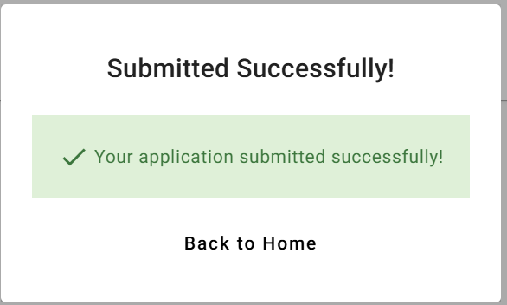

The application will then be received by the department for review and approval, as indicated by a message in the History column on the right hand side of your portal:

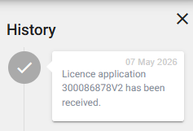

To receive this document in another format email Radiation Safety via email <radiation.safety@health.vic.gov.au> or via the online enquiry form <https://forms.business.gov.au/smartforms/servlet/SmartForm.html?formCode=queries-form-rad&tmFormVersion>
Authorised and published by the Victorian Government, 1 Treasury Place, Melbourne, May 2026
© State of Victoria, Australia, Department of Health, May 2026.

