

How to apply for a variation to your radiation use licence.
Victorian Radiation Use Licence – Online Licensing Portal.
OFFICIAL

Step 1: Log into the online licensing portal via https://licensing.health.vic.gov.au/

Step 2: Click on the three dots on the top right of the licence tile.
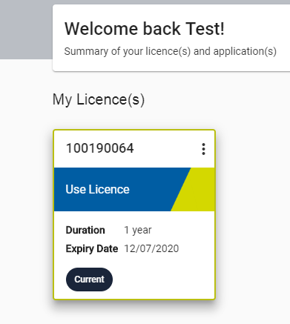

Step 3: Select ‘Add Variation’
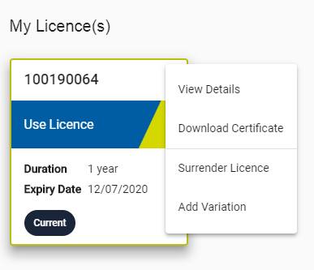
Step 4: Follow the steps within the variation application.
- Once the variation application variation has been submitted, it will be sent to Department of Health Radiation Safety for assessment and approval.
  - At any point within the assessment process, you may receive a notification requesting further information. This notification will be sent to you via email as well as displayed on the licence portal.

    - Once you have collated the requested information, click on ‘Process’
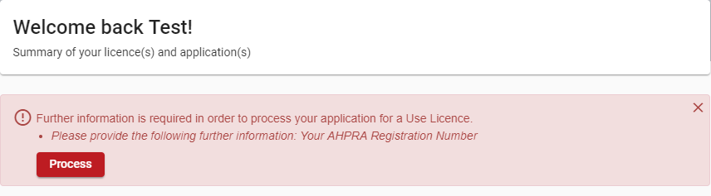

    - Upload the requested information.
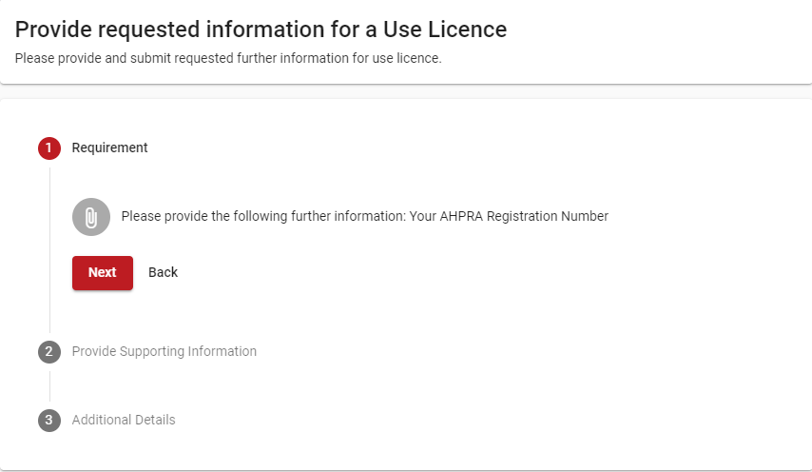

    - Once uploaded, press Submit
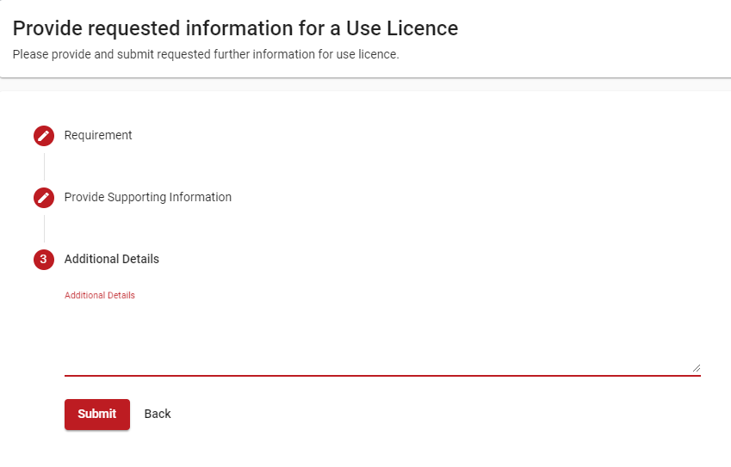

- The application will be sent to Department of Health Radiation Safety for another assessment.

Once the variation has been approved, a copy of the updated licence certificate can be downloaded.

To receive this document in another format, email Department of Health Radiation Safety, <radiation.safety@health.vic.gov.au>.
Authorised and published by the Victorian Government, 1 Treasury Place, Melbourne.
© State of Victoria, Australia, Department of Health, September 2021.

