Drug advice
Vape containing potent sedative ‘etomidate’ sold in Melbourne
Etomidate is a powerful drug used to produce general anaesthesia.
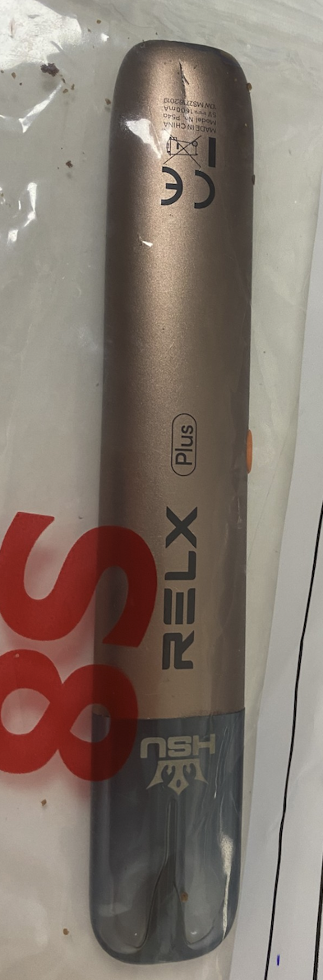
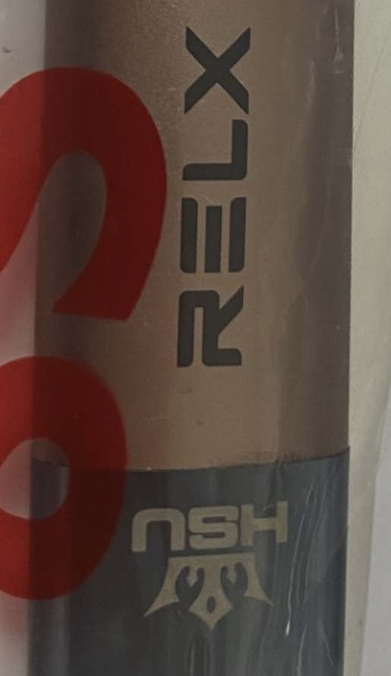
Etomidate is a powerful anaesthetic drug that has been detected in a vape product sold in Melbourne. Etomidate can cause rapid onset deep sedation, confusion, impaired coordination, vomiting, loss of consciousness and dangerously slow or ineffective breathing. These effects may be life-threatening, especially if etomidate is used with alcohol, opioids, benzodiazepines, GHB/1,4 BD/GBL or other sedatives.
Repeated exposure to etomidate may interfere with the body’s stress hormone system. This can cause weakness, dizziness, confusion, and collapse. This can be dangerous, especially during a period of illness, injury or other physical stress.
Be aware that illicit vapes sold as space oil, k-pods or space vapes may contain etomidate or another substance with a high-risk of causing harm, including potent novel opioids.
Know the signs of serious sedative toxicity and Call Triple Zero (000)
Reduced consciousness (meaning someone is hard to wake up) is the main sign of serious sedative toxicity. In some cases, the person may also have difficulty breathing or laboured breathing.
Naloxone can be lifesaving if opioids are involved. Naloxone reverses opioid overdose, but it does not reverse the effects of etomidate. Because unregulated drug products may contain unexpected opioids, naloxone is safe to give if someone has reduced consciousness and slow or difficult breathing.
Naloxone is an easy-to-use medication and can be accessed free of charge at participating pharmacies, needle and syringe programs, Mental Health and Wellbeing Locals, as well as the Victorian Pill Testing Service and the Medically Supervised Injecting Room. You can find an approved naloxone provider on the Take Home Naloxone program website.
Reduce the risk of harm
If you experience toxic drug effects, or are present when someone has an unexpected reaction, seek help immediately by calling Triple Zero (000).
All alcohol and other drug use comes with risks, so take these precautions:
- Start low and go slow, and make sure you’re in a safe environment with people you trust - vaping drugs can make it difficult to dose accurately.
- Avoid sharing vapes when you are not sure what might be in it. Don’t assume you know what is in the vape, especially if it has been sold illicitly.
- Be aware that other false or contaminated drug products may circulate in Victoria, even if no specific warning has been issued about them.
- Get free naloxone and carry it with you – no matter what drugs you think you’re getting.
Contact Harm Reduction Victoria’s DanceWize team for anonymous support and education from peers. Talk to DanceWize volunteers by email at info@dancewize.org.au.
If you or someone you know needs help with alcohol or drug use, call DirectLine on 1800 888 236 or visit directline.org.au for information and support to access treatment.

