

Downloading a copy of your use licence certificate.
Victorian Radiation Use Licence – Online Licensing Portal.
OFFICIAL

Step 1: Log into the online licensing portal via https://licensing.health.vic.gov.au/

Step 2: Click on the three dots on the top right of the licence tile.
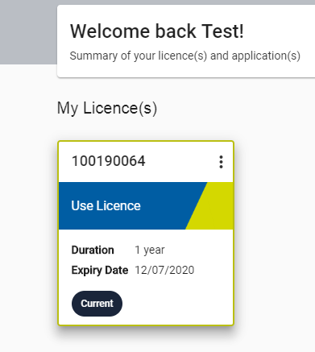
Step 3: Select ‘Download Certificate”
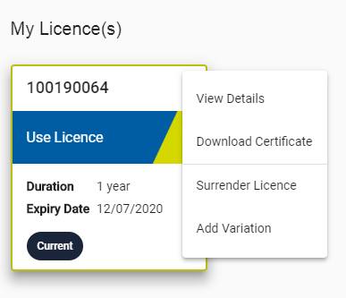

Step 4: A certificate should be downloaded as a .pdf file.
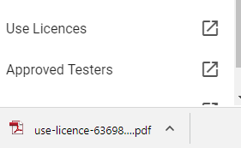

Once the licence certificate is downloaded, the licence certificate can be printed or saved.
To receive this document in another format, email Department of Health Radiation Safety, <radiation.safety@health.vic.gov.au>.
Authorised and published by the Victorian Government, 1 Treasury Place, Melbourne.
© State of Victoria, Australia, Department of Health, September 2021.

